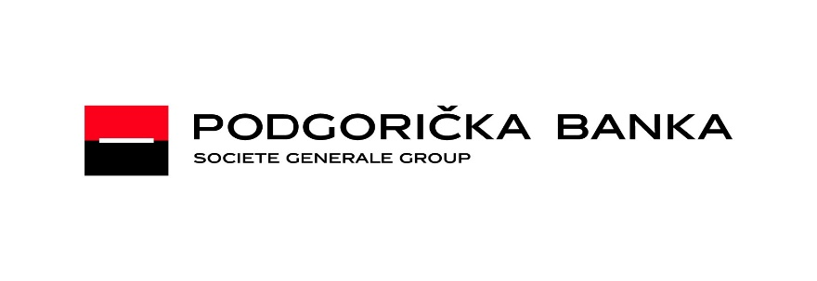

PAYMENT INSTRUCTIONS
For SWIFT transfers in EUR

Please pay as per instructions given below:

Field 56A: SOGEFRPP
(Intermediary) Societe Generale - Paris

Field 57A: PDBPMEPG
(Account with Inst) Podgoricka banka
Societe General Group AD Podgorica

Field 59: MINISTARSTVO FINANSIJA
(Beneficiary) ME25550005220000032317

Field 70: obligatory
(Remittance Information)

Iban je CBCGMEPG

List of correspondents for USD, CHF, GBP of Podgoricka banka Societe Generale Group AD:

Currency Bank SWIFT/BIC

USD Societe Generale New York SOGEUS33
CHF Credit Suisse AG Zurich CH CRESCHZZ80A
GBP Stopanska banka AD Skopje STOBMK2X

________________________________________________________________________________
Podgoricka banka Societe Generale Group AD, Novaka Miloševa 8a, 81 000 Podgorica, Montenegro, tel. +382 20 405 100

