**Izvještaj o posebnom nadzoru nad štetnim organizmima**

***Epitrix cucumeris*, *Epitrix papa*, *Epitrix subcrinita*, *Epitrix tuberis***

U nastavku su podaci o lokalitetima na kojima je izvršen pregled:

1. Trebaljevo 1 – GPS koordinate: 42° 52′ 07″ N, 19° 31′ 35″ E (Google maps [https://maps.google.com/?q=42.86874,19.5264](https://maps.google.com/?q=42.86874%2C19.5264)), dvije parcele površina oko 4000 m2;
2. Trebaljevo 2 – GPS koordinate: 42° 52′ 14″ N, 19° 31′ 38″ E (Google maps [https://maps.google.com/?q=42.8707,19.5273](https://maps.google.com/?q=42.8707%2C19.5273)), tri parcele ukupne površine oko 3500 m2;
3. Trebaljevo 3 – GPS koordinate: 42° 52′ 23″ N, 19° 31′ 38″ E (Google maps [https://maps.google.com/?q=42.87323,19.52737](https://maps.google.com/?q=42.87323%2C19.52737)) površina oko 2000 m2;
4. Sjerogošte – GPS koordinate: 42° 54′ 23″ N, 19° 32′ 35″ E (Google maps [https://maps.google.com/?q=42.90647,19.54305](https://maps.google.com/?q=42.90647%2C19.54305)) površina oko 2000 m2;
5. Mojkovac – GPS koordinate: 42° 57′ 30″ N, 19° 34′ 12″ E (Google maps [https://maps.google.com/?q=42.95845,19.57019](https://maps.google.com/?q=42.95845%2C19.57019)), površina oko 600 m2;
6. Lepenac – GPS koordinate: 42° 48′ 15″ N, 19° 29′ 31″ E (Google maps [https://maps.google.com/?q=42.99249,19.60272](https://maps.google.com/?q=42.99249%2C19.60272)) površina oko 1000 m2;
7. Bijelo Polje – GPS koordinate: 43° 03′ 23″ N, 19° 46′ 15″ E (Google maps [https://maps.google.com/?q=43.05657,19.77096](https://maps.google.com/?q=43.05657%2C19.77096)) površina oko 300 m2;
8. Bijelo Polje kod hotela IN – GPS koordinate: 43° 03' 44" N 19° 46' 21"E (Google maps [https://maps.google.com/?q=43.06239,19.77253](https://maps.google.com/?q=43.06239%2C19.77253)) površina oko 3000 m2;
9. Sutivan-GPSkoordinate: 43° 04′ 44″ N, 19° 46′ 37″ E (Google maps <https://maps.google.com/?q=43.07914,19.77706>) površina oko 2500 m2;
10. Unevina - GPS koordinate: 43° 06′ 49″ N, 19° 46′ 41″ E (Google maps [https://maps.google.com/?q=43.11362,19.77819](https://maps.google.com/?q=43.11362%2C19.77819)) površina oko 150 m2;
11. Zaton 1 - GPS koordinate: 42° 59′ 47″ N, 19° 48′ 05″ E, (Google maps

[https://maps.google.com/?q=42.99648,19.80146](https://maps.google.com/?q=42.99648%2C19.80146)), površina 600 m2;

1. Zaton 2 - GPS koordinate: 42° 58′ 37″ N, 19° 48′ 35″ E (Google maps

[https://maps.google.com/?q=42.96424,19.84574](https://maps.google.com/?q=42.96424%2C19.84574)), površina oko 1500 m2;

1. Bubanje 1 - GPS koordinate: 42° 57′ 57″ N, 19° 50′ 36″ E (Google maps

[https://maps.google.com/?q=42.96603,19.8435](https://maps.google.com/?q=42.96603%2C19.8435)) površina oko 10000 m2;

1. Bubanje 2 - GPS koordinate: 42° 57′ 51″ N, 19° 50′ 44″ E (Google maps

[https://maps.google.com/?q=42.96424,19.84574](https://maps.google.com/?q=42.96424%2C19.84574)) površina 150 m2;

1. Grahovo 1 - GPS koordinate: 42° 38′ 47.18″ N, 18° 40′ 52.31″ E (Google maps

[https://maps.google.com/?q=42.64644,18.6812](https://maps.google.com/?q=42.64644%2C18.6812)), površina oko 300 m2;

1. Grahovo 2 - GPS koordinate: 42° 39′ 16″ N, 18° 39′ 48″ E (Google maps

[https://maps.google.com/?q=42.65465,18.66339](https://maps.google.com/?q=42.65465%2C18.66339)), površina oko 2.5 ha.

U nastavku fotografije:

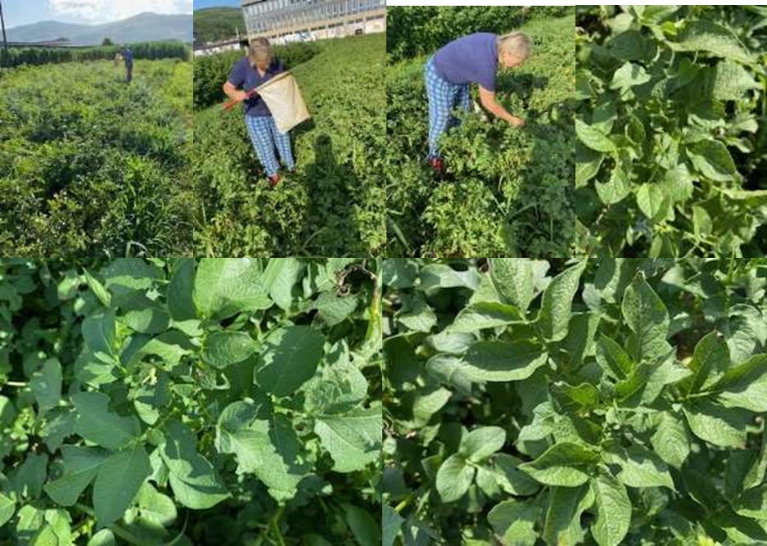

Kečeranje, pregled i listovi krompira bez prisustva i znakova prisustva buvača

Imaga uhvaćenih buvača u ekshaustru, među kojima nisu traženi buvači krompira

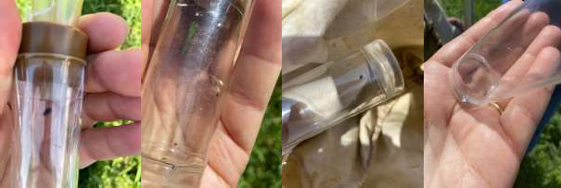

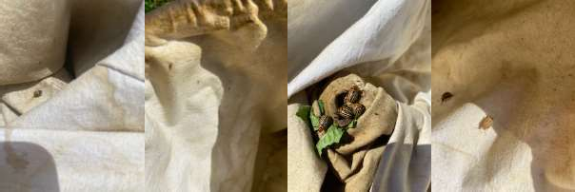 Različite vrste insekata uhvaćene u kečer