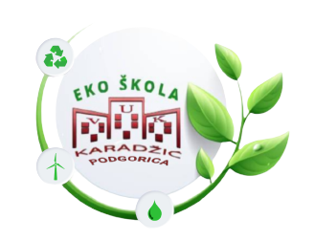
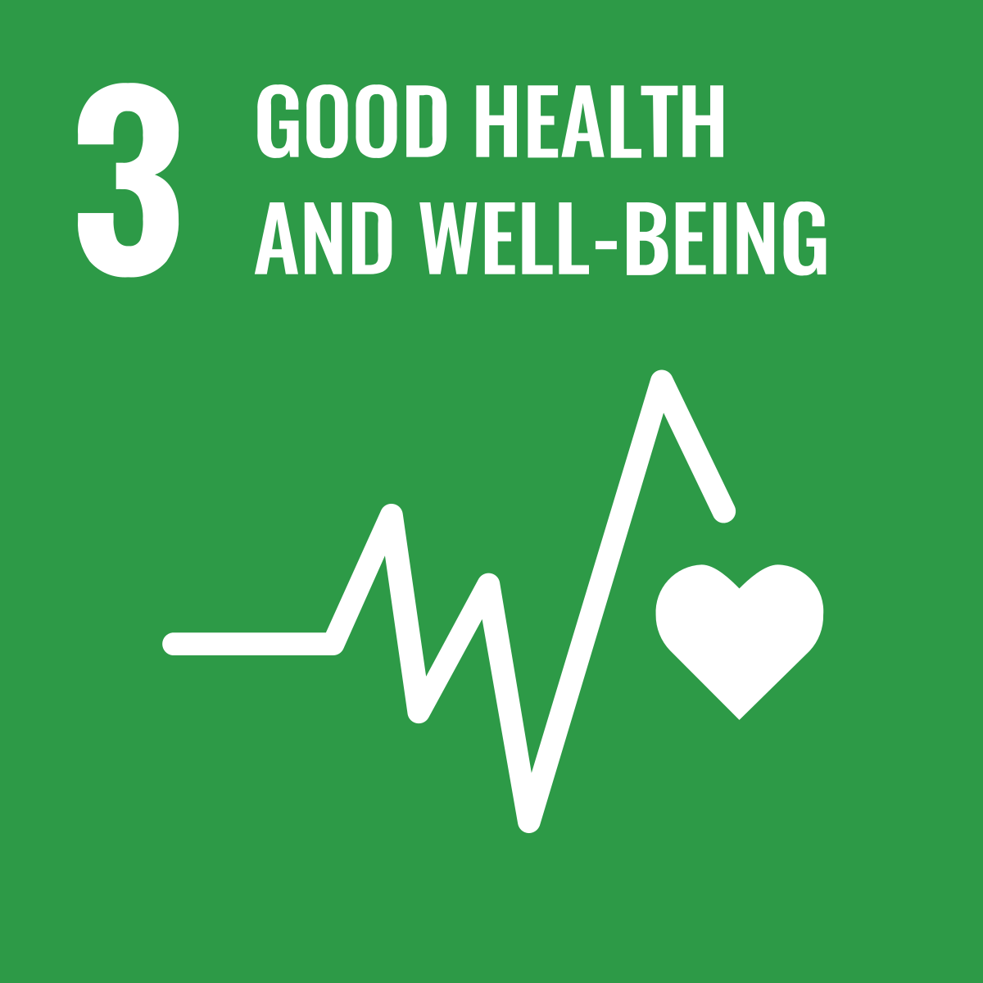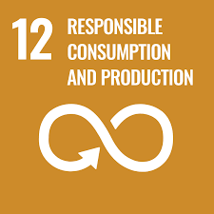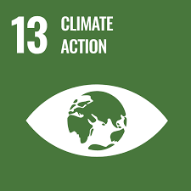

- AUTHOR DETAILS

- Name/s | Biljana Veličković, Ana Đurović
- Country | Montenegro
- Institution/School | JU OŠ ,, Vuk Karadžić” Podgorica
- Email
- Programmes the school is participating in (Eco-Schools/LEAF/YRE/other) | Eco - school
- Would you like to receive monthly updates through our Newsletter? Yes/No | Yes
- Submission date (dd/mm/yyyy) | 30. 08. 2023.

- THE LESSON PLAN

- Theme – The Ozone layer

B. Introduction – The lesson plan introduces students to the importance of the ozone layer. During the lesson, the students learned about the causes and consequences of the formation of ozone holes, as well as the prevention of their formation.

C. Age Group – The students were 11 years old (5th grade), and they had the mentoring support of students from the Club of Young Scientists who are 13 years old (8th, 9th grade).

D. Objectives or Learning Outcomes
Outcomes that students will achieve:
- They can explain the term ozone layer, environment
- They recognize the functions of the ozone layer in protecting the living world on Earth
- Recognize the causes that threaten the ozone layer,
- They predict the consequences and devise environmental protection measures in relation to the causes.
- They recognize personal responsibility and ways to contribute to the preservation of the environment

E. Time required to deliver the lesson plan – 45 minutes

F. Remote preparation - we prepared students who are members of the Club of Young Scientists how to cooperate with younger students and explained to them how they will participate in the workshop.

G. Resources Required to deliver the lesson plan – Laptop, projector, Ozzy ozzone cartoon, Ozzy ozzone educational game boards, dice, pawns, mobile phones, prepared quiz kahoot, large paper with problem tree drawn, root-shaped leaves, leaves and apples for writing causes, effects and solutions in the formation of ozone holes.

H. Activity
  - Introduction (15 minutes)
- The teachers divide the students into 4 groups-teams, using a random sample. Students themselves delegate a representative at the group level.
- Each group (team) gets one student representative of the Club of Young Scientists (8th or 9th grade), who has the role of moderating the group's work.
- At the team level, in the introductory part of the lesson, a conversation is started with the students of the Young Scientists Club on the topic of the ozone layer. The conversation is directed by the student-moderator with the help of pre-designed questions that aim to introduce the students to the topic and recognize their prior knowledge and personal experience. During the work, the teachers invite team representatives to answer questions or present a dilemma that will serve as an introduction to the next activity.
- They watch a specially adapted animated film OZZY OZZONE- the teacher directs the students to what they should pay attention to while watching the film and that the next activity will build on the content they had the opportunity to see in the film.

  - Development (20-25 minutes)
- After they have watched the animated film, the teacher initiates a discussion about the new information they learned while watching the animated film - the emphasis is on recognizing information related to phenomena and processes that occur in the environment and cause damage to the ozone layer directly or indirectly. The facts and personal stories of the animated heroes help the students to define/explain important terms and phenomena and, based on personal experience, independently draw conclusions from the story about the causes, consequences and possible solutions related to the preservation of the ozone layer.
- Club students - moderators present the OZI OZON educational game to each team and introduce them to the rules of the game. Students at the group level cross the fields (questions) in the game and try to reach the goal. The questions in the game are designed with the aim of repeating what has been learned and expanding knowledge. Moderators help students and give additional answers if they notice that a question during the game is not clear enough or they do not recognize the answer. The role of the moderator is also to motivate all team members to participate. The role of the game is to have fun and thus repeat what they learned and expand their knowledge by acquiring new, interesting information that they did not have the opportunity to hear while watching the animated film.
- After all the teams reach the goal in the game, the teacher invites them to participate in a quiz that is set with the help of the digital tool Kahoot. Moderators explain the rules of participation in the quiz to their team and give them a mobile phone that they will use to answer the questions that are being followed by the teacher on the video beam. It was especially emphasized that the quiz has a competitive character and that in addition to the correct answer, the speed with which the team sends the answers is also important. The quiz has 10 questions, and after each question the participants have the opportunity to follow the status of their team on the video beam. The questions follow up on the contents that the students had the opportunity to hear in the previous part of the lesson. In addition to recalling and sorting information, a certain number of questions are of a higher level and the participants are expected to think critically and draw conclusions independently.

  - Conclusion (5-10 minutes)
- After all the teams reach the goal in the game, the teacher invites them to participate in a quiz that is set with the help of the digital tool Kahoot. Moderators explain the rules of participation in the quiz to their team and give them a mobile phone that they will use to answer the questions that are being followed by the teacher on the video beam. It was especially emphasized that the quiz has a competitive character and that in addition to the correct answer, the speed with which the team sends the answers is also important. The quiz has 10 questions, and after each question the participants have the opportunity to follow the status of their team on the video beam. The questions follow up on the contents that the students had the opportunity to hear in the previous part of the lesson. In addition to recalling and sorting information, a certain number of questions are of a higher level and the participants are expected to think critically and draw conclusions independently.

I. Evaluation and Assessment
- Quiz results;
- The quality of the answers given by the students while crossing the fields in the game;
- Accuracy of answers when extracting/sorting information concerning: cause and effect in the requested tasks;
- Creativity and number of examples that students recognize in order to prevent and overcome problems in order to protect the ozone layer.

J. Dissemination –
https://m.facebook.com/story.php?story_fbid=pfbid02n62cxBE5KJRExZaew9VRJ9gs2Ndci4QCZjabkJW8GrTRZqotoC4exHFfhFE8rTp9l&id=100095174644850&mibextid=Nif5oz

K. References -
http://ozoneunit.me/wp-content/uploads/2020/08/Ozi-ozon-igra.pdf
https://www.youtube.com/watch?v=HXL_h3TTxIw&pp=ygUIb3ppIG96b24%3D
https://www.youtube.com/watch?v=WKrPd-8CJBM

