International Telecommunication Union

Join us and save the date!
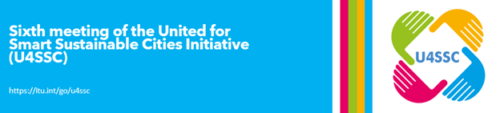
7 December 2021
Sixth meeting of the United for Smart Sustainable Cities Initiative (U4SSC)
Time: 10:00 – 15:30, Geneva time
Venue: Virtual
As part of the United for Smart Sustainable Cities (U4SSC) Initiative, the​​ International Telecommunication Union (ITU)​, United Nations Economic Commission for Europe (UNECE) and UN-Habitat, organized the Sixth meeting of the U4SSC Initiative.
The main objectives of the meeting were to provide presentation on :
- Discuss U4SSC activities;
- Provide an update on the work of the U4SSC thematic groups;
- Approve the U4SSC Terms of References and Annual Work Plan (2021-2022); and
- Present the latest U4SSC deliverables.
Register here


November - December 2021
Webinar Series on Digital Transformation for Cities and Communities
The International Telecommunication Union (ITU), together with other organizations and UN agencies, are organizing a series of webinars on "Digital transformation for cities and communities" running from September through to December 2021.
List of Episodes:
- ​18 November 2021 Episode #8: Network capabilities and emerging technologies to support IoT-enabled verticals​​ ​co-organized with CICT, China Mobile, China Unicom, EADN, Huawei, OKI and Tencent​​​​
- 6 December 2021 Episode #9: Addressing the Security Risks of Digital Transformation on IoT ​​co-organized with ITU-T Study Group 17 ​
- 7 December 2021 Episode #10: The role of digital technologies on aging and health ​co-organized with Pan American Health Organization (PAHO)​​
- 8 December 2021 Episode #11: Blockchain-based data management for supporting Internet of things and smart cities and communities co-organized with Open & Agile Smart Cities (OASC)​ and United Nations University (UNU)​
- 14 December 2021 Episode #12: Interoperability of IoT and satellite data for Earth observation supporting sustainable development co-organized with Mandat International and World Meteorological Organization (WMO)
- 3 February 2022 Episode #13: Architecting the Web of Things coordinated with the Web of Things WG of the World Wide Web Consortium (W3C)

Register here

More information on ITU-T activities on smart sustainable cities can be found here.



