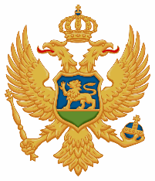

MONTENEGRO

PUBLIC WORKS ADMINISTRATION

Adress: Arsenija Boljevića 2a

City Mall, Podgorica. Crna Gora Tel: +38220/230-223

fax:+38220/230-228

MINUTES OF SITE VISIT & INFORMATION MEETING

30th June 2021

Project Title: MINISTRY OF ECOLOGY, SPATIAL PLANNING AND URBANISM MONTENEGRO ECO EFFICIENT BUILDING - II PHASE – WORKS

Contract notice reference number: PWA/E.E.B/01-908/21-2

The Contract Notice and Tender Dossier were published on the web sites of the Ministry of Finance and Social care – Directorate for public procurement Policy, Ministry of Ecology, Spatial Planning And Urbanism and Public Works Administration on 27th May 2021.

An optional information meeting and site visit started at 10.00 a.m. on 30th June 2021 in the Municipality of Podgorica at the premises of Public works Administration.

After the meeting participants toured the construction site.

The following representatives attended the site visit and information meeting:
- representatives of 16 companies,
- representatives of Public Works Administration.

After the representatives of all companies have received “Certificate of Site Visit Attendance” and signed the information meeting and site visit Attendance sheet and Confirmation of acceptance of the site visit certificate as well, the meeting was closed at 12.00 hours.

