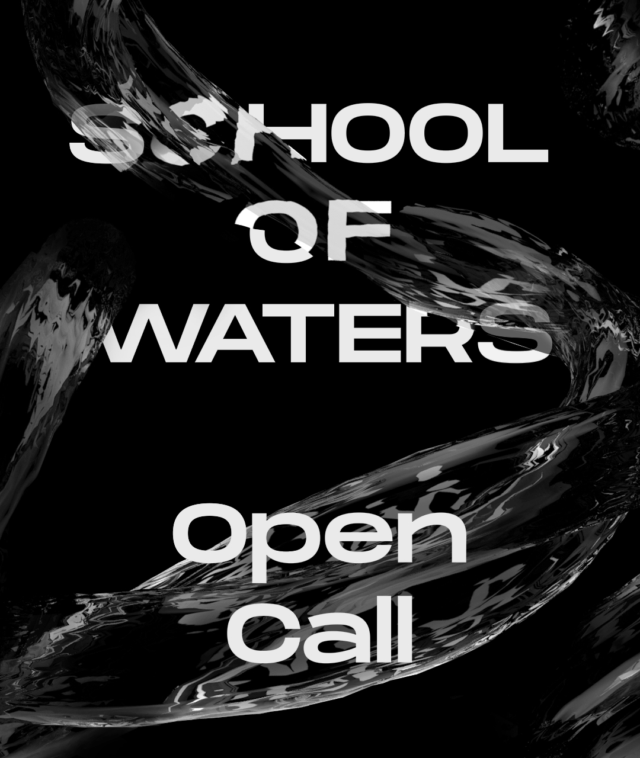

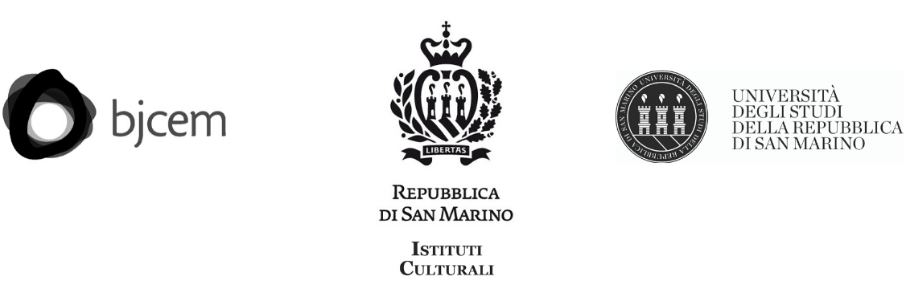

October 22nd 2020 – February 28th 2021
Opening Days October 22-25, 2020
Republic of San Marino
MEDITERRANEA 19 Young Artists Biennale
San Marino 2020
School of Waters
Curated by A Natural Oasis? A Transnational Research Programme

APPLICATION FORM

This form has to be filled in EVERY ENTRY and the validity of data is completely under your responsibility. The only accepted language is ENGLISH, no other languages will be accepted.

We appreciate your collaboration in writing all the useful information about you and your artwork in order to simplify all the procedures concerning the selection, the collection of catalogue’s materials, the request of VISA, the booking of rooms and the set-up of exhibitions.

The call is open to artists, writers and researchers, from 18 to 35 years old (born from January 1st 1984), coming from or based in the following territories: Albania, Algeria, Austria, Bosnia and Herzegovina, Cyprus, Egypt, France, Greece, Italy, Jordan, Lebanon, Libya, Malta, Montenegro, Morocco, Norway, Palestine, Republic of San Marino, Serbia, Syria, Slovenia, Tunisia, Turkey, UK.
Artists who have participated in more than one previous edition of the Biennale of young artists cannot apply.

DEADLINE FOR THE APPLICATION: January 26th 2020, 8pm Italian time

PERSONAL INFORMATION

This form has to be filled in EVERY ENTRY and please check that your data are written correctly (name, passport number).

NAME (as indicated in your passport)
SURNAME (as indicated in your passport)
GROUP NAME OR ARTISTIC NICKNAME (if present)
GENDER M   F
DATE OF BIRTH
PLACE OF BIRTH
NATIONALITY
ADDRESS (Place you are currently living)
COUNTRY
PASSPORT NUMBER
PASSPORT EXPIRY DATE
TELEPHONE NUMBER (specify international code)
MOBILE NUMBER (specify international code)
E-MAIL
WEBSITE (if any)

If you are a group please list below name, date of birth and nationality of the other members (maximum 3 members for each group)

1 Name Surname date of birth nationality

2 Name Surname date of birth nationality

TO BE PROVIDED:

All interested applicants are asked to submit one PDF (a free program to merge PDF in one file can be found here) including:

- application form (this form)
- complete CV
- portfolio (updated to 2019)
- statement
- a proposal of 400 words max and visual material responding to the curatorial concept of School of Waters (links to YouTube and Vimeo can be included)

Important additional information:
- The application can be sent ONLY via email (attachments up to 25 MB), to BJCEM at: application@bjcem.org
- The subject of the email should read: “MED19_Name_Surname”

PRIVACY

BJCEM aisbl, (Registered Office c/o Fidelium Boulevard Saint Michel, 65 B-1040 Bruxelles-Belgium; Executive Office Cortile del Maglio via Andreis 18 int. 18/c 10152 Turin – Italy T +39 011 19504733), informs, in compliance with art. 13 EU Regulation 2016/679 (GDPR), that will process data users collected through this form with the following modalities and for the following purposes:

- BJCEM collects the personal data of this form only for purposes related to the evaluation and selection of the participants to Mediterranea 19 Young Artists Biennale;
- Your email will be used by BJCEM, its members and the Curatorial Board just to get in touch with you, if required at any step of the evaluation process;
- BJCEM will use your name and surname only to promote the Biennale event and for its communication purpose;
- no data will be disclosed by BJCEM to third party.

Please notice that any information written in this form is considered definitive. Any further change in the technical form will not be accepted.

DATE................................... SCANNED SIGNATURE....................................................

