LESSON PLAN
School: Elementary school “Radoje Cizmovic”
Subject: Math
Correlation: Biology, English

PRODUCT DESIGN BY CIRCULAR ECONOMY MODEL
DON’T THROW AWAY – USE IT !!!
Introduction:
The activity encourages students to participate in circular thinking. It engages students in group work to sort and categorise circularity of different objects they use in daily life. It encourages students to strategies and communicate the concept of circular economy to influence the buying choices.
Single-use packaging and product waste is one of the most pervasive and rapidly growing issues. The primary reason for it is increasing consumption in amount and variety of disposable items, a very small percentage of which is recycled. The ‘take - make - use - waste’ philosophy of consumption has taken over lifestyles because it gives us unparalleled convenience at an affordable price. Reusing an object saves time, energy and resources and does away with the need for waste disposal or recycling.
Classroom activities:
Learning outcomes :
Students will be able to:
*identify/list resources that are used to develop commonly used products and services that we consume in our daily life
*conclude that most of the current system of production and consumption happens in a linear flow*realise that the problem of waste in human societies is due to linear flow systems of production and consumption
*identify products that are repairable and recyclable
Required time /duration - 90 minutes
Part 1 - Introducing students to the circular economy concept - 45 min
Part 2 - Practical work – 45 min
Teaching tools :
Lesson sheets, packaging boxes for ear sticks, cans (Coca Cola packaging), chips packaging, glass jar, geometry tools, decorative paper, scissors, glue
Procedure
Part 1 Short presentation “Product design in the model of circular economy“ https://sekopak.com/cirkularna-ekonomija-i-reciklaza/
This activity helps students to understand circularity in our daily life.
Students are divided into 4 groups.
Each group has a roller model.
I GROUP - COCA COLA PACKAGING (CAN)
II GROUP - EAR STICKS PACKAGING
III GROUP- CHIPS PACKAGING
IV GROUP - GLASS JAR
- Students get lesson sheets (attachment 1);
- They listen carefully to the instructions for each group;
- Each student, within the group, participates in solving the tasks, colaborates and answers the questions;
- Students consult the teacher when solving assigned problems ;
- They choose the captain of each group to present it on the board (students present solved tasks from their group to the rest of the class);
- The captain presents the task′s solution while students from other groups follow the presentation;
- Groups present publicly their work followed by the comments from other students and teacher.
- Students ask the group captain, as well as the teacher, for additional explanation.

Part 2
- Students start with the practical task creation (making pencil boxes);
- Finished products, in order to have their useful value, are given to lower grade students.
- In this way, students make conclusions why this belongs to circular economy.

Assessment of realization:
- Ask students to give their suggestions how to make products that can be useful in everyday life.
- Ask them to come up with their own examples that will not create waste.

Attachment 1

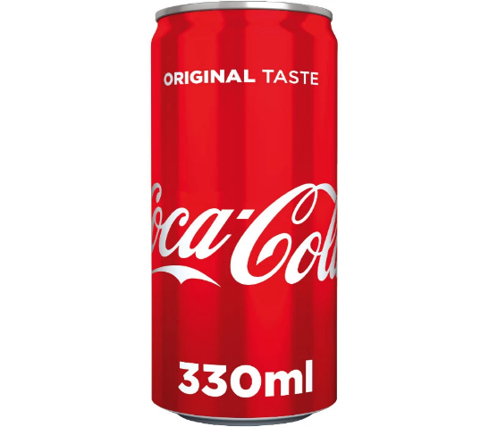
GROUP 1

- How much decorative paper is needed to make a pencil box from a Coca Cola can if 1m2 of decorative paper costs 1.20 Euros?
Note: Use a geometric tool to measure all necessary data to solve the tasks.

GROUP 2
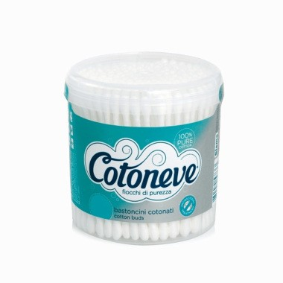
- How much decorative paper is needed to make a pencil box from an ear sticks packaging if 1m2 of decorative paper costs 1.20 Euros?
Note: Use a geometric tool to measure all necessary data to solve the tasks.

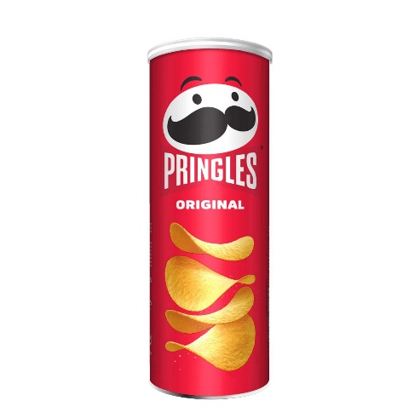
GROUP 3

- How much decorative paper is needed to make a pencil box from a chips packaging if 1m2 of decorative paper costs 1.20 Euros?
Note: Use a geometric tool to measure all necessary data to solve the tasks.

GROUP 4
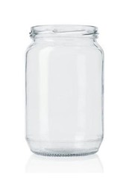
- How much decorative paper is needed to make a pencil box from a glass jar if 1m2 of decorative paper costs 1.20 Euros?

Note: Use a geometric tool to measure all necessary data to solve the tasks.

