
EN

PRACTICE PAPER

DISTINCTIVENESS OF THREE-DIMENSIONAL MARKS (SHAPE MARKS) CONTAINING VERBAL AND/OR FIGURATIVE ELEMENTS WHEN THE SHAPE IS NOT DISTINCTIVE IN ITSELF

Ministry of Economic Development and Tourism of Montenegro

Note from the Ministry:

This Practice Paper has been prepared in line with the Common Communication resulting of the Common Practice of Trade Marks developed by the European Union Intellectual Property Network (EUIPN) and is aimed to give guidance in relation to the distinctiveness of three-dimensional marks (shape marks) containing verbal and/or figurative elements when the shape itself is non-distinctive in itself. Tailor-made to the specificities of the Ministry of Economic Development and Tourism of Montenegro, it provides for an overview of the Ministry’s quality standards for applications.

This Practice Paper, adopted at national level, is made public with the purpose of further increasing transparency, legal certainty, and predictability for the benefit of examiners and users alike.
- BACKGROUND

This practice is in relation to the distinctiveness of three-dimensional marks (shape marks) containing verbal and/or figurative elements when the shape is not distinctive in itself, with the aim of establishing a minimum threshold for distinctiveness of shape marks when the shape itself is non-distinctive.

This practice is made public through this Practice Paper with the purpose of further increasing transparency, legal certainty, and predictability for the benefit of examiners and users alike.

The scope of the practice is the assessment of the overall inherent distinctiveness of shape marks consisting of a non-distinctive shape of the goods themselves, packaging or containers, and other elements to which the shape mark extends, within absolute grounds examination.

The following issues are out of scope of the practice:

- assessment of the distinctiveness of the shape;
- assessment of the distinctiveness of the elements on their own;
- implications on relative grounds;
- acquired distinctiveness;
- shapes, or other characteristics, which result from the nature of the goods themselves, which are necessary to obtain a technical result, or which give substantial value to the goods (Art. 4(1)(e) EUTMD).

- THE PRACTICE

The following text summarises the key messages and main statements of the principles of the practice. The complete text can be found at the end of this practice.

In order to determine if the threshold of distinctiveness is met, a number of elements and factors affecting the distinctiveness of the sign as a whole are borne in mind.

VERBAL AND FIGURATIVE ELEMENTS
As a starting point, if a non-distinctive shape contains an element that is distinctive on its own, it will suffice to render the sign as a whole distinctive. The size and proportion of the verbal/figurative elements, their contrast with respect to the shape, and their actual position on it, are all factors which may affect the perception of the sign when assessing its distinctiveness.
Size/proportion
DISTINCTIVE  Class 9 Secure digital memory cards | DISTINCTIVE    Class 14 Watches
When the verbal/figurative element is sufficiently large to be clearly identified as distinctive, and has sufficient impact on the overall impression given by the sign, it renders the sign as a whole distinctive. | Specific market realities must also be taken into consideration. Consumers are in the habit of identifying small elements on certain goods. Despite the small size the verbal elements can still be identified as distinctive elements in the representation.
Colour contrast
DISTINCTIVE  Class 32 Bottled drinking water | NON-DISTINCTIVE    Class 28 Playing balls
The use of less contrasting colours can still be sufficient to allow an element to be identified as distinctive in the representation and result in a distinctive sign. The overall assessment will depend on the distinctiveness of such an element. | When the element cannot clearly be identified as distinctive in the representation due to a lack of contrast, the element will have no impact on the assessment of the distinctiveness of the sign as the consumer will not be able to immediately identify such element and ultimately to distinguish the sign from others.
Position
DISTINCTIVE  Class 3 Cosmetics | NON-DISTINCTIVE  Class 3 Cosmetics
In some situations, elements may be perceived differently by the consumer because of their position on the goods and thus change the finding of distinctiveness.
COLOURS
In assessing the distinctive character of a colour, regard must be had to the general interest in not unduly restricting the availability of colours for the other traders who offer for sale goods or services of the same type as those in respect of which registration is sought (cf. Libertel and Heidelberger Bauchemie).
NON-DISTINCTIVE  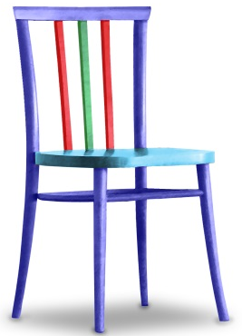  Class 9 Memory card / Class 20 Chairs | DISTINCTIVE    Class 7 Electric door opener
The mere fact of adding a single colour to the shape of a good in the absence of any other distinctive verbal or figurative element would not render the sign inherently distinctive. The chair’s colours combination conveys exclusively a decorative message and will not be recognised as a reference to its origin. | It cannot be excluded that a particular arrangement of colours which is uncommon for the goods and creates an overall memorable impression can render the sign as a whole distinctive.
COMBINATION OF FACTORS AND ELEMENTS
There are certainly situations where a shape mark contains more than one of the elements reviewed above. Moreover, there may be cases where more than one of the abovementioned factors are relevant to determine the impact of the elements in the distinctiveness of the sign. In all situations, the distinctiveness of the sign will depend on the overall impression produced by the combination of those factors and elements.
DISTINCTIVE  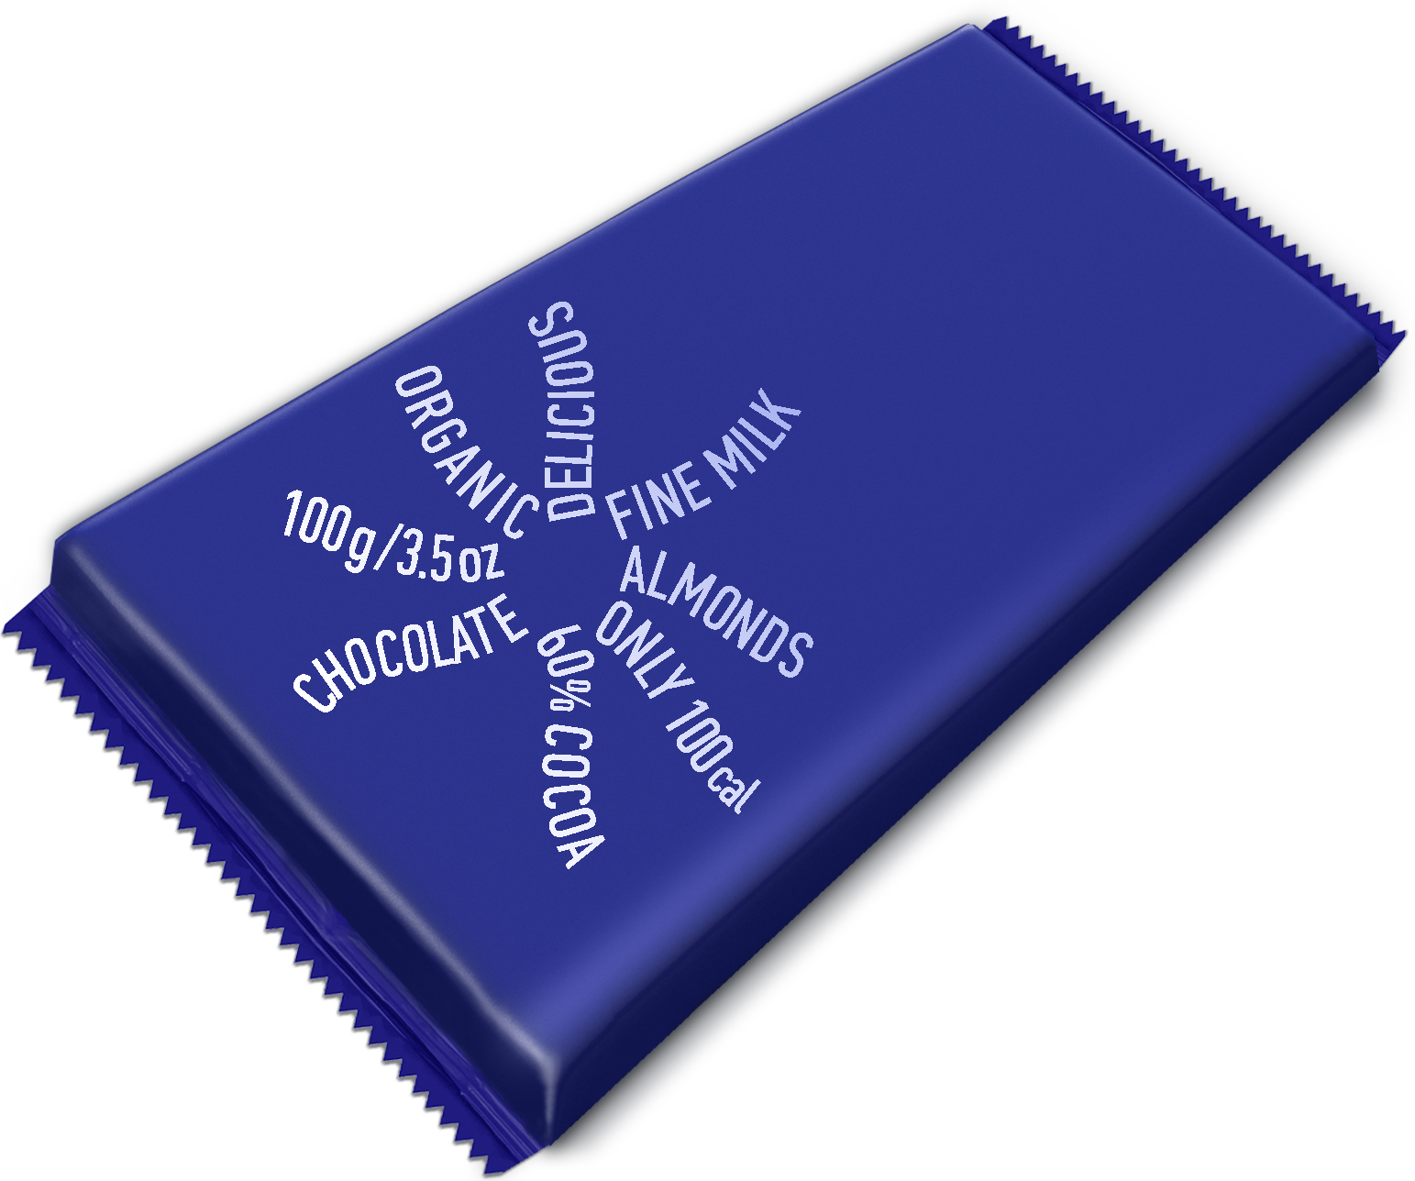  Class 30 Chocolate | NON-DISTINCTIVE  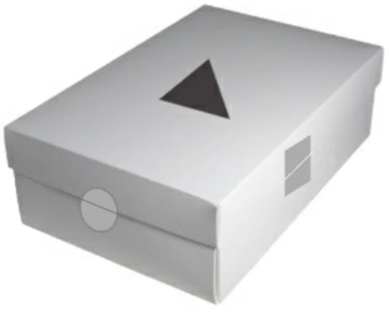  Class 25 Shoes / Class 16 Packaging
The combination of a non-distinctive shape with elements which are considered devoid of distinctive character could render the sign distinctive as a whole. In this example, even though the word elements are descriptive, their arrangement as a sun or a flower results in a distinctive overall impression. | The random arrangement of simple geometric shapes on the shape of the good in Class 16 and of the common packaging of shoes in Class 25 does not provide an overall impression which is distinctive as the consumer will not perceive this particular combination as an indication of commercial origin but merely as a possible decoration of the packaging.

EN

The Practice

DISTINCTIVENESS OF THREE-DIMENSIONAL MARKS (SHAPE MARKS) CONTAINING VERBAL AND/OR FIGURATIVE ELEMENTS WHEN THE SHAPE IS NOT DISTINCTIVE IN ITSELF

TABLE OF CONTENTS

1 Introduction 1
1.1 Objective of this document 1
1.2 Definition of shape marks 1
1.3 Practice scope 2
1.4 Common representation standards 2
2 Examination of Shape Marks: Assessing Distinctiveness 3
3 Principles of the practice 4
3.1 Verbal and figurative elements 4
3.1.1 Size/Proportion 4
3.1.2 Contrast 8
3.1.3 Position 13
3.2 Colours 15
3.3 Combinations of factors and elements 18
3.3.1 Combination of factors 19
3.3.2 Combination of non-distinctive elements 20
3.3.3 Combination of distinctive and non-distinctive verbal/figurative elements and colours 23

Introduction

Objective of this document

This Practice Paper aims to establish a minimum threshold for distinctiveness of shape marks containing other elements when the shape itself is non-distinctive. It is meant to serve as a reference for Intellectual Property offices, user associations, applicants, right holders, representatives and other interested persons.

It is made widely available and easily accessible, providing a comprehensive explanation of the principles on which the practice is based. These principles are designed to be generally applied, and aim to cover the large majority of cases. Although distinctiveness must be assessed on a case-by-case basis, the principles serve as guidance for the office when assessing distinctiveness of shape marks containing other elements when the shape itself is non-distinctive. It is not excluded that a sign may be rejected on grounds other than lack of distinctiveness.

The examples added to this document aim to illustrate the principles of the practice. These examples should be looked at in connection with their reasoning and based on the assumptions on which they rest.

Definition of shape marks

Shape marks are trade marks consisting of, or extending to, three-dimensional shapes, including containers, packaging, the product itself, or their appearance.

Shape marks, like all trade marks, should consist of a sign capable of distinguishing the goods of one undertaking from those of other undertakings and must be capable of being represented on the register in a manner which enables the competent authorities and the public to determine the clear and precise subject matter of the protection afforded to its proprietor (Article 3 EUTMD). For that purpose and to ensure legal certainty and sound administration of the trade marks’ registration system, it must be ensured that the sign is represented in a manner which is clear, precise, self-contained, easily accessible, intelligible, durable and objective (Recital 13 EUTMD).

Shape marks usually fall into three categories:

- shapes unrelated to the goods and services themselves;
- shapes that consist of the shape of the goods themselves or parts of the goods;
- shapes of packaging or containers.

Shapes that are unrelated to the goods or services themselves are usually distinctive. However, it may be more difficult to come to a finding of distinctiveness in the case of shapes that consist of the shape of the goods themselves and shapes of packaging or containers.

Finally, although the Court has stated on a number of occasions that it is not appropriate to apply more stringent criteria when assessing the distinctive character of three-dimensional marks comprising the shape of the goods themselves (07/10/2004, C-136/02 P, Torches, EU:C:2004:592, § 32), their particular characteristics, that is, their ability to take the form of the product itself or its packaging, give indeed rise to issues of distinctiveness that do not affect other types of marks, resulting in it being more difficult to come to a finding of distinctiveness as such marks will not be perceived by the relevant public in the same way as a word or a figurative mark (§ 30 of the case-law cited above). The relevant public is not in the habit of making assumptions about the origin of products on the basis of their shape or the shape of their packaging. Therefore, in the absence of any graphic (including colours) or word element the relevant shape must depart substantially from the norm or customs of the sector or, on the other hand, such graphic or word elements become essential to conferring distinctiveness on a shape mark which might not otherwise be eligible for registration.

Practice scope

The scope of the practice is the following:

Assessment of the overall inherent distinctiveness of shape marks consisting of a non-distinctive shape of the goods themselves, packaging or containers, and other elements to which the shape mark extends, within absolute grounds examination.

For the purpose of this practice, the shapes included as examples are considered to be inherently non-distinctive.

Within the practice, the following elements are reviewed:

- verbal and/or figurative elements;
- single colour and colour combinations;
- combination of elements.

The following issues are out of the scope of the practice:

- assessment of the distinctiveness of the shape;
- assessment of the distinctiveness of the elements on their own;
- implications on relative grounds;
- acquired distinctiveness;

shapes, or other characteristics, which result from the nature of the goods themselves, which are necessary to obtain a technical result, or which give substantial value to the goods (Article 4(1)(e) EUTMD).

Common representation standards

Article 3(b) EUTMD sets clear representation standards for all signs stating that they must be able to be represented on the register in a manner that allows competent authorities and the public to determine the clear and precise subject matter of protection afforded to its proprietor. Recital 13 adds the importance of requiring a sign to be capable of being represented in a clear, precise, self-contained, easily accessible, intelligible, durable and objective manner, wording which has been reproduced in Article 3(1) EUTMIR.

The representation of a trade mark (hereafter ‘the representation’) defines the subject matter of its registration, as stated in Article 3(2) EUTMIR (). Although the EUTMD does not provide such a clear statement, it can also be extracted from Article 3(b) EUTMD.

Therefore, a clear and precise representation of the shape, together with all the elements to which it extends, will define the subject matter of the trade mark application ().

Examination of Shape Marks: Assessing Distinctiveness

- Function of a trade mark: for a trade mark to possess distinctive character, it must be capable of fulfilling its essential function, namely to guarantee the identity of the commercial origin of the marked goods and/or services to the consumer by enabling him, without any possibility of confusion, to distinguish the goods or services from others which have another origin ().

- Reference to the goods: distinctiveness must be assessed, firstly, by reference to the goods in respect of which registration is sought and, secondly, by reference to the perception of the relevant public — consumer ().

- Consumer perception () and uniform legal standard: the perception is that of an average consumer who is reasonably well informed and reasonably observant and circumspect. However, as stated above, the perception of the average consumer is not necessarily the same in the case of shape marks, compared to word or figurative marks which consist of a sign that is independent from the appearance of the goods they denote (12/02/2004, C-218/01, Perwoll, EU:C:2004:88). In this respect, market realities play a role during this assessment as they influence the consumers’ perception of a sign consisting of a product itself or its packaging.

The examination of the distinctive character of shape marks should be conducted in the following steps.

Step 1: identification of the elements of the sign and assessment of their inherent distinctiveness.

The Office will identify all the elements to which the shape mark extends and their inherent distinctiveness, which for the purpose of this communication are:

- verbal and figurative elements,
- colours (single and colour combinations) and,
- a combination of the above.

Where the shape extends to verbal/figurative elements, their identification and assessment of distinctiveness should include consideration of the following factors:

- size/proportion of the elements with respect to the shape;
- contrast of the element with respect to the shape and;
- position of the element on the shape.

Where a shape extends to colour and colour combinations, their identification and assessment of distinctiveness should include consideration of the particular arrangement of colours on the specific shape.

Step 2: assessment of the distinctiveness of the sign as a whole.

The assessment of distinctiveness must be based on the overall impression of the combination of the shape and the elements to which it extends, in relation to the goods in question, and considering the consumer’s perception which can be influenced by specific market realities.

Principles of the practice

As a starting point, if a non-distinctive shape contains an element that is distinctive on its own, it will suffice to render the sign as a whole distinctive.

Examples:

DISTINCTIVE
Sign | Comments
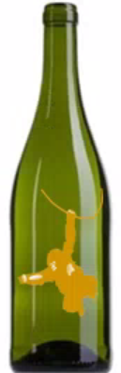  Class 33 Wine | The sign consists of a non-distinctive shape of a bottle and a clearly identifiable distinctive figurative element. Therefore, the sign as a whole is distinctive.

Verbal and figurative elements

The size and proportion of the verbal/figurative elements, their contrast with respect to the shape, and their actual position on it, are all factors which may affect the perception of the sign when assessing its distinctiveness.

Size/Proportion

The size and proportion of the elements must be taken into account when assessing the distinctive character of a shape mark. The assessment is first and foremost based on the representation of the sign, as submitted by the applicant, regardless of the usual size of the product. The distinctive element must be clearly visible in the representation to render the sign distinctive as a whole. No specific proportions between the elements and the shape are required.

- Consequently, when the verbal/figurative element is sufficiently large to be clearly identified as distinctive, and has sufficient impact on the overall impression given by the sign, it renders the sign as a whole distinctive.

Examples:

DISTINCTIVE
Sign | Comments
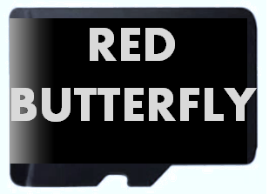  Class 9 Secure digital memory cards | Despite the very small size of this type of memory cards, the verbal element is large in proportion to the shape and can clearly be identified as a distinctive element in the representation thus rendering the sign as a whole distinctive.

- When the element is large, but identified as non-distinctive, its size alone, in proportion to the shape, will not be sufficient to render the sign as a whole distinctive.

Examples:

NON-DISTINCTIVE
Sign | Comments
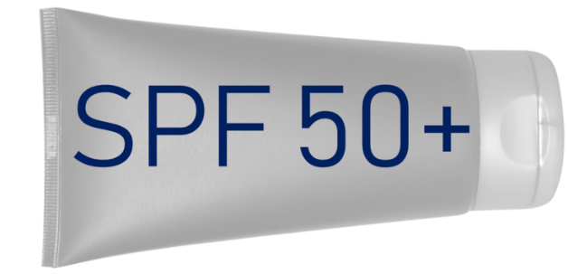  Class 3 Cosmetics | In these examples, despite the large non-distinctive verbal/figurative elements on non-distinctive shapes, the signs are not distinctive as a whole. One contains descriptive information about the goods in question, and the other contains a representation of a simple geometrical shape, which is also non-distinctive.
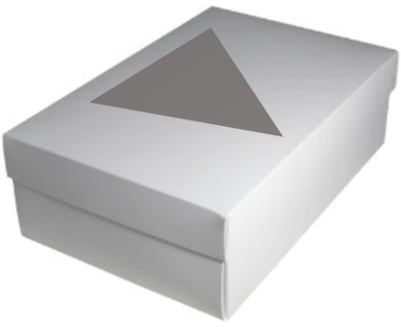

Class 16 Packaging/Class 25 Shoes

- Specific market realities must also be taken into consideration. Consumers are in the habit of identifying small elements on certain goods, in which case, relatively small-sized elements may still have a sufficient impact to render the sign as a whole distinctive as long as their size still allows them to be clearly identified as distinctive.

Examples:
DISTINCTIVE
Sign | Comments
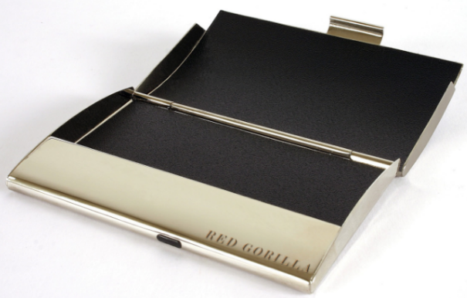  Class 18 Business card holders in the nature of card cases | Small badges of origin are commonly used for goods such as business card holders or watches. Therefore, despite the small size of the verbal elements in proportion to the non-distinctive shapes, the sign as a whole is distinctive as the verbal elements can be identified as distinctive elements in the representation, rendering the sign as a whole distinctive.


Class 14 Watches

  Class 12 Trucks | In this specific segment, badges of origin are usually relatively small in proportion to the goods. The fairly small size of the verbal element in proportion to the truck does not prevent it from being clearly identified as a distinctive element in the representation, thus having an impact on its overall impression, since consumers are accustomed to this practice.

- When the verbal/figurative element is small to the point it is not identifiable as distinctive, it will not have a sufficient impact on the overall impression and therefore will not render the shape as a whole distinctive.

Examples:

NON-DISTINCTIVE
Sign | Comments
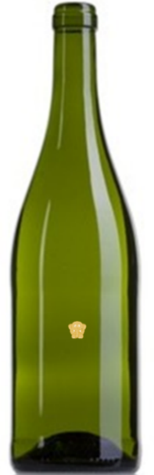  Class 33 Wine | In these examples, the verbal/figurative elements are so small that they cannot be identified in the representation and their distinctiveness cannot be determined.  Therefore, they do not have sufficient impact on the overall impression and the sign as a whole is non-distinctive.


Class 9 Secure digital memory card

Contrast

The use of contrast can also affect the capacity of the verbal/figurative element(s) to be identified, and ultimately to render the sign distinctive as a whole. Contrast can be achieved by the use of different shades of colours or by embossing/engraving/debossing certain elements on the specific goods.

- Colour contrast

- The use of less contrasting colours can still be sufficient to allow an element to be identified as distinctive in the representation and result in a distinctive sign. The overall assessment will depend on the distinctiveness of such an element.

Examples:

DISTINCTIVE
Sign | Comments
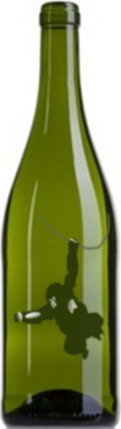  Class 33 Wine | Despite the use of less contrasting colours, the figurative element on the bottle is still capable of conferring distinctive character to the sign as a whole as the element can clearly be identified as distinctive in the representation.

- On the contrary, when the element cannot clearly be identified as distinctive in the representation due to a lack of contrast, the element will have no impact on the assessment of the distinctiveness of the sign as the consumer will not be able to immediately identify such element and ultimately to distinguish the sign from others.

Examples:

NON-DISTINCTIVE
Sign |  | Comments
  Class 28 Playing balls |  | In this case, the element cannot be clearly identified without close inspection due to a lack of contrast between the element and its background. The combination does not render the sign as a whole distinctive ().

- Engraving/Embossing/Debossing

Engraving should be understood in this context as the action of cutting or carving (a text or design) on the surface of a hard object.

Embossing should be understood here as the action of carving, moulding, or stamping a design on (a surface or object) so that it stands out in raised relief.

Debossing should be understood here as the action of ‘carving, moulding, or stamping a design on (a surface or object) so that it stands out in recessed relief’.

Due to their nature, the colour of engravings/embossings/debossings blends in with the product itself and makes them harder to be perceived and identified. Nevertheless, engravings are frequently used to distinguish shape marks.

- The effect of engraving/embossing/debossing may also influence the identification of the element and the overall assessment of the distinctiveness of the sign. When an element has been identified, a decision can be taken on its distinctiveness.

Examples:

DISTINCTIVE
Sign | Comments
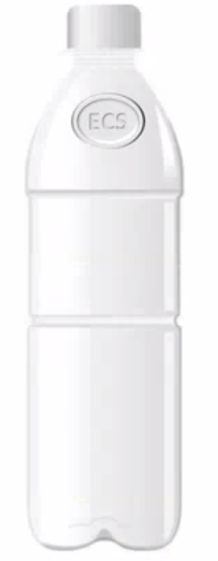  Class 32 Beverages | The embossed element can be identified as distinctive in the representation and therefore, the sign is distinctive as a whole.
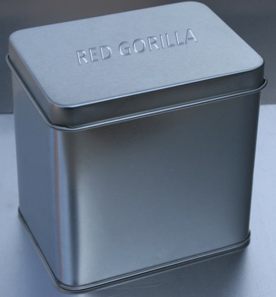  Class 16 Pencil boxes | The engraved element can also be identified as distinctive in the representation shown, therefore, the sign is distinctive as a whole.

NON-DISTINCTIVE
Sign | Comments
  Class 11 Toaster | The engraved figurative element does not have enough contrast with respect to the shape and therefore cannot be clearly identified in the representation. It therefore cannot render the sign as a whole distinctive.

- In principle, the fact of engraving/embossing/debossing a non-distinctive element on a non-distinctive shape is not in itself sufficient to render a sign distinctive.

Example:

NON-DISTINCTIVE
Sign | Comments
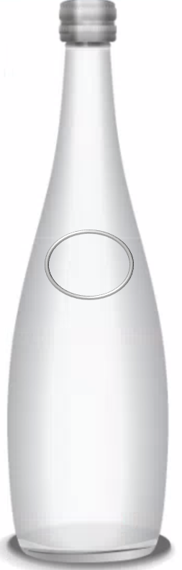  Class 32 Bottled drinking water | This non-distinctive element (simple geometric shape — circle) which has been engraved on the non-distinctive shape does not bring distinctiveness to the sign as a whole. The overall impression is non-distinctive as the consumer will not be able to distinguish this good to be originating from a specific undertaking.
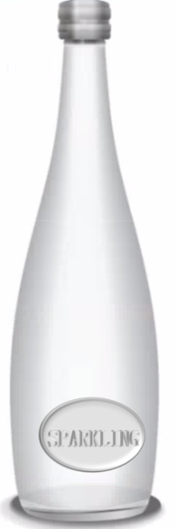  Class 32 Bottled drinking water | These non-distinctive elements which have been engraved on the non-distinctive shape do not bring distinctiveness to the sign as a whole. The overall impression is non-distinctive as the consumer will not be able to distinguish this good as originating from a specific undertaking.

Position

The position of an element to which the sign extends is also a factor to be taken into account when assessing the distinctive character of the sign, as it will affect the capacity of such element to be identified as distinctive or not, and ultimately convey a distinctive character to the sign.

- In general, distinctive elements will render a sign distinctive as a whole, irrespective of their position on the good and the usual presentation of the product on the market, as long as they can be identified as distinctive in the representation of the trade mark application.

Examples:

DISTINCTIVE
Sign | Comments
Class 32 Bottled drinking water | The verbal and figurative elements can be identified as distinctive in all of the examples, regardless of their position and thus render each sign distinctive as a whole.  Although signs of origin are not commonly placed in the bottom part of a bottle, as shown in the last example, this possibility cannot be excluded.
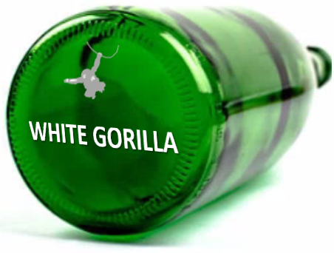

Class 32 Bottled drinking water

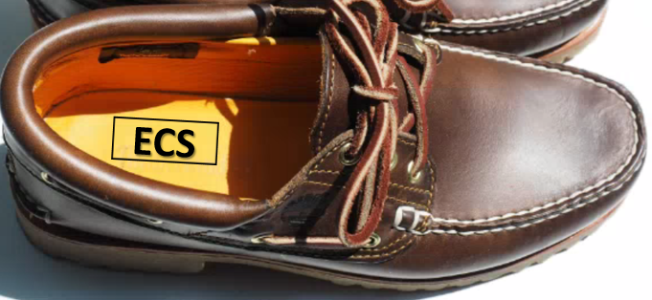  Class 25 Shoes | Badges of origin can be commonly found on the insole of shoes. In this case, the distinctive element has been placed in an expected position, and it can clearly be identified as distinctive in the representation, therefore it is able to render the sign distinctive as a whole.

NON-DISTINCTIVE
Sign | Comments
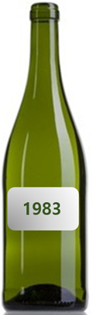  Class 33 Wine | The label containing the descriptive verbal element, placed in a typical position for this type of packaging of goods, does not render the sign distinctive as a whole.
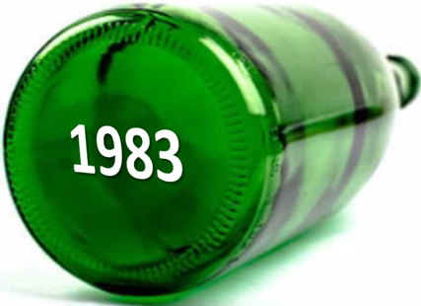  Class 33 Wine | The non-distinctive element (possibly the year of production) is placed on the bottom part of the bottle which might not be the typical position for this kind of descriptive information. Nevertheless, the unusual position does not add distinctive character to the clearly non-distinctive element, therefore, the sign is non-distinctive as a whole.

- In some situations, elements may be perceived differently by the consumer because of their position on the goods and thus change the finding of distinctiveness.

Examples

DISTINCTIVE | NON-DISTINCTIVE | Comments
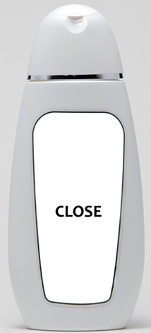  Class 3 Cosmetics | 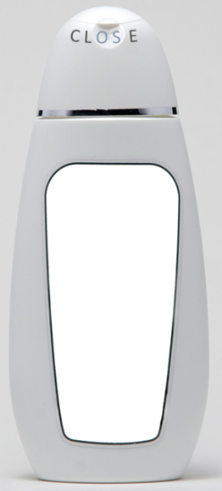  Class 3 Cosmetics | The verbal element ‘CLOSE’ bears no relation to the goods in Class 3.  When placed centrally, the verbal element is perceived as distinctive, as it does not provide a descriptive indication of the good. Therefore, the sign as a whole is distinctive.  However, when placed at the top of the product, next to the lid, it will be perceived as a descriptive indication of the opening/closing function of the lid.

Colours

In assessing the distinctive character of a colour, regard must be had to the general interest in not unduly restricting the availability of colours for the other traders who offer for sale goods or services of the same type as those in respect of which registration is sought, cf. judgments of 06/05/2003, Libertel, C-104/01, EU:C:2003:244, § 60, and of 24/06/2004, Blau/Gelb, C-49/02, EU:C:2004:384, § 41.

The situations in which colours cannot provide distinctiveness to the goods can be the following:

- in many instances, a colour would merely be a decorative element of the goods or comply with the consumer’s request (e.g. colours of cars or T-shirts), irrespective of the number of colours concerned;
- a colour can be the nature of the goods (e.g. for tints);
- a colour can be technically functional (e.g. the colour red for fire extinguishers, various colours used for electric cables);
- a colour may also be usual (e.g. again, red for fire extinguishers);
- a colour may indicate a particular characteristic of the goods, such as a flavour (yellow for lemon flavour, pink for strawberry flavour). See judgment of 03/05/2017, T-36/16, GREEN STRIPES ON A PIN (col.), EU:T:2017:295, §§ 43 to 47, in which the Court stated that the colour green, perceived as the colour of nature, would lead the relevant public to understand it as referring to the ecological nature of the goods at issue (wind energy converters).

As confirmed by the Court of Justice, consumers are not in the habit of making assumptions about the origin of goods based on their colour or the colour of their packaging in the absence of any graphic or word element, because as a rule, a colour is not used as a means of identification in current commercial practice (06/05/2002, C-104/01, Libertel, EU:C:2003:244). A colour is not normally inherently capable of distinguishing goods of a particular undertaking (§ 65). Therefore, a single colour will in principle not be distinctive for any goods and services except under exceptional circumstances. In all cases, the examination will require a case-by-case analysis.

- In principle, the mere fact of adding a single colour to the shape of a good in the absence of any other distinctive verbal or figurative distinctive element would not render the sign inherently distinctive.

Examples:

NON-DISTINCTIVE
Sign | Comments
Class 9 Memory card | In this example, consumers will not perceive the addition of a single yellow colour to the shape as an indication of origin. Use of colour on this type of goods is common on the market.
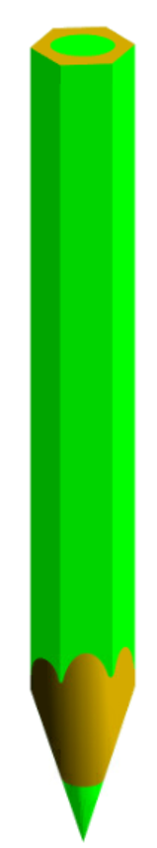  Class 16 Pencils | The use of a single colour in this case would not be perceived as a badge of origin, but provide information on the nature of the goods in question. The sign is therefore non-distinctive.

- However, it cannot be excluded that a particular arrangement of colours which is uncommon for the goods and creates an overall memorable impression can render the sign as a whole distinctive.

Examples:

DISTINCTIVE
Sign | Comments
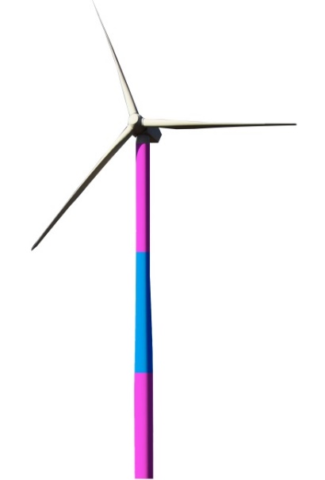  Class 7 Wind turbine | This particular colour arrangement applied to the wind turbine is unusual in the market and simple enough to create a memorable overall impression for the specialised consumer to recall as a means of identification.
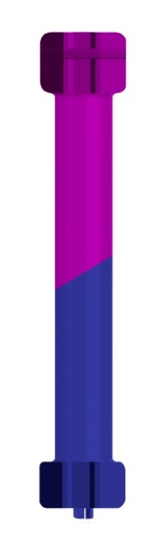  Class 7 Electric door opener | This particular colour arrangement applied to a tube motor for garage doors creates an easy to remember overall impression. In this specific market the goods are almost exclusively sought by professional consumers who have got used to identifying the commercial origin of these goods by colours. The goods are regularly not visible during use; therefore, the colour combination is not perceived as decorative.  As a result, the sign as a whole is distinctive.

Examples:

NON-DISTINCTIVE
Sign | Comments
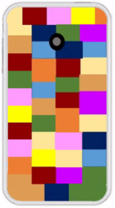  Class 9 Mobile phone cases | For mobile phone cases, use of colour combinations is common in the market. Therefore, the consumer will not perceive this colour combination as an indication of origin, but as a mere decoration for these goods. The sign is not distinctive as a whole.
Class 20 Chairs | This combination conveys exclusively a decorative message, which will not be recognised as a reference to its origin. Therefore, it cannot render the sign as a whole distinctive.

Combinations of factors and elements

There are certainly situations where a shape mark contains more than one of the elements reviewed above.

Moreover, there may be cases where more than one of the abovementioned factors are relevant to determine the impact of the elements in the distinctiveness of the sign.

In all situations, the distinctiveness of the sign will depend on the overall impression produced by the combination of those factors and elements.

Combination of factors

- When several factors (such as size, position or contrast) negatively affect the element from being identified as distinctive, this will lead to a non-distinctive overall impression of the sign.

Examples:

NON-DISTINCTIVE
Sign | Comments
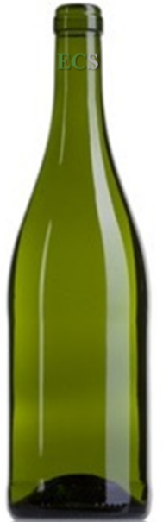  Class 33 Wine | Size, position and lack of contrasting colours of the verbal element result in a non-distinctive overall impression. The element cannot be identified as distinctive on the good without a very close inspection, as it has been placed in a less visible place on the bottle, using a very small size and a poor contrast. Therefore, it cannot render the mark distinctive as a whole.
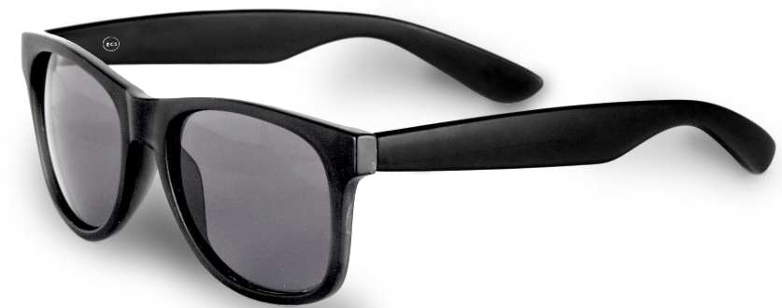  Class 9 Glasses | The size and engraving of the element do not enable it to be identifiable, as the elements cannot be found without close inspection. This results in a non-distinctive overall impression.

DISTINCTIVE
Sign | Comments
  Class 9 Glasses | In this case, the size of the element and its contrast with the goods allow for it to be identified as distinctive: it altogether results in a distinctive overall impression.

Combination of non-distinctive elements

- In general, combining a non-distinctive shape with verbal and/or figurative elements, which are considered individually devoid of distinctive character, does not result in a distinctive sign.

Examples:

NON-DISTINCTIVE
Sign | Comments
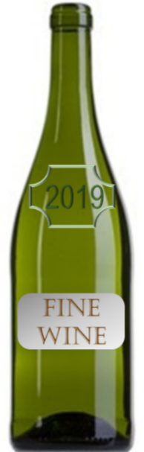  Class 33 Wine | The verbal and figurative elements are non-distinctive as they provide descriptive information of the goods in question. Although placed in a central position on the shape and despite their large size and sufficient contrast, they are unable to render the sign distinctive as whole as the consumer will not perceive the combination as a source of origin.
Class 25 Shoes/Class 16 Packaging | The random arrangement of simple geometric shapes on the shape of the good in Class 16 and of the common packaging of shoes in Class 25 does not provide an overall impression which is distinctive as the consumer will not perceive this particular combination as an indication of commercial origin but merely as a possible decoration of the packaging.
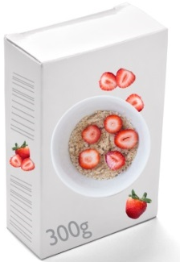  Class 30 Cereals | The combination of non-distinctive elements is unable to provide any distinctive character to the sign where the shape consists of a non-distinctive box of cereals as shown. Consumers would perceive it as a basic and common shape including descriptive information about the goods in question.
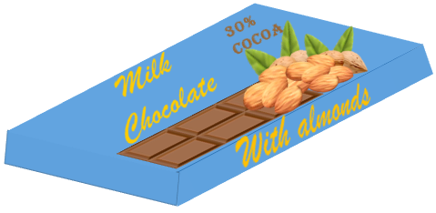  Class 30 Chocolate | This combination of elements, all of which are in themselves non-distinctive, does not render the sign distinctive as a whole.

- Nevertheless, combining a non-distinctive shape with elements which are although considered individually devoid of distinctive character could be perceived as a badge of origin due to the perception of the relevant consumer and composition of the sign, when considered as a whole.

Examples:

DISTINCTIVE
Sign | Comments
Class 30 Chocolate | The descriptive elements have been arranged in a way that they create the shape of a sun or a flower; a combination which can be perceived as a badge of origin and which therefore renders the sign distinctive as a whole.
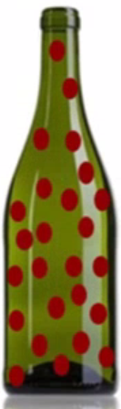  Class 33 Wine | Multiple repeated dots, in a contrasting colour, added to the non-distinctive shape result in an unusual combination in the market, rendering the sign distinctive as a whole.

NON-DISTINCTIVE
Sign | Comments
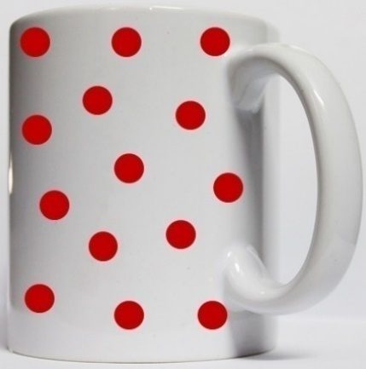  Class 21 Coffee cups | Multiple repeated dots, in a contrasting colour, will be seen in this case as mere ornamentation. The elements are therefore unable to render the sign distinctive as a whole because the use of decorative elements is usual in the market of the goods at stake.

Combination of distinctive and non-distinctive verbal/figurative elements and colours

- In general, combining a distinctive element together with other non-distinctive elements on a non-distinctive shape may render the mark distinctive as a whole, as long as the distinctive element can be clearly identified amongst all the other elements.

Example:

DISTINCTIVE
Sign | Comments
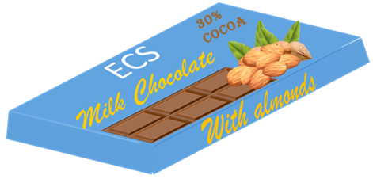  Class 30 Chocolate | Despite the combination of many non-distinctive elements, the verbal element ‘ECS’ can be identified as distinctive in the representation due to its size, position and contrast with respect to the good, and therefore it is able to render the sign distinctive as a whole.

- However, if the distinctive element is not immediately perceived by the consumer due to the presence of non-distinctive elements, the combination may result in a non-distinctive sign.

NON-DISTINCTIVE
Sign | Comments
  Class 30 Chocolate | The verbal element ECS is lost within multiple non-distinctive elements. Due to its position, size and lack of contrast, it cannot be identified as distinctive without close inspection and therefore, cannot render the sign distinctive as a whole.

() Commission Implementing Regulation (EU) 2018/626, of 5 March 2018.
() The principles in this practice are illustrated on examples standardised in format of 8x8cm.
() See C-39/97, Canon, § 28 and T-79/00, LITE, § 26.
() See C- 53/01 P, Linde, § 41, C-363/99, Postkantoor, § 34, Joined cases C-468/01 P to C-472/01 P, Tabs (3D), § 33.
() ‘Consumer’, for the purpose of this practice, refers both to the public at large and professionals.
() The contrast may vary depending on viewing conditions (screens, printed layouts, etc.) making the element more or less identifiable. For the purpose of this practice, the element is considered not clearly identifiable.

