**Flourishing Lives:**

**Supportive communities and sustainable development**

Podgorica, Montenegro

26 & 27 October 2017

Pre-conference meeting: 25 October

**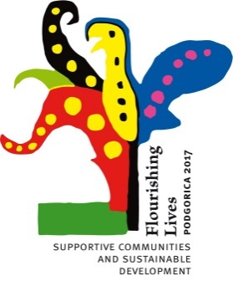**

**REGISTER** [**HERE**](http://bit.ly/ConferenceMontenegro)**!**

Join us in Podgorica to discuss **supportive communities and sustainable development**!

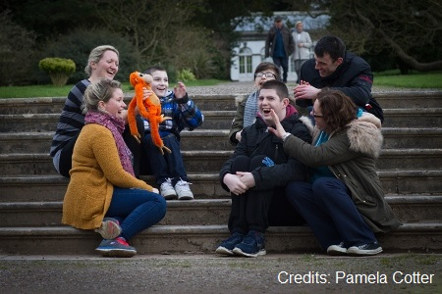

**Conference keynote sessions**

**What is inclusive development?** with

* + **Mr Alfredo Ferrante**, Chair of the Ad Hoc Committee of experts on the Rights of Persons with Disabilities, Council of Europe
  + **Mr Jean-Yves Barreyre**, Directeur du Centre d’études, de documentation et d’action sociale (CÉDIAS)
  + **Mrs Victoria Lee**, Programme Manager, Office of the United Nations High Commissioner for Human Rights

**How can we promote supportive communities?** with

* + **Mrs Ana Peláez Narváez,** Vice President of the European Disability Forum
  + **Mr Ervin Eros**, Director of Central European Service for Cross-border Initiatives
  + **Mrs Sanela Ziga** and **Mrs Svetlana Dujovic**, Association of parents of the children with disabilities “Ray of hope”, Montenegro

**Innovation and Scaling up** with

* + **Mrs Svetlana Dujovic**, Day care centre for children and youth with disabilities Pljevlja, Montenegro
  + **Mrs Jean Judes** - Beit Issie Shapiro
  + **Mr Yaniv Janson and Mrs Annick Janson**

**AND MORE!**

**Find FULL Conference agenda** [HERE](http://www.easpd.eu/sites/default/files/sites/default/files/draft_programme_conference_montenegro_en.pdf)**.**

**Our Featured Speakers**

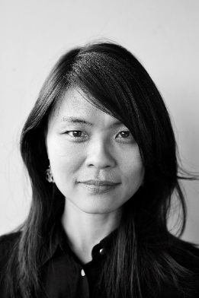

**Victoria Lee, a Programme Manager in the Human Rights & Disability Team of the UN Office of the High Commissioner for Human Rights will be giving a speech on “Sustainable Development Goals and UN CRPD Principles”**

Victoria Lee is a human rights lawyer working in the disability team within the UN Office of the High Commissioner for Human Rights coordinating a project linking implementation of the Sustainable Development Goals and the Convention on the Rights of Persons with Disabilities (CRPD). Formerly, she held several posts in non-governmental organisations most recently as Senior Human Rights Adviser of the International Disability Alliance to promote the participation of organisations of persons with disabilities and the mainstreaming of the rights of persons with disabilities across human rights mechanisms aligned with the CRPD.

*"Communities flourish when their members flourish. Recognising and embracing diversity in humanity -and humanity in diversity, ensures that space, support and strength is provided to all, including persons with disabilities; for everyone to benefit from, and contribute to the development and sustainability of our communities."*

*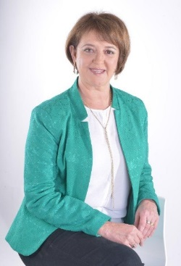*

**Jean Judes, the Executive Director of Isreal’s leading organization in the field of disabilities, Beit Issie Shapiro (BIS), will be giving a speech on “Think Large, Act Small – One (BIS) Experience of Scaling-Up: The Power to Create Community Change!**

Impacting on 500,000 people annually, the organization furthers the rights of people with disabilities to be fully included within the community. BIS plays a pioneering role in the development and provision of cutting edge services, changing attitudes in society and advocating for better legislation, and sharing knowledge throughout Israel, as well as internationally, through research, consultation and training. Jean has a Masters in Social Work, Planning and Management from the Bar Ilan University, and has been working in the field of disabilities for the past 20 years.

*“Our greatest challenge is to build communities that support inclusion and acceptance of differences, through investing our resources not only in direct service provision, but also in activities that change attitudes, legislation, and policies.”*

**Join us!**

**To join us in this fantastic conference (and learn more) go to:** [http://bit.ly/ConferenceMontenegro](http://bit.ly/ConferenceMontenegro%20)

**Conference Fees:**

EASPD members: 200 Eur

EASPD members from [selected countries](http://easpd.eu/en/content/annual-conference-2017-montenegro): 50 Euro

Non-EASPD members: 220 Euro

Non-EASPD members from [selected countries:](http://easpd.eu/en/content/annual-conference-2017-montenegro) 70 Euro

*The conference fee covers participation to all conference plenaries and workshops and includes all conference refreshments.*

**P:\Logos & maps\EASPD logo\EASPD LOGO_slogan large.tif**

**This conference is co-sponsored by**

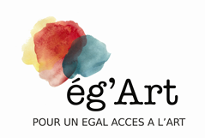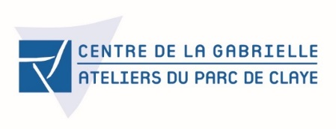

http://europa.eu/about-eu/basic-information/symbols/images/flag_yellow_high.jpg**This publication has been produced with the financial support of the European Union Programme for Employment and Social Innovation “EaSI” (2014-2020). The information contained in this publication does not necessarily reflect the official position of the European Commission.**