STRATEGIC ENVIRONMENTAL ASSESMENT
FOR THE
TRANSPORT DEVELOPMENT STRATEGY FOR MONTENEGRO
2018-2035

I INTRODUCTION 5
1. SHORT OUTLINE OF THE CONTENTS AND MAIN OBJECTIVES OF THE STRATEGY AND THEIR RELATION WITH OTHER PLANS AND PROGRAMMES 6
1.1. Strategy objectives 6
1.2. Strategy Area 6
1.3. Transport Policy – Chapter 14 8
1.4. Brief overview of the Strategy - Transport model 9
1.5. Relation with other plans and programs 13
2. ENVIRONMENTAL BASELINE DESCRIPTION 23
2.1. Air Quality and Climate Changes 23
2.1.1 Air Quality 23
2.1.2 Climate and Climate Changes 26
2.2. Geological and hydrogeological characteristics 34
2.2.1. Geological characteristics 34
2.2.2 Tectonic unit 38
2.2.3. Seismicity 40
2.2.4. Hydrogeological characteristics 42
2.2.5. Mineral resources 44
2.3. Soil and way of land use 49
2.3.1. Erosion 49
2.4. Waters 51
2.4.1 Fresh Waters 52
2.4.2 Sea 62
2.4.3 Floods 65
2.5. Biodiversity and Protected Areas 66
2.5.1 Biodiversity 66
2.5.2 Protected areas 73
2.6. Population 78
2.7. Cultural Heritage and Landscape 78
2.8. Noise and Vibration 79
2.9. Human Health 81
2.10. Economic activities 82
2.10.1 Agriculture 82
2.10.2 Forestry and Hunting 83
2.10.3 Tourism 87
2.10.4 Material assets – infrastructure 90
3. IDENTIFICATION OF AREAS WITH POSSIBILITY OF BEING EXPOSED TO A SIGNIFICANT RISK AND ENVIRONMENTAL CHARACTERISTICS IN THOSE AREAS 93
3.1. Identified expexted results 93
4. EXISTING PROBLEMS REGARDING ENVIRONMENT CONNECTED WITH STRATEGY 97
4.1. Air pollution from Traffic 97
4.2. Biodiversity 98
4.3. Noise 99
5. GENERAL AND SPECIFIC OBJESTIVES OF ENVIRONMENTAL PROTECTION 100
6. POTENTIAL SIGNIFICANT IMPACTS ON PUBLIC HEALTH AND THE ENVIRONMENT, INCLUDING FACTORS SUCH AS BIOLOGICAL DIVERSITY, POPULATION, FAUNA, FLORA, LAND, WATER, AIR, CLIMATIC ASPECTS, MATERIAL RESOURCES, CULTURAL HERITAGE, INCLUDING ARCHITECTURAL AND ARCHAEOLOGICAL HERITAGE, LANDSCAPE AND RELATIONS BETWEEN THESE FACTORS 106
6.1. Identification of environmental impacts 107
6.2. Soil and mineral resources 109
6.3. Air 110
6.4. Climate 112
6.5. Impact on water 112
6.6. Biodiversity/protected areas 114
6.7. Human health 117
6.8. Impact on noise 118
6.9. Cultural heritage 118
6.10. Landscape 120
6.11. Population and material assets 121
7. MEASURES ENVISAGED TO PREVENT, REDUCE OR ELIMINATE ANY SIGNIFICANT NEGATIVE IMPACT ON HUMAN HEALTH AND THE ENVIRONMENT CAUSED BY THE REALIZATION OF THE STRATEGY TO THE GREATEST POSSIBLE EXTENT 122
7.1. Measures predicted by legislation and standards 122
8. AN OVERVIEW OF THE REASONS THAT SERVED AS A BASIS FOR THE SELECTION OF THE CONSIDERED VARIANT SOLUTIONS 132
9. REVIEW OF THE POSSIBLE SIGNIFICANT TRANSBOUNDARY ENVIRONMENTAL IMPACTS 133
10. DESCRIPTION OF THE ENVIRONMENTAL MONITORING PROGRAM INCLUDING HUMAN HEALTH 136
11. CONCLUSIONS OF THE PROCESS OF DRAFTING THE REPORT ON STRATEGIC ENVIRONMENTAL IMPACT ASSESMENT PRESENTED ON WAY UNDERSTANDABLE FOR PUBLIC 139
12. SUMMARY 141
LITERATURE 145

I INTRODUCTION

Transport Development Strategy for Montenegro 2018-2035 (TDS) is realized through the project “Preparation of the Transport Development Strategy – Montenegro” (Project), which is finansied by IPA II – component III – Operative Program Rural Development (Lot 2 – Trafic and Infrastructure).
The aim of the TDS is to improve economic efficiency, safety, accessibility and environmental sustainability of the country’s transport system, whilst ensuring integration with the transport sector, and harmonization with national and EU policies. TDS will assist the Ministry of Transport and Maritime Affairs of Montenegro (MTMA) to provide a sound framework for its operations and at the same time to lay down the foundation for the future development of the transport sector in a way that is responsive to the socio-economic needs of Montenegro, and aligned with TEN-T guidelines and EU policy

The TDS is necessary to:
- determine the condition of the various areas of transport;
- to define the concept of development of infrastructure and transport;
- establish long-term goals for the development of the transport system;
- establish an Action Plan for their implementation.

As part of the Project, the Incetion Report and a Report on the Scope and Content of the Project were prepared as the initial results of the project, and after that the work on Transport Model and Problem Analysis was started.

The Report on Determining the Scope and Content of the Project included details of the activities to be carried out during the realization of the Project. It also includes an overview of the available data, including models, reports, etc., which were used for drafting the Strategy, an updated Consultation Plan and information related to the Risk Management Plan, the Transport Modeling Plan and the Project Plan. In addition, in accordance with the Terms of Reference, this Report includes the revision of the existing Transport Development Strategy 2008-2018, as well as an analysis of the degree of its application.
In parallel with the process of drafting the TDS (already in the initial phase - preparation of the Transport Model), the procedure for the preparation of the Report on Strategic Environmental Assessment was underway, in accordance with the Law on Strategic Environmental Assessment ("Official Gazette of Montenegro", no. 80/05 and 59/11), which prescribes the obligation to implement the strategic environmental impact assessment procedure for plans and programs where it is possible to their implementation cause consenquences for environmen, and which is fully aligned with the Directive 2001/42/EC on the assessment of the impact of specific plans and programs on the environment.

1. SHORT OUTLINE OF THE CONTENTS AND MAIN OBJECTIVES OF THE STRATEGY AND THEIR RELATION WITH OTHER PLANS AND PROGRAMMES

Strategy objectives

Building on the existing Transport Development Strategy 2008-2018, the Government of Montenegro initiated activities to develop the new Strategy, with the aim of establishing a long-term framework which in line with European standards of sustainability and come up with the socio-economic needs of the Montenegrin citizens. Regarding that, the scope of the project aims to improve the sustainability of the transport system of Montenegro (in terms of efficiency, safety, accessibility and the environment) and ensure integration into national and EU policies.

The project’s specific objective is to develop a sound Transport Development Strategy of Montenegro, which will include all necessary phases from scoping and data collection to problem analysis and proposal and prioritizing of solutions.

In the testing of various policies and transport scenarios, requires the need for a prioritization model and investment approach, that would reflect Montenegro’s economic, financial, social and environmental needs. In administrative and institutional terms, the overall strategy process will need to be strengthen in order that it be capable of monitoring, providing feedback and response to conditions as they emerge, thus being able to update the strategy action plans on a regular basis.
TDS is focused on improving safety and security, improving competitiveness of the domestic transport economy and connecting to the European transport network (TEN-T), increasing the quality of transport services, stimulating economic growth through more efficient and cheaper transport and minimizing the negative impact of traffic development and infrastructure on the environment.

Strategy Area

Strategy area is whole territory of Montenegro, (Capital: Podgorica) which is a sovereign state of approximately 650,000 inhabitants, located in the western part of the Balkan peninsula, next to the Adriatic Sea. The country’s road network includes 5,277 km (1,729 paved km).

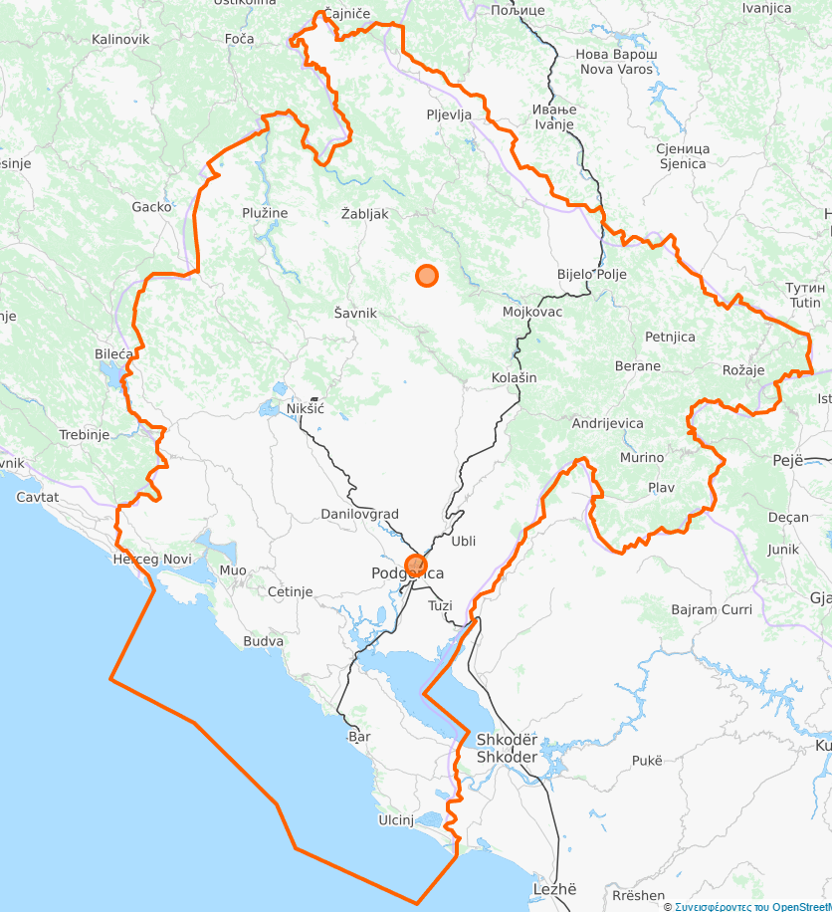
Picture 1.1. Study area
TDS refers to development of all 4 types of traffic in Montenegro in the mentioned period, and types of traffic are:
- Traffic on national roads;
- Railway transport;
- Air traffic;
- Maritime traffic.

Traffic on national roads is taking place on the state road network, which consists of magistral roads and regional roads. The total length of the state road network is 1798 km, which are completely paved, so that in Montenegro there are no shares in the state road network that are not covered by an asphalt layer. The length of the main roads is 846 km, and the regional roads 952 km.

At this moment, there are no highways (but they are planned), while the main roads which connect main city centers have one carriageway with one traffic lane per direction (and the third conveyor belt/strip for slow vehicles, only in individual locations). Also in several municipalities magistral roads have a traffic profile of the boulevard type, with two traffic lanes per direction of movement, with dividing islands and accompanying triplets for pedestrian traffic (bulevar Podgorica - airport, boulevard through Danilovgrad, boulevard through Budva). The regional roads have modest elements of the traffic profile, except in cases of newly reconstructed shares.

Railway transport of Montenegro consists of three (mostly) electrified railway lines, with a normal track, in total length of 150 km. These railways link the Port of Bar with Podgorica and Serbia (the Belgrade - Bar line), the cities of Podgorica and Nikšić (Podgorica – Niksić) and Podgorica and Albania (railway line Podgorica - Skadar). Railway line with Albania is almost exclusively used for freight traffic. The Railway is managed by four companies, independently for infrastructure management, passenger transport, transport of goods and maintenance of railway rolling stock.

In addition to land border crossings with neighboring countries, international arrival in/out of Montenegro can be achieved through the Port of Bar (regular ferry line from Italy) and international airports Podgorica (TGD) and Tivat (TIV), which records the total annual volume of 1.4 million passengers. There are also several smaller airports in the country that are used for general aviation.

The existence of an efficient transport system is, obviously, of critical importance for the economic and social prosperity of the citizens of Montenegro. But, problems and inappropriate road infrastructure as well as traffic restrictions, traffic accidents in road traffic, non-competitive railway system, insufficient use of sustainable forms of transport etc., have a significant negative impact on the socio-economic development of the country.

1.3. Transport Policy – Chapter 14

Transport policy of EU is aimed to improve functioning of internal market of EU, through providing safety, efficiency, availability and quality of traffic services, protection of users interests and protection of environment. Legal regulations that will ensure the smooth flow of people, goods and information in EU are consolidated in Chapter 14 - Transport policy.

Montenegro officialy opened Chapter 14 on December 21st 2015, on the Intergovernmental conferention in Bruxelles.

EU regulations under this chapter include: road transport, rail transport, inland waterway transport, combined transport, air transport and maritime transport, and concern technical, social and safety standards of these sectors. The EU seeks to integrate various transport sectors into effective logistics chains in order to optimize their use, as well as respecting environmental standards within the EU transport system.

Work in this area is under jurisdiction of: Ministry of Transport and Maritime Affairs, Ministry of Internal Affairs, Ministry of Sustainable Development and Tourism, Maritime Safety Authority, Police Authority, Port Authority, Direction for Transport, Direction for Railway, Port Authority Kotor, Port Authority Bar, Joint-stock company Railway Infrastructure of Montenegro, Joint-stock company Railway Transport, Joint-stock company Maintanance of Railway Rolling Stock, Civil Aviation Agency, Joint-stock company Airports of Montenegro, Joint-stock company Podgorica Airport, Joint-stock company Montenegro Airlines, Joint-stock company Luka Bar.

The challenges Montenegro faces in this area are the issue of inland waterways and the transposition of legal acts related to technical conditions for boats and issuance of certificates to captains in inland navigation. In this respect it is necessary, in accordance with Directive 2006/87/EC, to classify inland waterways in one of the 4 defined wather zones. It is necessary to ensure the independence of the regulatory body in railway traffic.

1.4. Brief overview of the Strategy - Transport model

Based on collected data, a basic "do-minimum" transport model for road and rail transport was prepared. Model based on PGDS was selected, which includes our segments of demand (i) road passenger traffic, (ii) road freight traffic, (iii) rail passenger traffic, and (iv) rail freight traffic. During the development of the model, efforts were made in order to establish the appropriate road and rail network for the basic case, its calibration and validation. As part of the calibration process, the demand for road and rail traffic has been updated and fine-tuning of network characteristics has been made in order to properly reflect the actual conditions. The results of calibration and validation suggest an adequate success of the application of the basic model.
A method for forecasting the demand for road and rail traffic was established and estimated future demand for the target years 2025 and 2035 for all segments of demand. Also, the future road and rail networks have been developed based on the scenarios "do-minimum” taking into account all projects in the field of road and rail transport, whose entry into the operational phase is planned by 2025. Finally, the model was applied to the basic case and to "do-minimum" case (2025 and 2035), and after that, based on the output of the model and according to a specially determined methodology, an assessment of the level of service was carried out.
“DO-MINIMUM” NETWORK
The do-minimum network for future years (2025 and 2035) includes all additional transportation projects, which are more likely to be implemented, i.e. all planned infrastructure links of the core and comprehensive networks plus any additional links included in the 2017 update of the Single Project Pipeline (SPP). It is assumed that these projects will remain the same for the two future years of the modeling exercise and no additional transportation projects will be developed in the period between these two target years.
The projects considered in the future to "do-minimum" networks:

Route 1: Coastal option of the Adriatic-Ionian Motorway-high-speed road along Montenegro's coast.
• Croatian Border - Herceg Novi (By-Pass Herceg Novi)
• Herceg Novi – Bijela
• Verige Bridge
• By-Pass Tivat
• Tivat – Tunnel Sozina Section
• By-Pass Budva
• By-Pass Bar
• Bar – Albanian Border

Route 2: Highway Bar-Boljare
• Mateševo-Andrijevica
• Podgorica By-Pass (Smokovac-Tološi-Farmaci)
• Đurmani-Farmaci
• Anrijevica-Boljare (Border with Serbia)

Railway Nikšić- border with BiH-Trebinje-Čapljina

Modernization of the railway line Podgorica - Tuzi – across the border with the Republic of Albania to Tirana (passenger service)
A single overview of individual coverage of projects "do-minimum" network

Route 1: Coastal option of the Adriatic-Ionian Motorway-high-speed road along Montenegro's coast.

Croatian Border - Herceg Novi (By-Pass Herceg Novi)

The By-pass Herceg Novi about 25 km long, has the task to cover the area of municipality of Herceg Novi with a road that would shift transit traffic from the existing Adriatic highway, main road M-2 Debeli brijeg - Herceg Novi - Kamenari. The Debeli Brijeg - Herceg Novi section passes through the upper edge of the settlement in Herceg Novi starting from Sutorinsko polje, from where the route climbs to several angles above Herceg Novi, and ends in the area of Zelenika settlement. Length of the section: Debeli brijeg - Herceg Novi (Zelenika) L = 12 km. The cross-sectional profile is not precisely defined yet, i.e. one or two car tracks in motion direction.

Herceg Novi – Bijela
The section of Herceg Novi By-pass of about 12 km long has the task to cover the area of Herceg Novi Riviera and connect the first section with the bridge/tunnel on Verige. It starts in the Zelenika area, then above Kumbor and Baošići goes up to Bijela. The cross-sectional profile is not precisely defined yet, i.e. one or two cart tracks in the direction of movement.

Verige Bridge
The Verige Bridge with a length of about 300 m, and height of over 70 m represents one of the most imposing buildings on this highway route. It represents the physical connection between the municipalities of Herceg Novi and Tivat. It represents the link between the By-pass of Herceg Novi and Tivat. It is located in the area of Rt Sv. Nedjelje from the Herceg Novi side and cape Opatovo from the Tivat side. The cross-sectional profile is not precisely defined yet, i.e. one or two cart tracks in the motion direction.

By-Pass Tivat
The By-Pass Tivat with its length of about 5.5 km is the connection between the boulevard which connect Tivat and Budva and the Herceg Novi By-Pass. The By-Pass starts at the area of Tivat airport and then climbs to higher parts of the Tivat municipality, and than by the southern side of the Vrmac hill extends to the area of the future bridge on the Opatovo cape. The cross-sectional profile is not precisely defined yet, i.e. one or two cart tracks in motion direction.

Tivat – Tunnel Sozina section
The section from Tivat to the Sozina tunnel is not precisely defined, the assumption is that the first section will start from the end of the Tivat By-Pass and connect with Budva By-pass. The starting point is in the area of the Vrmac tunnel, and the connection with the Budva By-Pass is in the area of Lastva Grbaljska, Topliša. The length of the section is approximately 12 km, and cross-sectional profile is not precisely defined yet, one or two cart tracks in the direction of movement. The corridor of this route is located in the hinterland of the Grbaljsko polje and its settlements.
The second section is from the end of the By-Pass Budva to the Sozina tunnel. The length of the section is approximately 25 km. The route extends in the higher parts of the hinterland of Budva, Petrovac to Sutomore and fitting with some kind of loop into the connector for Sozina tunnel.
Budva By-Pass
The Budva By-Pass with a length of about 15 km is the connection between the boulevard which connects Tivat and Budva and the section that continue along the Sozina tunnel and Bar. The By-Pass starts in the area of Lastva Grbaljska and goes to the high corners of the Topliš district, across the hinterland of Budva, to its last point in the area of Bečići, where the section toward Bar is continued.

Bar By-Pass
The Bar By-Pass, with its length of about 15 km, is a link between the section that separates from the loop near the Sozina tunnel towards Budva and the connector for the tunnel itself with a section leading to the border with Albania. The bypass goes to the higher corners of the hinterland of Bar due to the prevention of potential interference with the Podgorica-Bar rail line.

Bar – border with Albania
The section from Bar to the border with Albania includes the reconstruction of the regional road Bar - Krute - Vladimir - Sukobin – border cross Murićani (Albania), as well as connection with the previous section ie. By-Pass Bar. The total length of the section is approximately 35 km.

Route 2: Highway Bar-Boljare

Mateševo-Andrijevica
The Mateševo-Andrijevica section of the future Bar - Boljare highway, with its length of 23 km, is the fourth longest of all remaining sections. The section starts in the region of Mateševo on the loop and by overcoming the mountain Trešnjevik comes out to the Andrievica side of the same mountain, where it connects on a loop with a section that goes toward Berane. The cross-sectional profile of the roadway includes two lanes in each direction of movement, a dividing island and a protective zones on both sides of the road.

Podgorica By-Pass (Smokovac-Tološi-Farmaci)
This section is about 13 km long, at the same time represents the connection of the highway with the Adriatic Ionian Motorway. The section starts from the loop in Smokovac, goes through the north-western Tološi, Vranići, Vranjske Njive and part of the Rogami, and ends up in the Farmaci.

Đurmani-Farmaci
A section that is one of the most demanding since it should connect the Sozina tunnel with Podgorica. The route starts from the region of Đurman, i.e. the existing tunnel Sozina, descends to Virpazar and further accross the Skadar Lake and the hills in its hinterland continues to the Farmaci. The total length of the section is approximately 36 km.

Andrijevica-Boljare (border with Serbia)
The section between Andrijevica and Boljare acctualy consists of two sections: Andrijevica - Berane (11 km) and Berane - Boljare (41 km). It is planned that the route moves along the higher parts of the Lim River valley to avoid affecting populated areas between Andrijevica and Berane, passing the Berane city core in the region of Berane airport and continuing towards Boljari by crossing the Lim River and avoiding the landfill on Vasove vode.

Route 3: Railway Nikšić- border with Bosnia and Hercegovina - Trebinje-Čapljina
By the line Nikšić - Čapljina would be, inter alia, also established connection with the Paneuropean road corridor VCT, because, due to the war events in the 1990s, the state remained without connection with that corridor. The biggest benefit of this railway would bring to the Port of Bar, since there is a growing interest of businessmen from Bosnia and Hercegovina (BaH) for importing and exporting their goods through this port.
The total length of the railway would be 160 km, from which about 70 km in Montenego, and it would pass through Nikšićko polje, Trubjela, Velimlje, and further towards Vilusi and the border with BaH. Three scenarios have been made, and the third is the optimal one for Montenegro: single track, with all elements designed for only one track.
Bearing in mind that there is already one track from Nikšić to Podgorica, it would be a one-way section in general. According to this scenario, the estimated total investments are about 810 million EUR, and the share of Montenegro is about 180 million EUR.

Rout 4: Modernization of the railway line Podgorica - Tuzi – across the border with the Republic of Albania to Tirana (passenger service)
It is planned by the project to reconstruct and modernize the track in the length of 25 km, as well as to improve the elements of the track and electrification. The project includes the reconstruction, rehabilitation and replacement of the upper part, 5 bridges, 3 tunnels and 25 failures and the provision of the UIC-GB factory train profile, as well as the reconstruction of station lines and facilities and the rehabilitation of the existing signalization system, including the new signal-safety equipment and new contact network. For the mentioned project it is necessary to prepare and complete the whole Technical Documentation. Earlier documentation, from the construction period, is partly available. The estimated value of investments for this project is about 37 million EUR. The railway is wholly located in the area of the Tuško polje.

Picture 1.2. Future „do-minimum“network (new roads are marked red - Highway Bar-Boljare and Costal option of Adriatic Ionic highway; new railway marked purple - Railway Nikšić – BaH)

1.5. Relation with other plans and programs

Spacial Plan of Montenegro until 2020

The Spatial Plan of Montenegro until 2000 established, for the first time, the general basis for the organization and arrangement of the territory of Montenegro in genral. The spatial concept of long-term development of transport infrastructure has been defined, which, through the envisaged improvement of Montenegro's links with the economic space of the country (then SFRY), regional and inter-municipal ties and local accessibility, was treated as one of the key preconditions for achieving the goals set by the Plan, especialy in relation with more balanced regional development.

Spatial concept of the development of transport infrastructure
The Spatial Plan of Montenegro until 2020 provides the Concept of the Road and Railway Network Development, the Concept of Water Transport Development of, and the aviation infrastructure until 2020.
I Concept of the road network development
Bearing in mind the objectives of Montenegro's development, as well as the role of the road network in their realization, and given the existing state of the road network and the expected traffic flows until 2020, the concept of the road network of Montenegro has been defined.
1. The following proposed highway corridors must be preserved from other requirements and uses that are contrary with or interrupt the intended use (shown on the map):

- Sector of highway Beograd – Sout Adriatic through Monenegro: Boljare – Andrijevica – Mateševo – Bratonožići – western By-Pass Podgoriae – Sozina tunnel – Bar (Đurmani)

- Section of the highway from the connection with fighway Beograd - Bar to border with Serbia (Kosovo and Metohija): Andrijevica – Murino – Čakor - Bjeluha.

- Sector of the Adriatic-Ionic highway: border with BaH (Nudol region)– Grahovo – Čevo – Podgorica (By-Pass – detailed research of the rout needed) – tunnel through Dečić (border with Albania).

Explanation: As a consequence of the regional European initiative, which was partially realized by sections of highways in Croatia and Albania, corridors through Montenegro were analyzed. Connection points will be defined by international agreements between Montenegro, BaH and Albania. The corridor (one of the three discussed in the previous Spatial Plan, and proposed by the Study Basis) towards the wider region of Nudol (border to BaH), Grahovo - Čevo - Podgorica - north from Božaje (border to Albania) is proposed as the starting point. The route is determined on the basis of criteria for minimum terrain vulnerability, environmental protection, positivity of the impact on the established network of settlements and roads. The proposed route passes through a sparsely settled and anhydrous area. The highway will primarily be in the function of transit international traffic and will speed up the accompanying activities (trade, warehousing and other services), also significantly improving the international position of Montenegro and increase the availability of tourist offer.
2. The following proposed motorways for fast motor traffic must be preserved from other requirements and uses that are contrary with or interrupt the intended use (shown on the map):

- Adriatic motorway for fast motor traffic: Debeli brijeg (Border with Croatia) – Herceg Novi – crossing over Boka bay – Tivat - Budva – Bar – Ulcinj – Fraskanjela region (border with Albania).

- Šćepan polje (border with BaH)– Plužine – Nikšić – Podgorica.

II Railway network development

When planning a railway network, the principle of retaining the corridor of all previously abandoned railways is used. One of the priorities in Serbia is the construction of the Valjevo-Loznica railway line, which is of strategic importance for the Montenegrin railway network and the Port of Bar. Albania plans to modernize the Drač-Tirana and Tirana-Skadar-state border (connection in Podgorica with the Belgrade-Bar line), as well as the development of certain studies related to Corridor VIII. Plans and concepts of the development of railway networks of neighboring countries have a significant impact on the development of the railway network in Montenegro:

1. The following proposed primary network corridors must be provided from conditions and uses that are contrary or or interrupt the intended use, unless a final decision about construction is made (shown on the map):

    - Reconstruction of Montenegrin part of Beograd – Bar railway;

    - prong Podgorica - Nikšić (with moving part of the route through Duklja location)

    - part od the railway Podgorica – border with Albania (connection with Skadar)

2. The following proposed secundary network corridors must be provided from conditions and uses that are contrary or or interrupt the intended use, unless a final decision about construction is made (shown on the map):

    - Pljevlja – Bijelo Polje

    - Bijelo Polje – Berane – Peć

    - Nikšić – Bileća

3. When potentially determining the intermodal terminals, locations must be provided from conditions and uses that are contrary or obstructing the intended use, unless a final decision about construction is mada (indicated in the map):

    - Bijelo Polje

    - Podgorica

    - Bar

Explanation: Identification and determination of the appropriate location must be elaborated in more detailed spatial planning documents.

III Maritime traffic development
Link with port capacities development

1. The further development of the ports inside the Kotor Bay will be assessed in accordance with the restrictions regarding environmental protection, natural and cultural heritage and the international protected zone of Kotor-Risan Bay (UNESCO, World Natural and Cultural Heritage), the most important port is the Port of Bar.

2. Capacity development for nautical tourism in the coastal area will be carried out in accordance with the ecological and spatial possibilities of the appropriate locations, which are foreseen by the Spatial Plan of Special Purpose for the area of the Sea Well. Also, intensively work on the development of coastal maritime traffic and related infrastructure is necessary.

3. River tourism and excursion sailing on Skadar Lake and the Bojana river will be developed in accordance with ecological conditions and should create conditions for the developmental positioning of this are. Existing docks that shoul be regulated are: Plavnica, Rijeka Crnojevića, Virpazar, Krnjice and Ckla.

Aviation infrastructure development

1. The airport in Podgorica must further develop as the main international airport (class 4E), which will serve 60-70% of total air traffic and must have the power to serve all aspects of air traffic, starting from regular, charter, business aviation to transport of goods.

2. The airport in Tivat is the second most important airport in Montenegro that provides direct access to tourist centers on the coast and plays a key role in the tourism development process. Beside this basic role, Tivat is an alternative airport for the airports in the region, especially for the airport in Podgorica.

3. In the case of the potential development of the airports, locations must be preserved from other requirements and uses that are contrary with or interrupt the intended use, unless a final decision about construction or reconstruction is made:

      - Berane

      - Nikšić

      - Pljevlja

      - Žabljak

      - Ulcinj

Explanation: Berane airport will be developed into category 4D, while other airports (categories of at least 3C) will be developed primarily as aerports for special needs: recreative flying, sport flying and (seasonal) regional traffic, as well as for smaller business planes. In order to ensure the spatial conditions of the airport location, it is necessary to forecast the maximum category of airports in the future. Identification and determination of the appropriate location must be done in more detailed spatial planning documents.

National Strategy for Sustainable Development by 2030

The National Strategy for Sustainable Development by 2030 (NSSD) represents a long-term development strategy of Montenegro which sets out solutions for sustainable management of four groups of national resources: human, social, natural and economic ones, which are set as priorities of the overall sustainable development of the Montenegrin society. The NSSD is umbrella, horizontal and longterm development strategy of Montenegro that relates not only to environment and economics, but also to irreplaceable human resources and valuable social capital that should ensure prosperous development.

Safe, modern and efficient traffic system represents a presumption of entire economic, social and territorial cohesion of one country. One of the priorities in traffic system development are improvement of safety and security in all aspects of traffic, with the aim to preserve human lives and property. That aim requires regular maintenance of the existing infrastructure, investments in new traffic capacities by respecting security and safety standards, strengthening administrative capacities, control, traffic monitoring by implementing the criteria that are harmonized with metrological regulations, e.g. radars and ethylometers, as well as trainings and public campaigns.
Traffic sector in Montenegro is facing significant difficulties in its attempt to ensure adequate basis for the mobility of people, goods and services within the country and towards neighboring countries. Undeveloped road network and inexistence of highways, problems of insufficiently developed rail infrastructure and end-of-life rail vehicles, insufficient efficiency of traffic system and lack of implementation of modern approaches in traffic management, are just a part of the list of problems identified in this sector.

Terrain configuration itself causes high maintenance costs in the sector of rail and road traffic and development of new infrastructure. Insufficient level of infrastructure development in terms of sea traffic significantly contributes to sea pollution.

Share of rail traffic in total number of travelled passenger kilometers in Montenegro decreased in the period 2000-2012 from 52% to 36%, meaning that in the last couple of years road traffic has a dominant role in transport of passengers, which increases loads on the environment. Trends in cargo traffic are similar to passenger traffic, with somewhat less noticeable reduction of rail traffic share.

Total number of motor vehicles increased from about 128.000 in 2000 to 198.772 in 2015. Aside from the above stated, near 98% of vehicles in all categories were older than 10 years, 56% of vehicles uses oil as motor fuel, 43% gasoline, and very low number uses liquid petroleum gas. With the share of about 27% of overall final energy consumption (2013), traffic sector in Montenegro represents a significant consumer.

Great quantities of energy are consumed in traffic which greatly contributes to climate changes and leads to air pollution and connected negative impacts on human health and ecosystem condition. Construction of traffic infrastructure also causes negative impacts on space, water and biodiversity.

Imported fossil fuels (gasoline, diesel, kerosene) represent 99% of overall consumption, while remaining percentage is electric energy consumption. Road traffic is responsible for about 88% of final consumption in traffic sector and represents the priority in terms of optimization and savings.

Modern and efficient traffic system can significantly contribute to resource efficiency, competitiveness and sustainability. Results of UNEP/UNDP study (2012) indicate that investments in the amount of 34,2 million € into energy efficiency in traffic (in order to achieve an increase of 12% until 2020) would result in saving of energy-generating product consumption in the amount of 8,6%, avoided costs in the amount of over 43 million € and reduction of GHG emission of over 9%. Cost of achieving ambitious goals - increase of energy efficiency for 20% until 2020 in traffic sector would be 82 million €, which would lead to savings of 12,5% in energy consumption, avoided cost in the amount of 67 million €, and reduction of GHG emissions of over 14%.

Some of the most important measures of the European sustainable traffic policy include technological improvements of vehicles and application of alternative energy sources218, by facilitating tax policy, promoting public transportation and non-motorized means of transportation and similar. Furthermore, in accordance with European policies regarding sustainable urban mobility, cities need to provide multimodal traffic system and to deal with intermodal integrations as the main component of every urban mobility strategy, in accordance with sustainable development policies.

Stated measures should also be priorities in Montenegro, in the context of achieving resource efficiency goals as well as significant reduction of air-pollution and improvement of the quality of life of citizens and the quality of tourist offer. This above all means efficient public transportation with which we would significantly reduce the use of vehicles in cities and thus reduce crowds, especially in coastal area during tourist season (Kotor, Budva). The aim is also to redirect transport of (especially) cargo to rail and water.

In order to develop traffic system in terms of resource efficiency (respectively sustainable traffic) integrated approach will be needed, as well as significant efforts and means so as to modernize transportation stock and thus develop traffic infrastructure. Significant incentives are needed for faster introduction of vehicles with low emissions and new technologies/alternative fuels, better control of fuel quality, promotion of environment-friendly modes of transportation, and application of instruments that bring negative impacts of traffic on the environment to the lowest possible level (including standards, impact assessments, economic instruments and other).
Transport Development Strategy 2008-2018
Transport Development Strategy is based on the realistic image of the current situation, identified problems, analysis of solutions and in accordance with such defined activities that will lead to results. The fact that this is a document, which should determine a long-term development in Montenegro for the first time, it represents, per se, positive development in relation to the current situation and beginning of quality new observation of transport development and transport infrastructure in particular.

Undeveloped road network, problems existing in the railway sector related to the condition of the infrastructure and outdated vehicles, requirements for more efficient airport operation, and low capacity utilization of Luka Bar, do not support sufficiently development of economic activities.

Weak traffic connection of Montenegro with the region, insufficient availability of experienced and, according to market conditions, trained, highly-skilled staff and insufficient investments in research and development activities, represent important constraints for improvement of market position of companies providing transport services. What is particularly concerning, is the fact that it would take plenty of time to achieve positive effects of changes in this field, which from the aspect of motivation and readiness to change is the most limited resource.

The strategy provides guidelines on how to use potentials of geo-strategic position of Montenegro for transit traffic and how to harmonize foreign direct investment with the public interest, considering the economic justification and environmental impact. In addition, the special account has been given to the plans that should be realistically feasible both in terms of financial and institutional aspect.
Basic goals of strategic development of Montenegro’s transport system are:

1. Improvement of safety and security, in order to save human lives, material values and to preserve state resources;
2. Integration in the European Union, through connection to TEN-T and improvement of competitiveness of national transport economy;
3. Improvement of transport services quality;
4. Stimulation of economic growth through more efficient and less expensive transport;
5. Minimization of negative impacts of transport development and traffic infrastructure on environment and society in general.

Strategic plans of Montenegro, refered to traffic development, are defined through following strategic goals:

- Safe and secure transport - The transport system in Montenegro will be developed in a way to ensure safe and secure traffic for all participants, goods and the environment;
- Quality maintenance of the traffic infrastructure - The transport system in Montenegro will be developed in a way that will do the monitoring of the quality maintenance of the traffic infrastructure;
- Efficiency - The transport system in Montenegro will be developed in a way to be efficient.
- Economic development - The transport system in Montenegro will be developed in a way to contribute to economic development;
- Environment - The transport system in Montenegro will be developed in a way to minimize negative impacts of traffic on the environment;
- Integration to European Union - The transport system in Montenegro will be developed in a way to falcilitate integration to European Union.
State Road Development and Maintenance Strategy 2008-2018
State Road Development and Maintenance Strategy 2008-2018 represent the document which establish the objectives and basic tasks of development and maintenance of public roads for the period of 10 years, the related dynamics and scope of realisation, the framework of necessary financial resources and the sources of financing.

Starting bases for the realisation of a rational public roads management policy are defined by Transport Development Strategy of Montenegro, Spatial Plan for Montenegro until 2020 and the Law on Roads.

Implementing the State Road Development and Maintenance Strategy will create conditions which will provide:

- Safe and secure traffic, in the first place, through quality transport infrastructure, without weak places, which will prevent the occurrence of traffic accidents and traffic accidents;
- Financial sustainability and self-sustainability of the transport infrastructure in a way that the maintenance and improvement of the road network will be secured through the achievement of an adequate balance of funds from the Program budget and fees paid by road users;
- Quality maintenance of state roads through clear visible responsibility of the bearer of this work, emphasizing the need for preventive maintenance, efficient organization of corrective maintenance, as well as improvement of the entrepreneurial environment for the appearance of companies specialized in providing services to state institutions in connection with work on the transport infrastructure;
- Reducing the traveling time and cost for state road users by constructing bypasses at locations where bottlenecks are identified in traffic, third lanes, etc., which will contribute in avoiding congestion and crowds in traffic and improving the flow of state roads;
- Efficiency of the state roads management through the institutional system, adoption and implementation of medium-term plans and one-year programs for the construction and maintenance of state roads, strengthening the professional capacities of institutions, compiling a comprehensive database of state roads and facilities on them;
- More involvement of the private sector in the construction of new infrastructure projects based on concession arrangements and public private partnerships, increasing transparency of procedures during inviting tenders and concluding contracts for maintenance of road infrastructure in order to provide stronger competition among interested companies and increase the quality and efficiency of realization at maintenance and rehabilitation jobs, with the tightening of the penal policy and the implementation of appropriate mechanisms due to non-compliance with the contract in terms of dynamics, quality of works, etc.
- The responsible use of state roads through effective control of mass and axle load, the adoption and implementation of a legal framework that will demotivate carriers in freight traffic to overload vehicles, which damage road infrastructure, enhanced road safety cary alongside state roads, preventing usurpation, unloading of roads, planning of seasonal traffic regimes and special routes to guide the freight traffic;
- Improvement of economic development of Montenegro;
- Maximizing the development potentials of the regions of Montenegro through the improvement of the road infrastructure aiming balanced economic, demographic and social development, respectively creating conditions for the faster development of underdeveloped areas of Montenegro;
- Minimizing negative impacts on the environment by introducing the highest standards in planning and projecting the transport infrastructure and its use, and planed routing of new routes outside the most vulnerable areas;
- Integration of the traffic network of Montenegro into the Trans-European Transport Network (TNT).

State Road Development and Maintenance Strategy provided preconditions for:

- Quality and timely preparation of planning and project documentation in the sector of development and maintenance of road infrastructure;
- Planning and providing the necessary funds for investing in the road network of Montenegro;
- A rational policy of building and managing state roads.
Railway Development Strategy 2017-2027
The principles on which the Railway Development Strategy of Montenegro is based are in aligned with the transport policy of the European Union, the Transport Development Strategy of Montenegro 2007-2015 and the Negotiations on EU Accession.
The railway development vision is reflected in the development of a railway system that will be market-oriented, sustainable, which will support the economic development of Montenegro and integrated into the Single European Railway Area.
Railway system of Montenegro will be developet in a way to:
- Place users in the center of transport policy - transparent provision and use of funds for railway infrastructure;
- Encourages financial sustainability and self-sustainability of railway infrastructure;
- Provides quality and responsible maintenance of railway infrastructure and regularity of traffic;
- Maximize the development potentials of the regions of Montenegro, be competitive and with the improved service in the transport of passengers and goods;
- Support an efficient and effective system of state institutions that take care of the railway sector;
- Minimizes the negative impacts of transport on the environment;
- Be alligned with the expansion of the TNT network in the Western Balkans and support the process of integration of Montenegro into the European Union.

The goals of the Railway Development Strategy of Montenegro are adapted to the public interest, specifics and size of the railway sector.

Strategic goals defined through Railway Development Strategy:

1. Optimum use of the infrastructure which will be realized through:
- Putting users at the center of transport policy - transparency, provision and use of funds for railway infrastructure;
- Financial sustainability and self-sustainability of railway infrastructure;
- Quality and responsible maintenance of railway infrastructure and regularity of traffic;
- Maximizing the development potentials of the regions of Montenegro through the improvement of rail services.
2. The controlled development of the railway sector will be realized through:
- An efficient and effective system of state institutions that take care of the railway sector;
- Functional and modern railway system capable of confronting to competition;
3. Environment and integration into the European Union will be realized in a way of:
- Preserving the area of Montenegro from the negative impact of traffic;
- Integrating the Railway Network of Montenegro into the Trans-European Transport Network (TEN-T)
Airports Development Master Plan for Montenegro 2011-2030.
Airports Development Master Plan by 2030 defined the strategy for infrastructure development of Podgorica and Tivat airports for the period from 2011 to 2030, with the aim of improving the capacity and quality of service in relation to the forecasted traffic.
The document provides guidelines for development in two phases, the first by 2017 and the second by 2030. In the first phase, under the condition that the predicted traffic forecasts are realized, it will be necessary to provide between 65 and 70 million EUR.
The plan implies the realization of a number of development projects concerning the extension of the take off-landing slopes to both airports, the expansion of passenger terminal spaces, the expansion of paltforms, the provision of new parking positions, etc.
Detailed Spatial Plan for a Bar-Boljare highway

A Detailed Spatial Plan includes the area of the Bar - Boljare highway infrastructure corridor (from the Montenegrin coast to the border with Serbia), which was determined by the Spatial Plan of Montenegro until 2020, and also considers an alternative route with the bypassing of National Park Skadar Lake. The Detailed Spatial Plan includes in particular: - Corridors of existing and planned mainstream infrastructural systems, with a protective zone and accompanying facilities: the Bar-Boljare highway, part of the railway line Belgrade-Bar, airports in Podgorica and Berane, part of the electricity transmission and distribution network (transmission lines 400 kV, 220 kV, 110 kV and substations), gas pipeline, regional waterworks, main fiber optic cables, water surfaces and watercourses (Skadar Lake, Zeta, Morača and Tara rivers); and - Zone of infrastructure corridor influence in the width of the Plan, corridor of the Bar-Boljare highway designated by the Spatial Plan of Montenegro.

The area of the Detailed Spatial Plan covers a space of about 1400 km², which covers over 100 cadastral municipalities that form parts of the territory of seven municipalities (Bar, Cetinje, Podgorica, Kolašin, Andrijevica, Berane and Bijelo Polje). Highway sections - in accordance with the Terms of reference, the Detailed Spatial Plan area is divided into three sections:

Section I Đurmani – Smokovac - Covers an area of about 450 km² in a lenth of 50 km, which is consisted of the territory of the municipalities: - Bar: entire cadastral municipalities of Čanj, Sutomore, Mišići, Zankovići, Sozina, Gluhi Do, Limljani, Bukovik, Sotonici, Boljevici, Godinje, Brijege, Orahovo, Dupilo, Virpazar, Popratica, Brdani, Komarno; - Cetinje: part of cadastral municipality Čukovići and entire cadastral municipality Dodoši and Žabljak; i - Podgorica; the entire cadastre municipality of Vranjina, Bijelo Polje, Gostilj, Vukovci, Mahala, Golubovci, Grbavci, Cijevna, Goljemadi, Botun, Lijesnje, Donji Kokoti, Dajbabe, Draževina. Strategic Environmental Impact Assessment for Detailed Spatial Plan of Bar – Boljare highway 17/101 Beri, Farmaci, Donja and Gornja Gorica, Podgorica 1, 2 and 3, Baloci, Tološi, Velje Brdo, Rogami.
Section II Smokovac - Mateševo - Covers an area of about 350 km² in length over 40 km, consisted of the territories of the municipalities: - Podgorica: the entire cadastral municipalities of Doljani, Cerovice, Durkovici, Radeća, Mrke, Bioči, Ubli, Blizna, Momče, Klopot, Pelev Brijeg, Bolje Sestre, Lutovo, Duška, Brskut, Stupovi, Lijeva Rijeka, Grbi Do, Slacko, Lopate, Veruša, Trebešnica and part of the cadastral municipality of Opasanica; and - Kolašin: the entire cadastral municipalities of Kosa, Jabuka, Donja Tara, Padež and Mateševo;
Section III Mateševo - Boljare - Covers an area of approximately 600 km² in length of about 70 km, consisted of the territories of the municipalities: - Kolašin: the entire cadastral municipality of Sunga, Kraljske Bare and Vranještica; - Andrijevica: the entire cadastral municipalities of Oblo Brdo, Kralje, Andrijevica, Bojovici, Gnjili Potok, Sjenožeta, Slatina I, Seoce, Slatina II, Zabrđe, Trešnjevo I, Rijeka Marsenića, Trešnjevo II and Trepča; - Berane: entire cadastral municipalities of Vinicka I and II, Donja Rženica, Buče I and II, Pešca, Lužac, Donje Luge, Petnjica, Crni Vrh, Dolac, Berane, Budimlje, Zaostro, Polica, Bubanje, Štitari, Poda, Lozna; and - Bijelo Polje: all cadastral municipalities of Crnce Laholo, Radulovići, Kradenik, Goduša, Dubovo, Ivanje, Godijevo, Sipanje, Boljanina and part of cadastral municipality Korita.

The rule is that the boundaries of the Plan area are determined by the boundaries of cadastral municipalities or geographic boundaries, and are shown in cartographic annexes. The Detailed Spatial Plan of the Bar - Boljare highway is a long - term development document that encompasses the time horizon by 2020, with the stages of implementation.

The planned route: The Corridor of the highway from Bar to Boljare is defined in the direction: Bar (Đurmani) - Sozina tunnel - Virpazar - Tanki Rt - Farmaci (Podgorica) - Mareza (Podgorica) - Smokovac (Podgorica) - Bratonožici - Veruša - Mateševo ​​- Andrijevica - Berane – Boljare, and it is a part of the Corridor Bar - Belgrade - Budapest, where the transaction for construction of the highway from Horgoš to Požega is in the final stage. The approximate length of the highway rout from Bar to Boljare is 167 km, including a part of a 10 km long semi-highway on the Đurmani – Sozina tunnel – Virpazar sector, including the 4.2 km long Sozina tunnel. Highway rout: Highway Corridor Bar - Boljare starts from an angle of 0 m above sea level. From the terrain of the Adriatic Sea basin enters in the basin of the Skadar Lake by Sozina tunnel at 200m above sea level. The highway, further, goes along the border of the Crmničko polje and through the valley of the river Orahovštica comes to Jezera near the Tanki rt. From Tanki rt it goes through Jezera to Vranjina, where by the tunnel continues to Ponari through flooded and wetlands. From Ponari it goes along the limestone hillside to the Bersko polje and further along the hill of Zelenika comes to Tološko polje. From the crossing through Tološko polje, the highway goes down the slopes of the Velje brdo, after which it crosses the valley of the Zeta river and continues to the north eastern slopes of Vežešnik, to cross the Morača river northwest of Bioče. It goes further across the Vjeternik, west of Lijeva Rijeka, passing to Lopate in the Basin of Veruša River and further Tara to Mateševo. From Mateševo, it goes by the river Drcka basin, across or through Trešnjevik, entering the river Lim basin. Bypassing the Lim river at the confluence of the Crnča river it goes further along the hilly and mountainous terrain to Boljare.

2. ENVIRONMENTAL BASELINE DESCRIPTION

Information on the State of Environment in Montenegro for 2015 contains, together with the proposal of measures, assessment of the overall state of environment in Montenegro as well as recommendations in terms of planning annual environmental policy. This documents allows the stakeholders in Montenegro to gain clear and understanding consideration of changes in certain segments of environment. Information on the state of environment presents, amongst other things, state of environment per segments:
- Air
- Climate changes
- Water
- Marine ecosystem
- Soil
- Waste
- Biodiversity
- Noise

2.1. Air Quality and Climate Changes

2.1.1 Air Quality
Realisation of Air Quality Monitoring Programme, conducted by the Environmental and Nature Protection Agency is being carried out in line with the Rulebook on Manner and Conditions for Monitoring Air Quality (Official Gazette of MNE, no. 21/2011), which sets out manner of monitoring air quality and data collection as well as relevant measuring methods, criteria for obtaining quality data, securing quality of data and their validation.
Purpose of air quality control and monitoring in Montenegro is to assess, plan and manage air quality. The analysis of obtained results is used as basis for proposal of measures for improvement of air quality.
Automatic stationary stations for monitoring air quality monitor air quality in Podgorica, Nikšić, Pljevlja, Bar, Tivat, Golubovci and Gradina (Pljevlja) monitor air. Concentration of following parameters was measured: sulphur dioxide (SO₂), nitrogen monoxide (NO), nitrogen dioxide (NO₂), overall nitrogen oxides (NO_{x}), carbon monoxide (CO), methane (CH₄), non-methane hydrocarbons (NMHC), total hydrocarbons (THC), PM10 particles, ground-level ozone (O₃), benzene, toluene, ethyl-benzene, o-m-p xylene (BTX).
Assessment of air quality was performed in line with the Ordinance on determining type of polluters, limit values and other air quality standards (Official Gazette of MNE, no. 45/2008, 25/2012), (hereinafter: the Ordinance).
Figure 2.1 shows position of automatic stationary stations within the air quality zones (measure of metering points).
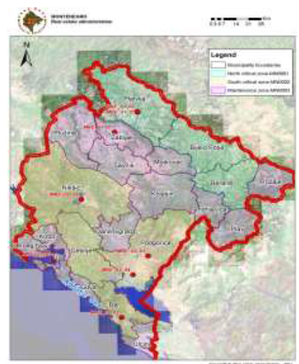
Figure 2.1. Network of metering points – air quality zones
In line with the Ordinance on establishing network of metering points for air quality monitoring (Official Gazette of MNE, no. 44/2010 and 13/2011), territory of Montenegro is divided into three zones (Table 2.1), which were defined in preliminary air quality assessment in respect to limits of pollutants based on available data on concentration of pollutants and modelling existing data. Limits of air quality zones match external administrative boundaries of municipalities which are composite part of these zones.
Table 2.1. Air quality zone na kvaliteta vazduha Opštine u sastavu zone
Air Quality Zone | Municipalities within the zone
Zone of air quality maintenance | Andrijevica, Budva, Danilovgrad, Herceg Novi, Kolašin, Kotor, Mojkovac, Plav, Plužine, Rožaje, Šavnik, Tivat, Ulcinj and Žabljak
Northern zone where air quality is necessary | Berane, Bijelo Polje and Pljevlja
South zone where air quality is necessary | Bar, Cetinje, Nikšić and Podgorica
Emissions of concentration of sulphur (IV) oxide (SO₂) in Bar, Nikšić, Golubovci and Gradina as hourly mean and mean daily values were within the set air quality standards.
The metering station in urban part of Pljevlja, 23 hourly values of sulphur (IV) oxide (SO₂) during 2015 where above the set limit value of 350 μg/m³ (must not be exceeded more than 24 times a year). On eighteen days, mean daily values were above 125 μg/m³ (must not be exceeded more than 3 times a year), which is limit value for mean daily concentration. All exceedance were recorded in the winter season (from October to March). These data are indicative of increased air load in urban part of Pljevlja with this pollutant and deterioration in air quality compared with previous period.
Concentration of nitrogen (IV) oxide (NO₂) was within the set air quality standards on all metering points.
On all metering points except in Bar (due to malfunction of sampler determining suspended particles PM10 was not conducted in January and February), higher number of exceedance of mean daily concentrations of PM10 particles than the permitted (maximum 35 over the calendar year) was recorded. Number of exceedance ranged from 39 in Bar to 189 in Pljevlja. In Pljevlja it was 82 and in Niksic 113 of exceedance of mean permitted daily concentration of PM10 particles in air. The highest number of exceedance and at the same time the biggest concentration of PM10 particles were recorded in November and December. In addition to air pollutants emission, this state was contributed by meteorological conditions (stable atmosphere, occurrence of inversions and high atmospheric pressure) which dominated the entire region. During these months, nearly daily exceedances of mean daily concentrations of PM10 particles were recorded. This problem was most present in Pljevlja, where daily exceedances and very high mean daily concentrations of PM10 particles in air were registered. Concentration of heavy meals in PM10 particles were within set norms. The area of Pljevlja valy has very specific microclimate conditions characterised by strong temperature inversions, forming of cold air lakes and high atmosphere stability index. These micrometeorological conditions are dominant in certain parts of the year and with the referred effects they can last throughout most of the day or as high as 24 hours. This situation mainly determines the state of environment in Pljevlja valley. Practice showed that whenever these microclimatological situations with described effects are active, there is always high concentration of pollutants in the ground level, i.e. in the inversion level (from ground surface to the level of temperature inversion). This is the case with other urban environments (worldwide) that undergo these microclimatological effects.
Mean annual concentration of benzoate pyrene on all metering points (Bar, Pljevlja, Nikšić and Podgorica) was above the set targeted value which is 1ng/m³.
Concentration of PM2.5 particles in air was monitored in Pljevlja, Nikšić, Bar and Tivat. Mean annual concentration in Bar and Tivat was below set limit value which is 25 μg/m³. Mean annual concentration in Pljevlja and Nikšić was above the limit value and amounted to 41,18 μg/m³ in Pljevlja and 27,55 μg/m³ in Nikšić.
Unlike primary pollutants, emitted directly into air, ground-level (tropospheric) ozone (O₃) is formed with complex photochemical reactions, and is affected by emissions of its precursors such as nitrogen oxides (known as NO_{X} which include NO and NO₂) and non-methane volatile organic compounds (NMVOC). Exceedance of targeted values for ground-level ozone was recorded at Gradina back station. Maximum daily eight-hourly mean value of ground-level ozone (O₃) 51 times exceeded set targeted value on this metering station. Targeted value, from the human health aspect of 120 μg/m³, must not be exceeded for more than 25 times over the calendar year. Maximum eight-hourly mean daily values of ozone exceeded daily value in Nikšić for ten days. Due to malfunction of the metering instrument in Bar, these pollutants were not measures over the summer period.
All maximal eight-hourly mean values of carbon(II) oxide (CO) at all metering points in 2015 were below the set limit values.
In the South and North zone, where, as per Ordinance on establishing network of metering points for monitoring air quality, it is necessary to improve air quality, dusty matters PM10 and PM2.5, content of benzene pyrene in PM10 particles, content of sulphur (IV) oxide (SO₂) in Pljevlja, as well as concentration of ground-level ozone at the back station Gradina (Municipality of Pljevlja) had the biggest impact on poor air quality. These zones include: Berane, Bijelo Polje i Pljevlja (northern zone) and Bar, Cetinje, Nikšić and Podgorica (south zone).
In the Quality maintenance zone which includes: Andrijevica, Budva, Danilovgrad, Herceg Novi, Kolašin, Kotor, Mojkovac, Plav, Plužine, Rožaje, Šavnik, Tivat, Ulcinj and Žabljak, air quality is monitored at EMEP station in Žabljak with equipment for so called semi-automatic monitoring in Tivat, where, due to malfunction of metering instruments, only PM2.5 particles concentration was metered. Based on measured concentration of monitored parameters, air quality in this zone was satisfactory.

2.1.2 Climate and Climate Changes
Air temperature growth trend in the second half of 20 century is evident at majority of Montenegro. According to available data, series of metering from 1949, and at certain stations from 1958 up to this date, it is evident that extreme heats, especially during august, were more often recorded. The trend of mean annual and extreme mean monthly temperatures at metering stations in the last 20 years was mainly stable, except variations recorded in 200-2005 and 2006-2008.
In majority of Montenegro, 2015 was the warmest year with temperature above the climate standard. According to distribution of percentages, air temperature was in the category of extremely hot while the amount of precipitation was in the category of very dry, dry and normal. Mean air temperature ranged from 7.2 °C in Žabljak to 18.6 °C in Budva and 17.7 °C in Podgorica. Deviations from mean air temperature was above the value of climate normal (1961-1990) and ranged from 1.5 °C in Nikšić to 3.1 °C in Rožaje, while Podgorica was by 2.0 °C hotter than the climate normal.
On the scale of biggest values, 2015 was the hottest in the area of towns Bar, Podgorica, Nikšić, Herceg Novi, Ulcinj, Budva, the second in Kolašin, Žabljak, Plav and Rožaje, and in other municipalities in the five hottest years.
Table 2.2 shows mean air temperature values as well as so far registered highest values and years when these were registered.
Table 2.2. Mean and annual maximal temperatures at metering stations
Metering stations | Mean air temperature  2015.g. [°C] | So far registered temperature maximum [°C]
Bar | 17,9 | 17,7 (2014.)
Podgorica | 17,7 | 17,6 (2007.)
Kolašin | 9,5 | 10,3 (2014.)
Žabljak | 7,2 | 7,6 (2014.)
Budva | 18,6 | 18,1 (2011., 2013.)
Nikšić | 12,5 | 12,4 (2007., 2011., 2013.)
Herceg Novi | 17,6 | 17,6 (2003., 2011.)
Ulcinj | 17,4 | 17,1 (1999., 2000., 2002., 2003.)
Plav | 10,2 | 10,8 (2014.)
Rožaje | 9,7 | 10,2 (2014.)
The amount of precipitation is one of the most significant climatological parameters that defines climate in a particular area. Mean annual amount of precipitation in Montenegro is very heterogeneous, with extremely highlighted rainy and less rainy region. Regions with the highest level of precipitation have nearly six times higher mean annual amount of rain than the regions with the least precipitations. South-west part, Orjen area, with 3000–5000 mm/year has the highest mean annual amount of rain. North-east and end northern parts have the lowest amount of rain. In them, mean annual amount of precipitation ranges between 700 and 1000 mm. In the past 20 years, annual precipitation amount in the central and south parts of Montenegro is noted with the exception of 2011, when sudden drop was observed. In the northern areas, during 1990 to 2011, the amount of precipitation varied, thought the overall trend was stable. Data from the last decade (2001–2010) are indicative of the reoccurring extreme events in the precipitation regime (2010 with the highest amount of precipitation in the mountainous area (over 1000 m)).
The amount of precipitation over 2015 ranged from 637 lit/m² in Bijelo Polje to 2787 lit/m² in Cetinje, 1175 lit/m² was measured in Podgorica which accounts for 71% of mean annual quantity. Achievement of the amount of precipitation in respect to the climate normal ranged from 59% in Budva to 96% in Žabljak. Maximum amount of snowfall of 156cm was measured in Žabljak on 6th March.
2.1.2.1 Greenhouse Gases Emission (GHG)
National Greenhouse Gases Inventory for the period 1990 to 2013 was prepared within the First Annual Updating of the Report per UN Framework Convention (FBUR). Inter-Government Climate Changes Panel methodology (IPCC) from 2006 was applied for the first time which required recalculation of the entire historical series (1990−2011) of inventories developed for the purpose of the Second Climate Change National Report, per 1996 methodology. Programme tool of Intergovernmental Panel on Climate Change was used for preparation of the inventory. GHG Emissions Inventory included calculation of emissions of following direct GHG: carbon(IV)oxyde (CO₂), methane (CH₄), nitrogen(I)oxide (N₂O), synthetic gases (fluorocarbon compounds – HFC, PFC and sulphur (VI) fluoride - SF₆).
Sources and absorbents of GHG direct emissions are divided into six main sectors:
1. Energy Supply
2. Industrial processes
3. Usage of dissolvent
4. Agriculture
5. Changes in the usage of land and forestry
6. Wasted

- Total CO₂eq emissions
GHG emissions were recalculated to CO₂eq in line with guidelines of Second Assessment Report of IPCC (SAR IPCC) where global warning potential (GWP) is: CO₂ -1, CH₄ – 21, N₂O - 310, CF₄ - 6500, C₂F₆ - 9200 i SF₆ - 23900.
Table 2.3. Total GHG emissions expressed as CO₂eq per sectors, for the period 1990-2013. (Gg)
Year | Energy Supplying (Gg CO₂eq) | Industrial processes  (Gg CO₂eq) | Agriculture and land usage  (Gg CO₂eq) | Waste  (Gg CO₂eq) | Total emissions with absorbents (Gg CO₂eq) | Total emissions without absorbents  (Gg CO₂eq)
1990 | 2352.61 | 2272.87 | -987.83 | 19.618 | 3657.27 | 5238.52
1991 | 2450.28 | 2909.18 | -691.16 | 34.97 | 4703.27 | 5985.49
1992 | 1809.33 | 1891.39 | -1504.53 | 45.41 | 2235.27 | 4293.39
1993 | 1602.90 | 709.60 | -1974.81 | 57.43 | 418.00 | 2923.52
1994 | 1428.09 | 94.12 | -1946.76 | 68.97 | -364.57 | 2121.89
1995 | 825.24 | 2272.87 | -1263.66 | 80.39 | 1914.84 | 3742.74
1996 | 1842.40 | 294.48 | -1592.61 | 91.69 | 635.96 | 2788.23
1997 | 1850.80 | 1547.59 | -1855.69 | 105.17 | 1647.87 | 4043.37
1998 | 2259.86 | 1471.88 | -1882.02 | 116.04 | 1965.76 | 4380.87
1999 | 2332.16 | 1648.27 | -1895.22 | 126.57 | 2211.78 | 4640.09
2000 | 2427.50 | 2046.92 | -1921.70 | 136.79 | 2689.51 | 5156.55
2001 | 2013.42 | 2173.09 | -1831.38 | 146.02 | 2501.15 | 4847.49
2002 | 2517.68 | 2223.86 | -2171.93 | 154.39 | 2724.00 | 5415.80
2003 | 2427.77 | 1846.00 | -1771.35 | 161.92 | 2664.34 | 4962.67
2004 | 2388.09 | 1665.62 | -1367.44 | 168.61 | 2854.88 | 4726.41
2005 | 2200.89 | 1544.11 | -1730.85 | 174.48 | 2188.63 | 4278.82
2006 | 2356.22 | 1635.67 | -1044.51 | 179.63 | 3127.01 | 4519.17
2007 | 2293.34 | 1769.81 | -2042.20 | 184.25 | 2205.20 | 4628.58
2008 | 2904.72 | 930.08 | -1907.74 | 188.21 | 2115.27 | 4355.32
2009 | 1979.14 | 572.38 | -2080.66 | 190.26 | 661.12 | 3009.31
2010 | 2725.54 | 722.66 | -1725.92 | 193.65 | 1915.93 | 3904.95
2011 | 2768.15 | 765.59 | -1583.79 | 197.41 | 2147.36 | 4017.89
2012 | 2684.24 | 398.94 | -1754.26 | 200.49 | 1529.41 | 3571.94
2013 | 2415.87 | 282.93 | -1941.39 | 199.26 | 956.67 | 3178.28

Figures 2.2 and 2.3 show total GHG emissions, expressed as CO₂eq for the period 1990 - 2013. Figure 2.2 shows total emissions taking into account their absorbents, while figure 2.3 shows emissions without the absorbents. Total emissions with absorbents range from -360.41 Gg CO₂eq., 1994 to 4691.47 Gg, 1991. High level of CO₂eq absorbents is result of good forestation of Montenegrin territory, while low level of estimated emissions from agriculture is partly result of incompletely estimated emissions due to lack of statistics data. This fact and unfavourable economic trends and constant decline in industrial production resulted in relatively low emission in certain years of the monitored period. Total greenhouse gas emissions (excluding the absorbents) shown as CO₂eq range from 2126.04 Gg, in 1994 to 5973.69 Gg, in 1991. Figure 2.4 shows CO₂eq emissions per secotrs for the period 1990 - 2013.
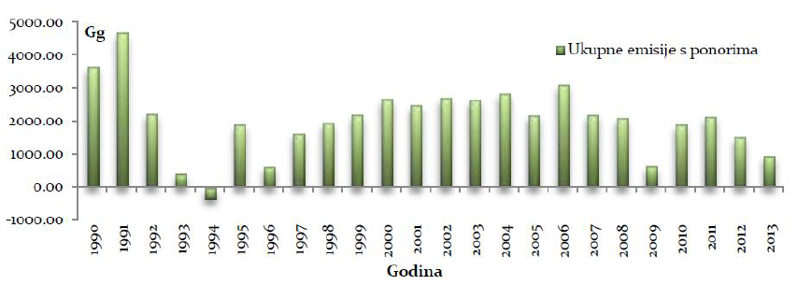
Figure 2.2. Total HGH emissions expressed as CO₂eq with absorbents, 1990 – 2013. (Gg)
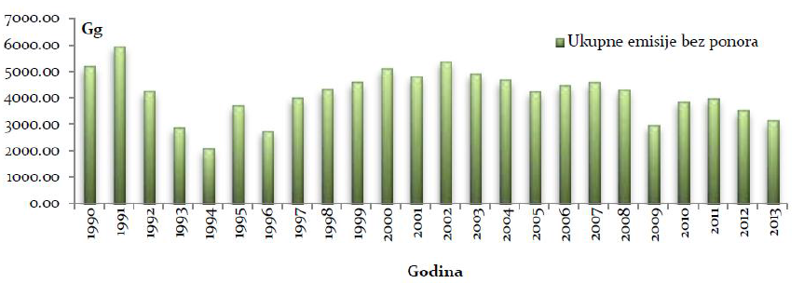
Figure 2.3. Total GHG emissions expressed as CO₂eq without absorbents, 1990 – 2013. (Gg)
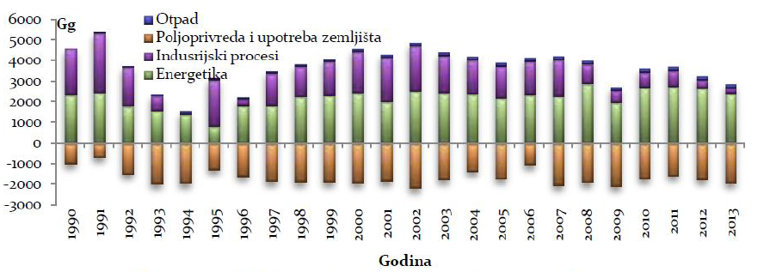
Figure 2.4. GHG emissions expressed as CO₂eq per sectors, 1990-2013. (Gg)
Energy supply and instruction processes sectors have the biggest share of the overall CO2eq emissions for the observed period. In that regard, depending on the consumption of energy generating substances, as well as levels of industrial production, drops and increases in emissions of estimated gases in the observed period are recorded. Share of emissions from the energy supply sector ranges from 22.12% for 1995, to 76.10% in 2013. Share of emissions from industrial processes ranges from 4.43% in 1994 to 60.91% in 1995. CO2 eq emissions from agriculture sector ranges from 6.54% in 2010 to 20.16% in 1994, while waste sector has the smallest share in the overall emissions ranging from 0.38% in 1990 to 6.33%, in 2009.
CO2 (24.6-74.5%) has the biggest share in the overall GHG emissions, followed by PFC (CF4 and C2F6) with share ranging from 3% to 40.9%, CH4 share ranging from 10% to 27.5%, while N2O share was from 2.3% to 5.8 %. SF6 had the smallest share in the overall emissions and ranged from 0.01% to 0.07%. In line with the data available for inventory recalculation, HFC emissions (2012, 2013) were estimated just for sub-sector 2.F. Use of alternative substances (2.F.1 – Refrigerators and Air-Conditioning Units).
- Total CO2 Emissions
Figure 2.5 shows total CO₂ emissions. For the observed period, energy supply sector had the biggest share in the overall CO₂ emissions (76.8 - 97.8%), while the share of the industry sector was 2.2 - 9.4%.
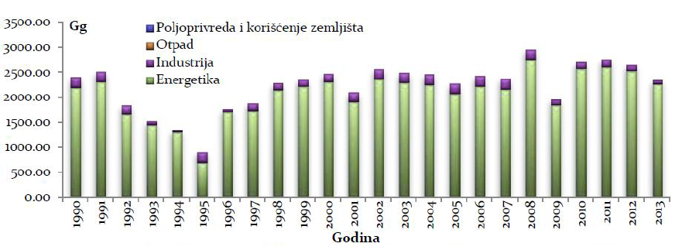
Figure 2.5. Total CO₂ emission per sectors, 1990-2013. (Gg)
- Total CH₄ emissions
Figure 2.6 shows overall CH₄ emissions. For the observed period, agricultural sector had the biggest share in CH₄ emissions (40.7 – 78.3%), while energy supply sector had a share of 11.6 – 22.4% while waste sector had a contribution in emission of CH₄ of 2.3 – 37.6%.
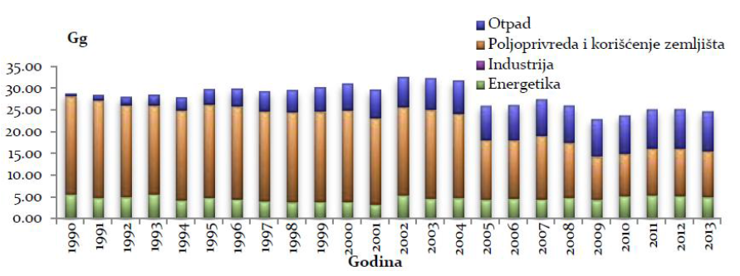
Figure 2.6. Total CH4 emissions per sectors, 1990-2013. (Gg)
- Total N₂O emissions
Figure 2.7 shows overall N₂O emissions. For the observed period, agricultural sector had the biggest share of N₂O emissions (54.9 – 81.7%), energy supply sector participated with 13.8-36% while waste sector contributed with 4-9.1% in the overall N₂O emissions.
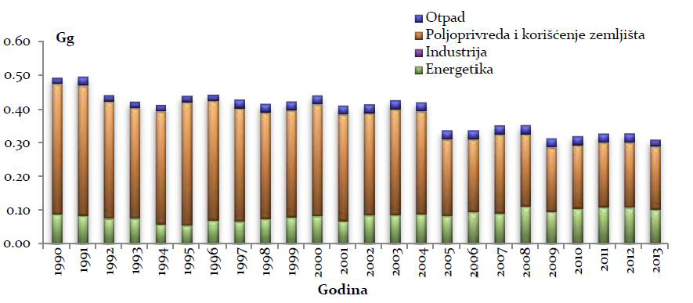Figure 2.7. Total N₂O emissions per sectors, 1990-2013. (Gg)
- Total PFC emissions
According to the available data for the observed period, PFC (CF₄, C₂F₆) emissions from the industry sector, i.e. aluminium production – electrolysis were assessed (figure 2.8).
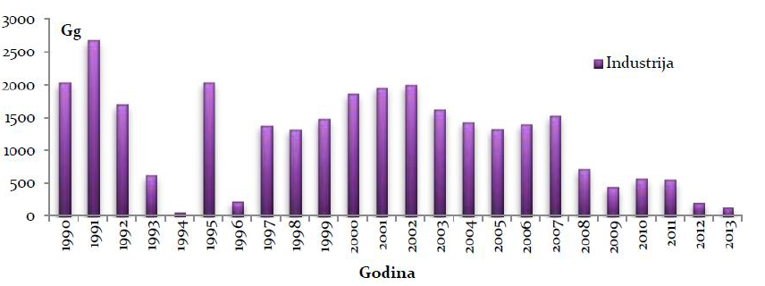
Figure 2.8. Total PFC emissions from industry sector, 1990-2013. (Gg)
- Total SF₆ emissions
Based on available data for the observed period, SF₆ emissions from sub-sector 2. G-Other production and use of products, i.e. from G.1-Electrical Equipment sector were assessed (figure 2.9)
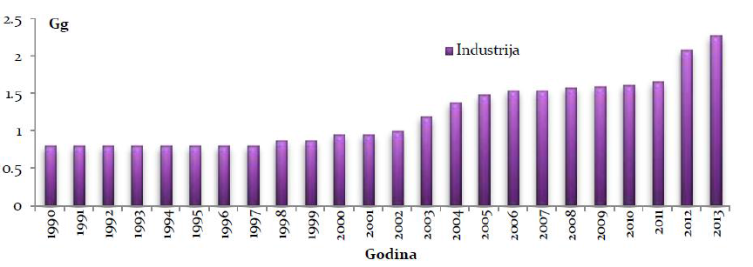
Figure 2.9. Total SF₆ emissions from industry sector, 1990-2013. (Gg)
- Total HFC emissions
Data for the period 2011-2013 where the only available for the assessment of the total HFC emissions. Emissions from subsector 2.F-Use of alternative substances, i.e. from activities 2.F.1-refrigerators and air conditioning units (figure 2.10) were assessed.
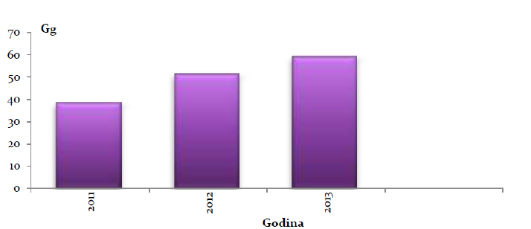
Figure 2.10. Total HFC emissions from industry sector, 2011-2013. (Gg)
Table 2.4 and figure 2.11 shows CO₂eq per capita.
Table 2.4. Total CO₂ per capita, 1990-2013. (t/capita)
CO₂eq (t/capita) | 1990 | 1991 | 1992 | 1993 | 1994 | 1995 | 1996 | 1997 | 1998 | 1999 | 2000 | 2001
Total CO₂eq no absorbents | 9.03 | 10.27 | 7.33 | 4.97 | 3.59 | 6.31 | 4.68 | 6.77 | 7.30 | 7.70 | 8.52 | 7.98
Total CO₂eq with absorbents | 6.31 | 8.07 | 3.82 | 0.71 | -0.62 | 3.23 | 1.07 | 2.76 | 3.28 | 3.67 | 4.45 | 4.12
CO₂eq (t/ capita) | 2002 | 2003 | 2004 | 2005 | 2006 | 2007 | 2008 | 2009 | 2010 | 2011 | 2012 | 2013
Total CO₂eq no absorbents | 8.88 | 8.11 | 7.71 | 6.97 | 7.35 | 7.52 | 7.06 | 4.87 | 6.30 | 6.48 | 5.76 | 5.12
Total CO₂eq with absorbents | 4.47 | 4.35 | 4.65 | 3.56 | 5.08 | 3.58 | 3.43 | 1.07 | 3.09 | 3.46 | 2.46 | 1.54

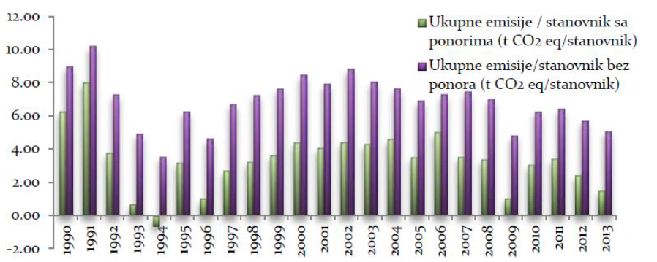
Figure 2.11. Total CO₂eq per capita, 1990-2013. (t/capita)

2.2. Geomorphology

The development of the relief of Montenegro is predisposed with the intense geotectonic activity during the geological evolution. Several relief units can be singled out in the territory of Montenegro. Those are:
• Montenegrin coast,
• Sparse deep karst (Krivosije, the area of Grahovo, Rudine and Banjani),
• Central cavity of Montenegro,
• The area of high mountains and areas,
• The area of northeastern Montenegro
The Montenegrin coast includes a narrow coastal belt which is severely separated from the rest of Montenegro by Orjen, Lovcen, Sutorman and Rumija. Their steep sides and vertical cuts are marked with deep grooves and toothed ridges. In the narrow belt between the lower hills along the coast and mountains in the hinterland, complexes of plain terrain have been formed, of which the Ulcinj and Vladimir fields in the southeast, Barsko, Buljaricko and Budvansko field in the central part, Mrcevo and Grbaljsko field and the bay Sutorina in the area of Boka Kotorska.
The plateau of a deep karst of an average height of 800-1000 m is the lower part of the mountain area of ​​Montenegro, which is one of the most typical karst areas in the world. This sprawling limestone-dolomite surface, 100 km long and 50 km wide, steps down from north-west to southeast to scandalous depression. The entire plateau is an area of ​​ scrapers with specific relief forms and specific hydrography. The basic geomorphologic structure of the region is characterized by the mountain areas of Orjen, Lovcen, Rumija, Somina, Njegusi, Pusti Lisac, Budos and Garca, and smaller karst fields.
The central valley of Montenegro, that is, the Zetska-Bjelopavlicka plain, Niksicko field and the Duga gorge is a very important morphological and geotectonic line in the area of Montenegro and the Dinarides as a whole. It stretches between the Gatacko field and Skadar Lake and further towards the southeast, and it is open to the Adriatic Sea.
The largest part of the northern region of Montenegro is the area of high mountains, which is considered one of the most typical areas of the Dinarides. The area consists of the higher mountain ranges of the Dinaric direction, between which there are deep canyons and areas. Canyon valleys of the Moraca, Tara and Piva rivers are of particular importance. Among the mountains are Golija, Vojnik, Maganik, Prekornica, Ziovo, Volujak, Ljubisnja, Durmitor, Sinjajevina, Bjelasica, Komovi, Visitor and Prokletije. In the valley of Tara, the most extensive are Mojkovac and Kolasin basin. In the valley of the Cehotina River, the most important are the Maocka and Pljevaljska basins.
The northeastern area extends along the northwest-southeast direction in a length of 140 km and a width of 35 km. The largest part of this area is built by paleozoic rocks (the wellspring parts of the Cehotina and Ljubovidja, parts of Pljevlja and Rozaje area), as well as several places in the river valleys. For the formation of certain forms of relief, the importance of young neogene deposits in the valleys and coves, primarily in the Berane and Pljevlja basins, where the deposits of coal are found. Within this area, the valleys of Cehotina, Lim and Ibar stand out as separate unities.

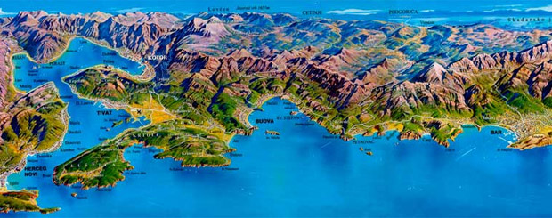
Figure 2.12. The relief of Montenegro

2.2. Geological and hydrogeological characteristics

2.2.1. Geological characteristics
The area of Montenegro was built from deposits that were created in the last 400 million years. The rocks belong stratigraphically to the Paleozoic, Mesozoic and Cenozoic era.
Paleozoic
The oldest layers in the area of Montenegro belong to the younger paleozoic (Devon, Carbon and Perm). Paleozoic crevices occur between Ibar, Lim and Tara. They are represented by rocks that are more or less shingled, clay –marl -sandy layers and various slopes with fewer passages and limestone and conglomerate lenses.
In the core of the anticline in the vicinity of Rozaje, the rocks of the Devonian age were discovered. On the larger surfaces in the valleys of the Ibar, Lim and Tara and partly in the valley of Cehotina, around Rozaje, Andrijevica, Berane, Bijelo Polje, Mojkovac and Kolasin, the rocks of the young Paleozoic, which belong to Devon and perm, are spread. The same age is also the Paleozoic sediment around Budva, Petrovac and around Rumija.
Mesozoic
Except for smaller zones of paleogenic flysch and quaternary sediments, the remaining area of ​​Montenegro was built from Mesozoic creatures (Triassic, Jurassic and cretaceous).
The lower Triassic, was developed in the clastic façade of the verphic layers, consisting of fissured sandstones and slopes, sandy shingles and, rarely, tartar limestone and dolomite. These sediments are by erosion most commonly found under the deep valleys, but they are at higher levels, tectonically raised. As a clastic mass, the verphic layers have a great hydrogeological significance, that is, a hydrogeological barrier, and numerous springs appear on a chain of verophene layers and limestone that overlaps them.
Verphic layers were established at Bjelasica, Visitor, border regions between Serbia and Montenegro, in the valley of Ibar and Cehotina, at the foot of Ljubisnja, in the Tara valley, and the greater part of the region of Mojkovac and Kolasin. The narrow zones of the above mentioned layers are also registered along the tectonic lines, at higher altitudes, on the Durmitor and Sinjajevina. Also, the verphic layers involve considerable space in Niksicka Zupa and in the area of ​​Crmnica.
The middle Triassic occupies a larger space than the lower Triassic. It usually occurs in the formation of pure limestone, but in the fisting of clastic rocks. Sediments of the middle triasssic are quite difficult to distinguish from the sediments of the upper Triassic, into which they often cross invisibly. Two intermittent zones of the middle Triassic, which stretch along the coast, were detected, all from Sutorina to the Bojana River. The narrow zones of the middle Triassic are also found in the interior, in Crmnica and in the Niksicka Zupa.
The largest area of sediment of the central Triassic lies in the northern part of Montenegro, Ljubisnja, around Pljevlja, as well as in the eastern parts, around Berane, and in the mountains east of the Lim River. The middle Triassic is also present at the Sinjajevina, Durmitor, and Piva and Tara valleys.
The upper Triassic is represented by dolomites, dolomite limestone, and limestone. In the southern and southwestern parts of Montenegro, the upper Triassic is more represented by dolomites, and in southeastern by limestone. The southwest belt of the dolomite of the upper Triassic is divided by the Zeta River into two longitudinal belts. The dolomitic belt southwest of the Zeta valley stretches from the border with Herzegovina, it covers a large part of the Grahovo field, and continues to Lovcen, Cetinjsko field, Rijeka Crnojevica and Crmnica, and further towards Rumija. On the north-east of the Zeta, there is a second belt of the Dolomite of the upper Triassic, which is less revealing and connected. It starts in the Piva valley and continues along the valley of Komarnica, through parts of Vojnik and Jasenovo field, on the eastern edge of the Nikšicko Field, to continue through Prekornica and Moraca volley to Kuci.
The limestones of the upper Triassic occupy a considerable area around the streams of the Cehotina, Ljubisnja, Maglic, Durmitor and Sinjajevina. In places where during the long geological history they are exposed to erosion, there is a wealth of karstic forms of relief.
Jurassic sediments are widespread in Montenegro. The largest area Jurassic occupies in the area of the deep karsts. Sediments of the lower Jurassic occur in the form of lithic gray limestone and red slopes of limestone. The litiotic limestone is often very muddy, even completely clay. They are abundant with fossils. They are represented on the parts of Lovcen, on the western edge of Grahovsko field, in the valley of Moraca and along the northeastern slopes of Rumija. Red plate, sometimes shedding limestone is present on the Vojnik and Piva Mountain.
Medium Jurassic occurs in the coast, in the area around Herceg Novi, to Verige, and from Becici to Sutomore. These are reddish thin layered limestones with pink. In the deep karst area, middle Jurassic does not have much distribution.
The upper Jurassic is present in the seashore, in the form of narrow belts, in the base of Orjen and Lovcen, and these layers usually end up with hornstones. In the deep karst area, the upper Jurassic can hardly be separated from the middle Jurassic. More explicitly, the upper Jurassic limestone belt is separated from the base of Rumija and around Skadar Lake, between the Albanian border and Virpazar, but also to the west in the part of Crmnica. In the area of the Kuci region, the upper Jurassic also appears in the middle Jurassic. They are presented with a long belt from the Pivska zupa, through Vojnik and the Niksicka zupa, further south-east to Ziovo. In the area of northeastern Montenegro, the upper Jurassic is mainly represented by a limestone profile that often reaches a thickness of over 400 m (parts of the Durmitor, Sinjajevin and Piva mountains).
In Montenegro, the cretaceous is represented in the foliation of limestone, dolomite and flysch. The sedimentation of the lower cousretac extends along the coast, through the Jurassic sediments. In the carbonate sediments of the lower cretaceous is the presence of silicon rocks. The lower cretacious extends in the part of Sutorina, in several places in Boka Kotorska, in the area of Budva, Sveti Stefan and Petrovac. In the middle part of Montenegro, the lower cretaceous was developed around the Skadar Lake in the Cijevna valley. These limestones in finishing parts move into dolomite. In the geotectonic unit of Kuci, the relatively wide belt is occupied from Kuci over Moraca, Prekornica, Maganik and around Niksic. Usually these are banked gray limestone.
The upper cretaceous is represented on the coast by a clastic limestone-silicon faction. These sediments are found in Boka Kotorska, around Budva, Petrovac and Bar. In the deep karst region and in the middle part of Montenegro, these sediments have a great distribution. They are discovered in an uninterrupted chain from the border to Albania, across the vicinity of Podgorica, Danilovgrad and Niksic, towards Herzegovina. Mostly they are pure limestone, while the dolomites are significantly less common. The upper dams also belong to partly flysch sediments around Herceg Novi, Morni and Risan Bay.
At the end of the cretaceous and the beginning of the paleogen, sediments that are known in the literature as the Durmitor flysch, consisting of large-scale heterogeneous limestone, breccias, conglomerates and sand-sedimentary sediments, have been deposited. These deposits are widespread in the Susica and Piva valleys, and they continue in the middle part of Durmitor, towards the southeast in the Tara valley upstream from Kolasin.
On Mesozoic sediments, numerous deposits of red and white bauxite have been formed.
Cenozoic
Paleogen sediments were discovered on the Montenegrin coast, in the form of parallel belts, the directions of providing northwest-southeast. These are mostly clastic rocks, which extend from Sutorina, through Boka, Budva, Buljarica, Bar and Ulcinj. These rocks are represented by conglomerates, nimulite limestone, sandstone and breccias, marls and alevrolites. Paleogenic sediments are also recorded in other locations, also in the narrow belts.
Neogen is developed in the feces of lake sediments, found in the large number of basins. These sediments are of great importance because they are followed by coal deposits. Neogene basins are located in the vicinity of Rozaje, Berane, and the most famous basins are in Pljevlja and its surroundings.
Quaternary sediments represent the youngest creations that build the territory of Montenegro. They are developed in all parts of the territory of Montenegro and have a very different lithological composition. Quaternary deposits have emerged in recent geological history, exogenous processes. Depending on the process by which the material of the quartile age is real, as well as the geological environment in which the process was occurring, a variety of lithological creations can be distinguished. According to the processes in which they occur, the quaternary sediment can be alluvial, deluvial, glacial (moraine), as well as fluvio-glacial, alluvial-deluvial and limno-glacial. Mostly they are clay, sand, gravel, various granulation and lithological composition.
The largest accumulations of alluvial sediments are found in the valleys of the river (Moraca, Zeta, Tara...) and in the watercourses in general. The presence of glacial sediments is associated with periods of glaciation, and the largest centers of glaciation, and therefore the largest deposits of moraine material, are the areas of the Durmitor, Sinjajevina, Bjelasica, Zijova, Maganik and others. Deluvial sediments are tied to the foothills of steep mountainous sides and are most often represented with limestone and dolomite pieces.
Magmatic rocks were discovered in all parts of Montenegro. Their outflow occurred after the lower Triassic, mainly during the middle triassic. Usually they are andesites, daisies, quartz-keratophers and keratophores, crossed with tuffs and tuffit.

Figure 2.13. Overview of the geological map of the area of Montenegro (Legend: 1. Alluvial and glacial sediments; 2. Neogene sediments; 3. Cretaceous and palaeologus flysch; 4. Cretaceous limestone and dolomite; 6. Jurassic diabass formation; 7. Triassic limestone and dolomite; 8. Middle-eastern eruptives 9. Lower Triassic sediments 10. Paleozoic shales and sandstones 11. Budva zone - Lower triassic-eocene 12. The boundaries of regional overlap fault and coves. The waters of Montenegro, PhD,. Branko Radojičić, Faculty of Philosophy in Niksic, Institute for Geography, 2005)

2.2.2 Tectonic unit
The territory of Montenegro belongs to the Southeastern Dinarides, which are characterized by a very complex textual structure. Today, the largest number of authors allocate four geotechnical units in the territory of Montenegro:
- Paraautohton (the Adriatic pine system)
- Budva – Cukali zone
- High karst (Visoki krs)
- Durmitor unit
Paraautohton seizes the area along the sea shore and partly beneath the sea, between the river Bojana and Herceg Novi. It has a Dinaric direction of stretching, except in the extreme southeastern part where it turns to a turn toward the east. This geotectonic unit was built of carbonate cliffs of the upper cretaceous and lower Eocene, flysch sediments and clastic sediments.
Budva - Cukali Zone represents a significant unit from the hydrogeological aspect. As a whole, it is a barrier complex, or a complete floor barrier. In the geological structure of this zone, the carbonate and silicate rocks of the Triassic, Jurassic and cretaceous ages, flysch creations of the Triassic and paleogene, as well as the eruptive triassic ages, are involved.
The High Karst Zone encompasses the area between the coastal belt and the Durmitor hill to the mountain massifs of Komovi, Durmitor and Volujak. In the geological structure of this geotectonic unit, the crabonate sediment of Mesozoic, the clastic sediment of the perma and the lower triassic, the flysch paleogenic age, the eruptive rocks of the middle triassic, as well as the miocene lake sediment and quaternary formation, are included.
The Durmitor geotectonic unit from the north and northeast fits on the High Karst. It covers the area of Komovi, Visitor, parts of Prokletije, Sinjajevina, Piva Mountain, Durmitor, Ljubisnja, Pljevlja, Lim Valley, Bijelo Polje, Berane basin and Rozaje. These terrains are built by the clastic sediment of the Palaeozoic and lower Triassic, carbonate, volcanic and silicic rocks of the middle triassic, the carbonate rocks of the upper triassic and the jurassic, as the walls of the diabase-rose formation and quaternary sediments.
Figure 2.14. Map showing the tectonic reionization of Montenegro

2.2.3. Seismicity
Montenegro is located in a relatively active seismic zone with the highest level of vulnerability and risk in the southeastern coastal area - coastal areas such as Zeta-Skadar depression and the Berane basin, which should be emphasized as areas of significant seismic activity in Montenegro. Seismic activity is associated with movement of tectonic plates. At the macro level, Montenegro is close to the border of the Eurasian plate and the African plate with the Adriatic and Aegean microplates between them. The complex movements of these plates lead to high seismic activity in this country; The Adriatic microplate is underneath the Aegean microplate.
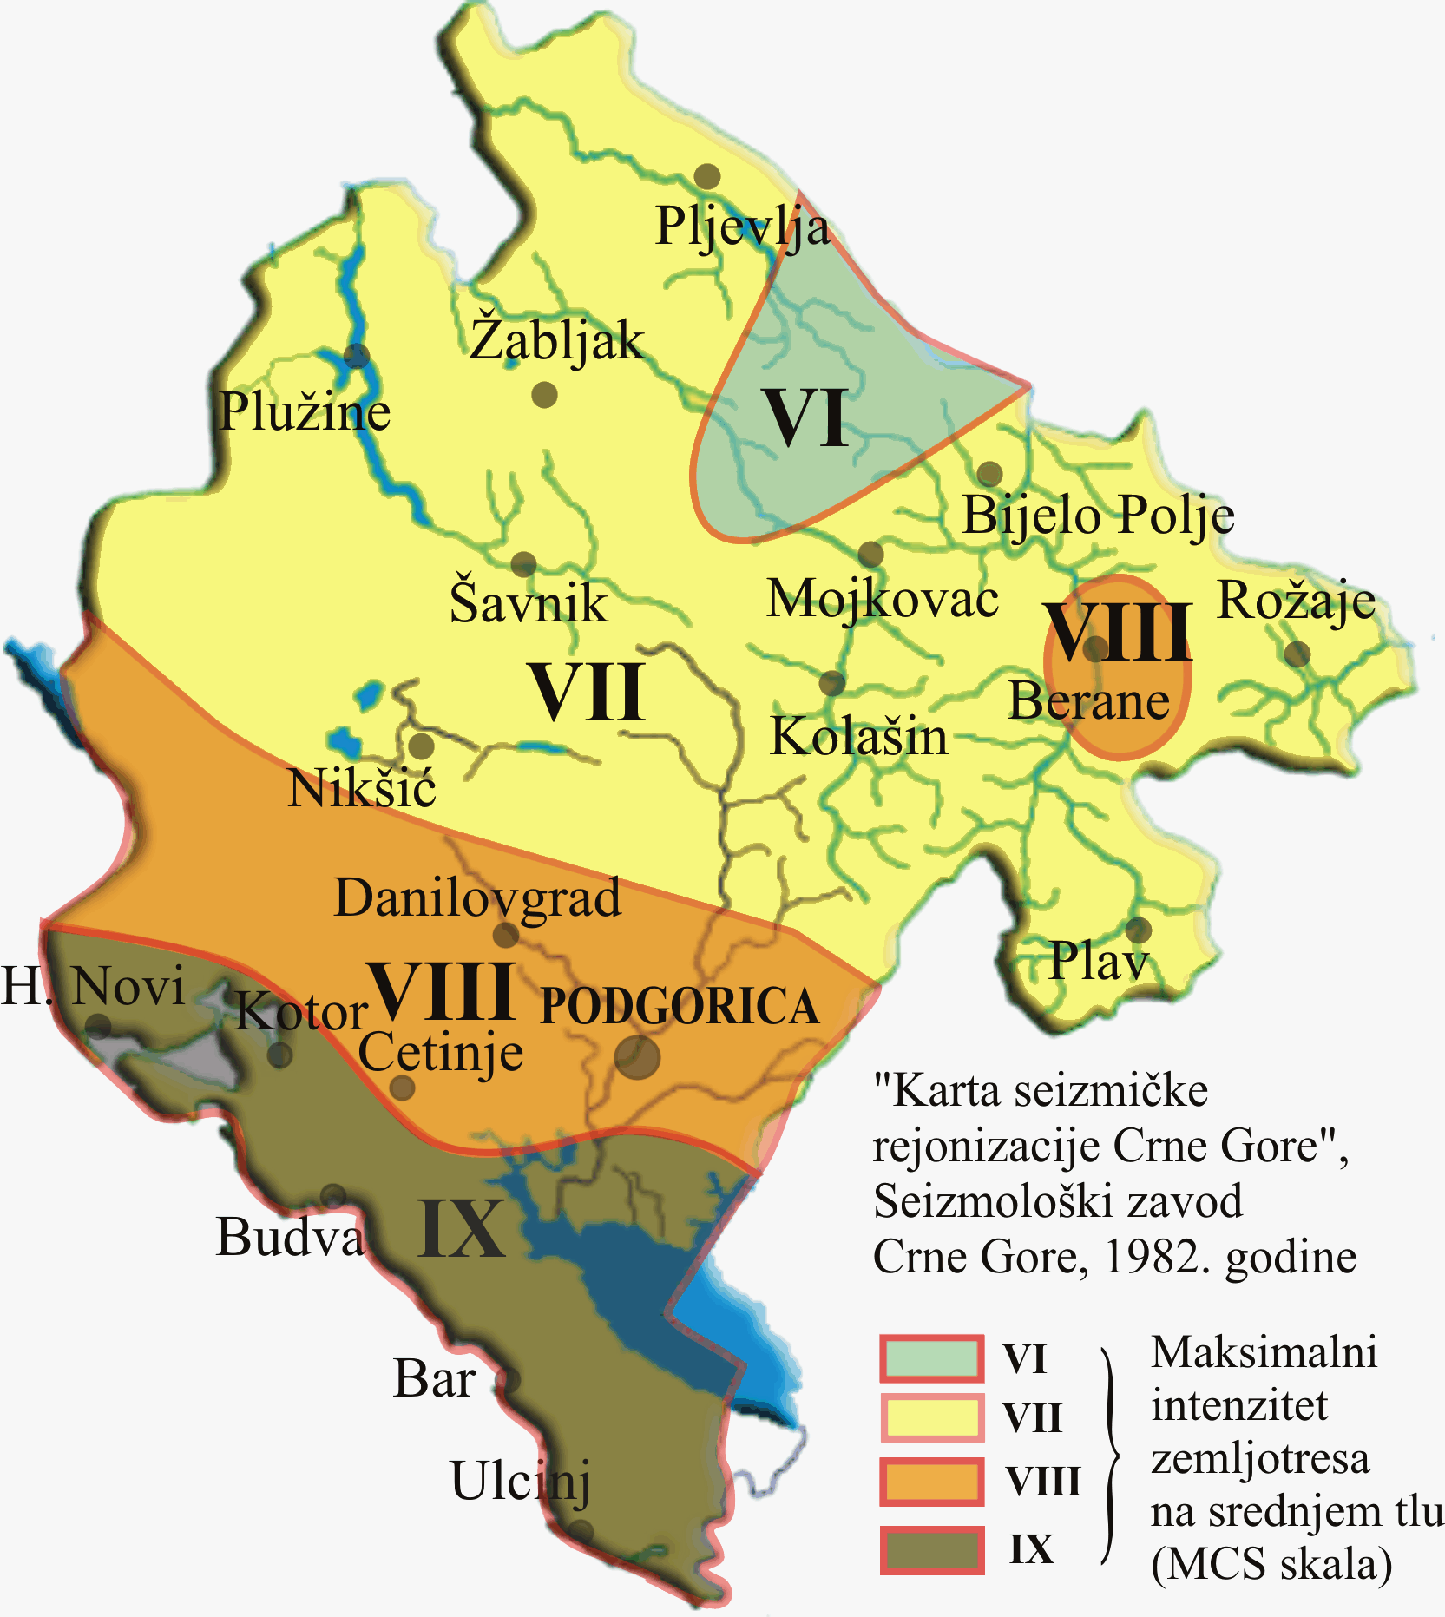

Figure 2.15. Map showing the seismic reionization of Montenegro
According to the National Strategy for Emergency Situations, most seismic zones are in the coastal area and their intensity decreases towards the east of the country. The highest zone (IX) occurs in the territory of southern Croatia and stretches along the Montenegrin coast and across the northern Albania to the southwestern Serbia. Areas around Ulcinj, Bar, Budva and Brajici as well as the Bay of Kotor, then in the immediate vicinity of Berane, the entire region of Skadar Lake, the Maganik Mountains and others are practically seismically active areas.
The region of Montenegro suffered a lot of severe and destructive earthquakes. On average, every third year, at least one earthquake of magnitude VII degree of Merkali's scale (MSC) occurs, every fifteen years earthquake of magnitude VIII degrees MSC and on average every sixtieth year a devastating earthquake with significant human casualties.
The last devastating earthquake was in April 1979 and destroyed the shore and the wider area around Skadar Lake, caused material damage of 4 billion US dollars (USD), killed 136 people and hit more than 100,000 inhabitants of Montenegro.
As we have already mentioned, destructive earthquakes are most often associated with large rock movements (landslides, rock erosion), floods, avalanches, regional fires and other natural hazards. The extent of human and economic losses, which occurs as a consequence of these natural and other related dangers, has been in a significant increase in recent years, and therefore Montenegro is faced with the imperative to reduce such losses. Although earthquakes can not be avoided and can not be eliminated, by applying technical measures, practices and experiences it is possible to narrow down the economic and social extent of such disasters. There are EU initiatives to prepare Montenegro for potential earthquakes on a large scale.
Based on the innovations of the seismic parameters of the Montenegrin area that are in compliance with European standards (EUROCODE 8), a map of the expected maximum magnitudes of the earthquake for a return period of 100 years was drawn up (Figure 2.16).

Figure 2.16. Map showing the maximum expected earthquake magnitude in Montenegro

2.2.4. Hydrogeological characteristics
Montenegro is abundant with various hydrological and hydrogeological phenomena. This is a consequence of the complexity of geological composition and soil, relief and climatic conditions. The zonal arrangement of the main geotectonic structures, the Dinaric direction - the northwest-southeast, directed the main flows of the waters, and the great differences in the lithological structure of certain parts of Montenegro caused differences in the wealth of submersible and surface waters.
In the hydrogelous sense, the rocks are divided into three groups:
- Group of permeable rocks - permeable rocks function as hydrogeological collectors. Within this group of rocks can be distinguished two subgroups:
  - permeable rocks - hydrogeological collectors, interbred porosity (alluvial, glacial, fluvioglacial, deluvial, limnogglacial sediments, as well as other geological environments represented mostly by sand, gravel and sand gravel)

  - permeable rocks - hydrogeological collectors, karst-cracking porosity (carbonate formations of different ages)
- A group of impermeable rock - impermeable rocks have the function of hydrogeological barriers or insulators. This group includes conditionally anhydrous parts of the terrain, or conditionally impermeable rocks, which are represented by paleozoic clastic sediments, magmatical rocks and highly glazed flysch lots.
- Hydrogeological complexes - which form groups of rock of collector and insulator character, ie complexes of permeable and impermeable rocks, such as fleece formations, formations of carbonate and clastic rocks, and similar. The permeable rocks of hydrogeological complexes can be of different lithological composition and type of porosity.
Geological-lithological analyzes show that 82% of the territory of Montenegro is built of limestone and dolomite. This claim can be confirmed by a sketch of the hydrogeological map in Fig. 2.17. The largest area on the territory of Montenegro is covered by the karst, or karst-cracking type, formed in carbonate structures of different ages. Karst, grown within the terrain made of carbonate rock masses, is saved directly from precipitation, through numerous surface karst forms, that is, depending on the site and part of the hydrological cycle, with vermiculite and permanent watercourses. Atmospheric precipitation is infiltrated into the underground, through numerous cracks, cracks and cavities, which permeate the interior of the limestone mass, where in deeper parts, broken rugged areas are formed in contact with impermeable rocks.
According to hydrodynamic characteristics one can distinguish:
• areas with a free level
• areas after pressure
In the largest part of the karst terrains of Montenegro, the karsts are released with a free level. This is particularly true of highly scattered terrain of karst plateau, in which the karstification process is continuous, in pure limestone, developed to great depths. Lower boundaries are usually made of clastic walls or compact batches of marble and bituminous limestone and dolomite.
Areas under pressure are mostly related to the scattered paleo-forests of unginous basins of karst fields, in the area where they are covered with limestone sediments, or sediments of paleogenic flysch.

Figure 2.17. the hydrogeological map of Montenegro (Legend: green color - karst and karst-cracks type of area; light blue color - compact type of area; light brown color - crack type of rea; dark brown color - conditionally anhydrous parts of the terrain)

2.2.5. Mineral resources
In Montenegro, 28 different types of mineral raw materials were discovered, of which 15 were exploited. This mineral potential can be classified into metals, non-metals and energy minerals (coal, oil, etc.).

Metals
Metals that can be found in quantities of economic importance for Montenegro are bauxite, lead and zinc. Copper also has some potential economic value.
The red bauxite sites are widespread in the central parts, and are more concentrated in the southern parts of Montenegro. They were formed in three geological periods: triassic, jurassic and early paleogen. Jurassic bauxites have the greatest economic significance. The sites were identified in the following regions: Niksicka Župa, mountains in Bjelopavlici, Banjani, Rudina and Katunska Nahija. However, the most important reserves of red bauxite are found in the wider Niksic area where the largest karst sites of red bauxite have been discovered: Liverovici I and II, Zagrad, Kutsko hill, Djurak’s valley, Bioci flat and Štitovo I and II.
Defined reserves (based on research) at the end of 2005 were about 39 million tons, however, economically viable reserves are about 54% of the total quantity (i.e. 21 million tons). In addition, the indicative reserves amount to another 30 to 50 million tons (depending on the criterion and the author). The exploitation of red bauxite in the last few years has been carried out by surface mining (in open pit mines) in the following mines: Zagrad, Djurak’s valley and Stitovo I and II, while in the mine Bioci flat (due to the high depth of bauxite), the underground methods of blasting. The exploited quantity of red bauxite in the period from 1948-2005 is about 23.2 million tons.
Lead and zinc deposits occur in the north of Montenegro with economically cost-effective concentration in the Ljubisnja mountain region (Šuplja stijena mine) and Bjelasica (Brskovo mine). The Suplja stijena mine consists of four sites: Suplja stijena, Djurdjeve vode, Paljevine and Ribnik. The economic reserves in the Supja stijena are 18.4 million tons, while the estimated potential reserves are between 10 and 40 million tons. Between 1954 and 2000 approximately 4.2 million tons of ore in surface mines and underground methods were exploited, which produced 78 662 tons of lead concentrate and 304 242 tons of zinc concentrate. In 2011, new facilities have been opened for the processing of an additional 300 000 tons of ore.
In Bjelasica, the second most important region for the exploitation of lead and zinc, is the Brskovo mine (which dates back to the 13th century), which was opened in 1976 and has only worked for twenty years. In the area of ​​this mine, lead and zinc ores were found at the following locations: Žuta prla, Razvrsje, Visnjica, Igrista, Brskovo and Gradina. The economic reserves in the Brskovo mine are 16 million tons of ore, and between 1976, and 1991. 2.85 million tons of ore were exploited and 32 588 tons of lead concentrate were produced, 89 263 tons of zinc concentrate and 133 910 tons of concentrated pyrite (FeS2). In addition to the aforementioned economic reserves, an estimated additional 30 million tons of this ore in the same area is indicative.
The established copper reserves in Varina near Pljevlja are about 5.3 million tons with 0.75% copper content and are also a potential economic site that has not yet been exploited.
Non-metals
Economically significant non-metals are: architectural and building stone, travertine, cement marl, brick clay, white bauxite, dolomite, bentonite and hornstones.
Architectural stone is exploited in the mines: Maljat and Krute (concessionaires Mermer a.d. Danilovgrad), Visocica (Šiskovic ltd. Danilovgrad), Raduje karst (Geoservis ltd Podgorica) and Zivsko razdolje (Ramini Company ltd Niksic). The total economic reserves in Bjelopavlici region are about 4 million m3, and in the coastal area about 2 million m3 of rock mass. Potential reserves were estimated at an additional 50 million m3 of rock mass.
Production of commercial blocks in 2007 it was about 13 500 m3. A special type of decorative stone "bauxite" is located in several locations in the coastal area and has a potential economic value of about 9.7 million tons, however, because of its physical and decorative quality the exploitation must be regulated by special regulations.
The economic reserves of travertine in the fields of Tavani near Savnik and Gornja Lijeska near Tomasevo amount to about 364 000 m3 of rock mass. Travertine sites should be protected by special regulations to be used only for the construction of facilities of national interest.
Montenegro is extremely rich in carbonate rocks that are used as a building stone. To date, 26 different sites of this rock have been examined and reserves of about 60 million m3 have been determined. Only one site of construction stone of volcanic origin has been registered and its reserves amount to about 2.5 million m3.
During 2007, in Montenegro, more than 1.17 million m3 of stone aggregates of different fractions were produced. The sand and gravel deposits (also used for the production of concrete) occur in alluvial sediments in riverbeds and in the form of glacial-fluvial sediments of the Cemovsko, Niksic, Grahovsko and other karst fields. During 2007, about 1,85 million m3 from the river and about 50,000 m3 from the glacial-fluvial sediments were produced. Exploitation from the riverbed is done through a concession aimed at regulating the river bed and under the authority of the Water Directorate. Unfortunately, the exploitation of the gravel is poorly controlled, so many irregular actions occur, especially in river channels. The lack of control over the exploitation of gravel can lead to an increased flood risk near the location of these works.
The most important site of brick clay was identified in the area of Pljevlja (Maljevac and Maoce) in the determined amount of reserves of 6.4 million tons. Indicative reserves at the Maoco site are over 500 million tons. Exploitation and processing of clay in brick in the second half of the 20th century was sometimes done in Pljevlja, Berane, Tivat, Spuz, Kolasin, Bijelo polje, Virpazar and Savnik. In recent years, there are no active clay mines in Montenegro or the production of clay for construction.
The most important site of lime cement is located in the Potrlica area near Pljevlja (where coal is exploited), in which reserves of 90 million tons have been determined. Cement production in Montenegro was carried out only in Pljevlja, between 1976 and 1988. In those 13 years, 1.66 million tons of cement were produced.
Bauxite was found in more than 100 locations in the territory of about 1,000 km2, between Niksic, Cev, Dragalj, Trebisnjica and Golija Mountains. The economic reserves in the area of Bijele Poljane in 2005 were 1.7 million tons, of which the best quality species known as "white bauxite" amounted to only 133 500 tons.
Four sites have been investigated in the area of Trubjela: Kruscica - Ravni vlak, Srni do, Gradac and Plitki do, where reserves of 3.9 million tons of ore were determined. Indicative reserves of white bauxite in the entire region are estimated between 10 and 30 million tons.
Montenegro is very rich in dolomite and it has been found that there are over 80 million tons of high quality dolomite that has not yet been used.
Barite reserves were established only in the area of Kovac Mountain, near Pljevlja, in the amount of only 400,000 tons. These reserves have not been used since 1956.
Bentonite sites were detected in Bijelo Polje near Petrovac and Donja Bukovica near Savnik, where reserves of 2.4 million tons were determined. Indicative reserves are about 1.4 million tons.
Quartz sand was found only in the myocene sediments of Ulcinj with indicative reserves of about 7 million tons which have not been used up to now.
Parsons are silicate minerals that are mainly used in the glass industry. Reserves were determined only at the site of Vrdola near Tivat in the amount of 1.2 million tons, but with a significant potential in other places.
Energy minerals
Energy minerals are coal, oil and gas. In Montenegro, exploitation of coal is carried out, while the potentials for oil and gas are still in the research and evaluation phase. Smaller sites of peat (organic rich soil) located near Skadar Lake, Montenegro, have not yet been used, but there are ideas and projects for the use of this mineral in the agro-industrial sector.
Coal is the second most important energy source in Montenegro. These are geographical two separate areas in the north and northeast of Montenegro, the Pljevlja region and the area of Berane:
Pljevlja area includes 3 basins:
- Pljevlja basin (deposits: Potrlica with Cementara, Kalusici, Grevo, Komini and Rabitlje) with gravitating small basins (deposits: Otilovici, Glisnica and Mataruge)
- Ljuce-Sumani basin(deposits: Sumani I and Ljuće II)
- Maoce basin
The degree of research is high. The total balance reserves in the Pljevlja area are about 188.4 million tons, of which 109.9 million tons in the Basin basin, 76.8 million tons in Pljevlja basin and 1.7 million tons in the Ljuce-Suman basin.
Estimated reserves in the basins of Glisnica and Mataruga are with a significant degree of reliability. Basin Glisnica is in the final phase of the research and defining of deposits, while the Mataruga pool was investigated in two periods (1982 and 1994) and according to these data, no amount of coal is questioned, but the required geological survey is needed in order to define quantities and quality of coal.
The area of Berane (basins: Polica, Petnjik and Zagorje) has not been sufficiently explored. Brown coal geological reserves amount to about 158 million tons, but exploitation reserves estimated in 2008, amount to a maximum of 17.8 million tons (IMC study, 2008).
Oil and gas
The exploration of oil and gas in the continental part of Montenegro began in 1949, to expand in the 1970s to exploration and vancontinental coastal waters. To date, 17 exploration wells have been drilled to a depth of 900 to 5309 m, while 4 exploration wells have been drilled in coastal waters from 3 700 to 4 750 m. In these wells the presence of bitumen, oil and gas has been determined.
In addition, research was carried out on the seabed of the Montenegrin coast, about 11 000 km 2D and 300 km of 3D seismic profiling. The results of the land and coast survey show the objective conditions for the formation of hydrocarbon sites.
For the purposes of research and production of hydrocarbons in the territory of Montenegro, it is divided into blocks (Decision on determining blocks for the award of a concession contract for the production of hydrocarbons in the offshore of Montenegro, Official Gazette of Montenegro no. 42/12, July 2012), Figure 2.18.
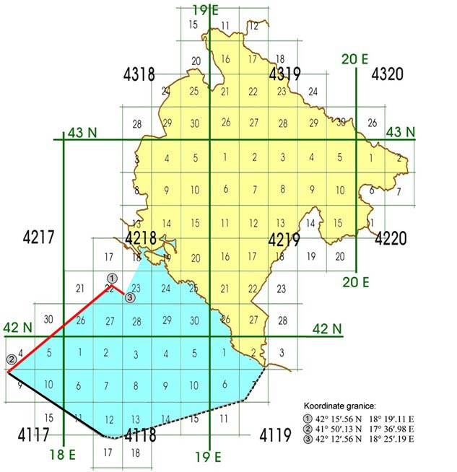
Figure 2.18. Division of the territory of Montenegro into blocks
At the first tender for allocation of concession for the exploration and production of hydrocarbons, the following blocks are shown in Figure 2.19.
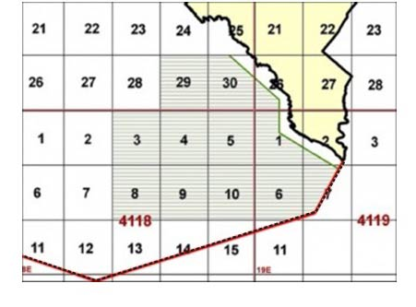
Figure 2.19. Blocks offered at the first tender for research and production of hydrocarbons in the underground of Montenegro (Source: the Ministry of Economy)
In September 2016, the Government of Montenegro signed an agreement on granting concessions for exploration and production of hydrocarbons in the offshore of Montenegro with ENI and Novatek, which were assigned blocks 4, 5, 9 and 10. After several months, the Government of Montenegro assigned another concession contract for the exploration and production of hydrocarbons in the offshore of Montenegro for Blocks 30 and 26 by Energian.

2.3. Soil and way of land use

In Montenegro, due to the natural factors of climate, geological background, relief, vegetation and man, various lands were formed. The following types of land are allocated:
- Karst terrain (Litosol) and sirozem (Regosol), with an area of ​​38,470 ha, are initial land on compact rocks and overgrown regolit;
-Limestone-dolomite black soil (Kalkomelansol), area of ​​660.000 ha, is the most widespread land in Montenegro;
- Rendzina, 31,205 hectares, similar to limestone black soil with profile and features, but formed on a loose carbonate substrate. It contains more skeletons than black soil, and arable areas are deeper varieties of sowers, karst fields and smaller plains;
- Humus silicate soil (Ranker), insignificant surface (6825 ha), because it is formed on silicate substrates above 1500 m. It is characterized by a highly acidic reaction and high humus content;
- Brown sour soil (Distric cambisol), with an area of 394,825 ha, comes in second place, most widespread in northeastern Montenegro;
- Brown eutric land (Eutric cambisol), area of 118,275 ha, occupies the lowest parts of river valleys (old river terraces), basins and karst fields;

2.3.1. Erosion
The planned routes through all types of erosion processes (excessive erosion, strong erosion, medium erosion, poor erosion and very poor erosion). The purpose and use of the land as a result of the projection of long-term socio-economic and demographic development into the territory of the territory of the Strategy region is shown through: agricultural land; forests and forest land and other land (settlements, aquatic areas, roads, rocks, etc.).

The present state of the soil in relation to the content of dangerous and harmful substances can be characterized as good one. However, the impact of traffic, I.e. emission of exhaust gases through increased content and organic and inorganic pollutants, i.e. polycyclic aromatic hydrocarbons (PAHs), lead (Pb) and cadmium (Cd), will be increased by the construction of planned road directions, or by its increasing functionality. The maximum permissible quantities of dangerous and harmful substances in the soil, which can lead to its pollution, are determined by the Rulebook on permitted quantities of hazardous and harmful substances in soil and methods for their examination (Official Gazette of the Republic of Montenegro no. 18/97).

Data from soil pollution monitoring programs at targeted locations indicate that the increased concentration of pollutants is mainly due to inadequate disposal of municipal and industrial waste, or emission of exhaust gases and dumping of harmful substances from exhaust gases near major roads.

The most important source of polychlorinated biphenyls (PCBs) in Montenegro is maritime traffic. In the total emissions of these substances, recorded in 2012, the share of maritime traffic is around 80%.
Figure 2.20. Padological map of Montenegro

2.4. Waters

Network of stations for testing quality of surface waters in 2015 included 13 watercourses with 36 metering profiles, 3 natural lakes with 11 metering profiles and coastal sea with 16 metering points. In terms of metering stations for testing underground water quality, it includes underground waters of first spring in Zeta plain. The network is comprised of 9 metering profiles that cover the entire area of Zeta plain. Sampling is done at private wells that are not piezometric drills.

2.4.1 Fresh Waters
To simplify display of basic characteristics of more important spring waters per certain hydrological segments, following regions were identified at the territory of Montenegro:

• Littoral karts (Para-autochthon, Cukali zone),
• Karst fields, plains and tall mountains (Tall karst and part of Durmitor tectonic unit),
• Karst of internal Dinarides (tectonic units: Lima, Rožaja i Ćehotine).

Aqueous environments where underground waters accumulations are formed and existing that are important for public water supplying of town and larger rural settlements, larger industrial facilities but also for irrigation of larger areas are:
•gravel, gravel-sandy and sandy deposits from the Quaternary – glacial-fluvial and alluvial sediments of inter-grain porosity,
•carbonate rocks from younger Palaeozoic, Mesozoic and Tertiary – limestone, dolomite limestones and dolomites of crack-cavern porosity.
Permeable diluvial and glacial sand, gravel and larger blocks of occasionally small areas and with underground water accumulations – springs are significant solely for individual water supplying therefore they are not included in basic aqueous environments.
Permeable rock masses, that alternate with impermeable Aqueous environmental are small areas and thickness, with limited accumulations of underground waters, therefore they have local significance for public water supplying. To certain extent, free, broken karst wells in Budva-Bar zone of Montenegrin littoral form an exception.
Practically impermeable rock masses have the function of water impermeable floor or water impermeable side and hanging barriers that prevent or direct movement of underground waters from aqueous environments. Formed underground water accumulations in certain zones with faults and in the crust of breaking of these rock masses are emptied at many springs capacity lower than 1.0 l/s, used or can be used for water supplying.
Certain springs in the zone of littoral karst are being salted (Škurda, Orahovački springs, Risanska spilja, Topliš, Plavda, etc.).
Figure below shoes zones of refilling the springs (Figure 2.21).
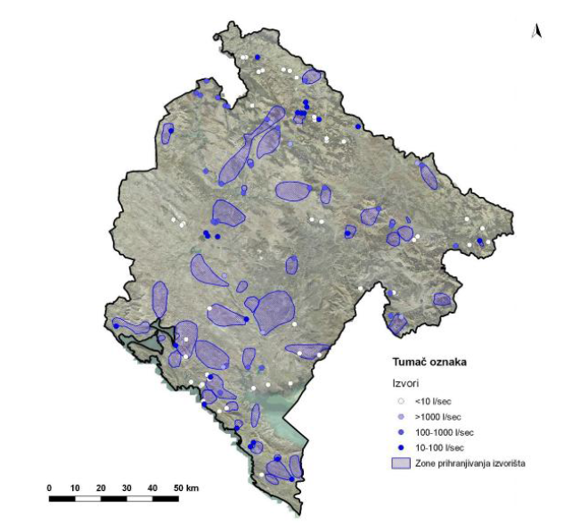
Figure 2.21. Zone of filling springs (Source: Spatial Plan of Montenegro by 2020)
State of quality of underground waters
Underground waters provide around 92% of total water demand for the settlements. In general, quality of underground waters in Montenegro in natural conditions for the most part of the year (eluding littoral springs which are under the impact of the sea) are categorised under first class.
In the littoral, impact of salt sea water on low karst springs in the littoral is the basic negative factor that affects the quality of underground waters. Numerous occurrences of underground waters in this zone or either salty or become exposed to the impact of sea water to the level of becoming undrinkable in the process of their exploitation.
In the continental part, natural quality of waters on nearly all the underground water springs has deteriorated mostly due to anthropogenic impacts and as result of inadequate sanitary protection and unsuitable sanitation of the catchment area.
Waters of the first (I) spring in Zeta plain are sampled at 6 locations and are categorised in the most demanding A class because waters in some wells are still being used as fresh water supply that does not require any treatment. In a lot of cases, water was not within the set class 63.3% class, of which 6.7% is VK, per content of ionic ratio Ca/Mg, phosphates, nitrites and nitrates. Pollution, parameters, their content and spatial distribution is mainly the same throughout the years. Chemically most polluted wells are those found in Farmaci, Vranje and Gostilje.
Water temperature ranged between 13.2-19.5°C, for the metering period of June to December. Most even water temperatures were registered in wells in, 0.7°C, while the biggest variations were registered in Drešaj well of 5.3°C.
Waters had satisfactory organoleptic properties – colourless and without specific scent.
Concerning contents of nitrates were found in wells Vranj, Gostilj and Drešaj where high content of these substances was found that reach up to 89.0 mg/l, i.e. 77.3 and 41.2, mg/l. This is due to impact of mineral fertilisers – salitre because the content of potassium is elevated and amounts to 14.2 i.e. 13.1mg/l.
Microbiological indicators had movement from their class into A1 by the number of coli bacteria in well Farmaci, Vranj and Drešaj and by the number of foil water or number of faecal bacteria was changed to A2 class in wells Vranj and Drešaj. In every sample taken from other wells this year had presence of faecal bacteria which is probably result of dry period.
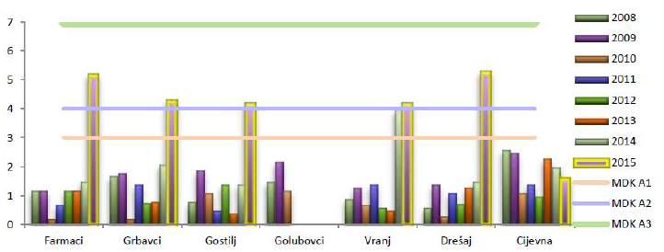
Figure 2.22. BPK5 in underground waters and wells of Zeta plain (mg/l)
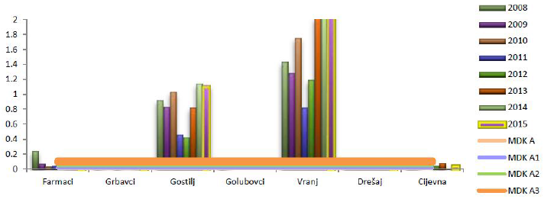
Figure 2.23. PO₄⁻³ in underground waters and springs of Zeta plaine (mg/l)
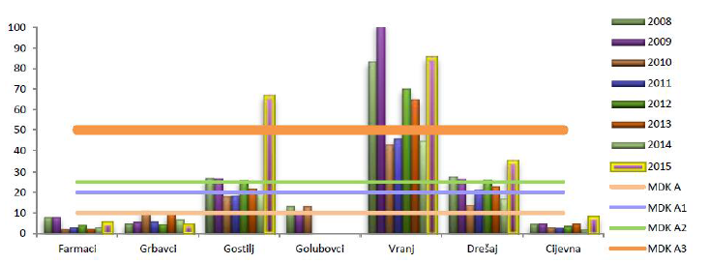
Figure 2.24. NO⁻³ in underground waters and springs of Zeta plain (mg/l)
State of fresh water
Pursuant to valid regulations in Montenegro, control of fresh water health correctness and quality in 2015 as well as testing of fresh water from the water supply system was performed at the Institute for public health Podgorica, Hygienic Epidemilogical (HE) department of the Health Centre Bar, Hygienic Epidemilogical Department at Health Centre Cetinje, PP Vodovod i kanalizacija Podgorica and D.O.O. “CETI”.
Institute for public health conducts regular water testing in 20 of the 22 municipalities in Montenegro. Hygienic regularity check in municipality of Pljevlja is carried out by the Institute for public health Užice, while there are no data on fresh water testing in municipality of Petnjica during 2015.
In line with the law on registry, all the laboratories that conduct fresh water tests submit the results to the Institute for Public Health that analyses received data and provides appropriate recommendations.
World Health Organisation (WHO) categorised fresh water quality as one of twelve basic health indicators of a country’s population which confirm its importance and role in health protection and promotion. Water used for drinking, food preparation and personal and general hygiene maintenance needs to meet basic health and hygienic requirements: must be in sufficient amount; must not have adverse health impacts, i.e. must not contain toxic or carcinogenic substances or pathogenic microorganisms and parasites.
Water has great physiological, hygienic, epidemiological and technological-economic importance. Hygienic epidemiological importance of water depends on its physical, chemical and biological properties. These properties depend on water circulation in nature, water and soil self-treatment capacity but also on water and soil pollutants in form of liquid and solid waste from households, industry, public and farmable areas.
Insufficient provision of water and hygienic non-potable water can lead to spreading of numerous contagious and non-contagious diseases.
In line with valid regulations, water potability is controlled through basic and periodic tests, per population equivalent. Full tests are done solely at request within exploration works at new aquifers but not in the existing aquifers.
Based on results of testing water potability and sanitary-hygienic state of aquifers, the conclusion is that:
In 2015, total of 11591 samples of fresh water from town mains and other public facilities for water supplying were tested in Montenegro. Of the total number of samples, 5831 were microbiologically tested, 5760 were physically and physically-chemically tested. According to the results of microbiological tests, 7.2% of tested samples of chlorinated waters did not meet set potability norms, often due to increased overall number of bacteria and identification of coliform bacteria.
Based on results of physical-chemical tests, 9.03% of tested chlorinated water samples did not meet valid regulations. This was most often due to insufficient concentration or complete absence of residual chloride as well as increased blurriness in the period of more abundant precipitation.
The inspection of sanitary-hygienic state showed that not all statutory set out sanitary protection zones were established, i.e. majority of aquifers has just direct protection zone. Tanks that exist in the systems of several town mains are not adequately sanitary protected. Manifold of majority of town mains is quite old which results in frequent malfunctions and significant network losses, which is also an epidemiological risk. Water disinfenction is not being carried out continuously on all town mains (in particular on those with lower population equivalent). With the exception of several large town mains, automatic dosing and registration of residual chlorine level was not established.
Even though water potability control in school and preschool institutions is mandatory, majority of these institutions does not adhere to this obligation, so set number of fresh water samples in educational institutions in 2015 was not tested.
Surface water
Basic property of Montenegrin hydrography is presence of two quite equal catchment areas: Black Sea and Adriatic catchment areas. Adriatic catchment area covers around 47.5% of the Republic, while Black Sea covers an area of approximately 52.5%.
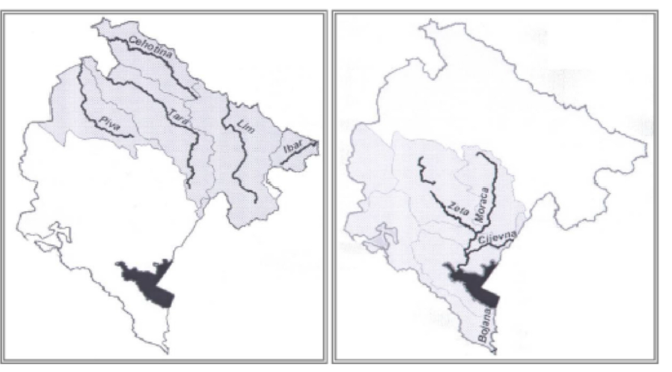
Figure 2.25. Catchment areas in Montenegro (Source: Diktas, Montenegro country report, 2012)
The specificity is that the highest mountain peaks and chains belong to the Black Sea catchment area, while watershed between Black Sea and Adriatic Sea is south of these. In general, both catchment areas have plenty of water, even according to world standards. However, significant part of Montenegro belongs to the continental karst area which does not have constant water courses, has plenty of precipice where waters dun into and flow below the ground to watercourses or the sea. Important rivers (main surface watercourses) of the Black Sea catchment area are: Morača, Zeta, Rijeka Crnojevića and Cijevna, which all run down Skadarsko Lake, from where they run into Bojana River tha flows into the Adriatic Sea. Hydrographical network of Montenegro is shown in the figure below.
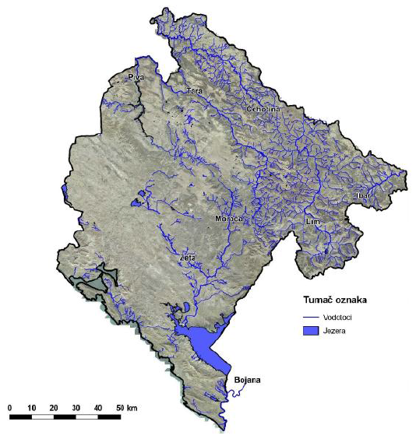
Figure 2.26. Hydrographical Network of Montenegro
Courses of continental cars flow through the precipices into the ground and emerge in watercourses of Adriatic or Black Sea revers or below the sea level. Part of these waters runs underground to adjoining territories (Trebišnjica, Konavlje). The biggest share of surface courses in Montenegro appears on form of torrents. These are grouped in torrent systems per specific geographical determinants: littoral, Skadar Lake, Boka Kotorska Bay, Niksic, Cetinje, Podgorica, Piva, Lim and others.
Out of littoral torrent systems, the most significant are subsystems: Boka Kotorska Bay, Budva torrent, Bar torrent, Sutomore and Ulcinj torrents. Out of Boka Kotorska Bay torrents, Zverinjak needs to be mentioned, Kučac out of Budva torrents, Željeznica and Rikavac out of Bar torrents, that run towards the sea. Following are specific for Ulcinj torrents: Međurječka, Vladimirska and Rastiška rivers that run towards Šask Lake and Bojana River.
Out of Skadar torrents, following subsystems are specific: Crmnica, Orahovac and Skadar Lake, of which Crmnica Field torrents Bistrica and Sutorman are significant.
Artificial lakes on following rivers are very important for Montenegro’s hydrography: Piva, Ćehotina, Zeta (Nikšićko field) and Grahovska river (Grahovo). Part of the territory of the country was flooded with construction of artificial lake for "Trebišnjica" Hydroelectric Power Plant. Natural lakes in Montenegro are relatively numerous, whereby they are located at low areas of the southern part of the country’s territory. Skadar Lake, formed in the spacious depression, is at the same time the biggest lake in the Balkan. Three fifths of the Skadard Lake area belongs to Montenegro. At the highest water level of around 10.44 masl, the area of this lake is around 525 km². Šasko Lake is the second largest lake in Montenegro and is located between Skadardsko Lake, Bojana River and the Adriatic Sea. Black, Plavsko and Biogradsko lakes are natural reservoirs, as typical examples of glacier lakes. All these lakes except Plavsko are found in national parks. In addition to these, there are many smaller lakes that are glacier or karst origin.
The state of quality of water surfaces
In terms of the type and the source of population, this has not changed in regards to the previous period. Just like in the past years, sanitary waste waters, often discharged in recipient in untreated form, in concentrated or diffused manner, are the biggest polluters of surface and underground waters. Industrial impact, primarily food industry, as well as small and medium size enterprises is also notable. It is important to mention the increasing impact of transportation infrastructure and fuel distribution to the quality of surface waters.
Changes in natural ionic relationship between Ca/Mg, which was often off the set limits is also indicative of seasonal but also long-term period (time trend) of change of natural composition of waters in watercourses.
Increased content of ammonium ion, phosphate, nitrate and detergents are often found in this group of water bodies. There was often increased oxygen saturation, which was result of natural factors, low water level and heightened or high air and water temperatures.
Like in previous years, the most polluted watercourses were Vezišnica and Ćehotina in Pljevlja area and Morača in the area below the discharge of Podgorica town collector. Waters of rivers Rijeka Crnojevića, Ibar in the section below Rožaje and lower course of Lim are polluted, while Lim (middle and upper course), Grančar and Tara had good status, and Zeta (in particular in the lower course) very good status, and Piva, Bojana, Kutska River and Cijevna had the best, or even excellent water quality. The results of metering reveal great sensitivity of these water systems, especially in the low-water level regime.
Water quality of all water courses, except Li, Ibar and Grančar in 2015 was worse than in 2014, which can be ascribed to unfavourable meteorological conditions – it was the hottest year in most of Montenegro.
Samples from Morača are taken at 6 points which, according to classification of its water, they need to belong to A1, S, K1 class upstream of Duklja (Pernica and Zlatica) to Skadar Lake delta, A2,C,K2 class (Momišići town beach, below town collector discharge point, Grbavci and Vukovci). The upper course already recorded changes in balance and certain parameters exceeded the boundaries of their classes in A2, A3. In regards to physical-chemical parameters those are: temperature, ammoniac, phosphates, TOC and detergents, out of microbiological parameters, number of faecal bacteria, and on just one profile they exceeded their class: phenols (Pernica), oxygen saturation, PBK5 and nitrites (Zlatica), and out of all the classes (VK) were ion ratio of Mg/Ca on both profiles. In regards to certain classes, the prescribed included profile Pernica 65.6% classes, 62.5% in profile Zlatica; there were 3.1% CK classes in both profiles.
In the town area, waters of Momišići town beach had the best values in regards to all metering point on Morača, which was probably due to inflow of Zeta waters, which has the best quality of water and water inflow is larger than in Morača. Out of certain classes for this metering point, 90.6% were in every class, and 3.1% was VK (ion ratio of Mg/Ca). As expected, the worst state of Morača water quality was registered downstream of the town collector discharge. There were 50.0% classes in each class, with 37.5% were VK, by: the content of ammoniac, phosphate and nitrate, as well as BPK5, oxygen saturation and microbiological indicators (class for swimming and fish breading), and A3 class contained: ion ratio Mg/Ca, detergents and number of coli and faecal bacteria (in class potable water). Downstream of this “main” pollution, the state changes drastically, due to characteristics of Moraca River – cold water, fast flow, sandy bottom and amount of water, as well as impact of meteorological conditions. Each class had 56.2% classes, and 31.3% was VK on Brbavci and 62.5% in own class and 21.9% VI at Vukovci, by the content of nitrites and number of coli bacteria, while they were within their own class by the number of faecal bacteria based on the aspect of potable water and water for swimming (A2,K2).
Sampls from Zeta River are taken at 4 metering points and according to classifications, its waters should belong to A1, S, K1 class upstream of Brezovik (Vidrovan), and downstream from Brezovik to Morača delta to A2, C, K2 class (Duklov Bridge, Danilovgrad and Vranjske njive). Waters of Vidrovan metering profile should belong to highly demanding level, and since this part of Zeta flows through settlements and is exposed to anthropogenic impact, this state is violated, in particular at low water level, which was throughout most of the year. Therefore 53.1% was within the requested quality, i.e. class. The content of detergemt, ammoniac and ratio Mg/Ca belongs to A3 class, while the content of phenol, phosphates, TOC, number of coli and faeces bacteria belong to A2 class. Further down the River, quality of water in Zeta changes, in profile Duklov Bridge, 25% classes were outside the set quality, of which 9.4% were VK, by the content of nitrites and oxygen saturation. In the lower course of Zeta, after its percolation and reception of waters from the hydropower plant, water quality is better (Danilovgrad and Vranjske njive) and more than 80% parameters were in their class. Duklov Bridge-Vranjske njive were in the set class-A2, K2 according to microbiological parameters compared with classes of potable water and classes of water for swimming.
Samples from Cijevna are taken on 2 points and as tributary of Morača, i.e. indirect tributary of Skadarsko Lake it is categorised in A1, S, K1 class. Water quality in Trgaj profile had changes in quality, 31.3% was out of set class, and ammoniac and detergent contents belonged to class A3. Metering point above the delta was sampled just once, in May, because river was dry in all other cases. In this case, the quality was good. Microbiological indicators showed excellent state from all aspects.
Samples from Crnojevića river was taken on 1 point (Brodska njiva) and its waters should belong to high demanding class A1, S, K1. Waste waters from Cetinje affect the state of quality of water, however, due to unfavourable hydrological situation, water level in 2015 was worse than in the previous year, and 40.6% classes where out of set class. According to the content of phosphate, waters were out of VK, while other parameters had changes in A3: TOC, ion ratio Ca/Mg and detergents. There was microbiological saturation with faecal bacteria (A2).
Samples from Bojana are taken at 1 point (Fraskanjel) and its waters need to belong to class A2, C, K2. It turns out that this water has very good quality, because 78.1% of certain classes were within the requested class. By the content of ammoniac, phosphate, nitrites, TOC and mole ratio Ca/Mg, the water was outside the requested class. Microbiological indicators are within the requested class, except the number of coli bacteria for class Š, which are the only reason why water was in VK.
Samples from Ćehotina are taken at 4 points and its waters should belong to class A1, S, K1 upstream of Pljevlja (Rabitlja) and A2, C, K2 class downstream of Pljevlja (below the town, below Vezišnica and Gradac delta). This watercourse has been for years the most polluted watercourse and 2015 data confirm this. Pollution was registered even in the upstream part of the watercourse above Pljevlja and a lot of parameters were outside the requested class, 40.6% set out classes. The state of quality is under the impact of agricultural activities, slowed down river flow and upstream accumulation. The works state was registered at points below the town where 43.7% of certain classes was VK: ion ratio MG/Ca, phosphate and nitrites and significant saturation with faecal bacteria. These data indicate that Ćehotina is endangered with sewage waters from the town and waters from Vezišnice. Downstream, water quality improves, and on Gradac 18.8% classes were VK, but Ćehotina water still looks bad, there is unpleasant smell and large amount of different waste in its riverbed and shores is noticeable.
Samples from Vezišnica are taken at 1 point, above Ćehotina delta and its waters need to be in A1, S, K1 class. The state of quality was far from the desired. Only 18.8% of certain classes is within the set class, so this watercourse was estimated as the most polluted. Waste waters from TPP Pljevalj have the biggest impact on this watercourse, but also anthropogenic impacts along its course and small water level.
Samples from Lim are taken at 6 points and its waters upstream of Berane should belong to class A1, S, K1 (Plav i Andrijevica) and downstream of Berane to class A2, C, K2 (Skakavac, Zaton, Bijelo Polje and Dobrakovo). Lim waters in 2015 had somewhat better quality than in the last year and 25.5% of certain classes were in non-demanding quality. The upper part of Lim belongs to very demanding A1 class. Balance shift is bigger and many parameters go to A2 and majority of parameters are within this class, but this section of watercourse was saturated with nutrients and microbiological indicators from the aspect of swimming water and 18.8% of certain classes at metering point Dobravkovo was VK.
Samples from Grnčar is taken at 1 point in the very town of Gusinje, above the bridge and waters should belong to A1, S, K1 class. Good natural quality is affected by low water level in the summer and the parameters came out of the set quality (A2,K2), but not of them was VK, the state was better than in the previous year, which was the case with Lim River waters.
Samples from Kutska Rijeka (Zlorečica) are taken at 1 point below Andrijevica bridge, and waters should belong to A1, S, K1 class. This is very cold river, with fast flow and mainly appears to be clean. No parameter was out of VK.
Samples from Ibar are taken at 2 points and waters above Rožaje should belong to class A1, S, K1 while waters below the town should belong to A2, C, K2 class (Bać). This watercourse is endangered by waste waters from the town of Rožaje. It is often blurred with a lot of waste and a lot of parameters are outside their class in 28.1% cases, but this year quality was better than the last, which might be ascribed to higher water level or to certain steps that were undertaken to improve utility infrastructure by authorities of Rožaje.
Samples from Tara are taken on 6 points and waters in its entire course should be in A1, S, K1 class, however, realistically, such situation is difficult to maintain at the entire water course. Taking into account the total watercourse, 33.9% of certain classes were moved from the required quality. Changes in the quality were more in A2 class and mainly at the entire watercourse. As far as macrobiotics parameters are concerned, faecal bacteria content at majority of metering points was in A2 class except Trebaljevo and Đurđevića Tara, while the number of coli bacteria in all metering points was within set quality.
Samples from Piva are taken at 1 point (Šćepan polje) and its waters, as well as overflow waters from Pivsko Lake, should be in A2, C, K2 class. Piva waters have excellent quality because in 87.5% of certain classes belong to their own class and also in a lot of cases A and A1 class. In all the metering, water temperature did not exceed 9°C and is still regarded as the River with the best water quality compared with monitored watercourses.
Samples from Skadarsko lake are taken at 9 points and waters are categorised in A2, C, K2 quality class. Water temperatures varied throughout the year depending on the sampling period and ranged from 9.6°C in the surface level in December (Virpazar) to 27.9°C in July in the middle of the lake. It was lower in other metering and in pelagic and littoral it ranged mostly 1-3m. Out of set classes 79.9% were in set class, and 4.1% VK by oxygen saturation, nitrites (Kamenik, Virpazar and Podhum) and TOC (in all profiles except Starčeva). Shifting of balance, i.e. transition into A3 class, is mostly found in parameters: ion ratio Ca/Mg, temperatures, saturation with oxygen, ammoniac, nitrites and detergents, as for the profile, those are the ones under the impact of inflow Rivers – Morače, Crnojevića river and Virpazarska river (Vranjina, Kamenik, Virpazar). The lake system manages to resist the pressure of received organic matter, so indicated oxygen parameters (HPK, BPK5) were within the set class on all the profiles. As for the microbiological bacteria, it was in better state than the prescribed and all metering points were in A or A1 (S), i.e. K2 class/.
“Vranjina” automatic station monitors water quality based on 6 parameters: temperature, PH value, electrical conductivity, oxygen content, saturation with oxygen and chlorophyll A as well as the height of the water column (H). Parameter values refer to the entire 2015. Successfulness of the metering station was 90-97%. Water temperature ranged from 3.1°C as minimal value (January), i.e. 7.5°C as minimal 95 percentile, up to 30.8°C as maximum value measures in August, i.e. 28.9°C as maximal 95 percentile which were relatively low and high and water was categorised in VK by minimal percentile as very cold, i.e. A3 per maximum percentage as quite warm, in this profile. Ph values were 6.31 -9.21. it needs to be noted that the values measured by June for this parameter need to be taken with reserve, because the probe was serviced in June. Electrical conductivity ranged from 215-291 μS/cm as minimal and maximal 95 percentile and the water was categorised in A1 class. Oxygen saturation ranged from 40-111% as minimal and maxima 95-percentile and value of the very oxygen, as well as the saturation should be taken with reserve which was impacted by low water level in the lake and inability to sufficiently immerse the probe in water. Results of chlorophyll A measuring ranged from 0.28-43.60μg/l, i.e. 0.85 as minimal 95-percentile and 10.99 as maximal percentile. The results showed that biomass production was in the period March-October, with the highest measured value in September of 7.96 μg/l when lowest water level in the lake was measured.
Samples from Plavsko lake are taken at 1 point (by the raft) and water should belong to A1, S, K1 class. Water temperature in the surface layer ranged from 8.5-23.0°C. Transparency was good and ranged between 3.6 – 4.8 m (to the bottom), which is indicative of low biomass production. Changes in the water quality was with: ion ratio Ca/Mg, by the content of ammoniac, phosphates and detergents (in A3), then temperature, oxygen saturation, TOC phenols and numerous faecal bacteria (in A2) class and 34% parameters was out of their class, but none was VK.
Samples from the Black Lake are taken at 1 point (at the raft) and this water should belong to A1, S, K1 ckass. Water temperature near the coast ranged from 8.2-20.2°C and transparency was good. Quality parameters changed set classes, mole ratio Ca/Mg as well as content of TOC was VK and ammoniac content was in A3 class, which is probably result of taking samples from shallow part which is often grown in grass. Microbiological indicators were within set classes.

2.4.2 Sea
Montenegrin littoral covers the territory of 2440 km2 and is the most densly populated region of Montenegro. The shore is 293.5 km long with 117 beaches, total length 73 km. the sea for Montenegro is an important tourist, economic and biological resource. Therefore it is extremely important for the country of Montenegro, as tourist destination to preserve marine ecosystem from pollution and eradication of species living in it. Since the population migrates into this region, that is not infrastructurally planned for increased number of residents, this system has been under increasing pressure which requires greater attention in regards to monitoring this segment of environment.
General direction of shore is northwest-southeast, with certain bigger and minor deviations. Boka Kotorska Bay is a unique by a set of parameters (shape, disaggregation, physical and chemical properties of the sea, flora and fauna properties, hydrological properties, natural surrounding, etc.). Other larger bays: Trašte, Trsteno, Jaz, Budvanski, Buljarički, Spičanski, Barski and Valdanoski, are mainly larger bays along open shore, characterised by rocky, sandy or gravel beaches with different hinterlands.
The sea has relatively small number of islands, of which Stradioti and St. Nikola are bigger. In terms of the coastal sea, two segments can be identified: Boka Kotorska Bay and the offshore. Boka Kotorska bay goes into the land around 28 km. It is a branched bay, edged with steep Montenegrin mountains. By its geographical and hydrographic properties, three units are identified: Herceg Novi Bay, Tivat Bay with Kumbor straight and Kotor-Risan bay with Verige straight. Mean sea depth is 27.3 m, and maximal 60 m. Depths of around 20 m are measured along the shore at spacing of 200 to 300 m. the bay closes the area of around 90 km². River mouths and undersea springs of fresh water (Škurda, Široka rijeka, Ljuta rijeka, Gurdić, Sopot, Gradišnica) are found along the entire bay shore.
Measuring and monitoring of meteorological and climate factors are being carried out in the area of Herceg Novi. By its hydrographic-oceanographic properties, Herceg Novi Bay substantially differentiates from Tivat and Kotor Bays because of direct contact with offshore waters at the connection of cape Oštra–Mirište cape, width 3 km. General course of water flow – sea current (November-February), shows great dependence on the impact of offshore, especially current, flow and ebb. Measuring performed in the summer period show even more complex dynamics of water masses in Herceg Novi Bay. General flow from the open sea along the shore moves at speed of 0.5 knots.
At the bottom and deep layer, currents have entrance direction with mean speed of 0.06 knots (3 cm/s). exit direction currents at depth 10 m appear during the flow. Sea changes daily amount to 22 cm, and maximal annual amplitude of higher, high, lower and low waters is 27.9 cm, and maximal annual amplitude is 106.5 cm. sea current brings clean sea water into the bay from the offshore into the entire Lustica shore. In addition, in the summer the current cool and in the winter warm the sea in the bay.
Mean annual temperature of sea water in the bay is 19.4 °C, which is by 3.3 degrees higher than the mean annual air temperature. It is important for the swimming season that the mean temperature of the sea in the surface layer is above 20 °C degrees for five-six months a year. In the summer period, sea temperature reaches as high as 27 °C. Salinity in the bay varies depending on the season and ranges from 37.72‰ in July to 1,82‰ in April. Transparency in the bay in June reaches 17 m to 5.74 m in November, while in the deep sea it is 56 m. from the aspect of addressing the issue of stability of shores, beach and structures on the sea, waves are the most important natural factors. At the station in Herceg Novi characteristics of waves are not measured just daily visual observations of the sea surface and direction of movement of waves. Shore in Herceg Novi can be directly exposed to the impact of large waves from the south and south-east direction. Results of the analysis of waves’ characteristics in the offshore, in deep sea, indicate that very tall waves, height searching 6.0 m can appear from the critical sector (south-southeast direction). However, complex configuration of entrance into Herceg Novi Bay, as well as the impact of configuration of the sea bed at propagation of the waves towards the shore, significantly changes characteristics of waves in shallow water. Waves refraction and diffraction, as well as de-shallowing, have the biggest impact on changes in characteristics of waves in shallow water.
Maximal wind speed from the east direction is 18 m/s, but its frequency is not significant –just 3.7%. Speeds of winds from north and northeast direction (bora) are substantially bigger – maximal wind speed from northeast direction reaches value of 30 m/s, and its frequency is substantially higher and amount to 30%.
The state of quality of sea water
The programme of monitoring sanitary quality of sea water at public beaches during summer tourist season in 2015 was realised in line with the Law on Waters ("Official Gazette of MNE" no. 27/07) and Ordinance on classification and categorisation of surface and underground waters ("Official Gazette of MNE" no. 27/07).
According to data of Public Enterprise for Coastal Zone Management, quality of sea water at public beaches in 2015 was monitored at the total of 90 locations along Montenegrin littoral, including: Municipality Ulcinj 14, Bar 11, Budva 23, Tivat 9, Kotor 13 and Herceg Novi 20 locations for which certified laboratory of the Marine Biology Institute from Kotor was hired. The analyses were carried out over 15-day intervals in the period from 1st May to 1st October, while on locations where regular measuring showed that the quality was outside the set limits, extraordinary and additional sampling and sea water analysis was made.
Pursuant to article 13 of the Ordinance on Classification and Categorisation of Surface and Underground Waters, sea waters used for swimming and recreation, based on mandatory microbiological parameters (Esherichia coli and Intenstinal enterococci) are categorised in two classes, whereby: class K1-excellent, class K2-satisfactory, while samples whose values exceed set limits for these two classes are categorised in group out of class - VK.
During 2015 season, sea water quality for swimming at Montenegrin littoral was mainly excellent (K1) (95,8% samples), while 4.0% samples had satisfactory quality (K2), while 0.2% samples was out of set quality.
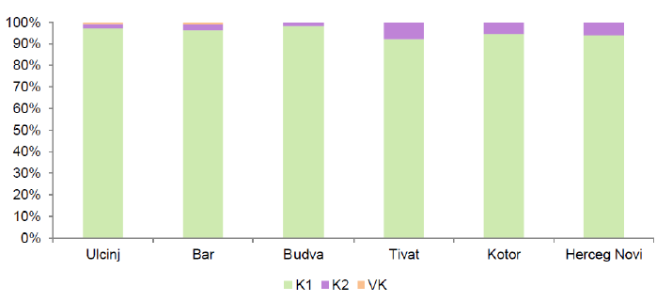
Figure 2.27. Comparative view of quality f sea water in respect to the overall number of taken samples for 2015 per municipalities
Compared data per municipalities show that Municipality Budva had the best quality of sea water in 2015 season where 98.3% samples had K1 water quality, while 1.7% was K2 satisfactory quality and there were no samples which deviated from VK class of set limits. The most frequent deviations of permitted parameters were recorded in municipalities Ulcinj and Bar.
In general, it can be concluded that sea water quality at public beaches over 2015 season was quite satisfactory.
Monitoring of sea ecosystem for 2015 was made for the first 6 months and at reduced number of locations therefore it is not easy to compare the data due to lack of comprehensive monitoring period. Certainly, data analysis for the same period in earlier years shows that the parameter values are at the level of last year’s without major deviations.
All the values of nutrient salts in 2015 including concentration of chlorophyll are expectedly increased in Kotor and Risan bay given that those are semi-closed pools with poor water circulation. Given that winter period is also included in the monitoring period when inflow of nutrients is higher, higher mean values of concentration of nitrates, phosphates and silicates, as well as TRIX index values were detected.
In terms of tested bacteriological parameters, retracted part of the bay (Risan) was under somewhat higher pressure and impact of heavy rainfalls but the number of bacteria was in the limits of permitted values in terms of main faecal indicators.
Tested areas that are mainly susceptible to eutrophication are Dobrota, Kotor, Orahovac. This state is mainly contributed by combined impact of inflow of fresh water and anthropogenic activities. However, somewhat increased values of nutrients in rainy winter period in the bay are expected. Monitoring needs to be continued.
Based on results for the period from January to July, it can be concluded that the density of microplanktons ranged up to 106 cells/l which is increased number typical for eutrophic areas (Kitsiou i Karydis 2001, 2002).
Majority of dominant species are typical for the areas abundant in nutrients (Revelante and Gilmartin 1980, 1985, Pucher-Petković and Marasović 1980), which is consistent with the species classification per their level of preference for eutrophication (Yamada et all. 1980).
These species are indicators of ecosystem state, which can reveal characteristics of one ecosystem. Presence of species that prefer areas abundant in nutrients is indicative of the changes that must be monitored. Toxic species from Dinophysis genus (Dinophysis acuminata, Dacuta and D. caudata, D. fortii) are recorded but still not at large number. However, their presence warns about the danger of their extensive development and negative impact on marine fauna. Toxic dinoflagellates Prorocentrum minimum i Phalacroma rotundatum are also recorded. Further explorations should provide answers to many questions, especially if the changes will have positive or negative effect.
Aimed at determining the trend of pollution, it is necessary to continuously conduct monitoring of the same range, at the same locations and metering periods and to obtain more detailed conclusions in that regard, it takes at least ten years of regular monitoring according to MEDPOL recommendations. Therefore, this report also recommend provision of additional funds for regular annual monitoring, given its importance in regards to monitoring coastal sea ecosystem.
We can say that the obtained data on this segment of environment are within acceptable limits and are not alarming, however, it is necessary to undertake a set of measures for adequate preservation and protection of ecosystem.

2.4.3 Floods
Floods in Montenegro occur primarily due to river hydrology (torrent type), meanders in plains, karst fields, presence of flood plains and conflicts with space limited with agricultural land and infrastructure. Protection from floods and alterations of riverbeds needs to be carefully planned in line with preservation of water ecosystems with great self-treatment capacity.

We stress that the additional risk of floods is caused by inadequately planned development in flood plains and karst fields. Practically all the rivers in Montenegro in their upper course and some along their entire length have torrential character. It means that there are great flow differences of bigger and smaller waters and regular occurrence of torrential waves with substantial concentration of sediments. Approach to addressing the torrent protection issue largely depends on the size of the watercourse. In case of massive torrential courses, protection against waters is achieved with classic measures of regulating the watercourse and defence against floods. In case of smaller torrential courses, the measures are based on complex anti-erosion catchment area regulation. There are great differences in the flow of large and small waters (bigger than 1000:1) and regular occurrence of torrential waves with substantial concentration of deposits. Such characteristic of the main course is not possible without numerous torrential tributaries of short flow and large longitudinal falls with all the conditions for forming devastating torrential waves. Each of the torrential courses endangers roads and settlements.

Railroad Beograd‒Bar (at the territory of Montenegro) is endangered by eight larger torrential watercourses, while larger number of small torrential watercourses descends towards Podgorica‒Nikšić railroad, and 12 torrents cuts through Bijelo Polje-Podgorica arterial road. Adriatic arterial road is a particular problem. Majority of torrential courses from that area has small catchment area but they are numerous. Floods in Montenegro mainly endanger large areas of land at the edge of Skadar Lake in the zone of Morača lower course and next to Bojana River. In addition, floods in Polimlje, from Gusinje to Zaton, at Kolasin and Mojkovac and also in the valley of Ćehotina river near Pljevlja have more relevance. In terms of importance, i.e. the size of damage, floods that occur in larger and smaller karst fields cannot be neglected. In that regard, the most frequent floods occur in Cetinjsko and Nikšićko polje.

Figure 2.28 Shows flood areas in the territory of Montenegro.
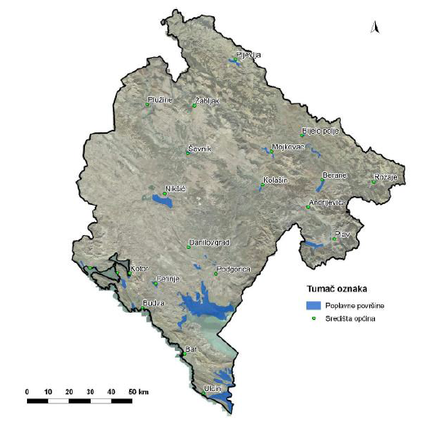

Figure 2.28. Floor areas in Montenegro (Source: Water Management Basis of Republic of Montenegro, Ministry of Agriculture, Forestry and Water Management, 2001)

2.5. Biodiversity and Protected Areas

2.5.1 Biodiversity
Various geological maps, areas, climates and lands, as well as geographic position of Montenegro in the Balkan Peninsula and Adriatic resulted in development of abundant biodiversity. By number of flora and fauna and diversity of ecosystems, Montenegro is one of the leading countries in Europe. Around 20% of the total flora is categorised as endemic and sub-endemic plants.
Because of its rarity and vulnerability, 410 plant and 428 animal species is protected. Ecosystem diversity is reflected in presence of different types of ecosystem, whereby: mountain, forest, grass, freshwater, marine, coastal, karst, cave and canyon. Habitats are populated with many species from nearly all systematic categories; due to lack of surveys, their final number is still unknown. Biodiversity is also very important natural resourse for the economic growth and development.

There are no sufficiently precise and systematised data on the state of ecosystem. The programme of monitoring biodiversity is being conducted for a relatively short period of time (since 2000), in a reduced range and does not provide full assessment of state and trends. Still, based on such limited data, significant pressures were registered as well as examples of degradation. The most endangered ecosystems consist of forest vegetation (due to constant exploitation), then coastal (due to turning of natural habitats into developed spaces) and water ecosystem (due to different forms of pollution and exploitation of gravel and sand which reduced productivity of these ecosystems).

There is increasing pressure on environment of space fragmented due to expansion of construction areas. This in particular affects the biodiversity and the value of landscapes and affects appeal and capacity of agricultural land.

The area of Montenegro contains two main biological-geographical regions: Mediterranean and alpine with different types of ecosystems and habitats.
The carried out analysis of specific ecosystems, habitats and geological formations distinguishes following ecosystems and habitats.

Table 2.5. Ecosystems and habitats

Ecosystems | Mountain | High mountain area of continental part of Montenegro. Dominant mountain peaks: Durmitor (2 523 m), Komovi (2 461 m), Prokletije (2 536 m), Sinjajevina (2 277 m), Bjelasica (2 037 m).  Coastal mountains: Orjen (1 893 m), Lovćen (1 749 m), Rumija (1 586 m)  Main types of habitats: mountain pastures, rocks and cliffs, barren land with rare vegetation and slipstones.
Ecosystems | Forest | These assume the biggest area in surface (54%), while natural forests occupy 45%.
Ecosystems | Grassland | Rare, mainly on alluvial soil (Ćemovsko polje, Karabuško, Tuško and Dinoško polje and lower parts of canyon valley of Cijevna River).
Ekosistemi | Fresh water | Wet habitats mainly in plains and at the littoral.  Skadar Lake (the biggest lake, great biodiversity ‒ presence of a large number of relicts and endemic species is particularly important);  Šasko Lake;  Cold high-mountain glacial lakes in the north of Montenegro, in particular within national parks “Durmitor”, “Biogradska gora” and “Prokletije”.
Ekosistemi | Marine | Over 300 types of algae, 40 types of sponge, 150 types of crustaceans, 340 types of mollusc, 400 types of fish, 3 types of sea turtles and 4 types of dolphins.  Boka Kotorska Bay and Bojana Delta distinguish by importance of biodiversity.
Staništa | Coastal | Sea coastline is 313 km long;  Rocky shores (cliffs), natural sandy beaches and eight smaller islands;  Velika ulcinjska beach / the Long Beach ‒ sandy dunes host unique halophyte / saline vegetation;  Southern slopes of marine mountains contain typical Mediterranean vegetation macchia and garigue;  Lower terrains and the shore ‒ saline vegetation as well as cultivated land (olive groves and orchards);  Tivat Salt Pans and Ulcinjska Salt Pans ‒ important for stay and wintering of wetland birds.
Staništa | Caves | Lipska Cave, Đalovica Cave;  Some of the deepest pits in the Balkan (Pit at Vjetrenim brdima and Durmitor, Duboki do on Lovćen).
Staništa | Canyons | Part is under the impact of the Mediterranean climate (Morača and Cijevna Canyons);  Part is under the impact of cold continental climate (Tara River Canyon, Remains of Piva and Komarnica Canyon, gorges like Ibarska, Tifransa and Đalovića).
Staništa | Karst (specific geological formation) | At heights above 1000 masl – typical vegetation are bushes.
Priority habitats: negative consequences are mainly present in water and forest ecosystems
Algae | Freshwater algae | So far, 1200 species and varieties were described, with groups of silicate (Bacillariophyta) and green algae as predominant.  Dominant species in the north are oligotrophic freshwater ecosystems with relatively small number of species.  The south is mainly habituated by mycotrophic and eutrophic ecosystems with bigger number of species.  The most significant location is Skadar Lake (endemic species Cyclotela skadariensis).
Alge |  | Other significant locations: the Black Lake, Bukumirsko, Ridsko, Plavsko, Zminje, Šasko, Veliko i Malo stabanjsko lake as well as artificial Krupačko Lake
Alge | Sea algae | Over 300 species of macroalgae of which majority are red algae (Rhodophyta).  Majority of species is widely distributed in the Adriatic and Mediterranean Sea.
Moss and lichen | Moss | At present there are 589 species (research are limited, so the actual number is probably bigger);  The majority of species related to forests of beech, hornbeam, oak and maple. Amount of species reduces with the increase in altitude, and thus forest ecosystems;  These are related to water courses and peat bogue (Barno Lake, Prokletije).
Moss and lichen | Lichen | 693 species were registered.
Vascular flora |  | Around 3.250 described species, mainly within families Asteraceae, Poaceae, Fabaceae and Caryophyllaceae.  High mountainous flora has great importance.  Centres of vascular flora biodiversity: Durmitor with Bioče and canyons Tara, Piva and Sušica; Bjelasica, Komovi and Prokletije with Visitor, Žijova and Hum Orahovski, Cijevna River canyon, Mortvica Canyon; Skadarsko Lake and northern slopes of Mt. Rumija.  Centres for endemism of vascular plants: Prokletije massif, Moračke Mountains, Bjelasica and Komovi.
Fungi |  | Around 2000 species of fungi.
Invertebrates | Land and fresh water invertebrates | Poorly explored group, mainly approximate comprehensive registries.  Many species are relict, especially from the Tertiary (Congeria kusceri‒sole known underground shell).  Important caves: Lipska cave (endemic genus of amphipods Typhlogammarus, endemic species of snails and copepods), Babotuša cave near Trnovo (endemic species of copepods, harvesters (Opiliones) and beetle, Obodska cave (endemic species of beetles, amphipods and snails) and Magara, cave near Podgorica (endemic species of beetles and harvesters).
Invertebrates | Sea invertebrates | Great number of species, small degree of endemism.  Poorly explored group.
Fish | Freshwater fish | In the area of the Adriatic Bay, around 60 species were registered, and in the area of the Black Sea around 30 (different due to geological past).  Salmonidae species are typical for fast mountain rivers (with a few Cyprinidae species).  Cyprinidae specias prevail in moderately fast rivers (with lower presence of Salmonidae species), and also in still rivers.
Fish |  | Skadar Lake is one of the most significant areas populated by freshwater fish, where over 40 species of fish is registered, including species that migrate from the marine into freshwater ecosystem.
Fish | Sea fish | Around 400 species within 117 families were recorded;  Habitats that have the most fish species are cliffs and reefs in the coastal zones near the shore;  Sandy bottoms, such as that at Bojana River delta have relatively low number of fish species, even though Posidonia meadows, shallow water glass, is significant spawning point.
Reptiles and amphibian |  | 18 species of amphibian and 38 species of reptiles as well as 69 sub-species are known.  Amphibian and reptiles biodiversity centres: littoral region of Montenegro and its hinterland, Skadar Lake, Lovcen (water habitats) and Prokletije (Bukumirsko and Ridsko lakes).  Other significant locations: Pošćenska Lakes, Komarnica Canyon, from Skakavice to below Duži village, Zminičko Lake, part of Tara River Canyon (Ćelije‒Borovi), Kotor‒Risan Bay, Platamuni, Katic Islan, Cijevna River Canyon, Ćemovsko polje, Buljarica, Mrtvice Canyon, Ada Bojana, Mala River Canyon, Rumija, Tivat Salt pans.
Birds |  | It is assumed that Montenegro regularly hosts 333 species of which 204 are nesting birds.  Magnitude of the species, including many predators, forest and marshland species; it is a significant habitat for a set of rare and endangered species of ornithofauna, including Dalmatian pelican, Pelecanus crispus and the pygmy cormorant, Phalacrocorax pygmeus;  Large migration corridor;  Centres of birds biodiversity: Skadar Lake and Ulcinj area, mountainous massif of Prokletije and Durmitor;  Other significant locations of birds include: Buljarica, Velika plaza, Ada Bojana, Tivat and Uclinj Salt pans, Šasko Lake in the Mediterranean region, meadows and flooded marshlands along Bojana River and further in the inside Durmitor, Bjelasica, Komovi and Pive Canyon, Tara, Morača and Cijevna, Maglić and Prokletije.
Mammals |  | Wealthy fauna of mamals, however, the data on the number and the size of the population are not systematised;  The biggest number of species appears in the forested mountainous area;  Mammals biodiversity centres: Durmitor Mountain massif, Sinjajevina, west part of Prokletije, Komovi and Bjelasica; lower concentration in east part of Prokletije, central parts of Montenegro, northern parts of Boka and Orijen and littoral Dinarides (Lovćen, Rumija with Skadar Lake).

Because of its geographical position, distribution and heterogeneity of habitats, terrain topography, geological past and climate variations is characterised by great diversity of species.
Montenegro contains numerous areas of international importance with rare, endemic and endangered species including 13 IBA areas, significant for birds staying (in addition to seven potential IBA areas) and 22 IPA areas (plant important areas).
Table 2.6. Areas of International Importance
Type of area of international importance | Location
IBA areas | Bojana River delta, Rumija Mountain, Skadarsko Lake, Plavsko Lake with flooded areas, Tivat Salt Pans, Ćemovsko field, Prokletije mountain chain, accumulation lakes at Nikšića, Hajla Mountain, Biogradska Gora, Durmitor, Cijevna Canyon, Zeta River valley*, Kučke Mountains*, Visitorske Mountains*, Komovi*, Golija*, Pivske Mountains*, Mt. Ljubišnja*.
IPA areas | Jerinja glava, Lukavica, Trebjesa, Starac, Bogićevica, Visitor, Hajla, Orjen, Lovćen, Rumija, Babji zub (Mt. Sinjajevina), Komovi, Durmitor, Biogradska gora, Skadar Lake, Velika plaža in Ulcinj, Piva, Tara, Komarnica, Mrtvica, Cijevna and Lim Rivers Canyons.
* potentially significant sites

Law on Nature Protection ensures putting under protection endemic, rare and endangered flora and fauna species. Special Resolution on putting certain flora and fauna species (O.G. MNE 76/06) put 873 species under protection.
Table 2.7. Number of protected species per registry
Group | Number of protected species | Group | Number of protected species
Fern | 2 | Mammals | 35
Senior plants | 272 | Birds | 298
Algae | 6 | Reptiles | 26
Moss | 27 | Amphibian | 16
Fungi | 111 | Fish | 11
Corals | 7 | Mollusc | 18
Sponge | 9 | Beetle | 14
Annelid | 6 | Arachnids | 5
Echinoderm | 6 | Crustaceans | 4
Source: O.G. MNE 76/06
Nearly all mountainous areas in Montenegro can be regarded as epicentres of vascular flora diversity (in particular Durmitor, Prokletije Massif and littoral mountains Orjen, Lovcen and Rumia). Regions with 1200 to 1400 taxon (species and subspecies) are: Durmitor with Bioče, including Tara, Piva and Sušica canyons; Bjelasica, Komovi and Prokletije with Visitor, Žijovo, Hum orahovski, canyons of rivers Cijevna and Mrtvice; Skadarsko Lake with northern slopes of Mt. Rumija. The area of Prokletije Massif, Moracke Mountains, Bjelasica and Komovi is recognised as the epicentre of endemic vascular flora.
The most important centres of biodiversity of birds are areas of Skadar Lake and Ulcinj, as well as mountainous areas of Durmitor and Prokletije. Centres of diversity of mammals are mountainous area of Durmitor, Sinjajevina, west side of Prokletije, Komovi and Bjelasica, with lower concentration of species on east side of Prokletije, northern parts of Boka Kotorska Bay and Orjen and littoral Dinarides (Lovćen and Rumija, with Skadar Lake).
Littoral part of Montenegro with the hinterland, Skadarsko Lake, Lovcen and Prokletije are considered to be the most important centres of diversity of reptiles and amphibian in the Balkan and Europe.
According to available date at the very area of Montenegrin Littoral are 1540 plant species, 113 lichen, 283 moss, 232 fungi, 289 invertebrates, 29 representatives of ichthyofauna, 18 amphibian, 38 reptiles, 249 birds and 69 mammals. Based on zoographic characteristics, fauna of Montenegrin littoral distinguishes cosmopolitan species – widely distributed throughout the world; Holarctic species – that populate north hemisphere; Palearctic species – that populate Europe, Asoa and North Africa; Mediterranean species – which can be regarded as Mediterranean endems and endemic species- that populate more or less limited space (east/west Mediterranean endems, Adriatic, Balkan, Dinarides, Montenegrin…).
One of the most significant biodiversity areas is Lovcen, which is specific by the number of endemic and relict species. The area of Lovcen hosts 1158 plant species, which are included in 476 genuses and 95 families (Tomić–Stanković, 1970), of that number, 12 taxsons are new for this area. In terms of endemic and rare species of plants, following are found in this area: Silene tommasini, Lamium lovcenikum, Crepis pantocsekii, Micromeria dalmatica, Micromeria parviflora, Amphoricarpus neumayeri, Silene reichenbachii, Hieracium waldsteinii, Lilium cattaniae, Saxifraga federici augusti. Lovćen fauna is characterised by the presence of a large number of amphibian and reptiles. So fare 16 taxons were recistered in these areas. Majority is under constant protection and are protected by national legislation of Montenegro. There is strong presence of endemic and relict species such as Sorex minutus, Lacerta mosorensis, L. oxycephala, Natrix n. Persa, Podarcis muralis, Podarcis melisellensis and such. (Đukić, 1995) .
Karst area in Montenegro is usually found at altitudes from 1000m, even higher up to 1900 meters (Mt. Orjen, 1894 m), as the biggest mountain massif between the coastal cretaceous chains. Vegetation consists of: shrubbery and bushes, and green vegetation (with large plains with common sage (Salvia officinalis)) is mainly poor, but has many endemic forms. Reptiles are the most typical animals for the karst area characterised by a high degree of endemicity. This area also contains specific ornitofauna.
Karst biodiversity is not substantial, therefore it is not possible to present actual state assessment.
Montenegrin part of south-east Dinarides is in the northern region and is part of a large biocorridor of southeast Dinarides (Dinarides arch) that goes from the Alps to Prokletije and Sarp-Pandor Massif. In the area of Prokletije, this bio-corridor is also connected with a great biocorridor called “The Green Belt”. Because of specificity of the usage regime of this zone in the past, it became important biodiversity corridor. Well known coastal mountains corridor Orjen – Lovćen – Rumija is connected with this corridor. Most of ecosystem is included in two primary ecological corridors. The third corridor is established in direction Orjen‒Pusti Lisac‒Maganik–Sinjajevina–Kovren.
Secondary corridors, that distinguish functional units, improve natural resilience of the ecosystem to negative effects of human activities.
Agro-ecosystem of Montenegro also has special importance. Biodiversity and ecosystem services contribute to social-economic development and wellbeing of people in various ways. In Montenegro, they are the most important factors for preservation of quality of water resources. Certain ecosystems, such as swamp habitats along the northern shore of Skadar Lake or along the shores of rivers, filter and prevent different forms of pollution from reaching water ecosystems. In addition to wetland, forest ecosystems in the catchment area also perform that function and they also affect the reserves of fresh water and thus contribute to its availability for usage. They also contribute to protection against natural hazards such as floods and erosions and modify climate. Simultaneously, they contribute to food production (fishing, forging edible wild species, land fertility, agro-ecosystems play important role in recreation and maintenance of land appeal –important for tourism development.

2.5.2 Protected areas
National network of protected areas currently covers 12.8% territory. There are only 8.6% protected areas onshore compared to the area of the coastal area, i.e. 0% protected areas offshore.
Existing protected natural assets include five national parks: NP Biogradska gora, NP Durmitor, NP Lovćen, NP Skadar Lake and NP Prokletije, special nature reservoir (Tivat salt pans), various nature monuments, various landscapes with special natural features as well as the area of Kotor-Risan Bay with the town of Kotor.

Table 2.8. Protected areas

Names of national categories | IUCN  Category | Area  [ha] | Year of establishing protection
National parks
NP "Skadarsko jezero" | II | 40.000 | 1983, amendments 1991.
NP "Lovćen" | II | 6.400 | 195., 1978, amendments 1991.
NP "Durmitor" | II | 31.200 | 1952, 1978, amendments 1991.
NP "Biogradska gora" | II | 5.400 | 1952, 1978, amendments 1991.
NP "Prokletije" | II | 21.000 | 2007.
Regional nature parks
Piva | V | 32.471 | 2011.
Komovi | V |  | 2012.
Nature monuments
Đalovića gorge | III/V | 1.600 | Res. No. 01-959 12. 12. 1968.
Lipska cave | III/V |  | Res. No. 01-959 12. 12. 1968.
Magara Cave | III/V |  | Res. No.01-959 12. 12. 1968.
Globočica Cave | III/V |  | Res. No.01-959 12. 12. 1968.
Spila Cave at Trnovo/Virpazar | III/V |  | Res. No.01-959 12. 12. 1968.
Babatuša Cave | III/V |  | Res. No.01-959 12. 12. 1968.
Novakovića Cave at Tomaševo | III/V |  | Res. No.01-959 12. 12. 1968.
Duboki do Pit in Njeguši | III/V |  | Res. No.01-959 12. 12. 1968.
Piva River Canyon | III/V | 1.700 | 1969
Komarnica River Canyon | III/V | 2300 | 1969
Tare River Canyon | III |  | Rk.br.01-172 01. 05. 1967.
Community of pine trees “krivulja” (Pinetum mughi montenegrinum) on Ljubišnja | III/V | 1.000
Community of pine trees “krivulja” (Pinetum mughi montenegrinum) on Durmitor | III/V | 5.200
Zajdnica bora krivulja (Pinetum mughi montenegrinum) na Bjelasici | III/V | 400
Communities of pine trees “munika” (Pinus heldraichii) on Orjen | III/V | 300
Communities of pine trees “munika” (Pinus heldraichii) on Lovćen | III/V | 300
Communities of pine trees “munika” (Pinus heldreichii) on Rumija | III/V | 100
Skadar Lake beaches | III/V |  | Res. No. 01-959 12. 12. 1968.
Long Ulcinj beach | III/V | 600 | Res. No. 01-959 12. 12. 1968.
Small Ulcinj beach | III/V | 1,5 | Res. No. 01-959 12. 12. 1968.
Valdanos beach | III/V | 3 | Res. No. 01-959 12. 12. 1968.
Veliki pijesak beach | III/V | 0,5 | Res. No. 01-959 12. 12. 1968.
Topolica beach, Bar | III/V | 2 | Res. No. 01-959 12. 12. 1968.
Sutomore beach | III/V | 4 | Res. No. 01-959 12. 12. 1968, 2011.
Lučice beach, Petrovac | III/V | 0,9 | Res. No. 01-959 12. 12. 1968.
Čanj beach | III/V | 3,5 | Res. No. 01-959 12. 12. 1968.
Pećin beach | III/V | 1,5 | Res. No. 01-959 12. 12. 1968.
Buljarica beach | III/V | 4 | Res. No. 01-959 12. 12. 1968.
Petrovac beach | III/V | 1,5 | Res. No. 01-959 12. 12. 1968, 2011.
Drobni pijesak beach | III/V | 1 | Res. No. 01-959 12. 12. 1968.
Sveti Stefan beach | III/V | 4 | Res. No. 01-959 12. 12. 1968.
Miločer beach | III/V | 1 | Res. No. 01-959 12. 12. 1968.
Bečići beach | III/V | 5 | Res. No. 01-959 12. 12. 1968, 2011.
Slovenska beach, Budva | III/V | 4 | Res. No. 01-959 12. 12. 1968, 2011.
Mogren beach | III/V | 2 | Res. No. 01-959 12. 12. 1968.
Jaz beach | III/V | 4 | Res. No. 01-959 12. 12. 1968, 2011.
Pržno beach | III/V | 2 | Res. No. 01-959 12. 12. 1968.
Savinska Dubrava, Herceg Novi | III/V | 35,46 | Res. No.01-307 22. 05.1968. Res. No.01-760 27. 06. 2000, 2014.
Botanical reservoir of laurus and oleander above Sopot sprong near Risan | III/V | 40
Botanical garden of mountain flora in Kolašinu | III/V | 0,64 | Res. No.01-78 21. 08. 1994.
Botanical garden of general Kovačević in Grahovo | III/V | 0,93 | Res. No.01-574/2 12. 06. 2000.
Park "13 jul" and "Njegošev park" in Cetinje | III/V | 7,83 | Res. No.01-300 28. 04. 1965. Res. No.01-298 07. 05. 1965.
Park at Hotel “Boka” in Herceg Novi | III/V | 1,2 | Rj. br. 01-299 28. 04. 1965.
Town park in Tivat | III/V | 3 | Res. No. 01-959 12. 12. 1968.
Park of the Castle in Toplica | III/V | 2 | Res. No.01-959 12. 12. 1968.
Plavsko Lake |  |  | 2007.
Special natural areas
Spas Hill above Budva | III | 131 | Res. No.01-959 12. 12. 1968, 2009.
Ratac Peninsula with Žukotrlica | III | 30 | Res. No.01-959 12. 12. 1968.
Old Ulcinj Island | III | 2,5 | Res. No.01-959 12. 12. 1968.
Trebjesa Hill, Nikšić | III | 159
Other areas ‒ municipal resolutions
Kotor-Risan Bay, Municipality Kotor | III | 15.000
Nature reservoirs:
NP “Skadar Lake”: Monastery property, Pančeva oka, Crni žar, Grmožur, Omerova gorica |  | 1.420 | Res. No.01-959 12. 12. 1968.
NP “Prokletije”: Hridsko Lake, Volušnica and Visitor |  |  | 2007.
NP “Durmitor”: Crna poda |  | 180 | 1952, 1978, amendments 1991.
Tivat salt pans | III | 150 | Res. No.01-12/2 12. 11. 2008.

As previously said, national network for protected areas covers around 12.8% territory of Montenegro, thus realising objectives of NSOR 2007 and National Biodiversity Strategies from 2010 of 10% share of protected areas of the overall area of the country. At the same time, this exceed the target value of indicator which refers to increased level of protected areas for the purpose of preservation of biological diversity, which is within the seventh Millennium development goal on providing sustainability of environment. In 2015, Regional Park Piva (Maglić, Volujak, Bioč), covering area of 32.471,2 ha, or 2.35% of the territory and Regional Park Komovi, partial territory of 13.232 km² were declared. Initial steps were taken to establish eco-network for the purpose of preservation of significant types of habitats, whereby referring to the importance for the EU network of habitats of interest for protection at European level (Natura 2000), and for Montenegro. It was planned to establish Natural Park Dragišnica and Komarnica, which will include Nevidio Canyon area 2.570,5 ha, or around 0,2% of the total territory of Montenegro. National Sustainable Development Strategy from 2007 and other strategic and planning documents confirm declaration of offshore protected areas. These areas have not yet been established but basic surveys were carried out for a large number of offshore sites.

Internationally protected nature areas are:
- Tara River Basin (World Biosphere Reservoir, declared in 1976),
- National Park „Durmitor“ (UNESCO World Heritage List, declared in 1980),
- Skadar Lake (Ramsar area, swamp bird habitat, declared in 1995),
- Tivat Salt Pans (Ramsar Area, swamp bird habitat, declared in 2013).
- Kotor-Risan Bay area protected as natural and cultural historic heritage (UNESCO World Heritage List, declared in 1979).

Planned protected natural resources
Spatial Plan of Montenegro (2008), National Biodiversity Strategy with Action Plan for the period 2010-2015, National Sustainable Development Strategy by 2030, and other local strategic and planning documents plan to place under protection new areas of nature. According to the draft of National Sustainable Development Strategy by 2030 (NSOR), activities for increase in the area of network of protected natural resources are ongoing.
Areas planned for protection of the coastal area of Montenegro are:
National Park – Orjen,
Regional Park – Rumija, brdo Vrmac,
Nature monument: Ada Bojana, Šasko Lake, Ulcinj Salt Pans with knete, Morinjski Bay,
Marine protected natural resources – sites: Luštica (from Mamule to Mačka cape); zone from Trašte cape to Platamuni (with a narrow zone of strict protection from Žukovac Cape to Kostovica); wider zone of Katič Island; zone from Volujica cape to Dobre vode cape; zone from Komina cape to cape at Stari Ulcinj cape; zone from Valdanos Bay to Velika Bay; Seka Đerane with southern part of zone in front of Velika plaža to Bojana River mouth,
Special natural landscape: Koštanjica (autochthonous habitats of chestnut and laurels Lauro-Castanetum sativae),
Individual dendrologic units: black poplar tree (Populus nigra L).

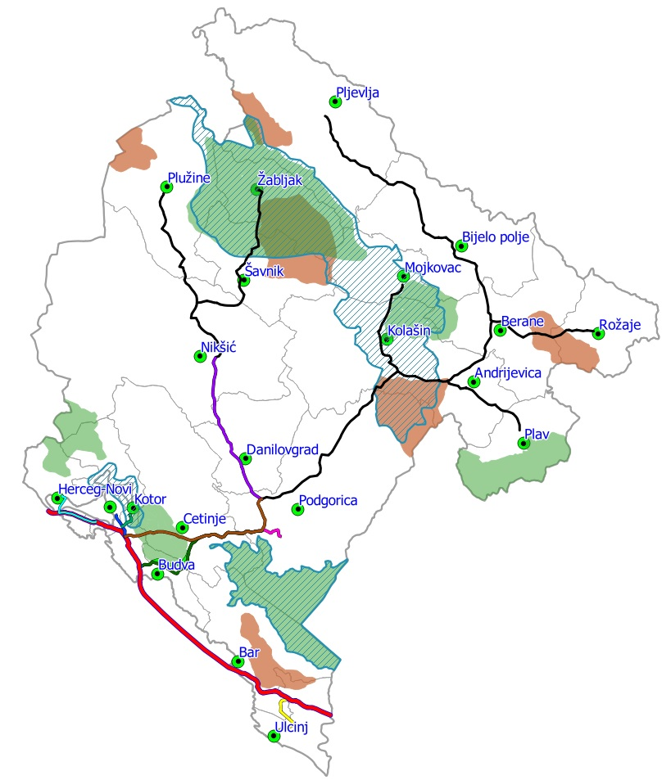
Figure 2.29. Protected areas of Montenegro

Ecologically significant / sensitive areas
Activities on establishing Natural 2000 network commenced in 2009 through cooperation between WWF, Nature Protection Institute of Montenegro (which in 2012 became part of the Environmental Protection Agency) and Daphne Institute for Applied Ecology. The project activities resulted in draft of relevant habitats and Natural 2000 species list in Montenegro, with the usage of earlier knowledge from the project for the identification of EMERAL network and based on the analysis of existing data. Draft of Natural 2000 habitats for Montenegro was prepared which was used for the first training for making field inventory and mapping earlier identified Natura 2000 habitats. Despite assumed activities, results did not ensure full identification and mapping of Natura 2000 sites.
Zones of existing and planned protected natural resources greatly overlap the EMERALD area zones which include ecologically significant habitats and types from resolutions 4 and 6 of Bern Convention.
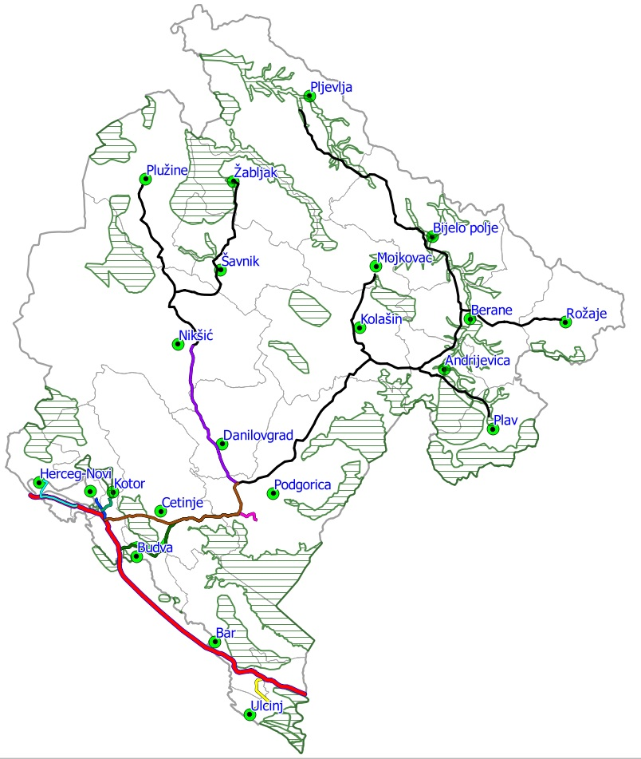
Figure 2.30. Emerald areas of Montenegro

2.6. Population

According to 2011 Census, Montenegro had total of 620 029 residents, of which, around third lives in the Capital, Podgorica. This is 1.3% higher than in 2003 when the previous Census was carried out. Of the total population, majority lives in the Central Region ‒ 293.509 (47,3%), followed by Northern Region ‒ 177.837 (28,7%), while the Coastal region had the lowest population ‒ 148.683 (24,0%).

According to available data, population in Montenegro increased for about 63% over the course between 1948 and 1991. Increase in the number of residents varies per regions; northern region of Montenegro records the lowest increase while population doubled in the middle and the coastal region. In general, number of residents at the state level mostly increased in the course from 1991 to 2011. According to data from the Census (2011), 444.049 residents lives within the boundary area. Mean population density within the boundary area (Coastal and middle region) is 67.48 residents/km2. The biggest density is recorded in the Coastal Region (Municipality of Tivat 307.64 residents/km2). For comparison, population density in Municipality Savnik in the Northern region is 3.89 residents/km2. In the area of Montenegro, internal migrations of population are one of more significant processes. The Coastal and Middle regions are areas of intensive immigration of population from the northern parts of the country.

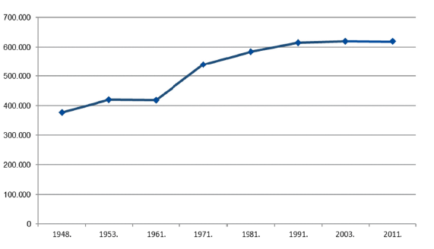

Figure 2.31. Number of residents in Montenegro over the course of 1948–2011

2.7. Cultural Heritage and Landscape

Montenegro has rich cultural heritage and diverse landscapes. Relatively small in size, cultural space of Montenegro formed through history under the impact of different civilisations and cultures. Diversity of immovable cultural heritage and rich museum, archive and library funds, are material evidences of specificity of cultural milieu of Montenegro.

With their wealth, diversity, historical representation and preservation, movable and immovable cultural heritage, as well as non-material cultural heritage (way of life, customs, beliefs, relationship towards the world and nature, spiritual values and such) at the territory of Montenegro, is insufficiently used development potential. Support to cultural heritage is still to a certain point seen as budgetary expense – true understanding of importance of its role in modern society and possibilities for its adequate valorisation are still missing. Such approach unfortunately is reflected in all the elements of cultural heritage protection system and cultural heritage management.

Cultural assets, as valorised part of cultural heritage of general interest, are protected in line with national legislation and international regulations. The Registry of Cultural Assets which Montenegro kept from 1961 to 2015 contains 1.900 cultural assets. The registry was carried out after the Montenegrin cultural assets revalorisation procedure.

2.8. Noise and Vibration

In line with the Law on Protection Against Environmental Noise ("Official Gazette of MNE", No. 28/11 of 10.06.2011, 28/12 of 05.06.2012, 01/14 of 09.01.2014), environmental noise is undesirable and harmful noise in the open space caused by human activity, including noise that results from road, railroad and air transportation and from industrial facilities for which an integrated permit is issued. Rulebook on limit noise values in environmental, determining noise incubators and acoustic zones and methods for assessing adverse noise effects (Official Gazette of MNE, No. 60/11) was prepared based on this Law.

Based on the above referred legislative regulations, the municipalities passed Resolution on acoustic zoning of their territories, which is basic condition for implantation of the Rulebook on limit environmental noise values, manner of determining noise indicators and acoustic zones and methods of assessing adverse noise impacts.
Through determination of acoustic zones, limit values for defined parts of municipal territories were set which is important for protection against environmental noise and for future planning of construction of structures and issuance of work permits to hospitality and other structures. Table 2.9 shows limit values of noise set out in the Rulebook.
Table 2.9. Limit values of noise in acoustic zones
Acoustic Zone |  | Noise level in dB(A)
 |  | L_{day} | L_{evenig} | L_{night}
1. | Silent zone in nature | 35 | 35 | 30
2. | Silent zone in agglomeration | 40 | 40 | 35
3. | Zone of elevated noise protection regime | 50 | 50 | 40
4. | Residential zone | 55 | 55 | 45
5. | Mixed use zone | 60 | 60 | 50
6. | Zones under the impact of traffic noise | L_{day} | L_{evenig} | L_{night}
6a. | Zones under heavy impact of air-traffic noise | 55 | 55 | 50
6b. | Zones under heavy impact of road traffic noise | 60 | 60 | 55
6c. | Zones under heavy impact of railroad traffic noise | 65 | 65 | 60
7. | Industrial zone | At the boundary of this zone, noise must not exceed limit values of noise level in the zone it adjoins to
8. | Zone of mineral raw materials exploitation | At the boundary of this zone, noise must not exceed limit values of noise level in the zone it adjoins to

Values indicated in this table refer to the overall noise level from all the sources in the acoustic zone. In the areas of delineation of acoustic zones, noise level in each acoustic zone must not exceed the lowest limit value set for the zone it adjoins to. Value of indicators presented in this table (L_{day}, L_{evening}, L_{night}) are mean daily values.
Environmental Noise Monitoring
Environmental noise monitoring in Montenegro has been performed in line with the Environmental Noise Monitoring Programme for 2015 in: Ulcinj, Podgorica, Budva, Petrovac, Kotor, Žabljak, Nikšić, Bijelo Polje, Berane, Kolašin and Mojkovac. Table 2.10 shows exact locations where noise was measured in specified municipalities.

Table 2.10. Metering points
Town | Metering point
Ulcinj | Bulevar 26.novembra bb, individual commercial building of Hypo Alpe Adria Bank, I floor
Podgorica | Stari Aerodrom, street Aerodromska 1, residential building, I floor I Proleterske brigade 33, mini roundabout, individual residential building, I floor
Budva | Jadranski put bb, residential building “Bogetića”, I floor
Petrovac | building “Crvena komuna”, Obala bb, joint commercial building, I floor
Kotor | The Old Town, the building of the Marine Museum, Square of Boka Navy 391, I floor
Žabljak | Vuka Karadžića 27, residential building, I floor
Nikšić | PHI General Hospital, plateau above the entrance doors
Bijelo Polje | Živka Žižića 30, residential building, I floor
Berane | centre, Dušana Vujoševića 5, commercial building, I floor
Kolašin | Palih Partizanki 8, residential building, I floor
Mojkovac | centre, Filipa Žurića 1, residential building, II floor

Each measuring over a day for a period of 24 hours was divided into daily, evening and night measuring in line with statutory defined measuring slots.
Lden – total indicator of noise during day, evening and night;
Lday – indicator of daytime noise level between 7 a.m. and 19 p.m.;
Levening – indicator of evening noise level between 19 p.m. and 23 p.m.;
Lnight – indicator of night-time noise level between 23 p.m. and 7 a.m.

Measuring was carried out over two cyclises: the first cycles was during summer and the second was in autumn/winter period of the year.
For the purpose of zoning, planning soundproofing and assessment of noise disturbance in settlements, systematic measuring of noise pressure level and defining of its time-dependence at selected metering sights was carried out per settlement zones of indicated territories

Based on the analysis of measuring results in regards to division of municipal territory to acoustic zones, following can be concluded:

Mixed zone – out of 6 metering points that belong to the mixed zone, out of 36 noise level indicators in both cyclises, 25 noise level indicators did not exceed limit values (69%), while 11 noise level indicators exceeded limit values (31%).

Zone under heavy road traffic noise impact – out of 4 metering points, of total of 24 noise indicators in both cyclises, not all 24 meet limit values (100%).

Residential zone – at metering points that belong to residential zone, of the total of six noise indicators in both cyclises, 4 do not exceed limit value (67%), while the other 2 indicators of noise level exceed limit value (33%).
Zone of increased noise protection regime – none of the 6 noise indicators meet limit values.

2.9. Human Health

Healthy population is the most important resource a country and all its development segments given that it contributes to the overall social and economic progress. Therefore, health requires full attention and engagement of all social sectors to create conditions for its preservation and enhancement. Principles of solidarity, universality, equality, availability and quality make bases for development of sustainable and integrated health care system with citizen in the centre. These principles are at the same time bearers of socially oriented European healthcare system, which Montenegro strives to, given it is a country in the process of accession to EU. Health pokicy defines following general objectives: life extension, improved quality of life in terms of health, reduced health risk and financial risk insurance. According to Eurostat data for 2013, expected life duration at birth for Montenegro was 74.1 years for men and 79.0 years for women, which is lower than EU average of 77.8 years for men and 83.3 years for women. New-born mortality rate, which is an important indicator of population health state and level of healthcare development, but also indicator of the overall social-economic development, was 4.3 (at 1.000 new-borns) in 2015, according to Worl Bank data. Though this rate is amongst the lowest in the region, it is still high compared with EU average (3.7). According to data from the same source, mortality rate amoungst children up to five yers of age, it was 4.7 (at 1.000 new-born children) in 2015 which is also higher than EU average (4.4). Data on maternal mortality for the period 2002-2012 show that there was only one death case related to pregnancy, birth and post-birth period (2007).
Reigstered demographic trend of population aging shows the need for the population of the old in Montenegro to be regarded as important human and important resource, which entails efforts that can contribute to further development of the entire society.

Most frequent cause of getting sick, handicapped or early deaths are chronic non-infectious diseases that are the main reason for large number of potentially lost years of life. According to available data on dying in Montenegro for the period 2008-2012, share of chronic non-infectious diseases in overall death causes is as high as 80% of which over 60% are blood vessel diseases and tumours. Nearly half of the total number of the deceased (44.3%) death was caused by hearth and blood vessel diseases and nearly one fourth of deaths (23.4%) were cause by maligns tumours. In more than 10% cases, death cause was unknown (symptoms, signs and pathological clinical and laboratory results). Ischemia hearth diseases, cerebral vascular diseases, lung cancer, affective disturbances (unipolar depression) and diabetes are chronically non-contagious disease that are responsible for nearly two thirds of total disease burden. According to data on hospital treatment in 2013, blood vessel diseases where in the first place in the structure of morbidity per hospital discharge lists (15.2%), while the second in line reason for hospitalisation were tumours (11,8%).20 Respiratory system diseases where in the fourth place (11.4%) that year, and digestion system diseases in fourth (10,4%). Next year, in 2014, hospitalisation rate was 134.2 per 1000 residents. From 2013, chronic non-contagious diseases registries are established in Montenegro, whereby: malignant neoplasm, diabetes, acute coronary syndrome and cerebral vascular diseases. More complete data, that will include total number of those affected by the referred diseases, are expected in the upcoming period as well as indicators which will be generated based on the registry.

In addition to the referred, it needs to be stressed that so far comprehensive surveys which would qualitatively and quantitatively determine interdependence of pollution impacts and health state of population have not been carried out.

2.10. Economic activities

2.10.1 Agriculture
Agricultural development is important for multiple reasons and is important for: providing stable and quality food supply, reduction of trade deficit, improvement of development of other sectors (such as tourism), creates conditions for better quality of life in villages and such.

MONSTAT data show that the share of agriculture and rural development in the GDP is 8% (2014), and that in this sector 48.870 estates employ 98.341 persons for who agriculture is either basic or complementary occupation. Total available land of agricultural estates was 309.240 ha and accounts for 22.8% Montenegrin territory. Multiannual meadows and pastures have the biggest share in agricultural land (223.131 ha or 72,15% of total available land), while the share of farmable land in the segment of used land is only 5.6 % (used courtyards, used farmed land, vineyards, orchards, plantations, and extensive and plant nurseries. Due to insufficient supply of domestic food, large amount of food products is being imported.

2.10.2 Forestry and Hunting

Forestry
By the degree of forestation, Montenegro is at the top scale amongst European countries. The forest covers 59.9% or 826.782 ha of the territory, while forest land covers 9.8% or 137.480 ha. This reaches targeted value determined within seventh millennium development goal, which refers to reaching environmental sustainability, i.e. share of land covered in forests (54%). Natural expansion of forest is evident in Montenegro and not just as result of artificial forestation but spontaneous spreading of forest vegetation at the account of agricultural land. However, data on the state of forests are incomplete because adequate monitoring and on-site changes control system has not been established. For example, monitoring and control of forest management is carried out on a ten-year programmes, while the Agenda requires the state to be updated every five years. However, it can be estimated that so far major forest cutting has been avoided, but certain forest areas were degraded or impoverished with unsustainable planning of tree felling and/or illegal felling.

The forests are affected by climate changes and increased risks of draughts, fires and biotic vermin, and this trend is expected to continue. Forest ecosystems are very vulnerable to climate changes impact, and on the other hand they have exceptional potential from the aspect of absorption of CO2. Risk of forest fires is extremely great. In the past 15 years, more than 1.500 fires were registered, which damaged or destroyed nearly 1.3 million m³ of wood mass, reduced biodiversity and resistance of forests, affected authenticity of landscape and increased the risk of erosion.
In addition, despite the increased demand in wood mass and wood products, forests continue to have key role in preservation of Montenegro’s biocapacity given that they account of 75% of the overall country’s biocapacity.

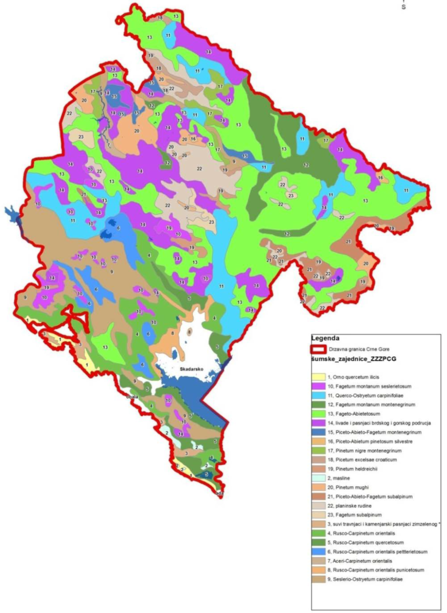

Figure 2.32. Forest communities

Hunting
Passing of Programme of Hunting Development in Montenegro for the period 2014-2024 was aimed at development of comprehensive and realistic insight in present state and adopted development directions, consideration of biological, economic, organisational and personnel opportunities for preservation and improvement of game population, primarily breeding of large and small game at 1.285.991 ha hunting ground area, in Montenegro, and in that way to plan management, development and enhancement of hunting in Montenegro for a period of 10 years.

Table 2.11. Hunting grounds in Montenegro

Hunting ground name | Area  (ha) | Name and seat of the hunting ground user
Mediterranean hunting area
„Ulcinj“ | 26.055 | Public company for breeding and protection of game „Ulcinj“
„Bar“ | 48.998 | Public company for breeding and protection of game „Rumija“  Bar
„Paštrovidi“ | 6.374 | Paštrovci hunting organisation for breeding, protection and hunting  divljači-Petrovac namoru
„Primorje“ | 5.312 | Hunting organisation „Primorje“- Budva
„Kotor“ | 16.664 | Hunting association „Boka”- Kotor
„Risan“ | 17.145 | Association for breeding, protection and hunting of game „Risan“ Risan
„Tivat“ | 4.589 | Hunting association „Tivat“ - Tivat
„Orjen“ | 23.324 | Hunting association „Orjen“- Herceg Novi
Submediterranean hunting area
„Podgorica I“ | 95.392 | Hunting organisation for breeding, protection and hunting of game  Podgorica
„Podgorica II“ | 7.837 | Hunting association „Zeta“- Podgorica
„Podgorica III“ | 13.043 | Hunting organisation for breeding, protection and hunting of game  Podgorica
„Danilovgrad“ | 42.630 | Public company for breeding and protection of game and fish - Danilovgrad
„Cetinje“ | 78.606 | Hunting association „Cetinje“- Cetinje
Central hunting area
„Nikšić“ | 137.857 | Hunting organisation for breeding, protection and hunting of game „Dr Zoran Kesler“-Nikšić
„Bratogošt“ | 48.958 | Association for breeding, protection and hunting of game „Bratogošt“ - Velimlje
„Grahovo“ | 26.679 | Organisation for breeding, protection and hunting of game „IlijaMilovid“- Grahovo
„Kolašin“ | 28.261 | Hunting association „Lovac“ - Kolašin
„Rovca“ | 19.874 | Hunting organisation „Rovca“- Kolašin
„Morača“ | 31.674 | Hunting association „Manastir Morača“- Kolašin
„Mojkovac“ | 33.286 | Hunting organisation „Milorad Bulatović“-Mojkovac
East hunting area
„BijeloPolje“ | 92.029 | Hunting organisation „BijeloPolje“- Bijelo Polje
„Smiljevica and  Bjelasica“ | 40.626 | Hunting organisation „Ivangrad“- Berane
„Petnjica“ | 25.298 | Hunting organisation „Petnjica“- Berane
„Andrijevica“ | 29.420 | Hunting organisation „Komovi“- Andrijevica
„Rožaje“ | 43.079 | Hunting association „Hajla“- Rožaje
„Maja Karanfili“ | 7.113 | Hunting organisation „MajaKaranfili“- Gusinje
„Hridsko jezero“ | 24.703 | Hunting organisation „Hridskojezero“- Plav
Northern hunting area
„Pljevlja“ | 110.445 | Hunting association „Pljevlja“- Pljevlja
„Plužine“ | 45.603 | Hunters and fishermen association „BajoPivljanin“-Plužine
„Žabljak“ | 28.511 | Hunting association „Durmitor“ - Žabljak
„Šavnik“ | 41.712 | Hunting-fishing association „Komarnica“- Šavnik
Special designation hunting areas
„Ljubišnja“ | 17.556 | Forestry administration
„Piva“ | 34.478 | Forestry administration
„Komovi“ | 23.920 | Forestry administration
„Dragišnica“ | 8.938 | Forestry administration
Ukupno: | 1.285.991

Figure 2.33. Hunting grounds in Montenegro

2.10.3 Tourism
In Montenegro, tourism is one of the most important activities with potential for economic growth and development. Number of foreign tourist arrival is at a constant increase since 2001 with significant increase since Montenegro regained its independence.

Table 2.11. Domestic and foreign tourist arrivals (from 2006 to 2012)
Year
Tourists structure | 2006 | 2007 | 2008 | 2009 | 2010 | 2011 | 2012
Foreign tourists | 377,798 | 984,138 | 1,031,212 | 1,044,014 | 1,087,794 | 1,201,099 | 1,264,163
Domestic tourists | 576,130 | 149,294 | 156,904 | 163,680 | 175,191 | 172,355 | 175,337
Total | 953,928 | 1,133,432 | 1,188,116 | 1,207.694 | 1,262,985 | 1,373,454 | 1,439,500

Tourism is best developed in the Coastal region which has beautiful disaggregated shore, various beaches for swimming and relaxation and medieval towns such as Budva, Kotor, Herceg Novi, Perast and Petrovac which are form of a tourist attraction. However, in the past 10 years more funds were allocated to promote central and northern mountain region tourism and for development of adventure tourism, mountaineering and biking. In parallel, cultural and religious tourism was more present in the central parts which contain main tourist attractions, Cetinje and medieval monasteries: Cetinje, Morača and Ostrog.
Registered number of tourists per months over the course of 2002 to 2007 reveals the fact that in addition to significant increase in number of tourists year after year, main tourist season is also starting to expand. A few years in a row, summer tourist season has started earlier (March-April) to end later (October-November). Also, northern tourist centres record better visitation in summer months which ultimately leads to more substantial reduction in seasonality of tourist activities.

Figure 2.34. Number of tourists in Montenegro during 1989 and in period from 2002 to 2007 per months
Tourism Development Strategy for Montenegro by 2020 recognises that tourism development leads to excessive tourist concentration on the shore in summer months. Taking into account the grey market, coastl region accounts for more than 95% of all overnight stays – often in the holiday season from July to August. Such pressure has economic, environmental and services quality consequences. The infrastructural and beach capacity overload has adverse impact on appeal of jobs and occasional gives impression of mass tourism at peak seasons.
The impact of climate changes and reduction in beach space with status of protected space together with increased transportation and food costs are identified as key threats for tourism sector.
Plans for tourism development recognise the fact that tourist potential of mountainous areas is underused and further tourism development in this area is very important not just for the overall tourist development of the country but for the development of the northern region. Current plans for development of tourism in mountain centres are directed on development of supper and winter and ski tourism.
The second most critical aspect of present tourism is focus on relatively short period of the year. In that regards, one of the measures for achieving successful and high quality tourism is identification of Montenegro as year-round tourist destination

2.10.4 Material assets – infrastructure

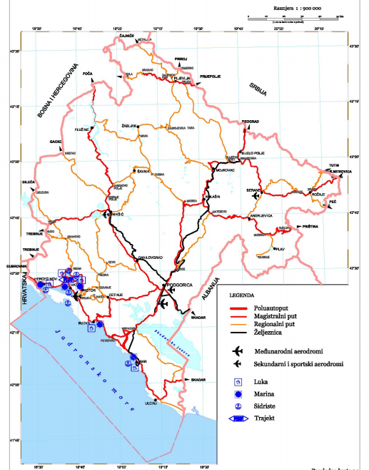
Figure 2.35. Road infrastructure of Montenegro – baseline state

2.10.4.1. Transportation

Road transportation
Length of road network in Montenegro is 6.928 km (846 km arterial roads, 950 km regional and 5.132 km local roads).
Factors that hinder functional connecting of Montenegro with immediate surrounding are natural conditions, unfavourable topography and mountain chains with difficult passages which results in insufficiently developed transportation infrastructure, category, state of roads and insufficient number of border crossings. The problems are partially mitigated with modernisation of sections Budva-Podgorica and Kolašin-Bijelo Polje, construction of Sozina Tunnel and connections to the existing main roads. The Northern region that accounts for more than half of Montenegro’s territory is particularly characterised by insufficiently developed road (and other) infrastructure, especially in rural areas.

Railroad transportation
The existing railroad network in Montenegro consists of railroads with one track standard length: Vrbnica-Bar, part of railway Beograd-Bar that goes through Montenegro (electrified); Podgorica Tuzi – state border (part of railway Podgorica-Skadar) (not electrified) and Podgorica-Nikšić (electrified).
Overall length of railway is 248,6 km, 327,6 km with station tracks. Railroad network of industrial tracks connects important companies in Bar, Podgorica, Spuž, Danilovgrad, Kruševo and Bijelo Polje. The state of railroad network does not have satisfactory density and due to quality of network it is under constant threat of system failure, deteriorated with the concentration of road and railroad transportation in the same corridor that goes through extremely harsh terrain.

Maritime transportation
At present, maritime transportation is carried out in ports for international maritime transportation: Bar, Kotor, Zelenika, Risan and Budva, and also in ports for local maritime transportation, marinas and piers on the shore.
Port Bar terminal differentiation was carried out in line with specific types of cargo. Recently, Port of Budva got status of international port, primarily designated for sea vessels. There are numerous marinas and substantial number of projects for construction of new marinas.

Air transportation
Primary network of airports in Montenegro includes airports in Podgorica and Tivat. Airport Podgorica has a runway 2.500 meters long. In general, airport complex has satisfactory spatial capacities for present needs.
Secondary network of airports includes: airports Berane and Niksic (recreational airport) and Ulcinj airport (recreational and agricultural aviation). Žabljak Airport exists solely as location. The proposed corridor of section IAP – Ulcinj goes near the location of future airport Burge. At this phase of planning, it is not possible to determine precise zone of the planned airport.

2.10.4.2. Other infrastructure
Electric power system of Montenegro was part of unique technical-technological electric power system of former SFRY, and it was built in line with that. Basic electric power network has voltage 400 kV, 220 kV and 110 kV and adequate distribution network that allows transmission of electric power to nearly all the settlements in Montenegro (except villages in the middle and northern part that are difficult to access). Overhead power line network voltage 400 kV and 220 kV, with facilities which are in function, include existing electric power plants, and connection with electric power systems in the surrounding was achieved. In that regard, overhead power transmission line 400 kV Podgorica – Elbasan was started.
According to available data, 65-70% population is supplied with water via water supply systems in municipal centres and important local centres, while just over 30% of population in rural areas is supplied with water from local water supply systems and individually from wells, with construction of wells for underground waters or construction of tanks for stormwater collection.
Water supply system is mainly used for towns and other urban, suburban and rural settlements in areas through which they pass. Urban water supply systems include 40 town, 174 suburban and rural settlements (total of 214 settlements). In percentages, 60% of urban population (37% of the total population) discharges waters into sewage network. Waste waters from the littoral (coastal) region are discharged into the sea, also without previous treatment.
Irrigation is used at only 2.000 ha. All previously developed systems for irrigation were never commissioned and most of them are degraded.

3. IDENTIFICATION OF AREAS WITH POSSIBILITY OF BEING EXPOSED TO A SIGNIFICANT RISK AND ENVIRONMENTAL CHARACTERISTICS IN THOSE AREAS

This chapter identifies the environmental segments which the implementation of the Strategy may have influence on. The identification of the area encompassed the "do-minimum" scenario, on which the Transport Model for Montenegro is based (the basis of the Traffic Development Strategy), and which includes projects whose realization is certain for the target years of 2025 and 2035, and also are included in the Single Project Pipeline updated in 2017:

Route 1: Coastal option of the Adriatic-Ionian highway-high-speed road along Montenegro's coast.
• Croatian Border - Herceg Novi (By-Pass Herceg Novi)
• Herceg Novi – Bijela
• Verige Bridge
• By-Pass Tivat
• Tivat – Tunnel Sozina Section
• By-Pass Budva
• By-Pass Bar
• Bar – Albanian Border

Route 2: Highway Bar-Boljare
• Mateševo-Andrijevica
• Podgorica By-Pass (Smokovac-Tološi-Farmaci)
• Đurmani-Farmaci
• Andrijevica-Boljare (Border with Serbia)

Railway Nikšić- border with BaH-Trebinje-Čapljina

Modernization of the railway line Podgorica - Tuzi – across the border with the Republic of Albania to Tirana (passenger service)

3.1. Identified expexted results

Air quality and Climate change
At the strategic level of the assessment, when specific impacts that are limited by legislation or are considered at the level of environmental impact assessment are exculed, the Strategy has a potentially positive and negative impact on air quality and climate change. By using newly built transport infrastructure, and by increasing the number of vehicles, inevitably there will be an increase of the amount of harmful exhaust gases and gases with a greenhouse effect (GHG gases), which will negatively affect on air quality. Implementing measures that contribute to the reduction of GHG emissions and the introducing an intermodal system based on ecological and innovative solutions will positively affect the air quality of and climate characteristics.

The Strategy will have an impact from the aspect of the amount of GHG gases through the development of all transport sectors. Transport is recognized as the sector that brings the most of polluting substances in the air, including GHG gases. The development of road transport, which mostly participates in emission of GHG gases, will affect its increase. On the other hand, the Strategy contributes to reducing the emissions of GHG gases through electrification of the railroads, and encouraging intermodal transport.

Protected areas
By analyzing spatial data on protected sites and the areas covered by the Strategy, it was determined that there are no conflicts in the area, that the reconstruction/modernization of the existing or the construction of a new planned transport infrastructure will not endanger the protected sites. Special remart should be put of the fact that the planned road directions will not jeopardize the areas of the National Parks in Montenegro. The potential impact can be expected within the section Đurmani - Farmaci, considering the proximity of National Park Skadar Lake, and which direction is as follows: the Sozina tunnel, which descends towards Virpazar and further through the Skadar Lake and the hill in its hinterland (Poseljani, Rječani, Rvaši, Kokoti).

Biodiversity
When implementing the Strategy, effects on biodiversity are possible, which is primarily reflected in the additional fragmentation of rare and endangered habitats, than disturbance of species, and the decrese of stability of significant ecosystems. Significant effects are possible due to changes in hydromorphological characteristics of water bodies which can lead to changes in habitat conditions. In addition, new roads significantly cut down habitats by causing marginal effects and the barrier effect. Through indicators given below will be analyzed the impacts of all the activities planned by the strategy which include: fragmentation of the area; fragmentation of wildlife habitats; the suffering of wild species in traffic; disturbance of wild species; intake and spread of invasive species; violation of protected areas, as well as degradation and habitat loss.

Landscape
Large infrastructure coverage of traffic and additional infrastructure generate a negative impact on the landscape. The impact strength depends on the area itself, i.e. its characteristics. The characteristics of each area are reflected through natural, anthropogenic (cultural) and visual qualities. Considering the number and types of coverage or types of traffic, the most significant impact of the Strategy is expected on the landscape unit/area of the Boka Bay due to the planned construction of the Verige bridge, as well as the Coastal Region of the Central and Southern Coast, as a landscape unit recognized by the Spatial Plan of Montenegro, and the plain area of the Nikšićko polje.

Soil
The construction of railroads and roads will lead to the generation of negative impacts on the land in the form of pollutants generated during railway and road traffic, potential soil degradation due to erosion and the movement of soil. Given that the impacts on the soil are mostly related to the narrow areas around the roads themselves, significant impacts on the land during the implementation of the Strategy are not expected.

Water
During the implementation of the Strategy, the negative impacts is expected, due to potential pollution of water bodies and water for human consumption, and the impact on the hydromorphological state of water bodies. Howewer, it is estimated that these impacts will not be significant if the existing legal regulations and water protection measures prescribed by the Strategic Impact Assessment are respected.

Cultural and historical heritage
Taking into account the exceptional values of the cultural property The cultural and historical area of Kotor, which is listed on the World Heritage List, is undoubtedly that the realization of the Route 1 planned by the Strategy, which includes building the Verige bridge, will have a negative impact on the preservation of the mentioned value of individual cultural goods and landscape.

Negative impacts on the architectural heritage (individual buildings, cultural and historical units) and cultural landscape is possible, so as on the archaeological zones and findings. The preliminary analysis of the Strategy shows significant impacts on the area of Boka Bay as a conflict area (Route 1 - the planned construction of the Verige Bridge). The greatest impact is expected on the cultural and historical heritage of the municipality of Kotor (Church of Holy Nedjelja), especially considering the fact that in the territory of Montenegro most of the cultural monuments are located in the municipality of Kotor (31%), i.e. in Boka Bay 44.60% of immovable cultural monuments, and in the rest of Montenegro 55.40%.

On several occasions, a large number of experts have considered the option of connecting the cities of Boka Bay with the construction of a Verige Bridge. Of many years standing analyzes and assessments were presented through the development of a Study of the Impact of Past and Future Interventions within the natural, cultural and historical area of Kotor on the comprehensive heritage (HIA) Study consideres the problem of the protection of the area of Boka Bay, as well as the specificity of the refer with the cultural property, which includes a particularly valuable and complex set of relations between individual cultural goods and landscapes in a way that precisely in this interaction provide exceptional values. The Study particularly focuses on the problem of traffic connections between the coastal parts of Montenegro, and especially the cities and municipalities of Kotor, Tivat and Herceg Novi, as well as the whole country with its neighbors (Croatia and Albania).

Agriculture
Realization of the planned infrastructure in terms of rail and road traffic may result in reintend and fragmentation of agricultural land. Given the presence of agricultural land, the impact of the reintend of land can be significant in Sutorinsko polje due to the construction of the Herceg Novi By-Pass, which represents the agricultural area, as well as the Barsko polje (olive trees - olive groves), due to the construction of the Bar-By-Pass.

Foresty
Significant impacts can be expected during the implementation of planned measures in the area of endangered forest communities Fagetum montanum montenegrinum, Pinetum nigre montenegrinum, Risco-Carpinetum orientalis, Rusco-Carpinetum quercetosum. The construction of planned road directions will result in fragmentation of forest areas.

Wild animals and Hunting
The basic influence that may arise from the realization of the Strategy relates to the fragmentation of hunting areas, harassment and starvation of wildlife on the roads. According to this, effect it is expected in the area of Special Purpose Hunting Ground "Komovi".

Tourism
The development of transport infrastructure will positively affect the availability of tourist destinations, comfort, speed and security of travel, as well as the mobility of tourists within destinations, which will be synergistically reflected in increasing of the tourism intensity indicators as well as the possibility of improving or creating new tourism products.

Socio-economic characteristics
The economic development of the country is unimaginable without the adequate development of the entire complex of transport infrastructure. A wide range of different means of transport and infrastructure plays a major role in raising the life quality of residents by improving accessibility and increasing travel speeds. This increases the mobility of the residents, ensures sufficient and fast supply of distant parts of Montenegro, which leads to intensification of business activities, strengthening of tourist activity, increasing the number of employees, and the growth of the general and economic well-being of the society.

4. EXISTING PROBLEMS REGARDING ENVIRONMENT CONNECTED WITH STRATEGY

This chapter gives an overview of the status of all environmental segments, including eventual problems if they are present. By analyzing the available documentation, significant existing environmental problems that would have a limiting charter on the activities planned by the Startegy are not recognized. Yet, existing environmental problems in the area of Montenegro are listed as follows, and which are the basis for determining the objectives and measures of protection.

4.1. Air pollution from Traffic

Air

Emissions from industry, energy, transport and fuel combustion in the household sector mostly contribute to air pollution in Montenegro. Air quality in urban areas has been improved for some of the main pollutants - sulfur dioxide, nitrogen dioxide and terrestrial ozone (SO2, NO2, O3).

The exceptions are suspended particles (PM10), where deterioration has been reported. High concentrations and a large number of exceeding the permissible average daily values of PM10 are most common in industrial-urban areas during the heating season. In the period 2009-2012 mid values of PM10 concentrations were above permitted in Nikšić and Pljevlja. The highest concentrations and the highest number of overdoses of allowed average daily concentrations are recorded in Pljevlja. The number of overruns has significaly increased in Podgorica in the last two years, and especially in Nikšić and Pljevlja. Therefore, the target value will not be reached.

The highest air burden with this pollutant was recorded at the measuring site in Pljevlja. Occasional high hourly concentrations were measured, which is the result of combustion of coal with high content of sulfur, which is used both in the Pljevlja Thermal Power Plant and in the households for heating. 2. The concentration of nitrogen (IV) oxide (NO2) at all measuring points was below the limit values. ") Of the fourth indicator under the seventh millennium objective - reducing the number of exceedances of measured PM10 concentrations in relation to the limit values ​​and limits of tolerance for the protection of human health , in Podgorica under 35, and a reduction in the tolerance threshold to 0% in 2015. Due to the registered exceedances of the concentration of PM10 particles, the Air Quality Plan for the Capital was developed; Only after the implementation of the measures that will be prescribed by this plan can it be expected to achieve the prescribed values. For the same reasons, air quality plans for Pljevlja and Niksic have already been prepared, which contain a package of technologically and financially demanding measures. No studies have been carried out on the effects of increased concentrations of certain pollutants on health, nor the assessment of the total damage the economy is suffering from due to air pollution and the environment in general (including eg costs of treatment, absenteeism, etc.).

It should be considered also the age/quality of used vehicles (according to MONSTAT data from 2013, more than 54.2% of vehicles used in Montenegro were produced before 1999), as well as traffic transit during the summer months. Of the total number of vehicles, 58.3% use diesel fuel.

Measures from NSSD (2001) related to air quality have been fully implemented. National legislation is largely (over 90%) in line with the EU acquis. The state station network for monitoring the air quality has been established, and activities aimed at increasing the number of measuring points (considering specific morphological and geographical characteristics of terrain in Montenegro) as well as provision of equipment for cross-border monitoring of air pollution are in progress. In June 2014, the Capital City of Podgorica started with the monitoring of environmental segments, which included monitoring of air quality at representative city locations.

It is necessary to enable metrological traceability of measurement results. Additionaly, National Strategy for Air Quality Management with the Action Plan 2013-2016, defines the measures that can be implemented in this period, bearing in mind the identified problems, the available funds, as well as the existing legal and institutional framework.

4.2. Biodiversity

Existing biodiversity issues related to the Strategy refer to:
- Fragmentation and conversion of habitats;
- Reduced productivity of certain endangered ecosystems (forest vegetation in certain locations, coastal ecosystems, aquatic ecosystems);
- Lack of conditions and trends assessment in species diversity;
- Lost features of individual protected goods and areas of nature planned for protection;
- Reduced hunting population of savage;
- Ignored value of biodiversity and benefits from ecosystem services in strategic, planning and program documents;
- eco-system approach is not used in the planning of economic activities;
- High share of dispersed urban areas.

Assessment of the state and trends in the area of species diversity in Montenegro is hampered by the inaccessibility of the required data. Available data also shows positive (stable trend or increase) and negative moves (decline in populations of monitored species, which was recorded, for example, in amphibians and certain bird species in 2011). Decrease and loss of species (especially in aquatic environments) and the decline in productivity of ecosystems are some of the major anticipated effects of climate change on biodiversity.

4.3. Noise
One of the identified existing problems in this area is the local exposure of the residents to increased noise values. At four locations belonging to the zone under the strong noise influence which derive from road traffic, out of 24 indicators of noise levels in both cycles, 23 do not meet the limit values (96%), while only one meets (4%).

5. GENERAL AND SPECIFIC OBJESTIVES OF ENVIRONMENTAL PROTECTION

Defined general objectives of environment protection are aligned with legislation and international agreements.
Table 5.1. General objectives
Environmental aspect | Environmental goal | Compliance with relevant documents
Air quality | - Improve air quality by reducing the emission of pollutants (SO₂, NO_{x}, PM, CO₂, HCl, HF) from transport sector | - Convention on Long Range Trans-boundary Air Pollution  - National strategy for Air quality management with Action Plan 2017-2020
Climate factors | - Prevention of transboundary transfer of air pollution  - Protection of objects from floods and extremely rainfalls | - United Nations Framework Convention on Climate Change (UNFCCC);  - Law on Kyoto Protocol ratification (“OGM”, no. 17/07);  - Convention on Long Range Transboundary Air Pollution  - Second national Report on Climate Change in Montenegro  - Technical needs assessment for mitigation and adaptarion on Climate change for Montenegro – National strategy with Action Plan (MSDT, 2012)
Landscape | - Save local values and landscape characteristics  -Improve eh landscape protection  - Provide management and planning of landscapes | - European convention on landscapes (“OGM”, no. 48/08)
Forests and Forestry | - To contribute to the management, conservation and sustainable development of forests and forestry | - United Nations Conference on Environment and Development (UNCED), 1992, Statement of Forest Principles  - Ministary Conference on Protection of European Forests, Helsinki 1993  (resolution H1 - "General guidelines for sustainable European governance  forests ", resolution H2 - "General guidelines for the protection of biodiversity", resolution H4 - "Adapting European forests to climate change ")
Land and Agriculture | - Reduce the emission of pollutants into the land  - Protect quality agricultural land  - Protect and secure free srfaces for livestock purposes  - Prevent soil erosion | - Directive of the European Parliament and of the Council on establishing a framework for the protection of soil and amending Directive 2004/35/EC;  - Action Plan for fighting against land degradation and Akcioni plan za borbu protiv degradacije zemljišta i mitigation of drough consenquences for Montenegro (2014);  - Strategy of ecoremediation in Montenegro with Action Plan 2014-2020
Water | - Improve and preserve the good ecological and chemical status of water bodies of surface water, as well as the chemical condition of underground water | - Water Framework Directive 2000/60/EC-WFD;  - Strategy of ecoremediation in Montenegro with Action Plan 2014-2020;  - Second National Report on Climate Change for Montenegro;  - Strategy for water management (Draft, 2015)
Biodiversity and protected areas | - Reduce direct pressures on forest and freshwater habitats, dry grasslands and karst habitats and ensure the protection of "hot spots" of biological diversity  - Prevent the spread of invasive species | - EU Directive on birds 79/409/EEC;  - EU Directive on habitats 92/43/EEC;  - National strategy of Biodiversity with Action Plan 2016-2020;  - National strategy of Sustainable Development to 2030;  - Bern Convention;  - Fifth annual Report on implementing Milenium goals in Montenegro (1st January – 31st December 2016).
Cultural heritage | - Protect archaeological and architectural heritage | - Convention concerning Protection of World Cultural and Natural Heritage;  - Culture Development Program 2016-2020.
Population and social issues | - Increase the possibility of employing local residents  - Protect areas of tourism importance | - Development Strategy,  2006;  - Strategy of Regional Development of Montenegro 2014–202;  - National strategy of Sustainable Development to 2030.
Health | - Reduce the exposure of the residences to infectious and respiratory diseases | - The new European  policy for health – Health 2020);  - Health Care Development Strategy to 2030.

Through the introduction of the highest standards in the planning and design of the traffic infrastructure, as well as in its use, mechanisms of protection of the environment and space have been provided.
These issues are especially highlighted in the protection of areas with high sensitivity to pollution and those that have special significance for the development of Montenegro. Such areas are the Montenegrin coast, national parks, all legally protected areas, canyons, mountain centers, etc. Coastal tourism is expected to be the main factor in economic growth in the coming period.

The lack of urban planning and services already called in questin this potential, while the second obstacle is the increase in traffic intensity and "choking" during the summer tourist season. Considerable number of options for overcoming this problem must be taken into account, eg: activities related to the construction of third lanes, construction of bypasses, determining alternative routes with new traffic modes, etc.

Through the Transport Strategy, specific objectives are defined, which realization will greatly contribute to the preservation of the environment:
- planning the new traffic routes out of the most sensitive areas,
- construction of a bypass for transit movements around vulnerable areas,
- construction of third lanes for avoiding bottlenecks in the tourist season,
- the establishment of a special regime for the freight assembly in certain periods,
- application of alternative variants of traffic in certain periods, etc.

In order to protect the environment, the Ministry of Transport and Maritime Affairs has identified the basic activities which realization will be aimed exclusively on the protection of the environment, i.e. minimizing the negative impacts of transport on the environment.

Thus, in the field of road transport, for the purpose of increasing the level of environmental protection, the Decision on the conditions that must be met by vehicles was addopted, which will consider as fulfilled the conditions for the protection of the environment and human health will, the existing standard has been retained for the import of used vehicles Euro 3 (2000-2005 production year), while for the import of new vehicles minimum an ecological standard Euro 5 was adopted (year of production 2011-2015).

The realization of these goals is planned through the following activities:
1. Rehabilitate and improve the road connection between Croatia and Montenegro through Vilusi and Nikšić, in order to protect the coast from transit traffic;
2. Regulate the banning of freight traffic on the roads in the part of the coast during the tourist season by adequate measures, to precisely limit "deliveries to the local" (00 - 06h);
3. Ensure a better access to the Boka Bay by improving the Vilusi - Risan route;
4. Support the increase in the capacity of ferries in the Boka Bay as a viable alternative to the road link;
5. Analyze the possibilities of introducing a seasonal shipping line on the Bar - Boka Bay line, which would provide similar bus services;
6. The highest standards of environmental protection (technical standard of rolling stock, design of lines, equipment and devices, transport discipline, intervention measures in preventing and mitigating the consequences of traffic accidents) shall be applied in all stages and activities related to traffic;
7. Promote more efficient use of railways, inland waterways and maritime traffic;
8. Promote and raise the quality level of services in public road transport, as well as railways, and popularize non-motorized modes of movement such as, for example, cycling, especially in cities that are overcrowded;
9. Take measures to meet the traffic requirements and reduce congestion;
10. Work on achieving a more efficient logistic approach.

From the aspect of pollution of the sea from vessels, it is planned to undertake the following activities:

• Providing, i.e. supplementing, the existing systems for the acceptance of waste materials from ships in Montenegrin ports, including all types of waste from ships -laundry, sewage, oily, chemicals, ballast water, etc;
• Providing procurement of adequate equipment for rapid sampling from the pollution site (equipment for sampling of oily and chemical pollution, air pollution, ballast water, etc.);
• Establishing a notification system - notification to the next port of the ship, about the condition of bilge waters, oily sewage waste and garbage on the boat concerned;
• Establishing the obligation for ships coming to our ports to empty into landing receptacles (in ports) of the maximum amount of waste before departing from our ports;
• Establishment of systems and procedures (extension of existing ones) for monitoring and surveillance, including monitoring from air, our coastal and territorial waters, with the goal of timely detection of possible outflow of polluting substances. For this purpose, it is necessary to start/complete, subregional arrangements, in order to t integrate into the systems and procedures for the observation and surveillance of the sea areas in a best way;
• Try to determine the appropriate covers/shelter for ships in distress, in order to reduce the risk of spreading eventual pollution;
• Strengthen and establish an adequate tackle system in a case of emergency and incidental situations, that is the tuging capacities in our coastal / territorial sea;
• Modernize and strengthen the existing capacities in our ports, in terms of a more comprehensive and better safety management in case of eventual pollution, which could occur during commercial operations of ships in our ports. In doing so, it is primarily meant for the development and implementation of an adequate Safety Management Plan in ports for incidental pollution.
• Provide prescribed and adequate equipment for responding to incidental pollution situations. These equipment could be deployed in the ports or at some qualified firm that would deal with this issue;
• Conduct permanent monitoring (radar, photographic) at sea and adequate cleaning and rehabilitation of marine aquatic environment;
• Control the handling of waste (chemical, biological and physical origins), created in various production and service activities along the coast and strengthen the penal policy in this area.

6. POTENTIAL SIGNIFICANT IMPACTS ON PUBLIC HEALTH AND THE ENVIRONMENT, INCLUDING FACTORS SUCH AS BIOLOGICAL DIVERSITY, POPULATION, FAUNA, FLORA, LAND, WATER, AIR, CLIMATIC ASPECTS, MATERIAL RESOURCES, CULTURAL HERITAGE, INCLUDING ARCHITECTURAL AND ARCHAEOLOGICAL HERITAGE, LANDSCAPE AND RELATIONS BETWEEN THESE FACTORS

Characteristics of all environmental segments that may be changed due the implementation of the Strategy are described in Chapter 3 - Identification of the area. This chapter provides an assessment of the expected impacts on the environmental segments caused by the realization of the Strategy, as well as the criteria / indicators on the basis of which the assessment was made.

The impact analysis were included the scenario "to do a minimum", based on the Transport Model for Montenegro (the basis of the Transport Development Strategy), which includes the projects whose realization is planned for the target years of 2025 and 2035. They are also included in the List of Priority Infrastructure Projects updated in 2017 (LPIP):

Route 1: Coastal option of the Adriatic-Ionian Motorway - high-speed road along Montenegro's coast.
Croatian Border - Herceg Novi (By-Pass Herceg Novi)
Herceg Novi – Bijela
Verige Bridge
By-Pass Tivat
Tivat – Tunnel Sozina Section
By-Pass Budva
By-Pass Bar
Bar – Albanian Border

Route 2: Highway Bar-Boljare
Mateševo-Andrijevica
Podgorica By-Pass (Smokovac-Tološi-Farmaci)
Đurmani-Farmaci
Anrijevica-Boljare (Border with Serbia)

Railway Nikšić- border with BiH-Trebinje-Čapljina

Modernization of the railway line Podgorica - Tuzi – across the border with the Republic of Albania to Tirana (passenger service)

Identification of environmental impacts

Table 6.1. Identification of potential impacts
Environment criteria | Identified impacts | Assessment of  the impact  (YES/NO)
Soil and mineral  resources | -impact on the fragmentation of areas of agricultural land and woodland  - use of renewable energy sources and biofuels  - construction waste management | YES
Air | -emission of pollutants into the air from transport which have harmful impacts on ecosystems and biodiversity  - emission of pollutants from transport, for which national emission ceilings have been determined | YES
Climate factors | “sensitivity” of the transport network to extreme weather events  - greenhouse gas emissions caused by fuels in transport | YES
Water | - impact on flood safety  - impact of harmful and hazardous substances on the quality of surface and ground water in the event of an accident (spillage of harmful and hazardous substances).  - impact on aquifers and the quality of drinking water  - impact on bathing waters | YES
Nature  (habitats, biodiversity, nature conservation areas) | - impact on the fragmentation of forest habitats  - impact on the migration of wild animals  - impact on the integrity and functionality of protected areas  - impact on valuable natural features | YES
Human health | AIR QUALITY  - impact on health (respiratory system) in the event of increased pollutant content in ambient air | YES
Human health | NOISE POLLUTION  - impact of noise pollution caused by transport on human health | YES
Human health | ELECTROMAGNETIC RADIATION POLLUTION  The impact cannot be assessed at the level of Strategic Environmental Assessment of Transport Development Strategy (TDS). | NO
Human health | LIGHT POLLUTION  The impact cannot be assessed at the level of Strategic Environmental Assessment of Transport Development Strategy (TDS). | NO
Human health | IMPACT ON THE QUALITY OF WATER (DRINKING AND BATHING WATERS)  The impact cannot be assessed at the level of Strategic Environmental Assessment of Transport Development Strategy (TDS). The impact is addressed in the field of waters. | NO
Human health | VIBRATIONS  The impact cannot be assessed at the level of Strategic Environmental Assessment of Transport Development. | NO
Population and material assets | -impact on material assets due to needs for space  -impact on accessibility and regional connections  - impact on traffic safety | YES
Cultural heritage | - impact on units of cultural heritage | YES
Landscape | - impact on changes in landscape and visible qualities of space | YES
The important impacts of the Strategy on the environment have been evaluated and assessed with the following grades:

A – no impact/positive impact
B – insignificant impact
C – impact is insignificant due to the implementation of mitigation measures
D – significant impact
E – destructive impact
X – determination of the impact is not possible

The assessments of the consequences of the plan of A, B and C grades mean that the impacts of plan implementation on the realization of the environmental criteria are acceptable. Insignificant impacts are graded with B, and impacts that are acceptable, provided mitigation measures are implemented, are graded with C. Grades D and E imply that the impacts are unacceptable. Indicators and evaluation criteria, and the evaluation of grades by individual important environmental impacts are described below.

Description of evaluation criteria and methodology for the evaluation of environmental impacts of the Transport Development Strategy.

6.2. Soil and mineral resources

The evaluation criteria and methodology for the evaluation of environmental impacts of the Transport Development Strategy are described in the table below: Ensure sustainable management of land and protection of soil.

Tabela 6.2. Impact on soil and mineral resources
Indicator/evaluation criteria | Evaluation of grades
- changes in the actual use of agricultural land and woodland  (construction of transport infrastructure within the zone of agricultural land and woodland would lead to their permanent loss and change in the category of the actual use of soil)  - the probability of the route of transport infrastructure in areas of protective forests  (construction of transport infrastructure in protective forests may significantly affect the qualities for which the woodland has been declared protective forest).  -recycling rate of construction waste generated during the construction and reconstruction of the transport network (measures in the construction of new and the reconstruction of existing facilities of transport infrastructure must ensure that at least 70 per cent of newly generated construction waste is recycled, and that as much excavated soil as possible is recycled as a construction filling) | C – impact is insignificant due to the implementation of mitigation measures  The highest impact on the agricultural land and woodland has construction of road and rail infrastructure. Construction of transport infrastructure within the zone of agricultural land and woodland would lead to their permanent loss and change in the category of the actual use of soil.  Depending on the route selection, different influences can occur. All identified impacts can be minimized during the implementation of mitigation measures, including strictly respect the legal frameworks and adopted plans.  Development of transport infrastructure generates large quantities of construction waste on one side, and on the another hand lids to the intensive exploitation of natural resources (construction stone and aggregate). Adequate construction waste management reduces the amount of waste in general, while also reduce the excessive exploitation of natural resources, which also entails space degradation (quarries).  X – determination of the impact is not possible  The impact cannot be determined due to the lack of data (level of detail and scope of national data.

6.3. Air

Description of criteria and methodology for impact assessment of the Transport Development Strategy on the air are described in the table below. It is necessary to ensure the attainment of quantities of pollutant emissions determined for the transport sector with national emission ceilings for atmospheric pollutants (prescribed at the national level.

Tabela 6.3. Impact on air
Indicator/evaluation criteria | Evaluation of grades
-annual quantity of pollutant emissions from transport (sulphur oxides, nitrogen oxides, non-methane volatile organic compounds, ammonia and particulates (Indicative emission ceiling for NOx from transport for any year between 2020 and 2029 is 13.27 kt and 6.31 kt after 2030  Indicative emission ceiling for PM2,5 from transport for any year between 2020 and 2029 is 0.981 kt and 0.392 kt after 2030.  Cumulative impacts of all measures of the Strategy must not cause the annual quantity of all emissions of an individual pollutant from transport to exceed the aforementioned emission ceiling or the emission ceiling prescribed at the national level. | C – impact is insignificant due to the implementation of mitigation measures  Pollutant emissions during the construction of transport infrastructure for which national emission ceilings have been determined to the extent that the ceilings stipulated for transport in the Operational Programme will be exceeded. To reduce emissions, mitigation measures must be anticipated which ensure that the emission ceilings stipulated in the Operational Programme for transport will not be exceeded.  Emissions of pollutants during the development of transport infrastructure are related to all forms of transport - road, railways. On the other hand, while performing traffic, it is considered that rail and water transport have a lesser impact on emissions of pollutants in air compared to road and air traffic. Thus, priority is given to the development of these two types of transport, with the aim of reducing overall emissions of pollutants into the air.  Plans and measures for improving transport infrastructure and conditions proposed by the Strategy will provide air emissions reducing.

6.4. Climate
Description of criteria and methodology for impact assessment of the Transport Development Strategy on climate change are described in the table below.
It is necessary to adapt transport infrastructure to climate change and reduce annual quantities of greenhouse gases in accordance with internationals protocols.

Tabela 6.4. Impact on climate

Indicator/evaluation criteria | Evaluation of grades
- adapting transport infrastructure to climate change  (All plans for construction or the reconstruction of transport infrastructure defined by Strategy must include measures to reduce or prevent the consequences of climate change, especially of floods, snow and glaze ice)  -annual quantity of greenhouse gas emissions from transport  (The highest quantity of greenhouse gas emissions from transport must not exceed the target annual quantities of greenhouse gas emissions from transport of 5,622 kt of CO2 equivalent in 2020 and 5,224 kt of CO2 equivalent in 2030.  The cumulative impacts of the Strategy must not cause the annual quantity of all greenhouse gas emissions from transport to exceed the target values stipulated by international protocols. | D – significant impact  Since fossil fuels are the main energy sources used in transport, the impact of traffic on greenhouse gas emissions is very high. Traffic is considered to be the second largest source of GHG emissions after the energy sector. Also, transport infrastructure is vulnerable to the impact of extreme weather events that are the consequence of climate change. The global rise in temperature leads to more and more frequent changes in the usual climate conditions that manifest themselves in extremely low temperatures, extreme precipitation, and droughts, as well as droughts and forest fires

6.5. Impact on water

Description of criteria and methodology for impact assessment of the Transport Development Strategy on climate change are described in the table below.

It is necessary to limit the effects of the pressure of transport infrastructure on surface water, groundwater, with special emphasis on preserving the quality of drinking water.

Tabela 6.5. Impact on water

Indicator/evaluation criteria | Evaluation of grades
-possibility of integration in water protection areas of water sources  (integrating measures outside water protection areas means less possibility for polluting groundwater intended for water supply)  -possibility of integration in areas of influence of bathing waters  (integrating measures in areas of influence of bathing waters means greater possibility for polluting bathing waters)  -possibility of integration in flood areas  (integrating measures in flood areas means reduces retention areas and the possibility of flood damage)  -possibility of integration in areas of aquifers with a high vulnerability level  (integrating measures in areas of highly vulnerable aquifers means greater possibility for polluting groundwater) | C – impact is insignificant due to the implementation of mitigation measures  The impact on water quality is expected during the period of construction and reconstruction of transport infrastructure, and also afterwards. After the construction, impacts are mostly less extensive, even that the impact during the construction is temporary.  Possible permanent impacts are related to the change of morphology of watercourses, hydraulic changes in the underground or surface water regime.  The significant impact on waters is expected during the accidents on the roads (spillage of hazardous and dangerous substances), which may have significant consequences on water quality.  The construction and reconstruction of the road network in flood areas may affect the possible damage, ie the level of flood waves, by changing the hydrological characteristics of watercourses by changing morphology of the area.  The largest direct influence on water quality especially sea water, has maritime traffic. The effect is also present during regular traffic, and during eventual accidental situations.  The main direct impacts of maritime transport on water quality stem from oil spills and ballast water discharge.

6.6. Biodiversity/protected areas
Description of criteria and methodology for impact assessment of the Transport Development Strategy on biodiversity/ protected area are described in the table below.

Tabela 6.6. Impact on biodiversity/protected area
Indicator/evaluation criteria | Evaluation of grades
- Potential impact on habitats of large mammals/carnivores (new and existing infrastructure corridors through dense forest may also may cause pressure on large mammal and their migratory routes).  - Potential impact on dense forest (planning of new infrastructure corridors through dense forest may also cause interruption of migratory routes of large mammal and habitat fragmentation.  - Potential impact on protected natural assets and habitats of protected plant and animal species. | C – impact is insignificant due to the implementation of mitigation measures  During the development of the road and railway networks impacts are mostly short term, limited and reversible. Potential impacts could be minimized due the implementation of adequate mitigation measures.  E – destructive impact  Planning of new infrastructure corridors through dense forest mean significant negative impact, since a large part of the forest would be lost, which would result in the fragmentation of wildlife habitat, and perhaps the complete loss of habitats of certain plant and animal species.  B – insignificant impact / C - impact is insignificant due to the implementation of mitigation measures / D – significant impact  If the legal framework and adopted plans are respected, corridors avoid spaces within the coverage of national parks and other significant area from the aspect of nature protection (Emerald habitat, the other categories of protection from aspect of nature protection, both at national and international level). Corridors with strategy of newly developed infrastructure road facilities do not pass through the space of national parks and can, in worst case, be nearby the boundary of national parks, impact can be assessed as meaningless.  However, in the part of already existing, both road and rail infrastructure facilities, during planned reconstruction, some negative effects can occur. Expected impacts can be meaningless, if appropriate mitigation measures are applied, and which are going to be defined through the Environmental Impact Assessment.  At the areas of meaningful habitat, from the aspect of protected plant and animal species, can be expected meaningful and constant impact. If newly planned corridors of road and rail traffic and reconstruction of already existing, as well as the construction or reconstruction of existing facilities in the sector of maritime and air traffic, planning on the habitats of protected plant and animal species, can expect a significant and sustained impact of the planned action.

On the basis of the analysis of possible impacts, relying on the defined indicators, map of the cross section of planned routes in relation to protected natural assets (Emerald habitats and National parks) is provided in section below.

According to the same, we note that the planned road infrastructure will not endanger the area of the National Parks of Montenegro. The potential impact can be expected within the section Đurmani – Farmaci (whose direction is as follows: the Sozina tunnel, which descends towards Virpazar and further through the Skadar Lake and the hill in its hinterland (Poseljani, Rječani, Rvaši, Kokoti), continues to the Farmaci), considering proximity to the National Park Skadar Lake.
Also, the impact of the Strategy is expected on the Kotorsko-Risan Bay - Emerald habitat, due to the planned construction of the Verige Bridge, as well as on the Canyon of the Mala Rijeka - Emerald habitat during the construction of the Motorway Bar-Boljare.
Picture 6.1. Map of the cross section of planned routes in relation to protected areas

6.7. Human health
Description of criteria and methodology for impact assessment of the Transport Development Strategy on human health are described in the table below.

Special emphasis should be placed on maintaining air quality, noise, electromagnetic radiation, light pollution, water quality and vibration, which can have an impact on human.
- Air quality
Indicator/evaluation criteria | Evaluation of grades
-annual number of days with excessive ambient air pollution in terms of pollutants, in accordance with date from (monitoring stations). Annual number of days with excessive ambient air pollution must not exceed 35. | C - impact is insignificant due to the implementation of mitigation measures  Impact on air quality in term of increasing pollutants in the air, during the reconstruction of existing infrastructure facilities may be a temporary and reversible. Due the implementation of adequate mitigation measures in accordance with relevant legislation; keeping the concentration of pollutants to on acceptable level makes possible impacts on human health meaningless and short-term.  D – significant impact  Permanent and significant impacts on human health through the emission of pollutants could be caused if adequate measures (in accordance with standards prescribed by legislative) were not applied during the realization of planned activities, as well as during reconstruction.
Tabela 6.7. Impact on air quality

6.8. Impact on noise
Description of criteria and methodology for impact assessment of the Transport Development Strategy on noise are described in the table below.

Indicator/evaluation criteria | Evaluation of grades
- exposure to noise from transport  (the less the disturbance in the environment due to noise, the less the impact on the quality of the environment, human health and the costs to society due to the number of exposed people whose health is affected) | D – significant impact  Permanent and significant impacts on human health through the emission of noise could be caused if adequate measures (in accordance with standards prescribed by legislative) were not applied during the realization of planned infrastructure, as well as during reconstruction.  Significant impact is expected during the construction and it is expected to be short-time and reversible.  The greatest impact during the construction is expected in the development of the road and railway networks, while development in the maritime and air transport network will be limited locally. In individual areas, a higher level of environmental pollution is expected during construction than during operation. Because of that, mitigation measures will have to be carried out during construction.
Tabela 6.8. Impact on nose

6.9. Cultural heritage
Description of criteria and methodology for impact assessment of the Transport Development Strategy on cultural heritage are described in the table below.

Tabela 6.9. Impact on cultural heritage
Indicator/evaluation criteria | Evaluation of grades
-probability of the route running across registered units of cultural heritage  (integrating measures for road, rail and public transport on units of cultural heritage may significantly endanger the integrity of heritage and modify its qualities. Especially endangered is Boka Kotorska Bay as UNESCO due the construction of Verige bridge including impact on cultural and historical landscape, as well as aspect of endangering cultural and religious objects in the area of the bay.)  -probability of destroying archaeological remains (integrating measures for planned roads on units of cultural heritage means encroachment upon soil and thus great probability of destroying archaeological remains) | D – significant impact / B- impact is insignificant due to the implementation of mitigation measures  The greatest impact during the construction is expected in the development of the road and railway networks, while development in the maritime and air transport network will be limited and insignificant only during the construction on land.  In individual areas, a higher level of environmental pollution is expected during construction than during operation. Because of that, mitigation measures will have to be carried out during construction.  Objects and areas of cultural heritage might be directly affected during the development of transport infrastructure (construction and operation of newly-planned infrastructure). Corridors of newly-created infra-structure facilities can lead to degrading and irreversible impacts on the landscape features of cultural heritage, as well as damage to cultural heritage objects (direct reversible effects), but also to the destruction of archaeological remains during construction (direct, local, irreversible impact);  Also, vibrations can cause damage to buildings of cultural heritage (indirect reversible impact);  A – no impact/positive impact  Positive and permanent impact is possible in the areas, which are close to planned infrastructure projects, firstly railway transport, which can lead to an increased number of visits to cultural and historical objects.  The preliminary analysis of the Strategy shows significant impacts on the Bay of Kotor as a conflict area (Rout 1 - planned construction of the Verige Bridge).  The greatest impact is expected on the cultural and historical heritage of the Municipality of Kotor (Church of the Holy Sunday), especially considering that in the territory of Montenegro the largest number of cultural monuments is in the Municipality of Kotor (31%).

6.10. Landscape
Criteria for assessment of potential impacts on valuable landscape characteristics, in order to ensure conservation of exceptional landscapes and landscape areas with distinctive features.

Tabela 6.10. Impact on landscape

Indicator/evaluation criteria | Evaluation of grades
-probability of the route passing through exceptional landscapes and landscape areas with distinctive features | D – significant impact  The probability of measures passing through exceptional landscapes and landscape areas with distinctive features at the national level is considerable, and thus its impact is significant. Measures will be integrated in natural areas with preserved natural elements and exceptionally balanced cultural landscape, and thus the impact on the high-quality landscape image will be significant. There are no mitigation measures to reduce the impact.  The most important Strategy impact is expected on the landscape unit / area of the Boka Kotorska Bay due to the planned construction of the Verige Bridge, as well as the Coastal Area, as a landscape unit recognized by the Spatial Plan of Montenegro. Realization of Road direction 1 will have the impact on area of Niksic Field.

6.11. Population and material assets

Description of criteria for assessing possible impacts on the population and material goods, from the aspect of improving social cohesion, traffic safety and sustainable mobility.
Tabela 6.11. Impact on populationa and materal assets

Indicator/evaluation criteria | Evaluation of grades
-accessibility from settlements to regional canters  (better and speedier accessibility improves social cohesion: speedier access to city canters means a better basis for the development of tourist and economic activities, which in turn means a positive impact on the income of individuals and local communities, the individual’s lifestyle and the value of material assets – real estate)  - inclusion of measures to improve traffic safety  (more measures means better traffic safety and fewer accidents)  -inclusion of measures to enhance opportunities for a healthy lifestyle  (sustainable mobility measures entail the good arrangement of recreational infrastructure (for example, cycling routes and footpaths, including their accessibility); recreation positively affects the mental and physical condition of people and thus reduces the costs of society due to a healthier lifestyle) | A – no impact/positive impact Measures will not affect the attainment of the objective, or the implementation of measures will enhance the connections between remote settlements and regional centres, and improve traffic safety and sustainable mobility.  B –insignificant impact  The implementation of measures will ensure connections between remote settlements and regional centres, traffic safety and sustainable mobility, but in comparison with the current state, they will be slightly poorer.  C – the impact is insignificant due to the implementation of mitigation measures  The implementation of measures will make the connections between remote settlements and regional centres, traffic safety and sustainable mobility significantly poorer in comparison with the current state. Mitigation measures must be observed to reduce the impact.

7. MEASURES ENVISAGED TO PREVENT, REDUCE OR ELIMINATE ANY SIGNIFICANT NEGATIVE IMPACT ON HUMAN HEALTH AND THE ENVIRONMENT CAUSED BY THE REALIZATION OF THE STRATEGY TO THE GREATEST POSSIBLE EXTENT
By analyzing the available data on all segments of the environment, and after identifying the potential impacts of the implementation of the Strategy, measures are defined to prevent, limit, reduce or eliminate, to the greatest possible extent, any significant identified negative impact (Chapter 6), or increase positive impacts on human health and the environment which the realization of the Strategy results.

This chapter covers the measures envisaged by laws and other regulations, norms and standards, as a measure and recommendation for preventing and limiting negative or increasing of positive effects, as well as achieving the objectives of environmental protection and improvement based on well-founded effects on all segments of the environment (tabular display).

Bearing in mind that one of the greatest infrastructure projects defined by the Startegy Bar – Boljare highway, we note that works on the construction of the Smokovac - Uvač Mateševo section have started, as well as that the measures of protection are related to the same defined by the Environmental Impact Assessment Elaborate consent of the Nature and Environmental Protection Agency.

7.1. Measures predicted by legislation and standards

General environmental protection measures include global knowledge from this domain that is appropriate to the global strategy and local spatial conditions and characteristics of the planned routes.

All activities proclaimed as part of the general development policy at the level of the state of Montenegro, which are concretized through the highest planning documents, should be taken into account in terms of rational environmental management for each individual investment enterprise.

Regardless those are temporary environmental impact, it is necessary to take all legal measures to minimize all temporary environmental impacts. This category includes all the protection measures to be taken within the framework of the planned and further design concept, and which application is a precondition for minimizing possible environmental impacts:

1. Implement all the conditions and requirements established by the competent authorities of the state of Montenegro when issuing approvals and consents for the execution of works and the use of temporary facilities;
2. Implement all legal procedures for activities for which licenses, approvals and consents are necessery, with special emphasis on the use and utilization of underground and surface waters;
3. Develop Urban Waste Management Plans (removal of urban waste must be entrusted to the competent communal organization);
4. Obtain the approval for the storage of non-hazardous building waste, and all the necessary documentation that precedes it.

In addition, the table below gives an overview of the measures for all segments of the environment, to which the realization of the Startegy may influence.

Table7.11. Measures and recomandations for prevention from negative impact

Segment | Measures and recomandations for prevention from negative impact on the environment
Land | - During the soil clearing phase, the surface layers must be preserved for future reuse in the rehabilitation and recultivation so as decorating of green areas. Surface layers must not be disposed of at a depth of more than 2 meters, because they will lose their biological qualities. Under no circumstances should they interfere with the excavation. Their quality must be maintained by the sowing of leguminous plants to enrich the content of nitrogen and stocks protect from erosion;  - Instead of deposit of surplus of land (land) at the landfill, an agreement with local communities on the use of surplus land can be realized;  - In order to reduce the risk of erosion, the exposed areas need to be rehabilitated and recultivated as soon as possible, which is done by re-using the removed surface layers and afforestation and trampling of clean areas and slopes immediately after the completion of the works. At the most critical points, temporary land cover with straw or fast-growing vegetation is also applied;  - In order to reduce the risk of erosion, it is also necessary to direct and slow down surface swelling of atmospheric waters from exposed areas and sites. For the execution of works, it is necessary to choose the best period in order to limit the risk of erosion (avoid the rain season);  - In case of formation of erosion hotspots, it is necessary to carry out land remediation immidietly and establish the autochthonous vegetation;  - During the editing and construction it is obligatory to prevent possible damage to agricultural land in the vicinity of the planned traffic infrastructure;  - Mostly, it is necessary to prevent the disposal of dangerous things to land during the editing and construction. In the event of any accident, it is necessary to react immediately and try to prevent soil contamination and / or conduct an appropriate rehabilitation. By limiting the use and utilization of hazardous materials on the construction site, the risk of their discharge in accident cases can be reduced in the long-term;  - Construction machinery and transport vehicles, which must be technically impeccable, are supplied with fuel at predicted locations for that activity. In the case of discharging hazardous substances from machinery, it is necessary to repair the contaminated site immediately. The construction site must have a place for the storage of dangerous goods that is adequately equipped. It is necessary to ensure proper handling of lubricants, fuel and solvents through safe storage, proper fuel loading and maintenance of equipment;  - Dangerous waste is handed over to authorized bodies for the collection of hazardous waste;  - During the works it is necessary to ensure unimpeded access to agricultural land in addition to the planned infrastructure (Routes 1,2,3 of the Strategy), as well as rehabilitation and recultivation of agricultural land that will be damaged during the construction process;  - The extra amount of the fertiled soil should be intended for the recultivation of other agricultural land, or the possible creation of new agricultural land (compensation);  - After the completion of the works it is necessary to bring the construction site to its original state. The removed layers must be rebuilt and re-spread over the area used for the construction site;  - It is necessary to provide controlled swelling of water through the slope, humusing the slope and greening of the slopes of the embankments (by trampling) with parterial greenery of autochthonous plant species for soil consolidation and reduction of erosion;  - It is necessary to provide adequate collection, discharge and purification of atmospheric water from the roadway and other driving surfaces along both planned routes. It is forbidden to dispose waste oils in the land;  - It is necessary to provide the two-sided defensive fences of the vehicles on the road in case of an accident on sensitive parts of the sections (areas of agriculture and water sources, bridges, loops, underpasses, overpasses, etc.);  - In order to reduce the negative consequences of lost of agricultural land, appropriate compensatory measures should be provided (monetary compensation, replacement of agricultural land, etc.).  - At a distance of 300m from the edge of the roadway on both sides of the highway, agriculture is not recommended in terms of cultivating fruits, vegetables and other plants intended for human and animal nutrition
Air and Climate Change | - It is necessary to provide as slightly emission in the air as possible due to earthworks and the use of machinery and vehicles during the editing and construction of the planned traffic infrastructure;  - Within the need, the sprinkler system limits the amount of dust on the construction site and the places for the disposal of materials, especially in the summer months;  - Modern and technically correct mechanization and vehicles are used, whose air emissions are minimized and within the allowed values;  - The transport of the material is done outside the period with the highest traffic intensity. Alternative routes are used to transport in order to minimize traffic congestion. It is obligatory to use covered trucks for transport material, so as drenching cargo to prevent the spread of dust in the air;  - During the dry season, it is necessary to drench sections of the roads near the inhabited areas;  - Asphalt bases and mixing plants for hot materials must be equipped with filters, chimnies, special caps and must have oil boilers for reducing air pollution;  - Along the highway and the coastal variant of the Adriatic-Ionian highway, it is necessary to raise in places a protective vegetation zone consisting of different types of high, leafy and dense vegetation resistant to air pollution, which serves as filter for contaminants between the road and settlements;  - An appropriate horticultural solution for protection against increased air pollution from the highways at the locations of associated facilities (rest areas, parking lots, petrol stations and motels) will be provided;  - All infrastructure projects arising from the Strategy should be planned by taking into account potential climate phenomens in the field of implementation. Projecting of areas should be carried out in accordance with informal guidelines: "Non-paper Guidelines for Project Managers: Making vulnerable investments climate resilient" (European Commission, Directorate for Climate Policy).
Water | - It is necessary to minimize the number of water surface crossings wherever possible. It is necessary to maximally conserve the natural riverbeds of the watercourses, which is why the regulation of the riverbeds is carried out only in places where it is necessary. Bypassing of the watercourses should be carried out without direct entry into the watercourses waterbed;  - During the construction of bridges, it is necessary to ensure that concrete works are isolated from water sources and that trucks with concrete mixers and other concrete treatment equipment are washed at a site that is isolated from water sources so that it does not allow toxic material to penetrate the streams that represent habitats of many species, including fish species;  - Works on the construction of the substraction of the bridges in the streams are carried out during the dry season in order to avoid the need for the soil partitions. In the case of using a bulkhead instead of soil barriers, a bulkheads in the form of steel box are used, which minimize the risk of entering sediments into streams with fish habitats;  - Always, whenever its possible, clean short designs for the bridge are used to eliminate the need for construction works in the riverbed;  - During the concreting of the bridge plate, it is not allowed to deposit toxic asphalt substances in water sources. During the color painting of the bridge depositing toxic colors from the blasting operations should be avoided;  - Special attention is needed in works near water surfaces, to minimize the risk of direct pollution of surface water;  - During the construction of the planned roads, the deposit of excavation material in water surfaces is prohibited;  - To the construction site, the compact waterproofing layer on parking areas, areas intended for storage and loading fuel, in mechanical workshops, etc., must be provided. It is necessary to ensure adequate collection and discharge of atmospheric water from the roadways and other driving surfaces along the entire route of both road direction;  - Atmospheric waters are collected in pools with oil separators, used to purify water from sludge, waste and pollutants before discharging into a natural recipient. Regular control of oil separators and their discharge is required;  - Urban waste water from the accompanying facilities (motels, resorts, train stations, gas stations) must be collected and disposed of via a sewage network. In a case of the absence of a sewerage network, wastewater should be collected in a watertight cave, which is periodically discharged by the competent organization, or purified by its own system;  - The maximum permissible concentrations of hazardous and harmful substances in waste waters that are allowed to be released into the recipient or in public sewage must be respected according to the Rulebook on the Quality and Sanitary-technical Conditions for Discharging Wastewater into the Recipient and Public Sewage, the Method and Procedure for Testing the Quality of Wastewater , the Minimum Number of Tests and the Content of the Report on the Established Quality of Wastewater ("Official Gazette of Montenegro", no. 45/08 of 31st July 2008 and 59/13 of 26th December 2013);  - It is necessary to respect the prescribed protection regime (underground and surface) of the water supply source and to foresee all necessary measures for protection of waters and soils from pollution in normal and accidental situations;  - In areas of direct protection of water supply sources, special projects need to provide complete isolation of the cross-sectional profile of the roads from the surface, in order to protect against pollution of the aquifer;  - Accompanying objects of the highway are not located in areas of direct protection of the water supply;  - It is necessary to implement special restrictions and regulations for the transport of dangerous goods on road sections through the protection zone of water supply;  -When constructing railway lines, use as much as possible the concrete thresholds, that is, to avoid the wooden thresholds which need to be treated with chemicals before use.
Nature and Protected Nature Areas | - In sections where the forest complexes is crossed by route of roads it is necessary to ensure the preservation of biological functions and further afforestation of the rest of the forest;  - Reconstruction and landscaping (with the use of various indigenous and allochthon plants) of the forest complex and the preservation of existing high vegetation, individual trees and forests, and especially with existing and planned motels, rest areas, parking lots, gas stations, loops, denivelised crossings and other contents and objects of planned routes is obliged;  - It is obliged to preserve individual trees and groups of trees, as important structural elements in the areas of the impoverished nature of the infrastructure corridor, which with the coastal vegetation of the Skadar Lake and the rivers Morača, Tara and Lim and their tributaries, including the coastal area (with a special emphasis on the Boka Bay) a special visual value for users of the transport infrastructure and has a significant biological function;  - New planting should focus on raising forest habitats in large, interconnected complexes, which are more striking for road users and greatly facilitate plant care and growth by using multiple forms of greening;  - Planting trees and shrubs, with a participation of trees of 10%, are suitable for protection from the reflections from the highway and the coastal variant of the Adriatic-Ionian highway, with the level of plantation of about 2.5 m enough for the plain parts of the route, and for the terrain in the form of troughs, higher plantings are needed – under condition that species with high yielding capacity are planted, in which the evergreen species and the species with dense canopy will be represented, in order to ensure the density of plants in old age and protection against reflection during the winter period;  - In order to increase the protection of the users of the traffic systems and the users of the space in the protection zones, it is necessary to provide:  - Protective forest zones, with priority raising: in the groundwater protection zone, in order to mitigate the negative effects of surface water spills and immission from the roads; in areas with herbal crops on the highest quality agricultural land and along the very edge of the highway; in the protection zones of the highway towards the settlements, tourist-recreative areas and areas with natural values ​​and immovable cultural goods;  - Protective greenery that is raised with respect to the technical and technological requirements of the infrastructure systems for transparency (loops, bridges, denivelised crossings, etc.) and protection from accidents (restrictions on greenery in the protection zones of gas pipelines and power lines);  - Possible measures for mitigation of negative impacts during work along the coastline are: to minimize the surface of areas that are disturbed; controlling swelling of sediments into streams through the use of best practices in erosion control and sediment control; as a compensation plant a coastal vegetation in the boundary coastal zones suitable for its development;  - It is necessary to ensure, wherever it is possible, the underpasses or overpasses for animals (ecological corridors) on the roads, at distances which will be determined on the basis of population analysis and the necessary level of communication of animal species (schedule of hunting, forest, arable land, watercourse and channels, position of depression, habitats with autochthonous vegetation, etc.);  - In areas where amphibious passes are possible, it is necessary to install protective amphibious fences and arrange appropriate omissions;  - Cutting down speed limits can reduce the number of collisions between vehicles and animals, especially at night and in places where the crossings of animals are frequent. Signs of animal warning in places where the corridor of animal movement crosses the road can also help avoid collisions. The risk of collision between animals and vehicles can be reduced by fencing or setting up forested barriers;  - Protection and landscaping in protected areas of natural heritage will be carried out in accordance with the established protection regime which: prohibits the change of the purpose of protected areas, undertake activities that can change the appearance or jeopardize the biological survival of the protected area; and allows the undertaking of biological and technical measures for protection in protected areas.
Noise | - Measures of noise protection are undertaken, related to the selection and use of low-noise ("silent") machines, devices, means of work and transport, i.e. using the best available techniques that are technically and economically profitable;  - Used machinery, vehicles and other equipment must comply with the prescribed technical standards related to the limited noise level, and the data on sound-power they emit must be marked on the product in accordance with special regulations as well as the guidelines and norms of the European Union;  - It is necessary to consider the need to set up temporary barriers or noise protection in works near vulnerable locations (eg houses, schools, hospitals, etc.);  - Work on the construction site near the residential areas is carried out only during the day, i.e. between 7am and 7pm. Under the normal circumstances, night work is avoided;  - Noise sources are positioned in a way to minimize the spread of noise in the space during their operation;  - In areas with built residential, business and / or commercial buildings, as well as in the areas of protection of natural good where noise levels are expected to exceed the limit values, adequate noise protection measures must be provided with which the noise level is reduced to the allowed values;  - Possible noise protection measures include: sound barriers, anti-noise embankment, covered caves, speed limits, smooth and maintained roadways, use of granular asphalt or bituminous surface coating of roadway, etc. Sound barriers belong to the most commonly used mitigation measures. They are most effective if they interrupt the line between noise sources and noise receiver that is protected, and if they are dense enough to absorb or reject received noise;  - Potential measure for preventing noise impact is the expropriation of property and the displacement of people from the area of excessive noise.
Human Health | - Health and social influences, as elements of the relationship to the environment, can refer to the population in neighboring economic facilities, residents of wider location and residents of the wider community. On the basis of the available data, certain negative health effects are expected (noise and emissions of particulate pollution in the air);  - Envisage the development of a detailed program of measures for problem zones in order to reduce the concentration of PM particles;  - During the process of projecting the routes, taking into account the prognostic values of the increase of the traffic, assess the importance of the impact and, if necessary, to implement appropriate noise protection measures;  - Forseen a measure in terms of reducing speeds on road sections, in order to reduce the noise level at source.
Population and material goods | - During the arrangement and construction of the planned routes and accompanying facilities it is necessary to: maintain the access during the execution of the works, to lay the safety fence around the construction site (especially to prevent the children from approaching heavy machinery); plan a special schedule for the construction machinery movements; determine the traffic rules that indicate the contractors to respect the rules applicable to the roads; plan procedures in the case of an accident or outflow of pollutants; to establish safety rules for site workers - handling hazardous materials, procedures in the case of fire, etc.;  -In cases when road construction requires the removal of certain local activities (houses, agricultural land, public property, etc.) from the area, the usual mitigation measure is to provide an alternative nearby location for these activities, as well as compensations or "Social and Commercial Rehabilitation”. Within the project, it is necessary to consider transferring and compensating for people whose homes, land or lifestyle are directly affected by project implementation. Compensation will also be provided through restructuring of property and arranging approaches that are disrupted by road construction;  - Negative impacts on the local community and the social environment during maintenance activities can be mitigated through well-designed traffic management plans, using silent equipment, working during day usual daily activities and focusing on improving the quality of signaling, buffers and other resources that contribute to security and local accessibility;  - All access roads required during the works should be entered into the general plan precisely showing the areas with the right of priority passage, the amount of the fee for the temporary use of the land and the obligation to subsequently bring it to the original position (usually the use of restored land as agricultural);  - Upon completion of the works, the contractor must do everything necessary to bring the construction site into its original state. Construction site objects such as wells, water storage, sewerage systems and buildings can sometimes be converted for local use after completion of the project;  - Fire and explosion protection will be provided by designing the elements of the physical structure of the gas station complex according to the zones of fire hazard and unimpeded access to fire vehicles;  - It is necessary to take into account possible rare disasters and determine the steps to bring their impact at the lowest level. Fire extinguishing, access roads to locations affected by fires, landslide and avalanche control measures, and flood mitigation measures, such as retention and drainage, are some of the examples covered by projections used to alleviate known problems affecting the given road sections. Simply recording disaster response measures, as well as regular training and dissemination, are important for successful disaster mitigation;  - No cultivation of fruits, vegetables and other plants intended for human and animal nutrition is recommended at a distance of 300 m from the edge of the roadway on either side of the highway;  - Eventual complaints of the local population regarding the route and exploitation of the highway need to be studied and, to the greatest extent possible, respected for the purpose of good public relations.
Cultural goods | - By tracing the highway it is necessary to avoid the protected areas and objects of cultural and historical heritage to the greatest extent;  - For monuments of culture registered as immovable cultural goods enjoying prior protection, until the establishment of technical protective measures in a protected environment, activities on the construction and arrangement of the premises can not be performed without the prior consent of the competent service for the protection of cultural monuments;  - No construction and activities that can jeopardize the atributes of the cultural monument and its protected environment are allowed. Only the construction and reconstruction of facilities and the arrangement of the space in the function of cultural monuments and its protected environment are permitted, in accordance with conditions established by the competent authorities and institutions;  - The arrangement and construction of road directions in the vicinity of the cultural heritage site is possible only under the supervision of the competent authorities and institutions and in accordance with their conditions. During construction and other works, any operation is prohibited directly on the building. At the end of the construction it is necessary to provide landscape design of the protected environment of the cultural monument;  - It is necessary to preserve the ambient-landscape quality of the cultural heritage: the preservation of forest edges in contact with heritage, characteristic silhouettes, vedutes and visions, and other landscape structures;  - If the contractor during the construction and other works encounters with objects and contents that indicate archaeological origin, he is obligated to interrupt works and to inform the competent cultural monument protection service. If an important site is discovered during the work on the planned road directions, the eventual relocation of the route / road section should be considered;  - During construction and other works in areas where great probability is expected of any archaeological sites, it is necessary to ensure constant supervision of experts - archeologists.  - During the preparation of planning documentation for the planned corridor of the Route 1 through the Boka Bay area, it is necessary to take into account the findings and recommendations of the Study of the Impact Assessment of Past and Future Interventions within the Heritage Impact Assessment (HIA) of the natural and cultural and historical area of Kotor.
Landscape | - It is necessary to provide such technical-technological solutions in an aesthetic-visual sense, which, in addition to functionality, provides a positive aesthetic characteristic to routes;  - By projecting the route it is neccessery to ensure that the road is fit into the relief in the best way ;  - Vertical lines and tracks in the bases must be buried in a natural relief as much as possible with technical obstacles such as slopes or radii of curves;  - Slope construction is principally designed in relation to the categories and slopes of the terrain (eg cascading slopes) and the greening of all slopes, and in the area of the horizontal parts of the cascades and regardless of the category of terrain. The slopes on both sides of the road can be of a different shape in order to fit into the natural appearance of the terrain;  - Bridges, viaducts and tunnels can cross over steep terrain better than over high cuts and embankments, in order to preserve the visual appearance of the landscape and its physical continuity;  - In the curve, emphasis must be given to transparency, while at the same time ensuring adequate passage safety. It is often better to avoid natural characteristics that are of particular importance;  - It is necessary to pay attention to the aesthetics of construction objects by selecting materials that are consistent with existing colors and textures and which give a simple shape in structure. For supporting walls and viaducts, whenever possible, natural stone is used, rather than plain concrete, since the natural stone is dominant in the Montenegrin architectural tradition;  - All multi-level crossings and caves should be realized in such a way that they are noticeable to the environment in the smallest possible level (eg caves should be planted with appropriate vegetation);  - Where the travel directions pass through the river valley, all construction and other works should be carried out with maximum care, without any unnecessary landing and destruction of the landscape. In case of cave, it is necessary to determine and recultivate the slopes with appropriate autochthonous vegetation;  - In the case of logging, it is necessary to limit the scope of the intervention to the smallest possible area and to avoid unnecessary destruction of the forest. It is necessary to try to take advantage of the natural passages in the existing vegetation;  - Recultivation of the environment around the roads should be carried out immediately after the completion of construction works. Appropriate autochthonous plant species are used for planting and trampling;  - To maintain a favorable visual appearance of route directions, maintenance of vegetation, slopes and buildings along the road is necessary. Planting of wild flowers and grass allows less maintenance along the road;  - The aesthetic and visual experiences of the users of the infrastructure corridor must be ensured by applying the principles of raising protective barriers and opening the view in the design of terrain for facilities and related contents;  - Where possible and feasible, it is necessary to provide favorable visibility from the highway and coastal variants of the Adriatic Ionian highway, especioaly from the bridges. When selecting the locations of rest areas and gas stations on the route, consider the environmental visibility of the environment from the potential locations. This is of particular importance in areas with larger landscape and ambient qualities (Boka Bay, Tara and Morača valley, Skadar Lake, etc.).  - Take into account the findings of the Study of the Impact Assessment of Existing and Future Interventions within the natural and cultural and historical area of Kotor to the comprehensive heritage. In accordance with the findings of the Study, it should be considered an alternative solution of traffic connections through Boka Bay, especially in the part of the Verige crossing. Namely, the Study proposes to consider the alternative solution of the crossing Boka Bay, through the review of a new location and technical solution for the traffic (both bridge and tunnel), in the area of Kumbor (along the western zone of the Porto Novi complex) as a connection to Tivat and Herceg Novi.

8. AN OVERVIEW OF THE REASONS THAT SERVED AS A BASIS FOR THE SELECTION OF THE CONSIDERED VARIANT SOLUTIONS

The Transport Development Strategy, which is based on the Transport Model, did not consider more variant solutions of the proposed road directions. Accordingly, the Strategic Assessment Report did not have a basis for analyzing several variant solutions from the aspect of the environment, in order to propose the most optimal solutions. If, in the further stages of the development of the Strategy supply variant solutions for any type of traffic: road, rail, sea and air (including all road directions) they will be discussed in detail, individually, and in crelation to all environmental segment.
Bearing in mind that this is a strategic level of planning, and taking into account the width of the corridor that will encompass the planned road directions, the variant solutions will be the subject of consideration at the level of spatial planning documents with the strategic assessment of the impact in line with the legislative framework, as well as at the level of environmental impact assessment, which would result in possible shifts in the corridor and obtaining the most acceptable solutions from the aspect of environmental protection due to a clearer picture in terms of the one planned on the one hand, as well as greater availability of data on all segments of the environment on the other.
In addition, the team which draft this report, based on the discussion of the possible impacts of the Route 1 - Coastal variant of the Adriatic-Ionian highway route - a fast road along the Montenegrin coast, which includes the planning of the construction of the Verige bridge, taking into account the findings of the above-mentioned Study of the Impact of Past and Future Interventions within the natural, cultural and historical area of Kotor on the comprehensive heritage (HIA), recommends consideration of the new alternative solution by the Strategy. Namely, referring to the Study, as a support of the proposal goes the fact that the UNESCO and ICOMOS professional bodies since 2008 have had a critical attitude to the idea of ​​constructing a bridge at the Verige site, where without clear and unequivocal verification of the visual impact on cultural good, i.e. confirmation that the proposal will not visually damage the attributes that make an exceptional universal value of the cultural and historical area of ​​Kotor on the World Heritage List, it can not be positively treat. Also, the experts examined the existing technical solution of the bridge, which was made at the location and in a manner that, on the basis of the requirements preceded by the preparation of the technical documentation, satisfied most of the technical and economic requirements, but did not take full care of the specifics cultural and historical area of ​​Kotor, which right in the zone of Verige has recognized one of the most significant visual axes at entering or leaving the zone of the strictest protection, i.e. a zone that is listed on the World Heritage List as an extremely valuable cultural asset.

9. REVIEW OF THE POSSIBLE SIGNIFICANT TRANSBOUNDARY ENVIRONMENTAL IMPACTS

The Law on Strategic Environmental Impact Assessment, as well as the Protocol on Strategic Environmental Impact Assessment in a Transboundary Context, defined cooperation between neighboring countries in the context of cross-border environmental impacts. The state administration body responsible for the affairs of environmental protection is obliged to initiate the procedure of exchanging information on transboundary impacts, if during the development of the plan or program it is determined that the realization of the same can lead to cross-border impact on the territory of neighboring countries.

Cross-border impacts may be the consequences of certain planned activities that may cause a change in the quality of environmental segments in countries bordering the territory of the state where the activity takes place. Based on the Protocol on Strategic Environmental Assessment in the Transboundary Context, participant parties, i.e. nighboring countries need to identify all possible impacts of planned activities on environment at an early stage of planning, and ensure mutual communication, through information and consultation on all activities that may have an environmental impact outside the state borders.

Methods of identification and criteria for determining significant environmental impacts of the Strategy include defining the intensity of the impact of the planned activities taking into account the cross-border nature of the impact.

In the process of identifying the impact of the activities planned by Strategy, it is estimated that the cross-border impact can be expected in the territories of neighboring countries, namely: the Republics of Croatia, the Republic of Bosnia and Herzegovina, and the territory of the Republic of Serbia and the Republic of Albania.

From the goals/activities planned by the Strategy, it is estimated that possible impacts on the territory of neighboring countries could occur during the realization of the part of the Route 1 - Coastal variant of the Adriatic-Ionian highway route - a fast road along the Montenegrin coast, Route 2 – highway Bar-Boljare and during the construction of the railway Nikšić - Border from BaH – Trebinje - Čapljina and during the modernization of the Podgorica-Tuzi railway line - across the border with Albania to Tirana (passenger line)

Picture 9.1. Spacial Plan of Montenegro to 2020
The transfer of negative impacts outside the borders of Montenegro (primarily noise and air pollution) can be expected in the zone of the corridor of planned infrastructure facilities, mainly by the realization of Routes 1 and 2, which is usually estimated at a space within the 500 m from border on both sides of the road .
Although one of the basic purposes of the realization of planned infrastructure facilities the improvement of economic development, more intensive development of the area is not expexted in the areas of planned facilities, which in any way would have a more intensive influence on the neighboring countries, except in the area of better communication and connection between the states.

10. DESCRIPTION OF THE ENVIRONMENTAL MONITORING PROGRAM INCLUDING HUMAN HEALTH

Given that the implementation of the Transport Strategy will have certain environmental impacts, it is important to monitor its realization, initial (zero state), during the construction and exploitation, in order to identify possible unforeseen negative effects and to provide undertaking the adequate corrective measures.

Monitoring also allows the testing of actual significant environmental impacts of the Transport Strategy implementation in relation to those forecasted. Therefore it helps to ensure that any problems that occur during the implementation will be identified, regardless whether they have been foreseen.

Monitoring will be also important for collecting baseline information for future plans and programs, as well as for preparing the information that will be needed for environmental impact assessment of individual projects. Monitoring and evaluating progress towards achieving goals can be a key part of the feedback mechanism. Feedback from monitoring process helps to provide more relevant information that can be used to identify specific work problems and significant effects, and ultimately lead to decisions based on more information.

In the Table 10.1 Monitoring Program for phases is given: before the construction, during the construction and during the exploitation. Organizer of the monitoring realization is Ministry of Transport and Marintime Affairs.

Table 10.1. Monitoring program

Subject/Indicator | Monitoring activity
Phase before the construction
Biodiversity –  Flora - Fauna | • Base analysis of the habitat according to the classification of the Directive on habitats and birds
Geology | • Full analysis of potentially unstable terrain - slip and escarpment risks in the areas in which the construction of the roads is planned  • Analysis of karst terrains in the areas in which the construction of roads is planned
Soil quality | - Basic soil quality analysis in the areas in which the construction of roads is planned
Water quality | • Determine the water quality at specific locations, full range of parameters, including heavy metals (surface and groundwater located in the areas in which the construction of the roads is planned)
Noise | - Before construction it is not necessary to measure the noise level in the areas in which construction is planned, as the permissible noise level is defined in the framework of municipal decisions / acoustic zoning solutions
Air quality | - Basic air quality analysis in areas in which construction is planned
Phase of construction
Biodiversity –  Flora - Fauna | • Periodic check of habitat according to  classification under the Directive on habitats  • Checking the vegetation cover and the protective corridor of forest ecosystems
Geology | • Regular monitoring of erosion control (especially landslide hazard)
Soil quality | - During the performance of the works, it is not necessary to conduct the testing of the soil quality
Water quality | - Determine that sanitary facilities and facilities for wastewater are built on the location in accordance with appropriate hygiene standards.
Noise | - During the construction, an increase in the noise level is expected, but given that it is of a temporary character because it originates from the mechanization that will be engaged in the construction, it is not necessary to monitor
Air quality | - Periodic air quality check
Phase of exploatation
Biodiversity –  Flora - Fauna | - Periodic monitoring of fauna
Geology | - Periodic monitoring of land stability because of slip-dangerous existance
Soil quality | - Regular annual monitoring of soil quality
Water quality | - Periodic quality control of surface and groundwater
Noise | - Regular annual monitoring of noise
Air quality | - Periodic monitoring of air quality

The implementation of the Monitoring Program in the Phase of exploitation is significant from the aspect of monitoring the impact on the environment and human health. Particular attention should be paid to monitoring of air quality and noise levels as segments of the environment that, in this case, can have an impact on human health.

11. CONCLUSIONS OF THE PROCESS OF DRAFTING THE REPORT ON STRATEGIC ENVIRONMENTAL IMPACT ASSESMENT PRESENTED ON WAY UNDERSTANDABLE FOR PUBLIC

The strategy will lead to improvement of the economic efficiency, safety, connectivity and ecological sustainability of the country's transportation system, ensuring simultaneous integration into the transport sector and harmonization with the national and EU policies. With the Transport Developmen Strategy, the Ministry of Transport and Maritime Affairs of Montenegro establishes a sustainable framework for the activities of its sector, as well as the basis for the future development of the transport sector in a way that meets the socio-economic needs of Montenegro and which is aligned with TEN-T Guidelines and EU Policies.
Transport Development Strategy is focused on improving safety and security, improving the competitiveness of the domestic transport commerce and connecting to the European transport network (TEN-T), increasing the quality of transport services, stimulating the economic growth through more efficient and cheaper transport and minimizing the negative impact of traffic development and transport infrastructure on the environment.
Transport Development Strategy refers to development of all four types of traffic in Montenegro in the mentioned period, and types of traffic are:
- Traffic on national roads;
- Railway transport;
- Air traffic;
- Water traffic.

The Report gives a detailed overview of the description of all segments of the environment within Chapter 2. A special accent is given to the segments of the environment which are expected to be affected by the realization of the planned route directions. In this regard, it should be noted in particular that the impacts are expected in terms of air quality, including climate change, due to the expected increased emissions of GHG gases, then in terms of biodiversity, with particular emphasis on forest habitats, as well as cultural goods and landscapes due to planned construction of the Verige bridge.

During the preparation of the planning documentation for the planned corridor of Route 1 through the Boka Bay, it is necessary to take into consideration the findings and recommendations of the Study of the Impact of Past and Future Interventions within the natural, cultural and historical area of Kotor on the comprehensive heritage (HIA).

In accordance with the findings of the Study, it should be considered an alternative solution of traffic connections through Boka Bay, especially in the part of the Verige crossing. Namely, the Study proposes to consider the alternative solution of the crossing Boka Bay, through the review of a new location and technical solution for the traffic (both bridge and tunnel), in the area of Kumbor (along the western zone of the Porto Novi complex) as a connection to Tivat and Herceg Novi.

Bearing in mind that one of the most important identified impacts represents the planned construction of the Verige bridge on the natural and cultural and historical area of Kotor, a special emphasis is placed on the protection measures for this area, including the mentioned recommendation for the consideration of an alternative solution.

The implementation of measures for other identified impacts has been defined in accordance with legal regulations, which will minimize the environmental impacts.

The economic development of the country is unimaginable without the adequate development of the entire complex of transport infrastructure. Realization of the Strategy will lead to the intensification of business activities, strengthening of tourist activity, increase of the number of employees, and economic growth of the society.

12. SUMMARY

Decision on the Drafting of Strategic Environmental Impact Assessment for the Transport Developmen Strategy of Montenegro for the period 2018-2035, on the basis of Article 13 of the Law on Strategic Environmental Impact Assessment ("Official Gazette of the Republic of Montenegro" No. 80/05 and "Official Gazette of the Republic of Montenegro No. 73/10, 40/11 and 59/11) was adopted by the Ministry of Transport and Maritime Affairs (Decision on the Development of a Strategic Impact Assessment for the Transport Development Strategy of Montenegro).

Building on the existing Transport Development Strategy 2008-2018, the Government of Montenegro initiated activities to develop the new Strategy, with the aim of establishing a long-term framework which in line with European standards of sustainability and come up with the socio-economic needs of the Montenegrin citizens. Regarding that, the scope of the project aims to improve the sustainability of the transport system of Montenegro (in terms of efficiency, safety, accessibility and the environment) and ensure integration into national and EU policies.

This Report contains the results of the Strategic Environmental Impact Assessment made for the mentioned Strategy. The Strategic Assessment procedure was conducted in accordance with the provisions of the Law on Strategic Environmental Impact Assessment, and the content of this Report is in accordance with the provisions of the Article 15 of the mentioned Law.

The necessity of the Strategy is reflected in the need to:
- determining the status of different areas of transport;
- defining the concept of infrastructure and traffic development;
- establishing long-term goals for the development of the transport system, as well as
- defining the Action Plan for the implementation of them.

Strategy area is whole territory of Montenegro, (Capital: Podgorica) which is a sovereign state of approximately 650,000 inhabitants, located in the western part of the Balkan peninsula, next to the Adriatic Sea. The country’s road network includes 5,277 km (1,729 paved km).
TDS refers to development of all four types of traffic in Montenegro in the mentioned period, and types of traffic are:
- Traffic on national roads;
- Railway transport;
- Air traffic;
- Water traffic.

Transport policy of EU is aimed to improve functioning of internal market of EU, through providing safety, efficiency, availability and quality of traffic services, protection of users interests and protection of environment. Legal regulations that will ensure the smooth flow of people, goods and information in EU are consolidated in Chapter 14 - Transport policy.

Montenegro officialy opened Chapter 14 on December 21st 2015, on the Intergovernmental conferention in Bruxelles.

Model based on PGDS was selected, which includes our segments of demand (i) road passenger traffic, (ii) road freight traffic, (iii) rail passenger traffic, and (iv) rail freight traffic. During the development of the model, efforts were made in order to establish the appropriate road and rail network for the basic case, its calibration and validation. As part of the calibration process, the demand for road and rail traffic has been updated and fine-tuning of network characteristics has been made in order to properly reflect the actual conditions. The results of calibration and validation suggest an adequate success of the application of the basic model.
Information on the state of environment is a representation of environmental state by segments.

Through the Report, the identification of the positive and negative impacts of the implementation of the Strategy was carried out on: air quality, climate change, protected goods, biodiversity, landscape, land, water, cultural and historical heritage, agriculture, forestry, savage and hunting, tourism and socio - economic characteristics.

By analyzing the available documentation, a significant existing environmental problems that would have a limiting charter in relation to activities planned by the Startegy are not recognized. The Report identifies the existing environmental problems on the teritory of Montenegro, which are the basis for determining the objectives and measures of protection.

General goals of environmental protection are defined according to legislation and international agreements.
Through the Transport Strategy, specific objectives are defined, which realization will greatly contribute to the preservation of the environment:
- planning the route of new traffic routes out of the most sensitive areas;
- construction of a bypass for transit movements around vulnerable areas;
- construction of third bands for relieving bottlenecks in the tourist season;
- the establishment of a special regime for the freight assembly in certain periods;
- application of alternative variants of traffic in certain periods, etc.

The Report provides a presentation of the assessment of the identified expected impacts on the environmental segments that may arise from the implementation of the Strategy, as well as the criteria / indicators on which basis the assessment was carried out.

By analyzing the available data on all segments of the environment and identifying the potential impacts of the implementation of the Strategy, measures to prevent, limit, reduce or eliminate, to the greatest extent possible, any significant identified negative or positive impact are defined.

The Report, in accordance with laws and other regulations, norms and standards, provides measures and recommendations for preventing and limiting the negative impacts that will lead to the achievement of the goals of protection and improvement of the environment.
During the preparation of planning documentation for the planned corridor of Route 1 route through the Boka Kotorska area, it is necessary to take into account the findings and recommendations of the Study of the Impact of Past and Future Interventions within the natural, cultural and historical area of Kotor on the comprehensive heritage (HIA).
Take into account the findings of the Study of the Impact Assessment of Existing and Future Interventions within the natural and cultural and historical area of Kotor to the comprehensive heritage. In accordance with the findings of the Study, it should be considered an alternative solution of traffic connections through Boka Bay, especially in the part of the Verige crossing. Namely, the Study proposes to consider the alternative solution of the crossing Boka Bay, through the review of a new location and technical solution for the traffic (both bridge and tunnel), in the area of Kumbor (along the western zone of the Porto Novi complex) as a connection to Tivat and Herceg Novi.

Bearing in mind that this is a strategic level of planning, and taking into account the width of the corridor that will encompass the planned road directions, the variant solutions will be the subject of consideration at the level of environmental impact assessment, which would result with most acceptable solutions from the aspect of environmental protection due to a clearer picture in terms of the one planned on the one hand, as well as greater availability of data on all segments of the environment on the other.
The Law on Strategic Environmental Impact Assessment, as well as the Protocol on Strategic Environmental Impact Assessment in a Transboundary Context, defined cooperation between neighboring countries in the context of cross-border environmental impacts. The state administration body responsible for the affairs of environmental protection is obliged to initiate the procedure of exchanging information on transboundary impacts, if during the development of the plan or program it is determined that the realization of the same can lead to cross-border impact on the territory of neighboring countries.

Monitoring Program defines monitoring of environmental segments which could be affected by the implementation of the Strategy. Monitoring realization is planned before and during the construction and during the exploitation, so eventual unforeseen negative impacts could be recognized and appropriate corrective measures undertaken.

LITERATURE

Nature and Environment Protection Agency, Reports on Environmental State in Montenegro for 2015
Ministry of Sustainable Development and Tourism, National strategy of Biodiversity 2010-2015, Government of Montenegro 2010
Ministry of Sustainable Development and Tourism, National strategy for Sustainable Development of Montenegro to 2030. godine, Government of Montenegro, 2016
Hydrology of Montenegrin karst, Phd Mićko Radulović, Public Institution Republic Institute for Geological Researches, Podgorica, 2000

Geography of Montenegro – nature bases, Branko Radojčić, University of Montenegro Podgorica, Faculty of Philosophy Nikšić, Unireks Nikšić, 1996

Maping and Tipology of the areas, Ministry of Sustainable Development and Tourism, 2015

Draft of the Second national strategy of the biodiversity with Action Plan 2016-2020, july -2015.
Hunting Development Program for Montenegro 2014 - 2024
Studies of Impact Assessment of Past and Future Interventions within the Natural and Cultural-Historical Areas of the Kotor on heritage in all (Heritage Impact Assessment -HIA), 2017.

ANNEX
REGULATIONS ON ENVIRONMENTAL PROTECTION OF MONTENENGRO
This Annex contains a list of the Montenegrin regulations (laws and bylaws) on environmental protection.
- HORIZONTAL REGULATIONS
1 | LAW ON ENVIRONMENT |  |  |  | "Off. Gazette of Montenegro", No. 48/08, 40/10, 40/11, 27/14, 52/16
 | 2 | Regulation on the national list of environmental indicators |  |  | “Off. Gazette of Montenegro”, No. 19/13
3 | LAW ON STRATEGIC ENVIRONMENTAL IMPACT ASSESSMENT |  |  |  | „Off. Gazette of Montenegro”, No. 80/05, „Off. Gazette of Montenegro”, No. 40/11, 59/11, 52/16
4 | LAW ON ENVIRONMENTAL IMPACT ASSESSMENT |  |  |  | “Off. Gazette of Montenegro“, No 80/05, “Off. Gazette of Montenegro“, No. 40/10, 73/10, 40/11, 27/13, 59/11, 52/16)
 | 5 | Regulation on the projects for which environmental impact assessment is made |  |  | “Off. Gazette of Montenegro”, No. 20/07, “Off. Gazette of Montenegro”, No. 47/13, 53/14
 |  | 6 |  | Rulebook on the content of the documentation submitted with the application for the decision on the need for environmental impact assessment | “Off. Gazette of Montenegro”, No. 14/07
 |  | 7 |  | Rulebook on the content of the documentation submitted with the application for the determinaiton of the scope and contents of the study on environmental impact assessment | “Off. Gazette of Montenegro”, No. 14/07
 |  | 8 |  | Rulebook on the content of the environmental impact assessment study | “Off. Gazette of Montenegro”, No. 14/07
 |  | 9 |  | Rulebook on the content, form and manner of keeping the public book on the procedures and decisions on environmental impact assessment | “Off. Gazette of Montenegro”, No. 14/07
10 | LAW ON FREE ACCESS TO INFORMATION |  |  |  | “Off. Gazette of Montenegro”, No. 44/12, 30/17
11 | LAW ON LIABILITY FOR ENVIRONMENTAL DAMAGE |  |  |  | “Off. Gazette of Montenegro”, No. 27/14, 55/16
12 | CRIMINAL LAW OF MONTENEGRO |  |  |  | “Off. Gazette of Montenegro”, No. 70/03, 13/04, 47/06, "Off. Gazette of Montenegro”, No. 40/08, 25/10, 32/11, 64/11, 40/13, 56/13, 42/15, 58/15
II. AMBIENT AIR QUALITY
1 | LAW ON AIR PROTECTION |  |  |  | “Off. Gazette of Montenegro”, No. 25/10, 43/15
 | 2 |  | Regulation on determination of the types of pollutants, threshold values and other air quality standards |  | “Off. Gazette of Montenegro”, No. 25/12
 | 3 |  | Regulation on maximum national emissions of certain pollutants |  | “Off. Gazette of Montenegro”, No. 3/12
 | 4 |  | Regulation on establishment of a network of measuring points for air quality monitoring |  | “Off. Gazette of Montenegro”, No. 44/10 and 13/11
 | 5 |  | Regulation on threshold values of the content of pollutants in liquid fuels of petroleum origin |  | “Off. Gazette of Montenegro”, No. 39/10
 | 6 |  | Regulation on threshold values of emissions of air pollutants from stationary sources |  | “Off. Gazette of Montenegro”, No.10/11
 | 7 |  | Regulation on the activities which affect or may affect air quality |  | “Off. Gazette of Montenegro”, No. 61/12
 | 8 |  | Rulebook on the method and conditions of air quality monitoring |  | “Off. Gazette of Montenegro”, No. 21/11
 | 9 |  | Rulebook on the content and the method of preparing the annual information on air quality |  | “Off. Gazette of Montenegro”, No. 27/12
 | 10 |  | Rulebook on detailed method and required documentation for the issuance of a permit for permissible emissions of air pollutants |  | “Off. Gazette of Montenegro”, No. 25/13, 61/13
 | 11 |  | Rulebook on the method and procedure for the measurement of emissions from stationary sources |  | “Off. Gazette of Montenegro”, No. 39/13
 | 12 |  | Rulebook on technical standards of air protection from volatile organic compound emissions resulting from the storage, decanting and distribution of motor petrol |  | “Off. Gazette of Montenegro”, No. 7/14
 | 13 |  | Rulebook on the list of gases and the method of development of the inventory of the greenhouse gases emission and exchange of information |  | “Off. Gazette of Montenegro”, No. 39/14
III. CLIMATE CHANGE
1 | LAW ON AIR PROTECTION |  |  |  | “Off. Gazette of Montenegro”, No. 25/10, 43/15)
 | 2 | Regulation on the substances damaging the ozone layer and alternative substances |  |  | “Off. Gazette of Montenegro”, No. 05/11
 | 3 | Regulation on threshold values of the content of pollutants in liquid fuels of petroleum origin |  |  | “Off. Gazette of Montenegro”, No. 39/10
 | 4 | Rulebook on the list of gases and the method of development of the inventory of the greenhouse gases emission and exchange of information |  |  | “Off. Gazette of Montenegro”, No. 39/14
5 | LAW ON ROAD SAFETY |  |  |  | “Off. Gazette of Montenegro”, No. 33/12, 58/14, 14/17
 | 6 | Rulebook on technical requirements and conditions for the vehicles which are imported or placed on the Montenegrin market for the first time |  |  | “Off. Gazette of Montenegro”, No. 05/15
7 | LAW ON EFFICIENT USE OF ENERGY |  |  |  | “Off. Gazette of Montenegro”, No. 57/14, 57/14, 03/15
8 | LAW ON ENVIRONMENTAL IMPACT ASSESSMENT |  |  |  | “Off. Gazette of Montenegro”, No. 27/13, 59/11, 52/16)
 | 9 | Regulation on amendments to the Regulation on projects for which environmental impact assessment is made |  |  | “Off. Gazette of Montenegro”, No. 47/13

IV. WATER MANAGEMENT
1 | WATER LAW |  |  |  |  | “Off. Gazette of Montenegro”, No. 27/07, 73/10, 32/11, 47/11, 48/15, 52/16, 55/16, 02/17
 | 2 | Regulation on the classification and categorization of surface and groundwater |  |  |  | “Off. Gazette of Montenegro”, No. 2/07
 | 3 | Regulation on the method of categorization and categories of water facilities and their management and maintenance |  |  |  | “Off. Gazette of Montenegro”, No. 15/08
 | 4 | Regulation on the content and management of water information system |  |  |  | “Off. Gazette of Montenegro”, No. 33/08
 | 5 | Regulation on the content and method of preparation of water management plan for water area of the river basin or for its related section |  |  |  | “Off. Gazette of Montenegro”, No. 39/09
 | 6 | Regulation on the method for determining the boundaries of water lands |  |  |  | “Off. Gazette of Montenegro“, No. 25/12
 |  | 7 | Rulebook on the content of the request and documentation for the issuance of water acts, methods and requirements for mandatory announcement in the procedure of determining water conditions and the content of water acts |  |  | “Off. Gazette of Montenegro“, 7/08
 |  | 8 | Rulebook on quality and sanitary-technical conditions for wastewater discharge into the recipient and public sewage system, the method and procedure of testing the quality of wastewater, the minimum number of tests and the content of the report on the determined waste water quality |  |  | “Off. Gazette of Montenegro“, No. 45/08, 9/10, 26/12, 52/12 i 59/13
 |  | 9 | Rulebook on the form, detailed content and method for keeping water books |  |  | “Off. Gazette of Montenegro“, No. 81/08
 |  | 10 | Rulebook on the detailed content and management of water register |  |  | “Off. Gazette of Montenegro“, No. 81/08
 |  | 11 | Rulebook on the determinaiton and maintenance of zones and areas of sanitary source protection and restrictions in these zones |  |  | “Off. Gazette of Montenegro“, No. 66/09
 |  | 12 | Rulebook on the manner and conditions for measuring the quantity of wastewater discharged into the receiver |  |  | “Off. Gazette of Montenegro“, No. 24/10
 |  | 13 | Rulebook on the method and procedure for measuring the amount of water at the water intake |  |  | “Off. Gazette of Montenegro“, No. 24/10
 |  | 14 | Rulebook on the composition and content of water infrastructure |  |  | “Off. Gazette of Montenegro“, No.. 11/11
 |  | 15 | Rulebook on detailed conditions to be met by a company for the exploitation of river sediments |  |  | “Off. Gazette of Montenegro“, No. 51/12
 |  | 16 | Rulebook on detailed conditions to be met by legal entities performing water quality testing |  |  | “Off. Gazette of Montenegro“, No.. 66/12
 |  | 17 | Rulebook on the detailed content of preliminary flood risk assessment and the plan of flood risk management |  |  | “Off. Gazette of Montenegro“, No. 69/15
 |  | 18 | Rulebook on the methodology foE declaring errosive areas |  |  | “Off. Gazette of Montenegro“, No. 72/15
 |  | 19 | Rulebook on the method for determining the environmentally acceptable flow of surface waters |  |  | “Off. Gazette of Montenegro”, No.. 2/16
 |  |  | 20 |  | Decision on determination of the waters of importance for Montenegro | “Off. Gazette of Montenegro”, No. 9/08, 28/09 i 31/09 i 31/15
 |  |  | 21 |  | Decision on determination of the sources intended for regional and public water supply and determination of their boundaries | “Off. Gazette of Montenegro”, No. 36/08
V. WASTE MANAGEMENT
1 | LAW ON WASTE MANAGEMENT |  |  |  |  | “Off. Gazette of Montenegro”, No. 64/11, 39/16
 | 2 | Regulation on the manner and procedure for the establishment of the system of taking, collecting and treatment of waste from electrical and electronic products and the operation of the system |  |  |  | “Off. Gazette of Montenegro“, No. 24/12
 | 3 | Regulation on the manner and procedure for the establishment of the system of taking, collecting and treatment of waste vehicles and the operation of the system |  |  |  | “Off. Gazette of Montenegro”, No. 28/12
 | 4 | Regulation on the manner and procedure for the establishment of the system of taking, collecting and treatment of waste tires and the operation of the system |  |  |  | “Off. Gazette of Montenegro”, No. 39/12
 | 5 | Regulation on detailed criteria, amount and method of payment of a special waste management fee |  |  |  | “Off. Gazette of Montenegro”, No. 39/12
 | 6 | Regulation on the manner and procedure for the establishment of the system for taking, collecting and treatment of waste batteries and accumulators and the operation of the system |  |  |  | “Off. Gazette of Montenegro”, No. 39/12
 | 7 | Regulation on the manner and procedure for the establishment of the system for taking, collecting and treatment of waste packaging and the operation of the system |  |  |  | “Off. Gazette of Montenegro”, No. 42/12
 | 8 | Regulation on the manner and conditions of waste storage |  |  |  | “Off. Gazette of Montenegro”, No. 33/13
 | 9 | Regulation on detailed conditions to be met by substances or objects resulting from the production process for by-products |  |  |  | “Off. Gazette of Montenegro”, No. 30/15
 |  | 10 | Rulebook on detailed conditions to be fulfilled by municipal sewage sludge, quantities, volume, frequency and methods of analysis of municipal sewage sludge for permissible purposes and conditions to be fulfilled by the land planned for its implementation |  |  | “Off. Gazette of Montenegro”, No. 89/09
 |  | 11 | Rulebook on the content, form and manner of keeping the register of issued permits for cross-border waste movement |  |  | “Off. Gazette of Montenegro”, No. 71/10
 |  | 12 | Rulebook on the detailed content of the documentation submitted with the application for the issuance of permit for import, export and transit of waste, as well as the lists of waste classification |  |  | “Off. Gazette of Montenegro”, No. 71/10)
 |  | 13 | Rulebook on waste oil treatment |  |  | “Off. Gazette of Montenegro”, No. 48/12
 |  | 14 | Rulebook on the treatment of equipment and waste containing PCB |  |  | “Off. Gazette of Montenegro”, No. 48/12
 |  | 15 | Rulebook on the conditions, manner and procedure of medical waste treatment |  |  | “Off. Gazette of Montenegro”, No. 49/12
 |  | 16 | Rulebook on construction waste treatment, method and procedure of construction waste processing, conditions and manner of disposal of cement asbestos construction waste |  |  | “Off. Gazette of Montenegro”, No. 50/12
 |  | 17 | Rulebook on the manner of keeping records of waste and the content of a form on waste transport |  |  | “Off. Gazette of Montenegro”, No. 50/12
 |  | 18 | Rulebook on the detailed content and manner of submission of annual reports on the implementation of waste management plans |  |  | “Off. Gazette of Montenegro”, No. 53/12
 |  | 19 | Rulebook on conditions to be met by a company or entrepreneur for waste treatment and/or disposal of waste |  |  | “”Off. Gazette of Montenegro”, No. 53/12
 |  | 20 | Rulebook on the detailed content and manner of drawing up a waste management plan of a waste producer |  |  | “Off. Gazette of Montenegro”, No. 05/13
 |  | 21 | Rulebook on the method of packaging and disposal of asbestos-containing waste |  |  | “Off. Gazette of Montenegro”, No. 11/13
 |  | 22 | Rulebook on the conditions to be met by a company or entrepreneur for waste collection and transport |  |  | “Off. Gazette of Montenegro”, No. 16/13
 |  | 23 | Rulebook on the manner of keeping and the content of the application for entry into the register of exporters of non-hazardous waste |  |  | “Off. Gazette of Montenegro”, No. 27/13
 |  | 24 | Rulebook on detailed characteristics of the site, building conditions, sanitary and technical conditions, mode of operation and closure of landfills |  |  | “Off. Gazette of Montenegro”, No. 31/13
 |  | 25 | Rulebook on incineration and/or co-incineration of waste |  |  | “Off. Gazette of Montenegro”, No. 33/13
 |  | 26 | Rulebook on detailed conditions for entry into the register of waste intermediaries and traders |  |  | “Off. Gazette of Montenegro”, No. 46/13 and 21/14
 |  | 27 | Rulebook on keeping the register of issued permits for the treatment and/or disposal of waste, the register of waste collectors, carriers, traders and intermediaries |  |  | “Off. Gazette of Montenegro”, No. 47/13
 |  | 28 | Rulebook on the collection and delivery of waste vehicles whose holder is unknown |  |  | “Off. Gazette of Montenegro”, No. 47/13
 |  | 29 | Rulebook on conditions for bio-waste treatment and criteria for the determination of quality of products of bio-waste organic recycling |  |  | “Off. Gazette of Montenegro”, No. 59/13
 |  | 30 | Rulebook on waste classification and waste catalogue |  |  | “Off. Gazette of Montenegro”, No. 59/13
 |  | 31 | Rulebook on the methods of testing hazardous properties of waste and detailed conditions to be fulfilled by an accredited laboratory for testing the hazardous properties of waste |  |  | “Off. Gazette of Montenegro”, No. 21/14
 |  | 32 | Rulebook on the method of calculating the minimum insurance sums in case of damage incurred to third parties or their property |  |  | “Off. Gazette of Montenegro”, No. 40/15
1 | LAW ON NATURE PROTECTION |  |  |  |  | “Off. Gazette of Montenegro”, No. 51/08, 21/09, 62/13, 6/14, 54/16
 |  | 2 | Rulebook on the types and criteria for determination of habitat types, manner of habitat map development, manner of monitoring the state and threats to habitats, content of the annual report, the measures of protection and conservation of habitat types |  |  | “Off. Gazette of Montenegro“, No. 80/08
 |  | 3 | Rulebook on detailed content and manner of keeping the register of protected natural resources |  |  | “Off. Gazette of Montenegro”, No. 79/09
 |  | 4 | Rulebook on detailed conditions to be met by the protected natural resource manager |  |  | “Off. Gazette of Montenegro”, No. 35/10
 |  | 5 | Rulebook on the detailed content of the annual program of monitoring of the state of conservation of nature and the conditions to be met by a legal entity performing the monitoring |  |  | “Off. Gazette of Montenegro”, No. 35/10)
 |  | 6 | Rulebook on detailed conditions to be met by a natural or legal person for keeping the temporarily seized protected wild species of plants, animals and fungi |  |  | “Off. Gazette of Montenegro”, No. 46/10
 |  | 7 | Rulebook on the detailed manner and conditions for collection, use and transport of unprotected wild species of animals, plants and fungi used for commercial purposes |  |  | “Off. Gazette of Montenegro”, No. 62/10
 |  | 8 | Rulebook on detailed conditions for keeping and breeding protected wild animal species |  |  | “Off. Gazette of Montenegro”, No. 67/10
 |  | 9 | Rulebook on the method of keeping records of habitat types |  |  | “Off. Gazette of Montenegro”, No. 22/14
 |  | 10 | Rulebook on the method of risk assessment for the importation of foreign species of wild plants, animals and fungi and their breeding specimens |  |  | “Off. Gazette of Montenegro”, No. 28/14
 |  | 11 | Rulebook on the marking method for strictly protected wild animal species kept in captivity |  |  | “Off. Gazette of Montenegro”, No. 28/14
 |  | 12 | Rulebook on the content, the manner of establishing and maintaining the register of caves |  |  | “Off. Gazette of Montenegro”, No. 22/14
 |  | 13 | Rulebook on the conditions for movement and the manner of handling protected wild species during transport |  |  | “Off. Gazette of Montenegro“, No. 29/15
 |  |  | 14 | Decision on the entry into the Central Registry of protected natural resources of Montenegro |  | “Off. Gazette of Montenegro”, No. 70/08
 |  |  | 15 | Decision on the protection of certain plant and animal species |  | “Off. Gazette of Montenegro“, No. 76/06
 |  |  | 16 | Decision on the entry into the Central Registry of protected natural resources of the Republic of Montenegro - Arboretum |  | “Off. Gazette of Montenegro“, No. 36/00)
 |  |  | 17 | Decision on the entry into the Central Registry of protected natural resources of the Republic of Montenegro |  | “Off. Gazette of Montenegro”, No. 8/07
 |  |  | 18 | Decision on the protection of natural resources |  | “Off. Gazette of Montenegro”, No. 30/68
 |  |  | 19 | Decision on the entry into the Central Registry of protected natural resources (Botanical Garden) |  | “Off. Gazette of Montenegro”, No. 20/94
 |  |  | 20 | Decision on the entry into the Central Registry of protected natural resources (Olive tree - Olea europaea L.) |  | “Off. Gazette of Montenegro”, No. 20/94
21 | LAW ON NATIONAL PARKS |  |  |  |  | “Off. Gazette of Montenegro”, No. 28/14, 39/16
22 | LAW ON FORESTS |  |  |  |  | “Off. Gazette of Montenegro”, No. 74/10, 47/15
 |  | 23 | Rulebook on marking and harvesting, the manner of technical acceptance and stamping of wood assortments |  |  | “Off. Gazette of Montenegro”, No. 62/12
 |  | 24 | Rulebook on the detailed content and method of preparation of the forest management program |  |  | “Off. Gazette of Montenegro”, No. 40/13
25 | LAW ON HUNTING AND WILDLIFE |  |  |  |  | “Off. Gazette of Montenegro”, No. 52/08, 48/15
 |  | 26 | Rulebook on hunting seasons |  |  | “Off. Gazette of Montenegro”, No. 34/09, 48/09, 60/10

VII. ASSESSMENT AND MANAGEMENT OF ENVIRONMENTAL NOISE
1 | LAW ON ENVIRONMENTAL NOISE PROTECTION |  |  | “Off. Gazette of Montenegro”, No., 28/11,1/14
 |  | 2 | Rulebook on the methods of calculation and measurement of the environmental noise level | “Off. Gazette of Montenegro”, No. 27/14
 |  | 3 | Rulebook on threshold values of environmental noise, the method of determining the noise indicators and acoustic zones and methods of assessing the harmful effects of noise | “Off. Gazette of Montenegro”, No. 60/11
 |  | 4 | Rulebook on the method of preparation and detailed content of strategic noise maps | “Off. Gazette of Montenegro”, No. 54/13
 |  | 5 | Rulebook on the conformity marks for noise sources that are put into circulation or use | “Off. Gazette of Montenegro”, No. 13/14

Railway traffic participates with about 2%, and air and wather traffic with the rest of 10%
On the other hand, development scenario that anticipates growth of industrial production means accelerated growth of cargo transport. Together with cargo transport of domestic products, we will have growth in transit traffic of goods. With higher living standards, number of private cars will also be doubled, which despite the expected meaningful improvement of specific fuel consumption of vehicles means even more than doubled energy consumption in transport.
Ministry of Sustainable Development and tourism, National Biodiversity Strategy 2010–2015, the Government of Montenegro, 2010.
Second National Biodiversity Strategy with Action Plan (2016‒2020), Draft, July 2015.
Fifth National Report of Montenegro oer UN Convention on Biological Diversity, March 2014.
Studija biodiverziteta i zaštite prirode obalnog područja Crne Gore, 2013 g.
Documentation backround of special purpose spatial plan for Natioal Park “Lovćen”, September 2011.
Second national biodiversity strategy with action plan (2016-2020), Draft, July 2015.
Over 2013, 9.04% Montenegrin territory was under protection, and that percentage became substantially reduced in 2014. Namely, new Law on National Parks was passed in 2014 in 2014 which set out new boundary of National Park Durmitor. In that way, the area of this park was reduced by 1.199,9 ha, or 0.09% of the territory. Next year, two other nature protected areas were declared in 2015 – Regional Park Piva (fully) and Regional Park Komovi (partially) – which resulted in increase in the share of protected areas in the overall area of Montenegro (to 12%).
Defined target value of the share of areas for preservation of biological diversity in the overall area of Montenegro was 10% for 2015.
Potential locations are: 1) Luštica (from Mamule to Mačka cape); 2) zone from Trašte Cape to Platamuni (with narrow zone of strict protection from Žukovac cape to Kostovica cape); 3) wider zone of Katič island; 4) zone from Volujica cape to Dobre Vode; 5) zone from Komina cape to cape at the Old Ulcinj island; 6) zone of Valdanos Bay to Velika uvala; and 7) Seka Đerane with southern part of zone in front of the Long beach to Bojana Delta (NS IUOP, MORT, 2015).
“Cultural asset is every immovable, movable and non-material asset determined to be of permanent historical, artistic, scientific, archaeological, anthropological, technical or some other social relevance.” (Law on Protection of Cultural Heritage, Official Gazette of Montenegro, No. 49/10)
Registry was carried out in line with the Law on Protection of Cultural Heritage (O.G. MNE, No. 49/10 and 41/11) and Rulebook on registry of cultural assets (O.G. MNE, No. 19/11)
World Health Organization, Montenegro: WHO statistical profile, Last updated: January, 2015, http://www.who.int/gho/countries/ mne.pdf.
Report of the Public Health Institute Montenegro.
MONSTAT, Montenegro Statistical Yearbook,
92 Ministry of Agriculture and Rural Development, First National Forest Inventory of Montenegro – Finishing Report, Podgorica, 2013.
MORT, Forestation of Montenegrin Economy, op. cit.
MORT, First National Report of Montenegro on Climate Changes per UN Framework Convention on Climate Changes (UNFCCC), Government of Montenegro, 2010.
Source: MONSTAT; Second national report on climate changes, February 2015)
Source: Tourism Development Strategy of Montenegro by 2020
Nature and Environmental Protection Agency - Information on Environmental state in 2014, Podgorica, 2015. ("1. The emission concentrations of sulfur (IV) oxides (SO2) in Bar and Nikšić and as one-hour mean and average daily values are significantly below the prescribed limit values. At measuring stations where background pollution is monitored in the suburban area: Gradina in the municipality of Pljevlja and Golubovci, all measured values are below the prescribed limit values.

