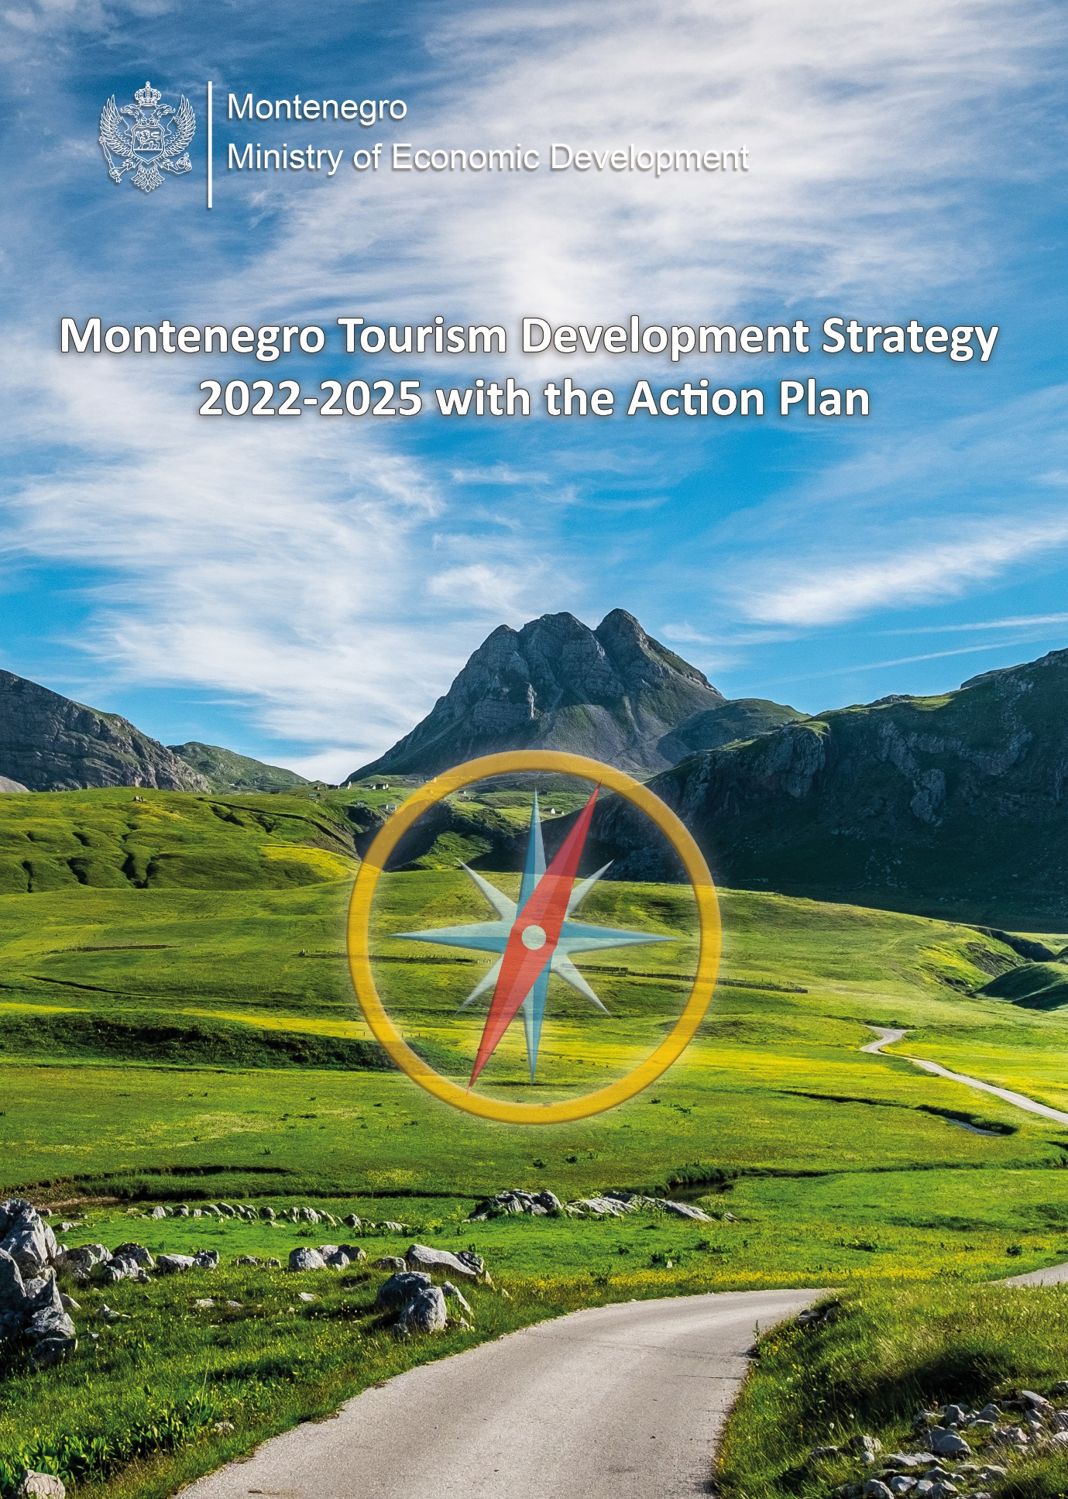

Podgorica, March 2022
IMPRESSUM

The Ministry of Economic Development thanks the members of the Interdepartmental Working Group, UNWTO and other international (ERBD, UNDP, World Bank) and national partners, tourism industry and the professional public, who took part and contributed to the development the Montenegro Tourism Development Strategy 2022-2025 with the Action Plan.

Project team:

MSc Aleksandra Gardašević-Slavuljica
Ministry of Economic Development

Goranka Lazović
Ministry of Economic Development

Jelena Mugoša
Ministry of Economic Development

Maja Kovačević
Ministry of Economic Development

Ana Todorović
Ministry of Economic Development

LIST OF ABBREVIATIONS

JSC – Joint-stock company
ATTA – Adventure Travel Trade Association
GDP – Gross domestic product
CEI - Central European Initiative
CEDIS - Montenegrin electricity distribution system
COVID-19 - Corona virus
CBM - Central Bank of Montenegro
CGES - Electric Transmission System of Montenegro
VET center - Center for Vocational Education and Training
DMO – Destination Management Organization
EU – European Union
EUROSTAT - Statistical Office of the European Union
EU PPCG - Montenegro’s Program of Accession to the European Union
EUSAIR - EU Strategy for the Adriatic-Ionian Region
EUSDR - EU Strategy for the Danube Region
EK – European Commission
EBRD - European Bank for Reconstruction and Development
FEE - Foundation for Environmental Education
GEF - Global Environment Facility
GIZ - German Agency for International Cooperation
GHG - The greenhouse effect
GMO - Genetically modified organisms
GSTC - Global Sustainable Tourism Council
HG - Hotel group
HTP - Hotel and Tourism Company
IUCN - International Union for Conservation of Nature
ICOMIA - International Council of Marine Industry Associations
IPH (Montenegro) - Institute of Public Health of Montenegro
ILS - International Life Saving Federation
Interreg IPA - Cross-border Cooperation Program
Interreg MED Program - Mediterranean Cooperation Program
IPA - EU Instrument for Pre-Accession Assistance
IPARD – EU Support Program for Agriculture Development
IDF – Investment and Development Fund
ISO - International Organization for Standardization
ISME - Institute for Standardization of Montenegro
PENPM – Public Enterprise National parks of Montenegro
PECZM - Public Enterprise for Coastal Zone (PECZM) of Montenegro
LTO - Local tourism organization
MED - Ministry of Economic Development
MESPU - Ministry of Ecology, Spatial Planning and Urbanism
MICE - Meetings, incentives, conferences and exhibitions
MONSTAT - Statistical Office of Montenegro
MoI - Ministry of Interior
MCI - Ministry of Capital Investments
MESCS – Ministry of Education, Science, Culture and Sports
MAFWM – Ministry of Agriculture, Forestry and Water Management
MoH – Ministry of Health
NTO Montenegro – National Tourism Organization of Montenegro
NGO – Non-governmental organization
OECD – Organization for Economic Co-operation and Development
CEM – Chamber of Economy of Montenegro
SDG – Sustainable development goals
TS – Tourist settlement
DIA – Directorate for Inspection Affairs
UN – United Nations
UNEP – United Nations Environment Program
UNESCO – United Nations Educational, Scientific and Cultural Organization
UNDP – United Nations Development Program
UNWTO – United Nations World Tourism Organization
WB – World Bank
WHO – World Health Organization
WTTC – World Travel and Tourism Council
EAM – Employment Agency of Montenegro
RIM – Railway Infrastructure of Montenegro

CONTENTS
1. INTRODUCTION 8
1.1. Tourism in Montenegro 8
1.2. Institutional, Legislative and Strategic Framework 10
2. SITUATION ANALYSIS 28
2.1. Implementation of the Montenegro Tourism Development Strategy until 2020 28
2.2. Quantitative and Qualitative Analysis of Tourism Parameters 29
2.2.1. Tourist Arrivals and Overnight Stays 29
2.2.2. Tourism Revenues 31
2.2.3. Seasonality and regional inequality 32
2.2.4. Emitting markets and participation in tourism turnover 35
2.2.5. Average stay of tourists 41
2.2.6. Accommodation capacities, collective and individual accommodation 42
2.2.7. Labor force in tourism 45
2.2.8. Earnings in tourism 46
3. IMPACT OF THE COVID-19 PANDEMIC ON TOURISM IN 2020 AND 2021 49
3.1. Assessment of the situation in tourism in 2020 compared to 2019 49
3.2. Rehabilitation policy in 2021 51
3.3. Results of tourism turnover during 2021 54
3.4. UNWTO - from crisis to transformation 55
4. SWOT ANALYSIS 59
5. PESTLE ANALYSIS 62
6. ANALYSIS OF PARTNERSHIPS IN TOURISM 65
7. COMPARATIVE ANALYSIS OF TOURISM IN COMPETITIVE MARKETS 67
8. PRIORITY EMITTING MARKETS 73
9. PROBLEM TREE 77
10. VISION, MISSION, CREDO 79
11. MODERN DIRECTIONS OF TOURISM DEVELOPMENT 81
11.1. Sustainable tourism 81
11.2. Inclusive tourism 82
11.3. Smart tourism 83
11.4. Green and responsible tourism 84
11.4.1. National Certificate for Responsible Tourism 84
11.4.2. Climate change 85
11.4.3. E - mobility 86
11.4.4. Certification in tourism 87
12. GOALS OF TOURISM DEVELOPMENT IN MONTENEGRO 90
12.1. Projections for the development of accommodation capacities and the workforce 90
13. SOLUTION TREE 97
14. STRATEGIC AND OPERATIONAL GOALS IN TOURISM 100
14.1. Operational goal 1 - Improved regulatory framework in tourism with formalization of tourism turnover 101
14.2. Operational goal 2 - Improved tourism infrastructure and supporting infra and supra structure 101
14.3. Operational goal 3 - Improved quality and quantity of accommodation capacities 102
14.4. Operational goal 4 - Improved quality of diversified tourism product 104
14.5. Operational goal 5 - Improved human resources, knowledge and skills in tourism 119
14.6. Operational goal 6 - Development of digital, innovative solutions and new technologies in tourism 120
14.6.1. Strengthening and optimization of the national statistical system 120
14.7. Operational goal 7 - Montenegro - a globally recognized tourist destination 121
15. TOURISM CLUSTERS 125
15.1. TOURISM CLUSTER 1 - Ulcinj with Ada Bojana 127
15.2. TOURISM CLUSTER 2 - Bar Riviera with Skadar Lake 129
15.3. TOURISM CLUSTER 3 - Budva Riviera 131
15.4. TOURIST CLUSTER 4 - Bay of Kotor 133
15.5. TOURISM CLUSTER 5 – The Old Royal Capital Cetinje 137
15.6. TOURISM CLUSTER 6 – The Capital City with the Central region 139
15.7. TOURISM CLUSTER 7 – Bjelasica, Komovi and Prokletije 143
15.8. TOURISM CLUSTER 8 – Durmitor and Sinjajevina with Tara and Piva rivers 145
16. STRATEGIC AND OPERATIONAL GOALS OF TOURISM DEVELOPMENT OF MONTENEGRO 2022 - 2025 153
17. STRATEGY IMPLEMENTATION 158
17.1. Financial framework for the implementation of activities 158
18. MONITORING, EVALUATION AND REPORTING ON THE IMPLEMENTATION OF THE ACTION PLAN 160
19. ACTION PLAN 162
20. COMMUNICATION PLAN 209
Annex I: Partnerships in tourism 210
Annex II: Investment activities in the tourism sector 216

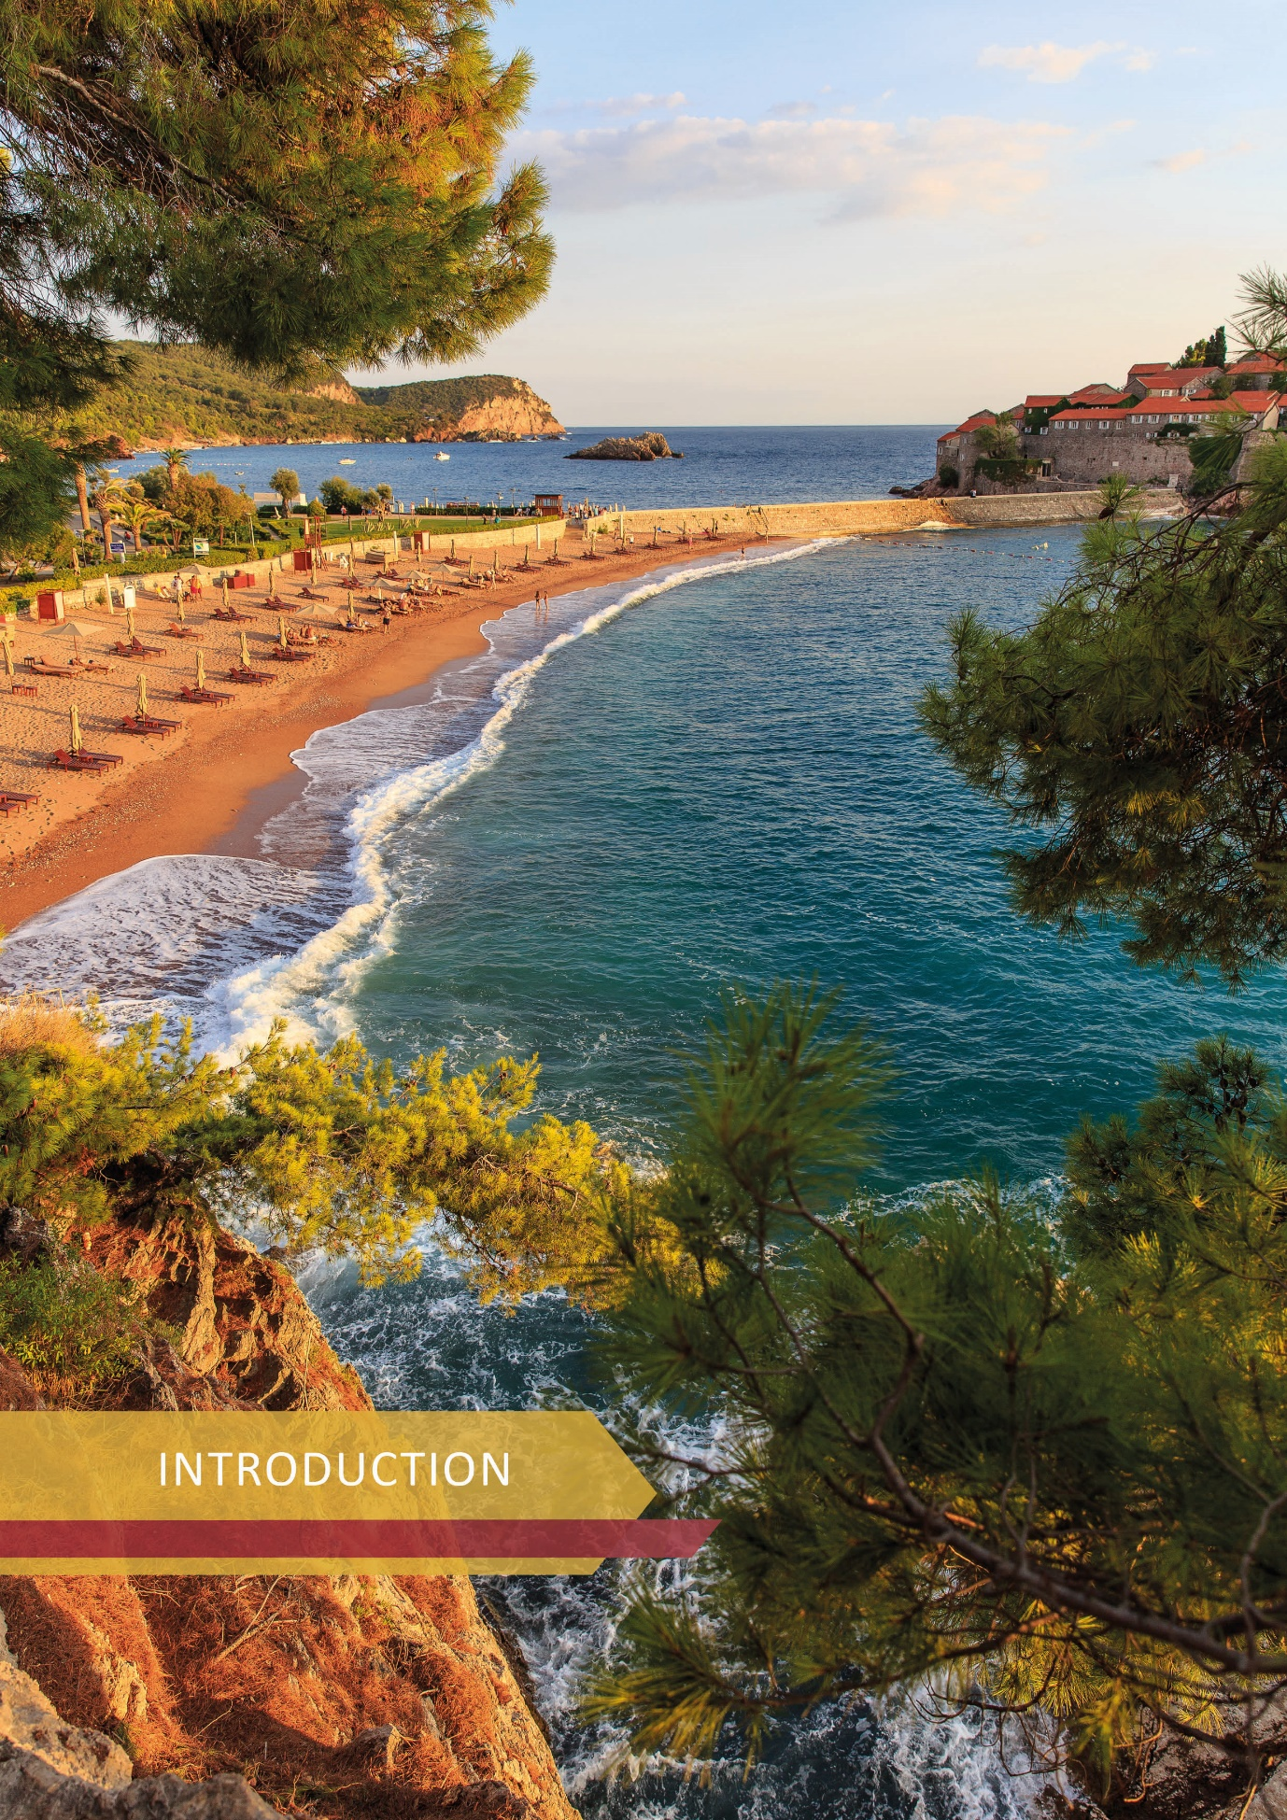

INTRODUCTION

Tourism in Montenegro

Tourism is a strategic economic branch of the Montenegrin economy. Until 2020, which is characterized by the outbreak of the COVID-19 pandemic, from year to year, the tourism sector had recorded an increase in the number of tourists and overnight stays, investments, and final revenues.
The key indicators from the report of the World Travel and Tourism Council (WTTC) for Montenegro, which refer to 2019, are the following: total (direct and indirect) contribution of the tourism and travel sector to gross domestic product (GDP) was 30.9%, the total contribution to employment was 31.9%, and the share of tourism in total exports was 52.6%. If we look at the data for the period from 2009 to 2019, it can be stated that the number of tourists increased by 119%, the number of overnight stays by 91%, and the total revenue by 92%. Statistics also show that over 90% of tourist visits are in the coastal region and mainly during the short summer period (June-September).
In order to further develop tourism to ensure employment increase, raise living standards, ensure more balanced regional development, but also improve the global recognizability of the country, the Government of Montenegro opted for continuous sustainable development of tourism, focusing on efficient use of resources, promoting Montenegro as sustainable, inclusive, green and smart tourist destinations. When creating a strategic approach, it is important to respect the constitutional provision that Montenegro is an ecological state, as well as the framework provided by the adoption of the National Strategy for Sustainable Development of Montenegro until 2030, which includes the principles of sustainability from the United Nations Agenda for Sustainable Development until 2030.
Montenegro is recognized as a country rich in natural diversity in a small territory, a country of contrasts of North and South, with five national parks, five UNESCO World Heritage Sites, six nature parks, two marine protected areas, three Ramsar sites and numerous lakes, with rich cultural and historical and multicultural heritage, authentic gastronomy, and whose potentials have not been adequately and sufficiently valorized so far, in order to create a year-round tourist destination. In order to achieve the above in the best possible way, the Concept of the Spatial Plan of Montenegro until 2040 for the field of tourism was used for the development of this Strategy in order to harmonize them. In other words, the project teams for the preparation of both documents directly cooperated, exchanged data and visions in the direction of defining common positions on the development of tourism in Montenegro. In that sense, the visions for the development of tourism clusters in this Strategy are fully compatible with the visions for the development of the regions defined in the Concept of the Spatial Plan of Montenegro until 2040.
Despite the progress made in the previous period, tourism has not developed in accordance with the principles of sustainability and preservation of the environment and resources. Among the goals of this Strategy, in addition to the segment of sustainability, special attention was paid to challenges such as: reducing seasonality with diversification of products and services, reducing regional development imbalance, improving the tourist experience, increasing the number of high-capacity accommodation in the Central and Northern region, improving accessibility by transport, implementation of innovative solutions and modern technologies, improving destination management, improving destination promotion, strengthening public-private partnerships, all in correlation with the strategic goals of the Government of Montenegro aimed at raising living standards.
In order to achieve better results in the tourism sector, it is necessary to diversify products and services. It can be achieved through continuous work on the sustainable use of all natural and created potentials that Montenegro has. By diversification, the product would exceed the offer of “sun and sea”, as Montenegro is most often perceived as a tourist destination, and that would result with extended tourist season and balanced regional development, reducing the pressure on the coast, while respecting the principles of sustainable development of the destination. Tourism, as the dominant development branch of Montenegro, is of key importance for achieving economic stability. As such, it promotes the further development of complementary industries, mostly agriculture and food industry, transport, trade, and construction. Complementarity with other sectors is the basis for wider coverage and further concretization of development plans, activities and measures that apply to the entire economy.
The global crisis in 2008 significantly affected the destabilization of tourism in Montenegro. In that year, the Montenegro Tourism Development Strategy until 2020 was adopted. This Strategy defines the strategic goal of tourism development, which reads: By applying the principles and sustainable development goals, Montenegro will create a strong position of a global high-quality tourist destination, tourism will provide the Montenegrin population with enough jobs and raise living standards, and the country will generate revenue in a stable and reliable way. However, the strategic and operational goals of the Strategy have not been implemented, as evidenced by numerous inherited problems and the situation in which tourism in Montenegro is, which is partly caused by the global economic crisis.
The Ministry of Economic Development has initiated the development of a new Montenegro Tourism Development Strategy 2022-2025 with the Action Plan. The Strategy refers to a four-year period due to more efficient strategic planning of tourism development in the conditions of altered reality, in accordance with the current pandemic and other potential challenges. The Strategy is an umbrella strategic document, which identifies opportunities for further development of tourism, taking into account the principles of sustainability, compliance, potential, development needs and requirements of the economy, domestic and foreign markets.
During the drafting of the Strategy, trends in the international market were taken into account, as well as the health and economic crisis caused by the COVID-19 pandemic. Therefore, it seems that it is the right moment to, in addition to the recovery of tourism, pay attention to the creation of a new development and management model. In this regard, Montenegro Tourism Development Strategy 2022-2025 with the Action Plan defines the directions of tourism development, with the development of competitiveness and better positioning of Montenegro on the global tourism map. The Action Plan defines key measures and activities as well as their holders, and envisages deadlines and financial framework for their implementation.
The preparation of the document included a wide range of stakeholders, at the state and local level, partners from the public and private sector - relevant ministries and other institutions with public authority, academia, the National Tourism Organization of Montenegro and local tourism organizations, tourism, business and tourism associations, the NGO sector, but also international actors such as the World Bank, the European Bank for Reconstruction and Development (EBRD), the German Agency for International Cooperation (GIZ) and the UN Development Program (UNDP). During the preparation of both the text of the Strategy and the Action Plan, it was taken into account that specific activities and projects of other relevant ministries (transport, energy, utilities, etc.) that are in the function of tourism development, are in principle presented in the Action Plan of this Strategy, because their specific and detailed implementation is the subject of the scope of work of relevant ministries, with a tendency to avoid overlapping in terms of inter-ministerial cooperation and taking into account cross-cutting documents.
The engagement of the United Nations World Tourism Organization (UNWTO) should be especially emphasized, since it followed the entire process of drafting the Strategy and with its suggestions and reports made by experts, contributed to harmonizing the goals of this Strategy with UNWTO goals and current, very demanding, present and future trends in the international tourism market, analyzing the Montenegrin market as well. Due to all of the above, the Strategy is internationally recognized.
Partnerships at all levels are envisaged for the implementation of the Action Plan measures, especially at the level of public and private sectors, because only through synergy, as well as comprehensive networking of a large number of stakeholders, tourism can fully contribute to Montenegro's economic prosperity.

Institutional, Legislative and Strategic Framework

Institutional framework and establishment of the National Tourism Council
In the existing institutional system, the Ministry of Economic Development, responsible for tourism, the National Tourism Organization of Montenegro and local tourism organizations have a leading role in defining development policies in tourism, destination management and creating a tourism product.
Taking into account the large share of tourism in GDP and its dominant impact on economic flows in the country, this Strategy proposes the establishment of the National Tourism Council, a body whose task would be to strengthen tourism as a sector, both nationally and internationally. The mission of the National Council would consist of proposing and implementing activities of importance for all entities in the country in the field of tourism and complementary branches, as well as raising standards in this sector with the aim of better global positioning of Montenegro as a tourist destination, strengthening the economy through better integration of tourism and other branches of the economy, creating a stable business and investment tourist environment and greater tourist satisfaction. The National Council would have a role in controlling the implementation of this Strategy, and it would include representatives of the private sector, which would further strengthen public-private partnership and the role of the private sector in making strategic decisions in the field of tourism.
Bearing in mind the need to improve the business and investment environment, as well as to create a new model of tourist destination management, it is necessary to consider the possibility of restructuring tourist and economic bodies in the field of tourism in the coming period, by introducing a destination management model. Within the destination management, it is necessary to improve the functioning and coordination of destination promotion, with the aim to better position Montenegro in the competitive international tourism market. The synergy of the National Tourism Organization of Montenegro with local tourism organizations and other tourism actors is necessary through the strengthening of public-private partnership, which should be the backbone of the future functioning of the sector.
A significant role in the institutional system in the context of tourism is played by the PE National Parks of Montenegro, as an enterprise that manages 7.7% of ​​our territory, but also by the Public Enterprise for Coastal Zone, which manages approximately 300 km of beaches. The role of these two enterprises should be further strengthened in the context of tourism, as they represent valuable partners in the system of planning, management, valorization and implementation of projects in tourism. In addition to the above, special attention should be paid to a number of companies which are of strategic importance, in terms of defining their future ownership, management and organizational structure.

Legislative framework and standards in tourism
The legal basis for the preparation and adoption of the Tourism Development Strategy is contained in the Law on Tourism and Hospitality (“Official Gazette of Montenegro”, No. 02/18, 013/18, 25/19, 67/19, 76/20, 130/21), which stipulates that tourism development is planned by the Tourism Development Strategy. In addition to the Law on Tourism and Hospitality, the legislative framework for tourism is also regulated by the Law on Tourism Organizations, the Law on Tourist Tax, the Law on Mountain Paths, the Law on Ski Resorts and the Law on Rafting.
With the aim of further harmonization of the national legislation with European legislation, as well as further normative improvement of business in the field of tourism, activities on the preparation of the new Law on Tourism and Hospitality are in the final stage for forwarding to the Government of Montenegro for adoption.
The legal solutions defined by the Law on Spatial Planning and Construction of Structures, the Law on Nature Protection, the Law on National Parks, the Law on Strategic Environmental Impact Assessment and the Law on Environmental Impact Assessment, with which the degree of necessary coherence is achieved, have a direct impact on the tourism sector.
In order to raise the level of competitiveness of the tourism product, while following modern tourist trends, the need for constant upgrading of the tourist business is set as an imperative, where the quality of services (products) is the basic means for success. In the direction of achieving a high level of service quality, satisfactory results are achieved with the implementation of ISO standards, as international proof of quality.
Quality management standards are especially important in tourism because the focus is on “human”, who is becoming more and more demanding tourists, so adapting to changes in the international tourism market creates opportunities and increases the competitiveness of the destination. In this regard, the COVID-19 pandemic has further heightened the need for standardization.
As a service activity, tourism puts in the forefront the emotional and spiritual component, in relation to the material component of the product, service or experience. The quality of the above grows with the greater commitment of the service provider and its contribution to make tourists satisfied and safe, i.e., that their travel, rest and leisure be in the function of raising the levels of satisfaction and quality of their life.
Standards improve orderliness and guarantee an organized approach to managing processes that meet the needs and requirements of service users / tourists, but also exceed their expectations. The quality of orderliness of the tourist destination is, among other things, reflected in the accommodation capacities that are improved by applying standards for: system requirements for adequate quality management, environmental protection, food safety, health and safety at work, energy management, information security, specialization for hotels, various types of tourism, travel, etc.
Strategic framework
In 2015, under the auspices of the United Nations (UN), world leaders adopted the universal 2030 Agenda for Sustainable Development, which is based on seventeen Sustainable Development Goals (SDGs), the fulfillment of which should result in achieving the ultimate goal, and that is a better future for humanity. Taking into account the nature of tourism as a driver of economies around the world, and considering the 17 above mentioned UN goals, it is possible to conclude that tourism has the potential to contribute to the achievement of all, directly or indirectly, depending on the type of goal. Analysis of 17 sustainable development goals indicates that tourism is included in the measures under goals 8, 12, 14 and 17. These 4 Tourism SDGs include economic growth and "work for everybody", sustainable patterns of production and consumption, conservation and sustainable use of seas, oceans and their resources, as well as partnerships in order to achieve all goals. Therefore, the goal of tourism development should be based on the creation of policies and business practices at the national level, which will be in the function of achieving these goals, while raising public awareness of tourism and the importance of UN sustainable development goals. All national and international strategic documents are based on UN strategic development goals.

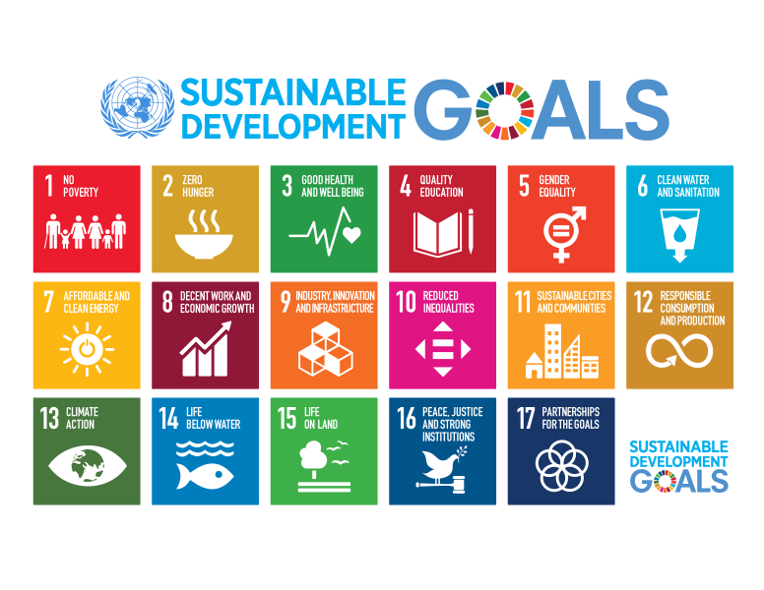
The following is an overview of the Strategic, National and International Framework, whose priorities are correlated with the priorities of Montenegro Tourism Development Strategy 2022-2025 with the Action Plan.

Strategic framework of Montenegro Tourism Development Strategy 2022-2025 with the Action Plan
Europe 2020 Strategy and South East Europe 2020 Strategy |  | Commitments from the EU accession process of Montenegro (Chapters 3, 20 and 27) |  | Smart Specialization Strategy of Montenegro 2019-2024
Multiannual Financial Framework EU 2021-2027 |  | National Strategy for Sustainable Development of Montenegro until 2030 |  | National Strategy in the field of Climate Change until 2030
EU: Tourism and Transport in 2020 and beyond |  | Montenegro Development Directions 2018-2021 |  | Strategy for the Development of Micro, Small and Medium Enterprises (MSMEs) in Montenegro 2018-2022
EU macro-regional strategy: for the Adriatic-Ionian region 2014-2020 (EUSAIR) and EUSDR |  | Montenegro’s Program of Accession to the European Union 2020 – 2022 |  | Strategy for the Development of Official Statistics 2019-2023
Europe's moment: Repair and Prepare for the Next Generation |  | Montenegro Economic Reform Program  2022 – 2024 |  | Disaster risk reduction strategy  2018-2023
For a new EU integrated Tourism Policy: EUROPE – 27. countries, one destination |  | Macroeconomic and fiscal policy guidelines for the period  2020 -2023 |  | National Employment Strategy 2021-2025
Europe, the world's number one tourist destination, new policy framework for tourism in Europe |  | Economic and Investment Plan for the Western Balkans |  | Strategy for the Development of Women's Entrepreneurship of Montenegro 2021 – 2024
 |  | Europe now! |  | Strategy for Regional Development of Montenegro 2014-2020
Strategic framework of the EU |  | Obligations of Montenegro in the process of accession of Montenegro to the EU and the Strategic Framework of Montenegro |  | Strategic framework of Montenegro
MONTENEGRO TOURISM DEVELOPMENT STRATEGY 2022-2025
Sectoral strategies |  | Thematic Strategies / Programs |  | Other relevant documents
Industrial policy of Montenegro 2019 – 2023 |  | Strategy of scientific research activity 2017 – 2021 |  | European Green Deal Investment Plan 2021-2030
Strategy for the Development of Forests and Forestry 2014-2023, National Forestry Strategy |  | Cultural Tourism Development Program of Montenegro  2019 -2021 |  | Study and road-map for policy and incentive options for green businesses in agricultural, tourism and energy sectors
Energy Development Strategy of Montenegro until 2030 |  | Health Tourism Development Program of Montenegro 2021-2023 |  | EC 2020 Progress Report on Montenegro
Transport Development Strategy 2019-2035 |  | Program of Rural Tourism Development of Montenegro 2019 - 2021 |  | GHG emissions from tourism 2018
Strategy for the development of agriculture and rural areas in Montenegro
2015-2020

Harmonization of Montenegro Tourism Development Strategy 2022-2025 with the Action Plan with the existing strategic framework

Understanding the current development concept, based on information on the achieved level of implementation of relevant policies, is one of the preconditions for establishing a framework for more efficient tourism development. In this regard, relevant policies and documents that represent a strategic framework at the national level and are important for identifying development potentials and orientations formulated in horizontal and thematic policies have been identified and analyzed.
Montenegro Tourism Development Strategy 2022-2025 with the Action Plan, as shown in the review of the Strategic Framework, is correlated with strategic national and EU documents. The key recommendations for formulating the Strategy stem from the process of creating a comprehensive development policy of Montenegro and harmonization with the strategic principles of the EU. They refer to the choice of measures application of which would effectively increase the competitiveness of Montenegro in the international tourism market.
The basic directions of tourism development identified in the Strategy, which relate to sustainable, inclusive, smart, green and safe tourism, are a strong link with the umbrella international and national documents.

National framework
The National Strategy for Sustainable Development until 2030 is the umbrella, horizontal and long-term development strategy of Montenegro, which refers not only to the environment and economy, but also to human resources and social capital that should enable prosperous development of Montenegro. Project activities in the tourism sector are primarily based on compliance with the principles of sustainability defined by the National Strategy for Sustainable Development of Montenegro until 2030.
In terms of implementing the National Strategy for Sustainable Development until 2030, as an umbrella document for sustainable development, which is in line with the sustainable development goals of the UN Agenda until 2030, Montenegro has committed itself to:
- improve the local entrepreneurial infrastructure and business environment for the development of entrepreneurship and small and medium-sized enterprises (SGD 8.9.1) in order to put into operation national, local and tourist business zones, through financial support for infrastructure equipment, improvement of the promotion programs, introduction of tax and administrative relief at the state and local levels, as well as an increase in investment in tourism encouraged by fiscalization measures. The goal will be achieved through additional relieves for investors investing in tourism in the northern and central region of Montenegro, and through the model of tourist development zones (green investments in tourism) which will be regulated by special regulations and through the model of establishing, managing and functioning of zones of national interest (SGD 8-8.3);
- strengthen incentives and tax relieves in tourism for the construction of high-class hotels and strengthening new forms of offer, in accordance with the principles of sustainable development and strategic planning documents (reducing return on investment in high-class hotels from 20 to 12 years, and significant net positive impact on public finance, as well as employment growth);
- improve the importance of culture as a fundamental value of spiritual, social and economic development that significantly improves the quality of life of citizens, promote cultural tourism as one of the most important branches of tourism and enable its sustainability with an emphasis on cultural and eco-tourism, since it is necessary to establish sustainable use of cultural heritage through their and the development of other forms of tourism, as well as agriculture, crafts and creative industries (SDG 11 (11.4) and SDG 8 (8.9));
- improve the efficiency of resources in the field of tourism: encourage greening of tourism and improve the efficiency of resources by supporting green investments in hotel and hospitality facilities, as well as capacities for water supply and waste management during the construction; reduce the amount of waste from tourism activities and improve the management of existing waste; protect vulnerable ecosystems from the impact of tourism development; stimulate the introduction of new green technologies in tourism; encourage the preservation of the attractiveness of the destination in the long run, including innovation through environmental management, marketing, new business or organizational forms; improve regulation in markets where price signals are ineffective (creating better price signals and market-based instruments that will be able to reduce costs incurred due to negative environmental externalities); introduce green public procurement to encourage the development of green innovation (link to goal 4.5 NSSD), SDG 6 (6.3), 7 (7.3), 11 (11.6), 12 (12.b), 15 (15.5).
The implementation of the principle of sustainability is aimed at creating preconditions for an even tourist offer from the regional aspect, in accordance with the Strategy for Regional Development of Montenegro 2014-2020. The tourism development strategy emphasizes the faster development of the North, which creates the conditions for regional tourist offers to be better harmonized. In this way, in the end, the reduction of differences in the development of the economy between the North and the coastal area will be ensured, because tourism is an activity with multiplicative effects on other economic branches. In addition to the above, the improvement of the tourism product aims to increase the number of newly created jobs and reduce migration from the North to the South, while raising the living standards of the population, in accordance with the National Employment Strategy 2021-2025.
In the sector of tourism, the holders of activities are primarily micro, small and medium-sized enterprises, which creates the preconditions for developing a family business that enables the employment of greater number of women (in the tourism sector more than 50% of employees are women) and young people, and in correlation with the Strategy for the Development of Micro, Small and Medium Enterprises 2018-2022, the Strategy for the Development of Agriculture and Rural Areas in Montenegro 2015-2020 and the Strategy for the Development of Women's Entrepreneurship 2021-2024.
In order to provide preconditions for achieving tourism prosperity, special attention is paid to improving the accessibility of Montenegro, from the aspect of international, regional and domestic markets, in accordance with the Transport Development Strategy for the period 2018-2035.
Improvement of destination management, which is one of the goals of the development of this Strategy, will be implemented through project activities of the National Brand Development Strategy of Montenegro 2022-2026 which states that “successful national branding also accumulates economic results which are reflected, among other things, in the development of tourism, i.e., greater attractiveness of the country for tourists”.
As one of the economic priorities of Montenegro, tourism is recognized in the following development documents of the Government of Montenegro:
Directions of development of Montenegro 2018-2021, a medium-term umbrella development implementation document, in which the strategic goal of development of Montenegro was determined, which is increasing the quality of life in the long run. In order to achieve the strategic development goal, four priority development sectors have been formally identified: tourism (“Tourism and Cultural Tourism”), energy, agriculture and rural development, and manufacturing industry. The plan in 2022 is to adopt the Directions of Development of Montenegro 2022-2025, which will be based on the current situation, at the national, regional and global level, as well as expectations, i.e., plans contained in sectoral strategic development documents;
Montenegro Economic Reform Program 2022-2024 is the most important document of Montenegro in the economic dialogue with the European Union and the key strategic document of the country for medium-term macroeconomic and fiscal programming, which contains the accompanying agenda of structural reforms which are important for reducing or eliminating obstacles to economic growth and strengthening overall competitiveness. Tourism has been identified through two priority reform measures, as follows: “Information systems with a mobile application for monitoring tourism parameters” and “Sustainable green tourism”;
The “Europe Now!” reform program for a more inclusive and sustainable model of economic development of Montenegro - At the end of December 2021, the Parliament of Montenegro adopted the Law on Budget for 2022, which is part of the “Europe Now “economic program. The goal of the Program is to achieve inclusive economic growth that will contribute to improving the quality of life of all citizens of Montenegro, i.e., reducing poverty, unemployment, preventing young people and skilled labor force from leaving the country, so the Government of Montenegro, in terms of proactive action, proposed a set of reform measures which is contained in this Program. The unambiguous orientation of the Government is reflected in improving the living standard and employment of citizens, improving the business and investment environment, reducing the gray economy and creating a sustainable, smart and inclusive economic model, in order to create a more favorable environment for living and working in Montenegro. In accordance with the above, the economic program – “Europe Now!” defines the following goals: increasing the living standard of citizens, employment growth, reducing the gray economy in the labor market and improving the business and investment environment;
Smart Specialization Strategy 2019-2024 - Based on the strategic vision of the development of Montenegro, by applying the S3 methodology and implementing the process of entrepreneurial discovery, four priority economic areas have been defined as follows: renewable energy sources and energy efficiency; sustainable agriculture and food value chain; sustainable and health tourism and ICT. Health tourism is growing steadily and is one of the most promising segments of the offer on the global market. According to the strategy of smart specialization, tourism and health, are, among others, the basic pillars of the sustainable development. Cooperation between the tourism and health sectors in Montenegro enables the achievement of a synergy effect for the improvement of health tourism, but also the year-round tourist offer. Montenegro with its geographical position, numerous natural tourist attractions, rich cultural heritage and developed offer in the segment of rehabilitation, prevention, dentistry and cosmetic surgery, has all the conditions to become an internationally recognized destination for health tourism. The vision of Montenegro for 2024 is the following: an internationally recognized destination for sustainable and health tourism with a year-round and diversified tourist offer based on the principles of sustainability, equality, competitiveness, innovation and authenticity.

Green growth and circular economy

Montenegro, which is very tourism-oriented and declared an ecological state, must pay special attention to the valorization of green growth and circular economy, by integrating demographic, social, nature and economic aspects of economic development, as stated in the National Strategy for Sustainable Development of Montenegro until 2030, which transferred the universal UN sustainable development goals to the national context. Industrial policy of Montenegro 2019-2023 accepts the principles based on the development of green economy, resource efficiency and sustainable production and consumption, industrial waste management, introduction of environmental standards and defining measures and activities for their implementation.
Special attention in the horizontal harmonization of strategic documents is paid to the analysis of harmonization with specific thematic strategies. Taking into account the strategic goal of tourism development and the need for diversification of the tourism product, the Government of Montenegro adopted the Program of Rural Tourism Development with the Action Plan until 2021, Cultural Tourism Development Program with the Action Plan 2019-2021, and Health Tourism Development Program with the Action Plan 2021 -2023, which define the topics of these important forms of tourism, restrictions but also measures, recommendations and guidelines regarding their development.
The strategic goal of rural tourism development is defined by the Program of Rural Tourism Development 2019-2021 and it is aimed at developing a diversified and authentic rural tourist offer of Montenegro, which will create a basis for the improvement of the living standards of the population and stopping the depopulation of rural areas. The program was not fully implemented due to the COVID-19 pandemic, so the continuation of implementation is envisaged by this Strategy.
Cultural Tourism Development Program of Montenegro with the Action Plan 2019-2021 envisages to enrich the tourist offer through the valorization of cultural heritage, while creating conditions for additional revenue, given that analyzes indicate that tourists whose main reasons for travel are cultural facilities, belong to the category of tourists who are willing to spend extra money on this type of tourist offer. Due to the COVID-19 pandemic, this Program was not implemented either, so the continuation of its implementation is envisaged by the new Tourism Strategy.
Based on the analysis of the situation, the Health Tourism Development Program of Montenegro with the Action Plan 2021-2023 defines key measures and goals for more intensive development of this form of tourism, in order to create preconditions for its more efficient development and creation of new jobs. This document will contribute to the improvement of the legislative framework for the development of health tourism, improvement and strengthening of the overall health infrastructure, positioning and recognition of Montenegro as a destination for health tourism.

Harmonization with key EU policies in the context of the European integration process and regional cooperation
- Commitments from the process of Montenegro's accession to the EU (Chapters 3, 18, 19, 20, 27 and 28):
Chapter 3 – The freedom to provide services from the aspect of tourism enables the functioning of the internal market of the European Union and includes the right of establishment of a company in any member state of the Union. Establishment of a company means the right to start and pursue activities in any Member State, by founding companies or as self-employed persons. The right to establish a company will enable Montenegrin business entities to initiate, start and pursue economic activities in a stable and continuous manner in one or more Member States of the Union.
Chapter 18 – Statistics is important as an instrument for monitoring and adopting development policies, and is primarily based on quantitative indicators. Economic policy makers should continuously monitor the development of statistics in tourism, and contribute to greater harmonization with the EU statistical system through joint inter-institutional efforts.
In Montenegro, the need for better statistical reports, primarily in terms of their timeliness, comprehensiveness and accuracy, is especially evident after MONSTAT, in 2017, began implementing EU Regulation 692/2011. This regulation defines that EU member states that have less than 1% of the total annual number of overnight stays in tourist accommodation facilities in the European Union, may process data on the number of tourist arrivals and overnight stays only for tourist facilities in hotels and other collective accommodation, while publishing data from private accommodation is not required. As Montenegro is below the 1% threshold, taking into account the national interest in data on tourist arrivals and overnight stays in individual / private accommodation, MONSTAT publishes data on individual / private accommodation on an annual basis. However, publishing annual data on tourism turnover in individual / private accommodation, which accounts for about 70% of total tourism turnover, is a problem both in terms of quality data processing and analysis during the year and in terms of the need for possible rapid response to changes in tourism market, which was especially evident during the crisis in 2020. The crisis caused by the war in Ukraine has additionally highlighted this problem, which indicates the need to find a fast and efficient model for obtaining data on total turnover in the shortest possible time intervals.
On the other hand, we highlight the example of good practice in statistical data processing. Specifically, it is about a pilot project - Tourism Satellite Accounting - TSA, which was experimentally implemented in Montenegro in 2011. The aim of the application of tourism satellite accounting is to measure the economic effects of tourism based on a comparison of tourism-generated demand for products and services, as well as their supply. All aspects of demand for products and services related to the activities of visitors, the connection with the supply of these products and services in the economy are also analyzed in detail and the relationship of supply with other economic aspects is described. The project was implemented by MONSTAT in cooperation with the Central Bank of Montenegro, the then Ministry of Sustainable Development and Tourism, the National Tourism Organization of Montenegro, the Faculty of Tourism Bar and the Institute for Strategic Studies and Prognoses. The project is financed from IPA funds, as a financial pre-accession instrument of assistance to Montenegro.
Bearing in mind that the process of determining revenue from tourism, i.e., daily consumption of tourists in Montenegro is still non-standardized (i.e., it is primarily based on MONSTAT data and research done by the Central Bank of Montenegro), it is necessary to intensify activities on the introduction of tourism satellite accounting and improving the revenue estimation methodology applied by the CBM.
Chapter 19 – Social policy and employment - includes the EU acquis in the field of social policy and employment. Policies in these areas primarily rely on the provisions of Article 3 of the Treaty on European Union, which states that the Union's basic objectives include: full employment, social rights and protection, equality between men and women, intergenerational solidarity, protection of the rights of the child, combating social exclusion and discrimination.
Chapter 20 – Enterprise and industrial policy - the goal is to create a favorable environment for producers and entrepreneurs by supporting competitiveness and equal business activities in Europe and around the world. Topics covered by the EU acquis are industrial policy, instruments of financial assistance to small and medium-sized enterprises, the tourism industry, the aerospace and maritime industry, the wood industry, the steel and metals industry.
Chapter 27 – The environment includes a significant scope of the EU acquis which is also demanding for the current Member States: horizontal legislation, water and air quality, waste management, nature protection, industrial pollution control and risk management, chemicals and genetically modified organisms (GMOs), noise and forestry , consistent application of which will create an optimal environment for further development and promotion of Montenegrin tourism and the determinant of Montenegro as an ecological state arising from the Constitution.
Chapter 28 – It consists of two major areas: consumer and health protection. The goal of consumer protection policy is to protect the economic interests of consumers, product safety, provide information on goods and services, educate consumers about their rights, as well as provide a legal remedy in case of violation of consumer rights. EU consumer legislation offers the possibility of out-of-court settlement of disputes, the right to compensation, the right to unilateral termination of contracts and contributes to the overall strengthening of consumer awareness and a secure EU market for all consumers. Consumer protection is an area of ​​public interest and is in the function of ensuring the quality of life of all citizens of the European Union.
- EU programs and funds
The existence of this strategic document creates an opportunity, and in many segments it is a precondition for applying for funds offered by various international sources of funding. Therefore, the Strategy represents a perspective for the use of many financial potentials, both for the relevant ministry, or other institutions of the public administration system, and other tourism actors who have so-called cross-cutting activities related to this Strategy.
In 2006, the European Union established the Instrument for Pre-Accession Assistance (IPA), with the aim of supporting institution building, implementing key reform processes on the path to the EU accession, but also supporting socio-economic development. So far, projects financed by IPA funds through the financial perspectives of IPA 2007-2013 (IPA I) and IPA 2014-2020 (IPA II) have been implemented and are still being implemented in Montenegro, and IPA 2021-2027 (IPA III) is being prepared. IPA also includes support provided through regional programs and instruments, such as the Multi-Beneficiary IPA Program, the Western Balkans Investment Framework and the EU Programs, as well as through cross-border and transnational cooperation programs. The IPA function is to assist countries which are in negotiations with the EU in achieving sustainable development and poverty rate reduction, and is also a preparation for the use of EU structural and cohesion funds, which are available after accession to the European Union.
Under the IPA I and IPA II programs, support was implemented through several components / sectors. Tourism is not recognized separately anywhere, but the components / sectors have been comprehensively defined, so many projects in the field of tourism have been financed from these funds.
Under the IPA I financial perspective (2007-2013), the European Commission has allocated a total of EUR 235 million to Montenegro through 5 components. Under the IPA II financial perspective (2014-2020), the European Commission has allocated EUR 279.1 million of support to Montenegro, directed through 8 components within which numerous projects in tourism have been implemented. When it comes to IPA III, funds available for all Western Balkan countries for the financial perspective 2021-2027 will amount to more than 14 billion euros.
Apart from the IPA program, in the previous period Montenegro has participated and will continue to participate in some other EU programs, including Horizon 2020, Creative Europe, Erasmus +, COSME, Europe for Citizens, European Program for Employment and Social Innovation (EaSI), IPARD II and III, etc., which are also relevant in the field of tourism.
The same as before, beneficiaries of funds for tourism projects can be non-profit entities with public authorities at the national and local level, NGOs, associations and unions, universities, and other non-profit entities whose activities are harmonized with the subject of the project.
The following are some examples of projects in the field of tourism whose implementation is underway, and within the European Territorial Cooperation Program, which includes partners from Montenegro:

- Projects financed from trilateral programs
Due Mari - Next Generation Tourism Development / May 15, 2019 – November 14, 2022/, is a thematic project within the Interreg IPA CBC Italy – Albania - Montenegro program. The total budget of the project is 5,206,934.15 euros. On the Montenegrin side, the partners are the Ministry of Economic Development and the National Tourism Organization of Montenegro, and the Ministry of Education, Science, Culture and Sports is an associate partner. The aim of the project is to synchronize the economic development of tourism, taking into account the advantages of the program area, through the use of smart technologies and better presentation of local and regional cultural and natural sites. Specific contributions for Montenegro are: collecting data from 270 tourist (cultural and natural) localities in Montenegro in the form of 360◦ videos and photos, creating a Due Mari virtual route, posting data on a common virtual V3D platform, new website of the National Tourism Organization of Montenegro, joint Strategy and Action Plan on Sustainable Management of the Due Mari platform and route, guidelines on the use of innovative digital media in joint promotion through the Due Mari tourism platform, exchange of experiences and modernization of the tourist offer, creation of a new tourist offer, etc.

WRECKS4ALL - Protecting Underwater Heritage Through its Digitalization and Valorization as a Novel Touristic Offer / August 15, 2020 – August 14, 2022 /, is a project implemented within the second call of the Interreg IPA CBC Croatia – Bosnia and Herzegovina – Montenegro. The total budget of the project is 1,016,778.32 euros. Project partners from Montenegro are the University of Montenegro - Faculty of Maritime Studies and the Tourism Organization of Municipality of Bar, and other partners are the Tourist Board of Herzegovina - Neretva Canton and the University of Split - Faculty of Maritime Studies. The main goal of the project is the valorization of the underwater cultural heritage of the eastern Adriatic in order to create a more diverse tourist offer and sustainable use of the cultural heritage of the cross-border area.
ePATH - Endemic Pathway /November 01, 2020 – October 31, 2022/ is a project implemented within the second call of the Interreg IPA CBC Croatia – Bosnia and Herzegovina – Montenegro. The total budget of the project is 1,540,375.30 euros. The partners in the project are the Public Enterprise of Hutovo Blato Nature Park from Bosnia and Herzegovina, the City of Makarska from Croatia and the Public Enterprise for Coastal Zone of Montenegro. The main goal of the project is to improve the tourist offer and preserve the natural and cultural heritage of the cross-border area by developing new natural and cultural trails.
ĆIRO II - Cross-border Thematic Tourism Destination: Old Narrow Gauge Railway / September 01, 2020 – August 31, 2022/, is a project implemented within the second call of the Interreg IPA CBC Croatia – Bosnia and Herzegovina – Montenegro. The total budget of the project is 1,770,362.68 euros. The project partners are the Agency for Construction and Development of Herceg Novi, the municipality of Ravno - Bosnia and Herzegovina and the municipality of Konavle - Croatia. The main goal of the project is to strengthen and make the offer of the neighboring areas of Herzegovina, Dubrovnik-Neretva County and the Bay of Kotor more diverse, through the tourist development of the old narrow gauge railway called ĆIRO. In Montenegro, a part of the bicycle path on the Sutorina - Njivice route will also be reconstructed, as well as the road to the old railway station of Sutorina.
HeritageREVIVED - Preservation, Valorization and Promotion of Cultural Heritage on the Outskirts of Urban Areas /October 15, 2020 – October 14, 2022/, is a project implemented within the second call of the Interreg IPA CBC Croatia – Bosnia and Herzegovina – Montenegro. The total budget of the project is 1,965,441.19 euros. The project is implemented by the Municipality of Ulcinj in cooperation with partners from Bosnia and Herzegovina (PI Development Agency of the West Herzegovina County and City of Ljubuški) and Croatia (City of Solin and County Road Administration Split). The project aims to promote and create a more diverse tourist offer of the cross-border area through revitalization and sustainable use of neglected cultural heritage.
CUHaCHa - Enhancing Sustainable Tourism Development through Culinary Heritage / August 15, 2020 – August 15, 2022/, is a project implemented within the second call of Interreg IPA CBC Croatia – Bosnia and Herzegovina – Montenegro. The total budget of the project is 710,946.24 euros. The project partner from Montenegro is the municipality of Tivat, and other partners are the Zadar County Rural Development Agency, Croatia, the Ministry of Education, Science, Culture and Sports of Herzegovina-Neretva Canton, Bosnia and Herzegovina and Zadar Canton, Croatia. Research of culinary heritage, recipes and old methods of food preparation, creation of culinary heritage trails, equipping traditional kitchens, one in each partner country which will promote the culinary heritage of project areas in various cooking classes, are just some of the project activities.

- Projects financed from bilateral programs
Cult Bike Route / July 15, 2021. – January 15, 2022/ is a project implemented within the second call of the IPA Cross-Border Cooperation Program Serbia – Montenegro. The total budget of the project is 299,898.00 euros. The partners in the project are the Ministry of Education, Science, Culture and Sports of Montenegro, the Discover Serbia NGO from Priboj and the Students’ Association of the Faculty of Transport and Traffic Engineering, Belgrade. The aim of the project is to develop a new cultural cycling route - CULT Bike Route - which connects Eurovelo 8 with Eurovelo 6/11.
Cultural heritage - Treasure of Cross Border Region, is a project implemented within the second call of the IPA Cross-border Cooperation Program Montenegro – Kosovo. The total budget of the project is 421,066.31 euros. The project is being implemented by the municipalities of Gusinje and Peja. The goal of the project is to contribute to the valorization of the cultural heritage of the Prokletije region by establishing new cultural routes and trails as a new tourism product and offer in the target area. The project will also engage and improve the knowledge and skills of people from rural areas to provide tourism services.
Katun Roads of Montenegro and Bosnia and Herzegovina /June 05, 2020 – June 04, 2022/, is a project implemented within the second call of the IPA Cross-border Cooperation Program Bosnia and Herzegovina – Montenegro. The total budget of the project is 466,530.53 euros. The project is implemented by the National Tourist Organization of Montenegro, Sarajevo Regional Development Agency SERDA, Faculty of Agriculture and Food, University of Sarajevo, Municipality of Fojnica and Regional Development Agency for Bjelasica, Komovi and Prokletije. The general goal of the project is to diversify the tourist offer of the cross-border area on the basis of natural and cultural heritage, with an emphasis on rural areas, i.e., katuns.

- Mediterranean program
SMARTMED - Empower Mediterranean for Smart Tourism /September 01, 2019 – September 30, 2022/, is a project that is being implemented within the Interreg Med Program, and the Ministry of Economic Development participates as an IPA partner. The goal of the SMARTMED project is to develop the Mediterranean as an attractive, smart and inclusive destination. The main challenges that the SMARTMED project has to face are the pronounced seasonality and the lack of effective cooperation among the key tourism strakeholders. Seasonality is reflected in high concentration of tourism turnover in time (in a specific, short period of the year, mainly in the summer months) and space (coastal area and a certain number of coastal towns). The main result of the SMARTMED project is the definition of a new business model of SMART tourism. In addition to the leading partner of the project, the Ministry of Tourism and Sports of the Republic of Croatia, 12 other partners are participating in the project. The total budget of the project is 3,000,000.00 euros, of which 2.55 million euros are co-financed from the European Regional Development Fund. The budget of the Ministry of Economic Development is 35,000.00 euros.
Alter Eco Plus - Alternative Tourist Strategies to Enhance the Local Sustainable Development of Tourism by Promoting Mediterranean Identity /June 01, 2021 – June 30, 2022/, is a project that is being implemented within the Interreg MED program, and the Ministry of Economic Development participates as an IPA partner. The total budget of the project is 400,000.00 euros, and the budget of MED is 50,000.00 euros. The partnership agreement for the Alter Eco Plus project was signed between the Ca 'Foscari University of Venice - Department of Economics, as the lead partner and the Valencia Institute of Building, the Government of Catalonia - Directorate General for Tourism, Development Agency of South Aegean Region - Energeiaki S.A., Ministry of Economic Development Montenegro, Dubrovnik-Neretva County - Department for Economy and Maritime Affairs, as partners. The task of the project is to find the optimal way to overcome the shortcomings and improve the capacity in the sustainable development of tourism by determining the “carrying capacity limit” for tourist places.

- European Green Deal
The European Green Deal 2019 is a development strategy goals of which are also implemented in the development documents of Montenegro. Its goal is to transform into a righteous and more prosperous society, with a modern, resource-efficient and competitive economy, with reduced CO2 emissions, where economic growth is separate from resource use. The aim of this strategy is to protect, but also to encourage human, social, natural and economic capital, and to help achieve the UN sustainable development goals in the countries.
All 27 EU member states have bound to transform the EU into the first climate-neutral continent by 2050. In order to achieve the above, they have committed to reduce greenhouse gas emissions by at least 55% by 2030, compared to the levels from 1990. The idea is to review every existing law on climate values, and also to lay a stronger foundation for the circular economy with the new legislation.
The overarching aim of the European Green Deal is for the European Union to become the world's first climate-neutral bloc and encourage more active action in a number of different sectors, including construction, energy, transport, agriculture and food production, and so on.
As the main driver of economic development and investment in Montenegro, the tourism sector is directly and indirectly responsible for a large part of GHG emissions, especially those originating from transport and accommodation facilities. In this regard, in cooperation with UNDP, Montenegro has implemented an innovative project - Towards Carbon Neutral Tourism in Montenegro funded by the GEF. The project aimed to contribute to the reduction of greenhouse gas emissions (primarily CO2) in the tourism sector and significantly reduce the negative impact on the environment. Support was granted to 32 investment projects introducing energy efficiency measures and using renewable energy sources, while about 30 hotels received a green certification and thus contributed to reducing CO2 emissions, while raising public awareness of the importance of nature protection and climate change at the same time. The project helped establishment of Eco Fund that will support the implementation of sustainable projects under the polluter pays principle.
The Economic and Investment Plan for the Western Balkans, adopted by the European Commission on October 6, 2020, aims to encourage the region's long-term economic recovery, support green and digital transition, strengthen regional integration and moving closer to the European Union. The investment plan will be a key driver that will enable public and private investments of European and international financial institutions in the region. Among other things, the Plan defines the priority of “private sector competitiveness”, in order to provide conditions for increasing the amount of grants while guaranteeing capacity to support the private sector while mobilizing aid for sustainable rural development.

- Regional cooperation
The strategic goals presented by the Europe 2020 Strategy are further developed through the South East Europe 2020 Strategy, the Strategy for the Adriatic and Ionian Region, the EU Strategy for the Danube Region and the Central European Initiative, but from the aspect of the region, their potentials and advantages that can provide faster and sustainable economic growth and development, while removing recorded barriers at the same time and overcoming weaknesses that are barriers to development.
The EU Strategy for the Adriatic and Ionian Region (EUSAIR) includes nine countries in the Adriatic-Ionian region: Italy, Greece, Slovenia, Croatia, Serbia, Montenegro, Bosnia and Herzegovina, North Macedonia and Albania. The main goal is the accelerated socio-economic development of the Adriatic-Ionian macro region through enhanced cooperation among the nine countries in the fields of transport infrastructure, energy, blue growth, and tourism and biodiversity conservation, while maximizing the contribution of tourism to growth and employment and promoting cooperation between EU countries, especially by exchanging good practices.
The European Union Strategy for the Danube Region (EUSDR) was adopted in the field of regional connection and cooperation of the Danube region, which includes 14 countries: Austria, Bulgaria, Germany, Hungary, Romania, Slovakia, Croatia, Serbia, Moldova, Ukraine, The Czech Republic, Slovenia, Montenegro and Bosnia and Herzegovina. The strategy is based on four pillars and 11 priority areas, where for the field of tourism development, the importance of connecting people and countries through culture and tourism within priority area 3 (To promote culture and tourism, people to people contacts) is especially emphasized.
Central European Initiative (CEI) - In 2021, Montenegro continued its presidency of the Initiative, which began in 2020, which confirmed its commitment to regional cooperation, further progress in EU integration process, development of good neighborly relations, as well as active engagement in numerous project activities within the Initiative. In the period marked by the COVID-19 pandemic, regional cooperation has gained importance, and the effectiveness of the Initiative in strengthening partnerships with all CEI member states, the Secretariat and other relevant regional actors is ensured through constructive dialogues and project-oriented cooperation in strategic areas. Montenegro is the first country since the establishment of the CEI to chair the Initiative for two years in a row.
All these activities and projects in which special emphasis is placed on synchronization with EU legislation and funds will contribute to more efficient and effective economic and sustainable development of tourism, i.e., improving the position of Montenegro on the international economic scene. According to the report of the World Economic Forum on the competitiveness of travel and tourism for 2019, Montenegro was ranked 67th out of 140 countries in terms of competitiveness and was better positioned compared to the countries of the Region (Table 1).

Table No. 1: World Economic Forum - Tourism and Travel / Competitiveness Index, 2019
Country | Rank of 140
Montenegro | 67
Albania | 86
Bosnia and Herzegovina | 105
Greece | 25
Croatia | 27
Italy | 8
North Macedonia | 101
Slovenia | 36
Serbia | 83
Source: World Economic Forum, https:// https://reports.weforum.org/travel-and-tourism-competitiveness-report-2019/rankings/

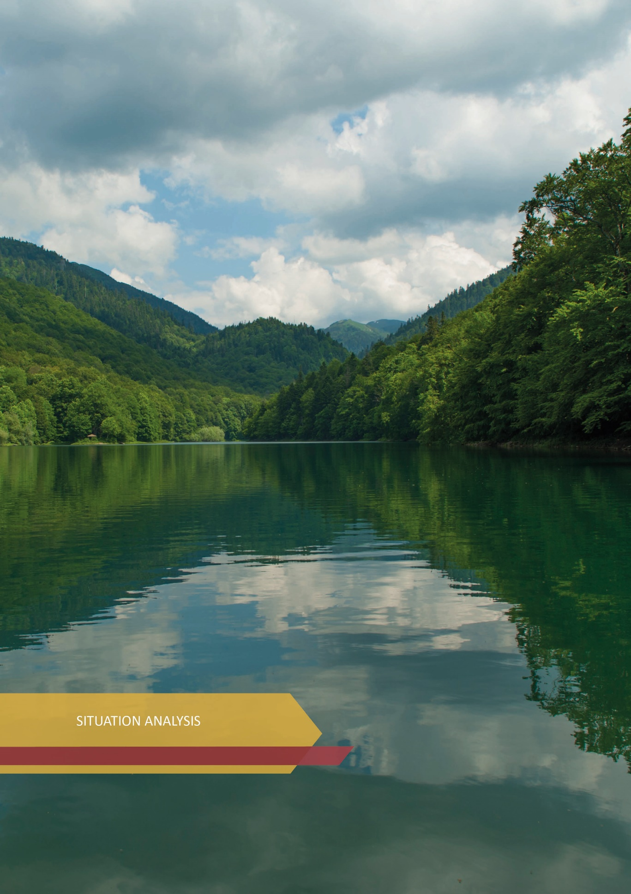

SITUATION ANALYSIS

2.1. Implementation of the Montenegro Tourism Development Strategy until 2020
The Montenegro Tourism Development Strategy until 2020 was adopted by the Government of Montenegro in December 2008, and it defined a strategic goal which reads: “By applying the principles and sustainable development goals, Montenegro will create a strong position of a global high-quality tourist destination, tourism will provide the Montenegrin population with enough jobs and raise living standards, and the country will generate revenue in a stable and reliable way.”
In order to achieve this goal, the Strategy also includes an Action Plan with holders of responsibility. The Action Plan contained five operational goals (with measures and priorities), as follows:
- Montenegro develops tourist and accompanying infrastructure with the aim of achieving the strategic goal;
- Montenegro forms a special, unique sales offer;
- Montenegro is known and accepted as a “year-round” tourist destination;
- Institutional and legal framework meets the requirements of successful and sustainable tourism development;
- The local population is increasingly involved in the tourism industry (“internal marketing”).
Taking into account that the Montenegro Tourism Development Strategy until 2020 did not contain indicators on the implementation of individual measures, and sources of financing, it made it impossible to determine the degree of implementation of the Action Plan for the twelve-year period of the strategic document. In the implementation analysis of the Action Plan of the Montenegro Tourism Development Strategy until 2020, the following was stated:
- unsatisfactory condition of infrastructure related to traffic accessibility, water supply, quality of maintenance and improvement of the energy network, etc., as well as waste separation and disposal;
- regional inequality of tourist offer (at the annual level, on average, 95% of tourism turnover is generated in the coastal region of Montenegro, and as much as 40% of accommodation facilities are located only in the municipality of Budva; regional imbalance in the development of tourist offer is characterized by excessive reliance on the coast and seasonal tourism);
- high seasonality in the business of the tourism industry (at the annual level, on average, 70% of the tourism turnover is generated in the period June-August);
- a significant share of the gray economy in all segments of tourism (it is estimated that approximately 1/3 of GDP is generated in the informal business zone, i.e., 26-31%);
- unsatisfactory level of service quality and education of staff in tourism, which requires additional efforts to improve knowledge, professional abilities and a set of skills, such as communication skills, knowledge of English and other foreign languages, education of local people about tourism potentials, in order to actively participate in creating tourist experiences;
- the need to expand the scope of the methodology for collecting statistical data by the Statistical Office - MONSTAT and the accuracy of this methodology, in order to obtain accurate data on tourism turnover in real time, in all types of accommodation;
- insufficient number of high quality hospitality facilities;
- limited marketing impact, inadequate and insufficient promotion of the destination, where special attention is paid to the lack of a recognizable destination brand, but also to the need to strengthen public-private partnerships in this segment;
- inefficient destination management and devastation of space due to unplanned construction and poor urban planning;
- insufficient valorization for the purpose of developing special forms of tourism and product diversification;
- lack of cooperation among key stakeholders in the tourism industry;
- inadequately defined target markets from the aspect of marketing and promotion;
- unfulfilled investment commitments including failed privatizations.

2.2. Quantitative and Qualitative Analysis of Tourism Parameters
The analysis of tourism parameters is based on official data from MONSTAT and the Central Bank of Montenegro. It refers to the period 2009-2019, while 2020 was separately analyzed, given its specifics caused by the COVID-19 pandemic.

2.2.1. Tourist Arrivals and Overnight Stays
During the period from 2009 to 2019, Montenegro recorded a constant increase in the number of tourist arrivals and overnight stays. In 2019, the second largest increase in international tourist arrivals in Europe was recorded in the tourism sector of Montenegro, by 20.84% ​​compared to 2018. Specifically, Montenegro, which has only 0.6 million people, was visited by more than 2.6 million international tourists.
In 2019, when compared to 2009, the increase in the number of tourist arrivals was 119%, while the increase in the number of overnight stays was 91%, which means that tourism turnover in the country doubled in this period. The number of overnight stays in 2019 was 14.5 million or 11.8% more than in 2018. Out of this amount, domestic tourists accounted for 0.52 million overnight stays or 7.4% more than in 2018, while foreign tourists accounted for 13.9 million overnight stays or 12% more than in the previous year. (Table No. 2 and Chart No. 1)

Table no. 2 - Number of tourist arrivals and overnight stays, Montenegro, period 2009-2019
 | Arrivals |  |  | Overnight stays
 | Total | Domestic | Foreign | Total | Domestic | Foreign
2009 | 1,207,694 | 163,680 | 1,440,014 | 7,552,006 | 856,332 | 6,695,674
2010 | 1,262,985 | 175,191 | 1,087,794 | 7,964,893 | 987,033 | 6,977,860
2011 | 1,373,454 | 172,355 | 1,201,099 | 8,775,171 | 956,368 | 7,818,803
2012 | 1,439,500 | 175,337 | 1,264,164 | 9,151,236 | 1,008,229 | 8,143,007
2013 | 1,492,006 | 167,603 | 1,324,403 | 9,411,943 | 997,728 | 8,414,215
2014 | 1,517,376 | 197,079 | 1,350,297 | 9,553,783 | 957,127 | 8,595,656
2015 | 1,713,109 | 153,185 | 1,559,924 | 11,054,947 | 747,576 | 10,307,371
2016 | 1,813,817 | 151,696 | 1,662,121 | 11,250,005 | 721,530 | 10,528,475
2017 * | 2,000,009 | 122,797 | 1,877,212 | 11,953,316 | 483,184 | 11,470,132
2018 | 2,204,856 | 128,053 | 2,076,803 | 12,930,334 | 486,524 | 12,443,810
2019 | 2,645,217 | 135,592 | 2,509,625 | 14,455,920 | 522,382 | 13,933,538

Source: Statistical Office (MONSTAT), http://monstat.org/cg/page.php?id=44&pageid=44

Chart no. 1 - Number of tourist arrivals and overnight stays, Montenegro, period 2009-2019

Source: Statistical Office (MONSTAT), edited by the Ministry of Economic Development

The following are a few characteristics of tourism turnover in 2019 that apply analogously to all years in the observed period:
- from the aspect of all types of accommodation capacities, i.e., collective (hotels, tourist settlements, motels, boarding houses, and similar facilities) and individual (private accommodation: rooms, houses, apartments and flats) accommodation capacities - 32.4% of the total number of overnight stays accounted for collective and 67.6% for individual accommodation;
- within all types of accommodation, the share of the number of overnight stays in hotels was 21.7%.
Therefore, the largest part of tourism turnover in Montenegro is generated in individual (private) accommodation, while turnover in hotels accounts for only about 20% of turnover in all types of accommodation facilities. As the hotel industry, according to numerous analyzes, is the most important segment of the tourist offer, it is unequivocal that there is a need to improve the structure of accommodation capacities aiming to increase the share of hotels in total capacities.
When it comes to tourism turnover, it is important to note that a large part of it (unregistered) is generated through business in the gray zone, which is one of the long-standing problems in the tourism industry and is the basis for intensifying and improving inspection services.

2.2.2. Tourism Revenues
Revenues in tourism were constantly increasing, if we look at the period ending in 2019, primarily due to the continuous increase in the number of overnight stays. The Central Bank of Montenegro (CBM) estimates tourism revenues from foreign guests (who account for about 90% of total revenues on an annual basis) on a quarterly basis, while the Ministry estimates revenues from domestic guests (at an average annual level of about 10% of total revenues). According to the above calculation methodology, with an estimate of turnover in the gray economy, revenues generated in 2019 are 92% higher than in 2009 (Table 3 and Chart 2). Over the last five years, and before the COVID-19 pandemic, tourism revenues in Montenegro had grown at an average annual rate of about 10%.
Table 3: Revenues from travel / tourism from domestic and foreign guests

Year | Amount of revenue | Index
2009 | € 597 million | -
2010 | € 635 million | 106
2011 | € 671 million | 106
2012 | € 700 million | 104
2013 | € 721 million | 103
2014 | € 729 million | 101.1
2015 | € 862 million | 118.2
2016 | € 881 million | 102.2
2017 | € 959 million | 108.8
2018 | € 1.039 billion | 108.3
2019 | € 1.140 billion | 109.7
Source: Assessment of the Ministry of Economic Development based on data from the Central Bank of Montenegro, https://www.cbcg.me/me/statistika/statisticki-podaci/ekonomski-odnosi-sa-inostranstvom/platni-bilans

Chart no. 2 - Overview of tourism revenue growth for the period from 2009 to 2019

Source: Ministry of Economic Development based on data from the Central Bank of Montenegro, https://www.cbcg.me/me/statistika/statisticki-podaci/ekonomski-odnosi-sa-inostranstvom/platni-bilans

This positive trend in tourism turnover was confirmed by the report of the World Travel and Tourism Council (WTTC), according to which in 2019, the total (direct and indirect) contribution of tourism to GDP was 30.9 % (the largest share since 2003 when the WTTC started writing reports for Montenegro), and the total contribution of tourism to employment was 31.9%, while the share of tourism in total exports was 52.6%. These data confirm the predictions of the WTTC from previous years, when Montenegro was at the very top of the countries in terms of speed of development in the next ten-year period.

2.2.3. Seasonality and regional inequality
Analyzes of recorded tourism turnover by months in the period from 2009 to 2019, indicate the fact that in addition to a significant increase in the number of overnight stays from year to year, the main tourist season has been extended. Considering the statistical data of the past years, the duration of the main tourist season has been extended to a certain extent, therefore, it can be stated that the season started earlier (April) and ended later (October).
Specifically, the analyzes indicate the fact that the share of generated tourism turnover in April and October in 2019 when compared to the same months in 2009 increased by 88.18% and 129.26%, respectively (in absolute terms, the increase is for more than 3 or 4 times respectively). The overview is below:

Number of overnight stays | 2009 | 2019 | Index 2019 / 2009
Total | 7,550,846 | 14,447,880 | 191.34
April | 123,582 | 444,973 | 360.06
% April in total | 1.64 | 3.08 | 188.18
October | 143,609 | 629,957 | 438.66
% October in total | 1.90 | 4.36 | 229.26

When it comes to the analysis of tourism turnover in the peak of the season, i.e., in the period of June-July-August, its share in total turnover decreased in 2019 compared to 2009 by 9.37% (i.e., it decreased from 74.83% in 2009 to 67.82% in 2019):
Number of overnight stays | 2009 | 2019 | Index 2019 / 2009
Total | 7,550,846 | 14,447,880 | 191.34
June-July-August | 5,650,447 | 9,798,478 | 173.41
% VI-VII-VIII in total | 74.83 | 67.82 | 90.63

However, despite the above, it can be concluded that there is still a pronounced seasonality and high concentration of tourists in the coastal region during the main tourist season (June-July-August), resulting in huge pressures on infrastructure, environmental segments, beach capacities, local population, etc. (Chart No. 3).

Chart No. 3 - Overview of generated overnight stays in the period 2009-2019, by months
Source: Statistical Office (MONSTAT), edited by the Ministry of Economic Development
http://monstat.org/cg/page.php?id=366&pageid=44

The pronounced seasonality in the tourism industry business is primarily caused by the main motives for coming to Montenegro. Specifically, according to the survey conducted among visitors (Guest survey 2017, NTO Montenegro and Survey on the attitudes and consumption of tourists in Bar in 2019, TO Bar), the main reasons for staying in Montenegro are holidays (69%, or 74.8%) and entertainment (58% and 49.3%, respectively). These motives are the main causes of a high degree of seasonality, because they are predominantly related to the tourist offer during the summer tourist season.

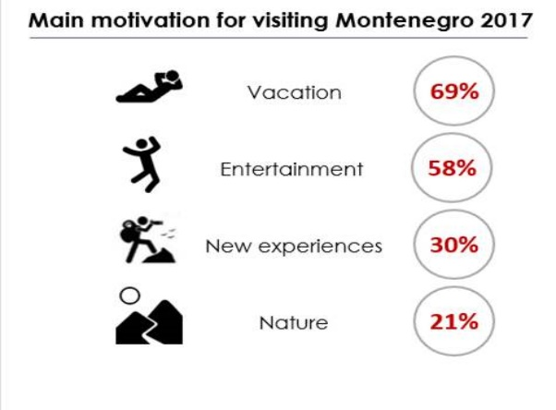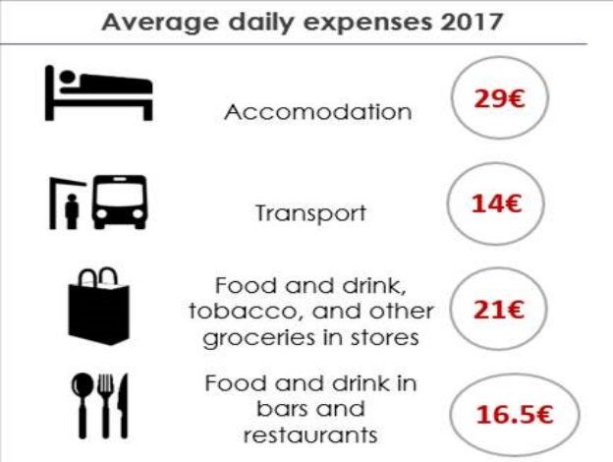
Source: NTO Survey - Guest survey 2017
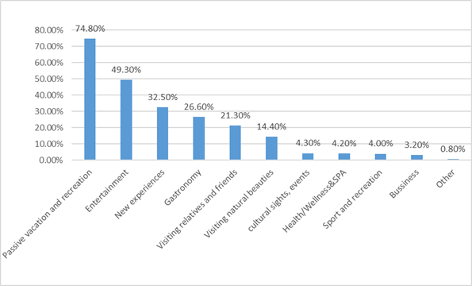Source: Survey on the attitudes and consumption of tourists in Bar in 2019, source TO Bar

The results of the Guest survey 2017 are also confirmed through data obtained from analyzes of tourism turnover (number of overnight stays) from the aspect of spatial distribution of tourist places, i.e., from the regional aspect (Table 4).

Table no. 4 - Tourist overnight stays according to the spatial distribution of tourist places, 2009-2019
 | Total | Capital City | Coastal places | Mountain places | Other tourist places | Other places
2009 | 7,552,006 | 103,464 | 7,244,830 | 99,500 | 102,208 | 2,004
2010 | 7,964,893 | 112,569 | 7,643,320 | 123,151 | 83,896 | 1,957
2011 | 8,775,171 | 103,636 | 8,493,955 | 107,506 | 68,249 | 1,825
2012 | 9,151,236 | 102,875 | 8,858,226 | 110,172 | 76,002 | 3,961
2013 | 9,411,943 | 116,532 | 9,128,809 | 107,548 | 56,136 | 2,918
2014 | 9,553,783 | 128,115 | 9,258,017 | 90,341 | 75,154 | 2,156
2015 | 11,054,947 | 155,410 | 10,687,914 | 127,448 | 81,982 | 2,193
2016 | 11,250,005 | 177,191 | 10,827,495 | 143,290 | 98,851 | 3,178
2017 | 11,953,316 | 261,219 | 11,347,174 | 195,388 | 136,026 | 13,509
2018 | 12,930,334 | 282,757 | 12,269,115 | 223,447 | 142,408 | 12,607
2019 | 14,455,920 | 310,593 | 13,714,814 | 258,260 | 151,545 | 20,708
Source: Statistical Office (MONSTAT), http://monstat.org/uploads/files/publikacije/godisnjak%202020/19.pdf

Most of it, i.e., 95% of tourism turnover is generated in the coastal region, while in the rest of Montenegro only 5% of turnover is generated, i.e., in the central region 3% and in the North only 2% (Chart 4).
Chart no. 4 – Tourist turnover - number of overnight stays by regions, 2019

Source: Statistical Office (MONSTAT), edited by Ministry of Economic Development

In accordance with all the above, it can be stated that it is necessary to undertake activities to improve the offer and development of tourism products and services, primarily in municipalities in the North, but also in the central region of Montenegro, to create preconditions for reducing seasonality in business and regional development inequalities at the state level.

2.2.4. Emitting markets and participation in tourism turnover
In the period from 2009 to 2019, there was a significant increase in tourism turnover from emitting markets that are strategically important for Montenegro, i.e., from Western and Central European countries (Germany, Great Britain, Poland, Austria and France), and from Russia. During this period, tourism turnover with Serbia was at a standard high level.
When it comes to arrivals, in 2019, compared to 2009, + 794.08% of tourists from Germany stayed in Montenegro, + 473.3% from Great Britain, + 409.5% from Poland, then +186.8% from Austria, + 172.3% from France and + 164.3% from Russia. There were 18.87% more tourists from Serbia, which indicates the continuity of a large share of arrivals from Serbia in the total number of tourists during the observed ten-year period. In terms of the number of overnight stays, the highest growth was recorded by tourists from Germany + 485.7%, then by Great Britain + 432.6%, Russia + 227.3% and Serbia + 30.0% when comparing 2019 and 2009 (Chart No. 5).

Chart No. 5 - Index of arrivals and overnight stays by country of affiliation, 2019/2009

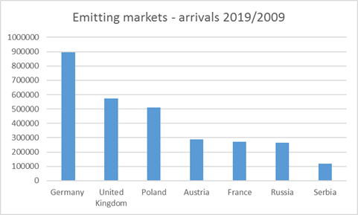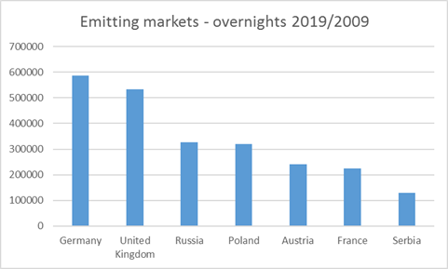
Source: MONSTAT, http://monstat.org/cg/page.php?id=366&pageid=44

During 2019, according to the countries of affiliation, the largest part, i.e., 46.3% of the total number of foreign overnight stays (in all types of accommodation - collective and individual) were recorded by tourists from Russia (24.9%) and Serbia (21.4%), while the highest growth was recorded by tourists from Kosovo (169, 1%), followed by tourists from Germany (45.3%) and Great Britain (30.4%). When observed from the aspect of the structure of accommodation capacities, in 2019, tourists from Russia (29.1%) and Serbia (25.3%) were the ones who predominantly generated overnight stays in individual (“private”) accommodation.
According to a survey conducted by the Rural Tourism Association - Tourism in villages and the Regional Development Agency for Bjelasica, Komovi and Prokletije in 2021 (73 rural households participated) based on the question: “Which countries did your guests come from in the period before the pandemic?”, it was stated that France was listed as the source market by 40 respondents, Germany by 35, Russia by 26, etc., while some mentioned regions: Scandinavia, the Balkans and the like, as well as the US diaspora. (Chart No. 6)

Chart No. 6 - The structure of guests in rural households before the COVID-19 pandemic

Source: Survey conducted by the Rural Tourism Association - Tourism in villages and the Regional Development Agency for Bjelasica, Komovi and Prokletije, May 2021

Considering the data related to the arrival of tourists in Montenegro in 2019, it can be stated that 52.25% of the total number of overnight stays were generated by tourists from Europe, compared to 2009 when that number was 47.7%. When it comes to the tourists from the Region, they were in the lead in the number of generated overnight stays in 2009 and accounted for 51.1%, and in 2019 they accounted for 38.4% of the total number of overnight stays. By analyzing the structure of guests (EU countries, countries of the Region: Serbia, Bosnia and Herzegovina, Kosovo, North Macedonia and Albania and non-European countries), i.e., the number of their overnight stays, it can be stated that during the past ten years, due to investment activities to raise the quality of accommodation, relatively good accessibility, improving the quality of the tourism product and promotional activities, there was a change in the structure of guests, and therefore, in 2019 in Montenegro there were more overnight stays of tourists from Europe compared to the predominantly more tourists from the Region in 2009. (Chart No. 7)

Chart No. 7 – Overview of the number of tourist overnight stays from Europe, the region and non-European countries

Source: MONSTAT, edited by the Ministry of Economic Development http://monstat.org/cg/page.php?id=366&pageid=44

Turnover generated in the period 2009/2019 observed by a more detailed overview of emitting tourist markets follows below:

Montenegro's connection with emitting markets is carried out by road, rail, sea and air transport (Table no. 5). According to the data of the United Nations World Tourism Organization for 2019, 59% of tourists traveled to their destination by air, 35% by road, 5% by sea, and only 1% by rail.
Table no. 5 - Travelers traffic by means of transport

Means of transport | 2019 | % of participation | 2020 | % of participation
Road | 16,456,269 | 77.74 | 4,450,786 | 88.12
Sea | 1,906,836 | 9.01 | 31,872 | 0.63
Air | 2,636,540 | 12.46 | 534,887 | 10.59
Rail | 167,473 | 0.79 | 33,454 | 0.66
Total | 21.167.118 | 100 | 5,050,999 | 100
Source: Report of the Border Control Department, Ministry of the Interior of Montenegro

When it comes to Montenegro, looking at the previous table, it can be stated that most travelers in 2019 (78%) came by road (this share increased to 88% in 2020 due to the outbreak of the coronavirus pandemic), which is correlated with the fact that the share of tourists from the Region is dominant in the total tourism turnover. In doing so, it must be taken into account that the data on the basis of which the table was prepared, are submitted by the Border Control Department of the Ministry of the Interior of Montenegro and it refers to travelers (one of which refers to tourists) who cross the state border (enter Montenegro). Furthermore, bearing in mind the connection between the Montenegrin people and the people in the countries of the Region, it is quite certain that a certain number of crossings across the border are made by the same persons (occasionally and several times during the same day). All of the above requires additional efforts in the analysis of data on touristm turnover in road transport, i.e., in determining the most accurate number of tourists who come to Montenegro by road.
The arrival of tourists from the Region is predominantly characterized by road transport and travel to Montenegro by car, while sea and railway transport are still insufficiently represented as a way of arriving in Montenegro.
On the other hand, when observed from the aspect of geographical position, Montenegro is not close to the main directions of European main corridors. Its distance from the main road communications (the closest connection to the motorway in the Republic of Serbia is about 300 km away, and the motorway in the Republic of Croatia is about 260 km away, or through Bosnia and Herzegovina about 200 km) makes it relatively peripheral and with limiting infrastructure in relation to the main European courses. The regional Adriatic highway and the Belgrade-Bar railway partially mitigate the consequences of the mentioned distance.
Bearing in mind the above, it can be stated that Montenegro, as in the previous period, is still predominantly an air destination when it comes to tourist arrivals from Europe and outside Europe, or from distant (so-called third) markets, from which there is an evident growth of interest when observed in the period 2009-2019 (the most numerous were tourists from the USA, Israel, Canada, Australia, Japan and New Zealand) (Chart No. 8)

Chart No. 8 – Tourism turnover (overnight stays) from distant emitting markets 2009-2019

Therefore, due to its geographical position, Montenegro is a predominantly air destination, because it is far from important emitting markets, and it is important for its positioning as a tourist destination the introduction of direct airlines, scheduled, charter and low cost airlines to / from important emitting markets, throughout Europe, but also around the world. In order to increase the number of direct airlines and the frequency of flights on certain routes to Montenegro, it is necessary to create incentive conditions for airline companies. At the session of the Government of Montenegro held on December 9, 2021, a decision was adopted to improve the incentive scheme of Montenegrin airports by defining a list of 13 strategic routes, 10 routes between Podgorica and London, Paris, Rome, Brussels, Berlin, Stockholm, Milan, Barcelona, ​​Munich and Dortmund, as well as 3 strategic routes between Tivat and London, Manchester and Berlin.
Given that in 2021 air transport globally experienced a certain recovery compared to 2020, the expectation of the Montenegrin tourism industry is that during 2022 there will be a significant recovery in air transport, given the mass immunization of the population against the COVID-19 virus, and the opening of borders and facilitated movement with Covid certificates, which would return tourists from important emitting and well-paying markets in Europe and the world.
The issue of valorization of Podgorica and Tivat airports, i.e., the final commitment of the Government of Montenegro on the issue of concessions to airports, is also of great importance for the tourism sector. It is also expected that the newly established national airline Air Montenegro will improve the air connection of Montenegro with Europe.

2.2.5. Average stay of tourists

The average duration of stay of tourists in Montenegro in 2009 was 6.25 days, while in 2019 it was 5.46 days (Chart no. 9).
This trend of decreasing the average length of stay of tourists is the consequence of, on the one hand, more frequent but shorter intraregional trips, and on the other hand, the increasing presence of tourists from distant emitting markets, who want to visit as many destinations as possible during one travel, so they spend a short amount of time on each destination. Accordingly, the need for further strengthening of regional cooperation in order to develop joint cross-border tourism products can be stated.

Chart no 9 - Overview of the average duration of stay of tourists in days, period 2009 – 2019

Source: MONSTAT, edited by the Ministry of Economic Development

The analysis of the average tourist stays by municipalities (Chart no. 10), found that tourists stay the longest in Bar (9.54 days), Plav (8.74 days), Herceg Novi (8.11 days), Tivat (7.24 days) and Rožaje (5.76 days), all in close dependence on the offer (in Bar the tourist offer is based on the sea, lake and rural area) and the structure of guests (in Bar and Plav predominate guests from the diaspora whose stay is traditionally longer). All of the above points to the need for further intensive development of new innovative offers following modern trends in demand in the international tourism market in the direction of creating a unique experience for visitors.

Chart no. 10 - Average tourist stay in the number of days in 2019

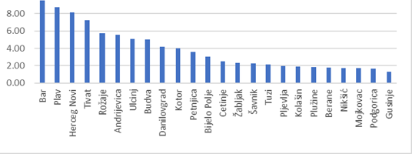
Source: MONSTAT, edited by the Ministry of Economic Development

2.2.6. Accommodation capacities, collective and individual accommodation
According to official data, the number of accommodation capacities in hotels in Montenegro has increased over the past decade as the most important segment of the accommodation offer. Specifically, in 2010 there were 309 registered hotels and similar facilities (collective accommodation), and in 2019 there were 406 facilities, which represents an increase of 30.8% (Table no. 6). If we compare 2017 and 2019, there is an increase of 8.9% in accommodation capacities in collective accommodation (since 2017 MONSTAT publishes data only for collective accommodation according to the new methodology):
Table no. 6 - Capacities in collective accommodation 2019*
Accommodation categories | Number of facilities | Number of accommodation units | Rooms | Suites | Camp places | Number of beds | Permanent | Temporary
MONTENEGRO 2019 | 406 | 20,882 | 17,329 | 2,635 | 918 | 48,837 | 44,783 | 4,054
MONTENEGRO 2017 | 370 | 19,112 | 15,829 | 2,491 | 792 | 45,964 | 43,061 | 2,903
 | 2019
Apart hotel | 10 | 385 | 251 | 134 |  | 1,166 | 1,020 | 146
One star * | 1 | 142 | 142 |  |  | 415 | 404 | 11
Three stars *** | 2 | 25 | 4 | 21 |  | 86 | 74 | 12
Four stars **** | 7 | 218 | 105 | 113 |  | 665 | 542 | 123
Boutique hotel | 13 | 255 | 161 | 94 |  | 447 | 406 | 41
Four stars **** | 9 | 125 | 96 | 29 |  | 274 | 243 | 31
Five stars ***** | 4 | 130 | 65 | 65 |  | 173 | 163 | 10
Garni hotel | 49 | 841 | 653 | 188 |  | 1.945 | 1.732 | 213
Two stars ** | 2 | 24 | 24 |  |  | 57 | 57
Three stars *** | 24 | 411 | 354 | 57 |  | 914 | 844 | 70
Four stars **** | 23 | 406 | 275 | 131 | 0 | 974 | 831 | 143
Hotel | 132 | 12,404 | 11,246 | 1,157 | 1 | 27,623 | 24,908 | 2,715
One star * | 3 | 145 | 145 |  |  | 338 | 338
Two stars ** | 19 | 1,866 | 1,791 | 75 |  | 4,455 | 4,201 | 272
Three stars *** | 28 | 1,637 | 1,472 | 165 |  | 3,892 | 3,757 | 119
Four stars **** | 74 | 7,701 | 6,892 | 808 | 1 | 16,516 | 14,596 | 1,920
Five stars ***** | 8 | 1,055 | 946 | 109 |  | 2,422 | 2,016 | 460
Camp | 12 | 950 | 48 | 20 | 882 | 2,925 | 2,895 | 30
One star * | 2 | 135 |  | 20 | 115 | 510 | 480 | 30
Two stars ** | 3 | 333 | 3 |  | 330 | 1,166 | 1,166
Three stars *** | 4 | 115 | 45 |  | 70 | 346 | 346
Four stars **** | 3 | 367 |  |  | 367 | 903 | 903
Small hotel | 140 | 2,298 | 1,722 | 576 | 0 | 5,615 | 4,900 | 716
One star * | 1 | 5 | 4 | 1 |  | 10 | 10
Two stars ** | 17 | 268 | 233 | 35 |  | 663 | 626 | 35
Three stars *** | 57 | 928 | 712 | 216 |  | 2,309 | 2,127 | 111
Four stars **** | 59 | 995 | 711 | 284 | 0 | 2,366 | 1,903 | 214
Five stars ***** | 6 | 102 | 62 | 40 |  | 267 | 234 | 28
Motel | 5 | 56 | 40 | 16 |  | 107 | 107
Two stars ** | 1 | 19 | 3 | 16 |  | 42 | 42
Three stars *** | 4 | 37 | 37 |  |  | 65 | 65
Tourist settlement | 5 | 1,762 | 1,542 | 220 |  | 3,911 | 3,785 | 125
One star * | 1 | 404 | 376 | 28 |  | 1,026 | 980 | 45
Three stars *** | 3 | 864 | 725 | 139 |  | 1,944 | 1,864 | 80
Four stars **** | 1 | 494 | 441 | 53 |  | 941 | 941
Ethno village | 6 | 110 | 76 | 19 | 15 | 277 | 273 | 4
Hostel | 9 | 286 | 284 | 2 |  | 908 | 903 | 5
Other | 25 | 1,535 | 1,306 | 209 | 20 | 3,913 | 3,854 | 59
Source: MONSTAT, http://monstat.org/cg/page.php?id=444&pageid=45
* NOTE: Other: resort, health resort, boarding houses, inns, etc.

By analyzing the structure of collective accommodation by regions, in the period from 2010 to 2019 it can be stated that the highest growth in the number of facilities was recorded in the central region by 79.4%, and when it comes to the number of beds this growth is 53.6 %, with the note that in this region in 2010 there were the fewest facilities compared to other regions, i.e., only 34 buildings. In the same period, the coastal region recorded an increase in the number of facilities and beds by 29.3% and 15.5%, respectively. However, the Northern Region in 2019 participates at almost the same level in the total number of accommodation capacities as in 2010, i.e., the number of facilities increased by only 6%, and the number of beds in by 17.6%, with the growth in the number of beds achieved largely due to the increase in the number of camps in this region (Table no. 7).
Table no. 7 - Structure of collective accommodation by regions of Montenegro
Region | 2010 |  | 2019
 | Number of facilities | Number of beds | Number of facilities | Number of beds
Coastal region | 225 | 36,213 | 291 | 41,818
Central region | 34 | 2,639 | 61 | 4,054
Northern region | 50 | 2,522 | 53 | 2,965
Total | 309 | 41,374 | 406 | 48,837
Source: MONSTAT, edited by the Ministry of Economic Development
When it comes to the number of accommodation capacities in hotels and similar facilities in 2019 in relation to the plan defined by the previous Montenegro Tourism Development Strategy until 2020, it can be stated that the plan was implemented at the level of 35.39%.
On the other hand, it is important to note that the structure of accommodation capacities in 2019 is more favorable compared to the projections given in the previous Strategy. Specifically, in 2019, hotels and similar facilities of 4 and 5 stars accounted for 56.04% of the total capacity, while the Strategy planned their participation of 50.20% (Table no. 8).

Table no. 8 - Degree of implementation of the plan from the Montenegro Tourism Development Strategy until 2020

Hotels and similar facilities | Tourism Development Strategy Plan |  | Categorized facilities by the Commission of the Ministry |  | Implementation of the Strategy
Hotels and similar facilities | 2020 |  | 2019 |  | 2019
Hotels and similar facilities | Beds | Structure in % | Beds | Structure in % | in %
5* | 19,000 | 15.20 | 3,838 | 8.67 | 20.20
4* | 43,750 | 35.00 | 20,954 | 47.36 | 47.89
total - 4 and 5 * | 62,750 | 50.20 | 24,792 | 56.04 | 39.51
total - 4 and 5 *
3* | 42,750 | 34.20 | 10,954 | 24.76 | 25.62
2* | 17,250 | 13.80 | 7,583 | 17.14 | 43.96
1* | 2,250 | 1.8 | 914 | 2.07 | 40.62
total - 1 - 5* | 125,000 | 100.00 | 44,243 | 100.00 | 35.39

By summarizing the structure of accommodation capacities, according to MONSTAT data, it can be stated that in 2019, within the collective accommodation, hotels (as the most important segment of the tourist offer) participated with 67%.
However, when it comes to total (collective and individual) accommodation capacities, according to the same source, low competitiveness capacities dominate, i.e., individual (so-called private) accommodation, at the level of 70%.
In addition to the above, a special challenge from the aspect of the structure of accommodation capacities are secondary housing units, the so-called facilities for “secondary housing”, which are mainly represented in the coastal region.
Therefore, as a result of the development of the real estate sector, which on the one hand causes an increase in individual accommodation, and poorly implemented privatizations of hotel companies which, on the other hand cause a decrease or insufficiently fast growth of hotel capacity, tourism in Montenegro is real estate based tourism instead of being hotel-based.
Solving the problem of the structure of accommodation capacities in Montenegro is an important segment and aspect of the development of the document which is in the preparation phase, and relates to spatial planning. This is the Spatial Plan of Montenegro until 2040. According to the analyzes presented in the Concept of the Spatial Plan of Montenegro until 2040, secondary housing, together with rooms and houses for rent in households, camps and other accommodation, accounts for as much as 73% of the total capacity.
Accordingly, and bearing in mind that the turnover in private and secondary housing is the main source of gray economy, it is necessary to intensify activities in the direction of their formalization, i.e., legalization of business.

2.2.7. Labor force in tourism
MONSTAT keeps records of data on the annual and monthly number of employees in companies, institutions and organizations of all forms of ownership, as well as on foreign citizens employed in our country. Persons who work under a service contract or under a contract for the performance of temporary and occasional work are not considered employed persons.
Data are published by sectors of activity, and according to the Classification of Activities 2010.

2.2.7.1 Employees in the accommodation and food service sector

The accommodation and food services sector includes the provision of accommodation services for shorter stay of visitors and other travelers, as well as the preparation of meals and beverages for immediate consumption, i.e., sections: 55 - Accommodation and 56 - Food and beverage service activities (Table no. 9 and Chart no. 11).
Table no. 9 - Number of employees, sector - Accommodation and food services, 2009 - 2019.
 | Accommodation and food services | Total Montenegro | % participation
2009 | 16,678 | 174,152 | 9.6
2010 | 13,131 | 161,742 | 8.1
2011 | 12,429 | 163,082 | 7.6
2012 | 13,209 | 166,531 | 7.8
2013 | 14,333 | 171,474 | 8.3
2014 | 14,182 | 173,595 | 8.2
2015 | 14,393 | 175,617 | 8.2
2016 | 14,684 | 177,908 | 8.3
2017 | 15,033 | 182,368 | 8.2
2018 | 16,024 | 190,132 | 8.4
2019 | 18,350 | 203,545 | 9.0
Source: MONSTAT,
https://monstat.org/cg/page.php?id=23&pageid=23 https://www.monstat.org/uploads/files/Bilten/2021/2/3.pdf

Chart no. 11 - Number of employees in the sector - Accommodation and food services
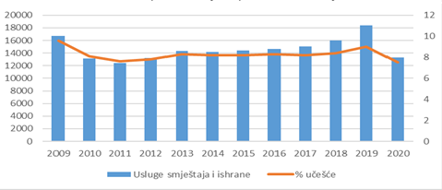
Source: MONSTAT, edited by the Ministry of Economic Development
The analysis of data on the number of employees confirms the fact that tourism is an economic activity that is extremely sensitive to crisis situations. Specifically, during 2010-2011, i.e., in the period marked by the global economic crisis, there was a decrease in the number of employees in the accommodation and food services sector, so that in 2011 there were 25.5% fewer employees compared to 2009. Period 2012-2019 is characterized by continuous growth in the number of employees in this sector. The crisis situation caused by the COVID-19 pandemic has caused a new decline in the number of employees in 2020 by 27.4% compared to 2019.
Given the fact that tourism is one of the strategic branches of economic development of Montenegro, and bearing in mind the principles of the Youth Guarantee program, young people will have the opportunity to train, educate or improve for occupations in demand in the labor market or employment opportunities in the areas of tourism. This will provide additional support for the employment of domestic labor force.

2.2.8. Earnings in tourism
Regarding the overview of average earnings in tourism, MONSTAT monthly reports include companies, institutions, cooperatives or organizations of all forms of ownership, as well as their units within, according to the organizational-territorial principle, starting from the municipal level.
In accordance with legal regulations, the employee's salary is gross salary which includes salary for work performed and time spent at work, increased salary, salary compensation and other personal income, which are subject to personal income tax, determined by law, collective agreement and work contract.
The average salary is calculated by dividing the amount of total paid salaries in the month by the number of employees to whom the payments are made (Table no. 10, Chart no. 12).

Table no. 10 - Average net and gross earnings, sector I-Accommodation and food services, 2015-2020 (in euros)

 | Net earnings  sector I | Net earnings  Montenegro | Gross earnings  Sector I | Gross earnings Montenegro
2015 | 405 | 480 | 605 | 725
2016 | 388 | 499 | 580 | 751
2017 | 388 | 510 | 580 | 765
2018 | 415 | 511 | 621 | 766
2019 | 429 | 515 | 642 | 773
2020 | 392 | 524 | 589 | 783
Source: MONSTAT, https://monstat.org/cg/page.php?id=24&pageid=24 and data 2020 for https://monstat.org/cg/page.php?id=1743&pageid=246
Chart no. 12 - Average net earnings in Montenegro and the sector of Accommodation and food services
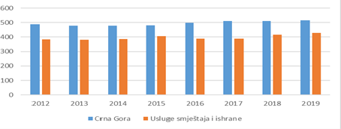
Source: MONSTAT, edited by the Ministry of Economic Development

As it can be concluded from the table, salaries in the services, accommodation and food sector are constantly below the average salaries in Montenegro, which is one of the reasons why this sector is unattractive when choosing a future occupation. Also, due to the seasonal nature of the tourism industry, young people do not show special interest in education and specialization in this area.
In order to solve the above-mentioned problem, the new Tourism Development Strategy envisages the development of a diversified tourist offer, which will create conditions for higher demand for labor force in the period before and after the main tourist season. In that sense, it is necessary to work on strengthening human resources, in order to have a qualified and satisfied domestic labor force in the medium and long term. In order to implement the above, it is necessary to consider the possibility of introducing the category of “permanent seasonal worker” into the legislation, as is already the case in countries competing with Montenegro. Special attention should be paid to the inclusion in the legal flows of all those who operate outside them, in order to combat the gray economy.

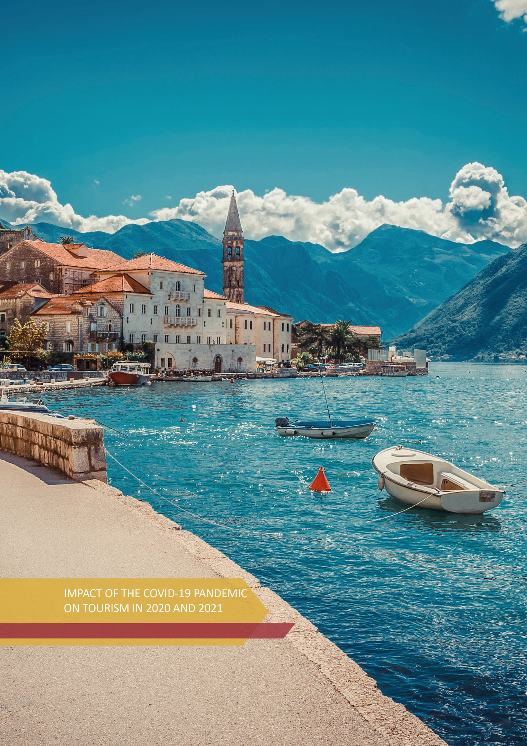

IMPACT OF THE COVID-19 PANDEMIC ON TOURISM IN 2020 AND 2021

Given that the COVID-19 pandemic caused drastic changes in almost all economic activities, both on the supply side and on the demand side, the tourism sector, as an extremely sensitive activity, suffered huge business losses to unpredictable circumstances.
In 2020, tourism on a global scale “returned” to the level of 30 years ago. According to the United Nations World Tourism Organization (UNWTO), international tourist arrivals decreased by 73%, the real contribution of tourism to GDP decreased by $ 2 trillion, the share of tourism in GDP decreased by 50%, and revenues from international tourism decreased by 65% ​​to $ 1.1 trillion (Table no. 11).

Table br. 11 - Impact of the COVID-19 Pandemic on Tourism

 | 2019 | COVID-19 impact (2020) | 2020 | 2021 (ending with November)
International  tourist arrivals | $ 1.5 billion | - $ 1.1 billion  (-73%) | $ 402 million | $ 370 - 420 million
Direct contribution of tourism to GDP | $ 3.5 trillion | - $ 2 trillion | $ 1.6 trillion | $ 1.9 - 2.0 trillion
Participation of tourism  in global GDP | 4% | - 50% | 1.8 % | 2%
Revenues from international tourism | $ 1.7 trillion | - $ 1.1 trillion  (-65%) | $ 635 billion | $ 700-800 billion
Source: United Nations World Tourism Organization – UNWTO

In order to overcome the crisis, the UNWTO has formulated key actions under the auspices of three key priorities, which follow: crisis management (#traveltomorrow), restarting tourism (#restarttourism) and accelerating transformation (#futuretourism).
As part of a number of UNWTO activities, seventeen countries have received technical support to recover from the pandemic, in co-operation with the European Bank for Reconstruction and Development, including Montenegro. Activities are underway to prepare a tourism recovery plan, destination marketing program and analysis of the statistical system in tourism, within which an analysis with guidelines for further steps has been prepared, some of which are an integral part of this document, and the rest will be included in the Action Plan for the next period of implementation of this Strategy.

3.1. Assessment of the situation in tourism in 2020 compared to 2019
Due to the global situation caused by the COVID-19 pandemic, travels around the world were reduced to a minimum, so in 2020 Montenegro was visited by 444,065 tourists, or 83.21% less than in 2019, with 2,587,255 overnight stays, or 82.10% less than the previous year. Also, instead of focusing on regional tourism, which was the recommendation for “small countries” from renowned international tourism organizations, led by the UNWTO, and thus ensure the preservation of tourism, the Government of Montenegro closed borders to traditionally important regional markets, which was assumed to be a political decision. The tourism industry was left with the option to focus predominantly on domestic tourists, who could not compensate for the lack of tourists from the region and Europe.
Domestic tourists accounted for 93,270 arrivals (-31.21%), which resulted in 360,729 overnight stays (-30.95%), while foreign tourists accounted for 350,795 arrivals (-86.02%) and 2,226,526 overnight stays (-84, 02%). Foreign tourists accounted for 79.00% in arrivals and 86.06% in overnight stays in 2020. Citizens of Serbia (20.21%), Russia (17.71%), Bosnia and Herzegovina (15.20%), Ukraine (8.52%) and Albania (6.65%) had the largest share in the total overnight stays of foreign guests.
On the other hand, it is necessary to take into account the fact that Montenegro is a small market, i.e., that domestic tourists have a relatively small share in total tourism turnover, and that their purchasing power is low, which puts it at an unfavorable position when compared to large tourist destinations, whose domestic tourists to some extent compensated for the reduced arrival of foreign tourists during the pandemic. This was an additional reason for Montenegro to focus on the regional market, in accordance with the recommendations of renowned international tourism organizations, which advised that small countries must focus on the immediate environment.
When it comes to financial effects in tourism in 2020, according to estimates, they amounted to about 159 million euros, which is 86% less than in 2019 (source: Central Bank of Montenegro, based on MONSTAT data).
According to WTTC data in 2020 compared to 2019, a decline in tourism revenues was recorded in Montenegro’s competing destinations in the region, -76.9% in Greece, -65.7% in Croatia, -62% in Italy and -53.9% in Albania.
In spite of unfavorable business conditions in the new circumstances caused by the COVID-19 pandemic during 2020, hotel capacities in Montenegro got richer with 13 new facilities, specifically 4 five-star hotels, 3 four-star hotels and 6 three-star hotels with a total of 686 beds.
*****************

The World Travel and Tourism Council (WTTC), which represents the global private travel and tourism sector, gave Montenegro the opportunity to use the international Safe Travels label in 2020. It is a specially designed label, which allows travelers to identify destinations and companies all around the world that have adopted global health and hygiene standards, as an important precondition for safe travel, during the pandemic. Safe travels label is also applied in Montenegro, and is awarded by the National Commission based on the verification of the fulfillment of the set criteria, as well as the control of the fulfillment of the conditions defined by the security protocols. The work of the Commission is coordinated by the National Tourist Organization of Montenegro, and the Ministry of Economic Development is involved.

3.2. Rehabilitation policy in 2021

The year 2021 was the year of economic and tourism recovery of Montenegro. From the beginning of the year, serious work on preparations and harmonization of the business environment with the standards imposed by the “new normality” under the influence of COVID-19 has been made. The goal of the Government of Montenegro was to preserve the tourism and economic substance, and above all jobs, with uncompromising care for the health of the local population and tourists. However, as serious preparations in stages for the recovery of tourism indicated the possibility of greater consolidation already in the pre-season period, it was decided to define the goal more ambitiously.
The recommendations of the World Health Organization (WHO), the United Nations World Tourism Organization (UNWTO) and the Organization for Economic Co-operation and Development (OECD) were followed, as well as travel in the post-Covid period, which presupposed a number of new standards, with an emphasis on maintaining health, creating resilient destinations flexible to the crisis, new respect for nature and sustainable development, etc.
According to a survey by the European Travel Commission (ETC), safety when traveling and staying at a destination (21.4%) were the dominant criteria when choosing a holiday destination during the COVID-19 pandemic.
In such circumstances, with the emphasis on the potential of the tourism sector on economic development, as well as its multiplicative effects on almost all other industries, synergistic action had to be provided in all segments and at all levels.
Given the complexity of the COVID-19 pandemic, which is characterized by a simultaneous health and economic crisis, the Montenegrin system responded through a set of remedial measures:
- an assessment of fiscal policy needs was made and additional financial resources were identified;
- additional financial resources were provided in a timely manner and directed to the most urgent needs;
- business continuity has been ensured in conditions of mandatory physical distance;
- continuity of all payments from public funds for salaries, pensions, financing of all public functions (health, social benefits, defense, security, etc.) and financing of all international obligations has been ensured;
- the substance of the economy and jobs has been preserved.
In order to create conditions for the most efficient recovery of the tourism industry, the focus of activities of the Government of Montenegro was:
- objective perception of changes in the market (analysis and research) with flexibility to new circumstances (quick reactions, adaptation to the situation);
- establishing a more favorable financial environment in order to support the necessary investment activities;
- measures of the Government of Montenegro to support the tourism and hospitality sector in order to overcome the crisis caused by the COVID-19 pandemic;
- intensifying destination promotion;
- maintaining liquidity and enabling favorable loan arrangements;
- promotional activities aimed at the region, as well as targeted international emitting markets, which were defined as priority emitting markets before the COVID-19 pandemic;
- strengthening the institutional framework (staff development, efficient professional training with practical training in hospitality facilities, student employment, strengthening public-private partnerships, etc.);
- introduction of new health and epidemiological standards and protocols in the business of the tourism industry, in accordance with the current pandemic;
- clear and truthful reporting on the real situation in the country as well as on precautionary measures and circumstances that may arise due to the re-emergence of the negative consequences of the spread of COVID-19;
- reduction of the informal (gray) economy in tourism: reforming and streamlining the process of starting and running a tourism / hospitality business (simplification of procedures, removal of administrative barriers, providing incentives / stimulus for the transition to a formal economy, etc.);

Measures of financial support of the Government of Montenegro to the tourism and hospitality sector in order to overcome the crisis caused by the pandemic COVID - 19

The Government of Montenegro has adopted measures to support the economy and citizens, within which the tourism sector is financially supported as well, as one of the sectors most vulnerable to the crisis. The support was primarily implemented with the aim of providing liquidity to the business of tourism and hospitality companies and preserving as many jobs as possible.
In that sense, some of the implemented support measures adopted by the Government of Montenegro were:
- Measure to support the economy through earnings subsidies - the measure was implemented in the period from April 2020 to June 2021, and entities in the tourism and hospitality sector were paid 45.5 million euros for this purpose;
- Subsidizing interest rates during the grace period given during the reprogramming of existing special-purpose loans for tourism and hospitality - the public call was published in August 2020, and the activities were implemented ending with May 2021. Out of a total of 180 requests from companies and entrepreneurs, whose predominant activity is tourism and hospitality, a positive decision was made in 136 requests. The amount of EUR 7,000,000 was planned for this measure, and EUR 6,735,372.28 was paid according to the approved requests;
- Application of a reduced VAT rate of 7% on services of preparation and serving of food, drinks and beverages, except alcoholic beverages, carbonated beverages with added sugar and coffee in hospitality facilities - fiscal effect of the measure was € 5 million in 2020 and € 11 million in 2021;
- Support to users of marine resources - the measure included a reduction of the annual fee for the use of marine resources, with a fiscal effect of € 3.5 million (in 2020);
- Subsidizing travel agencies – travel organizers, i.e., tour operators - the procedure was conducted through a public call in February 2021. A total of 71 applications were received, and on this basis, funds were paid to 59 travel agencies in the amount of € 150,000;
- Awarding tourist vouchers to health, social and educational workers - support to private accommodation renters - the procedure was conducted through a public call in February 2021, and 439 renters of registered private accommodation met the conditions to be on the platform through which accommodation was booked. The measure was valid until December 31, 2021, and the individual value of the voucher was 200 euros. Renters of private accommodation were paid € 4.1 million as there were 20,500 voucher users;
- Allocation of one-time financial assistance for tourist guides - the procedure was conducted through a public call during May 2021, to which 128 tourist guides applied. After the assessment of the fulfillment of the conditions, funds were approved for 124 guides, and support in the amount of € 37,200.00 was paid, i.e., the amount of € 300 per guide;
- Awarding tourist vouchers in the amount of 50 euros to all citizens over 50 years of age, who got vaccinated with the first dose of vaccine during July 2021 - This measure was to promote the vaccination process and support tourism companies (HTP “Ulcinjska Rivijera”, AD, Ulcinj, “Budvanska Rivijera” HG, AD, Budva and “Dr Simo Milošević” Institute, Igalo) in the amount of € 27,225.00, based on used tourist vouchers of citizens in the form of two nights on a half board basis. A total of 2,700 vouchers were awarded.

Safety and health protocols
The Ministry of Health and the Institute of Public Health of Montenegro, in cooperation with the Ministry of Economic Development, have prepared a Guide through safety and health protocols for COVID-19 entitled “Montenegro - Safe and Responsible Tourist Destination”. Safety and health protocols include a set of measures and activities that reduce the risk of humans getting infected with coronavirus. The Government of Montenegro implements a national strategy within which health and safety protocols are its communication backbone. Full information of the local population, tourism industry and guests are a precondition for preserving the health of all, and then for the achievement of a successful tourist season. The Guide includes protocols applicable in case of guest being infected in the accommodation facility, as well as general instructions for the tourism and hospitality sector, protocols for accommodation facilities, restaurants, bars, wineries and picnic areas. Part of the guide includes the protocols that are valid in passenger facilities and means of transport, on beaches and bathing areas, swimming pools, water parks, but also in national and nature parks.
As its contribution to the fight against the COVID-19 pandemic, in a certain period the Government of Montenegro bore the costs of hospital treatment for all tourists who got infected with COVID-19 during their stay in Montenegro.

Results of tourism turnover during 2021
One of the dominant tendencies of the Government of Montenegro was creating a responsible environment in terms of preparation and implementation of the summer tourist season, with the aim of achieving tourism and overall recovery of the country, while preserving the health of citizens and the economy. The Preparation and monitoring of the summer tourist season in 2021 was handled by the Coordination Body for the preparation and monitoring of the tourist seasons. The goal was to achieve economic recovery of the country and stabilization of public finances through the recovery of tourism, while preserving the health of citizens, in order to overcome the difficult situation caused by the COVID-19 pandemic as efficiently and with as few negative effects as possible.
Summarizing the results of the tourist season in 2021 in the context of the extraordinary circumstances in which the season took place, good results were achieved. According to the official data of the Statistical Office - MONSTAT (Table no. 12), in Montenegro in 2021 in all types of accommodation 1,670,879 tourist arrivals were registered, or 276.3% more than in 2020 and the achievement of 63.1% compared to the record 2019. In the same period, there were 9,872,573 overnight stays, i.e., 281.5% more than in 2020, and achievement of 68.3% compared to 2019. Of the total number of overnight stays, foreign tourists account for 95.5%, and domestic tourists account for 4.5% of overnight stays.
During 2021, the arrival of 117,321 domestic guests was registered, which is an increase of 25.79% compared to 2020 and an achievement of 86.53% compared to 2019. A total of 448,770 overnight stays of domestic guests were registered, which is an increase of 24.41% compared to 2020 and an achievement of 85.91% compared to 2019, with an average tourist stay of 4 days.
During 2021, a total of 1,553,558 foreign guests arrived, which is an increase of 342.87% compared to 2020 and an achievement of 61.90% compared to 2019, with 9,423,803 overnight stays of foreign tourists, which represents growth of 323.25% more than in 2020 and an achievement of 67.63% compared to 2019, with an average tourist stay of 6.06 days.
Table no. 12 - Number of tourist arrivals and overnight stays during 2019, 2020 and 2021
Tourists / overnight stays | 2019 | 2020 | 2021 | Index 21/20 | Index  21/19
Tourists | 2,645,217 | 444,065 | 1,670,879 | 376.27 | 63.17
Domestic | 135,592 | 93,270 | 117,321 | 125.79 | 86.53
Foreign | 2,509,625 | 350,795 | 1,553,558 | 442.87 | 61.90
Overnight stays | 14,455,920 | 2,587,255 | 9,872,573 | 381.58 | 68.29
Domestic | 522,382 | 360,729 | 448,770 | 124.41 | 85.91
Foreign | 13,933,538 | 2,226,526 | 9,423,803 | 423.25 | 67.63
Source: MONSTAT

In the structure of overnight stays of foreign tourists, in 2021, tourists from Serbia (32.6%), Bosnia and Herzegovina (12.9%), the Russian Federation (12.1%), Ukraine (9.2%), Kosovo (4.8%), Germany (4.0%), and Poland (2.3%) accounted for most overnight stays. Tourists from other countries accounted for 22.1% of tourist overnight stays.
In the structure of overnight stays by types of tourist destinations in 2021, most overnight stays were generated in coastal towns (94.7%), mountain resorts (2.1%), the capital city (2.0%) and other places (1.2%).
According to the Central Bank of Montenegro (CBM), tourism revenues in 2021 amounted to 757.8 million euros, which is 69% of tourism revenues compared to the record year of 2019 (1.1 billion euros), and five times more revenue when compared to 2020 (144.5 million euros).
With the application of the model that proved to be successful during the preparation and implementation of the summer tourist season, which is based on the coordination of activities and partnership between stakeholders, the preparation of the winter tourist season 2021/2022 was conducted. Specifically, the Season Preparation Plan has been structured and it includes indicators for defined activities of relevant stakeholders in the tourism sector, which can serve as a model for the preparation of all upcoming seasons. The coordination body managed the planning of the preparation and monitoring of the implementation of the winter tourist season 2021/2022, with special emphasis on further recovery of tourism, with an unequivocal obligation to preserve the health of citizens, considering the current health and epidemiological circumstances.
In accordance with the survey of the Montenegrin Employers Federation in 2021, the number and structure of employees in the tourism sector in the period June-August, were the same as in the comparable period in 2019 with 51% of survey participants, and the number of employees was increased with 32% of businessmen, while 17% of them stated that the number of employees was reduced. When it comes to the structure of employees in the period June-August 2021, businessmen estimated that 45% were domestic population and 55% foreign labor force. This indicates the dependence of the labor market in the tourism sector on foreign labor force, and that the problem of lack of domestic labor force which has been a problem present for many years has been confirmed in this year as well.
In order to overcome this situation and improve the labor market, the activities of the relevant Ministry, among other things, are aimed at youth employment, which will be implemented through the implementation of the Youth Guarantee program. The main principle of the Program is that every young person, within 4 months after completing education or training or becoming unemployed, receives a quality job offer, internship, further training or continuation of education. The implementation of the Program is in line with the implementation of the principles of the European Pillar of Social Rights, specifically Principle 4 – Effective Active Support to Employment, and Montenegro has the possibility of additional financial support for this program through the Economic and Investment Plan for the Western Balkans from October 2020.

UNWTO - from crisis to transformation
In accordance with the partnership that the Ministry of Economic Development has with the United Nations World Tourism Organization (UNWTO) and the tendency to work together to recover tourism from the COVID-19 pandemic, the UNWTO in cooperation with the European Bank for Reconstruction and Development (EBRD) provides Montenegro with technical support in the form of the Project for the Facilitating Tourism Recovery in Aftermath of Covid-19 in Montenegro. During the development of this Strategy, we note that the UNWTO / EBRD Project is still ongoing and will include the following components:
      - Measuring the impact of COVID-19 on Montenegrin tourism,
      - Tourism recovery plan,
      - Marketing strategies to support tourism recovery and
      - Overview of safety protocols.
However, in order to use the information for the purposes of this Strategy, the UNWTO has prepared a brief Report, as a preliminary review of the state and prospects of the development of Montenegrin tourism in the post-Covid era.
The report focuses on the recovery of small and medium-size enterprises, the consolidation of the economy and the proposal for the transition to a mode of growth. The project methodology involves extensive research, and includes a wide network of tourism stakeholders, predominantly including the private sector, as well as the managerial level of research participants.
Numerous proposals for improvement have been identified, as well as support mechanisms for tourism enterprises, the main ones being support measures of the Government of Montenegro, homogenization and cohesion of the sector (given that the sector is dispersed and dominated by a large number of micro enterprises) strengthening the system of inter-institutional and inter-sectoral information exchange, more consistent, gradual and simpler measures, tax reliefs, removal of administrative barriers, simplification of conditions related to credit borrowing, extension of loan repayment periods (from 10 to 20-25 years), etc.
The extract of the Report also shows the need to strengthen public-private partnership, as the main generator of future economic development. In this regard, it was pointed out that the tourism industry greatly appreciates the process led by the Ministry of Economic Development during the drafting of this document, which concerns active communication with all stakeholders in the field of tourism, including the private sector and international organizations.
The report indicates that the dominant problem is the lack of adequate labor force in tourism and hospitality, which makes it impossible to provide high quality services. That is the reason why tourist companies decide to hire foreign labor force, even though this administrative process is complicated and long, and workers are needed only for a short period of time. Besides that, young people do not see the prospect of employment in the tourism industry in Montenegro and have a negative perception of the sector, primarily due to low earnings, but also due to the seasonal nature of employment. Therefore, maintaining the motivation and continuous engagement of operational employees is one of the key managerial challenges. The lack of communication skills and adequate attitude towards guests is also a big problem, as well as the language barrier of the operational staff. The report points out that the existing education system is not efficient, nor does it provide practical and modern knowledge in the field of tourism. Even the majority of teachers have no practical experience, and tourism professionals from the sector are not sufficiently engaged, as it is stated in the report. So, from the aspect of human resources, the tourism industry needs a long-term strategy.
Informal employment and the gray economy in Montenegro are also recognized as one of the key problems of the sector. Strengthening inspection capacities is a precondition for the recovery of the economy, and thus tourism. It is proposed to strengthen the engagement of inspection services in the segment of unregistered accommodation, as well as private accommodation, given that the largest number of overnight stays is generated in this accommodation segment. A significant number of private accommodation renters also pointed out that they would like to leave the informal business zone, if a simple registration system is provided, which is not too bureaucratically demanding. Private accommodation (maximum capacity of 20 beds) is the responsibility of the local self-government. Each municipality has a different registration procedure, which complicates the issue.
Regarding the airport infrastructure, it is pointed out that it is insufficiently developed, and other types of transport, especially road infrastructure, are inadequate. This is a huge problem for the tourism industry. Tivat and Podgorica airports need to increase their capacity, as well as the number and frequency of air connections to key emitting markets. An additional challenge is the inoperability of Tivat airport when it comes to night flying. In addition, road access to key tourist sites, especially those located in the Bay of Kotor, is inadequate during the season and alternative modes of transport need to be explored.
Insufficient recognition of the brand of Montenegro as a destination is one of the biggest problems. The report states that there are few who know, even in Western Europe, where Montenegro is. The necessity of destination management, as a model of destination management, better coordination in the field of marketing and promotion of the destination, are the conditions for further prosperity in the field of tourism. Also, more active participation of the private sector is needed, as well as better communication and coordination between the National and local tourism organizations, which was assessed as a weak link in the chain of promotion. In addition, the budget for promotion is considered to be limited, given the significant contribution of tourism to GDP. Destination marketing and promotion goals are unclear and need to be redefined.
In addition to the above, the lack of adequate tourism statistics is evident, and the official statistical methodology requires revision in several aspects, in order to adjust the data to the challenges facing the sector. Aspects such as data quality, frequency, availability, portfolio of indicators, must be adapted to current challenges, in order to make the decision-making process more efficient.
It was also stated that the creation of a stable business and investment environment is a precondition for further recovery of the economy and tourism. Policies to attract investment need to be developed. In this regard, it is necessary to study the possibilities and collect relevant data, create an investment catalog focused on key subsectors (e.g., health tourism, sports tourism, hotel privatization), identify potential investors, promote joint investment initiatives, offer investment incentives, etc.
The UNWTO states that an appropriate strategy could double tourism revenues in the country, but, above all, this requires adequate infrastructure, appropriate investments and a skilled labor force for tourism.

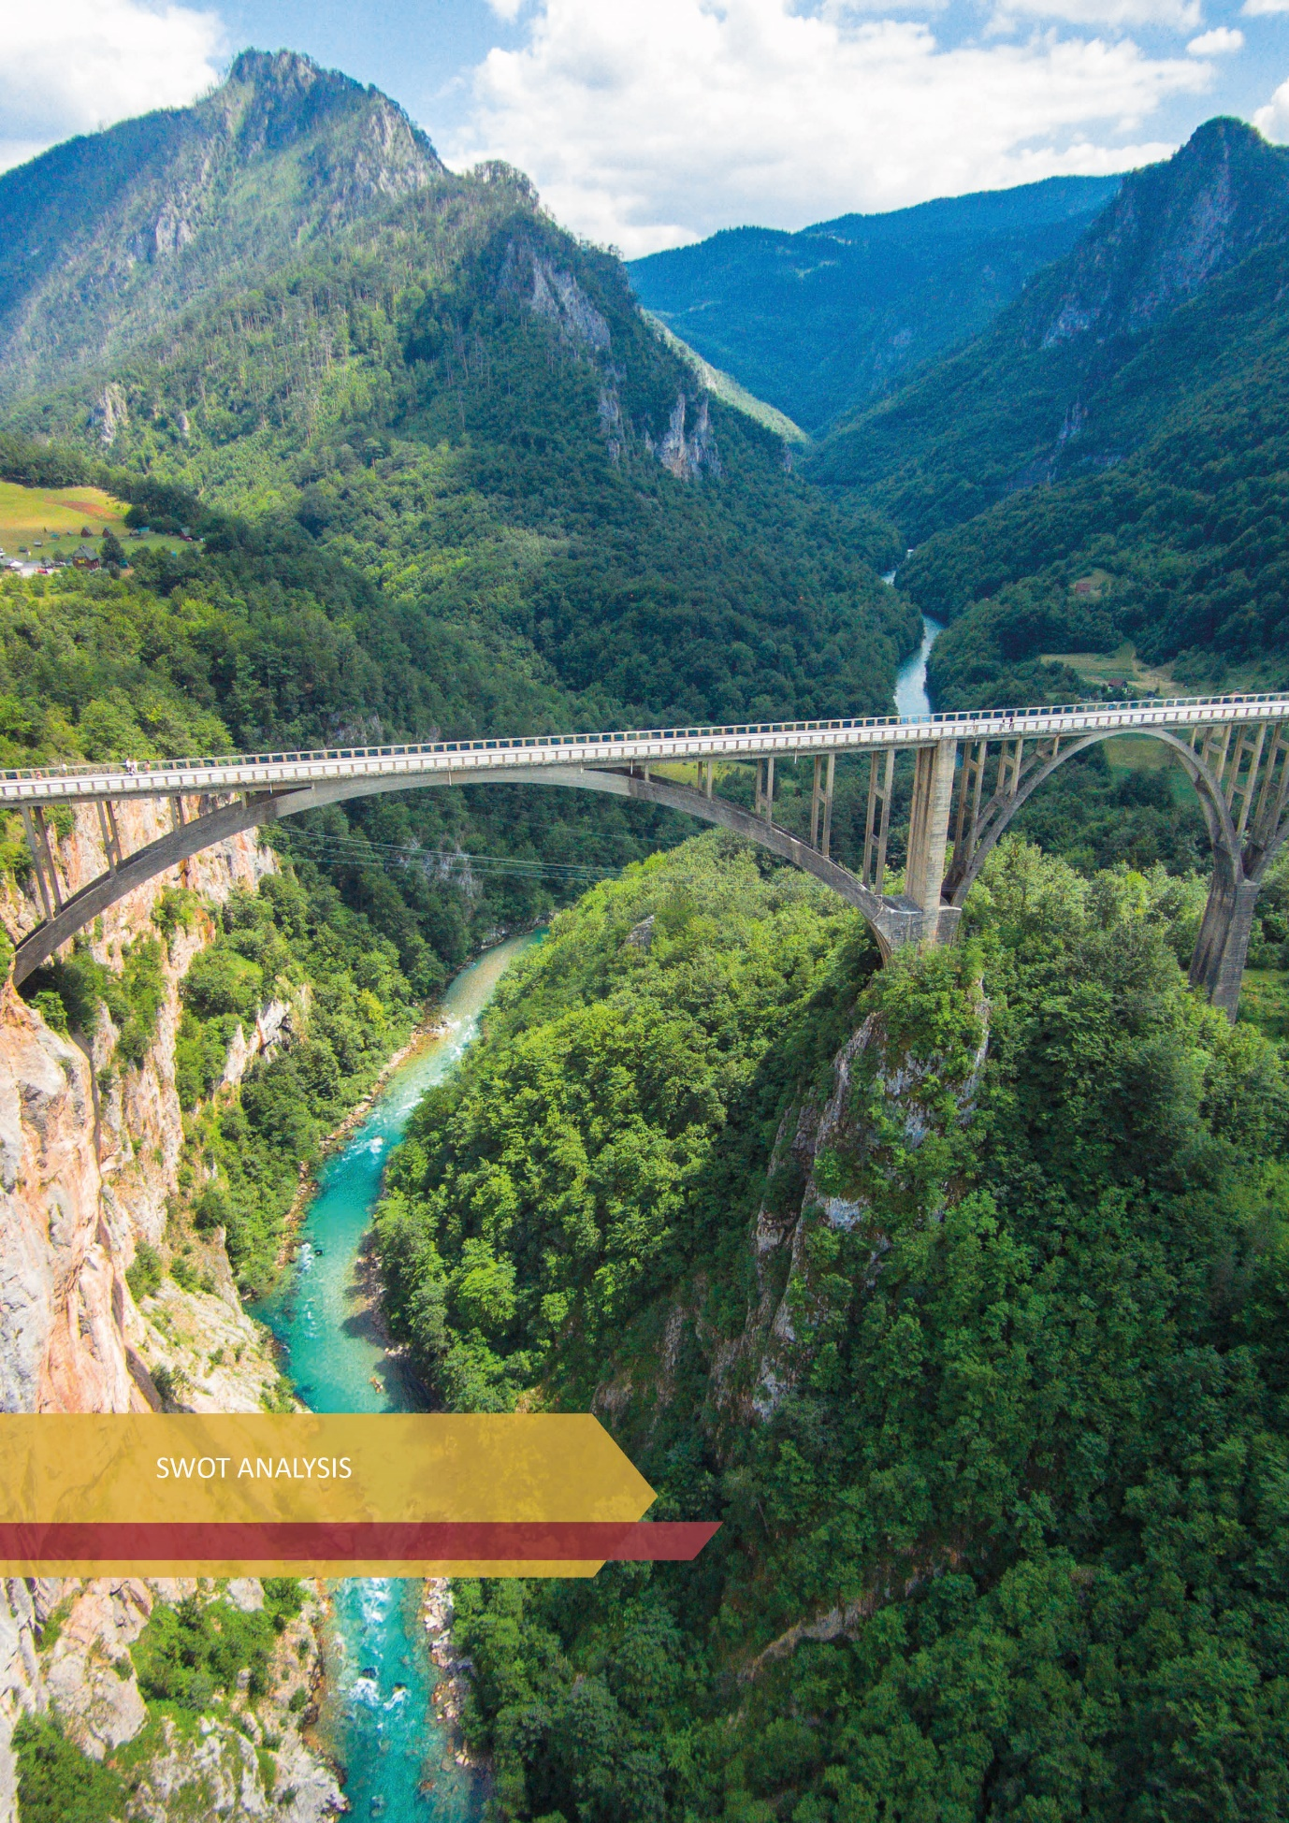

SWOT ANALYSIS

The following is a SWOT analysis which represents a revision and analysis of the strategic position of the Montenegrin tourist destination. Maximizing strengths and opportunities, while minimizing weaknesses and threats, should lead to defining an adequate tourism development strategy.
Strengths | Weaknesses
- Geographical position of Montenegro  - Three different but mutually complementary regions  - Authenticity of landscape, offers and traditional values  - A wealth of natural beauty  - Variety of offers (close to the sea and mountains)  - EU candidate status - use of funds  - Favorable climate conditions  - 5 national parks and 6 nature parks, as centers for tourism development in the hinterland  - Natural and cultural heritage under UNESCO protection  - Cultural and historical heritage  - Long tourist tradition  - Adequate visa regime  - Traditional gastronomic offer  - Hospitality of the local population | - Lack of awareness of development policies  - High degree of dependence on “sun and sea” products  - Insufficiently recognized destination  - Insufficient diversification of the tourism product  - Concentration of tourist movements in the Coastal Region  - Inadequate infrastructure and suprastructure (utility and water infrastructure, electrical, road, etc.)  - Expressed seasonality  - Great presence of the gray economy  - Regional inequality of tourism turnover  - Lack of capacity for EU projects  - Insufficiently fast development of the tourist offer  - High prices in relation to the quality of the offer (general perception of tourists, according to research)  - Depopulation of rural areas  - Devastation of space / Unplanned construction  - Wastewater treatment and illegal landfill  - Insufficient cooperation between the public and private sectors  - Inefficient control and congestion system at border crossings  - Noise  - Insufficient participation of high-paying guests  - Low level of quality of accommodation capacities  - Unfavorable structure of accommodation capacities - 30%: 70% ratio of collective and individual accommodation  - Insufficient level of digitization  - Lack of adequate labor force  - Lack of financial resources and knowledge of new technologies  - Low level of intersectoral cooperation
Opportunities | Threats
- Tourism as a stimulator of development of other economic and non-economic branches  - Return to nature  - Integration of Montenegro into the European Union - EU pre-accession funds  - Improving air accessibility  - Improving road infrastructure  - Product diversification (rural, cultural, health, nautical, sports and recreational, MICE tourism ...)  - Strengthening public-private partnerships  - Proximity to developed emitting markets  - Increasing demand for organic agricultural products  - Global trends show that more and more tourists want to spend their holidays in nature while respecting healthy lifestyles. | - Depopulation of northern municipalities  - Lack of information about the possibilities of “green tourism”  - Increasing environmental pollution  - Lack of financial capacity of local governments  - Insufficient valorization of cultural heritage  - COVID-19 pandemics, new variants of the virus and potential crises  - Inconsistency of the quality of the tourism product and its promotion  - Inadequate labor force  - Climate change  - Insufficiently strengthened public-private partnership  - Increased uncertainty in Eastern Europe (war in Ukraine, economic sanctions against the Russian Federation by many countries, etc.)
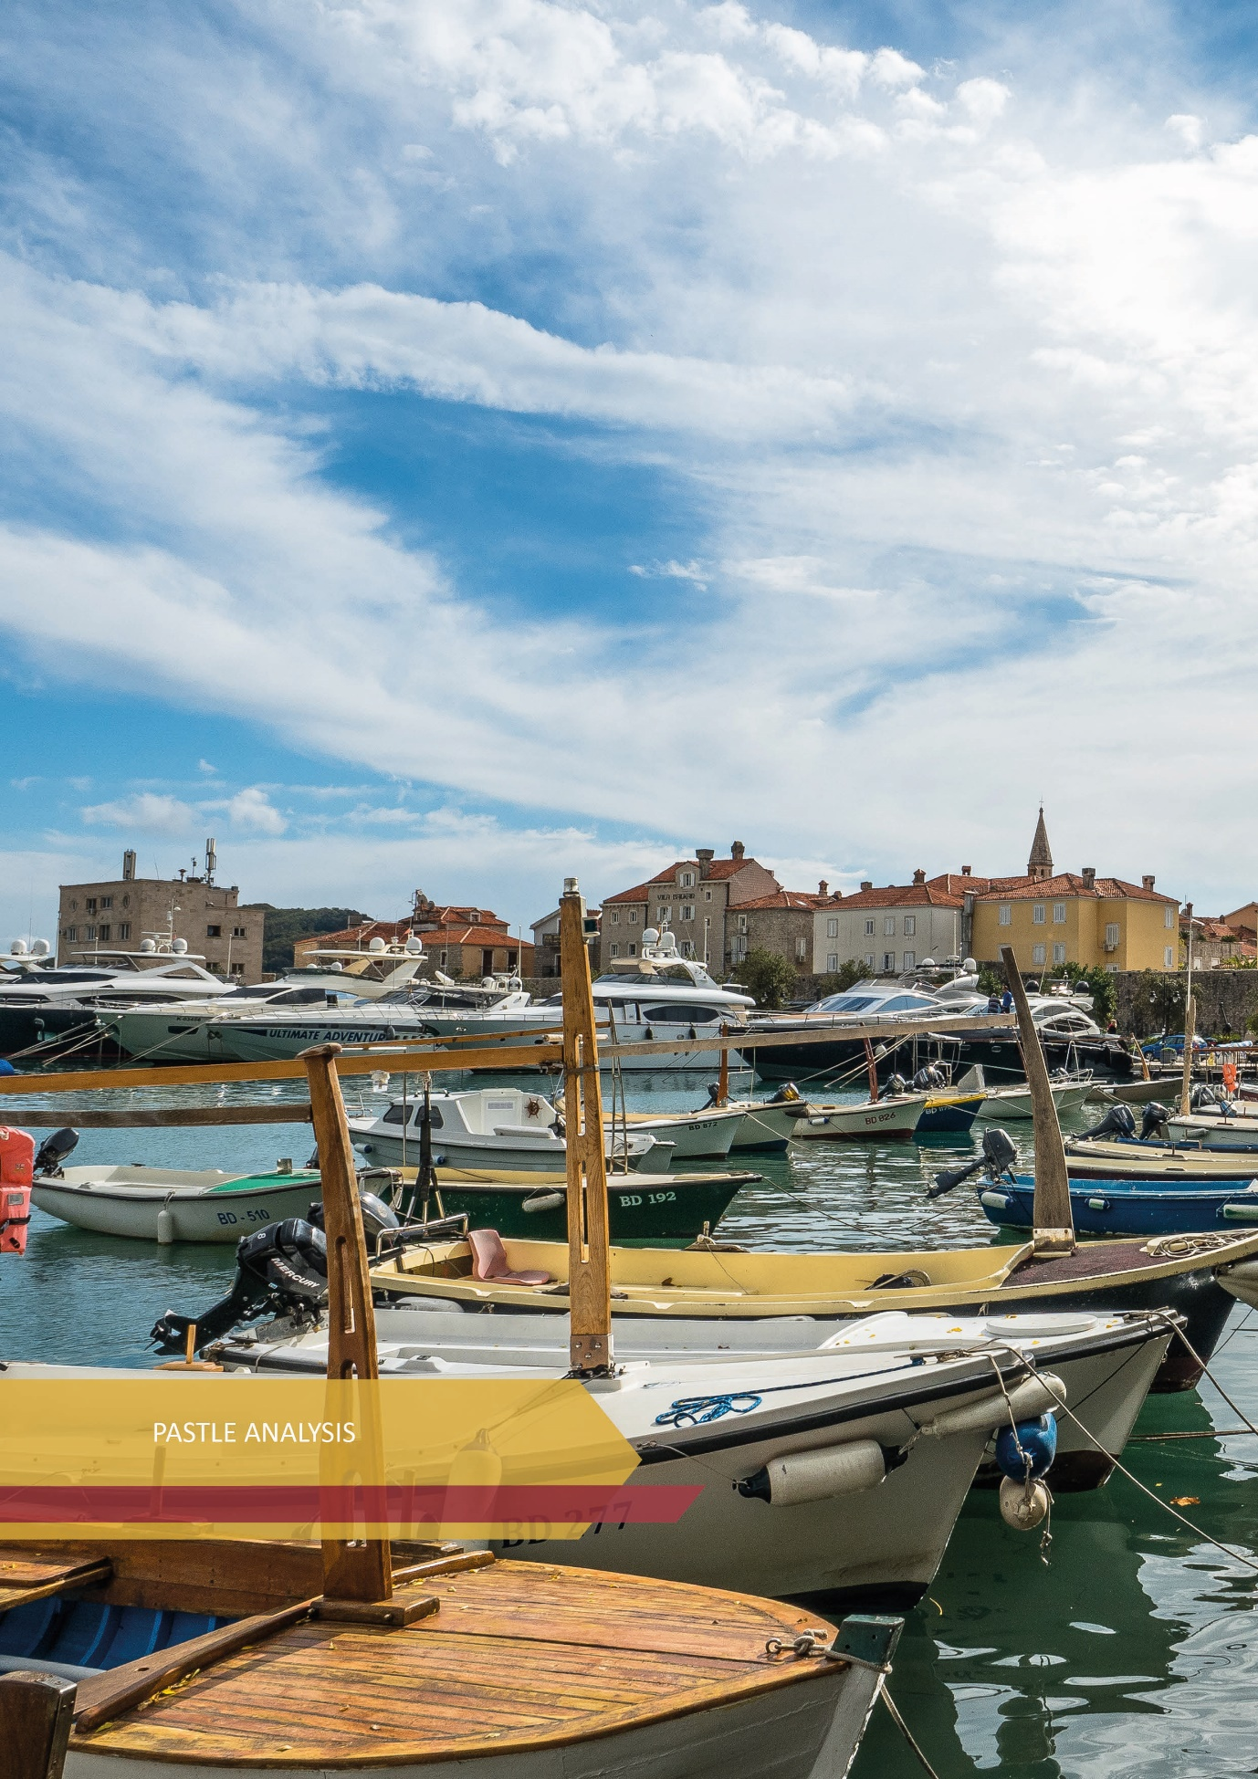

PESTLE ANALYSIS
The analysis examines political, economic, socio-cultural, technological, legal and environmental factors. PESTLE analysis shows the positive and negative changes taking place in the state, economy, society, as well as new trends affecting the development of tourism in Montenegro.
P | POLITICAL | - NATO member and EU candidate country (candidate for EU membership - December 2010, negotiations started on June 29, 2012);  - Continuation of the current full compliance with EU foreign and security policy, as well as participation in joint missions;  - Constructive role of Montenegro in the context of regional cooperation and good neighborly relations;  - Montenegro has been involved in 35 regional organizations and initiatives;  - Parliamentary elections on August 30, 2020 and the election of the new Government of Montenegro in December 2020; a vote of no confidence in the Government in February 2022;  - Adequate visa regime of Montenegro;
E | ECONOMIC | - Macroeconomic developments in Montenegro during 2020 and 2021 under the great influence of the COVID-19 pandemic;  - Montenegro's GDP in 2020 amounted to EUR 4,186 million, and in 2019 to EUR 4,951 million; GDP in 2021 has recovered in nominal terms to the level of 2019;  - GDP per capita in 2020 was EUR 6,737, or 45% of the EU average, and in 2019 EUR 7,959, or 26.6% of the EU average;  - WTTC Report - the contribution of tourism to GDP in 2019. was 30.9%, and in 2020 it was 8.8%, and contribution to employment in 2019 was 65.0% (31.9% of the total number of employees), and in 2020 it was 51.8% (27.3% of total number of employees);  - Projections of the European Bank for Reconstruction and Development (EBRD) - the Montenegrin economy will grow by 12.3% in 2021 and by 5.7% in 2022;  - According to the World Bank forecasts, GDP growth in 2021 will be 10.8%, and in 2022 it will be 5.6%;  - Due to the COVID-19 virus pandemic, a decrease in tourism turnover was recorded;  - In 2021, according to the CBM data, revenues from tourism in 2021 amount to EUR 757.8 million, which represents 69% of the generated revenues from tourism compared to the record year 2019 (EUR 1.1 billion), and five times more revenues compared to 2020 (EUR 144.5 million);  - Primary and secondary income accounts recorded a surplus of EUR 365.6 million, which is an increase of 47.7% on an annual basis. A surplus of EUR 84.0 million was generated on the primary income account, which is 34.7% more than in the same period last year;  - The Montenegrin economy has significant external imbalances, with a calculated deficit;  - Economic stabilization is expected in the coming years, even in the tourism sector - increased investment, infrastructure development, season extension, and revenue growth.
S | SOCIAL | - Population in Montenegro - 620,000, 1/3 lives in Podgorica, and 67.15% live in all urban areas;  - Presence of migration of the population from the Northern region towards the Coastal region and Podgorica;  - 24.9% of the population of Montenegro is younger than 18, 62.3% are aged 18 to 64, and 12.8% are older than 65, source Census of Montenegro 2011;  - The Human Development Index for 2020 puts Montenegro in the first place among the countries of the Western Balkans.  - Loss of tax revenues due to informal employment and undeclared work is estimated at 2.8% of GDP per year.  - According to the United Nations-UN analysis related to the assessment of the social impact of the COVID-19 pandemic, a recommendation was made to consider the possibility of creating practical programs of education in tourism.  - UN Analysis of the Situation in the Country - defined focus on: improving service delivery, maintaining spending on health, education and social protection and reducing discrimination against vulnerable groups, improving the quality and digitization of data, improving public administration to fight corruption and nepotism, with the aim of creating an inclusive society.
T | TECHNOLOGICAL | - Smart Specialization Strategy (S3) for the period 2019-2024. - Development of sustainable and health tourism with the application of innovative technological solutions.  - Transport Development Strategy for the period 2018-2035 - modernization of transport infrastructure, ITS technology, reduction of border crossing time, etc.  - UN 2021 plan - Promotion of the natural and cultural heritage of Montenegro (EuroVelo cycling routes and Cultural Routes of the Council of Europe).  - Green economy (development of green technologies, innovation in the field of sustainable agriculture and tourism, encouraging entrepreneurship, investing in quality jobs).
L | LEGAL | - Direct impact: the Law on Tourism and Hospitality, the Law on Tourist Organizations, the Law on Tourist Tax, the Law on Mountain Trails, the Law on Ski Resorts and the Law on Rafting.  - Indirect impact: the Law on Spatial Planning and Construction of Structures, the Law on Nature Protection, the Law on National Parks and the Law on Environmental Impact Assessment.  - Documents at the Government level: Program of economic reforms (“diversification of the tourism product”), Directions of development of Montenegro 2018 - 2021 (“Tourism and cultural tourism”).  - Fulfillment of obligations from the process of Montenegro's accession to the EU, - Chapters 3, 18, 20 and 27.
E | ENVIRONMENTAL FACTORS | - The Constitution defines Montenegro as “a civil, democratic, ecological and a country of social justice, based on the rule of law”.  - Richness of biodiversity and natural diversity;  - 5 national parks: Skadar Lake NP, Lovćen NP, Biogradska Gora NP, Durmitor NP, Prokletije NP (7.7%);  - UNESCO protected heritage: natural and cultural area of ​​the city of Kotor, Durmitor NP with the Tara river basin, Stećci (Tombstones) on Durmitor, Venetian defense fortifications, Boka Navy;  - The National Strategy for Sustainable Development until 2030 integrated the 2030 Agenda into the national strategic framework;  - National goal in the use of energy from renewable sources is achieved - the share of energy from renewable sources in gross final consumption is 33% in 2020.  - Montenegro has joined international efforts to combat climate change and reports regularly in accordance with the UN Framework Convention on Climate Change, and has established a legal and institutional framework to reduce disaster risk.

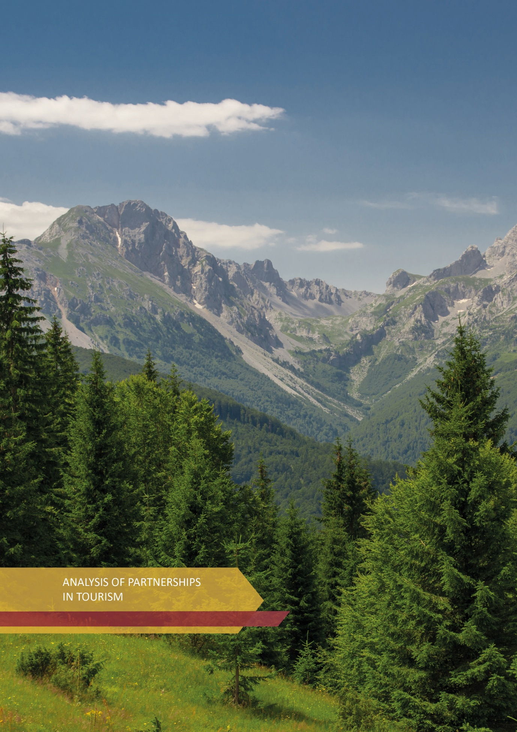

ANALYSIS OF PARTNERSHIPS IN TOURISM
In order to achieve high quality, sustainability and implementation of the Montenegro Tourism Development Strategy 2022-2025, the synergy of key stakeholders, from the national, regional and local levels, oriented towards the creation of a common tourism product, is necessary. In Scheme 1, partnerships are presented through an evaluation mechanism, defining two evaluations (from 1 - minimum to 5 - maximum) which show:
  - level of interest and
  - level of influence (power)
of stakeholders to implement this Strategy.
Scheme 1: Overview of key actors in tourism
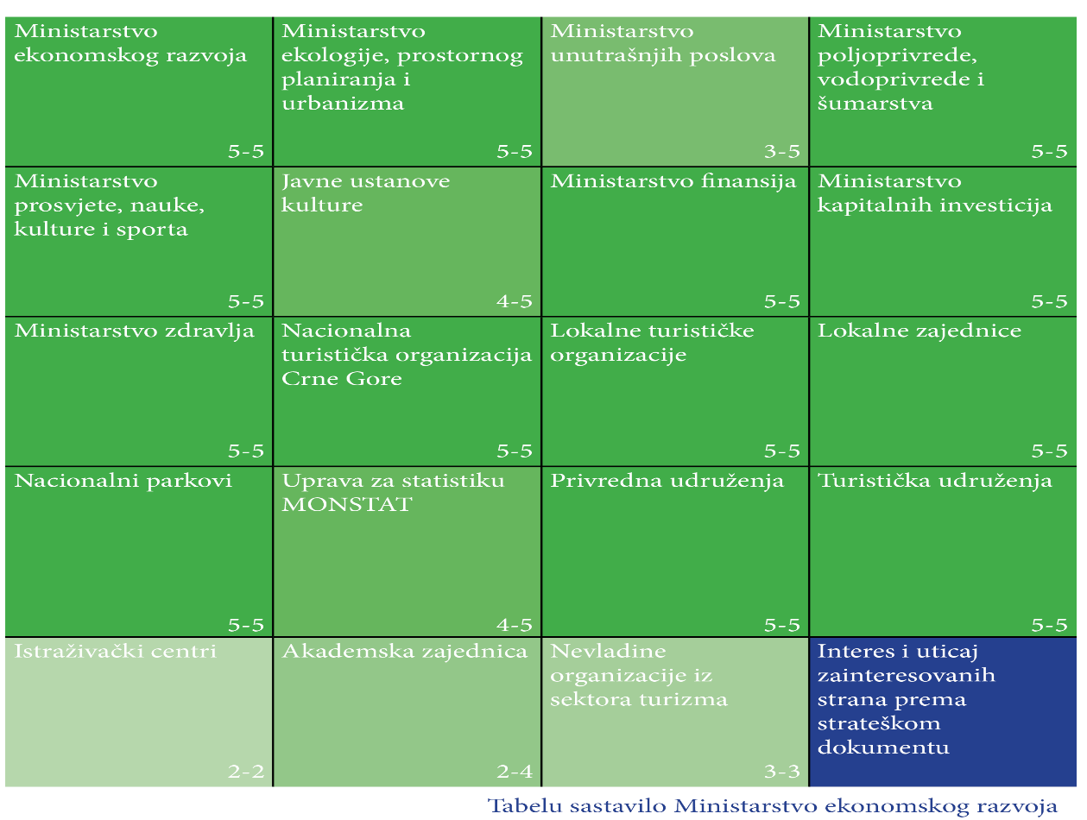
High marks concerning both segments, interest and influence, indicate the need to raise the level of awareness and commitment of all partners in the direction of their more efficient and effective interconnection. In this way, partnerships contribute to the strengthening of tourism as one of the development priorities of the overall economy of Montenegro.

Annex I: Detailed processing of the Analysis of partnerships in tourism
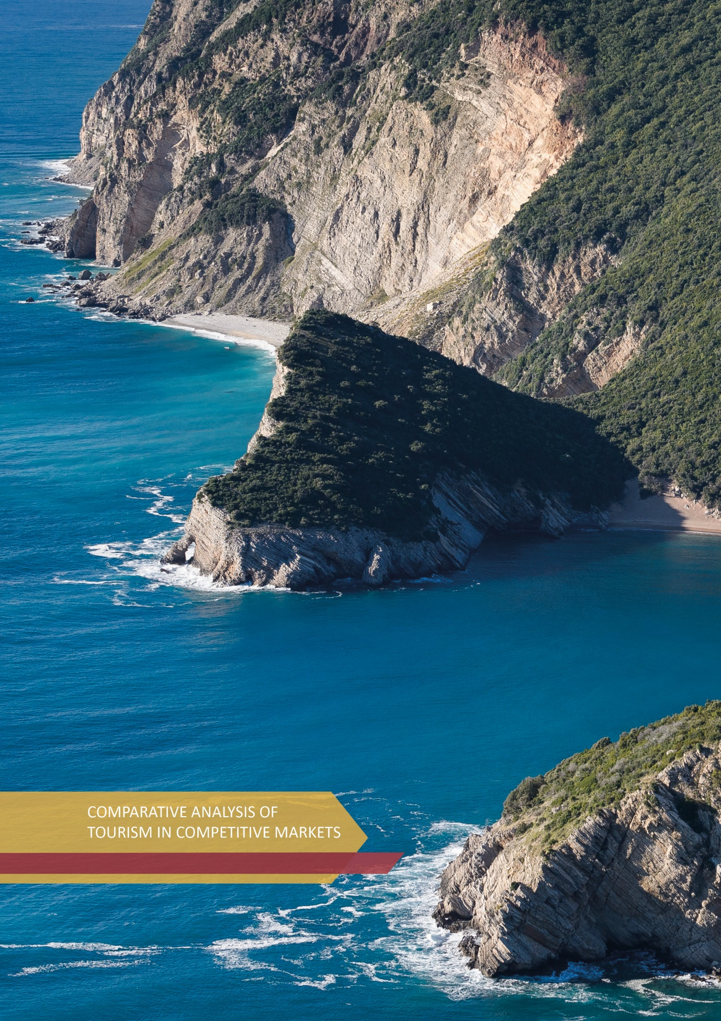

COMPARATIVE ANALYSIS OF TOURISM IN COMPETITIVE MARKETS

Country | CROATIA
Tourism turnover | In 2018, the total contribution of tourism to GDP was 19.6%, with revenues from tourism amounting to € 10.1 billion. In the same year, the tourism industry directly employed 86,600 people, which represents 6.6% of total employment.  According to statistical data, the number of foreign guests in 2018 amounted to 16.6 million, with 83.2 million overnight stays, or 92.8% of the total number of guests. The average duration of stay of tourists in Croatia is five nights. The main strategic markets for Croatia are Germany (16.7%), Austria (8.2%) and Slovenia (8.2%). Some growth is evident from distant markets such as the USA, Canada and China.
Tourism management and financing | The Ministry of Tourism and Sports of Croatia is responsible for drafting strategic documents and policy proposals in tourism. The Croatian National Tourist Board is in charge of tourism promotion.
  Tourism budget in 2018 | about € 31 million / 0.2% of the total state budget
  Total budget of the Croatian National Tourist Board (tourist tax (47.8%), state budget, membership fees and other sources) | about € 43 million
Tourism policies and program | Croatian tourism development strategy until 2020 has defined the following goals:  - Improve the tourism product and raise quality through investment, innovation, smart specialization and sustainability.  - Strongly position the Croatian brand on international markets, increase tourism turnover while increasing average consumption and support the private sector.  A new Strategy for the Development of Sustainable Tourism until 2030 is being drafted.
The main challenges in tourism in Croatia | - Lack of labor force in tourism - 64% of employers have difficulty finding suitable staff;  - Excessive construction - Newly built accommodation facilities in some areas along the coast cause environmental degradation, with a negative impact on natural resources and infrastructure;  - High tourist pressure and waste management - Cruisers have been identified as one of the main potential polluters;  - Seasonality and regional imbalance (direct dependence on the sun and sea, without sufficient innovative and high quality tourism products).

Country | GREECE
Tourism turnover | Tourism is one of the most important sectors of the Greek economy and a key pillar of economic growth. In 2018, the total contribution of tourism to GDP was 6.8%. In 2018, the tourism sector directly employed 381,800 people, which is 10.0% of the total employment in the country. Travel exports accounted for 43.3% of total services exports in 2018. In the same year, Greece was visited by 33.1 million tourists, with 230.7 million overnight stays. The markets of Germany (+ 18.2%) and France (+ 7.3%) grew significantly, recording a total of 4.4 million and 1.5 million arrivals, respectively. Guests from the USA made 1.1 million arrivals, which is an annual increase of 26.9%.
Tourism management and financing | The Ministry of Tourism is responsible for creating and developing tourism policy in Greece. The ministry cooperates with other interested ministries and tourism authorities, such as the Association of Greek Tourism Enterprises and the Tourism Research Institute. The Greek National Tourism Organization (GNTO) conducts destination promotion and marketing activities, while the Ministry of Tourism manages a network of 14 regional tourism offices responsible for licensing, implementing quality control and regulating the tourism sector.
  Tourism budget in 2018 | € 63.7 million / of which € 20.6 million allocated to GNTO
Tourism policies and program | The National Strategic Plan for the Tourism Sector was adopted for the period 2014-2020. Greece tourism strategy aims to promote the country as a global and attractive year-round destination, offering unique and authentic travel experiences. Tourism is at the heart of government policy for national development, innovation and openness.  The National Strategic Tourism Plan defines five priorities:  - High standards of infrastructure, in order to attract high quality investments, eliminate bureaucracy and optimize the spatial distribution of tourism;  - Improving accessibility and connectivity, through improving air accessibility and expanding and upgrading the national marina network;  - Compliance with the principles of sustainability;  - Increasing the quality and attractiveness of the tourist offer through sustainable destination management and improving education in tourism;  - Redesign of the tourism product and brand, in order to focus on quality, authenticity, resilience and sustainability.
The main challenges in Greek tourism | Excessive crowds caused by a large number of tourists, especially during the summer tourist season. Intensive work is being done in this direction in order to provide the necessary legal and other prerequisites for the diversification of the tourist offer, the discovery of new tourist sites and attracting guests to lesser-known places, with the aim of reducing seasonality. Digital transformation is the next key priority, through: digital transformation of services; digital improvement of tourism education; integrated online data collection and processing system; and the use of new technologies in tourism promotion.

Country | ITALY
Tourism turnover | Including indirect effects, tourism accounted for 13.0% of GDP in 2017. The Italian tourism industry employed two million people in 2018, or 8.3% of total employment. According to statistics, 63.2 million tourists visited Italy in 2018. The top inbound markets in the analyzed period are Germany (19.3% of tourists), the United States (9.0%), France (7.5%), the United Kingdom (6.0%) and China. Almost 60% of international arrivals go to only four regions: Veneto, Lombardy, Lazio and Tuscany.
Tourism management and financing | The Directorate General for Tourism in the Ministry of Cultural Heritage, Activities and Tourism adopts and regulates the strategic direction of tourism development, in coordination with the regions and autonomous provinces, and supervises the Italian National Tourist Board (ENIT) and the Italian Alpine Club. In 2020, the Italian National Tourist Board (ENIT) switched from a public to a private-public body. Tourism received support from the Culture and Innovation Program 2014-2020 which is financed from EU structural funds. The Investment Fund for Tourism, established by the Government in 2014, is managed by the National Investment Bank Cassa Depositi e Prestiti.
Tourism policies and program i | The National Strategic Plan for Tourism 2017-2022 is based on four topics:  - Culture and heritage: cultural and natural heritage should be enhanced through sustainable management practices and innovative use of property;  - Competitiveness and employment: competitiveness in tourism should be encouraged in order to create added value and increase the quantity and quality of employment;  - Putting tourists at the center: the Italian tourism experience needs to meet market demands and expectations;  - Integration and interoperability: the system of tourism associations and operators should be fully integrated, encouraging cooperation and partnership.
The main challenges in Italian tourism | Special emphasis was placed on promotional activities to expand the national offer, i.e., shift the focus from the main tourist attractions to lesser-known destinations / sites. The aim is to shift the focus from popular sites and expand the economic benefits of tourism in time and space, using other resources, history and the uniqueness of the places throughout Italy. The goal of such a policy is to develop products that will satisfy various types of interest, such as wine, sports, adventure and prosperity, with special emphasis on local communities that will have the opportunity to develop an authentic small-scale tourism offer characteristic for a given place.

Country | SLOVENIA
Tourism turnover | In 2017, the share of GDP related to tourism was 2.3 billion euros, or 5.3%. Taking into account direct and indirect impacts, the contribution of tourism to GDP is estimated at 3.6 billion euros, which is approximately 8.4% of total GDP. In 2018, the tourism industry employed 68,150 people, which directly accounted for 7.7% of the total employment in the country. The number of foreign tourists amounted to 4.4 million in 2018, with 11.2 million overnight stays. The main markets are Italy (13.5% of all inbound visitors), Germany (11.4%), Austria (8.6%), Croatia (4.9%), the Netherlands (4.2%), United Kingdom (3.7%) and Serbia (3.1%).
Tourism management and financing | The Ministry of Economic Development and Technology is responsible for implementing the national tourism policy. The Slovenian Tourist Board is responsible for the promotion and marketing of the destination, as well as for processing tourist information, coordinating product development, engaging stakeholders and market research. Twelve regional development organizations are also responsible for the overall development at the regional level, including the definition of tourism development programs.
  Tourism budget in 2018 | € 13.5 million / of which € 12.9 million belongs to the Slovenian Tourist Board.
  Total revenues of the Slovenian Tourist Board (tourist tax, additional promotional taxes ...) | € 4.5 million + € 18 million from the state gambling concession, which are awarded to pre-determined areas of Slovenia
Tourism policies and program | In 2017, the Government of the Republic of Slovenia adopted a new Strategy for the Sustainable Growth of Slovenian Tourism 2017-2021, with a strategic vision according to which Slovenia will be recognized as a global, green, five-star boutique destination for demanding guests. The strategic goal of Slovenian tourism is to increase the revenue from foreign guests to € 3.7 billion by 2021 from the then € 2.7 billion. Other targets include new additional 5-5.5 million arrivals, 16-18 million overnight stays and 18,000 to 22,000 new rooms in accommodation facilities.  Six key policies have been identified:  - Development of a new organizational structure of Slovenian tourism through the formation of four macro destinations (Mediterranean Slovenia, Alpine Slovenia, Thermal Pannonian Slovenia and Central Slovenia with Ljubljana) and 35 leading destinations.  - Rationalization of institutional and legal frameworks for creating a better business environment. This implies a more efficient distribution of tourist tax at the local level; extending the definition of accommodation to new forms and standards of accommodation quality, such as glamping facilities; new regulations for mountain bike and hiking trails; training in outdoor sports; and improving the Law on Security and Safety.  - Investment in new and existing accommodation facilities and supporting infrastructure in order to increase competitiveness and raise quality.  - Investing in training and education, course development, national center for education and on-the-job training; providing assistance to small and specialized hotels to improve the skills and training of employees.  - Improving spatial planning.  - Encouraging entrepreneurship.

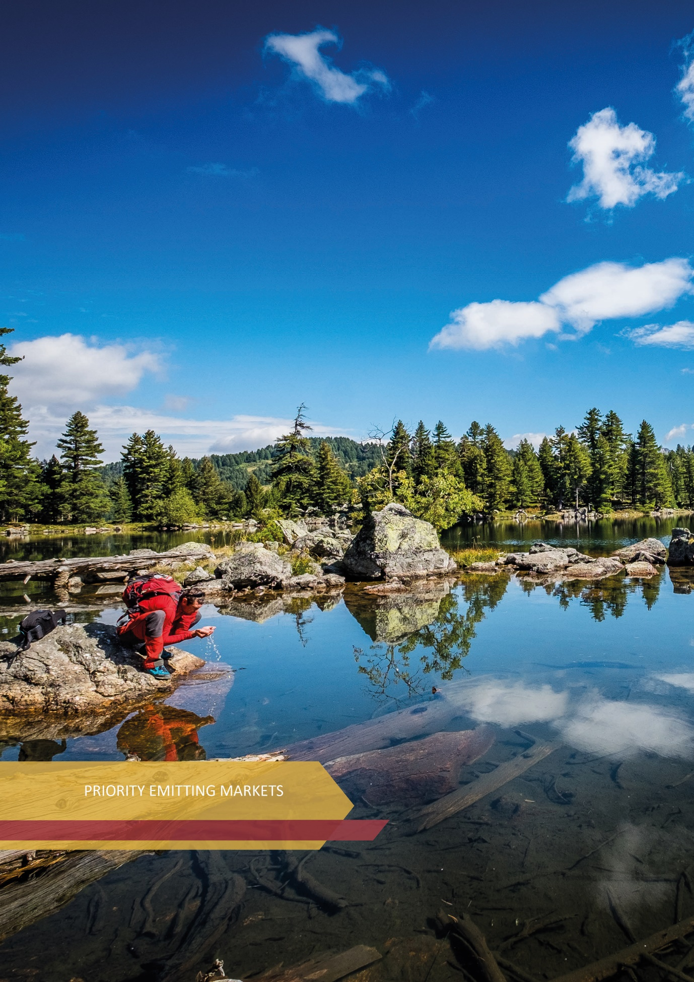

PRIORITY EMITTING MARKETS

According to official statistics on tourism turnover in 2019, among the most numerous tourists who come to Montenegro and spend the most nights, in addition to traditional emitting markets such as countries in the region and Russia, there are tourists from China and Ukraine (Table no. 13).

Table no. 13 - Top 10 emitting markets according to the number of tourists and overnight stays in 2019

Top 10 emitting markets according to the number of tourists 2019 |  | Share in total number of tourists in %
Serbia | 402,866 | 16.1
Russia | 384,689 | 15.3
Bosnia and Herzegovina | 203,766 | 8.1
Kosovo | 169,601 | 6.8
Germany | 163,877 | 6.5
France | 90,083 | 3.6
Great Britain | 80,876 | 3.2
Albania | 79,001 | 3.1
Poland | 76,620 | 3.1
China and Hong Kong | 74,833 | 3.0
Top 10 emitting markets according to the number of overnight stays in 2019 |  | Share in total number of overnight stays in %
Russia | 3,470,593 | 24.9
Serbia | 2,988,690 | 21.4
Bosnia and Herzegovina | 1,185,972 | 8.5
Kosovo | 755,246 | 5.4
Germany | 643,651 | 4.6
Ukraine | 463,551 | 3.3
France | 436,526 | 3.1
Great Britain | 422,978 | 3.0
Poland | 396,390 | 2.8
Albania | 241,918 | 1.7
Source: MONSTAT, edited by the Ministry of Economic Development

Also, analyzes indicate that during 2021, the most numerous were tourists from Serbia, Bosnia and Herzegovina, Ukraine, Russia, Kosovo, Germany, Albania, Poland, France and the Republic of North Macedonia (Table no. 14).

Table no. 14 - Top 10 emitting markets according to the number of tourists and overnight stays in 2021
Country of affiliation | Arrivals | Structure in % | Overnight stays | Structure in % | Length of stay in days
Serbia | 429,106 | 27.6 | 3,072,845 | 32.6 | 7.16
Bosnia and Herzegovina | 214,570 | 13.8 | 1,217,931 | 12.9 | 5.68
Ukraine | 135,997 | 8.8 | 871,314 | 9.2 | 6.41
Russia | 108,025 | 7.0 | 1,140,173 | 12.1 | 10.55
Kosovo | 107,111 | 6.9 | 450,265 | 4.8 | 4.20
Germany | 70,653 | 4.5 | 374,868 | 4.0 | 5.31
Albania | 56,547 | 3.6 | 177,831 | 1.9 | 3.14
Poland | 40,776 | 2.6 | 217,170 | 2.3 | 5.33
France | 35,985 | 2.3 | 151,369 | 1.6 | 4.21
Republic of North Macedonia | 27,965 | 1.8 | 157,177 | 1.7 | 5.62

Determining the categories of emitting markets from which tourists come to Montenegro, was done on the basis of market analyzes conducted in cooperation with the NTO Montenegro, i.e., analysis of the generated tourism turnover in the past years (overnight stays and total consumption), then based on the geographical position of the market in relation to our country, as well as air and other connections, but also the announcement of flights by airlines, tour operators, etc.
According to the above parameters, emitting markets active until 2025 can be divided into groups as follows:
GROUP A | GROUP B | GROUP C
- Germany | - Italy | - USA
- Great Britain | - Scandinavia | - Japan
- France | - Netherland | - UAE and other Gulf countries
- Austria | - Belgium | - Turkey
- Poland | - Russia
- Ukraine | - Hungary
- Region | - Czech Republic
 | - Switzerland
 | - Israel
 | - People's Republic of China

- Regional markets (Serbia, Bosnia and Herzegovina, Kosovo) showed a positive trend until 2019 and strong growth in 2021. Tourists from these markets are characterized by a dominant stay during the summer season and they mostly stay on the Montenegrin coast.
- Eastern European markets - Russia is an important emitting market for Montenegro and it was among the ten leading world emitting markets in the period before the COVID-19 pandemic. Specifically, in the region of Eastern Europe, Russia accounts for 82% of all overnight stays, while the second most important is Ukraine (participates with 13%) and the third is Belarus with 6%. Montenegro ranks 16th on the Russian list of preferences in relation to the choice of holiday destinations. Tourism turnover with Ukraine has significantly increased in 2021, so it is necessary to further improve direct air connectivity in order to animate, in addition to the Ukrainian, other markets of the former republics of the USSR.
- Western European markets - Tourists from Germany, compared to other European tourists, are interested in coming to Montenegro in periods outside the main tourist season, i.e., during spring and autumn. In this sense, further activities are needed to improve products/experiences based on nature and culture, in order to increase the market share of German tourists in the pre- and post-season. Tourists from France and the UK had significant market potential during the summer seasons before the pandemic. In 2020, their absence was recorded, while in 2021, due to the global epidemiological situation, interest from these markets was low.
- Central European markets - Tourists from Poland, traditionally friendly with the Montenegrin people, significantly contribute to increasing turnover throughout the year, and especially show interest in staying in the North of Montenegro. The situation is similar with other countries in this part of Europe (Czech Republic, Hungary, Slovakia).
- Remote markets (USA, PR China and Israel) - the trend of tourists coming from these markets has not rehabilitated compared to the level of 2019, so their participation in tourism turnover will continue to depend predominantly on the global epidemiological situation.
***

Considering that tourism is an extremely sensitive economic branch that reacts promptly to all crisis events, it is expected that the current political crisis between Russia and Ukraine, i.e., war events on the territory of Ukraine, negatively affect global tourism trends. This means that in the period when tourism is still recovering from the consequences of the Covid-19 pandemic, it is also facing a new crisis whose repercussions on tourism cannot be more precisely predicted at this time.

When it comes to Montenegro as a tourist destination, the experiences gained during the recovery of tourism from Covid-19 will be used. This means that practical solutions will be adapted to any potential crisis situation.

This adds value to this strategic document, as it aims to position Montenegro globally as a responsible, adaptable and a destination resilient to all types of crises.

Accordingly, the definition of priority emission markets will be adjusted.

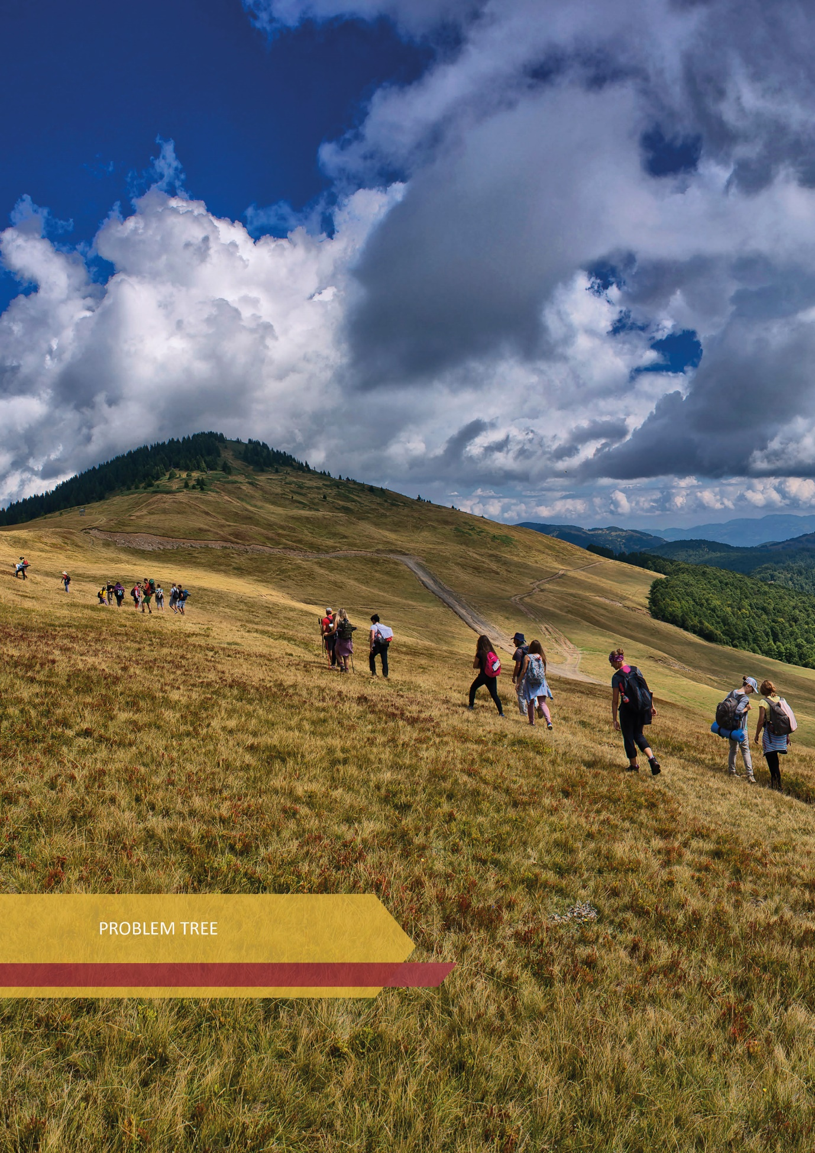

PROBLEM TREE

UNDEVELOPED INFRA AND SUPRA STRUCTURE
INADEQUATE LEGISLATION, SYSTEM FAILURES, INSPECTION CAPACITIES
INSUFFICIENT ECOLOGICAL AWARENESS (ENDANGERING NATURAL RESOURCES, INADEQUATE WASTE MANAGEMENT)
LOW AWARENESS OF THE IMPORTANCE OF TOURISM
LIMITED PERFORMANCE OF THE DESTINATION MANAGEMENT MODEL AND LIMITED MARKETING PERFORMANCE
SHORT PERIOD OF BUSINESS OF TOURISM INDUSTRY
INSUFFICIENT PRIORITIZATION OF TOURISM DEVELOPMENT
LACK OF STRATEGICALLY MANAGED DESTINATION MARKETING
POPULATION MIGRATION
GRAY BUSINESS ZONE
ECOLOGICAL BLACK SPOTS
SEASONALITY,
REGIONAL IMBALANCE,
INADEQUATE QUALITY OF SERVICE (STAFF, CAPACITY),
GRAY ECONOMY
INSUFFICIENTLY DIVERSIFIED TOURISM PRODUCT
LACK OF QUALITY STAFF, EDUCATION, TRAINING AND DUAL EDUCATION
ECONOMIC REGIONAL INEQUALITY
LACK OF INNOVATIVE TECHNOLOGICAL SOLUTIONS
PROBLEM
CONSEQUENCES

INSUFFICIENT QUALITY OF SERVICE
CAUSES OF THE PROBLEMS
KEY PROBLEMS
INADEQUATE AVAILABILITY OF PRODUCTS AND SERVICES
REGIONAL IMBALANCE

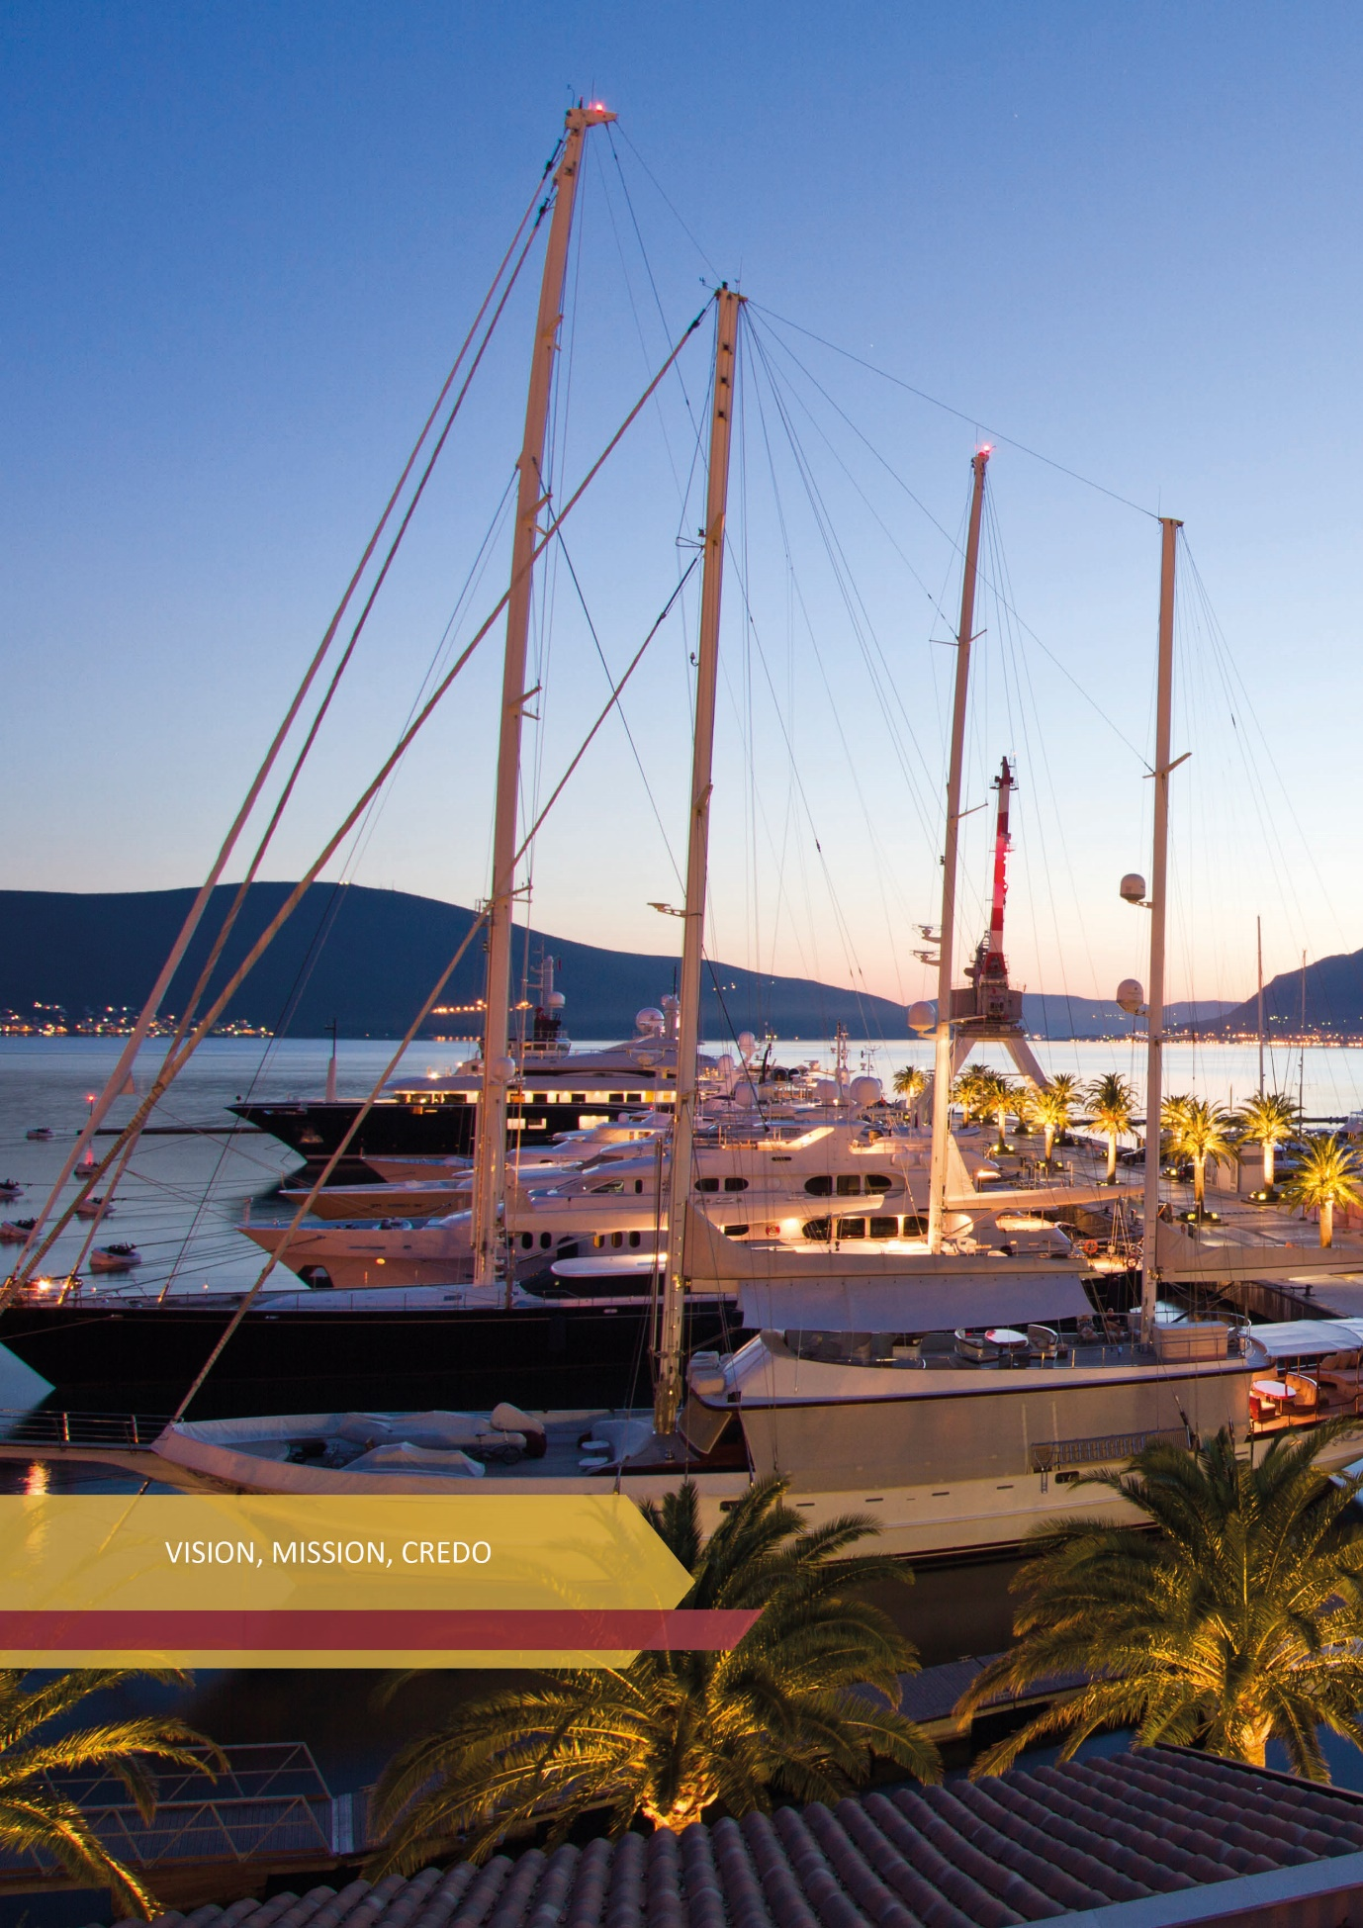

VISION, MISSION, CREDO

The vision of this Strategy clearly defines the ultimate goal. The mission is a roadmap that leads to the achievement of that goal, while the credo is a system of beliefs and guiding principles.

VISION
In 2025, Montenegro is a globally recognizable tourist destination.
MISSION
Montenegro manages the destination in a sustainable way, creating an innovative, green and inclusive tourism product, influencing the increase in tourism spending, reducing seasonality and regional imbalance, with the aim of raising living standards of local population and tourist satisfaction.

CREDO
Montenegro is promising, explore it.

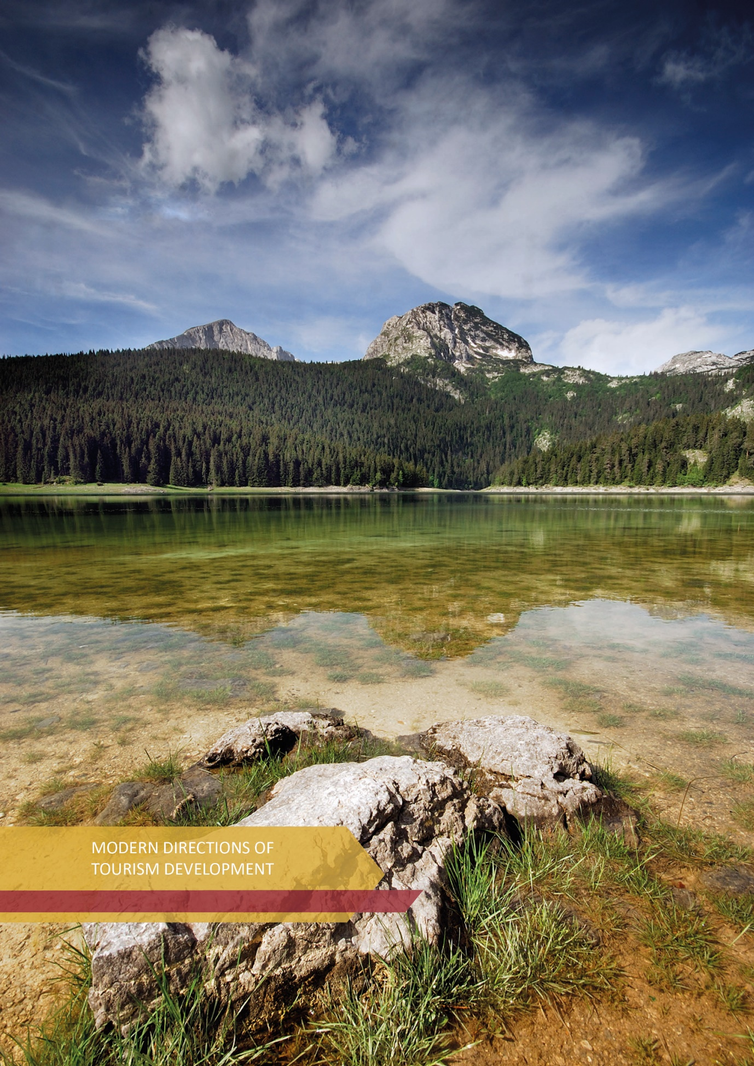

MODERN DIRECTIONS OF TOURISM DEVELOPMENT

TOURISM SHOULD BE SUSTAINABLE, INCLUSIVE, SMART, GREEN AND RESPONSIBLE

11.1. Sustainable tourism
The principle of sustainability encompasses environmental, economic and socio-cultural aspects of tourism development, so it is important to establish and maintain a balance between these three dimensions.

In 2016, Montenegro adopted the National Strategy for Sustainable Development until 2030, which is a long-term development strategy of Montenegro which defines solutions for sustainable management of four groups of national resources - human, social, natural and economic, as priorities for overall sustainable development of Montenegrin society.
According to the United Nations World Tourism Organization (UNWTO), sustainable tourism should strive to provide:
  - Optimal use of environmental resources;
  - Respect for the socio-cultural authenticity of the host communities, preservation of their cultural heritage and traditional values ​​with intercultural understanding and tolerance;
  - Ensure sustainable, long-term economic activities, providing socio-economic benefits that are equitably distributed, including stable employment and income-generating opportunities and social services for host communities, while contributing to poverty reduction.
Encouraging sustainable tourism development is a continuous process in which it is necessary to include all stakeholders in society, and policy makers, but also all other entities, including tourists themselves. It is important to monitor this process, but also to actively raise awareness of the importance of sustainability in the sector.
One of the trends in tourism that can contribute to sustainability is “Slow tourism”. For tourists who strive for relaxation and slowing down the daily pace, this is an interesting choice. The goal is for tourist visits to be carried out outside key tourist sites, and for tourism to be “slower and smarter” after the COVID-19 pandemic. Slow tourism is a response to mass tourism, and at the same time the concept of how to spend a healthy vacation. This concept can equally apply to a weekend in a city, as well as a longer stay somewhere in the mountains or on the coast, as long as the pace is slower and more moderate than before. Confirmation of interest in this type of tourist offer can be found in Guest survey 2017, NTO, and Survey on the attitudes and consumption of tourists in Bar in 2019, TO Bar, according to which passive rest and enjoyment, as well as enjoyment of gastronomy, are two of the three main holiday motives. This indicates the perception of Montenegro as a holiday tourist destination, which is also a good basis for the development of slow tourism in some sites.

11.2. Inclusive tourism
The COVID-19 pandemic had a huge impact on all segments of society and the economy. Developed and developing economies have also been affected, and the whole situation has mostly had a negative impact on marginalized groups and the most vulnerable populations.
Inclusive tourism tends to make tourism accessible to all, that all people, without distinction, have the right to enjoy tourist experiences. In fact, this form of tourism is adapted to people such as: those with disabilities, the elderly, people with chronic health problems, people with acute illnesses and parents with young children, women, young people… so that everyone has equal access to tourism services.

Also, in accordance with the concept of inclusive tourism and growth, which according to the Organization for Economic Cooperation and Development (OECD) is “economic growth that is equitably distributed in society and creates opportunities for all”, more attention should be paid to employment of young people and women, persons with disabilities, representatives of minorities, etc.
It is very important to envisage the involvement of young people through the implementation of the Youth Guarantee program launched by the European Commission so that all persons under 30 receive a quality offer for: job, further education, internship or professional training, within four months after completing formal education or losing job. Montenegro has the possibility of financial support for this program through the Economic and Investment Plan for the Western Balkans from October 2020. In October 2021, the EC launched the first phase of a process that will lead to the formulation of an implementation plan in all Western Balkan countries by June 2022. Given that tourism is one of the strategic branches of economic development of Montenegro, and bearing in mind the principles of the Program, young people will have the opportunity to train, educate or improve for occupations in demand in the labor market. This will further encourage and support the employment of the domestic labor force with greater inclusion of young people.
In the context of supporting the employment of women in the sector, the existence of incentives for women's entrepreneurship is very important, and the adoption of the Strategy for the Development of Women's Entrepreneurship of Montenegro for the period 2021-2024 which is a mechanism for strengthening the participation of women in entrepreneurship, even in the tourism and hospitality sector, is especially important. The formulation of incentive measures in this segment is a sure way to better inclusion of women.
The importance of the concept according to which tourism should be inclusive was confirmed by the United Nations World Tourism Organization (UNWTO), so the theme of World Tourism Day 2021 was Tourism for Inclusive Growth.

11.3. Smart tourism
The concept of smart tourism refers to the application of information and communication technologies (ICT), artificial intelligence and virtual reality, mobile applications, innovative solutions in the direction of improving tourism.

The COVID-19 pandemic has negatively affected tourism, but it has also imposed special standards and opened up opportunities for new forms of business. In that sense, it encouraged the digital transformation of tourism in the direction of sustainable development, with the application of new technologies and smart tourism solutions, and led service providers in the sector to transform their business in order to use their potentials and resources more efficiently. Digital solutions have enabled more direct and active interaction between tourists, tourism products and destinations. A high degree of interaction and personalized approach has been enabled through the implementation of digital solutions, which has become one of the leading requirements of modern tourists.
The existence of the European Commission's initiative, established in 2018, called Smart Tourism Destinations, supporting EU cities to facilitate access to tourism and hospitality products and services through technological innovations, speaks in favor of the claim to make tourism in Europe smart. The goal is for EU cities to implement innovative digital solutions to make tourism sustainable and accessible, by using their cultural heritage and creativity to enhance the tourism experience.
Entities in Montenegro are working on digitalization in tourism through various projects, in which the emphasis is on the application of smart technologies to improve the visibility of the destination, creating virtual reality content, promoting the destination in digital format, etc.
The digital era has also brought a number of benefits when it comes to working from home, and the situation caused by the COVID-19 pandemic has further encouraged this type of business, through a special category of digital nomads. According to some estimates, there were almost five million digital nomads in the world before the pandemic, now there are four times as many, and research predicts that by 2035, one billion people will work online. The Government of Montenegro has recognized this growing trend and undertaken activities in preparation for the Program for Attracting Digital Nomads, in the hope that Montenegro will become a globally attractive destination for them, which would greatly contribute to further development of tourism, IT sector and overall increase in economic activity in our country. Montenegro has a good predisposition to attract digital nomads, such as - relatively low cost of living, fast and cheap internet, good geographical location, rich nature, low crime rate, favorable tax rates for residents and business owners, etc. According to the proposed Program, one of the goals of the Government is to have 250 digital nomads in Montenegro in 2023, and 1,000 digital nomads two years later.

11.4. Green and responsible tourism
The term green tourism does not only mean a special type of tourism, but a horizontal component relevant to all types of tourism. Green tourism refers to the encouragement of a specific way of doing business, in terms of reducing energy consumption and water savings, reducing the use of plastic, efficient and environmentally friendly waste disposal, promoting biodiversity, reducing carbon footprint, but also staying in the local community and using food from local population.
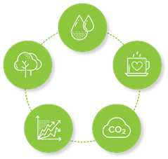
The responsible tourism component came to the fore during the COVID-19 pandemic. In order to withstand future crises, a tourist destination must be recognized as responsible. This is an increasingly pronounced demand of tourists who have high expectations when it comes to preserving health and the environment. Of course, such an environment is the result of synergistic planning and action of all local and national stakeholders.
From the aspect of green tourism, in order to overcome regional inequality, and underdeveloped offers in the northern region, as well as reducing seasonality in business, development directions relate to:
- development of so-called “Green” or eco types of accommodation facilities that meet the requirements of environmental standards (e.g., eco lodge, wild beauty resorts, ethno villages, etc.);
- business - intensifying the application of new technologies and digitalization in the tourism business;
- development of the offer or products that are, among other things, in the function of a unique experience and healthy lifestyle, i.e., redirecting the tourist offer and products to the types that put the individual and the care of a healthy life in the forefront (sports tourism, adventure tourism, camp tourism, tourism in protected areas, etc.);
- increasing the energy efficiency of tourist facilities with electricity saving measures;
- energy transition to renewable energy sources - use of solar energy in tourist facilities.

11.4.1. National Certificate for Responsible Tourism
The creation of a national certificate for responsible tourism can influence the better positioning of Montenegro as a responsible destination, in the light of the pandemic which, according to eminent tourism experts, will dictate business conditions at least until the middle of 2023. Tourists have become very demanding in terms of destination responsibility and the implementation of high hygienic and health standards. Also, tourists already got use to international certificates, but with them, additional strength is given to the destination by national certificates, the implementation of which is carried out and primarily controlled through inter-ministerial and inter-institutional mechanisms. In accordance with the new circumstances, our goal is to provide everyone with a safe and comfortable stay. Regardless of whether a tourist is in one of our diverse accommodation facilities, enjoying restaurants or exciting trips, the tendency is to behave responsibly and respect a number of safety measures, which ensure a responsible, clean and unpolluted environment during the trip. Based on the above postulates, a national brand (label) will be created, which will be a guarantee of responsible behavior in all segments of tourism and hospitality. The brand will have several levels (bronze, silver and gold) and will be awarded by the relevant ministry responsible for tourism. Unlike many certificates of a similar type which are awarded without verification, based on a checklist, this certificate will be the result of continuous verification and compliance with safety standards and requirements of tourists imposed by new circumstances. A national brand of this kind will be an additional strength of the destination. This means that all tourism professionals who care about their reputation will tend to become owners of the National Certificate for Responsible Tourism. As many certificates as possible, with very high defined standards, will influence the promotion of Montenegro as a responsible destination and will position it high on the list of desirable destinations where tourists feel safe.

11.4.2. Climate change
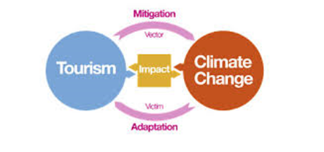
The implementation of emergency climate actions in tourism is of particular importance for creating the necessary conditions for greater resilience of this sector. Climate action is reflected in efforts to measure and reduce GHG (greenhouse gases) emissions and strengthen the capacity to adapt to climate impacts. Montenegro is one of the first countries in the Balkans to demonstrate its commitment to combating climate change by reducing CO2 emissions, working both internationally and nationally to accelerate the implementation of climate change measures through clean energy, clean technology and renewed focus on green infrastructure and green economy development. By signing the Paris Agreement in 2015, Montenegro committed itself to reducing carbon emissions by 30% by 2030 and has already managed to achieve this goal before the defined deadline. Although a relatively small country with less than a million inhabitants, it is in a group of only 16 countries, out of a total of 197 globally, that have already met this goal. Montenegro is resolutely paving its way towards a green transition and is at the forefront in using renewable energy sources. More than half of the total electricity produced annually is from renewable energy sources. During 2021, on the occasion of the 30th anniversary of the proclamation of the ecological state, the national contribution for the reduction of greenhouse gas emissions was determined and the reduction goal was increased to 35% by 2030.
In this regard, the Glasgow Declaration on Climate Action in Tourism was adopted, with the aim of raising awareness of tourism stakeholders and providing stronger action to support global commitment to reducing emissions and reaching a net zero rate before 2050. The Declaration was signed by a large number of leaders in the tourism industry, followed by a large number of countries and other stakeholders in tourism. The signatories of the Glasgow Declaration agree on five common procedures to ensure that climate actions are harmonized throughout the tourism sector, as follows: measurement, decarbonization, renewal, cooperation and finance.
Montenegro, like many other countries that have contributed the least to climate change, will face the harmful and sometimes devastating effects of global warming - rising sea temperatures, extinction of ecosystems, droughts and floods - which will have an undesirable domino effect on human health, the economy and sectors which depend on weather patterns, such as agriculture, forestry and tourism.
Existing risk assessments as well as available scientific research lead to the conclusion that Montenegrin tourism is at risk of multiple climate hazards, especially changes in precipitation patterns (floods and droughts), higher temperatures and coastal erosion, changes in the marine environment, stormy winds and storms. A number of factors affecting exposure and vulnerability have been identified, including dependence on foreign tourists, concentration in a relatively small number of tourist “hot spots”, demographic trends, etc.
The operational goal proposed by the strategy, which refers to the diversification of the tourism product, includes important measures in the direction of reducing climate risk, i.e., development is directed towards less exposed and vulnerable regions. It is essential to support these regions in developing adequate infrastructure and capacity to cope with the increased number of visitors in relation to potential changes in climate parameters and resource base (e.g., loss of beach, increased water scarcity).
Competent institutions for climate change are establishing a legal and strategic framework in response to international obligations on this issue, and tourism is being considered in several areas. In the following period, work will be done on the National Adaptation Plan (NAP) and a special adaptation plan for the tourism sector.
In addition to the above, the areas of national park policy, health and safety, infrastructure development, agriculture, land use planning, with emphasis on defining expected risks in relation to tourist destinations, the role of stakeholders and adaptation measures are of special importance for climate change.

11.4.3. E - mobility
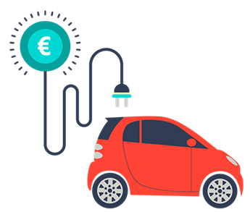
According to estimates, global tourism contributes to total global greenhouse gas emissions of about 5%, of which about 40% belongs to air transport, 30% to road transport and 20% to tourist accommodation.
The development of e-mobility, as a foundation for sustainable and clean transport, is one of the key elements of the transition to a low-carbon economy. The dynamics of this process depends on the success of overcoming barriers that prevent or slow down the development of market and business models, increasing the share of electric vehicles in the fleet and building infrastructure for their charging. Globally, e-mobility is still in the initial stage of development in Montenegro, and in order to reach a state in which further development takes place exclusively on market principles, it is necessary to encourage development by applying incentive measures. In this regard, within the project of Development of low-carbon tourism in Montenegro, which was implemented in cooperation with the Ministry responsible for environment and tourism and UNDP, and funded by the Global Environment Facility (GEF), the Feasibility study on e-mobility was prepared in order to present this concept in Montenegro, which would contribute to the reduction of greenhouse gas (GHG) emissions in transport. Within the Study, analyzes were conducted in relation to the situational analysis of the legal, institutional and financial framework for e-mobility, then the cost-benefit analysis of this concept and the analysis of the e-mobility market in Montenegro. According to the above analyzes and the Study, it can be concluded that the required financial incentives for the development of e-mobility in Montenegro are absolutely necessary.

11.4.4. Certification in tourism
An important instrument in environmental protection at the global level is eco-labeling, or environmental certification. Environmental certification is a voluntary mechanism for confirming the quality of sustainable business. The certification process involves an expert assessment of the compliance of the business with certain sustainability criteria. In addition to the following (a description of several of them follows), there are a large number of other certificates whose application will be considered in the coming period.

Green destinations is a certification created by the Global Sustainable Tourism Council (GSTC) creating global standards for sustainability in travel and tourism. The criteria are used for education and awareness raising, policy making for businesses and government agencies and other types of organizations, measurement and evaluation, and as a basis for certification. They appeared as a need to establish sustainability standards in tourism at the global level and are divided into four pillars: sustainable management, socio-economic impacts, cultural impacts and environmental impacts (including consumption of resources, reducing pollution, and conserving biodiversity and landscapes). The criteria are the minimum, not the maximum that businesses, governments and destinations need to achieve in order to move closer to social, environmental, cultural and economic sustainability. An example of good practice in Montenegro is Tivat TO, which started the process of implementing the Green Destinations program, and won the award of Top 100 Sustainable Destinations 2020 and was declared the winner in the category of “Nature and Ecotourism” at the Green Destinations Sustainable Story Award 2021. There is interest from some other local entities to be involved in this project, and the recognition of micro destinations in Montenegro as green and sustainable, would certainly raise the rating of the destination as a whole, so it is desirable to encourage such concepts.
Several more internationally recognized certificates are available in Montenegro, which are awarded to service providers in the tourism and hospitality sector, as follows:
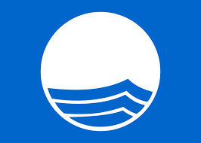
Blue flag is an international recognition and an exclusive environmental feature awarded to beaches and marinas that meet 32 ​​binding criteria. It has been awarded in Montenegro since 2003, based on the decision of the International Jury consisting of representative of UNEP (UN Environment Program), UNWTO (UN World Tourism Organization), ILS (International Life Saving Federation), IUCN (International Union for Conservation of Nature), an international expert on environmental education, representative of ICOMIA (International Council of Marine Industry Associations) and representative of FEE (Foundation for Environmental Education), which implements the Blue Flag program. International jury considers candidacies submitted by the Montenegro National Commission set up by the ministry in charge of tourism.
Ecolabel and Travelife are international environmental certificates which were initially introduced through the project of Development of low-carbon tourism in Montenegro which was implemented by UNDP and the Government of Montenegro with the support of GEF.

The European Union Ecolabel is a label established by a regulation of the European Commission, with the aim of providing support to users and tourists to more easily identify products and services that are less harmful to the environment. The ultimate goal of this certificate is to reduce the negative impact of consumption and production on the environment, health, climate, resources and energy.

Travelife is an initiative for training, management and certification of tourism companies, which are dedicated to sustainable business. Travelife is an internationally recognized certification scheme, whose criteria for obtaining the certificate are divided into four thematic groups: a) general management; b) environmental protection; c) labor rights, human rights and cooperation with local communities; and d) conditions in supply chain (vendors and guests).
Tour operators such as TUI Travel, Thomas Cook, Virgin Holidays, Kuoni and Neckermann require an international certificate such as Travelife for accommodation facilities.

Green Key is an eco-label that confirms the commitment of the company and compliance with and adherence to strict criteria and rules, prescribed by the Foundation for Environmental Education (FEE). The most widespread is the international eco-label, awarded to about 3,100 hotels and other facilities in 66 countries around the world, including Montenegro. Green Key is constantly looking for new and sustainable methods of work and use of technology in order to keep the overall environmental footprint as small as possible, through methods such as reducing the use of energy, water, waste, etc.
In addition to the above, there are additional certificates that are less presented in practice.

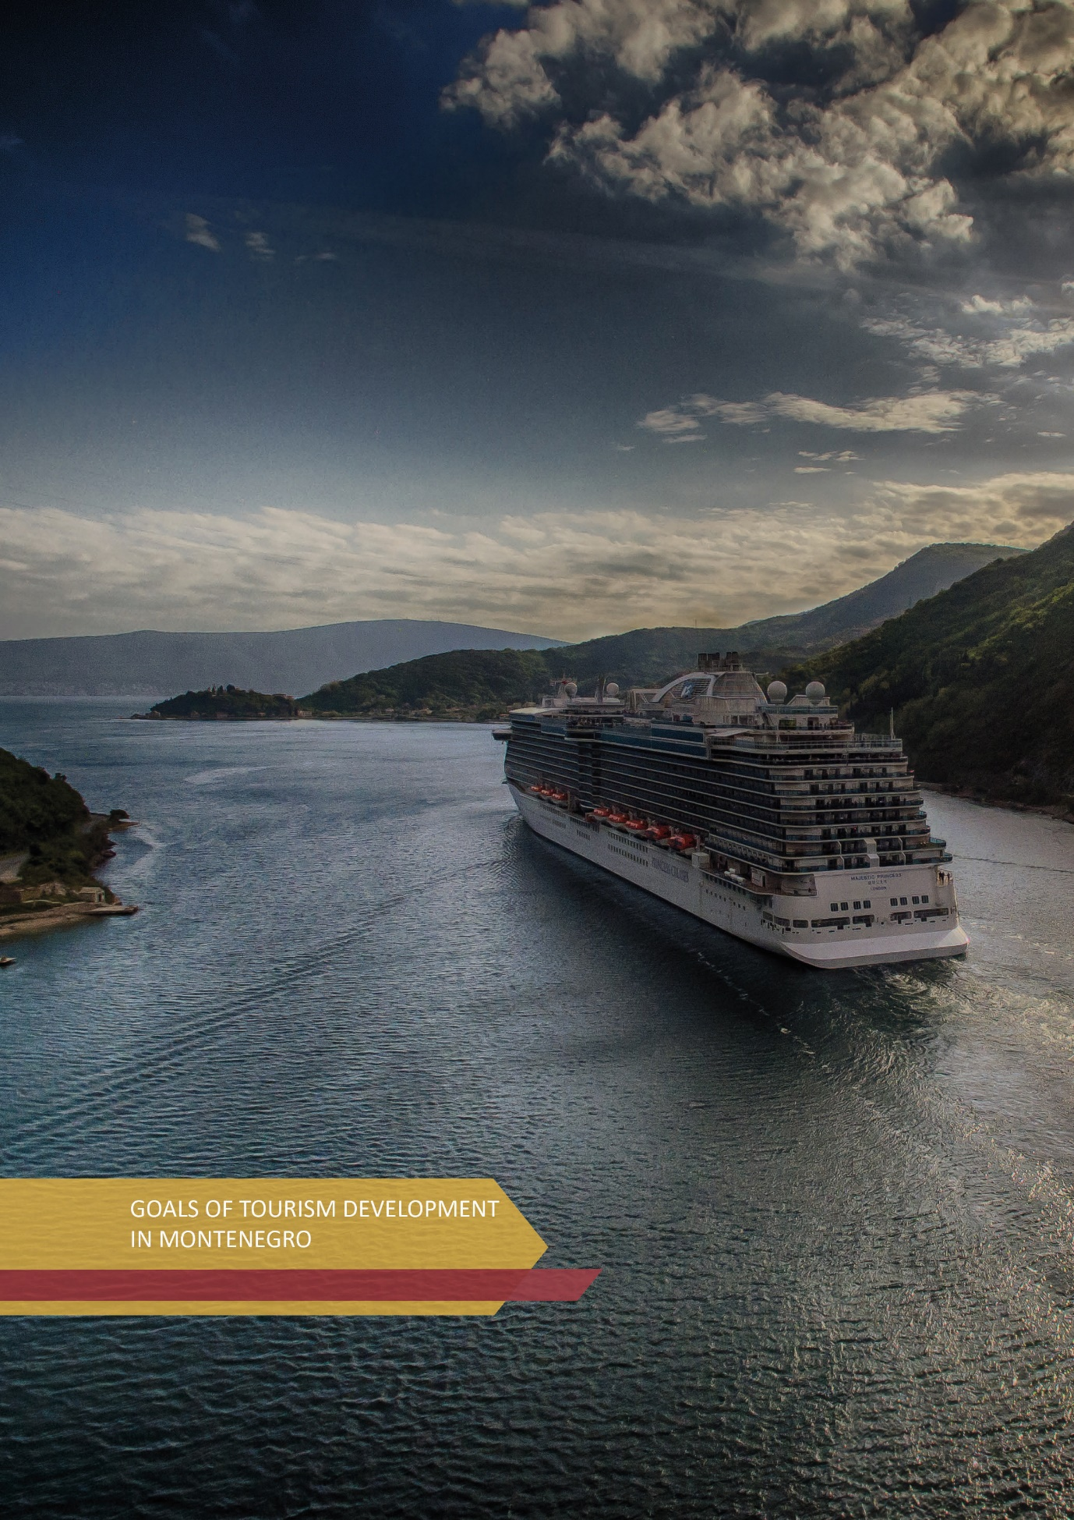

12. GOALS OF TOURISM DEVELOPMENT IN MONTENEGRO
Tourism is the dominant industry in Montenegro, complementary to almost all other economic activities and specific in its export component, i.e. the fact that, on average, annually, more than 90% of turnover is generated by foreign tourists.

Analyzes of the situation in the tourism sector during the previous period pointed to numerous restrictions on faster development, which are the main cause of the still short period of tourism business during the year, as well as the imbalance of tourist offer between the coastal and northern regions. In this regard, we can identify three main "concentrations" that need to be reduced in the coming period:
- 95% of tourism turnover (overnight stays and income) is achieved on the coast,
- 75% of tourism turnover is achieved in the summer months, and
- 70% represents the share of individual (private) accommodation in total accommodation capacity.
In order to overcome this situation and create preconditions for the most efficient development of tourism, and thus other industries, future activities will be focused on:
- Raising the level of quality of a tourism product on the coast in relation to its quantity. The goal is to achieve that accommodation capacities of level 3-5 * prevail, to improve the quality of beaches, improve the accompanying infrastructure (road, water supply, utilities, etc.), to develop accompanying facilities for active holidays (coastal hinterland), etc.;
- Diversification of the tourism product with a combination of urban and rural products, with an emphasis on the year-round offer and the North of Montenegro (offer based on nature and improving the tourist experience);
- Encouraging "green" accommodation capacities of hotel and similar type with eco characteristics (wild beauty, eco lodge, eco village, etc.). In this way, the quality of the offer will be improved, seasonality will be reduced, i.e. the duration of the tourist season will be extended and the share of hotels in the total accommodation capacities will be increased, all while respecting the principles of sustainability and applying responsible destination management.

12.1. Projections for the development of accommodation capacities and the workforce
Having in mind that the hospitality industry is the most important segment of the tourism product, special attention will be paid to activities related to the further development and improvement of hotel capacities in Montenegro. In this regard, the following is a projection of expected capacities in hotels and similar facilities both at the level of Montenegro and at the regional level, based on current and planned investment projects, i.e. greenfield and brownfield investments.
According to projections, at the level of Montenegro in 2025, the number of beds in hotels and similar facilities will be 52,200, which is an increase at an average annual rate of 4.2% in the period from 2019 to 2025. In the same period, when it comes to camps, the growth of their capacities is projected at 7.4%, and private accommodation at 1.3% (Table No. 15 and Graph No. 13).

Table No. 15 - Model of growth of accommodation capacities of Montenegro until 2025

Accommodation capacities | 2011 |  | 2019 |  | Average annual growth rate 2019/2011. | 2025 |  | Average annual growth rate 2019/2025.
Accommodation capacities | Capacity (number of beds) | Partici  pation | Capacity (number of beds) | Partici  pation | Average annual growth rate 2019/2011. | Capacity (number of beds) | Partici  pation | Average annual growth rate 2019/2025.
Hotels and similar facilities | 35.306 | 23,02% | 40.814 | 23,7% | 1,8% | 52.200 | 26,7% | 4,2%
5* | 1.310 | 0,9% | 2.862 | 1,7% | 10,3% | 6.000 | 3,1% | 13,1%
4* | 8.432 | 5,50% | 21.736 | 12,63% | 12,6% | 34.200 | 17,5% | 7,8%
3* | 8.385 | 5,5% | 9.210 | 5,4% | 5,4% | 11.000 | 5,6% | 3,0%
2* | 13.045 | 8,5% | 5.217 | 3,0% | 3,0% | 1.000 | 0,5% | -24,1%
1* | 4.134 | 2,7% | 1.789 | 1,0% | 1,0% | 0 | - | -100,0%
Camps | 2.554 | 1,7% | 2.925 | 1,7% | 1,7% | 4.500 | 2,3% | 7,4%
Private accommodation | 115.508 | 75,3% | 128.386 | 74,6% | 1,3% | 139.000 | 71,0% | 1,3%
Total | 153.368 | 100% | 172.125 | 100% | 1,5% | 195.700 | 100,0% | 2,2%
Source: MONSTAT, processing by the Ministry of Economic Development

Graph No. 13 - Model of growth of accommodation capacities of Montenegro until 2025
Source: MONSTAT, processing by the Ministry of Economic Development
According to projections in the Coastal Region in 2025, the number of beds in hotels and similar facilities will be 42,300, which is an increase at an average annual rate of 3.1% in the period from 2019 to 2025. In the same period, when it comes to camps, the growth of their capacities is projected at 5.4%, and private accommodation at 0.6% (Table No. 16 and Graph No. 14).

Table No. 16 - Model of accommodation capacity growth in the Coastal Region until 2025
Accommodation capacities | 2011 |  | 2019 |  | Average annual growth rate 2019/2011 | 2025 |  | Average annual growth rate 2025/2019
Accommodation capacities | Capacity (number of beds) | Partici  pation | Capacity (number of beds) | Partici  pation | Average annual growth rate 2019/2011 | Capacity (number of beds) | Partici  pation | Average annual growth rate 2025/2019
Hotels and similar facilities | 31.262 | 21,2% | 35.289 | 18,1% | 1,5% | 42.300 | 20,2% | 3,1%
5* | 1.310 |  | 2.335 | 1,2% | 7,5% | 4.000 | 1,9% | 9,4%
4* | 6.707 |  | 19.071 | 9,8% | 14,0% | 28.800 | 13,8% | 7,1%
3* | 7.068 |  | 7.443 | 3,8% | 0,6% | 8.500 | 4,1% | 2,2%
2* | 12.154 |  | 4.735 | 2,4% | -11,1% | 1.000 | 0,5% | -22,8%
1* | 4.023 |  | 1.705 | 0,9% | -10,2% | 0 | - | -100,0%
Camps | 1.869 | 1,3% | 2.266 | 1,2% | 2,4% | 3.100 | 1,5% | 5,4%
Private accommodation | 114.515 | 77,6% | 157.781 | 80,8% | 4,1% | 164.000 | 78,3% | 0,6%
Total | 147.646 | 100% | 195.336 | 100% | 3,6% | 209.400 | 100,0% | 1,2%
Source: MONSTAT, processing by the Ministry of Economic Development

Graph No. 14 - Model of accommodation capacity growth in the Coastal Region until 2025
Source: MONSTAT, processing by the Ministry of Economic Development
When it comes to the Central region, by 2025, an average annual growth rate of 5.4% is projected, i.e. 4,900 beds in hotels and similar facilities. When we talk about camps, the growth of their capacities is projected at the level of 5.4%, while the growth of capacities in private accommodation is projected at the level of 0.6%, for the same period (Table No. 17 and Graph No. 15).
Table No. 17 - Model of accommodation capacity growth in the Central region until 2025
Accommodation capacities | 2011 |  | 2019 |  | Average annual growth rate 2019/2011 | 2025 |  | Average annual growth rate 2025/2019
Accommodation capacities | Capacity (number of beds) | Partici  pation | Capacity (number of beds) | Partici  pation | Average annual growth rate 2019/2011 | Capacity (number of beds) | Partici  pation | Average annual growth rate 2025/2019
Hotels and similar facilities | 1.845 | 96,7% | 3.580 | 49,8% | 8,6% | 4.900 | 54,1% | 5,4%
5* | 0 | 0,0% | 527 | 7,33% | - | 1.000 | 11,0% | 11,3%
4* | 933 | 48,9% | 1.791 | 24,93% | 8,5% | 2.400 | 26,5% | 5,0%
3* | 580 | 30,4% | 1.028 | 14,31% | 7,4% | 1.500 | 16,6% | 6,5%
2* | 332 | 17,4% | 224 | 3,12% | -4,8% | 0 | - | -100,0%
1* | 0 | 0,0% | 10 | 0,14% | - | 0 | - | -100,0%
Camps | 0 | 0,0% | 0 | 0,0% | - | 100 | 1,1% | -
Private accommodation | 63 | 3,3% | 3.605 | 50,2% | 65,8% | 4.050 | 44,8% | 2,0%
Total | 1.908 | 100% | 7.185 | 100% | 18,0% | 9.050 | 100,0% | 3,9%
Source: MONSTAT, processing by the Ministry of Economic Development
Graph No. 15 - Model of accommodation capacity growth in the Central region until 2025
Source: MONSTAT, processing by the Ministry of Economic Development
In the period until 2025, the growth of accommodation capacities in the northern region is expected, according to projections, at an average annual growth rate of 17%, or 5,000 beds in hotels and similar facilities, at a rate of 12.4% when it comes to camps, and at the rate of 2% for private accommodation (Table No. 18 and Graph No. 16).
Table No. 18 - Model of accommodation capacity growth in the Northern region until 2025
Accommodation capacities | 2011 |  | 2019 |  | Average annual growth rate 2019/2011 | 2025 |  | Average annual growth rate 2025/2019
Accommodation capacities | Capacity (number of beds) | Partici  pation | Capacity (number of beds) | Partici  pation | Average annual growth rate 2019/2011 | Capacity (number of beds) | Partici  pation | Average annual growth rate 2025/2019
Hotels and similar facilities | 2.199 | 57,6% | 1.945 | 44,7% | -1,5% | 5.000 | 60,2% | 1,.0%
5* | 0 | 0,00% | 0 | 0,00% | 0,0% | 1.000 | 12,0% | -
4* | 638 | 16,71% | 874 | 20,08% | 4,0% | 3.000 | 36,1% | 22,8%
3* | 759 | 19,87% | 739 | 16,98% | -0,3% | 1.000 | 12,0% | 5,2%
2* | 691 | 18,09% | 258 | 5,93% | -11,6% | 0 | 0,0% | -100,0%
1* | 111 | 2,91% | 74 | 1,70% | -4,9% | 0 | 0,0% | -100,0%
Camps | 685 | 17,9% | 659 | 15,1% | -0,5% | 1.330 | 16,0% | 12,4%
Private accommodation | 935 | 24,5% | 1.749 | 40,2% | 8,1% | 1.970 | 23,7% | 2,0%
Total | 3.819 | 100% | 4.353 | 100% | 1,6% | 8.300 | 100,0% | 11,4%
Source: MONSTAT, processing by the Ministry of Economic Development
Graph No. 16 - Model of accommodation capacity growth in the Northern region until 2025

Source: MONSTAT, processing by the Ministry of Economic Development
Having in mind the stated projection of the growth of accommodation capacities, it is necessary to provide the necessary workforce that will provide quality services in the same. In this regard, according to projections by 2025, it is expected that 18,220 new jobs will be created at the level of Montenegro, of which 14,530 in the Coastal, 1,790 in the Central and 1,900 new jobs in the Northern region (Table No. 19).
Table No. 19 - Projection of the number of new jobs until 2025
Number of new jobs according to the model of accommodation capacity growth until 2025
Hotels and similar facilities | The planned number of accommodation units until 2025 | Employment rate  (number of employees in relation to one accommodation unit by categories) |  | Number of new jobs until 2025
Coastal region
5* | 2.000 | 1,3 |  | 2.600
4* | 14.400 | 0,7 |  | 10.080
3* | 4.250 | 0,4 |  | 1.700
2* | 500 | 0,3 |  | 150
Total number of new jobs in the Coastal Region that will be created until 2025 according to the model of accommodation capacity growth |  |  |  | 14.530
Central region
5* | 500 | 1,3 |  | 650
4* | 1.200 | 0,7 |  | 840
3* | 750 | 0,4 |  | 300
2* | 0 | 0,3 |  | 0
Total number of new jobs in the Central Region that will be created until 2025 according to the model of accommodation capacity growth |  |  |  | 1.790
Northern region
5* | 500 | 1,3 | 650
4* | 1.500 | 0,7 | 1.050
3* | 500 | 0,4 | 200
2* | 0 | 0,3 | 0
Total number of new jobs in the Northern region that will be created until 2025 according to the model of accommodation capacity growth |  |  | 1.900
Total number of new jobs that will be created in Montenegro until 2025 according to the model of accommodation capacity growth |  |  | 18.220
Source: MONSTAT, processing by the Ministry of Economic Development

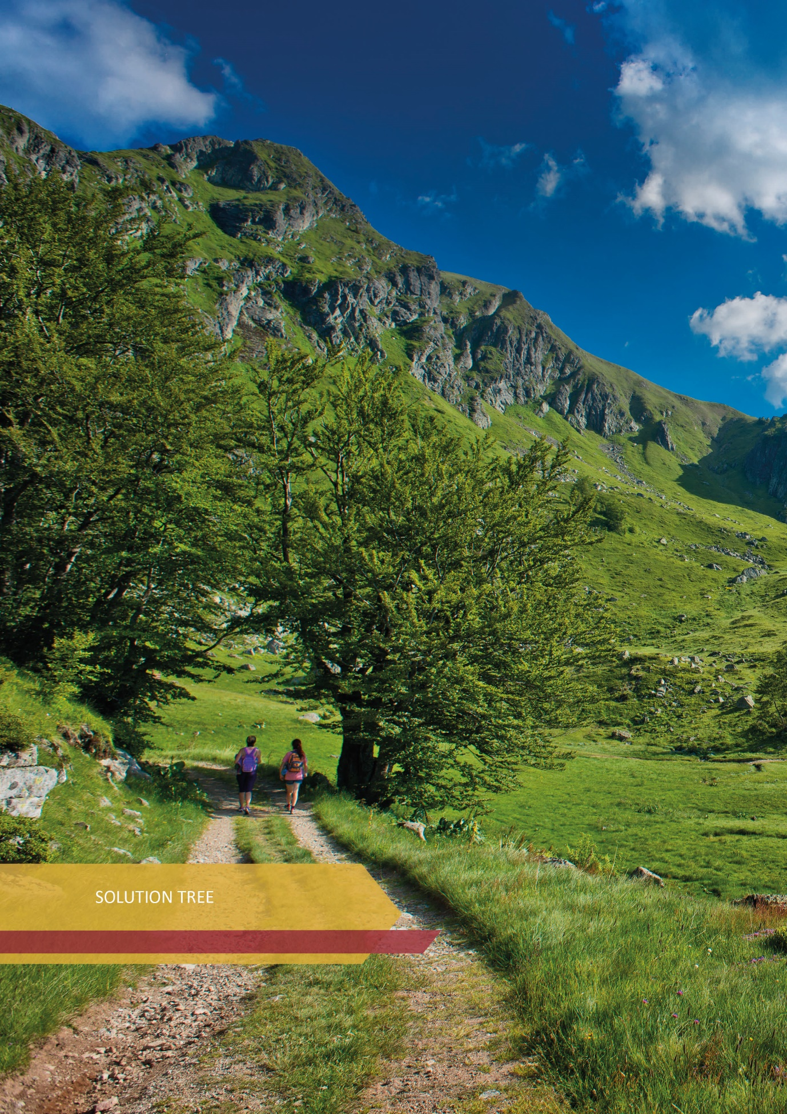

13. SOLUTION TREE
The analysis of the situation has determined the causes of problems in tourism in Montenegro and their consequences.
Based on the cause-and-effect relationship, the key problems in tourism in Montenegro have been defined, namely: seasonality, regional inequality, inadequate quality of service (staff, capacity) and the gray economy.
Recognized strategic goal provides an answer to the solution of key problems from the "problem tree", while the causes of the problems are transformed into operational goals that actually represent the answer to the question - through which measures and activities we can solve them (Action Plan). In other words, the operational goals define the direction of development to be monitored and the activities that need to be implemented in the period 2022-2025, in order to achieve the set strategic goal.
Consequences of the problem (Problem Tree), we interpret as effects (Solution Tree), the implementation of which is sought in the period 2022-2025.


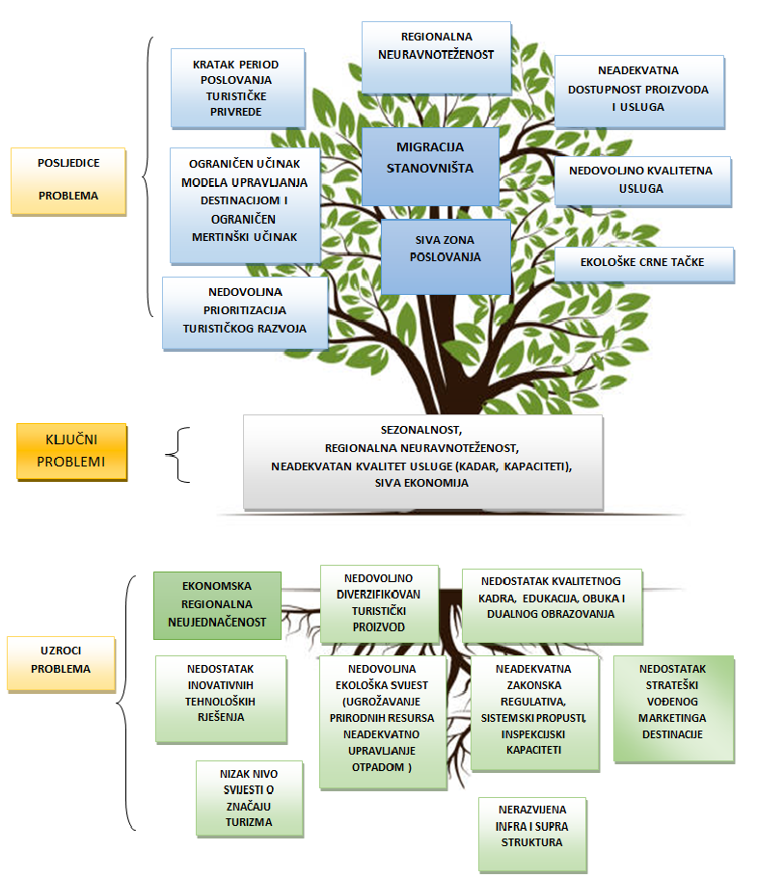
LACK OF STRATEGICALLY GUIDED DESTINATION MARKETING
UNDEVELOPED INFRA AND SUPRA STRUCTURE
INADEQUATE LEGISLATION, SYSTEM FAILURES, INSPECTION CAPACITIES
INSUFFICIENT ECOLOGICAL AWARENESS (ENDANGERING NATURAL RESOURCES, INADEQUATE WASTE MANAGEMENT)
LOW LEVEL OF AWARENESS OF THE IMPORTANCE OF TOURISM
LACK OF INNOVATIVE TECHNOLOGICAL SOLUTIONS
LACK OF QUALITY STAFF, EDUCATION, TRAINING AND DUAL EDUCATION
INSUFFICIENTLY DIVERSIFIED TOURIST PRODUCT
ECONOMIC REGIONAL INEQUALITY
SEASONALITY, REGIONAL INEQUALITY, INADEQUATE QUALITY OF SERVICE (STAFF, CAPACITY) AND THE GRAY ECONOMY
CAUSES OF PROBLEMS
KEY PROBLEMS
INSUFFICIENT PRIORITIZATION OF TOURIST DEVELOPMENT
LIMITED PERFORMANCE OF THE DESTINATION MANAGEMENT MODEL AND LIMITED MARKETING PERFORMANCE
GRAY ZONE OF BUSINESS
POPULATION MIGRATION
ENVIRONMENTAL BLACK SPOTS
INSUFFICIENT QUALITY SERVICE
INADEQUATE AVAILABILITY OF PRODUCTS AND SERVICES
REGIONAL IMBALANCE
SHORT PERIOD OF TOURIST ECONOMY BUSINESS
CONSEQUENCES OF THE PROBLEM
MINIMIZED GRAY ZONE OF BUSINESS
BY INVESTMENT AND FORMALIZATION OF TOURISM TURNOVER, MONTENEGRO IS AFFIRMED AS A GLOBALLY RECOGNIZED TOURIST DESTINATION, WITH REDUCED SEASONALITY OF BUSINESS, MODERATE REGIONAL IMBALANCE, AND PRIORITIZATION OF TOURISM IN DEVELOPMENT POLICIES.
PROBLEM TREE
SOLUTION TREE
IMPROVED REGULATORY FRAMEWORK IN TOURISM WITH FORMALIZATION OF TOURISM TURNOVER
IMPROVED QUALITY AND QUANTITY OF ACCOMMODATION CAPACITIES
IMPROVED TOURIST INFRASTRUCTURE AND ACCOMPANYING INFRA AND SUPRASTRUCTURE
DEVELOPMENT OF DIGITAL, INNOVATIVE SOLUTIONS AND NEW TECHNOLOGIES IN TOURISM
IMPROVED HUMAN RESOURCES, KNOWLEDGE AND SKILLS IN TOURISM
GLOBALLY RECOGNIZABLE DESTINATION
EQUAL DEVELOPMENT
QUALITY SERVICE
IMPROVED ACCESSIBILITY CG
MINIMIZED ENVIRONMENTAL PROBLEMS
A YEAR ROUND PRODUCT
SUSTAINABLE DESTINATION MANAGEMENT
PRIORITIZATION OF TOURISM IN DEVELOPMENT POLICIES
IMPROVED QUALITY AND DIVERSIFIED TOURIST PRODUCT
STRATEGIC GOAL
OPERATIONAL GOALS
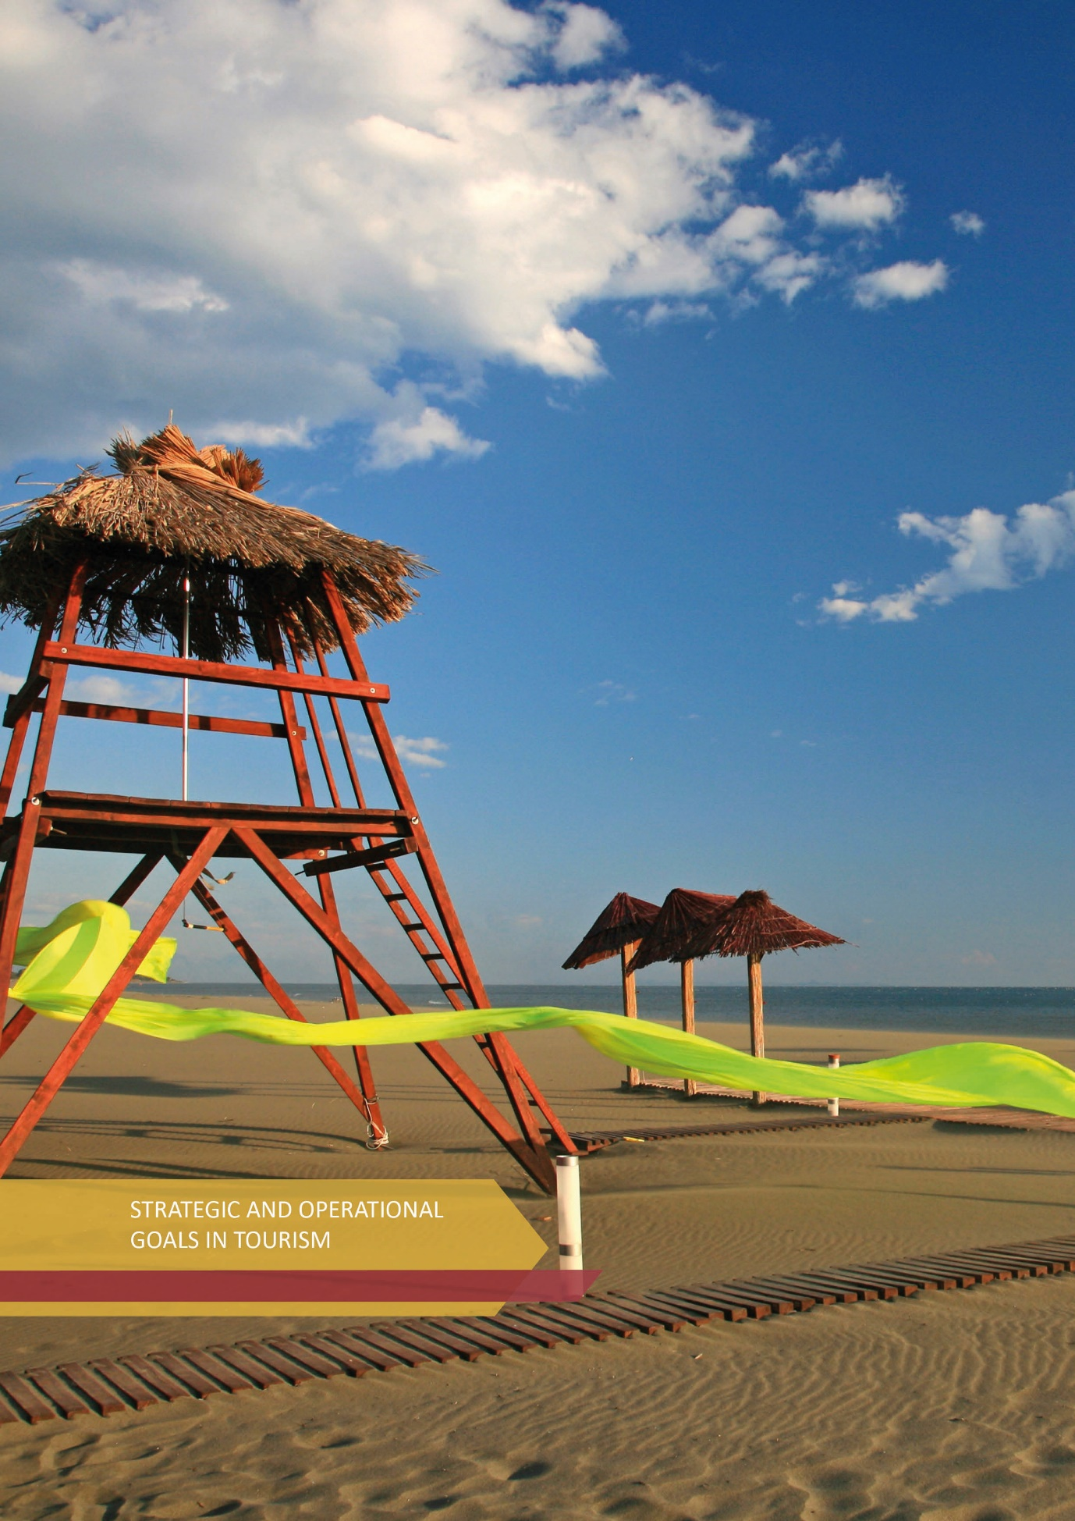

14. STRATEGIC AND OPERATIONAL GOALS IN TOURISM

STRATEGIC GOAL
BY INVESTMENT AND FORMALIZATION OF TOURISM TURNOVER, MONTENEGRO IS AFFIRMED AS A GLOBALLY RECOGNIZED TOURIST DESTINATION, WITH REDUCED SEASONALITY OF BUSINESS, MORE MODERATE REGIONAL IMBALANCE AND PRIORITIZATION OF TOURISM IN DEVELOPMENT POLICIES.
The implementation of this strategic goal, based on the analysis from the problem tree and the given development guidelines, includes seven (7) key operational goals in tourism, as follows:

- Operational goal 1 - Improved regulatory framework in tourism with formalization of tourism turnover;
- Operational goal 2 - Improved tourism infrastructure and supporting infra and supra structure;
- Operational goal 3 - Improved quality and quantity of accommodation capacities;
- Operational goal 4 - Improved quality of diversified tourism product;
- Operational goal 5 - Improved human resources, knowledge and skills in tourism;
- Operational goal 6 - Development of digital, innovative solutions and new technologies in tourism;
- Operational goal 7 - Montenegro - a globally recognized tourist destination.

Research shows that successful destinations provide visitors with experiences that meet both the needs and expectations of visitors, all in line with the experiences that the destination brand guarantees. Destinations must continuously maintain and improve their existing products, with constant investment in new products, but also in supra and infrastructure, as well as other components that contribute to strengthening the attractiveness and competitiveness of the destination.
Modern tourists are increasingly looking for interesting and unique experiences that are accompanied by "picturesque stories", to make the atmosphere complete. In this way, the destination achieves the loyalty of tourists, while "turning" tourists into the best marketing instrument because, as analyzes have shown, the recommendations are one of the most effective channels of promotion and sales. Designing experiential tourism requires good planning and understanding of target markets, in order to create unforgettable experiences, a high level of satisfaction, while exceeding expectations.
In order to provide these conditions, it is necessary to encourage entrepreneurial thinking, connecting with other sectors where there are complementary advantages and mutual benefits.

14.1. Operational goal 1 - Improved regulatory framework in tourism with formalization of tourism turnover
Improved institutional framework, which primarily improves legislation and harmonizes with EU legislation, will be the basis for secure business, good business environment and reduction of the informal economy. The gray economy, from the point of view of economic flows, improving public finances, as well as the overall well-being of the local population, is one of the biggest challenges in tourism, and is present in almost all segments of tourism.
According to various analyzes, about 30% of business in tourism is in the so-called "gray zone", and the percentage grows with the expansion of business into virtual space. Some of the specific problems are the performance of the spectrum of tourism and hospitality activities by unregistered natural and legal entities, the sale of programs illegally (unlicensed tourist guides, adventure and excursion programs), especially through online platforms, etc.
All of the above affects the creation of unfair competition, non-payment of taxes and fees, and above all the creation of a bad image of local, i.e. micro destinations, as well as the destination of Montenegro as a whole. Therefore, it is necessary to strengthen the legal and institutional framework, as well as to strengthen the institution of inspections, to introduce penalties for accommodation providers through "sharing" platforms, frequent controls and generally high-penal policy.
The introduction of fiscalization will improve the market situation, but the assessment of the value of flows hidden from the public and the law will continue to be a challenge in the coming period.
Therefore, only the establishment of healthy competition can contribute to reducing the level of this problem, which should be minimized through joint efforts.
It is necessary to ensure the rationalization of the entire process, including, inter alia, the registration of companies, collection of taxes and assigned revenues, etc., then the removal of administrative barriers, as well as the unification of existing ones, with the definition of new incentives for the transition from the informal to the formal economy.

14.2. Operational goal 2 - Improved tourism infrastructure and supporting infra and supra structure
Infrastructure is crucial for tourism growth and the competitiveness of Montenegrin destination. We can understand the tourism infrastructure as a system of facilities and organizations that serve tourists, and it includes passenger transport, roads, water supply, electricity, purification systems, heating, air conditioning, energy sources and more. Infrastructure development is of fundamental importance for tourism. The general goal is to help the development of infrastructure with state incentives, for the private sector to recognize this need and start investing primarily in the construction of accommodation facilities, and then the accompanying commercial and complementary facilities. In this way, public-private partnerships are strengthened, which should result in mutual benefits, as well as benefits for the local population. The development of additional facilities improves the offer, prolongs the stay of guests at the destination.
The analysis of the state of infrastructure and suprastructure, as an inseparable part of the tourist offer, shows that it is necessary to direct further activities towards improving the availability of Montenegro, communal infrastructure, electricity and water supply. Therefore, given the limited space and potential, Montenegro must commit to sustainable tourism development. This means that every link in the chain of complex tourism product must meet all quality standards because sustainable tourism means taking responsibility.
Improving the existing infra and supra structure is one of the development priorities of every tourist destination. Due to its geographical position, Montenegro is primarily an air travel destination, although it is accessible from some markets by land and sea. Having in mind the readiness of tourists from important emitting markets to visit Montenegro in the periods before and after the season, special emphasis should be placed on the highest quality network of air accessibility of Montenegro. Also, the issue of quality water supply, as well as adequate treatment of wastewater and solid waste is set as an imperative for further development. This also applies to the supply of electricity, and if it is not adequately developed, the quality of all other activities undertaken in terms of improving the tourism product is also in question.
The level of construction of the tourist supra structure must be significantly increased, especially in terms of catering facilities, galleries, congress facilities, sports halls of open and closed type, etc. The development of infrastructure and suprastructure raises the attractiveness and competitiveness of the destination. Tourists usually expect that the facilities in the chosen destination will be comparable to what they enjoy at home. Thus, good infrastructure at the destination stimulates the demand for its products, and at the same time reduces the "pressure" on the destination itself. The pressure on the destination is reduced by "expanding" the possibility of locating tourists from major tourist sites, redirecting activities to the pre and post season with adequate pricing and promotional policies, creating attractive programs of visits that connect activities, provide discounts on excursions, etc., then by improving public transport, etc.
The Single List of Priority Infrastructure Projects of Montenegro, whose implementation is planned through the Capital Budget, includes 16 projects related to the improvement of tourist infrastructure in the North of Montenegro. The total estimated value of the given projects is € 222.7 million.

14.3. Operational goal 3 - Improved quality and quantity of accommodation capacities
Montenegro should carefully manage the development of tourist accommodation offer, through the construction of new and improving the quality of existing accommodation facilities, in a way that gives priority to sustainable development of accommodation facilities that create the greatest benefits for the economy, both in terms of income and employment. The main emphasis is placed on the construction and improvement of accommodation tourist capacities that will meet the criteria of middle and higher categories, because they achieve the best occupancy throughout the year, and thus higher revenues. As a precondition for its achievement, it is necessary to create a safe and motivating investment environment, in order to position Montenegro as a safe destination for investment in tourism.
In this regard, it is necessary in the future to work on cost optimization in order to shorten the payback period in high-end hotels, and by providing a stimulating investment environment. It is necessary to work on rationalization of administration, then harmonizing cadastral records with the actual situation on the ground, reducing long deadlines for issuing building permits, harmonizing legal regulations, as well as introducing international models of tourist real estate management. It is necessary to have a systematic overview of all relevant documents through one platform, in order to create a clear procedure - investment path of investment implementation. It is necessary to make a situational cross-section of the situation, where all disputable points of functioning of the investment implementation would be targeted and work on their elimination.
The possibility of improving the accommodation units is directly conditioned by the income generated by tourist real estate, and the income is conditioned by the occupancy and reduction of the seasonality of the destination. In order to enable the tourism industry to generate higher revenues, and thus improve the quality of accommodation, strong institutional support is needed for hotels, small hotels and family hotels, through local tourism organizations, which should define individual sales of accommodation as a single tourism product. which would be further marketed in foreign markets and offered to global tour operators. Also, it is necessary to work on shortening the seasonality and tie the tourism product not only to coastal tourism, but also to improve the tourist offer in the rest of the country, by organizing various events, manifestations, excursion tours, eno-gastronomic offer, etc.
Also, in order to improve accommodation capacities in the North of Montenegro, it is necessary to implement infrastructure projects that will be the basis for individual investments, both for new accommodation capacities and for existing ones, which will justify future investments. In this regard, it is necessary for the Government of Montenegro to intensify continuous sustainable investment in infrastructure projects in the North in the direction of creating further preconditions for the development of mountain tourism. The capital budget for 2022 has allocated significant funds for the implementation of these projects and it is expected that this trend of investment in the North of Montenegro will continue in the future.
Investing in infrastructure projects in the North of Montenegro ensures more balanced regional development, creates new jobs and increases the attractiveness of the entire space for domestic and foreign investors. In this way, the state actively participates in creating the basis for the development of new tourist capacities by private investors.
Investment activities in hotel capacities that were the subject of privatizations in the previous period, which have not been completed or whose implementation has not started at all, will continue in the following period. In this regard, due to non-fulfillment of the contracted investment by the investor, proceedings have been initiated to terminate the contracts, which gives the opportunity to give them to a potentially new investor, who is ready to implement the investment project.
Goals:
- increase of the share of hotel accommodation in the total capacities at the level of Montenegro by at least 3%;
- increase of hotel capacities in the North of Montenegro by at least 15% in relation to the current total hotel offer of Montenegro;
- raising the standard of existing accommodation capacities from 1 and 2 stars to 3, 4 and 5 stars;
- construction of new capacities with 4 and 5 stars, as well as accommodation capacities such as wild beauty resort and eco lodge;
- Encouraging the development of rural households in all regions, especially in that area.
That Montenegro is attractive as a tourist destination and has something to offer is confirmed by the presence of some of the world's leading hotel brands, such as "Chedi", "Hilton", "Aman", "Regent Four Points by Sheraton", "Melia", "Iberostar", "Falkensteiner", Ramada, as well as the first "One & Only" resort in Europe, while the hotel of the brand" Accor "is under construction, and "Ritz Carlton" is also announced. In addition to the above, together with domestic investors and entrepreneurs, Montenegro is slowly getting more serious and quality hotel offer.
Annex II: Investment activities in the tourism sector

14.4. Operational goal 4 - Improved quality of diversified tourism product
Sustainability of destinations is a feature of modern tourism development, while seasonality is a feature of unsustainable tourism. The tendency of development of year-round tourism as well as finding solutions that contribute to better development of society, in the form of using natural resources and putting them in the function of developing specific types of tourism, should be the strategic goal of the destinations.
Extension of the tourist season is possible only in the case of a diversified tourist offer, i.e. if the destination as a target product has a range of tourist segments, which include several types of tourist demand, and which meet a larger number of travel requirements over a wider period of time.
The diversity of Montenegro, both in terms of natural, socio-cultural, historical and ethnic characteristics, as well as in terms of commitment to further development of tourism, is a strong basis for developing specific and unique types of tourist offer.
Accordingly, the potentials of tourism development in Montenegro are in the development and improvement of specific forms of tourism, among others: rural, cultural and religious, health, sports and recreation, ski, adventure, MICE, nature-based tourism (hiking, biking, mountaineering), camping, glamping, golf tourism, casino tourism, etc.
- Rural tourism
Especially due to the conditions imposed by COVID-19, rural tourism has differentiated itself as the fastest growing segment of tourism. As such, it creates the conditions to meet the needs of a growing number of tourists who strive for a healthy lifestyle and seek experiences that include a sense of satisfaction in nature, traditional cuisine, hospitality of farms/households in rural areas, enjoying tradition and preserved customs and other authentic experiences.
Recognizing the potentials of rural areas of Montenegro, i.e. wanting to enable their tourist valorization, primarily the legal and by-law regulations for this segment of the tourist offer have been improved. In this way, service providers in rural tourism, i.e. rural households, were offered a legal basis in order to simplify the procedure of their registration. The Ministry in charge of tourism has developed a Program of Rural Tourism Development with an Action Plan until 2021. Also, brochures have been published by the relevant Ministry: Small guide for rural households, Brochure with all registered households and Dictionary intended for easier communication of households with guests (in seven language variants). Due to the consequences of the COVID-19 pandemic, the Program has not been fully implemented, so this Strategy envisages the continuation of its implementation.
In the previous period, strong support for the development of rural tourism was provided through the provision of financial resources by The Ministry in charge of tourism and the Ministry in charge of agriculture, forestry and water management, aimed not only at increasing the number of rural households, but also at diversifying and specializing the offer which is an important component for further development of this form of tourism. Through IPARD II program implemented by the Ministry in charge of agriculture, forestry and water management, through measure 7, Farm diversification and business development, sub-measure/Public call: Support investments for the development of rural tourism- support is provided to stakeholders who want to invest in rural areas in the direction of developing the tourist offer. In addition, the goal is to encourage employment, create new and preserve existing jobs through the development of business activities and valorization of natural and agricultural assets, promotion of healthy and organic food, as well as encouraging economic activity and mitigating the trend of migration from rural areas. Cross-sectoral cooperation among complementary stakeholders will contribute to improving the environment in both tourism and agriculture.
In addition to the above, the Program for the Development of Agriculture and Rural Areas of Montenegro within IPARD III 2021-2027 (IPARD III program) will enable the use of European pre-accession funds through IPA III - the field of agricultural and rural development policy.
More than € 80 million in grants will be available to farmers for the implementation of the IPARD III program, of which EU funds amount to € 63 million, while national co-financing amounts to around € 19 million. With the contribution of IPARD III beneficiaries of over € 50 million, over € 130 million will be invested in Montenegrin agriculture in the programming period 2021-2027.
In 2019, there were only 60 registered rural households in Montenegro, while in 2021 there were 189, which confirms the already established trend of development of this type of tourism and the directions of future development policies in tourism.
According to the research of the organization "United Rural Households – Tourism in Villages" and the Regional Development Agency "Bjelasica, Komovi and Prokletije" from 2021, the greatest interest in this type of offer was expressed by tourists from France, Belgium, Germany, Russia, USA, etc.
During 2022, The Program of Rural Tourism Development with the Action Plan 2023-2025 will be prepared, as a continuation of the previous one, in order to ensure continuity in the development projects of this type of tourism.
The potential of rural tourism in Montenegro was recognized by the UNWTO, which in November 2021, at the General Assembly held in Madrid, awarded two (2) Montenegrin villages, Gornja Lastva Grbaljska and Godinje, with the prestigious Best Tourism Villages - upgraded program. The award implies further UNWTO support to these villages, providing continuous promotion of rural tourism in Montenegro, providing technical support, hiring experts and finding partners, which could significantly affect the further perspective of the development of villages and their surroundings.
- Cultural tourism
The potential for the formation and development of a tourism product based on culture is a rich tangible and intangible cultural heritage, created as a result of tumultuous Montenegrin history.
According to numerous analyzes, cultural tourism is one of the main drivers of development of cities, regions and countries. The social impact of cultural tourism is not only material, but also has intangible effects, such as the development of awareness of the importance and care for the preservation of cultural heritage, as well as the creation of cultural identity of the destination. The theme of the fourth UNWTO/UNESCO World Conference on Tourism and Culture, held in 2019, was "Investing in Future Generations" and related to cultural transmission, community and capacity building. The UNWTO report on synergies between tourism and culture, from 2018, emphasizes the close relationship between tourism and culture and the interdependence of these two sectors. The report, which was made through a survey of UNWTO member countries, confirms that today cultural tourism plays a major role in global tourism, and that, in line with changes in tourism as a whole, it has also been transformed by changing lifestyles, new forms of culture and creativity, evolution and innovation in technology.
Cultural tourism in Montenegro should be developed because it contributes to strengthening the destination brand, extending the tourist season, maintaining and protecting cultural heritage, provided that they have sustainable development. In fact, sustainable cultural tourism, which takes into account the culture consumed, is a symbol of quality tourism. Local culture is an important feature of every destination, including Montenegro, and thanks to tourism it can become the driving force of its social and economic development.
Following modern trends and the increasingly diverse needs and requirements of tourists, as well as with the aim of reducing the seasonal nature of the tourism industry, the Program of Development of Cultural Tourism of Montenegro with the Action Plan 2019-2021 has been prepared, with the aim of developing this type of tourist offer in the best possible way, rounding off the experience or stay of tourists from the aspect of cultural uplift and getting to know the cultural heritage of Montenegro. During 2022, the Program of Development of Cultural Tourism will be prepared with the Action Plan 2023-2025, in order to ensure continuity in the development of this extremely important segment of the tourist offer.
- Religious tourism
This is one of the oldest forms of tourist movement, and is an important element of cultural tourism in Montenegro. It includes visits to religious centers of all three religions, cultural goods, buildings, various localities, as well as participation in important religious events, and paying attention to church, monastery and mosque architecture, iconography, authentic souvenirs, etc. When it comes to the development of this form of cultural tourism in Montenegro, it can be said that the potential is huge. Regular visits to sanctuaries are also frequent, such as: Ostrog Monastery, Kotor Cathedral, Hussein Pasha's Mosque, etc. which are attracting more and more attention of foreign tourists and pilgrims from year to year, and are especially connected with the festivities related to the dates that mark these holy places.
According to the Guest Survey from 2017, for 7.8% of tourists, getting to know cultural landmarks, events and happenings is the leading motive for coming to Montenegro. According to age, it looks like this: up to 29 years - 6.3%, between 30 and 49 years - 8.1%, 50 and older - 9.9%.
These data indicate that there is interest, but that for a quality tourist offer it is necessary to valorize existing resources, make cultural heritage more visible and accessible, and take advantage of technology (e.g. virtual reality and audio guides). In addition to the above, it is of special importance that visits to cultural heritage sites are conducted in a quality and sustainable manner, taking into account the extreme limits of their carrying capacity. Also, an indispensable part and an important component for the development of cultural tourism are human resources, and the potential is in the local population, which is mostly best acquainted with the knowledge of their own culture. In this regard, local communities should recognize the direct interest in the development and valorization of local cultural heritage, i.e. recognize the potential and create lines of support, with the use of EU funds.
- Sports tourism
There is a unified definition for tourism, while there is no unified one for sports tourism. This is because sports tourism as such can be active or passive, it can refer to individual travel, group, professional, amateur, participation in competitions, following the competition from the aspect of the audience, camp preparation, etc. What unequivocally connects tourism and sports is travel, so that sports tourism is rightly assessed as a significant perspective for tourism development.
Dominantly, the development of sports tourism implies adequate infrastructure, including sports facilities, as well as human resources. These segments are missing in the offer of Montenegro and are limiting factors that limit the development of this segment of the tourist offer, especially when it comes to training camps for professional athletes and the organization of elite competitions. However, with the influence of foreign direct investments, the development of road, accommodation and sports-commercial infrastructure, and an adequate marketing and promotion strategy, Montenegro can attract a significantly larger number of tourists whose reasons for travel are related to professional sports activities. This presupposes the definition of a strategic investment plan that would give clear guidelines to potential investors. Also, a detailed situation analysis is a prerequisite for defining the goals of sports tourism development, because the potentials must be identified, and the existing, although limited capacities must also be presented. It is necessary to make a detailed market research, in order to determine the target group and development direction, because when it comes to sports tourism, we must not deviate from what is offered, i.e. the quality of service must correspond to the price and the previously defined offer. In addition to the above, it should be noted that the favorable climate stimulates the development of sports tourism, which stimulates the shortening of seasonality, reducing regional imbalances, increasing tourist spending, extending the stay of guests at the destination, etc. These are all reasons why special attention must be paid to sports tourism. If we take into account that before the COVID-19 pandemic, at the global level, sports tourism generated 10% of total tourist revenues, this is a figure that should not be underestimated and which confirms the importance of this tourism segment.
Having in mind the multiple importance of sport, as well as its impact on tourism, it is necessary to strengthen interdepartmental cooperation and define strategic partnerships among stakeholders, while strengthening the public-private model of functioning.
Among the priorities of sports tourism, whose Development Program has been identified through this Strategy, will be infrastructure for the development of cycling tourism (Euro Velo 8 and other trails), diving as a recreational activity, and many others, and Montenegro has the potential to be a dominant destination for sports camping preparations, which also have the greatest commercial effect.
According to the Guest Survey from 2017, for 7.7% of tourists, sports and recreation are the leading motive for coming to Montenegro. According to age, it looks like this: up to 29 years - 10.1%, between 30 and 49 years - 7.5%, 50 and over - 4.9%.
Therefore, having in mind the comparative advantages of Montenegro as a destination, it is necessary to make a situational analysis and analysis of global trends and demands in the context of sports tourism and define future development perspectives. In accordance with the Work Program of the Government of Montenegro in 2022, it is planned to adopt the Program for the Development of Sports Tourism in Montenegro 2023-2025 with the Action Plan.

- Health tourism
The tourism and travel sector is becoming an increasingly important factor in economic prosperity, while health tourism as a form of tourism of special importance is experiencing great expansion and is one of the growing segments of the world tourist offer. The importance of this segment of tourism has been increased by the situation of the COVID-19 pandemic. According to the 2017 Guest Survey, for 6.5% of tourists, health and wellness reasons are the motive for coming to Montenegro. According to age, it looks like this: up to 29 years - 3.5%, between 30 and 49 years - 8.2%, 50 and older - 3.6%.
If we analyze the current situation in Montenegro, we can conclude that our country has very good preconditions, which are not sufficiently used or promoted, for the development of profitable health and tourism activities: natural resources, rich historical, cultural and industrial heritage, favorable geographical position , traditional hospitality of people, existing tourist infrastructure, multiethnic character of Montenegro and multicultural traditions, as well as the growing awareness of tourism employees about the benefits that the development of the health tourism sector can bring to overall economic development. Also, strengthening public-private partnerships can significantly contribute to the expansion of potential in this field. Due to the lack of free time, stress, unhealthy lifestyle, technology, pollution and other influences, health tourism is taking an increasingly important role in revitalizing the psycho-physical abilities of people, so the expansion of the health industry includes health tourism.
Tourism and health are the main pillars of commitment to sustainable development, and cooperation between the tourism and health sectors in Montenegro enables the achievement of a synergy effect in order to improve health tourism, year-round tourist season and reduction of regional imbalance.
Having in mind the significant natural and infrastructural potentials for the development of this form of tourism, the Government of Montenegro has adopted the Health Tourism Development Program of Montenegro 2021-2023 with the Action Plan until 2023.

- Nautical tourism
Nautical tourism in Montenegro is becoming increasingly important as a new value of the tourist offer. Montenegro has positioned itself as a destination that, with great natural wealth and significant cultural and historical heritage, has the potential to become a recognizable center of nautical tourism. In the past period of accelerated tourism development, Montenegro has recognized the importance of investing in high-quality tourist offer and the development of this type of tourism, which represents a new development opportunity for more complete valorization of the evident potentials of Montenegro, with a significant improvement in the level of quality of offer and services in all existing marinas. In the previous period, through various development documents, strategic planning and construction of a significant number of modern marinas was defined, in which way Montenegro can be positioned as a recognizable center of nautical tourism. More and more tourists arrive by sea, so cruising tourism becomes the basis for the development of year-round tourism product, i.e. for a significant reduction in seasonality and an increase in tourist revenue.
Not taking into account the COVID-19 implications, the number of yachts in Montenegro, both stationed and in transit, has increased from year to year, which is a relevant indicator of the true development path of our country towards achieving the set goals in the field of nautical tourism.
In the new context of sustainable development, funding for infrastructure development must be provided, in a way that eliminates bottlenecks in transport and achieves a balance of use between maritime and rail transport in relation to road transport. In 2019, 4,775 foreign vessels for leisure, sports and recreation (MONSTAT) entered the territorial sea of Montenegro, which is 1.4% more than in 2018. Of these, 4,211 vessels sailed by sea and 564 were brought in by land. The number of passengers who arrived on these vessels in 2019 was 28,562, which is 3.2% more than in 2018.
The main challenges that nautical tourism faces in the Adriatic are:
- lack of resources in existing ports - small number of berths,
- lack of adequate infrastructure for passenger reception,
- lack of infrastructure for waste and wastewater collection,
- lack of quality local small and medium enterprises that would support the organization of excursion programs and transfers, etc.
With large investments in the tourism and hospitality sector in Montenegro in recent years, there has been a dynamic development of nautical tourism. As part of the largest investments in this part of the Adriatic, such as Porto Montenegro, Porto Novi and Luštica Bay, the offer of nautical tourism has been developed as one of the central products. An inseparable segment of the development of nautical tourism are updated nautical charts, new services for vessels, sailing schools, and work has been done to improve the business environment for the development of nautical tourism, because this type of tourism attracts well-paying clients.
In accordance with the Work Program of the Government of Montenegro in 2022, the adoption of the Nautical Tourism Development Program in Montenegro 2023-2025 with the Action Plan is planned.
- Tourism of protected areas of Montenegro
In world practice, protected areas represent exceptional tourist potentials and directly affect the creation of the destination's image. The importance of protected areas is closely related to tourism, which is confirmed by the role of the International Union for Conservation of Nature (IUCN) and the World Commission on Protected Areas (WCPA), in defining international standards in the field of categories and principles of protected area management, inter alia for tourism purposes. It follows from the above that protected areas, in addition to systems, levels and measures of protection, represent a significant niche in the world tourist offer.
Adopting the status of protection over a certain area directly creates the scope and structure of tourist visits. Defined as such, the destination brings direct and indirect benefits to all entities.
The interdependence of tourism as a social phenomenon and the environment is unbreakable. Protected areas are directly responsible for the development of the destination, influencing the forms and structure of visits, bringing on the one hand economic benefits to the local community, and on the other hand contributing to the improvement of natural and cultural values of the destination. In addition to the above, tourism directly affects the natural environment, i.e. resources that are exploited and used as key elements of tourism products or services. All this together can create a conflict, when protection is the only way to preserve and sustain a tourist destination. However, at the same time, it strengthens the awareness of the population that destinations with rare and sensitive elements should be protected as much as possible and that tourism is actually the initiator of a given conservation that brings income to the local community. Given that resources are also needed to manage the protected area, the development of ecotourism is an ideal solution.
With five national parks, six nature parks, two declared marine and coastal protected areas, five UNESCO protected areas, namely: Natural and Culturo-Historical Region of Kotor, Durmitor National Park with the canyon of the Tara river, Stećci - medieval cemeteries (3 sites within the multinational nomination: Greek Cemetery and Bare Žugića in Žabljak, as well as the Greek Cemetery in Plužine) and Venetian fortifications from the 16th to the 17th century (Kotor Fortress within the multinational nomination and the Boka Navy), and numerous other natural potentials, Montenegro is an ideal destination for the development of this type of tourism. Attached to the above are the results of the "Guest Survey" from 2017, according to which for 21.1% of tourists the motive for coming to Montenegro is to get to know the natural beauty. According to age, it looks like this: up to 29 years - 20%, between 30 and 49 years - 20.7%, 50 and over - 28.2%.
Skadar Lake National Park, Lovćen National Park, Durmitor National Park and Prokletije National Park, with the exception of Biogradska Gora National Park, are open for visits throughout the year, but due to the pronounced seasonality, there is insufficient attendance at parks. Visitors to the national parks of Montenegro are most often individual tourists who come in their own arrangement, and then organized groups of visitors who come through travel agencies.
If we compare the data from 2019 with 2018, there was an overall growth of visitors by 30.0%. The largest number of visitors is recorded in the Durmitor National Park, which accounts for 46.1% of the total number of visitors in 2019, however, based on the data, it can be concluded that Durmitor National Park records the lowest growth in the number of tourists if we compare the data from 2019 and 2018 (growth of 22.8%), while the highest growth is recorded by the Skadar Lake National Park of 52.3% (Table no. 20).
Table No. 20: Number of visitors, National Parks of Montenegro, 2009-2019
 | Durmitor National Park | Skadar Lake National Park | Biogradska gora National Park | Lovćen National Park |  | Prokletije National Park
2009 | 35.946 | 32.070 | 30.855 |  | 26.444 | 0
2010 | 41.099 | 40.242 | 30.900 |  | 36.463 | 0
2011 | 67.245 | 45.362 | 27.828 |  | 33.429 | 0
2012 | 82.307 | 60.304 | 25.280 |  | 1.735 | 0
2013 | 101.609 | 74.242 | 25.405 |  | 946 | 0
2014 | 109.462 | 64.916 | 26.417 |  | 32.406 | 0
2015 | 130.755 | 71.488 | 30.213 |  | 74.614 | 2.524
2016 | 131.717 | 66.682 | 28.313 |  | 90.496 | 3.178
2017 | 184.654 | 65.935 | 45.637 |  | 19.551 | 10.168
2018 | 220.207 | 95.363 | 58.506 |  | 62.868 | 14.488
2019 | 270.315 | 145.237 | 72.209 |  | 80.560 | 18.644
Source: National Parks of Montenegro
Data for 2020 are not presented, because they do not show the real situation, given that the year was marked by the COVID-19 pandemic and the absence of regular guests, as well as the decision of the Government that Montenegrin citizens do not pay the entrance fee for national parks.
The proclamation of the Tivat Salina (Tivatska Solila) as a special nature reserve in 2008 and the Ulcinj Salina as a protected area in 2019, and the establishment of two nature parks "Platamuni" and "Katič", as the first marine and coastal protected areas in Montenegro, created preconditions for best practices for effective management and control of activities, training and capacity building of these protected areas. Ulcinj Salina, a wetland of global importance for feeding, nesting and wintering birds of almost half of all European bird species and an area of exceptional biodiversity as well as Tivat Salina, are exceptional tourist sites for bird watching in Montenegro, as well as a good base for the development of eco-tourism based on the valorization of salt for tourism purposes. In addition, the diversification of the offer through wildlife observation should be encouraged, which includes the construction of observatories and feeding grounds for wild animals, which can offer a unique experience in protected areas, but also in other areas of Montenegro where there is richness of fauna. There is a worldwide trend of increasing the number of amateur animal observers, and protected natural areas are the best areas for such activity. Unlike the usual forms of tourism, wildlife watching allows unlimited use of resources and at the same time, the development of this type of tourism in the local population raises awareness of the values that surround them. In accordance with all the above, it is evident that the natural potentials attract great attention of tourists who visit our destination, and it is of great importance to improve the offer in this segment and provide tourists with an unforgettable experience, and generate new jobs and income for the local community and the state.
In the forthcoming period, the development of the Tourism Development Program in Protected Areas 2025-2027 with the Action Plan is planned, in order to strategically plan the development of a sustainable tourism product in protected areas.
In addition to the mentioned types of tourism whose development is already taking place or planned through special programs, the following is an overview of other types of tourism for which Montenegro has development potentials.
- Adventure tourism
Adventure tourism is a form of recreational tourism based on recreation, but with the presence of risk and excitement, and requires physical and mental preparation from the participants. In fact, this form of tourism is a combination of sports, recreation and entertainment, and is intended for tourists who want to have a special experience on their trip, but also to enjoy the natural beauty of the chosen destination.
The Adventure Travel Trade Association (ATTA) ​​defines adventure tourism as a journey that includes at least two of the following three elements: physical activity, natural environment, and cultural experience.
According to the 2014 UNWTO Global Report on Adventure Tourism, adventure tourism is resilient, attracts high purchasing power tourists, benefits the local economy / community and encourages sustainable practices.
Adventure tourism is becoming increasingly popular in the world due to its positive impact on people, the environment and the economic growth of the destination. The development of this type of tourism is most influenced by trends, but also by the fast pace of life of people. People increasingly want to fill their free time with activities in which they would spend excess energy and to experience an unusual adventure.
The development of adventure tourism in Montenegro is mostly based on preserved natural resources. In 2019, the Government of Montenegro passed the Regulation on minimum technical conditions and the manner of providing certain tourist services that include sports-recreational and adventure activities, which created the basis for providing services in various forms of adventure tourism.
Numerous adventurous activities have been practiced in Montenegro for many years, such as the inevitable rafting on the Tara river, canyoning in the Nevidio canyon of the Komarnica river, as well as the Mrtvica and Medjureč rivers, speleological tours in the Lipa cave, a zip line ride on the Đurđevića Tara bridge, Brajići and other, still less well-known, activities that need to be better promoted in terms of marketing. Tourists have at their disposal many other adventurous activities such as hiking on the mountain peaks of Durmitor, Prokletije, cycling on mountain trails, bungee jumping, safari tours, paragliding, paintball, etc.
Windsurfing and kitesurfing are extremely popular on Ada Bojana, as well as the Long Beach in Ulcinj. Also, Skadar Lake has the potential to develop the offer of this type of adventure tourism. In addition, diving is today one of the adventurous sports that is becoming increasingly popular worldwide. It belongs to extreme sports not only because of the conditions in which it takes place, but also because of the necessary psycho-physical complexity, equipment and risk that this type of tourist service has. Diving in the waters of Montenegro, provides exceptional experiences of the underwater landscape, caves and sunken both warships and ships that are purposely sunk. Diving as a special type of tourist offer in Montenegro will be further improved in the coming period, both through legal regulations and program documents.
This type of tourism does not require significant investments, but mainly depends on a well-designed development strategy. Improvement and further development of the content of adventure tourism should serve as a means of building the image and recognition of Montenegro, which will have positive environmental and socio-economic effects and be a means to ensure the conservation and sustainable use of natural resources.
- MICE tourism
MICE is an acronym used to group four types of tourism - Meetings, Incentives, Conferences & Exhibitions. MICE tourism is very popular among business people, because it leads to live interaction, which is still ahead of virtual communication, regardless of the great technological advances and circumstances imposed by the pandemic. It usually takes place in attractive tourist destinations, and in the post-COVID era, further potential for its development lies ahead.
The size of the global MICE industry is estimated at $ 805 billion in 2017 and is estimated to reach $ 1.377.4 billion by 2028.
In order to be a desirable destination for MICE, the country needs to develop according to international standards, especially when it comes to accommodation, but also to have quality and adequate access to infrastructure facilities and venues. This travel segment has been significantly affected by the COVID-19 pandemic, so business trips, meetings, conferences and forums have largely shifted from the concept of face-to-face to a number of online platforms. Much could be said about the effectiveness of their implementation in this way, but the tendency to return to the old MICE forms is unquestionable.
In Montenegro, there is potential for the development of this offer in all regions of the country. All hotel facilities that contain congress halls, smaller meeting rooms with the necessary technical support, have a predisposition for MICE tourism. With significant investments in this area, Montenegro could better position itself on the list of MICE destinations. In that sense, it is necessary to pay more attention to the improvement, reconstruction and construction of new facilities and spaces in the coming period, which would best suit the target clientele.
The importance of this segment of tourism is evidenced by the fact that the world's leading MICE destinations (Barcelona, Berlin, Copenhagen, Paris, Vienna, etc.) treat it not only as a subfield of tourism, but recognize it as one of the most important drivers of economic development strategy. What is characteristic of all MICE destinations is a good geographical position, good traffic connections both internationally and nationally, a diverse offer of high quality hotels and restaurants and a variety of cultural facilities.
- Event tourism
Event tourism is one of the aspects of tourist movements. There are different forms of events, depending on whether they are based on culture, sports and recreational activities, ethnographic and historical or religious content, and the promotion of local gastronomy or tradition.
Events are used in an effort to attract more tourists to the local area, thus generating more revenue, so if organized in the right way, they can be a driver of the entire tourism industry and a stimulus to the local community.
An important role in their organization and implementation have local tourism organizations, but also cultural, educational, sports, scientific and other institutions and organizations in an effort to organize quality, massively attended events of various contents, improving the image of the area.
A positive feature of event tourism is that it is not tied exclusively to a season like some other types of tourism, and is therefore a great mechanism for encouraging tourism turnover outside the so-called peak season.
The events also serve as a great opportunity for small local producers of food, drinks, souvenirs, etc. to present their products to a larger number of people. For tourists and locals on the other hand, the events are an opportunity to participate in some kind of local festival, to taste food and drink and buy local products.
- Camping and glamping tourism
Camping, and especially camping with a "mobile-home" vehicle, is one of the most favored types of vacation in almost all European markets. Every year, tens of millions of Germans, French, British, Dutch and Scandinavians go on this increasingly popular type of vacation. Contrary to prejudices, this type of vacation close to nature is not reserved for low-paying tourists, given the market prices of mobile-home vehicles, caravans, tents and other necessary equipment. On the other hand, tourists who love camping, as a form of sustainable tourism, are not demanding and the construction of camps does not require large investments and gives fast results, in terms of achieving economic benefits. They are demanding only in terms of the hygienic-sanitary and infrastructural standards that are implied.
According to EUROSTAT (Statistical Office of the European Union), in 2018, there were 23,200 registered campsites in Europe. Most of them were located in rural areas (68%) or cities and suburbs (26%), while 6% of campsites were located in cities. Visitors made a total of 352 million overnight stays in EU campsites in the same year, accounting for 13% of all overnight stays in tourist accommodation within the EU. These data clearly indicate the stability and development potential of this tourist offer.
The main motives of campers to choose Montenegro as a destination for rest and entertainment are undoubtedly the specific experience of untouched nature, picturesque landscapes, protected natural resources, natural sandy beaches, numerous glacial lakes and mountain peaks, rich biodiversity, etc. In this regard, Montenegro has all the predispositions for the development of this tourist offer and the conditions to be a famous camping destination. In the coming period, it is necessary to undertake all necessary activities for the affirmation and development of campsites in Montenegro, i.e. to enable a more serious positioning of our country as a destination with a positive trend of developing high quality campsites, which will meet all requirements of modern campers.
The legal basis for the development of campsites is defined by the Law on Tourism and Hospitality, as well as the Rulebook on Classification, Minimal Technical Conditions and Categorization of Camps. Currently, there are 19 campsites in Montenegro that have an approval for performing activities issued by the competent Ministry.
Glamping, also known as luxury or glamorous camping, unlike traditional camping is an active vacation that allows tourists to enjoy nature and accommodation that provides high quality service. In fact, glamping has become especially popular in recent years among tourists looking for the luxury of five-star hotel accommodation, but in conditions that could be described as camping in nature. At a time of mass tourism, which is causing multiple damage to many tourist destinations and historic sites around the world, more and more people are embracing this ecological concept of travel. The COVID-19 pandemic has increased the development aspects of this segment of tourism.
Recently, a more glamorous type of camping has appeared, which is called "glamping" and means accommodation more luxurious than those of traditional camping.
The three main differences between camping and luxury camping are in terms of: electrical connection, private toilet, kitchen and separate room, availability of Wi-Fi, accompanying technical equipment that makes the stay more comfortable, but also the fact that in the first case the costs of the stay are much lower, but also the comfort itself.

- Eno-gastro tourism
The modern tourist is constantly looking for authentic and unique experiences when visiting a particular tourist destination. Getting to know and consuming local food and wine creates a special experience for tourists that connects them and introduces them to the culture of the local population. Eno-gastro tourism represents the travel and stay of tourists in a destination with a dominant motive of enjoying gastronomic specialties and wines of a particular area.
Thanks to the interest in gastronomy and food and beverage culture of various countries and regions, culinary and enological trips are becoming more and more popular all over the world, and gastronomic and enological tourism is slowly becoming a separate product within tourism. However, due to the fact that many destinations have this type of offer, so tourists have become more demanding, the challenge is greater in terms of creating authentic products.
UNWTO perceives eno-gastro tourism as very important for tourism as a whole, so in 2015 the UNWTO Gastronomy Network was created, and at the same time this organization is the co-organizer of six global conferences on wine tourism held so far.
The Sixth UNWTO World Forum on Gastronomy Tourism said that gastronomic tourism gives vitality to rural communities, supports small, local food producers and strengthens their market position. According to the 2016 UNWTO Survey on Gastronomy Tourism, the majority (87%) of surveyed organizations (tourism organizations, academia, research centers, etc.) believe that gastronomy is a characteristic and strategic element in defining the image and brand of each destination. At the fifth UNWTO Global Conference on Wine Tourism, it was concluded that wine tourism and its connection with the territory, local products and traditions opens up new opportunities for job improvement and inclusion in rural areas.
The main characteristic of the rich Montenegrin gastronomic offer is its tradition. The skills of growing fruits and vegetables, indigenous grape varieties and food preparation have been passed down for generations, and Montenegro can boast of a number of products for which it is recognizable. The richness of nature, relief shape and climate zones have shaped the diverse cuisine and marked it into three so-called "zones": coastal, central region cuisine and mountain cuisine. Namely, geographical diversity and natural conditions dictated the type of agricultural production, available food and diet.
NTO Montenegro has prepared a Guide to Montenegrin gastronomic culture, which shows dishes and products primarily from the continental part of Montenegro, starting with prosciutto, Njeguši sausage, košet (dried and cured leg of lamb), castradine, olive oil, various types of cheese, kajmak, cicvara and kačamak (porridge), sour milk, different types of fish (baked or smoked), roasted lamb and goat under the sac, etc. During the year, a significant number of events are held in Montenegro, which is an exceptional opportunity for guests to get acquainted with local customs, traditional food and wines from the Montenegrin region.
According to the Guest Survey from 2017, for 33.6% of tourists, the pleasure of eating and drinking (gastronomy) is the motive for coming to Montenegro. According to age, it looks like this: up to 29 years - 33.7%, between 30 and 49 years - 34.8%, 50 and older - 27.4%.
As a destination that aims to be highly developed and attract high paying tourists, it is important to pay attention to improving the offer and services related to national cuisine, organizing events presenting local gastronomy and wine, with the aim of enriching the offer and extending the tourist season.
- Casino tourism
This is a segment of tourism that more and more destinations are using as an opportunity to revive their economy. Tourists who are attracted to this type of tourism, i.e. destinations with a developed casino offer, use their visits to gain unique and new experiences. In order to increase revenue, most countries with developed casino offerings improve and diversify their tourist offer and offer various facilities near casinos, so that tourists who come in principle for games and entertainment can enjoy the offer of other content.
According to the Report on the work of the Administration for Games of Chance of Montenegro, for 2019 and 2020, the total revenues from the operation of casinos in 2019 amounted to € 4.6 million, while in 2020 this amount was € 1.4 million.
Apart from the economy of the state, through tax obligations, this type of tourism has a great impact on the local population in many segments of work and life. Quality provision of services in casinos requires improving the knowledge and skills of staff, i.e. various types of training are needed, which would open space for retraining and additional training of staff. Casino tourism, as an additional offer, certainly makes the destination more interesting and popular for a wider target group, but also attractive for the period in the pre- and post-season. Good air connectivity of the destination is the basis for the development of a quality tourist destination, but also for the development and improvement of casino tourism.
- Golf tourism
Golf tourism is one of the most competitive and profitable forms of tourism in the world. Tourist trips motivated by playing golf are in great expansion in the world's leading emitting tourist markets. Golf is very popular and has 4.11 million registered players in Europe. The rich sports history of Montenegro also consists of the first golf club in Montenegro, formed by the royal family Petrović, in Cetinje in 1906, but unfortunately this, as it is often characterized as a "noble sport" has not expanded in Montenegro.
Golf courses are an integral part of the tourist offer and create added value and attractiveness to the destinations of all developed countries. According to certain strategies for the development of tourism in the world, countries that do not have golf courses in their tourist offer cannot seriously compete on the world tourism market in the segment of consumers with high purchasing power. Bearing in mind that this type of tourism is considered relatively expensive, so golfers have more purchasing power than other tourists, even boaters, golf resorts in the world earn high incomes on various bases.
Since golf courses are built in the most beautiful natural environments, they should be turned into "friends of nature". That is why the development of golf tourism in Montenegro implies the preservation of the natural environment and its valorization, in a way that the natural beauty and resources are put in the function of golf development, but without disturbing them.
- Film tourism
Due to the accelerated development of the entertainment industry, film tourism shows a continuous growth trend on a global scale. The film industry influences the promotion and marketing of the destination, contributes to the creation of the attractiveness of the destination, which in total affects the greater competitiveness of the destination in the tourism market.
There are more and more destinations that try to attract the attention of film production companies, because in that way revenues are generated on the basis of filming (payment for the use of location, use of hotels, restaurants and other content of the destination offer by the film crew) but also on creating a positive image after the broadcast of a film or series, as the site becomes recognized and thus a choice in future tourist trips.
Whether the destination will become a filming location depends on the decision of the film production, but based on the destination's marketing strategy. Regardless of the way in which a certain destination becomes the location for the shooting of a future film, it is almost certain that it will become even more attractive after being shown in the film, which we have witnessed after the screening of a series of films shot in Montenegro or mentioned in the context of the place of the action.
The possibility of connecting Montenegrin tourism and the world film industry represents the potential for the development and branding of Montenegro as a "film" destination. The diversity of Montenegrin landscapes can be an inspiration for choosing the location of the shooting, i.e. frames for the film industry. In addition, Montenegro as a destination has already shown potential for non-film products (advertisements), some of which have become recognizable to the world public. Non-film products are a particularly interesting source of tourism revenue that is not particularly demanding in the implementation process, unlike film products, and can be a source of frequent income.
The Decree on more detailed criteria, manner and procedure for exercising the right to a refund of part of the funds spent on the production of a cinematographic work (“Official Gazette of Montenegro” No. 54/17) defines the conditions under which foreign producers have the right to reimbursement of part of funds spent in Montenegro for the production of a cinematographic work, as an incentive measure, in the amount of 25% of the total production costs, which is a good incentive measure in the selection of Montenegro as a location for filming. The Film Center of Montenegro as a public institution founded in 2017, in order to improve and develop Montenegrin cinematography, is dedicated to providing the necessary conditions for film production and co-production cooperation. In 2020, the Film Center launched a special program Film in Montenegro, which promotes Montenegro as a film destination.
The DMO (Destination marketing organization) strategic activities promote locations for film producers and highlight incentive packages that make filming at their locations cost-effective. Incentives include tax breaks, additional travel and accommodation costs, and security. Thus, the potential to increase tourism turnover from "film money" is one of the many development opportunities for Montenegro.

14.5. Operational goal 5 - Improved human resources, knowledge and skills in tourism
Human resources are a key strength of the sector. As the tourism and hospitality sector is one of the most important sectors of the Montenegrin economy, and generates a significant number of jobs, this sector is therefore of great economic importance for our country.
According to the National Strategy for Sustainable Development of Montenegro until 2030,, knowledge is the main resource for sustainable development, education is a priority strategic interest of Montenegro, which requires the greatest possible responsibility in accessing all levels of education. In the structure of wealth of developed countries, as much as 81% belongs to the so-called intangible capital, while in high-middle-income countries this share is 69%. This fact speaks in favor of the view that the acquisition of new knowledge, skills and values through education is a guarantee that a society can keep up with intense social and technological changes and challenges.
Tourism is a highly labor-intensive activity, so its results largely depend on the quality of human resources. In order to achieve a high degree of efficiency in the sector, adequate human resource management is very important, because it results in increased economic performance and competitiveness in the tourism market.
In the tourism and hospitality sector in Montenegro, it has been recognized for years that there is a shortage of skilled labor, and the situation was further aggravated by the outflow of labor due to the crisis caused by the COVID-19 pandemic, when a number of employees lost their jobs, which is why they sought employment in other sectors or outside Montenegro.
In order to improve the quality of the workforce in the sector, the need for the development of dual education was recognized, and the inevitable improvement of cooperation between educational institutions in the field of tourism and the economy, in order to implement programs and training of practical skills necessary for service providers. All of the above will be implemented by secondary vocational schools for tourism and hospitality, as well as higher education institutions (University of Montenegro - Faculty of Tourism and Hotel Management in Kotor, Mediterranean University - Faculty of Tourism, Faculty of Business and Tourism - Budva, Faculty of Management - Herceg Novi , University of Donja Gorica - Faculty for Culture and Tourism and others) that represent the potential for quality development of secondary and higher education in the field of tourism in Montenegro.
As it is most important to provide tourists with a memorable experience, it is necessary to improve many skills of service providers, such as communication skills, knowledge of foreign languages, IT skills, but also practical knowledge and competencies of operational staff in tourism and hospitality facilities (receptionists, waiters, maids, chefs, tourist guides, etc.), staff involved in the transport segment, but also quality managerial staff which is lacking. Following the modern trends, the necessity of continuous implementation of trainings for employees in tourism and raising the level of expertise and competencies of the workforce is emphasized.

14.6. Operational goal 6 - Development of digital, innovative solutions and new technologies in tourism
The COVID-19 pandemic has conditioned the tourism sector to accelerate its digitalization and implement innovative technological solutions, in order for tourism to recover as soon as possible, while respecting the principle of sustainability. New travel trends and tourists that have become more demanding, new processes in service industries, IT platforms and mobile applications, "contact-less" alternatives, are just some of the digital starting points and solutions that today's tourists expect. Although all of the above is in the function of simplifying and accelerating tourist movements, tourists have in fact become more careful and demanding by applying these trends, and they insist on them. This is especially true for the high-paying clientele, which takes great care of the mentioned, newly created norms when choosing a destination. Tourist demand has become more specific, and thus the offer that adapts to it.
Digitalization and innovation are primarily related to the safety and security of tourists and locals. Better visibility through technological tools is a new opportunity for everyone, from those who are positioning themselves on the market for the first time, through those who want to improve their position, to destinations with a high level of developed infrastructure. Thus, digitalization and innovative technological solutions improve productivity, as well as the resilience of destinations, which is a guarantee of better adaptation to crises.
Therefore, digitalization and innovations in tourism will be focused on supporting tourism service providers, encouraging the development and promotion of tourism in a sustainable and inclusive way, encouraging tourism experiences, quality content with a focus on cultural heritage and above all the authenticity of the destination.

14.6.1. Strengthening and optimization of the national statistical system
Monitoring of tourism turnover and quantification of results essentially condition strategic planning in tourism. One of the indicators of success and progress in the development of a tourist destination is the achieved tourism turnover expressed through the number of tourists and achieved overnight stays, as a precondition for realistic determination and projecting of economic policy goals, objective review of achieved results, as well as for the proper determination of Montenegro's position in the international framework.
Considering that we do not have reliable official statistical data, which refer to individual, so-called “private accommodation”, nor approximate data on the participation of the gray economy, as well as the fact that the official statistical processing body, the Statistical Office–MONSTAT, at the end of the current month publishes data for the previous month and only for collective accommodation, and in the first quarter of the year data on registered individual accommodation for the previous year, it is concluded that the current parameters in tourism cannot be monitored. It is necessary to improve the methodology of data collection and the accuracy of the methodology, in order to present data in real time, in all types of accommodation in a way that improves the existing administrative data sources. They would thus provide accurate information on the basis of which data would be processed according to the European methodology prescribed by EUROSTAT, which also meets national data needs. Of crucial importance is the possibility that during the tourist seasons (winter and summer) we can monitor the development of turnover in the tourism sector, with the aim of making good and timely decisions in the future.
In order to overcome the shortcomings related to the coverage of tourism turnover and its monitoring in real time, as well as unification and faster availability of data, the Ministry in charge of tourism will implement a project of creating an information system with accompanying mobile application for monitoring tourist parameters. The system will ensure the consolidation of data on tourism turnover through the reform of all institutions and organizations that participate in its creation. It is envisaged that the process system through the application will enable the creation of different types of reports and automatically consolidate information in real time.
The application will be an integrated information system that will connect all necessary institutions and organizations whose data will contribute to quality and accurate calculation of tourism turnover, provide daily insight into the situation and represent a single database with data on accommodation facilities and accommodation providers, number and structure of guests, destinations from which tourists come, check-in and check-out of tourists in order to better collect tourist tax and other taxes and duties, and will generate different types of reports, all with the aim of more realistic view of revenue generation in the tourism sector, thanks to better strategic planning. Also, the application will enable all interested state bodies: the Ministry in charge of tourism, the Ministry in charge of finance, the National Tourism Organization of Montenegro, the Statistical Office of Montenegro- MONSTAT, the Ministry of Interior, the Administration for Inspection Affairs, the Revenue and Customs Administration, the Central Bank of Montenegro, etc., to use the data from the system to exercise their statutory competencies, without additional administrative requirements or barriers, in a very simple way, which will have numerous administrative and financial benefits for these state institutions.

14.7. Operational goal 7 - Montenegro - a globally recognized tourist destination
Destination Management Organization (DMO) means the process of managing all the elements that make up the destination, i.e. coordinated actions aimed at improving the economic, socio-cultural and environmental dimensions of the tourist destination. This new concept implies overall management, not just destination marketing. Thus, destination management has a strategic approach to connecting all entities, which often act out of sync, in order to better manage the destination. As such, DMO includes the process of market research, planning, organization and coordination of management of all aspects of the destination, to improve the tourist experience and increase the benefits of local people, with the integration of micro tourism products into diversified and comprehensive destination tourism offer. DMO involves strategic, organizational and operational decisions aimed at commercializing a tourist destination, and includes public and private stakeholders operating within the partnership model, from the aspect of participation but also financing. DMO can be recognized in the form of (national) tourism councils or other accredited bodies and organizations, it should be a strategic leader in destination development. Thus, from the traditional marketing and promotional focus, the trend is to form a leading DMO organization with a broader mandate, which includes strategic planning, coordination and management of activities within the state structure, integrating the private sector and all interested stakeholders into its work.

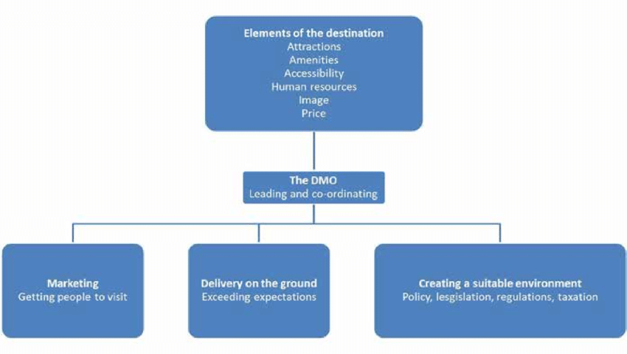
Source: https://www.unwto.org/policy-destination-management
The concept of destination marketing includes the process of research, promotion, branding, destination image management, and creating its superior position in relation to the competition, as well as communications aimed at attracting tourists and investors through various communication channels, emphasizing its potentials that make it unique. So, destination marketing helps to position the destination as an attractive brand, superior to alternatives, emphasizing the things that make it desirable and unique, while destination management represents a strategic destination management approach.

- Destination marketing and branding
Destination branding is a strategy, while destination marketing is a set of tactical goals and tools used during the marketing and promotion process. Defining a destination brand is crucial for the successful implementation of marketing goals.
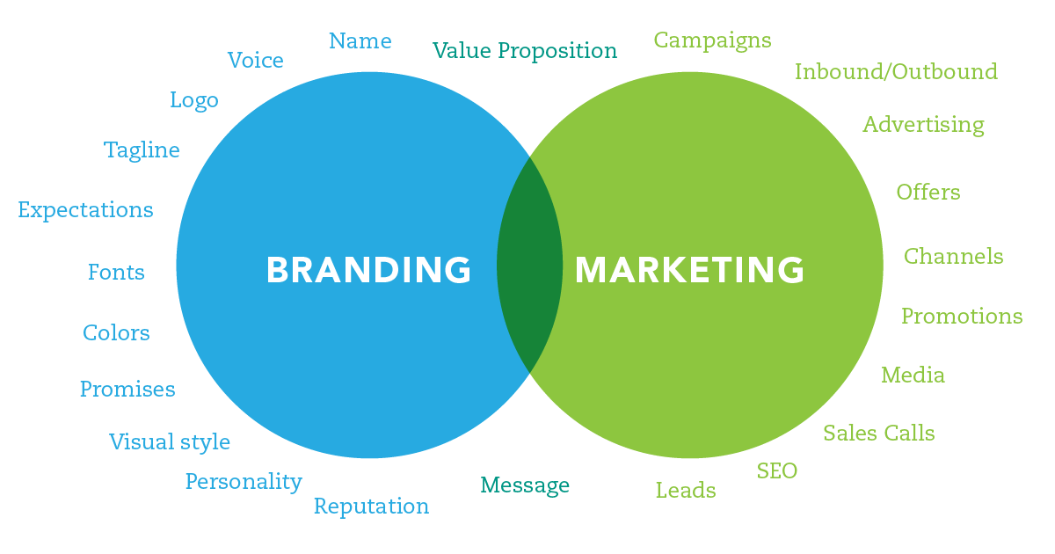
Source: https://brandingcompass.com/
The power of the destination brand lies in its ability to attract tourists. Unlike the previous image of the Montenegrin destination, "re-branding" means changing the same and presenting the destination in accordance with new trends. Once established, the new destination brand will be the basis of all marketing activities designed to promote the destination and attract tourists. Therefore, re-branding of the destination is absolutely necessary for Montenegrin tourism, and the new brand of the destination is crucial for the new messages we want to convey to the world through destination marketing.
The rebranded destination implies a new tourist portfolio and an innovative way of planning, marketing, promotion and facing challenges. However, from a practical point of view, using examples of good practice, if there is a unique formula for successful destination marketing, then it is the application of the IMC strategy - Integrated Marketing Communication.



IMC is a coordinated strategy that provides an intensive online presence, by activating all relevant communication channels and all models of marketing activities, all with the aim of better positioning the destination brand. IMC allows us to reach the target group in multiple ways and through the use of multiple platforms.
Through multiple and different channels that act in sync, we transmit the same message and thus empower it.

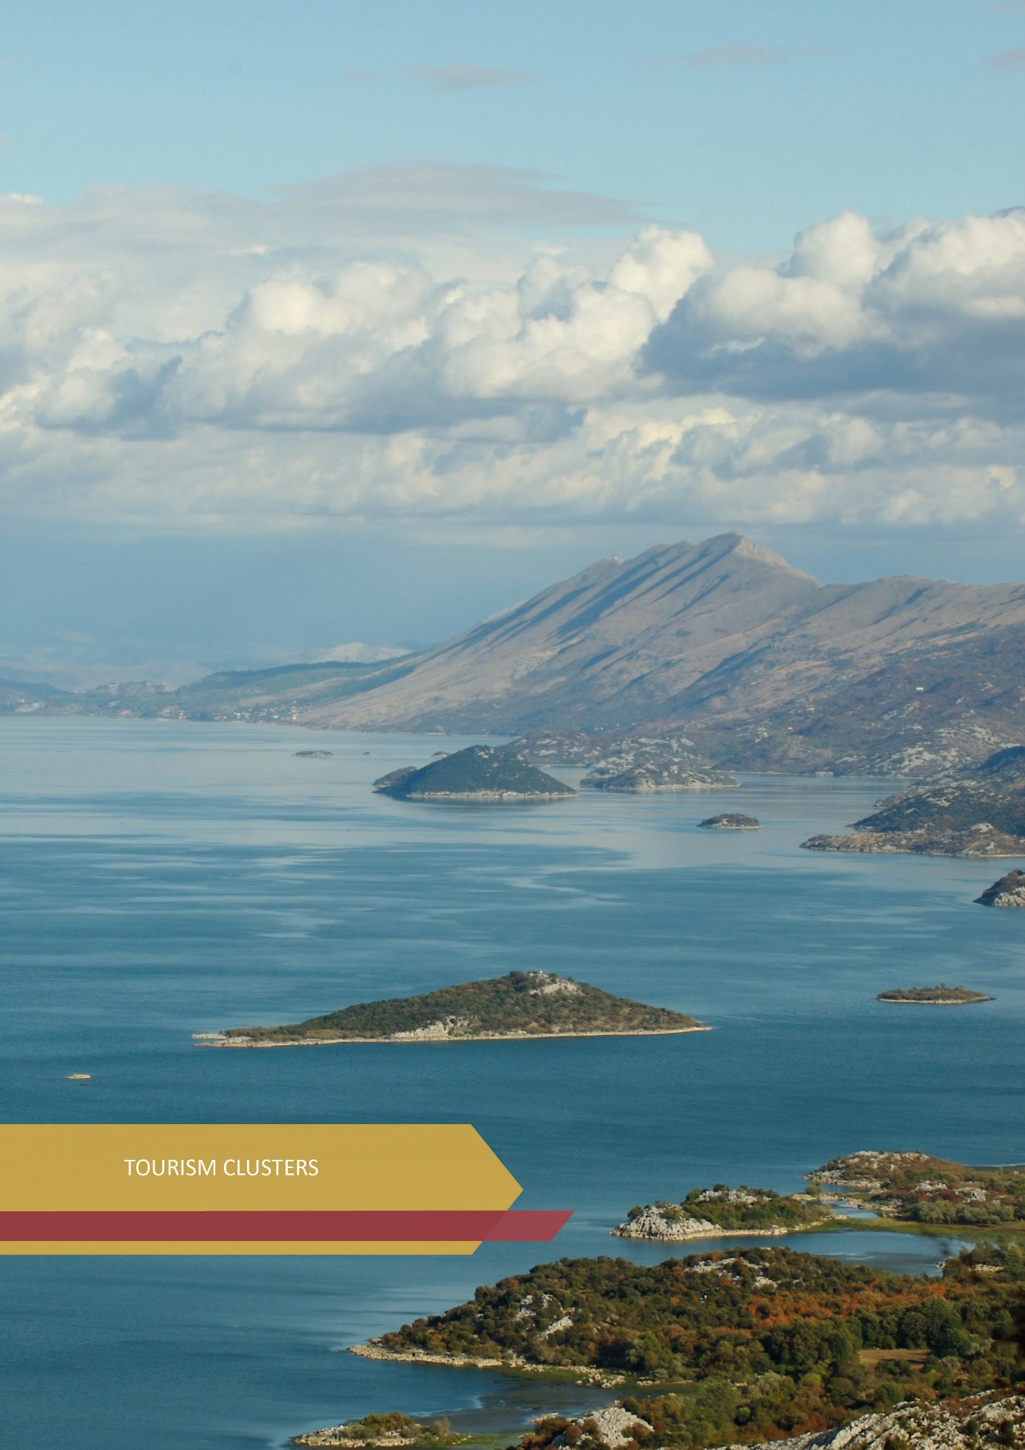

15. TOURISM CLUSTERS
Montenegro as a tourist destination is divided into eight tourism clusters, which differ in socio-cultural, historical, traditional, natural and economic characteristics, and also represent the basis for a unique and specific tourism product of Montenegro:

1. Ulcinj with Ada Bojana

2. Bar Riviera with Skadar Lake

3. Budva Riviera

4. Bay of Kotor

5. The Old Royal Capital Cetinje

6. The Capital City with the Central region

7. Bjelasica, Komovi and Prokletije

8. Durmitor and Sinjajevina with Tara and Piva rivers

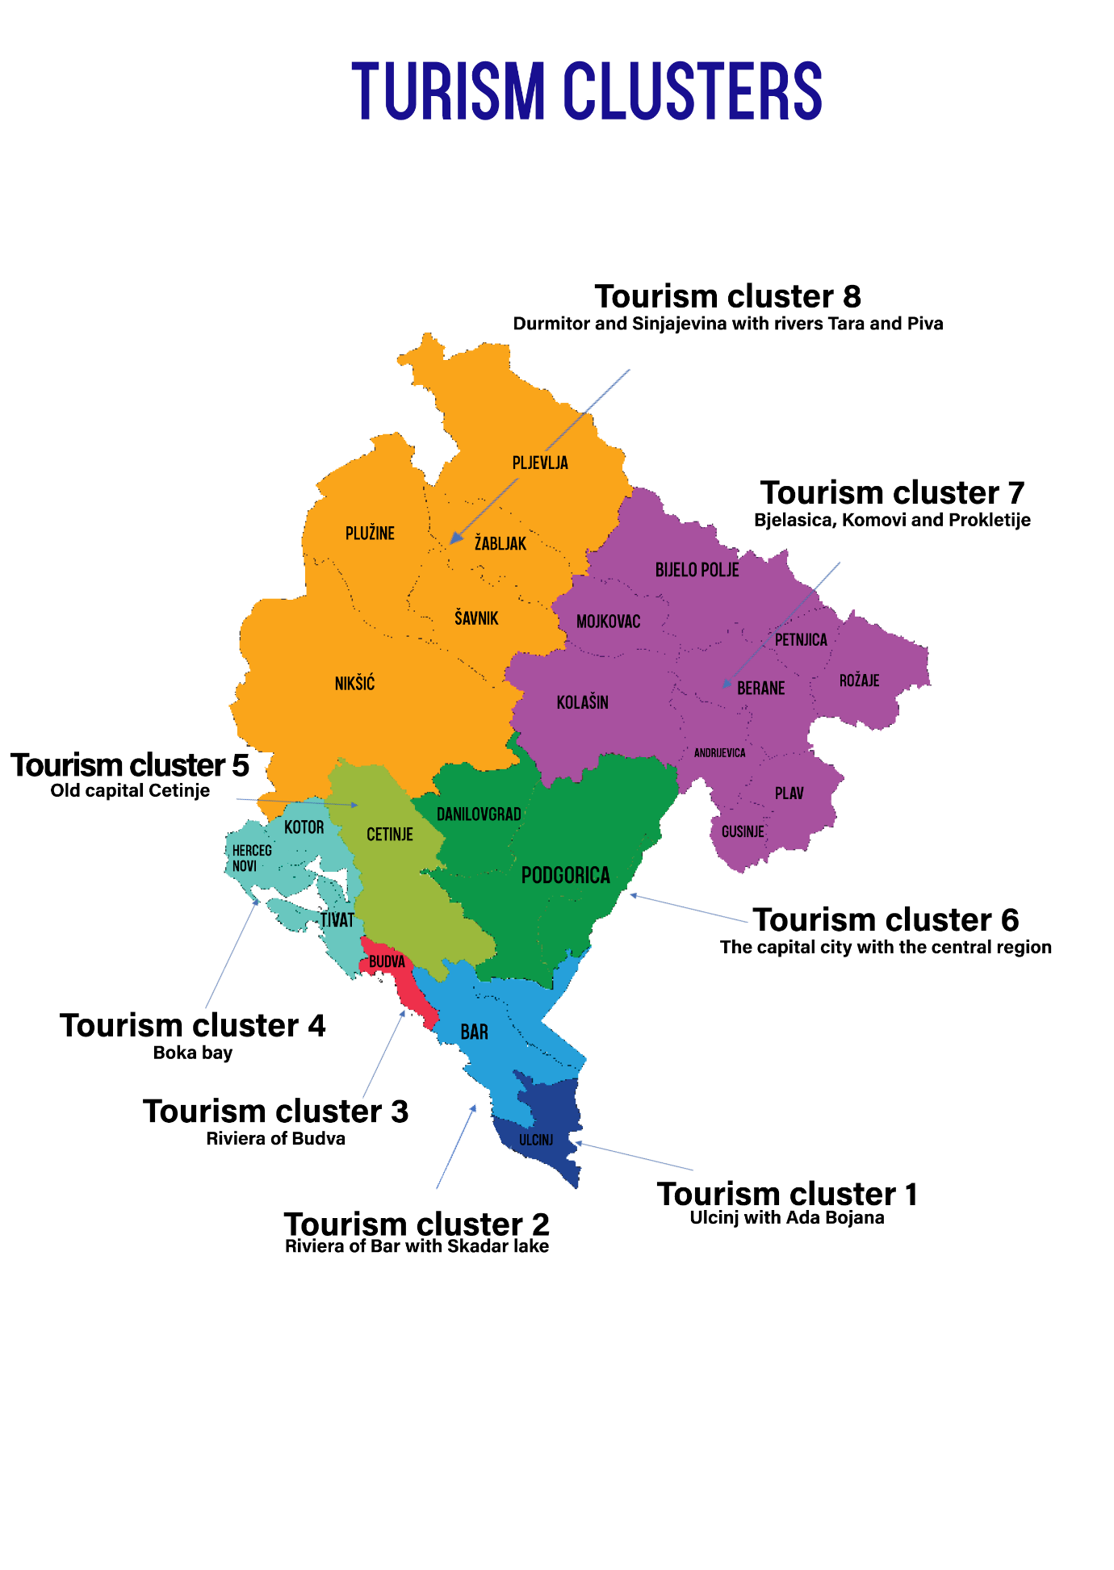

VISION OF DEVELOPMENT OF THE COASTAL REGION
"Destinations in the coastal region are recognized globally as destinations of high quality service and sophistication of space, which in an innovative and advanced way deliver the tourist experience of the Mediterranean and the Mediterranean hinterland to the most demanding market segments." - Concept of the Spatial Plan of Montenegro until 2040

15.1. TOURISM CLUSTER 1 - Ulcinj with Ada Bojana
CHARACTERISTICS
Ulcinj with its beaches, Bojana river, Ulcinj Salina, Šasko Lake, Ulcinj Old Town, etc. has great potential for the development of high quality tourism. Velika plaža (the Long Beach) is one of the most attractive surf destinations in the Mediterranean, and Ulcinj Salina, as a protected area, and its 14.5 km2 of salt basins, is a habitat for over 241 bird species, which is 50% of the total number of registered birds in Europe. Valdanos Bay and its olive groves are the largest living monument of olive growing in Montenegro, of outstanding economic and environmental value. In addition to natural potentials, Ulcinj with its history of 25 centuries, three religions and rich cultural heritage, is a jewel of the Montenegrin coast.
VISION OF CLUSTER DEVELOPMENT
Ulcinj with Ada Bojana is becoming a quality year-round destination, with accommodation facilities of high level of service and diversified tourist offer oriented to nature (beach tourism, birdwatching, hiking, hiking tours within the Salina with tourist valorization of "salt", as well as horseback riding etc.), sports and recreational activities (kitesurfing, paragliding, windsurfing, etc.), culture and tourist valorization of numerous legends, historical events (Ulcinj as a slave market and a famous pirate center in the 17th century, etc.), several sunken ships and galleys from various eras, as well as other rich cultural heritage.
INVESTMENTS, SPACE, HOTEL STANDARDS AND INFRASTRUCTURE
Space and investments
- Interdisciplinary develop strategies/models and possible scenarios and incorporate the most acceptable (sustainable) ones into planning documents, in order to provide a basis for sustainable tourism development;
- Make the most of brownfield sites and analyze the justification of possible greenfield investments;
- Stop the informal expansion of settlements and take remedial action for already existing informal settlements;
- Harmonize new and reconstructed buildings with the conditions of their wider context (harmonization with the natural, urban, cultural environment), while respecting the standards defined by the plan, which refer to well-thought-out architecture of urban structures that skillfully combines local tradition with elements of modern architecture;
- When rehabilitating and planning new zones, it is necessary to work on the standardization of buildings in terms of levels and shapes of buildings, their materialization and application of colors and appropriate ground floor arrangement;
- Protect the area along the Bojana river, stop further construction of temporary facilities along the Bojana river and stop the erosion of the beach on Ada Bojana, through a permanent solution. Also, protect the area around Šasko Lake (where the remains of the town of Svača are located) and the lake itself as a habitat for 240 different birds. Through special tourist offer programs, valorize Šasko Lake and its surroundings in a better way, because it also represents an excellent potential for the development of excursion tourism;
- Continue activities on valorization of the sites of the former Hotel Galeb, the former Hotel Jadran and the former Hotel Grand Lido and the Lido Apartments, monitor activities to improve the standard of accommodation capacity of the Hotel Mediteran;
- Create project activities through support programs in order to connect tourism and agriculture, small business and entrepreneurship.

Standardization and unification of facilities
In order to create the image of the city of Ulcinj, and through defined programs of private - public partnership (e.g. "New face of the city") it is necessary to work on refreshing the facades of facilities in urban areas, standardize solutions through the use of materials and colors that are aesthetically acceptable, neutral and that fit in with the environment.
Build facilities in the Mediterranean style, combining exceptional aesthetics and functionality in order to achieve complete unification of interior design and exterior space.
At the level of local self-governments, target the oldest buildings that have cultural and historical value, as well as buildings in which important historical figures lived or stayed, and protect, revitalize and valorize them.
In parts of the city that have historical value, facilities should be built on the motives of local ethno-architecture, with indigenous materials.
When creating new contents, it is necessary to pay special attention to the architectural design and materialization of facilities, especially taking into account that the volumes of facilities are carefully designed in order to obtain a homogeneous image of the settlement and city. Facades of facilities and roof coverings should be provided with quality and durable material and should be installed with quality.
Hotel standards
In the first line to the sea, it is necessary to strive for a 4 and 5-star hotel offer, with a variety of additional facilities.
When planning a hotel along the Long Beach, respect the criterion to provide 100 m2 of green space for one accommodation unit.
In the hinterland zone, it is necessary to have 3-5-star hotel, which will be open all year round. Hotels must be built thematically with additional facilities, which will rely on the diversified offer of the city, and not only on beach tourism.
It is necessary to work on increasing the standards of existing accommodation capacities and improving the quality of service in the tourism sector.
Infrastructure
It is necessary to implement activities on:
- The Improvement of inadequate and construction of the missing traffic network, especially the secondary road network;
- The suppression of the usurpation of public and private property through temporary facilities;
- Solving the environmental problem of the "Port Milena" canal;
- The urgent solution of the problem of erosion of Velika plaža and Ada Bojana;
- Improving the existing and building the missing infrastructure in order to supply the population with quality drinking water;
- The completion of works on the construction of the sewerage network;
- The improvement of electricity supply especially in the area along the Long Beach.

TOURISM PRODUCT
Main tourism products | Additional tourism products
- Nature-based tourism (bird watching, hiking, cycling, hiking tours of the "salt" in Ulcinj Salina, horseback riding, etc.)  - Sports and recreational tourism (kitesurfing, windsurfing, wakeboarding, paragliding and surfing, camps for athletes, sports schools,  - MICE (number of hotels with congress facilities)  - Health tourism (Ladies beach, healing mud)  - Nudist tourism  - Gastronomic and eno tourism(. | - Cultural tourism - events, cultural heritage, legends (pirates, slave square, etc.)  - Family tourism  - LGBT tourism  - Digital nomads

15.2. TOURISM CLUSTER 2 - Bar Riviera with Skadar Lake
CHARACTERISTICS
Bar Riviera includes the territory of the municipality of Bar, Sutomore and other tourist places in the territory of this municipality. It is recognized for its pebble and rocky beaches in the municipality of Bar and the sandy Sutomore beach, the Old Town of Bar, King Nikola's Palace, the Old Olive Tree which is protected as a natural monument (1957) and is one of the oldest in Europe, as well as numerous events held in this area. The municipality of Bar is located between two shores, i.e. the sea and the lake, and the Port of Bar is also important for its position. Religious buildings, churches and mosques, centuries old, also have a significant place in the offer. The trademark of the Bar Riviera are also olive groves, and the local population is recognized for the production of olive oil. In addition to numerous hotels and private accommodation, the offer is still not at a significant level, and this segment lacks complementary facilities - MICE, spa & wellness, etc.
Skadar Lake is one of the five national parks in Montenegro/since 1983/, with an area of approximately 400 km2. In 1989, it received the status of an area of international importance for the residence of birds, and in 1995 it was inscribed on the Ramsar List - World List of Wetlands of International Importance. Skadar is the largest lake, a habitat for 280 species of birds and 48 species of fish. This area is connected to the Capital and the Municipality of Bar and the Port of Bar by highway and railway, which confirms that it has the prerequisites for further development, among other things as a tourist micro destination. In this area there is a rich cultural and historical heritage - archaeological sites, fortifications, medieval monasteries, churches, traditional rural architecture. There are several sites from the Illyrian-Hellenistic and Roman periods, as well as monasteries from the XIV and XV centuries, from the period of the rule of the Balšić and Crnojević dynasties and fortification complexes from the period of Ottoman domination. Specific folk architecture - old rural units, individual examples of fishing and residential buildings, stone bridges and mills on river watercourses, confirm the cultural landscape of special architectural value. In this area is one of the most important wine regions in Montenegro - Crmnica. A number of tourist events take place in this region.
VISION OF CLUSTER DEVELOPMENT
Bar Riviera with Skadar Lake - a unique destination with high quality hotels with developed MICE and spa & wellness offer, which attracts tourists throughout the year, with a typical Mediterranean gastronomic offer, and events and concerts throughout the year, but also organized cultural tourism.
Skadar Lake area - a destination for active vacation - fishing, water sports, hiking and biking trails, recognized as a region where wine is grown and produced from indigenous Crmnik varieties.
INVESTMENTS, SPACE, HOTEL STANDARDS AND INFRASTRUCTURE
Space and investments
- Positioning of the municipality of Bar as a municipality of dynamic and sustainable economic growth and development;
- Positioning of the Bar Riviera with Skadar Lake as a destination characterized by nature tourism, sports and rural tourism, and within the city municipality - MICE and cultural tourism;
- On the territory of the municipality of Bar, there are preconditions for the development of nautical tourism, which would be accompanied by hotel accommodation facilities of appropriate quality and standards;
- Stop the informal expansion of settlements (Utjeha, Dobre Vode, Sutomore) and take remedial action for already existing informal settlements, in order to solve utility equipment, traffic network, improve the quality of life and environmental standards. It is necessary to solve the problem of insufficiently developed system for selective waste disposal, rehabilitate a large number of landfills for municipal and construction waste;
- Untouched landscapes, Skadar Lake National Park - the focus of development of the zone is on better valorization of space, through strictly controlled construction of accommodation and hospitality facilities, while guided by the principle of environmental protection;
- It is necessary to make the Management Plan of the Skadar Lake National Park;
- Sustainable development of the construction development of Skadar Lake is an absolute imperative in the further development of this region. No new large-scale construction should be planned in the lake zone except in individual facilities or smaller groups of suitable facilities.

Standardization and unification of facilities
In order to create the image of the municipality of Bar, and through defined programs of private-public partnership (e.g. "new face of the city") it is necessary to work on refreshing the facades of facilities in urban areas, standardize solutions through the use of materials and colors that are aesthetically acceptable, neutral and that fit in with the environment.
Work on the harmonization of new and reconstructed buildings, respecting the standards defined by the plan, which refer to well-thought-out architecture of urban structures, which skillfully combines local tradition with elements of modern architecture.
Facilities should be built in the Mediterranean style, combining exceptional aesthetics and functionality in order to achieve complete unification of interior design and exterior space.
At the level of local self-governments, target the oldest buildings that have cultural and historical value, as well as buildings in which important historical figures lived or stayed, and protect, revitalize and valorize them for tourism.
Create project activities at the local level, through various support programs created by the local tourism organization in order to connect tourism and agriculture, small business and entrepreneurship. The development of rural tourism in the hinterland of the urban complex of Bar needs to be strongly supported by the competent authorities at the state and local level.
Hotel standards
In the first line to the sea, it is necessary to strive for a 4 and 5-star hotel offer, with various additional facilities.
In the hinterland zone, the hotel offer should be in the category of 3-5 stars, which will be open all year round. For new hotels, especially in the part outside the urban matrix of the city, during the construction of the hotel it is necessary to respect the criterion to provide 100 m2 of green space for one accommodation unit.
It is necessary to work on increasing the standards of existing accommodation capacities and improving the quality of service in the tourism sector.
- Infrastructure
It is necessary to implement activities on:
- The Strategic Approach in solving communal problems in the municipality of Bar, which are reflected in insufficiently developed water supply network, lack of wastewater drainage systems, insufficient coverage of sewage network, lack of wastewater treatment systems, poor quality of local roads in rural areas and weak connection of rural areas with the city center, as well as congestion of the main road during the summer tourist season;
- The expansion of the existing capacities of the regional Možura sanitary landfill and on the construction of a recycling center and a center for the treatment of biodegradable waste in order to complete the municipal waste management system;
- The improvement of inadequate and construction of missing traffic networks, especially secondary road networks and suppression of usurpation of public and private property through temporary facilities.

TOURISM PRODUCT
Main tourism products | Additional tourism products
- Beach tourism - sandy and pebble / rocky beaches  - High quality and exclusive hotels with developed MICE and spa & wellness offer  - Nautical tourism  - Gastro and eno tourism (olive oil production) | - Cruising tourism  - Diving tourism  - Cultural tourism  - Event tourism and concerts, nightlife

15.3. TOURISM CLUSTER 3 - Budva Riviera
CHARACTERISTICS
Budva Riviera is one of the oldest settlements in the Adriatic, and is recognized for its beautiful beaches, high-quality hotels and is considered the metropolis of tourism in Montenegro. The Budva Riviera consists of the municipality of Budva and the tourist town of Petrovac. The most recognizable symbols of the Budva Riviera offer are, in the field of cultural attractions, the Old Town with sacral buildings, the City Museum with archeological and ethnographic exhibits and Roman mosaics in Petrovac, and when it comes to natural attractions, Sveti Stefan Peninsula, Sveti Nikola Island, Miločer Park and beaches, of which the longest is Slovenska Beach. Apart from bathing tourism, Budva is also recognized for a large number of events, but also for its nightlife, which is why it attracts a large number of young tourists.
Also, in the Budva Riviera there are a large number of high quality hotels, some of which operate under well-known world brands, have MICE and spa & wellness facilities. It is connected by main road with Tivat Airport, but also with the Capital and Podgorica Airport, and the Port of Bar, which makes it a well-positioned tourist destination.
VISION OF CLUSTER DEVELOPMENT
Budva Riviera - a unique destination with high quality hotels with developed MICE and spa & wellness offer, which attracts tourists throughout the year, with a typical Mediterranean gastronomic offer, and events and concerts throughout the year, but also organized cultural tourism offer.
INVESTMENTS, SPACE, HOTEL STANDARDS AND INFRASTRUCTURE
Space and investments
- Positioning the municipality of Budva as a modern, developed local community and an attractive tourist destination in the region, relying on the rich cultural and historical heritage and natural resources, which meet the diverse interests of visitors;
- Through the Spatial-urban plan of the Municipality of Budva, it is necessary to reconsider the principle of planning facilities larger than four floors along the Slovenska beach, because in that way the views towards the sea are blocked. Also, when planning space, it is necessary to be guided by the principle of the common good of society;
- Plan as many public spaces as possible, which will relieve the current overdevelopment in its urban area;
- Stop the informal expansion of the Rafailovići settlement and take remedial action for the already existing informal settlements, in order to solve the utility equipment, traffic network, improve the quality of life and environmental standards. It is necessary to solve the problem of insufficiently developed system for selective waste disposal, rehabilitate a large number of landfills for municipal and construction waste;
- Maximum utilization of brownfield sites, as well as expert analysis of the justification of possible greenfield investments (Buljarica and Jaz).
- Continue activities aimed at tourist valorization of the started investment projects Hotel "Crystal Riviera" in Petrovac and Hotel "As" in Perazića Do, as well as the location of the hotel "Queen's Beach" in Miločer.

Standardization and unification of facilities
In order to create the image of the municipality of Budva, and through defined programs of private-public partnership (e.g. "new face of the city") it is necessary to refresh the facades of facilities in urban areas, standardize solutions through the use of materials and colors that are aesthetically acceptable, neutral and that fit in with the environment.
Work on the harmonization of new and reconstructed buildings, respecting the standards defined by the plan, which refer to well-thought-out architecture of urban structures, which skillfully combines local tradition with elements of modern architecture. The buildings should be built in the Mediterranean style, combining exceptional aesthetics and functionality in order to achieve complete unification of interior design and exterior space.
At the level of local self-governments, it is necessary to target the oldest buildings that have cultural and historical value, as well as buildings in which important historical figures lived or stayed, and to protect, revitalize and valorize them.
Create project activities at the local level, through various support programs formulated by the local tourism organization, in order to connect tourism and agriculture, small business and entrepreneurship. The development of rural tourism in the hinterland of the urban complex of Budva needs to be strongly supported by the competent authorities at the state and local level.
Hotel standards
In the first line to the sea, it is necessary to strive for a 4 and 5-star hotel offer, with various additional facilities;
In the hinterland zone, it is necessary to have a 3-5-star hotel offer, which will be open all year round. For new hotels, especially in the part outside the urban matrix of the city, during the construction of hotels it is necessary to respect the criterion to provide 100 m2 of green space for one accommodation unit;
It is necessary to work on increasing the standards of existing accommodation capacities and improving the quality of service in the tourism sector.

Infrastructure
It is necessary to implement activities on:
- Improvement of existing and construction of missing communal infrastructure;
- Protection of the environment, which has been particularly damaged in the past period due to excessive construction activities, poor application, i.e. implementation of urban plans, lack of planning documentation, non-compliance with special criteria for environmental protection in planning, as well as due to unplanned use of space and occupation of construction land;
- Improvement of existing and construction of missing traffic network, especially secondary road network with suppression of usurpation of public and private property through construction of temporary facilities.

15.4. TOURIST CLUSTER 4 - Bay of Kotor
CHARACTERISTICS
The Bay of Kotor is the largest bay in the Adriatic Sea and includes the area of Kotor, Herceg Novi and Tivat, but also the area of smaller settlements - Perast, Igalo and Risan. This is the southernmost fjord in Europe, and in recent years, projects of luxury tourist resorts have been implemented and started in it- Porto Montenegro, Porto Novi and Luštica Bay, which make this part of our coast the most exclusive. With the mentioned investments, the Bay of Kotor also got marinas for luxury yachts, exclusive restaurants and retail chains, but also a rich clientele.
This part of the coast also has cultural sights, and in Kotor, the Old Town stands out among them with a fortification above the town, which are on the UNESCO list of protected cultural heritage, religious buildings, etc. Kotor is internationally known as a cruising destination, but also a carnival city. Also, one of the recognized tourist attractions is the "Boka Aquarium", founded in 2020 and consisting of a public aquarium and a rescue center for sea turtles. Boka Aquarium is the only institution in Montenegro that combines research and education to promote and practice effective protection of marine animals.
In Herceg Novi, the most recognizable sights are the Citadel and the Clock Tower, Fortress Spanjola and Forte Mare, the Kanli Kula Fortress, museums, the Vrbanj Adventure Park, but also the Orjen Nature Park, Tito's Villa "Galeb" and the Savina Monastery.
Tivat is one of the most modern cities on the Montenegrin coast, which includes the islands of Flowers, St. Mark, Our Lady of Mercy, Tivat Riva and the village of Donja Lastva. Also, recently it has been recognized for its hotel complex Porto Montenegro with an exclusive marina, numerous events and activities aimed at the development of tourism in the city center and its wider surroundings.
Perast is recognized for its typical architecture, the islands of St. George and Our Lady of the Rocks, but also museums and villas that were owned by rich sailing families, and today are often used as hotels.
Risan, an ancient place, the oldest in the area, and especially recognized by Roman mosaics.
Igalo, known for its healing mud and the Dr Simo Milošević Institute, is the center of health tourism in Montenegro.
The Bay of Kotor is also recognized for its authentic Boka folklore and costume - the Boka Navy, which has been on the UNESCO World Intangible Cultural Heritage List since December 2021, but also for numerous legends about sailors (Tre sorelle, etc.). As on the rest of the coast, it is characterized by typical Mediterranean gastronomy.

VISION OF CLUSTER DEVELOPMENT
The bay of Kotor -exclusive year-round destination that offers tourists authentic experiences in high quality resorts and hotels, with the possibility of developing MICE offer, health, yachting tourism, as well as a rich offer of nature-based tourism (mountaineering, biking, hiking, etc.)
INVESTMENTS, SPACE, HOTEL STANDARDS AND INFRASTRUCTURE
Space and investments
- Positioning the Bay of Kotor as a high quality destination of authentic identity, whose basic offer will consist of its landscapes and cultural diversity, which will be market-oriented towards cultural, sports, bathing, health tourism and which will be an international destination with up to 10,000 hotel beds category 3- 5 stars;
- Focus on improving the appearance of the environment and creating opportunities for sports as a basis for improving the attractiveness of the Igalo Institute (Igalo area), integration of neglected mountain villages into tourism development (Gornja Lastva and other rural settlements), creating additional offers to encourage guests for a longer stay in Boka (concept of stay), capacity expansion and modernization of the airport in Tivat;
- The zone should be developed in a focused and controlled way, using natural, cultural and created potentials in a sustainable way;
- The development of tourist accommodation needs to be planned very carefully, because the carrying capacity of municipalities in this cluster, especially in Kotor, is almost exhausted;
- Work on extending the duration of the season, through valorization and revitalization of existing facilities and construction of new accommodation facilities. Pay attention to the conversion of former military and industrial facilities into hotel facilities and nautical tourism facilities;
- Stop the construction of residential areas in the hinterland, which are unplanned and out of order positioned in the area and very often without adequate infrastructure;
- The zone is a great potential for the development of nautical tourism, and existing ports and marinas need to be significantly improved in terms of expanding capacity and quality of services;
- Make the most of the potential of individual settlements (Prčanj, Risan, Meljine, Igalo) for the development of health and wellness tourism and connect smaller family hotel facilities with large carriers of health and wellness tourism programs;
- Of special value in the municipality of Kotor are the natural features in the Bay of Kotor-Risan, which as a natural and cultural-historical area of Kotor is on the UNESCO World Heritage List. Protection of cultural heritage is an absolute imperative in further planning and development of the city;
- Follow and continue to respect the postulates represented by the PPPN for the coastal area through the development of detailed plans;
- When drafting strategic documents and implementing activities, keep in mind international agreements and conventions.

Standardization and unification of facilities
In order to create the image of the municipalities of Kotor, Tivat and Herceg Novi, and through defined programs of private - public partnership (e.g. "new face of the city") it is necessary to work on refreshing the facades of facilities in urban areas, standardizing solutions through the use of materials and colors which are aesthetically pleasing, neutral and which fit in with the environment.
It is necessary to work on the harmonization of new and reconstructed buildings, while respecting the standards defined by the plan, which point to a well-thought-out architecture of urban structures.
Build facilities in the Mediterranean style, combining exceptional aesthetics and functionality in order to achieve complete unification of interior design and exterior space.
At the level of local self-governments, it is necessary to target the oldest buildings that have cultural and historical value, as well as buildings in which important historical figures lived or stayed, and to protect, revitalize and valorize them.
Continue activities on the implementation of tourist valorization of started investment projects, primarily for the location of the former Fjord Hotel in Kotor, the former Igalo Hotel, Tamaris Hotel, the old Boka Hotel, as well as improving standards in the Plaža Hotel, which is also the largest hotel in Herceg Novi.
Create support programs to connect tourism and agriculture, small business and entrepreneurship.

Hotel standards
In the first line to the sea, it is necessary to strive for a 4 and 5-star hotel offer, with additional facilities.
In the hinterland zone, the hotel offer should be in the category of 3-5 stars, with additional facilities.
It is necessary to work on increasing the standards of existing accommodation capacities and improving the quality of service in the tourism sector.
The goal of positioning is to make the cluster in question a destination with a total of up to 10,000 beds, and with larger tourist complexes with up to 800 beds in the municipality of Herceg Novi, Tivat and on the Luštica peninsula (Porto Montenegro, Porto Novi, Luštica Bay), and in Kotor and the villages around the bay in the form of small family hotels with a maximum of 100 beds. Individually, there may be deviations from the goal set, if detailed analyzes justify the implementation of a different concept of investments.
Infrastructure
It is necessary to implement activities on:
- Balanced, quality and long-term sustainable development and improvement of traffic and overall infrastructure of the zone in question;
- Strategic approach to solving utility problems, especially in the municipality of Herceg Novi, which is reflected in the underdeveloped water supply network and lack of wastewater disposal system, insufficient coverage of the sewerage network, lack of wastewater treatment system, poor quality of local roads in rural areas and weak connection of rural areas with the city center, as well as the congestion of the main road during the summer tourist season;
- Improvement of inadequate and construction of missing traffic network, especially secondary road network, but also suppression of usurpation of public and private property through temporary facilities;
- Improvement of the existing and construction of the missing utility infrastructure in order to supply the population with quality drinking water, with an emphasis on Herceg Novi;
- Implement the project of water supply and sewerage in the Bay of Kotor - construction of sewerage system for the settlements of Risan, Perast, Stoliv and Prčanj which will collect wastewater from these settlements and transport it to the connection with the central collection system of the Municipality of Kotor.

TOURISM PRODUCT
Main tourism products | Additional tourism products
- High quality and exclusive resorts and hotels with developed MICE and spa & wellness offer  - Health tourism  - Nautical tourism  - Cultural tourism - museums, castles, religious buildings, archeological sites, authentic architecture, Boka Night, Fašinada (intangible cultural assets - customs, rituals, ceremonies)  - Gastronomic tourism | - Diving tourism  - Event tourism  - Excursion tourism

VISION OF DEVELOPMENT OF THE CENTRAL REGION
"The Central Region, through its diversity of experiences throughout the year, creates a motive to visit an innovative, advanced and attractive area that combines the urban and rural character of Montenegro." - Concept of the Spatial Plan of Montenegro until 2040.

15.5. TOURISM CLUSTER 5 – The Old Royal Capital Cetinje
CHARACTERISTICS
The Old Royal Capital Cetinje is the cultural and historical core of Montenegro. Short distance, and the main road connection with the Montenegrin coast (approx. 29 km to Budva and 49 km to Tivat airport), Podgorica Capital City (approx. 37 km) and the Port of Bar (approx. 67 km), are excellent prerequisites for its development. The Old Royal Capital Cetinje has great potential for the development of active tourism related to nature (hiking, biking and hiking routes, water sports, etc.), bearing in mind that its territory includes a national park and numerous caves, the most famous of which is Lipska cave, and some of the most beautiful resorts in Montenegro such as Rijeka Crnojevića, Žabljak Crnojevića and Njeguši. There are numerous cultural sights on the territory of the Capital, such as the Mausoleum Lovćen, the Mausoleum on the Orlov krš, Museum of King Nikola, the Blue Palace, Biljarda, the History Museum, the Art Museum, the Ethnographic Museum, the Money Museum, Birth House of Njegoš, etc., as well as several religious buildings, the most important of which is the Cetinje Monastery. There are also facilities in Cetinje where the embassies of the great powers were located after the proclamation of Montenegrin independence at the Berlin Congress in 1878. These are now the former embassies of England, Italy, France, Germany, Russia, Turkey, Bulgaria, Belgium, Serbia and Austria-Hungary, which house university and art centers of Montenegro, such as the Faculty of Fine Arts, Faculty of Dramatic Arts, Music Academy, Faculty of Montenegrin Language and Literature. All of the above, makes the capital an ideal area for further development of cultural tourism, which according to all research, globally, is one of the reasons for the largest number of tourist trips.
SCENARIO / VISION
The capital of Cetinje - a destination with a year-round offer, developed on the basis of recognized cultural and natural sights, orientation towards active, cultural and event tourism.
INVESTMENTS, SPACE, HOTEL STANDARDS AND INFRASTRUCTURE
Space and investments
- Positioning the zone of the Old Royal Capital Cetinje with the Lovćen National Park as a destination characterized primarily by cultural tourism, and then sports, rural tourism and MICE tourism;
- Protection of the cultural heritage of the Old Royal Capital Cetinje;
- Strengthen controls over the implementation of planning solutions, in order to preserve the cultural and historical appearance of the Old Royal Capital Cetinje;
- Protection of the Historical Core of the Old Royal Capital Cetinje by joining the UNESCO list;
- Focus on the promotion of investment potentials and the implementation of development projects in the Old Royal Capital Cetinje;
- Valorization of the brownfield site through the establishment of a multipurpose complex in the area of the former "Obod", where it is necessary to plan the establishment of various cultural, artistic, tourist and economic facilities;
- The construction of the cable car that will connect Kotor, Lovćen and Cetinje is a development project, and its implementation would give Montenegro a unique, modern, new and attractive segment of the tourist offer;
- “Return” Lokanda hotel to the Old Royal Capital Cetinje; this hotel was located in the center of Cetinje, and was demolished due to damage after the 1979 earthquake, and had the status of a cultural monument;
- Continue activities on the implementation of the project "Beautiful Cetinje", which involves the reconstruction of buildings in the historic center of the city, with the application of the most modern energy efficiency measures;
- Decorative lighting of the exterior of tourist attractions, which includes the installation of modern high-performance decorative LED lighting on the facades of museum units, former embassies and religious buildings. The project provides security, functionality and aesthetic appearance of major tourist attractions;
- "Cetinje smart city" project in full capacity - connecting "stakeholders" and full functionality of the card that allows tourists to combine services in one place;
- Valorization of the site "Ševrlja" in the function of building a tourist camp. Provide the necessary documentation and start its construction (public or private-public partnership);
- Complete the “thematic trails” project, which includes cultural-historical and gastronomic routes;
- Carry out adequate works in order to make the Žabljak Crnojevića Fortress accessible and adequately tourist valorized as a cultural and historical heritage of Montenegro;
- Untouched areas of "Lovćen" National Park - the focus of zone development is on better valorization of space, through strictly controlled construction of accommodation and hospitality facilities, while guided by the principle of environmental protection.

Standardization and unification of facilities
In order to create the image of urban municipalities, and through defined programs of private-public partnership (e.g. "new face of the city") it is necessary to work on refreshing the facades of facilities in urban areas, while standardizing solutions through the use of materials and colors that are aesthetically acceptable, neutral and that fit in with the environment.
It is necessary to work on harmonizing new and reconstructed buildings with the conditions of their wider context, while respecting the standards defined by the plan, which refer to well-thought-out architecture of urban structures, which skillfully combines local tradition with elements of modern architecture.
Outside urban areas, build facilities in a traditional style, combining exceptional aesthetics and functionality in order to achieve complete unification of interior design and exterior space.
At the level of local self-governments, target the oldest buildings that have cultural and historical value, as well as buildings in which important historical figures lived or stayed, and protect, revitalize and valorize them.
It is necessary to create support programs in order to connect tourism and agriculture, small business and entrepreneurship. The development of rural tourism in the vicinity of urban areas of the Old Royal Capital Cetinje needs to be strongly supported by the competent authorities at the state and local level.
Hotel standards
In the city zone, it is necessary to strive for a hotel offer (small hotels) of at least 4 stars, with additional facilities.
In other zones, the hotel offer should be at least 3 stars, which will be open all year round, and encourage the development of rural households.
It is necessary to work on increasing the standards of existing accommodation capacities and improving the quality of service in the tourism sector.
Infrastructure
It is necessary to implement activities on:
- Balanced, high-quality and long-term sustainable development and improvement of traffic and overall infrastructure of the zone in question. Special attention should be paid to ensuring the development of underdeveloped water supply network and lack of wastewater drainage systems, insufficient sewerage coverage, lack of wastewater treatment systems, poor quality of local roads in rural areas and poor connectivity of rural areas with the city center;
- Improving inadequate and building the missing traffic network, especially the secondary road network, but also combating the usurpation of public and private property through temporary facilities.

TOURISM PRODUCT
Main tourism products | Additional tourism products
- Product based on active tourism - hiking, mountaineering, cycling, etc.  - Cultural tourism - museums, castles, religious buildings, archeological sites, authentic architecture, etc.  - Rural tourism  - Gastronomic and eno tourism | - Sports tourism  - Excursion tourism  - Adventure tourism  - Event tourism

15.6. TOURISM CLUSTER 6 – The Capital City with the Central region
CHARACTERISTICS
Podgorica Capital City is characterized by the harmony of traditional and modern architectural styles, and harmony in the fusion of old and new. The capital of Montenegro and its rich cultural heritage - Stara Varoš and Clock Tower, archeological sites Duklja and Medun, as well as natural attractions such as the canyons of the rivers Morača and Cijevna, camping, recreation and hiking in the Kučke Mountains, panoramic tour "The Circle around Korita” and lookouts represent the main tourist offer of the Capital City. In addition to the above, cruising Skadar Lake, bird watching, lake landscapes, visits to many authentic villages in the area and a diverse eno and gastronomic offer, which is a combination of Mediterranean and continental national cuisine and a rich wine treasury of indigenous wines of superior quality, represent part of a quality offer.
Danilovgrad is recognized as a destination by the monasteries Ostrog and Ždrebaonik, by the relatively preserved architecture of the city center with specific old balconies, the only Art Colony in Montenegro with an enviable number of sculptures, Homeland Museum, Spuž Fortress and Martinic Gradina, and the Zeta river with numerous beaches, which has been declared a nature park. One of the tourist attractions is the Donkey Farm in Martinići, which in a short time attracted the attention of not only domestic but also a large number of foreign media. On the river Zeta there are several bridges from different time periods, which testify to the rich history of past times.
Tuzi has a good geographical position and natural resources, it is located about 40 km from the coast and about 14 km from neighboring Albania. It has access to Skadar Lake, the Cijevna river, and extends over part of Ćemovsko Field. Confirmation of cultural and historical significance is proof that this area was inhabited in the Neolithic. It is located on the ancient Roman road to Shkodra, and in Illyrian times it was inhabited by Labeats. In the area of Tuzi there are remains from the period of the rule of the Illyrians, Romans, Ottomans, as well as the remains of early Christian churches.
VISION OF CLUSTER DEVELOPMENT
The Cluster of the Capital City with the Central Region consisting of the Podgorica Capital City, the municipalities of Danilovgrad and Tuzi are destinations for excursion, eno-gastronomic, MICE, religious, but also family tourism.
INVESTMENTS, SPACE, HOTEL STANDARDS AND INFRASTRUCTURE
Space and investments
Podgorica
- The spatial vision of the development of the Podgorica Capital City is the protection, upgrading and development of a quality structure of the city and urban region.
- The territory of Podgorica can be divided into southern, central and northern zones. The southern zone includes the area of Skadar Lake with the hinterland and has great potential for the development of various types of tourism, as well as the development program of tourist facilities in the areas of Vranjina, Plavnica and Podhum, and great potential is recognized when it comes to the development of wine tourism. The central zone includes the area of the city's planning area with the potential to become a congress center, with adequate development of larger hotel capacities, primarily 4 * and 5 * hotels, as well as expanding the network of smaller hotel facilities in the city center. The northern zone includes the area of hills - Lijeva Rijeka area, Bratonožići, Piperi, Malesija and Kuči, which belong to protected areas (Komovi mountain range and Cijevna river canyon) and in this part it is possible to develop eco-tourism, hiking and winter sports and recreational activities, while the wider recreational area includes Žijevo and Korita.
- The main directions of arranging the integral tourist offer in the Capital are better use of the existing material base, increasing the capacity and quality of the existing infrastructure, arranging the city and protecting Skadar Lake and the Morača, Zeta, Ribnica, Cijevna and Sitnica rivers, valuing cultural goods in the tourist offer, improving cultural, entertainment and sports content, arranging picnic areas, valuable natural environments and other tourist locations.
- Veruša is a village located halfway between Podgorica and Kolašin, at 1,216 meters above sea level and has long been recognized as a resort for people from Podgorica, but due to the very poor infrastructural connection of Veruša with Podgorica (old road Mateševo-Veruša-Kolašin) the number of visitors is relatively low. Accordingly, Veruša as a quality tourist center will gain importance after the opening of a new highway to Kolašin, when all its potentials will be fully valorized as a mountain-green oasis with the development of sports, recreation, family and excursion tourism, not only for Podgorica but also for coastal municipalities. Also, the area of Veruša is very suitable for various winter activities, with the need to improve the quality of children's resorts, traditionally recognized for the use of holidays during winter and summer school holidays.
Danilovgrad
- Positioning of the municipality of Danilovgrad, according to the planning documentation is a destination characterized by sustainable tourism, where all forms of tourism development offer in the Municipality must have an environmental component, as one of the most important tourist offers. A key feature of the tourist offer, in addition to spiritual heritage, is based on natural beauty and activities in nature, especially in rural areas, mountain resorts and mountain katuns, or a combination of all these values. Rural tourism, in all this, has or will have a significant share, through different levels of services and programs such as: agro-tourism, ethno-tourism, eco-tourism, hunting and sports-recreational tourism, excursion and health tourism, cultural tourism etc.
- It is necessary to create conditions for the construction of accommodation facilities, especially hotels, in 3, 4 and 5-star categories, which the municipality of Danilovgrad lacks. Currently, the municipality has 3 hotels, one of which is outside the city center.
- It is necessary to create planning preconditions for the development of eco-tourism, because the municipality of Danilovgrad, thanks to its climate and geographical position, but also natural values, has all the prerequisites for the development of this branch of tourism.
Tuzi
- The tourist offer of the municipality of Tuzi must be observed through the integrated offer of the wider zone, which extends to the territory of neighboring municipalities, in order to create a recognizable tourism product, more tourist programs, activities or types of tourism, as well as cross-border tourism projects with Albania.
- From the aspect of the level of tourist mobility, this area has the potential for the development of transit tourism, bearing in mind that the highway Podgorica - Tuzi - border crossing Božaj, which connects Montenegro with Albania, and the road Podgorica - Gusinje via Albania, which connects North and South of Montenegro.
- Develop rural tourism related to the environment of the village and its immediate surroundings, and all its activities (agriculture, events, gastronomy, folklore, ethnology and other activities) that are components of rural tourism. The municipality of Tuzi has preserved nature and a wide range of food products, as well as unused rural capacities that can be combined into one success story.
- One of the significant potentials for the development of tourism is the valorization of the Podhum dock, where in cooperation with the locals and through the education of all key entities it is possible to make a tourism product. Nearby is the "Pančeva Oka" reserve, a place for observing pelicans, which is a kind of attraction. Above the Podhum dock, there is a registered hiking trail with a view of Lovćen, Rumija, Prokletije, Albania and Podgorica.
- On the territory of the municipality of Tuzi there are potentials for the development of various forms of tourism such as: excursion tourism - the river Cijevna with its canyon and waterfall "Niagara", near the Kuće Rakića, about ten meters high, one of the city’s most popular resorts during the summer months. As this is a canyon that is still intact in most locations, there is potential for the development of tourism based on fishing, cycling and walking. Also, potential locations that stand out for excursion tourism are Vitoja, Podhum and other popular excursion places.
- Eno-tourism (wine tourism), as a subtype of gastronomic tourism, is represented through the activities of the company "13 Jul - Plantaže A.D.", and refers to visits to vineyards and wineries, wine tasting and gastronomic specialties. In the area of the municipality of Tuzi, there is a wine cellar "Šipčanik" at an average depth of over 30 meters below the ground, in the form of a tunnel 356 meters long, and spreads over 7000 m2. A tour of this cellar is an indispensable part of the tourist program "Wine Route". Within the wine tourism, it is possible to include small private wineries from this area.
- Cultural tourism - many cultural assets provide excellent conditions for the presentation of cultural and historical tourism. Cultural tourism includes several segments such as: religious, festival, folklore, cultural tourism related to cultural and historical heritage, as well as intangible cultural tourism.
- Event tourism - carnival in Tuzi.

Standardization and unification of facilities
In order to create the image of urban municipalities, and through defined programs of private-public partnership (e.g. "new face of the city") it is necessary to work on refreshing the facades of facilities in urban areas, standardizing solutions through the use of materials and colors that are aesthetically acceptable, neutral and that fit in with the environment.
It is necessary to work on the harmonization of new and reconstructed buildings, while respecting the standards defined by the plan, which point to a well-thought-out architecture of urban structures.
Outside urban areas, build facilities in a traditional style, combining exceptional aesthetics and functionality in order to achieve complete unification of interior design and exterior space.
At the level of local self-governments, target the oldest buildings that have cultural and historical value, as well as buildings in which important historical figures lived or stayed, and protect, revitalize and valorize them, especially in the Podgorica Capital City.
It is necessary to create project activities through various support programs in order to connect tourism and agriculture, small business and entrepreneurship. Development of rural tourism in the vicinity of urban units of Podgorica, Danilovgrad, Nikšić and Tuzi.
Hotel standards
In urban areas, it is necessary to strive for the 4 and 5-star hotel offer with additional facilities.
In other zones, the hotel offer should be in the category of 3-5 stars, which will be open all year round. In addition to hotel capacities, it is necessary to encourage the development of rural households in settlements and villages outside the city.
It is necessary to work on increasing the standards of existing accommodation capacities and improving the quality of service in the tourism sector.
Infrastructure
The precondition for balanced, quality and long-term sustainable development is the development and improvement of traffic and the overall infrastructure of the zone in question. Special attention should be paid to the development of insufficiently developed water supply network and wastewater drainage systems (fecal and atmospheric sewage), insufficient sewerage network coverage, local roads in rural areas and poor connection of rural areas with the city center.
It is necessary to work on improving the inadequate and building the missing traffic network, especially the secondary network of roads (access streets, parking lots, etc.). Suppress the usurpation of public and private property through temporary facilities, which are being built on sidewalks, green and park areas, which prevent safe movement of pedestrians and prevent the planning of areas for movement for people with special needs.

TOURISM PRODUCT
Main tourism products | Additional tourism products
- MICE tourism  - Product based on active tourism - hiking, mountaineering, cycling  - Rural tourism  - Protected areas  - Cultural tourism - museums, religious buildings, archeological sites, authentic architecture  - Gastro-eno tourism | - Event tourism  - Fishing and sport-fishing tourism  - Excursion tourism  - Adventure tourism, etc.

VISION OF DEVELOPMENT OF THE NORTHERN REGION
"The northern region is a destination with a high level of quality of experience of nature and rural environment of Montenegro, available throughout the year, through the abundance of sustainable tourism products and experiences." - Concept of the Spatial Plan of Montenegro until 2040.

15.7. TOURISM CLUSTER 7 – Bjelasica, Komovi and Prokletije
CHARACTERISTICS
Tourism cluster Bjelasica, Komovi and Prokletije is a mountain tourist destination with a tourist offer based on ski and rural tourism, as the backbone that connects this area into a single system.
The areas of the national parks Biogradska gora and Prokletije represent one of the main development tourist potentials of this area. The tourist offer is diversified and based on a developed network of hiking and biking trails, thematic routes created around the most important cultural and historical heritage and natural potentials, as well as high-quality hotels with MICE facilities. Agriculture is closely related to tourism, and domestic products are sold in the households themselves, but also in hotels and restaurants in the region, as well as in the whole of Montenegro. Tourism as an economic activity is connected to all other sectors and benefits a large number of people, especially in rural areas, but also women and young people.
INVESTMENTS, SPACE, HOTEL STANDARDS AND INFRASTRUCTURE
In accordance with the Special Purpose Spatial Plan Bjelasica and Komovi, the construction of several modern mountain and ski centers is planned in the area of the Bjelasica and Komovi Mountains.
In the southern part of the Bjelasica area on the territory of the municipality of Kolašin, the development of the mountain and ski center Kolašin 1600 is underway, which is recognized as a carrier of winter tourism in Montenegro, and significant infrastructural activities are being carried out to improve the tourist offer. The zone for the base settlement of the mountain center Kolašin 1600 has an area of 27.19 ha and will consist of a zone with the facilities of the central settlement with hotels, suites, reception and public facilities, a zone of separate groups with facilities of single and multifamily accommodation units and area for starting ski lifts. In the mountain center Kolašin 1600, the construction of 3 hotels with a total of 2,485 beds in hotels, suits and similar facilities is planned. This will be a new and competitive tourism product of Montenegro.
The zone of the mountain center Žarski is located in the northern part of the area of Bjelasica, in the municipality of Mojkovac, and covers an area of 1,550 ha at an altitude of 1650 m. The settlement of the mountain center will consist of a zone with facilities of the central settlement with hotels (14 in total), suits, reception and public facilities, a zone of separate groups with facilities of single-family and multi-family accommodation units (6,796 beds in total) and ski lift starting areas. The ski slope zone is interpolated into the base settlement zone in a way that provides ideal accessibility for skiers. The construction of the Ski Center "Žarski" is underway, which will be put into full function in the planned time interval, as a completely new and modern ski resort.
The zone of the base settlement Cmiljača is located in the northern part of the area of Bjelasica on the territory of the municipality of Bijelo Polje, at 1,620 m above sea level, on an area of 7.5 ha. Zones with 4 hotels and 22 bungalows are planned in the base settlement, as well as areas for the starting point of ski lifts, with a total of 1,995 beds. The construction of the ski center "Cmiljača" is underway, which will be put into full function in the planned time interval, as a completely new and modern ski resort.
The aim of the Local Study of the "Hajla and Štedim" location was to create spatial planning preconditions for the created economic development of distinct natural potentials, spatial coverage of Rusolija, Štedim, Ahmica, Bandžov and Hajla, as well as the corridor that functionally connects this area with the center of Municipality of Rožaje. The plan covers an area of 4,326.49 ha, and the area within the intervention of the Local Study is recognized as a mountain, summer, winter, sports - recreational area. The location in question is the highest quality mountain tourist site in the Municipality of Rožaje. The construction of the ski center on Hajla and Štedim will contribute to the development of tourism and additionally influence the increased demand for agricultural and forest products, various services, real estate, etc., which will increase the attractiveness and competitiveness of the area as a whole. Ski center "Štedim-Hajla" will be put into full function in the planned time interval, as a completely new and modern ski resort.
A special gem in the tourist offer of Montenegro will be Đalovića cave, which belongs to the wider area of Đalovića gorge, i.e. the area defined as a "protected area". The valorization area is the area of Đalovića gorge from the Podvrh Monastery with the Church of St. Nicholas to the entrance to Đalovića cave, on an area of approximately 114 ha. Đalovića cave, and the wider area to which this locality belongs, are ideal for all forms of adventure tourism: speleology, canyoning, zip-line, kayak on fast waters, free climbing, mountain biking, hunting and fishing, hiking, mountaineering and various forms of nature adventure parks.
Significant investment in infrastructure in rural areas - roads, water supply, energy system, but also strengthening the signal for mobile telephony and internet availability.
Therefore, the strategic stronghold is important due to the fact that the protection and creative interpretation of this mountain area or cluster must be taken as a factor of differentiation in relation to similar locations within the region and wider, i.e. Europe. In other words, the strategic stronghold that "tourism is the guardian of space" in the modern context of tourism means the following: in order to be successful in tourism, this area must retain, improve and, if necessary, rehabilitate its natural originality.
For this cluster, the key to success is the unique management of the entire tourist value chain of space, both in the phase of opening major investment projects and in the phase of organizing and managing the destination management of this attractive tourist and recreational space; as well as a balanced concept of tourism, urban and rural-agricultural development of this region, which thus supports year-round economic activities caused by tourism as a lever of development.

Standardization and unification of facilities
It is necessary to work on the harmonization of new and reconstructed buildings, respecting the standards defined by the plan, which refer to well-thought-out architecture of urban structures, which skillfully combines local tradition with elements of modern architecture.
Outside urban areas, build facilities in a traditional style, combining exceptional aesthetics and functionality in order to achieve complete unification of interior design and exterior space.
At the level of local self-governments, target the oldest buildings that have cultural and historical value, as well as buildings in which important historical figures lived or stayed, and protect, revitalize and valorize them for tourism.
When creating new contents, it is necessary to pay special attention to the architectural design and materialization of facilities, especially taking into account that the volumes of facilities are carefully designed in order to obtain a homogeneous image of the settlement and city. Facades of facilities and roof coverings should be made of quality and durable material and should be installed with quality. In parts of the city that have historical value, build facilities on the motifs of local ethno architecture, with indigenous materials.
It is necessary to create project activities through various support programs in order to connect tourism and agriculture, small business and entrepreneurship.
Hotel standards
In urban areas, it is necessary to strive for a 4 and 5-star hotel offer with additional facilities.
In out-of-town zones, it is necessary to have a 3-5-star hotel offer, and to encourage the development of 3-star rural households in settlements and villages.
It is necessary to work on increasing the standards of existing accommodation capacities and improving the quality of service in the tourism sector.
Infrastructure
The precondition for balanced, quality and long-term sustainable development is the development and improvement of traffic and the overall infrastructure of the cluster in question. Special attention should be paid to the development of insufficiently developed water supply network and wastewater drainage systems (fecal and atmospheric sewage), better sewerage network coverage, wastewater treatment system, poor quality of local roads in rural areas and poor connectivity of rural areas with the city center.
It is necessary to work on improving the inadequate and building the missing traffic network, especially the secondary network of roads - collector streets, access streets and parking lots. Suppress the usurpation of public and private property through temporary facilities, which are being built on sidewalks, green and park areas, which prevent safe movement of pedestrians and prevent the planning of areas for the movement of people with special needs.

TOURISM PRODUCT
Main tourism products | Additional tourism products
- Protected areas (national parks and nature park) with a diversified offer  - Winter tourism - ski centers  - Nature-based tourism - hiking and mountaineering, cycling, skiing, horseback riding, etc.  - MICE tourism (existing and under construction capacities)  - Rural tourism - rural households and katuns  - Gastro tourism | - Eco and ethno villages offer  - Hunting and fishing tourism  - Cultural tourism (events, cultural heritage)  - Family tourism

15.8. TOURISM CLUSTER 8 – Durmitor and Sinjajevina with Tara and Piva rivers
CHARACTERISTICS
Durmitor National Park with the canyon of the Tara river is on the UNESCO list of world natural and cultural heritage / 1980 /. It includes the Durmitor mountain massif, the canyons of the Tara, Draga, Sušica rivers and the highest part of the Komarnica canyon. Durmitor is recognized for the exceptional beauty of its mountain peaks and 18 glacial lakes, the so-called "Mountain Eyes", of which the most famous are Black Lake, Škrčka Lakes, Zminičko and Zminje, etc. In the center of the national park is Žabljak, a town at the highest altitude in the Balkans. There are also stećci tombstones on the territory of the national park, a UNESCO protected cultural asset. Durmitor National Park and Piva Nature Park are the backbone of the tourist offer, and investments in road infrastructure (road Nikšić - Žabljak) and the establishment of a panoramic route "Durmitor Ring", have made this area more attractive for tourist arrivals. Durmitor was once a famous ski resort due to its challenging slopes, which today has the Savin Kuk ski resort with insufficiently modernized infrastructure. The characteristic coniferous forest, but also the richness of flora and fauna in general, is home to numerous animal species, and in this territory there is also the Crna Poda Natural Reserve. The Tara bridge, the Dobrilovina monastery and numerous other cultural and historical monuments also represent a significant cultural and historical heritage. Via Dinarica is the backbone of the adventure offer and is transnational in nature, along with many other hiking and biking trails, panoramic routes, etc., and rafting on the Tara river and canyoning in the Nevidio canyon are the most attractive adventure activities. In the last few years, the number of registered rural households has increased, which is significant given that this region has typical products such as Durmitor cheese and skorup, Pljevaljski cheese, and an increasing number of organic products, which contributes to the overall tourist offer.
The Durmitor Ring panoramic road, as one of the tourist offers of this cluster, is a 76-kilometer-long round trip. The beginning of the panoramic road is in the center of Žabljak and continues around the mountain massif of Durmitor. Along this route, tourists have the opportunity to see the deepest canyon in Europe, vast plateaus and some of the highest peaks in Montenegro and get to know the local population and the traditional life of mountaineers. In order to raise the quality of the offer, tourists have at their disposal a mobile application - an audio guide for touring this panoramic road.
The mountain massif of Sinjajevina, which covers an area of almost 40 km, is a mountain that is important from the aspect of livestock breeding because it is characterized by vast pastures. On its territory there is one of the most beautiful lakes, Zabojsko Lake. It borders the national parks Durmitor and Biogradska gora. Hiking and cycling tours are organized in this area, and tourists can also enjoy horseback riding.
Piva Nature Park is located in the far northwest of Montenegro (between the state border with Bosnia and Herzegovina and the border of the Durmitor National Park) and occupies a significant part of the territory of the municipality of Plužine. The Piva Regional Nature Park is a natural link between the Durmitor National Park and Sutjeska National Park in Bosnia and Herzegovina, and its establishment has been recognized by a number of national and international documents and initiatives. The regional park is rich in exceptional natural features.
There are over 1,500 species of plants in the regional park, many of which are rare and endangered species and about 2,000 species of fungi; well-preserved forests of white and black pine, beech and fir, maple, spruce and ash, etc., only complete the richness of the flora in the park. The rivers Tara and Piva represent exceptional natural potentials, but also centers of rafting tourism, kayaking and other types of active holiday. Komarnica river and its Nevidio Canyon are a special attraction, with the fact that the Nevidio Canyon is the last conquered canyon in Europe.
In addition to the above, this area has about 20 smaller villages, blended into the area with characteristic original architecture, and there are numerous traditional livestock katuns, as elements of cultural heritage that testify to the history and culture of Piva region. The development of rural tourism is the basis for the development and improvement of the tourist offer of this nature park.
Nikšić, which is the largest municipality in Montenegro, has a good geographical position and is connected by highways with the Capital City, the Bay of Kotor, but also Žabljak. Nikšić also has cultural and natural potentials for the development of tourism, among which are the archeological site Crvena stijena, Carev most, King Nikola's palace, Bedem - city fortress, Cathedral Church of St Basil of Ostrog, several lakes, park-forests, picnic areas like Trebjesa, etc.
Pljevlja, the third largest municipality in Montenegro, is located in the far north, bordered by forested mountains and intersected by the rivers Tara, Ćehotina and Breznica. Islam and Christianity are strongly intertwined in Pljevlja. The symbols of the city are two cultural, historical and archeological monuments - the Holy Trinity Monastery and the Hussein Pasha's Mosque. For several centuries, the Holy Trinity Monastery has been one of the main centers of spiritual, educational and cultural life in the northern part of Montenegro. Hussein Pasha's Mosque is one of the most significant monuments from the period of Ottoman rule, built in the 16th century and has the tallest minaret in the Balkans. Near Pljevlja, there are excavations of an ancient Roman settlement - Municipum S and it is believed that this settlement was the second largest after Duklja. Pljevlja is partly located in the territory of the Durmitor National Park. According to the opinion of the Municipality of Pljevlja, the mountain Ljubišnja fulfills all the conditions to declare the wider area of that mountain a regional park. Ljubišnja has exceptional conditions for the construction of ski resorts and the development of summer, mountain, adventure, recreational, winter and hunting tourism.
Plužine are located between the mountain massifs of Durmitor, Volujak and Maglić on one side, and the Tara canyon on the other. These natural borders separate Plužine from the neighboring municipalities of Žabljak, Šavnik and Nikšić. In the heart of the area of the municipality of Plužine is the canyon of Piva with Piva Lake, which is why the whole area is called Piva. The canyons of the rivers Tara, Piva, Komarnica and Sušica, Piva Lake, mountain massifs with Trnovačko, Stabansko and Škrčko lakes, idyllic villages of the Piva Mountain, represent the main potential for the development of adventure, rural and nature-based tourism.
Šavnik is located on the slopes, valleys and areas of the mountain massifs of Durmitor, Sinjajevina, Moračke mountains, Krnovo plateau and Vojnik mountain. This small authentic town is located on the rivers Bijela, Bukovica and Šavnik, which make up the river Pridvorica.
VISION OF CLUSTER DEVELOPMENT
Durmitor and Sinjajevina with the rivers Tara and Piva - a destination recognized for ski tourism with accompanying infrastructure, rural tourism, as well as for active holidays - mountaineering, hiking, snowshoeing, rafting, camping, horseback riding, etc. Also, the cluster is recognized for its developed hotel offer based on MICE facilities and family tourism, with authentic gastronomy, sports-recreational and adventure facilities (camps for athletes, zip line, bungee jumping, off road caravans, etc.)
Durmitor National Park is guided by sustainable principles in creating a tourist offer not only in the strictly protected zone but also beyond, and is a flywheel for tourism in the entire region. The Piva Nature Park functions in the same way, and contributes to expanding the tourist offer and income from tourism to other parts of the region, and to reducing the tourist pressure on the most attractive zone. The backbone of the cultural offer are the stećci tombstones that are under UNESCO protection, but all other cultural and historical monuments are adequately included in the offer. A variety of local products characteristic of this region are in use in the hospitality sector in the region and beyond, and local gastronomy is presented in restaurants throughout the region. Rural households provide services in tourism, so adventurers on the trails have services, and local people earn income by providing services.
Natural and ambient conditions, natural beauties with forests, pastures and meadows provide all opportunities for the development of ski, rural, adventure and nature-based tourism in the municipalities of Nikšić, Pljevlja, Plužine, Žabljak and Šavnik.

INVESTMENTS, SPACE, HOTEL STANDARDS AND INFRASTRUCTURE
Space and investments
Montenegro is committed to create a high quality tourism product in the area of Durmitor, which means improving the quality and significantly redesigning the offer and overall infrastructure, in the direction of improving its competitive position as a special tourist destination. In that sense, the commitment is to carefully manage the development of the tourist offer, in such a way that the priority is on the sustainable development of the offer that creates the greatest benefits for the economy, both in terms of income and employment, but also protects the environment.

The Savin Kuk site includes the zone of the existing Savin Kuk ski resort with its immediate surroundings and is planned as a destination of high category and quality offer, intended primarily for visitors engaged in sports and recreation. Reconstruction of the complete existing ski infrastructure is planned. Detailed analysis of this area and investments from several aspects, offers a clear conclusion on the justification and profitability of investments in this locality, but with strict consideration of sustainability in terms of preserving exceptional universal values of World Heritage, or sensitive space where old installations are replaced. The modern ski resort on the Savin kuk site will be put into full function in the planned time interval.
It should be noted that the development and economic commitment of one part of the Durmitor area is eco-tourism and agriculture, with controlled use of resources. The valorization of valuable natural and cultural resources creates a rich tourist offer in the entire area of Durmitor.
Current tourism trends are encouraging destinations such as Durmitor, which still has relatively untouched nature, natural resources, rich cultural heritage and a special local culture. The region as a whole can benefit from the growing trend of increased demand for as authentic experiences as possible and the preservation of a special "experience" of the destination on the international market.
Durmitor has the potential to become an example of sustainable eco-tourism through the harmonization of sustainable tourism planning, design and development. The plan proposes the concept of year-round business.
Investments in the Durmitor area will significantly affect the more dynamic economic, social and demographic development with the rational use of natural potentials and resources of the area. First of all, revitalization and economic revival of the existing economy is expected, which will be able to offer better quality products and services to the market. Planning and elaboration of new profitable programs and projects, primarily in tourism, will be interesting for both domestic and foreign investors.
The new investment policy will also have a positive impact on the revitalization of rural areas and individual farms. This will create an opportunity for the production of significant market surpluses that the rural population will be able to offer primarily to guests and visitors to the Area. The production of biologically appropriate food and domestic products with their branding will increase the income of the rural households.
Nikšić
- Nikšić, through its architectural and urban design, should be adapted to the natural environment and local folk architecture. When organizing tourist accommodation in the rural part of the municipality, it is necessary to respect the local principles of construction, while providing comfort in an authentic environment, formulated on the basis of recognized natural and cultural sights. The area of the territory of Nikšić should be oriented towards cultural, mountain, religious and sports-recreational tourism.
- The rural area of Nikšić represents a significant economic resource that needs to be revitalized through primarily infrastructural equipping of villages and encouragement of the population to connect the tourism and agriculture sectors, through types of tourism such as agro, rural, eno-gastronomic and other types of tourism.
- Improvement of accommodation capacities (there are 11 hotels in the municipality of Nikšić, one of which is not in operation, namely the small hotel "Glava Zete", which needs rehabilitation and upgrading of existing capacities, in terms of forming a high category tourist resort. Favorable position on the river bank, natural environment, and built capacities of sports and recreation in the contact zone, are quality prerequisites for organizing the tourist offer).
- Construction of hostels in the city center (recognizing the existence of this type of tourist facility would affect the improvement of the tourist offer of the city).
- Mapping of trails and setting up info tourist points (better information about the tourist destination, excellent service, higher attendance, better promotion); construction of a trim trail around Trebjesa (established location for recreational running; enriched tourism product; improved psycho-physical health of the citizens of Nikšić) and construction of a bicycle trail.
- Tourist valorization of cultural heritage (protection and promotion of cultural heritage, mapping of cultural-historical, religious buildings and sites in the function of tourism development and tourist visits, as well as improving the condition of religious buildings on the tourist route).
- Improving cultural tourism (at the place where the holiday is spent, it is necessary to get the opportunity to experience culture "live"; the offer should be conceived in such a way that it keeps pace with the living and social environment).
- Development of rural tourism - development of rural households and combinations of accommodation, hospitality and agriculture in rural complexes with integration into the host family (language barrier), with the offer of observation and care of domestic animals, with the consumption of local food and drinks, with reasonable prices.
- Development of sports tourism, especially in the off-season, in order to attract as many tourists as possible (best short-term potentials are aviation, sailing, parachuting (tandem jumps) that attract high-paying clientele; another reason is regional and international training camps and competitions; second priority area in which investments are already planned and where there is a need for good marketing are certainly water polo and other water sports.
- Digital nomads (pay special attention to digital nomads as a separate category that requires specific conditions, excellent internet network that covers most, if not the entire territory of the municipality of Nikšić) especially in the digitalization of services.
- The lack of staff capacities was recognized as an obstacle to the development of tourist capacities on the territory of the municipality of Nikšić. It is necessary to educate and encourage the local population (education of the local population, which owns private farms, to valorize their potentials for tourist purposes, additionally equip them, register and include them in the tourist offer of Nikšić).
- The main threat is the lack of strategic investments in three main areas, namely accommodation capacities, completion and sustainable maintenance of infrastructure and good marketing and sales. It is also necessary to strengthen human resources.
Standardization and unification of facilities
The concept of the organization of the space of the Durmitor area envisages revitalization, with a slight upgrade of the existing system of settlements. The revitalization of city cores, rural settlements and katuns is planned, as well as the legalization of illegal settlements that were created mainly as a result of the construction of a large number of cottages in the previous period. One of the basic commitments is the reduction of the scheme of fragmented construction and urban consolidation
By nurturing the local architectural typology and presenting the heritage through construction, the Durmitor area creates a recognizable regional identity, and visitors will be able to recognize and experience this area in a special way. This ambience can be a kind of motive for the visit.
The design and construction of new facilities should be harmonized with existing typologies. It is necessary to envisage the preservation of the existing fund of buildings, protection of elements of architectural heritage and architectural traditional construction, which will be achieved by defining urban and technical conditions for the reconstruction of existing and construction of new buildings.
Preservation of the existing housing stock and heritage is a tangible expression of culture, which reminds residents and visitors of the local identity and attracts tourists who are interested in historical and environmental data. Existing facilities should be adapted for residential and tourist accommodation or for commercial purposes, in accordance with folk tradition. Old buildings should be renovated and incorporated into the created ambience of the urban or natural environment with the use of traditional materials and adequate, modern design methods. Modern construction techniques should be used only if they can give results in accordance with the local characteristics of construction.
The architecture of hotel facilities should show a high standard and compliance with the regional architectural typology. Visitors to the area will have high expectations in terms of experiencing the authentic ambience in these facilities. Regulatory factors should emphasize the importance of traditional design for tourism facilities.
There are some outstanding examples of regional architectural heritage in the municipality of Žabljak, however, there is no adequate protection that would allow these resources to be preserved.
Hotel standards
Given that the hotel's tourist offer has higher revenues and represents better support to the local economy, the construction of hotel facilities based on eco-tourism has an advantage over the construction of other tourist accommodation. Less building structures are needed for hotel facilities, so the impact on nature and landscapes is smaller.
Hotel facilities, resorts and other tourist accommodation are expected to be located in the locations of the main attractions, in order to reduce the need to use private cars and transport, and create the possibility of walking from one location to another.
In urban areas, it is necessary to strive for a 4 and 5-star hotel offer. Hotels in urban areas, in addition to basic facilities, need to have an adequate diverse structure of facilities that consists of: primarily congress facilities, wellness centers, theme restaurants, sports fields, and/or other facilities of tourist infrastructure and suprastructure.
In addition to hotel capacities, it is necessary to encourage the development of a larger number of 3-star rural households in the villages and network them with the built panoramic routes, through adequate mappings, in order to obtain a purposeful tourism product.
It is necessary to work on increasing the standards of existing accommodation capacities and improving the quality of service in the tourism sector.

Infrastructure

The precondition for balanced, quality and long-term sustainable development is the development and improvement of traffic and the overall infrastructure of the cluster in question. Special attention should be paid to the provision of underdeveloped water supply network and lack of wastewater drainage systems (fecal and atmospheric sewage), insufficient sewerage network coverage, lack of wastewater treatment system, poor quality of local roads in rural areas and poor connectivity of rural areas with the city center.
It is necessary to work on improving the inadequate and building the missing traffic network, especially the secondary network of roads - collector streets, access streets and parking lots. Suppress the usurpation of public and private property through temporary facilities, which are being built on sidewalks, green and park areas, which prevent safe movement of pedestrians and prevent the planning of areas for movement of persons with special needs.
Air pollution and noise reduction, which as well as visual disturbances result in increased car traffic, can have a significant impact on the visitor experience in the most picturesque and environmentally sensitive areas. Therefore, it is necessary to offer attractive collective forms of transport, and thus reduce the intensity of private car traffic. A bus or van line should be established to transport passengers to tourist destinations along a defined route.
As part of the arrangement of hiking trails, rest areas and lookouts, it is necessary to envisage urban furniture, whose design and materialization should reflect the character of the space and the natural ambience. Vertical traffic signals and information boards should be provided as part of urban furniture.
It should be envisaged that the system of hiking and biking trails and roads connects settlements and localities into a single chain of experiences, highlighting the beauty of the area, unique views of the mountains, National Park, Regional Nature Park and rural ambience of settlements and katuns. Lookouts and rest areas, as well as information and service points with accompanying facilities should be provided nearby and on the trail itself. At these points, information will be provided on the geographical and natural characteristics of the environment, history, culture and customs, flora and fauna.

TOURISM PRODUCT
Main tourism products | Additional tourism products
- Winter tourism - ski centers  - Protected areas (Piva National Park and Nature Park) with a diversified offer  - Nature-based tourism - hiking and mountaineering, cycling, camping, skiing, horseback riding, etc.  - Adventure tourism - rafting, zip line, canyoning, etc.  - MICE tourism (existing and facilities under construction)  - Rural tourism - rural households and katuns  - Gastronomic and eno tourism | - Eco and ethno villages offer, traditional gastronomy  - Hunting and fishing tourism  - Family tourism  - Cultural tourism - religious buildings, stećci tombstones and other cultural heritage

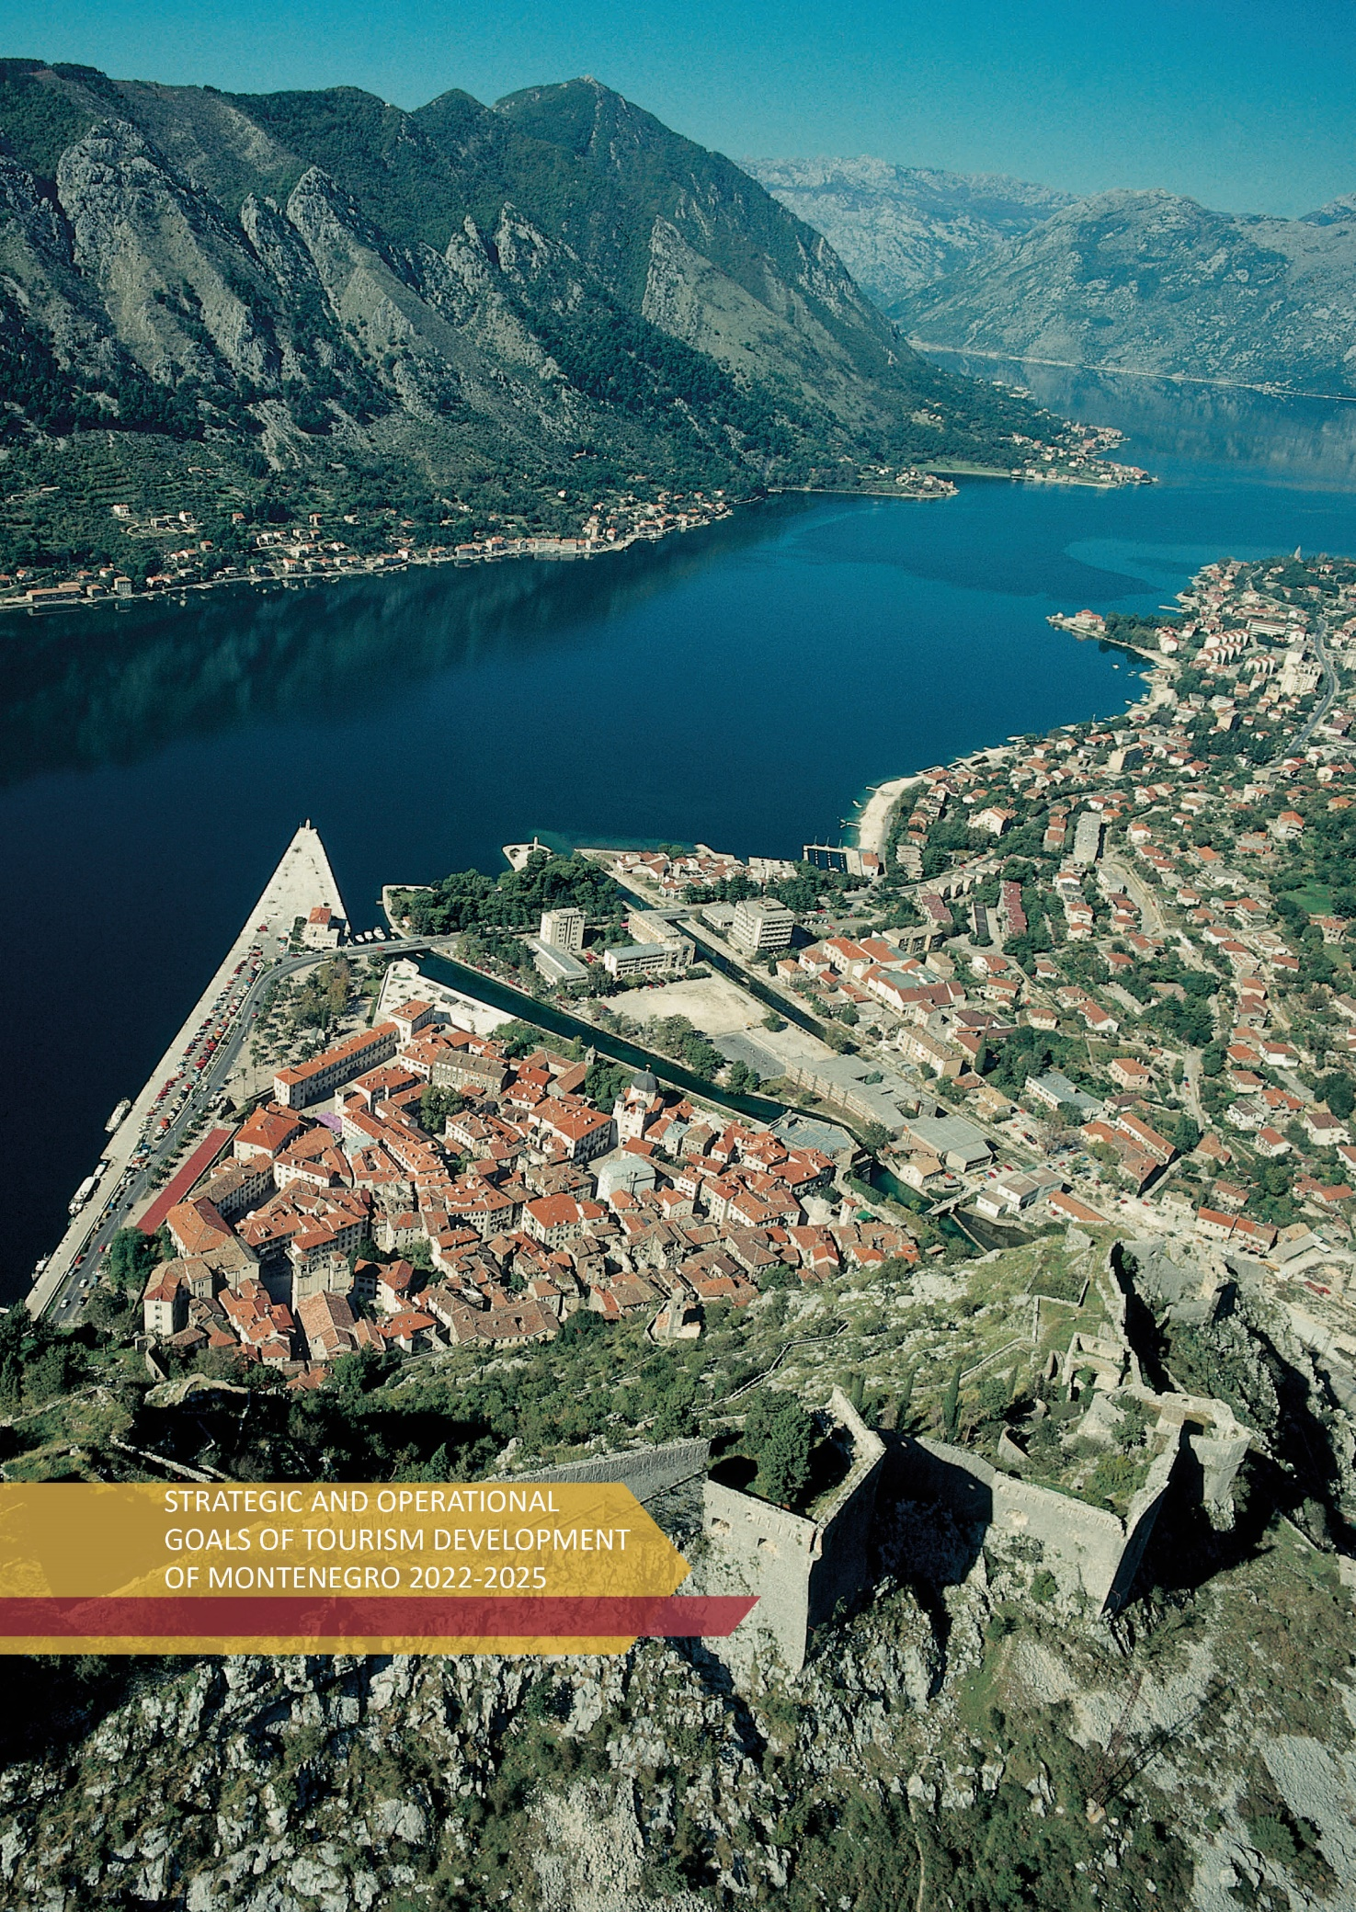

16. STRATEGIC AND OPERATIONAL GOALS OF TOURISM DEVELOPMENT OF MONTENEGRO 2022 - 2025
Starting from the identified challenges and main obstacles to tourism development identified in the Analysis of Key Problems, the Tourism Development Strategy 2022-2025 defines the following strategic and operational goals to be achieved, as well as the measures by which they will be achieved.

STRATEGIC GOAL

BY INVESTMENT AND FORMALIZATION OF TOURISM TURNOVER, MONTENEGRO IS AFFIRMED AS A GLOBALLY RECOGNIZED TOURIST DESTINATION WITH REDUCED SEASONALITY OF BUSINESS, MORE MODERATE REGIONAL DISBALANCE
AND PRIORITIZATION OF TOURISM IN DEVELOPMENT POLICIES.
Impact indicator | Initial value for 2019 | Target value for 2023 | Target value for 2025
Number of overnight stays | 14,5 mil. | Index 23/19 – 130 | Index 25/19 - 140
Revenues in tourism | 1,140 bil. € | Index 23/19 – 140 | Index 25/19 - 150
Tourism share in GDP | 31% | 20% | 25%
The strategic goal provides guidelines for future activities in the direction of ensuring full and quality valorization of all potentials in a dynamic and optimal way, in accordance with current market circumstances and respecting the principles of sustainability, which relate to operational goals, namely: improved regulatory framework in tourism with formalization of tourim turnover; improved tourist and accompanying infrastructure and suprastructure; improved quality and quantity of accommodation capacities; improved quality of diversified tourism product; improved human resources and skills in tourism; development of digital, innovative solutions and new technologies in tourism, and a globally recognized tourist destination:

Operational goal 1
Improved regulatory framework in tourism with formalization of tourism turnover

Performance indicator | Initial value for 2019 | Target value for 2023 |  |  | Target value for 2025
Performance indicator No. 1:
Number of harmonized laws / bylaws | 0 | +5 |  |  | + 2  (compared to 2023)
Performance indicator No. 2:
Increasing the number of tourist overnight stays in the Northern and Central region of Montenegro | 741.000  (number of overnight stays in the Northern and Central region of Montenegro in 2019) | Index 23/19 – 103 |  |  | Index 25/19 - 105
Operational goal 2
Improved tourist and accompanying infrastructure and suprastructure

Performance indicator | Initial value for 2021 | Target value for 2023. |  |  | Target value for 2025
Performance indicator No. 1:
Number of projects of tourist and accompanying infrastructure and supra structure | 0 | At least 15 project activities |  |  | At least 30 project activities
Operational goal 3
Improved quality and quantity of accommodation capacities
Performance indicator | Initial value for 2019 | Target value for 2023. |  | Target value for 2025
Performance indicator No. 1:
Number of beds in 4 and 5 * hotels and similar facilities | 24.598 | 34.700 |  | 40.200
Performance indicator No. 2:
Number of beds in 3 * hotels and similar facilities | 9.210 | 10.000 |  | 11.000
Operational goal 4
Improved quality of diversified tourism product

Performance indicator | Initial value for 2021 | Target value for 2023. |  | Target value for 2025
Performance indicator No. 1:
Number of new tourism products | 1 | + 2 |  | + 1  (compared to 2023)
Operational goal 5
Improved human resources, knowledge and skills in tourism

Performance indicator | Initial value for 2021 | Target value for 2023. |  | Target value for 2025
Performance indicator No. 1:
Number of trainings and additional trainings for staff in tourism | 0 | 10 |  | 15
Operational goal 6
Development of digital, innovative solutions and new technologies in tourism

Performance indicator | Initial value for 2021 | Target value for 2023. |  | Target value for 2025
Performance indicator No. 1:
Number of implemented innovative / digital projects | 0 | 3 |  | 5
Operational goal 7
Globally recognized tourist destination

Performance indicator | Initial value for 2019 |  | Target value for 2023. |  |  | Target value for 2025
Performance indicator No. 1:
Increasing the number of overnight stays of tourists from priority markets | Data for priority markets (to be defined) from official statistics for 2019 |  | + 3% |  |  | + 5%

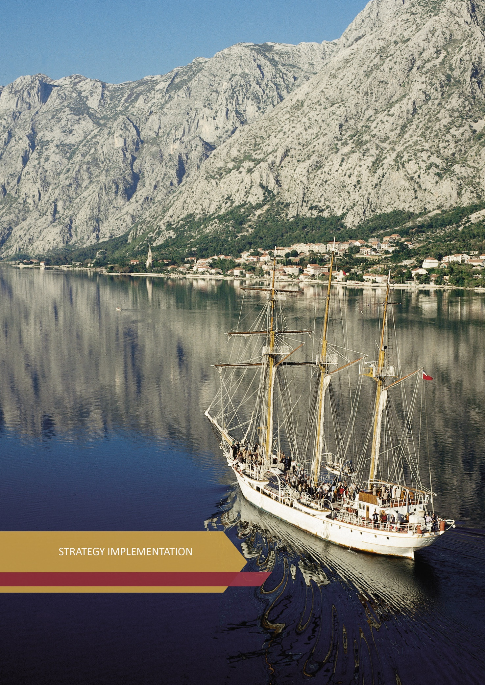

17. STRATEGY IMPLEMENTATION

17.1. Financial framework for the implementation of activities

Tourism Development Strategy of Montenegro 2022-2025 with the Action Plan, i.e. its individual activities, will be financed from the Budget of Montenegro, local government budgets, donor funds (EU funds, IPA funds, etc.) and other sources of funding.

Through the Action Plan for 2022, expenditures in the amount of € 27,047,673.65 are planned to achieve operational goals, of which 88.74% of funds (€ 24,002,583.65) relate to investment projects planned within the Capital Budget for 2022; 7.39% (€ 2,000,090.00) from the current budget for 2022 and 3.87% (€ 1,045,000.00) from donor sources (Interreg IPA CBC Italy-Albania-Montenegro, Interreg Med Program, as well as other potential donor sources). We note that for a certain number of activities the amount and source of funds is planned, while for the remaining part of the activities the financial framework will be defined in the process of reporting on the implementation of the Action Plan for 2022 and preparation of the Action Plan for the next period.

For the implementation of the Framework Plan for the period 2023-2025, according to currently available information, it is necessary to provide € 5,176,000.00 from the Budget of Montenegro, which means that the total funds required for the implementation of the Tourism Development Strategy of Montenegro 2022-2025, amount to € 32,223,673.65.

Structure of sources of funds | Amount (€)
Structure of sources of funds | 2022. | % | 2023-2025.
Budget of Montenegro (current) | 2.000.090,00 | 7,39 | 5.176.000,00
Budget of Montenegro (capital) | 24.002.583,65 | 88,74 | /
Donor funds | 1.045.000,00 | 3,87 | /
TOTAL | 27.047.673,65 | 100,00 | 5.176.000,00
TOTAL | 32.223.673,65
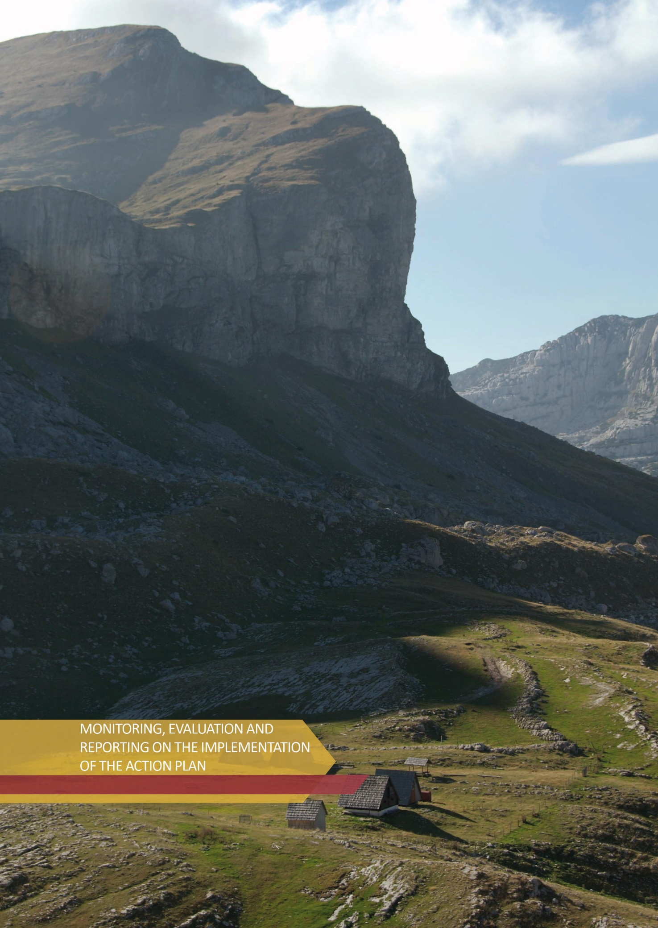

18. MONITORING, EVALUATION AND REPORTING ON THE IMPLEMENTATION OF THE ACTION PLAN
The Ministry of Economic Development is the umbrella institution responsible for creating and implementing the strategic document in question. The Action Plan for 2022 defines operational goals with measures and activities, holders and partners, deadlines, indicators on the basis of which the implementation will be monitored and the evaluation of the achieved results will be performed, as well as the amounts and sources of financial resources. Monitoring and evaluation of the implementation of the Action Plan will be performed by the Ministry of Economic Development as the ministry in charge of tourism, based on the annual report of the operational team and the ex post evaluation report of the external evaluator.
Implementation of the Tourism Development Strategy of Montenegro 2022-2025 with the Action Plan requires the involvement of a number of institutions. Accordingly, the relevant institutions that are the bearers of individual activities, as well as their partners, are obliged to provide information on the activities implemented under the Action Plan. This is necessary for the timely and adequate collection of data for the preparation of annual and final reports on implementation, as well as measuring the degree of performance, but also for identifying challenges that may arise during the implementation of planned activities.
In order for the process of monitoring the implementation of the Strategy to be carried out as well and efficiently as possible, the Ministry of Economic Development will form an operational team consisting of representatives of relevant institutions (holders and partners). The operational team will be chaired by a representative of the Ministry, and will meet at least twice a year. The work of the operational team will be specified in the work plan prepared by the Ministry.
The data necessary for compiling the report will be collected in the second half of the year (during the third quarter) by the operational team and will be submitted to the Ministry no later than the beginning of the fourth quarter, before compiling the annual or final report.
The Ministry of Economic Development will be in charge of compiling and processing the collected data relevant to the preparation of the report, as well as the coordination and work of the operational team. The Ministry will consolidate them and make a report. After agreeing with the operational team, the Ministry will send the report (annual/final) to the General Secretariat of the Government of Montenegro for an opinion, after which it will be forwarded to the Government of Montenegro for introduction and adoption.
In order to ensure transparency in the process of implementing the Strategy and informing the public, the reports will be published on the Ministry's website.
The evaluation of the strategic document in question will be conducted ex post (performed after the implementation of the strategic document) by an external evaluator due to the complexity and scope, but also to ensure a greater degree of objectivity in its development. Funds for the evaluation will be provided from the budget of the Ministry, and accordingly, for 2025, financial resources in the amount of € 5,000.00 will be planned.
The Ministry of Economic Development will review the Action Plan annually, if justified needs are indicated.
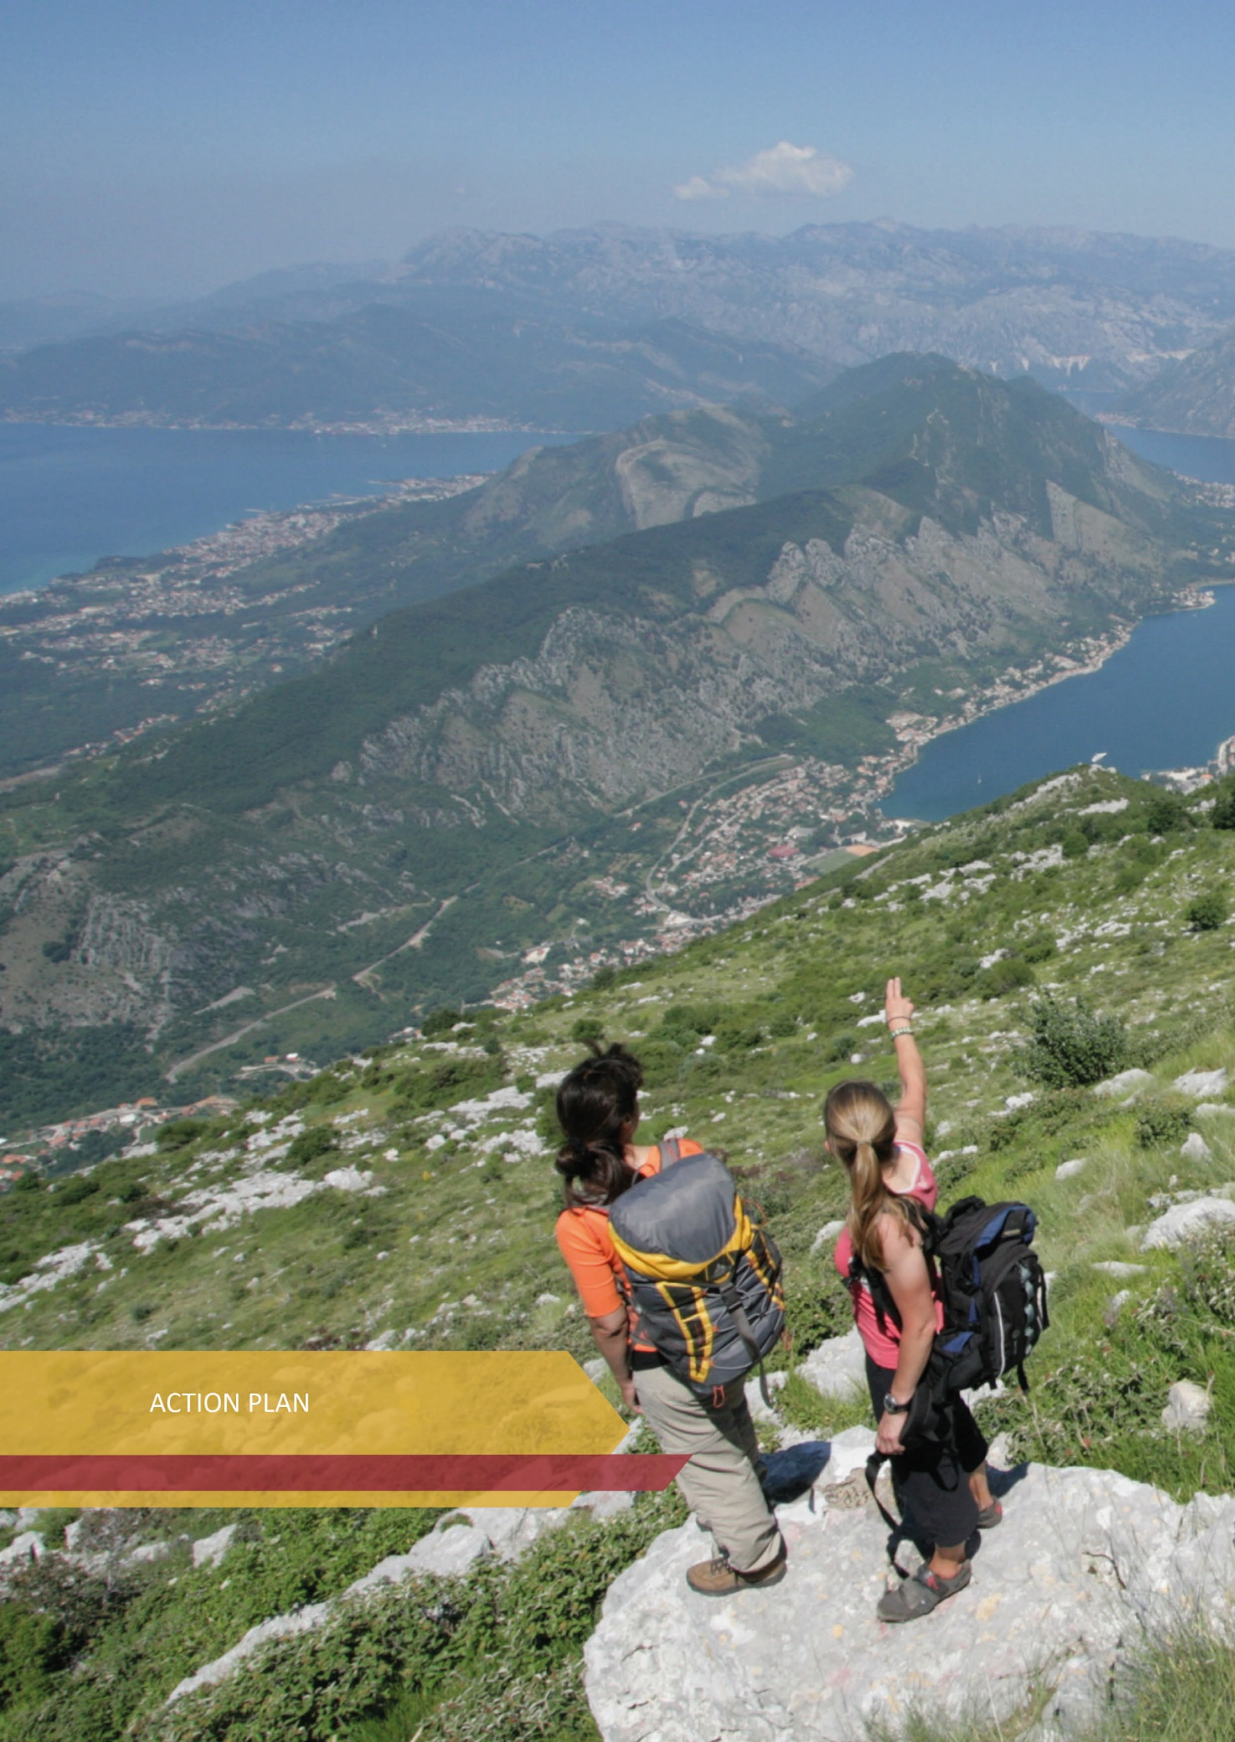

19. ACTION PLAN
The Action Plan is a set of operational goals with accompanying measures and activities, all of which are aimed at achieving the strategic goal of the destination. The Action Plan sets operational goals, measures and activities that result from the participation of a number of actors involved in the process of drafting the Montenegro Tourism Development Strategy 2022-2025 with the Action Plan for 2022, and in accordance with their competencies and interests shown to meet the goals of of this plan.
The envisaged measures will be implemented through the implementation of activities, which are defined as priorities. Activities are defined from a strategic (more comprehensive) level, both for the tourism sector and for other sectors that are directly or indirectly related to tourism, with a tendency to avoid "overlap" in terms of interdepartmental cooperation and taking into account "cross-cutting" documents. Implementation holders for activities related to tourism are line ministries, and the Ministry of Economic Development, which is in charge of tourism, will be a partner. Holders and partners, deadlines - time frame for implementation, indicators and sources of their verification, as well as amounts and sources of financial resources for their implementation have been defined for the activities determined by the Action Plan for 2022.

Bearing in mind that the tourism product is very complex and diverse, as well as the fact that economic activities will continue to take place in the uncertain circumstances imposed by the COVID-19 pandemic, it is considered expedient to define the development of individual tourism products, i.e. segments of the tourist offer, through special programs. The programs are, by their structure, much more specific and operational and provide an opportunity for an easier process of implementation and reporting on the level of implementation. Also, as such, they will enable a clearer overview of the state of special tourist forms, as well as provision of more precise inputs for activities in the coming period. We note that in accordance with the development needs, the Ministry of Economic Development will revise the Action Plan on an annual basis, if justified needs are indicated, which, among other things, includes planning new development programs, such as MICE tourism development programs, adventure tourism, etc.

In addition to the above, we emphasize the readiness of the Ministry of Economic Development to possibly adjust the Action Plan to the new circumstances, with special emphasis on strengthening public-private partnerships.

STRATEGIC GOAL
WITH INVESTMENTS AND FORMALIZATION OF TOURISM TURNOVER, MONTENEGRO IS AFFIRMED AS A GLOBALLY RECOGNIZED TOURIST DESTINATION WITH REDUCED SEASONALITY OF BUSINESS, MORE MODERATE REGIONAL IMBALANCE AND PRIORITIZATION OF TOURISM IN DEVELOPMENT POLICIES
Impact indicator |  |  | Initial value in 2019 |  | Target value in 2023 |  |  |  | Target value in 2025
Number of overnight stays |  |  | 14.5 million |  | Index 23/19 – 130 |  |  |  | Index 25/19 - 140
Revenues in tourism |  |  | € 1.140 billion |  | Index 23/19 – 140 |  |  |  | Index 25/19 – 150
Share of tourism in GDP |  |  | 31% |  | 20% |  |  |  | 25%
ACTION PLAN FOR 2022
Operational goal 1: Improved regulatory framework in tourism with formalization of tourism turnover
Impact indicator |  |  | Initial value for 2021 |  | Target value for 2023 |  |  |  | Target value for 2025
Impact indicator 1:
Number of harmonized laws / secondary legislation |  |  | 0 |  | + 5 |  |  |  | + 2  (compared to 2023)
Impact indicator 2:
Increasing the number of tourist overnight stays in the Northern and Central region of Montenegro |  |  | 741,000  (number of overnight stays in the Northern and Central region of Montenegro in 2019) |  | Index 23/19 – 103 |  |  |  | Index 25/19 – 105
Measure | Activity |  |  |  | Holder / partners |  | Deadline |  | Indicator / verification source |  | Funds (in €) / source
1.1 Advisory and regulatory framework | 1.1.1 | Implementation of activities on the establishment of the National Tourism Council |  |  | MED |  | I Q – IV Q 2022 |  | National Tourism Council has been established  Annual MED work reports |  | No financial resources are required
1.1 Advisory and regulatory framework | 1.1.2 | Drafting of the Law on Tourism and Hospitality |  |  | MED /  WG |  | I Q 2022 |  | Adaptation of the Law  Annual MED work reports |  | No financial resources are required
1.1 Advisory and regulatory framework | 1.1.3 | Drafting of the Law on Amendments to the Law on Tourist Organizations |  |  | MED /  NTO, WG |  | IV Q 2022 |  | Adaptation of the Law  Annual MED and NTO’s work reports |  | € 12,500.00  Budget of Montenegro
1.1 Advisory and regulatory framework | 1.1.4 | Drafting of the Law on Amendments to the Law on Tourist Tax |  |  | MED /  NTO, WG |  | IV Q 2022 |  | Adaptation of the Law  Annual MED and NTO’s work reports |  | € 12,500.00  Budget of Montenegro
- Health -  epidemiological environment | 1.2.1 |  | Development, introduction and application of health - sanitary - epidemiological protocol standards, conditions and measures within the provision of tourism and hospitality services (with monitoring of the application and measurement of the impact of the epidemic on tourism trends) |  | MOH, IPH /  MED, CEM, ISME tourism industry |  | I Q– IV Q 2022 |  | Number of adopted protocols / standards  Annual work report of competent institutions |  | No financial resources are required
1.3 Strengthening institutional capacities (Inspection Services and Statistical Office - MONSTAT) | 1.3.1 |  | Implementation of activities to increase the number of tourism and other inspectors who supervise the implementation of laws in the field of tourism |  | DIA /  MED |  | I Q– IV Q 2022 |  | Number of newly-employed inspectors  Annual work report of competent institutions |  | Budget of the competent institution
 | 1.3.2 |  | Carrying out activities on organizing education, training and equipping inspectors, as well as creating models for evaluation of their work |  | DIA /  MESCS |  | I Q – IV Q 2022 |  | Number of workshops / trainings  Annual work report of competent institutions |  | Budget of the competent institution
 | 1.3.3 |  | Implementation of activities on coordination of the work of the tourism inspection and other inspection services |  | DIA |  | I Q – IV Q 2022 |  | Number of jointly conducted inspection activities  Annual DIA work reports |  | Budget of the competent institution
 | 1.3.4 |  | Implementation of measures and activities to increase the number of employees and their education in the Statistical Office - MONSTAT in the sector in charge of collecting and processing data in the field of tourism |  | MONSTAT /  MED, support from experts |  | I Q- IV Q 2022 |  | Number of newly-employed  Number of trainings, seminars, etc.  Annual work report of competent institutions |  | Budget of the competent institution
 | 1.3.5 |  | Establishment of a Working Group for the implementation of activities on the preparation of a plan for the organization of education, apprenticeship, training of employees in local tourism organizations in the part related to the collection of data on tourism turnover |  | MED /  LTO  Local self-governments, MONSTAT |  | I Q- IV Q 2022 |  | Working Group has been formed and Plan has been adopted  Annual work report of competent institutions and organizations |  | No financial resources are required
Total amount of funds for implementation of  Operational goal 1: € 25,000.00 |  |  |  | Budget of Montenegro (current): € 25,000.00
Operational goal 2: Improved tourism and supporting infrastructure and suprastructure
Impact indicator |  |  | Initial value for 2021 |  | Target value for 2023 |  |  |  | Target value for 2025
Impact indicator 1:
Number of tourism and supporting infrastructure and suprastructure projects |  |  | 0 |  | Minimum 15 project activities |  |  |  | Minimum 30 project activities
Measure | Activity |  |  |  | Holder / partners |  |  | Deadline | Indicator / verification source | Funds (in €) / source
2.1 Tourism infrastructure and suprastructure | 2.1.1 |  | Continuation of the construction of the “Kolašin 1600” ski center in Kolašin |  | MED / Public Works Administration / LLC Ski Resorts of Montenegro |  |  | I Q – IV Q 2022  A multi-year project whose implementation continues after 2022 and will be the subject of the next AP Strategy | Number of activities that were implemented in the direction of improving the infrastructure within the Kolašin 1600 ski center  Annual work reports of MED , Public Works Administration and LLC Ski Resorts of Montenegro | Capital budget for 2022:  3,014,283.65
2.1 Tourism infrastructure and suprastructure | 2.1.2 |  | Continuation of activities on the construction of the “Žarski” ski center in Mojkovac |  | MED / Public Works Administration / LLC Ski Resorts of Montenegro |  |  | I Q – IV Q 2022  A multi-year project whose implementation continues after 2022 and will be the subject of the next AP Strategy | Number of activities that were implemented in the direction of putting into operation the “Žarski” ski center  Annual work reports of MED , Public Works Administration and LLC Ski Resorts of Montenegro | Capital budget for 2022:  3,000,400.00
2.1 Tourism infrastructure and suprastructure | 2.1.3 |  | Continuation of activities on the construction of the “Cmiljača” ski center in Bijelo Polje |  | MED / Public Works Administration / LLC Ski Resorts of Montenegro |  |  | I Q – IV Q 2022  A multi-year project whose implementation continues after 2022 and will be the subject of the next AP Strategy | Number of activities that were implemented in the direction of putting into operation the “Cmiljača” ski center  Annual work reports of MED , Public Works Administration and LLC Ski Resorts of Montenegro | Capital budget for 2022:  3,100,600.00
2.1 Tourism infrastructure and suprastructure | 2.1.4 |  | Continuation of activities on the construction of the “Savin kuk” ski resort in Žabljak |  | MED / Public Works Administration / LLC Ski Resorts of Montenegro |  |  | I Q – IV Q 2022  A multi-year project whose implementation continues after 2022 and will be the subject of the next AP Strategy | Number of activities that were implemented in the direction of putting the “Hajla – Štedim” ski center into function  Annual work reports of MED , Public Works Administration and LLC Ski Resorts of Montenegro | Capital budget for 2022:  2,200,500.00
2.1 Tourism infrastructure and suprastructure | 2.1.5 |  | Continuation of activities on the construction of the “Savin kuk” ski resort in Žabljak |  | MED / Public Works Administration |  |  | I Q – IV Q 2022  A multi-year project whose implementation continues after 2022 and will be the subject of the next AP Strategy | Number of activities implemented in the direction of improving the infrastructure within the “Savin kuk” ski resort  Annual work reports of MED and Public Works Administration | Capital budget for 2022:  1,635,400.00
2.1 Tourism infrastructure and suprastructure | 2.1.6 |  | Construction of a garage for the needs of the “Kolašin 1600” ski center, Kolašin |  | MED / Public Works Administration / LLC Ski Resorts of Montenegro |  |  | I Q – IV Q 2022 | Garage was built within the “Kolašin 1600” ski center  Annual work report of  MED, Public Works Administration and LLC Ski Resorts of Montenegro | Capital budget for 2022:  1,175,300.00
2.1 Tourism infrastructure and suprastructure | 2.1.7 |  | Construction of hydro-technical infrastructure for the needs of the “Kolašin 1600” Ski Center |  | MED / Public Works Administration / LLC Ski Resorts of Montenegro |  |  | I Q – IV Q 2022  A multi-year project whose implementation continues after 2022 and will be the subject of the next AP Strategy | Number of activities have been implemented in the direction of providing hydro-technical infrastructure  Annual work report of  MED, Public Works Administration and LLC Ski Resorts of Montenegro | Capital budget for 2022:  950,200.00
2.1 Tourism infrastructure and suprastructure | 2.1.8 |  | Construction of infrastructure for the needs of connecting the “Cmiljača” and “Žarski” ski centers |  | MED / Public Works Administration / LLC Ski Resorts of Montenegro |  |  | I Q – IV Q 2022  A multi-year project whose implementation continues after 2022 and will be the subject of the next AP Strategy | Number of activities that were implemented in the direction of connecting the “Cmiljača” and “Žarski” ski centers  Annual work report of  MED and Public Works Administration | Capital budget for 2022:  50,200.00
2.1 Tourism infrastructure and suprastructure | 2.1.9 |  | Reconstruction of the existing cable car / construction of a new cable car along the existing route at the “Savin kuk” ski resort in Žabljak |  | MED / Public Works Administration, LLC Ski Resorts of Montenegro |  |  | I Q – IV Q 2022  A multi-year project whose implementation continues after 2022 and will be the subject of the next AP Strategy | Number of activities that were implemented in the direction of reconstruction of the existing and construction of the new cable car in “Savin kuk”  Annual work report of MED and Public Works Administration | Capital budget for 2022:  900,100.00
2.1 Tourism infrastructure and suprastructure | 2.1.10 |  | Construction of ski slopes within the “Savin kuk” ski resort |  | MED / Public Works Administration, LLC Ski Resorts of Montenegro |  |  | I Q – IV Q 2022  A multi-year project whose implementation continues after 2022 and will be the subject of the next AP Strategy | Number of activities that were implemented in the direction of construction of ski slopes within the “Savin kuk” ski resort  Annual work report of MED and Public Works Administration | Capital budget for 2022:  300,100.00
2.1 Tourism infrastructure and suprastructure | 2.1.11 |  | Construction of assembly/disassembly bobsleigh on rails at the “Kolašin 1600” ski center |  | MED / Public Works Administration / LLC Ski Resorts of Montenegro |  |  | I Q – IV Q 2022  A multi-year project whose implementation continues after 2022 and will be the subject of the next AP Strategy | Number of activities that were implemented in the direction of construction of assembly/disassembly bobsleigh within the “Savin kuk” ski resort  Annual work report of  MED, Public Works Administration and LLC Ski Resorts of Montenegro | Capital budget for 2022:  510,000.00
2.1 Tourism infrastructure and suprastructure | 2.1.12 |  | Continuation of construction on the speleological object of Đalovića cave |  | MED / Public Works Administration |  |  | I Q – IV Q 2022  A multi-year project whose implementation continues after 2022 and will be the subject of the next AP Strategy | Number of activities that were implemented in the direction of putting into operation the speleological object “Đalovića cave”  Annual work report of  MED, Public Works Administration and LLC Ski Resorts of Montenegro | Capital budget for 2022:  3,010,500.00
2.1 Tourism infrastructure and suprastructure | 2.1.13 |  | Construction of the missing infrastructure for the needs of the project for the construction of the panoramic cable car Kotor – Lovćen |  | Investment Agency / MED / Concessionaire |  |  | I Q – IV Q 2022  A multi-year project whose implementation continues after 2022 and will be the subject of the next AP Strategy | Number of activities that were implemented in the direction of putting the panoramic cable car into operation  Annual work report of  competent institutions | Capital budget:  4,155,000.00  Investor
2.1 Tourism infrastructure and suprastructure | 2.1.14 |  | Implementation of measures and activities to improve the quality of infrastructure in the Coastal Zone |  | MESPU,  PECZM /  MED |  |  | I Q – IV Q 2022  The implementation of activities continues after 2022 and will be the subject of the next AP Strategy | Number of new nautical anchorage zones  Number of new anchorages  Number of coastal infrastructure development projects  Annual work report of competent institutions | Budget of PE for Coastal Zone
2.1 Tourism infrastructure and suprastructure | 2.1.15 |  | Implementation of measures and activities on maintenance of existing and installation of new tourist signs along main and regional roads |  | MED/  Local governments, Directorate for Transport,  PENPM |  |  | I Q – IV Q 2022  The implementation of activities continues after 2022 and will be the subject of the next AP Strategy | Number of existing (repaired) and new tourist signs  Contractor's report  Annual work report of competent institutions | € 40,000.00  Budget of Montenegro
2.1 Tourism infrastructure and suprastructure | 2.1.16 |  | Implementation of measures and activities to maintain and improve the quality of rest areas and lookouts along roads |  | Local governments |  |  | I Q – IV Q 2022  The implementation of activities continues after 2022 and will be the subject of the next AP Strategy | Number of existing maintained and new rest areas and lookouts along the roads  Annual work report of local government | Budget of local government
2.1 Tourism infrastructure and suprastructure | 2.1.17 |  | Implementation of measures and activities on arranging and mapping mountain trails within the National Mountain Trail Networks |  | MED/  Mountaineering Association of Montenegro, mountaineering clubs, LTO |  |  | I Q – IV Q 2022 | Number of marked hiking trails  Annual work report of competent institutions and organizations | € 50,000.00  Budget of Montenegro
2.1 Tourism infrastructure and suprastructure | 2.1.18 |  | Implementation of the Schengen Action Plan  - Update Analysis of mountain tourism transport with neighboring countries |  | MED, MoI /  Mountaineering Association of Montenegro, LTO, mountaineering clubs |  |  | I Q –IV Q 2022 | Analysis has been updated  Annual work report of competent institutions and organizations | € 20,000.00  Budget of Montenegro
2.1 Tourism infrastructure and suprastructure | 2.1.19 |  | Implementation of the project “Valorization of new and insufficiently used tourist attractions” |  | MED / LTO, local government |  |  | I Q - IV Q 2022 | Number of tourism valorized attractions  Annual work report of MED | € 50,000.00  Budget of Montenegro
2.2 Transport infrastructure planned through “cross cutting” documents | 2.2.1 |  | Implementation of measures and activities to maintain and improve the quality and capacity of airports in Montenegro |  | MCI /  JSC Airports of Montenegro |  |  | I Q – IV Q 2022  The implementation of activities continues after 2022 and will be the subject of the next AP Strategy | Number of projects / activities implemented in order to maintain / improve the quality and capacity of airports in Montenegro  Annual work report of MCI / JSC Airports of Montenegro | Budget of competent institutions
 | 2.2.2 |  | Implementation of measures and activities to improve the air transport accessibility of Montenegro |  | MCI /  Airports of Montenegro |  |  | I Q – IV Q 2022  The implementation of activities continues after 2022 and will be the subject of the next AP Strategy | Number of new direct airlines, frequency of flights  Annual work report of MCI / JSC Airports of Montenegro / ToMontenegro | No financial resources are required
 | 2.2.3 |  | Implementation of measures and activities on maintenance of existing and construction of new infrastructure in road transport |  | MCI /  Directorate for Transport , local governments |  |  | I Q – IV Q 2022  The implementation of activities continues after 2022 and will be the subject of the next AP Strategy | Number of roads that have been improved / built  Annual report on the work of competent institutions | Budget of the competent institution
 | 2.2.4 |  | Implementation of measures and activities to improve the quality and capacity of border crossings |  | MoI /  MCI |  |  | I Q – IV Q 2022  The implementation of activities continues after 2022 and will be the subject of the next AP Strategy | Number of border crossings with improved quality and / or capacity | Budget of the competent institution
 | 2.2.5 |  | Implementation of measures and activities on maintenance and improvement of railway infrastructure |  | MCI /  RIM |  |  | I Q – IV Q 2022  The implementation of activities continues after 2022 and will be the subject of the next AP Strategy | Number of implemented activities on maintenance and improvement of railway infrastructure  Annual work report of competent institutions | Budget of the competent institution
 | 2.2.6 |  | Establishment of local marine transport as an integral part of local transport (emphasis on the Bay of Kotor), in order to combat bottlenecks in road transport.  - Defining waterways for local maritime transport within the Bay of Kotor with berths for ships (water buses) and access parking lots. |  | MCI, Administration for Maritime Safety and Port Management, local governments /  MED, PECZM |  |  | I Q – IV Q 2022  The implementation of activities continues after 2022 and will be the subject of the next AP Strategy | Number of established local marine transport lines  Annual work report of competent institutions | Budget of the competent institutions
2.3 Community  infrastructure planned through cross-cutting documents | 2.3.1 |  | Implementation of measures and activities for maintenance and improvement of water supply |  | MAFWM / local government |  |  | I Q – IV Q 2022  The implementation of activities continues after 2022 and will be the subject of the next AP Strategy | Number of projects / activities to improve water supply  Annual work report of competent institutions | Budget of the competent institutions
 | 2.3.2 |  | Implementation of measures and activities of national waste management plans |  | MESPU / local governments |  |  | I Q – IV Q 2022  The implementation of activities continues after 2022 and will be the subject of the next AP Strategy | Number of implemented project activities to improve waste management  Annual work report of competent institutions | Budget of the competent institutions
 | 2.3.3 |  | Solving the problem of insufficient number of parking spaces in tourist places |  | local government |  |  | I Q – IV Q 2022  A multi-year project whose implementation continues after 2022 and will be the subject of the next AP Strategy | Number of new parking spaces by municipalities  Annual work report of local governments | Local government budget
 | 2.3.4 |  | Implementation of the “Clean and green step” project - Reduction of illegal landfills in attractive tourist locations |  | MED /  local government, NTO, private sector |  |  | I Q– IV Q 2022 | Number of tourist sites from which illegal waste has been removed  Annual work report of competent institutions | € 100,000.00  Budget of Montenegro
2.4 Energy infrastructure planned through "cross cutting" documents | 2.4.1 |  | Implementation of activities to improve electricity supply |  | MCI / CGES |  |  | I Q – IV Q 2022  A multi-year project whose implementation continues after 2022 and will be the subject of the next AP Strategy | Number of implemented project activities to improve electricity supply  Annual work report of competent institutions | Budget of competent institutions
 | 2.4.2 |  | Implementation of activities to improve the electricity distribution network |  | MCI / CEDIS |  |  | I Q – IV Q 2022  A multi-year project whose implementation continues after 2022 and will be the subject of the next AP Strategy | Number of implemented project activities to improve the electricity distribution network  Annual work report of competent institutions | Budget of competent institutions
Total amount of funds for the implementation of the Operational goal 2: € 24,262,583.65 |  |  |  | Budget of Montenegro (capital): € 24,002,583.65
 |  |  |  | Budget of Montenegro (current): € 260,000.00
Operational goal 3: Improved quality and quantity of accommodation capacities

Impact indicator |  |  | Initial value for 2019 |  | Target value for 2023 |  |  |  | Target value for 2025
Impact indicator 1:
Number of beds in 4 and 5* hotels and similar facilities |  |  | 24,598 |  | 34,700 |  |  |  | 40,200
Impact indicator 2:
Number of beds in 3* hotels and similar facilities |  |  | 9,210 |  | 10,000 |  |  |  | 11,000
Measure | Activity |  |  |  | Holder / partners |  |  | Deadline | Indicator / verification source | Funds (in €) / source
3.1 Hotels and similar accommodation  – Increasing the share of hotel capacities in total capacities for accommodation | 3.1.1 |  | Conducting monitoring of the implementation of contractual obligations for hotels from priority tourism projects |  | MED |  |  | I Q – IV Q 2022  A multi-year project whose implementation continues after 2022 and will be the subject of the next AP Strategy | Report has been prepared  Annual work report of MED | Budget of Montenegro for 2022 (€ 144,890 - Consulting services in the field of monitoring investment projects)
 | 3.1.2 |  | Conducting monitoring of the implementation of contractual obligations for hotels from the Economic Citizenship project |  | MED |  |  | I Q – IV Q 2022  A multi-year project whose implementation continues after 2022 and will be the subject of the next AP Strategy | Report has been prepared  Annual work report of MED | No financial resources are required
 | 3.1.3 |  | Conducting monitoring of the implementation of contractual obligations for hotels that were privatized in the previous period |  | MED |  |  | I Q – IV Q 2022  A multi-year project whose implementation continues after 2022 and will be the subject of the next AP Strategy | Report has been prepared  Annual work report of MED | Budget of Montenegro for 2022 (€ 35,000.00 - Consulting services in the field of monitoring investment projects)
 | 3.1.4 |  | Defining project activities within the Program for Improving the Competitiveness of the economy in 2022:  Incentive measures for the development of green / eco types of hospitality facilities for accommodation - stimulating decarbonization and introduction of new environmentally friendly technologies (green transition / circular economy) in hospitality facilities, as well as for the development of types of hospitality facilities with new innovative technological offers S3 strategy: Sustainable and health tourism) |  | MED /  Donors, IDF, commercial banks |  |  | I Q– IV Q 2022 | Program has been adopted and number of projects have been supported through incentive measures  Annual work report of MED | € 1,000,000.00  Budget of Montenegro / Donor / EU funds / Credit funds IDF, commercial banks)
 | 3.1.5 |  | Preparation of an analysis of the existing regulatory framework in the tourism industry with a proposal of measures to improve the business environment for investment in tourism and hospitality |  | MED |  |  | I Q - IV Q 2022 | Analysis has been conducted  Annual work report of MED | € 70,000.00  Budget of Montenegro
 | 3.1.6 |  | Development and selection of bidders for printing brochures on incentive measures available through various support programs for domestic and foreign investors |  | MED /  Montenegrin Investments Agency |  |  | I Q -IV Q 2022 | Number of printed brochures for potential investors  Annual work report of competent institutions | € 10,000.00  Budget of Montenegro
 | 3.1.7 |  | Implementation of international and domestic investment promotional activities, study trips and professional trainings |  | MED |  |  | I Q - IV Q 2022 | Implementation of promotional activities, number of study trips and professional trainings  Annual work report of MED | 150.000,00€  Budget of Montenegro
3.2 Raising the level of security in tourism | 3.2.1 |  | Implementation of the project of “Safety in tourism - Be safe”- Introduction of a national certificate for tourism and hospitality companies in order to strengthen the destination brand |  | MED /  ISME, CEM,  tourism industry, business and tourism associations |  |  | II Q – IV Q 2022 | Standard has been made  Annual work report of competent institutions | € 50,000.00  Budget of Montenegro
Total amount of funds for implementation of  Operational goal 3: € 1,459,890.00 |  |  |  | Budget of Montenegro (current): € 459,890.00
 |  |  |  | Donor / EU / Credit funds (IDF, commercial banks): € 1,000,000.00
Operational goal 4: Improved quality of diversified tourism product

Impact indicator |  |  | Initial value for 2021 |  | Target value for 2023 |  |  |  | Target value for 2025
Impact indicator 1:
Number of new tourism products |  |  | 1 |  | + 2 |  |  |  | + 1  (in comparison to 2023)
Measure | Activity |  |  |  | Holder / partners |  |  | Deadline | Indicator / verification source | Funds (in €) / source
4.1 Improving the quality of the offer | 4.1.1 |  | Implementation of incentive measures in the field of tourism - Strengthening the tourism market  (Public call for co-financing of projects in the field of event tourism, cultural, camping and other types of tourism) |  | MED |  |  | I Q – IV Q 2022 | Number of projects supported through public calls  Annual report of MED | € 500,000.00  Budget of Montenegro
4.2 Diversification of the tourism product | 4.2.1 |  | Preparation of the Nautical Tourism Development Program of Montenegro 2023-2025 with the Action Plan |  | MED  / MCI, tourism industry, local governments, NTO |  |  | I Q – IV Q 2022 | Program has been adopted  Annual work report of competent institutions | € 80,000.00  Budget of Montenegro
4.2 Diversification of the tourism product | 4.2.2 |  | Preparation of the Health Tourism Development Program of Montenegro 2023-2025 with the Action Plan |  | MED /  MESCS, CEM,  tourism industry, local governments, NTO |  |  | I Q – IV Q 2022 | Program has been adopted  Annual work report of competent institutions | € 40,000.00  Budget of Montenegro
4.2 Diversification of the tourism product | 4.2.3 |  | Participation in specialized international fairs and conferences and presentation of the offer of health tourism in Montenegro |  | MED, MoH /  Health tourism cluster, private sector, NTO, LTO, CEM, MESCS, FTH-UCG |  |  | I Q – IV Q 2022 | Number of fairs and conferences have been attended and number of presentations have been held | € 15,000.00  Budget of Montenegro
4.2 Diversification of the tourism product | 4.2.4 |  | Organizing conferences, fairs and educational seminars in Montenegro on the topic of health tourism, as well as affirmation and strengthening of health tourism associations |  | MED, MOH,  Health tourism cluster / MESCS, FTH-UCG, MF, “Dr S. Milošević” Institute, CEM |  |  | I Q – IV Q 2022 | Number of organizational conferences, fairs and seminars of health tourism | € 15,000.00  Budget of Montenegro
4.2 Diversification of the tourism product | 4.2.5 |  | Adoption of business model proposals for the introduction of smart tourism (guidelines and recommendations for the adoption of strategic policies) |  | MED /  International partners |  |  | I Q – IV Q 2022 | Smart Tourism Business Model (Smartmed Project) has been adopted  Annual work report of MED | € 15,000.00  Donor funds  (Project Smartmed Interreg Med Program)
Total amount of funds for implementation of  Operational goal 4: € 665,000.00 |  |  |  | Budget of Montenegro (current): € 650,000.00
 |  |  |  | Donor funds: € 15,000.00
Operational goal 5: Improved human resources, knowledge and skills in tourism

Impact indicator |  |  | Initial value for 2021 |  | Target value for 2023 |  |  |  | Target value for 2025
Impact indicator 1:
Number of trainings and additional trainings for staff in tourism |  |  | 0 |  | 10 |  |  |  | 15
Measure |  |  | Activity |  | Holder / partners |  |  | Deadline | Indicator / verification source | Funds (in €) / source
5.1 Development of a program for lifelong education of staff in tourism | 5.1.1 |  | Establishment of a Working Group for the preparation of a Plan for the improvement of educational programs with the aim of increasing the competitiveness of competencies and skills of staff in tourism / Dual education (based on best practices) as well as for further training of unemployed people in tourism |  | MED / MESCS , CSO, Faculties of Tourism, CEM, tourism industry |  |  | I Q – IV Q 2022 | Working group has been established  Plan has been adopted  Annual work report of competent institutions | No financial resources are required
 | 5.1.2 |  | Establishment of a Working Group for the preparation of a Plan for the improvement of the system of employment of students and young people in tourism, with the aim of meeting the needs of the tourism industry for highly educated staff |  | MESCS, EAM / MED, CEM |  |  | I Q – IV Q 2022 | Working group has been established  Plan has been adopted  Annual work report of competent institutions | Budget of the competent institutions
 | 5.1.3 |  | Participation in the Youth Forum – “Connecting youth with the tourism sector” with the aim of promoting the national Student League UNWTO 2022 (Sorrento, Italy, June 27 – July 3, 2022) |  | MESCS, MED /  UNWTO |  |  | I Q - III Q 2022 | Participation in the Forum  Annual work report of MED | Donor funds – UNWTO
 | 5.1.4 |  | Preparation of a guide for more efficient use of available EU funds in the field of tourism |  | European Integration Office |  |  | I Q – II Q 2022 | A guide for users of EU funds from the tourism industry and LTO have been developed  Annual work report of competent institutions | Budget of the competent institution
5.2 Improving the knowledge and skills of employees in tourism | 5.2.1 |  | Preparation of a plan for organizing trainings / courses for LTO employees |  | MED, LTO  /  Human Resources Department |  |  | I Q - IV Q 2022 | Plan has been adopted  Annual work report of competent institutions | No financial resources are required
 | 5.2.2 |  | Preparation of a plan for organizing educational seminars for the tourism industry |  | MED, MESCS / CSO, EAM, Faculties of Tourism, CEM |  |  | I Q - IV Q 2022 | Plan has been adopted  Annual work report of competent institutions | No financial resources are required
 | 5.2.3 |  | Establishment of a working group for the preparation of a plan for organizing seminars with the aim of improving the knowledge of tourist guides (special emphasis on non-valorized segments of cultural heritage, as well as cultural and natural assets on the UNESCO World Heritage List) |  | MESCS, experts in the field of cultural heritage, CSO Faculties of Tourism / MED, CEM |  |  | I Q – IV Q 2022 | Working group has been established  Plan has been adopted  Annual work report of competent institutions | No financial resources are required
 | 5.2.4. |  | Establishment of a working group for the preparation of a plan for organizing staff training in order to obtain licenses for mountain guides, canyoning guides, speleological guides, etc. |  | MESCS, CSO Faculty of Tourism / MED , CEM |  |  | I Q - IV Q 2022 | Plan has been adopted  Annual work report of competent institutions | No financial resources are required
 | 5.2.5 |  | Organizing training of staff in tourism in cooperation with the UNWTO |  | MED /  UNWTO |  |  | II Q -IV Q 2022  The implementation of activities will continue after 2022, if necessary | Number of completed trainings / certified participants  Annual work report of MED | No financial resources are required
 | 5.2.6 |  | Organizing training of staff in tourism in cooperation with other international and national tourism partners |  | MED /  international tourism organizations |  |  | II Q – IV Q 2022  The implementation of activities will continue after 2022, if necessary | Number of completed trainings / certified participants  Annual work report of MED | No financial resources are required
5.3 Training and certification – GSTC Global Sustainable Tourism Training Program (STTP) | 5.3.1 |  | Organizing workshops - education, certification and continuous international networking in sustainable destination management |  | NTO MNE /  MED, GSTC, Green Destinations |  |  | II Q - IV Q 2022 | 4 certified representatives  Annual work report of MED and NTO | 2,100.00  (400,00 one workshop and  1,700.00  for 4 certifications)  Budget of Montenegro
 | 5.3.2 |  | Implementation of activities on joining the relevant Ministry of Tourism in the GSTC |  | MED /  GSTC |  |  | II Q 2022 | Membership in the GSTC  Annual work report of MED | Membership fee in the amount of 3,100.00 (annually)  Budget of Montenegro
Total amount of funds for the implementation of the Operational goal 5: € 5,200.00 |  |  |  | Budget of Montenegro (current): € 5,200.00
Operational goal 6: Development of digital, innovative solutions and new technologies in tourism

Impact indicator |  |  | Initial value for 2021 |  | Target value for 2023 |  |  |  | Target value for 2025
Impact indicator 1:
Number of implemented innovative / digital projects |  |  | 0 |  | 3 |  |  |  | 5
Measure | Activity |  |  |  | Holder / Partners |  |  | Deadline | Indicator / verification source | Funds (in €) / source
- Digital business transformation  in tourism | 6.1.1 | Development of an integrated information system with a mobile application that will connect all the necessary institutions and organizations whose data will contribute to the quality and accurate calculation of tourism turnover |  |  | MED / MUP  MFSW, MPADSM, MONSTAT, Directorate for Inspection Affairs, Revenue and Customs Administration, NTO |  |  | I Q - IV Q 2022 | Information system has been developed  Annual work report of competent institutions | € 400,000.00  Budget of Montenegro
- Digital business transformation  in tourism | 6.1.2 | Implementation of the Go Digital Montenegro project - Digitization in tourism |  |  | MED /  MPADSM |  |  | I Q – IV Q 2022 | Digital platform has been created  Annual work report of MED and MPADSM | € 200,000.00  Budget of Montenegro
- Digital business transformation  in tourism | 6.1.3 | Development of software solutions for the purpose of promotion and analysis for policy making in the field of tourism |  |  | MED /  International partners |  |  | I Q - IV Q 2022 | Digital platform has been created (Due Mari project)  Annual work report of MED | € 30,000.00  Donor funding (IPA CBC Interreg Program Italy, Albania, Montenegro)
Total amount of funds for the implementation of the Operational goal 6: € 630,000.00 |  |  |  | Budget of Montenegro (current): € 600,000.00
 |  |  |  | Donor / Credit funds (IDF, commercial banks): € 30,000.00
Operational goal 7: Globally recognized tourist destination

Impact indicator |  |  | Initial value for 2019 |  |  | Target value for 2023 |  |  | Target value for 2025
Impact indicator 1:
Increasing the number of tourist overnight stays from priority markets |  |  | Data for priority markets (to be defined) from official statistics for 2019 |  |  | + 3% |  |  | + 5%
Measure | Activity |  |  |  |  | Holder / partners |  | Deadline | Indicator / verification source | Funds (in €) / source
7.1 Improving the positioning of the destination on the international market | 7.1.1 |  | Improving destination management and establishing an inter-ministerial working group |  |  | MED, NTO/  Inter-ministerial WG, LTO, private sector |  | I Q - IV Q 2022 | Inter-ministerial working group has been established  Annual work report of competent institutions | No financial resources are required
 | 7.1.2 |  | Defining priority markets, preparing and implementing promotion programs |  |  | NTO  / private sector, LTO |  | I Q – IV Q 2022 | Program for different markets has been adopted and implemented  Annual work report of NTO | Budget of the competent institution
 | 7.1.3 |  | Establishing a new destination management model (Destination Management) |  |  | NTO  MED /  LTO, local government, tourism industry |  | I Q - IV Q 2022  A multi-year project whose implementation continues after 2022 and will be the subject of the next AP Strategy | Destination management model has been established  Annual work report of NTO | No financial resources are required
 | 7.1.4 |  | Defining a new framework for destination management partnerships  - Networking (creating partnerships) at national and local level |  |  | NTO, LTO, local government /  MED, tourism industry |  | I Q - IV Q 2022 | A new framework for destination management partnerships has been defined  5 Acts on cooperation  Annual work report of NTO | No financial resources are required
 | 7.1.5 |  | Development of a program of research in tourism and their implementation |  |  | NTO |  | I Q - IV Q 2022  A multi-year project whose implementation continues after 2022 and will be the subject of the next AP Strategy | Number of research  Annual work report of NTO | NTO Budget
Total amount of funds for the implementation of the Operational goal 7: € 0.00

The previous presentation of the Action Plan for 2022 provides a detailed description of activities, amounts and sources of funds for their implementation. Please note that a number of activities, as indicated in the implementation deadlines, will be the subject of Action Plans for the next years of implementation of the Strategy, because these are continuous or multi-year projects.
In addition to the above, in order to implement the Strategy, in the period 2023-2025, the following is the Framework Plan of Activities with an estimate of the financial resources needed for their implementation, based on the information currently available:

Framework plan - activities with estimated financial resources for the period 2023-2025 of implementation of the Strategy
Operational goal | Indicative overview of activities by operational goal | Holder / partners | Deadline |  | Indicator / verification source | Funds (in €) / source
Operational goal 1: Improved regulatory framework in tourism with formalization of tourism turnover | Drafting of the Law on Tourism | MED / WG |  | I Q – IV Q 2023 | Adaptation of the Law  Annual work report of MED |  | € 5,000.00  Budget of Montenegro
 | Drafting of the Law on Hospitality | MED / WG |  | I Q – IV Q 2023 | Adaptation of the Law  Annual work report of MED |  | € 5,000.00  Budget of Montenegro
 | Drafting secondary legislation | MED / WG |  | I Q 2023 – IV Q 2025 | Number of adopted secondary legislation  Annual work report of MED |  | € 6,000.00  Budget of Montenegro
 | Implementation of the Plan for organizing education, apprenticeship, training of employees in local tourism organizations in the part related to the collection of data on tourism turnover | LTO,  Local governments / MONSTAT, MED |  | I Q- IV Q 2023 | Number of trainings / workshops / participants  Annual work report of competent institutions and organizations |  | Budget of Local government and LTO
Operational goal 2: Improved tourism and supporting infrastructure and suprastructure | Implementation of the project of water supply and drainage of wastewater, Bay of Kotor - Construction of sewerage system for the settlements of Risan, Perast, Stoliv and Prčanj | Vodacom LTD, Local governments /MCI, MED |  | I Q 2024 - IV Q 2025 | Sewerage network has been installed and connected to the central collector system of the municipality of Kotor |  | € 5,000,000.00  Budget of Montenegro/ Municipal budget
 | Continuation of the implementation of multi-year projects from the Capital Budget:  - Construction of the “Kolašin 1600” ski center, Kolašin  - Construction of the “Žarski” ski center, Mojkovac  - Construction of the “Cmiljača” ski center, Bijelo Polje  - Construction of the “Hajla-Štedim” ski center, Rožaje  - Construction of the “Savin Kuk” ski resort, Žabljak  - Construction of hydro-technical infrastructure for the needs of the “Kolašin 1600” ski center  - Construction of infrastructure for the needs of connecting two ski centers - “Cmiljača and Žarski”  - Works on the reconstruction of the existing / construction of a new cable car with the existing route on the “Savin Kuk” ski resort, Žabljak  - Construction of ski slopes within the “Savin kuk” ski resort, Žabljak  - Construction of assembly / disassembly bobsleigh on the “Kolašin 1600” ski center  - Continuation of construction on the speleological object of Đalovića cave  - Construction of infrastructure for the needs of the project for the construction of the panoramic cable car Kotor – Lovćen | MED /  competent institutions |  | I Q 2023 – III Q 2025 | Number of activities have been implemented in order to complete the project |  | Capital budget of Montenegro
 | Implementation of measures and activities to maintain and improve the quality of existing and construction of new pedestrian and bicycle paths outside the city center | MED /  Montenegro Cycling Federation, Mountaineering Association of Montenegro, cycling clubs, LTO |  | I Q 2023– IV Q 2024 | Number of marked bike trails  Annual work report of competent institutions and organizations |  | € 20,000.00  Budget of Montenegro  Donor funding sources
 | Development and improvement  e-mobility in the tourism sector in Montenegro  Introduction of Incentive Measure / co-financing for the procurement of battery electric vehicles in the public sector and tourism industry | MESPU, Eco Fund MNE /  MED |  | I Q – IV Q 2023 | Incentive measures have been implemented as well as a number of co-financed e-vehicle procurement projects in the tourism industry  Number of e-vehicles in the public sector and tourism industry  Annual work report of competent institutions |  | Budget of Montenegro, Donor funding sources (Green Climate Fund GCF) co-financing from the Budget - assessment according to the Study on the introduction of e-mobility - UNDP: € 7,500 per vehicle - 50 vehicles in the first year of implementation of incentive measures
 | Preparation of the Analysis of the possibility of building promenades along riverbeds as part of the tourist offer in municipalities where it can be implemented | Local governments /LTO, MESPU |  | I Q – IV Q 2023 | Number of analyzes have been conducted  Annual work report of local governments |  | Budget of Montenegro / Local government budget  Donor funds
Operational goal 3: Improved quality and quantity of accommodation capacities | Implementation of activities to increase standards in registered individual accommodation  Incentive measures and certification | MED /  Chamber of Economy, private sector,  IDF, ISMA |  | I Q 2023-IV Q 2024 | Number of high quality registered individual accommodation |  | Budget of Montenegro
Operational goal 4: Improved quality of diversified tourism product | Adoption of international ISO standards (their introduction into the national framework and implementation in the economy) | ISME /  MED , tourism industry |  | I Q - IV Q 2023 | Number of standards have been adopted  Annual work report of competent institutions |  | € 10,000.00  Budget of Montenegro
 | Support for the implementation of environmental certificates for accommodation facilities in order to improve the quality of services and encourage efficient use of resources (Ecolabel, Travelife) | MED /  Donors |  | I Q – IV Q 2023 | Number of accommodation facilities were awarded an eco-certificate  Annual work report of MED |  | Budget of Montenegro  Donor funds
 | Introduction of national certificates in the tourism industry (hospitality and accommodation facilities)  -Analysis of the situation and examples of good practice (certificate for rural tourism, accommodation facilities, etc.) | MED /  Donors  NTO, ISME |  | I Q – IV Q 2023 | Number of national certificates have been established  Annual work report of competent institutions and MED |  | Budget of Montenegro  Donor funds
 | Preparation of the Rural Tourism Development Program of Montenegro with the Action Plan for 2023-2025 | MED /  MAFWM, CEM  tourism industry, local government, NTO |  | I Q – III Q 2023 | Program has been adopted  Annual work report of competent institutions |  | € 10,000.00  Budget of Montenegro
 | Preparation of the Cultural Tourism Development Program of Montenegro with the Action Plan for 2023-2025 | MED /  MESCS, CEM local government, NTO |  | I Q – III Q 2023 | Program has been adopted  Annual work report of competent institutions |  | € 10,000.00  Budget of Montenegro
 | Preparation of the Health Tourism Development Program of Montenegro with the Action Plan for 2024-2026 | MED /  MOH, CEM,  tourism industry, local government, NTO |  | I Q – IV Q 2023 | Program has been adopted  Annual work report of competent institutions |  | € 10,000.00  Budget of Montenegro
 | Preparation of the Tourism Development Program in Protected Areas of Montenegro with the Action Plan for 2025-2027 | MED /  MESPU,  PENPM, local government,  Nature parks |  | I Q -IV Q 2024 | Program has been adopted  Annual work report of competent institutions |  | € 50,000.00  Budget of Montenegro
Operational goal 5: Improved human resources, knowledge and skills in tourism | Preparation of the Strategy for Human Resources Development in Tourism with the Action Plan for 2024-2027 | MED /  MESCS , CEM tourism industry |  | I Q – IV Q 2023 | Strategy has been adopted  Annual work report of competent institutions |  | € 50,000.00  Budget of the Government of Montenegro
 | Organizing the Conference in cooperation with the UNWTO and / or WTTC | MED /  UNWTO/WTTC |  | I Q - IV Q 2023 | Conference was held  Annual work report of MED |  | Budget of Montenegro
 | Organizing trainings and certification of LTO representatives, municipalities by GSTC | LTO, local government / GSTC, Green Destinations |  | I Q – IV Q 2023 | Number of certificates have been awarded  (Green Destinations, Good Travel Seal trained representatives LTO  Annual work report of LTO |  | Local government budget
Operational goal 6: Development of digital, innovative solutions and new technologies in tourism | Introduction of incentive measures for the application of e-business in tourism companies | Tourism industry / NTO, LTO, MED |  | I Q –IV Q 2023 | Number of companies implementing e-business  Annual work report of NTO, MED |  | Innovation Fund
 | Implementation of the Project for the Introduction of Tourism Satellite Accounting (TSA) in Montenegro | MONSTAT/  MED , NTO, CBM |  | I Q – IV Q 2023 | System of tourism satellite accounting in tourism has been developed  Annual work report of competent institutions |  | Budget of Montenegro  Donors
Operational goal 7: Globally recognized tourist destination | Re-branding destinations - Preparation of a Montenegrin brand study for selected priority markets, with revision of the current brand and visual aspect, taking into account guidelines for defining visual identities of sub-brands arising from the visual identity of the national (umbrella) brand | MED, NTO/  LTO,  tourism industry |  | I Q – IV Q 2023 | Study has been prepared  Annual work report of NTO |  | Budget of Montenegro
External Evaluation | Announcing a public call for evaluation  Selection of the most favorable bidder | MED |  | I Q – IV Q 2025 | External Evaluation  Report has been prepared |  | € 5,000.00  Budget of Montenegro

20. COMMUNICATION PLAN
While recognizing the need for public policies to be further affirmed, in order to increase the interest of professional and other segments of the public, and emphasize the importance of specific activities for the general benefit and quality of life of citizens, it is necessary to prepare appropriate information for the public. The Communication Strategy emphasizes the need for communication with citizens to be aimed at presenting the vision, goals and results achieved by the Government in terms of improving the quality of life in Montenegro, in a way that is easily understood and adapted to the needs and interests of the public.
The implementation of the key goals of the Strategy largely depends on the relevant institutions and organizations responsible for its implementation, on the one hand, and the tourism industry, on the other. In this sense, in order for the implementation of the Strategy to be successful, the involvement and active participation of a significant number of stakeholders is necessary, as well as the strengthening of public-private partnerships. In this regard, the target public has been identified who are the direct holders of the implementation of activities within the Strategy - internal public or public that are targeted as those that can contribute to more efficient implementation - external public. The internal public consists of employees in state administration and local self-government, while the external target public consists of: representatives of the tourism industry, NGO sector, academic community, international organizations / donors, media, etc.
Communication activities in the direction of reporting on the implementation of the key goals of the Strategy will be focused on media relations and integrated communication channels.

Annex I: Partnerships in tourism

Grades 1 to 5 are given for “Interest” and “Influence / Strength”:
- 1 represents the least interest of stakeholders in the implementation of the strategic document, as well as the least influence (strength) of stakeholders on the implementation of the strategic document.
- 5 represents the greatest interest of stakeholders for the implementation of the strategic document, as well as the greatest influence (strength) of stakeholders on the implementation of the strategic document.
Table - Stakeholders and their influence and interest / strength, proposal
Stakeholder | Relation to the strategic document | Interest  (grade from 1  up to 5) | Influence / strength  (grade  from 1 to 5)
Ministry of Economic Development | Holder and responsible institution for the implementation of the Strategy | 5 | 5
Ministry of Ecology, Spatial Planning and Urbanism | Competent for the development of the tourist offer by prescribing business conditions in tourism, sustainable valorization of potentials and ecological advantages of national parks and protected nature areas from the aspect of tourism development, connecting coastal and continental tourism, formation of tourist places and areas, categorization and classification of tourist facilities | 5 | 5
Ministry of Interior | Responsible for keeping the register of residence RB90, based on the Law on Foreigners  Administrative database of tourists | 3 | 5
Ministry of Agriculture, Forestry and Water Management | Performs activities related to the development of rural areas in Montenegro, according to which cooperation is established from the aspect of tourism in terms of development and improvement of rural tourism | 5 | 5
Ministry of Education, Science, Culture and Sports | Responsible for education, science, culture and sports - cooperation in terms of contributing to the quality of tourist valorization and improving the quality of tourist offer in all segments of the competencies of this Ministry | 5 | 5
Public cultural institutions | PI National Museum of Montenegro and PI Maritime Museum of Montenegro, participate in the tourist offer, and generate significant revenues from tourism. Also, other museums, both national and municipal and private, carry out activities that are in the function of improving the tourist offer | 4 | 5
Ministry of Finance | Preparation of proposals for the current economic policy of Montenegro and monitoring of its implementation; preparation, planning, drafting and execution of the budget of Montenegro  Planning of strategic goals (Tourism Development Strategy 2021-2025) in accordance with the medium-term plan of the Ministry of Finance | 5 | 5
Ministry of Capital Investments | Performs tasks related to the preparation and evaluation of development investment projects of interest to Montenegro in the field of energy, mining, transport and maritime affairs, as well as conducting development policy, monitoring the situation and taking measures | 5 | 5
Ministry of Health | Institution that monitors the development of health services, improving the health status and health needs of the population, improving the health care of patients, as well as monitoring the development of health standards. It is also responsible for monitoring the implementation of resolutions, declarations, conventions and protocols in the field of health care, i.e., preparation of drafts and proposals of laws and other regulations in the field of health care, health insurance and other areas of public health in accordance with international standards.  In relation to the Tourism Development Strategy, this Ministry has a special influence when it comes to health tourism, which is described in detail in the Health Tourism Development Program, but also when it comes to measures in terms of safety / health security (especially during a pandemic) which affects tourism. | 5 | 5
National Tourism Organization of Montenegro | NTO plans, organizes and implements the general tourist and propaganda activity of Montenegro in the country and abroad, adopts annual programs of tourist and propaganda activity; monitors, analyzes, organizes research on domestic and foreign tourism market; creates conditions and provides funds to promote tourist values and opportunities of Montenegro. Participates in the establishment and development of a unique information system in tourism in Montenegro and ensures its connection with other information systems; coordinates and integrates information and promotional activities of all entities in the field of tourism and cooperates with tourism organizations in the country and abroad. | 5 | 5
Local tourism organizations | Local tourism organizations improve and promote the original values of the municipality for which they were established; participate in the implementation of projects for development and diversification of tourist offer as well as in creating conditions for activating tourist resources in the municipality; encourage, coordinate and organize cultural, artistic, entertainment, economic, sports and other events, which contribute to the enrichment of the tourist offer; also provide information to guests on available accommodation facilities in primary and complementary hospitality facilities, hospitality facilities that are preparing and serving food and beverages and private accommodation facilities, cultural events, happenings and other service information on tourist services in the municipality, etc. | 5 | 5
Local communities | The municipality regulates and ensures the performance and development of communal activities, maintenance of community infrastructure and communal order; regulates and ensures the performance of construction, reconstruction, maintenance and protection of municipal roads; regulates and provides passenger transport in urban and suburban regular transport and taxi transport; regulates transport; arranges construction land; regulates and provides conditions for the development of entrepreneurship; provides conditions and takes care of the protection of the environment and its individual parts (air quality, noise protection, waste management, etc.); regulates, provides and creates conditions for the development of culture and protection of cultural property; regulates, organizes and creates conditions and takes care of the development of tourism, as well as the development of activities that improve the development of tourism; creates conditions for the development and improvement of sports for children, youth and citizens, as well as the development of inter-municipal sports cooperation; in accordance with the possibilities, regulates and provides for the solution of housing needs of persons in a state of social need and persons with disabilities and assists the work of humanitarian and non-governmental organizations in these areas, etc. | 5 | 5
National parks | National parks are areas of special beauty and significant and rare natural phenomena. They form an ecological and geographical unit that is separated and protected by a special law. Each national park is characterized by a specific natural and cultural heritage. National parks are responsible for the protection and management, preparation and implementation of protection programs, control of the use of natural resources, establishment of internal rules and promotion, in accordance with relevant laws and acts. | 5 | 5
Statistical Office – MONSTAT | The Statistical Office of Montenegro - Monstat is the competent body for the production of official statistics, and as such it is recognized by the domestic and international public.  Examination of possibilities, as well as planning the production of missing data in the field of tourism, as well as the development of TSA. | 4 | 5
Chamber of Economy | The efforts of the Chamber of Economy are aimed at successfully representing the interests of Montenegrin companies and creating favorable conditions for improving their competitiveness in the global economic environment. The activities of the Chamber are primarily aimed at creating the most favorable business environment.  The planning of the Strategy and its implementation will certainly have an impact on economic entities and their opinion needs to be taken into account - where they see the problems, how they see the way to solve them, the vision of development, etc. | 5 | 5
Montenegro Business Alliance | Montenegro Business Alliance is a business association that brings together entrepreneurs, domestic and foreign investors. It was established in September 2001 by ten Montenegrin companies. Since its establishment, it has been working to promote the development of the private sector and point out the problems in the existing legislation, with the intention of contributing to the removal of existing barriers and improving the overall business environment in Montenegro. Today, the Montenegro Business Alliance brings together about 500 of the most successful companies in Montenegro. | 5 | 5
Tourism associations - Montenegrin tourism association | The Montenegrin Tourism Association consists of the Association of Hoteliers and Restaurateurs of Montenegro, the Montenegrin Hotel Association and the Association of Travel Agencies. It was founded as a non-governmental organization in 2006. The key activities of this organization are: representing the interests of the tourism profession, developing dialogue and negotiation on issues relevant to the interests of the tourism industry, active participation in drafting regulations related to the tourism industry, engaging in promotion and quality of Montenegro as a tourist destination, providing services to its members in order to improve their business, cooperation at the domestic and international level, in accordance with international standards and recommendations and an active role in the governing bodies of LTO and NTO and other public sector institutions to develop the tourism economy of Montenegro (Public Private Partnership).  With the opinion / experience of the entities that make up this association, or their representatives, problems in the tourism sector can be seen more realistically and goals and measures can be better planned. | 5 | 5
Research centers | Research centers / agencies / institutes have conducted various research in the field of tourism. In the absence of official statistics, or in order to obtain new ones through projections / estimates, they can be planned through research centers. | 2 | 2
Academic community | The faculties that include the field of tourism in their educational program significantly contribute to the quality of the Strategy itself. Specifically, through various professional and scientific papers, projects, research and analysis, which are partly presented in this analysis, the academic community can significantly contribute to the quality of the Strategy, and later to the implementation of planned activities through scientific projects (e.g., gray economy assessment in tourism). | 2 | 4
NGOs from the tourism sector | Cooperation between the Government and civil society has de facto become an integral part of the political criteria for full EU membership for the countries of the Western Balkans. The partnership between the Government and NGOs has been confirmed in the development of a large number of national and local strategies, reform programs and laws. NGOs, through various forms of pre-accession assistance and other funds, can contribute to the achievement of strategic goals. | 3 | 3

Annex II: Investment activities in the tourism sector

- Implementation of priority projects in the field of tourism

The implementation of priority projects in the field of tourism refers to: valorization of localities in the areas of Bjelasica and Durmitor; construction of a tourist complex, marina and supporting infrastructure of Porto Montenegro – Tivat; construction of the tourist complex of Portonovi, Kumbor, Herceg Novi; construction of the tourist complex of Luštica Bay, Tivat; construction of the tourist complex of “Plavi horizonti“ - Tivat; reconstruction of the Mamula fortress on the island of Lastavica, Herceg Novi; construction of the “Kraljičina plaža” Hotel – Sveti Stefan, Budva; tourist valorization of a part of the property of HTP “Ulcinjska Rivijera”, AD Ulcinj – “Bellevue” and “Olympic” hotels and construction of the tourist complex of “Montrose” (“Ritz Carlton Montenegro”).

When it comes to the tourist valorization of localities in the area of Bjelasica and Durmitor, we emphasize that the lease agreement for the location of the former military tourist resort Mediteran in Žabljak and the lease agreement for the location of the mountain center of Kolašin 1600, Kolašin have entered into force, and initiated activities on the preparation of project documentation and other activities of importance for the beginning of the implementation of investment obligations. At the location of the Kolašin 1600 ski center, the construction of a hotel and tourist complex with a total value of 77 million euros is planned and the project activities are proceeding according to the planned dynamics. Work continued on the “K16” Hotel and the construction of the apartment building Q has begun. When it comes to the project on the site of the military-tourist resort Mediteran in Žabljak, it is important to note UNESCO opinion. In the meantime, the investor filed a lawsuit for damages due to the impossibility of building the project.

In connection with the implementation of the Portonovi project, 2021 was marked by the opening of the first and only “One & Only” hotel in Europe, which officially started on May 1, 2021, and during the summer tourist season and the Portonovi resort and One & Only hotel recorded a high occupancy rate, which amounted to up to 90%. We would like to point out that in the course of the implementation of the Portonovi project so far, according to the data submitted by the investor, almost 800 million euros have been invested, of which slightly less than 20 million euros in 2021.

Also, the year 2021 was marked by significant investment activity within the Porto Montenegro project, i.e., the beginning of the construction of the Boka Place five-star hotel with 240 accommodation units, which will be managed by Kerzner International. This is a project whose investment exceeded the agreed amount of 450 million euros, so far 788 million euros have been invested in the project, of which 58.2 million euros in 2021.

In the previous period, significant activities were implemented within the Luštica Bay project, so since the beginning of the implementation, 293 million euros have been invested, and in 2021, 27.2 million euros. In 2021, the preparation of project documentation for the construction of a new 5-star hotel with a capacity of 200 accommodation units has begun, and several villas and residential buildings have been built in the “Marina Village” and “Centrale” apartment complexes.

Also, the construction of a hotel of museum character on the island of Lastavica - Mamula Fortress continues, which is taking place in accordance with strict conservation conditions, where the total amount of investment in the project exceeded 20.9 million euros.

Regarding the implementation of the “Kraljičina plaža“ Hotel project, after the construction application was made on November 1, 2019, construction works on the hotel began, and the project was included in the List of development projects in the field of tourism within a special investment program of special importance for economic and business interest of Montenegro (November 7, 2019). So far, 11.5 million euros have been invested in the project, and the total planned investment in that project is 73 million euros.

Tourist valorization of a part of the property of HTP “Ulcinjska Riviera”, AD Ulcinj - Bellevue and Olympic hotels in the southernmost Montenegrin municipality has significantly improved the tourist offer, and the “Karisma Hotels Adriatic Montenegro” Ltd. Company invested 24 million euros and fulfilled its investment obligations, within the first and second phases of the investment, according to the reports of the Controller (“PwC”).

After formalizing the cooperation with the renowned brand, the Montrose project was renamed “Ritz Carlton Montenegro”, and the previous period was characterized by activities aimed at building the necessary infrastructure, as a precondition for building a future luxury tourist complex, in accordance with the Lease Agreement. According to the data received from the investor, 34 million euros have been invested in the project since the beginning of the implementation.

- Implementation of development projects on the improvement of tourist infrastructure

Implementation of development projects on improvement of tourist infrastructure, includes activities primarily in ski centers in Bjelasica and Komovi, Durmitor and Hajla, but also natural attractions - Đalovića cave, which include construction of new lifts, ski slopes, artificial snow systems, base stations, access roads and supporting infrastructure, as well as the necessary measures for their implementation.

Therefore, work continued on all construction sites in the north of Montenegro, which were preserved during the winter period, in accordance with the planned activities. This is supported by the data that the Public Works Administration has achieved investments in these projects in the north of the country in the amount of over 5.75 million euros, as of September 30, 2021.

In general, it is important to emphasize that the most important infrastructural activities take place in the north of Montenegro, in the mountains of Bjelasica and Komovi, Hajla and Štedim, Durmitor, as well as in Đalovića gorge. So far, over 86 million euros have been invested in these projects.

For the development of three ski resorts in the area of Bjelasica and Komovi - Kolašin 1600 in Kolašin, Žarski in Mojkovac and Cmiljača in Bijelo Polje, the multi-year budget plans significant investments in infrastructure development at these sites, and so far a total of over 52.4 million euros has been invested, as of September 30, 2021.

After the opening of the “Kolašin 1600” Ski Center in February 2019, which put into operation a cable car with a capacity of 2,600 skiers per hour, worth 8,979,740 euros, with infrastructure that serves over 10 km of ski slopes, final works are underway as well as the construction of a new K7 cable car worth 8,998,000 euros, which will connect two existing ski centers, accompanying ski slopes along the K7 cable car, as well as activities at the new substation to power the new cable car and contracted construction of a garage for ski resorts in Kolašin. Also, we are working on the preparation of the project of water supply of the new mountain center and snowing of the existing and new ski slopes. On the implementation of this project, 24,483,576 euros have been spent so far, of which in 2021, as of September 30, 1,526,480 euros.

So far, 10,731,423 euros have been invested in the future “Žarski” Ski Center, of which 49,003 euros in 2021, as of September 30. Investments were invested in the infrastructural works of the access road of Vragodo-Vrioci-Žarski katun, in the preparatory activities for the implementation of the secondary electric power infrastructure and water supply of the service facilities of the base station. Also, the construction of a cable car worth 8,990,700 euros is underway, as well as accompanying ski slopes in the length of about 9.5 km, worth 1,899,700 euros.

When it comes to the future “Cmiljača” Ski Center, activities are underway on the construction of road, electricity infrastructure, cable cars from the accompanying 3 km of ski trails, as well as the base station, which is planned to be completed in October 2022. So far, 17,031,448 euros have been invested in the implementation of this project in the total infrastructure of this ski center, of which 91,784 euros in 2021, as of September 30.

Intensive activities are underway to create infrastructural preconditions for the valorization of the Đalovića cave, which is located on the territory of the municipality of Bijelo Polje. So far, 15,181,093 euros have been invested in the construction of infrastructure, of which 3,423,305 euros in 2021, as of September 30. Works on the construction of the cable car and gondola and road and electricity infrastructure are in progress. Also, works are underway on arranging the interior of the cave itself. Reconstruction of the local road of Gubavač - Bistrica in Bijelo Polje, with a bridge over the river Bistrica, construction of a visitor center and regulation of the riverbed are also contracted works whose implementation takes place within this project.

In the current period, 8,817,344 euros have been invested in the infrastructural equipment of the future “Štedim – Hajla” Ski Center, of which in 2021, a total of 30,548,856 euros as of September. In this ski center, works are underway on the implementation of projects for the construction of a ski lift with accompanying ski slopes, a base station facility, as well as works on road infrastructure.

The special purpose spatial plan for the Durmitor area was adopted in 2016, which was the basis for initiating the planned activities on the Savin Kuk project. So far, 9,815,015 euros have been invested in the infrastructure of this project through the Capital Budget (a large part of this amount refers to the purchase of a cable car that is not installed on Sava Kuk, but was repurposed to Bjelasica by the Government Decision), of which in September 2021, a total of 111,137.00 euros. All further activities related to the contracts carried out by Public Works Administrations for ski infrastructure construction projects at the Savin kuk ski resort in Žabljak have been temporarily suspended, in accordance with UNESCO guidelines. In order to continue investment activities and improve the offer at the Savin Kuk ski resort, a Program Task was drafted to prepare a Feasibility Study for the reconstruction of the old or construction of a new cable car with the existing cable car route on the Savin Kuk cable car, Žabljak, and in December a new tender was announced for the preparation of a Feasibility Study for the reconstruction of the old or construction of a new cable car with the existing cable car route on Savin kuk, Žabljak, conducted by the Ministry of Economic Development.

The competent Ministry of Culture and the UNESCO Office, as an organizational unit of the Ministry, will be involved in the challenges related to the protection of UNESCO sites in Montenegro during investment activities.

- Investments that are not implemented
In addition to the successful conduct of investment activities, in general, a number of privatizations have not been completed in accordance with contractual obligations, specifically:
- “Cristal Rivijera” Hotel, Petrovac
- “As Perazića Do” Hotel
- “Galeb” Hotel, Ulcinj
- Purchase and sale agreement of the “Grand Lido” Hotel and “Lido” Apartments, Ulcinj
- Location of the former “Jadran” Hotel in Ulcinj
- Sale contract of 59,4516 % of the share capital of the HTP “Boka” JSC company, Herceg Novi – “Vektra Montenegro” Ltd, Podgorica
- “Jezera” Hotel, Žabljak
- “Planinka” Hotel, Žabljak

However, it is necessary to further carry out activities on the valorization of the localities in question and resolving their status through legal proceedings. They represent a significant potential that through adequate investment activities would become recognizable tourist complexes that would be the drivers of high quality tourism development, which would provide many benefits for the municipalities in which they are located, and for the overall tourism industry.

World Travel & Tourism Council, 2021 Annual Research: Key Highlights
“Official Gazette of the Republic of Montenegro”, no. 11/04 of February 20, 2004, 46/07 of July 31, 2007, “Official Gazette of Montenegro”, No. 73/10 of December 10, 2010, 40/11 of August 08, 2011, 45/14 of October 24, 2014, 42 / 17 from June 30, 2017, 27/19 from May 17, 2019)
“Official Gazette of the Republic of Montenegro”, no. 11/04 of February 20, 2004, 13/04 of February 26, 2004, “Official Gazette of Montenegro”, No. 73/10 of December 10, 2010, 48/15 of August 21, 2015
“Official Gazette of Montenegro”, No. 51/08 of August 22, 2008, 53/11 of November 11, 2011
“Official Gazette of Montenegro”, no. 13/07 from December 18, 2007, 40/11 from August 08, 2011, 21/14 from May 06, 2014, 44/17 from July 06, 2017
“Official Gazette of Montenegro”, No. 53/11 of November 11, 2011, 53/16 of August 11, 2016, 57/16 of September 02, ’20
Source: Health Tourism Development Program of Montenegro with the Action Plan 2021-2023
https://www.eu.me/category/mne/info/press-info/press-ipa/
https://duemari.italy-albania-montenegro.eu/
https://www.interreg-hr-ba-me2014-2020.eu/project/wrecks4all/
https://www.interreg-hr-ba-me2014-2020.eu/project/epath/
https://www.interreg-hr-ba-me2014-2020.eu/project/ciro-ii/
https://www.interreg-hr-ba-me2014-2020.eu/project/heritagerevived/
https://cbcsrb-mne.org/project/cult-bike-route/
https://cbc-mne-kos.org/project-of-the-2nd-cfp/culture-heritage-treasure-of-cross-border-region/
https://cbc.bih-mne.org/me/podrzani-projekti/
https://www.poslodavci.org/biblioteka/publikacije/neformalna-ekonomija-u-crnoj-gori-stvaranje-ambijenta-za-odrzivi-razvoj-preduzeca-u-crnoj-gori
* Since 2017, the Statistical Office (MONSTAT) publishes monthly data only for collective accommodation. Total data on tourist arrivals and overnight stays are published annually.
World Travel & Tourism Council, 2021 Annual Research: Key Highlights
https://www.e-unwto.org/doi/pdf/10.18111/9789284422456
https://www.iata.org/en/pressroom/2021-releases/2021-11-03-02/
https://www.gov.me/dokumenta/a97c1693-5ee5-4799-a212-60f6b8eb514a
https://monstat.org/userfiles/file/klasifikacije/2.%20Publikacija%20KD%202010.pdf
TOURISM : FROM CRISIS TO TRANSFORMATION, UNWTO and the COVID-19 crisis, 2021
https://www.poslodavci.org/
Source: UNWTO/EBRD Mission Report: UNWTO/EBRD Project for the facilitating tourism recovery in aftermath of Covid-19 in Montenegro
More details on the links https://www.mindtools.com/pages/article/newTMC_09.htm, https://processpolicy.com/pestle-analysis.htm , as stated in the Methodology of policy development, drafting and monitoring of the implementation of strategic documents, on p. 26, footnotes 21 and 22
https://www.oecd-ilibrary.org/sites/e1fa2868-en/index.html?itemId=/content/component/e1fa2868-en
https://www.oecd-ilibrary.org/sites/f3180e03-en/index.html?itemId=/content/component/f3180e03-en#section-d1e42386
https://www.oecd-ilibrary.org/sites/3d4192c2-en/index.html?itemId=/content/component/3d4192c2-en
https://www.oecd-ilibrary.org/sites/93f6c6fb-en/index.html?itemId=/content/component/93f6c6fb-en#chapter-d1e88342
https://www.unwto.org/sustainable-development
https://www.un.org/development/desa/disabilities/issues/promoting-accessible-tourism-for-all.html
https://www.gov.me/clanak/intenzivira-se-rad-na-garanciji-za-mlade-na-zapadnom-balkanu
Augmented Intelligence: Leverage Smart Systems, João M.F. Rodrigues (Universidade do Algarve, Portugal & LARSyS, Institute for Systems and Robotics, Lisbon, Portugal), Pedro J.S. Cardoso (Universidade do Algarve, Portugal & LARSyS, Institute for Systems and Robotics, Lisbon, Portugal), Jânio Monteiro (Universidade do Algarve, Portugal & INESC-ID, Lisbon, Portugal) and Célia M.Q. Ramos (Universidade do Algarve, Portugal & CIEO, Portugal), 2020
https://www.me.undp.org/content/montenegro/sr/home/presscenter/articles/klimatska-kriza-trai-sutinske-promjene-i-odgovornost-svih.html
https://www.gstcouncil.org/gstc-criteria/
http://zeleni-kljuc.org.me/
https://ipard.gov.me/IPARD_program
https://ipard.gov.me/IPARD_III_PROGRAM
https://www.e-unwto.org/doi/epdf/10.18111/9789284422579
https://www.e-unwto.org/doi/book/10.18111/9789284418978
https://www.iucn.org/
https://www.iucn.org/commissions/world-commission-protected-areas
National Parks of Montenegro (2020): "Report on the implementation of the annual management program for 2019", p. 27
https://orjen.me/ponuda-parka/posmatranje-zivotinja/
https://www.adventuretravel.biz/
Copyright © 2014, World Tourism Organization (UNWTO), AM Reports, Volume nine – Global Report on Adventure Tourism
Mice Industry by Event Type (Meeting, Incentive, Conventions and Exibitions): Global Opportunity Analysis and Industrz Forecast 2017-2028
https://www.themeetingsindustry.org/storage/industry_news/14.3_UNWTO_Global+Report+on+Mtgs+Industry
https://ec.europa.eu/eurostat/en/web/products-eurostat-news/-/ddn-20200611-1
https://glampsource.com/en/differences-entre-le-camping-et-le-glamping/
https://www.unwto.org/news/unwto-bcc-forum-highlights-gastronomy-tourism-as-driver-of-rural-development
https://www.unwto.org/gastronomy-wine-tourism
https://www.unwto.org/event/5-unwto-global-conference-on-wine-tourism
https://www.montenegro.travel/files/multimedija/16014764.pdf
https://www.statista.com/statistics/807374/europe-numbers-of-golf-players-by-country/
https://fccg.me/
https://www.gov.me/dokumenta/6852d215-af43-4671-b940-cbd0525896c1
https://www.montenegro.travel/info/ruta-4-krug-oko-korita
https://www.parkpiva.com/
The initial value of the impact indicator is represented by data related to tourism turnover, i.e. the number of overnight stays and income in tourism, as well as the total share of tourism in GDP achieved in 2019, as the year preceding the pandemic year 2020, which due to a significant decline in the achievement of all parameters of tourism turnover, cannot be taken as a starting point for determining target values.
Source - MONSTAT
Central Bank of Montenegro
The goal is to develop the total share of tourism in GDP to the level of 25% (in 2020 the share in GDP was 8.8%) in order to avoid the dominant dependence of GDP on tourism (source WTTC)
Source - MONSTAT
Source MONSTAT (similar facilities: tourist resorts and motels)
Source MONSTAT (similar facilities: tourist resorts and motels)
The initial value is tourism turnover from priority markets, i.e. the number of overnight stays in 2019, given that 2020 due to the COVID-19 pandemic cannot be compared to any other year, and official data on the achievement of total turnover for 2021 (MONSTAT) are published only in the first quarter of next (2022) year.
The initial value of the impact indicator is represented by data related to tourism turnover, i.e., the number of overnight stays and revenue in tourism, as well as in the total share of tourism in GDP achieved in 2019, as the year preceding the pandemic in 2020, which due to a significant decline in all parameters of tourism turnover, cannot be taken as a starting point to set target values.
The goal is to develop the total share of tourism in GDP to the level of 25% (in 2020 the share of GDP was 8.8%) in order to avoid the dominant dependence of GDP on truism (WTTC source)
The initial value is tourism turnover, i.e., the number of overnight stays in 2019, given that 2020 due to the COVID pandemic cannot be compared with any other year, and official data on the turnover achievement for 2021 (MONSTAT) are published only in the first next quarter (2022) for the previous year.

