MONTENEGRO
MINISTRY OF FINANCE

REPORT ON THE GENERAL
GOVERNMENT DEBT OF MONTENEGRO
As of December 31, 2019

March, 2020

Contents
Introduction 2
1. Stock and Flow of General Government Debt of Montenegro 3
2. Central Government Debt Flow during 2019 5
2.1 Foreign debt 6
2.2 Domestic debt 8
3. Debt repayment 10
4. Local Government Debt 11
5. Trend of Government guarantees during 2019 12
5.1 Foreign Guarantees 13
5.2 Domestic Guarantees 15

Table 1 Debt stock as of December 31, 2019.......................................................................................................... 4
Table 2 The biggest foreign creditors in 2019 ....................................................................................................... 6
Table 3 Biggest liabilities for domestic debt, at the end of 2019 ................................................................... 8
Table 5 Consolidated debt of Local Government in mill. Euro ..................................................................... 10
Table 6 Foreign Guarantees in mill. eur...............................................................................................................12 Table 7 Domestic guarantees in mill. Euro ........................................................................................................... 14

Figure 1 Central Govt. debt and General Govt. debt Trend ............................................................................... 3
Figure 2 Net Central Govt. debt and General Govt. debt .................................................................................... 3
Figure 3 Share of foreign and domestic debt .......................................................................................................... 5
Figure 4 Currency structure of Central Govt. debt ............................................................................................... 5
Figure 5 Interest rate structure of Central Govt. debt ........................................................................................ 5
Figure 6 Trend of real weighted average interest rate 2014-2019............................................................... 6
Figure 7 Undisbursed loan funds in mill. Euro ...................................................................................................... 7
Figure 8 Domestic debt structure ............................................................................................................................... 8 Figure 9 Share of consolidated domestic and foreign debt of Local Govt. debt ...................... 11
Figure 10 Government Guarantees in mill. Euro .................................. Error! Bookmark not defined.

Introduction

Provisions of the Law on Budget and Fiscal Responsibility (Official Gazette of Montenegro, No 20/14, 56/14, 70/17, 4/18, 55/18 and 66/19) define the legislation governing the matter of the public debt of Montenegro.

According to this Law, the public debt is defined as the debt of Central Government Level and Local Government Level, i.e. the General Government Level. The Central Government Level includes the State Authorities and State Administration Authorities, legal persons and companies predominantly providing services of public interest, which are controlled and mostly financed by the State. The Local Government Level are the municipal authorities, legal persons and business organisations predominantly providing services of local interest and which are controlled and mostly financed by a municipality.

Pursuant to provision of the Law, the Ministry of Finance manages the State debt and maintains the records of the existing State debt, taken in long-term and short-term borrowings and guarantees issued.

A competent municipality authority keeps records on existing municipal debt, taken in long-term and short-term borrowings and guarantees issued, and submits to the Ministry of Finance a quarterly report thereof, within 30 days as of the lapse of the quarter.

The Ministry of Finance consolidates the records on the public debt and submits the annual report on the public debt to the Government of Montenegro within 90 days of the lapse of the fiscal year.

1. Stock and Flow of General Government Debt of Montenegro

The total General Government Debt of Montenegro, as of December 31, 2019, was €3,789.26 million, or 76.54% of GDP.
Taking into account deposits of the Ministry of Finance, (including also 38,477 ounces of gold), which were €597.13 million at the end of 2019, the net public debt of Montenegro, as of December 31, 2019, was €3,192.14 million, or 64.47% of GDP.
Figure 1 Trend of Central govt. debt&General govt. debt Figure 2 Net Central govt. debt& General govt. debt

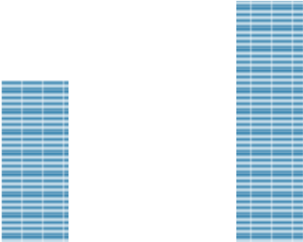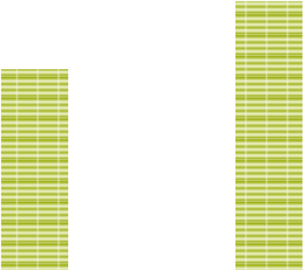

,62%
67
74.91%
70
,09%
76.54%

65
,00%
68
,00%
71
,00%
74
,00%
,00%
77
2400
2800
3200
3600
4000
2018
2019
Central Govt.Debt in mill.eur
General Govt. Debt in mill.eur
Central Govt.Debt as GDP
General Govt.Debt as GDP%
,68%
61
62
,85%
,15%
64
64
,47%
60
,00%
62
,00%
64
,00%
66
,00%
2400
2600
2800
3000
3200
2018
2019
Central Govt.Debt in mill.eur, including deposits
General Govt. Debt in mill.eur, including deposits
Central Govt.Debt as GDP%, including deposits
General Govt.debt as GDP%, including deposits

Table 1 Debt stock as of December 31, 2019
 |  |  | GDP | 4,951
Creditor | Debt stock in mill.  Euro | Debt stock as % of GDP | Share of  Foreign/Domestic  Debt in % | Share of General  Govt  Debt in %
International Bank for Reconstruction and Development (IBRD) | 184.88 | 3.73% | 5.91% | 4.88%
Paris Club of Creditors | 78.04 | 1.58% | 2.49% | 2.06%
International Development Association (IDA) | 31.98 | 0.65% | 1.02% | 0.84%
European Investment Bank (EIB) | 107.66 | 2.17% | 3.44% | 2.84%
European Bank for Reconstruction and Development (EBRD) | 23.27 | 0.47% | 0.74% | 0.61%
Council of Europe Development Bank (CEB) | 32.51 | 0.66% | 1.04% | 0.86%
European Commission | 0.30 | 0.01% | 0.01% | 0.01%
German Development Bank (KFW) | 38.31 | 0.77% | 1.22% | 1.01%
Hungarian loan | 2.97 | 0.06% | 0.09% | 0.08%
Polish loan | 4.85 | 0.10% | 0.15% | 0.13%
French loan – NATIXIS | 3.02 | 0.06% | 0.10% | 0.08%
Steiermarkische Bank und Sparkassen AG | 3.30 | 0.07% | 0.11% | 0.09%
Credit Suisse | 54.22 | 1.10% | 1.73% | 1.43%
China EXIM Bank | 671.71 | 13.57% | 21.47% | 17.73%
Instituto del credito oficial (ICO) - Spanish loan | 2.49 | 0.05% | 0.08% | 0.07%
Austrian loan - Erste Bank | 1.33 | 0.03% | 0.04% | 0.04%
Banka Intesa | 20.00 | 0.40% | 0.64% | 0.53%
IFAD | 1.89 | 0.04% | 0.06% | 0.05%
OTP-Erste Group-Zagrebačka banka (Syndicated loan) | 48.60 | 0.98% | 1.55% | 1.28%
Export Development Canada EDC | 18.85 | 0.38% | 0.60% | 0.50%
PBG 2 - (Syndicated loan) | 250.00 | 5.05% | 7.99% | 6.60%
EUROBOND | 1,548.54 | 31.28% | 49.50% | 40.87%
Total foreign debt | 3,128.72 | 63.19% | 100.00% | 82.57%
Old foreign currency savings | 10.81 | 0.22% | 1.86% | 0.29%
Restitution Liabilities | 86.35 | 1.74% | 14.89% | 2.28%
Loans from commercial banks | 140.23 | 2.83% | 24.18% | 3.70%
Pensions in arrears | 1.90 | 0.04% | 0.33% | 0.05%
Treasury bills | 72.00 | 1.45% | 12.41% | 1.90%
Domestic bonds - GB16 | 80.41 | 1.62% | 13.86% | 2.12%
Domestic bonds - GB24 | 92.44 | 1.87% | 15.94% | 2.44%
Domestic bonds - GB26 | 50.00 | 1.01% | 8.62% | 1.32%
Legal persons and business organisations | 45.80 | 0.93% | 7.90% | 1.21%
Total domestic debt | 579.96 | 11.71% | 100.00% | 15.31%
Total Central Government Debt | 3,708.67 | 74.91% |  | 97.88%
Local Government Debt | 80.59 | 1.63% |  | 2.12%
Total General Government Debt | 3,789.26 | 76.54%
Deposits | 597.13 | 12.06%
Total Central Government Debt, including deposits | 3,111.55 | 62.85%
General Government Debt, including deposits | 3,192.14 | 64.47%

2. Central Government Debt Flow during 2019

Figure 3 Share of foreign and domestic debt
The total Central Government debt (without deposits) as of December 31, 2019, was €3,708.67 million, or 74.91% of GDP. The total Central Government debt including deposits, as of the end of 2019, was €3,111.55 million or 62.85% of GDP. The foreign debt was €3,128.72 million, or 63.19% of GDP, while the domestic debt was €579.96 million, or 11.71% of GDP.
84
,4%
15
,6%

Foreign debt

Domestic debt

The Central Government debt includes part of the local self-government debt of €38.11 million, under contracts signed by the Ministry of Finance with foreign creditors and where on-lending contracts were signed with municipalities, since the Ministry of Finance features as the direct borrower.

Figure 4 Foreign currency Central Govt. debt structure
Compared to the end of 2018, the Central Government debt increased by €555.69 million in total, which is the result of increased foreign debt of €368.47 million, and of the increased domestic debt by €186.98 million. The foreign debt increased primarily due to issuing of Eurobonds at the international market, in the amount of €500 million, as well as due to borrowing from the Chinese EXIM Bank, for the construction of the priority section of the highway. The domestic debt was increased mostly due to issuing domestic bonds, in the amount of €142,44 million.
80
,4%
18
,7%
0
,9%
EUR
USD
Other

Figure 5 Interest rate Central. Govt. debt structure
Regarding the interest rate aspect, the loan portfolio is stable, considering the dominant share of borrowing under fixed interest rate, while the borrowings under variable rate are mainly fixed to EURIBOR, which records historically law values.
79
,4%
20
,6%

Fixed

Variable

Also, the average debt maturity was extended from 5.2 years, as it was at the end of 2018, to 5.9 years as it was at the end of 2019.

Figure 6 Trend of real weighted average interest rate 2014-2019
The Central
the end of 2018.
4
,30%
3
,60%
3
,70%
3
,10%
3
,00%
2
,8%
2
,50%
,90%
2
,30%
3
,70%
3
4
,10%
,50%
4
2014
2015
2016
2017
2018
2019
debt
Government
structure

at the end of
2019

has real weighted
average interest rate of
2
.
8
%,
which
implies

that
the
cost
of
borrowing is decreased
by
0
,
2
%
compared with

2.1 Foreign debt

The foreign debt, as of the end of 2019, was €3,128.72 million, or 63.19% of GDP.

Table 2 The biggest foreign creditors in 2019
 | In mill. €
Eurobond | 1,548.54
China EXIM Bank | 671.71
PBG syndicated loan | 250.00
International Bank for Reconstruction and Development (IBRD) | 184.88
European Investment Bank (EIB) | 107.66

At the end of September 2019, bonds were issued at the international market in the amount of €500 million, with maturity of 10 years and the interest rate of 2.55%, which represent the most favourable terms so far for this transaction type. These bonds will be used for repayment of debt for liabilities maturing during 2020.

During 2019, the increase of foreign debt was affected also by disbursement of loan funds in the total amount of €186.5 million, as follows:

- From the China EXIM bank loan for the project of “Financing Bar–Boljare Highway
(Smokovac-Mateševo)”, in the amount of €142,9 million;
- For the World Bank projects, in the amount of €11.2 million;
- For projects from the European Bank for Reconstruction and Development (EBRD) loans, in the amount of €10.0 million;
- For projects from KfW loans, in the total amount of €9.1 million;
- For projects from the Council of Europe Bank (CEB) loans, in the total amount of €9.9 million;
- For the project from the IFAD loan, in the amount of €0.7 million;
- For the project from the Export Development Canada (EDC) loan, in the amount of €2.7 million.

The repayment of foreign debt in 2019 was €328,9 million, which refers to the repayment of the foreign debt for loan arrangements with international creditors.

The data on the stock of undisbursed funds from creditors, under loan arrangements for which all contracted funds have not been disbursed are presented in the following Figure.

Figure 7 Undisbursed loan funds in mill. Euro
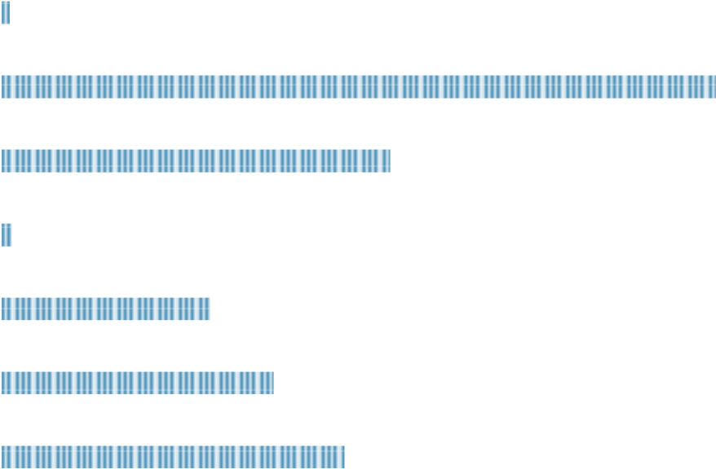
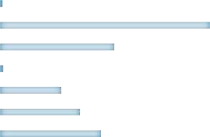
IFAD
82
,
55
65
,
50
50
,
13
2
,
48
93
,
54
171,97
1
,
99

Exim China highway

Credit Institute for Reconstruction – Germany (KFW)

Council of Europe Development Bank (CEB)
EBRD
European Investment Bank (EIB)
International Bank for Reconstruction and Development
(IBRD)

0,00 40,00 80,00 120,00 160,00 200,00
According to the existing foreign debt stock, the debt with international financial institutions (World Bank and its affiliates – IBRD, IDA; then the Paris Club, EIB, EBRD, CEB, European Commission, KfW and IFAD) amounts to around 10.07% of GDP, debt under bilateral (soft) loans (contracts with the Governments of Austria, Hungary, Poland, France, Spain, China EXIM bank and Steiermarkische Bank und Sparkassen AG, Export Development Canada EDC – Helicopters) amounts to around 14.31% of GDP, while the debt under loan facilities for the Budget financing (Eurobond, Credit Suisse, Banca Intesa, OTP Bank and Zagrebačka Bank, Syndicated loan – PBG) amounts to around 38.81% of GDP.
The following loan facilities were signed during 2019:
- With the International Bank for Reconstruction and Development (IBRD), for the Project Tax Administration Reform – Additional Financing, in the amount of €4,8 million;
- With the European Investment Bank (EIB), for the realisation of the Project "Program for the Improvement of Montenegrin Education", in the amount of €18 million;
- With the Council of Europe Development Bank – CEB, for realisation of the Project "Preschool Infrastructure in Montenegro - 2", in the amount of €10 million;
- With the Council of Europe Development Bank – CEB, for realisation of the phase IV of the social housing project 1000+, in the amount of €10 million;
- With the German Development Bank - KfW, for realisation of the project „Energy Efficiency in Public Buildings – phase III”, in the amount of €45 million.

Foreign debt amount does not include liabilities arising from unresolved debtor-creditor issues with Libya, Kuwait and Slovakia, in the amount of around 1% of GDP. Montenegro inherited the debt towards the governments of these three countries as a result of the division of nonallocated debt (5.88% out of 38% for Serbia and Montenegro) and it is being resolved by applying positions agreed within the Committee for Division of Financial Assets and Liabilities of the former SFRY, in accordance with the Agreement on Succession Issues from Vienna of June 29, 2001.

2.2 Domestic debt

The domestic debt at the end of 2019 was €579.96 million, or 11.71% of GDP.
The most of the domestic debt includes the debt for restitution, domestic bonds GB16, GB24 and GB26, treasury bills and short-term and long-term loans with domestic commercial banks. The stock of domestic debt also includes the debt of legal persons and companies that predominantly provide public interest services. Table 3 shows the biggest liabilities towards residents.

Table 3 Biggest liabilities for domestic debt, at the end of 2019
 | In mill. eur
Credit lines with commercial banks | 140.23
Domestic bonds GB24 | 92.44
Liabilities for restitution | 86.35
Domestic bonds GB16 | 80.41
Treasury bills | 72
Domestic bonds GB26 | 50

Figure 8 Domestic debt structure
30,00%
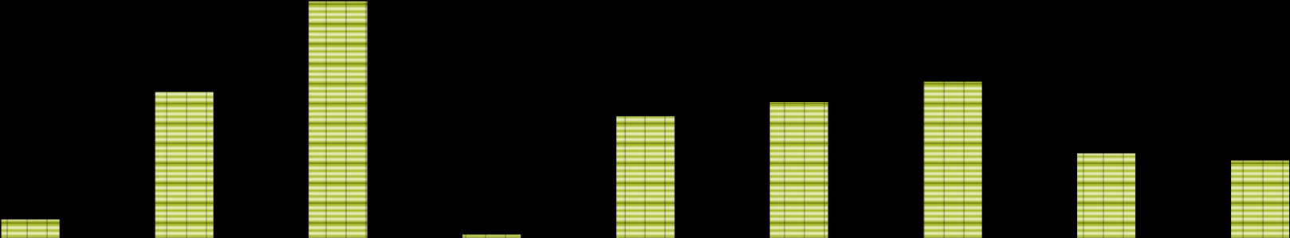
25,00%
1
,86%
14
,89%
,18%
24
0
,33%
12
,41%
,86%
13
15
,94%
8
,62%
7
,90%
Old foreign
Currency savings
Restitution
Liabilities
Loans from
Commercial banks
Pensions
Arrears
T-bills
Domestic
Bonds- GB16
Domestic
Bonds- GB24
Domestic
Bonds- GB26
Legal entities
and companies
20,00%
15,00%
10,00%
5,00%
0,00%

Credit lines with commercial banks include short-term revolving loans and long-term loans, concluded in the period before 2019, as well as long-term loans taken during 2019. During 2019, short-term revolving loans, were refinanced for the maturity of one year under lower interest rates, in the range of 2.65-2.99%. Debt for loans with domestic commercial banks increased by €47.58 million, which occurred as the result of new borrowing in the amount of €77.00 million on one side, and repayment of debt in the amount of €29.42 million, on the other side.
During 2019, the following long-term loan facilities were signed:
- With Crnogorska komercijalna banka a.d. Podgorica - CKB, for purchasing armoured vehicles for Ministry of Defence, in the amount of €30.00 million;
- With Podgoricka Banka a.d. Podgorica OTP Group – PGB, in order to secure lacking funds for financing the 2019 budget, in the amount of €47.00 million.

At the end of 2019, total liability resulting from restitution was around €86.35 million, which was €0.25 million less than at the end of 2018, when this liability was €86.60 million. Decrease of the debt for restitution was in the amount of around €4.38 million, and resulted from repayment of the regular restitution instalment in the amount of around €2.16 million and from payment of custom duties and taxes in the amount of around €2.22 million while on the other hand the debt under new decisions during 2019 was increased by around €4.13 million. The debt stock under this grounds records mild decreases from one period to another, however, it should be noted specifically that the debt under this grounds records increase from time to time due to enacting new decisions on restitution of property entitlements that were taken away.
The debt under domestic bonds relates to bonds issued during 2016, as well to bonds issued during 2019, with repayment term of five and seven years. Under this ground, the debt increased during 2019 by the total amount of €142.44 million, or by €92.44 million for bonds issued with maturity of five years – GB24, with interest rate of 3%, and €50.00 million for bonds issued with maturity of seven years – GB26, and with the interest rate of 3.5%.
During 2019, part of the debt for foreign currency savings in the amount of around €1.08 million was repaid. Also, during this year the debt under treasury bills was refinanced, as well as under treasury bills that were used for current liquidity during the year in the amount of around €144.00 million. At year's end, the debt under treasury bills was decreased by around €5.00 million, compared to the end of 2018.

The total repayment of domestic debt, including refinancing of treasury bills in the amount of €144.00 million, was €178.42 million.

The domestic debt stock includes also debt of legal entities and companies predominantly providing services of public interest, which are under management control and with majority financing from the central government budget in the amount of around €45.80 million. The majority of this debt includes the debt of the Railway Infrastructure in the amount of around €38.48 million, the Railway Transport in the amount of around €6.92 million, the debt of the Public Broadcasting Services of Montenegro in the amount of around €0.38 million and other.

During 2019, the debt of legal entities and companies was increased in the amount of €2.98 million, primarily due to the disbursement of railway companies’ loan funds under loan agreements that were already signed.

3. Debt repayment

During 2019, the Central Government debt repayment of principal to residents and nonresidents as well as repayment of liabilities from previous period was in the total amount of €508.67 million. Out of this, the principal repayment to residents was in the amount of €178.42 million, primarily due to debt refinancing under treasury bills, in the amount of around €144.00 million. The principal repayment to non-resident was €328.93 million, which includes €169.1 million for repayment of Eurobonds issued in 2014. The repayment of the debt from previous period for old foreign currency savings was €1.08 million, while repayment of liabilities for restitution amounts to €0,25 million.
Repayment of interest to residents and non-residents amounts to €105.60 million. Out of this amount, interest repayment to residents was in the amount of €6.91 million, out of which the most was for repayment of interest for loans taken from domestic banks, while interest repayment to non-residents was €98,69 million and primarily relates to liabilities under refinanced Eurobonds interests.
Repayment breakdown is presented in the following table.

Table 4 Central Government Debt Servicing in 2019 in mill. Euro
Budget line item | 2019
4611 - Repayment of principal to residents | 178.42
4612 - Repayment of principal to non-residents | 328.93
4630 - Repayment of liabilities from previous years – old currency savings | 1.08
4630 - Repayment of liabilities from previous years – restitution | 0.25
Total repayment of principal | 508.67
4161 - Repayment of interest to residents | 6.91
4162 - Repayment of interest to non-residents | 98.69
Total repayment of interest | 105.60
TOTAL | 614.27

4. Local Government Debt

Consolidated debt of municipalities was around €118.70 million, according to the data provided by municipalities as of end of 2019, as well as according to the Ministry of Finance data, which is around €32.10 million less than at the end of 2018. Local municipalities’ debt is presented in two ways:
- Under the Central Government foreign debt stock, which includes the debt of municipalities under contracts signed by the Government of Montenegro with foreign creditors, and on-lending agreements with municipalities in the amount of around €38.11 million (amount of disbursed and outstanding funds);
- Under the local government debt stock of around €80.59 million
The following table presents the consolidated debt of Local Government at the end of 2019

Table 4 Consolidated debt of Local Government in mill. Euro
Town | Domestic debt | Foreign debt | Total
Andrijevica | 0.55 | 0.11 | 0.66
Bar | 0.00 | 2.04 | 2.04
Berane | 3.77 | 0.00 | 3.77
Bijelo Polje | 8.74 | 0.22 | 8.96
Budva | 0.19 | 24.53 | 24.72
Cetinje | 6.47 | 1.51 | 7.98
Danilovgrad | 1.71 | 1.16 | 2.87
Gusinje | 0.00 | 0.00 | 0.00
Herceg -Novi | 1.29 | 6.22 | 7.51
Kolašin | 4.88 | 0.00 | 4.88
Kotor | 0.00 | 1.01 | 1.01
Mojkovac | 0.29 | 0.00 | 0.29
Nikšić | 1.27 | 11.78 | 13.06
Petnjica | 0.00 | 0.00 | 0.00

Plav | 0.54 | 0.00 | 0.54
Plužine | 0.14 | 0.00 | 0.14
Pljevlja | 0.16 | 2.51 | 2.67
Podgorica | 2.17 | 18.90 | 21.06
Rožaje | 3.21 | 1.05 | 4.26
Šavnik | 0.14 | 0.00 | 0.14
Tivat | 0.00 | 8.02 | 8.02
Ulcinj | 3.05 | 1.06 | 4.12
Žabljak | 0.00 | 0.00 | 0.00
Tuzi | 0.00 | 0.00 | 0.00
TOTAL | 38.58 | 80.12 | 118.70

Figure 9 Share of consolidated domestic and foreign debt of Local Government
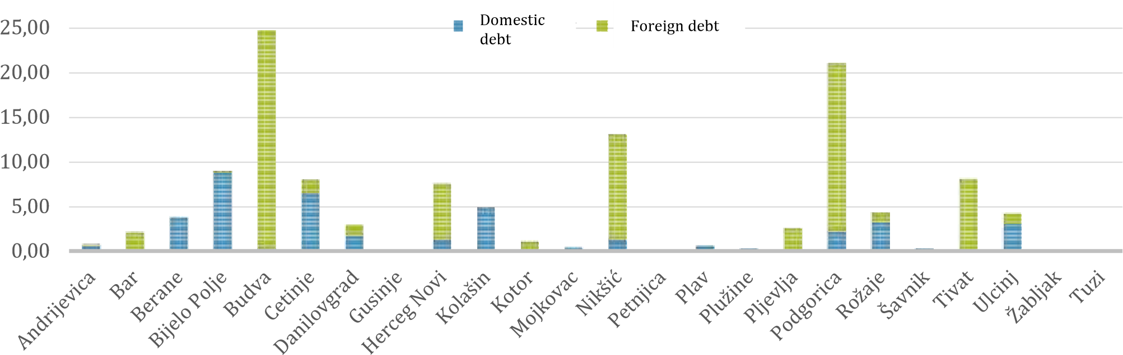

5. Trend of Government guarantees during 2019

Figure 10 Government guarantees in mill. Euro
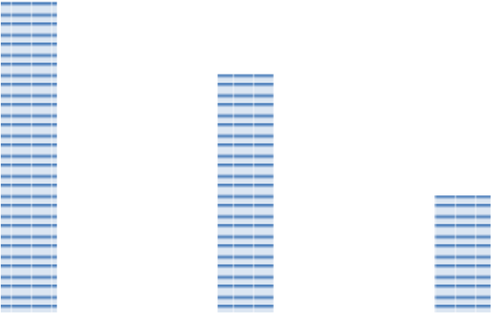
Contracted amount of guarantees issued by the Government at the end of 2019 was around €601.93 million, which is around €30.89 million more compared to the same period in 2018. Out of this amount, around €477.77 million was disbursed. The debt stock for guarantees issued to domestic and foreign creditors was €244.30 million, which was 4.93% of GDP. When compared to the end of 2018, the debt stock at the end of 2019 under state guaranties issued was reduced by €43.19 million.
529.78
405.71
198.95
72.15
72.06
45.35
601.93
477.77
244.30
0
,
0
100,0
200,0
300,0
400,0
500,0
600,0
700,0

Stanje duga
Ino garancije

Total
Contracted amount
Disbursed in 2019

Debt stock

Foreign

guar
a
ntees

Domestic

guarantees

Domestic guarantees were mainly issued in order to support companies for realisation
of major projects, for restructuring and as a support to implementing local self-governments’ resolution plans. Foreign guarantees were issued for implementation of various infrastructure projects, providing support to development of small and medium sized enterprises, as well as to support railway infrastructure restructuring, modernisation of airports and energy system.
Pursuant to the 2019 Budget Law, the Government of Montenegro issued the following guarantees:

- for the loan facility between syndicate of banks, including the Prva Bank and the Erste Bank, and the "Regionalni vodovod crnogorsko primorje", in the amount of €10 million;
- for the loan facility between the Railway Infrastructure of Montenegro and the European Investment Bank (EIB), for projects related to reconstruction and improvement of railway infrastructure, in the amount of €13 million;
- for realisation of loan facility between the EPCG and the German Development Bank (KfW), for reconstruction and modernisation of HE Perućica Plant, phase 2, in the amount of €33 million;
- for the loan facility between the EBRD and Regionalni vodovod Crnogorsko primorje, for realisation of the Extending Regional Water Supply System Project in the amount of €12 million;
- for the loan facility between Prva Bank of Montenegro, established in 1901 and the Teachers’ Housing Cooperative, for realisation of the project to build apartments for teachers in the Budva Municipality, in the amount of €1.2 million.

In the previous period, two guarantees with the European Investment Banka for the Invest Bank Montenegro and the Atlas Bank were activated in the amount of €2.2 million and €7.2 million, respectively, or € 9.4 million in total. These guarantees were issued in 2009 and 2010, and they were activated because these banks were put into receivership on December 7, 2018 and temporary suspension of liabilities payment (moratorium) was introduced, which prevented discharging obligations towards the EIB.
In addition, the Government guarantee in the amount of €29.25 was activated. It was issued to the German and Austrian company WTE/EVN Group, for construction of wastewater purifying plant in Budva.
Activation of new guarantees is not expected in the upcoming period.

5.1 Foreign Guarantees

Committed/disbursed amount of guarantees issued by the Government of Montenegro for loans with foreign creditors was around €405.71 million, while the debt stock under them was €198.95 million or 4.02 % of GDP.
Table 5 Foreign Guarantees in mill. eur
Creditor | Borrower | Signing date | Amount (EUR) | Committed amount | Debt stock
European Roads Project | Monteput | 17/05/2004 | 24.00 | 24.00 | 13.48
Reconstruction of the electric power system | EPCG and CGES | 15/08/2002 | 11.00 | 8.02 | 2.77
Airports modernisation | PE Airports of  Montenegro | 27/03/2004 | 12.00 | 12.00 | 5.07
Small and medium-sized enterprises via commercial banks | Commercial banks | 02/07/2009 | 90.00 | 90.00 | 7.96

Modernisation of railways infrastructure | ZICG | 03/01/2011 | 7.00 | 7.00 | 6.85
Reconstruction of railways infrastructure | ZICG | 20/03/2017 | 20.00 | 14.00 | 14.00
Total EIB |  |  | 164.00 | 155.02 | 50.12
Project for construction of the regional water supply system - south branch Phase I | PE Regional Water  Supply  Company  PE Regional Water  Supply  Company  PE Regional Water  Supply  Company | 09/11/2007 | 8.00 | 8.00 | 4.92
Project for construction of the regional water supply system - south branch Phase II |  | 16/05/2008 | 7.00 | 7.00
Project for construction of the regional water supply system - south branch Phase I Annex |  | 10/07/2009 | 3.00 | 3.00
Project for reconstruction of the railways infrastructure – Phase III | ŽICG - III tranche | 06/04/2009 | 4.00 | 4.00 | 2.23
Project for reconstruction of the railways infrastructure – Phase III Annex | ZICG | 12/10/2012 | 10.00 | 9.86 | 7.47
Project for urgent  reconstruction of the railways infrastructure 2 | ZICG | 11/12/2009 | 15.00 | 13.72 | 6.43
Project for procurement of electric engine units and diagnostic equipment | Railways transport JSC | 8/11/2010 | 13.55 | 13.55 | 6.92
Credit line for deposits protection | Deposit Protection Fund | 8/11/2010 | 30.00 | 0.00 | 0.00
Pljevlja Interconnection Cable | CGES | 09/06/2014 | 20.00 | 50.53 | 40.80
Installation of high voltage line
between Tivat and Pljevlja |  | 30/12/2015 | 40.00 | 0.00 | 0.00
Project for construction of the regional water supply system - south branch. phase I | PE Regional Water  Supply  Company | 26/12/2019 | 12.00 | 0.00 | 0.00
Total EBRD |  |  | 162.55 | 109.67 | 68.76
EPCG - Piva | EPCG | 28/12/2007 | 16.00 | 10.18 | 0.18
EPCG – transformer substation Podgorica – Ribarevine | EPCG and CGES | 20/07/2007 | 5.40 | 4.79 | 0.00
EPCG - Filter replacement in the TPP Pljevlja and extension of the substations Podgorica-  Ribarevine | EPCG and CGES | 11/12/2008 | 15.00 | 14.81 | 5.06
Interconnecting cable | CGES | 08/05/2013 | 25.00 | 22.43 | 12.71
Interconnecting cable - Luštica | CGES | 26/12/2018 | 20.00 | 0.00 | 0.00
HE Perućica Plant reconstruction Phase II | EPCG | 11/10/2019 | 33.00 | 0.00 | 0.00
Total KfW |  |  | 114.40 | 52.21 | 17.95
Procurement and overhaul of ships | Montenegrin maritime transport company  (Crnogorska Plovidba) | 26/01/2010 | 42.36 | 42.36 | 23.30
Procurement and overhaul of ships | Bar maritime transport company  (Barska plovidba) | 29/01/2013 | 41.47 | 41.47 | 37.32
Total EXIM |  |  | 83.83 | 83.83 | 60.62
Completion of the railroad Podgorica - Nikšić | ZICG | 12/12/2011 | 5.00 | 4.98 | 1.49
Total Czech Export Bank |  |  | 5.00 | 4.98 | 1.49
TOTAL |  |  | 529.78 | 405.71 | 198.95

5.2 Domestic Guarantees

Committed amount of guarantees issued by the Government of Montenegro for loans with domestic creditors was around €72.06 million, while the debt stock under them at the end of 2019 was €45.35 million or 0.92% of GDP.
Table 6 Domestic guarantees in mill. Euro
Creditor/Purpose | Borrower | Signing date | Amount (EUR) | Committed amount | Debt stock
Restructuring Plan | Montenegro Airlines | 06/05/2011 | 2.00 | 2.00 | 0.00
Restructuring Plan |  | 16/12/2015 | 1.12 | 1.12 | 0.44
Restructuring Plan |  | 16/12/2015 | 1.50 | 1.50 | 0.18
Total Hipotekarna Bank AD |  |  | 4.62 | 4.62 | 0.62
Restructuring Plan | Montenegro Airlines | 13/12/2011 | 0.41 | 0.41 | 0.00
Total NLB Montenegro Bank AD |  |  | 0.41 | 0.41 | 0.00
Loan for removing industrial waste (grit) | Adriatic Shipyard JSC Bijela | 19/01/2012 | 1.05 | 1.05 | 0.16
Total Crnogorska komercijalna banka AD |  |  | 1.05 | 1.05 | 0.16
For construction of residential building for education sector employees in Budva | Housing cooperative of education sector  employees of Montenegro  “Solidarno” Podgorica | 20/07/2015 | 5.28 | 5.28 | 5.28
Total Societe Generale Montenegro Bank AD |  |  | 5.28 | 5.28 | 5.28
Implementation of the  Resolution Plans of Local self-government units | Local selfgovernment units | 2015 | 42.89 | 42.80 | 26.67
Total commercial banks |  |  | 42.89 | 42.80 | 26.67
Refinancing of the Abu Dhabi Development Fund loan | PE Regional Water Supply Company | 27/04/2017 | 6.70 | 6.70 | 1.96
For discharging obligations towards the Strabag AG | PE Regional Water Supply Company – BUDVA | 08/05/2019 | 5.00 | 5.00 | 4.72
Total Erste Bank AD |  |  | 11.70 | 11.70 | 6.67
For discharging obligations towards the Strabag AG | PE Regional Water Supply  Company – BUDVA | 08/05/2019 | 5.00 | 5.00 | 4.75
For construction of residential building for education sector | Housing cooperative of education sector  employees of Montenegro  “Solidarno” Podgorica | 30/12/2019 | 1.20 | 1.20 | 1.20
employees in Budva
Total Prva Bank |  |  | 6.20 | 6.20 | 5.95
TOTAL |  |  | 72.15 | 72.06 | 45.35

According to the Monstat data, 2019 GDP was €4,951 million.
The presented Central Government Debt stock does not include the debt for pension arrears and debt of legal entities and companies, in total amount of €47.7 million.
Under exchange rate on December 31, 2019
This amount includes also refinancing of treasury bills in the amount of €144 million

