- AUTHOR DETAILS

- Name/s | Dragana Aprcović
- Country | Montenegro
- Institution/School | Elementary school “Kekec” Sutomore
- Email | dragana.aprcovic@os-kekec.edu.me
- Programmes the school is participating in (Eco-Schools/LEAF/YRE/other)- | Eco Schools in Montenegro
- Would you like to receive monthly updates through our Newsletter? Yes/No | Yes
- Submission date (dd/mm/yyyy) | 23th August 2023.

- THE LESSON PLAN
- Theme – The title of the lesson | Reduction of trash and waste
- Introduction – A brief description of what the lesson is about. (100 words max.) | Waste is one of the important topics that students need to know more and more about.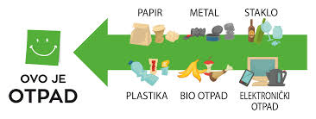  Throughout my years of teaching, I have always tried to develop responsibility towards the environment in children, to learn about renewable energy sources, to introduce them to the circular economy, to learn what recycling is, how it is created and how they can reduce personal waste.  In the Art class, I wanted to present them with ways, but also to encourage them to practically transform individual waste into a new product/object.
- Age Group – Age group that it is suitable for (e.g. Age 6 to 9, Age 10 to 11, etc.) | Age 9 to 11
- Objectives or Learning Outcomes – List 3-5 objectives/learning outcomes that you are expecting to achieve during the lesson. | Art lesson plan outcomes:  During learning, students will be able to:  - Design and execute a sculpture from different materials;  - They evaluate student works;  - Build a responsible attitude towards nature and actively participate in its protection;  - They analyze the use of different materials in everyday life.  Key competencies  Students will be able to:  4. Digital competence  1.4.3. Use different sources of information and data in digital  6. Civic competence  1.6.5. Recognize the importance of natural resources and environmental protection in preserving the quality of life  1.6.10. Present their opinions and views on solving problems, while respecting the opinions of others  1.6.16. Emphasize the importance of a responsible attitude towards the environment  7. Entrepreneurial  1.7.1. Convert a problem/opportunity from one's own immediate environment into an idea/activity with support, predicting the result of the undertaken activity  1.7.5. Recognize the impact of his/her choices and behavior on the community and the environment
E. Time required to deliver the lesson plan – If more than one class session (30-45mins), please indicate the time required. | Two lessons, 45 minutes each
F. Remote preparation - (if any) Anything that you (or the students) need to do BEFORE the lesson. (e.g. collect and bring to school 3 items labelled as hazardous). | Before class, the students had the following task:  During their free days, they monitor and photograph the piling up of garbage in their surroundings as well as its removal. They will post the photos in a set place so that they can be seen by everyone. In the environment where there is no garbage, they take and post photos of pure nature.  They will also collect plastic bottles, bowls, plastic caps, rolls of paper towel and toilet paper, cardboard boxes etc. They need all of the above to make a sketch of Petko doll from recycled material.  The teacher has:  - prepared slips with different objects drawn on them;  - collected and brought the necessary material for class work: plastic gun, iron, baking paper and similar.
G. Planning considerations - (if any) such as (i) ‘warnings’ about misconceptions students might have about the lesson’s topic and how to deal with them; (ii) safety precautions; (iii) tips and other useful information | There should not be any problems during the implementation of this topic because the topic is familiar to students from the previous lesson. Possible problems are expected during the melting of plastic, which we will deal with on the spot.
H. Resources Required to deliver the lesson plan – Material, equipment and reading resources needed | In order to complete the lesson, the students are obliged to bring the necessary material; glue, scissors, felt-tip pens, erasers...
I.Activity – Steps or description of how the lesson will be conducted/facilitated by the teacher.  Structure your description using these main headings:  - Introduction  - Development  - Conclusion | - Introduction  Activity 1. At the beginning of the class, students draw lists of different items and are divided into groups (plastic bottles, corks, paper).  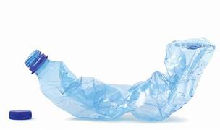  Activity 2. They talk about the collected photos and waste/garbage in their surroundings.  https://padlet.com/draganaprcovic/smanjenje-sme-a-i-otpada-kn7esr3yq5lefp6e  - Development  Activity 1.  Group work:  1. They make the front part of the T-shirt for the doll Petko out of plastic caps. On the baking paper, they arrange the corks according to the desired colour and shape, then place the baking paper over the corks again. With a heated iron, they go over the paper and melt the corks, creating a homogeneous whole.  2. They make the body, legs, and arms of the Petko doll out of cardboard. Using a larger box, they form the body, then using rolls of paper towel and toilet paper, they form limbs that they will glue or secure with rubber bands.  3.They make the head of the Petko doll out of plastic bowls.  At the end of the work, the students put the parts together and complete the Petko doll which will take care of reducing waste with them.  Activity 2. Petko introduces itself and talks to the students:  I am a Petko doll, as you know, made from various recycled materials. I am someone who loves nature. People who take care of the amount of waste and its proper use make me very happy.  But let's start from the beginning. From the first grade, you promote environmental protection and the use of renewable energy sources. I know you were curious last year and did research about space debris, so I decided to share some information with you.  One day I was doing research on the amount of waste people make.  Waste is things that we plan to throw away because we no longer need them, but they can be reused or recycled.  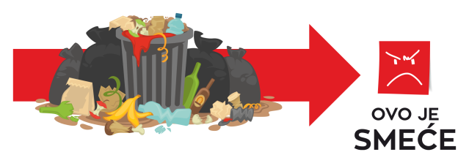  Garbage is waste that is handled inappropriately or incorrectly. Mixing different types of waste creates garbage that is difficult and only partly possible to recycle at high costs.  Single-use plastic is used every day, which is already a problem in many places, because the quantities are increasing. We also witness that we use a large amount of paper that ends up in the trash.  I was very worried when I came across information that I did not like at all. I found out that in 2019, municipal waste generated per capita amounted to 547.9 kg. Municipal waste is waste generated in households or/and similar properties to households.  Imagine how much it is now per inhabitant, in 2023.  If we go back earlier to the past of our great-grandmothers and great-grandfathers, you will see that they were more careful to the environment. They used glass bottles that have multiple uses, cloth bags that could be washed and reused, clothes were passed down from older to younger generation of people in close or distant family , each family mostly made compost.  I noticed that citizens do not even use the recycling yards that have been set up; that it is more and more in the habit of citizens to use disposable items that very quickly end up in the bins. (Petko’s talk ends here.)  They discuss and conclude that one of the problems in Montenegro is excessive waste, which is already slowly suffocating our nature.  Then Petko introduces them to how waste is divided.  Waste can be divided into:  - Communal  - Commercial  - Industrial.  And on the type of the waste.  Depending on the hazardous characteristics affecting human health and the environment, waste can be:  - harmless;  - inert;  - dangerous.  Activity 3. Discussion with the students.  Questions as follows:  What was it made from?  What would happen to boxes, bottles, rolls, paper if they were not used to make dolls?  Waste from small bins continues its journey but where does the waste go? Who wants to talk about a used bottle of water?  Waste is actually a treasure that should be used. We wonder HOW?  Students are thinking.  How can they reduce the production of different waste, plastic bottles?  - Conclusion  Activity 1. Together with Petko, they make coasters for glasses/bottles from the collected corks.  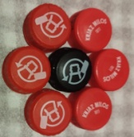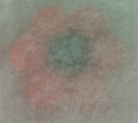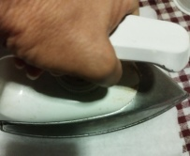  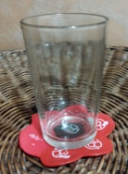
- Evaluation and Assessment – How will you check that the Objectives or Learning Outcomes (listed in D) were achieved? | - Completing the evaluation sheet;  https://forms.office.com/e/Az3rsS2CTN  - In the following period, we will monitor their attitude towards everyday waste. (Monitoring is limited only during the stay at school)
- Dissemination – How will you communicate about the products of the lesson for awareness raising? If your lesson plan has already been implemented, attach a link of a product produced during the lesson (e.g., video, poster, presentation, URL link/website link). | They have the task of drawing the people's attention to the existing problem with a short video. They will post their work on the Eco School page as well as on the school's Instagram account.
- Follow-up activity - (if any) Suggest an activity that can build on what the students learned during your lesson. | In the future, the students will use plastic bottles with the help of PETko recyclers and 3D printers to discover how to use selected waste (plastic five bottles).  Each student will make a small pendant.  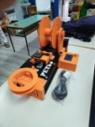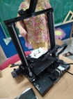
- Adaptations for students with learning difficulties – (if any) | We do not have students with learning difficulties in the class.
- Extension for gifted students – (if any) | There are gifted students in the class. Since it's an art class, gifted art students will have the task of painting an anchor chart- Let's reduce personal waste.
- Background information for teachers - Include any website links and resources that would provide teachers with useful information about the lesson’s topic | https://www.ecoportal.me/svjetski-dan-zastite-zivotne-sredine-borba-sa-prekomjernom-plastikom/  https://www.savjesno.eu/papir/  https://nationalgeographic.rs/zivotna-sredina/a21347/6-jednostavnih-nacina-da-svako-od-nas-doprinese-ocuvanju-zivotne-sredine.html?page=2  Uprava za statistiku - MONSTAT  Vrste otpada - Komunalni otpad (zcgo.hr)  https://www.youtube.com/watch?v=jBak3jwqV58  https://www.youtube.com/watch?v=mmuBlQGImVU
- References – Acknowledge the resources that were used while developing the Lesson Plan. | Art Curriculum  Yearly Art plan  Course: GAIA 20:30 Circular Economy Course (feeacademy.global)

