

Delegate Handbook

Regional Conference of Ministers of Justice and Ministers of Interior of South-East Europe

”Strengthening Co-operation in Fight against Organized Crime
in South East Europe”

Budva (Bečići), Montenegro
16 – 18 March 2011

1. Draft Programme

Venue: Hotel “Splendid Conference And Spa Resort”, Bečići bb, 85310 Budva

Programme

Wednesday, 16 March 2011

Afternoon Arrival of participants

19:30 Cocktail in the lobby of Hotel Splendid

20:00 Dinner hosted by Mr Duško Marković, Deputy Prime Minister and Minister of Justice of Montenegro (Hotel restaurant)

Thursday, 17 March 2011

09:00 – 09:30 Registration of participants

09:30 - 10:00 Opening of the meeting and welcome address:
Mr Duško Marković, Deputy Prime Minister and Minister of Justice of Montenegro
Mr Ivan Brajović, Minister of Interior of Montenegro
Mr Sarunas Adomavicius, Chief of OSCE Mission to Montenegro

10:00 – 10:30 Coffee break

10:30 – 11:00 Justice Session „Strengthening Mutual Legal Assistance in Criminal Matters“

Introduction: Mr Duško Marković, Deputy Prime Minister and Minister of Justice of Montenegro

International presentations
EUROJUST
COUNCIL FOR REGIONAL COOPERATION

11:00 – 12:30 National presentations:
Countries by alphabetical order (10 minutes each)

12:30 – 13:00 Family photo (Heads of Delegations)

13:00 – 14:30 Lunch (Hotel Splendid)

14:30 – 15:30 National presentations:
Countries by alphabetical order (10 minutes each)

15:30 – 15:45 Coffee break

15:45 – 16:15 Discussion

16:30 – 17:00 Press conference

19:30 Cocktail in the lobby of the Hotel

20:00 Dinner hosted by Mr Ivan Brajović, Minister of Interior
of Montenegro (Hotel restaurant)

Friday, 18 March 2011

09:00 – 09:30 Registration of participants

09:30 - 10:00 Internal Affairs Session „Regional Cooperation Mechanisms in Fight against Organized Crime“

Introduction: Mr Ivan Brajović, Minister of Interior
of Montenegro

International presentations:
International organizations (tbc)

10:00 – 11:30 National presentations:
Countries by alphabetical order (10 minutes each)

11:30 – 12:00 Coffee break

12:00 – 13:30 National presentations:
Countries by alphabetical order (10 minutes each)

Discussion

13:30 – 14:00 Family photo (Heads of Delegations)

14:00 – 15:30 Lunch (Hotel Splendid)

15:30 – 16:00 Adoption of the Declaration on Strengthening regional co-
operation and co-ordination in the fight against organised
crime in the countries of SEECP

16:00 - 16:30 Endorsement of the Regional Strategic Document (RSD) on Justice and Home Affairs 2011-2013

16:30 – 17:00 Press conference

17:30 Departure to Old Royal Cetinje

18:00 Sightseeing Old Royal Cetinje

20:00 Dinner in „Royal Government House“ (Cetinje) hosted by Mr Duško Marković, Deputy Prime Minister and Minister of Justice of Montenegro and Mr Ivan Brajović, Minister of Interior of Montenegro

22:00 Return to hotel Splendid Bečići

2. General Information

2.1. Location

The Regional Conference of Ministers of Justice and Ministers of Interior of South-East Europe will take place in the Hotel Splendid - Conference & Spa Resort***** (http://www.montenegrostars.com/web/indexspl.html).

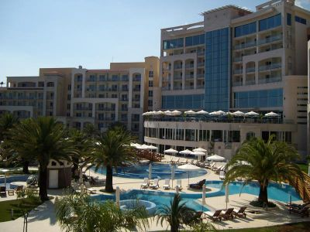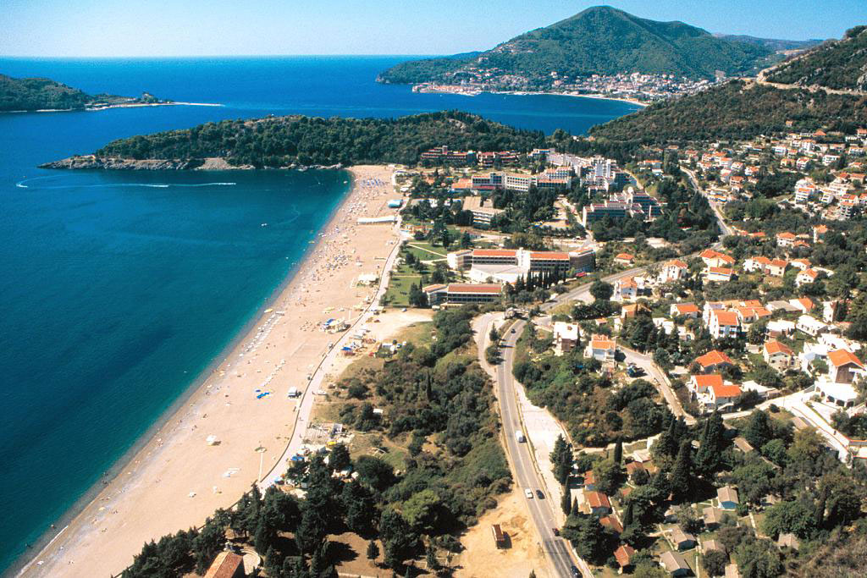

Situated the edge of the pristine waters of the Adriatic Sea in Bečići, the Hotel Splendid is an exquisite melding of natural beauty with sophisticated comfort.

2.2. Meeting Room

The Conference will be held in the Hotel Splendid, Hall of Dynasties (III floor).

For the bilateral meetings additional meeting room in Conference area will be available (V floor).

Delegations are kindly requested to indicate their interest in bilateral meetings in the accreditation forms annexed here-to no later than 4 March 2011.

During the Conference a Liaison Officer will be designated to each delegation, responsible for liaising with the organisers from the host country.

The Press Conferences will take place in Hotel Splendid (Conference Floor, III floor).

2.3. Offices

Office will be provided for the SEECP Secretariat, delegates and press.

Office will be equipped with a telephone line, internet access, computers, printers, fax machines and photocopiers (Conference Floor, III floor).

2.4. Interpretation

The working languages of the Regional Conference of Ministers of Justice and Ministers of Interior of South-East Europe are English and Montenegrin.

Heads of Delegations requiring interpretation are requested to bring their own interpreters and cover the relevant costs.

Technical support (interpretation booths) will be provided during the Conference upon a request of delegations in the Accreditation form, however not in rooms for bilateral meetings.

2.5. Accommodation

The delegations will be accommodated in the Hotel Splendid. The costs incurred for the accommodation of Heads of Delegation of delegation shall be borne by the host country.

Other 2 members of delegations, Security Officer, additional security personnel, etc. will be responsible for financing expenses connected with their accommodation.

The room rates are: Single Room: 85 EUR per night, breakfast and lunch included; Double Room: 140 EUR per night, breakfast and lunch included (tax is 1.5 EUR per person per night). The rooms are available from noon until 12 a.m.

Delegations are kindly asked to send the accommodation form annexed here-to no later than 4 March 2011.

2.6. Delegations

We kindly requests that during the sessions:

- the Heads of Delegation shall be accompanied by maximum two members of delegation and
- one representative of the diplomatic mission accredited to Montenegro.

Delegations are kindly requested to submit the final list of delegates no later than 4 March 2011.

2.7. Visas

Members of delegation requiring entry visas for Montenegro are requested to acquire the visas prior to entry at the diplomatic representations of Montenegro in their countries or to contact Ministry of Foreign Affairs and European Integration of Montenegro, Consular Department (+382 20 225 954).

2.8. Information & Accreditation Desk

Information & Accreditation desk will be located at the Hotel Splendid and will be opened throughout the Regional Conference of Ministers of Justice and Ministers of Interior. It will start on Wednesday, 16 March 2011, at 12.00 and will stay open until the end of the Conference. Accreditations for Heads of delegation and their delegations will be given upon their arrival to Montenegro.

2.9. Badges

All delegates and other participants attending the Conference meeting must be accredited in advance. The accreditation badges shall carry the logo of the Montenegrin SEECP Presidency, the person’s name, surname and function.

Accreditation badges will be provided for:
1st category: Heads of Delegation,
2nd category: other members of delegation,
3rd category: organisers,
4th category: security.

Delegation members should wear the ID badges all the time.

2.10. Transportation

There are two international airports in Montenegro: Podgorica and Tivat.
Airport Golubovci - Podgorica 75 km from Budva and Airport Tivat - 20 km from Budva.

Airport Podgorica is highly recommended.

Ministry of Justice and Ministry of Interior of Montenegro will provide adequate transport from Podgorica/Tivat Airport to Hotel Splendid and back for Heads of Delegation/Special Guests. A car with police escort will be provided for each Head of Delegation. Only the car of the Ambassador of each SEECP Member State accredited to Montenegro may be included in the motorcade. For arrival at a border crossing a police escort will be also provided for each Head of Delegation arriving by car.

Organized transport will be provided for other members of delegation by car from Podgorica/Tivat Airport to Hotel Splendid and back.

Organised transportation will be provided for no more than 10 persons per delegation.

Delegations are kindly asked to send their transportation details and needs no later than 4 March 2011.

2.11. Security

Security officers during the Conference will be ensured by the Office for the Protection of Constitutional Officials and Diplomatic Missions of the Ministry of Interior.

2.12. Useful information

Capital: Podgorica
Official language: Montenegrin
Currency: Euro
Electricity: 220 V, 50 Hz
Phone: - International exit code: 00
- International country code: 382
- Code for Podgorica: (0)20
- Code for Budva: (0)33

AIRPORTS___________________________________________________________________
http://www.montenegroairports.com/eng/index.php?menu=1
Podgorica: +382 20 444 244
+382 9804
info@apm.co.me
Tivat: +382 32 671 337
+382 32 670 930
+382 9804
info.tivat@apm.co.me

BUS STATIONS
Podgorica: +382 20 620 430
Budva: +382 33 456 000
Ulcinj: +382 30 413 225
Bar: +382 30 346 141
Tivat: +382 32 672 620
Kotor: +382 32 325 809
Herceg Novi: +382 31 321 225

LOCAL TRANSPORTATION
Principal taxi stations in Budva are situated in Slovenska Obala, near the Jat Airways office, bus station Merkur, tourist complex Slovenska beach and hotel complex in Bečići. Beside the taxi services you can also use the local transportation (bus) on relations Budva-Becici-Sveti Stefan-Petrovac–Budva (the telephone number of the bus station is provided above). The starting position is at the circular intersection.
Taxi Station in Budva: +382 33 456 777

USEFUL PHONE NUMBERS______________________________________________________
Help on the road: 19807
Information: 1181
Exact time: 125
Telegrams: 126
Fire-brigade: 123
Police: 122
Ambulance: 124
Weather forecast: 044800200

BANKS
There are 6 banks operating in Budva. Those are:
- Crnogorska komercijalna banka a.d. Podgorica, branch office in Budva
Mediteranska 7
- NLB Montenegrobanka, branch office in Budva
Mediteranska 19
- Podgorička banka a.d. Podgorica, branch office in Budva
Mediteranska b.b.
- Atlasmont banka a.d. Podgorica, branch office in Budva
Slovenska Obala 13
- Komercijalna banka a.d. Budva, branch office in Budva
Mediteranska 17
- Opportunity bank, branch office in Budva
Novembra bb

3. Telephone Numbers

Ministry of Justice

Mr Nikola Šaranović, Chief of the Cabinet
Cell: +382 67 637 273
e-mail: nikola.saranovic@mpa.gov.me

Mr Vladimir Vujotić, Advisor
Cell: +382 67 386 868
e-mail: vladimir.vujotic@mpa.gov.me

Ministry of Interior

Mrs Tanja Krivokapić, Head of Department for International Cooperation and European Integration
Cell: +382 67 672 070
e-mail: tanjakrivokapic@t-com.me

Mrs Svetlana Rajković, Chief of the Cabinet
Cell: +382 67 203 466
e-mail: svetlana.rajkovic@mup.gov.me

State Protocol

Mr Aleksandar Klikovac, Chief of State Protocol
Cell: +382 69 022 262

Diplomatic Protocol

Mr Ljubomir Mišurović, Chief of Diplomatic Protocol
Cell: +382 69 072 198

OEBS

Mrs Marina Lutovac, National Legal Officer
Cell: +382 67 626 037

4. Maps

Montenegro Map

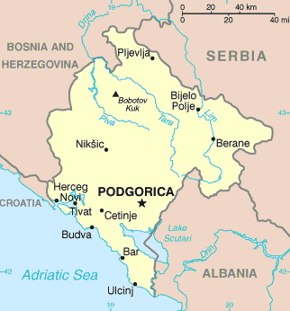

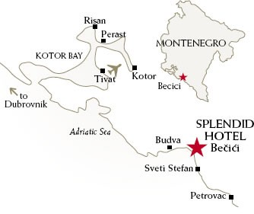

Accreditation Form
Deadline for sending this form is 4 March 2011

Regional Conference of Ministers of Justice and Ministers of Interior of South-East Europe:

Head of Delegation
Passport number

Blood Type
Possible Medical Problems of Head of Delegation
Food Limitations
Members of Delegations  (name, function, passport number) | 1
Members of Delegations  (name, function, passport number) | 2.
Members of Delegations  (name, function, passport number) | 3.
Members of Delegations  (name, function, passport number) | 4.
Members of Delegations  (name, function, passport number) | 5.
Security Officers  If more than two, please attach additional list. The license for carrying weapons may be obtained for one security officer | Name: | Date and Place of birth | Passport (Type and No)
 | 1.
 | Type of weapon, reg. No., No of ammo & caliber:
 | 2.
Request for technical support for interpreter
Arrival | Date:
Arrival | Time:
Arrival | (Border crossing – if arriving by car):
Departure | Date:
Departure | Time:
Departure | (Border crossing – if arriving by car):
Means of Transportation to and from Montenegro | Type and registration no. of aircraft:
Means of Transportation to and from Montenegro | Does the aircraft remain at the airport until departure of the delegation? : YES NO  If NO – Time of Departure: Time of return:
Means of Transportation to and from Montenegro | Time and registration plates of vehicles (if arriving by car):
Contact person at the Embassy | Name:
Contact person at the Embassy | Function:
Contact person at the Embassy | Telephone:
Contact person at the Embassy | Fax:
Contact person at the Embassy | E-mail:
Request for bilateral meetings

Return this Form to relevant contact person in the ministry
(Ministry Of Justice: vladimir.vujotic@mpa.gov.me)
(Ministry of Interior: tanjakrivokapic@t-com.me)

Accommodation Form
Deadline for sending this form is 4 March 2011

Personal Data:
Country/Organisation
Name and Surname
Position:
Phone: |  | Fax: |  | E-mail:
Accompanying person (s): |  | Name: |  | Surname:

Hotel Splendid - Conference & Spa Resort*****:
Single Room 85 EUR
Double Room 140 EUR
Breakfast and lunch are included in the price.
Tax fee is 1,50 euro per person, not included in price.

Arrival:
Date of arrival: |  | Time:

Remarks:

Departure:
Date of Departure: |  | Time:

Remarks:

Method Of Payment:
Cash

Credit Card
Amex Diners Master Visa

Other
Remarks:

Return this Form to relevant contact person in the ministry
(Ministry Of Justice: vladimir.vujotic@mpa.gov.me)
(Ministry of Interior: tanjakrivokapic@t-com.me)
Media Accreditation Form
Deadline for sending this form is 4 March 2011

Participant’s name and surname:
(please print in capital letters)

Country:

Press House - Company:

Telephone : | Fax: | E-mail:

Return this Form to relevant contact person in the ministry
(Ministry Of Justice: vladimir.vujotic@mpa.gov.me)
(Ministry of Interior: tanjakrivokapic@t-com.me)

