Appendix 10

SHORT INSTRUCTIONS REGARDING THE USE OF THE IMS

Criteria for reporting irregularities

Criteria for reporting irregularities differs depending on the programming period they refer to.

- Criteria for reporting irregularities via the IMS system in accordance with IPA II Framework Agreement:

The IPA II beneficiary shall report any suspected fraud and other irregularities which have been the subject of a primary administrative or judicial finding without delay to the Commission and keep the latter informed of the progress of administrative and legal proceedings.
A primary administrative finding refers to the Conclusion on irregularity (Annex 03), while judicial finding refers to requesting indictment by the State Attorney’s Office.

There are no exemptions from reporting!

- Criteria for reporting irregularities via the IMS system in accordance with IPA III Framework Agreement:

The IPA III beneficiary shall report any suspected fraud and other irregularities including fraud, which have been the subject of a primary administrative or judicial finding without delay to the Commission and keep the latter informed of the progress of administrative and legal proceedings using, when required, the dedicated Irregularity Management System (IMS).

A primary administrative finding refers to the Conclusion on irregularity (Annex 03), while judicial finding refers to requesting indictment by the State Attorney’s Office.

EXEMPTIONS FROM REPORTING:
- Irregularities for an amount lower than EUR 300 in EU contribution and
- irregularities which are detected and corrected by the IPA III beneficiary before inclusion in a payment application submitted to the Commission

However, the above-mentioned exemptions shall not apply to irregularities that give rise to the initiation of administrative or judicial proceedings at national level in order to establish the presence of fraud or other criminal offences. In other words, this provision shall not apply to cases that present suspected fraud.

Explanation of the Terms "Request" and "Case"

When creating the initial report, the IMS system automatically assigns a request number (Request ID) to the report. Once OLAF receives the request, it assigns a unique case number (Case ID) to the initial request, which remains unchanged. This allows for case searching and further tracking. Therefore, the case number is used in all subsequent communications and records (e.g., the Register of irregularities, etc.).

On the other hand, the request number changes with each new report update (e.g., a request for updating, closing, or cancelling a case).

Image: Relation between requests and cases:

Brief Description of the Life Cycle of an Irregularity Report

When the Creator works on an irregularity report, the report is categorized as "Draft" and can be modified and supplemented until it is sent to the Manager. The request can only be modified by the person who created it.

Once the Creator (OzN) completes and finalizes the report and sends it to the Manager, the report is categorized as "Finalised" and can no longer be changed unless the Manager rejects it, in which case it is returned to the Creator.

When the Manager submits the report to the AFCOS, the report moves to the "Outgoing" category.

If the Manager or the AFCOS unit rejects the report, it is returned to the Creator and categorized as "Rejected."

When the Creator receives a rejected report, two options appear at the bottom of the page: "Reject" and "Renew Request." If "Reject" is selected, the request will be deleted. On the other hand, if "Renew Request" is selected, the request can be updated (supplemented/corrected).

When the AFCOS unit submits the report to OLAF, the report is categorized as "Sent to OLAF."

For open cases, the following options appear at the bottom of the page: "Update Case," "Close Case," "Cancel Case," "View History," "Print," and "Export." Selecting one of these options determines the next action for the report.

For closed cases, the available options are: "Reopen Case," "Cancel Case," "View History," "Print," and "Export." Again, selecting one of these options determines the next steps for the report.

A useful feature is "View History," which allows users to see when a case was created and track all requests related to that case.

"Open-Close" Case

If an irregularity case is identified within a single quarter and all conditions for closing the case are met within the same quarter, it is possible to create an initial report that is closed immediately ("Open-Close" case).

This report serves as the initial report, where the fields required for case closure must be completed. These include:
- Indicating the case closure date in field 1.17 Case closure date
- Marking in field 1.16 Financial status that all funds have been returned to the EC
- Entering "0.00" in field 9.6 Balance to recover

Common Errors and Questions When Creating Reports in the IMS System

- Programming Period and Fund

Some fields in the IMS system are designed as drop-down menus. In some cases, these fields are interdependent. This applies to fields 1.1. Fund and 1.3. Programming period.

In one case, a user was unable to select the fund name because they had entered an incorrect programming period. As a result, the user manually entered the fund name in field 11.1 Comments - Initiating authority. The source of the issue was later identified, and the user had to cancel the case and create a new report with the correct programming period and fund name.

- Year and Quarter

A common mistake involves entering the year and quarter in the report (field 1.2. Year and field 1.11. Quarter).

When preparing a report in the IMS system, it is necessary to enter the quarter and year to which the request refers.
- For initial reports, the quarter in which the irregularity was established must be entered (based on the date of the Conclusion on irregularity).
- For follow-up reports, the quarter in which the event requiring an update occurred must be entered (e.g., receiving information about court case results, an OLAF request for additional details, etc.).

For example, considering the previous case of an incorrect programming period entry, the new irregularity report should reflect the quarter relevant to the new request, not the quarter of the canceled request.

Additionally, when creating a report for Q4 2019 in Q1 2020, field 1.2. Year should indicate 2019, and not 2020.

Quarter IV year „n“  - period of establishing irregularity (adoption of Conclusion on irregularity) | Quarter I year „n+1“  - period of drafting / creating of irregularity report in IMS
 | 1.2 Year: 2019/4

- In field 1.15 Proceedings, select the appropriate type of procedure initiated regarding the irregularity from the drop-down menu:
- AP – Administrative procedure
- JP – Judicial procedure
- PP – Criminal procedure

- In field 1.16 Financial Status, select the financial status of the case from the drop-down menu. IMS offers the following options:
- NATR – No amount to be recovered
- ATBC – Amount to be calculated
- RTBS – Recovery to be started
- RUNW – Recovery underway
- ALRS – Appeal submitted, recovery suspended
- ACRL – Appeal completed, recovery initiated
- FULR – Amount fully recovered
- EUSW – EU share withdrawn, expenses fully covered by the national budget
- NRW4 – Amount not recovered within 4 years
- NRW8 – Amount not recovered within 8 years
- AIRR – Irrecoverable amount

When closing a case, ensure that the final financial status is selected (e.g., NATR, FULR, EUSW). Do not leave statuses such as RUNW or RTBS.

- In fields 2.1.4 (Company name / Family name) and 2.1.5 (Trade name / First name), enter the identity of natural and/or legal entities and other entities involved in the irregularity, along with their role. If multiple individuals are involved, include as many as possible.

- All financial fields related to the project and irregularities must be completed accurately. IMS will flag errors if sums are incorrect (a + b = c + d = e).

- In field 6.2 Source, specify how the irregularity was detected, such as:
- Administrative check of the payment request
- On-the-spot check
- Audit Authority
- European Commission
- OLAF
- European Court of Auditors
- Internal audit
- Inspection
- Anonymous report

- 6.8. Type of irregularity - Avoid using T90 / 99 – Other irregularities unless absolutely necessary. Instead, select the category that best describes the nature of the irregularity.

- 6.9 Modus Operandi - Provide the essential details about the irregularity, including:
- Project details (name, contract type, contracting parties, beneficiary, and purpose)
- How the irregularity was detected (source/indicators leading to suspicion)
- Which controls were conducted in order to establish irregularity
- How the irregularity was corrected

If the field lacks space, continue the description in field 11.1 Comments. Modus operandi should answer the following questions: Who, What, Where, Why, When, and How?

Examples of descriptions of irregularity can be found in Appendix 03.

- 7.6 OLAF Investigation - If the irregularity was detected as a result of an OLAF administrative investigation, this must be indicated in field 7.6.

- Fields 8.2 to 9.6 - The following equation must be respected:
8.2 Amount of irregularity
- 8.2.1 whereof not paid
- 9.4 Amount deducted, written off etc.
- 9.5 9.5 Amount recovered
- 9.6 Balance to recover
= 0

Do not leave amount fields blank – enter zero (0) where applicable (e.g., in 9.4 Deducted Amount, 9.5 Recovered Amount, 9.6 Balance to Recover).

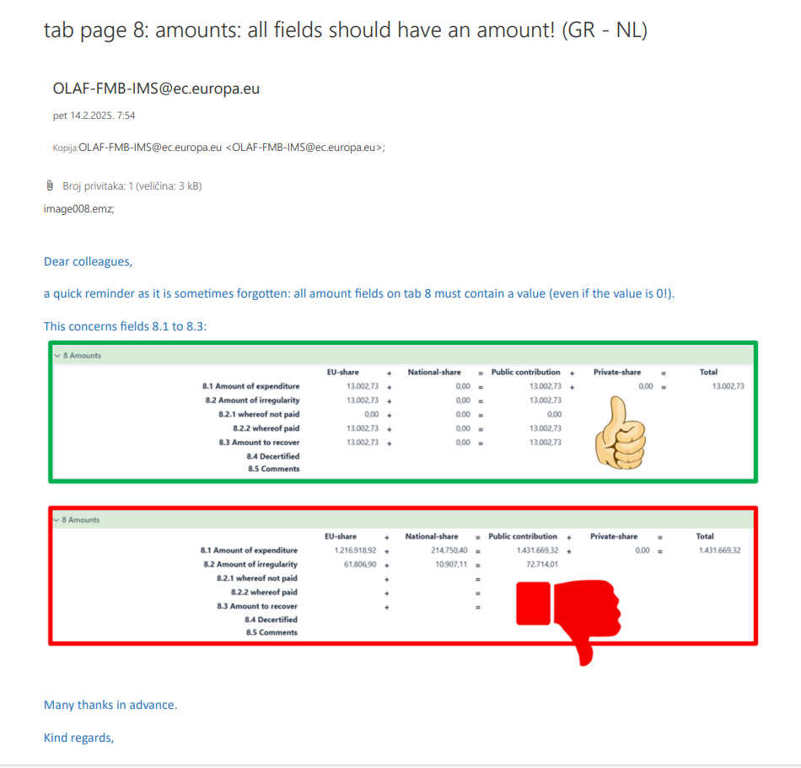
- Field 10.1 Procedures initiated to impose penalties must be completed with the appropriate value: SP1, SP2, SP3, or SP4.

- Use field 11.1 Comments - Initiating authority for additional information that does not fit under modus operandi or any other relevant case notes.

- Attach the Conclusion on irregularity (Annex ) and any other necessary documents in field 11.4 Attachments description

This refers to so called initial reporting.

