

EDUCATION ENERGY EFFICIENCY PROJECT IN MONTENEGRO
NON-TECHNICAL SUMMARY
AUGUST 2024

Client: | European Bank for Reconstruction and Development (EBRD)
Project: | Education Energy Efficiency Project in Montenegro
Document: | Non-technical Summary
Support in preparation: | ENOVA
Date: | August 2024

Contents
Abbreviations 2
1 Introduction 3
2 Brief Project Description 4
3 Environmental and Social Impacts/Risks and Mitigation Measures 9
4 Disclosure and Communication 13
5 Appendices 14
Appendix A: Locations of Project buildings 14

Abbreviations
ACM | Asbestos-Containing Materials
ACMMP | Asbestos-Containing Materials Management Plan
CESMP | Construction Environmental and Social Management Plan
CWMP | Construction Waste Management Plan
EBRD | European Bank for Reconstruction and Development
EE | Energy Efficiency
E&S | Environmental and Social
ESMP | Environmental and Social Management Plan
ESP | Environmental and Social Policy
GBVH | Gender-based Violence and Harassment
GHG | Greenhouse Gases
MoESI | Ministry of Education, Science and Innovation
NTS | Non-technical Summary
OHS | Occupational Health and Safety
PIU | Project Implementation Unit
PV | Photovoltaic
RE | Renewable Energy
SEP | Stakeholder Engagement Plan
TMP | Traffic Management Plan

Introduction
Project background. EBRD is considering providing financing to the Ministry of Education, Science and Innovation (“the Ministry” or “MoESI”) for the execution of energy efficiency (EE), renewable energy (RE), accessibility, and safety enhancements in 24 educational buildings in 10 cities in Montenegro (“the Project”).
For more details on the specific measures to be implemented and a comprehensive list of the educational buildings involved, please refer to Chapter 2 Brief Project Description.
The Project has been classified as category "B" according to the EBRD's Environmental and Social Policy (ESP) of 2019.
Project implementation arrangements. The MoESI has the overall responsibility for Project preparation and implementation. The Project will be managed by a Project Implementation Unit (PIU). A PIU Support Consultant will be engaged to provide expertise in tendering procedures, environmental and social (E&S) monitoring and overall Project reporting. Construction works will be carried out by third party Contractors.
Compliance with local requirements. Obtaining permits and authorisations for each Project building depends on the final scope of works and the development of the Main Designs. The Law on Spatial Planning and Construction distinguishes between the requirements for remodelling and reconstruction activities. The owner of the building or investor, in this case the MoESI, must accurately present all works to be carried out and apply for the appropriate permits and authorisations to the Ministry of Spatial Planning, Urbanism, and State Property – Directorate for Inspection Supervision and Licenses.
If the Project activities are categorised as remodelling, the legal process requires only the submission of application(s) before starting the works. For the remodelling of Project buildings in Kotor, which is inscribed on the UNESCO World Heritage List as a natural and cultural asset, no conservation conditions will be required in case Project activities are considered maintenance works.
If the construction works are categorised as reconstruction, it will be necessary to obtain permits and approvals, such as Urban-Technical Conditions, Contractor permits/approvals, and Notification of Building Works. In addition to these, obtaining Conservation Conditions will be required for works in Kotor.
According to Montenegrin regulations, an environmental impact assessment or Environmental Permit is not required for the Project.
Compliance with EBRD and EU requirements. The Project will be fully designed and implemented in accordance with the EBRD ESP and its Performance Requirements. It is also compliant with a range of EU requirements, primarily the Energy Efficiency Directive, Energy Performance of Buildings Directive, European Climate Law, and Renewable Energy Directive II.
This document is the Non-technical Summary (NTS) of the E&S Assessment of the Project, carried out in the period June – July 2024. The NTS provides a Project summary in non-technical language covering the Project background and description, legal requirements, E&S impacts with mitigation measures needed to structure the Project to meet the EBRD ESP 2019, and the disclosure and communication requirements of the Project. This NTS is part of the Project’s disclosure package developed during the E&S Assessment, together with the Stakeholder Engagement Plan.

Brief Project Description
Project buildings. Project buildings are spread throughout entire Montenegro, covering both the continental and coastal regions of the country, and include two kindergartens, 18 primary schools, three secondary schools and one university dormitory:
Table 1: List of Project buildings
City/Municipality​ | Project Building​
Bar​ | - Primary school “Blazo Jokov Orlandic”  - Primary school “Meksiko”  - Secondary school “Gimnazija Niko Rolovic”  - Primary school “Kekec”
Budva​ | - Primary school “Stefan Mitrov Ljubisa”  - Kindergarten “Ljubica V. Jovanovic – Mase”​
Gusinje​ | - Primary school “Dzafer Nikocevic”
Herceg Novi​ | - Primary school “Milan Vukovic”
Kotor​ | - Primary school “Narodni heroj Savo Ilic”​  - Secondary schools Gimnazija and Srednja pomorska skola​  - Primary school “Nikola Djurkovic”
Niksic​ | - Primary school “Ratko Zaric”​  - Primary school “Olga Golovic”​  - Kindergarten “Dragan Kovacevic”​  - Primary school “Luka Simonovic”​  - Primary school “Pavle Kovacevic”​
Podgorica​ | - Primary school “Pavle Rovinski”  - Primary school “Sutjeska”  - Primary school “Dr Dragisa Ivanovic”​  - University dormitory Podgorica​
Rozaje​ | - Primary school “25. maj”
Tivat​ | - Primary school “Drago Milovic”​  - Mixed secondary school “Mladost”​
Zabljak​ | - Primary school “Dusan Obradovic”
Detailed maps of the buildings in each city/municipality are available in Appendix A: Locations of Project buildings.

The majority of the Project buildings have previously undergone construction or renovation works, indicating a familiarity with managing such projects. All Project buildings have main, and alternative entrances, which can facilitate continued access and reduce inconveniences during construction works. Five of the institutions (Secondary school “Gimnazija Niko Rolovic”, Primary school “Stefan Mitrov Ljubisa”, Secondary school “Gimnazija Kotor”, Primary school “Nikola Djurkovic” and Primary school “Dusan Obradovic”) share their buildings with other educational institution. Four buildings lease space to private entities and sports clubs (Primary school “Blazo Jokov Orlandic”, Secondary school “Gimnazija Niko Rolovic”, Primary school “Stefan Mitrov Ljubisa” and Primary school “Narodni heroj Savo Ilic”). Although none of the buildings are under cultural protection, the facades of at least three institutions (Primary school "Stefan Mitrov Ljubisa“, Primary school "Sutjeska“ and University dormitory Podgorica) are protected by intellectual property rights.
Most of the Project buildings are not near surface water bodies within a 300-meter radius, with exceptions in Budva (Kindergarten “Ljubica V. Jovanovic – Mase”), Herceg Novi (Primary school “Milan Vukovic”), and Gusinje (Primary school “Dzafer Nikocevic”). They are also not close to major sources of air or noise emissions, reducing environmental risks during construction. Several Project buildings have suffered climate-related damage in recent years, highlighting their vulnerability to adverse weather conditions.
Project measures. The Project will involve twelve EE and RE measures, along with the five supplementary (non-EE) measures, as presented in Table 2 below. These measures are selected based on the Feasibility Study and EE audits conducted for all Project buildings from November 2023 to June 2024. The Main Designs for the Project are yet to be developed.
Table 2: Proposed Project measures
Measure | Short description
EE and RE measures
(M1) External wall insulation (in 22 buildings) | Implementation of a contact thin-layer system to uninsulated facades
(M2) Roof insulation (in all buildings) | Heat and water insulation of roofs
(M3) Openings replacement (in 14 buildings) | Installation of new PVC windows and doors
(M4) Lighting system replacement (in all buildings) | Installation of high efficiency luminaires
(M5) Heat pump installation (in 7 buildings) | Installation of new heat pump systems to replace old and inefficient fuel oil heating systems and/or electric heaters
(M6) New pumps (circulators) installation (in 22 buildings) | Replacement of heating systems’ old pumps with new ones equipped with inverters
(M7) Thermostatic radiator valves installation (in 17 buildings) | Installation of energy-efficient valves in radiators to control room temperature
(M8) Photovoltaic (PV) system installation (in 18 buildings) | Installation of PV modules on roofs or nearby ground to provide part of the required electricity for building’s operation
(M9) Boiler upgrade (in 5 buildings) | Dismantlement of existing fuel oil boilers and installation of new high-efficiency boilers
(M10) Solar collector installation (in 2 buildings) | Installation of a solar system for preparation of domestic hot water system on the building’s roof
(M11) Building Management System installation (in all buildings) | Installation of a central control system with local energy monitoring
(M12) Water savings measures (in all buildings) | Installation of water-saving fixtures, rainwater harvesting systems, water meters, and conducting water usage and efficiency audits
Non-EE measures
(M13) Accessibility ramps (in 9 buildings) | Installation of accessibility ramps to enhance inclusivity and usability
(M14) Electrical system renovation (in 21 buildings) | Renovation of electrical systems, including new main and sub-switchboards
(M15) Fire system improvement (in all buildings) | Installation of fire hydrants, alarms, and development of evacuation plans
(M16) Removal of asbestos-containing materials (ACMs) (to be determined*) | Removal of asbestos-containing materials (ACMs) in locations where their presence is confirmed upon completion of asbestos survey  Note: The presence of ACMs has already been observed in some of the Project buildings. To ensure the safe implementation of the Project, a comprehensive asbestos survey will be conducted in all Project buildings before the commencement of any construction work.
(M17) Structural strengthening (in 2 buildings) | Crack repairs and stabilisation with piles and carbon strips
*The buildings where this measure will be implemented are to be determined upon completion of asbestos surveys.
Table 3 below summarises proposed measures for each Project building. Cells shaded in blue indicate the measures that will be implemented.
Table 3: Proposed measures for each Project building
City/  Municipality | Project building | M1 | M2 | M3 | M4 | M5 | M6 | M7 | M8 | M9 | M10 | M11 | M12 | M13 | M14 | M15 | M16 | M17
Bar | Primary school "Blazo Jokov Orlandic”
 | Primary school "Meksiko“
 | Secondary school "Gimnazija Niko Rolovic“
 | Primary school "Kekec”
Budva | Primary school "Stefan Mitrov Ljubisa“
 | Kindergarten "Ljubica V. Jovanovic - Mase“
Gusinje | Primary school "Dzafer Nikocevic“
Herceg Novi | Primary school "Milan Vukovic“
Kotor | Primary school "Narodni heroj Savo Ilic“
 | Secondary schools Gimnazija and Srednja pomorska skola
 | Primary school "Nikola Djurkovic“
Niksic | Primary school "Ratko Zaric“
 | Primary school "Olga Golovic“
 | Kindergarten "Dragan Kovacevic“
 | Primary school "Luka Simonovic“
 | Primary school "Pavle Kovacevic“
Podgorica | Primary school "Pavle Rovinski“
 | Primary school "Sutjeska“
 | Primary school "Dr Dragisa Ivanovic“
 | University dormitory Podgorica (a) – Dom I
 | University dormitory Podgorica (b) – Dom II
 | University dormitory Podgorica (c) - Restaurant
Rozaje | Primary school "25. maj“
Tivat | Primary school "Drago Milovic“ |  | *Note
 | Mixed secondary school "Mladost”
Zabljak | Primary school "Dusan Obradovic“

Scheduling of construction works. Considering the full occupancy of most Project buildings, a phased implementation schedule is necessary. More extensive works are planned during the summer and winter breaks, as well as during weekends or after operating hours. Contractors will coordinate preferred construction schedules with the PIU and buildings’ representatives.
Project benefits. The proposed Project is expected to deliver a range of E&S benefits:
- The introduction of EE measures is anticipated to reduce energy consumption in the Project buildings, leading to lower GHG emissions and reduced operating costs. Additionally, the installation of heat pumps and PV systems will decrease reliance on fossil fuels, thereby reducing dependence on electricity from the grid.
- Upgrading building insulation and replacing windows and doors are expected to improve indoor comfort, helping to maintain cooler temperatures in summer and warmer temperatures in winter. This will enhance the buildings' resilience to changing climate conditions.
- Insulating the roofs is projected to address issues related to heavy rainfall, such as leaks, which have been commonly reported in many Project buildings.
- Implementing water-saving measures will contribute to resource conservation while simultaneously lowering operating costs.
- Upgrading electrical systems, enhancing fire protection, removing ACMs, and strengthening the building structures are aimed at improving the safety of the Project buildings, thereby reducing risks for occupants.
- The addition of accessibility ramps will increase inclusivity, making the buildings more accessible for persons with disabilities.
- The Project is expected to generate employment opportunities in the local construction and energy sectors.
- By enhancing the energy efficiency of the Project buildings, the initiative will support Montenegro's Nationally Determined Contribution and strategic documents, including the country's Energy Development Strategy.

Environmental and Social Impacts/Risks and Mitigation Measures
The identified negative E&S impacts of the Project are site-specific and can be effectively avoided, reduced or remedied through the implementation of mitigation measures outlined in the Project's E&S Management Plan (ESMP) and the E&S Action Plan. Measures are defined for both the construction and design phases to ensure that specific provisions are integrated into the Main Designs, preventing potential impacts from arising later on.
To effectively manage identified risks and impacts in the construction phase, the Contractors will need to develop and implement a Construction Environmental and Social Management Plan (CESMP), based on the prepared ESMP. The CESMP will encompass Construction Waste Management Plan (CWMP), Traffic Management Plan (TMP), OHS Plan, and ACMs Management Plan (ACMMP) where applicable.
A summary of potential E&S impacts is provided below, followed by measures to be put in place to mitigate any such impacts/risks. The PIU will oversee the implementation of specified mitigation measures.
- Biodiversity: Unused attics can serve as habitats for certain bird and bat species, which is particularly relevant due to the planned roof renovations for all Project buildings. Planned roofing works could impact these species, so it is essential to take them into consideration during the planning and execution of this measure, to mitigate any negative effects on local biodiversity.
At each Project building with an attic, if bird nests or bats are found prior to the commencement of construction works, the CESMP will include specific measures for relocation of these species. These measures include consultations with local environmental authorities, relocation outside the nesting season, and engaging a qualified ecologist for execution and monitoring of measures.

- Soil: No impact on soil quality is expected during the implementation of Project’s indoor activities. However, during construction works on the external parts of Project buildings, the quality of surrounding soil could be affected by movement of heavy machinery and potential spills of hazardous substances, such as fuel and oil. It is important to note that these are considered localised accidental situations with a limited spatial extent and are not anticipated to occur during the regular course of construction activities. Improper disposal of hazardous waste, including waste fuels and lubricants, waste from electrical and electronic equipment, and particularly waste containing asbestos, may also lead to soil contamination.
The CESMP will include specific measures for hazardous substance management during construction works, including the appropriate storage of oils, lubricants and other hazardous substances, immediate remedial actions in case of accidental spills, equipment integrity checks and more. Measures defined under the point Waste and Hazardous Materials below will be implemented as well.

- Waste and Hazardous Materials: The generation of construction waste, small quantities of municipal waste and hazardous waste is inevitable. This includes paints, adhesives and significant amounts of waste from electrical and electronic equipment, resulting from the replacement of lighting fixtures, PV systems installation, and the upgrade of electrical infrastructure. A particular concern is the generation of asbestos-containing waste, especially during the planned works on building envelopes.
As part of CESMP, the Contractors will develop and implement CWMP, which will include measures for waste separation, appropriate storage, and disposal by authorised third parties. In all Project buildings, a comprehensive asbestos survey will be conducted during the Project’s preparation phase, and ACM Registers will be prepared for each building where ACMs presence is confirmed. Where applicable, an ACMMP tailored specifically to each building will be developed, based on the already developed Framework ACMs Management Plan. These ACMMPs will provide clear actions and procedures for safe ACM management and removal.

- Water: Potential adverse impacts on groundwater from spilled grease and oil are unlikely, as substantial pollutants would be needed for contamination, and the planned construction activities have a very low probability of causing such a scenario. However, there is a risk of surface water pollution due to hazardous substance spills from heavy machinery and improper construction waste disposal. This risk is particularly relevant for Project buildings within a 300-meter radius of surface water bodies, such as Kindergarten "Ljubica V. Jovanovic - Mase" in Budva, Primary School "Milan Vukovic" in Herceg Novi, and Primary School "Dzafer Nikocevic" in Gusinje. It is important to emphasise that this impact is considered a localised accidental situation and it is not expected during regular construction activities.
The CESMP will include measures defined under Soil, with the addition of designating marked areas for temporary stockpiling of materials and waste, and defining "no-go" zones to prevent contamination, particularly along the Adriatic coast (in Budva and Herceg Novi) and Grncar River (in Gusinje).

- Air: During construction works, the quality of outdoor air will be temporary affected by increased dust emissions. Furthermore, the release of exhaust gases from machinery will be unavoidable. However, due to the nature of works, these impacts will be minimal and of temporary character.
The CESMP will include specific mitigation measures for air emissions management at construction sites. These measures will include regular maintenance of machinery and vehicles, the use of high-quality fuels, and regularly moistening the construction site to avoid the spread of dust. Simultaneous activities that may generate large amounts of dust will be avoided, and vehicle speed on gravel surfaces will be limited to reduce dust emissions. If cumulative impacts are expected with other developments in the area, an agreement on the schedule of execution of works will be organised with the contractor and the supervising engineer to avoid the simultaneous execution of works that generate large amounts of dust.

- Noise: The source of noise will be the planned works, including the operation of machinery and equipment, especially when drilling walls or ceilings or when hammering is required. The impact of noise during construction is of a temporary and confined character.
The CESMP will include noise mitigation measures such as using sound control devices on vehicles and equipment and ensuring all equipment is well-maintained and in good working order. Additionally, protective gear will be provided to workers. In accordance with the Communication and Coordination Procedure which will be established (please see Health and Safety Risks for Students/Children, Staff and Visitors below), school, dormitory, and kindergarten staff will be timely informed about scheduled works involving loud activities. If cumulative impacts are expected with other developments in the area, an agreement on the schedule of execution of works will be organised with the contractor and the supervising engineer to avoid the simultaneous execution of noise-intensive works.

Climate Change: Climate hazards identified at each Project site include extreme heat events, heavy rainfall, and exposure to floods, particularly for all buildings in Niksic. Coastal cities such as Bar, Budva, Herceg Novi, Kotor, and Tivat face drought risks, while water stress is projected in Gusinje, Niksic, Rozaje, and Zabljak. Project buildings at risk of wildfires include four primary schools in Bar, Kotor, Niksic, and Zabljak (Primary Schools "Kekec", "Nikola Djurkovic", "Pavle Kovacevic", and "Dusan Obradovic"), due to their proximity to significant vegetation and changing climate conditions. The implementation of Project measures will mitigate these hazards, prevent damage, and avoid service disruptions, while also contributing to climate change mitigation through a significant reduction in GHG emissions.
The Main Designs will need to adhere to the technical requirements outlined in the Montenegrin Regulation on Minimum Energy Efficiency Requirements for Buildings and consider the expected temperature rise when selecting equipment and materials. They will also incorporate comprehensive flood-resistant design principles, with an emphasis on using water-resistant materials and implementing effective waterproofing measures to minimise potential flood damage. As part of CESMP, an Emergency Preparedness and Response Procedure will be developed, outlining appropriate actions to safeguard workers’ health during extreme heat and rainfall events. Additionally, measures regarding fire protection, as defined under the point OHS below, will also be implemented.

- OHS: OHS challenges will emerge during construction activities and electrical works, associated with insulating external walls, replacing openings, constructing accessibility ramps, renovating or replacing electrical and lighting systems, installing heat pumps and related equipment, and setting up solar collectors and PV systems. Additionally, ACMs have been identified in some Project buildings, posing an additional risk to workers related to the removal of these materials.
To mitigate OHS impacts and risks, compliance with fire safety regulations will be addressed within Main Designs. Before construction begins, a thorough risk assessment to identify and mitigate potential hazards will be conducted, providing Method Statements for high-risk activities. An OHS Plan covering site organisation, equipment and hazard mitigation will be developed and regularly updated. Moreover, qualified workers will be employed, and safety protocols and training provided. An Emergency Preparedness and Response Procedure will be developed, outlining plan, actions and responsibilities in case of emergency. Sufficient types and quantities of firefighting equipment will be ensured and available at the construction site, and all personnel will be trained in the proper use of this equipment. In Project buildings where ACMs are identified, an ACMMP will be developed and strictly followed.

OHS risks have also been identified for the operational phase. Some educational facilities have developed essential documents such as an OHS Plan, Job Hazard Analysis, and Emergency Preparedness and Response Procedure, while others lack these procedural frameworks needed to effectively address OHS concerns in their day-to-day operations. Consequently, activities proceed routinely without clearly defined procedures delineating roles and responsibilities, creating a gap in the systematic implementation of safety protocols.
To address OHS challenges, all Project buildings will conduct a thorough Job Hazard Analysis, assessing newly introduced roles and tasks, while defining necessary measures and equipment for a secure work environment. The Rulebooks on OHS and Safety Manuals will be revised to encompass newly introduced risks associated with the operation and maintenance of the new infrastructure. Additionally, maintenance and operation training sessions for technical staff in educational buildings will be organised post-Project completion, tailored to address specific job risks. Corrective measures defined in the developed Framework Life and Fire Safety Report will be implemented in all Project buildings, with their implementation monitored by the Ministry.

- Health and Safety Risks for Students/Children, Staff and Visitors: To minimise disruptions, most preferable option for the planned construction works is during summer or winter breaks. Relocating students during construction is generally not feasible for most educational institutions, though a few could manage with substantial planning. Nonetheless, construction activities introduce several health and safety concerns for students/children, staff and visitors, including:
- Demolition and drilling operations will release dust and particulate matter, posing a risk of air contamination if not managed properly.
- Painting, adhesive application, flooring and certain activities emit VOCs and chemical fumes.
- Construction materials and processes can generate lingering unpleasant odours.
- Refurbishment activities involving loud machinery and construction works can lead to heightened noise levels within and around the building’s environment.
- Overhauls of electrical distribution systems carry the potential for electrical accidents, such as shocks or fires, if proper safety measures are not adhered to.
Furthermore, the introduction of construction workers into the sensitive environment of educational public institutions may pose a gender-based violence and harassment (GBVH) risk. Additionally, given the importance of the educational institutions and the vulnerability of the population they serve, it is crucial to proactively address the risks associated with earthquakes, especially since Montenegro is in earthquake-prone region. Construction activities might lead to increased traffic congestion and temporary closures of access paths, which could inconvenience staff, students, and guardians trying to reach the institutions. However, this risk is minimal because these facilities have multiple access routes, and construction is scheduled for times when students are not present. Still, it is important to note that some facilities stay open year-round, so there remains a slight chance of disruption.
To mitigate the impact of indoor air emissions during construction works, the CESMP will include mitigation measures such as dust control, the use of low-VOC materials, and regular cleaning. To enhance coordination throughout the construction period, the PIU will establish a Communication and Coordination Procedure to include a formal coordination procedure among construction managers and representatives of educational institutions, outlining the processes for scheduling, executing and supervising construction activities, with a special emphasis on coordinating noisy construction works; weekly meetings of educational institutions staff to discuss works planned for each week, allowing class teachers to prepare for any disruptions or relocation of students to other classrooms if feasible, and ensuring that facility’s staff are regularly informed about potential health and safety issues and providing updated on EE measures being implemented as well as instructions on handling any safety incidents related to the works. GBVH risks will be minimised through implementation of mandatory GBVH training for construction workers, enhanced monitoring, the use of physical barriers, and careful planning of construction schedules. All educational institutions will develop Earthquake Emergency Plan in line with the National Earthquake Protection and Rescue Plan. Additionally, Contractors will develop TMP to mitigate traffic congestion and ensure unobstructed emergency evacuation routes.

- Cultural Heritage and Intellectual Property: Some educational institutions have statues or memorials to Second World War freedom fighters, which, while not officially protected, hold cultural and historical significance for the local community. During construction, there is a risk these could be damaged. Additionally, facades of at least three schools are protected by intellectual property rights. Work affecting these areas requires permission from the rights holders to avoid legal issues, compensation claims, or work stoppages.
To mitigate the risk associated with cultural heritage and intellectual property, PIU will ensure that Contractors protect statues and memorials during construction and, if needed, safely relocate them in consultation with educational institution representatives. Additionally, the PIU will verify intellectual property rights with state authorities during the Main Design phase and secure necessary permissions or adjust the design to avoid protected areas.

- Communication and Grievances: The existing grievance procedures for education in Montenegro cover mechanisms for users of public educational institutions to communicate and file complaints. Public educational institutions typically use Viber groups, email, teachers' councils and notice boards for internal communication, while external channels include meetings with the Parents' Council, announcements in local media, and notices at school entrances.
To mitigate the risk of inefficient communication, it will be crucial to coordinate between educational institutions and the PIU regarding any complaints received during construction. Additionally, a public grievance mechanism will be established by the PIU in line with the Stakeholder Engagement Plan. The PIU will manage grievances and track them by type, including those related to GBVH. At least 30 days before construction starts, the PIU will issue a notice about the work schedule and grievance mechanism, published on relevant websites, displayed at key locations, and sent to business users. The Contractors will also post a site sign with details on the construction schedule and PIU contact information.

- Labour and Working Conditions: All construction works will be performed by third-party Contractors, who must adhere to national labour legislation. However, due to the construction industry's characteristics, such as seasonal work patterns and multiple subcontracting levels, there are potential risks of labour regulation non-compliance, including undeclared work and long hours, or unavailability of a worker grievance mechanism if not properly managed. In the context of public procurement for PV modules, potential risks also include non-compliance with labour standards by suppliers.
The PIU will mandate Contractors to comply with labour laws, establish worker grievance mechanisms and oversee Contractor performance through the Supervision Engineer. While child labour or forced labour are not anticipated due to national labour legislation, to further mitigate risks, the Contractors will be required to submit, prior to procurement of the PV modules, a self-declaration from the manufacturer stating their products are free from child or forced labour, along with evidence of the manufacturer’s policy prohibiting such practices in their operations and supply chain.

Disclosure and Communication
A Stakeholder Engagement Plan (SEP) has been developed to identify stakeholders, outline engagement methods and establish a grievance mechanism specific to the Project. The SEP aims to transparently communicate the stakeholder engagement program throughout the entire Project cycle, facilitating timely decision-making and encouraging active involvement of stakeholders.
The PIU will disclose this NTS, the SEP, the Project Grievance Leaflet and the Project Grievance Form as early as possible in the Project development process. These documents will be available in Montenegrin and English language in electronic and printed forms on the website of the Ministry (https://www.gov.me/mps) and its physical address (Vaka Đurovića BB, Podgorica, Montenegro). The PIU will also ensure that all educational institutions publish the link with the documents on their websites.
After disclosure, stakeholders will have a period of one month to provide feedback (their opinions and suggestions with regard to the Project). To encourage feedback, the PIU will (in parallel with disclosure) publish on the Ministry’s website and ensure that all educational institutions publish on their websites a notification with the contact person details of the PIU, as well as the timeframe for sending feedback. All comments and proposals will be considered by the PIU. A brief report (“comments matrix”) on comments/proposals received and responses from the PIU will be published on the Ministry’s website following the public review period.
The PIU will commit to providing clear information about the planned construction activities. This will include publishing a notice detailing the start and duration of the works, along with the Public Grievance Leaflet and Project Grievance form, at least 30 days before the start of the works through:
- the websites listed above
- displaying the notice at the entrances to the educational institutions (and the reception counter of the University dormitory Podgorica)
- displaying the notice at the entrances of spaces that educational institutions lease to business users and/or sending the notice to business users by email or post.
Note that any concerns can be reported to the PIU verbally (personally or by telephone) or in writing using the Project Grievance Form (submitted in person, by mail, or email above). Grievances may also be submitted anonymously or without the use of the form if preferred. After construction begins, the form can be submitted to the Contractors or Supervision Engineer, who will forward it to the PIU within 24 hours for processing.
PIU contact information:
Education Energy Efficiency Project in Montenegro – Project Implementation Unit
Email: kabinet@mpni.gov.me
Tel. +382 20 410 100
Address: Vaka Djurovica BB, 81000 Podgorica
Website: www.gov.me/mps

Appendices

Appendix A: Locations of Project buildings
Legend:
Kindergartens
Primary schools
Secondary schools
Student dormitories

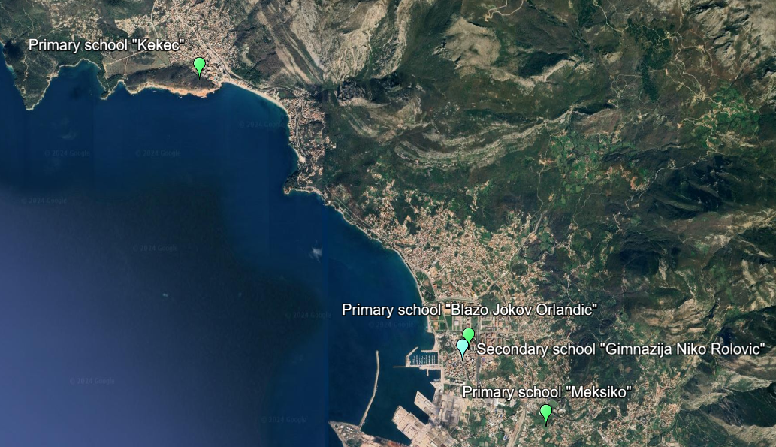
Figure 1: Project buildings in Bar
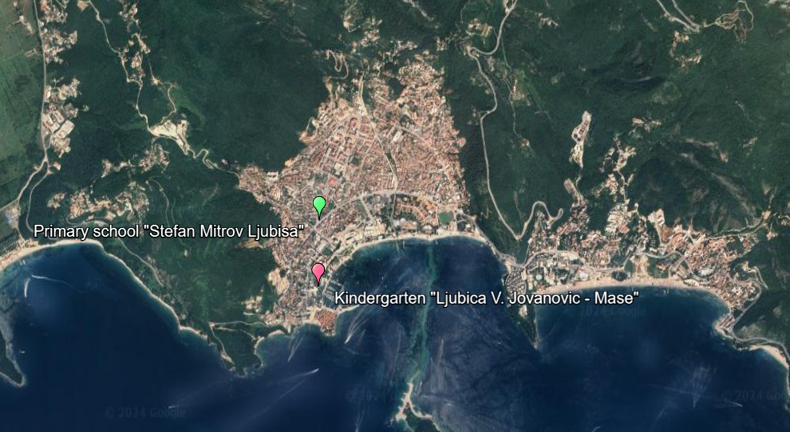
Figure 2: Project buildings in Budva
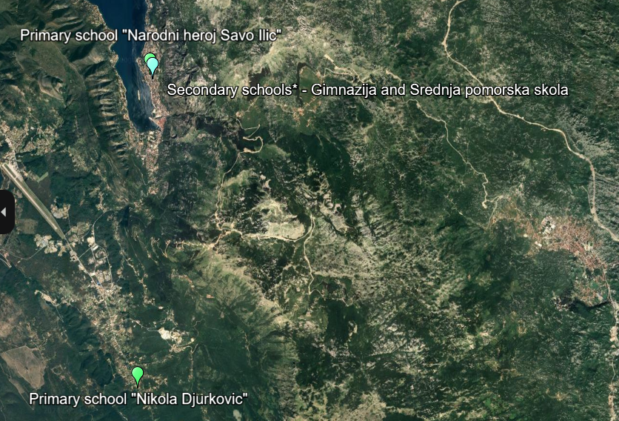
Figure 3: Project buildings in Kotor
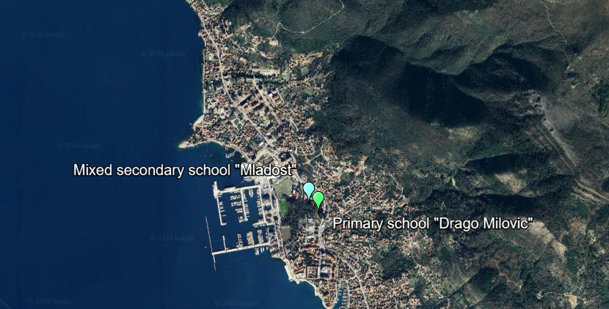
Figure 4: Project buildings in Tivat
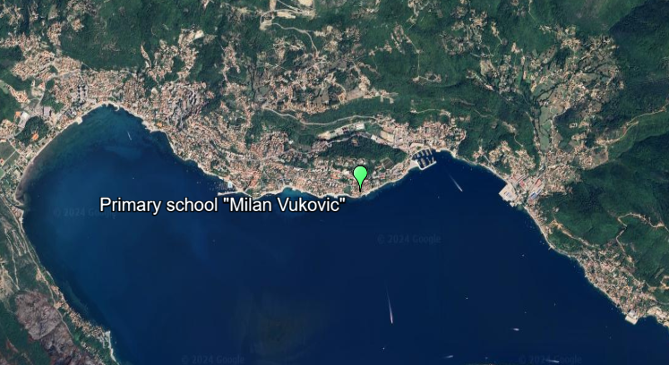
Figure 5: Project buildings in Herceg Novi
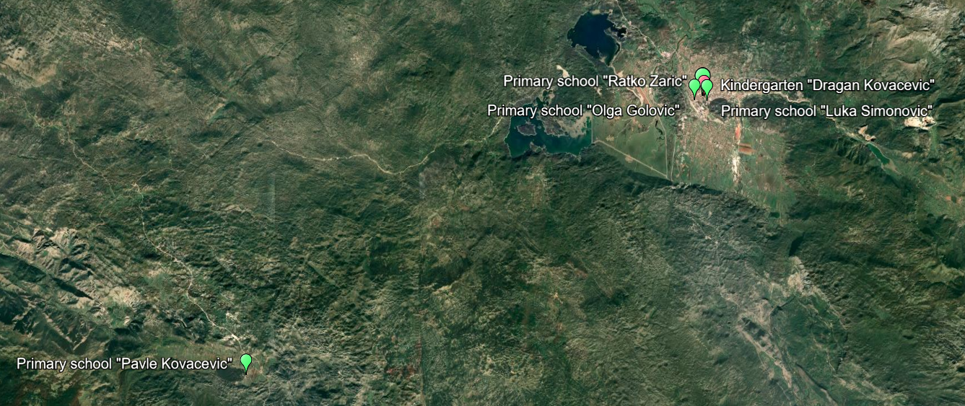
Figure 6: Project buildings in Niksic
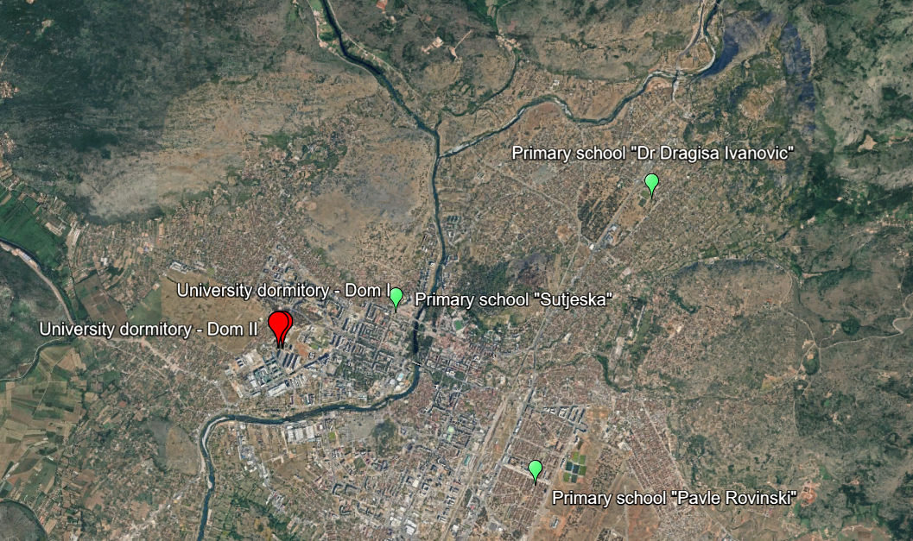
Figure 7: Project buildings in Podgorica
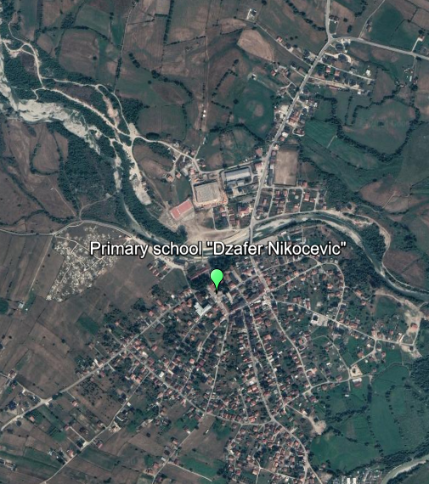 | 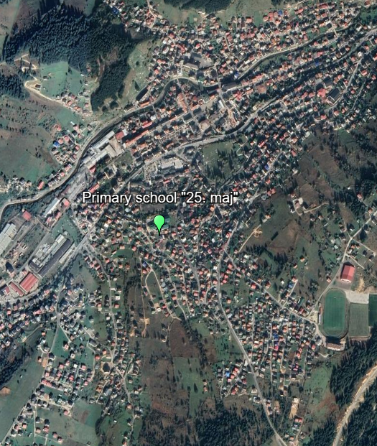
Figure 8: Project buildings in Gusinje (left) and Rozaje (right)
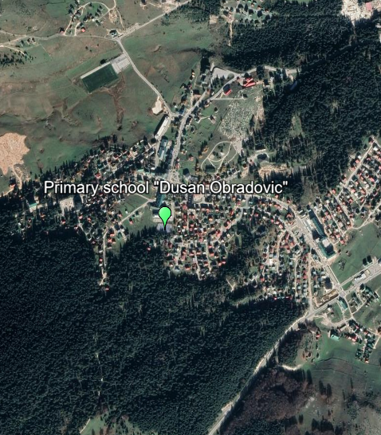
Figure 9: Project building in Zabljak

These cities include: (i) Bar, (ii) Budva, (iii) Gusinje, (iv) Herceg Novi, (v) Kotor, (vi) Niksic, (vii) Podgorica, (viii) Rozaje, (ix) Tivat and (x) Zabljak.
According to the EBRD Environmental and Social Policy (ESP), a project is categorised “B” when its potential environmental and/or social impacts are typically site-specific, and/or readily identified and addressed through effective mitigation measures.
Remodelling means works on the existing structure which: change the organisation of space in the structure, replacement of equipment and installations not affecting the structural stability and safety, do not change the external appearance, etc.
Reconstruction means works resulting in: extensions and additions, repairing of damaged structures, reinforcing the construction, other works impacting structure stability and safety, changing structural elements, altering the external appearance of the building, etc.
For ease of reading purposes, all educational buildings are referred to as “Project buildings”.
Please note that the University dormitory consists of three facilities: 20.a – Dom I (dormitory building No. 1), 20.b – Dom II (dormitory building No. 2) and 20.c. Restaurant/café)
As stated above, this measure is expected to be applicable to other buildings as well. The buildings where this measure will be implemented are to be determined upon completion of asbestos surveys.
This measure was initially included for this school per the Feasibility Study. However, a public procurement announcement for roof repair was announced in March 2024. Therefore, it is reasonable to assume that M2 will not be implemented in this school as initially planned.

