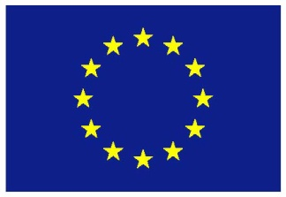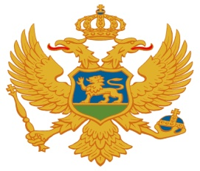

**Invitation to submit an Expression of Interest for participation ingeneral training courses in connection with development and implementation of H2020 project proposals**

The Ministry of Science announces this Invitation to submit an Expression of Interest for participation in general training courses in connection with development and implementation of H2020 project proposals, implemented under the project “Increasing Montenegrin capacities for participation in HORIZON 2020” which is financed by the European Commission (IPA - Operational Programme for Human Resources Development 2012-2013).

Horizon 2020 is a 7-year EU Research and Innovation programme with nearly €80 billion of funding available from 2014 to 2020. The Montenegrin scientific research community’s experience with Horizon 2020 shows a satisfactory number of applications submitted, but an inadequate level of quality in terms of prepared budget documents and consortium members. This may be explained by the complexity of procedures, current international and national funds for the scientific community and lack of adequate networking skills and experience in drafting Horizon 2020 project proposals.

The Government of Montenegro strongly supports participation in Horizon 2020 (H2020), but recognizes the need to strengthen national capacities for participation in H2020 which should lead to improved success rates.

An international consultancy company (IBF) will provide support to increase Montenegrin capacities for participation in H2020 within the areas of **Agriculture, Food Safety, Health and ICT.** One of the components of this support includes general training courses which will focus on:

* HORIZON 2020 (purpose, types of Calls, searching for partners, how to apply, etc.);
* Proposal writing: Preparation of Technical Proposals and Budgets for HORIZON 2020 Calls for Proposals (emphasis on practical exercises);
* Project Implementation: grants financed under HORIZON 2020 (project management, administrative and contractual provisions, financial management, best practices, etc.);
* Project Cycle Management.

This assistance will be provided in **6 different training cycles** which will be held during the project period which finishes in November 2017.

**The sixth training cycle will be held from 09th - 13th October, 2017 (Training courses are of 5 working days duration (Monday to Friday)).**

**The venue is Ministry of Science (Meeting Room, Rimski trg bb, Podgorica, Montenegro).**

Lunch and refreshments will be provided as well as accommodation and travel costs for those participants who are coming from outside of Podgorica.

Target groups are scientific research institutions, public sector and SMEs.

The official language of the training courses will be English.

*Notice: In case you are selected you will be asked to bring a lap top with you.*

**Time table**

**Deadline: 2nd October 2017**

**Please submit your Expression of Interest (name of organisation, position and contact details) electronically to:**

Ministry of Science

Att: Ivana Lagator

E-mail: [ivana.lagator@mna.gov.me](mailto:ivana.lagator@mna.gov.me)

Tel: +382 67 590 902