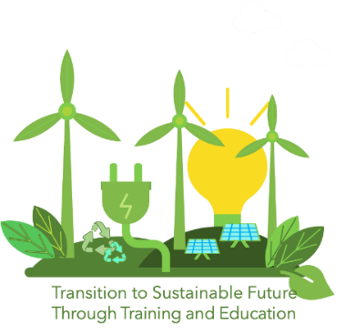
APPLICATION FORM FOR THE COMPETITION
FOR THE BEST DRAWING

Project Title: TRANSITion to Sustainable Future Through Training and Education – TRANSIT
The primary schools and their pupils of ages 7-11 are invited to take part in the competition for the best drawing depicting renewable energy, organized by TRANSIT project. The winner of the competition will receive a present offered by the organiser, while the school of the winner will receive a national trophy and 300 Eur. If you are willing to participate in the competition, please complete and sign this application form and return it to the following email address with attached drawings (as photos or scanned versions) _____________________.

- General data
Primary school name
Address
E-mail address
Website
Drawing 1 | Author’s name and surname
 | Age
 | Gender
 | Title of drawing
Drawing 2 | Author’s name and surname
 | Age
 | Gender
 | Title of drawing
Drawing 3 | Author’s name and surname
 | Age
 | Gender
 | Title of drawing
Drawing 4 | Author’s name and surname
 | Age
 | Gender
 | Title of drawing
Drawing 5 | Author’s name and surname
 | Age
 | Gender
 | Title of drawing
Drawing 6 | Author’s name and surname
 | Age
 | Gender
 | Title of drawing
* Please, insert rows for each participating drawing.

- Drawings
Attach the drawings. Please, indicate clearly the serial number of each drawing.

- Participant’s statements
Please tick the appropriate boxes
- I certify that all information provided in this application form is correct.
- I agree to take part in the competition for the best drawing.
- I confirm that each participating child-author gave consent to have the drawing published on the TRANSIT project and EU platforms.

_____________________ ______________ __________
Name of Participant Date Signature

