SCHOOL | HIGH SCHOOL OF ECONOMICS „MIRKO VESOVIC“ PODGORICA
TEACHERS | Violeta Đukanović  Božana Vujadinović  Adrijana Mugoša | DATE | 14th February, 2023.
TEACHING ACTIVITY | Experimetal lesson- Eco School  Activities dedicated to World’s day of Energy preservation (14th February) i World's Day of Energy efficiency (5th March) | GRADE AND CLASS | 3rd and 4th grade  3-1 class and 4 -1class
TOPIC | DO GOOD, SAVE THE ENERGY  (Energy and energy efficiency) | NUMBER OF LESSONS  2 (two) | Two-day activity:  -rasearch  (until 15th February.);  -experminmetal lesson implementation (on 15th February, two consecutive lessons);
EDUCATIONAL OUTCOMES | - To train students to identify problems related to energy efficiency;  - To present to students the advantages and disadvantages of using various energy sources;  - To recognise problems related to energy consumption and proposes possible solutions to the problem situation;  - To identify elements of energy efficiency of living space;  - To analys the energy efficiency of residential, commercial or public buildings and proposes measures to improve  - To adjust the way of presenting the results of the research to the specifics of the target group and the goal of the action;
LEARNING OUTCOMES | On completion of these outcomes the student will be able to:  - To define the importance of energy efficiency  - To observes the consequences of irresponsible energy consumption;  - To explain the process and procedure for calculating the carbon footprint  - To compare data on a quarterly basis (bills on consumed electricity and heating costs) and build personal satisfaction because he/she has played a significant role in energy efficiency through his responsible actions.  - To explain the importance of social responsibility and transfer acquired knowledge and habits at home
FORMS OF WORK | Individual, group, frontal
METHODS/  TECHNIQUES | Dialogue method, exposition method, presentation method, role playing method, demonstration method, explanation method.
TEACHING AID | Computers, smartphones, internet connection, PowerPoint Presentation, video recordings, gathered documentation ( project, invoices, bills)
PRE-LESSON ACTIVITIES | Students in groups with female teachers and a school janitor:  - They visit the school to perform an energy audit, and collect data that will be used to give an assessment of shortcomings in the school during the organized class and offer possible suggestions for improving energy efficiency in the school premises and for calculating the carbon footprint;  - They review the collected documentation (bills for consumed electricity, consumed water, heating costs ; construction project of the school with data on thermal insulation, ventilation, lighting, location of the school and exposure of rooms to the sun on the east side of the school ; existence of insulating strips on doors and windows, control locks on doors and windows, the existence of energy-saving light bulbs, all with the aim of creating a strategy for saving energy);
LESSON ACTIVITIES | Shown according to the parts of the lesson  Due to the volume of collected data and the great interest of the students in the topic of the class, the teachers decided to hold 2 lessons consecutively .
Introductory part of the lesson(preparatory phase-20 min) | - • Introduction to the topic and presentation of the objective of the lecture (discussion on the importance of energy, types of energy, division of energy sources into renewable and non-renewable ones, emphasis on solar energy and its use in school); To remind the students that our school was very notable and won the first prize at the Energy underlined in green competition, when it presented the construction of the first solar classroom in Montenegro, which would be powered by solar energy, i.e. Photovoltaic solar panels. Financial resources made it impossible to implement the project as a whole, which did not stop us from intending to realize the project in its entiretyin the future. We used the funds won in this competition to buy a solar bench, which found its place in the school yard.  - • The teacher informs the students about the need for energy efficiency, and measures that can be taken both on a personal level and at the level of the institution, and announces group work in which group representatives will present homework on energy conservation measures;  - • The teacher announces and presents the existing form/model for calculating the carbon footprint at the school level;
The main part of the lesson(operational phase) 50 min | Teacher activity:  - Before the start of the lecture, the teachers suggest watching the short film "7 ways to save energy", link https://www.iea.org/topics/saving-energy.  - In the film, it is proposed to conserve energy in the following way:  1. Method: To reduce the heating temperature by 1 degree in the rooms where you stay, students will be able to comment on the temperature in the rooms, ie. factual situation taken in the previous days, when teams of students led by female teachers were preparing for this lesson. Every month we will take data on the consumption of electricity and fuel oil and draw conclusions about savings.  2. Method: To reduce the temperature on the thermostat on the boiler. In the school, it was noted that there are 3 small boilers, two of which are connected to electricity and one to central heating. On all boilers, the temperature on the thermostat has been reduced in order to save energy. Suggestions were given to the students, considering that boilers in flats have a much larger volume, to reduce the temperature on the boiler thermostat at home and to compare two consecutive electricity bills. The differences in the accounts will be considerable.  3. Method: To check gaskets and locks on windows and doors, prevent the entry of cold air by installing special gaskets on the windows and repair damaged locks, in order to ensure maximum savings when heating rooms;  4. Method: To replace old light bulbs with LED bulbs, in order to ensure lower consumption. Energy-saving light bulbs are far more efficient because they last up to five times longer than regular ones and consume 5 times less electricity.  5. Method: To ride a bicycle on short distances (recommendation to come to school by bicycle), show the students that the school has a bicycle parking spaces under video surveillance  6. Method: To use city buses for transportation to school on longer distances (urban and suburban areas)  7. Method: To suggest students informing their parents when driving private cars to do it with an average speed and keeping the tires at the recommended pressure of 2.2 bar will save on fuel consumption.  - After the given recommendations, the teachers show the students the advantages and disadvantages of different energy resources, including the impact on the environment, health and safety, via a PowerPoint presentation. Students are introduced to the concept of energy efficiency. They show students how energy policy can affect energy production, as well as energy supply, demand and consumption.  - The teachers move on to explaining the carbon footprint, defining what the carbon footprint is and how it is measured. After that, the teacher shows each student how to use the CO2 calculator and how to calculate their carbon footprint in order to see for themselves how much carbon dioxide and other greenhouse gases they produce in their daily activities.  - The teachers give the project task "Analysis of energy efficiency in the school" (they give instructions for the work, asking at the beginning that the students prepare the data collected in the previous days)  - As part of the project assignment, the students together with the teachers enter the prepared data into the CO2 calculator for calculating the carbon footprint.  - 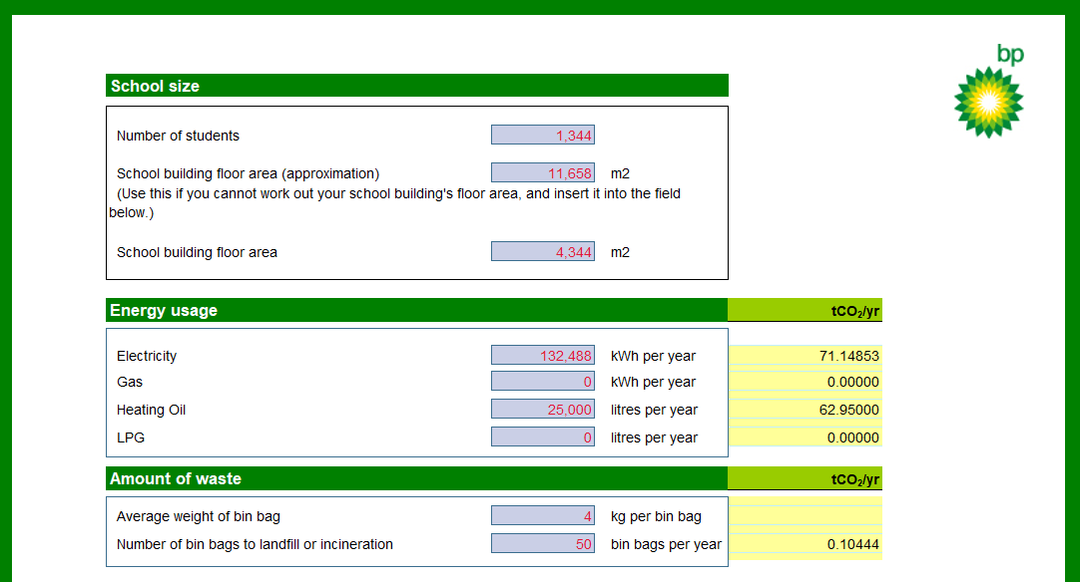  - 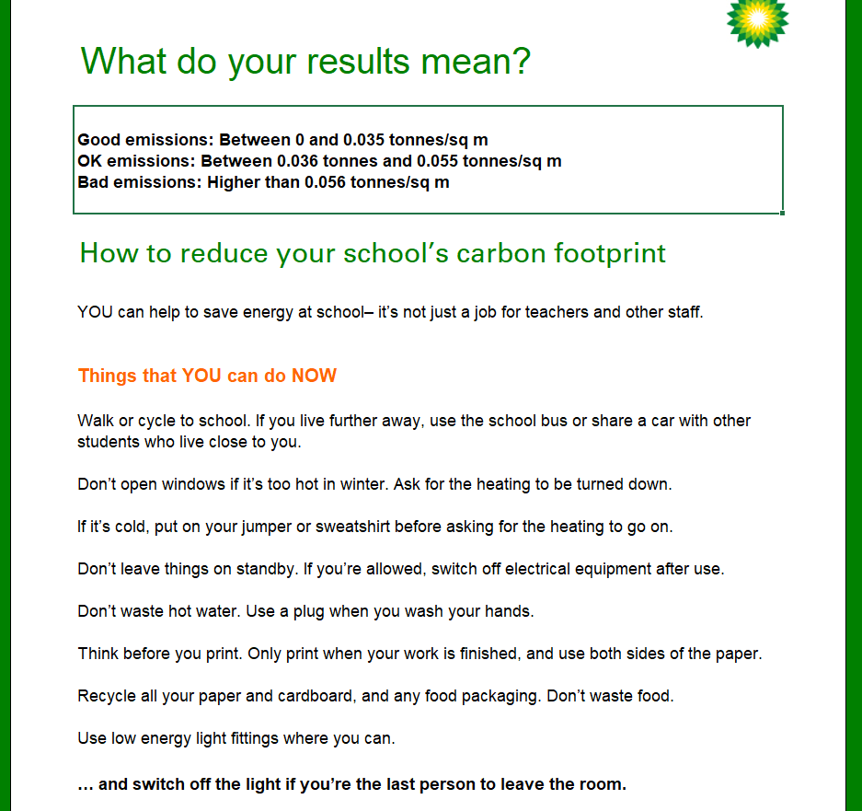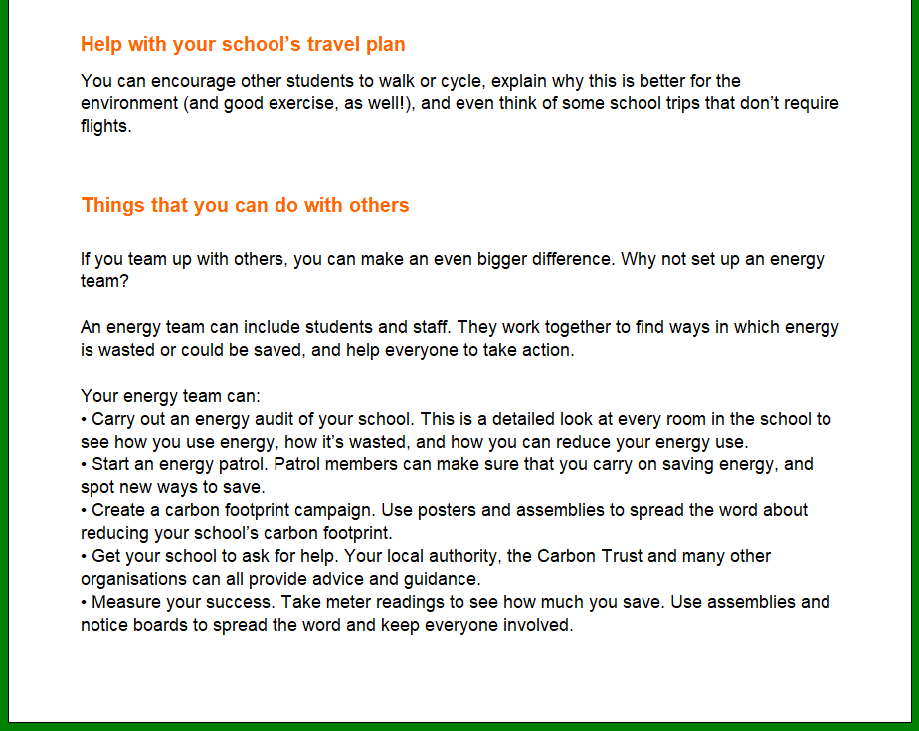  Students’ Activities:  - The students' task is to, using the knowledge and collected data, do a thorough analysis of energy consumption in our school.  - The students, in groups/teams, submit reports on their work as essential material for the further course of the lesson.  The students' task is to, using the knowledge and collected data, do a thorough analysis of energy consumption in our school. This includes electricity and heat. It is necessary that the condition and characteristics of the existing thermal insulation, carpentry, heating installation, ventilation, lighting, etc. which we found during the research for the needs of this lesson, (from the collected documentation and in the field),are compared to the standards that apply to energy efficiency classes. Then they should propose measures and make a conceptual project for improving the energy efficiency of the school building.  The project should contain an analysis of savings, investment and current costs. The essence of the task is to make an analysis of the total energy consumption during school operation (taking into account the months when students are on holidays, because they are not representative) and to offer a better solution for achieving greater energy efficiency.  At the beginning, for the purposes of this small project, the students will enter the necessary data in Excel prepared for the calculation of the carbon footprint, so at the beginning we will find out the total energy consumption in our school for a year. We will also try to calculate the personal participation of our daily activities in the production of carbon dioxide and other greenhouse gases.  The teachers propose a discussion and presentation of the observations of the students, after the previously conducted activities.
The final part of the lesson (Integrative phase – 20 min) | - - Discussion - students notice which elements directly affect the size of their carbon footprint, as well as the elements that affect the size of the school's carbon footprint  - - Aware of the fact that they can reduce the carbon footprint, they make proposals for different ways of increasing energy efficiency;  The students' observations after the activities carried out before and during these two classes are as follows:  - Students emphasize excessive heating of school premises during spring, summer and autumn, when a large amount of heat accumulates in the school, due to poor ventilation in the central part of the school. Namely, the central part of the school, above the halls, has large glass surfaces, the "windows" in question are fixed, without opening mechanisms. It is clear that the light in the central part of the school is provided in this way, however, this also creates the effect of the so-called greenhouse. Excessive heating occurs, due to the large windows and the impossibility of opening them, in order to ensure air circulation. The students propose to replace the existing windows with new ones with remote opening mechanisms. Due to these reasons, we invited an architect from the Faculty of Civil Engineering, who praised the students' observations and confirmed that a large saving in electricity consumption would indeed be achieved by providing better ventilation in the halls.  - The students have noticed numerous defects in the anodized locksmith work, which has not been repaired to date , since 2006. (17 years since its installation), in terms of replacement of gaskets and damaged locks. A large number of windows have damaged locks and are therefore fixed with screws, without the possibility of opening; the gaskets on all the windows are in a visibly damaged condition, which causes the rooms to cool down during the "heating season". It is necessary to heat the rooms additionally, in addition to central heating with fuel oil, some rooms are additionally heated with air conditioning devices, which reduces energy efficiency. The students believe that replacing of the gaskets on the windows would be repaid through reduced electricity bills, because the central heating would probably be a sufficient heat source due to better insulation of the windows (by installing new gaskets).  - The students think that the existing lighting in the school excessively consumes electricity because it is outdated (neon lighting), the panels with neon lighting are also in a dilapidated condition, they produce a large amount of noise, which irritates and affects the attention of students and the concentration of teachers. After an examination and research had been conducted by experts , we received information that the noise from the neon panels can be the product of a failure in the neon starter or in the neon stick itself. Repairing them would be expensive and ineffective. The students propose to replace the neon panels with LED panels, which produce better white light and at the same time consume less electricity. One LED bar 60 cm long consumes only 0.7 A of electricity, which is quite economical. Also, when it comes to the lighting of the rooms,we should make sure to turn off the lights in the rooms when they are not in use (especially at night);  - The students have noticed the large coverage of the school with computers and projectors. Today, all classrooms have at least one laptop and one projector; computer classrooms have a total of 40 PCs; cabinets for Simulatecd Companies 14 computers; it is necessary to keep all computers, laptops, printers and projectors disconnected from the electricity supply in the evening hours,and during the day, accordingly to its use .  - The students have noticed that the school yard was very green in the previous period. There are numerous pine, linden, oleander, olive trees and other low vegetation. The students suggest that the students take care of the seedlings and that at least one tree should be planted once a year, if the schoolyard does not have space for such an action, the planting should be redirected to Ljubović or Gorica hills.  - The students praised the bicycle parking spaces in the school yard, and expressed their satisfaction with the fact that at the time of conducting research and collecting preparatory material for this class, several students' bicycles were parked in the bicycle parking spaces. They propose to conduct workshops of an educational character on increasing the use of bicycles, especially for students whose place of residence is not more than 2 km from the school. Also, in the workshops, the use of city transport in order to increase energy efficiency both in your own homes (use cars and taxis less) and at the local level (use the city transport vehicles that are on offer and reduce traffic congestion and air pollution from exhaust fumes) should be emphasized.  The students showed great creativity and interest in the topic of this lesson, and we believe that we have at least slightly influenced the students' awareness of the importance of saving energy.  Students are given material with a homework assignment, instructions are given for the homework, and students are divided into teams.  Homework assignment: Calculate the energy footprint of the family vehicle.  Suggestions: Make an analysis of the total energy consumption during car production, use and recycling of a passenger vehicle. Investigate energy efficiency during the exploitation of electric vehicles and hybrids (combined drive), and especially take care of energy efficiency during the production of batteries for cars, which are not long-term and are made of ion-lithium (in most cases). The goal of the homework is for the students to get into the above-mentioned issue and come to the most objective conclusions possible. The students are divided into groups for homework, with the leader in each group being a student who participated in the national competition and on that occasion gave proposals for solutions to increase energy efficiency in the automotive industry.

