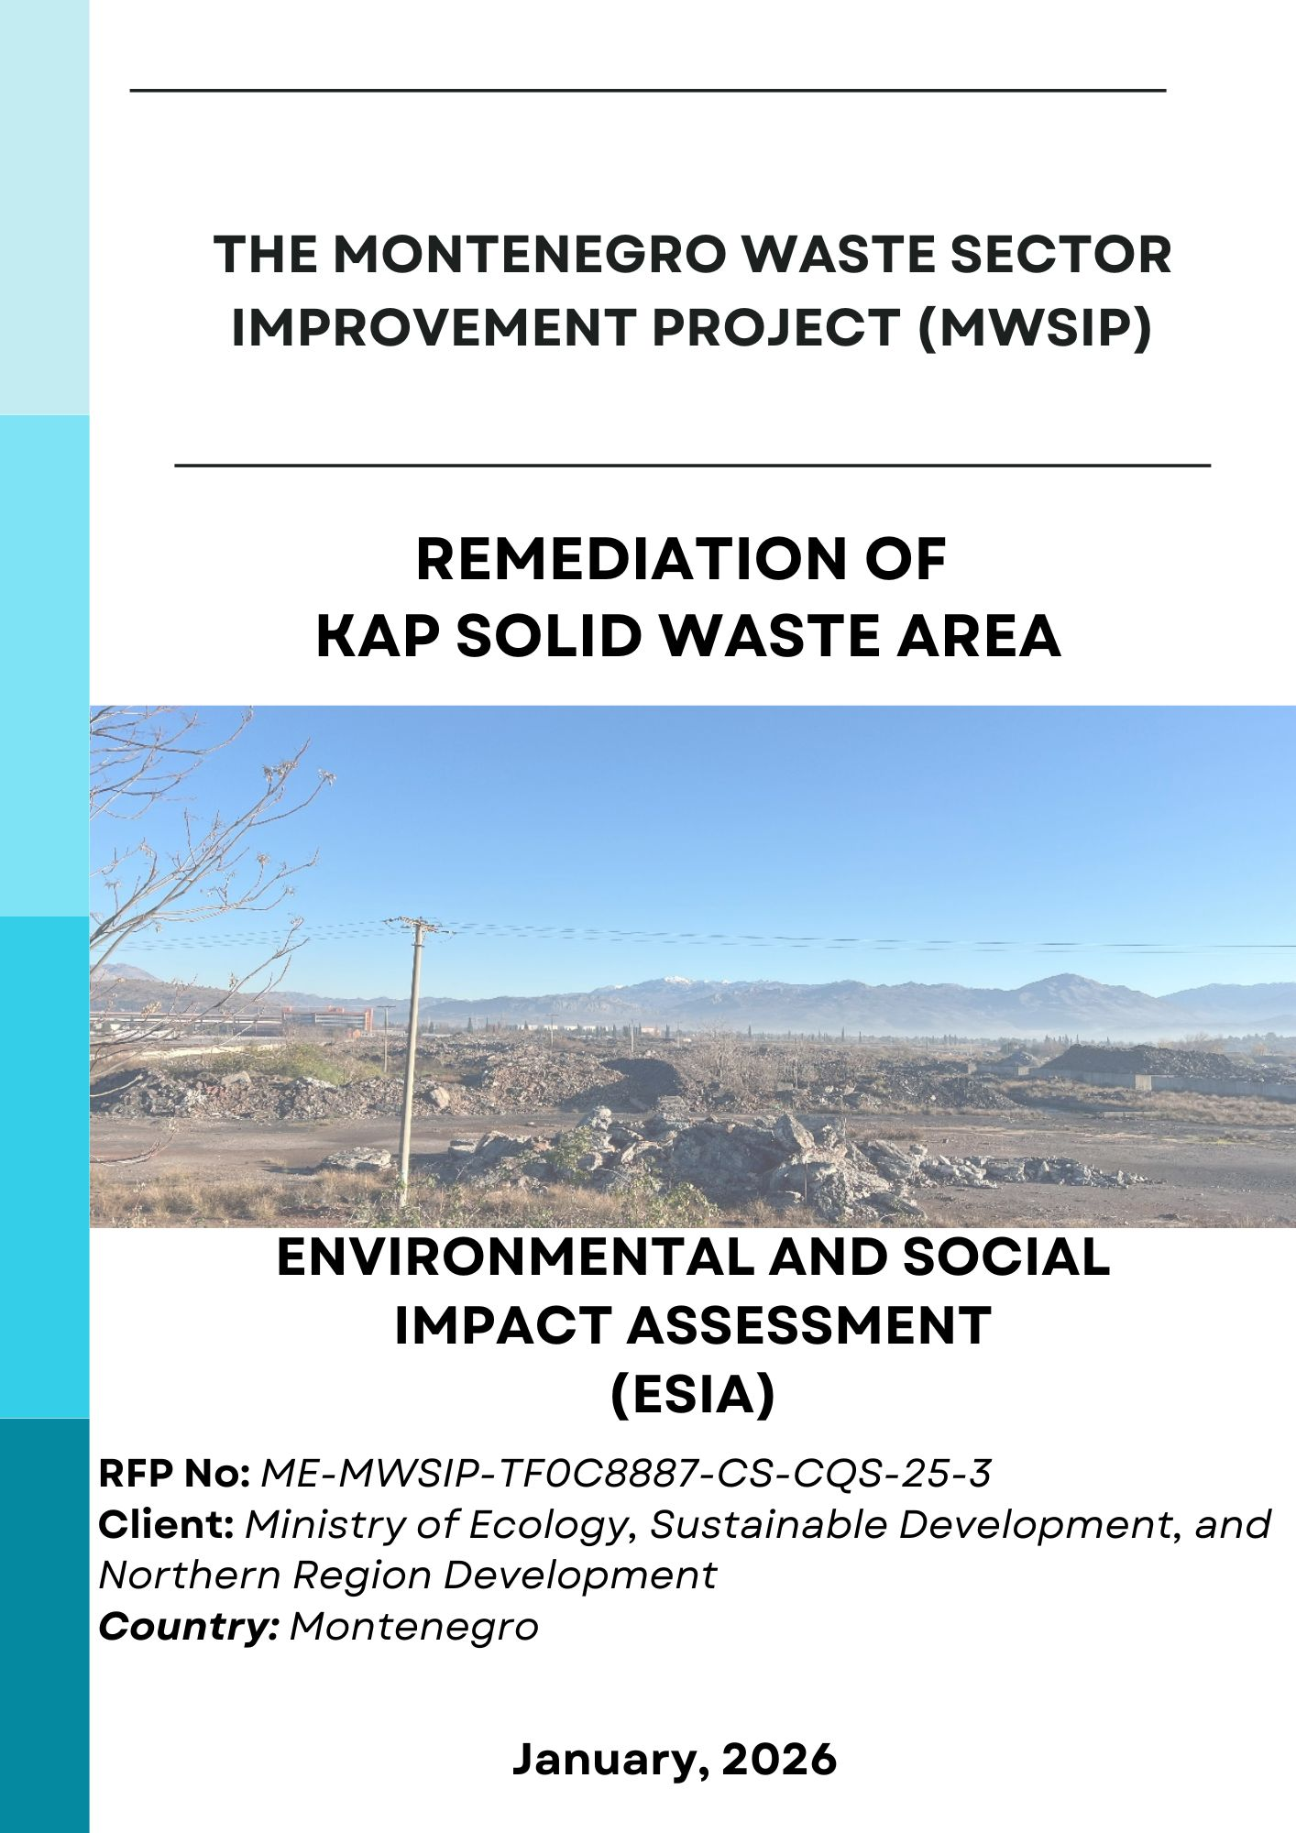

TABLE OF CONTENTS

TABLE OF CONTENTS i
LIST OF TABLES vi
LIST OF FIGURES i
ABBREVIATIONS iii
EXECUTIVE SUMMARY 1
1 INTRODUCTION 0
1.1 Project Background 0
1.2 Scope and Purpose of the ESIA Studies 6
1.3 Standards and Guidelines Applied 7
1.4 Structure of the ESIA report 9
2 POLICY, LEGAL AND INSTITUTIONAL FRAMEWORK 10
3 PROJECT DESCRIPTION 11
3.1 Project Location 11
3.2 Proposed Works for the Remediation of the Site 14
3.3 Equipment & Material Needs 19
3.4 Organizational Capacity 19
3.5 Project Schedule 20
4 ENVIRONMENTAL AND SOCIAL BASELINE CONDITIONS 21
4.1 Study Area and Sources of Baseline 21
4.1.1 Sources of Baseline Data 21
4.2 Characteristics of the Physical Environment 22
4.2.1 Topography, Geology, Hydrogeology and Hydrology of the Region 22
4.2.2 Erosion and Land Use 26
4.2.3 Climate 30
4.2.4 Seismicity 30
4.3 Quality of Physical Environment 32
4.3.1 Water Quality 32
4.3.2 Solid Waste Characterization 39
4.3.3 Soil Quality 41
4.3.4 Air Quality 43
4.3.5 Noise 44
4.3.6 Landscape Features 45
4.3.7 Radioactivity 46
4.4 Ecology and Biodiversity 46
4.5 Socioeconomic Environment 53
4.5.1 Population 53
4.5.2 Transportation Network 54
4.5.3 Community Facilities in the Wider Project Area 55
4.6 Protected Areas, Cultural Heritage, and Assets 56
5 ENVIRONMENTAL AND SOCIAL IMPACT ASSESSMENT 57
5.1 Scope-in/Scope-out Process 58
5.2 Impact Assessment Approach and Methodology 59
5.2.1 Potential Area of Influence (AoI) 62
5.2.2 Determination of Environmental and Social Impact Level and Significance 64
5.3 Impacts on Physical Environmental Characteristics 67
5.3.1 Impacts on Hydrogeology and Hydrology 67
5.3.2 Impacts on Erosion, Land Slide, and Land Use 67
5.4 Impacts on Physical Environmental Quality 68
5.4.1 Impacts on Water Quality 68
5.4.2 Impacts on Soil Quality 69
5.4.3 Impacts on Air Quality 70
5.4.4 Noise Impacts 71
5.4.5 Waste Generation Impacts 75
5.4.6 Impacts on Landscape Characteristics 76
5.4.7 Radioactivity Impacts 76
5.5 Impacts on Biological Environment 76
5.5.1 Impacts on Internationally Recognised Areas within the Region of the Project Area 77
5.5.2 Impacts on Terrestrial Habitat and Flora-Fauna 77
5.5.3 Impacts on Aquatic Environment 78
5.6 Impacts on Socio-economic Environment 79
5.6.1 Impacts on the Local Population 79
5.6.2 Impacts on Economy and Livelihoods 79
5.6.3 Impacts on Local Public Infrastructure 80
5.6.4 Community Health and Safety 80
5.7 Impacts on Cultural Heritage 81
5.8 Occupational Health and Safety 81
6 PROJECT ALTERNATIVES 82
6.1 No Action/Project Alternative 82
6.2 Remediation Alternatives 82
7 ENVIRONMENTAL AND SOCIAL MANAGEMENT PLAN 83
7.1 Mitigation Plan 83
7.1 Monitoring Plan 87
8 ENVIRONMENTAL AND SOCIAL MANAGEMENT SYSTEM 89
8.1 Environmental and Social Management Structure 89
8.2 Roles and Responsibilities 90
9 PUBLIC PARTICIPATION AND INFORMATION DISCLOSURE 92
9.1 Summary of Previous Public Information and Consultation Activities 92
9.2 General Approach for Public Consultation 93
9.3 Public Consultation for ESIA/EIA Elaborate 94
REFERENCES 96
ANNEXES 97
ANNEX-1 Policy, Legal and Legislative Framework 97
Annex 1.1 Legal Framework for Environmental Protection and Conservation 97
Annex 1.2 Legal Framework for Health and Safety 98
Annex 1.3 Legal Framework for Expropriation and Resettlement 98
Annex 1.4 Montenegrin/European Environmental Legislative and Permitting Framework 99
Annex 1.4.1 EU Directives 99
Annex 1.4.2 Horizontal Legislation 99
Annex 1.4.3 Nature Protection 100
Annex 1.4.4 Air Quality 100
Annex 1.4.5 Cultural Heritage Protection 100
Annex 1.4.6 Spatial Planning and Construction of Structures 101
Annex 1.4.7 Waste Management 101
Annex 1.4.8 Water Quality 101
Annex 1.4.9 Industrial Pollution 101
Annex 1.4.10 Energy Efficiency 102
Annex 1.5 Occupational Health and Safety 102
Annex 1.6 National EIA Procedure 103
Annex 1.7 International Environmental and Social Regulatory Framework 104
Annex 1.7.1 International Treaties and Conventions 104
Annex 1.7.2 World Bank Environmental and Social Framework 105
Annex 1.7.3 Gaps between the World Bank ESSs and Montenegrin EIA Procedure 107
Annex 1.7.4 Good International Industry Practice 109
ANNEX-2 The List of Flora Species in the Project’s Potential AoI 111
ANNEX-3 The List of Amphibians and Reptiles Species in Potential AoI of the Project 114
ANNEX-4 The List of Bird Species in the Project’s Potential AoI 115
ANNEX-5 The List of Mammal Species in the Project’s Potential AoI 117
ANNEX-6 The List of Possible Freshwater Fish Species in Potential AoI of the Project 118
ANNEX-7 Sampling Procedures for KAP Disposal Site Environmental Monitoring 119
1 Background and Context 0
2 Objective of the Assignment 1
3 Locations and Context of Analytical Activities 1
3.1 KAP (Podgorica) 1
3.1.1 Soil Quality 5
3.1.2 Groundwater 6
3.1.3 Surface Water 6
3.1.4 Air Quality and Noise 6
3.2 Nikšić (WMC) 6
4 Scope of Laboratory Investigations 7
4.1 KAP Location – Mandatory Laboratory Investigations 7
4.2 Nikšić Location – Laboratory Investigations in a Subsequent Phase 16
5 Methodology 17
6 QA/QC Requirements 17
7 Deliverables 18
7.1 Field Activities Report 18
7.2 Analytical Results 18
7.3 Supporting Technical Documentation 18
7.4 Final Technical Report 18
7.5 Deadlines and Submission 19
8 Organization of Work and Communication 19
9 Occupational Health and Safety (OHS) 19
10 Contractor Qualifications 20
ANNEX-8 Social Survey Methodology 21
1. Purpose and Scope 23
2. Social Survey Methodology 23
2.1 Target Groups 23
2.2 Survey Approach 23
3. Ethical Principles and Safeguards 23
4. Questionnaire Format 23
Module 0 – Informed Consent 23
Module 1 – Respondent Profile 23
Module 2 – Residence and Tenure (Households) 24
Module 3 – Livelihoods and Income 24
Module 4 – Use of Project Area and Access Patterns 24
Module 5 – Vulnerability Indicators 24
Module 6 – Perceived Project Impacts 24
Module 7 – Community Health and Safety 24
Module 8 – Stakeholder Engagement and Grievance Mechanism 24
5. Enumerator Guidance Note 24
6. Data Coding and Analysis Framework 24
1.1 ESS5 Screening Rules (Summary) 24
Questionnaire (Vulnerable-Group Sensitive) 25
Cover Page (Enumerator-Completed) 25
Module 0 — Informed Consent (Read Out) 25
Module 1 — Respondent Profile 25
Module 2 — Residence and Tenure 25
Module 3 — Livelihoods and Income Sources 26
Module 4 — Use of Project Area / Access Patterns 26
Module 5 — Vulnerability and Risk Indicators (Sensitive, Non-stigmatizing) 27
Module 6 — Perceived Impacts of Project (Baseline Expectations) 27
Module 7 — Community Health & Safety 28
Module 8 — Stakeholder Engagement and Grievance Mechanism 29
Module 9 — Closing 29
ANNEX-9 Chance Find Procedure 30
ANNEX-10 Contributors 34

LIST OF TABLES

Table 1 Land Use Characteristics (CORINE, 2018) 29
Table 2 Environmental Quality Standards (EQS)Surface Water (Regulation on the Method and Deadlines for Determining the Status of Surface Waters, Official Gazette of Montenegro, No. 25/2019) 32
Table 3 Groundwater – Chemical Status Limits (Regulation on the Method and Deadlines for Determining the Status of Groundwater Official Gazette of Montenegro, No. 52/2019) 32
Table 4 Physico-chemical characteristics of Lake Skadar water for the period 2003–2004 (Rakočević, 2006; 2012) 36
Table 5 Medium and maximum values of different chemical parameters in the Zeta Plain ground waters, at different sampling sites, in period from 1990–1996 (after Royal Haskoning, 2006; modified): MAC–maximum allowable concentration according to Directive on classification and categorization of surface and ground waters (Official Gazette no. 2/07). 39
Table 6 Waste Characterization Results (CETI, 2021) 40
Table 7 The amount and characteristics of solid and hazardous waste from various technological units of KAP (after Royal Haskoning, 2006; modified). 41
Table 8 Soil Quality at Project Footprint (CETI, 2021) 41
Table 9 Maximum concentrations of hazardous and toxic substances (mg/kg) detected in the soil in the area of KAP (COWI, 2012; modified) 42
Table 10 Soil pollution in villages Srpska and Botun in 2005 (WYG International, 2011; modified) 43
Table 11 Minimum and maximum concentrations of PCB at sites within the KAP (B-17, B-18, B-19, AS-1, AS-2, AS-3) and in the immediate vicinity (Srpska, Botun, Mahala) in the period from 1990 to 1996 (Royal Haskoning, 2006; modified). 43
Table 12 Emissions of air pollutants from Alumina Plant Podgorica in 2005, 2006 and 2007 (Marković, 2007; modified) 44
Table 13 Radiological Analyses of Water Sample 46
Table 14 ESS List Concerning the Project 57
Table 15 Color Code Used in the Scope-in/Scope-out Process 58
Table 16 Environmental and Social Impact Sources, Activities and Possible Interacts (Before Mitigation Measures are Taken) 59
Table 17 Impact Significance Matrix* 61
Table 18 Matrix Table with Identification of Impact Level in Terms of Environmental and Social Attributes 65
Table 19 Assessment of Impact on Erosion, Land Slide and Land Use 67
Table 20 Assessment of Impacts on Surface and Groundwater 68
Table 21 Assessment of Impacts on Soil Quality 69
Table 22 Stage III B Emission Standard for Non-Road Diesel Engines 70
Table 23 List of Construction Machinery 71
Table 24 Calculated Total Emissions from Construction Machinery 71
Table 25 Assessment of Impacts on Air Quality 71
Table 26 Noise Level Guidelines of IFC 72
Table 27 Machinery and Equipment and their Noise Intensity Levels (Lw) 72
Table 28 Distribution of Noise Generation Relative to Distance 73
Table 29 Assessment on Noise Impacts 74
Table 30 Assessment of Impacts of Waste Generation 75
Table 31 Assessment of Impacts on Landscape 76
Table 32 Assessment of Impacts on Contents of Radionuclides in Surface Waters 76
Table 33 Assessment of Impacts on Terrestrial Habitats and Flora/Fauna 78
Table 34 Assessment of Impacts on Aquatic Habitats and Flora/Fauna 79
Table 35 Assessment of Impacts on Economy and Livelihoods 79
Table 36 Assessment of Impacts on Community Health and Safety 81
Table 37 Assessment of Impacts on Occupational Health and Safety 81
Table 38 Mitigation Plan for Construction Phase 84
Table 39 Mitigation Plan for Operation (Post-Closure) Phase 86
Table 40 Monitoring Plan for All Phases 88
Table 41 Chronological Overview of Development of Previous Documentation 92
Table 41 Gaps between ESSs and Montenegrin EIA Procedure 107
Table 42 Recommended soil sample locations 5
Table 43 Recommended underground water locations 6
Table 44 Recommended Surface Water Locations 6
Table 45 Recommended Air Quality and Noise Locations 6
Table 46 Soil Analysis Parameters and Methods 8
Table 47 Surface Water Parameters and Methods 9
Table 48 Groundwater Parameters and Methods 11
Table 49 Sediment Analysis Parameters and Methods 14

LIST OF FIGURES

Figure 1 Project Location 2
Figure 2 Project Area Photos 6
Figure 3 General View 13
Figure 4. Site Layout (Source: Preliminary Design Book 1 Volume 2 Building Design – Construction) 15
Figure 5 Section View of a Basin (Source: Preliminary Design Book 1 Volume 2 Building Design – Construction) 17
Figure 6 Schematic Representation of Works by Phases (Source: Preliminary Design Book 1. Volume 4. Construction Design – Construction Organization and Technology) 18
Figure 7 Indicative Organizational Chart for the Construction Management (Source: Preliminary Design Book 1. Volume 4. Construction Design – Construction Organization and Technology) 19
Figure 8 Indicative Organizational Chart for the Operation (Post Closure) Phase 20
Figure 8 Topography Map of the Project Area 23
Figure 9 Map of Slope Groups 24
Figure 10 Erosion Map of Montenegro (Spatial Plan of Montenegro Until 2020, March 2008) 27
Figure 11 Land Use Characteristics of Project Area and its Close Vicinity (CORINE, 2018) 28
Figure 12 Maps of seismic re-ionization of Montenegro territory (1982): a) within the return periods of 200 years and b) within the return-period of 500 years 31
Figure 13 Terrain of Skadar/Shkodra Lake in 3D 35
Figure 14 Drainage basin of ground waters 39
Figure 15 Industrial Zone of Podgorica - KAP 45
Figure 16 Map of Internationally and Nationally Designated or Recognized Areas around the Project Area (updated version of map retrieved from University of Montenegro Faculty of Sciences and Mathematics Protected Area Gap Assessment with Comprehensive Plan for a Representative Pas (Protected Area System), November, 2012, www.protectedplanet.net, https://whc.unesco.org/en/list/100/) 48
Figure 17 Map of KBAs 49
Figure 18 Map of Emerald Network Sites 50
Figure 19 Visual Representation of the Project’s Potential Social Area of Impact, 2026 54
Figure 20 Community Facilities in the Wider Project Area 55
Figure 21 Project Area and Vicinity including the AoI for Water Resources 63
Figure 22 Distribution of Noise Generated in the Project Area with respect to Distance 74
Figure 24 Environmental and Social Management Structure 90
Figure 25 Announcement Letter 95
Figure 26 Photographs from the meeting 95
Figure 24 EIA Procedure in Montenegro 104
Figure 1 Sampling Locations Map 4

ABBREVIATIONS

AoI | Area of Influence
CITES | Convention on International Trade in Endangered Species of Wild Fauna and Flora
Consultant | ENCON Environmental Consultancy Co.
EA | Environmental Assessment
EHS Guidelines | Environmental, Health and Safety Guidelines
EIA | Environmental Impact Assessment
Encon | Encon Environmental Consultancy Ltd. Co.
EPA | Environmental Protection Agency of Montenegro
ESF | Environmental and Social Framework
ESIA | Environmental and Social Impact Assessment
ESMP | Environmental and Social Management Plan
ESSs | Environmental and Social Standards
EU | European Union
EU | European Union
GIIP | Good International Industry Practice
GIS | Geographical Information System
HDPE | High Density Polyethylene
IA | Implementing Agency
IUCN | International Union for Conservation of Nature
IWMCP | Industrial Waste Management and Cleanup Project
KAP | The Kombinat Aluminijuma Podgorica
LSIEMP | Lake Skadar/Shkodra Integrated Ecosystem Management Project
MESDNRD | Ministry of Ecology, Sustainable Development, and Northern Region Development
MESPU | Ministry of Environment, Spatial Planning and Urbanization
MWSIP | Montenegro Waste Sector Improvement
NGO | Non-Governmental Organization
PAH | Polycyclic Aromatic Hydrocarbons
PAP | Project Affected People
PCB | Polychlorinated Biphenyls
PM | Particulate Matter
PMU | Project Management Unit
The Project | Remediation Activities on KAP Solid Waste Area
ToR | Terms of Reference
WB | World Bank

EXECUTIVE SUMMARY

The Government of Montenegro is advancing the preparation of the Montenegro Waste Sector Improvement Project (MWSIP), with the objective of strengthening the national waste management system and improving environmental performance across the sector. The Project aims to support the development of a modern and integrated waste management framework, address historical environmental liabilities associated with industrial and municipal waste, and promote alignment with European Union directives and international good practice.

The Ministry of Ecology, Sustainable Development, and Northern Region Development (MESDNRD) serves as the lead implementing agency for the Project and is responsible for coordinating project preparation activities, engaging with relevant national institutions, and ensuring that environmental and social considerations are integrated into project planning and design in accordance with national legislation and the World Bank Environmental and Social Framework (ESF).

As part of earlier World Bank–financed interventions in the waste sector, an Environmental and Social Impact Assessment (ESIA) was prepared in 2012 under the Industrial Waste Management and Cleanup Project (IWMCP). The 2012 ESIA was developed in accordance with the World Bank safeguard policies (Operational Policies – OPs) applicable at that time and assessed the potential environmental and social risks and impacts associated with the remediation of selected industrial waste disposal sites across Montenegro. One of the sites assessed under the IWMCP was the KAP solid waste dumpsite located in the vicinity of the Aluminium Plant Podgorica (KAP).

In the context of the preparation of the MWSIP and the transition from the World Bank safeguard policies to the World Bank Environmental and Social Framework, the ESIA for the KAP site has been updated and revised to ensure alignment with the requirements of the Environmental and Social Framework (ESF). This updated ESIA has been jointly prepared by Encon Environmental Consultancy Ltd. Co. (Encon) and E3 Consulting under a joint venture arrangement, building upon the findings of the 2012 ESIA while reflecting current project design, updated baseline conditions where relevant, and enhanced environmental and social risk management approaches in line with the Environmental and Social Standards (ESSs).

The scope of remediation work includes site preparation and clearance works, containment of waste into designated encapsulation basins within the side boundary, construction and preparation of these encapsulation basins, which will have installation of protective lining systems, placement of waste in controlled layers, final capping, and construction of surface water drainage systems, . Project activities are planned to be implemented in a phased manner to ensure environmental protection, operational safety, and effective risk management throughout construction and operation.

The ESIA identifies baseline environmental and social conditions within the Project Area of Influence, covering physical, biological, and socio-economic components. Potential environmental and social impacts associated with the Project have been assessed, with particular attention to risks related to soil contamination, surface water and runoff management, air quality (including dust), noise, waste handling, occupational health and safety, and community health and safety.

In line with the mitigation hierarchy, appropriate avoidance, minimization, mitigation, and management measures have been defined for all identified impacts and consolidated in a comprehensive Mitigation Plan. These measures are designed in accordance with national regulatory requirements, EU directives, Good International Industry Practice (GIIP), and the World Bank ESF.

A Monitoring Plan has been developed to verify the effectiveness of mitigation measures and ensure ongoing compliance with regulatory and lender requirements. In addition, a detailed monitoring methodology prepared by Encon provides recommended monitoring parameters, frequencies, and mapped sampling locations, supporting a systematic, transparent, and risk-based monitoring approach throughout Project implementation.

The Project is expected to deliver significant long-term environmental benefits by reducing contamination risks, improving land stability, preventing further dispersion of pollutants, and contributing to the overall improvement of waste management practices in Montenegro. Provided that the mitigation and monitoring measures outlined in this ESIA are fully implemented, residual environmental and social impacts are assessed as low to moderate and manageable.

Overall, the Project is considered environmentally and socially acceptable and consistent with national legislation and the requirements of the World Bank Environmental and Social Framework.

INTRODUCTION

Project Background

The Government of Montenegro is advancing the preparation of the MWSIP with the objective of strengthening the national waste management system and improving environmental performance across the sector. The Project seeks to support the development of a modern, integrated waste management framework, address historical environmental liabilities associated with industrial and municipal waste, and promote alignment with European Union directives and international good practice.

The MESDNRD serves as the lead implementing agency for the Project. MESDNRD is responsible for coordinating project preparation activities, engaging with relevant national institutions, and ensuring that environmental and social considerations are integrated into project planning and design in accordance with national legislation and the World Bank ESF.

As part of earlier World Bank–financed interventions in the waste sector, an ESIA was prepared in 2012 under the IWMCP to assess the potential environmental and social risks and impacts associated with the remediation of selected industrial waste disposal sites across Montenegro. One of the sites assessed under the IWMCP was the KAP solid waste dumpsite located in the vicinity of the KAP.

Since the preparation of the original ESIA, project conditions have evolved, including changes in site characteristics, institutional arrangements, regulatory requirements, and the availability of updated technical designs for remediation and waste management activities. In addition, the transition from the World Bank safeguard policies to the Environmental and Social Framework necessitates an updated assessment approach that reflects current World Bank requirements and international good practice. Accordingly, the present ESIA has been prepared as an update to the earlier assessment to ensure that potential environmental and social risks and impacts are identified, assessed, and managed in line with the ESF and applicable national legislation.

The KAP solid waste dumpsite is located within the Zeta Valley, an area of high environmental sensitivity due to its function as a major groundwater recharge zone and its proximity to key surface water bodies, including the Morača River, the Cijevna River, and Skadar Lake. Skadar Lake is a nationally and internationally protected ecosystem, designated as a national park in Montenegro and a nature reserve in Albania. The environmental setting of the site, together with the presence of nearby industrial and agricultural land uses, highlights the importance of a comprehensive and up-to-date environmental and social assessment to ensure the protection of water resources, ecosystems, and nearby communities during the planning and implementation of proposed activities.

This ESIA has been prepared to inform project decision-making, support the identification of appropriate mitigation and management measures, and provide a basis for stakeholder engagement and disclosure in accordance with the requirements of the World Bank ESF and national environmental impact assessment procedures.

KAP Production Plant is located in the south of Montenegro, approximately 10 km south of the Podgorica and between the Moraca River and the road connecting Podgorica to the coastline. In the vicinity of KAP Production Plant, there are several industrial properties and agricultural areas. The solid waste disposal site is located next to the plant.

The key issue about KAP Production Plant’s location is that this area stays within the Zeta Valley, which is a large natural drinking water reservoir and known for its fertile lowland. It stretches from Podgorica in the north to the Skadar Lake in the south. It is the biggest plains area in Montenegro. The Morača River passes nearby the site of KAP and flows into Skadar Lake. The Cijevna River passes approximately 1.5 km south of the KAP site, and flows into the the Morača River. The Skadar Lake lies on the border of Albania and Montenegro and is the largest lake in Southern Europe. The Montenegrin section of the lake and surrounding land has been designated as a national park, while the Albanian section is a nature reserve. Lake Gornje Malo Blato, located approximately 5.5 km southwest of the KAP site, is a large inland water body. It is situated north of Muljage, and west of Oblun - Markova Gorica.

The location of the Project is shown on a map given in Figure 1.

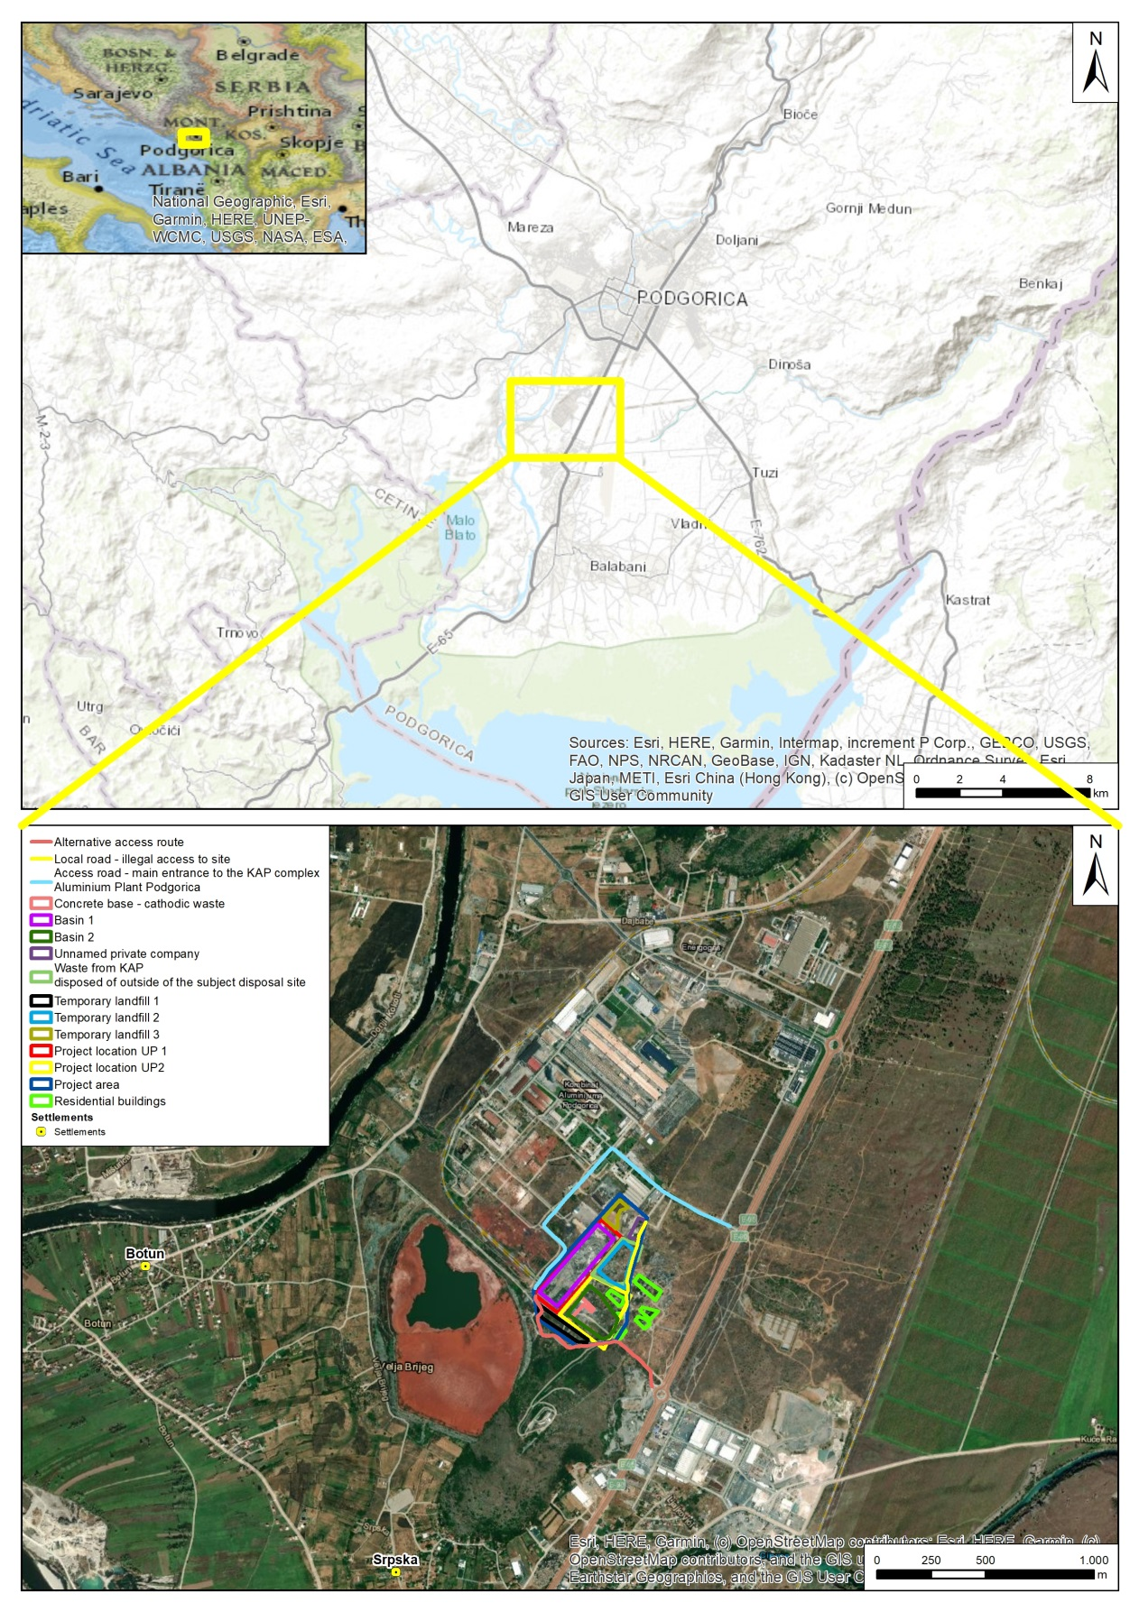

Figure 1 Project Location

Solid waste was stored in a partially controlled disposal area located within the former KAP industrial complex, in an unsatisfactory disposal site/landfill without selection or possible prior treatment. The site was historically associated with alumina and aluminum processing activities, and was used for waste disposal prior to the shutdown of KAP operations. Given the historically management of the disposal site, the waste stream cannot be attributed to a single origin with certainty. It is therefore assumed that the waste represents a heterogeneous mixture of municipal, commercial, construction-related, and potentially minor industrial and hazardous waste streams, accumulated over decades without segregation or pre-treatment.

It is estimated that today, at the location of the unsatisfactory disposal site/landfill for solid waste, there are approximately 529,773.87 m³ of various solid materials, that became completely mixed and homogenized over time, partly due to non-selective storage and partly due to the long term influence of the atmospheric conditions such as precipitation, wind and surface runoff..

Effective remediation of the existing waste disposal site would reduce ongoing and future environmental risks, including secondary pollution pathways and impacts related to excavation, and handling activities, and will be supported by risk management and chance finds procedures to be defined in the ESMP.

In the present situation, the KAP Solid Waste Area has several negative impacts on the environment and on the social-economic environment. The objective of the remediation is to limit the negative impact by implementing various mitigation measures.

Overall, the project will have a significant positive impact on the environment at the site and in its surroundings. Although the site is fenced and secured against unauthorized access waste is stored without any measures to prevent the impact on the air and water. The remediation activity will mainly ensure the reducing the negative impact of currently existing waste at the disposal site. After the implementation of the project, the spread of pollutants will be limited and within the allowed level. Therefore, the project will have a significant positive impact on the environment. However, during the implementation of the remediation some short-term minor negative impacts might be expected including noise, increased traffic or dust related to the construction works during implementation of the remediation.

A site visit was conducted on 17 December 2025 in order to observe the current conditions of the project area and to support the assessment with visual evidence. The visit aimed to gain first-hand understanding of the site characteristics, existing solid waste conditions, surrounding land use, and potential environmental and health and safety risks.

During the site visit, observations were made regarding surface conditions, waste distribution and containment status, accessibility of the area, and nearby sensitive receptors. Photographs were taken at representative locations to document the existing conditions and to support the findings presented in this report.

The photographs below provide visual documentation of the site conditions observed during the visit and are intended to complement the baseline description and impact assessment sections of the study.

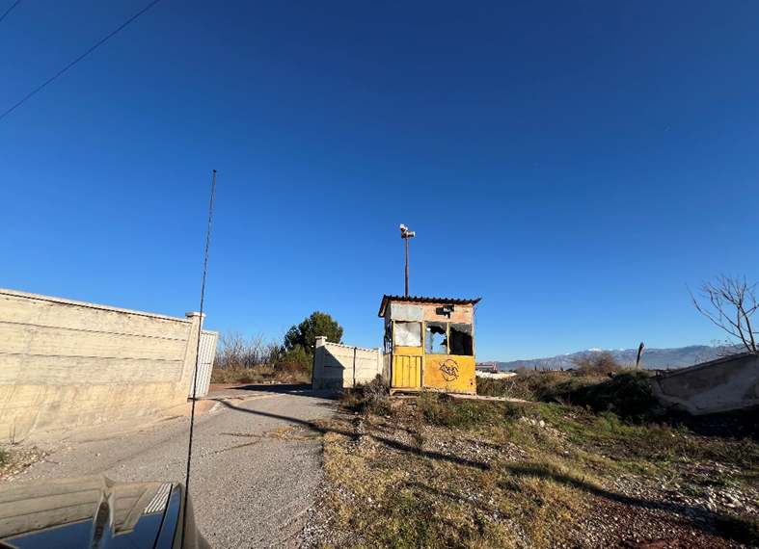

Entrances from KAP Access Road to the Solid Waste Area (Project Area)
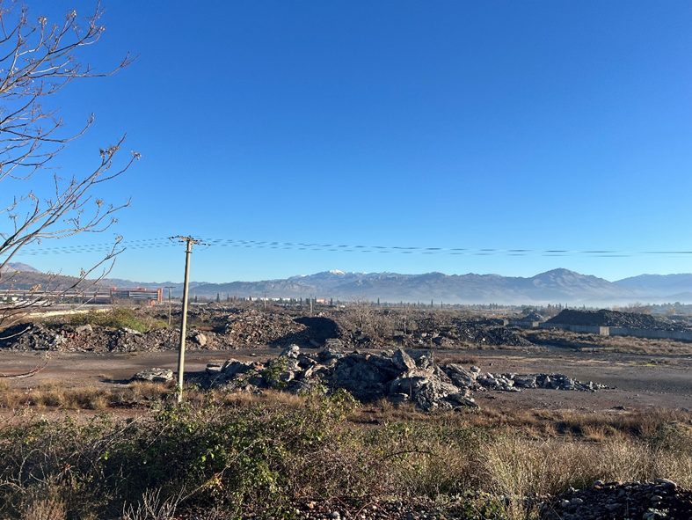

Solid Waste Area
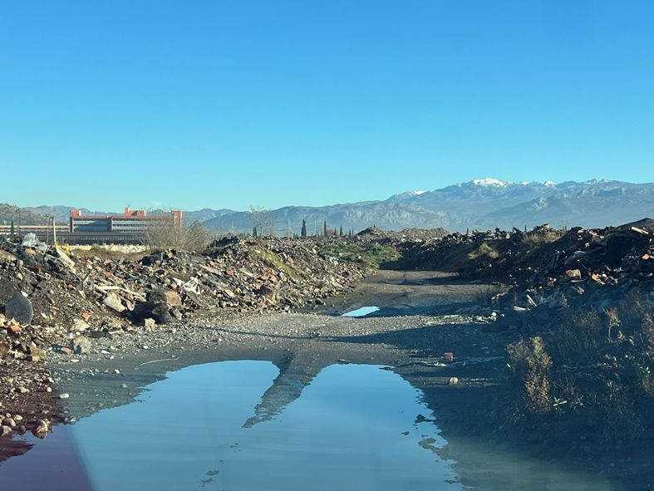

Condition of Roads within the Zone - Project Area
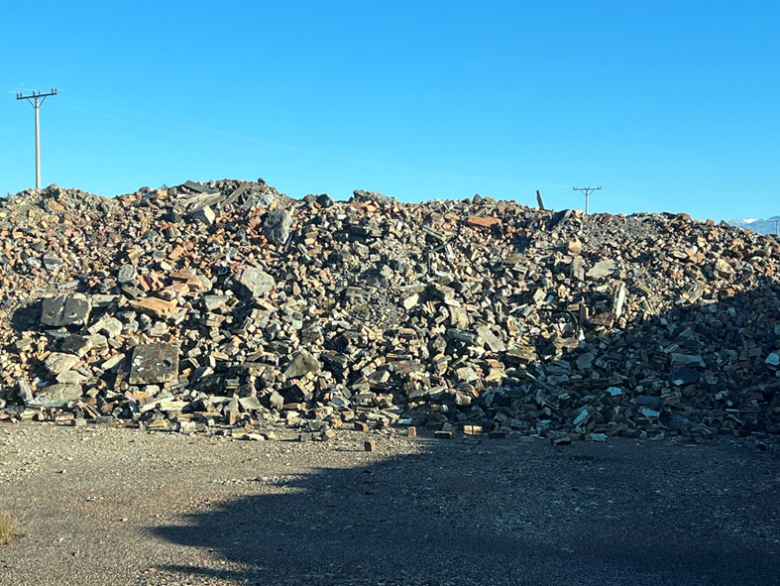

Waste / types of Waste Present at the Site:
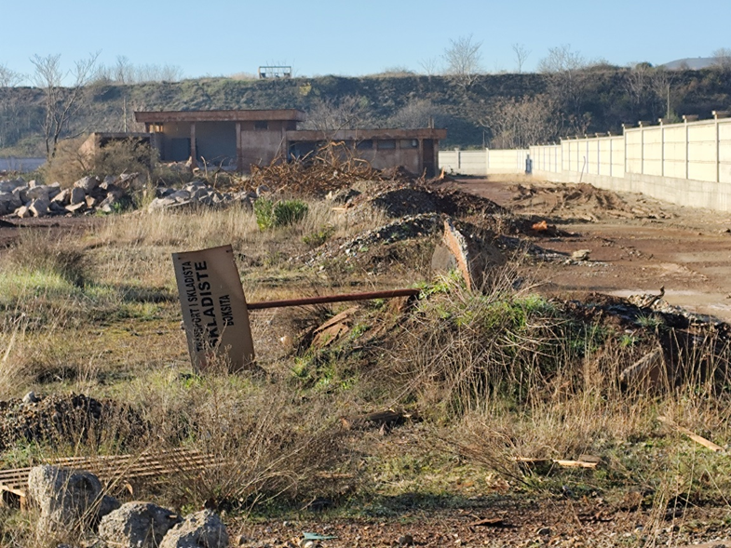

Waste / types of Waste Present at the Site:
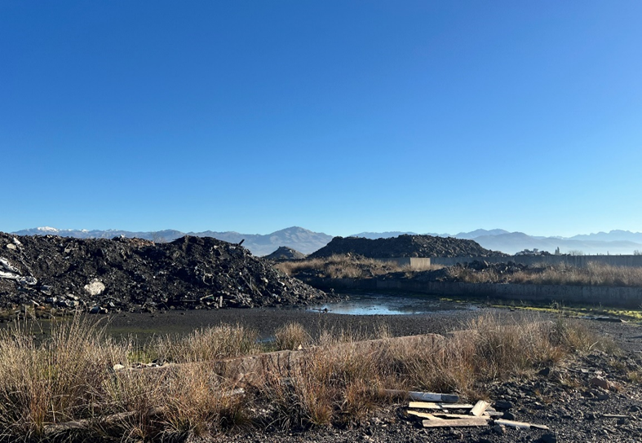

Condition of the Area (Accumulation of Rainwater in Certain Sections, Soil Contamination)

Figure 2 Project Area Photos

Scope and Purpose of the ESIA Studies

An ESIA was originally prepared in 2012 during the preparation of the IWMCP to assess the potential environmental and social impacts associated with the remediation of five contaminated industrial waste sites in Montenegro, including the KAP solid waste area in Podgorica. The earlier assessment was developed in line with the World Bank safeguard policies applicable at that time and supported the implementation of remediation activities under the IWMCP framework.

In parallel with the former ESIA, a national EIA Elaborate was prepared in accordance with Montenegrin environmental legislation for the remediation of the KAP solid waste area. The national EIA focused on the identification of environmental impacts and definition of mitigation and monitoring measures required for permitting and implementation at the national level, including the conduct of public consultations as mandated by domestic regulations.

Since the completion of the original assessments, project conditions have evolved, including updates to technical designs, changes in regulatory and institutional arrangements, and the adoption of the World Bank ESF. These developments necessitate an updated and consolidated environmental and social assessment to ensure that potential risks and impacts associated with the proposed activities are identified and managed in accordance with current World Bank requirements and national legislation.

The purpose of this updated ESIA is to assess the potential environmental and social risks and impacts associated with the proposed remediation and waste management activities at the KAP solid waste area, taking into account current baseline conditions and the proposed scope of works. The ESIA has been prepared in accordance with the requirements of the World Bank Environmental and Social Framework, particularly Environmental and Social Standard 1 (ESS1), and relevant Montenegrin environmental legislation.

The scope of the ESIA includes:

- a description of the proposed project activities and feasible alternatives;
- identification and assessment of potential environmental and social risks and impacts during pre-construction, construction, operation, and, where relevant, closure phases;
- definition of appropriate mitigation, enhancement, and monitoring measures;
- preparation of an Environmental and Social Management Plan (ESMP) outlining institutional responsibilities and implementation arrangements; and
- stakeholder engagement and information disclosure activities conducted in line with national requirements and the World Bank ESF.

This ESIA is intended to inform project decision-making, support regulatory approval processes, and provide a framework for the effective management of environmental and social risks throughout the project lifecycle.

Standards and Guidelines Applied

This ESIA has been prepared in accordance with applicable national legislation and the World Bank ESF, which provides the overarching policy framework for the assessment and management of environmental and social risks and impacts associated with projects financed by the World Bank. The ESF comprises ten ESSs, which have guided the preparation of this ESIA, taking into account the nature, scale, and risk profile of the Project.

The following Environmental and Social Standards are particularly relevant to the Project:

- Environmental and Social Standard 1 (ESS1): Assessment and Management of Environmental and Social Risks and Impacts – Establishes the requirements for identifying, assessing, and managing environmental and social risks and impacts in a manner consistent with the mitigation hierarchy. ESS1 provides the overarching framework for this ESIA and informs the development of project-specific mitigation, monitoring, and management measures.

- Environmental and Social Standard 2 (ESS2): Labour and Working Conditions – Addresses fair treatment, non-discrimination, occupational health and safety, and the establishment of grievance mechanisms for Project workers. Labour and working conditions are assessed as part of the ESIA, with management measures incorporated into the Environmental and Social Management Plan (ESMP).

- Environmental and Social Standard 3 (ESS3): Resource Efficiency and Pollution Prevention and Management – Establishes requirements related to the efficient use of energy, water, and other resources, as well as the prevention and control of pollution. The ESIA evaluates potential Project-related emissions, waste generation, and resource use and defines appropriate mitigation measures in line with GIIP.

- Environmental and Social Standard 4 (ESS4): Community Health and Safety – Addresses risks and impacts of Project activities on the health, safety, and well-being of affected communities, including traffic safety, emergency preparedness, and exposure to environmental hazards. These risks are assessed within the ESIA, and relevant mitigation and management measures are proposed.

- Environmental and Social Standard 5 (ESS5): Land Acquisition, Restrictions on Land Use, and Involuntary Resettlement – Applies to projects that involve physical or economic displacement resulting from land acquisition or restrictions on land use. While the Project does not require land acquisition or resettlement, screening has been undertaken to assess the potential for access restrictions or livelihood impacts, in line with ESS5 requirements.

- Environmental and Social Standard 6 (ESS6): Biodiversity Conservation and Sustainable Management of Living Natural Resources – Promotes the protection of biodiversity and ecosystem services. The ESIA includes an assessment of baseline ecological conditions and evaluates potential Project-related impacts on habitats and species, with mitigation measures proposed where relevant.

- Environmental and Social Standard 8 (ESS8): Cultural Heritage – Addresses the protection of tangible and intangible cultural heritage. The ESIA evaluates potential cultural heritage sensitivities within the Project area and includes chance-find procedures to be implemented during Project activities.

- Environmental and Social Standard 10 (ESS10): Stakeholder Engagement and Information Disclosure – Establishes requirements for meaningful stakeholder engagement, information disclosure, and grievance redress. Stakeholder engagement activities conducted for the ESIA are described in the Stakeholder Engagement Plan (SEP) and are integrated into the assessment process.

In addition to the World Bank ESF, the ESIA has been prepared in compliance with applicable national environmental legislation and regulatory requirements of Montenegro, including the national EIA framework and associated technical guidelines.

Together, these standards and regulatory requirements define the scope, depth, and quality of the ESIA. They ensure that the assessment not only fulfils legal obligations but also reflects Good International Industry Practice (GIIP) by systematically addressing environmental and social risks, incorporating stakeholder inputs, and supporting the environmentally and socially sustainable implementation of the Project.

Structure of the ESIA report

The structure of this ESIA Report has been developed in line with the World Bank ESF and relevant ESSs, as well as applicable national environmental legislation of Montenegro. The ESIA has been prepared to ensure systematic identification, assessment, and management of potential environmental and social risks and impacts associated with the proposed project, in accordance with international good practice.

The report is organized to present project information, baseline conditions, impact assessment, and management measures in a clear and logical manner that support informed decision-making by the relevant authorities, stakeholders, and the World Bank. The main sections of the ESIA Report are summarized below:

- Chapter I. Introduction;
Provides an overview of the project and the ESIA process, including project background, objectives, and the scope and purpose of the environmental and social impact assessment.
- Chapter II. Policy, Legal and Institutional Framework;
Describes the applicable national legislation of Montenegro, relevant international agreements, and the World Bank Environmental and Social Framework, including an overview of the national EIA procedures.
- Chapter III. Project Purpose and Description;
Presents a detailed description of the proposed project, including its location, components, technical characteristics, associated activities during different project phases, and the implementation schedule.
- Chapter IV. Environmental and Social Baseline Conditions;
Describes the existing physical, biological, and socio-economic conditions within the project area of influence.
- Chapter V. Environmental and Social Impact Assessment and Mitigation Measures; Identifies and assesses the potential positive and negative environmental and social impacts of the project and defines appropriate mitigation measures.
- Chapter VI. Project Alternatives;
Examines feasible alternatives to the proposed project, including design, technology, and operational alternatives, as well as the “no-project” alternative.
- Chapter VII. Environmental and Social Management Plan;
Defines the management and monitoring measures, institutional responsibilities, and implementation arrangements required to effectively manage identified environmental and social risks and impacts.
- Chapter VIII Environmental and Social Management System (ESMS)
Describes the project-level Environmental and Social Management System established to ensure systematic implementation, monitoring, and continuous improvement of environmental and social performance throughout the project lifecycle. This chapter outlines the organizational structure, roles and responsibilities, internal policies and procedures, capacity-building measures, reporting and documentation requirements, and mechanisms for compliance with national legislation and the World Bank Environmental and Social Framework.

In line with the World Bank ESF, supplementary information, such as lists of preparers and contributors, references, official letters, related reports, etc., which are relevant to the contents of the chapters listed above, are provided in the annexes of the ESIA Report.

POLICY, LEGAL AND INSTITUTIONAL FRAMEWORK

This chapter provides an overview of the policy, legal, and institutional framework applicable to the Project at the national, European Union, and international levels. It summarizes the key environmental and social legislation of Montenegro, relevant European Union environmental directives, international conventions, and the requirements of the World Bank ESF that are applicable to the Project.

The Project will be developed and implemented in compliance with the environmental protection and sustainable development principles established under Montenegrin legislation, including requirements related to environmental impact assessment, waste management, water protection, occupational health and safety, spatial planning, and land acquisition. Given Montenegro’s status as a candidate country for European Union (EU) membership, relevant EU environmental directives have also been considered in the preparation of this ESIA.

In addition to national and EU legislation, the Project is subject to the World Bank Environmental and Social Framework. The applicable Environmental and Social Standards (ESSs) provide the overarching requirements for the assessment and management of environmental and social risks and impacts, labor and working conditions, resource efficiency and pollution prevention, community health and safety, land acquisition, biodiversity conservation, cultural heritage, and stakeholder engagement.

In accordance with the World Bank ESF, the Project has been assigned an Environmental and Social Risk Classification of Substantial. This classification reflects the nature, scale, and sensitivity of the proposed activities, including environmental remediation works, waste transportation, and the environmentally sensitive setting of the Project area. Accordingly, this ESIA has been prepared in line with the requirements of the ESF and has assessed the Project’s potential environmental and social risks and impacts with reference to the applicable ESSs.

A detailed review of applicable national legislation, EU directives, international conventions, and the World Bank Environmental and Social Standards is provided in Annex 1 (Policy, Legal and Institutional Framework) of this ESIA Report.

PROJECT DESCRIPTION

This chapter provides a description of the proposed Project, including its objectives, location, main components, and planned activities during different phases of implementation. The Project Description is intended to provide a clear understanding of the nature and scope of the proposed works in order to support the identification and assessment of potential environmental and social risks and impacts.

The Project focuses on the remediation and improved management of the KAP solid waste area located in the vicinity of the Aluminium Plant Podgorica. The proposed activities are designed to address legacy environmental contamination, reduce risks to human health and the environment, and improve environmental performance in line with national legislation, European Union requirements, and the World Bank ESF.

The Project will be implemented through a series of activities covering the pre-construction, construction/remediation, and operation (post-remediation) phases. These activities include site preparation, remediation works, implementation of waste handling and management measures, and environmental monitoring. The Project does not involve the development of new industrial production facilities and is solely focused on environmental remediation and risk reduction limited to only within the waste disposal site

During the construction/remediation phase, there will be designated temporary storage areas as part of site arrangement . The designated areas are intended solely for the temporary collection and short-term storage of existing waste prior to its controlled transfer into appropriately designed and constructed final disposal basins within the boundaries of the same waste disposal site. No further permanent storage or disposal activities are planned or permitted within these temporary storage areas.

In accordance with this approach, the temporary storage areas will be prepared in advance, including necessary grading and leveling works. Following site preparation, waste will be temporarily placed at ground level for a strictly limited period, only for the duration required to enable transfer to the final basins. All activities associated with temporary storage will be implemented in compliance with applicable environmental protection measures, occupational health and safety requirements, and monitoring provisions.

Detailed technical specifications related to the design, construction, operation, and maintenance of the temporary storage areas will be further defined during the implementation phase, in line with the approved Environmental Impact Assessment, relevant national legislation, and the World Bank ESSs.

During the operation (post-remediation) phase, activities will be limited to site management, maintenance, and environmental monitoring. These activities have been considered in the assessment of environmental and social risks related to waste handling, transport safety, and occupational health and safety.

Project Location

KAP Production Plant is located in the south of Montenegro, approximately 10 km south of the Podgorica and between the Moraca River and the road connecting Podgorica to the coastline. In the vicinity of KAP Production Plant, there are several industrial properties and agricultural areas. The solid waste site is located next to the plant.

The key issue about KAP Production Plant’s location is that this area stays within the Zeta Valley, which is a large natural reservoir of drinking water and known for its fertile lowland. It stretches from Podgorica in the north to the Skadar Lake in the south. It is the biggest plains area in Montenegro. The Morača River passes nearby the site of KAP and flows into Skadar Lake. The Cijevna River passes approximately 1.5 km south of the KAP site, and flows into the the Morača River. The Skadar Lake lies on the border of Albania and Montenegro and is the largest lake in Southern Europe. The Montenegrin section of the lake and surrounding land has been designated as a national park, while the Albanian section is a nature reserve. Lake Gornje Malo Blato, located approximately 5.5 km southwest of the KAP site, is a large inland water body. It is situated north of Muljage, and west of Oblun - Markova Gorica.

The location of the Project is shown on a map given in Figure 1. General view of the site is given in Figure 3.

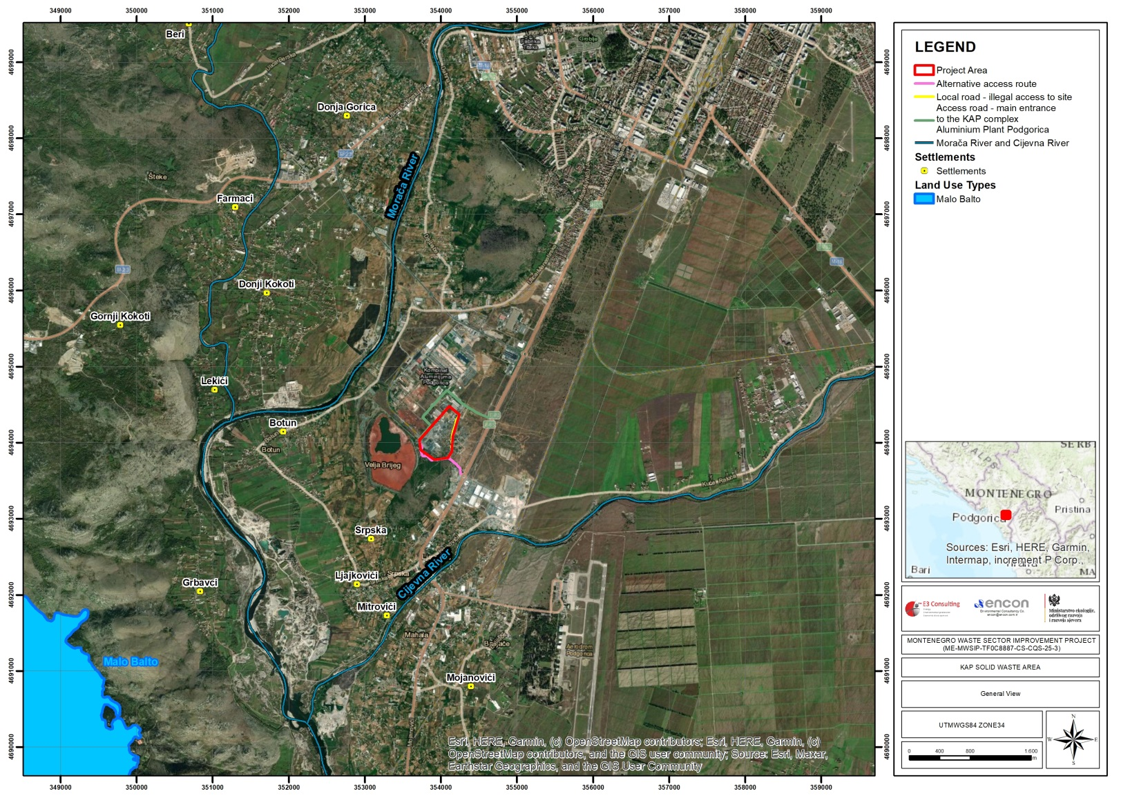
Figure 3 General View

Proposed Works for the Remediation of the Site

Activities at this site were started in 1969. Since then, different types of solid waste were stored at this location in an uncontrolled way without capsulation, pre-sorting, or pre-treatment. Currently, as it is stated by the Preliminary Design Book 1 Volume 1 – Building Design – Waste Recultivation, the total volume of the stored waste is estimated as 529,773.87 m³. The site contains both hazardous and non-hazardous waste. This situation acts as a substantial source of pollution for soil, water, and air environment..

To prevent further pollution or to minimize it to the extent possible, a technical solution has been developed. To draft this technical solution, the designer referred to the previous works that are given below:

- Report on Strategic Environmental Assessment, Amendments to the DUP, Industrial Zone of KAP, Podgorica - July 2019
- Lake Skadar Integrated Ecosystem Management Project (LSIEMP) - Government of Montenegro - Ministry of Environment, Spatial Planning and Urbanization - March 2011
- Report on the Best Applicable Environmental Options - Ministry of Environment, Spatial Planning and Urbanization - May 2012
- Assessment of the impact of the national hazardous waste disposal facility on the environment and society - Ministry of Environment, Spatial Planning and Urbanization, Environmental Protection Agency - June 2012
- Environmental Impact Assessment of Solid Waste Disposal Site Remediation at the Aluminium Plant Podgorica - Ministry of Environment, Spatial Planning and Urbanization, September 2012
- Preparation of a site selection study for a hazardous waste disposal facility in Montenegro, Ecorem and Hidroplan - April 2012

First activity in the solution is to prepare three temporary storage basins within the boundaries of the existing site without triggering land acquisition. From the point of land acquisition, it is important to note that all land plots on which the storage sites are located, as well as all the surrounding land plots (outside the immediate project implementation area) are owned by the Government of Montenegro and/or the Capital City Podgorica. Additionally, the temporary storage area is surrounded by a few residential objects, a car scrapyard, Red Mud Basin, a small private business entity and UNIPROM KAP. All of these entities and objects are located outside the project boundaries, but they still constitute the primary stakeholders due to their proximity to the project location, and they are going to be duly consulted with during all project phases.

The basic information about the temporary storage sites is as follows:

- Temporary waste storage site 1: 157,454.13 m³
- Temporary waste storage site 2: 290,475.54 m³
- Temporary waste storage site 3: 108,317.98 m³

The layout of the temporary waste storage sites is given in Figure 4.

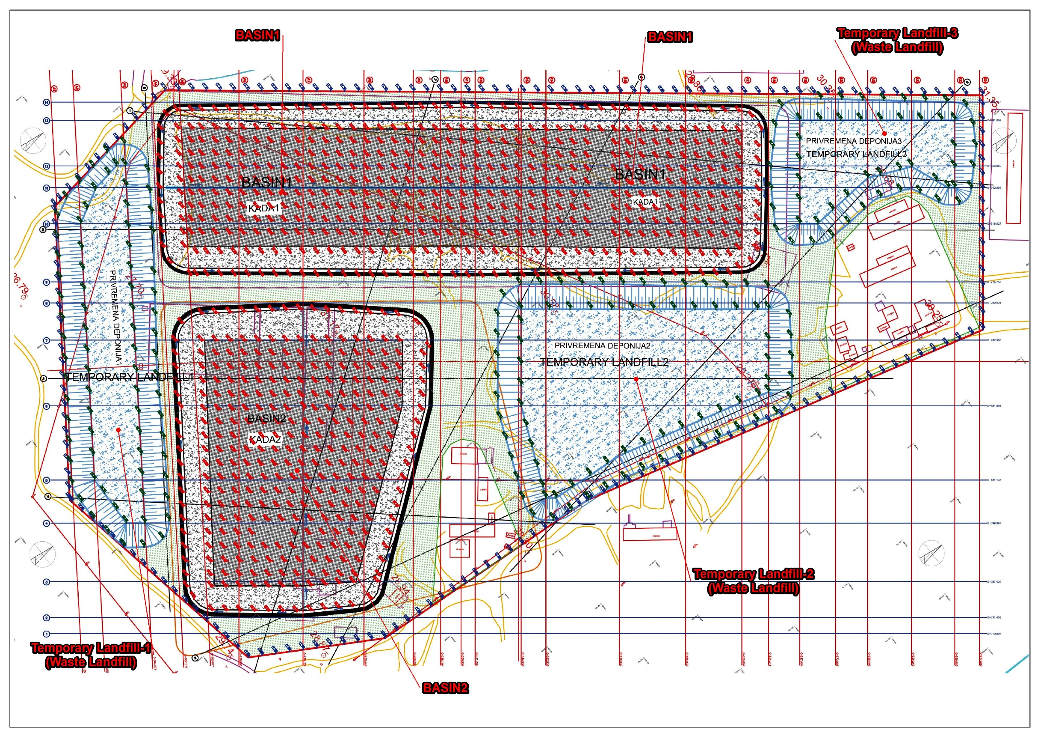

Figure 4. Site Layout (Source: Preliminary Design Book 1 Volume 2 Building Design – Construction)

It is planned that the wastes currently present at the KAP site will first be stored in these three temporary storage areas at KAP Solid Waste Area. While the wastes are temporarily stored prior to their permanent placement in the basins, they shall be managed and stored in a manner that does not pose any environmental or social risks. As indicated above, the volumes of the three temporary storage areas are provided separately, and the total planned capacity of the temporary storage areas is 556,247.65 m³. The total volume of waste currently present on site, as stated above, is 529,773.87 m³. While temporarily storing the solid waste at temporary sites, works will be performed to construct two basins that consist of different layers to prevent further leachate reach to soil, and surface and groundwater sources, and encapsulation to prevent interaction between solid waste and air environment, and precipitation. According to the design documents, the total capacity of these two basins is 529,773.87 m³. So that there will be no leachate occurring from the planned KAP Solid Waste Area after remediation works have been completed.

Accordingly, the total capacity is sufficient to accommodate the existing wastes at the KAP site.

According to design studies, the structure of the basins are planned as below:
- Humus 30cm
- Recultivation material 70 cm
- Drainage geocomposite, 650gr/m2 50kPa, permeability i=1x10º
- Drainage gravel layer 50 cm thick (1x10⁻⁴m/S)
- Geotextiles 800g/m²
- HDPE geomembrane 1mm rough on both sides
- Bentonite substrate 5500g/m²
- Levelling layer 50 cm thick
- Waste 610cm thick
- Geotextiles 400g/m²
- Drainage gravel layer 50 cm thick
- Geotextiles min 1200g/2m²
- HDPE geomembrane 2.5mm
- Bentonite substrate 5500g/m²
- Clay material 50 cm thick

Section view of a basin is presented in Figure 5. In Figure 6, schematic representation of works to be performed is given.

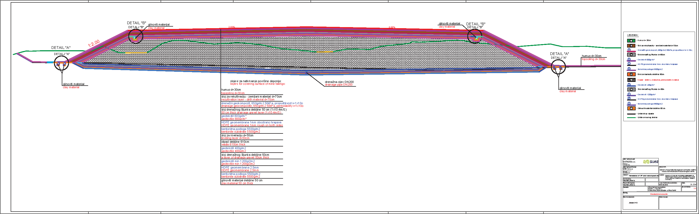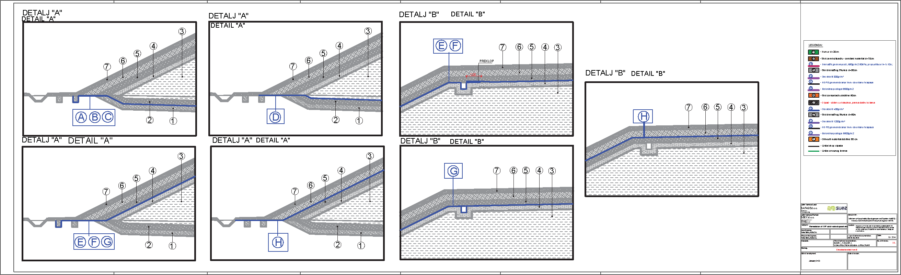

Figure 5 Section View of a Basin (Source: Preliminary Design Book 1 Volume 2 Building Design – Construction)

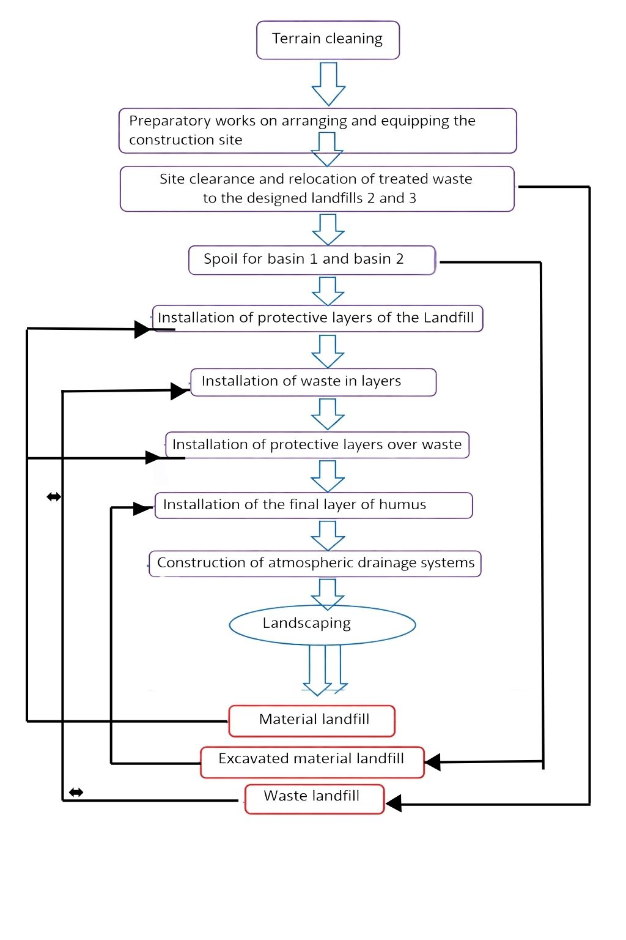

Figure 6 Schematic Representation of Works by Phases (Source: Preliminary Design Book 1. Volume 4. Construction Design – Construction Organization and Technology)

Equipment & Material Needs

Equipment and material need of the Project, especially the material needs, are highly important for an accurate assessment. The source of the material needed for the Project might enlarge the Project’s Area of Influence (AoI) thus leading to an increase in the Project’s impact footprint. This is unknown at this stage. In any case, the materials will be supplied from a licensed facility.

Organizational Capacity

The indicative organizational chart of the construction management is given in Figure 8. The organizational capacity during the construction phase, which is the most important phase of the Project in terms of E&S impacts, will play a key role in the management of these impacts associated with the Project. The organizational chart is missing an E&S Specialist who will ensure effective implementation of the requirements of this ESIA. However, it is considered that this gap can be filled by E&S Specialist to be assigned by Contractor, and to be guided by the Supervisor to be assigned for the Project implementation. In addition, similar environmental and social requirements, including oversight of ESIA implementation, will be explicitly included in the Site Supervision contract, ensuring that the Supervisor has adequate capacity and responsibility to monitor compliance with E&S obligations throughout the Project lifecycle. So that this requirement will be included within the ToR for the Contractor to ensure compliance.

Figure 7 Indicative Organizational Chart for the Construction Management (Source: Preliminary Design Book 1. Volume 4. Construction Design – Construction Organization and Technology)

During the post-closure phase, site activities will be limited to environmental monitoring, safety control, and site security, controlled site access for community safety. Therefore, staffing requirements will be minimal and will primarily consist of a Site Inspector responsible for environmental and structural monitoring, supported by security guards to prevent unauthorized access and illegal dumping. Specialized maintenance services will be provided on an on-call basis if required.

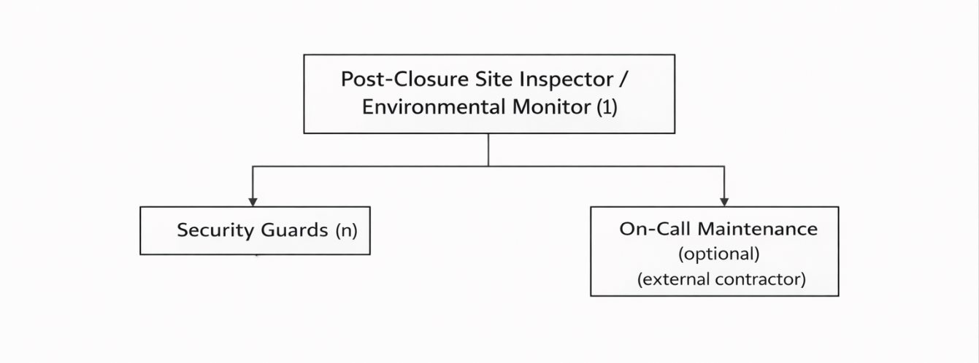
Figure 8 Indicative Organizational Chart for the Operation (Post Closure) Phase

Project Schedule

The Project’s construction phase will last for 99 weeks. The works will be performed in one shift in the daytime.

ENVIRONMENTAL AND SOCIAL BASELINE CONDITIONS

Baseline conditions presented in this ESIA are based on available historical data, previous investigations, and site-specific information collected during the preparation of the study. In addition, baseline investigations will be conducted to assess existing environmental pollution at the site prior to the commencement of any Project-related works. Where new or materially different information becomes available as a result of these investigations, the ESIA will be updated accordingly to reflect the actual baseline conditions.

Baseline monitoring will be carried out in accordance with the Sampling and Monitoring Plan developed as part of the Project Terms of Reference (ToR). The Sampling and Monitoring Plan, including parameters, locations, methodologies, and frequencies, is provided in the annexes of this ESIA (Annex 7) and will form the basis for all pre-construction monitoring activities.

Study Area and Sources of Baseline

The Project Area is located on the South border of Podgorica Municipality, which has a distance of 7 kilometers from Podgorica city center. KAP is situated between the Moraca River and the road connecting Podgorica to the coastline. In the vicinity of KAP Production Plant, there are several industrial properties and agricultural areas. The rehabilitation area is located next to the plant. KAP area is connected to Podgorica city center via the road E80, while rehabilitation area is accessibly by a local road from Podgorica.

Other than Podgorica City and Zeta Municipality; the closest settlements to the Project Area are Botun, Srpska, Ljajkovići, Lekici, Grbavci, Donji Kokoti and Mitrovići..

Sources of Baseline Data

A baseline data adequacy review has been conducted to evaluate existing data relevant to the project and project area. The adequacy of the available information has been checked to meet the ESIA requirements and identifying data gaps. During this baseline review, firstly the existing reports and project documentation for the Project have been reviewed. In addition, the existing data has been collected from literature and related sources and institutions. The list of sources for preparation for the ESIA including sources for baseline data is given in the References of this report.

In the further section of this ESIA Report, some of the baseline data belonging to Preliminary Design Documents prepared for the rehabilitation of Red Mud Basins are used to ensure consistency since these two rehabilitation areas are adjacent to each other.

Characteristics of the Physical Environment

Topography, Geology, Hydrogeology and Hydrology of the Region

Topography

In contrast to most of Montenegro, Podgorica lies in a mainly flat area at the northern end of the Zeta plain, at an elevation of 40 m. The only exceptions are hills which overlook the city. The most significant is 130.3 m high Gorica Hill, city's namesake, which rises above the city centre. The other hills include Malo brdo ("little hill", 205.4 m), Velje brdo ("big hill", 283 m), Ljubović (101 m) and Dajbapska gora (172 m). For the most part, these are too steep for development and thus limit the city's expansion, especially to the north. However, urbanization has been encroaching on the lower slopes of the hills since the 1990s. Podgorica city proper has an area of 108 square kilometres, while actual urbanized area is much smaller.

KAP is situated on the southern border of the municipality of Podgorica, which has a distance of 7 kilometers from Podgorica city center. KAP is located at an altitude of 32 m above sea level.

Topography and slope maps of KAP and its close vicinity are presented in Figure 9 and Figure 10, respectively.

Geology

KAP terrace is composed of clayey-sandy gravel and conglomerates. The main rocks are grayish limestones, dolomitic limestones and dolomites. The texture is banked and massive, rarely layered. Over the carbonate base are fluvioglacial sandy gravels and rounded stones, well bound and cemented with a carbonate binder into the conglomerate. The river Morača cut into them.

Quaternary glaciofluvial sediments are represented by sandy gravel and weaker to more strongly bound conglomerates, of variable thickness from about 15 to 50-60 m. The surface of the terrain is covered with a thin layer of deluvium – red soil (terra rossa). However, the morphology of the terrain in the KAP zone has been more or less altered by anthropogenic activity and the terrain is covered with an embankment of various thicknesses and characteristics.

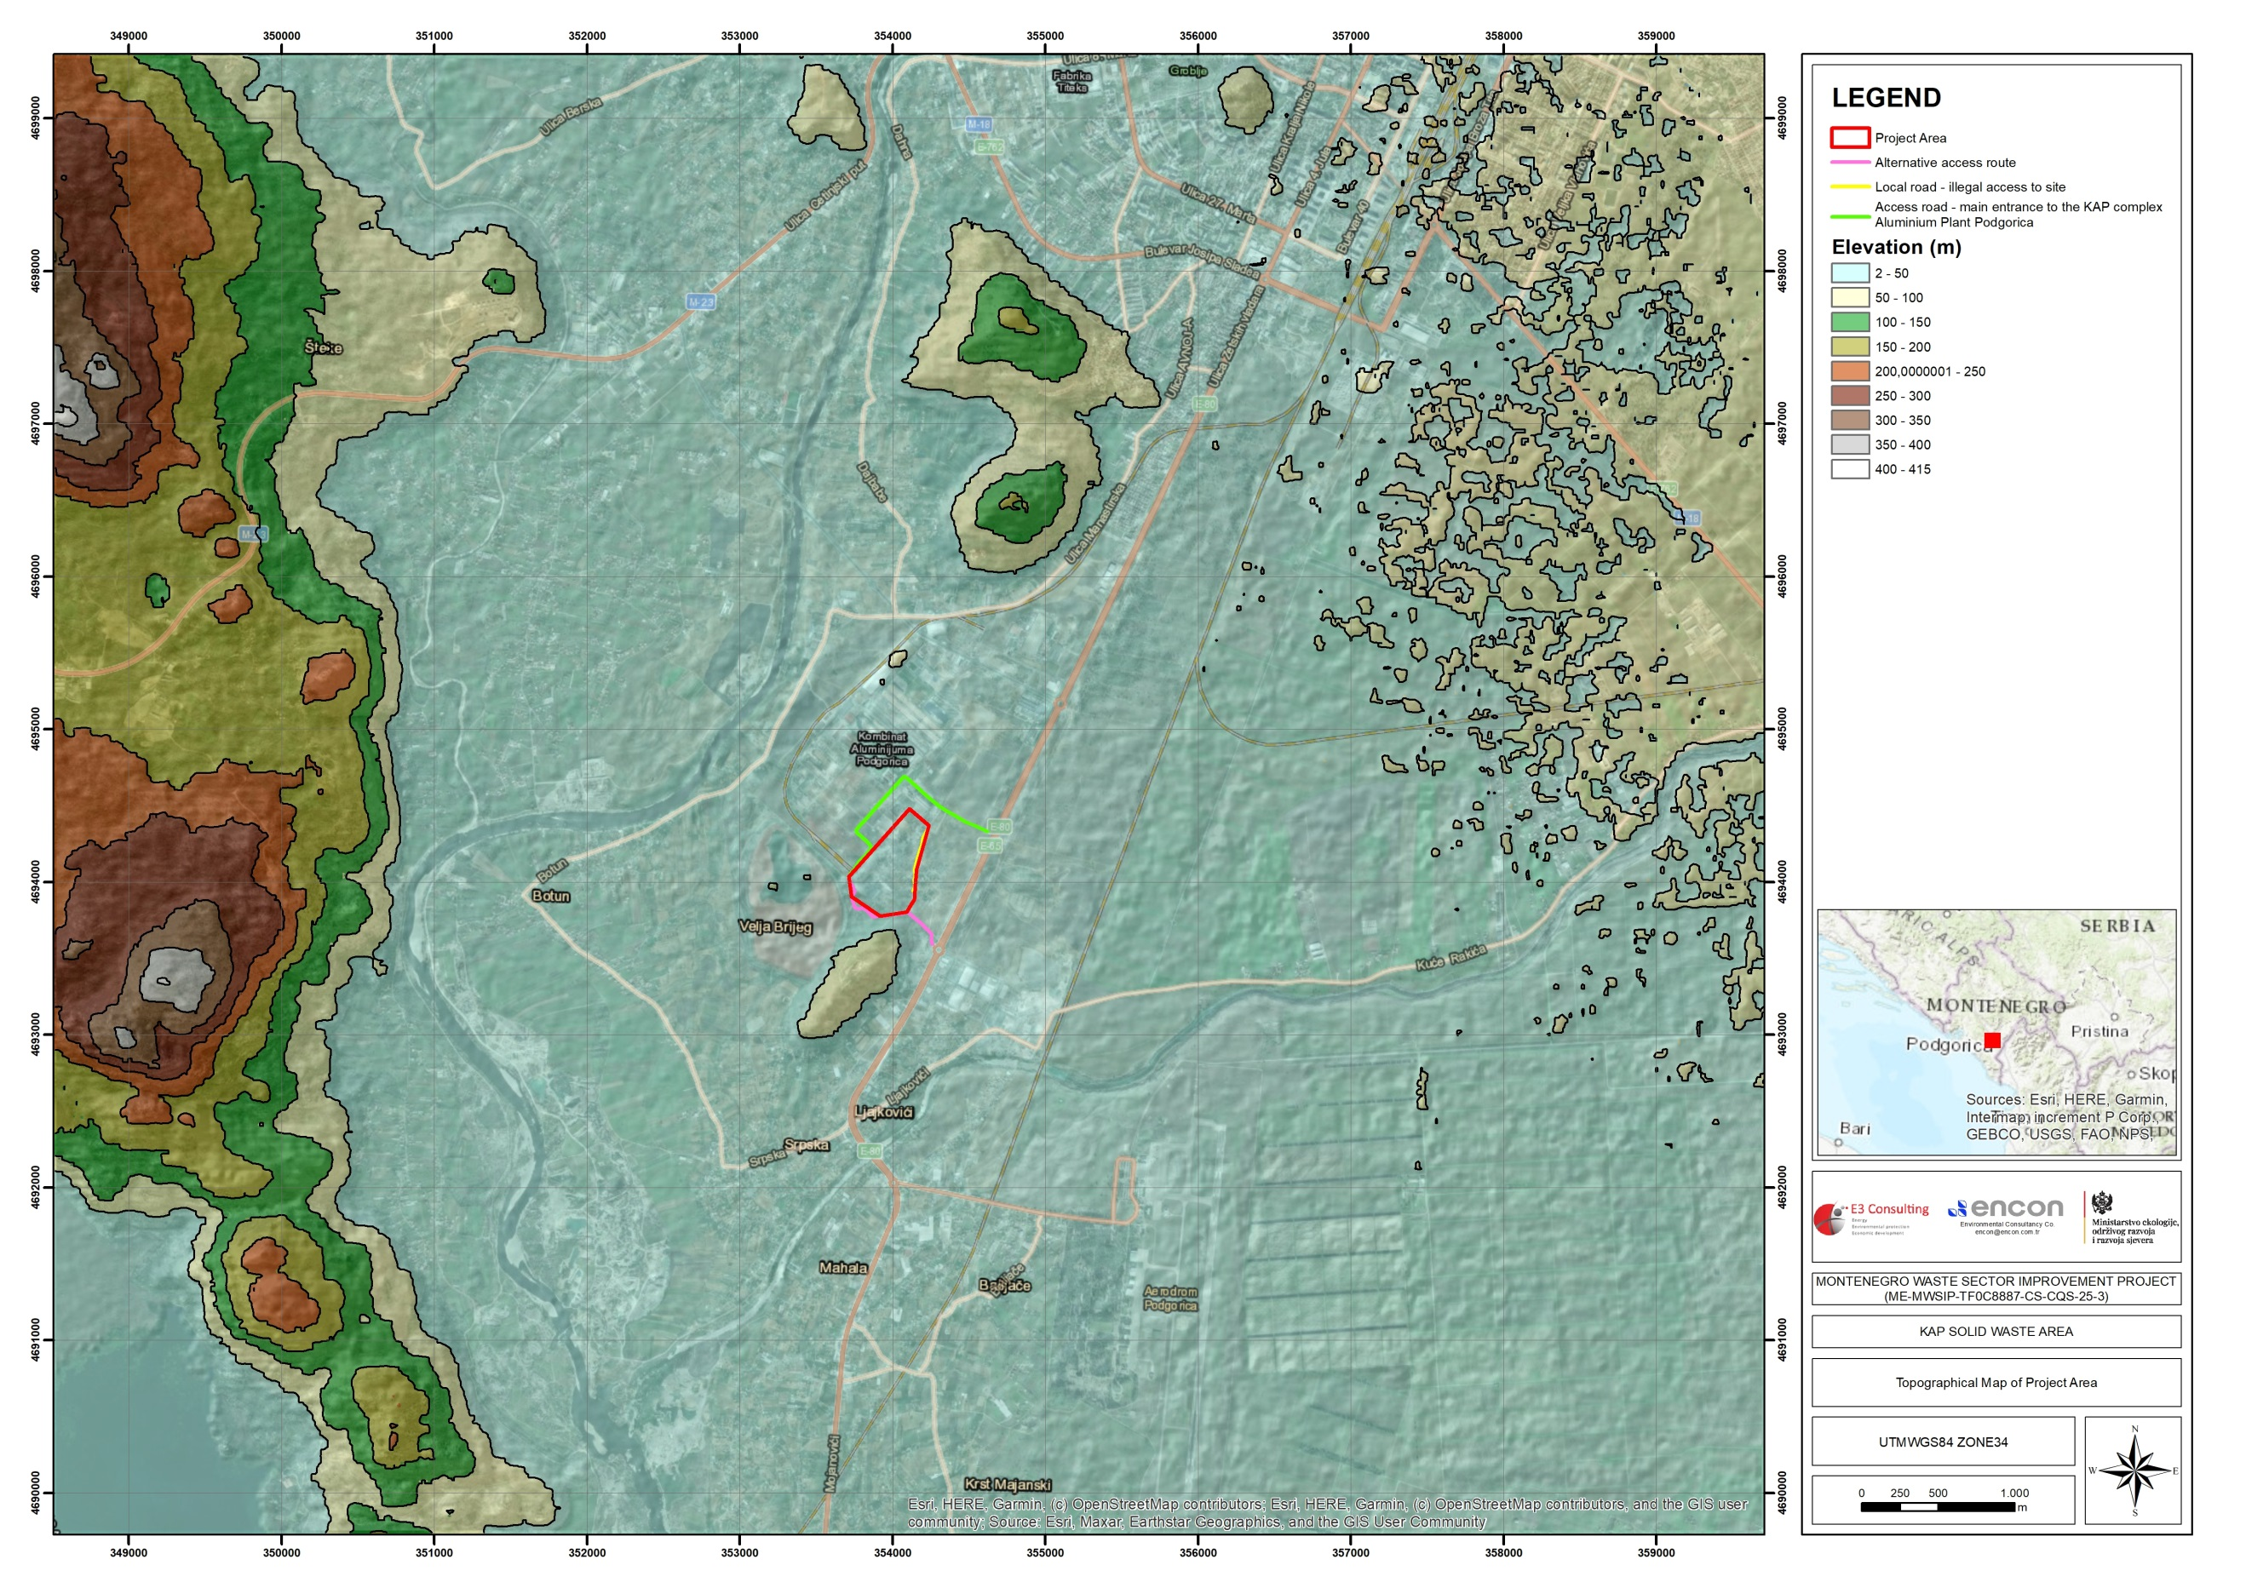

Figure 9 Topography Map of the Project Area
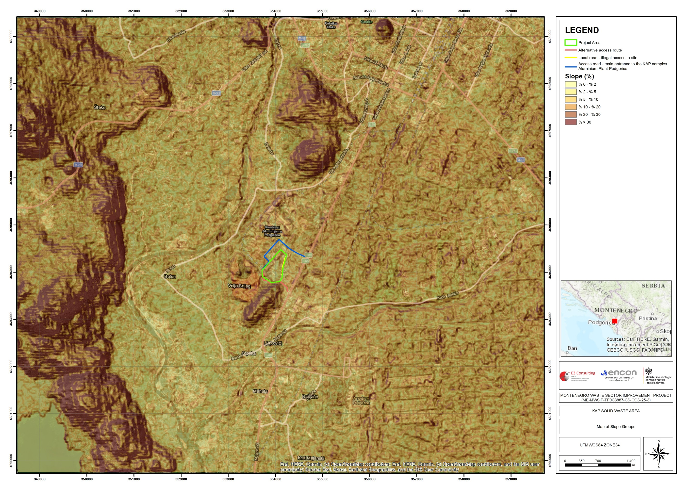

Figure 10 Map of Slope Groups

Hydrogeology

The KAP area is located in the peripheral part of the Ćemovsko field, which is a morphologically and hydrogeologically integrated part of the Zeta valley. The KAP is built on glaciofluvial sediments of the Zeta valley. The area of the valley is 484 ha. The direction of the groundwater flow in the area varies throughout the year depending on the water level in the river Moraĉa but is generally from the north-northwest toward south-southeast. The flow in the river varies from a minimum of 5.5 m³/second to 900 m³/second with an average of 132 m³/second. The depth from the surface to the groundwater ranges from about 17 meters in the summer period to about 13 meters during high water periods.

Based on the hydrogeological properties and functions of rock masses in the wider area of the KAP, the following can be singled out as it is stated by the Conceptual Design Documentation for Remediation of KAP Solid Waste Disposal Site, Preliminary Design Book 1 Volume 2, Building Design, Construction:

- compacted type of aquifer present in glaciofluvial sediments is represented by sandy gravel and weakly to more strongly bound conglomerates and
- karst type of aquifer is present in limestones of the rim and bottom of glaciofluvial sediments.

The compacted aquifer is widespread in the wider area of research, i.e. in the entire territory of the Zeta plain, and represents a very valuable water resource, especially in the hydrological minimum. This aquifer is formed partly in the alluvial sediments of the river Morača as well as in the glaciofluvial sediments (surface area over 200 km², and thickness mostly in the range of 30 - 100 m) which were deposited over paleorelief limestone. The recharge of this compacted aquifer takes place at the account of rainwater, the Morača and Cijevna rivers, as well as the underground inflow from the karst aquifer of the peripheral limestone terrains. Discharge of aquifer is performed by direct discharge into Skadar Lake. The compacted aquifer of the Zeta plain is characterized by good filtration characteristics, with an average filtration coefficient of about Kf = 5,0 x 10-3 m/s, and a transmissibility coefficient of T = 1,79 x 10-2 m²/s.

Based on approximate calculations, the minimum average flow of the aquifer flow (dynamic reserves) through the profile of the Zeta plain, 12 km wide, is about 12 – 15 m3/s. In the researched area within the natural terrain, fluvioglacial sediments are present, which are characterized by good filtration properties. During the exploratory drilling, the groundwater level was not registered even in the deepest wells up to a depth of 20 m.

According to the granulometric analysis of soil samples, the filtration coefficients are:

- Layer 1, metallurgical waste on one sample, Kf=1.8x10-3 cm/s.
- Layer 2, clay from the embankment, on one sample, Kf=1.15x10-7 cm/s.
- Layer 3, clay with sandy gravel, Kf=8.89x10-3 cm/s.
- Layers 4 and 5, sandy gravel and conglomerates, Kf=7.76x10-0 – 6.97x10-3 cm/s.

Quaternary glaciofluvial sediments are represented by sandy gravel and weaker to more strongly bound conglomerates, of variable thickness from about 15 to 50-60 m. The surface of the terrain is covered with a thin layer of deluvium – red soil. However, the morphology of the terrain in the KAP zone has been more or less altered by anthropogenic activity and the terrain is covered with an embankment of various thicknesses and characteristics.

Hydrological Characteristics

KAP area is situated between two rivers – Morača River and Cijevna River immediately south of the River Morača, approximately 15 km upstream of the Lake Skadar. The area where the KAP is located is part of the Zeta Valley, which is the largest plain in Montenegro and a large natural drinking water reservoir. The Morača River flows through KAP's site and into Skadar Lake, a significant national park in Montenegro shared with Albania on Albania's border. The Montenegrin section of the lake and surrounding land has been designated as a national park, while the Albanian section is a nature reserve. Lake Gornje Malo Blato, located approximately 5.5 km southwest of the KAP site, is a large inland water body. It is situated north of Muljage, and west of Oblun - Markova Gorica.

Malo blato is a separate water basin out of which water continually flows into Skadar Lake, and at high water level it looks like the lake's gulf. It is located in the karst depression, in the northern part of Skadar Lake Basin, with which it is hydrologically connected by Bisevina River, its outflow. Malo blato drains into Bisevina River, which after meeting Segrtnica River creates Karatuna River. Karatuna receives the flows of Bazagurska Matica under Prevlaka peninsula and then flows into River Crnojevica. The most important Skadar Lake tributaries are Moraca, Karatuna, Bazagurska matica, Crnojevica, Orahovstica and Crmnicka Rivers. The lake receives significant amounts of flow from smaller rivers that drain into Zeta Plain. River Moraca exerts the greatest influence on water volume of Skadar Lake. It provides 62% of total inflow. Skadar Lake outflows by Bojana River with a mean annual flow of 322 m³/s.

Average annual precipitation in the Skadar Lake basin varies from 1750 mm to 3250 mm, depending on the location. Due to abundance of precipitation (over 2000 mm annually) in Skadar Lake, watershed has remarkable inflow. River Moraca is the most important tributary (mean flow 175 m³/s) and it provides over 62% of the total inflow. On the other side, Skadar Lake oufflows by Bojana River with average flow of 322 m³/s. The lake and river together create one unique system.

Erosion and Land Use

Soil erosion is mainly present in areas with impermeable geological grounds, where the soil is mostly non-resistant and susceptible to erosion. Frequent occurrence of erosion is recorded in places with rather devastated vegetation cover, on steep slopes and in places with insufficient protection of the soil from possible erosion.

The most densely populated and urbanized area in the whole Montenegro is the area of Podgorica with its suburbs. In the area of municipality of Podgorica, various types of land with various physical-chemical characteristics and fertility are present. The most important factors influencing the formation of soil and their properties are geological background, dynamic montane relief, climate, hydrography, vegetation and humans. The existing land use is influenced by demographic and socio-economic factors. In the area downstream of KAP, agricultural land use prevails on the Zeta plain area and Morača plain downstream of Podgorica. The northern shore of the Skadar Lake has a very large littoral zone under influence of regular (annual) floods and so in this part, there is no distinct shoreline. This area is covered with rich swamp vegetation, expansive meadows and flooded forests.

KAP area belongs to “very weak erosion” type according to the map (Figure 11) found in “Spatial Plan of Montenegro Until 2020” March 2008.

Erosion can be external or internal. Internal erosion is more dangerous because it is not visible until it appears on the slopes of the landfill in KAP, and then the condition is critical. It is characterized by the appearance of springs and ponds and the removal of material from the landfill. External erosion can be affected by wind and heavy rains. Remedial measures should be taken as soon as this phenomenon is observed. As measures to prevent erosion, occasional recultivation and grazing of landfill slopes is envisaged.

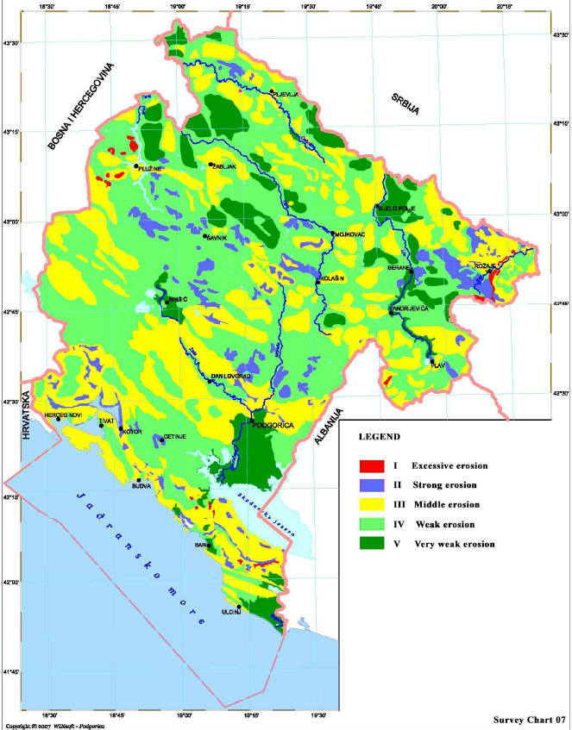

Figure 11 Erosion Map of Montenegro (Spatial Plan of Montenegro Until 2020, March 2008)

The land use characteristics of the Project area and its close vicinity according to CORINE database (2018) is given in Figure 12. Following the map, the results are presented in Table 1.

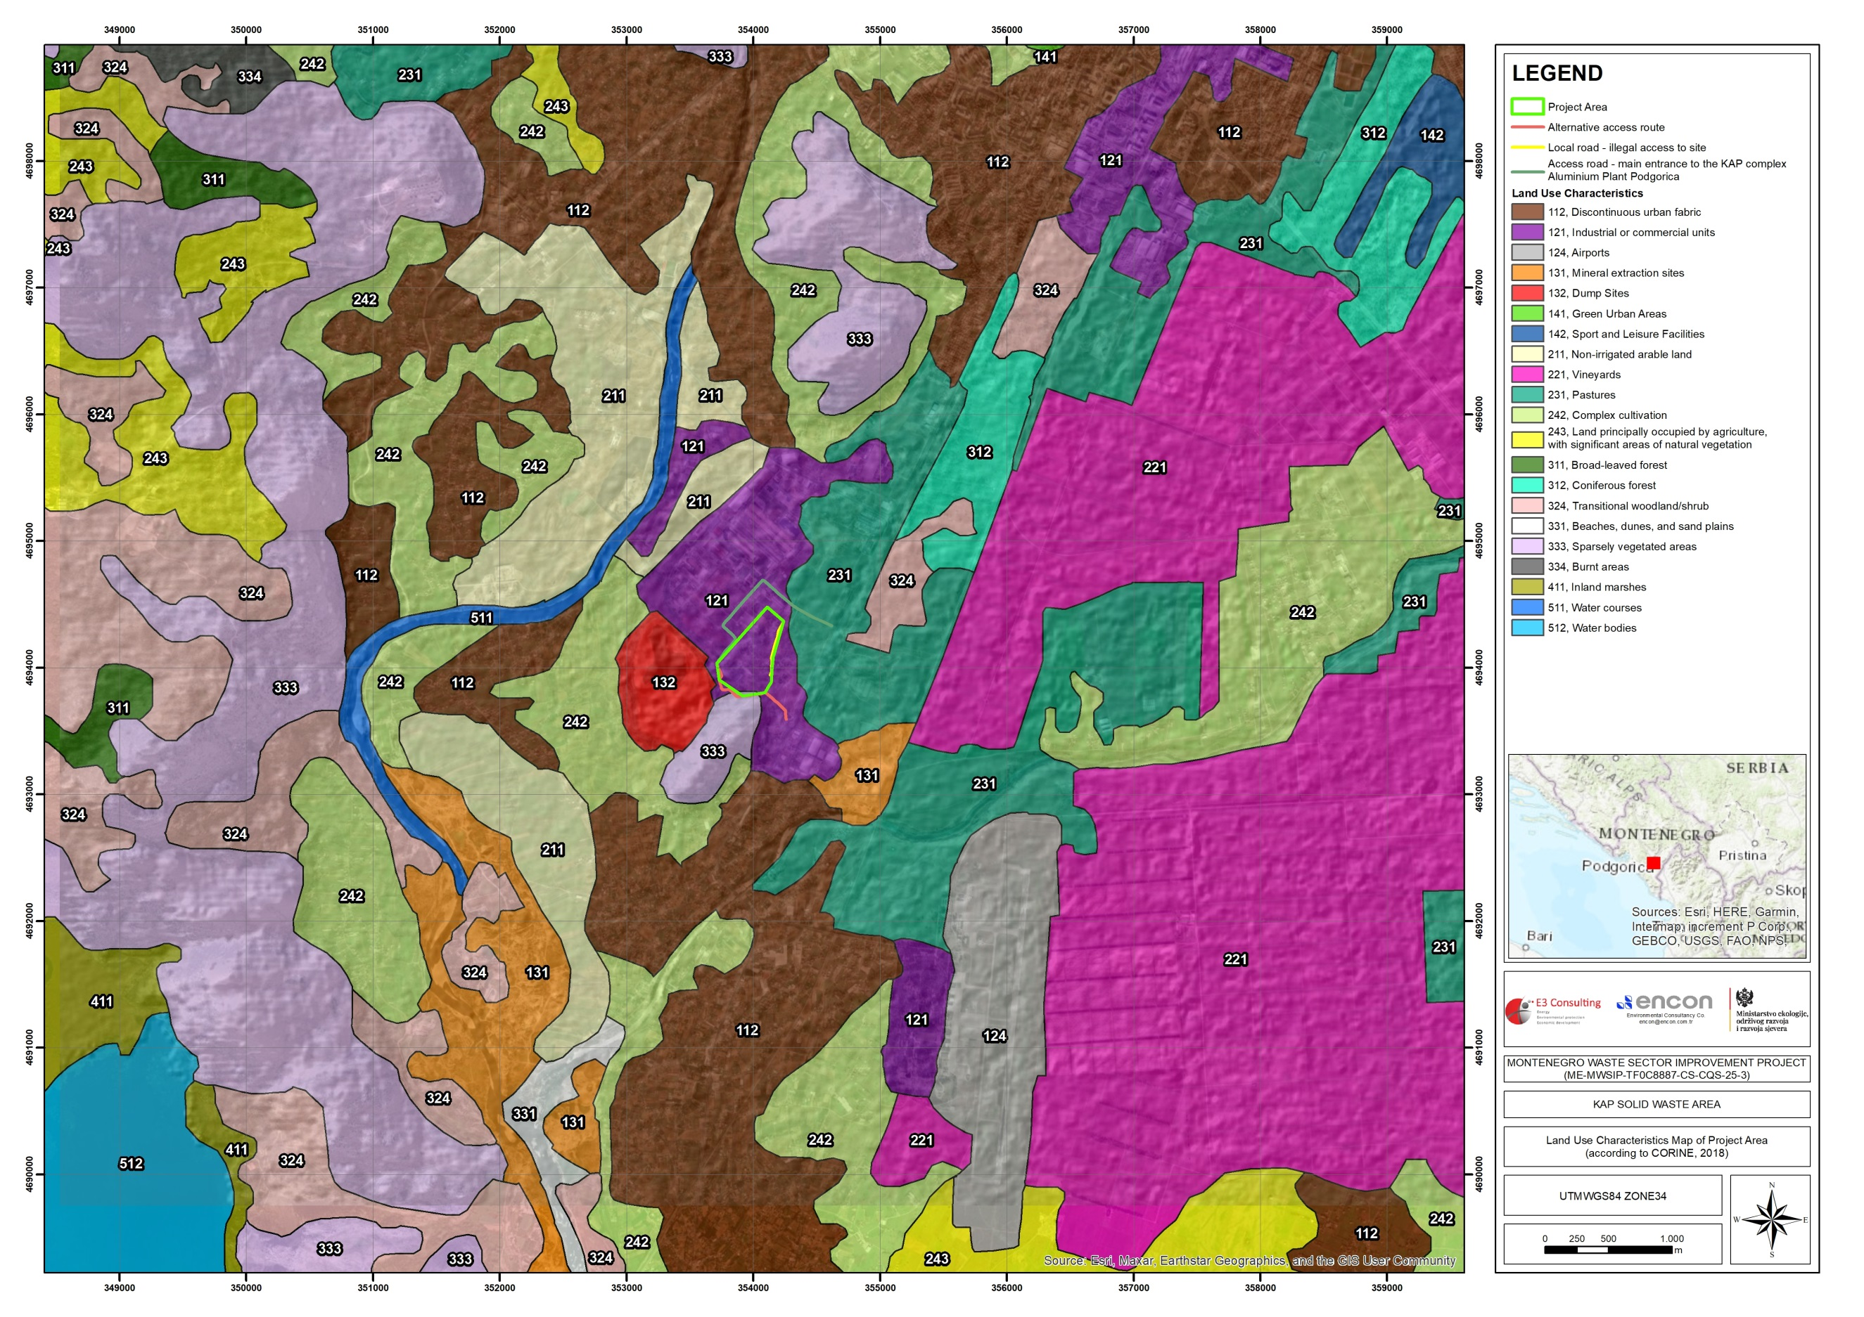

Figure 12 Land Use Characteristics of Project Area and its Close Vicinity (CORINE, 2018)

Table 1 Land Use Characteristics (CORINE, 2018)

Level 1 | Level 2 | Level 3 | Code 2018 | Section 1 |  |  | Level 1 |  | Level 2 |  | Level 3
 |  |  |  |  |  |  | Total Area (ha) |  | Total Area (ha) |  | Total Area (ha)
 |  |  |  | Area | Area | Percent  (%) | Area (ha) | Percent  (%) | Area (ha) | Percent  (%) | Area (ha) | Percent  (%)
 |  |  |  | (m²) | (ha)
1. Artificial surfaces | 1.2. Industrial, commercial and transport | 1.2.1. Industrial or commercial units | 121 | 198.017,66 | 19,80 | 98,13 | 19,80 | 98,13 | 19,80 | 98,13 | 19,80 | 98,13
3. Forests and seminatural areas | 3.3. Open spaces with little or no vegetation | 3.3.3. Sparsely vegetated areas | 333 | 3.770,74 | 0,38 | 1,87 | 0,38 | 1,87 | 0,38 | 1,87 | 0,38 | 1,87
Total |  |  |  | 201.788,40 | 20,18 | 100,00 | 20,18 | 100,00 | 20,18 | 100,00 | 20,18 | 100,00

Climate

Montenegro is located in the central part of a moderately warm zone in the Northern Hemisphere (latitudes 41° 52’ to 43° 32’ N and longitudes 18° 26’ to 19° 22’ E). Owing to its latitude, i.e., its proximity to the Adriatic and Mediterranean Seas, it has a Mediterranean climate with warm and somewhat dry summers, and mild and rather humid winters. Besides latitude and altitude, the climate in Montenegro is determined by the presence of large bodies of water (Adriatic Sea, Lake Skadar), the sea entering deeply into the land (Boka Bay), moderately high mountainous area near the coast (Orjen, Lovćen, Rumija), Ulcinj field in the far southeast and the mountainous massif of Durmitor, Bjelasica and Prokletije. The warm climate is present in the lower parts of the country, while the cold climate can be found in the mountainous inland areas, mainly at altitudes above 1,000 m.

The large water surface, the height and direction of the coastal mountains, and the relief of the land locally and regionally affect its climate, creating, in a small area, large differences between the climate of the coastal region and the climate of the highland region, with numerous transitional forms of the local climate. The southern part of Montenegro and the Zeta plain have Mediterranean climate with long, hot and dry summers and relatively mild and rainy winters. Podgorica is the city with the highest mean monthly temperature in the summer, and with the highest average number of tropical days.

An overview of the climate in the Project area and surrounding regions shows that Montenegro’s annual average air temperature is approximately 9.2 °C based on observed climate data for the period 1991–2020. In mountain locations such as Žabljak, which is representative of higher-elevation climatic conditions near the Project area, the mean annual temperature is around 5.7 °C. Seasonal variability is pronounced, with cold winters and milder summers

Mean annual cloudiness generally increases from the southern coastal areas towards the northern mountainous regions of Montenegro. Lower cloudiness values are typically observed along the coast, the Zeta plain, and the Nikšić area, while higher values are characteristic of the northern mountainous areas. Seasonal variations indicate lower cloudiness during summer months in the south and higher cloudiness during the winter period (November–February) in the north.

Annual precipitation in Montenegro shows pronounced spatial variability, ranging from approximately 800 mm in the northern regions to over 4,000 mm in the southwestern mountainous areas. Exceptional precipitation levels have been recorded on the slopes of Mount Orjen, including the Crkvice area, which is recognized as one of the rainiest locations in Europe. With an average annual precipitation of approximately 1,600 mm, the KAP Project area is characterized by relatively high precipitation levels, influenced by its proximity to the Adriatic Sea.

Seismicity

The Government of Montenegro recently adopted National Strategy for Emergency Management, recognizing the seismic risk as a dominant one that affects very wide range of economic and social values. The Institute of Hydrometeorology and Seismology is a state administration body, with competency in the field of seismology. The Institute takes care of the establishment, development, and work of the meteorological, hydrological and seismological observation and forecasting stations on the entire territory of Montenegro.

The entire area of Montenegro, and especially its coastal and central part, is a seismically active area. Territory of Montenegro is an area with high seismic risk, with frequent small to moderate sized earthquakes, and occasionally very strong, devastating earthquakes such as the one that struck in 1979. Catastrophic earthquake of April 15, 1979 at 07:19 am (local time) with the magnitude of 7.0 and with epicentre intensity of 9 degrees on the MSC scale is the most severe earthquake that hit this area in the 20th century. The effects of the earthquake were felt on the area of over 50,000 km², including Dubrovnik, hitting at the same time the area of Skadar and Lјeš in Albania. Epicenter of the earthquake was located in the Adriatic Sea, between Ulcinj and Bar, at a 15 km distance from the coast. This earthquake took 101 lives in Montenegro, 35 in Albania, left over 100 thousand people homeless, with the direct and consequential damage that amounted to 4.5 billion USA dollars at the which amounted to 4 times the value of Montenegrin gross national income for 1979.

As a direct result of seismic activity and its primary effects, secondary hazards may be produced: fire, technical-technological accidents, local epidemics, social unrest, etc. As the particularly active seismic area, the following zones should be emphasized: seismologic zones around Ulcinj and Bar, Budva and Brajići, Boka Kotorska but also immediate surroundings of Berane, the entire region of the Skadar Lake, Maganik etc.

The map of seismic re-ionization of the Montenegrin territory (Figure 13) which reflects possible seismic intensity degrees divides several zones of different seismic hazard.

- Southern, coastal region with Ulcinj, Skadar, Budva and Boka Kotorska zones with the possible maximum intensity (in the middle ground) of nine degrees of the MSC scale,
- Southern, coastal region with Ulcinj- Skadar, Budva and Boka Kotorska zone with a possible maximum intensity (in the middle ground) of nine degrees of the MSC scale,
- Podgorica - Danilovgrad zone with the expected maximum intensity of eight degrees of MSC scale,
- The central part of Montenegro with the northern region including Nikšič, Žabljak and Pljevlja with possible maximum intensity of seven degrees of the MSC scale,
- An isolated seismologic Berane zone that may generate earthquakes with a maximum intensity of eight degrees on the MCS scale.

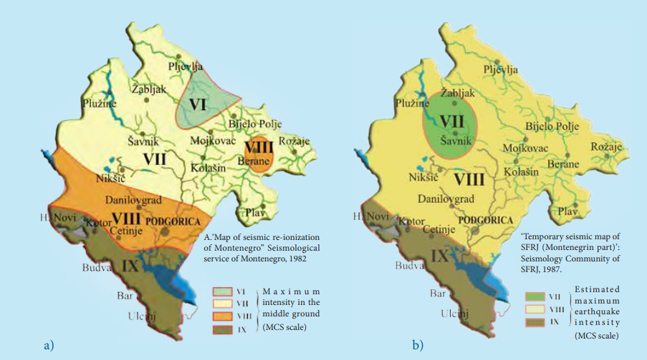

Figure 13 Maps of seismic re-ionization of Montenegro territory (1982): a) within the return periods of 200 years and b) within the return-period of 500 years

The wider area of municipality of Podgorica belongs to the seismically high region with a degree of seismic intensity of VIII-degree MCS scale (see Figure 13) within the return periods of both 200 years and 500 years. Thus, the KAP area is vulnerable to seismic events.

Given the highest seismicity of terrain in Montenegro as observed and concentrated in the coastal area and Skadar-Zeta depression, probability of formation of large landslides is most prominent in the middle course of Morača River. In the upper and middle course of Morača River, massive landslides, rockslides or rockfalls may occur as follow up events of strong earthquakes with catastrophic consequence.

Quality of Physical Environment

Water Quality

Water quality is assessed based on ecological status and chemical status, in accordance with the Regulation on the Method and Deadlines for Determining the Status of Surface Waters (Official Gazette of Montenegro No. 25/2019) and the Regulation on the Method and Deadlines for Determining the Status of Groundwater (Official Gazette of Montenegro No. 52/2019).

Ecological status is determined using biological quality elements (e.g., aquatic flora and fauna), hydromorphological conditions, and supporting physicochemical parameters such as dissolved oxygen, nutrient concentrations, temperature, and turbidity.

Chemical status is evaluated by comparing measured concentrations of priority and hazardous substances against Environmental Quality Standards (EQS) established under national legislation aligned with the EU Water Framework Directive (2000/60/EC).

Table 2 Environmental Quality Standards (EQS)Surface Water (Regulation on the Method and Deadlines for Determining the Status of Surface Waters, Official Gazette of Montenegro, No. 25/2019)

Parameter | EQS / Guideline Value | Unit
Dissolved Oxygen | ≥ 5.0–7.0 | mg/L
pH | 6.0 – 9.0
Biological Oxygen Demand (BOD₅) | ≤ 5 | mg/L
Chemical Oxygen Demand (COD) | ≤ 25 | mg/L
Ammonium (NH₄⁺) | ≤ 0.5 | mg/L
Nitrate (NO₃⁻) | ≤ 50 | mg/L
Total Phosphorus | ≤ 0.1 | mg/L
Lead (Pb) | ≤ 7.2 | µg/L
Cadmium (Cd) | ≤ 0.08–0.25 | µg/L
Mercury (Hg) | ≤ 0.07 | µg/L
Nickel (Ni) | ≤ 20 | µg/L
PAHs (e.g., Benzo[a]pyrene) | ≤ 0.00017 | µg/L

Table 3 Groundwater – Chemical Status Limits (Regulation on the Method and Deadlines for Determining the Status of Groundwater Official Gazette of Montenegro, No. 52/2019)

Parameter | Threshold Value | Unit
Nitrate | ≤ 50 | mg/L
Ammonium | ≤ 0.5 | mg/L
Chloride | ≤ 250 | mg/L
Sulphate | ≤ 250 | mg/L
Conductivity | ≤ 2500 | µS/cm
Arsenic | ≤ 10 | µg/L
Lead | ≤ 10 | µg/L
Cadmium | ≤ 5 | µg/L
Mercury | ≤ 1 | µg/L

Water Quality of the Gornje Malo Blato

Gornje Malo Blato is a large inland body of standing water, and situated north of Muljage, and west of Oblun - Markova Gorica. It is located in the southern part of the country, 14 km southwest of Podgorica, at the latitude and longitude coordinates of 42.341667 and 19.166667. It covers 6.3 square kilometers. The estimated terrain elevation above sea level is 3m. Its average depth is 3m, as well as the long water retention period in this part of the lake and its slow flowing into Bisevina River causes the water to heat evenly, and the deepest layers to be in the same isothermal frame and depend on solar radiation.

The area around Gornje Malo Blato is almost completely covered with mixed forest. Large flocks of migratory bird species that spend the winter on Skadar Lake gather in Gornje Malo Blato. Fishing enthusiasts are mainly interested in fishing at Gornje Malo Blato. All year long, particularly during the season, local population is engaged in fishery.

The climate is humid and subtropical at Gornje Malo Blato Lake. The average temperature is 15 °C. The warmest month is July, at 27 °C, and the coldest January, at 3 °C. The average rainfall is 2,431 millimeters per year. The wettest month is January, with 325 millimeters of rain, and the wettest August, with 57 millimeters.

Malo blato is a separate water basin, and it is also part of the Skadar Lake. Malo blato has typical characteristics regarding biodiversity, geomorphology, hydrogeology, thermal regime, etc. as the Skadar Lake. In this area, there are no registered rare or endangered species. Gornje Malo Blato is located in the karst depression, in the northern part of Skadar Lake Basin, with which it is hydrologically connected by Bisevina River, its outflow. The only outflow of Gornje Malo Blato is Bisevina River, located in its southwest shore. The minimum measured flow of Gornje Malo Blato’s outflow “Bisevina River” is around 5,65 m³/s. In the winter periods this flow is much higher.

Water Quality of the Skadar Lake

Skadar Lake is a transboundary lake shared by Montenegro and Albania. It is one of the largest freshwater lakes in Europe and has an extremely wide floodplain in its northern part. Ramsar convention from 1996 included Skadar Lake into list of internationally important swamps, as significant water birds' habitat. The lake harbours 279 bird species, some 90% of which are migratory species of international importance. A rare species of pelican nests on the lake. There are more than 50 species of fish, 15 of which are endemic. The region’s flora is diverse: within the borders of the national park alone there are some 1,400 plant taxa (species and subspecies), more than 30 rare plant species and several nationally and/or internationally endangered species.

The most important Skadar Lake tributaries are Moraca, Karatuna, Bazagurska matica, Crnojevica, Orahovstica and Crmnicka Rivers. The lake receives significant amounts of flow from smaller rivers that drain into Zeta Plain.

The only effluent from the lake is the Bojana/Buna River, which flows through Albanian territory for about 18 km and then forms the border between Montenegro and Albania at a distance of about 25 km. River Moraca is the most important tributary (mean flow 175 m³/s) and it provides over 62% of the total inflow. On the other side, Skadar Lake oufflows by Bojana River with average flow of 322 m³/s.

Figure 14 Terrain of Skadar/Shkodra Lake in 3D

The largest amount of industrial waste waters, 29,835,160 m³ per year, generated in KAP, flows directly into the Morača river and reaches Skadar Lake. For that amount of liquid aluminum, 516 000 tons of bauxite is used with 1 806 000 liters of firing oil, 1 689 GWh of electricity and over 180 tons of other material per year, along with the 33 000 000 m³ of water. This kind of production leaves about 400 000 tons of red mud every year. Also, throughout the whole production period about 325 000 m³ of solid waste was disposed, which, like the red mud, is mostly hazardous waste.

The large amount of waste, municipal and industrial water (over 69 million m³/year), which Morača river and ground waters bring into the lake, also bring a large amount of organic matter. Agricultural activity in the Zeta Plain includes the use of artificial fertilizers that also negatively affects and intensifies eutrophication of the lake.

During the period 2003-2004 the measurements period of water temperature of Lake Skadar were conducted. Minimum water temperature was noted in December (4.4°C) and maximum in July (30.1°C). The highest average water temperature was measured in June (28.7°C) and the lowest average water temperature in December (6.48°C). The average temperature for the winter period was 8°C, and 24.5°C for the summer period (see Table 4).
Table 4 Physico-chemical characteristics of Lake Skadar water for the period 2003–2004 (Rakočević, 2006; 2012)

Parameter |  | May | June | July | Aug | Sep | Oct | Nov | Dec | Feb | Mar | Apr
t (°C) | Avg | 23.97 | 28.70 | 28.46 | 28.60 | 20.41 | 13.55 | 11.23 | 6.48 | 8.10 | 13.80 | 15.49
t (°C) | Min | 22.00 | 24.90 | 23.90 | 25.40 | 17.80 | 12.00 | 9.90 | 4.40 | 7.30 | 11.60 | 14.00
t (°C) | Max | 25.60 | 29.90 | 30.10 | 28.80 | 21.90 | 14.80 | 12.30 | 10.80 | 8.60 | 15.30 | 17.00
Secchi (m) | Avg | 2.37 | 1.67 | 1.34 | 1.23 | 1.72 | 2.10 | 2.70 | 2.87 | 2.13 | 2.73 | 2.46
Secchi (m) | Min | 1.00 | 1.00 | 0.80 | 0.60 | 0.80 | 1.20 | 2.00 | 2.00 | 1.20 | 2.00 | 1.90
Secchi (m) | Max | 4.00 | 2.80 | 2.50 | 2.20 | 3.50 | 3.50 | 3.50 | 3.50 | 3.00 | 3.50 | 3.50
pH | Avg | 8.2 | 8.1 | 8.2 | 8.3 | 8.1 | 8.0 | 8.00 | 8.4 | 7.9 | 8.3 | 8.2
pH | Min | 7.6 | 7.7 | 7.8 | 7.6 | 7.8 | 7.6 | 7.7 | 8.0 | 7.8 | 7.9 | 7.8
pH | Max | 8.4 | 8.4 | 8.4 | 8.9 | 8.3 | 8.4 | 8.3 | 8.7 | 8.0 | 8.6 | 8.2
O₂ (mg/l) | Avg | 9.26 | 9.29 | 8.83 | 8.76 | 8.19 | 9.80 | 10.27 | 10.93 | 9.57 | 11.69 | 10.88
O₂ (mg/l) | Min | 7.30 | 7.60 | 5.80 | 5.70 | 6.99 | 8.50 | 8.60 | 10.00 | 9.00 | 10.39 | 10.00
O₂ (mg/l) | Max | 9.93 | 11.90 | 11.00 | 11.70 | 9.08 | 11.40 | 11.50 | 11.60 | 11.00 | 14.00 | 12.00
EC (µS/cm) | Avg | 249 | 260 | 251 | 238 | 257 | 263 | 288 | 298 | 258 | 248 | 250
EC (µS/cm) | Min | 210 | 199 | 199 | 191 | 207 | 197 | 254 | 255 | 179 | 238 | 206
EC (µS/cm) | Max | 365 | 378 | 404 | 415 | 371 | 310 | 366 | 303 | 333 | 285 | 310
TN (mg/l) | Avg | 0.18 | 0.66 | 0.62 | 0.48 | 0.36 | 0.18 | 0.28 | 0.15 | 0.15 | 0.16 | 0.16
TN (mg/l) | Min | 0.15 | 0.16 | 0.16 | 0.15 | 0.15 | 0.15 | 0.20 | 0.15 | 0.15 | 0.15 | 0.15
TN (mg/l) | Max | 0.34 | 1.32 | 1.10 | 0.85 | 0.70 | 0.33 | 0.60 | 0.15 | 0.15 | 0.20 | 0.20
TP (mg/l) | Avg | 0.012 | 0.026 | 0.025 | 0.019 | 0.012 | 0.010 | 0.005 | 0.005 | 0.005 | 0.005 | 0.010
TP (mg/l) | Min | 0.005 | 0.005 | 0.005 | 0.005 | 0.005 | 0.005 | 0.005 | 0.005 | 0.005 | 0.005 | 0.005
TP (mg/l) | Max | 0.040 | 0.060 | 0.041 | 0.035 | 0.024 | 0.018 | 0.008 | 0.006 | 0.005 | 0.005 | 0.032

Water Quality of the Moraca River

The 99-kilometre long Moraca flows through Podgorica, drains about 32% of Montenegrin territory and provides 62% of the Skadar Lake’s water. The largest amount of industrial waste waters generated in KAP, flows directly into the Morača River and reaches Skadar Lake.

Threats to water quality in the Morača River are believed to mainly derive from pollutants (metals, PCBs, PAHs) from industry, in particular the KAP and also the steelworks at Niksic. The main pollutants are heavy metals and other toxic substances from industry, especially linked to earlier years when the KAP was fully functioning; these pollutants are now expected to be mainly found in sediments and biota in the downstream Morača, in Skadar Lake.

Water quality in the upper and middle reaches of Morača River is excellent until just upstream of Podgorica where it degrades due to human activity. Water quality further degrades downstream of the City wastewater treatment plant and also near the KAP.

Concentrations of PCB in surface water were above the detection limit in the Morača River between 1990 and 1995. Recent measurements of PCB and PAH concentrations are below the detection limit and are currently no reason for concern for surface water quality (as long as the measures taken by KAP remain effective).

The analysis of metals in the water of the Morača River, Crenojevica River and in Lake Skadar in 1981 (and the years before) showed minimum concentrations of Na, K, Cu, Zn, Cr, Pb, Mn, Co, As, Hg, Cn and Fe. The comparison between their concentrations upstream of the rivers and at the lake showed little difference, except for some insignificant increased concentrations of Na and Fe at a specific site in the Morača River.

This implies that the lake water at that time was hardly polluted by the existing industries within the lake basin. Note that the KAP began its first production at its full capacity in 1973. Further, all analyzed metals were below the Montenegrin Maximum Permissible Concentrations standards for drinking water.

Recent analyses of lake water and sediments show an increase in concentrations of heavy metals. The concentrations are higher at the mouth of the Morača River, mainly due to the industrial wastes originating from the KAP. The highest Hg content in July 2005 was 1.77 mg/kg in sediments (0.40 mg/kg in fish), while it was undetectable in 1974-1977 (Filipovic, 1981, p.99).

Water Quality of the Cijevna River

The River Morača has several tributaries, of which rivers Zeta, Mrtvica and Cijevna are the most important. These three rivers are permanent, whereas other inflows often dry out during summer. The Cijevna River is a left tributary of the Morača River. KAP is located in the close proximity of Moraca and Cijevna rivers.

The Cijevna River is formed in the high mountain massif of Prokletije. The length of 26,5 km runs through Albania, while in the territory of Montenegro it runs a length of 32,3 km.

Ecological indicators and water quality assessment have consistently shown that the Cijevna is one of the least polluted rivers in the country. Since 2008-2010 environmental monitoring has become more frequent.

In Montenegro, the river is ranked as one of the cleanest rivers in the country. The municipality of Podgorica declared the river canyon a "natural monument" in 2017. Environmental organizations argue that despite their formal commitment to protect the river's basin, Montenegrin authorities have consistently allowed sewage pollution, gravel exploitation and unauthorized construction. In the lower part, beyond the canyon, industrialized agriculture and the Podgorica landfill have contributed to the deterioration of surrounding land quality.

As the Cijevna pours into the Morača, it can contribute up to 35 m³/s to the total discharge of 210 m³/s of that river into Lake Skadar. The Cijevna has a Mediterranean climate as it reaches the Morača. The annual temperature averages 6.8-7 C - January being the coldest month at -3 °C and July the hottest at 15.7-20 °C. Water temperatures range from 5 °C in the spring to 13 °C in the summer.

Groundwater Quality of the Project Area

The main consumptive use of water in Montenegro is for the supply of settlements/population. In 2005, 2008 and 2011, annual water abstractions in this category were 102, 107 and 110 million m3 respectively, whereas some 90% of total abstractions was from groundwater sources. Industry is the second largest user with average annual consumption of 49 million m³ in the period 2004 – 2008. Industrial facilities predominantly rely on their own supply system (less than 3% of water used by industry is from public water supply systems) with roughly 2/3 of abstractions from surface and 1/3 from groundwater.

The groundwaters of KAP area lay from the plain north of Podgorica and mouth of Zeta, and valleys Ćemovsko, Zagoričko, Dinoško, Tološko and Lješko and extend to the Lake Skadar (Figure 15). The size of the area is around 157.4 km². The thickness of the aquifer filled with water varies from 20 to 60 m and it is thinner in the northern part. Elevation of the water level in this area is at H=35 masl and at the southern at H=10 masl therefore, the direction of the groundwater flows is from north to south (to the Skadar Lake).

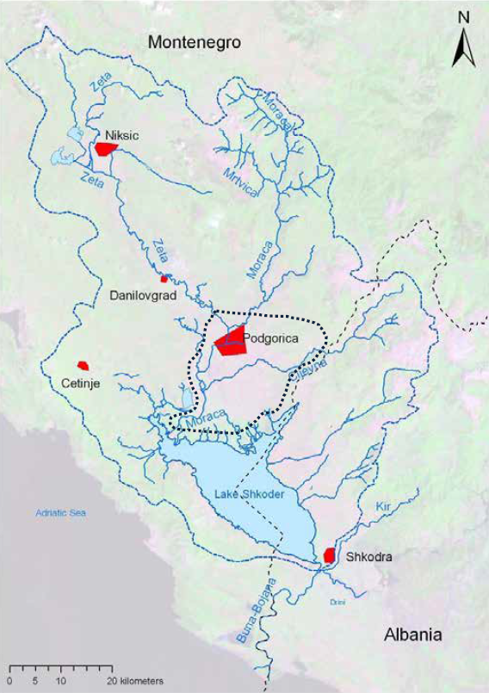

Figure 15 Drainage basin of ground waters

Table 5 shows average and maximal concentrations of various hazardous substances in the ground waters at different locations in this area, along with the values of MAC.

Table 5 Medium and maximum values of different chemical parameters in the Zeta Plain ground waters, at different sampling sites, in period from 1990–1996 (after Royal Haskoning, 2006; modified): MAC–maximum allowable concentration according to Directive on classification and categorization of surface and ground waters (Official Gazette no. 2/07).

Parameter |  | I | II | III | IV | MAC
pH | Avg | 7.30 | 8.24 | 7.20 | 7.46 | 6.5–8.5
pH | Max | 7.70 | 12.31 | 7.50 | 7.55 | 6.5–8.5
F⁻ (mg/l) | Avg | 0.125 | 1.44 | 0.26 | 0.329 | 1.5
F⁻ (mg/l) | Max | 1.10 | 51.56 | 1.07 | 2.660 | 1.5
PCB (µg/kg) | Avg | 1.923 | 1.98 | 0.58 | 0.149 | 0.01*
PCB (µg/kg) | Max | 20.12 | 78.10 | 2.01 | 0.743 | 0.01*
PAH (µg/kg) | Avg | 1.386 | 4.23 | 2.91 | 0.425 | 0.2
PAH (µg/kg) | Max | 9.46 | 198.10 | 11.90 | 1.730 | 0.2
Phenols (µg/kg) | Avg | 0.50 | 2.90 | 1.20 | 0.75 | 5.0
Phenols (µg/kg) | Max | 2.10 | 12.60 | 2.30 | 1.55 | 5.0

Average values of pH ranged from 7.20 to 8.24, while maximum values ranged from 7.50 up to 12.31, which indicate an increase in accordance to MAC. The average concentration of fluorides ranged from 0.125 to 1.44 mg/l. Their maximum concentrations at locations II (51.56 mg/l) and IV (2.66 mg/l) were higher than the allowed concentration of 1.5 mg/l. The average and maximum concentrations of polychlorinated biphenyls exceeded the maximum allowable concentrations at all four locations, after these standards. Average concentrations ranged from 0.149 μg/kg (IV) to 1.98 μg/kg (II), which is about 200 times higher than MAC. When it comes to maximum concentrations, these differences are even more drastic. Maximal values ranged from 0.743 μg/kg, which is 74 times higher than MAC, and up to 78.1 μg/kg, which is 7 810 times higher than MAC. Polyaromatic hydrocarbons concentrations have also been much higher than allowed at all locations. Average concentrations ranged from 0.425 to 4.23 μg/kg, which is from 2 to 20 times higher than MAC. The maximum concentration of PAH ranged from 1.73 to 198.1 μg/kg (990 times higher than the allowable value). The average concentrations of phenols ranged within allowable limits (0.5-2.9 μg/kg).

Solid Waste Characterization

The background conditions at the solid waste area at zero-state are not known at the moment since there were no soil sampling and analysis performed before the accumulation of the solid waste at the disposal site.

To come up with a long-term solution to the problem, the quality of the stored material should be determined in addition to its quantity. To have an idea on the quality of stored waste, CETI performed a sampling and analysis campaign at the waste disposal site in 2021. Several boreholes were drilled; samples were taken from these boreholes and sent to laboratories for detailed analysis. The characterization results are presented in Table 6.

Table 6 Waste Characterization Results (CETI, 2021)

Parameter | Limit value | B-3  (0.2-0.9m) | B-3  (1-2m) | B-3  (2.1-2.9m) | B-4  (0.4-1m) | B-4  (2.3-2.8m) | B-7  (0-1m) | B-7  (1.8-2.7m) | B-8  (0-1m) | B-8  (4-4.8m) | B-9  (1-2m) | B-9  (5-6m) | B-9  (9-10m) | B-12  (0-0.8m) | B-12  (1-2m) | B-16  (0-1.2m)
pH | > 6 | 7.85±0.12 | 8.21±0.13 | 7.71±0.12 | 8.13±0.13 | 8.53±0.13 | 8.30±0.13 | 8.16±0.13 | 8.30±0.013 | 7.80±0.12 | 9.90±0.15 | 8.24±0.13 | 8.13±0.13 | 8.30±0.13 | 8.55±0.13 | 6.9±0.1
Copper (Cu) (mg/kg) | 1 | 84±8 | 43±3 | 224±20 | 153±15 | 234±22 | 87±8 | 59±5 | 175±17 | 55±5 | 50±4 | 63±5 | 4.3±0.4 | 17±2 | 44±3 | 71±7
Mercury (Hg) (mg/kg) | 1.5 | 0.032 | 0.037 | 0.019 | 0.055 | 0.087 | 0.022 | 0.045 | 0.010 | 0.014 | 0.21 | 0.058 | 0.010 | 0.036 | 0.046 | 0.018
Cadmium (Cd) (mg/kg) | 0.07 | 0.44±0.04 | 0.36±0.03 | 054±0.05 | 2.4±0.2 | 1.9±0.2 | 0.086±0.08 | 2.2±0.2 | 0.62±0.06 | 0.95±0.09 | 4.2±0.4 | 2.4±0.2 | 0.46±0.04 | 0.41±0.03 | 1.6±0.2 | 0.54±0.05
Magnesium (Mg) (mg/kg) | 1 | 229 | 14570 | 230 | 905 | 1407 | 504 | 1270 | 276 | 371 | 493 | 1649 | 4297 | 6574 | 4237 | 696
Nickel (Ni) (mg/kg) | 0.3 | 52±5 | 22±2 | 66±6 | 79±7 | 71±7 | 55±5 | 98±9 | 60±6 | 41±3 | 91±8 | 50±5 | 6.1±0.5 | 31±3 | 72±7 | 41±4
Lead (Pb) (mg/kg) | 2 | 32±3 | 18±2 | 44±4 | 73±7 | 77±8 | 64±5 | 72±7 | 68±6 | 51±5 | 104±10 | 43±4 | 2.0±0.2 | 22±2 | 38±3 | 32±2
Zinc (Zn) (mg/kg) | 1 | 221±20 | 25±2 | 275±22 | 209±20 | 291±28 | 202±20 | 135±12 | 236±22 | 110±10 | 409±40 | 189±17 | 10.4±1.0 | 38±4 | 107±10 | 117±12
Chrome (Cr) (mg/kg) | 5 | 29±3 | 29±3 | 41±4 | 116±11 | 109±10 | 55.3±5.4 | 142±14 | 51±5 | 62±6 | 265±22 | 104±10 | 7.2±0.7 | 38±4 | 109±10 | 45±4
Vanadium (V) (mg/kg) | 1 | 55 | 15 | 96 | 134.4 | 96 | 66 | 132 | 1.3 | 64 | 263 | 90 | 7.9 | 26 | 87 | 54
Fluorides (F) (mg/kg) | 300 | 23200 | 15600 | 7120 | 96000 | 8400 | 18800 | 13200 | 8000 | 16800 | 880 | 6040 | 548 | 5280 | 5800 | 1120
Chlorides (Cl) (mg/kg) | 800 | 3.3 | 2.6 | 2.1 | 4.3 | 3.1 | 1.9 | 1.7 | 2.6 | 2.3 | 2.6 | 1.9 | 1.7 | 5 | 72 | 3.9
Cyanides (CN) (mg/kg) | 5 | 146 | < 0.4 | 48 | 16 | 13.5 | 43 | 5.5 | 20.7 | 172 | 1.2 | 6.3 | 0.72 | < 0.4 | 3.29 | 3.76
PAHs (16PAHs) (mg/kg) | 0.005 | 77.7±13.4 | 4.8±0.8 | 1163±202 | 212±37 | 495±86 | 124±22 | 130±23 | 1167±202 | 2176±377 | 15.7±2.7 | 112±19 | 3.7±0.6 | 16.5±2.9 | 130±23 | 71.1±12.3
PCB congeners (mg/kg) | 10 | 0.23 | 0.05 | 0.30 | 11.4 | 4.2 | 3.4 | 2.3 | 0.6 | 6.9 | 1.8 | 0.5 | 0.02 | 0.04 | 0.69 | 0.39
Arsenic (As) (mg/kg) | 2 | < 0.25 | < 0.25 | < 0.25 | < 0.25 | < 0.25 | < 0.25 | < 0.25 | < 0.25 | < 0.25 | < 0.25 | < 0.25 | < 0.25 | < 0.25 | < 0.25 | < 0.25
Barium (Ba) (mg/kg) | 100 | < 0.1 | 0.010 | < 0.1 | < 0.1 | 0.13 | < 0.1 | < 0.1 | < 0.1 | < 0.1 | < 0.1 | < 0.1 | < 0.1 | < 0.1 | 0.10 | < 0.1
Cadmium (Cd) (mg/kg) | 1 | < 0.01 | < 0.01 | < 0.01 | < 0.01 | < 0.01 | < 0.01 | < 0.01 | < 0.01 | < 0.01 | < 0.01 | < 0.01 | < 0.01 | < 0.01 | < 0.01 | < 0.01
Total chrome (Cr) (mg/kg) | 10 | < 0.1 | < 0.1 | < 0.1 | < 0.1 | < 0.1 | < 0.1 | < 0.1 | < 0.1 | < 0.1 | < 0.1 | < 0.1 | < 0.1 | < 0.1 | < 0.1 | < 0.1
Copper (Cu) (mg/kg) | 50 | 0.080 | 0.050 | 0.050 | 0.050 | 0.070 | 0.070 | 0.060 | 0.050 | 0.050 | 0.050 | 0.050 | 0.040 | 0.040 | 0.060 | < 0.040
Molybden (Mo) (mg/kg) | 10 | < 0.1 | < 0.1 | 0.53 | < 0.1 | < 0.1 | < 0.1 | < 0.1 | < 0.1 | < 0.1 | < 0.1 | 0.12 | < 0.1 | < 0.1 | < 0.1 | 0.11
Nickel (Ni) (mg/kg) | 10 | < 0.01 | < 0.01 | < 0.01 | < 0.01 | < 0.01 | < 0.01 | < 0.01 | < 0.01 | < 0.01 | < 0.01 | < 0.01 | < 0.01 | < 0.01 | < 0.01 | < 0.01
Lead (Pb) (mg/kg) | 10 | < 0.1 | < 0.1 | < 0.1 | < 0.1 | < 0.1 | < 0.1 | < 0.1 | < 0.1 | < 0.1 | < 0.1 | < 0.1 | < 0.1 | < 0.1 | < 0.1 | < 0.1
Antimony (Sb) (mg/kg) | 0.7 | < 0.2 | < 0.2 | < 0.2 | < 0.2 | < 0.2 | < 0.2 | < 0.2 | < 0.2 | < 0.2 | < 0.2 | < 0.2 | < 0.2 | < 0.2 | < 0.2 | < 0.2
Selenium (Se) (mg/kg) | 0.5 | < 0.1 | < 0.1 | < 0.1 | < 0.1 | < 0.1 | < 0.1 | < 0.1 | < 0.1 | < 0.1 | < 0.1 | < 0.1 | < 0.1 | < 0.1 | < 0.1 | < 0.1
Zinc (Zn) (mg/kg) | 50 | <0.1 | < 0.1 | < 0.1 | < 0.1 | < 0.1 | < 0.1 | < 0.1 | < 0.1 | < 0.1 | < 0.1 | < 0.1 | < 0.1 | < 0.1 | < 0.1 | < 0.1
Chloride (Cl) (mg/kg) | 15000 | 3.0 | 2.4 | 2.0 | 4.0 | 3.0 | 1.7 | 1.4 | 2.3 | 1.8 | 2.4 | 1.6 | 1.4 | 4.8 | 69 | 3.8
Fluorine (F) (mg/kg) | 150 | 840 | 820 | 580 | 480 | 500 | 620 | 540 | 560 | 740 | 134 | 440 | 114 | 262 | 380 | 420
Sulfates(SO4) (mg/kg) | 20000 | 69 | 16±1 | 411 | 65 | 58 | 62 | 55 | 29 | 121 | 11 | 189 | 11±1 | 86 | 139 | 52

Soil Quality

Soil Quality at Project Footprint

The waste disposal site of KAP is a potential polluter of groundwater resources, and surface water resources such as Moraca River and Lake Skadar. Quantity and characteristics of solid and hazardous waste generated by the different technological units of KAP are given in Table 7. It can be seen that the pH is about 11.5. However, direct measurement of pH in the basin of “red mud” indicates that maximum value can reach 13.85 (Kadović et al., 2004).

Table 7 The amount and characteristics of solid and hazardous waste from various technological units of KAP (after Royal Haskoning, 2006; modified).

Technological units of KAP | The amount of solid and hazardous waste (t/year) | Characteristics of solid and hazardous waste from KAP
Alumina processing unit | -Solid “red mud”: 309,168 t | pH>11.5, PAH, PCB, CN, F, crude oil, fuel oil
Electrolysis | - Carbonic foam: 620 t  - Used anodes and cathodes: 2,950 t  - PCB: 25 t | PAH, PCB, Cd, CN, As, Hg, F, carbon foam, Al, phenols
Anode factory | - Settling from the anodes: 17,600 t | PAHs, phenols, Cd, Hg, As
Foundry | - Slag: 1,800 t  - Other: 80-120 t | Morinit, asbestos
Cylumin factory | - Solid Al dust: 4,200 t | Al, colours, salts
Aluminium forge | - Cement with ammonia: 1,462 t | NH₃
Cold rolling mill | - Diatomaceous earth: 1,697 t | Si, Al, Fe oxides, mineral oil
Processing | - Diatomaceous earth: 2,274 t | Si, Al, Fe oxides, mineral oil

During 2021 sampling campaign, CETI also sampled the soil found at the bottom layer of the disposal site. Samples were taken from the bottom of four different boreholes and sent to laboratory for analysis. The results are presented in Table 8. The results showed that the soil is highly polluted in terms of mercury, fluorine, PAHs, and PCBs.

Table 8 Soil Quality at Project Footprint (CETI, 2021)

Parameter | Limit value | B-12  (3-4m) | B-9  (14-15m) | B-8  (5-5.7m) | B-4  (5-6m)
Cadmium (Cd) (mg/kg) | 0,2 - 400 | 0.25±0.02 | 0.26±0.03 | 0.20±0.02 | 0.56±0.05
Lead (Pb) (mg/kg) | 1 – 400 | 4.6±0.4 | 1.1±0.1 | 3.9±0.4 | 2.9±0.3
Mercury (Hg) (mg/kg) | 0,0001 | 0.061±0.005 | 0.011±0.001 | 0.038±0.004 | 0.046±0.005
Arsenic (As) (mg/kg) | 2 - 200 | 1.4±0.1 | 0.59±0.06 | < 1 | < 1
Chrome (Cr) (mg/kg) | 0,2 - 400 | 13.3±1.2 | 4.2±0.4 | 13,1±1.3 | 15.8±1.6
Nickel (Ni) (mg/kg) | 0,2 - 400 | 16.3±1.6 | 4.6±0.4 | 14.6±1.5 | 18.1±1.7
Fluorine (F) (mg/kg) | 300 | 1040 | 648 | 460 | 644
Copper Cu) (mg/kg) | 0,2 - 400 | 6.2±0.5 | 3.4±0.3 | 5.9±0.6 | 6.9±0.7
Zinc (Zn) (mg/kg) | 0,2 – 400 | 14.4±1.4 | 9.1±0.9 | 13.7±1.4 | 13.9±1.4
Bor (B) (mg/kg) | 0,5 - 200 | < 0.8 | < 0.8 | < 0.8 | < 0.8
Cobalt (Co) (mg/kg) | 1 – 400 | 2.4±0.2 | 0.42±0.04 | 1.7±0.2 | 2.0±0.2
Molybden(Mo) (mg/kg) | 1 - 200 | < 1 | < 1 | < 1 | < 1
PAHs (16 PAHs) (mg/kg) | 0,6 | 3.1±0.5 | 2.9±0.5 | 135±23 | 10.3±1.8
PCB (mg/kg) | 0,004 | 0.028±0.003 | <0.02 | 0.107±0.009 | < 0.02
Monobutyl-tin (mg/kg) | 0,004 | < 0.004 | < 0.004 | < 0.004 | < 0.004
Dibutyl-in (mg/kg) | 0,004 | < 0.004 | < 0.004 | < 0.004 | < 0.004
Tributyl-tin (mg/kg) | 0,004 | < 0.004 | < 0.004 | < 0.004 | < 0.004
Monooktyl-tin (mg/kg) | 0,004 | < 0.004 | < 0.004 | < 0.004 | < 0.004
Tetrabutyl-tin (mg/kg) | 0,004 | < 0.004 | < 0.004 | < 0.004 | < 0.004
Dioctyl-tin (mg/kg) | 0,004 | < 0.004 | < 0.004 | < 0.004 | < 0.004
Trifenil-tin (mg/kg) | 0,004 | < 0.004 | < 0.004 | < 0.004 | < 0.004
Tricyclohexyl-in (mg/kg) | 0,004 | < 0.004 | < 0.004 | < 0.004 | < 0.004

Soil Quality around KAP

Over several decades, KAP created about 325,000 m³ of solid waste, deposited at the site and classified as hazardous waste, because of high content of fluorides, polyaromatic hydrocarbons (PAHs), polychlorinated biphenyls (PCBs), phenols, and nickel, chromium, copper, cadmium, zinc, arsenic, mercury, cyanide, mineral oils and other.

In Table 9, the results of measurements of the concentration of hazardous and toxic substances in the solid waste area, directly below it and in deeper soil layers are presented. Of the 12 parameters, 10 of them in shallower or 6 in the deeper layers had a concentration of 1 to 30 times higher than MAC. Seven parameters exceeded even high-risk concentration (cyanides, PAHs, PCBs, mercury, chromium, copper and nickel).

Table 9 Maximum concentrations of hazardous and toxic substances (mg/kg) detected in the soil in the area of KAP (COWI, 2012; modified)

Parameter | Concentration on the waste disposal site | Concentration in the soil directly below the waste | Concentration in deeper soil layers below the waste | MAC for hazardous and harmful substances in the soil (Official Gazette, 18/97)
Fluorides | 40494.00^{1,2} | 10911.00^{1,2} | 6226.00^{1,2} | 300.0
Cyanides | 1302.00³ | 73.10³ | 3.87 | –
PAH | 7772.60^{1,3} | 237.61^{1,3} | 86.90^{1,3} | 0.6
PCB | 459.50^{1, 3} | 15.67^{1,3} | 0.045¹ | 0.004
Arsenic (As) | 80.70^{1,2,3} | 12.50 | 8.24 | 20.0
Cadmium (Cd) | 556.22^{1,2,3} | 1.86² | 1.42² | 2.0
Lead (Pb) | 345.65 | 48.09 | 43.88 | 50.0
Mercury (Hg) | 0.098 | 22.81³ | 0.073 | 1.5
Chromium (Cr) | 494.39³ | 404.88³ | 33.18 | 50.0
Nickel (Ni) | 843.94^{1,2,3} | 245.01^{1,2,3} | 162.02^{1,2,3} | 50.0
Copper (Cu) | 1273.83^{1,2,3} | 182.97^{1,2} | 25.70 | 100.0
Zinc (Zn) | 553.29^{1,2} | 210.13² | 583.21^{1,2} | 300.0

WYG International (2011) shows the contamination of soil in villages Botun and Srpska (please see Table 10). Of the 14 measured parameters, only 4 (lead, mercury, nickel and PAHs), had a higher concentration than MAC: from 1.42 times (lead) to 36 times (PAHs). However, since these metals, their salts and polyaromatic hydrocarbons are highly toxic substances, these results are alarming.

Table 10 Soil pollution in villages Srpska and Botun in 2005 (WYG International, 2011; modified)

Pollutant (mg/kg) | MAC | Srpska – cultivated | Srpska – uncultivated | Botun–Velji brijeg – cultivated | Botun–Velji brijeg – uncultivated
Cadmium | 2 | 0.71 | 0.68 | 0.53 | 1.47
Lead | 50 | 38.97 | 35.62 | 34.19 | 71.22
Mercury | 1.5 | 3.28 | 2.31 | 5.28 | 7.10
Arsenic | 20 | <2 | <2 | <2 | <2
Chromium | 50 | 26.96 | 32.84 | 27.67 | 46.99
Nickel | 50 | 102.1 | 105.83 | 147.77 | 123.42
Fluorine | 300 | 50.09 | 41.6 | 23.47 | 48.75
Zinc | 300 | 290.75 | 260.04 | 215.7 | 279.65
Copper | 100 | 39.33 | 40.88 | 35.9 | 39.56
Cobalt | 50 | 11.96 | 12.97 | 14.1 | 15.25
PAHs | 0.6 | 1.49 | 2.21 | 4.98 | 21.72
PCBs | 0.004 | <0.003 | <0.003 | <0.003 | <0.003
PCB congeners | 0.004 | <0.002 | <0.002 | <0.002 | <0.002
Mineral oils | - | 4.69 | 3.56 | 1.32 | 3.56

PCB content in the soil was measured between 1990 and 1996 in the KAP site and the closest villages (Srpska, Botun and Mahala). Results showed increased concentration (17 to 381 times higher than MAC) within the plant, but in the surrounding soil it was below this value (see Table 11).

Table 11 Minimum and maximum concentrations of PCB at sites within the KAP (B-17, B-18, B-19, AS-1, AS-2, AS-3) and in the immediate vicinity (Srpska, Botun, Mahala) in the period from 1990 to 1996 (Royal Haskoning, 2006; modified).

Location | PCB (µg/kg)
Location | min | max
Piezometer B-17 | 225 | 381,100
Piezometer B-18 | 51 | 17,310
Piezometer B-19 | 125 | 52,280
AS-1 | 10,490 | 245,400
AS-2 | 1,230 | 73,500
AS-3 | 14,390 | 144,900
Srpska | 230 | 469
Botun | 452 | 783
Mahala | 125 | 234

Air Quality

Air pollution emissions from the KAP are calculated in tons per year for successive years: 2005, 2006 and 2007 (see Table 12). The amount varied from 5,453.04 to 11,437.75 tons per year.

Table 12 Emissions of air pollutants from Alumina Plant Podgorica in 2005, 2006 and 2007 (Marković, 2007; modified)

Pollutants from KAP | 2005 (t/year) | 2006 (t/year) | 2007 (t/year)
Total nitrogen oxides | 498.98 | 421.96 | 468.23
Carbon monoxide | 1,140.23 | 7,981.42 | 2,880.03
Sulphur dioxide | 3,699.46 | 2,645.53 | 5,997.62
Particulate matter | 114.34 | 383.31 | 99.93
The sum of heavy metals | 0.0028 | 0.0098 | 0.0098
Hydrogen chloride | – | 4.26 | 2.28
Hydrogen fluoride | 0.03 | 1.26 | 0.30
Total | 5,453.04 | 11,437.75 | 9,448.40

Deposition rate depends on the wind velocity and direction, the distance from the source, atmospheric stability and height of the chimney. These studies have shown that pollutants from industrial facility chimneys can be transmitted by air over long distances and to further endanger the Skadar Lake.

The biggest differences in the air quality for Podgorica is rapidly increasing concentrations of polycyclic aromatic hydrocarbons (PAHs), which are directly connected with the work of KAP, as well as a drastically increasing number of vehicles, and the combustion of fossil fuels.

Montenegro has set an ambitious GHG mitigation target through its INDC (Intended Nationally Determined Contribution), which is for a 30% reduction in GHG emissions by 2030 (compared to the reference year 1990). At the time of producing the NDC, this equated to target GHG emissions of 3,667 Gg CO2eq in 2030. Montenegro already achieved and exceeded this target in 2013 and continued to meet it in 2014 and 2015. This was achieved as a result of reduced economic activity by KAP and in the agricultural sector.

Noise

Montenegro has fully aligned with the EU Noise Directive and works on the preparation of strategic noise maps align with Law on Protection from Noise in the Environment (Official Gazette of Montenegro, No. 28/11, 1/14); Rulebook on the Methods and Instruments of Noise Measurement and the Conditions to be met by Noise Measure Organizations (Official Gazette of Montenegro, No. 27/14); and Rulebook on value limits of Environmental Noise, the Method for Determining the Acoustic Noise Indicators and Assessment Methods of the Harmful Effects of Noise (Official Gazette of Montenegro, No. 60/11).

Center for Eco-Toxicological Research Ltd. conducted a "program of environmental noise monitoring" for 2013. The program includes twelve measuring positions in eleven municipalities of Montenegro (Podgorica, Nikšić, Žabljak, Petrovac, Budva, Kotor, Ulcinj, Kolašin, Mojkovac, Bijelo Polje, Berane). Two measurements were made for all the measuring positions, one during the warm period of the year and the other in the cold season.

Analysis showed that almost all the measuring positions recorded higher values of noise indicators in the I, warm cycle, than in II, colder cycle. The noise monitoring results in 2012 and 2013 confirmed that the traffic noise is the biggest source of noise in the Podgorica.

Landscape Features

Landscape diversity of Montenegro was created by the combination of dynamic natural conditions and traditional way of using space. Landscape grounds are largely determined by the highland relief, water surfaces, and conditions pertaining to the climate zones. The National Spatial Plan for Montenegro separates the country into landscape types and landscape units based on an analysis of bio-geographical and environmental factors.

KAP Project area belongs to “larger river valleys in the lowlands”. The wider area of KAP belongs to “mountainous”, “anthropogenic” and “higher sub-mediterranean” as landscape type; “Skadar Lake area”, “Zeta- Bjelopavlići Plain”, “Canyon valleys in Morača watershed” and “Cijevna Canyon” as unit.

The narrow area around the KAP production plant is dominated by industrial properties and agricultural land with several settlements south and southeast of the site. Anthropogenic landscape is dominant in the area of KAP. The impact of urbanization and the industrial zone is clearly seen (Figure 16). The quality of landscape within the KAP area is important for both physical and mental health of the people, and therefore has an exceptional ecological significance.

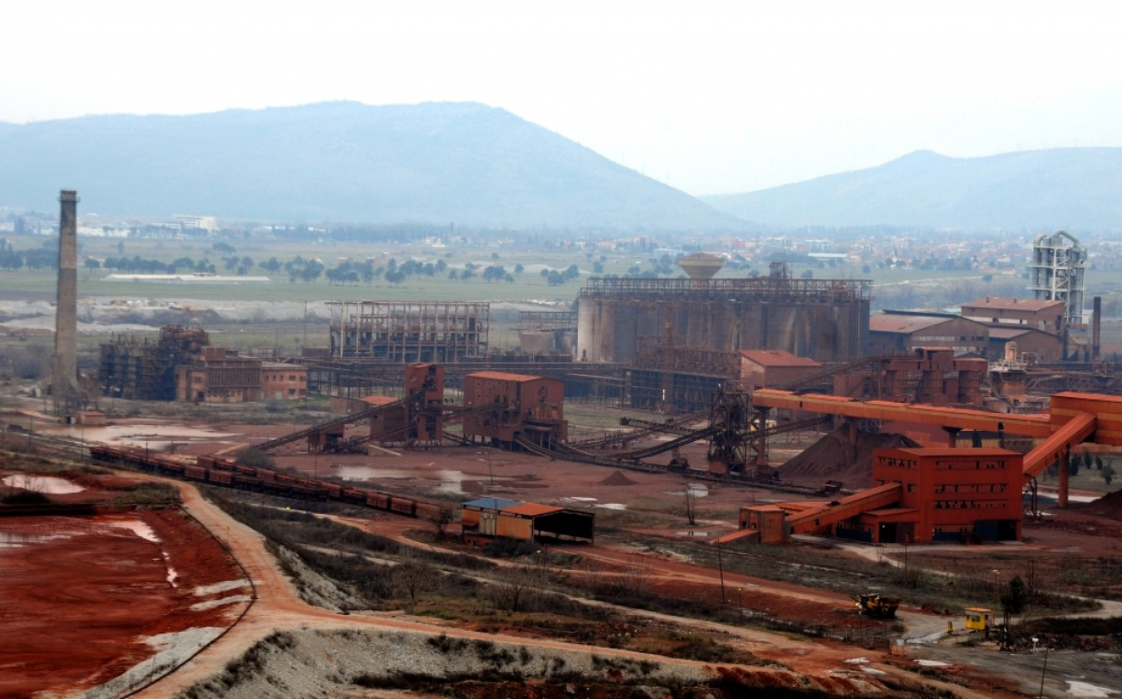

Figure 16 Industrial Zone of Podgorica - KAP

A typical cultural landscape might be seen in the surroundings. The land was heavily domesticated by humans. Almost all land is used for agricultural purposes, which means it is most likely used for growing crops and vegetables. There is minimal forest vegetation, except for a few individual trees and rows of trees throughout the cultivated fields. Poor and degraded plant communities are expected due to the spatial characteristics of the vicinity of the red mud basins

In addition, Skadar Lake is one of the other receptors indirectly affected by the KAP area. In terms of landscape, Skadar Lake area is identified as a separate landscape unit based on the unique appearance in relation to the environment and the exceptional harmony of the natural and cultural heritage. Elements of this characteristic landscape are a large lake surface (the largest in the Balkans), a dynamic shore line with a number of bays, promontories, small rocky islands, rich swamp vegetation, extensive meadows and flooded forests. The northern shore of the Skadar Lake is a huge area under influence of regular floods and so in this part, there is no distinct shore line. This area is also recognized by its rich cultural heritage sites and monuments. The area is protected by law as a national park and is located on the Ramsar List of international importance.

Radioactivity

Measuring levels of radioactivity, which occurs in the environment through natural or artificial processes, is important for human health and environment. Radioactivity measuring is realized in line with the national Program of systematic testing of radionuclide content in the environment, pursuant to the regulations.

Water radiological analyses were performed by Centre for Ecotoxicological Research of Montenegro, at July 4, 2006 at Gornje Malo Blato nearby KAP area. The analyses covered natural radionuclide 40K, 226Ra, 232Th, 235U and 238U. Values for artificial radionuclides Cs137 and Sr90 were also given. Due to very low concentration of some radionuclides, the latter could not be detected, even though the samples were concentrated. These values were given as minimum detectible activity, and are individually specified in Table 13.

Table 13 Radiological Analyses of Water Sample

⁴⁰K (mBq/l) | ¹³⁷CS (mBq/l) | ²²⁶Ra (mBq/l) | ²³²Th (mBq/l) | ²³⁵U (mBq/l) | ²³⁸U (mBq/l) | ⁹⁰Sr (mBq/l)
15.20±1.92 | <1.93 | <3.74 | <1.98 | <12.67 | <0.22 | <0.1

The performed analysis has shown that the activity of all the analyzed radionuclides in the given sample was below permitted values, and in compliance with the provisions stipulated by Regulation on limitations of radioactive contamination of the environment and guidelines for decontamination process (The Official Gazette of the FRY No. 9/99, 1/2003). In terms of radiological validity, the sample is satisfactory.

Ecology and Biodiversity

In order to evaluate the baseline conditions and the potential impacts of the Project on the biological environment and various species inhabiting natural habitats around the Project Area, both the terrestrial and aquatic ecosystems were studied to identify the existing biological conditions.

In the scope of the biological studies for the Project, biological environment studies which included terrestrial flora and fauna, aquatic environment, and national and international designated areas, have been conducted with desktop studies described in detail in the following sections. The assessment follows the recommendations and requirements of the WB ESS6 definitions.

Internationally and Nationally Recognised Areas within the Region of the Project Area

This section provides details on the qualifying features for each of the Internationally Recognised Areas located in the vicinity of the Project Area. These include Key Biodiversity Areas (KBAs), Important Plant Areas (IPAs), Important Bird Areas (IBAs), and the Emerald Network site. The International Recognized and National Protected Areas described in this section are shown in Figure 19, Emerald Network Sites in Figure 20 and KBAs are given in Figure 21.

There are no protected natural areas of the KAP site; however, 3.3 km south of the site, the “Skadarsko Jezero” National Park is situated. Skadar Lake National Park is an important biodiversity conservation area with its RAMSAR, KBA, IBA, and nominated candidate Emerald Site statuses. Moraca River, which is one of the rivers feeding Skadar Lake, is also registered as KBA. The nearest UNESCO site is Kotor Risan Bay, 37.4 km from the Project Area.

There are no Emerald Network Sites in and around the Project Area. Cijevna Canyon and Hum Orahovski IPA/KBA is located 1.6 km southeast, Zeta Valley KBA is located 3.5 km north, and Cemovsko Field KBA is located 3.6 km southeast of the Project Area (see Figure 17, Figure 18 and Figure 19). The Cijevna Canyon and Cemovsko Field KBAs are also Emerald Network Sites (see Figure 21).

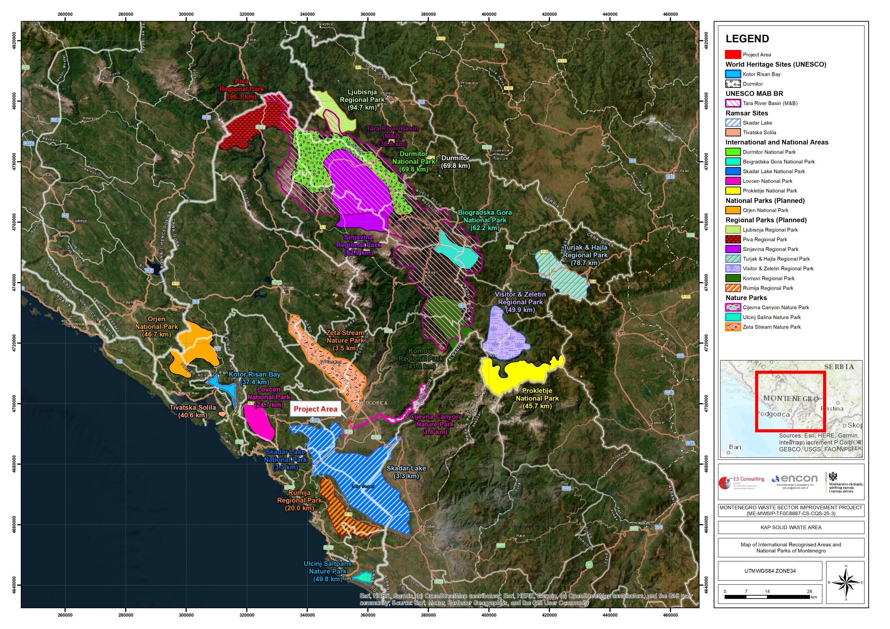

Figure 17 Map of Internationally and Nationally Designated or Recognized Areas around the Project Area (updated version of map retrieved from University of Montenegro Faculty of Sciences and Mathematics Protected Area Gap Assessment with Comprehensive Plan for a Representative Pas (Protected Area System), November, 2012, www.protectedplanet.net, https://whc.unesco.org/en/list/100/)
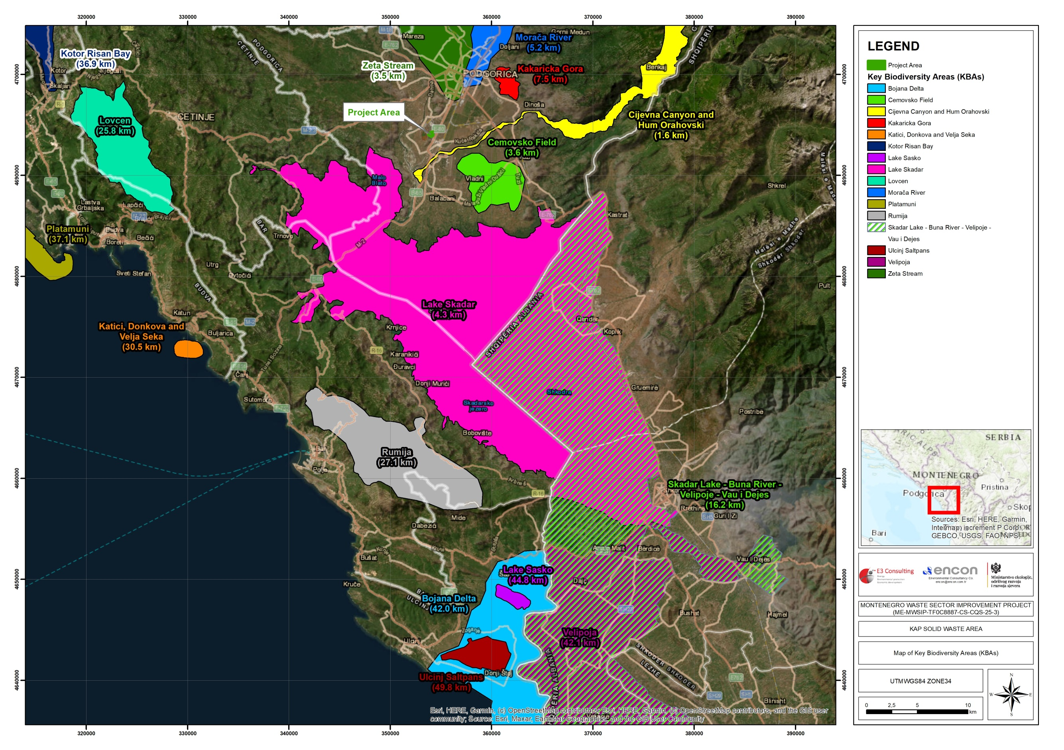

Figure 18 Map of KBAs
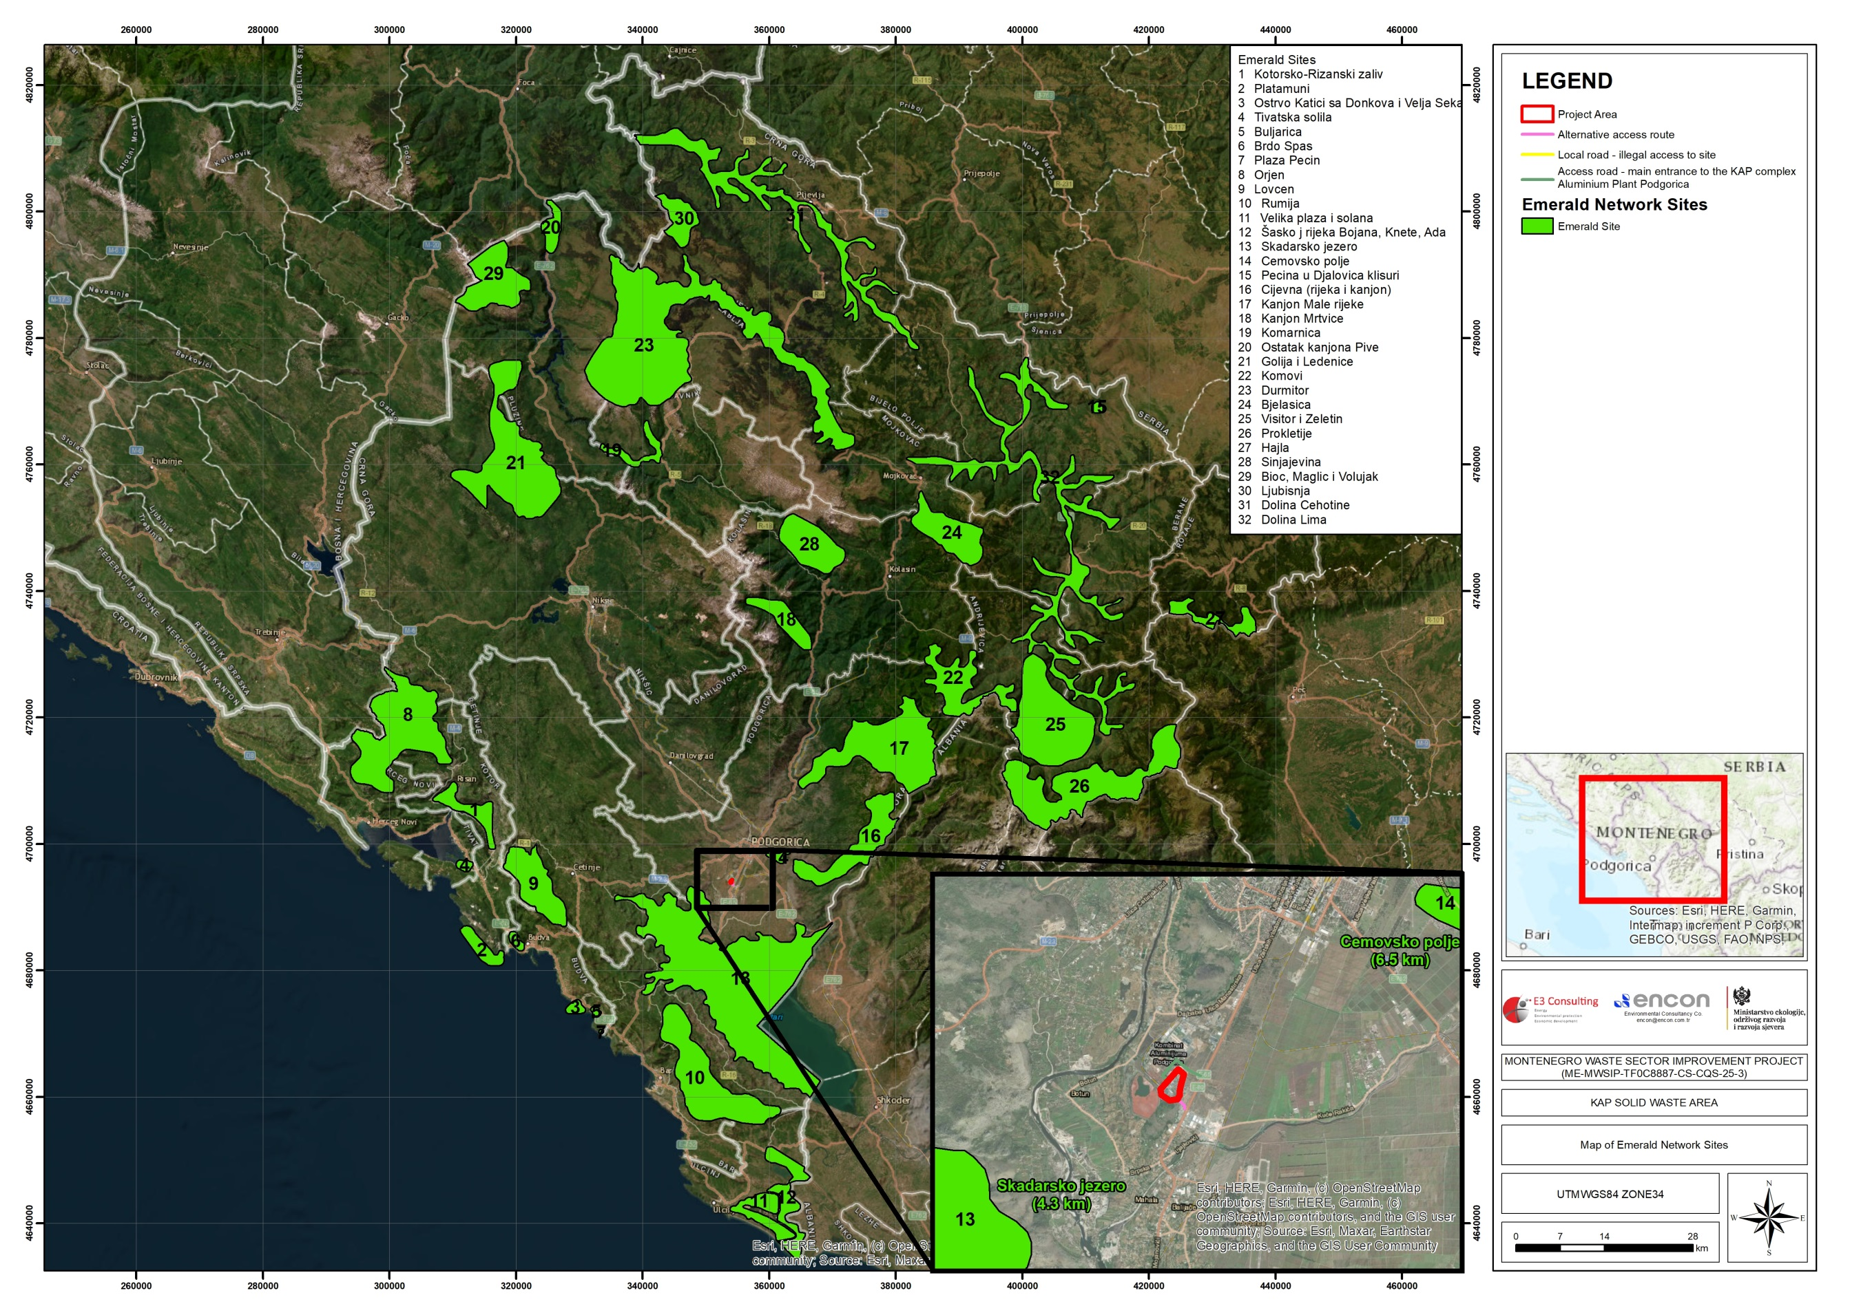

Figure 19 Map of Emerald Network Sites

Vegetation and Habitat Types of the Terrestrial Ecosystem

The Project Area has a modified habitat and has not inhabited natural vegetation. According to the literature studies, general habitat types are described below:

Podgorica is located in the zone of the oriental hornbeam (alliance Carpinion orientalis, order Quercetalia pubescentis). In accordance with the Prodromus of Plant Communities of Montenegro (Blečić & Lakušić, 1976), the three woody communities are recorded in the area: Paliuretum adriaticum Horvatić 1963, Rusco-Carpinetum orientalis Blečić & Lakušić 1966, Quercetum trojanae montenegrinum Blečić & Lakušić 1966, as well as the two grass communities: Asphodelo-Chrysopogonetum grylli Horvatić 1958. and Pseudoovino-Poetum bulbosae Ht. 1956. These five plant communities represent only a minor part of the vegetation diversity of the city area. Fragments of the mentioned woody communities are still noticeable in the micro localities of the city hillocks. Still, their constant degradation, in the sense of cutting, fires, and grazing, leads to the formation of karst terrain communities. The associations from the class of karst pastures and dry meadows (Therorachypodietea Br.-Bl 1947) are typical for city hillocks and peripheral areas of Podgorica. The vegetation of the flooded land willow and poplar thickets is evident at Mareza and partially, along the courses of Sitnica, Morača and Ribnica Rivers.

The Capital Podgorica region has almost uninterrupted vegetation thanks to favourable microclimatic conditions. According to literature data, the area and its surroundings are characterized by relatively diverse plant species, primarily Mediterranean vegetation.

The vascular flora of this region is quite diverse, with native and non-native species. It is located in the vegetation zone where various plant communities have been recorded (Carpinion orientalis, Querceta pubescentis ).

The ecological-phytogeographic study carried out in the Podgorica urban area showed that more than 1200 species and subspecies live in this area, representing more than a third of the vascular flora of Montenegro (Stešević, 2009). The dominant families representing vegetation are Poaceae, Asteraceae, and Fabaceae. Among the herbs, Eleusine indica, Eleusine tristachya, Sporobolus poiretii and Paspalum dilatatum species are quite common. The incidence of Aster squamatus, Helianthus tuberosus, Conyza bonariensis, and Crepis sancta species is high. Fabaceae is dominated by various species of the genera Lathyrus cicera, Lotus corniculatus, Medicago orbicularis, Medicago grandiflora, Medicago sativa, Medicago rigidula, Trifolium sp, and Vicia sp.

Area is located in the large karst area - Ćemovsko Polje. In the most comprehensive study on the vascular flora of Ćemovsko Polje, 1153 taxa (species and subspecies) are presented. Some botanists refer to the habitat of Ćemovsko Polje as "semi-desert" due to drought, xeromorphic, and the absence of trees. Asphodelus microcarpus species is dominant in the aquatic environment. Endemic plant species are represented by geophytes such as Hyacinthella dalmatica, Colchicum hungaricum, and Fritillaria gracilis (along with shrubs). Wild almonds (Amygdalus webii) are common in the area.

Terrestrial Flora

The Project Area is located on the right side of the Podgorica-Golubovci main road, in the area of the KAP Area. It is part of a large industrial area where natural and semi-natural habitats, degraded habitats, and green spaces (cultivated habitats) are defined.

The Project Area is a degraded, flat area filled with disposed of industrial waste from KAP. Therefore, it does not have any natural habitat. The vegetation of the Project Area is almost non-existent. The existing vegetation in the project area is homogeneously distributed, and herbaceous species (such as Cynodon dactylon) adapted to anthropogenic effects are dominant.

Cynodon dactylon, Aegilops, Hordeum murinum, Avena sp., Dactylis glomerata, Artemisia sp., Inula sp., Echium italicum, Sanguisorba minor, Erodium cicutarium, Teucrium capitatum, Andropogon ischaemum, Allium sp., Eleusine indica, Verbascum sp., Plantago sp., Malva silvestris, Carduus sp., Centaurea solstitialis, Tordylium apulum, Cichorium inthybus, Daucus carota, Convolvulus arvensis, Urtica dioica from herbaceous species and individual trees and shrub forms of Ailanthus altissima, Rubus ulmifolius, Rosa sp., and Ficus carica are present along the edge of the red mud pool.

Along the edge of the hill of Srpska Gora, in the south of the area, there are trees Robinia pseudoaccacia, Celtis australis, Ailanthus altissima, Ficus carica, as well as shrub forms Rubus ulmifolius, Punica granatum, Rosa sp, Ficus carica. The ground of herbaceous plants is dominated by grass, as well as Cichorium inthybus, Plantago sp., Urtica dioica, Echium italicum, and Sanguisorba minor.

Flora species in the vicinity of the Project Area specified literature search are listed in Table 1 in Annex-2. Protection status defined by IUCN (International Union for Conservation of Nature) and explanation of the scope of Bern Convention Appendix-1 List and CITES and EU habitat Directives are presented.

Terrestrial Fauna

As stated in the previous sections, the Project Area has lost its natural vegetation. The immediate surroundings of the project area are agricultural and industrial areas with anthropogenic effects. There are no areas where wild animals will acquire habitats in these areas. The faunal individuals who can use the area incidentally and the fauna species that can make the project area a living space are mentioned in the following headings.

The taxonomic classifications and names of fauna elements determined after the literature review and compilation of previous studies are given in the tables with their Latin and English names (if any). Per the threatened categories of IUCN, Bern Convention CITES, and EU Directives, an assessment is made for all faunal elements likely to live in the study area.

The fauna elements specified in the study area are investigated under three different headings; Mammalia, Aves (Birds) and Amphibia -Reptilians. Fauna elements specified after literature search are given with their taxonomic classification, their names in Latin and English names (if any), in the tables. Evaluation is carried out for all fauna elements that possibly inhabit the study area according to threatened categories of IUCN, Bern Convention, CITES and EU Directives.

Amphibia and Reptiles

Ponds, wetlands, numerous canals in cultivated meadows and fields, and streams in oak and beech forests represent suitable habitats for amphibians. No amphibian and reptile species have been identified in the project area, and the list of amphibian and reptile species that could be found in a wider area is given in Table 1 in Annex-3.

Aves

There is no nesting area for birds in the Project Area. Skadarsko Jezero RAMSAR-IBA, about 10 km away from the Project Area, is known to be a habitat for a large number of waterfowl (seeError! Reference source not found.). These species can be seen incidentally (such as passing over the area) on the Project area, but there is no suitable site where they can acquire a habitat. The list of bird species that could be found in the wider area is given in Error! Reference source not found.Table 1 in Annex-4.

Mammals

There are no protected mammals in the Project Area and of influence. It should be indicated that the Project Area is an area that has already been degraded by human activities where the ecosystem has already reached a balance. Mammal species that can acquire habitat around the project area and that would be found incidentally in the Project Area are listed. The list of mammal species is given in Table 1 in Annex-5

Aquatic Environment

The Morača River passes nearby the site of the Project Area and flows into Skadar Lake. The Cijevna River passes approximately 1.5 km south of the KAP site, and flows into the Morača River.

It is known that trout species are dominant in the Morača River. Among the species that may be found in the Morača River, Anguilla anguilla is listed as Critically Endangered (CR), Cyprinus carpio as Vulnerable (VU), and Salmo montenegrinus as Endangered (EN) according to the IUCN.

Fish species that could be found in the Project Area of influence are given in Table 1 in Annex-6.

Socioeconomic Environment

Population

The Project is located in the premises of KAP facility area, Pogdorica, Montenegro. According to the most recent official census that was conducted in 2023, the population of Montenegro was 623,633.

Podgorica represents the main urban and business centre of Montenegro, whereby population size of Podgorica was 179,505 in 2023 (Census data)..

The socio-economic impacts of the Project might be most visible for the settlements within the circular area with 1 km radius from the Project area. This is also defined as the Project’s potential social area of impact. Therefore, it would be beneficial to understand background conditions of the settlements located in the said area. These settlements/cadastral municipalities are Cijevna, Botun, and Srpska. The visual representation of the area is presented in Figure 20.

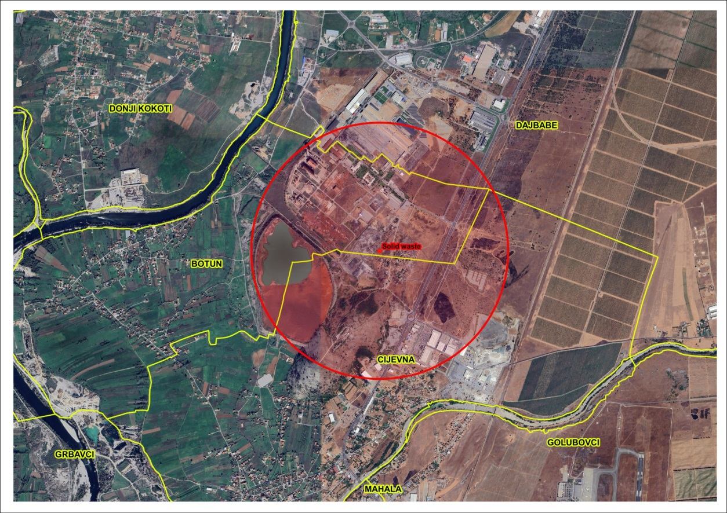

Figure 20 Visual Representation of the Project’s Potential Social Area of Impact, 2026

It is important to note that the Project is located in the rural part of Podgorica, which is characterized by rural and agricultural land, whereby the wider project area is also characterized by a number of business objects that operate in sectors of wholesale and trade, logistics and distribution, gas stations, etc.

A detailed social survey will be carried out according to the methodology defined in Annex 8 and accordingly social baseline assessment will be incorporated in the final draft of this document.

Transportation Network

Wider project area is connected to two main roads, E80 and the new road which connects two banks of the River Moraca (“Jugozapadna obilaznica”). Road E80 leads from Podgorica towards the Podgorica Airport and coastal area of Montenegro – Bar, Ulcinj. On the other hand, “Jugozapadna obilaznica” runs next to the KAP facility and connects the settlement of Donja Gorica to the Main Road E80, thus allowing bypass through the city and connecting the overall population of Podgorica to the wider project area and the abovementioned Airport Podgorica and coastal towns. The access road will be defined by the Ministry and relevant environmental and social assessment will be ensured to be carried out by PIU. . Illegal or uncontrolled access to the site will be avoided. This is going to be done through the Construction Site Organisation Plan, which will be develop by the Contractor.

Podgorica is well connected to rural areas, such as the wider project area, via bus lines. The bus line which connects the city centre with the wider project area is L-26. This bus lines runs through Botun, Dahna and Dajbabe, and it runs 13 times per day (on work days), while it runs 4 times on Saturday (it does not run on Sundays). The importance of this bus line for the population in the wider project area is in the fact that it provides them with public transport to and from the city centre and thus enables people to tend to their business, education and other activities uninterruptedly.

Community Facilities in the Wider Project Area

Community facilities, including educational institutions, cultural/historical monuments in the wider project area have been identified and they include Dajbabe Monastery, Church of St. George, Distribution centre “Voli”, Football club “Bratstvo” and Agricultural cooperative Cijevna (“Zemljoradnicka zadruga Cijevna”). All of the abovementioned facilities and objects are located outside of the 1km radius for both project areas.

On another note, two facilities which are located in the 1km radius from the project areas include Elementary school “Vladika Danilo” and a stadium. The stadium which is located in the 1km radius was used by FC “Bratstvo” until 2007, but it has not been used for official football games since then.

All the community facilities and other relevant objects which have been screened are presented in Figure 21.

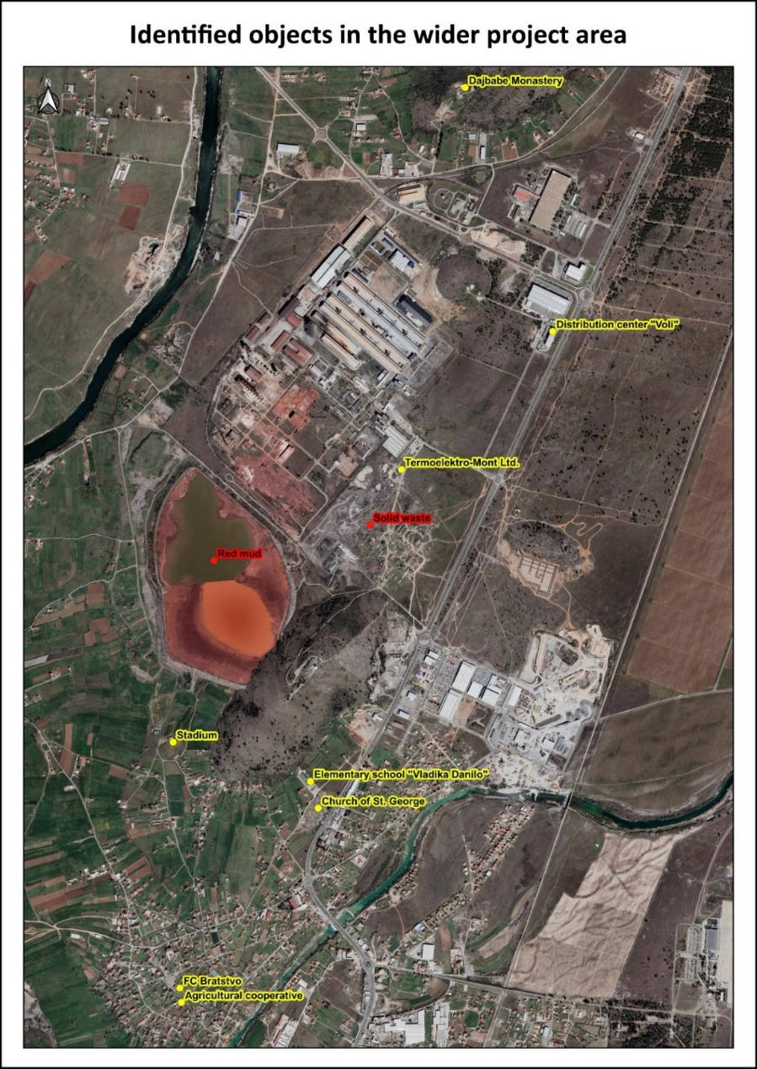

Figure 21 Community Facilities in the Wider Project Area

Protected Areas, Cultural Heritage, and Assets

Montenegrin cultural heritage is unique and it was under different impacts of western and east civilizations. This is witnessed on many archive materials, library funds and variety of architectural styles. Montenegro is rich in cultural and historical monuments that have remained until the present day against all the numerous wars that this country faced. There are hundreds of ancient cities and monasteries, balneal resorts, unique natural landmarks and beaches of Montenegrin Riviera making Montenegro one of the best countries for tourism development.

In the more recent past, the area has been subjected to a turbulent history and was frequently the location for confrontations, conflicts and wars. This has unfortunately destroyed substantial amounts of cultural assets. In addition, several catastrophic earthquakes caused destruction on an enormous scale which has further eroded the remaining sites of cultural heritage and archaeological interest. With such erosion of cultural values, it is especially important to attempt to ensure the preservation of what remains.

Podgorica is located in the Skadar Lake Cave at the confluence of five rivers. The territory of Podgorica has been inhabited since the 5th century AD and ancient Duclea (located three kilometers away from the modern Podgorica) is one of the biggest antic territories, which is at a distance of approximately 9.5 km to the KAP Project site. Duclea was a typical Roman town with features such as the forum, temples, spas, and urban villas.

Dajbabe Monastery is a Serbian Orthodox Christian Monastery in Podgorica, which is at a distance of approximately 2 km to the KAP Project site. It is located in a cave on Dajbabe hill, which raises above Zeta valley. The monastery was founded in 1897.

In the minor area/vicinity of the KAP Project area of influence, there are no monuments protected by law, nor other important cultural and historical heritage assets that need special attention during implementation of the Project.

ENVIRONMENTAL AND SOCIAL IMPACT ASSESSMENT

The main purpose of an environmental and social impact assessment is to identify and assess the potential positive and adverse impacts/risks that may be caused by the Project activities on the natural environment and on the socio-economic wellbeing and conditions of the population (community and workforce) at local and regional level. The following assessment is based on the Project characteristics and all activities and the baseline conditions in the Project Area.

As a result of this assessment, relevant mitigation measures were developed to avoid, minimize, mitigate and off-set significant adverse impacts and enhance beneficial impacts. Furthermore, the significance of Project-induced residual adverse effects on the environment and community after implementation of the mitigation measures are assessed. And finally, planned monitoring activities for checking effectiveness of the proposed mitigation measures are identified.

Considering the potential interactions between Project activities and environmental receptors, Project impacts need to be evaluated on the following issues:

- Physical Environmental Risks and Impacts
- Water Quality
- Soil Quality
- Air Quality
- Noise
- Landscape Characteristics
- Radioactivity Impacts

- Biological Environment
- Internationally Recognised Areas within Region of the Project Area
- Terrestrial Habitat and Flora-Fauna
- Aquatic Environment

- Socio-economic Environment
- Local Population
- Economy and Livelihoods
- Local Public Infrastructure
- Community Health and Safety

- Cultural Heritage

- Occupational Health and Safety

The Project has been prepared according to WB ESS requirements that are listed in the Table 14.

Table 14 ESS List Concerning the Project

Physical Environment | Relevant ESS
Water Quality | ESS1, ESS3, ESS4
Soil Quality | ESS1, ESS3, ESS4
Air Quality | ESS1, ESS3, ESS4
Noise | ESS1, ESS3 , ESS4
Landscape Characteristics | ESS1, ESS3 , ESS4
Radioactivity | ESS1, ESS3 , ESS4
Biological Environment | Relevant ESS
Internationally Recognised Areas within Region of the Project Area | ESS1, ESS6
Terrestrial Habitat and Flora-Fauna | ESS1, ESS6
Aquatic Environment | ESS1, ESS6
Socio-Economic Environment | Relevant ESS
Local Population | ESS1
Economy and Livelihoods | ESS1
Local Public Infrastructure | ESS1, ESS3, ESS4
Community Health and Safety | ESS4
Cultural Heritage | ESS8
Occupational Health and Safety | ESS2

Scope-in/Scope-out Process

The ESIA scoping process for the Project considered relevant project activities and the environmental and social aspects they would interact with in order to identify the issues to be focused on in the ESIA studies. The analysis of these potential interactions has been done using a color code (see Table 14) in a modified Leopold matrix (Table 16) This approach provided the means to identify the potential interactions each Project activity may have on a range of resources/receptors within the Project Area of Influence (AoI).

Table 15 Color Code Used in the Scope-in/Scope-out Process

(White) | An interaction is not reasonably expected. | Aspect “scoped out”
(Grey) | An interaction is reasonably possible, but none of the resulting impacts are likely to lead to significant effects, and/or interaction is addressed through embedded mitigation measures. | Aspect “scoped out”, but rationale is provided in relevant section of current report
(Red) | An interaction is reasonably possible and at least one of the resulting impacts is likely to lead to a negative effect (low, medium or significant). | “Scoped in” – subject to impact assessment.
(Green) | Impacts that are considered likely to be positive. | “Scoped in” – subject to impact assessment.

Those interactions that are colored white are scoped out of further consideration in the impact assessment process and no discussion is warranted in the ESIA report. Those interactions that are colored grey are also scoped out, but during the impact assessment process these potential interactions have been reviewed to confirm that resulted impacts are not significant and/or are appropriately addressed through one or more embedded controls. Those interactions marked with red and green are scoped in and subject to impact assessment as part of the ESIA process. These impacts would be assessed for their significance and additional mitigation measures, beyond the already planned embedded controls, would be proposed as necessary.

Table 16 summarize the potential interactions between the Project and environmental resources (air, water, noise, etc.) and socioeconomic receptors.

Table 16 Environmental and Social Impact Sources, Activities and Possible Interacts (Before Mitigation Measures are Taken)

Source of Impact and Activity | Environmental and Social Factors
Source of Impact and Activity | Environmental |  |  |  |  |  |  |  |  |  |  |  | Social
Source of Impact and Activity | Land Use Properties | Topography | Soil Environment | Geology | Biological Environment | Surface Waters | Groundwater | Air Environment | Background Noise Level | Traffic Load | Landscape and Visual Env. | Protected Areas | Local Socioeconomic Env. | Community Health and Safety | Occupational Health and Safety | National Economy
Construction activities (including access roads and site organization)
Provision of material, equipment and service
Recultivation of the site
Construction vehicles traffic
Vehicle/equipment use and maintenance
Energy usage
Employment of workforce

Impact Assessment Approach and Methodology

The goal of impact assessment and definition of mitigation measures is to identify, assess, and understand the significance of potential impacts—both positive and negative—as well as risks on identified receptors and resources, based on specific assessment criteria. This process involves developing and outlining measures to prevent or reduce any potential adverse effects, while also enhancing potential benefits. Additionally, it includes reporting on the significance of the remaining impacts after mitigation efforts have been implemented.

While making the impact assessment, collected data from desk study and outcomes of site visits were taken into consideration. The assessment of environmental and social impacts/risks has been done based on the criteria provided below using mainly expert judgement, relevant standards and guidelines:

- Nature of the impact: Positive (+), Negative (-)
- Type of Impact: Direct, Indirect, Cumulative
- Extent/area of Impact: On-site/project footprint, Local, Regional, National
- Duration of Impact: Short term, Mid-term, Long term, Permanent
- Likelihood of Impact Occurrence: Very likely/certain, Likely, Unlikely

The magnitude and severity of the adverse impacts have been assessed based on the criteria given above and significance of the impacts has been determined based on this assessment and sensitivity of the receiver/source exposed to the impact, as much as possible. The sensitivity of the environment to change refers to how susceptible the natural surroundings are to alterations or disturbances, including those that may be introduced by a project.

The matrix given in Table 17 combines the sensitivity information with the magnitude of impacts. The significance of the impact is first designated without mitigation measures and then evaluated with proposed mitigation measures. This evaluation serves to determine the significance of the residual impacts (impact left after employing mitigation measures).

Table 17 Impact Significance Matrix*

Sensitivity of Receptor | Magnitude of Impact
Sensitivity of Receptor | High | Medium | Low | Negligible/None
High | High | High | Medium | Negligible/None
Medium | High | Medium | Low | Negligible/None
Low | Medium | Low | Low | Negligible/None
* Adapted from Scottish Natural Heritage – A handbook on environmental impact assessment, 2013

The Project aims to reduce and manage the environmental and health risks associated with the KAP solid waste area through a set of remediation and environmental restoration measures. The proposed activities are intended to improve environmental conditions at the site and its surroundings in line with national legislation and the World Bank ESF.

The implementation of the remediation measures is expected to contribute to the following outcomes:

- Improvement of surface water quality by reducing the potential for contaminant runoff and leachate generation.
- Reduction of groundwater contamination risks in the surrounding area.
- Reduction of air and soil pollution through stabilization of waste materials and improved site management.

The social impact assessment for the ESIA update of the KAP site has been designed to establish a robust social baseline and to identify potential project-related social risks in line with the World Bank ESF, with particular reference to ESS1, ESS4, ESS5 and ESS10.

The methodology (see Annex 8) is based on a primary social survey, implemented prior to any site isolation, access restriction, construction, or enforcement activities. The survey aims to identify Project-Affected Persons (PAPs), including informal site users, and to assess potential risks of physical or economic displacement, with particular attention to vulnerable and marginalized groups.

A mixed-methods approach is applied, combining quantitative and qualitative tools. Data collection methods include structured household surveys or household census (where population size allows), time-location sampling and intercept interviews targeting intermittent or informal users of the Project area, and key informant interviews with relevant local authorities, social services, non-governmental organizations, and community representatives. Where appropriate and safe, limited focus group discussions are also conducted to complement individual-level data.

The survey targets households residing in or adjacent to the Project area, individuals accessing the site for informal or irregular activities, and vulnerable groups such as women-headed households, elderly persons, persons with disabilities, and socially marginalized populations. This approach ensures that both residential and non-residential forms of Project-related exposure are captured.

All data collection activities follow strict ethical principles, including informed consent, voluntary participation, confidentiality, and a do-no-harm approach. Enumerators are instructed to act neutrally and professionally, refrain from making promises related to compensation or employment, and avoid interviews with minors. Any identified cases of severe vulnerability or safeguarding concerns are escalated to the survey supervisor in accordance with established protocols.

The questionnaire is organized into thematic modules covering respondent profile, residence and tenure conditions, livelihoods and income sources, use of the Project area, vulnerability indicators, perceived Project impacts, community health and safety issues, and awareness of stakeholder engagement and grievance mechanisms.

Collected data are anonymized, systematically coded, and analyzed using a structured framework that allows screening of ESS5 relevance, identification of vulnerable households, and assessment of community health and safety risks under ESS4. Rule-based screening criteria are applied to distinguish intermittent or unsafe activities from genuine livelihood dependency, ensuring a proportionate and evidence-based assessment of social risks and impacts.

The Project implementation will primarily involve remediation and construction-related activities at the waste disposal site. During these activities, temporary adverse environmental and social impacts may occur, including impacts on hydrology, soils, air quality, ecosystems, and the socio-economic environment.

Potential Area of Influence (AoI)

The Area of Influence (AoI) of the Project encompasses the geographical areas that may be affected by the Project’s activities, including direct and indirect impacts. In accordance with the World Bank ESF, particularly ESS1, the AoI has been defined based on the nature of the proposed activities, the characteristics of the receiving environment, and the types of potential environmental and social impacts.

The AoI is not limited to the Project footprint alone and varies depending on the environmental and social component considered. For the physical, biological, and socio-economic environments, the AoI includes the Project site and its immediate surroundings, extending beyond the Project footprint where impacts such as noise, dust, traffic, and visual disturbance may occur.

The KAP is located between two rivers, the Morača River and the Cijevna River and located above Lake Skadar. The area is part of the Zeta valley, the main plain of Montenegro and a large reservoir of natural drinking water. Also, the Morača River passes near the KAP site and flows into Lake Skadar, a large National Park, which is located on the Albanian border. The potential AoI would involve these surface water resources as well.

In terms of the socioeconomic environment, the AoI would include the close-by settlements mainly Botun.. There are residential buildings located on publicly owned land, which were constructed illegally. These buildings were already in use during the period when the industrial waste disposal site was actively operated and predate the closure of the landfill. Although the land is publicly owned, the buildings are privately occupied; the de facto owners rent them out, and they are currently inhabited by other families. In addition, the surrounding close settlements where generated dust and noise could reach are considered as sensitive receptors in terms of impacts on physical and social environment.

For water resources and associated aquatic ecosystems, a wider AoI has been defined to reflect hydrological connectivity. This includes nearby surface water bodies and downstream receptors, given that rivers in the vicinity of the Project area drain into Skadar Lake, a sensitive and protected ecosystem of national and international importance.

In addition, the Area of Influence (AoI) includes transportation routes used for the transfer of waste materials associated with the Project to the Project site or to other approved facilities. These transport corridors are considered part of the AoI due to potential impacts related to traffic safety, accidental spills, community health and safety, and occupational risks.

The defined AoI also encompasses nearby communities and sensitive receptors that may be affected by Project-related activities. The spatial representation of the Area of Influence for different environmental and social components is presented in Table 18.

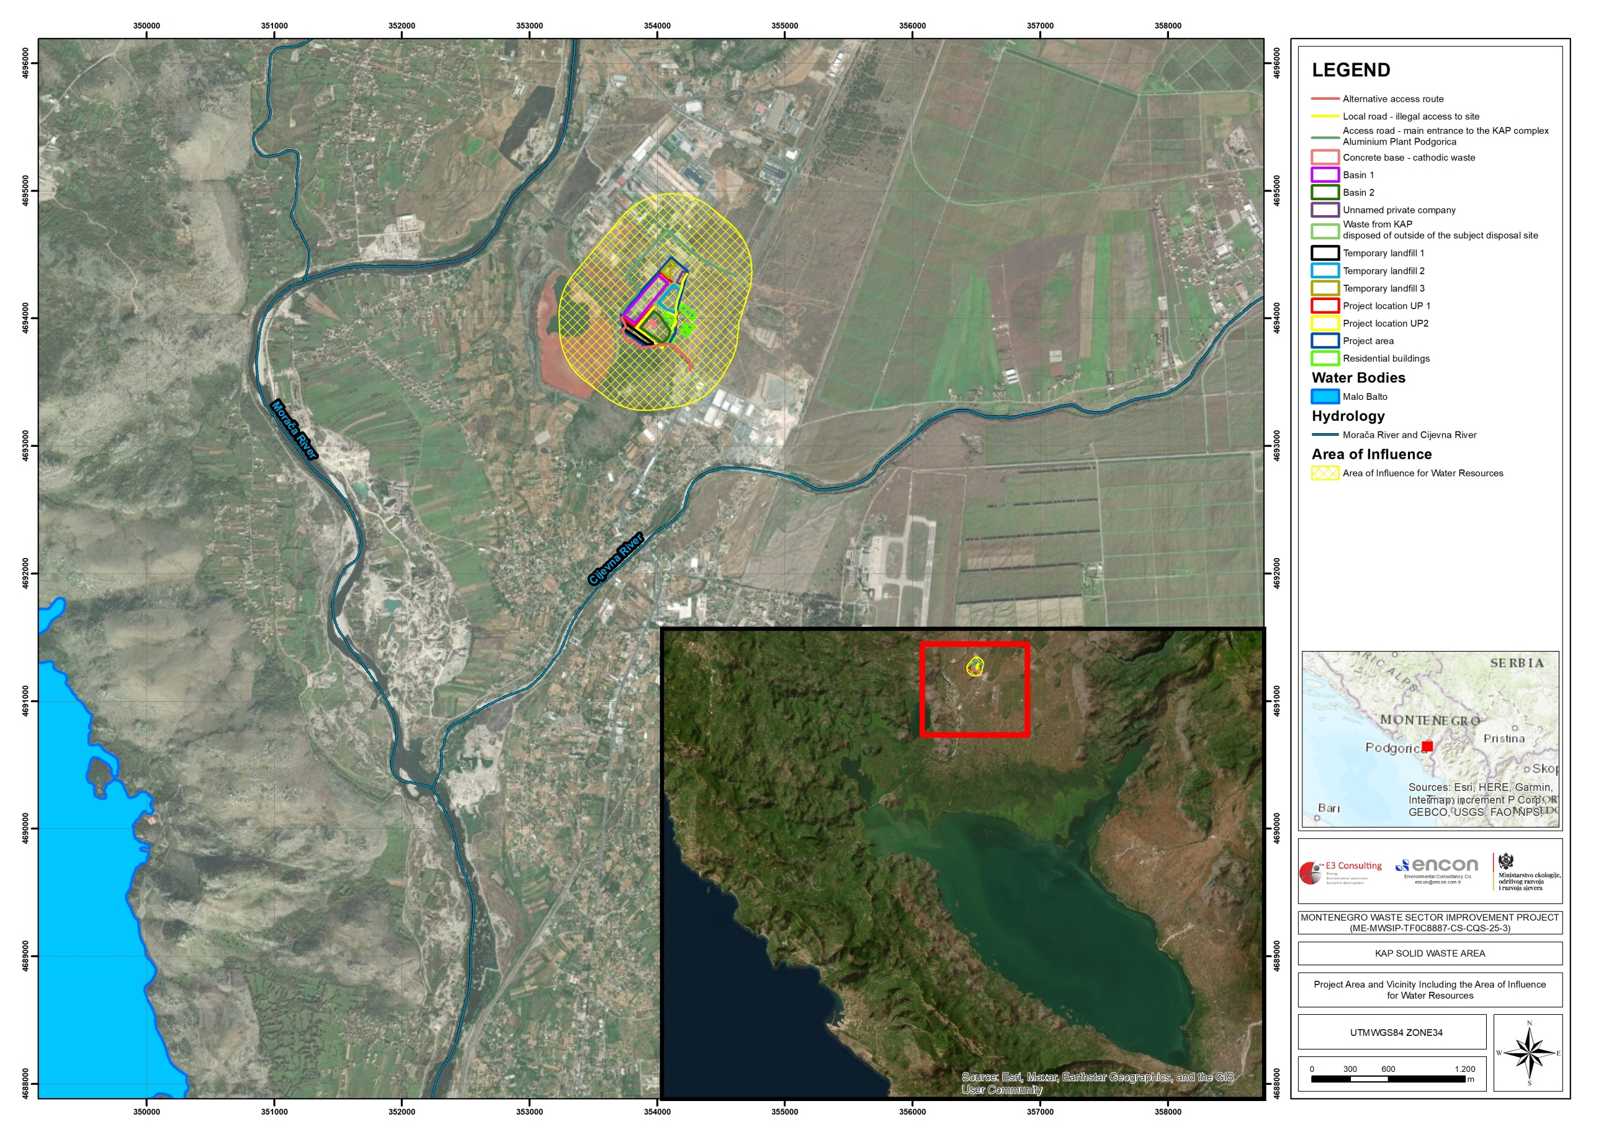

Figure 22 Project Area and Vicinity including the AoI for Water Resources

Determination of Environmental and Social Impact Level and Significance

The potential environmental and social impacts of the Project on the physical, biological, and socioeconomic environment are identified and assessed in this Section. The assessment focuses on the determination of impact magnitude and significance, with the results summarized in Table 18.

Table 18 Matrix Table with Identification of Impact Level in Terms of Environmental and Social Attributes

No | Environmental and Social Attributes | Impact
No | Environmental and Social Attributes | Nature |  | Type |  |  | Extent/area |  |  |  | Duration |  |  |  | Likelihood of Occurrence |  |  | Sensitivity of the Receptor | Magnitude of the Impact | Impact Significance Before Mitigations | Impact Significance After Mitigations
No | Environmental and Social Attributes | Positive (+) | Negative (-) | Direct | Indirect | Cumulative | On-site/ Project footprint | Local | Regional | National | Short term | Mid-term | Long term | Permanent | Very likely/ certain | Likely | Unlikely | High | High | High | High
 |  |  |  |  |  |  |  |  |  |  |  |  |  |  |  |  |  | Medium | Medium | Medium | Medium
 |  |  |  |  |  |  |  |  |  |  |  |  |  |  |  |  |  | Low | Low | Low | Low
 |  |  |  |  |  |  |  |  |  |  |  |  |  |  |  |  |  | Negligible/ None | Negligible/ None | Negligible/ None | Negligible/ None
CONSTRUCTION/ REMEDIATION PHASE
1. Air Quality
1 | Exhaust emissions (CO, SO₂, VOC and NO_{x}) |  | ✓ | ✓ |  |  |  | ✓ |  |  |  | ✓ |  |  | ✓ |  |  | Medium | Low | Low | Low
2 | Impact on human health |  | ✓ |  | ✓ |  |  | ✓ |  |  |  | ✓ |  |  |  | ✓ |  | Medium | Low | Low | Negligible/ None
3 | Fugitive dust emission containing asbestos |  | ✓ | ✓ |  |  | ✓ |  |  |  | ✓ |  |  |  | ✓ |  |  | Medium | Low | Low | Negligible/ None
2. Climate Change
1 | Contribution to climate change through Greenhouse Gas (GHG) emissions |  | ✓ |  |  | ✓ |  |  | ✓ |  |  | ✓ |  |  | ✓ |  |  | Low | Low | Low | Low
3. Soil and Soil Quality
1 | Erosion potential |  | ✓ | ✓ |  |  | ✓ |  |  |  |  |  | ✓ |  | ✓ |  |  | Medium | Low | Low | Low
2 | Contamination of soil |  | ✓ | ✓ |  |  | ✓ |  |  |  |  |  | ✓ |  |  | ✓ |  | Medium | Low | Low | Low
4. Water Resources and Water Quality
1 | Change in surface water quality |  | ✓ | ✓ |  |  |  | ✓ |  |  |  | ✓ |  |  |  |  | ✓ | Medium | Low | Low | Low
2 | Change in groundwater quality |  | ✓ | ✓ |  |  |  | ✓ |  |  |  | ✓ |  |  |  |  | ✓ | Medium | Low | Low | Low
3 | Increase in water usage |  | ✓ | ✓ |  |  |  | ✓ |  |  |  | ✓ |  |  | ✓ |  |  | Low | Low | Low | Negligible/ None
5. Noise and Vibration
1 | Increase in noise level |  | ✓ | ✓ |  |  |  | ✓ |  |  |  | ✓ |  |  | ✓ |  |  | Low | Low | Low | Low
6. Use of Resources and Waste Management
1 | Resources used during works |  | ✓ | ✓ |  |  |  | ✓ |  |  |  | ✓ |  |  | ✓ |  |  | Low | Low | Low | Negligible/ None
2 | Improper waste management |  | ✓ | ✓ |  |  |  | ✓ |  |  |  | ✓ |  |  |  | ✓ |  | Medium | Low | Low | Low
7. Socioeconomic Environment
2 | Infrastructure damage |  | ✓ | ✓ |  |  |  | ✓ |  |  |  | ✓ |  |  |  | ✓ |  | Low | Low | Low | Negligible/ None
8. Community Health and Safety and Security
1 | Trespassing and community encroachment |  | ✓ | ✓ |  |  | ✓ |  |  |  |  | ✓ |  |  |  |  | ✓ | Low | Medium | Low | Negligible/ None
9. Labor Force and Working Conditions
1 | Working conditions and protecting the workforce |  | ✓ | ✓ |  |  | ✓ |  |  |  |  | ✓ |  |  | ✓ |  |  | Medium | Low | Low | Low
2 | Workers’ exposure to work-related occupational health and safety (OHS) risks |  | ✓ | ✓ |  |  | ✓ |  |  |  |  | ✓ |  |  | ✓ |  |  | High | High | High | Low
3 | Workers Engaged by Third Parties and the Supply Chain |  | ✓ | ✓ |  |  | ✓ |  |  |  |  | ✓ |  |  | ✓ |  |  | Medium | Low | Low | Low
10. Landscape and Visual
1 | Impairment of quality of life due to the overall presence of annoying construction works and activities and altered landscape |  | ✓ | ✓ |  |  |  | ✓ |  |  |  | ✓ |  |  | ✓ |  |  | Low | Medium | Low | Low
OPERATION/POST-REMEDIATION PHASE
1. Air Quality
1 | Exhaust emissions (CO, SO₂, VOC and NOx) |  | ✓ | ✓ |  |  |  | ✓ |  |  |  |  | ✓ |  | ✓ |  |  | Medium | Low | Low | Negligible/ None
2 | Impact on human health |  | ✓ |  | ✓ |  |  | ✓ |  |  |  |  | ✓ |  |  |  | ✓ | Medium | Low | Low | Negligible/ None
2. Soil and Soil Quality
1 | Contamination of Soil |  | ✓ | ✓ |  |  | ✓ |  |  |  |  |  | ✓ |  |  |  | ✓ | Medium | Low | Low | Negligible/ None
3. Water Resources and Water Quality
1 | Change in surface water quality |  | ✓ | ✓ |  |  |  | ✓ |  |  |  |  | ✓ |  |  |  | ✓ | Low | Low | Low | Negligible/ None
2 | Change in groundwater quality |  | ✓ | ✓ |  |  |  | ✓ |  |  |  |  | ✓ |  |  |  | ✓ | Low | Low | Low | Negligible/ None
3 | Increase in water usage |  | ✓ |  | ✓ |  |  | ✓ |  |  |  |  | ✓ |  |  |  | ✓ | Low | Low | Low | Negligible/ None
4. Noise and Vibration
1 | Increase in Noise Levels |  | ✓ | ✓ |  |  |  | ✓ |  |  |  |  | ✓ |  |  | ✓ |  | Medium | Low | Low | Low
5. Use of Resources and Waste Management
1 | Waste management |  |  |  |  |  |  |  |  |  |  |  |  |  |  |  |  | Positive
6. Socioeconomic Environment
1 | Restricted land use and access to the site |  | ✓ | ✓ |  |  |  | ✓ |  |  |  |  | ✓ |  |  | ✓ |  | Low | Low | Low | Negligible/ None
7. Community Health and Safety and Security
1 | Unauthorized access / trespassing to the remediated site |  | ✓ | ✓ |  |  |  | ✓ |  |  |  |  | ✓ |  |  |  | ✓ | Low | Low | Low | Negligible/ None
2 | Community exposure to residual contamination |  | ✓ | ✓ |  |  |  | ✓ |  |  |  |  | ✓ |  |  |  | ✓ | Low | Low | Low | Negligible/ None
8. Labor Force and Working Conditions
1 | Occupational health and safety risks for monitoring personnel |  | ✓ | ✓ |  |  | ✓ |  |  |  | ✓ |  |  |  | ✓ |  |  | Low | Low | Low | Negligible/ None
10. Landscape and Visual
1 | The existence of the Dump Area |  | ✓ | ✓ |  |  |  | ✓ |  |  |  |  |  | ✓ | ✓ |  |  | Low | Low | Low | Low

Impacts on Physical Environmental Characteristics

Impacts on Hydrogeology and Hydrology

To prevent the further pollution of groundwater and surface water resources induced by the leachate from the solid waste area, the remediation of site will be performed and together with the construction of drainage channels and capping, rainfall and surface run-off contact with disposed material will be prevented. This will decrease the pollution contribution of generated leachate and erosion of disposal site on nearby surface water resources, namely Moraca River.

In general, the potential impacts of the Project on hydrology and hydrogeology of the area would be generally positive.

Impacts on Erosion, Land Slide, and Land Use

The solid waste area itself is a typical anthropogenic land, where the former natural layer is practically destroyed. Therefore, there will be no change of the land use in the extent of the Project.

Other impacts on land use will be mainly during the construction phase of the Project in regard with the construction machinery movement in the close vicinity of the Project Area, and although not planned, opening of new access roads in case of a need.

Since the Project focuses on recultivation of the existing uncontrolled disposal site, it is not expected to have any negative erosion impacts due to the Project. However, the construction works to be performed at the disposal site, especially excavation works, might trigger land slide on the slopes. These sorts of problems would be eliminated by following the implementation guidance given in design documents and sticking into international good practice for construction works.

To ensure reclamation of the disposal site, all stored waste will be excavated and transported to three temporary storage locations. The temporary storage areas will be located within the premises of KAP, and adjacent to the existing site. Therefore, no additional land is required for this purpose.

Following completion of the reclamation works, future land use of the site will be determined based on the results of post-closure environmental monitoring and the residual level of environmental degradation, if any. Post-closure monitoring will be implemented to assess the long-term condition of soil, groundwater and other relevant environmental components, and to verify the effectiveness of the remediation measures.

Any future use of the site will be restricted to activities compatible with the post-remediation environmental conditions and applicable regulatory requirements. In addition, access to the reclaimed area will be controlled, as necessary, through physical and administrative measures to prevent unauthorized entry and to ensure protection of human health and the environment during the post-closure period.

Table 19 summarizes the potential impacts of the Project on erosion, land slide and land use.

Table 19 Assessment of Impact on Erosion, Land Slide and Land Use

Affected Ecosystem Component | Source of Impact | Project Phase | Definition of Potential Impact | Type of Impact | Impact Significance Before Mitigation
Land | Erosion and landslide risks | Construction | Erosion and sliding on the slopes | Negative | Negligible
Land | Erosion and landslide risks | Operation | Erosion and landslide potential of the site will be lowered | Beneficial / Positive | -

Impacts on Physical Environmental Quality

Impacts on Water Quality

As stated in Chapter 4, Moraca and Cijevna Rivers are passing very close to the solid waste area. The KAP, together with its red mud basin and solid waste area, has long-term negative impacts on water quality, both for surface and groundwater quality. These two disposal sites create pollution stress for all water resources in the region, including Skadar Lake located downstream of Moraca and Cijevna.

The Project aims to mitigate the already existing impacts on water quality in the area, so once implemented it would have positive impacts on surface and groundwater quality. The potential impacts of the Project on water quality would be during the construction due to uncontrolled disposal of waste, potential leakage from construction vehicles/equipment maintenance and fuelling, and soils and solid waste reaching the surface water as sediments.

It should be noted that there is no characterization study performed for the leachate that is already present in the disposal site. During the relocation of stored material, it is expected to reach leachate accumulation layer on the bottom. The uncontrolled discharge of the existing leachate would have significant negative impacts on surface and groundwater resources. To define mitigation measures and treatment methodology for this strong wastewater, a characterization study needs to be performed before the commencement of construction works at the site. The results of this test can be also used to assess the quality and quantity of the leachate to be generated after the recultivation. After the construction completed, it is expected that the solid waste will not generate leachate since the engineering design with encapsulation will not allow groundwater contact.

During the operation phase of the Project, main impact might be related with the efficiency of water drainage system around the solid waste area. Clogging of the channels should be monitored to manage associated potential adverse impacts. Therefore, the significance of impacts regarding the operation phase are considered negligible.

Table 20 summarizes the potential impacts on surface and groundwater quality.

Table 20 Assessment of Impacts on Surface and Groundwater

Affected Ecosystem Component | Source of Impact | Project Phase | Definition of Potential Impact | Type of Impact | Impact Significance Before Mitigation
Surface waters (streams and rivers) | Uncontrolled disposal of waste, oil and fuel leakage from construction vehicles, sediments (soil) reaching surface waters by runoff | Construction | Change of water quality (pollution) | Negative | Medium
Groundwater | Uncontrolled disposal of waste, oil and fuel leakage from construction vehicles | Construction | Change of water quality (pollution) | Negative | Medium
Surface and groundwater | Uncontrolled discharge of existing leachate | Construction | Change of water quality (pollution) | Negative | Medium
Surface and groundwater | Recultivation and development of drainage system | Operation | Improvement of water quality | Beneficial / Positive | -

Impacts on Soil Quality

Examination of soil quality in the solid waste disposal site, at the nearest settlement and in the close vicinity of KAP (presented in Chapter IV) revealed that the analyzed samples are contaminated with heavy metals; where all of them multiple times greater than the regulatory MAC. Although the exact cause of this contamination could not be known, it can be said that the disposal site and red mud basin are major contributors. However, the realization of this Project would create a positive impact on the area regarding soil in the long run though recultivation of the site.

During the relocation of stored solid waste, temporary storage areas are foreseen for the temporary collection and short-term storage of existing waste prior to its transfer into appropriately designed and constructed basins. No permanent storage or disposal of waste is envisaged within these temporary storage areas. In line with this approach, the areas will be prepared in advance, including grading and leveling, after which waste will be temporarily placed at ground level. The duration of storage will be limited strictly to the period necessary before transfer to the final basins, and the activities will be carried out in accordance with applicable environmental protection, health and safety, and monitoring requirements.

The potential adverse impacts of the Project on soil quality would be due to use, fueling, maintenance and repair of the construction vehicles, waste disposal and to a rather smaller extent dust generation and dispersion/deposition of the particulates on the lands around the construction site. During the construction phase, temporary storage areas will also accommodate temporary and strictly controlled construction-related activities, in accordance with environmental protection and occupational health and safety requirements.

The main impacts on soil quality would be during the construction phase, which is a limited duration. Most of the above-mentioned potential adverse impacts could be easily controlled with standard measures. For example, forming designated areas with containment for vehicle washing, maintenance (such as oil changing, etc.), fueling would prevent spilling of oil and fuel into the surrounding soil, and groundwater. In case of accidental oil and fuel spillage, necessary emergency actions such as cleaning off the spilled oil using an absorbent and removal of the contaminated surface layer of the soil would be implemented.
Table 21 summarizes the potential impacts of the Project on soil quality.

Table 21 Assessment of Impacts on Soil Quality

Affected Ecosystem Component | Source of Impact | Project Phase | Definition of Potential Impact | Type of Impact | Impact Significance Before Mitigation
Soil | Dust dispersion from the disposal site and deposition on the soils in the vicinity | Construction | Soil contamination | Negative | Low
Soil | Inadequate maintenance and fueling of the vehicles and construction machinery at non designated areas, uncontrolled waste disposal | Construction | Soil contamination by spillage and natural drainage | Negative | Low

Impacts on Air Quality

Main impact of the project activities on air quality would be dust generation and exhaust gas emissions. Dust would be generated from the dry surfaces with no vegetation coverage due to wind and operation of vehicles on these surfaces. In addition, when there is excavation, hauling and storing of materials dust is a potential impact to consider. Exhaust gases would be generated by the construction vehicles/equipment. These impacts will have a local character.

It is known from the preliminary design documentation that the stored solid waste also includes asbestos containing materials. Therefore, fugitive dust generating activities to be performed at the disposal site shall be performed with utmost care with professional guidance to be provided by asbestos experts. In case mitigation measures are not taken during these works, the negative impacts associated with dust generating activities would be in medium in significance.

The emissions from construction vehicles are estimated based on the specifications and standards regarding the drive motors of the construction machinery/equipment and the planned number of machine hours. All the drive machines must meet the norms for the emission limits stipulated by the EU Directive 97/68/EC, which defines standards for the manufacturers.

The emissions provided below were estimated according to the standard values for off-road machinery, i.e. construction equipment for the standardized allowed emissions of CO, HC, NO_{x} and PM10. Thus, construction machinery to be used would meet the guidelines for the EU Stage IIIb standards but bearing in mind that the machines which were produced until 2006 are used; the calculation was carried out in line with the guidelines for the EU Stage III standard.

Table 22 with the Stage III B emission standard shows general values of the emission of harmful gases and dust (particulate matter), which were calculated according to data about the prevised working machines and their respective machine hours (calculation in line with EU Stage III). Considering that calculated emissions will represent the maximum allowed values, actual levels of emission will be lower. Thus, the estimated emissions may be seen as the worst-case scenario in terms of emissions of exhaust gases.

Table 22 Stage III B Emission Standard for Non-Road Diesel Engines

Cat. | power | Date | CO | HC | NO_{x} | PM
Cat. | kW | Date | g/kWh
L | 130 ≤ P ≤ 560 | 2011.01 | 3.5 | 0.19 | 2.0 | 0.025
M | 75 ≤ P < 130 | 2012.01 | 5.0 | 0.19 | 3.3 | 0.025
N | 56 ≤ P < 75 | 2012.01 | 5.0 | 0.19 | 3.3 | 0.025
P | 37 ≤ P < 56 | 2013.01 | 5.0 | 4.7* |  | 0.025
*NO_{x}+HC

The number of construction vehicles to be used at the same time and location will be the highest during the excavation, relocation, construction and lining the surface with impermeable material. The list of construction machinery is provided in Table 23 and the calculated emissions originated due to the operation of these machineries are provided in Table 24.

Table 23 List of Construction Machinery

Type of the Machinery | Number of Machinery | Estimated Power
Excavator | 6 | 239 kW
Loader | 3 | 164 kW
Bulldozer | 2 | 331 kW
Rubber wheeled roller | 4 | 103 kW
Dump truck | 15 | 243 kW
Grader | 2 | 136 kW

Table 24 Calculated Total Emissions from Construction Machinery

Parameters | Calculated Total Emissions (g/h) | Limit Values (mg/m³)
NO_{x} | 16,957 | 110
CO | 23,740 | 10
HC | 1,288 | -
PM | 168 | 50

The exhaust emissions originated from the construction machinery will be in line with the national legislation.

During the operation phase of the Project, any impacts on air environment are not anticipated. Moreover, recultivation of the entire site will minimize the current impacts of the site on air quality, especially observed during windy conditions. Therefore, the Project will have a positive impact on air environment. No methane emissions are expected to occur since the waste character is dominantly industrial wastes.

Table 25 presents the potential impacts on air quality and impact significance.

Table 25 Assessment of Impacts on Air Quality

Affected Ecosystem Component | Source of Impact | Project Phase | Definition of Potential Impact | Type of Impact | Impact Significance Before Mitigation
Air | Fugitive dust emission containing asbestos | Construction | Negative impacts on workers’ and community health and safety | Negative | Medium
Air | Exhaust gas emissions from construction machinery and dust generation | Construction | Change of air quality | Negative | Low
Air | Recultivation of the site will lower its dust generation potential | Operation | Less dust formation and increased air quality | Beneficial / Positive | -

Noise Impacts

Emission limits for noise generated through the operation of machinery in the open spaces are determined by the EU Directives (2000/14/EC and 2006/42/EC) and they have been applied in this Project. Law on Environmental Noise Protection (“Official Gazette of Montenegro, No. 28/11, 28/12 and 1/14) and the Rulebook on threshold values of environmental noise, the method of determining the noise indicators and acoustic zones and methods of assessing the harmful effects of noise (“Official Gazette of Montenegro, No. 60/11) were applied for the assessment of potential noise impacts.

According to the Rulebook on threshold values of environmental noise, the method of determining the noise indicators and acoustic zones and methods of assessing the harmful effects of noise (“Official Gazette of Montenegro”, No. 60/11) and the Decision on determining the acoustic zones in Podgorica, the solid waste disposal site belongs to the industrial zone.

In addition to the EU Directives and Montenegrin legislation, noise limit levels are also described under, Environmental, Health and Safety (EHS) Guidelines, General EHS Guidelines: Environmental Noise. The noise limit values are based on World Health Organization Guidelines for Community Noise. Noise levels defined by WBG are presented in Table 26.

Table 26 Noise Level Guidelines of IFC

Receptor | One Hour L_{Aeq} (dBA)
Receptor | Daytime 07:00 – 22:00 | Nighttime 22:00 – 07:00
Residential, institutional, educational | 55 | 45
Industrial, commercial | 70 | 70

The list of machinery and equipment, which will be used during the construction phase, are likely to cause noise, and their number and noise intensity levels are presented in Table 27.

Table 27 Machinery and Equipment and their Noise Intensity Levels (Lw)

Machinery and Equipment | Number | Noise Intensity Level (dBA)
Truck | 15 | 85
Loader | 3 | 115
Bulldozer | 2 | 111
Rubber-wheeled Roller | 1 | 105
Grader | 2 | 112
Excavator | 6 | 115

In order to assess the noise impacts of the activities that will be conducted during construction phase, the total noise generations should be calculated for the worst-case scenario and should be compared with the legislative and ESS3 requirements in order to have an idea. To satisfy this need, noise generation calculation is performed below with the assumption of worst-case scenario. The worst-case scenario assumes that all machinery and equipment operate simultaneously at maximum noise intensity levels at the same location (at the nearest border of the site) in the Project Area.

The formulas given below were used for the calculation of noise levels regarding land preparation and construction phase of the Project. Formula (1) is used to calculate total noise level at the source according to noise intensity level of each equipment, Formula (2) is used to calculate the noise level that reaches a definite distance (Lpt), and Formula (3) used to include topographical absorption effect into consideration.

L_{wt} = 10 log $\sum_{i=1}^{n}{{10L}^{wi/10} }$ (1)
L_{pt} = L_{wt} + 10log (Q/4πr²) (2)
C1 = 5xlog(d_{o}/d) (3)

L_{wt} : Noise level at the source
L_{pt} : Noise level that reaches a defined distance
Q : Orientation coefficient/atmospheric reduction factor (assumed as 1)
r : Distance from the source
C1 : Topographical noise absorption
d : Distance

As it is mentioned before, in the equations given above, it is accepted that construction equipment and machinery are used at the same physical location (at the nearest border of the tailings pond site area), non-stop at maximum noise intensity levels (worst case scenario). Therefore, it is expected that in reality noise level caused by construction activities will be much smaller than the worst-case scenario calculation result.

L_{wt} = 10 log $\sum_{i=1}^{n}{{10L}^{wi/10} }$
= 10 log (15x10^{8.5}+3x10^{11.5}+2x10^{11.1}+1x10^{10.5}+2x10^{11.2}+6x10^{11.5})
L_{wt} = 125 dBA

The calculation of noise level that reaches to the nearest building (which is 80 m away from the nearest border of the site) is as follows:

L_{pt} = L_{wt} + log (Q/4πr²)
L_{pt (80m)} = 125+10 log(1/4x3.14x80²)
L_{pt (80m)} = 75.9 dBA

Topographical absorption for 80 m:

C1 = 5xlog(d_{o}/d)
C1 = 5xlog(1/80)
C1 =-14.5 dBA

L_{pt} at 80 m by taking into consideration of topographical absorption

L_{pt (80m) total}= L_{pt (80m)} + C1
L_{pt (80m) total}= 75.9 dBA -9.5 dBA
L_{pt (80m) total}= 66.4 dBA

The distribution of noise with respect to distance from the source is presented in tabular format in Table 28 and graphically in Figure 23. Environmental noise level decreases below the limit value defined for construction activities (70 dBA) at a distance about 60 m from the source. The closest receptor, which is a settlement, is located about 80 meters southeast of the border of the tailings pond site.

Table 28 Distribution of Noise Generation Relative to Distance

Distance (m) | L_{pt} (dBA) | L_{pt} with topographical absorption (dBA) | Distance (m) | L_{pt} (dBA) | L_{pt} with topographical absorption (dBA)
15 | 90.4 | 85.6 | 500 | 60.0 | 46.5
50 | 80.0 | 71.5 | 600 | 58.4 | 44.5
80 | 75.9 | 66.4 | 700 | 57.1 | 42.8
100 | 74.0 | 64.0 | 800 | 55.9 | 41.4
200 | 68.0 | 56.4 | 900 | 54.9 | 40.1
300 | 64.4 | 52.0 | 1000 | 54.0 | 39.0
400 | 61.9 | 48.9 | 1500 | 50.4 | 34.6

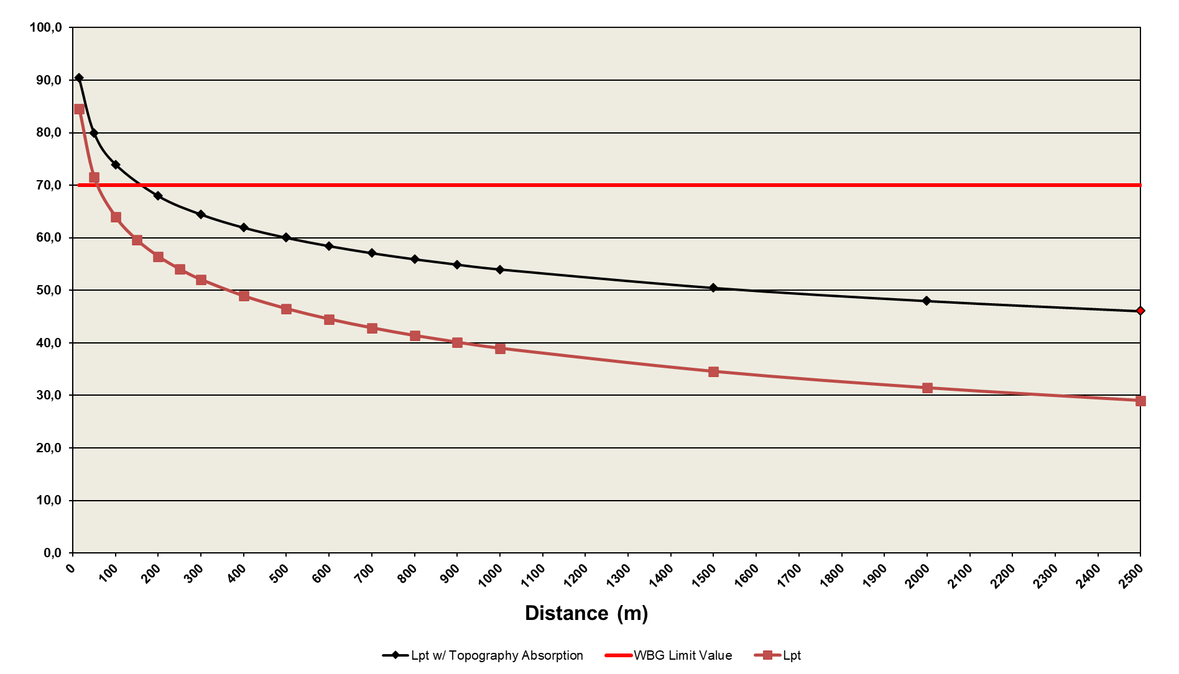

Figure 23 Distribution of Noise Generated in the Project Area with respect to Distance

As seen from the above, under the worst-case conditions, noise level near the closest building to the border of the site caused by the construction phase of the Project is below WBG limit values. Moreover, it is unlikely that all construction machinery and equipment are used at the same physical location and non-stop at maximum noise intensity levels (worst case scenario). In addition, as the construction activities will occur outdoors, it is expected that there will be a decrease in noise level depending on the distance due to the atmospheric reduction in real conditions. Similarly, topology around the solid waste disposal site and vegetation cover are also among the factors that could reduce the impact during the dispersion of noise. However, since calculations are based on the worst-case approach, factors such as effect of location, atmospheric reduction, vegetation cover, etc. have not been taken into consideration. According to all these evaluations, it is expected that in real terms the noise level at the nearest building will be lower than the calculated value during the construction activities of the Project.

The proposed project activities would use limited number of construction equipment and would be conducted in a limited area, so vibration would be generated rather locally. Therefore, any impact of vibration would be rather insignificant and would not be felt by the nearby settlements.

The assessment of noise impacts majorly to be observed during the construction phase of the Project is summarised in Table 29.

Table 29 Assessment on Noise Impacts

Affected Ecosystem Component | Source of Impact | Project Phase | Definition of Potential Impact | Type of Impact | Impact Significance Before Mitigation
Local Communities | Construction machinery/equipment | Construction | Increase in noise levels | Negative | Low

Waste Generation Impacts

During the construction phase of the Project, municipal solid waste will be generated from site personnel. In addition, limited quantities of hazardous waste (e.g., used oils, oil filters, batteries/accumulators) may arise from minor equipment maintenance activities. However, routine servicing and major maintenance of construction machinery will not be conducted on-site. Vehicles and heavy equipment are expected to be maintained at licensed off-site service facilities, and any hazardous wastes generated during servicing will be managed and disposed of by these licensed operators in accordance with national regulations.

On-site hazardous waste generation is therefore expected to be minimal and limited to minor operational needs, and all such wastes will be stored temporarily in designated areas and transferred to licensed waste management companies for proper treatment and disposal. No excavation waste will be generated during the construction phase.

On the basis of data on the machinery, which will be engaged at the project site, the following types and quantities of waste can be produced annually:

- waste engine oils (13 02 06* synthetic motor oils, gearbox and lubricating oils): 360 litres (approx. 315 kg)
- oil filters (16 01 07*oil filters): 15-20 kg
- batteries (16 06 01* lead-acid batteries): 120 kg
- absorbents and wiping cloths (15 02 02* absorbents, filter materials (including oil filters that are not otherwise specified) wiping cloths, protective clothing, which are contaminated with hazardous substances): up to 30 kg
- antifreeze (16 01 14*antifreeze which containing dangerous substances): 60 litres (approx. 68 kg)
- brake fluid (16 01 13*brake fluid): 8 liters (approx. 7.8 kg)

The wastes arising from the Project activities would be disposed to the existing landfills or an authorized waste company would be engaged for their disposal, except for excess rock and soil, which will be disposed on-site, in accordance with the specifications of the Municipality.

From this it can be concluded that the types and volumes waste generated during the construction phase of the Project will be small. Occasional hazardous wastes may arise from maintenance operations, clearance of drainage facilities and separators, and clean-up of accidental spills. The management of mentioned types of waste will be carried out in accordance with the construction contractor’s environmental and social management system (ESMS) documentation, which are needed to be in line with both IFC PS1 and WB ESS1 standards and requirements. No significant impact is predicted to arise from resource use or waste disposal during operation in regard to maintenance of the site. Table 30 summarizes the potential impacts and impact significance of waste generation.

Table 30 Assessment of Impacts of Waste Generation

Affected Ecosystem Component | Source of Impact | Project Phase | Definition of Potential Impact | Type of Impact | Impact Significance Before Mitigation
Local Communities and Environment | Domestic waste and waste generation due to use of machinery | Construction | Generation and disposal of wastes | Negative | Low

Impacts on Landscape Characteristics

The solid waste disposal site has been in use for many years, which caused loss of land and change in landscape characteristics. Already imposed impacts of the site on the landscape and visual and aesthetic effect would be restored by recultivation of the entire site. In the construction phase of the Project, active works to be performed on site will create some adverse impacts on landscape, but it would not be more powerful than the current poor aesthetics of the site. Together with the completion of recultivation works, the poor aesthetic image created by site itself will be eliminated. Overall, it can be said that the Project will have a beneficial/positive impact on the landscape characteristics of the region.

Table 31 presents the potential impacts on landscape and impact significance.

Table 31 Assessment of Impacts on Landscape

Affected Ecosystem Component | Actual impact | Project Phase | Definition of Potential Impact | Type of Impact | Impact Significance Before Mitigation
Landscape | Loss of land and visual impacts | Construction | Visual impacts of construction activities | Negative | Low
Landscape | Loss of land and visual impacts | Operation | Already realized impacts on the landscape will be reversed and, depending on the quality of recultivation work, the area could gain significant value | Beneficial / Positive | -

Radioactivity Impacts

Although 2006 study performed by CETI on the measurement of radioactivity around the tailings pond site showed a compliance with the regulatory limit values, the stabilization and recultivation of the site will create positive impacts on the surrounding area, especially for Moraca river. The realization of the Project will prevent reach of stored material to Moraca river by erosion and surface run-offs; therefore, less radionuclides would reach to the river. Table 32 presents the summary of the impacts of radioactivity.

Table 32 Assessment of Impacts on Contents of Radionuclides in Surface Waters

Affected Ecosystem Component | Source of Impact | Project Phase | Definition of Potential Impact | Type of Impact | Impact Significance Before Mitigation
Content of radionuclides in surface waters | Recultivation of the site | Operation | Less radionuclide reach to surface water resources | Beneficial / Positive | -

Impacts on Biological Environment

In this section, the Project's potential impacts on the biological environment are considered. Potential impacts will affect terrestrial flora-fauna and aquatic ecosystems directly or indirectly. Therefore, the impacts of project activities can be further divided into the target group of biological elements as terrestrial and aquatic.

The following subsections define the potential impacts of the Project considering the foreseen project activities during construction and operation. The potential impacts are assessed for terrestrial flora, terrestrial fauna, and aquatic environment, respectively. Mitigation measures to be taken in order to minimize these impacts are also included in the assessments.

The impact of project activities on ecological components is related to the size of the impact and the vulnerability of the recipient. For terrestrial and aquatic flora-fauna species, the size and significance of the effects according to the matrices presented below have been determined in accordance with the criteria determined according to the ecological sensitivities of the species. It is known that the features of each step in the systematic classification of species are different from each other. Accordingly, the forms and dimensions of the influence of the Project will vary within themselves. Sensitivities of terrestrial flora and fauna species determined within the Project Area are explained in detail in the report. Criteria for significance for ecological components are explained in following topic.

Impacts on Internationally Recognised Areas within the Region of the Project Area

IFC PS6 states that internationally and/or nationally recognized areas of high biodiversity value are likely qualified as critical habitats.

There are no protected areas in the Project Area. There is 3.3 km south of the site, the “Skadarsko Jezero” National Park is situated. Skadar Lake National Park is an important biodiversity conservation area with its RAMSAR, KBA, IBA, and nominated candidate Emerald Site statuses. Moraca River, which is one of the rivers feeding Skadar Lake is also registered as KBA. Therefore, negative impacts on the water quality and the lake ecosystems cannot be excluded considering that the Moraca River and Skadar Lake are located downstream of the KAP site.

The scope of the project's solid waste storage actions will be remediated and the destruction of the solid waste dumpsite on biodiversity will recover.

The Morača River and Cijevna Canyon which were affected by the storage areas in terms of water contamination will be no longer having pollution stress by the site.

Therefore, the internationally recognized areas are assessed as being negligible. Therefore, no negative impact is expected on this site during the execution of the Project. A significant indirect positive impact is expected on this zone.

Impacts on Terrestrial Habitat and Flora-Fauna

The disposal site has been in operation since 1969, which has already affected the vegetation and flora-fauna species. Because of the solid waste storage has lost all habitat, and terrestrial fauna moved away from the area. When remediation activities are done, ecosystems of the area would be recovering over the years.

There will be no loss of vegetation outside the project boundaries. The possible impact will be the opening of new access roads. Another direct impact of the construction phase will be the vehicle traffic for construction. The fauna species, which have limited mobility, might be faced with fauna mortality. The risk of crushing will increase as the animals cross the road. Some of the expected indirect impacts will be as follow;

- Alien species invading the altered ecosystems,
- Changes in the composition of soil and water quality
- Changes in air quality (dust generation, etc.),
- Solid and hazardous wastes to be generated due to project activities,
- Noise pollution that might impact species’ behavior, especially that of fauna elements.

The magnitude, severity, and significance of impacts on terrestrial habitats and flora-fauna are shown in Table 33.

Table 33 Assessment of Impacts on Terrestrial Habitats and Flora/Fauna

Affected Ecosystem Component | Source of Impact | Project Phase | Definition of Potential Impact | Type of Impact | Impact Significance Before Mitigation
Terrestrial Habitats and Flora/Fauna | The risk of crushing will increase as the animals cross the road  Alien species invading the altered ecosystems  Changes in the composition of soil and water quality  Changes in air quality (dust generation, etc.)  Solid and hazardous wastes to be generated due to project activities  Noise pollution that might impact species’ behavior, especially that of fauna elements | Construction | Disturbance of fauna species in the vicinity of the Project area  Loss of flora populations in the vicinity of the Project area | Negative | Low
Terrestrial Habitats and Flora/Fauna | Solid Waste Dumpsite Area already converted the modified habitat (loss of vegetation), and due to the high anthropogenic elements in the area, the fauna species moved away from the site. With the implementation of the project, biodiversity will improve, and the ecosystem balance will be restored. | Operation | Formation of new vegetation in the Project area  Creation of new habitats for fauna species  To reach an ecological balance | Beneficial / Positive | -

Impacts on Aquatic Environment

Morača River, Cijevna River, and Skadar Lake are located in the vicinity of the KAP solid waste disposal site. The Morača River passes nearby the site of KAP and flows into Skadar Lake. The disposal site contaminates the river by erosion and mixing with precipitation. These issues affect both the water quality and the bottom structure of the river negatively. Therefore, the river's biodiversity is currently under threat due to the solid waste dumpsite.

Solid wastes will not be stored anymore in the area after the project is realized. Therefore, the pollutants reaching the river due to waste will be eliminated. This will have a positive impact on the river. During construction, the impacts on the aquatic environment might be as follows;

- Water pollution due to discharge of construction wastes into the river
- Intervention of the river flow and deterioration of the bottom structure of the river
- Increased sedimentation
- Discharging chemical wastes to the river during construction
- Construction equipment passes over the river to contaminate the water quality of the river and destroy the bottom structure

The magnitude, severity, and significance of impacts on aquatic habitats and flora-fauna are shown in Table 34

Table 34 Assessment of Impacts on Aquatic Habitats and Flora/Fauna

Affected Ecosystem Component | Source of Impact | Project Phase | Definition of Potential Impact | Type of Impact | Impact Significance Before Mitigation
Aquatic Habitats and Flora/Fauna | The pollutants are mixed with rainwater and reach the rivers and/or contaminate the rivers by erosion | Construction | Disturbance for freshwater fish species  Changes in the composition of sediment and water quality of the river | Negative | Low
Aquatic Habitats and Flora/Fauna | Pollution caused by stored solid waste will be prevented | Operation | Improved conditions for aquatic habitats in the river | Beneficial / Positive | -

Impacts on Socio-economic Environment

Impacts on the Local Population

At this stage of the Project design, the number of workers required to implement construction activities is not known. It is expected to be very limited in numbers, around 20-30. Therefore, it is expected that the Project will not trigger any worker influx to the region thus, no impacts are expected on local population.

Impacts on Economy and Livelihoods

Although the project will not create many job opportunities, in such case, the priority for employment during the construction phase will be given to local people. This will lead to an increase in local employment potential. In addition to that, consideration of local sources in the procurement processes might also have positive impacts on the local economy. No negative impacts on livelihood are anticipated.

At the preliminary site visit, it has been observed that the houses in the area are used for residential purposes, and no economic activities (even informal) in the area were recorded at the time.

The construction work related to the remediation can be tendered nationally or internationally according to the WB procurement procedure. It is expected that national procedure will result in more input from companies located in Montenegro whereas the exchange of know-how will be less. Impacts on economy and livelihoods are summarized in Table 35.

Table 35 Assessment of Impacts on Economy and Livelihoods

Affected Ecosystem Component | Source of impact | Project Phase | Definition of Potential Impact | Type of Impact | Impact Significance Before Mitigation
Local economy and livelihoods | Construction works | Construction | Employment and trade opportunities | Positive | -
Local economy and livelihoods | Recultivation of the site | Operation | Opportunity of having clean environment and the improvement in the environmental conditions might attract new residents to the region | Positive | -

Impacts on Local Public Infrastructure

The proposed Project is going to be implemented in the area which is not characterized by extensive public infrastructure. However, there is an OHL line in the middle of the Project site, and further information about this power line is going to be collected through the phase of engagement with institutional stakeholders. Montenegrin Electricity Distribution System is going to be included in the consultation process, whereby the technical requirements for potential relocation of the OHL tower (due to the planned remediation of the solid waste disposal site) are going to be duly agreed upon and incorporated into the Main Design for the project.

Thereby, potential impacts may be expected in relation to the local power line, in the sense that there may be temporary disturbance in power supply. However, all of the technical details regarding the mutual dependency between the planned works and the OHL tower in the project area are going to be discussed with CEDIS and included in the Main Design, whereby the expected impacts are going to be defined in this ESIA accordingly.

The access road for remediation works contractors has not been defined yet, and it is going to be defined through the Contractor’s Construction Site Organisation Plan, taking into account avoiding any disruption of structures or livelihood of community members living in the area

Community Health and Safety

Key identified reasons for potential negative effects on community health and safety will be seen in air, soil and water pollution, as well as noise. Previous sections presented the results of relevant assessments, and it could be seen that the proposed Project would not have significant effects on the health and safety of the community.

One of the limited negative impacts of the Project on community health and safety would be related with the fugitive dust emissions containing potentially hazardous particles, including suspected asbestos fibers,. To manage this impact and prevent asbestos emissions, the construction contract would be advised to prepare an Asbestos Management Plan that will be in line with WB ESS1 and ESS3.

Another negative impact on community health and safety would be related with the use of construction machinery and traffic related risks. To manage the traffic impacts, the construction contractor would be advised to prepare a Traffic Management Plan that will be in line with WB ESS4. Moreover, once the Project’s construction phase ends, the traffic impacts will disappear.

In the operation phase of the Project, together with the anticipated improvements in the environmental characteristics of the region, the current community health and safety threats that the solid waste disposal site create will be eliminated. However, any emergency situation to be experienced during the operation phase should be considered prior the commencement of works for the Project.

The overall assessment of the impacts on community health and safety is presented in Table 36.

Table 36 Assessment of Impacts on Community Health and Safety

Affected Ecosystem Component | Source of impact | Project Phase | Definition of Potential Impact | Type of Impact | Impact Significance Before Mitigation
Community Health and Safety | Asbestos dust emission | Construction | Negative impacts on workers’ and community health and safety | Negative | Medium
Community Health and Safety | Vehicle movements and traffic | Construction | Traffic accidents | Negative | Low
Community Health and Safety | Emergencies (natural disasters, failures, accidents etc.) | Construction / Operation | Emergency situations should be managed in order to prevent community health and safety risks | Negative | Low

Impacts on Cultural Heritage

Natural resources, which have specific values, are in the wider area of the project site. Although any impacts are not anticipated on cultural heritage, interactions with chance finds are possible during the construction phase. In such a case, construction works will be stopped immediately. In case of result of any damage on protected areas or cultural assets due to the Project during construction phase, the damage will be compensated by the construction contractor. In case of a chance find, the communication with the relevant stakeholders will be performed. This is going to be defined in the duly prepared Chance Find Procedure (Annex 9), which shall be developed and implemented by the Contractor(s). In addition to the national legislation, the provisions of WB ESS8 will be followed and complied with during all phases of the Project.

Occupational Health and Safety

Regarding the context of the Project, OHS is an issue only related the construction phase and is an integral part of project management. The project owner, even in the Preliminary Design Documents, has already defined OHS requirements to keep the Project in line with both national and international requirements. During the realization of the project, potential OHS impacts would be mainly the risk of accidents associated with construction works, therefore the construction contractor is needed to have an OHS Management Plan, which will have a section dedicated for working with all hazardous wastes including asbestos. The OHS Management Plan will include specific procedures for asbestos handling, as well as measures for the safe management of other hazardous wastes and materials, such as contaminated soil, hazardous construction debris, fuels, oils, chemicals, and any unforeseen hazardous waste encountered on site.

The impacts are summarized in Table 37 together with their significance.

Table 37 Assessment of Impacts on Occupational Health and Safety

Affected Ecosystem Component | Source of impact | Project Phase | Definition of Potential Impact | Type of Impact | Impact Significance Before Mitigation
Workers | Construction activities | Construction | Incidents | Negative | Medium

PROJECT ALTERNATIVES

This section discusses the recultivation of the solid waste disposal site planned to reduce contamination of natural resources and health risks and further process alternatives for the site, where the Project assessed in this ESIA is a part of the preferred alternative. Following this discussion, the alternatives in the Project are evaluated, including alternative methods for construction, and alternative methods of remediation of the disposal site. In this context the reasons for selecting the preferred/proposed alternative are also provided. Before the discussion on how to proceed with the proposed activities, the “no action” alternative, which represents the continuation of the current status without any intervention, is presented as well.

No Action/Project Alternative

This scenario implies the situation in which the current activities continue as usual, without any action to minimize the current or future negative impacts or risks.

In case of the project is not actualized, the situation will continue and the current negative impacts from the site will continuously represent a risk for the environment and for humans. Therefore, considering the aspects of environmental quality and public health, the “no action” alternative is not considered as a reasonable alternative.

Remediation Alternatives

The first alternative evaluated during the development of project framework is to transfer the stored waste to another controlled disposal site. This alternative is not found feasible since costs associated with excavation, transportation and re-disposal are higher than the cost of the selected alternative. If selected, it was known that this method would create capacity problems for the relocation site.

The second alternative was to safe enclosure of the solid waste disposal site to limit contact of the stored material with air environment. However, this alternative would not prevent groundwater seepage to the site in wet-season, thus resulting only in minimizing the pollution loads.

Therefore, the third alternative that is subject to this ESIA Report is selected to have a sustainable and long-term securing of the solid waste disposal site. This alternative has its own advantages and disadvantages, where advantages outweigh disadvantages. One of the major advantage of this alternative is to have a solution to the problem at the KAP footprint without requiring additional land and additional costs associated with transportation of stored material. As a disadvantage, similar to all other alternatives, this alternative requires a strict monitoring programme to assess the efficiency of the solution.

ENVIRONMENTAL AND SOCIAL MANAGEMENT PLAN

The Environmental and Social Management Plan (ESMP) has been prepared to define the measures required to manage the environmental and social risks and impacts identified in this ESIA and to ensure that the Project is implemented in compliance with applicable national legislation and the World Bank ESF. The ESMP forms an integral part of the Project implementation and establishes the framework for mitigation, monitoring, and reporting throughout the Project lifecycle.

Overall responsibility for ensuring implementation of the ESMP rests with the Project Implementation Unit (PIU). The ESMP requirements and commitments will be incorporated into tender documents and contractual arrangements to ensure that contractors are aware of and comply with environmental and social obligations.

During the pre-construction and construction phases, the Contractor will be responsible for implementing the mitigation and monitoring measures relevant to its activities in accordance with the ESMP. Prior to commencement of construction works, the Contractor will prepare site-specific management plans, as required, to support effective implementation of ESMP measures.

During the operation phase, the responsibility for implementing relevant environmental and social management and monitoring measures will rest with the facility operator or maintenance contractor, as applicable.

The implementation and effectiveness of the ESMP will be monitored through regular supervision and reporting. Monitoring results will be used to identify any non-compliance or unforeseen impacts and to define corrective actions, where necessary. Environmental and social performance reporting will be carried out in accordance with the requirements of the World Bank ESF.

Mitigation Plan

The Mitigation Plan follows the mitigation hierarchy and provides clear, practical, and implementable actions, including good international industry practice (GIIP), management measures, and technical controls. Responsibilities for implementation, timing, and performance expectations are defined to ensure that mitigation measures are effectively integrated into project planning and execution.

The Mitigation Plan serves as a foundation for the ESF of the Project and provides the basis for subsequent monitoring, reporting, and adaptive management activities to ensure compliance and continuous improvement throughout the project lifecycle.

Table 38 Mitigation Plan for Construction Phase

Issue | Impact Significance Before Mitigation | Mitigation Measure | Impact Significance After Mitigation | Cost of Mitigation  (if substantial) | Responsible Party/Parties
Physical Environment
Surface and Groundwater Resources (Water Quality) | Medium | - The leachate accumulated at the bottom layer of the site will be treated before discharging to any receiving environment. The effluent quality will satisfy the limit values defined by Montenegrin legislation. Contractor might prefer collecting existing leachate and sending it to licensed leachate treatment plant.The Contractors’ ESMP will define methodology, mitigation measures and monitoring requirements for the management of leachate. The Contractor’s ESMP will be developed in line with ESS3, and this ESIA requirements.  - Driving of machinery within surface water, streams or on their banks will be prevented.  - Maintaining, refuelling and cleaning of construction machinery will be carried out at dedicated locations with proper containment and drainage and related waste material would be stored at a controlled area.  - Training will be provided to machine operators regarding sensitivities and working procedures in works near water.  - All machines and equipment will be checked for leaks prior to use.  - Oil and fuel will be stored in places with secondary containment. No drums will be placed directly on the ground.  - Storage and handling of fuels, oils and other hydrocarbons will be controlled, involving measures to prevent soil and water contamination. Designs will include storage on sealed surfaces and within secondary containment and refuelling of all plant, vehicles and machinery will not be allowed within 50 m of any watercourse.  - Precautions such as planting against erosion will be taken.  - Preparing site specific emergency plans to respond to any incidents or spillages of hazardous material to water environment. | Low | Included in construction cost | Contractor  Client
Soil quality | Medium | - Limiting the construction area/work sites  - Parking, washing, maintenance and fuelling of the construction machinery would be done at designated sites with concrete ground and in the event that soil is contaminated by spillage, affected layer would be removed in line with the relevant regulation and internal management plans.  - All packaging waste material for oil and other petroleum derivatives would be stored at a designated area.  - Storage and handling of fuels, oils and other hydrocarbons would be done at designated areas with solid grounds (not soil) and located at least 50 m away from any watercourse.  - Opening of non-controlled and unplanned access roads to any part of the Project site will be forbidden  - Systematic collection of solid waste during construction (including food and material packaging, and other types of waste) would be undertaken and wastes would be disposed at licensed facilities specified by national authorities  - Drainage channels will be constructed in accordance with the topographical conditions of the Project Area. | Low | Included in construction cost | Contractor  Client
Air quality | Medium | - An asbestos expert will be employed to guide excavation works to be performed for relocation of stored solid waste.  - Frequent watering of work grounds will be done during dry periods and water intended for this purpose must be used in quantities that will not result in generation of run-off  - Speed limits will be enforced on the Project area and public roads to limit the levels of dust generation.  - Vehicles delivering material will be covered.  - All vehicles, equipment and machinery used for construction will be regularly maintained and inspected/certificated to ensure that the exhaust emission levels conform to the standards prescribed.  - No works causing dust formation are allowed when strong wind is blowing in the direction of the nearby settlements.  - Loading and unloading will be carried out without scattering | Low | Included in construction cost | Contractor  Client
Noise | Low | - Raising workers awareness on the noisy activities  - Construction time will be limited to day-hours (07.00 to 19.00)  - Use of modern equipment and machines with noise suppressors  - Regular maintenance of construction vehicles and equipment  - Avoiding the simultaneous operation of several noisy machines, when possible  - Using natural acoustic barriers or screens around the machines, such as trees and topographical factors, in case of a grievance  - Regular maintenance of access and temporary roads and limiting the speed of vehicles  - Leaving engines idling at the site will be avoided unless absolutely necessary. | Low | Included in construction cost | Contractor  Client
Wastes | Medium | - Systematic collection of solid waste during construction (including food and material packaging, and other types of waste) would be undertaken and wastes would be disposed at licensed facilities specified by national authorities  - All packaging waste material for oil and other petroleum derivatives would be stored at a controlled area. | Low | Included in construction cost | Contractor  Client
Landscape | Medium | - Preparation of a landscape restoration plan in line with the remediation design including the realistic requirements to minimize short term visual impacts from the site operations and to maximize the long-term recovery potential of the landscape | Low | Included in construction cost | Contractor  Client
Biodiversity/Flora and Fauna | Low | - Clearing up and removal of vegetation will be minimized to the extent necessary for the execution of works  - No works will be performed at riparian areas of Moraca river  - Proper implementation of rehabilitation measures from the design which envisage the complete isolation of the deposited material by a waterproofing layer (with humus) in order to restore the flora and then the fauna of the site  - Perform a permanent covering of cut parts of landfill body with protective film in order to avoid a rinsing of the polluted loose material towards surrounded habitats.  - Restoring the site with native plants  - Set established rules for the workers on the ban on lighting fires, collecting birds' eggs, disturbing and hunting of wild animals and birds, destroying of floral species and similar  - Scattering of wastes with the wind within and out of the project area will be prevented by collecting and temporary storage of waste at designated areas.  - Vehicle speeds will be limited to prevent any accidents causing animal death and no new roads would be opened unless approved by relevant authority.  - Incineration or burying of wastes by any means at site and/or dumping of wastes to nearby roads or water resources will be absolutely prohibited. | Low | Included in construction cost | Contractor  Client
Social
Community Health and Safety | Low | - Construction contractor will develop and implement an Asbestos Management Plan and employ an asbestos expert for fixed time.  - The construction contractor will develop and implement a Traffic Management Plan to manage traffic related risks.  - Emergency Preparedness and Response Plan that will be developed by the construction contractor will cover community health and safety aspects. The plan will also define communication channels with stakeholders in case of an emergency. | Negligible | Included in construction cost | Contractor  Client
Social issues | Low | - Limited working hours (07:00-19:00) to avoid nuisance of the population living nearby  - The excavation and similar works should not be performed during strong wind to avoid the spreading of the dust  - Locals will be given priority for temporary employment during construction  - Appropriate disclosure of information and consultation with affected persons and community will be implemented. A consultation schedule will be prepared by the Contractor. Consultations shall be conducted with identified stakeholders on a quarterly basis or when grievances are received in order to maintain continuous stakeholder engagement and easy access to a grievance mechanism. | Negligible | Included in construction cost | Contractor  Client
Cultural heritage | Low | - Contractor will follow the national requirements with respect to “chance finds” which may emerge during construction.  - Contractor is not allowed to perform excavation, demolition, alteration or any works that may harm the properties of any cultural monument.  - In case of chance finds, the Contractor shall mark and secure new identified sites (with a protective railing or other means of protection) to avoid damage and immediately notify the relevant authority. | Negligible | Included in construction cost | Contractor  Client
Occupational Health and Safety | Low | - Include both management measures and reporting and investigating any incidents, i.e. Implement international OHS standards in all contracts  - Identify potential risks before commencement of works. The emergency response provisions will include an OHS Management Plan, which will also indicate a contact person available in the event of an accident. OHS Management Plan will be submitted to the project owner for approval. Contractor will ensure the following in terms of workers/occupational health and safety:  - Drugs and alcohol usage are forbidden on site.  - Contractor is to include a provision for safe working environment and safety measures and personal protective equipment (PPE) for all workers in its OHS Management Plan, including gloves, hard hats, goggles, ear protection and safety footwear.  - OHS Management Plan is to include a provision for first aid to be administered on site and a trained person must be engaged in line with the Law on Occupational Health and Safety (Official Gazette of Montenegro, No. 034/14).  - Contractor shall provide to its workers potable water supply, toilets and water supply for washing.  - Contractor shall perform all project activities following the OHS Management Plan and all Montenegrin laws and by-laws | Negligible | Included in construction cost | Contractor  Client

Table 39 Mitigation Plan for Operation (Post-Closure) Phase

Issue | Impact Significance Before Mitigation | Mitigation Measure | Impact Significance After Mitigation | Cost of Mitigation  (if substantial) | Responsible Party/Parties
Water quality (surface and ground water) | Low | - Regular cleaning and maintenance of the water drainage system | Low | Included in operation cost | Client
Flora (planted surface) | Low | - Checking and recording germination success of planted areas  - If it is necessary, repeat sealing and planting by using of native species | Negligible | Included in operation cost | Client
Erosion and land stability | Low | - Maintenance of the slopes when necessary | Negligible | Included in operation cost | Client
Emergency | Low | - The project owner should review and revise the construction phase Emergency Preparedness and Response Plan for all potential natural disasters, failures and accidents for the operation phase, also covering community health and safety aspects.  - To avoid landslides on the slopes and embankments, technical requirements in line with the Main Design and Emergency Action Plan will be implemented | Low | Included in operation cost | Client
Other Environmental and Social Characteristics | Low | - In the operation phase of the Project, no adverse/negative impacts are anticipated other than the emergency situations. Monitoring Plan needs to be followed.  - Installation and long-term maintenance of physical access controls (e.g., fencing, gates, barriers);  - Placement of clear warning and information signage indicating restricted access and site status.  - Periodic site patrols or inspections to detect trespassing, illegal dumping, or vandalism.  - Land-use restrictions to prohibit settlement, informal waste dumping, agriculture, construction, or other incompatible activities. | Negligible | Included in operation cost | Client

Monitoring Plan

In addition to the ESIA, a detailed monitoring methodology has been prepared by ENCON to support the effective implementation of the Monitoring Plan. This methodology defines monitoring parameters, frequencies, responsibilities, and sampling and measurement techniques, and includes spatially referenced monitoring and sampling locations mapped in detail (see Annex 7). The same methodology will be used for baseline monitoring to be conducted prior to the commencement of any Project-related works.

The monitoring locations have been selected based on the project components, identified impact pathways, sensitive receptors, and site-specific conditions, in line with international good practice and lender requirements. The use of predefined and mapped sampling locations is recommended to ensure consistency, traceability, and comparability of monitoring results throughout the project lifecycle. The outline and scope of the baseline monitoring were developed as part of the consultancy Terms of Reference (TOR), and are reflected in the Monitoring Plan and Annex 7.

The Monitoring Plan presented in the ESIA has been developed in accordance with this recommended monitoring methodology, ensuring a systematic, transparent, and risk-based approach to environmental and social monitoring during the construction and operation phases. While baseline sampling has not yet been carried out at the time of ESIA preparation, baseline monitoring will be implemented prior to the start of works, based on the monitoring plan and methodologies set out in the Annexes, and the ESIA will be updated if required based on the results. The integration of the ESIA Monitoring Plan with the ENCON monitoring methodology is considered best practice, as it strengthens data reliability, facilitates regulatory and lender reporting, and supports adaptive management where necessary.

Table 40 Monitoring Plan for All Phases

Issue | Parameter | Frequency | Location | Equipment costs | Operational costs | Responsibility for the implementation of monitoring (provision of funds)
Construction Phase
Air quality | TSP, PM10, and Heavy Metal Content in TSP, asbestos | Every two months by an accredited institution | Cijevna, Botun, Srpska | Involved in offer  Contractor | Involved in offer  Contractor | Contractor  Client
Noise level | Work hours  Noise level | On a daily basis  Upon grievance | At the boundaries of the work site  At the complainant’s house/business | Minor | Involved in offer  Contractor | Contractor  Client
Social feedback | Surrounding population satisfaction with realized works | Interviews during the construction on a quarterly basis and at the end of the remediation | Local municipalities | Limited | Involved in  offer  Contractor | Contractor  Client
Groundwater  (Piezometric wells) | pH, Conductivity, heavy metals | Every two months | Observation wells | In line with real cost analysis | Involved in  offer  Contractor | Contractor  Client
Surface water quality | In accordance with the Regulation on the Method and Deadlines for Determining the Status of Surface Waters (“Official Gazette of Montenegro”, No. 25/2019) | Quarterly | Moraca and Cijevna rivers (upstream and downstream)  Skodar Lake (two locations; one to be determined the ingress area, one from the middle of the lake) | Involved in  offer  Contractor | Involved in  offer  Contractor | Contractor  Client
Biodiversity | State of the Ecosystem and assessment of the risk of residual contamination.  Monitoring the number of returns of destroyed plant and animal species that are specific to the site | Once after the completion of the rehabilitation. | Location of recultivated land on landfill surface and a close environment | Develop a site monitoring program of the representative plant and animal species | According to the real costs of the performers | Contractor  Client
Leachate | Effluent characteristics before discharge (pH, Conductivity, heavy metals, COD) | Monthly | Leachate treatment unit | Involved in  offer  Contractor | Involved in  offer  Contractor | Contractor  Client
Operation Phase
Air Quality | TSP, PM10, and Heavy Metal Content in TSP | Once a year by an accredited institution for the first two years | Cijevna, Botun, Srpska. | Develop a site monitoring program | According to the real costs of the performers | Client
Surface water | In accordance with the Regulation on the Method and Deadlines for Determining the Status of Surface Waters (“Official Gazette of Montenegro”, No. 25/2019) | 2 times a year in the period of high and low water levels | Moraca and Cijevna rivers (upstream and downstream)  Skodar Lake (two locations; one to be determined the ingress area, one from the middle of the lake) | Develop a site monitoring program | According to the real costs of the performers | Client
Groundwater | pH, Conductivity, CN, Heavy metals | Once a year | Observation wells | Develop a site monitoring program | According to the real costs of the performers | Client
Biodiversity | State of the Ecosystem and assessment of the risk of residual contamination.  Monitoring the number of returns of destroyed plant and animal species that are specific to the site | Once a year for the first two years | Disposal site | Develop a site monitoring program of the representative plant and animal species | According to the real costs of the performers | Client
Erosion and land stability | State of slopes stability | Once a year | Disposal site | Develop a site monitoring program | According to the real costs of the performers | Client

ENVIRONMENTAL AND SOCIAL MANAGEMENT SYSTEM

The primary responsibility for the implementation of the environmental and social requirements set out in this ESIA rests with the MESDNRD. MESDNRD has the institutional capacity and experience to manage the implementation of projects involving environmental remediation and to oversee compliance with national legislation and the World Bank ESF.

A PIU will be established within MESDNRD to carry out the day-to-day operational and administrative implementation of the Project. The PIU will be staffed by personnel with relevant experience in managing projects financed by international financial institutions, including familiarity with environmental and social requirements. The PIU will be responsible for coordinating Project execution, ensuring implementation of ESMP measures, managing contractors, addressing environmental and social issues as they arise, and maintaining communication with regulatory authorities and the World Bank.

An independent outsourced supervision team (Construction Supervision Consultant / Environmental and Social Supervisor) will be engaged to carry out the monitoring and oversight function. This supervisory team will be responsible for verifying contractor compliance with ESMP requirements, monitoring environmental and social performance, conducting site inspections, reviewing monitoring results, and reporting non-compliances or corrective actions to the PIU and MESDNRD. This arrangement ensures a clear separation between implementation responsibilities (PIU) and oversight and monitoring responsibilities.

MESDNRD, through the PIU, will ensure effective coordination among all implementing and oversight entities and will maintain accountability for compliance with ESIA commitments throughout the Project lifecycle.

The mitigation and monitoring measures presented in this ESIA define the responsibilities of the relevant parties and provide the basis for environmental and social management throughout the Project lifecycle.

To ensure effective implementation of environmental and social requirements, it is recommended that the following obligations be incorporated into the tender documents and contractual arrangements for all contractors involved in the Project:

- Compliance with the technical and procedural requirements of the ESMP;
- Fulfilment of environmental, social, and occupational health and safety obligations in line with national legislation and the World Bank ESF;
- Implementation of additional environmental and social measures required to address unforeseen issues that may arise during Project implementation.

Environmental and Social Management Structure

An Environmental and Social Management Structure (ESMS) is a framework or system implemented to address and manage environmental and social risks and impacts associated with projects or activities. It is designed to ensure that environmental and social considerations are integrated into decision-making processes and that appropriate measures are taken to minimize negative impacts and enhance positive outcomes.

As the potential impacts and impact levels of the Project vary according to different phases of the Project (construction and operation) environmental and social management of the Project are assessed separately. ESMP consists of three main components in that scope, which are as follows:

- Mitigation Plan,
- Monitoring Plan,
- Monitoring Report.

ESMS ensures compliance with applicable environmental and social laws, regulations and standards in all regions of operation. This includes obtaining necessary permits and approvals, conducting environmental and social impact assessments where necessary, and adhering to industry best practices and international guidelines. The graphical representation of the environmental and social management structure is given in Figure 24.

Figure 24 Environmental and Social Management Structure

Roles and Responsibilities

The PIU to be established within the MESDNRD will include qualified environmental, social, and OHS specialists responsible for supervising the implementation of the environmental and social requirements defined in this ESIA. These specialists will oversee compliance with the ESMP, document environmental and social performance, and identify any corrective actions required during Project implementation.

The PIU specialists will provide guidance to project staff and contractors on the requirements of the World Bank ESF, including stakeholder engagement, information disclosure, and reporting obligations. MESDNRD, through the PIU, will also ensure that the World Bank is informed of any material changes to the Project scope or unforeseen circumstances that may affect the environmental and social performance of the Project.

MESDNRD will retain overall responsibility for the environmental and social performance of the Project, including the performance of contractors, subcontractors, and any third parties involved in Project implementation. The PIU will be responsible for coordinating operational and administrative tasks, supervising contractors, and supporting the preparation and review of technical documentation related to Project implementation, as required.

During the construction phase, environmental and social monitoring will be carried out jointly by the Contractor, the Construction Supervision Consultant, and the PIU. The Contractor will prepare monthly Environmental and Social Monitoring Reports (ESMRs) in accordance with the monitoring requirements defined in the ESMP and submit them to the PIU for review. The PIU will review these reports and use them to track compliance, identify non-compliance issues, and define corrective actions where necessary.
In addition, prior to the commencement of any construction activities, the Contractor will be responsible for fulfilling all pre-construction environmental and social requirements defined in the ESMP. These will include, inter alia, the appointment of qualified specialists (e.g. asbestos specialist, environmental and OHS personnel), and the preparation, submission and approval of all required management and planning documents, such as the Contractor’s ESMP, Occupational Health and Safety Plan, Waste Management Plan, Hazardous Materials Management Plan, and other site-specific plans as applicable. No works will commence until these requirements have been met and approved by the PIU and the Construction Supervision Consultant.

During the operation phase of the Project, responsibility for environmental and social monitoring will rest with MESDNRD, through the PIU, or with the designated facility operator, as applicable. Monitoring results and environmental and social performance information will be reported to the World Bank Environmental and Social Fund (ESF) in accordance with the commitment plan and general reporting requirements.

The PIU will designate an on-site representative, as appropriate, to support the implementation of environmental and social measures and to facilitate communication between contractors, outsourced supervision teams, and relevant authorities.

PUBLIC PARTICIPATION AND INFORMATION DISCLOSURE

The Project’s ESIA study is being carried out and public information and consultation activities will be organized in accordance with the World Bank ESF, in particular Environmental and Social Standard ESS10. The Project is classified as a moderate-risk investment, and stakeholder engagement activities will be conducted in a manner commensurate with the nature, scale, and potential environmental and social risks and impacts of the Project.

Public information disclosure and consultation will be undertaken to ensure that affected communities and other interested stakeholders are provided with timely, relevant, understandable, and accessible information regarding the Project and its potential impacts, and are given meaningful opportunities to express their views and concerns. Stakeholder engagement activities will be implemented in line with the SEP prepared for the Project and will continue throughout the Project lifecycle.

Summary of Previous Public Information and Consultation Activities

With the aim of developing the document “ESIA for the purpose of remediation of 5 environmental black spots”, public consultations were held in line with the OP 4.01 including two public discussions.

Component 1 of the IWMCP is comprised of investigation and subsequent remediation of the five selected contaminated industrial sites. The following sites were selected for this purpose:

- Kombinat Aluminium Plant Podgorica
- Steel Plant Nikšić
- Thermal Power Plant Pljevlja
- Adriatic Shipyard Bijela
- Gradac Flotation Tailings Pond

The first public consultation for the IWMCP was carried out in the period 09/04/2012 to 11/04/2012. It was held in Podgorica on 11/04/2012, which covers this Project.

In the scope of remediation activities of KAP solid waste disposal site, the first public consultation was held in hall of cultural centre "Budo Tomovic" Podgorica. Total of 23 people attended this consultation meeting.

The second public consultation for the IWMCP was carried out in the period 09/07/2012 to 12/07/2012. It was held in Podgorica on 10/07/2012, which covers KAP Red Mud Basins.

In the scope of remediation activities of KAP solid waste disposal site, the second public consultation was held in conference room of hotel "Ramada", Podgorica. Total of 23 people attended this consultation meeting, in addition to representatives of EPA Montenegro and KAP, and four representatives of COWI and CDM who conducted consultation. These activities are listed chronologically and summarized in Error! Reference source not found.Table 41.

Table 41 Chronological Overview of Development of Previous Documentation

ESIA of Remediation of Five Contaminated Sites
No. | Date | Public Discussion Venue / Mode of Informing | Conclusions
1 | 11 April 2012 | Podgorica, remediation of the KAP solid waste disposal site | First Public Consultation
2 | 10 July 2012 | Podgorica, remediation of the KAP solid waste disposal site | Second Public Consultation

General Approach for Public Consultation

During the ESIA, public consultation and disclosure of information are conducted to ensure collaboration of local authorities, local non-governmental organizations and local affected community in the project area. Community’s involvement is one of basic conditions to ensure local support and it also represents viewpoint of local authority and community on the project. By public consultation, some undefined advert impacts and mitigation measures can be identified and added in the Second Draft or Final ESIA/ESMP Report. In practice, it will be better for information exchange and update between project’s implementer and the community if there is public involvement from the project preparation. In that case, the project can get valuable idea contribution from local community. In this context objectives of the Public Consultation are:

- To share all information on the activities of the project with Stakeholders (local communities and local authorities;
- To gather opinions/comments and concerns from local authorities and the community on local particularities and environmentally sensitive matters in the project area, especially those one that the environmental assessment impact group has not been aware of. On such basis, the concerns of the local community may be proposed for proper settlement during the selection of project design options;
- To collect opinions/comments from the local community on the project’s tasks in the preparation of the ESIA as well as comments on the First Draft ESIA/ESMP to adequately and precisely assess environmental impacts and propose the most effective and feasible mitigation measures for negative environmental impacts.

Stakeholders are considered to include all organizations and individuals who may be affected by these investments and associated infrastructure or who have an interest in them. These may include elected representatives, government authorities and other public bodies, affected people and their representatives, commercial and community enterprises, NGOs representing environmental, social, labour, commercial and other interests, academic and research organizations, international bodies, representatives of civil society and the public.

The participation by the public in the ESIA is pertinent for the integration of the project into its socio-economic context. Timely, well planned and appropriately implemented public involvement programs will contribute to ESIA procedure and to the successful implementation, operation and management of proposals.

Specifically, public involvement is a valuable source of information on key impacts, potential mitigation measures and the identification and selection of alternatives. It also ensures the ESIA process is open, transparent and robust, characterized by defensible analysis. At a minimum, public involvement must provide an opportunity for those directly affected by a proposal to express their views regarding the proposal and its environmental and social impacts.

Public participation is an active and constructive exchange of information, meanings, and opinions. The public participation has many roles such as:

- Provide data and information that is essential for the assessment of impacts on the physical and social environment
- Reduce conflicts through the early identification of contentious issues
- Help to identify local citizens and groups with special expertise
- Identify local and regional issues
- Provide historical perspective to current environmental conditions
- Help to generate field data
- Provide criteria for evaluating the significance of identified impacts
- Suggest forms and help organizing mechanisms for public participation
- Help to define the scope of work and schedule for the overall assessment process
- Provide a link between the assessment team members and key organizations
- Identify and evaluate potential mitigation measures
- Increase public confidence in the ESIA process.

Public Consultation for ESIA/EIA Elaborate

The Public participation and information disclosure aims to ensure that the environmental and social impacts expected from the Project, described in this report including all the mitigation measures proposed, are communicated to and understood by all those concerned and that stakeholders are consulted on issues that directly affect them.

In this regard, the stakeholders are categorized into two groups: primary and secondary stakeholders. Primary stakeholders are those one directly affected by the development intervention either positively or negatively (citizens of Podgorica and surroundings). Secondary stakeholders are those who influence a development intervention or those that are affected indirectly by the proposed project (see Table 56).

After the approval for the First Draft ESIA/ESMP, the Client will inform authorities, organizations and the public concerned about the manner, time and venue for public access to the reports, submission of opinions and remarks, as well as the time and venue for holding the public meeting on the ESIA. The public debate may not be held sooner than 10 days from the day when the authorities, organizations and the public concerned were informed and documents made available. The information about the public participation and disclosure of the documents will be published in one printed media, on the web site of the MESDNRD and direct invitations will be in place (mostly send via email). Hard copies will be made available in the MESDNRD office and KAP office.

The information about the public debate will be also printed and posted at the community boards located at Botun, Srpska, Ljajkovići, Lekici, Grbavci, Donji Kokoti, Srpska and Mitrovići. Public participation meeting shall be organized and chaired by the IWMCP management, Encon and EPA Competent Authority representatives. The project developer and at least one person who participated in the ESIA/EIA report shall participate in the public debate. Presentation of the ESIA and findings, collection and appropriate address of the comments and remarks during the debate, report on the process and public participation meeting, and integration of the findings will be responsibility of the ESIA Consultant. Minutes including questions and answers from this meeting should be included in Final ESIA Report.

In the case the public consultation is organized together with the public meeting envisaged for the EIA elaborate, the provisions of the EIA law on the public participation should be respected (Law on Environmental Impact Assessment; Official Gazette of Montenegro No. 75/18).

Following the completion of the draft ESIA/ESMP, a public consultation meeting was held in Golubovci in accordance with the World Bank Operational Plan (WB OP/BP) to inform stakeholders about the environmental and social issues included in the draft ESIA/ESMP and to receive comments on the project from all relevant parties/stakeholders.

Public consultation was announced by the means of printed media and signposted on the information boards of the settlements of the nearby Project area. (see Figure 25). Both the announcement and the documents were published on the project website (http://www.rio.org.me/). Also, the printed documents were made available at the EPA office.

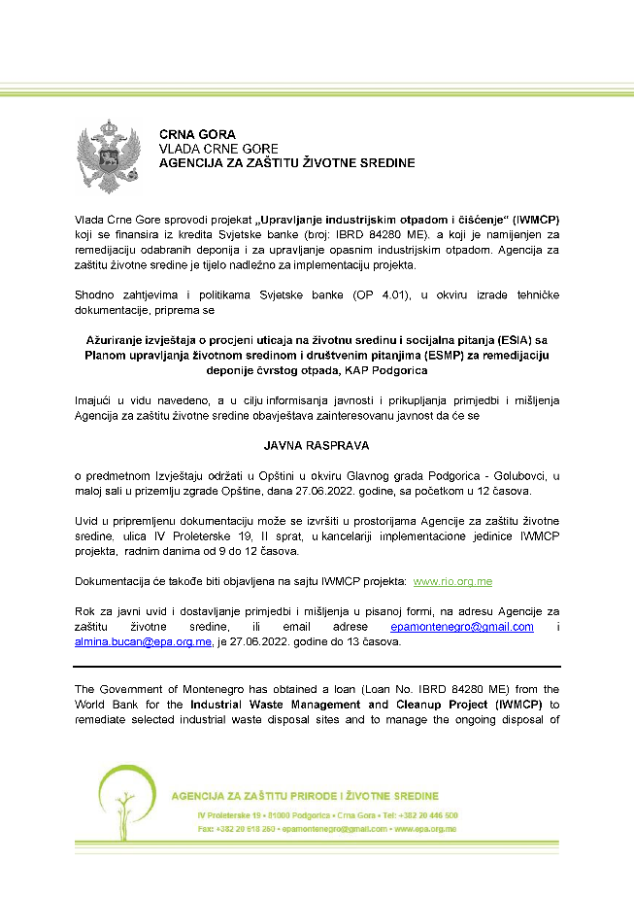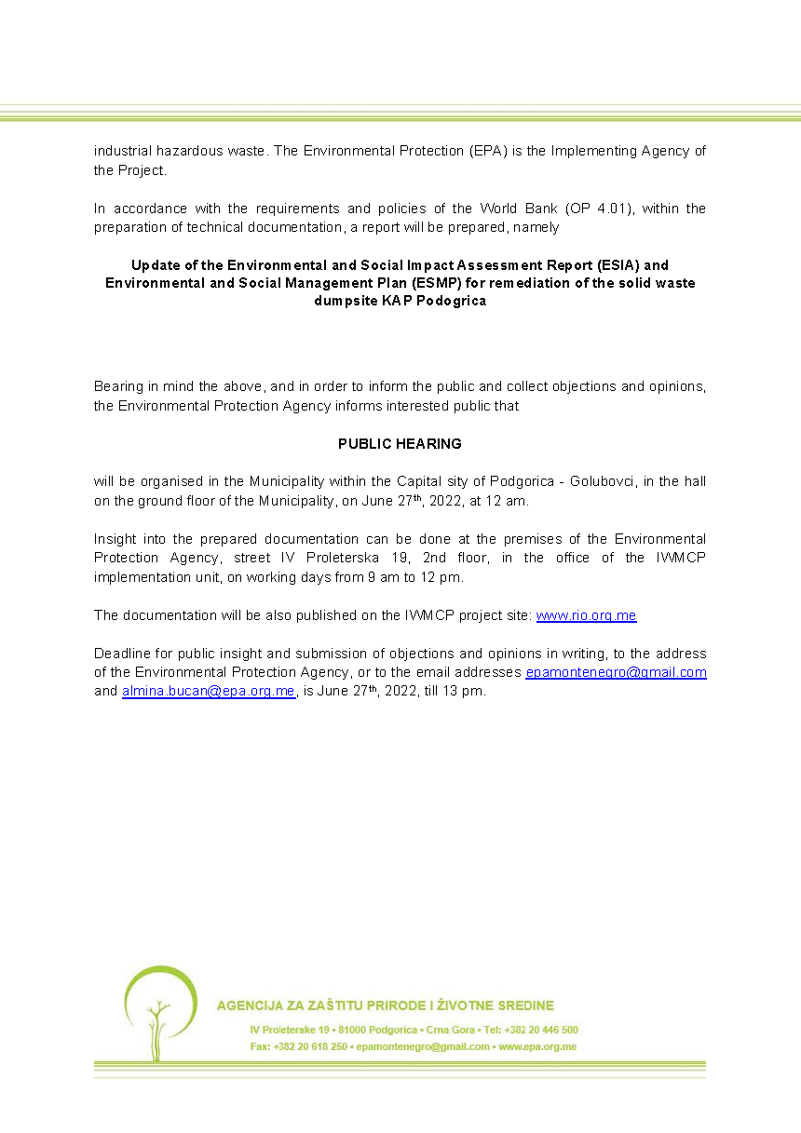

Figure 25 Announcement Letter

Public discussion and presentation of Project’s draft ESIA/ESMP was held on the ground floor of the Golubovci Municipality on June 27, 2022, starting at 12:00 PM. The main issues consulted, and measures and actions taken as a result of this meeting were integrated into the ESIA study.

This public discussion was attended by four people from the public. Some photographs from the meeting is given in Figure 26.

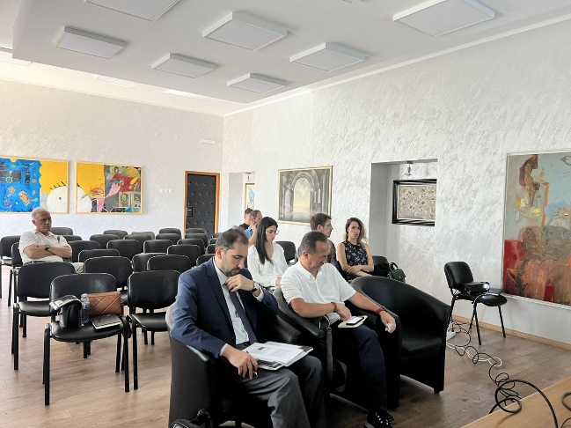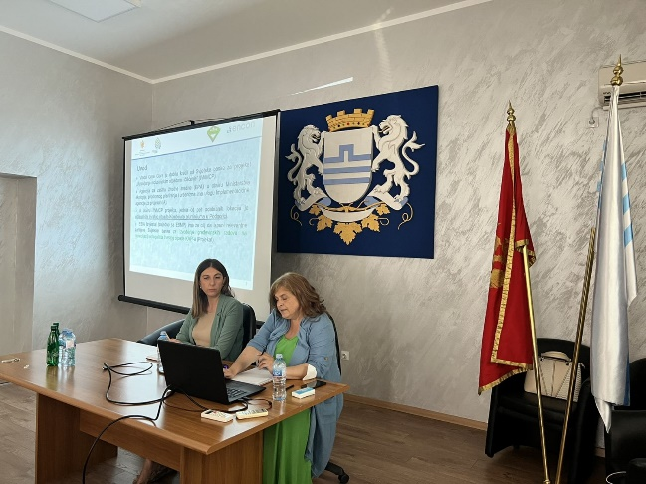

Figure 26 Photographs from the meeting

REFERENCES

- Adaption to Climate Change: Montenegro 20 September 2020
- Checklist of CITES Species (https://checklist.cites.org)
- Dragojevic S. 2020. “Montenegro Third National Communication on Climate Change.”
- Environmental Impact Assessment Study on Regional Water Supply System of Montenegrin Coast from Water Source Bolje Sestre. March 2007
- Implementing the EU Water Framework Directive in South-Eastern Europe. Shorezone Functionality. Skadar/Shkodra Lake.
- Interpretative Report on Detailed Geotechnical Investigation for Preliminary and Final Design of Remediation of Kombinat Aluminijuma Podgorica – KAP Solid Waste Disposal Site, Ground Engineering, February 12, 2021.
- IUCN 2022. The IUCN Red List of Threatened Species. Version 2021-3 (https://www.iucnredlist.org)
- Ministry for Spatial Planning and Environment. 2010. The Initial National Communication on Climate Change of Montenegro to the United Nations Framework Convention on Climate Change (UNFCCC).
- Ministry of Economic Development (Contract No. 01/367/2/02, 9th December 2007). “Spatial Plan of Montenegro Until 2020”
- Ministry of Sustainable Development and Tourism, Environmental Protection Agency. January 2013. Environmental and Social Impact Assessment of Remediation of Five Contaminated Sites.
- Montenegro Energy Efficiency Project – MEEP 2. 2018. Environmental and Social Management Framework (ESMF).
- Mrdak, Danilo. "Environmental risk assessment of the Morača dams: fish fauna of Morača river canyon and Skadar Lake." Report committed by WWF MedPO and Green Home under the framework of Sharing Water Project–Skadar Lake component. Podgorica (2009)
- Stešević, Danijela, Danka Caković, and Slobodan Jovanović. "The urban flora of Podgorica (Montenegro, SE Europe): annotated checklist, distribution atlas, habitats and life-forms, taxonomic, phytogeographical and ecological analysis." Ecologica Montenegrina 1.4 (2014): 1-171
- Sundic D., Radujkovic B., 2012, Pollution of Skadar Lake
- United Nations Economic Commission for Europe. Third Review. Montenegro Environmental Performance

ANNEXES

ANNEX-1 Policy, Legal and Legislative Framework

Annex 1.1 Legal Framework for Environmental Protection and Conservation

In Montenegro, the Constitutional Law particularly defines environmental protection. Article 1 of the Constitution, among other things, defines Montenegro as an ecological state. Article 23 of the Constitution of Montenegro defines that “everyone shall have the right to a sound environment and shall have the right to receive timely and full information about the status of the environment, to influence the decision-making regarding the issues of importance for the environment, and to legal protection of these rights”.

The framework of the environmental legislation of Montenegro is laid down in the Law on Environment ("Official Gazette of Montenegro”, No. 52/16, 73/19, and 84/24). The Law regulates principles of environmental protection and sustainable development, instruments and measures for environmental protection and other issues of importance for the environment. Article 9 defines that, when performing their activities, national and foreign legal and natural persons shall ensure rational use of natural resources, incorporation of environmental protection costs within investment and production costs, and implementation of regulations, i.e., undertaking of environmental protection measures in accordance with this Law and other regulations.

Ministry of Ecology, Sustainable Development and Northern Region Development has the key role in formulation and implementation of the environmental policy in Montenegro. The Ministry performs administrative supervision over a number of institutions that are involved in environmental monitoring and nature protection.

The Environmental Protection Agency of Montenegro (EPA), established in 2008 and operational since 2009, is an administrative authority within the MESPU and ensures implementation of the environmental legislation. Its mandate includes implementation of strategies, programs, laws and regulations in the field of environment, implementation of international treaties within its jurisdiction, environmental permitting, EIA, SEA, IPPC licensing, environmental monitoring, keeping relevant registers and databases, and reporting and coordination of reporting on the state of the environment. The EPA is also responsible for provision of information to national and international organizations and to the public. Also, as the competent authority for designation of natural objects as protected areas, EPA is responsible for preparation and implementation of biodiversity monitoring, preparation and maintenance of an environmental database (including biodiversity data) and issuance of all types of permits relating to nature protection.

The Ministry of Agriculture, Forestry and Water Management (MAFWM) has major environmental competencies through its mandate in water management, forestry, agriculture, rural development, fishery, and hunting.

Major steps have been taken in Montenegro during the last decade towards alignment with the EU environmental legislation, and also toward integration of environmental considerations in other policies. With regards to policy documents, the Montenegro prepared the main strategic documents for different areas: waters, climate change, waste, etc. The strategic documents relevant for the Project are as follows:

- National Strategy on Sustainable Development (adopted in 2016)
- Municipal Wastewater Management Plan of Montenegro (2020-2035)
- National Waste Management Plan (prepared and adopted in 2025)
- National Strategy on Climate Change (adopted in 2015)

Annex 1.2 Legal Framework for Health and Safety

As the key authority, the Ministry of Economic Development, among other things, performs the activities related to monitoring, studying and encouraging the development of Occupational Health and Safety (OHS), preparing regulations in the field of OHS, monitoring and implementing ratified conventions and EU directives in the field of OHS, preparing professional basis for development of a national program for development of occupational safety and monitoring its implementation. Supervision of implementation of the Law on Safety and Health at Work (“Official Gazette of Montenegro”, No. . 34/14, 44/18, and 084/24) and other applicable regulations is conducted by the Labour inspection, through the Labour inspectors for occupational safety and health at work, if the law does not establish that the supervision of such regulations in specific activities is performed by other authorities.

The provisions of OHS Law shall apply to all persons employed in the territory of Montenegro with legal entities and entrepreneurs in all sectors of activity, government bodies, state administration and local self-government units. Protective measures shall not bear any cost to the employee.

Article 14 of the Law on Safety and Health at Work defines the rights, obligations and responsibilities of employer. The Article states that “The employer shall take protective measures by preventing, controlling and eliminating risks at work, informing and training employees, as well as by providing the necessary organization and means.”

Annex 1.3 Legal Framework for Expropriation and Resettlement

The Constitution of Montenegro lays down the legal basis for expropriation of land and protects property rights, only exceptionally allowing the possibility of limiting these property rights in case when it is imposed by public interest and established by the law or based on the law. According to the Law on property-legal relations, no person may be deprived of his/her property or of the rights deriving from it, except in cases concerning the public interest determined by law. In case of deprivation (complete expropriation) or restriction (partial expropriation), rightful compensation for the property not lower than its market value at the time of expropriation is guaranteed. The beneficiary of expropriation may submit the expropriation proposal only after the determination of the public interest in expropriation.

The Law on Expropriation (’’Official Gazette of the Republic of Montenegro“, No. 55/2000, 12/2002 – Decision US RCG, 28/2006, and "Official Gazette of Montenegro", No. 21/2008, 30/2017, 75/2018, 33/2024, and 53/2025) guides the land/property management and serves as a general framework for the land/property expropriation on the territory of Montenegro. The Law provides the right to appeal at many stages of the expropriation procedure, such as administrative and judicial appeals (i.e. against the decision on public interest, the decision on expropriation, and regarding compensation), among other rights of affected citizens (those with formal legal rights).

Annex 1.4 Montenegrin/European Environmental Legislative and Permitting Framework

Annex 1.4.1 EU Directives

The following EU directives in the field of environmental legislation are fully or partially transposed into the legal system of Montenegro:

- Directive 2001/42/EC (SEA) on the assessment of the effects of certain plans and programmes on the environment
- Directive 2011/92/EU (EIA), as amended by Directive 2014/52/EU, on the assessment of the effects of certain public and private projects on the environment (EIA)
- Directive 2003/4/EC on public access to environmental information
- Directive 2003/35/EC providing for public participation in respect of the drawing up of certain environmental plans and programmes and access to justice
- Directive 2004/35/EC on environmental liability with regard to the prevention and remedying of environmental damage, as amended by Directive 2006/21/EC, Directive 2009/31/EC and Directive 2013/30/EU
- Directive 2008/99/EC on the protection of the environment through criminal law
- Directive 2008/98/EC on waste (Waste Framework Directive), as amended by Directive 2018/851/EU
- Landfill Directive 1999/31/EC on the landfill of waste
- Directive 2010/75/EU on industrial emissions (IED), which repealed Directive 2000/76/EC on waste incineration and incorporates IPPC requirementsDirective 94/62/EC on packaging and packaging waste, as amended by Directive 2004/12/EC, Directive 2005/20/EC, Directive (EU) 2018/852
- Directive 86/278/EEC on the protection of the environment, and in particular of the soil, when sewage sludge is used in agriculture

Annex 1.4.2 Horizontal Legislation

The Law on the Strategic Environmental Impact Assessment (SEA) (“Official Gazette of the Republic of Montenegro”, No. 80/05 and “Official Gazette of Montenegro”, No. 40/11, 59/11, 52/16, and 084/24) establishes the obligation to develop the SEA for plans and programs and other strategic documents that serves as basis for effective environmental protection and the implementation of sustainable development principles during their elaboration and in the decision-making process on final solutions.

The Law on the Environmental Impact Assessment (EIA) (“Official Gazette of Montenegro“, No. 75/18, and 84/24) is fully harmonized with the EU directives regulating this area. The Law regulates the EIA procedure for projects that can have a significant impact on the environment, the content of the study, the participation of interested authorities and organizations and the public, the assessment and approval process, notification of projects that can have a significant impact on the environment of another state, supervision and other issues. The EIA is intended for the projects in the field of industry, mining, energy, transport, tourism, agriculture, forestry, water management and utilities, as well as for all projects planned in a protected natural asset and in a protected environment of a fixed cultural property. The Law contains separate chapters dedicated to reporting, keeping records and providing information for inspection, also for public consultation. All the national waste facilities in Montenegro will be subject to carrying out an EIA according to the regulation.

The Law on Liability for Environmental Damage (“Official Gazette of Montenegro”, No. 27/14) defines the responsibility of the legal entity and the entrepreneur (operator) that caused damage or imminent danger to the environment. Environmental damage compensation is based on the “polluter pays” principle, according to which the legal and physical person who caused damage in the environment or imminent danger from damage must compensate for the caused danger by implementing preventive measures and remediation measures at its own expense.

Annex 1.4.3 Nature Protection

The Law on Nature Protection (“Official Gazette of Montenegro”, No. 54/16, 18/19, and 084/24) provides comprehensive nature protection through identification of protected areas of nature using the European typology of habitats important for the protection and establishment of an efficient system for managing protected natural assets (in line with IUCN management categories). The prescribed measures of protection will ensure the conditions for reasonable use of natural resources on the principles of sustainability, and for the benefit of present and future generations. The key novelties of this Law are providing grounds for establishing the ecological network NATURA 2000 and the EPA is a body that, in cooperation with expert and scientific institutions, will form a database and prepare documentation for establishment of an ecological network area.

Annex 1.4.4 Air Quality

The Law on Air Protection (“Official Gazette of Montenegro”, No. 25/10, 40/11, 43/15, 073/19, and 84/24), regulates the way of monitoring air quality, protection measures, assessment and improvement of air quality, as well as air quality planning and management. Air, as a natural value of general interest, is part of the environment and has special protection in Montenegro. Protection of air from pollution by radioactive substances, genetically modified organisms, noise and natural disasters is regulated by specific regulations. The Law prescribes that, in zones where concentrations of pollutants exceed any established marginal or target value, considering the tolerance limits, the Ministry in charge of environmental issues, in cooperation with the EPA and local government authorities is obliged to pass the Air Quality Plan to reach the values as determined by the Decree on the Determination of Types of Pollutants, Limits and Other Air Quality Standards ("Official Gazette of Montenegro", No. 25/12). On the basis of the available data, the territory of Montenegro was divided in three air quality zones in 2011, whereas network for air quality monitoring was expanded to include nine automatic stations in order to meet minimum requirements set out in Directives 2008/50/EC and 2004/107/EC. All pollutants regulated in the legislation of Montenegro are monitored regularly. Air Quality data are available on-line in real time (https://epa.org.me/mjesecni-izvjestaji-o-kvalitetu-vazduha/) and annually reported to the EU through EIONET.

Annex 1.4.5 Cultural Heritage Protection

Ministry of Culture is in charge of the cultural and historical sites protection policy. The Law on Cultural Heritage Protection (Official Gazette of Montenegro, No. 49/10, 040/11, 044/17, and 018/19) provides the information of the protection of cultural heritage in detail. The law regulates types and categories of cultural heritage, the manner of establishing the protection, a regime and measures of protection, rights and obligations of the owners of cultural heritage and other issues of importance for the protection and preservation of cultural heritage.

Cultural value of the immovable, movable and non-material heritage is determined by a professional body formed by the Cultural Heritage Protection Administration (Art. 23 of the Law).

In accordance with the mentioned Law, when performing construction, agricultural or any other works, and activities on land or in water occur on findings of archeological significance, the contractor (the accidental inventor) is obliged to:

- terminate the works and to secure the site or part of the site with the findings against possible damage, destruction and unauthorized access of other persons;
- immediately report the location, ie findings to the Cultural Heritage Protection Administration, the nearest public institution for protection of cultural heritage, the administration authority responsible for police affairs or the administration body responsible for marine security affairs in case of findings in the sea;
- keep the detected objects at the place of destination in the condition in which they were found until the arrival of the authorized persons of the subjects referred to in item 2 of this paragraph;
- provide all relevant information regarding the location and location of the findings at the time of disclosure of the circumstances under which they were discovered.

Annex 1.4.6 Spatial Planning and Construction of Structures

Ministry of Spatial Planning, Urbanism and State Property is the line ministry for spatial planning and construction of structures. The Law on Construction of Structures (Official Gazette of Montenegro, No. 19/2025, and 92/2025) regulates the manner and conditions for construction of objects, carrying out construction activities ,and other issues of importance for the planning and construction of objects..

Annex 1.4.7 Waste Management

The Law on Waste Management (“Official Gazette of Montenegro”, No. 034/24 and 092/24) represents the legislative framework in the waste management sphere. The Law describes the waste management processes, including prevention or reduction of the amount of waste, reuse of waste collection, transport, processing and disposal facilities, monitoring of these procedures and subsequent maintenance of the landfill.

Basic principles of waste management that EU waste management is based on, even though integrated in the National Waste Management Strategy and National Waste Management Plan, are still not fully applied in the system in Montenegro, particularly when it comes to the hierarchy principle which ensures compliance with the order of priorities in waste management (prevention, preparation for re-use, recycling and other recovery operations (use of energy) and waste disposal). This also applies to the management of specific waste streams in Montenegro. Systems for separate collection of municipal waste are not still established at a satisfactory level, while exportation is the only option at present for certain types of specific waste streams (e.g. waste oils). The main waste management infrastructure developed includes regional landfills of non-hazardous waste (in Bar and Podgorica), several recycling centers and also medical waste treatment facilities in Podgorica and Berane.

Annex 1.4.8 Water Quality

Water quality is governed by an extensive legal framework, while the key legislation is the Law on Waters (“Official Gazette of Montenegro”, No. 27/07, 73/10, 32/11, 47/11, 48/15, 52/16, 55/16, 02/17, 80/17, 84/18, and 84/24). The Law regulates the legal status and integrated water, coastal land and water facilities management, conditions and methods of water activity and other significant issues of management and water resources (regulates status and the ways for managing all types of water, water resources, as well as other matters of relevance for water resources management).

Annex 1.4.9 Industrial Pollution

Control of industrial pollution is governed mainly by the Law on Integrated Pollution Prevention and Control – IPPC (“Official Gazette of Montenegro“, No. 80/05, 54/09, 42/15, 54/16). The Law regulates the conditions and procedure for issuing an integrated permit for installations and activities that may have negative effects on human health, environment or material goods.

Annex 1.4.10 Energy Efficiency

Ministry of Economy is responsible for creating and implementing energy efficiency policies. Law on Efficient Use of Energy (adopted in 2015) is the key piece of primary legislation that creates a legal basis for energy efficiency regulation in the country. The Law on Efficient Use of Energy:

- Develops regulations within the area of efficient energy use in the sectors which consume final energy;
- Sets out the obligation of adopting programmes and plans for improving energy efficiency at national and local levels, as well as at the level of energy entities and consumers;
- Describes the public authorities’ responsibilities for the introduction and implementation of energy efficiency policy, as well as all additional energy efficiency measures and entities responsible for their implementation.

Annex 1.5 Occupational Health and Safety

Health and safety at work is mainly governed by Law on Health and Safety at Work (Official Gazette of Montenegro, No 34/14, 44/18, and 084/24) and other legal rulebooks in order to provide working conditions that will not lead to work injuries, professional diseases and work related illnesses, and create preconditions for full physical and psychological protection of employees. Main legal documents related to occupational health and safety at work in Montenegro are following:

- Law on Health and Safety at Work (Official Gazette of Montenegro, No. 34/14, 44/18, and 084/24),
- Rulebook on the Use of Personal Protective Equipment and Equipment at Work (Official Gazette of Montenegro, No. 135/21),
- Rulebook on the Manner and Procedure for Performing Previous and Periodical Specialist Medical Examinations of Workers (Official Gazette of Montenegro, No. 25/80, 1/81),
- Rulebook on Health and Safety Measures at Works against Exposure to Noise (Official Gazette of Montenegro, No. 37/16),
- Rulebook on occupational safety measures in the working environment (Official Gazette of Montenegro, No. 104/20),
- Rulebook on Protection Measures during Using of Working Equipment (Official Gazette of Montenegro, No. 27/15),
- Rulebook on Equipment and Procedure for First Aid and Organization of Rescue Service in the Event of an Accident at Work (Official Gazette of FRY, No. 21/71 and 28/66),
- Rulebook on the Manner and Procedure of Training Employees for Safe Work (Official Gazette of Montenegro, No. 79/04),
- Equipment of Personal Protection at Work and Working Environment Conditions (Official Gazette of Montenegro, No. 135/21),
- Rulebook on the Content and Method of Issuing the Report on Injury at Work (Official Gazette of Montenegro, No. 18/93),
- Rulebook on the Manner and Procedure of Risk Assessment at the Workplace (Official Gazette of Montenegro, No. 79/04),
- Rulebook on Keeping Records in the Field of Safety at Work (Official Gazette of Montenegro, No. 67/05),
- Rulebook on Signs for the Health and Safety at Work (Official Gazette of Montenegro, No. 024/15).

Article 51 of the Montenegrin Law on Health and Safety states the following key terms:

- The employer is obliged, at least once a year, to make a report on Safety and health at work of employees, which is to be considered by the authorities that perform management tasks, together with business reports.
- The employer shall, at the request of the competent inspector, provide a report on the state of Safety and health at work of employees, as well as the measures conducted in this field with the employer.
- The employer shall immediately and not later than 24 hours from onset, report in writing to the Labour Inspectorate on every death, collective, serious and other injury at work resulting in employee’s absence from work for more than three days, and dangerous phenomena that could jeopardize the safety and health of employees. The employer is obliged to issue to injured employee and the medical facility where the medical examination of the employee was taken, a report of the injury of the employee at work, in deadline and on a form prescribed by the act of the state authority responsible for health.

Annex 1.6 National EIA Procedure

An Environmental Impact Assessment (EIA) for certain projects is required to be carried out in Montenegro in accordance with the Montenegrin Law on EIA and associated secondary legislation. This Law and the associated secondary legislation set out the requirements for undertaking environmental assessments of potential environmental impacts of public and private projects which are likely to have a significant impact on the environment before development consent / construction permit is granted in the form of an approval for project implementation. Hence, it is required that before development consent is granted for certain types of projects, an EIA has to be carried out. The EIA process is meant to anticipate potential environmental harm and to avoid or mitigate such harm while balancing environmental, social and economic objectives. The whole EIA process includes three specific procedures. They are the following:

- Screening as the stage of determining whether an EIA is required;
- Scoping as the stage of determining the scope or extent of the environmental impact assessment;
- Review as the stage of reviewing the EIA study to see if it has been undertaken to an acceptable standard and in accordance with the legal requirements.

According to Montenegrin Legislation, the EIA Procedure is shown schematically in Figure 2 below. This procedure is in full compliance with the EU EIA Directive (2011/92/EU) and the general implementation in the world. The EPA is the competent authority for the EIA process for projects where project development consent (e.g. construction permit) is issued by a state (national) authority. The local self-government unit responsible for environmental protection is ‚the competent authority for other projects for which approvals, permits and licenses are issued by local authorities.

The types of projects that require an EIA are determined by the “Decree on determining projects for which an environmental impact assessment shall be carried out” - EIA Decree, Law on Environment (“Official Gazette of Montenegro” No. 75/18, and 84/24). Under the EIA Decree, projects are classified in two groups (lists): projects listed in List 1 are all subject to compulsory EIA while for projects in List 2 the assessment contains an element of discretion, noting that an EIA procedure will, in any event, be required for projects with potentially significant environmental impacts. The public and other parties are to be consulted in all stages of the EIA procedure.

This Project is included in the List 1 of the EIA Decree within the point 11. (a) Installations for the treatment or removal of hazardous waste by incineration, chemical, mechanical or biological treatments as well as landfills for temporary and permanent storage of hazardous waste.

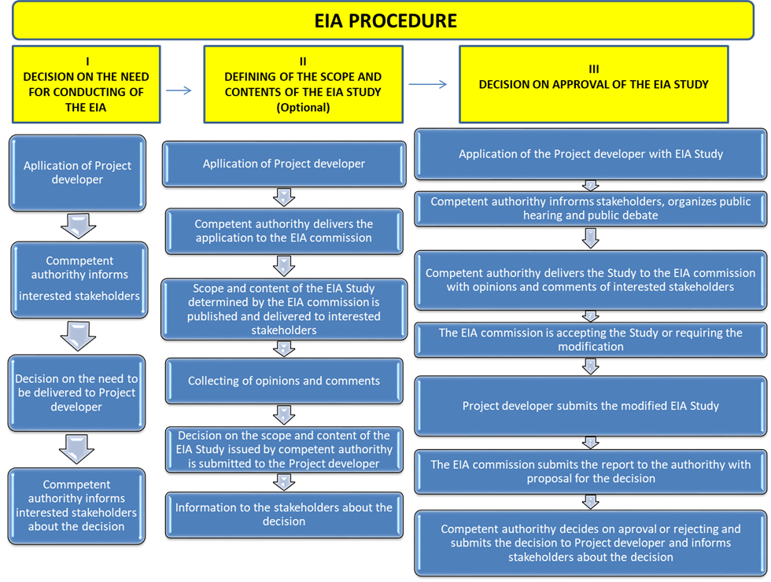

Figure 27 EIA Procedure in Montenegro

Annex 1.7 International Environmental and Social Regulatory Framework

Annex 1.7.1 International Treaties and Conventions

Montenegro has ratified a number of international treaties and conventions along with the ongoing process of transposing EU law into the National legal and policy framework. All treaties and conventions relevant to the Project will be considered during the elaboration of the ESIA, such as the Aarhus Convention.

The Convention on Public Participation, Access to Information and Access to Justice in Environmental Matters (Aarhus, 1998) - Aarhus convention is part of the national legal system. Its implementation started in 2009. Access to justice in respect of environmental matters is governed by several pieces of legislation, which fully transposed relevant provisions of the EU legislation governing public access to environmental information and public participation in making decisions on environmental matters, while these are also aligned with Aarhus Convention.

Montenegro ratified the United Nations Framework Convention on Climate Change (UNFCCC) by succession in 2006, thus becoming a member of the Convention as a Non-Annex Party on 27 January 2007. The Kyoto Protocol was ratified on 27 March 2007 (the Ratification Law was published in the Official Gazette of the Republic Montenegro 17/07), so that Montenegro became its member as an Non-Annex B country on 2 September 2007. Having ratified the UNFCCC and Kyoto Protocol, Montenegro joined the countries that share concerns and play an active role in international efforts to identify the solutions to the problems of climate change.

Montenegro has ratified all of ILO fundamental and governance conventions including Forced Labour Convention, 1930 (No. 29), Discrimination (Employment and Occupation) Convention, 1958 (No. 111), Worst Forms of Child Labour Convention, 1999 (No. 182) and Minimum Age Convention, 1973 (No. 138) which prohibits child labour. The Project shall ensure no child is employed in the project activities.

Annex 1.7.2 World Bank Environmental and Social Framework

Since the main finance source of the Project is WB; the Project must be in compliance with the good international practice, including WB ESSs, guides, performance standards and best practices documents alongside the national legislation.

After a thorough assessment of the risks and impacts associated with this project, it has been classified as of Substantial Risk. This classification takes into consideration various factors, including the project's complexity, environmental and social scale, impact size, and location sensitivity. While not as complex as High-Risk projects, this project still presents significant risks and impacts. These include temporary, predictable, and reversible risks that may require substantial investment and time to address. Additionally, there are concerns regarding adverse social impacts, potential conflicts, and risks to human security. The project's magnitude and spatial extent are medium, with potential for cumulative and/or transboundary impacts that are less severe than those of High-Risk projects. Moreover, there is a medium to low probability of serious adverse effects on human health and the environment, with mechanisms available to prevent or minimize such incidents.

. World Bank ESF on environmental and social protection measures are the backbone of its support to sustainable poverty reduction. The aim of these protective measures is to prevent and mitigate undue damage to people and their environment. These measures provide guidelines to the Bank and the loan beneficiary in the identification, preparation and implementation of programs and projects.

- ESS1: Assesment and Management of Environmental and Social Risk and and Impacts
- ESS2: Labour and Working Conditions
- ESS3: resource Efficiency and Pollution Prevention and Management
- ESS4: Community Health and Safety
- ESS5: Land Acquisition, Restrictions on Land Use and Involuntary Resettlement
- ESS6: Biodiversity Conservation and Sustainable Management of Living
- ESS7: Indigenous People/Sub-Saharan African Historically Underserved Traditional Local Communities (not applicable for this Project)
- ESS8: Cultural heritage
- ESS9: Financial Intermediaries
- ESS10: Stakeholder Engagement and Information Disclosure

The World Bank assigns an Environmental and Social Risk Classification (ESRC) of High/Substantial/Moderate/Low based on the nature and magnitude of potential risks and impacts, and the Borrower’s capacity to manage them.

The ESRC reflects the nature, scale, sensitivity, and complexity of the project’s potential environmental and social risks and impacts, as well as the Borrower’s institutional capacity to manage them. Based on these criteria, the World Bank assigns one of the following four risk levels:

High Risk:

Project with potentially significant adverse environmental or social risks and impacts that are:
- diverse, irreversible, unprecedented, or
- cumulative and/or complex,
- difficult to predict or mitigate,
- or when the Borrower has low implementation capacity.

These projects require a comprehensive ESIA, detailed ESMP, and additional ESF instruments (SEP, LMP, ESCP, etc.).

Substantial Risk:

Projects with potentially adverse environmental and social risks and impacts that are:
- mostly site-specific,
- largely predictable and mitigable using known measures,
- but may be significant due to scale, sensitivity, external factors, or institutional capacity limitations.

These projects also require ESIA/ESMP but with moderate complexity.

Moderate Risk

Projects with:
- limited, generally reversible environmental and social impacts,
- predictable effects that can be mitigated through standard measures,
- no significant cumulative or transboundary impacts.

Such projects may require a simplified ESIA or focused management plans.

Low Risk:

Projects with minimal or negligible environmental and social risks that:

- have predictable impacts,
- do not require complex mitigation,
- and pose no meaningful environmental or social sensitivity.

Typically require minimal ESF instruments.

Annex 1.7.3 Gaps between the World Bank ESSs and Montenegrin EIA Procedure

The Montenegrin requirements for the EIA procedure are quite like the requirements of the WB, but there are some differences which are presented in the Table 42 below.

Table 42 Gaps between ESSs and Montenegrin EIA Procedure

Subject | Montenegrin requirements | WB requirements
Screening | Categorization and screening is based on the EIA decree with the List 1 of installations and facilities requiring an EIA and List 2 of activities for which the Ministry or local authority determine whether an EIA is necessary. | The screening process results in the assignment of an Environmental and Social Risk Classification (High, Substantial, Moderate, or Low) and determines the scope of required Environmental and Social (E&S) instruments, such as an ESIA, ESMP, Stakeholder Engagement Plan, and other relevant plans. Screening under the ESF covers both environmental and social aspects, including labor and working conditions, community health and safety, biodiversity, land acquisition, cultural heritage, and stakeholder engagement, and applies a risk-based and proportionate approach.
Categorization and EA documentation content | Category 1. (significant impact) Installations and facilities to be assessed for their impact on the environment requiring full EIA (List 1). The study must also incorporate the comments and suggestions of governmental and non-governmental organizations as well as the results of the public consultations.  Category 2. (moderate impact)  Ministry (or local authority) screens the project and decides whether an EIA is required (List 2). The law defines facilities/installations which undergo screening and criteria for screening, such as size, cumulative impact, use of natural resources, sensitivity, etc.  Category 3. (Low impact or no impact)  All facilities and installations below the threshold levels regulated in the EIA decree.  The EIA procedure is not required. | High Risk  Projects with potentially significant adverse environmental and/or social risks and impacts that are diverse, irreversible, or unprecedented, or that involve complex or cumulative impacts, sensitive locations, or limited Borrower capacity. Such projects require a comprehensive ESIA, a detailed ESMP, and additional Environmental and Social (E&S) instruments as required under the ESF, including Stakeholder Engagement Plan (SEP), Labor Management Procedures (LMP), and an Environmental and Social Commitment Plan (ESCP).  Substantial Risk  Projects with potentially adverse environmental and social risks and impacts that are largely site-specific, predictable, and manageable through established mitigation measures, but which may be significant due to project scale, environmental or social sensitivity, waste transportation, or institutional capacity considerations. These projects require the preparation of an ESIA and ESMP, with a level of detail proportionate to the identified risks.  Moderate Risk  Projects with limited adverse environmental and social risks and impacts that are generally site-specific, reversible, and readily mitigated using standard measures. Environmental and social assessment requirements are more focused and may include a targeted ESIA, ESMP, or specific management plans, depending on the nature of the Project.  Low Risk  Projects with minimal or negligible environmental and social risks and impacts. These projects typically do not require a full ESIA and are subject to limited environmental and social due diligence under the ESF.
Public consultation and disclosure | Public consultations are the responsibility of the competent institutions.  Projects from list 1:  Public disclosure and public consultation will be held after EIA is submitted to the competent authority.  Projects from list 2:  Projects from list 2 are made publicly available after the documentation regarding the decision on EIA procedure is made available. Depending on the screening results (if decision is taken that an EIA is required), projects from the List 2 undergo public disclosure and public consultation, just like the projects from the List 1.  For Projects for which an EIA is required, EIA should be disclosed 15 calendar days prior to the public consultation. The public discussion shall be organized and chaired by the Competent Authority. | Under the World Bank ESF, meaningful stakeholder engagement and information disclosure are required throughout the project lifecycle in accordance with Environmental and Social Standard 10 (ESS10). Public consultation is not treated as a one-time event but as a continuous process that begins at the early stages of project preparation and continues through implementation and operation.  For projects requiring an ESIA, the World Bank requires that relevant environmental and social documentation, including draft ESIA reports, be disclosed in a timely, accessible, and culturally appropriate manner prior to public consultations. Disclosure must allow sufficient time for stakeholders to review the information and provide feedback before project decisions are finalized.  Public consultations must be conducted in an inclusive and transparent manner, enabling affected communities and other interested stakeholders to express their views, concerns, and recommendations. The Borrower is responsible for organizing and documenting stakeholder engagement activities, responding to comments received, and demonstrating how stakeholder input has been considered in project design and mitigation measures.  The outcomes of public consultations, including stakeholder comments and responses, are required to be documented and disclosed as part of the ESIA process. Ongoing information disclosure and stakeholder engagement will continue during project implementation, supported by a grievance mechanism established in line with ESS10.
EA review and approval | The Competent Authority shall decide on granting the approval or rejecting the application for approval of the EIA Study, based on the report and proposals of the EIA Commission. The Competent Authority is obliged to inform the organizations and public concerned about its decision. | Before formal clearance of environmental and social aspects of the project, the WB reviews the results of the EA (especially consultations, ESMP and institutional capacities), ensuring that the EA is consistent with the ToR.
Mitigation and monitoring | For projects requiring an EIA, mitigation measures and monitoring are described in the EIA study, which are also included in the Environmental Permit.  For other categories for which an Environmental Permit is issued, measures for protection of air, water, soil, flora and fauna, waste management etc., and monitoring, are included in the permit itself. | Mitigation measures are included in the ESMP. Obligation to carry out the ESMP and additional measures contained in the ESMP needs to be included in the tender documentation/contract.  Monitoring Plan is included in the ESMP.

Annex 1.7.4 Good International Industry Practice

Good International Industry Practice (GIIP) is defined as the exercise of professional skill, diligence, prudence and foresight that would be reasonably expected from skilled and experienced professionals engaged in the same type of undertaking under the same or similar circumstances globally.

The WB requires borrowers/clients to apply the relevant measures (at necessary levels) of GIIP. In this context, Environmental, Health, and Safety (EHS) Guidelines are technical reference documents with general and industry-specific examples of GIIP. These General EHS Guidelines are designed to be used together with the relevant Industry Sector EHS Guidelines, which provide guidance to users on EHS issues in specific industry sectors. The EHS Guidelines contain the performance levels and measures that are generally considered achievable in new facilities by existing technology at reasonable costs. Application of the EHS Guidelines to existing facilities may involve the establishment of site-specific targets, with an appropriate timetable for achieving them. For this Project, use of multiple industry-sector guidelines would be necessary. These are guidelines relevant to:

- Environmental
  - Air Emissions and Ambient Air Quality
  - Energy Conservation
  - Wastewater and Ambient Water Quality
  - Water Conservation
  - Hazardous Materials Management
  - Waste Management
  - Noise
  - Contaminated Land
- Occupational Health and Safety
  - General Facility Design and Operation
  - Communication and Training
  - Physical Hazards
  - Chemical Hazards
  - Biological Hazards
  - Radiological Hazards
  - Personal Protective Equipment (PPE)
  - Special Hazard Environments
  - Monitoring
- Community Health and Safety
  - Water Quality and Availability
  - Structural Safety of Project Infrastructure
  - Life and Fire Safety
  - Traffic Safety
  - Transport of Hazardous Materials
  - Disease Prevention
  - Emergency Preparedness and Response
- Construction and Decommissioning
  - Environment
  - Occupational Health & Safety
  - Community Health & Safety

ANNEX-2 The List of Flora Species in the Project’s Potential AoI

Table 1 The List of Flora Species in the Project’s Potential AoI

Familya | Species | English Name | Endemism | IUCN | Bern Convention | CITES | EU Habitat Directive
AMARYLLIDACEAE | Allium ampeloprasum L | Wild Leek | - | - | - | - | -
AMARYLLIDACEAE | Allium carinatum L. | Keeled Garlic | - |  | - | - | -
APIACEAE | Daucus carota L. | Wild Carrot | - | LC | - | - | -
APIACEAE | Tordylium apulum L. | Mediterranean Hartwort | - | - | - | - | -
ASTERACEAE | Artemisia absinthium L. | Common Wormwood | - | - | - | - | -
ASTERACEAE | Artemisia alba L. | - | - | LC | - | - | -
ASTERACEAE | Aster squamatus L. | - | - | - | - | - | -
ASTERACEAE | Carduus acanthoides L. | Spiny Plumeless Thistle | - | - | - | - | -
ASTERACEAE | Carduus candicans L. | - | - | - | - | - | -
ASTERACEAE | Centaurea solstitialis L. | Yellow Star-Thistle | - | - | - | - | -
ASTERACEAE | Cichorium inthybus L. | Chicory | - | - | - | - | -
ASTERACEAE | Conyza bonariensis L. | Erigeron Bonariensis | - | - | - | - | -
ASTERACEAE | Crepis sancta L. | - | - | - | - | - | -
ASTERACEAE | Helianthus tuberosus L. | Jerusalem-Artichoke | - | LC | - | - | -
ASTERACEAE | Inula britannica L | British Yellowhead | - | - | - | - | -
ASTERACEAE | Inula conyza L. | Ploughman's Spikenard | - | - | - | - | -
BORAGINACEAE | Echium italicum L. | Pale Bugloss | - | - | - | - | -
CANNABACEAE | Celtis australis L. | Southern Nettle Tree | - | LC | - | - | -
COLCHICACEAE | Colchicum hungaricum L. | - | - | - | - | - | -
CONVOLVULACEAE | Convolvulus arvensis L. | Field Bindweed | - | - | - | - | -
FABACEAE | Lathyrus cicera L. | Chickling Vetch | - | LC | - | - | -
FABACEAE | Lotus corniculatus L. | Bird's-Foot Trefoil | - | - | - | - | -
FABACEAE | Medicago grandiflora L. | - | - | - | - | - | -
FABACEAE | Medicago orbicularis L. | - | - | - | - | - | -
FABACEAE | Medicago rigidula L. | Tifton Bur Clover | - | LC | - | - | -
FABACEAE | Medicago sativa L. | Alfalfa | - | LC | - | - | -
FABACEAE | Robinia pseudoaccacia L. | Black Locust | - | - | - | - | -
FABACEAE | Trifolium angustifolium L. | Narrowleaf Crimson Clover | - | - | - | - | -
FABACEAE | Trifolium arvense L. | Hare's-Foot Clover | - | - | - | - | -
FABACEAE | Vicia bithynica L. | Bithynian Vetch | - | - | - | - | -
FABACEAE | Vicia faba L. | Broad Bean | - | - | - | - | -
GERANIACEAE | Erodium cicutarium L. | Common Stork's-Bill | - | - | - | - | -
LAMIACEAE | Teucrium capitatum L. | - | - | - | - | - | -
MALVACEAE | Malva silvestris L. | Cheeses | - |  | - | - | -
MORACEAE | Ficus carica L. | Fig | - | LC | - | - | -
PLANTAGINACEAE | Plantago bellardii L. | - | - | - | - | - | -
POACEAE | Aegilops cylindrica L. | Jointed Goat Grass | - | LC | - | - | -
POACEAE | Aegilops geniculata L. | Ovate Goat Grass | - | LC | - | - | -
POACEAE | Andropogon ischaemum L. | Yellow Bluestem | - | - | - | - | -
POACEAE | Avena barbata L. | Slender Wild Oat | - | - | - | - | -
POACEAE | Avena sativa L. | Oat | - | - | - | - | -
POACEAE | Cynodon dactylon L. | Scutch Grass | - | - | - | - | -
POACEAE | Dactylis glomerata L. | Couch Grass | - | - | - | - | -
POACEAE | Eleusine indica L. | Indian Goosegrass | - | LC | - | - | -
POACEAE | Eleusine tristachya L. | - | - | LC | - | - | -
POACEAE | Hordeum murinum L. | False Barley | - | LC | - | - | -
POACEAE | Paspalum dilatatum L. | Dallis Grass | - | - | - | - | -
POACEAE | Sporobolus poiretii L. | - | - | - | - | - | -
ROSACEAE | Rosa canina L. | Dog-Rose | - | - | - | - | -
ROSACEAE | Rosa sempervirens L. | Evergreen Rose | - | - | - | - | -
ROSACEAE | Rubus ulmifolius L. | Elmleaf Blackberry | - | - | - | - | -
ROSACEAE | Rubus ulmifolius L. | Blackberry | - | - | - | - | -
ROSACEAE | Sanguisorba minor L. | Salad Burnet | - | - | - | - | -
SALICACEAE | Populus alba L. | White Poplar | - | - | - | - | -
SALICACEAE | Salix alba L. | White Willow | - | - | - | - | -
SCROPHULARIACEAE | Verbascum blattaria L. | Mullein | - | - | - | - | -
SIMAROUBACEAE | Ailanthus altissima L. | Tree Of Heaven | - | - | - | - | -
URTICACEAE | Urtica dioica L. | Common Nettle | - | LC | - | - | -

ANNEX-3 The List of Amphibians and Reptiles Species in Potential AoI of the Project

Table 1 The List of Amphibians and Reptiles Species in Potential AoI of the Project

Family | Species | English Name | IUCN | CITES | BERN  Convention | EU Habitat Directive
BUFONIDAE | Bufo bufo | Common Toad | LC |  | App-III | -
SALAMANDRIDAE | Triturus carnifex | Italian Crested Newt | LC | - | App-II | App-IV
RANIDAE | Rana temporaria | European Common Frog | LC | - | App-III | App-V
TESTUDINIDAE | Testudo hermanni | Forest Turtle | NT | App-II | App-III | App-II
LACERTIDAE | Podarcis melisellensis | Dalmatian Wall Lizard | LC | - | App-II | App-IV
LACERTIDAE | Dalmatolacerta oxycephala | - | LC | - | App-III | -
NATRICIDAE | Natrix tessellate | Dice snake | LC | - | App-II | App-IV
COLUBRIDAE | Zamenis longissimus | Aesculapian Ratsnake | LC | - | App-III | -

ANNEX-4 The List of Bird Species in the Project’s Potential AoI

Table 1 The List of Bird Species in the Project’s Potential AoI

Family | Species | English Name | IUCN | CITES | BERN  Convention | EU Bird Directive
ACCIPITRIDAE | Gyps fulvus | Griffon Vulture | LC | App-II | App-II | Ann-I
ACCIPITRIDAE | Circus cyaneus | Hen Harrier | LC | App-II | App-II | Ann-I
ALAUDIDAE | Galerida cristata | Crested Lark | LC | App-III | - | -
ALAUDIDAE | Melanocorypha calandra | Calandra Lark | LC | App-III | App-II | Ann-I
ALAUDIDAE | Calandrella brachydactyla | Greater Short-toed Lark | LC | - | App-II | Ann-I
BURHINIDAE | Burhinus oedicnemus | Eurasian Thick-knee | LC | - | App-II | Ann-I
COLUMBIDAE | Streptopelia decaocto | Eurasian Collared-dove | LC | - | App-III | Ann-II
COLUMBIDAE | Columba palumbus | Common wood pigeon | LC | - | App-III | Ann-I-II-III
COLUMBIDAE | Columba oenas | stock dove | LC | - | App-III | Ann-II
CORVIDAE | Pyrrhocorax graculus | Yellow-billed Chough | LC | - | App-II | -
CORVIDAE | Corvus corax | Common raven | LC | - | App-III | -
CORVIDAE | Pica pica | common magpie | LC | - | - | Ann-II
EMBERIZIDAE | Emberiza melanocephala | Black-headed Bunting | LC | - | App-II | -
FALCONIDAE | Falco subbuteo | Eurasian Hobby | LC | App-II | App-II | -
FRINGILLIDAE | Fringilla coelebs | Common chaffinch | LC | - | App-III | Ann-I
LANIIDAE | Lanius collurio | Red-backed Shrike | LC | - | App-II | Ann-I
LANIIDAE | Lanius minor | Lesser Grey Shrike | LC | - | App-II | Ann-I
LANIIDAE | Lanius senator | Woodchat Shrike | LC | - | App-II | -
LARIDAE | Larus michahellis | Yellow-legged Gull | LC | - | - | -
LARIDAE | Larus ridibundus | Black-headed Gull | LC | - | - | Ann-II
MEROPIDAE | Merops apiaster | European Bee-eater | LC | - | App-II | -
MOTACILLIDAE | Anthus campestris | Tawny Pipit | LC | - | App | Ann-I
MUSCICAPIDAE | Oenanthe oenanthe | Northern wheatear | LC | - | App-III | -
PASSERIDAE | Passer montanus | Eurasian Tree Sparrow | LC | - | App-III | -
PASSERIDAE | Passer domesticus | house sparrow | LC | - | - | -
PHASIANIDAE | Perdix perdix | Grey Partridge | LC | - | - | Ann-II
STURNIDAE | Sturnus vulgaris | common starling | LC | - | - | Ann-II

ANNEX-5 The List of Mammal Species in the Project’s Potential AoI

Table 1 The List of Mammal Species in the Project’s Potential AoI

Family | Species | English Name | IUCN | CITES | BERN  Convention | EU Habitat Directive
CANIDAE | Vulpes vulpes | Red Fox | LC | - | - | -
CANIDAE | Canis aureus | Golden Jackal | LC | App-III | - | App-V
ERINACEIDAE | Erinaceus roumanicus | Northern White-breasted Hedgehog | LC | - | - | -
MURIDAE | Apodemus sylvaticus | Long-tailed Field Mouse | LC | - | - | -
MURIDAE | Rattus rattus | House Rat | LC | - | - | -
MUSTELIDAE | Lutra lutra | Eurasian Otter | NT | App-I | App-II | App-II, App-IV
MUSTELIDAE | Martes foina | Beech Marten | LC | - | App-III | -
MUSTELIDAE | Meles meles | Eurasian Badger | LC | - | App-III | -
RHINOLOPHIDAE | Rhinolophus hipposideros | Lesser Horseshoe Bat | LC | - | App-II | App-II
RHINOLOPHIDAE | Rhinolophus ferrumequinum | Greater Horseshoe Bat | LC | - | App-II | -
SCIURIDAE | Sciurus vulgaris | Eurasian Red Squirrel | LC | - | App-III | -
SORICIDAE | Crocidura suaveolens | Lesser Shrew | LC | - | App-III | -
SORICIDAE | Crocidura leucodon | Bicolored Shrew | LC | - | App-III | -
TALPIDAE | Talpa europaea | European Mole | LC | - | - | -
VESPERTILIONIDAE | Myotis nattereri | Natterer's Bat | LC | - | App-II | -

ANNEX-6 The List of Possible Freshwater Fish Species in Potential AoI of the Project

Table 1 Possible Freshwater Fish Species in Potential AoI of the Project

Family | Species | English Name | IUCN | CITES | BERN  Convention | EU Habitat Directive
ANGUILLIDAE | Anguilla anguilla | European Eel | CR | App-II | - | -
CYPRINIDAE | Cyprinus carpio | - | VU | - | - | -
CYPRINIDAE | Rutilus basak | - |  | - | - | -
CYPRINIDAE | Squalius cephalus | Chub | LC | - | - | -
CYPRINIDAE | Telestes souffia | - | LC | - | - | -
CYPRINIDAE | Phoxinus phoxinus | - | LC | - | - | -
CYPRINIDAE | Scardinius knezevici | Skadar Rudd | LC | - | - | -
CYPRINIDAE | Pseudorasbora parva | Topmouth gudgeon |  | - | - | -
GASTEROSTEIDAE | Gasterosteus aculeatus | Threespined Stickleback | LC | - | - | -
LEUCISCIDAE | Alburnus alburnus | Bleak | LC | - | - | -
LEUCISCIDAE | Oncorhynchus mykiss | Rainbow Trout | - | - | - | -
LEUCISCIDAE | Carassius auratus | Goldfish | LC | - | - | -
PERCIDAE | Perca fluviatilis | European perch | LC | - | - | -
PETROMYZONTIDAE | Petromyzon marinus | Sea Lamprey | LC | - | App-III | App-II
SALMONIDAE | Salmo trutta | Brown Trout | LC | - | - | -
SALMONIDAE | Salmo marmoratus | Marble trout | LC | - | - | App-II
SALMONIDAE | Salmo dentex | - | DD | - | - | -
SALMONIDAE | Salmo farioides | - |  | - | - | -
SALMONIDAE | Salmo montenegrinus | - | EN | - | - | -
SALMONIDAE | Thymallus thymallus | Grayling | LC | - | App-III | App-V

ANNEX-7 Sampling Procedures for KAP Disposal Site Environmental Monitoring

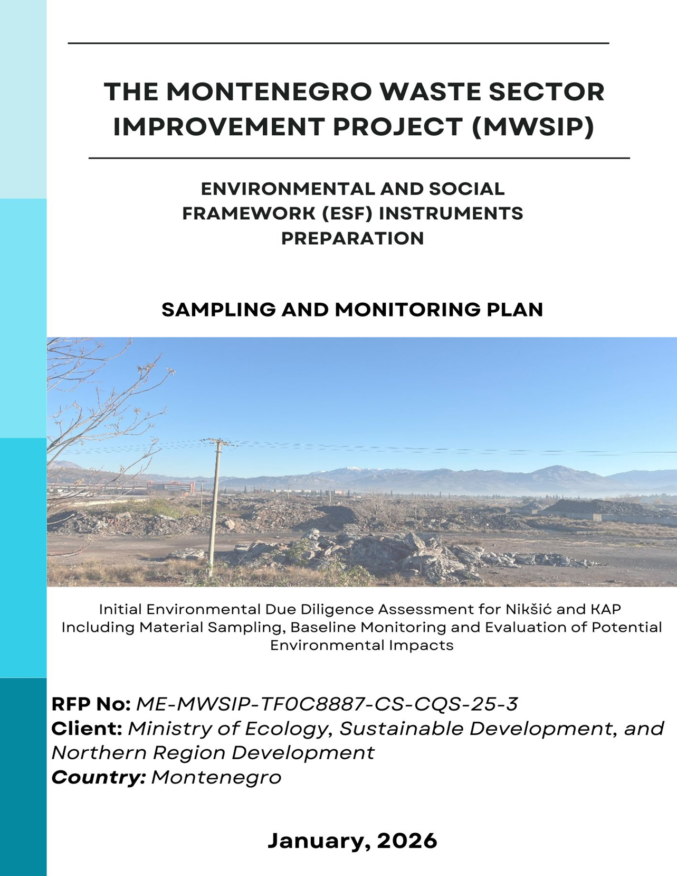

Table of Contents

1 Background and Context 0
2 Objective of the Assignment 1
3 Locations and Context of Analytical Activities 1
3.1 KAP (Podgorica) 1
3.1.1 Soil Quality 5
3.1.2 Groundwater 6
3.1.3 Surface Water 6
3.1.4 Air Quality and Noise 6
3.2 Nikšić (WMC) 6
4 Scope of Laboratory Investigations 7
4.1 KAP Location – Mandatory Laboratory Investigations 7
4.2 Nikšić Location – Laboratory Investigations in a Subsequent Phase 16
5 Methodology 17
6 QA/QC Requirements 17
7 Deliverables 18
7.1 Field Activities Report 18
7.2 Analytical Results 18
7.3 Supporting Technical Documentation 18
7.4 Final Technical Report 18
7.5 Deadlines and Submission 19
8 Organization of Work and Communication 19
9 Occupational Health and Safety (OHS) 19
10 Contractor Qualifications 20

List of Tables
Table 1 Recommended soil sample locations 5
Table 2 Recommended underground water locations 6
Table 3 Recommended Surface Water Locations 6
Table 4 Recommended Air Quality and Noise Locations 6
Table 5 Soil Analysis Parameters and Methods 8
Table 6 Surface Water Parameters and Methods 9
Table 7 Groundwater Parameters and Methods 11
Table 8 Sediment Analysis Parameters and Methods 14

List of Figures
Figure 1 Sampling Locations Map 4

Background and Context
The Montenegro Waste Sector Improvement Project (MWSIP) aims to strengthen Montenegro’s capacity in the field of waste management, improve sector performance, and support further alignment with European Union practices and standards. The Project is financed by the World Bank and implemented by the Ministry of Ecology, Sustainable Development and Northern Region Development (MESDNRD) through the Project Implementation Unit (PIU).
The Project consists of three components:
- Strengthening governance and institutional capacities in the waste sector through improvements to the regulatory framework, enforcement of regulations, data collection and transparency systems, public awareness raising, inter-institutional cooperation, and assessment of public-private partnership opportunities.

- Investment in waste management infrastructure, including the establishment of a regional Waste Management Centre (WMC) in Nikšić, serving the municipalities of Nikšić, Šavnik, Plužine and Žabljak, with the possibility of including additional municipalities.

- Addressing environmental risks through remediation of unmanaged and contaminated sites, including remediation of the former KAP aluminium complex site in Podgorica.
In order to provide relevant data for the planned infrastructure and remediation measures, it is necessary to carry out a baseline environmental assessment at the Nikšić and KAP locations. This assessment includes:
- environmental conditions at the sites,
- the level and spatial distribution of existing soil, groundwater and surface water contamination,
- linkages between the sites and sensitive receptors and ecosystems,
- environmental pressures and sources of pollution in the surrounding area,
- assessment of potential risks to the environment and human health.

Objective of the Assignment
The objective of this assignment is to carry out preparatory field activities and laboratory investigations at the KAP (Podgorica) and Nikšić locations covered by the MWSIP, in accordance with the Sampling and Monitoring Plan to be prepared by the E&S Consultant under a separate assignment.
These activities are required in order to:

- establish and document the baseline environmental conditions,
- verify and supplement existing contamination data,
- ensure comparability with previously conducted investigations,
- support the preparation and updating of E&S documentation (ESIA, ESMP, LMP, Generic ESMP, SEP, ESCP) for project components related to waste management, remediation and rehabilitation of illegal dumpsites.

Within the scope of this assignment, the following activities will be carried out:

- site visits to the KAP and Nikšić locations to verify site conditions and coordinate the sampling process,
- sampling and laboratory analysis of environmental media at the KAP site (soil, groundwater, surface water, sediments), in accordance with applicable regulations and previous studies,
- planning of activities for the Nikšić location, where laboratory investigations will be conducted in a subsequent phase, in line with the project schedule and the Sampling and Monitoring Plan.

Locations and Context of Analytical Activities
The environmental assessment covers two locations defined under the MWSIP. The scope and sequence of activities differ depending on site characteristics and the need for laboratory investigations during the preparatory phase.

KAP (Podgorica)
The former KAP complex site in Podgorica represents a priority location for laboratory investigations due to historical contamination by solid waste and contaminated soils in the landfill area and the wider surroundings (Botun, Srpska, Mahala). Previous studies have identified elevated concentrations of fluorides, PAHs, PCBs, phenols, metals (Ni, Cr, Cu, Cd, Zn, As, Hg), cyanides, mineral oils and other contaminants.
At this location, sampling and analysis of soil, groundwater, surface water and sediments (where present) will be conducted in accordance with applicable Montenegrin regulations and recommendations from previous studies, in order to ensure:
- confirmation and supplementation of existing knowledge on environmental quality,
- comparability with previous measurement campaigns (COWI, WYG, Royal Haskoning, etc.),
- a basis for updating the ESIA, ESMP and LMP for the KAP site.

The planned sampling locations for soil, groundwater, surface water, sediments, and air quality monitoring are summarized in the tables below and spatially presented in Figure 28. Sampling points have been selected to represent both historically affected areas (including the landfill and surrounding communities such as Botun, Srpska, and Mahala) and background/control locations, ensuring spatial coverage of potential contamination pathways. The proposed network aims to capture contaminant distribution patterns, support trend comparison with previous investigation campaigns, and provide a robust baseline dataset for risk assessment and future environmental and social management planning.

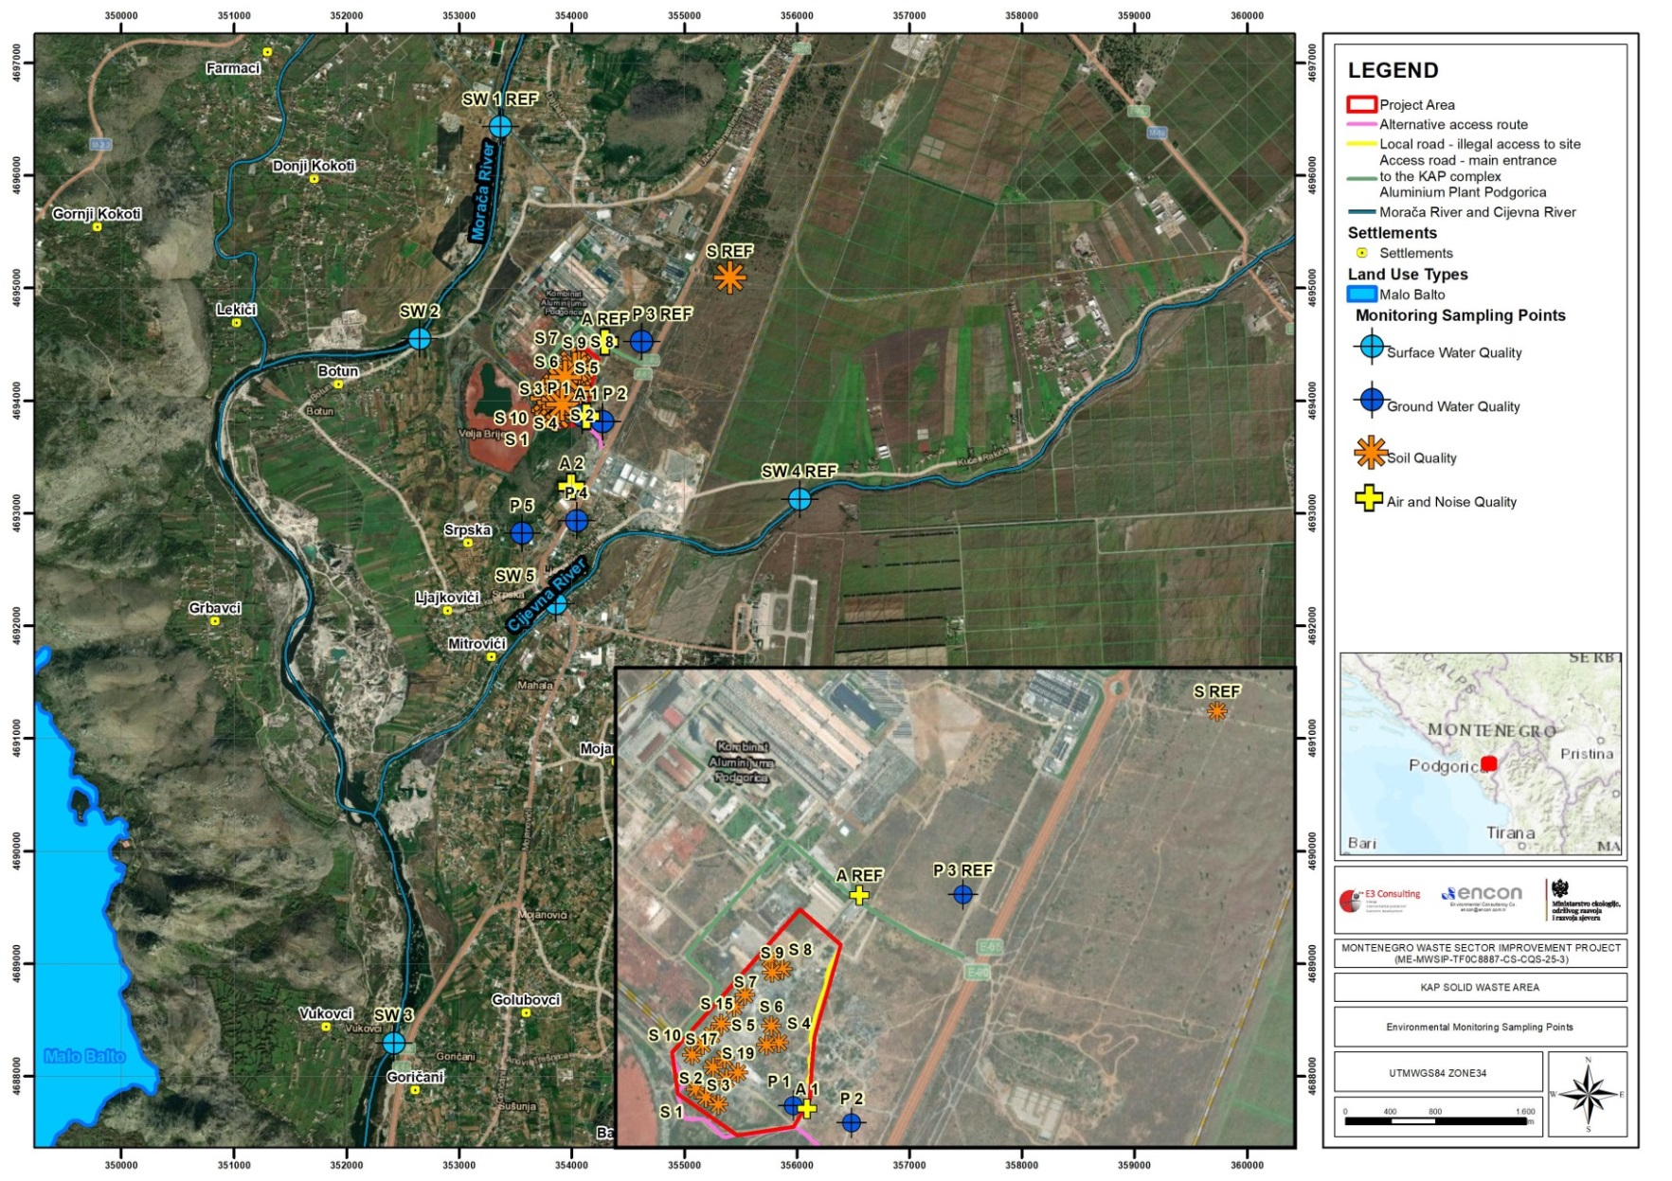
Figure 28 Sampling Locations Map

Soil Quality

For soil samples S1 to S9 (temporaray landfields) sampling is planned 2 times, before and after temporary solid waste disposal in order to provide data that there was no soil contamination at temporary locations. For samples S10 to S19 (S10-S15-Basin 1 and S16-S19 Basin 2) sampling is planned at every meter of depth from the 15th to the 20th meter, i.e. to the depth where there is no longer any contamination, given that the data show that there is still some contamination at the 15 meter depth of the soil layer.

Table 43 Recommended soil sample locations
Sample number | Latitude | Longitude
S 1 | 42°23'1.72"N | 19°13'25.91"E
S 2 | 42°23'0.89"N | 19°13'27.27"E
S 3 | 42°23'0.19"N | 19°13'28.98"E
S 4 | 42°23'6.56"N | 19°13'37.06"E
S 5 | 42°23'6.32"N | 19°13'35.36"E
S 6 | 42°23'8.22"N | 19°13'35.93"E
S 7 | 42°23'14.99"N | 19°13'35.54"E
S 8 | 42°23'14.00"N | 19°13'37.25"E
S 9 | 42°23'13.63"N | 19°13'35.95"E
S 10 | 42°23'5.17"N | 19°13'25.29"E
S 11 | 42°23'6.23"N | 19°13'26.67"E
S 12 | 42°23'7.19"N | 19°13'27.97"E
S 13 | 42°23'8.33"N | 19°13'29.15"E
S 14 | 42°23'10.09"N | 19°13'30.86"E
S 15 | 42°23'11.32"N | 19°13'32.33"E
S 16 | 42°23'3.94"N | 19°13'28.16"E
S 17 | 42°23'4.86"N | 19°13'29.71"E
S 18 | 42°23'2.78"N | 19°13'30.03"E
S 19 | 42°23'3.45"N | 19°13'31.54"E

Groundwater

Table 44 Recommended underground water locations
Sample number | Latitude | Longitude | Status
P 1 | 42°23'0.24"N | 19°13'39.21"E | Piezometer
P 2 | 42°22'58.60"N | 19°13'47.20"E | Piezometer
P 3 ref | 42°23'21.86"N | 19°14'1.67"E | Piezometer
P 4 | 42°22'29.94"N | 19°13'37.90"E | Private Wells
P 5 | 42°22'25.99"N | 19°13'16.75"E | Private Wells

Surface Water

Table 45 Recommended Surface Water Locations
Sample number | Latitude | Longitude | Location
SW 1 - REF | 42°24'22.88"N | 19°13'5.11"E | Morača
SW 2 | 42°23'21.35"N | 19°12'35.37"E | Morača
SW 3 | 42°19'58.41"N | 19°12'31.16"E | Morača
SW 4 - REF | 42°22'37.45"N | 19°15'4.34"E | Cijevna
SW 5 | 42°22'5.93"N | 19°13'30.45"E | Cijevna

After temporary removal of solid waste, before remediation, if there is drainage water, it is necessary to analyze two samples as waste water in Basins 1 and 2.

Air Quality and Noise

Table 46 Recommended Air Quality and Noise Locations
Sample number | Latitude | Longitude
A 1 | 42°22'59.97"N | 19°13'41.06"E
A REF | 42°23'21.59"N | 19°13'47.57"E
A 2 | 42°22'39.76"N | 19°13'35.68"E

Nikšić (WMC)
The Nikšić site represents the planned location of the regional Waste Management Centre (WMC), which is a key element in improving the municipal waste management system. Given the planned infrastructure development, a comprehensive baseline environmental assessment prior to construction is required (soil, water and sediments where present). However, laboratory investigations at this site will be carried out in a subsequent project phase, following the establishment of baseline data for the KAP site, in accordance with the Sampling and Monitoring Plan.

Scope of Laboratory Investigations
The scope of laboratory investigations under this assignment applies to the KAP location. Laboratory investigations for the Nikšić location will be conducted in a subsequent phase of the project.
All analyses shall be carried out in accordance with applicable Montenegrin regulations, ISO/IEC 17025 standards, and other relevant international technical standards. Detection limits shall be sufficient to identify concentrations of contaminants relevant to industrial sites and comparable with previous monitoring campaigns conducted at the KAP site.

KAP Location – Mandatory Laboratory Investigations
At the KAP site, sampling and analysis of soil, groundwater, surface water and sediments (where present) will be conducted. The analytical scope is defined based on:
• regulatory requirements,
• site characteristics and typical industrial contaminants present at KAP.

a) Soil
“9923 Soil Quality –Practices for Sampling from Surface Oil, Preserving and Transporting Soil Samples Standard” is used for soil sampling. Taking a representative sample is important due to the possibility of change in soil structure even between few meters distance within the same field. Necessary amount of sample is collected from 20-40 or 40-60 decare area by paying attention to similarities in various aspects of the field or land from which a representative sample is going to be taken. During collecting soil samples,
- Preferably plastic container or bag is used due to the possibility of contamination from metal containers to soil.
- Samples cannot be taken from places, such as excavation or field leveling is done, lime, commercial and farm fertilizer is applied formerly, roadsides, dense vegetation areas etc.
- Field is seperated into sampling areas by minimizing local differences and ensuring enough uniformity. The number of sample to be collected in each point, is determined and at least 2 and at most 8 samples are collected by walking in a zigzag mode in these sampling areas. A hole is opened with approximately 20 cm in V shape by using a scoop and a soil slice of 2 cm thickness is taken out from the smooth part of the holes by using a plow. Some part of soil is cut and thrown away from both sides of the scoop using a trowel and the remaining soil slice of nearly 6 cm width is put into a plastic bucket.
- The soil in the bucket is mixed after the last sample is transfered to the bucket. The plant residuals and stones in the representative sample mixed in the bucket are sorted and thrown away. At least 500 g of the remaining sample is transferred into a plastic sample container or bag. They are labeled with “Sampling Label” and transferred to the laboratory as soon as possible.

Table 47 Soil Analysis Parameters and Methods

# | Parameter | Method
1 | BTEX | EPA 5021 A, EPA 8260 D
2 | PAH | EPA 3540 C, EPA 3620 C, EPA 8270 E
3 | Total Organic Halogen | EPA 9020 B
4 | Total Petroleum Hydrocarbons  EC5 - EC8 EC8> - EC16 EC16> - EC35 EC5 - EC9 EC9> - EC16 | TNRCC Method 1005/TNRCC  Method 1006
5 | VOCs | EPA 5021 A, EPA 8260 D
6 | Mercury (Hg) | EPA 3051 A, EPA 6010 D
7 | Zinc (Zn) | EPA 3051 A, EPA 6010 D
8 | Copper (Cu) | EPA 3051 A, EPA 6010 D
9 | Nickel (Ni) | EPA 3051 A, EPA 6010 D
10 | Chromium (Cr), (Total) | EPA 3051 A, EPA 6010 D
11 | Lead (Pb) | EPA 3051 A, EPA 6010 D
12 | Selenium (Se) | EPA 3051 A, EPA 6010 D
13 | Arsenic (As) | EPA 3051 A, EPA 6010 D
14 | Antimony (Sb) | EPA 3051 A, EPA 6010 D
15 | Molybdenum(Mo) | EPA 3051 A, EPA 6010 D
16 | Titanium (Ti) | EPA 3051 A, EPA 6010 D
17 | Tin (Sn) | EPA 3051 A, EPA 6010 D
18 | Barium (Ba) | EPA 3051 A, EPA 6010 D
19 | Beryllium (Be) | EPA 3051 A, EPA 6010 D
20 | Cr³⁺ | EPA 3060 A, EPA 7196 A
21 | Cr⁶⁺ | EPA 3060 A, EPA 7196 A
22 | Vanadium (V) | EPA 3051 A, EPA 6010 D
23 | Cobalt (Co) | EPA 3051 A, EPA 6010 D
24 | Thallium (Tl) | EPA 3051 A, EPA 6010 D
25 | Silver (Ag) | EPA 3051 A, EPA 6010 D

In accordance with the Regulation on Permitted Quantities of Hazardous and Harmful Substances in Soil, soil will be analyzed for:
Heavy metals and elements:
As, Cd, Pb, Hg, Cr, Ni, Cu, Zn, B, Co, Mo, F
Organic substances:
- ΣPAH (16 EPA PAHs),
- PCB – 7 indicator congeners
Industry-specific contaminants:
- total cyanides,
- mineral oils,
- phenols,
- organotin compounds (monobutyltin, dibutyltin, tributyltin, tetrabutyltin, monooctyltin, dioctyltin, triphenyltin, tricyclohexyltin).

Additional parameters (e.g. fluorides as soluble anions in soil) may be included, subject to agreement with the Client and the E&S Consultant, to ensure a comprehensive assessment.
b) Groundwater and Surface Water
Surface Water
Sampling points for surface waters are determined considering the water quality in the sampling field and the regional changes of this quality. In streams, sampling region is between two points that disturbs continuity such as branch, wastewater discharge, drainage waters that turns from irrigation. The locations are determined in desktop study and the exact locations of these sites will be decided during the site surveys considering the upstream and downstream conditions of the project target area.
In streams, samples are collected 30-40 cm below the surface from the section where total mixture is ensured after the river branch or wastewater discharge. Sampling point should be determined before with a detailed section investigation where wastewater or river branch is mixed totally. Samples are collected by dividing into sections at different flow rates during section investigation. If there is no monitoring station for flow rate at the sampling point, it should be built. One single sampling is enough for other measurements at sampling points with homogeneous composition. If homogeneous water quality doesn’t exist (example; very large stream bed), samples should be collected from several points and at different depths through whole river section width.
In rivers, sampling points are determined in a way to account for the effects of shoreline activities and to characterize the changes in quality in whole water mass, with at least five sampling points in addition to main water inlet and outlet points.
Composition of pollution sources and hydrodynamic properties of water bodies are taken into account when sampling points are determined. Sample is collected from different points of sections that are obtained by division of water surface, in different seasons. Routine sampling points are determined according to the results of this investigation for future monitoring purposes.
The surface water samples will be collected in one season to observe the water quality at the upstream and downstream points.

Table 48 Surface Water Parameters and Methods

# | Parameter | Method
1 | pH | SM 4500 H+ B
2 | Conductivity | SM 2510 B
3 | Temperature | SM 2550 B
4 | Total Dissolved Solids | SM 2540 C
5 | Turbidity | SM 2130 B
6 | Dissolved Oxygen | SM 4500-O G
7 | Oxygen Saturation | SM 4500-O G
8 | Redox Potential | SM 2580 B
9 | Salinity | SM 2520 B
10 | Chemical Oxygen Demand (COD) | SM 5220 B
11 | Biochemical Oxygen Demand BOİ5 | SM 5210 B
12 | Total Suspended Solids | SM 2540 D
13 | Calcium (Ca), (Total and Dissolved) | EPA 3015 A, EPA 200.7
14 | Magnesium (Mg), (Total and Dissolved) | EPA 3015 A, EPA 200.7
15 | Sodium (Na), (Total and Dissolved) | EPA 3015 A, EPA 200.7
16 | Potassium (K), (Total and Dissolved) | EPA 3015 A, EPA 200.7
17 | Chloride (Cl-) | SM 4110 B
18 | Sulfate (SO4) | SM 4110 B
19 | Bicarbonate | SM 2320 B
20 | Carbonates | SM 2320 B
21 | Nitrate | SM 4110 B
22 | Nitrite | SM 4110 B
23 | Ammonium | SM 4500-NH3 B,F
24 | Floride | SM 4110 B
25 | Phosphate | SM 4110 B
26 | Free Cyanide | SM 4500-CN E
27 | Bromide | SM 4110 B
28 | Cr⁶⁺ | SM 3500-Cr B
29 | Oil and grease | SM 5520 B
30 | Sulfur | SM 4500-S2- D
31 | Silver (Ag), (Total and Dissolved) | EPA 3015 A, EPA 6020 B
32 | Aluminum (Al), (Total and Dissolved) | EPA 3015 A, EPA 6020 B
33 | Arsenic (As), (Total and Dissolved) | EPA 3015 A, EPA 6020 B
34 | Barium (Ba), (Total and Dissolved) | EPA 3015 A, EPA 6020 B
35 | Beryllium (Be), (Total and Dissolved) | EPA 3015 A, EPA 6020 B
36 | Cadmium (Cd), (Total and Dissolved) | EPA 3015 A, EPA 6020 B
37 | Cobalt (Co), (Total and Dissolved) | EPA 3015 A, EPA 6020 B
38 | Chromium (Cr), (Total and Dissolved) | EPA 3015 A, EPA 6020 B
39 | Copper (Cu), (Total and Dissolved) | EPA 3015 A, EPA 6020 B
40 | Iron (Fe), (Total and Dissolved) | EPA 3015 A, EPA 6020 B
41 | Mercury (Hg), (Total and Dissolved) | EPA 3015 A, EPA 6020 B
42 | Manganese (Mn), (Total and Dissolved) | EPA 3015 A, EPA 6020 B
43 | Nickel (Ni), (Total and Dissolved) | EPA 3015 A, EPA 6020 B
44 | Lead (Pb), (Total and Dissolved) | EPA 3015 A, EPA 6020 B
45 | Antimony (Sb), (Total and Dissolved) | EPA 3015 A, EPA 6020 B
46 | Selenium (Se), (Total and Dissolved) | EPA 3015 A, EPA 6020 B
47 | Thallium (Tl), (Total and Dissolved) | EPA 3015 A, EPA 6020 B
48 | Vanadium (V), (Total and Dissolved) | EPA 3015 A, EPA 6020 B
49 | Zinc (Zn), (Total and Dissolved) | EPA 3015 A, EPA 6020 B
50 | Boron (B), (Total and Dissolved) | EN ISO 15587-1-2, EN ISO 17294 1-2
51 | Bismuth (Bi), (Total and Dissolved) | EN ISO 15587-1-2, EN ISO 17294 1-2
52 | Gallium (Ga), (Total and Dissolved) | EN ISO 15587-1-2, EN ISO 17294 1-2
53 | Lanthanum (La), (Total and Dissolved) | EN ISO 15587-1-2, EN ISO 17294 1-2
54 | Lithium (Li), (Total and Dissolved) | EN ISO 15587-1-2, EN ISO 17294 1-2
55 | Molybdenum(Mo), (Total and Dissolved) | EN ISO 15587-1-2, EN ISO 17294 1-2
56 | Phosphorus (P), (Total and Dissolved) | EN ISO 15587-1-2, EN ISO 17294 1-2
57 | Silicon (Si), (Total and Dissolved) | EN ISO 15587-1-2, EN ISO 17294 1-2
58 | Tin (Sn), (Total and Dissolved) | EN ISO 15587-1-2, EN ISO 17294 1-2
59 | Strontium (Sr), (Total and Dissolved) | EN ISO 15587-1-2, EN ISO 17294 1-2
60 | Tellurium (Te), (Total and Dissolved) | EN ISO 15587-1-2, EN ISO 17294 1-2
61 | Thorium (Th), (Total and Dissolved) | EN ISO 15587-1-2, EN ISO 17294 1-2
62 | Titanium (Ti), (Total and Dissolved) | EN ISO 15587-1-2, EN ISO 17294 1-2
63 | Total Nitrogen | Calculation
64 | VOCs | EPA 5030 C, EPA 8260 D
65 | PAHs | EPA 3510 C, EPA 8270 E
68 | Phthalates | EPA 3535 A
69 | PCBs (18,20,28,31,44,52,101,105,118,138,149,153,170,180,194) | EPA 3510C, EPA 3665A, EPA 8082A

Groundwater
The exact locations will be decided on site surveys and private wells used by the local villagers can be used for sampling and groundwater level measurements. The target should be at least two wells and in case possible more samples can be collected depending on the direction of the groundwater table, site observations, interviews with locals and availability of wells on site.
When collecting samples from groundwaters, sample should be collected from source openings if water sample is collected from source and it should be taken below the water level in open wells. After sampling, the bottles should be closed with cap and there should not be any air space left. If water sample is collected from a deep well by pump, it should be drained (purged) for at least 10-15 minutes or till the water quality parameters such as pH and EC values becomes stable during purging, for preventing side effects and obtaining representative sampling. Samples can be collected seasonally, monthly, weekly or daily intervals in order to observe quality changes that could form as a result of any pollution and to take necessary precautions.

Table 49 Groundwater Parameters and Methods

# | Parameter | Method
1 | pH | SM 4500 H+ B
2 | Conductivity | SM 2510 B
3 | Temperature | SM 2550 B
4 | Total Dissolved Solids | SM 2540 C
5 | Turbidity | SM 2130 B
6 | Color | TS EN ISO 7887 B
7 | Odour | TS 266
8 | Dissolved Oxygen | SM 4500-O G
9 | Redox Potential | SM 2580 B
10 | Salinity | SM 2520 B
11 | Calcium (Ca), (Total and Dissolved) | EPA 3015 A, EPA 200.7
12 | Magnesium (Mg), (Total and Dissolved) | EPA 3015 A, EPA 200.7
13 | Sodium (Na), (Total and Dissolved) | EPA 3015 A, EPA 200.7
14 | Potassium (K), (Total and Dissolved) | EPA 3015 A, EPA 200.7
15 | Chloride (Cl⁻) | SM 4110 B
16 | Sulfate (SO₄) | SM 4110 B
17 | Bicarbonate | SM 2320 B
18 | Carbonate | SM 2320 B
19 | Nitrate | SM 4110 B
20 | Nitrite | SM 4110 B
21 | Ammonium | SM 4500-NH3 B,F
22 | Floride | SM 4110 B
23 | Phosphate | SM 4110 B
24 | Cr⁶⁺ | SM 3500-Cr B
25 | Silver (Ag), (Total and Dissolved) | EPA 3015 A, EPA 6020 B
26 | Aluminum (Al), (Total and Dissolved) | EPA 3015 A, EPA 6020 B
27 | Arsenic (As), (Total and Dissolved) | EPA 3015 A, EPA 6020 B
28 | Barium (Ba), (Total and Dissolved) | EPA 3015 A, EPA 6020 B
29 | Beryllium (Be), (Total and Dissolved) | EPA 3015 A, EPA 6020 B
30 | Cadmium (Cd), (Total and Dissolved) | EPA 3015 A, EPA 6020 B
31 | Cobalt (Co), (Total and Dissolved) | EPA 3015 A, EPA 6020 B
32 | Chromium (Cr), (Total and Dissolved) | EPA 3015 A, EPA 6020 B
33 | Copper (Cu), (Total and Dissolved) | EPA 3015 A, EPA 6020 B
34 | Iron (Fe), (Total and Dissolved) | EPA 3015 A, EPA 6020 B
35 | Mercury (Hg), (Total and Dissolved) | EPA 3015 A, EPA 6020 B
36 | Manganese (Mn), (Total and Dissolved) | EPA 3015 A, EPA 6020 B
37 | Nickel (Ni), (Total and Dissolved) | EPA 3015 A, EPA 6020 B
38 | Lead (Pb), (Total and Dissolved) | EPA 3015 A, EPA 6020 B
39 | Antimony (Sb), (Total and Dissolved) | EPA 3015 A, EPA 6020 B
40 | Selenium (Se), (Total and Dissolved) | EPA 3015 A, EPA 6020 B
41 | Thallium (Tl), (Total and Dissolved) | EPA 3015 A, EPA 6020 B
42 | Vanadium (V), (Total and Dissolved) | EPA 3015 A, EPA 6020 B
43 | Zinc (Zn), (Total and Dissolved) | EPA 3015 A, EPA 6020 B
44 | Boron (B), (Total and Dissolved) | EN ISO 15587-1-2, EN ISO 17294 1-2
45 | Bismuth (Bi), (Total and Dissolved) | EN ISO 15587-1-2, EN ISO 17294 1-2
46 | Gallium (Ga), (Total and Dissolved) | EN ISO 15587-1-2, EN ISO 17294 1-2
47 | Lanthanum (La), (Total and Dissolved) | EN ISO 15587-1-2, EN ISO 17294 1-2
48 | Lithium (Li), (Total and Dissolved) | EN ISO 15587-1-2, EN ISO 17294 1-2
49 | Molybdenum(Mo), (Total and Dissolved) | EN ISO 15587-1-2, EN ISO 17294 1-2
50 | Phosphorus (P), (Total and Dissolved) | EN ISO 15587-1-2, EN ISO 17294 1-2
51 | Silicon (Si), (Total and Dissolved) | EN ISO 15587-1-2, EN ISO 17294 1-2
52 | Tin (Sn), (Total and Dissolved) | EN ISO 15587-1-2, EN ISO 17294 1-2
53 | Strontium (Sr), (Total and Dissolved) | EN ISO 15587-1-2, EN ISO 17294 1-2
54 | Tellurium (Te), (Total and Dissolved) | EN ISO 15587-1-2, EN ISO 17294 1-2
55 | Thorium (Th), (Total and Dissolved) | EN ISO 15587-1-2, EN ISO 17294 1-2
56 | Titanium (Ti), (Total and Dissolved) | EN ISO 15587-1-2, EN ISO 17294 1-2
57 | Chemical Oxygen Demand (COD) | SM 5220 B
58 | Biochemical Oxygen Demand BOİ5 | SM 5210 B
59 | TOC | 8195 EN 1484
60 | VOC | EPA 5030 C, EPA 8260 D
61 | PAH | EPA 3510 C, EPA 8270 E
62 | Pesticides | EPA 508 / 525.2
63 | TPH | EN ISO 9377-2
64 | Total coliform | EN ISO 9308-1
65 | E. coli | EN ISO 9308-1
66 | Fecal coliform | EN ISO 9308-2
67 | Total bacterial count | EN ISO 6222
68 | Total alpha activity | EN ISO 9696
69 | Total beta activity | EN ISO 9697
70 | Hardness | SM 2340 C
71 | H₂S | SM 4500-S2- D

Analyses shall be conducted in accordance with the Rulebook on the Method and Deadlines for Determining the Status of Groundwater (Official Gazette of Montenegro, No. 52/19 of 10 September 2019) and the Rulebook on the Method and Deadlines for Determining the Status of Surface Waters (Official Gazette of Montenegro, No. 25/19 of 30 April 2019), supplemented with parameters characteristic of industrial activities at the KAP site.

Physico-chemical parameters:
pH, temperature, conductivity, turbidity, colour, dissolved oxygen, suspended solids
Nutrients and organic load:
NH₄⁺, NO₃⁻, NO₂⁻, PO₄³⁻, BOD₅, COD, TOC
Metals and elements:
Fe, Mn, Cu, Zn, Co, Ni, total Cr, As, Cd, Pb, Hg, Ba, B

Industry-specific substances:
mineral oils, phenols, total cyanides, ΣPAH, surfactants
Additional parameters (e.g. fluorides, sulphates) may be included in accordance with the Sampling and Monitoring Plan and E&S documentation requirements.

c) Sediments (where present)

Sediments shall be analysed in zones of particle accumulation and potential binding of metals and organic contaminants (e.g. depressions, channels, water bodies near the landfill). Sediment sampling locations will be placed where surface water samples are collected. ISO 5667-12 Water Quality –Sampling-Part 12:Guidance on Sampling of Bottom Sediment is used during sampling operations from bottom sedimenof rivers, streams, lakes, bays and harbours.

Although having some advantages with glass vessels such as having visible inside surfaces and being sterilized more easily than plastic materials in microbiological samplings; polyethylene, polypropylene and polycarbonate vessels are also used together with glass vessels for sampling.

Selection of sampling areas for simple sampling stations is generally easy. For example; areas that have a bridge which is appropriate for observing sediment quality continously or areas where waste is discharged in upstream region or areas where branches of rivers flow into the main river before the station, are selected.

In selection of sampling area, the following criteria should be taken into consideration.

- Easy access to area (tide effects)
- Seasonal suitability (affected from shower rains)
- Condition of sea traffic (traffic density)

Following two factors limit the choice of sampling method:

- Need for sampling from layers undisturbed remarkably
- Need for sampling for general morphological or chemical examination from a distrubed area which is close to the surface of the bed.
- The conditions in sampling location are very important for correct sampling. These conditions should be known before sampling. Conditions regarding to climate, water, geology and sea transportation should be considered during the selection of device to be used.
- High flow rates in rivers should be considered during sampling. If it is possible, samples should be collected in low water level periods where sample device is sligthly affected. Other hydrographic conditions should also be examined before sampling.

Sediment samples are generally kept in glass vessels and transported at nearly 4ºC or below. When there is a need to keep samples for more than one month, this process should be done in a deep freezer by considering physico-chemical changes which could affect colloids while freezing.

Table 50 Sediment Analysis Parameters and Methods

# | Parametre | Metot
1 | BTEX | EPA 5021 A, EPA 8260 D
2 | PAH | EPA 3540 C, EPA 3620 C, EPA 8270 E
3 | Total Organic Halogen | EPA 9020 B
4 | Total Petroleum Hydrocarbons  EC5 - EC8 EC8> - EC16 EC16> - EC35 EC5 - EC9 EC9> - EC16 | TNRCC Method 1005/TNRCC  Method 1006
5 | VOCs | EPA 5021 A, EPA 8260 D
6 | Mercury (Hg) | EPA 3051 A, EPA 6010 D
7 | Zinc (Zn) | EPA 3051 A, EPA 6010 D
8 | Copper (Cu) | EPA 3051 A, EPA 6010 D
9 | Nickel (Ni) | EPA 3051 A, EPA 6010 D
10 | Chromium (Cr), (Total) | EPA 3051 A, EPA 6010 D
11 | Lead (Pb) | EPA 3051 A, EPA 6010 D
12 | Selenium (Se) | EPA 3051 A, EPA 6010 D
13 | Arsenic (As) | EPA 3051 A, EPA 6010 D
14 | Antimony (Sb) | EPA 3051 A, EPA 6010 D
15 | Molybdenum(Mo) | EPA 3051 A, EPA 6010 D
16 | Titanium (Ti) | EPA 3051 A, EPA 6010 D
17 | Tin (Sn) | EPA 3051 A, EPA 6010 D
18 | Barium (Ba) | EPA 3051 A, EPA 6010 D
19 | Beryllium (Be) | EPA 3051 A, EPA 6010 D
20 | Cr³⁺ | EPA 3060 A, EPA 7196 A
21 | Cr⁶⁺ | EPA 3060 A, EPA 7196 A
22 | Vanadium (V) | EPA 3051 A, EPA 6010 D
23 | Cobalt (Co) | EPA 3051 A, EPA 6010 D
24 | Thallium (Tl) | EPA 3051 A, EPA 6010 D
25 | Silver (Ag) | EPA 3051 A, EPA 6010 D

Heavy metals:
As, Cd, Pb, Hg, Cr, Ni, Cu, Zn, B, Co, Mo, F
Organic substances:
ΣPAH (16 EPA PAHs), PCB – 7 indicator congeners

Industry-specific contaminants (as required):
mineral oils, phenols, total cyanides

d) Air Quality

Air Quality measurements will be carrried out for KAP Disposal Site Environmental Monitoring activities in different locations. The locations are selected in a desktop study and nearest settlements were selected as target points. The exact locations will be determined during the monitoring site survey and the nearest residential buildings will be selected as air quality monitoring stations.

PM₁₀ Sampling

The Objective of PM₁₀ sampling and measurement is to measure particulate matter with aerodynamic diameter ≤10 µm in ambient air. A high or low-volume air sampler with PM₁₀ inlet is used to collect particles on pre-weighed filters; determine mass gravimetrically.

PM_{2.5} Sampling

The Objective of PM_{2.5} sampling is to measure particulate matter with aerodynamic diameter ≤2.5 µm in ambient air. A high or low-volume air sampler with PM_{2.5} inlet is used to collect particles on pre-weighed filters and weigh filters to calculate concentration (µg/m³).

Settled Dust (Deposition Dust)

By this method, particulate matter that settles from the atmosphere over time is measured and dust is collected on clean flat surfaces or deposition gauges for a defined period; weigh collected dust to determine deposition rate (mg/m²/day).

Passive Sampling

In order to measure the air pollutant (e.g., NO₂, SO₂, VOCs) diffusion without active pumping is used, passive samplers are deployed at breathing height for a defined period; extract and analyze chemicals in the lab; average concentration (µg/m³) is reported.

e) Noise
Environmental noise measurements will be carrried out for KAP Disposal Site Environmental Monitoring activities in three different locations. The locations are selected in a desktop study and nearest settlements were selected as target noise monitoring points. One location at the north and two locations at the south part of the disposal site are selected. The exact locations will be determined during th monitoring site survey and the nearest residential buildings will be selected as noise quality monitoring stations.

Environmental noise levels arising from traffic and construction activities are measured in accordance with EN ISO 1996-2 and the Regulation on the Assessment and Management of Environmental Noise.
Measurements are conducted using a Class 1 sound level meter, operated in A-weighted [dB(A)] and Slow time-weighting modes. The instrument is calibrated using an acoustic calibrator before and after each measurement.

The microphone is positioned at approximately 1.5 m above ground level, away from reflective surfaces and obstacles. Traffic noise measurement performed at roadside locations representing the nearest receivers, while construction noise measurements are carried out at the site boundary and at sensitive receptors such as residential areas, schools, or hospitals.

The measurement duration is determined based on the characteristics of the noise source and is typically at least 5–15 minutes. During measurements, the equivalent continuous sound level (Leq) and relevant statistical noise parameters are recorded. Measurements are not conducted under adverse meteorological conditions such as strong wind or precipitation.

Measured noise levels are evaluated by comparison with the applicable regulatory limit values and reported accordingly.

Nikšić Location – Laboratory Investigations in a Subsequent Phase
Laboratory investigations at the Nikšić site will not be conducted under this assignment. Activities will be implemented after completion of work at the KAP site, in line with the project schedule and the Sampling and Monitoring Plan.
The expected analytical scope for Nikšić will be aligned with the requirements for establishing baseline environmental conditions and will include:
a) Soil
As, Cd, Pb, Hg, Cr, Ni, Cu, Zn, B, Co, Mo, F, ΣPAH, PCB (7 congeners)

b) Groundwater and Surface Water
Parameters consistent with those planned for the KAP site (physico-chemical parameters, nutrients, metals, industry-specific substances)

c) Sediments (if present)
Metals, PAHs, PCBs; industry-specific contaminants (mineral oils, phenols, total cyanides), as required.

All laboratory results shall clearly indicate detection limits, measurement uncertainty and any deviations from standard procedures.

Methodology
All sampling and laboratory investigations shall be carried out by an accredited laboratory in accordance with:
- the laboratory’s accredited procedures (ISO/IEC 17025),
- applicable Montenegrin regulations,
- recognised international technical standards,
- the Sampling and Monitoring Plan prepared by the E&S Consultant.

The methodology must ensure that results are accurate, reliable, representative and comparable with previous studies.
The laboratory shall be responsible for:
- ensuring proper sample collection, handling, transport and analysis in accordance with accredited procedures,
- using validated methods that provide appropriate detection limits and analytical accuracy,
- ensuring proper calibration and maintenance of analytical equipment,
- maintaining complete chain-of-custody documentation from sampling to analysis and archiving,
- maintaining clear records of sampling locations, field conditions and applied laboratory procedures,
- submitting complete technical documentation in accordance with the requirements of this ToR.

Sampling locations at the KAP site shall be defined and confirmed in coordination with the Client and the E&S Consultant prior to commencement of field activities. Any changes to the Sampling and Monitoring Plan during implementation may only be made with prior approval of the Client and the E&S Consultant.

QA/QC Requirements
The laboratory shall ensure that all sampling, sample handling and laboratory analyses are conducted in accordance with internal quality procedures and applicable technical standards.
Laboratory obligations include:
- application of validated and technically appropriate analytical methods (standard methods, including EPA/ISO/EN where applicable),
- ensuring accuracy and reliability of results through internal quality control procedures,
- proper calibration and maintenance of equipment, including calibration records,
- maintaining complete documentation on sample origin, handling, transport, storage and analysis (chain of custody),
- documenting all activities in accordance with accredited procedures and Client requirements.

The Client may, if required, engage independent verification (inter-laboratory comparison or re-analysis of selected samples).

Deliverables
The Contractor shall submit the following deliverables upon completion of field activities and laboratory analyses:

Field Activities Report
The report shall include:

- description of activities carried out at the KAP site (soil, water and sediment sampling),
- overview of collected samples (matrix type, sample ID, depth/detail, sampling date, brief location description),
- information on the status of the Nikšić site (site visit conducted, preliminary sampling locations, planned matrices), with a note that laboratory investigations will be conducted at a later stage.

Analytical Results
The laboratory shall provide:
- laboratory results in electronic format,
- overview of applied analytical methods,
- result tables in a format suitable for use in technical and E&S documentation (sample ID, location, matrix, depth, date, parameter, unit, result, comments).

Supporting Technical Documentation
Supporting documentation shall include:

- chain-of-custody forms,
- confirmation of application of accredited procedures and methods (copy of valid accreditation scope),
- records of quality control procedures applied during laboratory analyses (e.g. QC sample summaries).

Final Technical Report
The final report shall include:
- a concise summary of field activities,
- consolidated laboratory results by matrix and location,
- a brief technical discussion and preliminary interpretation of results in relation to applicable regulations (MACs, limit values) and project expectations, highlighting parameters exceeding reference values.

Deadlines and Submission
Deadlines for submission of reports shall be defined in the contract, in line with the project schedule and E&S documentation requirements. All documentation shall be submitted in electronic format suitable for archiving and further use (Word, Excel, PDF, GIS formats).

Organization of Work and Communication
The Contractor shall carry out activities in coordination with the Client (MESDNRD/PIU) and the E&S Consultant, with mandatory information exchange throughout all phases of preparation and implementation.
The Client shall:
- provide access to the KAP and Nikšić sites,
- confirm sampling locations and fieldwork schedule (in accordance with the Sampling and Monitoring Plan),
- provide access to relevant information and documentation (previous studies, maps, permits) necessary for implementation.

The Contractor shall:
- coordinate field activities with the Client and the E&S Consultant,
- promptly inform the Client of any constraints or changes to the work plan,
- ensure that all activities are carried out professionally, safely and in accordance with applicable procedures,
- participate in coordination meetings as required.

Occupational Health and Safety (OHS)
The Contractor shall conduct all field activities in accordance with applicable occupational health and safety regulations, internal OHS procedures of the accredited laboratory, and international good practice.
Contractor obligations include:

- preparation and implementation of an OHS plan for field activities,
- identification of potential site risks (e.g. hazardous materials, unstable ground, work near water bodies, traffic),
- use of appropriate personal protective equipment (PPE) by all personnel involved in sampling,
- ensuring safe access to sampling areas,
- ensuring that all personnel are informed of and trained in OHS procedures,
- immediate notification of the Client of any circumstances affecting safe execution of the assignment, including incidents and near-miss events.

Contractor Qualifications
The Contractor shall meet the following minimum requirements:
- ISO/IEC 17025 accreditation for relevant soil, water and sediment analytical methods,
- at least 5 years of experience in sampling and analysis at industrial, remediation and environmentally sensitive sites (preferably experience with sites similar to KAP, industrial landfills and waste disposal sites),
- proven references from similar projects (preferably projects financed by international financial institutions such as the World Bank, EBRD, etc.),
- a qualified team including at minimum: a Project Manager, field technicians experienced in sampling, and laboratory analysts,
- capability to produce GIS data (sampling locations) and to maintain chain-of-custody documentation in accordance with the requirements of this ToR.

ANNEX-8 Social Survey Methodology

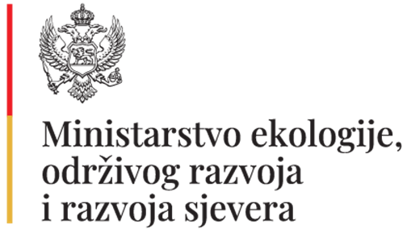

THE MONTENEGRO WASTE SECTOR IMPROVEMENT PROJECT (MWSIP)

KAP SOLID WASTE AREA

Social Survey Methodology and Questionnaire
KAP Montenegro – ESIA Update

Purpose and Scope

This document sets out the Social Survey Methodology, Questionnaire, Enumerator Guidance, and Data Coding Framework to be applied at the start of the Project for the update of the Environmental and Social Impact Assessment (ESIA) of the KAP site in Montenegro. The survey is designed in line with the World Bank Environmental and Social Framework (ESF), with particular reference to ESS1, ESS4 (Community Health and Safety), ESS5 (Land Acquisition, Restrictions on Land Use and Involuntary Resettlement), and ESS10 (Stakeholder Engagement and Information Disclosure).

Social Survey Methodology

The social survey will establish a baseline prior to any site isolation, access restriction, construction, or enforcement activities. It aims to identify Project-Affected Persons (PAPs), with particular attention to informal users and vulnerable groups, and to assess potential physical or economic displacement risks.

2.1 Target Groups

- Households residing in or adjacent to the Project area (including informal settlements)
- Individuals intermittently accessing the site for informal activities (e.g. waste picking, scrap-related activities)
- Vulnerable groups, including women-headed households, elderly persons, persons with disabilities, and socially marginalized groups

2.2 Survey Approach

A mixed-methods approach will be applied:

- Household census or structured household survey (where population size allows)
- Time-location sampling (TLS) and intercept interviews for informal site users
- Key Informant Interviews (KIIs) with local authorities, social services, NGOs, and community mediators
- Limited Focus Group Discussions (FGDs), where appropriate and safe

Ethical Principles and Safeguards

All data collection shall follow ethical principles including informed consent, confidentiality, voluntary participation, and a strict do-no-harm approach. Enumerators shall not promise benefits, compensation, or employment. Children shall not be interviewed.

Questionnaire Format

Module 0 – Informed Consent

Enumerators shall read the consent script verbatim and proceed only if consent is provided.

Module 1 – Respondent Profile

Age group, gender (optional), education level, literacy, household size, presence of disability or chronic illness.

Module 2 – Residence and Tenure (Households)

Residence status, length of stay, housing type, access to basic services, tenure status, and eviction concerns.

Module 3 – Livelihoods and Income

Main livelihood sources, income bands, income stability, and dependency ratio.

Module 4 – Use of Project Area and Access Patterns

Frequency and purpose of access to the Project area, duration of visits, estimated benefits, and participation of household members.

Module 5 – Vulnerability Indicators
Food insecurity, utility stress, health limitations, documentation barriers, discrimination risks, language barriers, and voluntary minority self-identification.

Module 6 – Perceived Project Impacts
Perceived impacts of access restriction, importance of affected income, and coping capacity.

Module 7 – Community Health and Safety

Observed accidents, perceived hazards, and suggestions for safety improvements.

Module 8 – Stakeholder Engagement and Grievance Mechanism

Awareness of grievance mechanisms, preferred communication channels, and barriers to access.

Enumerator Guidance Note

Enumerators must act neutrally, respectfully, and professionally. Sensitive topics shall be addressed using neutral language. No interviews with minors are permitted. Any severe vulnerability, child safeguarding issue, or security concern must be reported immediately to the supervisor.

Data Coding and Analysis Framework

Survey data shall be entered into a structured database with anonymized identifiers. Coding will allow identification of ESS5 relevance, vulnerability flags, and ESS4 risk patterns. Rule-based screening will be applied to distinguish intermittent unsafe activities from genuine livelihood dependency.

ESS5 Screening Rules (Summary)

- Potential Economic Displacement: Regular access to Project area and important or primary income dependency
- Potential Physical Displacement: Residence within Project footprint or credible eviction risk
- High Vulnerability: Presence of multiple vulnerability indicators

Questionnaire (Vulnerable-Group Sensitive)

Cover Page (Enumerator-Completed)
- Survey ID:
- Date/time:
- Location (GPS optional):
- Interview type: ☐ Household ☐ Individual (TLS/intercept)
- Interview setting: ☐ Home ☐ Public place ☐ Near access point
- Language used:
- Enumerator name:
- Notes on context/safety:

Module 0 — Informed Consent (Read Out)
- I am working with the Project team to understand local conditions before activities begin. Your participation is voluntary. You may skip questions or stop anytime. Your answers are confidential and will be reported in aggregate. This survey does not guarantee benefits or compensation. Do you agree to participate?
☐ Yes ☐ No (end interview)
- Consent to anonymized use of information in ESIA/ESMP reporting?
☐ Yes ☐ No
- Consent to be contacted for follow-up (optional)?
☐ Yes ☐ No
If yes, preferred contact method: _________

Module 1 — Respondent Profile
- Respondent age group: ☐ 18–24 ☐ 25–44 ☐ 45–64 ☐ 65+
- Gender (optional): ☐ Female ☐ Male ☐ Other ☐ Prefer not to say
- Education: ☐ None ☐ Primary ☐ Secondary ☐ Vocational ☐ Higher ☐ University
- Literacy (self-reported): ☐ Reads easily ☐ With difficulty ☐ Cannot read
- Household size (if HH): Adults ___ / Children ___
- Any household member with disability/serious illness? ☐ Yes ☐ No
If yes, brief type (optional): _________

Module 2 — Residence and Tenure
- Do you currently live in this settlement/area? ☐ Yes ☐ No
- Years living here: ___ years
- Housing type:
☐ Permanent a fixed, long-term residence (house or apartment)
☐ Semi-permanent a partly fixed dwelling, not intended for long-term use
☐ Temporary a place used only for a short period of time

- Access to services:
- Water: ☐ Piped ☐ Well/other ☐ None
- Electricity: ☐ Legal connection ☐ Informal connection ☐ None
- Sanitation: ☐ Sewer ☐ Septic ☐ None
- Tenure status (choose best description):
- ☐ Own (formal)
- ☐ Rent (formal)
- ☐ Informal occupant / no formal documents
- ☐ Other: _________
- Have you received any prior notices, or do you have concerns about potential eviction or loss of access?☐ Yes ☐ No ☐ Unsure
If yes, by whom and when: _________

Module 3 — Livelihoods and Income Sources
- Main livelihood sources of household/respondent select up to 3):
☐ Wage employment
☐ Self-employment/services
☐ Informal trade
☐ Waste picking / recycling collection
☐ Scrap/vehicle dismantling related work
☐ Agriculture/gardening
☐ Social assistance/pensions
☐ Other: _________
- Approx. monthly household income band (optional):
Social assistance <450EUR or an open question; and then 450-600; 601-800; 801-1000; 1001-1200; 1201-1500; 1500+; prefer not to say ☐ Prefer not to say
- Income stability: ☐ Stable ☐ Seasonal ☐ Irregular ☐ No income
- Dependency ratio: number of dependents relying on this income: ___

Module 4 — Use of Project Area / Access Patterns
- Since 2012, have you (or household members) accessed the landfill/scrap area or nearby Project area?
☐ Yes ☐ No → skip to Module 6
- Purpose of access (multi-select):
☐ Passing through
☐ Waste picking/recyclables
☐ Scrap-related activity
☐ Disposal of waste (own)
☐ Other: _________
- Frequency: ☐ Daily ☐ Weekly ☐ Monthly ☐ Less than monthly
- Seasonality: ☐ Year-round ☐ Only certain months: _________
- Average earnings/benefit per visit (if applicable): Prefer not to say
- Who usually participates? ☐ Adults ☐ Youth (15–17) ☐ Children (under 18)
(If children under 15: do not interview children; record and flag for safeguarding.)

Module 5 — Vulnerability and Risk Indicators (Sensitive, Non-stigmatizing)
- In the past 12 months, did you experience any of the following? (multi-select)
☐ Difficulty paying for food
☐ Difficulty paying rent/utilities
☐ Health-related work limitations
☐ Lack of identification documents
☐ Discrimination affecting access to work/services
☐ None of the above
☐ Prefer not to say
- Do you have access to social assistance programs? ☐ Yes ☐ No ☐ Unsure
If yes, which type (optional): _________
- Would you like to self-identify as part of a minority group?
☐ Yes (optional: _________)
☐ No
☐ Prefer not to say

Module 6 — Perceived Impacts of Project (Baseline Expectations)
Explain neutrally: “The Project may secure/isolate the area and restrict unauthorized access for safety and environmental reasons.”
- If access to the area is restricted, how would this affect you/your household?
☐ No impact
☐ Minor inconvenience
☐ Loss of occasional benefit
☐ Loss of important income source
☐ Loss of shelter/housing risk
☐ Other: _________

Why do you think you would experience these impacts?

- If it affects income, how significant is that income for your household?
☐ Not important
☐ Supplementary
☐ Important secondary income
☐ Primary income source
- Coping capacity: If this activity stops, what alternatives do you have? (select up to 2)
☐ Other job opportunities
☐ Social assistance
☐ Family support
☐ No alternatives
☐ Other: _________

Module 7 — Community Health & Safety
- Have you observed any safety incidents near the landfill/scrap area (injuries, fires, accidents)? ☐ Yes ☐ No
If yes, describe briefly: _________
- Key hazards perceived (multi-select):
☐ Sharp objects
☐ Hazardous/contaminated materials
☐ Heavy vehicles/machinery
☐ Unstable ground
☐ Violence/harassment
☐ Other: _________
- What measures would improve safety? (open-ended) _________
- What are the project impacts perceived (environmental, social, safety)?

- What are the project benefits perceived (environmental, social, safety)?

Module 8 — Stakeholder Engagement and Grievance Mechanism
- Do you know how to raise concerns/complaints about the Project? ☐ Yes ☐ No
- Preferred grievance channel:
☐ Phone ☐ In-person ☐ Community representative ☐ Email ☐ Other: _________
- Barriers to using a grievance mechanism:
☐ Literacy ☐ Language ☐ Fear of consequences ☐ Lack of trust ☐ Other: _________
- Do you have a community representative? If yes, should the project-related information be shared with you? If yes, provide contact.

Module 9 — Closing
- Any additional comments or concerns? _________
- Would you be willing to participate in a future discussion meeting? ☐ Yes ☐ No

Module 10 Enumerator's comments/observations

ANNEX-9 Chance Find Procedure

Given the historical poor management of the disposal site and the heterogeneous nature of the waste body, there is a credible risk of encountering unexpected materials, including cultural heritage artifacts, hazardous or unidentified waste streams, and potentially unexploded ordnance (UXO). Therefore, a robust Chance Finds Procedure will be implemented throughout all site activities involving excavation, waste handling, and remediation.

            - Scope of Chance Finds

- Chance finds may include, but are not limited to:
- Archaeological or cultural heritage objects, structures, or remains
- Unexpected hazardous waste (e.g., chemical containers, medical waste, asbestos, industrial residues)
- Pressurized containers, reactive materials, or unknown substances
- UXO or other military remnants
- Human remains

            - Immediate Response Measures

If any suspected chance find is encountered, all works in the affected area shall immediately cease. The following steps will be taken:

- Secure and cordon off the area to prevent unauthorized access
- Prohibit handling, relocation, or disturbance of the material
- Notify the Site Manager and Environmental & Social (E&S) Officer immediately
- Record the location, type, and visible characteristics of the find
- Implement health and safety exclusion zones if hazardous materials or UXO are suspected

            - Risk-Specific Procedures

a) Cultural Heritage

- Notify the relevant national cultural heritage authority
- Engage qualified archaeologists or heritage specialists
- Resume works only after official clearance and guidance

b) Unexpected or Hazardous Waste

- Engage certified hazardous waste specialists
- Conduct waste characterization and risk assessment
- Store, transport, and dispose of materials in accordance with national hazardous waste regulations and international best practices
- Update the Waste Management Plan accordingly

c) UXO or Military Remnants

- Immediately suspend all works in the vicinity
- Evacuate personnel to a safe distance
- Notify national defense or bomb disposal authorities
- Resume activities only after formal clearance and safety confirmation

d) Human Remains (if encountered)

- Stop work immediately
- Secure the area
- Notify legal and forensic authorities
- Follow national legal procedures

            - Roles and Responsibilities

- Contractor: Ensure workforce awareness, stop work, secure site
- Site Manager: Coordinate response and reporting
- E&S Officer: Liaise with authorities, maintain records, oversee compliance
- Specialized Experts: Provide technical evaluation and clearance
- Authorities: Provide formal approvals and regulatory guidance

            - Training and Awareness

All workers will receive mandatory training on:

- Recognizing chance finds
- UXO awareness
- Safe handling of unknown or hazardous materials
- Stop-work protocols and reporting chains

Toolbox talks will be conducted regularly due to the high-risk nature of legacy waste.

            - Documentation and Reporting

All workers will receive mandatory training on:

- Recognizing chance finds
- UXO awareness
- Safe handling of unknown or hazardous materials
- Stop-work protocols and reporting chains
- Toolbox talks will be conducted regularly due to the high-risk nature of legacy waste.

Given the long history of uncontrolled waste disposal at the site, the implementation of a comprehensive and multi-risk Chance Finds Procedure is considered critical to managing unforeseen environmental, safety, and legal risks and ensuring compliance with international lender standards.

PART A

Project Location (Province): | District:  Neighborhood: | Date: | Form No:
Name of person reporting chance find:

Was work stopped in the immediate vicinity of the chance find? ☐ Yes ☐ No

Was a buffer zone created to protect the chance find? ☐ Yes ☐ No

NOTIFICATION

Municipality contacted ☐ Yes ☐ No

CHANCE FIND DETAILS

GPS coordinates |  | Photo record ☐ Yes ☐ No  If not, explain why:  Other records ☐ Yes ☐ No  Specify (drawings, videos, etc.):
Description of chance find:

Description of site/finding and other specifications of site/finding (e.g. surface sediment type, ground surface visibility, etc.):

Chance Find Report Form

Date of Find | Summary of Chance Find | Name of Authority Notified | Action Taken | Chance Find Form Completed | Status Open or Closed | Remarks

Chance Find Register

ANNEX-10 Contributors

Name-Surname | Profession
Dr. Ibrahim Haluk ÇERİBAŞI | Environmental Engineer
Dr. Okan BILKAY | Mechanical Engineer
Tolga BALTA | Environmental Engineer
Hüseyin TEKİN | Environmental Engineer
Ülkü ÖZEREN | Environmental Engineer
Hatice ÇİNAR | Environmental Engineer
Ebru GÜLER | Environmental Engineer
Nazan Duygu YİĞİTER | Urban Planner
Barış USLU | Hydrogeology Engineer
Kübra ÇİBUK | Environmental Engineer

World Bank Environmental and Social Framework available at https://www.worldbank.org/en/projects-operations/environmental-and-social-framework
Decree on Determining the Types of Pollutants, Limit Values and Other Air Quality Standards, Official Gazette of Montenegro No: 25/12
Source: https://www.ifc.org/wps/wcm/connect/Topics_Ext_Content/IFC_External_Corporate_Site/Sustainability-At-IFC/Policies-Standards/EHS-Guidelines/

