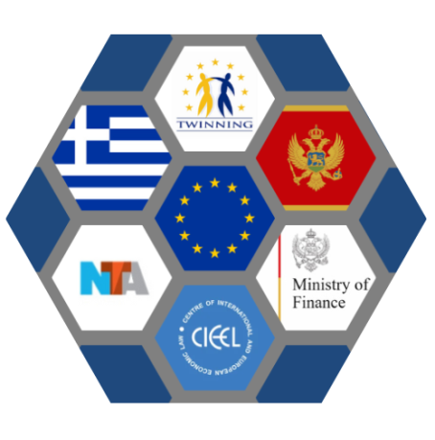
Twinning Light Project
“Improving the capacities of the AFCOS System bodies in the field of irregularities management”
MN 20 IPA FI 01 22 TWL

Strategy for the Fight Against Fraud and Irregularity Management for Protection of Financial Interests of the European Union 2019 – 2022

Ex-post evaluation report

Tzin Tsisou & Giorgos Kasapas
May 2023

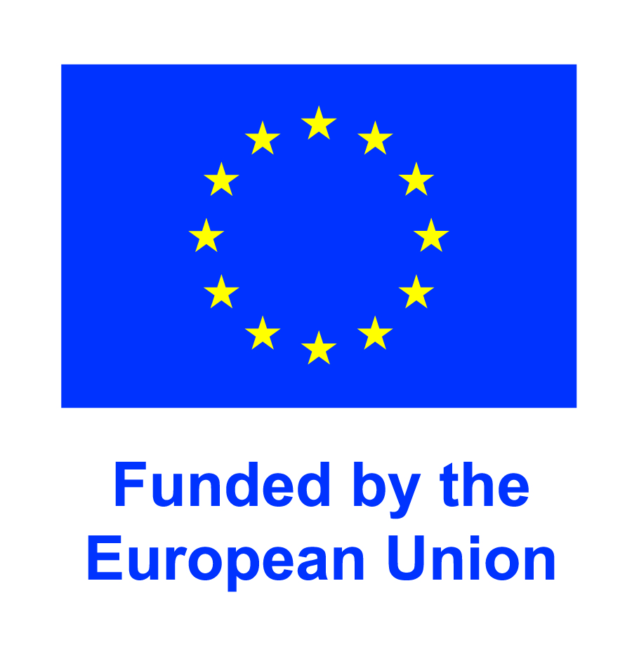

Table of Contents
Foreword 3
Executive Summary 4
1. Introduction 8
1.1 Structure 8
1.2 Objective, Scope, Process 8
1.3 Methodology 9
2. Background 12
3. Structure and content of the Montenegrin NAF Strategy 2019 – 2022 15
4. Key findings 19
4.1 Relevance 19
4.2 Effectiveness 25
4.3 EU added value 35
5. Conclusions 38
6. Recommendations for the new Strategy 2024 – 2027 41
Annex I: Relevance matrix 44
Annex II: Institutions with participants in the interviews 46
Annex III: Questionnaire 47
Annex IV: Evaluation Roadmap 55

Foreword
Evaluation of public policies is a crucial element of good governance that decisively contributes to ensuring and improving the quality, responsiveness and efficiency of services provided by the State to the citizens and businesses. At the same time, evaluation is essential for understanding what works, for what purpose, with whom and under what conditions, as well as for drawing conclusions and proposals for improving public policies, while ensuring that decisions are made on the basis of reliable evidence and produce the desired results (OECD, 2020).
The aim of an evaluation is therefore to draw lessons from identifying key achievements and weaknesses. In addition, it provides specific recommendations to inform policy makers' choices in determining future strategic steps. The assessment report at hand is a policy evaluation and as such, the primary aim is not to assess whether and to what extent each activity has been implemented, but rather to consider whether the strategy has been able to contribute, in this regard, to improving a country's efforts to prevent and combat fraud through the establishment of an integrated irregularities management system.
In this framework, the assessment of the Strategy for Combating Fraud and Irregularities Management for Protection of Financial Interests of the EU 2019-2022 of Montenegro aims to assess the relevance, effectiveness and the added value or importance of the policy in protecting the financial interests of the EU and provide input to the design of its successor.

Executive Summary
The report provides an ex-post evaluation of the Strategy for the Fight Against Fraud and Irregularity Management for the Protection of Financial Interests of the European Union 2019 – 2022 of Montenegro (hereinafter also referred as 2019 – 2022 Strategy or the Strategy) undertaken in the framework of the third Component of the Twinning Light Project "Strengthening the capacity of the AFCOS system in the area of irregularity management".
Based on the lessons learned from the 2015 – 2017 Strategy, the Strategy for the Fight Against Fraud and Irregularity Management for Protection of Financial Interests of the European Union 2019 – 2022 was developed, as the main strategic document encapsulating Montenegro’s priorities, goals, and objectives in the respective policy areas, seeking to improve the country’s ability to protect the EU’s financial interests and meet the requirements set in Chapter 32 of the Pre – Accession Agreement. The purpose of the Strategy was to ensure a high quality and efficient protection of EU financial interests to the same extent as protection of own resources, through the coordination of activities on the establishment of a normative, institutional and operational framework, as well as defining the risks, objectives and measures that will contribute to a more efficient and effective fight against fraud through the promotion of cooperation between competent authorities, both nationally and internationally.
The Strategic Goal of the 2019 – 2022 Strategy “Strengthening the capacity of Montenegro to fight fraud and improve the management of irregularities” breaks down into three Operational Objectives:
- The first Operational Objective under the title “Improving the functioning of the AFCOS system in Montenegro through the establishment of an adequate legal framework and inter-institutional cooperation of the bodies of the AFCOS system” prioritizes the adoption of legislative initiatives for the establishment of a functioning AFCOS System as well as inter-agency cooperation through the signing of Protocols on Cooperation.
- The second Operational Objective under the title “Improvement of the work of the bodies of the Irregularity Reporting Structure in the area of irregularity management” puts focus on process standardization along with the development of methodological tools for the operationalization of a comprehensive system for the management of irregularities and the detection/prevention of fraud.
- The third Operational Objective under the title “Strengthening the administrative capacity of the AFCOS system” emphasizes the design and implementation of an integrated training scheme in the areas of fraud prevention and detection and irregularities management.
Each Operational Objective was pursued by the implementation of a set of measures (10 in total), with the latter being materialized through a series of activities (20 in total), which took place within the framework of Annual Action Plans.
The Strategy’s external, independent and ex-post evaluation was foreseen within the 2019 – 2022 Strategy, as an integral part of the final report on the implementation of the Strategy, which would be submitted to the Government of Montenegro and also as a lesson – learning and forward – looking exercise, leading to useful recommendations for the new 2024 – 2027 Strategy. Within this context, the Strategy’s ex-post evaluation was conducted, with its primary objective being to critically assess the relevance, effectiveness and added value of the Strategy, understand and identify what worked and what didn’t and to also draw lessons on its impact towards the direction of establishing a comprehensive framework for the protection of the EU financial interests in the country and provide recommendations for the design of its successor.
Based on the need identification of the AFCOS Office as the main beneficiary, while also taking into consideration data availability (both primary and secondary) and evaluation limitations, the criteria of relevance and effectiveness were put under scrutiny and guiding evaluation questions were formulated. The methodological framework applied, was based on relevant normative documents issued by the European Commission, the OECD and the Montenegrin Administration, while qualitative and quantitative data collection methods were combined, through a) the review of existing documents, b) the dissemination of questionnaires, c) the conduct of semi – structured interviews and d) the development of tailored scoring tools matrixes (Annex I, Relevance matrix). The evaluation’s key findings are organized in relation to the main evaluation questions and related judgement criteria that were endorsed by the evaluation team and the AFCOS Office with the evaluation roadmap (Annex IV).
With regards to the 2019 – 2022 Strategy’s relevance, effectiveness and added value evaluation, the following key findings were derived:
Relevance.
- Finding 1: Strong correlation exists between the declared goals, objectives and measures of the 2019 – 2022 Montenegrin Strategy and the beneficiaries’ priorities, indicating that the Strategy was designed in high alignment with identified needs.
- Finding 2: An open consultation supported the design and drafting of the Strategy. However, the degree of stakeholder’s engagement in the process was extremely low.
- Finding 3: A comprehensive intervention logic is partly in place, with the absence of a comprehensive set of output and outcome indicators, identified as an important methodological limitation.
- Finding 4: The strategic scope is broad and inclusive, covering every stage of the anti-fraud cycle with clear and specific objectives as well as highly relevant measures further analyzed into time-framed yet loosely defined activities.
- Finding 5: The Strategy remains highly relevant even after the end of the current policy cycle (2019-2022).
Effectiveness.
- Finding 6: The Strategy achieved an overall high completion rate. The majority of measures included under Operational Objectives 2 and 3 have been successfully implemented. On the other hand, significant delays hindered the realization of measures foreseen in Operational Objective 1.
- Finding 7: Timely implementation of the Strategy’s activities was achieved to a substantial degree.
- Finding 8: The anticipated legal basis necessary for a fully functional AFCOS system in Montenegro wasn’t established during the Strategy’s timespan.
- Finding 9: The signing of bilateral cooperation protocols has been a first step towards the establishment of an effective co-ordination mechanism, with high – quality partnerships and deeper inter – institutional cooperation however still missing.
- Finding 10: The introduction of new tools and procedures significantly improved the operational framework of irregularity management system nevertheless, progress reached is not reflected in the number of cases reported.
- Finding 11: A more systemic approach has been introduced in the conduct of trainings. However, co-operation between the AFCOS Office with the Montenegrin Human Resource Management Authority (HRMA) should be strengthened.
- Finding 12: Political instability in combination with the high employee turnover in the Montenegrin public administration impaired significantly the Strategy’s consistent implementation, hindering simultaneously its potential positive spillover effects.
- Finding 13: AFCOS Office’s ongoing diligence and commitment was singled out as a decisive enabler, allowing for the realization of activities even after the end of the implementation period.
EU added value.
- Finding 14: The Strategy was designed taking into consideration national priorities towards the EU accession and has delivered substantial contributions in laying a strong foundation for the protection of the EU financial interests in Montenegro.
According to the evaluation’s key findings, the following conclusions were drawn:
- Based on a systemic approach, the 2019 – 2022 Strategy covered every aspect of the anti – fraud cycle, seeking to establish a solid legal framework, promote inter – institutional cooperation and strengthen operational capacity within the Montenegrin AFCOS system.
- The newly established AFCOS Office demonstrated strong commitment, took ownership of the process and consistently accomplished the demanding tasks of co – ordination, implementation and reporting throughout the Strategy’s timespan.
- During the Strategy’s implementation, political turbulence undermined the adoption of key legislative initiatives, which in turn impaired the promotion of inter – agency cooperation, while limited visibility, along with a low level of engagement on behalf of key stakeholders, further accentuated by high personnel turnover didn’t allow for the full operationalization of the AFCOS system in Montenegro.
- Despite the significant challenges faced, Montenegro reaped considerable benefits from the implementation of the Strategy and managed to put in place key pieces for the establishment of a modern framework for the management of irregularities and the fight against fraud. A satisfactory implementation rate of the Strategy was accomplished and tangible outputs were delivered as regards especially the operational pillar of the AFCOS system.
- Though there is room for improvement and further initiatives are required, a solid basis has been laid and is expected to significantly contribute in the planning and implementation process of the new Strategy for 2024 – 2027.
As regards to the design, planning and implementation of the new Montenegrin National Anti – Fraud Strategy for 2024 – 2027, the evaluation team taking into consideration the findings of the evaluation exercise, the conclusions drawn, along with practical considerations, recommends the following:
- The Guidelines for the development of National Anti – Fraud Strategies and the Practical steps towards the drafting of a National Anti – Fraud Strategy developed by OLAF should be consulted for the design of the new Strategy.
- The design and implementation of the Strategy will significantly benefit from the adoption of a more clear and concrete theory of change.
- Continuity in strategic orientation should also be a priority by building on what already has been achieved and by capturing lessons learned.
- An adequate and comprehensive set of “SMART” output and outcome indicators must be a component of the new Strategy.
- Adoption of measures for strengthening inter – institutional cooperation in every stage of the Strategy’s cycle (consultation, design, implementation, monitoring, evaluation) as a key element of success.
- Promoting synergies with institutions and adopting best practices at the national level.
- Implementing actions to foster visibility of the AFCOS Office and promote the creation of a common understanding on the importance of the National Anti – Fraud Strategy importance.
- Investing in the human resources capacity building of the IPA Management Structure.
- Development of standardized forms to describe foreseen measures and activities, which will greatly enhance implementation.

1. Introduction

1.1 Structure
Following this first brief introductory chapter on the subject, purpose and process of the evaluation, a brief description of the methodology, limitations and the evaluative activities carried out in the course of the exercise is provided. The remainder of the report presents the evaluation findings grouped around the core evaluation criteria of relevance, effectiveness and strategic added value. Individual sections address different aspects of each criterion and include a detailed presentation of findings and results emerging from the analysis of relevant documentation as well as stakeholder’s responses gathered through the dissemination of questionnaires and the conduct of semi-structured interviews. Conclusions and recommendations are presented in the final chapter of the report in order to support fact-based policy formulation in view of the next Strategy for the period 2024-2027.

1.2 Objective, Scope, Process
The report provides an ex-post evaluation of the Strategy for the Fight Against Fraud and Irregularity Management for the Protection of Financial Interests of the European Union 2019 – 2022 of Montenegro undertaken in the framework of the third Component of the Twinning Light Project "Strengthening the capacity of the AFCOS system in the area of irregularity management".
The primary objective is to critically assess the relevance, effectiveness and added value of the Strategy, understand and identify its strengths and weaknesses, draw lessons learned especially on its impact towards the direction of establishing a comprehensive framework for the protection of EU financial interests in the country and provide recommendations for the design of its successor.
In line with the evaluation objective, the scope of the exercise extends throughout the implementation period 2019-2022 encompassing every goal, objective and measure foreseen in the strategic document in order to identify outputs and results delivered, as well as key enabling factors, impediments and potential multiplier effects generated through the intervention. In addition, the evaluation team assessed the formative elements of the document and the extent to which the latter meets the standards set in the EU Guidelines for National Anti-Fraud Strategies. Issues related to Human Resources management and capacity building, key interactions and coordination modalities of the AFCOS System along with the provisions of the management system in the areas of monitoring, reporting and evaluation are also covered in the framework of the present exercise.
In summary, the following elements are included in the evaluation:
- Relevance of outputs to the identified needs,
- Actual progress made towards project objectives,
- Extent to which desired — and unforeseen — outcomes have been achieved,
- Extent to which the measures have contributed to the desired outcomes,
- Extent to which the design and implementation provisions facilitated the realization of set goals,
- Extent to which the Strategy has met the EU Guidelines on NAFS,
- Implementation strengths and weaknesses, measured against the project log frame (objectives, results etc.) and
- Crosscutting issues of major importance such as inter-institutional co-ordination, human resource management and capacity building initiatives as key means for the effective operationalization of the irregularities management system.
The evaluation was conducted between January and May 2023. To prepare this report, the evaluation team carried out a series of on-site visits to Podgorica to meet with the team of the Montenegrin AFCOS Office and the members of the Evaluation Reference Group in order to: (i) observe the situation on the ground, (ii) collect relevant documentation and (iii) conduct a series of interviews with key stakeholders engaged in the design and implementation of the Strategy Against Fraud and Irregularity Management for the Protection of Financial Interests of the European Union 2019 – 2022.

1.3 Methodology
The evaluation of the Montenegrin 2019 – 2022 Strategy builds on the following normative documents:
a) “Guidelines on National Anti – Fraud Strategies” and the “Practical steps towards the drafting of a National Anti – Fraud strategy” both drafted by a group of Member States experts with support from the European Anti – Fraud Office (OLAF),
b) “Manual for the Evaluation of Strategic Documents and the Methodology for policy development, drafting and monitoring of strategic planning documents” issued by the Secretariat General of the Montenegrin Government,
c) “EVALSED: The resource for the evaluation of Socio - Economic Development - Evaluation guide”, European Commission and
d) “Applying Evaluation Criteria Thoughtfully”, OECD DAC Network on Development Evaluation (EvalNet).
The sum total of norms and standards included in the afore-mentioned documents define the methodological framework applied during the conduct of this exercise for evaluating the structure, goals, objectives, outputs, results, performance and added-value of the Montenegrin NAFS 2019-2022, within the framework of certain criteria.
The evaluation begins by addressing main questions, regarding the degree to which the 2019-2022 Strategy meets the EU standards on National Anti-Fraud Strategies Based on the need identification of the Montenegrin AFCOS Office - the main beneficiary of this exercise - while also taking into consideration data availability (both primary and secondary) the criteria of strategic relevance and effectiveness are put into scrutiny. These criteria also dictated the formulation of the guiding evaluation questions on which this exercise was built on. These are:
- To what extent are the strategic and operational objectives, as well as the measures of the Strategy justified in relation to needs?
- To what extent are the objectives of the Strategy adequately defined, realistic and feasible?
- Was there a logic model or a certain theory of change in place when designing the Strategy?
- To what extent are the objectives and measures of the Strategy still relevant?
- To what extent do the Strategy’s objectives and measures correspond to national and European standards and priorities?
- To what extent were the measures of the Strategy successfully implemented, delivering the intended outputs and results? To what extent have the set goals been achieved or when could they be expected to be achieved?
- What were the factors that had the greatest impact on achieving or not achieving the objectives of the Strategy (advantages that have supported implementation and obstacles that have hindered implementation)?
- Did the implementation of the strategic document and accompanying Action Plan proceed based on the initial timeframe during the period of reference of the Strategy?
- What is the added value of the Strategy in terms of the institutional/legal framework, inter – institutional cooperation, operational effectiveness of the Irregularity Reporting Structure and administrative capacity building?
- To what extent have the measures of the Strategy contributed to creating an enabling environment for the effective fight against fraud and management of irregularities in Montenegro?

Data sources
This assessment report used the following data sources:
- Programmatic and operational texts, institutional and regulatory framework, recommendations, EU progress reports, TA deliverables etc.,
- Monitoring reports of the Montenegrin AFCOS Office,
- Data from secondary analysis and desk research,
- Data drawn from interviews with the stakeholders and
- Data derived from questionnaires completed specifically for this report and supported relevant field research.

Data Collection Methods
Data-collection methods applied to assess the outputs, results and outcomes of the Strategy are:
(a) Desk review and secondary data-collection analysis of the strategic documents 2015-2017 and 2019-2022, annual progress reports, deliverables of the Twinning light project: “Capacities development for Anti-Fraud Coordination Service (AFCOS), (TLP 24/222), documentation concerning the implementation of activities measures and relevant consolidated reports
(b) Semi-structured interviews were used to validate and triangulate information and findings from desktop research. To this direction, data-collection tools used for these interviews included specific interview guides that were applied in a semi-structured fashion. Further to that, the evaluation team prepared and disseminated questionnaires to key stakeholders and members of the AFCOS Network. Based on the answers provided and with the valuable help of the AFCOS Office team, personal interviews were held face to face during the field visits in Podgorica and
(c) Field visits gave the opportunity to the evaluation team to listen to the opinions of key stakeholders regarding the impact, relevance and effectiveness of the Strategy and also draw valuable conclusions from direct observation of the modus operandi of the Montenegrin Public Administration.

Evaluation limitations
The main limitations that affected this report are:
- Lack of availability, mainly of output and measurable result indicators, regarding the implementation of activities and attainment of objectives,
- Limitations related to the collection of data through the interviews and the filled questionnaires due to the appointment in some cases of contact points with little or no knowledge of the Strategy (newly appointed/recently transferred personnel).

2. Background
In 2003, the European Union reiterated its "unequivocal support to the European perspective of the Western Balkan countries" and its conviction that "the future of the Balkans is within the European Union". In light of this, Montenegro’s European perspective was reaffirmed by the EU Council in June 2006 shortly after the country’s independence from the State Union of Serbia and Montenegro. On October 15, 2007, Montenegro signed the Stabilization and Association Agreement (SAA), by which the country formally agreed on an association with the EU, thereby accepting responsibility for its European future.
In 2008, Montenegro applied for EU membership and was granted the status of candidate country in December 2010. Accession negotiations began in June 2012 followed by the dynamic process for meeting the EU requirements and for transposition of the EU values, standards, rights and obligations as prescribed by the EU acquis. So far, out of a total of 35 negotiation chapters of the EU acquis, 33 have been opened for negotiations, of which three have already been provisionally closed.
That said, Chapter 32 was opened for Montenegro at the Intergovernmental Conference on June 24, 2014. The Acquis on the protection of the financial interests of the EU is part of the 3rd benchmark of Chapter 32 - Financial Control, covering four main areas: public internal financial control (PIFC), external audit, protection of the financial interests of the EU and protection of the euro against counterfeiting. In this framework, the country was required to i) establish a solid legal and institutional framework for the protection of the EU's financial interests, ii) enable administrative investigations by the investigators of the European Anti-Fraud Office (hereinafter: OLAF) and iii) harmonize the Montenegrin Criminal Code in order to ensure the appropriate sanctioning of criminal offenses at the expense of the EU's financial interests.
Effective financial management of EU resources is of particular interest for Montenegro. Since the SAA, the country became a beneficiary of the Pre-Accession Assistance Program (IPA) which allocates EU funds aiming at providing financial and technical assistance to candidate countries in the process of preparing for full European membership. EU has grown to be Montenegro's largest donor and its main partner in providing financial and technical support for the nation's ongoing reforms and development, providing more than 620 million euros in non-refundable aid since 2007. Under this spectrum, Montenegro undertook the obligation to provide a legal framework establishing an adequate institutional structure in order to develop the administrative capacity necessary for the application of the acquis communautaire, including the capacity of legislative and judicial bodies to respond to cases where the EU financial interests are jeopardized.
Therefore, in the framework of the pre-accession negotiations and in line with the regulatory obligations stemming from the country’s status as an IPA beneficiary, Montenegro set out to progressively establish a management and control system for the sound management of EU funds as required by provisions of the Commission Regulation (EC) No 718/2007, IPA IR, and Commission Implementing Regulation (EU) No 447/2014. The Decree on the organization of the decentralized management of the Pre-accession Instrument Assistance and the Decree on organization of the indirect management for implementation of Union financial assistance under Instrument for pre-accession assistance (IPA II) provided an outline for the structure of the management and control system and, the Montenegrin Government subsequently adopted a Decision on the appointment of persons responsible for carrying the functions in relation to decentralized and/or indirect management of pre-accession funds of the European Union (EU). In accordance with the aforementioned legislation, the established institutional structure includes authorities that perform management, control, supervision, monitoring, evaluation, reporting and internal audit of the EU assistance as well as specific functions linked with the prevention, detection and correction of irregularities and reporting them to the Commission. The management and control system in Montenegro comprises of:
- The National IPA Coordinator (NIPAC)
- The National Authorising Officer (NAO)
- The management structure composed of the National Fund and the NAO Support Office
- The operational structure for particular annual/multiannual programmes
- The operational structure for particular cross-border programmes
- The operational structure for the rural development programme
On that ground, a Decision on Establishing Coordination Body for Monitoring and Managing Policy for the Prevention and Suppression of Irregularities and for the Protection of the European Union Financial Interests (AFCOS network) was approved by the Montenegrin government on December 5, 2013. According to the provisions of the decision, a horizontal network of administrative authorities was established for direct collaboration with OLAF and to coordinate legislative, administrative, and operational actions taken to safeguard the Union's financial interests. Montenegro's AFCOS institutional structure consists of (a) Accredited bodies of the IPA Management and Control System (Irregularity Reporting Structure), (b) Anti-fraud and Anti-corruption agencies (AFCOS Network) and (c) the Department for Combating Irregularities and Fraud - AFCOS Office designated as the competent body for the protection of financial interests of the European Union in Montenegro.
Along with the institutionalization of the AFCOS system, the first anti-fraud strategy, i.e. the Strategy for Combating Fraud and Irregularities Management for Protection of Financial Interests of the EU 2015–2017, was also adopted by the Montenegrin Government. The Strategy’s role was crucial in designating key players and procedures in the process of introducing the EU assistance management system, system developing and coordination. In this context measures for the operationalization of the AFCOS system as well as measures for the control of fraud and irregularities were foreseen. The Strategy sought to ensure sound and effective protection of EU financial interests through the institutionalization of critical normative and operational aspects for the establishment of a comprehensive anti-fraud and irregularities management framework in the country. The general objectives of the strategy were:
- Improvement of the legal framework to protect EU financial interests in Montenegro,
- Sustainable administrative capacity and training at all levels of the AFCOS network;
- Prevention of irregularities and fraud through communication with the public and between employees and through compliance with codes of conduct and ethical codes of public administration;
- Improvement of the communication system between AFCOS entities (IPA structures, AFCOS Office and other entities of the AFCOS network responsible for combating fraud, corruption or any other form of irregularity in the system);
- Promote cooperation with national institutions and OLAF and
- Ensure timely reporting of irregularities and fraud and response to reports.

3. Structure and content of the Montenegrin NAF Strategy 2019 – 2022
The Strategy for the Fight Against Fraud and Irregularity Management for Protection of Financial Interests of the European Union 2019 – 2022 is the main strategic document encapsulating Montenegro’s priorities, goals, and objectives in the respective policy areas, as well as measures to achieve them. The purpose of the Strategy is to ensure a high quality and efficient protection of EU financial interests to the same extent as protection of own resources, through the coordination of activities on the establishment of a normative, institutional and operational framework, as well as defining the risks, objectives and measures that will contribute to a more efficient and effective fight against fraud through the promotion of cooperation between competent authorities, both nationally and internationally.
Based on the lessons learnt from the Strategy 2015-2017 and the analytical assessment delivered in the context of Twinning Project 24/222, the 2019-2022 Strategy was developed by the AFCOS Office with significant contribution from external experts and endorsed by the Government of Montenegro, thus setting an ambitious and comprehensive national policy framework in line with national and EU priorities seeking to improve the country’s ability to protect EU financial interests and meet the requirements set in Chapter 32 of the Pre-Accession Agreement. The Strategic Goal of “Strengthening the capacity of Montenegro to fight fraud and improve the management of irregularities” breaks down into three Operational Objectives:
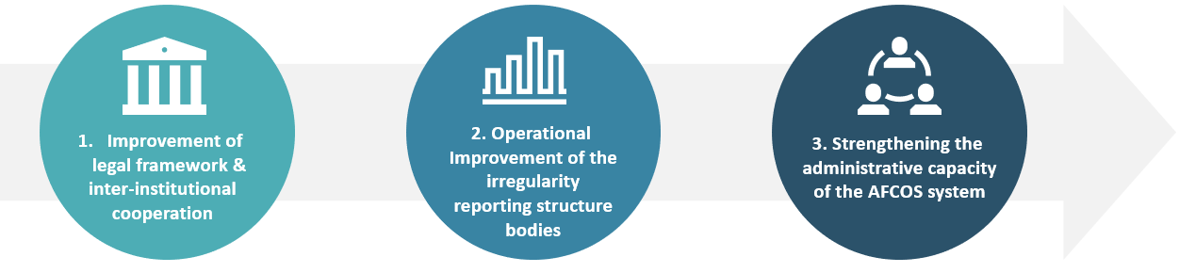
The first Operational Objective under the title “Improving the functioning of the AFCOS system in Montenegro through the establishment of an adequate legal framework and inter-institutional cooperation of the bodies of the AFCOS system” prioritizes the adoption of legislative initiatives for the establishment of a functioning AFCOS System as well as inter-agency cooperation through the signing of Protocols on Cooperation. The objective is pursued through four (4) measures:
1.1 Adopt the legal basis for the functioning of the AFCOS system and protection of the EU’s financial interests in Montenegro,
  - Making the AFCOS system fully operational,
  - Improvement of inter-institutional cooperation of AFCOS system bodies and cooperation of AFCOS system bodies with OLAF in the area of irregularity management,
  - Improve the work of the AFCOS Office.
The second Operational Objective under the title “Improvement of the work of the bodies of the Irregularity Reporting Structure in the area of irregularity management” puts focus on process standardization along with the development of methodological tools for the operationalization of a comprehensive system for the management of irregularities and the detection/prevention of fraud. The objective is pursued through five (5) measures:
  - Effective risk management in the area of irregularities and fraud,
  - Improving communication between AFCOS system bodies as well as improving public relations and communication in cases of irregularities and suspected fraud,
  - Promoting ethics and integrity in public administration,
  - Protection of whistle-blowers
  - Improvement of irregularity management procedures.
The third Operational Objective under the title “Strengthening the administrative capacity of the AFCOS system” emphasizes the design and implementation of an integrated training scheme in the areas of fraud prevention and detection and irregularities management. The objective is pursued through the following measure:
  - Systematic implementation of training in irregularities management.
The measures of the Strategy materialized through a series of activities the implementation of which took place in the framework of Annual Action Plans. The evaluation team in an initial attempt to deconstruct the causal logic of the document classified these twenty (20) activities into four (4) broad thematic areas namely legal framework – inter-agency coordination – operational procedures & tools – capacity building initiatives.
CLASSIFICATION OF ACTIVITIES PER THEMATIC AREA
MEASURE | ACTIVITIES | THEMATIC AREA
1.1 | Adopt amendments to the Law on Budget and Fiscal Responsibility | IMPROVE LEGAL FRAMEWORK
1.2 | Make the Decision to establish an AFCOS Advisory Body | IMPROVE LEGAL FRAMEWORK
1.3 | Adopt a Decree on the institutional framework for the functioning of the AFCOS system in Montenegro | IMPROVE LEGAL FRAMEWORK
1.3 | Sign cooperation protocols between the Ministry of Finance and the Audit Authority, the State Prosecutor's Office and the Police Directorate | INTERAGENCY CO-OPERATION
1.4 | Develop internal procedures (work procedures) for the operation of the AFCOS office | IMPROVE PROCEDURES
2.1 | Development of a methodology for risk management in the area of irregularities and fraud within the management and use of IPA funds | IMPROVE PROCEDURES
2.1 | Conducting risk analysis in accordance with the methodology of risk management in the area of irregularities and fraud within the management and use of IPA funds | IMPROVE PROCEDURES
2.2 | Adopt procedures for communication between AFCOS system bodies and the public regarding cases of identified irregularities and suspected fraud in the context of management and use of IPA funds and incorporate them into the overall Communication Strategy. | IMPROVE PROCEDURES
2.3 | Hold 2 training in the field of ethics and integrity in public administration | CAPACITY BUILDING
2.4 | Activate special e-mail addresses by Irregularity Reporting Structures to which irregularities can be reported anonymously | IMPROVE PROCEDURES
2.5 | Develop Guidelines on Irregularity Management | IMPROVE PROCEDURES
2.5 | Incorporate procedures from the Irregularity Guidelines into the "Irregularities" section of the Manual of Procedures on Irregularity Reporting Structures | IMPROVE PROCEDURES
2.5 | Timely reporting of irregularities to OLAF | IMPROVE PROCEDURES
2.5 | Reduce the number of returned reports of irregularities by the AFCOS office to the Implementing Agencies for refinement | IMPROVE PROCEDURES
2.5 | Replace paper-based irregularities with electronic IMS reporting | IMPROVE PROCEDURES
2.5 | Monitoring changes in the IMS reporting system | IMPROVE PROCEDURES
3.1 | Develop Guidelines for the implementation of training related to the field of irregularities management for the period 2021-2022 | IMPROVE PROCEDURES
3.1 | Conduct an analysis for the training needs of bodies in the AFCOS system in order to assess the existing capacity of officials and identify weaknesses that need to be addressed | CAPACITY BUILDING
3.1 | Develop a training program in line with the results of the conducted analysis of the needs for body education in the AFCOS system | CAPACITY BUILDING
3.1 | Conduct training in the field of irregularity management in accordance with the Training Program | CAPACITY BUILDING
Quantitative analysis demonstrates that the majority of activities (12 out of 20) focus on strengthening the irregularity management system in terms of efficiency and effectiveness through the development of standardized procedures and new tools. Amongst them the development of Guidelines on Irregularity Management along with the introduction of fraud risk management and the update of the Manual of Procedures on Irregularity Reporting are recognized as initiatives with the potential to significantly upgrade the overall performance of the AFCOS System in terms of effectiveness. Digital transformation initiatives form a small cluster in this thematic area with two (2) actions on the optimization of the anti-fraud reporting system through the use of the IMS and one (1) action dedicated to the establishment of a channel for receiving anonymous complaints from whistleblowers via e-mail.
Three (3) activities of the Strategy aim to the adoption of primary (Amendment of the Law on Budget and Fiscal Responsibility) and secondary (Decree on the institutional framework for the functioning of the AFCOS system and Decision to establish an AFCOS Advisory Body) legislative acts to improve identified gaps and systemic shortcomings and set up a solid legal basis for the proper and effective function of the AFCOS System.
A single activity is envisaged to promote inter-agency co-operation through the signing of Memorandums of Cooperation (MoCs) between the Montenegrin Ministry of Finance and the Audit Authority, the State Prosecutor’s Office and the Ministry of Internal Affairs. The institutionalization of co-operation schemes in the form of bilateral Protocols is considered as a key enabler for the operationalization of the institutional arrangements in place and as a pre-condition for the formation of an effective horizontal communication network between the competent authorities of the AFCOS System.
Capacity building through training is identified as a critical cross-cutting issue in the Montenegrin NAFS and relevant actions are foreseen for the materialization of Objectives 2 and 3 of the Strategy. Parallel to dedicated training courses on ethics and integrity across the Montenegrin Public Administration, the Strategy aims to end fragmentation in the conduct of training through the adoption of a systemic approach that builds on a needs assessment to deliver targeted results in the field of anti-fraud and irregularity management.
Provisions for a comprehensive management system covering the areas of monitoring, reporting and evaluation are included in the strategic document. In line with them, the AFCOS Office consistently submitted quality analytical Annual Reports to inform the Government (Government on its session adopted those reports) on the progress achieved and highlight delays and deviations from initial planning. To this direction and although no standardized monitoring process was in place, effective communication channels have been established with AFCOS Office initiative on an ad hoc basis while the exchange of information and collection of relevant data between the stakeholders was taking place mostly by phone and email.
Furthermore, the management system attributes great importance to policy evaluation and provides for the conduct of an ex-post and an on-going/interim one. However, the latter did not take place as initially designed because the AFCOS Office lacks the resources to conduct the exercise with own means while the COVID-19 pandemic has been an important obstacle for receiving external expertise to deliver the task. As a consequence, there has been no review/update of the Strategy during the implementation period (2019-2022) that would allow for a) the adoption of corrective measures concerning structural components of the document (i.e. output and result indicators) and b) the introduction of mitigating measures in response to implementation challenges and to emerging threats from the external environment (i.e. COVID-19).

4. Key findings
This chapter presents the review of the overall performance of the Montenegrin Strategy for the Fight against Fraud and Irregularity Management for the Protection of Financial Interests of the European Union for the period of 2019 – 2022 and its Action Plans under the perspective of relevance, effectiveness and added value within the framework of the country’s accession progress. Key findings are organized in relation to the main evaluation questions and related judgement criteria that were endorsed by the evaluation team and the AFCOS Office with the evaluation roadmap (Annex IV). Evaluation findings, and thus what is referred to as ‘evidence’ throughout the report, derive from thorough review of documents made available by the AFCOS Office, secondary sources gathered by the evaluation team throughout the process, filled questionnaires allowing for quantitative analysis of views and interviews allowing for qualitative analysis of views and perceptions with the main beneficiary and key stakeholders.

4.1 Relevance

In order to effectively safeguard the financial interests of the EU, the 2019–2022 Strategy must address the demands and objectives of the primary beneficiary and other important stakeholders. Thus, a relevance evaluation is necessary.

Finding 1: Strong correlation exists between the declared goals, objectives and measures of the 2019 – 2022 Montenegrin Strategy and the beneficiaries’ priorities, indicating that the Strategy was designed in high alignment with identified needs.
Τhe Strategic document along with the first Annual Action Plan were developed in the context of the Twining Light Project “Capacities development for the Anti – Fraud Coordination Service (AFCOS)” implemented by Croatian experts during the 3rd Quarter of 2018, for six (6) months, with the goal to enhance the capacity of the AFCOS system in Montenegro. External experts in close co-operation with national stakeholders and competent authorities delivered a comprehensive assessment of the legal and institutional framework, procedures and practices for the protection of the EU financial interests in Montenegro including the following elements:
- Analysis of the institutional arrangements in the field of anti-fraud and irregularities management,
- Identification of key shortcomings and deficiencies at the institutional and operational level,
- Results achieved from the implementation of the National Anti – Fraud Strategy of the period 2015-2017 and
- Recommendations for strengthening the operational capacity and performance of the AFCOS System.
Building on previous achievements and identifying existing shortcomings and horizontal aspects (i.e., strengthening the capacity of human resources, establishing effective coordination mechanisms and implementing targeted raising awareness initiatives) the assessment highlighted the following, as key needs to be addressed by the 2019-2022 Strategy:
- Establishment of a comprehensive legislative framework for the effective protection of the EU financial interests,
- Centralization and digitization of the function of irregularity reporting,
- Capacity building initiatives to strengthen the first level of reporting,
- Process standardization for the management of irregularities and subsequent update of the IPA Manual of Procedures,
- Assignment of clear roles and competencies to the members of the AFCOS Network,
- Promotion of inter – institutional co-operation,
- Inclusion of measures that weren’t materialized during the 2015 – 2017 Strategy and
- Raising Awareness activities.
The afore-mentioned set of conclusions and recommendations formed the basis for the design of the 2019 – 2022 Strategy in terms of goals, objectives and measures. Although the analysis focuses mainly on critical aspects and features of the AFCOS System and as such, it does not qualify as a Fraud Risk Assessment in terms of risk identification, assessment (likelihood – impact) and classification, continuity in strategic orientation has been achieved to a satisfactory degree during the design and drafting of the Strategy The Strategy took into account the priorities and requirements that the AFCOS Office—the system's primary beneficiary—and other important stakeholders had identified. As a result, the anticipated actions and programs outlined in the Strategy serve as key pieces for Montenegro’s progressive construction of a strong and efficient national anti-fraud framework.

Finding 2: An open consultation supported the design and drafting of the Strategy. However, the degree of stakeholder’s engagement in the process was extremely low.
Desktop review and interviews with stakeholders conducted within the scope of this evaluation confirm that an open consultation with a broad spectrum of relevant stakeholders (including law enforcement agencies and the accredited bodies of the IPA Management and Control System) took place during the preparatory phase of the Strategy. In line with the provisions of the Manual for the Evaluation of Strategic Documents and the Methodology for policy development, drafting and monitoring of strategic planning documents questionnaires were disseminated and follow up interviews were conducted with interested parties. In addition, the AFCOS Office uploaded online the drafted Strategy, disseminated copies of the document to every major stakeholder and extended an open invitation for public debate over the strategic document to competent state authorities, civil society organizations, journalists and the general public. Participation in the event was extremely limited.
The above point to the fact that, despite AFCOS Office continuous efforts to promote the Strategy and raise awareness concerning its importance both for enhancing the capacity of the AFCOS System as a whole as well as for the successful conclusion of pre-accession negotiations, a significant number of stakeholders including members of the IPA II Structure did not have a clear understanding of their role and their potential contribution to the design of the Montenegrin NAFS. Despite the Strategy having been developed in the aftermath of a wide consultation process the latter was understood by the majority of the parties involved more as a formative obligation rather than a substantive element for the drafting of an inclusive NAFS. As a result, it was characterized by limited participation and low level of stakeholders’ engagement.
Data collected from questionnaires and follow up interviews with representatives of the AFCOS system shows that the majority of respondents were uncertain on whether a consultation process took place prior to the design of the Strategy. Furthermore, 2019-2022 Strategy has been recognized as an important policy initiative beneficial only to the AFCOS Office. While the afore-mentioned findings can be explained by the huge personnel turnover in the IPA Structures as well as by the fact that most respondents identified themselves as newly appointed employees or as recently transferred to their current post at the same time, they indicate (i) the existence of differentiated perceptions and expectations among the members of the AFCOS system concerning the Strategy and its significance for individual institutions (ii) a noteworthy level of ambiguity on behalf of key stakeholders with regards to their role in the framework of the Strategy and (iii) the absence of effective communication channels across the AFCOS system.

These findings stress the need to plan resources for the design and implementation of a raising awareness campaign to increase the visibility of the next Strategy and stress its added value across the Public Administration including the members of the AFCOS System (IPA Bodies, AFCOS Advisory Body). In this context, emphasis should also be put on the role of the AFCOS Office as an integral part of the IPA III Structure and as an institution that performs a key function essential to the effective operation of the overall IPA Management System in Montenegro.

Finding 3: Α comprehensive intervention logic is partly in place with the absence of a comprehensive set of output and outcome indicators, identified as an important methodological limitation.
The intervention logic adopts a structural/systemic approach seeking to resolve identified shortcomings and address key issues (horizontal and thematic), with the aim intending to ensure the effective management of irregularities. To this end, two main intervention pillars were introduced, laying the foundation for defining the Strategy’s objectives:
- Actions for the establishment of the appropriate legal and regulatory framework within Montenegro to effectively implement the acquis communautaire and to clearly define the roles and responsibilities of the members of the AFCOS network and
- Initiatives for the enhancement of operational capacity and the introduction of the appropriate institutional arrangements within the AFCOS system.

Based on an understanding of the protection of the EU financial interests as part of a broader compendium of national strategic priorities within the framework of a reform agenda on the road to joining the EU, priority is put on creating an enabling legal and regulatory framework to that direction. Recognizing simultaneously that solely the adoption of the appropriate legal framework doesn’t ensure the Strategy’s sound and effective implementation, a range of measures is foreseen, for the enhancement of operational capacity and for strengthening the overall performance of the AFCOS system.

Following the aforementioned rationale, for every objective identified corresponding actions were designed, in the form of measures. For every measure, a set of activities was identified, the implementation of which would lead to the realization of the relevant measure thus, contributing to the achievement of the set Objective.
According to the analysis, the intervention logic of the Strategy has a solid structure and is built on a holistic rationale. However, it remains partly incomplete as it does not include a comprehensive set of indicators to measure performance. More precisely, the main methodological handicap identified during the scope of the evaluation is the absence of output indicators directly related to the measures foreseen in the document as well as the lack of measurable outcome indicators. While a small number of outcome indicators are included in the document, the latter are not adequately defined, baseline values are missing whereas in some cases, they resemble more output rather than outcome indicators, since, according to their phrasing, they seek to measure quantifiable outputs rather than expected results directly linked to the operational objectives.
The development of an integrated system of S.M.A.R.T. (Specific, Measurable, Achievable, Relevant and Time – Bound) indicators (output and outcome) is considered by the evaluation team as a priority for the monitoring and evaluation of the next Strategy as they will provide a clear and objective way to measure progress towards foreseen strategic goals and operational objectives, ensure accountability, drive continuous improvement, inform fact-based policy formulation and resource allocation decisions.

Finding 4: The strategic scope is broad and inclusive, covering every stage of the anti-fraud cycle with clear and specific objectives as well as highly relevant measures further analyzed into time-framed yet loosely defined activities.
The scope of the Strategy is wide and inclusive covering the protection of expenditures of the EU Budget. To this direction, the document encompasses every stage of the anti-fraud cycle and incorporates all major priority areas identified in the EU Guidelines of
PRIORITY AREA | DEGREE OF RELEVANCE
PREVENTION | 80%
DETECTION | 83%
MANAGEMENT | 78%
REPORTING | 75%
FOLLOW UP | 63%
COORDINATION | 60%
National Anti - Fraud Strategies namely, prevention, detection, management, reporting, including follow up recovery of funds and sanctions and policy co-ordination. The relevance matrix developed in the framework of the evaluation (Annex I) identifies a high degree of relevance between the contribution of foreseen activities to the realization of strategic priorities.
The Strategic Objective of the 2019 – 2022 Strategy was to ensure the effective and efficient protection of the EU’s financial interests, by strengthening the AFCOS system in Montenegro in the area of irregularity management. The Strategic Objective is clear and specific plainly defining the strategic direction of the document by setting a broad overarching goal.
Operational Objectives outline a three-pronged approach for the realization of the Strategic Objective focusing on the (i) establishment of a solid legal basis (ii) improvement of systemic function through the introduction of new methods, procedures and tools and (iii) increase of the capacity of the AFCOS system.
In this framework the measures included in the Montenegrin NAFS 2019-2022 are classified in the following four (4) key thematic areas namely, (i) strengthening the legal and institutional framework, (ii) promote inter-institutional co-ordination, (iii) improve processes and development of operational tools (iv) capacity building through training. A brief yet concise description of each one of them is included in the strategic document while their implementation is considered realistic and feasible given the four – year implementation period of the Strategy.
Moreover, the Strategy materialized through the implementation of two (2) Action Plans, (one covering the period 2019 – 2020 and one for year 2022). In this framework, measures were further broken down into twenty (20) activities with concrete implementation timetables including start dates and planned end dates. The evaluation was unable to reach concrete conclusions on their feasibility due to the absence of detailed descriptions concerning their scope, implementation steps, stakeholders involved and expected outputs.
Desktop research further shows that there has been no provision for national funding to support the implementation of activities. However, several EU financial instruments were identified (i.e. Twining Light Projects (TLP), Technical Assistance and Information Exchange (TAIEX) and Support for Improvement in Governance and Management (SIGMA)) as potential funding sources and were linked to specific activities on a programmatic basis. The above highlight that EU funding has been of critical importance to the implementation of the Montenegrin NAFS 2019-2022. Given the above, the evaluation team considers that a more consistent budgeting during the design of the Strategy 2024-2027 will contribute to avoid delays throughout implementation and will enhance significantly the capacity of the AFCOS Office to plan in advance and deliver expected outputs and results in a promptly.

Finding 5: The Strategy remains highly relevant even after the end of the current policy cycle (2019-2022)

With the 2019 – 2022 Strategy having reached its end, the main stakeholders and members of the AFCOS system in Montenegro still recognize a high degree of correspondence between their institutional needs and the Strategy’s objectives and measures:

source: Questionnaire
During the interviews, participants representing key stakeholders within the AFCOS system identified a strong and clear correlation between measures of the Strategy and their institution’s needs. The measures recognized as the most relevant were those delivering outputs with direct impact in their line of work, such as the updated guidelines on irregularity management, the amendment of the Manual of Procedures for the IPA management agencies, access to the IMS for reporting irregularities and the training activities.
Apart from the aforementioned measures, most respondents didn’t seem to acknowledge the 2019 – 2022 Strategy in its entirety as relevant to their institution’s needs or competencies pointing out once again the low level of stakeholders’ engagement and the significantly differentiated perceptions towards the Strategy and its overall importance for the protection of the EU financial interests and the pre-accession negotiation process.
To this direction, the evaluation team identifies the absence of a solid legal basis clearly defining the competences of the AFCOS Office as a major impediment that creates ambiguity concerning its institutional role and hampers the full operationalization of the AFCOS System.

4.2 Effectiveness
Measuring effectiveness, examines to what extent the Strategy managed to achieve its priorities goals and objectives. To this end, the absence of measurable output and result indicators has been a major obstacle that limits the ability of the evaluation team to draw conclusions regarding the degree to which the anticipated results were achieved based on quantified data. In an attempt to overcome the afore-said restriction relevant information was collected in order to draw conclusions through:
- Monitoring overall completion rate
- Thorough review of the deliverables and outputs delivered
- Critical assessment of non-implemented activities and their impact for the roll out of the Strategy,
- Questionnaire analysis verified by interviews findings with the main beneficiary and key stakeholders

Finding 6: The Strategy achieved an overall high completion rate. The majority of measures included under Operational Objectives 2 and 3 have been successfully implemented. On the other hand, significant delays hindered the realization of measures foreseen in Operational Objective 1.
The course of the Strategy’s implementation wasn’t smooth, considering the unexpected delays that occurred during the first two years of implementation due to the COVID-19 pandemic. Nevertheless, the overall implementation rate is considered satisfactory, since according to the evidence gathered during desktop research, further verified by the degree of satisfaction expressed by the main beneficiary and key stakeholders during the interviews, by the end of 2022 70% of activities foreseen were completed, 20% were partially implemented and 10% were not implemented, as illustrated in the following chart:
Activities implementation rate
The highest implementation rate was observed in Operational Objectives 2 (82%) and 3 (75%), whereas Operational Objective 1 demonstrated the lowest implementation rate (47%) with the majority of its activities either not implemented, or partially implemented. Measures and activities implemented exclusively by the AFCOS Office faced less challenges and were completed without major delays in comparison to those that required the involvement of third parties in order to materialise.
Operational Objective 1 included five (5) activities which focused mainly on introducing the appropriate legislative and institutional framework for the establishment of a fully functional AFCOS system in Montenegro and for improving inter – institutional cooperation within the AFCOS network. Nonetheless, the only activities that were realized by the end of the Strategy were the:
- Adoption of the Decision establishing the AFCOS Network in Montenegro and the
- Development of internal procedures for the operation of the AFCOS Office.
Activities implementation rate - Operational Objective 1
The evaluation revealed that the most successful activities completed to date, in delivering expected outputs without significant obstacles or delays, have been the development of internal procedures for running AFCOS Office. The Decision to set up the AFCOS Network was not completed as originally planned, an amendment to the existing Decision was issued, updating the names of the representatives to the AFCOS Network, instead of issuing a new legal act clearly defining the institutions to which the Advisory Board is composed of. This approach is not considered effective as it increases the need for periodic adjustments, thereby preventing recognition of each institution's role and significance within the AFCOS Network. On the contrary, an increase of ownership and commitment would contribute to improved institutional cooperation while at the same time strengthening interinstitutional cooperation by introducing a normative act that clearly names competent bodies, describes their role and lays down its responsibilities.
Operational Objective 2 exhibited notable implementation progress, since according to the available documentation, nine (9) out of eleven (11) activities were completed by the end of the Strategy. It should be also highlighted that the aforesaid Objective contained the largest number of activities, the majority of which focused on the operational improvement of the bodies constituting the irregularity reporting structure.

Activities implementation rate – Operational Objective 2
More precisely, the said Objective included a series of intertwined activities aiming to strengthen the institutional capacity, operation wise within the IPA management structure. To this end, the activities implemented were dedicated to introducing new tools, improving procedures, and taking first steps towards the digitization of reporting. Within this framework:
- A risk management methodology in irregularities and fraud was developed as a fraud prevention tool,
- Guidelines on the effective management of irregularities were created and incorporated in the Manual of Procedures of the structure for reporting irregularities,
- Whistleblowers protection was enhanced through activating special e-mail addresses for anonymous online reporting,
- The reporting of irregularities by all the competent agencies became exclusively electronical through authorized access of all reporting agencies to the IMS and
- Trainings were also organised for the promotion of ethics and integrity in public administration.

The one activity that wasn’t implemented concerned the conduct of a risk analysis in the field of irregularities and fraud in the management and use of funds from the IPA program, following the risk analysis methodology that was developed. According to information gathered during the evaluation, risk assessment exercises took place within the programming period of IPA II. However, the latter focused on identifying and addressing systemic risks. The gradual adoption of the risk methodology developed regarding fraud and its incorporation within the procedures of the IPA management structure should be a priority for the upcoming period, as it is considered a good practice regarding fraud prevention and anti-fraud policy formulation within the EU member states.

On the other hand, the activity that was partially implemented, regarded the adoption of procedures intended to improve:
a) the communication between the AFCOS system bodies and
b) the public’s awareness on cases of established irregularities and suspected or identified fraud.
As regards to establishing effective channels of communication within the AFCOS system, the development of the guidelines on irregularity management, was assessed as partially efficacious to that end. As for raising public’s awareness, communication material was developed in the form of leaflets, both in Montenegrin and in English, within the Twining Light Project “Capacity development for the Anti – fraud coordination service (AFCOS)”. The leaflets included information on the AFCOS Office and the bodies that comprise the AFCOS system, the IPA II, the Irregularity Reporting Structure in the country and the European Anti – Fraud Office (OLAF). They also included crosswords with terms related to fraud, in an effort to familiarize the broader public with fraud nomenclature. Most importantly, all the necessary contact details for more information and for reporting irregularities and fraud were also included.
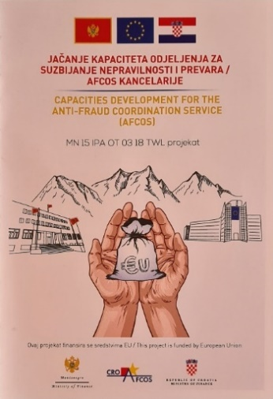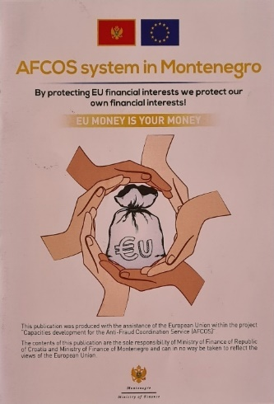
Raising the public’s awareness on fraud – Leaflet images
However, the evaluation found that these actions, though helpful were isolated and not integrated into an inclusive and systemic approach, since a communication strategy wasn’t developed as initially designed. Deploying a systemic fraud awareness strategy is a complementary practice of substantiated added value for combating fraud and effectively protecting EU common values.
Lastly, Operational Objective 3 also exhibited a high completion rate (75%), with three (3) out of four (4) activities completed and one partially implemented:
Activities implementation rate - Operational Objective 3
The evaluation found that a more systemic approach was adopted in identifying training needs and designing training programs for the enhancement of the AFCOS system’s human resources.
More precisely:
- An analysis was conducted for the identification of the training needs of the bodies within the AFCOS system, to assess the existing capacity of officials and identify weaknesses that needed to be addressed,
- Guidelines were developed for the implementation of training related to the field of irregularities management for the period 2021 – 2022 and
- Training programs were planned in line with the aforesaid analysis.
Training programs and workshops on the topic of irregularities and fraud have been organized and implemented with the initiative of the AFCOS Office since the implementation period of the previous Strategy (2015 – 2017). What was absent, was a systemic approach in identifying training priorities and designing integrated training programs, directed towards addressing substantiated needs and improving operational performance more sustainably.
To this direction, in 2019, the conduct of the analysis of training needs within the AFCOS system took place, offering valuable insight into existing capacities and deficiencies, while conducting a learning needs analysis. Based on the results of the analysis, an indicative training plan and training catalogue were recommended for 2019 – 2021. However, the pandemic impacted on the ability to organize and hold the training. In 2021, the AFCOS Office, building on the experience and results accumulated by the analysis, developed the Guidelines for the implementation of educational programs related to the field of irregularity management for the period 2021-2022. The programs proposed were based on addressing specific needs, while adopting a more systemic approach on defining educational priorities.
In conclusion, the Strategy was successfully implemented to a satisfactory degree, especially regarding the activities which were mostly depended on the diligence and commitment of the AFCOS Office and focused on operational improvement and capacity building. There is however notable room for improvement in delivering the desired outputs with the outmost success.

Finding 7: Timely implementation of the Strategy’s activities was achieved to a substantial degree.
According to the desktop research and the evidence gathered, all of the activities characterized as completed or partially implemented did not exhibit significant delays, except from the conduct of the training. It should be also noted that updated timeframes were estimated and cited in the 2022 Action Plan, the vast majority of which were associated to activities that weren’t implemented by the end of the Strategy.

More explicitly, all of the activities included in Operational Objectives 1 and 2 that were both completed or partially implemented, were realized within the two first years of the Strategy, as reported in the Monitoring Report for 2020 – 2021, hence further demonstrating the high implementation rate exhibited within the framework of the 2nd Operational Objective.

As far as Operational Objective 3 is concerned, with the first two years of the Strategy coinciding with the pandemic’s outbreak and its most ambiguous era, the conduct of the foreseen training wasn’t at the time possible. Simultaneously, according to the information provided during the interviews, the required infrastructure, technical resources, and capacity weren’t available for holding the seminars online. Consequently, the implementation of the training demonstrated significant delays.

Finding 8: The anticipated legal basis necessary for a fully functional AFCOS system in Montenegro wasn’t established during the Strategy’s timespan.
The anticipated establishment of the legal basis ensuring the effective functioning of the AFCOS system and thus protection of the EU financial interests in Montenegro wasn’t realized during the Strategy’s timeframe (Measure 1.1).
The most significant measure within Operational Objective 1 was the adoption of the legal basis for a fully functioning, and recognized as such, AFCOS system and for the most effective protection of the financial interests of the EU in Montenegro, which included two activities:
- The adoption of amendments of the Law on Budget and Fiscal Responsibility and
- The adoption of the Regulation on the institutional framework for the functioning of the system for combating fraud and irregularities (AFCOS system) in Montenegro.
The adoption of the amendments of the Law was expected to solidify the importance of the protection of the EU funds within the national legal framework, while at the same time signifying the institutional role of the AFCOS Office and the AFCOS system, hence increasing its visibility and recognition. Although the content of the amendment of the Law on Budget and Fiscal Responsibility was loosely defined within the Strategy and its initial Action Plan, a brief description was included in the 2020 – 2021 Monitoring Report, substantiating the significance of the intended activity. The rationale was that the protection of the EU funds must be treated with equal importance, rigor, and thoroughness as national funds, considering especially that the recovery of unduly paid expenditure would derive from the state budget.
The proposal for the amendment was submitted in 2019 within the stipulated time according to the Strategy’s initial Action Plan. However, according to the Monitoring Report for 2020 – 2021 the activity wasn’t implemented during that timeline and was therefore included in the 2022 Action Plan. The Strategy ended with the amendment not being implemented. As a result, the Decree regulating the institutional framework of the Montenegrin AFCOS system, as part of the related secondary legislation wasn’t also adopted within the Strategy’s timeframe. According to the information gathered during the field visits and the interviews with the main beneficiary, this shortcoming was mainly due to the recent volatile political climate in the country, with the continuous changes in government and the consequent delays in legislative procedures and the progress of administrative reforms (see also Finding 12).

Finding 9: The signing of bilateral cooperation protocols has been a first step towards the establishment of an effective co-ordination mechanism, with high – quality partnerships and deeper inter – institutional cooperation however still missing.
With the amendment of the Law and the adoption of the Decree in the institutional framework for the functioning of the AFCOS system in Montenegro not having proceeded, the anticipated reinforcement of inter – institutional cooperation wasn’t also realized as expected, with the latter being especially reflected in the implementation progress of measure 1.3. which included the signing of three (3) cooperation protocols between the Ministry of Finance and selected bodies of the AFCOS Advisory Body (the Audit Authority, the Ministry of Internal Affairs and the State Prosecutor’s Office), as a good practice adopted by other neighboring countries. By the end of the reference period, the measure has been partially implemented. Building on the existing inter-institutional co-operation arrangements one protocol has been signed, between the Ministry of Finance and the Audit Authority, while the other two agreements have not materialized as planned. In 2023, a second protocol has been concluded by the Ministry of Internal Affairs pointing to the fact that there is progress towards the institutionalization of cooperation in mutual agreed areas of common interest not without delays.
Interviews with representatives of the AFCOS Advisory Body highlighted that a small number of multilateral meetings took place during the period 2019-2022. Interviewees also noted that the provisions of the regulatory framework create ambiguity on what is expected from each institution and on the potential areas of co-operation with the IPA Management Structure thus, deterring the promotion of synergies among different actors of the AFCOS system especially in the areas of detection and sanctioning.
The above findings are viewed as very encouraging and show considerable potential for improvement in the area of inter-institutional cooperation, both by promoting and taking practical steps towards efficient collaboration mechanisms and procedures.

Finding 10: The introduction of new tools and procedures significantly improved the operational framework of irregularity management system nevertheless, progress reached is not reflected in the number of cases reported.

Despite the steps forward on operational enhancement, the Strategy’s associated results have yet to be achieved, since the number of irregularities reported by the Irregularity Reporting Structure remains surprisingly low. It should be highlighted that, in 2020 five (5) irregularities were reported, in 2021 two (2) irregularities, in 2022 (5) and zero (0) fraud cases throughout the entire implementation period of the Strategy.
During the interviews with key stakeholders, the evaluation team identified cases where the distinction between fraud and irregularities wasn’t always clear by the interviewees and there also seemed to be a low awareness on the broad – spectrum impacts of fraudulent activities, which, according to the evaluation team’s view could be associated to the quality and quantity of irregularity reporting.
Part of the discussions with the representatives from the IPA management agencies and especially with participants serving as irregularity officers, was devoted to exploring the low number of irregularities reporting and the zero number of fraud reporting. In some occasions, while exchanging views and examples of potential irregularity and fraud cases, fraudulent activities were mistaken for irregularity incidents.
At the same time, as was highlighted earlier within the analysis of the 5th Finding, many of the key stakeholders recognize the Strategy as moderately important to their institutions and primarily important to the AFCOS Office. These observations, along with the fact that a large number of the employees serving in the IPA management structure are either recently appointed or transferred are indications that further raising awareness initiatives on fraud could prove extremely beneficial in establishing a strong anti – fraud culture within the AFCOS system, which in turn could contribute to the increase of the number of irregularities and fraud cases detected and reported. In addition, a deeper inter – institutional cooperation between the IPA management agencies and the members of the AFCOS Advisory Body is expected to deepen the understanding of the former on legal matters and practical aspects on detection practices, prosecution and sanctioning, which could increase the level of professional confidence hence also leading to a higher number of irregularities and fraud cases being reported.

Finding 11: A more systemic approach has been introduced in the conduct of trainings. However, co-operation between the AFCOS Office with the Montenegrin Human Resource Management Authority (HRMA) should be strengthened.

Parallel to the training activities foreseen in the Strategy, the Human Resource Management Authority (HRMA) in Montenegro has incorporated in its annual training planning, components related both to the protection of the financial interests of the EU through the prevention of irregularities and fraud in the context of pre-accession aid, along with systematic seminars on ethics and integrity in the public sector. According to data provided by HRMA, twenty-nine (29) seminars have been conducted on integrity and ethics issues within the Strategy’s implementation period, with a total of five hundred and eighteen (518) attendees from the public sector. Moreover, during the identification of training needs for the annual planning of training programs for 2022, fifty-five (55) officials expressed interest in attending the training program “Protection of the financial interests of the EU through the prevention of irregularities and fraud in the context of pre-accession aid”. Although the AFCOS Office has significant thematic expertise in the said field, the latter did not participate in the design and implementation of the training organised by HRMA.
Notwithstanding the progress reached towards the adoption of a more systemic approach to training, the existence of parallel schemes/programmes delivered by different institutions in the field of anti-fraud and irregularities management without prior consultation among them highlights a level of fragmentation as well as the need to promote synergies between the AFCOS Office and the HRMA in order to avoid duplication of effort.
The evaluation team considers that strengthening cooperation between the two institutions in planning, designing and conducting training activities in the field of irregularity management and anti-fraud should be a priority within the coming period. The combination of AFCOS Office operational expertise along with the horizontal competence of the HRMA in the field of training has the potential to create multiple spill over effects in the areas of strengthening the administrative capacity of the AFCOS system, enhancing the visibility of the AFCOS network and increasing public sector’s awareness on the importance of protecting the EU financial interests. A first step to bridge the existing gap and foster inter-institutional synergies would be the establishment of a regular communication channel among the two institutions and the certification of the AFCOS Office personnel as anti-fraud and irregularities experts and trainers.

Finding 12: Political instability in combination with the high employee turnover in the Montenegrin public administration impaired significantly the Strategy’s consistent implementation, hindering simultaneously its potential positive spillover effects.
The existing political climate in the country with the frequent change in government during the past few years and the subsequent delays in legislative and administrative reforms has been identified as a significant shortcoming in effectively and efficiently implementing certain activities of the Strategy, while also hindering its overall added value and positive spillover effects.
The political scene in Montenegro has been turbulent during the entire lifespan of the Strategy. In 2022 alone, the intensity of the political instability and friction was reflected by the fall of two governments, with the last one continuing its work in a technical mandate until the country’s presidential elections in March 2023 and parliamentary elections in June 2023.
The lack of strong and structured political support can significantly impact the degree of commitment and ability to effectively design and implement strategic reforms and policy initiatives. This became evident especially with regards to Activity 1.1 of the 2019 – 2022 Strategy and the inability to proceed with the adoption of the legal basis for the functioning of the AFCOS system and the protection of the EU’s financial interests in Montenegro, through the timely amendment of the Law on Budget and Fiscal Responsibility within the validity period of the Strategy.
Concurrently, the aforestated existing condition seems to have had another side effect, also hampering the Strategy’s successful implementation, related to human resources management. It was highlighted during the interviews that quite often, changes in political leadership are accompanied by changes in the top and middle level management of public administration. These constant changes destabilise and take a toll on institutional continuity and the capacity of building institutional knowledge within the AFCOS system, negatively affecting operational performance.
In addition, the high rate of internal mobility observed within the Montenegrin public administration and especially within the IPA management agencies is another disabling condition in establishing operational stability and institutional continuity. That became extremely evident during the interviews, with the representatives of the IPA agencies especially, having been recently appointed or transferred to their current position, including in most cases the irregularity officers that participated. The combination of a great number of newcomers systematically entering the IPA structure and remaining at the same position from 2 – 5 years in average at the most, along with frequent changes in the higher hierarchy limits the reaping of benefits in building institutional knowledge, operational capacity, and sustainable effectiveness.

Finding 13: AFCOS Office’s ongoing diligence and commitment was singled out as a decisive enabler, allowing for the realization of activities even after the end of the implementation period.
The AFCOS Office demonstrated during the Strategy’s course of implementation and afterwards a high level of commitment, with its resolution being recognized by all the key stakeholders. Throughout the Strategy, the AFCOS Office personnel remained rigorous and resilient in its efforts to implement the entirety of the Strategy’s activities, despite the difficulties occurring either due to unexpected circumstances such as the pandemic, or to weaknesses and shortcomings deriving from the external environment.
A high degree of satisfaction was recorded by every participating key stakeholder during the interviews, which was also verified by the data gathered from the filled questionnaires, as can be seen in the following chart:

source: Questionnaire
It must be also highlighted that, even after the end of the Strategy and during the conduct of the evaluation, the AFCOS Office continued all efforts to conclude activities that weren’t completed. As a result, the amendment of the Law on Budget and Fiscal Responsibility was passed in the first quarter of 2023, the Decree regulating the institutional framework for the functioning of the system for combating fraud and irregularities in Montenegro was issued, a second protocol of cooperation was signed with the Ministry of Internal Affairs and trainings that weren’t realized, are being implemented through the Twining Light Project “Improving the capacities of the AFCOS System bodies in the field of irregularities management”. Hence, the majority of the Strategy’s measures and activities have at this point been completed, stretching to a completion rate of 90%, laying a strong foundation for the future.

4.3 EU added value
In view of the country's strategic goal to become an EU Member State, the evaluation findings are presented and analysed through the lens of strategic added value in support of EU accession as well as its contribution towards developing the necessary conditions for the effective protection of European financial interests in Montenegro.

Finding 14: The Strategy was designed taking into consideration national priorities towards the EU accession and has delivered substantial contributions in laying a strong foundation for the protection of the EU financial interests in Montenegro.

The Strategy’s main purpose was to ensure a high quality of efficient protection of the EU financial interests, to the same extent as protection of own resources, through the coordinated implementation of activities on the establishment of a strong relevant normative, institutional and operational framework. The evaluation found that the Strategy’s intervention logic was indeed based on the understanding and principle that the effective protection of the EU financial interests, as part of a broader compendium of national strategic priorities within the framework of a reform agenda on the road of joining the EU requires both a) an enabling legal and regulatory framework along with b) a set of interventions related to the increase of operational effectiveness and administrative capacity. Furthermore, it was pointed out that the Strategy encompassed every stage of the anti – fraud cycle and incorporated all major priority areas identified in the EU Guidelines of National Anti – Fraud Strategies, namely prevention, detection, management, reporting, including follow up recovery of funds and sanctions and policy coordination. Within this framework, three (3) operational objectives were relatively defined and twenty (20) activities were identified, classified under the following four key thematic areas i) strengthening the legal and institutional framework, ii) promoting inter – institutional cooperation, iii) improving processes and developing operational tools and iv) capacity building through training.
During the Strategy’s timespan, a series of intertwined activities aiming to strengthen the institutional capacity within the IPA management structure were successfully implemented and tangible outputs were also delivered with regards to capacity building initiatives and training. Owing to the ongoing strong commitment of the AFCOS Office the adoption of legislative initiatives for the establishment of a fully functional AFCOS system was accomplished after the end of the Strategy and efforts for the promotion of inter – institutional cooperation were further intensified. The delivered outputs serve as evidence of the progress made in the key thematic areas of institutional/legal framework, inter-institutional cooperation, operational effectiveness of the irregularity reporting structure and the enhanced administrative capacity of competent stakeholders, taking Montenegro one step closer towards joining the EU, through adding institutional and operational building blocks in the process of meeting the EU requirements, within the framework of Chapter 32 of the Pre – Accession Framework Agreement.
In addition, the Strategy’s importance is further stressed, through its consistent acknowledgment in the annual reports of the European Commission for the systematic monitoring of the progress of the overall reforms implemented in Montenegro towards joining the EU. More precisely, the following are mentioned in each annual report:
2019 Report of the European Commission | “A 2019-2022 national anti-fraud strategy needs to be adopted to provide a strategic basis for improving the capacity of the national Anti-Fraud Coordination service (AFCOS) and the overall functioning of the AFCOS network.”
2020 Report of the European Commission | “A 2019-2022 national anti-fraud strategy was adopted in May 2019.  The strategy provides a basis to improve the capacity of the national anti-fraud coordination service (AFCOS) and the functioning of the AFCOS network.”
2021 Report of the European Commission | “The national Anti-Fraud Coordination Service (AFCOS) ensures the implementation of a 2019-2022 national anti-fraud strategy, which provides a basis for improving the capacity of the national anti-fraud coordination service and the functioning of the AFCOS network.”
2022 Report of the European Commission | “A new national anti-fraud strategy 2022-2025 is under preparation.”
Moreover, the evaluation found that key stakeholders also seem to share a similar belief, as it transpired during the interviews that were held and the qualitative analysis of the replies provided in the questionnaires. More accurately, the participants recognize the Strategy’s contribution in improving the level of national cooperation in the field of irregularity management as a national goal, especially considering the assessment of needs of the members of the AFCOS system that was conducted during the design preparatory phase. The Strategy’s contribution in intensifying efforts in the distinct priority areas of prevention, detection and prosecution was also recognized, while highlighting the fact that EU membership is a national priority for Montenegro.
Despite the Strategy’s contribution to the process of creating the appropriate conditions for the effective protection of the EU financial interests, there is room for improvement, especially in the field of detecting and reporting irregularities and fraud cases through further intensifying and conducting tailor made training, planning and implementing raising awareness initiatives and placing special emphasis in conducting a fraud risk assessment prior to designing the next Strategy.

5. Conclusions
Montenegro has built on the lessons learned during the 2015 to 2017 implementation period, designed in collaboration with external experts and subsequently implemented a comprehensive Strategy for the Fight Against Fraud and Irregularity Management for Protection of Financial Interests of the EU, in the context of the pre-accession negotiations and in accordance with the provisions of Chapter 32 (Pre-accession Framework Agreement).
In order to achieve the objective of establishing a strong legal framework in these areas between 2019 and 2022, support for Interinstitutional Cooperation and Strengthening Operational Capability of National Participants shall be provided.
The Montenegrin NAFS formed a policy framework drafted in line with EU Guidelines with clear goals and objectives accompanied by a comprehensive management system. Based on a structural/systemic approach this ambitious document covered every aspect of the anti-fraud cycle and contributed to the application of the intended theory of change, through the introduction of a systematic process of strategic planning.
To this direction, strong commitment of the AFCOS Office throughout the Strategy’s timespan has been a decisive factor. Τhe newly established Agency responded convincingly to emerging threats from the external environment such as the COVID-19 Pandemic (not always without delays), took ownership of the process and consistently accomplished the demanding tasks of co-ordination, implementation and reporting. Moreover, it succeeded in mobilizing EU Funds to support the implementation of relevant measures and activities.
However, political turbulence undermined the adoption of key legislative initiatives as initially envisaged. The absence of a concrete regulatory framework has been a major setback also for further promoting inter-agency co-operation by creating ambiguity over the role and the competences of the AFCOS Office within the AFCOS System. Moreover, limited visibility, low level of engagement on behalf of key stakeholders along with significantly differentiated perceptions towards the importance of the Strategy and key concepts around it, further accentuated by high personnel turnover, did not allow for the full operationalization of the AFCOS System in Montenegro. The numbers of reported irregularities remain extremely low while zero cases of fraud have been reported to OLAF regardless of the introduction of standardized procedures and new digital tools. To this direction, the assessment identified the following areas/issues as topics that need to be further elaborated and improved in the framework of the Strategy 2024 – 2027:
- Stronger political support is needed for the adoption of the remaining regulatory initiatives needed to establish a solid mandate for the AFCOS Office and promote its role as the key anti-fraud co-ordination mechanism and as an integral part of the IPA Structure.
- Strengthen participation of interested parties/stakeholders in every stage of the policy cycle (consultation, design, implementation, evaluation).
- Design and implement a comprehensive communication campaign as part of the next Strategy to raise visibility and create common understanding on its importance.
- Introduce a system of Indicators to measure outputs and results (per activity and operational objective respectively) and commit resources to improve budgeting during the design.
- Promote synergies among competent institutions at the national level to promote a more tailored approach to the needs of key target groups in the field of anti-fraud training and avoid duplication.
- Develop a standardized form (project fiche) to clearly define the scope, expected deliverables and results of each foreseen activity and assign roles and responsibilities to the parties involved in their implementation.
Nevertheless, and despite the fact that implementation faced significant challenges, Montenegro seized considerable benefits from the implementation of the Strategy and managed to put in place key pieces for the establishment of a modern framework for the management of irregularities and the fight of fraud at the national level. The 2019-2022 Strategy demonstrates a satisfactory implementation rate (70% of foreseen activities have been completed by the end of 2022) that allowed the country to introduce a series of interventions and deliver tangible outputs and results as regards the operational pillar of the AFCOS System, introduced a systemic (yet still fragmented) approach in the conduct of training and paved the way for the institutionalization of inter – institutional cooperation through bilateral agreements. Amongst them, the updated guidelines on irregularity management, the amendment of the Manual of Procedures for the IPA management agencies, access to the IMS for reporting irregularities and the training activities had been the ones with the greatest added value.
The solid basis laid down during the 2019-2022 implementation period, is expected to contribute significantly in the planning and implementation process of the new Strategy for the period 2024-2027.
To sum up:
- Based on a systemic approach, the 2019 – 2022 Strategy covered every aspect of the anti – fraud cycle, seeking to establish a solid legal framework, promote inter – institutional cooperation and strengthen operational capacity within the Montenegrin AFCOS system.
- The newly established AFCOS Office demonstrated strong commitment, took ownership of the process and consistently accomplished the demanding tasks of co – ordination, implementation and reporting throughout the Strategy’s timespan.
- During the Strategy’s implementation, political turbulence undermined the adoption of key legislative initiatives, which in turn impaired the promotion of inter – agency cooperation, while limited visibility, along with a low level of engagement on behalf of key stakeholders, further accentuated by high personnel turnover didn’t allow for the full operationalization of the AFCOS system in Montenegro.
- Despite the significant challenges faced, Montenegro reaped considerable benefits from the implementation of the Strategy and managed to put in place key pieces for the establishment of a modern framework for the management of irregularities and the fight against fraud. A satisfactory implementation rate of the Strategy was accomplished and tangible outputs were delivered as regards especially the operational pillar of the AFCOS system.
- Though there is room for improvement and further initiatives are required, a solid basis has been laid and is expected to significantly contribute in the planning and implementation process of the new Strategy for 2024 – 2027.

6. Recommendations for the new Strategy 2024 – 2027
Taking into consideration the findings of the evaluation exercise, conclusions drawn, along with practical considerations, the evaluation team recommends the following for the design, planning and implementation of the new Montenegrin National Anti – Fraud Strategy for 2024 – 2027:
- The Guidelines for the development of National Anti – Fraud Strategies and the Practical steps towards the drafting of a National Anti – Fraud Strategy developed by OLAF should be consulted for the design of the new Strategy.
Even though the guidelines and the working document are not mandatory for member states or accession countries, they do reflect good practices and are a result of a collaborative work process involving experts from the Member States, OLAF and the Commission authorizing services responsible for European Structural and Investment Funds (ESIF). Emphasis should be put on the preparatory stages, during which the mapping of the country’s current situation regarding the existing anti – fraud measures takes place considering all the stages of the anti – fraud cycle, along with a comprehensive fraud risk assessment with the aim to provide the basis for building a solid Strategy.
- The design and implementation of the Strategy will significantly benefit from the adoption of a more clear and concrete theory of change. Theory of change is a representation of how and why a complex change process will succeed in delivering the anticipated results, under certain circumstances. Fundamental components of the theory of change are necessary resources and inputs, desired outcomes, key stakeholders’ analysis, activities that will lead to the outcomes, causal pathways between outcomes and activities, indicators and the underlying rationale. Formulating and adopting a theory of change for the next period will allow for more specificity about objectives, measures and activities, adequate resources and enabling conditions while developing the Strategy and also for a clear framework to check milestones and stay on course during the monitoring and implementation. Within this framework, it should be emphasized that a more consistent budgeting during the design of the Strategy 2024-2027 will contribute to avoid delays throughout implementation and will enhance significantly the capacity of the AFCOS Office to plan in advance and deliver expected outputs and results in a promptly.
- Continuity in strategic orientation should also be a priority by building on what already has been achieved and by capturing lessons learned. During the design process and the identification of potential activities for the new strategy, special consideration should be given initially in incorporating all the activities that weren’t concluded or were partially implemented during the 2019 – 2022 period. Furthermore, the new Strategy must build on what already has been achieved, through defining the necessary next steps in every identified priority area while simultaneously addressing existing and potential future challenges and making the most of available opportunities.
- An adequate and comprehensive set of “SMART” output and outcome indicators must be a component of the new Strategy. The establishment of an adequate and comprehensive set of output and outcome indicators is a necessary prerequisite for the Strategy’s proper design, implementation, monitoring and evaluation. To this end, useful guidelines are provided within the Methodology for policy development, drafting and monitoring of strategic planning documents issued by the Montenegrin Secretariat General of the Government.
Documenting outputs consists of counting what exactly was delivered through the implementation of an activity, whereas outcomes represent the expected result, usually in a type of change, that took place and is directly associated to the activity implemented. Output indicators are related to the activities implemented and outcome indicators are correlated with the Strategy’s objectives.
Regardless of the final set of indicators established, all the indicators selected must be SMART:
- Specific,
- Measurable,
- Achievable,
- Relevant and
- Time bound.
With regards to outcome indicators, special attention must be given in identifying and ensuring adequate and available data sources, which can either be existing data pools e.g. the Statistical Office of Montenegro, NAO AMD Annual Assessment Reports, etc. and/or planned interventions for this purpose, such as surveys, in order to accurately define baseline and end values.
- Adoption of measures for strengthening inter – institutional cooperation in every stage of the Strategy’s cycle (consultation, design, implementation, monitoring, evaluation) as a key element of success. The evaluation found that there is much room for improvement in the field of inter – institutional cooperation, both through promoting and adopting effective formal and informal cooperation mechanisms and practices. The adoption of measures such as the identification of stakeholder needs during the design process and how they could be met through the Strategy’s implementation, both within the framework of activities and of potential forms and areas of cooperation, their involvement in all the stages of the Strategy by describing possible forms of action from their end, the establishment of formal and informal channels of communication, along with the active use of their feedback could strengthen the level of engagement, commitment and participation throughout the entire course of the Strategy.
- Promoting synergies with institutions and adopting best practices at the national level. During the interviews good practices followed by members of the AFCOS system were identified (e.g. the banner on the website of the Montenegrin Agency for the Prevention of Corruption for reporting corruption), which could be further explored and perhaps adopted within the framework of the new Strategy, while cultivating effective partnerships at the same time. In addition, another finding of the evaluation was that there is room for improvement regarding the collaboration in the area of training, i.e. with the Montenegrin HRMA, as to promote a more tailored approach to the needs of key target groups in the field of anti – fraud training, avoiding duplications and strengthening synergies, taking into consideration relevant findings of the evaluation.
- Implement actions to foster visibility of the AFCOS Office and promote the creation of a common understanding on the importance of the National Anti – Fraud Strategy importance. Findings and conclusions of the evaluation point to a low visibility and awareness when it comes to AFCOS Office’s role and responsibilities, along with the Strategy’s overarching contribution in the protection of the country’s best interests within the framework of the EU accession process. To this end, the design and implementation of a comprehensive communication strategy and campaign as part of the next Strategy, both within the public administration and regarding the public’s awareness on fraud is highly recommended.
Within this framework, provisions should be introduced for the formal participation of the AFCOS Office in the annual meeting of the Monitoring Committee for the IPA III, in order to enhance AFCOS Office visibility as the national anti-fraud co-ordination expert and establish an annual high-level reporting mechanism on major developments concerning irregularities management during the programming period of IPA III.
- Invest in the human resources capacity building of the IPA Management Structure. High personnel turnover within the IPA system is identified as a major bottleneck with sever repercussions for the operational continuity of the IPA system in Montenegro. The introduction of specific measures to increase both the attraction and the retention of qualified personnel is deemed necessary for the effective protection of the EU funds in the mid – term and the long – term.
- The development of standardized forms (standardized document) with clear definitions of the scope, the expected deliverables and results of each foreseen activity and the assignment of roles and responsibilities to the parties involved, is another measure that would contribute to the specificity of the Strategy’s activities while also facilitating the implementation and monitoring process.

Annex I: Relevance matrix
ACTIVITIES | PREVENTION | DETECTION | MANAGEMENT | REPORTING | FOLLOW UP | COORDINATION | ACTIVITY CONTRIBUTION
Adopt amendments to the Law on Budget and Fiscal Responsibility | 2 | 2 | 2 | 1 | 1 | 2 | 10
Adopt a Decree on the institutional framework for the functioning of the AFCOS system in Montenegro | 2 | 2 | 2 | 2 | 1 | 2 | 11
Make the Decision to establish an AFCOS Advisory Body | 2 | 2 | 2 | 1 | 1 | 2 | 10
Sign cooperation protocols between the Ministry of Finance and the Audit Authority, the State Prosecutor's Office and the Police Directorate | 2 | 1 | 1 | 1 | 1 | 1 | 7
Develop internal procedures (work procedures) for the operation of the AFCOS office | 2 | 2 | 2 | 2 | 2 | 2 | 12
Development of a methodology for risk management in the area of irregularities and fraud within the management and use of IPA funds | 2 | 2 | 1 | 1 | 1 | 1 | 8
Conducting risk analysis in accordance with the methodology of risk management in the area of irregularities and fraud within the management and use of IPA funds | 2 | 2 | 2 | 1 | 1 | 1 | 9
Adopt procedures for communication between AFCOS system bodies and the public regarding cases of identified irregularities and suspected fraud in the context of management and use of IPA funds and incorporate them into the overall Communication Strategy. | 2 | 2 | 1 | 1 | 1 | 1 | 8
Hold 2 training in the field of ethics and integrity in public administration | 1 | 1 | 1 | 1 | 1 | 1 | 6
Activate special e-mail addresses by Irregularity Reporting Structures to which irregularities can be reported anonymously | 2 | 2 | 0 | 1 | 0 | 0 | 5
Develop Guidelines on Irregularity Management | 2 | 2 | 2 | 2 | 2 | 2 | 12
Incorporate procedures from the Irregularity Guidelines into the "Irregularities" section of the Body's Manual of Procedures on Irregularity Reporting Structures | 2 | 2 | 2 | 2 | 2 | 2 | 12
Timely reporting of irregularities to OLAF | 1 | 1 | 2 | 2 | 2 | 2 | 10
Reduce the number of returned reports of irregularities by the AFCOS office to the Implementing Agencies for refinement | 0 | 1 | 2 | 2 | 1 | 0 | 6
Replace paper-based irregularities with electronic IMS reporting | 1 | 1 | 1 | 2 | 2 | 1 | 8
Monitoring changes in the IMS reporting system | 1 | 1 | 1 | 1 | 1 | 1 | 6
Develop Guidelines for the implementation of training related to the field of irregularities management for the period 2021-2022 | 2 | 2 | 2 | 2 | 1 | 0 | 9
Conduct an analysis of the training needs of bodies in the AFCOS system in order to assess the existing capacity of officials and identify weaknesses that need to be addressed | 1 | 2 | 2 | 2 | 2 | 1 | 10
Develop a training program in line with the results of the conducted analysis of the needs for body education in the AFCOS system | 1 | 1 | 1 | 1 | 1 | 1 | 6
Conduct training in the field of irregularity management in accordance with the Training Program | 2 | 2 | 2 | 2 | 1 | 1 | 10
RELEVANCE SCORE PER PRIORITY AREA | 32/40 | 33/40 | 31/40 | 30/40 | 25/40 | 24/40

Annex II: Institutions with participants in the interviews
- Management Structure (IPA Indirect management)
- Ministry of European Affairs
- Audit Authority of Montenegro
- Directorate for Finance and Contracting of the EU Assistance Funds (CFCU)
- Ministry of Economic Development and Tourism
- Revenues and Customs Administration
- Ministry of Internal Affairs/Police Administration
- Capital Projects Administration
- Ministry of Agriculture, Forestry and Water Management of Montenegro (IPARD Agency)
- Agency for Prevention of Corruption
- Ministry of European Affairs / HOS Office
- Ministry of European Affairs / NIPAK Office
- Secretariat - General of the Government of Montenegro

Annex III: Questionnaire
Ι. Interviewee’s Details
- Institution / Unit

- Position of Interviewee & contact information

- Interviewee’s role in the implementation and monitoring phase (operator, contact point, etc.)

- Measure(s): a) implemented by your institution or b) by which your institution benefited from

- Main tasks undertaken during the implementation phase

- Main tasks undertaken during the monitoring phase

II EVALUATION QUESTIONS
- How would you evaluate the course of implementation of the Strategy overall (according to whether the measures were fully or partially implemented and if they were implemented as planned):
Scoring:
LOW MODERATE GOOD VERY GOOD EXCELLENT
Justification:

- Would you recognize any strong points or weaknesses with regards to the Strategy?
Answer:
STRONG POINTS: DID NOT EXIST LIMITED ENOUGH IMPORTANT MANY
WEAKNESSES: DID NOT EXIST LIMITED ENOUGH IMPORTANT MANY
Description of opportunities / threats:

- Would you recognize any opportunities or threats with regards to the Strategy?
Answer:
OPPORTUNITIES: DID NOT EXIST LIMITED ENOUGH IMPORTANT MANY
THREATS: DID NOT EXIST LIMITED ENOUGH IMPORTANT MANY
Description of opportunities / threats:

- To what degree do the Strategy’s objectives and integrated measures correspond to your institution’s needs, taking into consideration relevant national and European priorities?
Scoring:
NOT AT ALL PARTLY ENOUGH VERY FULLY
Justification:

- Could you identify any results related directly to the outputs of the measure(s) of the Strategy that are related with your institution?
Scoring:
NOT AT ALL PARTLY ENOUGH VERY FULLY
Justification:

- To what extent do the strategic and operational objectives of the Strategy remain relevant and meet the current needs of your institution?
Scoring:
NOT AT ALL PARTLY ENOUGH VERY FULLY
Justification:

- What were, according to your experience, the factors that had the greatest impact on the implementation of the Strategy (advantages that have supported implementation and disadvantages that have hindered implementation)?
Answer:
DID NOT EXIST LIMITED ENOUGH IMPORTANT MANY
Description of results:

- Are there any beneficiaries that benefited from the implementation of the related measure(s) apart from your institution?
Answer:
DID NOT EXIST 1-3 4-5 6-10 MORE THAN 10
List of beneficiaries and benefits:

- To what extent are you satisfied by the existing management system of the Strategy by the AFCOS Office?
Scoring:
NOT AT ALL PARTLY ENOUGH VERY FULLY
Description of elements of the management system that affected positively the implementation and/or monitoring of the Strategy:

Description of elements missing from the management system that would have contributed positively in the implementation and/or monitoring if they were in place:

- To what extent are you satisfied by the existing procedures with regards to the design and drafting of the Strategy?
Answer:
NOT AT ALL PARTLY ENOUGH VERY FULLY
Justification:

- Was there a consultation phase held for the design and drafting of the Strategy in which you participated?
Answer:
YES NO I DON’T KNOW
If yes, please describe the consultation process (i.e. expert working group, steering committee):

- To what extent was the participation of stakeholders in the overall strategy formulation satisfactory?
Answer:
NOT AT ALL PARTLY ENOUGH VERY FULLY
Justification:

- What would you suggest to be improved in the overall strategy formulation procedure (design, drafting, implementation, monitoring, evaluation, update of the strategy)?

- To what extent would you describe your cooperation with the AFCOS Office as satisfactory?
Scoring:
NOT AT ALL PARTLY ENOUGH VERY FULLY
Justification:

- What would you describe as the added value of the Strategy in terms of the institutional/legal framework, inter – institutional cooperation, operational effectiveness of the Irregularity Reporting Structure and administrative capacity building?

- To what extent have the measures of the Strategy contributed to creating an enabling environment for the effective fight against fraud and management of irregularities in Montenegro?

- What would you like to see happen differently in the next Strategy?

- What additional initiatives and measures do you believe would significantly increase the next Strategy’s chances of success?
i.e. institutional/legal, operational, management mechanisms

Annex IV: Evaluation Roadmap

1. Background information and context
1.1 Background and rationale
Membership in the European Union is a strategic goal of Montenegro. In accordance with this goal, comprehensive reforms are being implemented with the aim of establishing the best possible institutional and legislative framework and achieving measurable results on the European path. Montenegro applied for membership in the European Union on December 15, 2008, and in December 2010 became a candidate for membership. On the way to the European Union, for Montenegro and other countries with the same goal, funds are available from the pre-accession assistance program (IPA) aimed at providing financial and technical assistance to potential candidate countries and countries in the preparation process for full EU membership.

In June 2012, Montenegro began negotiations for membership in the European Union. As a beneficiary country of funds from the IPA program of pre-accession assistance, Montenegro is obliged to provide a legislative framework for the protection of its financial interests in the pre-accession period. In accordance with the requirements of the European Commission (EC), each candidate country should establish a so-called AFCOS system (Anti-Fraud Coordination Service) in charge of combating irregularities and fraud that may arise from the use of European Union (EU) funds, as well as for providing more efficient and better protection of its financial interests. This system has been operating in all candidate countries and EU members since 2001, and in Montenegro it consists of the so-called AFCOS office and the AFCOS network. The AFCOS office cooperates with OLAF (European Anti-Fraud Office) and with other AFCOS offices in EU member states in order to more effectively fight against fraud and irregularities that may arise from the use of EU funds.

On December 5, 2013, the Government of Montenegro passed the Decision on the establishment of the Coordinating Body for Monitoring and Leading the Policy of Prevention and Suppression of Irregularities for the Protection of the Financial Interests of the European Union (AFCOS Network). In this way, the prerequisites for the protection of the financial interests of the EU in Montenegro were created. From an organizational point of view, the structure in charge of protecting EU financial interests takes the form of a network of authorities (AFCOS-system) through which legislative, administrative and operational activities are coordinated in direct cooperation with the European Anti-Fraud Office (OLAF).

On February 26, 2015, the Government of Montenegro signed the Framework Agreement with the European Commission on arrangements for the implementation of financial assistance from the Union to Montenegro within the framework of the Instrument for Pre-Accession Assistance (IPA II). The agreement emphasizes the need to establish mechanisms for control and reporting on possible irregularities among member countries, candidate countries and potential candidates that use EU aid (Article 51) (also, the Law on Ratification of the Financial Framework Partnership Agreement between the EC and Montenegro presented by the Government of Montenegro on models of implementation of EC financial support in Montenegro within the framework of IPA III was published in the Official Gazette of Montenegro 06/22 21.10.2022). In addition, on April 16, 2015, the Government of Montenegro adopted the Strategy for the fight against fraud and management of irregularities for the period 2015-2017, which was followed by the new Strategy for the period 2019-2022, adopted on May 30, 2019 (including an Action plan for the period 2019-2020). The aforementioned Strategy, as well as other relevant documents, were prepared through the Twinning light project "Capacity Development of the Anti-Fraud Coordination Service (AFCOS)" (MN 15 IPA OT 03 18 TVL). The project aimed to strengthen the role and capacity of the AFCOS office in Montenegro, in order to effectively coordinate the legislative, administrative and operational activities of its network members, with the ultimate goal of improving the capacities of the Montenegrin administration to protect the financial interests of the EU. The strategy is the main strategic document in which the priorities related to the protection of the financial interests of the EU are emphasized, as well as the measures by which they are realized. The strategy defines the scope of work and responsibilities of the AFCOS system authorities, as well as measures and activities to strengthen the mechanisms for the protection of the financial interests of the EU in Montenegro.

The AFCOS system in Montenegro includes:
a) accredited bodies of the IPA II management and control system (Irregularity reporting structure);
b) authorities dealing with the fight against fraud, corruption and all other forms of illegal activities in the system (AFCOS network);
c) Ministry of Finance - AFCOS office, as the body responsible for the protection of the financial interests of the European Union in Montenegro, which coordinates the AFCOS system and is the main contact point of OLAF.

1.2. Related programs and other donor activities
Montenegro is working intensively on meeting European standards and creating conditions for closing of Chapter 32 - Financial control. The focus of activities in the coming period will be on further harmonization of legal and strategic documents, implementation of regulations and strengthening of administrative capacities. Montenegro ensures effective and efficient coordination of anti-fraud activities in order to guarantee the fulfillment of future obligations arising from Article 325(3) TFEU and the application of the provisions of Regulation (EC) no. 2185/96 on on-the-spot checks and inspections carried out by the Commission, in particular the obligation to provide assistance to OLAF inspectors. Montenegro provides results in cooperation with the Commission on reported irregularities and investigative cases involving EU funds.

The implementation of the Twinning light project "Capacity Development for the Anti-Fraud Coordination Service (AFCOS)", number: MN 15 IPA OT 03 18 TVL, the total value of which was 200,000 euros, began on September 12, 2018, and ended on 11 March 2019. The project aimed to strengthen the role and capacity of the Montenegrin Anti-Fraud Coordination Office for effective coordination of legislative, administrative and operational activities of its network members with the ultimate goal of improving the capacity of the Montenegrin administration to protect EU financial interests. This was done through two components: Strengthening the institutional arrangement and legal framework of AFCOS and the AFCOS network (Component 1) and Increasing the capacity and awareness of the public on anti-fraud issues (Component 2).

In June 2019, a TAIEX expert mission was held in Montenegro with the aim of improving and developing the skills of using the IMS application for better reporting of irregularities and fraud.
In the following period, as already mentioned, a new Strategy for the fight against fraud and the management of irregularities for the protection of EU financial interests for the period 2023-2026 will have to be developed. This will be done within the framework of the Public Finance Management Reform Program 2022-2026.

As part of the Public Finance Management Reform Program 2022-2026 (PFM 2022-2026), the AFCOS office planned to develop a new Strategy for the fight against fraud and management of irregularities for the protection of EU financial interests for the period 2023-2026. The strategy would be integrated with the Action Plan for the further strengthening of the legal framework and for the capacity building of the AFCOS office and the AFCOS system. This would include, among other things, the adoption of the Communication Strategy (to improve communication between AFCOS authorities and with the public), the development of a risk analysis methodology in the field of irregularity management and a training catalog for the period 2023-2025. Also, an Indicative Training Plan for the period 2023-2025 will be developed with the aim of improving the capacity, knowledge and expertise of all structures responsible for managing EU funds.

2. Aim, purpose and expected results
2.1 Aim and purpose
The general aim of the evaluation of the Strategy for the fight against fraud and the management of irregularities for the protection of the financial interests of the EU for the period 2019-2022 is to provide an independent and evidence – based assessment of the aforementioned Strategy, in terms of its relevance, effectiveness (DAC criteria), while also assessing its EU added value. In addition, it will be a lesson – learning and forward – looking exercise, leading to useful recommendations for the next relevant Strategy, for 2023 – 2026.
More precisely:
- The objective is to perform the external, independent and ex-post evaluation of the 2019 – 2022 Montenegrin Strategy for the fight against fraud and the management of irregularities for the protection of the financial interests of the EU.
The focus of the aforementioned evaluation, in terms of evaluation criteria will regard the Strategy’s relevance and effectiveness, while also assessing the Strategy’s overall added value especially in meeting the EU objectives concerning national anti – fraud strategies.
- The purpose of this evaluation is to offer an understanding, based on findings, of what worked and what didn’t work with the 2019 – 2022 Strategy in terms of its management, implementation and delivery of results and using this knowledge as a building block to improve the management and delivery of desired results of the next relevant Strategy. In other words, the evaluation will be used as an extra management tool and learning exercise for improving the design, implementation, monitoring and evaluation of the next Strategy, while strengthening the institutional capacity of all the engaged stakeholders and of the AFCOS Office especially.
The evaluation shall lead:
- to the identification of a set of lessons learnt,
- to conclusions based on objective, credible, reliable and valid findings and
- shall provide the AFCOS Office with a set of strategic, operational, targeted and useful forward-looking recommendations.

2.2 Expected results
The main deliverable expected is an Evaluation Report with substantial findings and recommendations for the next Strategy.
In more detail, within the framework of Component 3 the following activities and deliverables are expected:

• Definition of the evaluation roadmap, with the main criteria and questions to be answered during the evaluation (the so-called evaluation roadmap),

• Organizing meetings, interviews with the main interested parties (representatives of the bodies of the IPA structure, representatives of the bodies responsible for combating fraud, corruption and any other type of irregularities - AFCOS network, employees of the AFCOS office),

• Presentation and discussion of the main findings,

• Final Evaluation Report including:
- Assessment of the relevance, effectiveness and EU added value of the Strategy for the fight against fraud and the management of irregularities for the protection of EU financial interests for the period 2019-2022 and
- Recommendations for the preparation of a new Strategy for the fight against fraud and the management of irregularities for the protection of the financial interests of the EU for the upcoming period, by consulting on the main areas and actions of intervention.

3. Qualifications and tasks of evaluators
3.1 Qualifications and skills of the evaluators
• University education or equivalent professional experience of 7 years in public administration;
• At least 3 years of professional experience in thematic areas related to this assignment;
• Computer skills;
• Level of English language work (oral and written);
• Presentation, communication and organizational skills;
• Minimum of 3 years of professional experience in monitoring and evaluating government strategies/programs/projects in the area of protection of EU financial interests;
• Experience in cooperation with OLAF regarding irregularities and fraud;
• Minimum of 3 years of experience in building institutions in the field of combating irregularities and fraud;
• Knowledge of legislation related to the protection of EU financial interests.

3.2 Tasks of the evaluators
• Cooperation with the main user and representatives of authorities in the AFCOS system in undertaking all activities;
• Undertaking all the activities listed within the project and achieving the required results;
• Ensuring quality implementation of the planned activities;
• Providing expert advice to the main user and representatives of authorities in the AFCOS system during the project implementation period.

4. Evaluation criteria and evaluation questions
- The evaluation will begin by addressing main questions, regarding the degree to which the Strategy at hand meets the EU standards on National Anti-Fraud Strategies. The assessment will take place through the use of a checklist.
- The evaluation team will focus on two out of the five revised evaluation criteria first laid out by the OECD’s Development Assistance Committee (DAC) (relevance, effectiveness, efficiency, impact and sustainability), which have become a common reference point for evaluation of development programs and beyond, and which are also stated in the Methodology for policy development, drafting and monitoring of strategic planning documents created by the Secretariat General of the Government of Montenegro.
Based on the needs identification of the Montenegrin AFCOS Office which is the main beneficiary of this evaluation while also taking into consideration data availability (both primary and secondary) the criteria chosen are relevance and effectiveness.
In more detail:
- Relevance: Evaluating relevance will focus on whether the Strategy has done the right things, in alignment with the beneficiary’s and stakeholders’ needs, thus allowing to demonstrate whether the Strategy has proven to be useful and valuable.

Evaluation questions:
- To what extent are the strategic and operational objectives, as well as the measures of the Strategy justified in relation to needs?
- To what extent are the objectives of the Strategy adequately defined, realistic and feasible?
- Was there a logic model or a certain theory of change in place when designing the Strategy?
- To what extent are the objectives and measures of the Strategy still relevant?
- To what extent do the Strategy’s objectives and measures correspond to national and European standards and priorities?

- Effectiveness: Evaluating effectiveness will help understand to what extent the Strategy has achieved its strategic and operational objectives. In addition, the evaluation questions chosen will shed light to the reasons that either contributed to or prevented the successful implementation of the Strategy’s goals. To overcome the possible risk of unavailability or lack of data the evaluation team will begin with an assessment of the implementation progress. A high completion rate will be a key finding that points to the strong commitment of Montenegro in fulfilling the EU benchmark.

Evaluation Questions:
- To what extent were the measures of the Strategy successfully implemented, delivering the intended outputs and results? To what extent have the set goals been achieved or when could they be expected to be achieved?
- What were the factors that had the greatest impact on achieving or not achieving the objectives of the Strategy (advantages that have supported implementation and obstacles that have hindered implementation)?
- Did the implementation of the strategic document and accompanying Action Plan proceed based on the initial timeframe during the period of reference of the Strategy?

- The combination of the findings from both (a) and (b) and the entire evaluation process will lead to concrete conclusions with regards to the Strategy’s added value in meeting the EU standards and objectives, especially concerning the requirements of Montenegro’s accession process.

Evaluation questions:
- What is the added value of the Strategy in terms of the institutional/legal framework, inter – institutional cooperation, operational effectiveness of the Irregularity Reporting Structure and administrative capacity building?
- To what extent have the measures of the Strategy contributed to creating an enabling environment for the effective fight against fraud and management of irregularities in Montenegro?

5. Methodology
5.1 Methodological approach
This is an ex-post evaluation undertaken in the aftermath of the implementation period of the Strategy 2019-2022 by an independent evaluation team of the National Transparency Authority of Greece and is conducted in the framework of the third Component of the Twinning light project "Strengthening the capacity of the AFCOS system in the area of irregularity management". The evaluation will answer the afore-mentioned evaluation questions through the application of a formative (assessing structural elements of the document) and performance-based methodological approach (focusing on the measures’ outputs as well as on the delivered results).
Through the analysis of progress achieved, the exercise will deliver a set of solid evaluation findings and non-binding recommendations concerning the design and management of the Strategy for the period 2023-2026 in order to inform data-based policy formulation.
The methodology will combine qualitative and quantitative methods for data collection and analysis, seeking to triangulate information received from various stakeholders engaged in different stages of the policy cycle. To do so, the evaluation team will make use of both desktop and field research. Quantitative analysis will be based on data collection and analysis, through various techniques (see below). The focus will be on measuring the concrete outputs and identifying the results of the Strategy 2019-2022 in the policy areas of anti-fraud and management of irregularities in Montenegro. These findings (quantitative) will provide input to the conduct of the qualitative analysis. The latter will focus on the current situation on the ground after the end of the implementation period. The evaluation team will undertake a systematic assessment and interpretation of information with a particular focus on the underlying factors that contribute or hamper the realization of the strategy on the ground (“why” things happen - or don’t).
It must be noted that this process is not linear as more often than not, the boundaries between quantitative and qualitative methods are blur. Sometimes, the foundations of many quantitative evaluations are qualitative, i.e. when qualitative statements by individuals are classified and added, they become quantitative.
Data collection will be done through: a) the review of existing documents and b) the dissemination of questionnaires c) semi – structured interviews and d) the development of tailored scoring tools matrixes (relevance and effectiveness).
Given the possibility of unforeseen challenges that may arise during the conduct of the evaluation (i.e. limited data etc.), changes may occur with regards to the methodological tools applied, i.e. for data collection and/or data analysis. Any changes concerning the methodological framework deemed necessary in later stages of the project will be discussed and agreed with the AFCOS Office of Montenegro.

5.2 Overview of documentation that will be made available to the evaluators
• Strategy for the fight against fraud and management of irregularities in order to protect the financial interests of the EU for the period 2015-2017
• Strategy for combating fraud and managing irregularities in order to protect the financial interests of the EU for the period 2019-2022
• Action plan for 2019 and 2022
• Report on the implementation of measures from the Action Plan for the implementation of the Strategy for years 2019, 2020, 2021
• Final report for the Twinning light project "Capacity development for the Anti-Fraud Coordination Service (AFCOS)", number: MN 15 IPA OT 03 18 TVL
• Report on the assessment of the functioning of the AFCOS system in Montenegro within the framework of the Twinning light project "Capacity development for the Anti-Fraud Coordination Service (AFCOS)", number: MN 15 IPA OT 03 18 TVL
• Methodology for developing policies, drafting and monitoring the implementation of strategic documents
• Evaluation manual
• Registers of appointment of officials for irregularities in the IPA structure, registers of officials from the IPA structure who have access to the IMS application
• Registers of seminars and training held on the subject of fraud and irregularities
• Guidelines on management of irregularities
• Manual for determining conflicts of interest in the public procurement process, in the case of projects financed from IPA/EU funds
• A collection of cases of irregularities and fraud recognized in practice through the implementation of projects financed from the funds of the European Union
• A practical guide for identifying fraud, conflicts of interest, and the so-called. warning indicators in the public procurement process for IPA/EU funds
• Manual on detection of falsified documents in the field of IPA funds
• Other available evaluations with regards to the country’s progress in meeting the accession requirements
• Information, data, reports from the monitoring phase and, if applicable, from previous evaluations of this or the previous Strategy
• Documentation concerning the implementation of the Strategy’s measures (primary data, i.e. generated as a direct consequence of the Strategy and secondary administrative data with regards to the implemented measures)

5.3 Mapping of key stakeholders
The key stakeholders for the aforementioned ex – post evaluation are the bodies involved in the Montenegrin AFCOS system, namely:

• Ministry of Finance – Department for Combating Irregularities and Fraud (AFCOS office)

• IPA structure – Appointed irregularity officers as representatives of bodies that manage and use EU funds and are accredited by the EU as bodies responsible for the Operational Program.

• Authorities responsible for combating fraud, corruption and any other irregularities in the system – Appointed persons who represent the authorities dealing with combating fraud, corruption and other types of irregularities.

6. Timeframe
Α/Α | Project title | PLANNED  START DATE | PLANNED  END DATE
1.1 | EX-POST EVALUATION OF THE MONTENEGRIN ANTI-FRAUD STRATEGY 2019-2022 | 17/1/23 | 19/5/23
1.1.1 | KICK OFF EVENT | 17/1/23 | 17/1/23
1.1.2 | DRAFT & FINALISATION OF EVALUATION ROAD MAP | 17/1/23 | 15/2/23
1.1.3 | INITIAL MEETINGS WITH KEY STAKEHOLDERS | 13/2/23 | 15/2/23
1.1.4 | DESKTOP RESEARCH – FOLLOW UP MEETINGS | 5/2/23 | 8/3/23
1.1.5 | DATA ANALYSIS | 1/3/23 | 15/3/23
1.1.6 | FOLLOW UP ON INITIAL FINDINGS/DISCUSSION ON MAIN FINDINGS | 5/4/23 | 8/4/23
1.1.7 | PREPARATION OF THE 1st DRAFT OF THE EVALUATION REPORT | 16/3/23 | 21/4/23
1.1.8 | SHARING OF THE 1st DRAFT – RECEPTION OF COMMENTS | 21/4/23 | 2/5/23
1.1.9 | INCORPORATION OF COMMENTS – FINALISATION OF REPORT | 3/5/23 | 19/5/23

7. Evaluation matrix
The evaluation matrix is a key element of the evaluation methodology, as it demonstrates how the answer to each evaluation question will be arrived at, providing a clear view of the evaluation criteria, questions, sources and methods of data collection.
In accordance with: a) the Manual for Evaluation of Strategic Documents and b) the Methodology for policy development, drafting and monitoring of strategic planning documents, both published by the Secretariat General of the Montenegrin Government the following table represents the evaluation matrix for the ex-post evaluation of the Strategy for the fight against fraud and management of irregularities for the period 2019 – 2022:

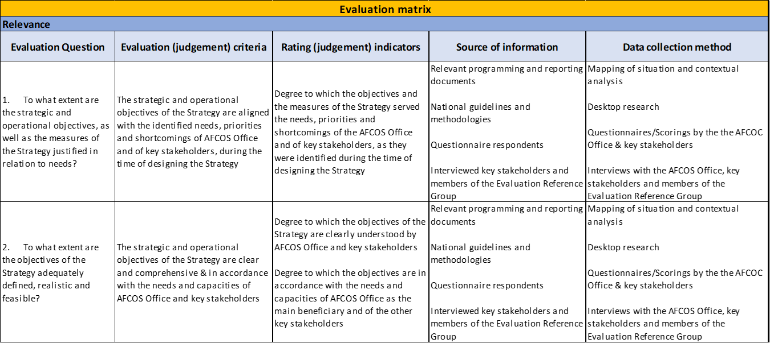

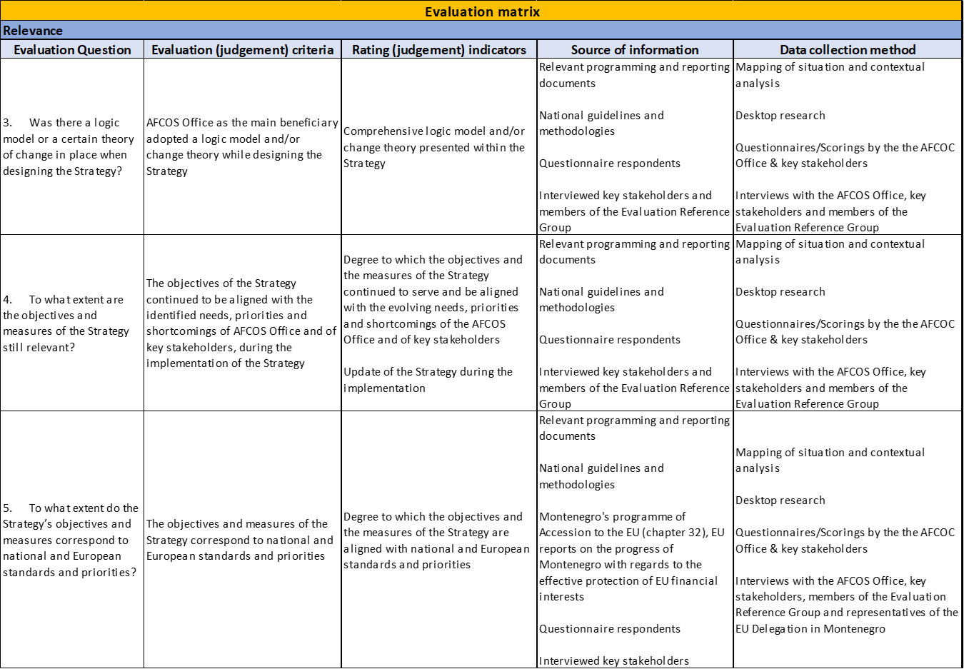

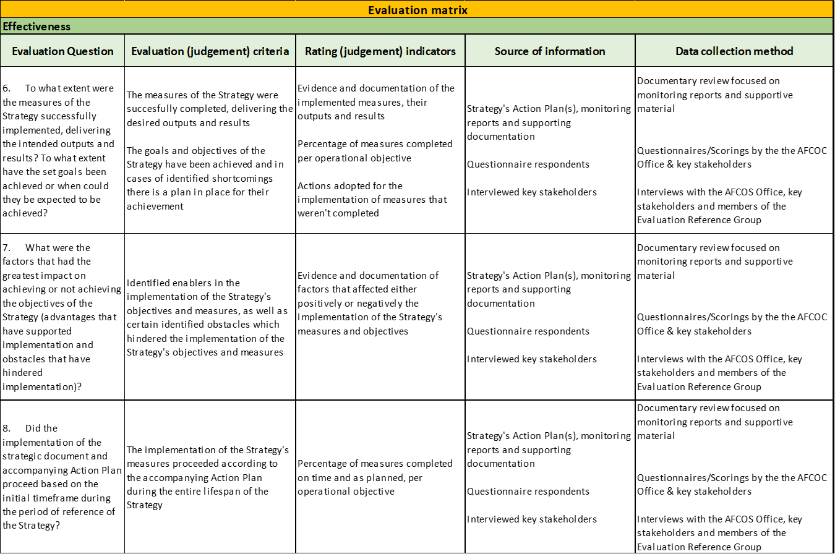
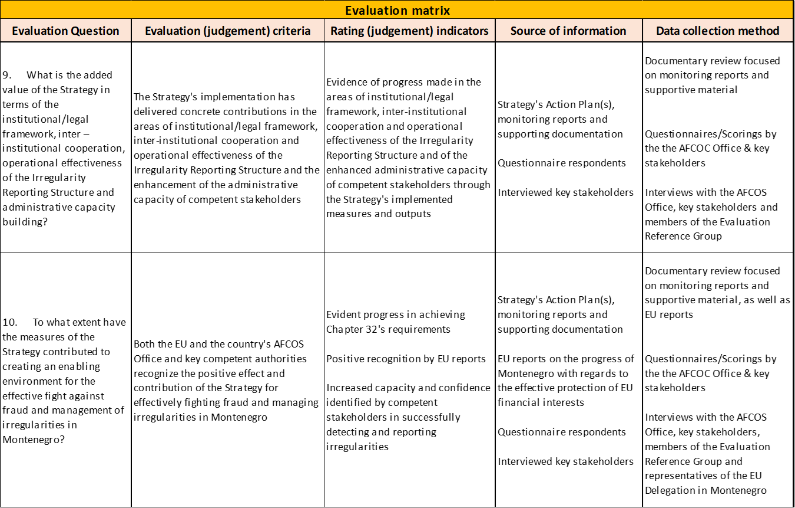

Declaration of the Eu-Western Balkans Summit, Thessaloniki, June 21, 2003
In accordance with internationally accepted standards and recommendations of the EU, the term PIFC implies a comprehensive system that is established to manage, control, audit and report on the use of funds of the national budget and EU funds. Institutional framework: PIFC – Ministry of Finance and Social Welfare and other entities of the public sector at central and local level; External audit – Parliament of Montenegro and the State Audit Institution; Protection of EU financial interests: AFCOS – Ministry of Finance and Social Welfare and the members of the AFCOS network (Ministry of Justice, Human and Minority Rights, Ministry of Interior, Police Administration, Tax Administration, Customs Administration, State Audit Institution, Supreme Public Prosecutor, Agency for Prevention of Corruption); Protection of the euro against counterfeiting – Central Bank of Montenegro, Ministry of Justice, Human and Minority Rights and Police Administration.
COMMISSION REGULATION (EC) No 718/2007 of 12 June 2007 implementing Council Regulation (EC) No 1085/2006 establishing an instrument for pre-accession assistance (IPA I); Commission Implementing Regulation (EU) No 447/2014 of 2 May 2014 on the specific rules for implementing Regulation (EU) No 231/2014 of the European Parliament and of the Council establishing an Instrument for Pre-accession assistance (IPA II)
Government Gazette No. 33/11; Government Gazette No. 50/15, 39/16 and 33/18
Government Gazette No. 04/18
Government Gazette 60/2013).
Strategy for Fight Against Fraud and Irregularity Management for Protection of Financial Interests of the European Union 2015 - 2017
The protection of the revenues of the EU Budget is a competence exercised by the Tax and Customs Authority of Montenegro and as such falls out of the Strategy’s scope.
COMMISSION STAFF WORKING DOCUMENT, Montenegro 2019 Report (29.5.2019) file:///C:/Users/ttsisou/Desktop/MONTENEGRO/EVALUATION/EC%20Annual%20Reports/Montenegro%20Report%202019.pdf
COMMISSION STAFF WORKING DOCUMENT, Montenegro 2020 Report (6.10.2020) file:///C:/Users/ttsisou/Desktop/MONTENEGRO/EVALUATION/EC%20Annual%20Reports/Montenegro%20Report%202020.pdf
COMMISSION STAFF WORKING DOCUMENT, Montenegro 2021 Report (19.10.2021) https://neighbourhood-enlargement.ec.europa.eu/system/files/2021-10/Montenegro%202021%20report.PDF
COMMISSION STAFF WORKING DOCUMENT, Montenegro 2022 Report (12.10.2022) https://neighbourhood-enlargement.ec.europa.eu/system/files/2022-10/Montenegro%20Report%202022.pdf
https://ec.europa.eu/sfc/sites/default/files/EN-ORI-General%20Guidelines%20on%20National%20Anti-Fraud%20Strategies%20ARES%282016%296943965.pdf
https://www.politicheeuropee.gov.it/files/Practical%20steps%20towards%20the%20drafting%20of%20a%20National%20Anti-Fraud%20Strategy.pdf

