GR. I. TASK: EXPLAIN RENEWABLE & NONRENEWABLE ENERGY SOURCES

- There are essentialy two types of energy sources; nonrenewable (also known as conventional) and renewable (also known as alternative) energy sources.
- Renewable types of energy include: solar, wind, hydroelectric, biomass and geothermal energy , while the nonrenewable energy sources include the fossile fuels (coal, crude oil, and natural gas).
- Renewable resources are those which are generally replenished faster than they are being used up, which include: air, water, biomass, the solar radiation and wind. Some types of these can become nonrenewable, providing they're being exploited much faster than they can be restored (for example; the underground water deposits).
- Nonrenewable resources can not be replenished naturally, after they're used up and they include: metalic ore, minerals, crude oil, coal, natural gas. These are protected by rational, economical exploitation as well as prudent management of wastes and losses that arise during production, transport, processing and application, as well as finding the alternative materials that can replace them.
- By excessive use of natural resources humans unfavorably tip the ecosystem ballance. Therefore, the natural cycles of matters and energy in the ecosystems have already been altered significantly by human activity. In fact; the human activity is one of the leading causes that overthrows the ecosystem ballance.
- What are some natural consequences of using the nonrenewable natural resources and energy coming from this? Some of the most worrying include:
- The greenhouse effect
- Global warming
- Expected rise in global temperature for 1 to 3,5°C by 2100. year
- Melting of the icecaps and glaciers
- Climate change, often unpredictable

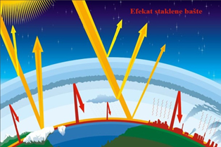
(https://energyeducation.ca/wiki/images/thumb/1/11/Photovoltaiceffect.png/400px-Photovoltaiceffect.png)
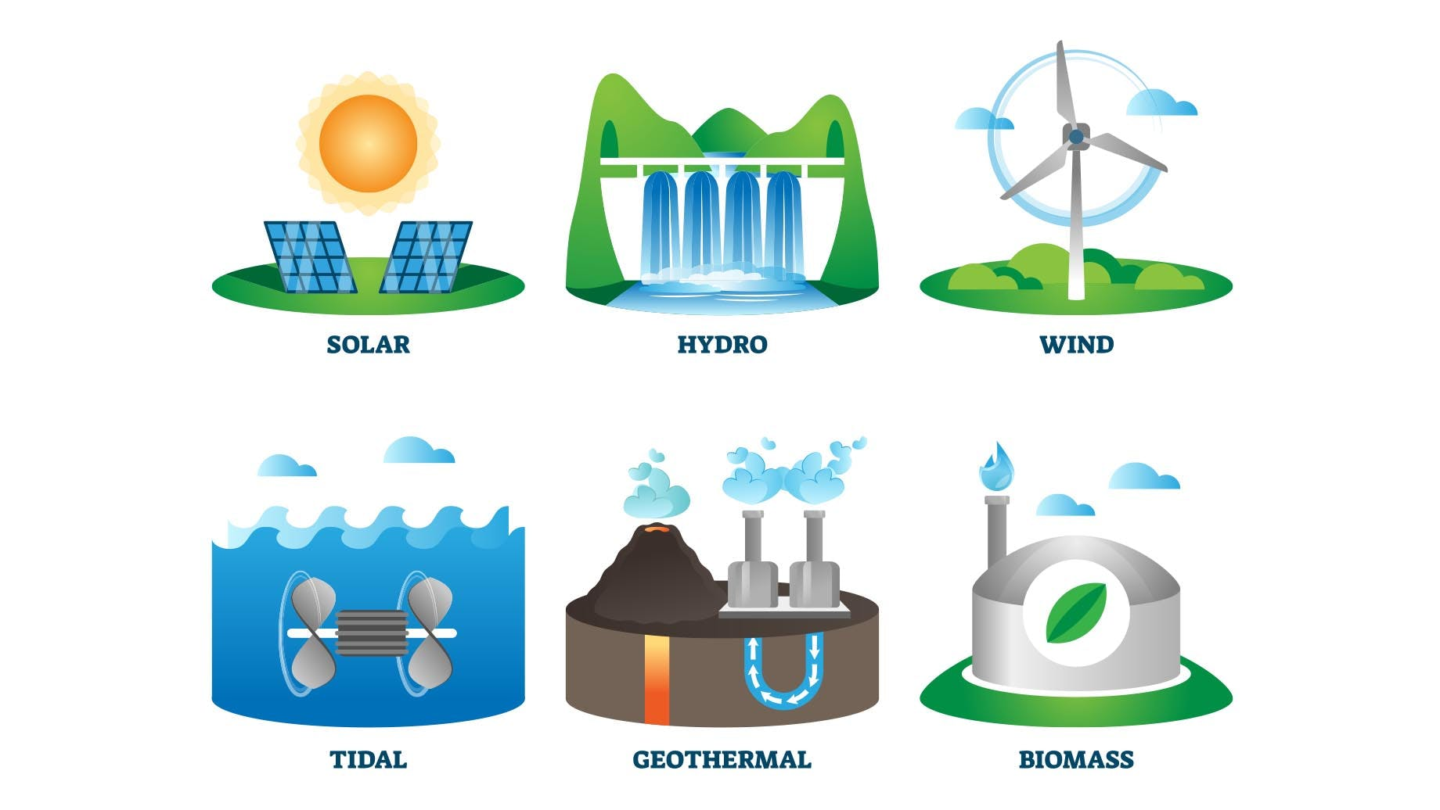
(https://images.prismic.io/inspirecleanenergy/types-of-renewable-energy-sources.jpeg?auto=compress,format&rect=0,0,1840,1036&w=1840&h=1036)

GR. II. Elaborate on the biomass as a renewable source of energy

Biomass is a renewable energy source, made up of several types of plant and animal byproducts.
- From the energy point of view biomass includes all the bio-waste originating from plants and animals that can be used as a fuel of kinds. This includes; but is not limited to; crop wastes, forest residues, purpose-grown grasses, Woody energy crops, microalgae, urban Wood waste and food waste.
- The advantages of using the biomass are: the fuel is accessible and can be used “in situ”, transportation is either not needed or not demanding, and the amounts are constantly replenished.
- Biomass use as a fuel has smaller carbon footprint than that of the coal and other nonrenewable fuels even if it’s not carbon neutral. As one of the possible strategies to prevent air pollution, it’s widely suggested to use more fuels like biodiesel and other biofuels. Unlike conventional fuel (petrol), biofuel does not contain Sulphur (that is the content of Sulphur compounds is extremely low), which in turn helps reduce the optimal conditions for occurrence of acid precipitation.
- Biodiesel also does not contain toxic aromatic compounds such as benzene. The higher O2 content contributes to a reduced particle exhaust output, and complete combustion also reduces the amount of carbon monoxide released.
- As with all other fuels, biodiesel combustion results in the release of CO2. However, since the plants use the atmospheric CO2 (in the photosynthesis process) for growth, the CO2 amounts released by combustion of the biodiesel, is generally balanced with the amount absorbed during annual development of the plants grown for vegetable oil production.

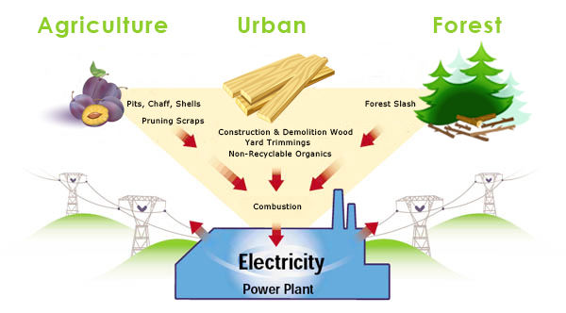
(https://www.calbiomass.org/wp-content/uploads/2013/02/biomass-fuel-sources.jpg)

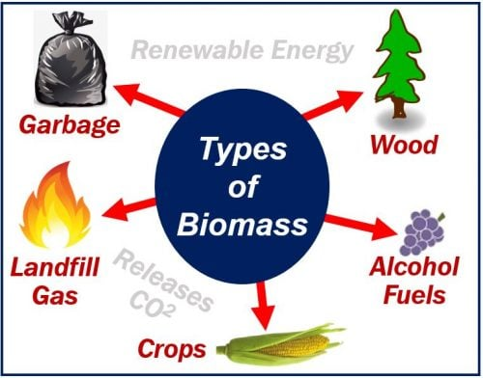
(https://marketbusinessnews.com/wp-content/uploads/2018/09/Biomass-500x392.jpg)

GR III. ELABORATE ON SOLAR RADIATION AS A RENEWABLE ENERGY SOURCE

- Even though the sunlight is an unlimited source of energy for the Earth’s biosphere, it’s harnessing rquires special equipment. Usability of solar radiation depends greatly on the equipment used, and therefore it’s natural to expect larger initial investment in equipments and facilities.
- Solar radiation can be converted to electric power by means of photovoltaic cells (syn. Solar cells), or to thermal power by means of energy collectors and heat exchnagers.
- Most solar panels are about 20% efficient. That means about 20% of the solar energy it collects is converted into electrical energy, and while it may seem like a small percent, considering that the energy imput is passive, and renwable, it really pays off long term.
- A common myth is that the solar panels don't work at night or when it's cloudy. Solar panels technically still function at night, but they won't be generating much, or any electricity. However, they will still produce fair ammount of electricity during cloudy weather. As long as there's at least a little sunlight, solar panels will generate electricity

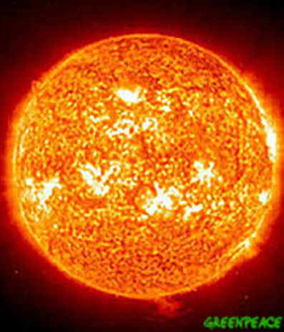
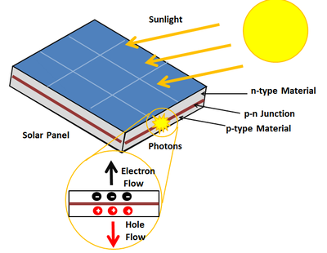

(https://energyeducation.ca/wiki/images/thumb/1/11/Photovoltaiceffect.png/400px-Photovoltaiceffect.png)

GR IV. ELABORATE ON THE USE OF WIND POWER

- During the last millennium, the wind power has been used in all of its different forms and for different purposes; as a propelling force for ships, as a source for mechanical force needed in irrigation or food production like flour milling (windmills) etc. "Wind farms" (syn. Wind parks, wind power plants) are a popular source of energy in areas with frequent winds.
- The mechanism of using wind power to produce electricity is rather simple; the wind turbines harness energy from the wind using mechanical power to spin a generator and create electricity
- Wind power is a clean energy source, the use of wind turbines is not associated with increased pollution.
- There has been a great expansion in the use of wind power during the 2000s; (in 2001st there was an increase in 70% of electricity produced by wind farms, in comparison to the 2000th.). The amount of electricity generated by wind increased by 265 TWh in 2022 (up 14%)

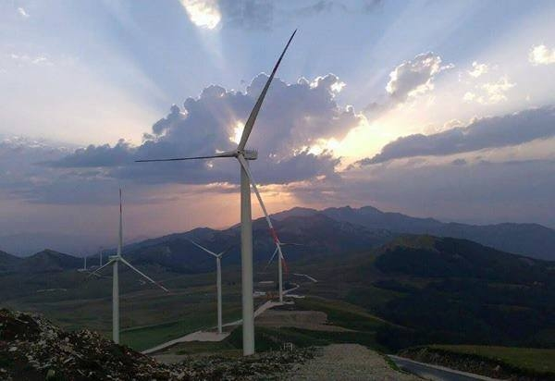

The Krnovo Windmill park, Montenegro

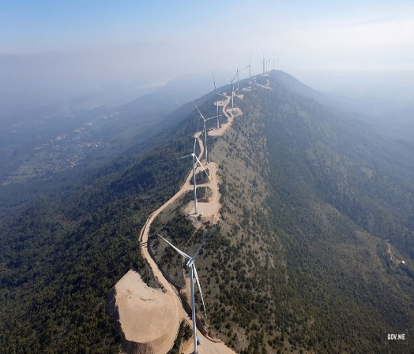

The Mozura Windmill station , Montenegro

GR. V ELABORATE ON THE USE OF HYDROENERGY

- Energy obtained from the water (hydroelectricity) is a significant, renewable energy source, and also the only one that can economically compete with the fossil fuels and nuclear energy based energy production.

- The hydroelectricity application is dependent on the presence of fast flowing lotic water systems (rivers, streams etc.) and their availability throughout the whole year.
- Montenegro has an enormous hydroelectric potential. The state rivers are very fit for construction of hydropower installations, the largest two in the Montenegro are: HE Piva and HE Perućica.
- Hydropower is also a very clean form of energy much like wind power.
- Impoundment hydropower creates reservoirs that offer recreational opportunities such as fishing, swimming, and boating.

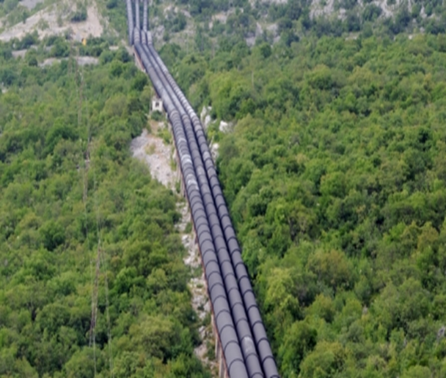
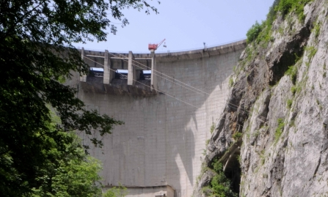
HE Piva, Montenegro
HE Perućica, Montenegro

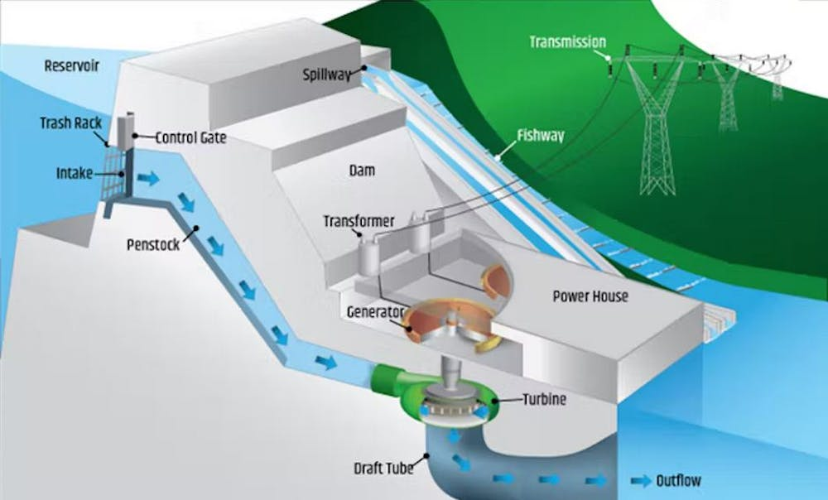
(https://theconversation.com/what-is-hydroelectric-energy-and-how-does-it-work-190886)

