Local publication for call for proposals
Cross - Border Cooperation Programme Montenegro - Kosovo (2014 – 2020) – 1st Call for Proposal
EuropeAid/138-710/ID/ACT/MULTI

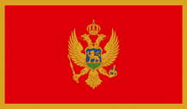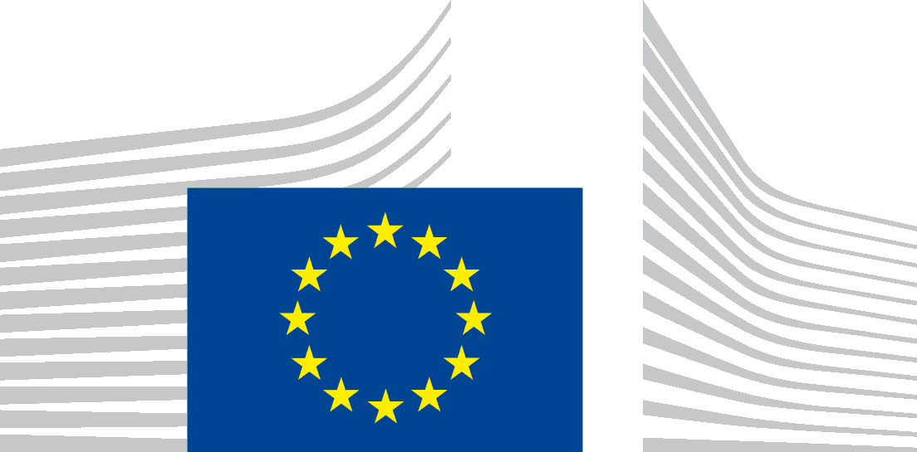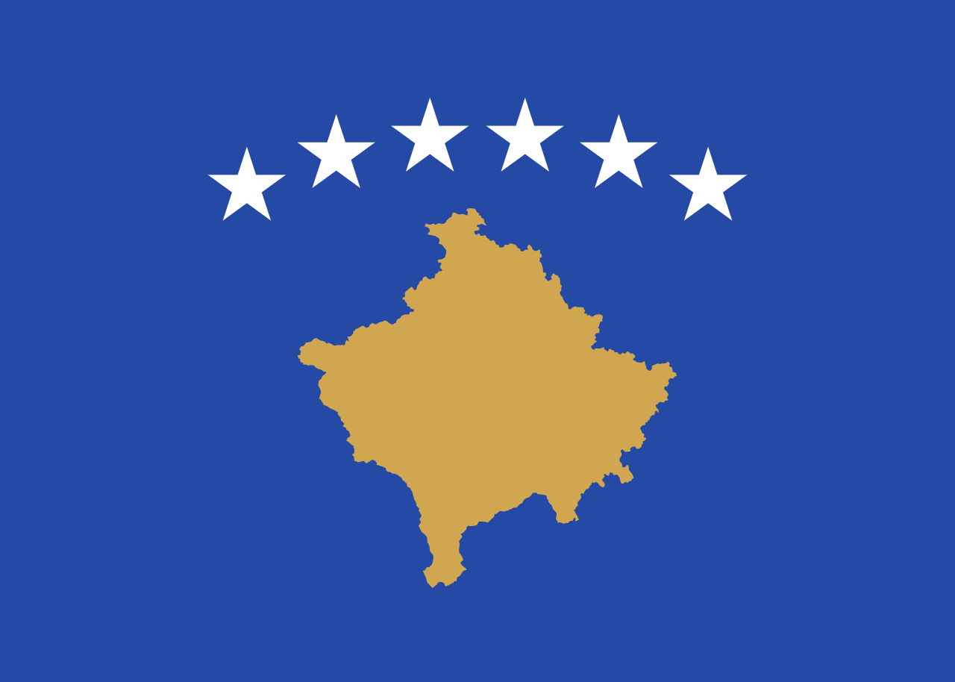
The Directorate for Finance and Contracting of the EU Assistance Funds of the Ministry of Finance of Montenegro is seeking proposals for improvement the standard and quality of living of the people through the environmentally sustainable and socially inclusive economic development of the border regions in Montenegro/Kosovo with financial assistance from the Cross - Border Cooperation Programme Montenegro - Kosovo (2014 – 2020).
The full Guidelines for Applicants are available for consultation at:
The Ministry of Finance
The Directorate for Finance and Contracting of the EU Assistance Funds (CFCU)
Stanka Dragojevića 2
81 000 Podgorica, Montenegro
and on the following internet sites:
- https://webgate.ec.europa.eu/europeaid/online-services/index.cfm?do=publi.welcome
- http://www.mf.gov.me/rubrike/CFCU_tenderi/Tenderi/Otvoreni
The deadline for submission of concept notes is 25th April 2017 at 16:00h (local time).

An information session on this call for proposals will be held in:
- Podgorica - 20th March 2017
- Bijelo Polje - 21st March 2017
- Djakovica (Gjakovë) - 22nd March 2017
- Peć (Pejë) - 23rd March 2017
Time and place will be published after publishing call for proposals on:
the EuropeAid website:
- https://webgate.ec.europa.eu/europeaid/online-services/index.cfm?do=publi.welcome
the website of the Contracting Authority:
- http://www.mf.gov.me/rubrike/CFCU_tenderi/Tenderi/Otvoreni

