GUIDELINES
FOR CREATING
A LESSON PLAN
#litterlessplus

This document provides teachers with guidelines on developing a lesson plan on the subject of pollution. To improve your chances of winning the Litter Less Plus Competition, please fill-in as many details as possible and bear in mind that your lesson plan needs to address one or more of the following topics:
  - Reduction of litter and waste
  - Promotion of responsible production and consumption
  - Increasing knowledge and taking actions to reduce invisible pollutants
  - Promotion of the circular economy model

We thank you in advance for your participation and will do our best to share it with our network.
- Foundation for Environmental Education

- AUTHOR DETAILS

- Name/s | Miloš Laković
- Country | Montenegro
- Institution/School | Primary school ‘’Oktoih’’
- Email | milos.lakovic@os-oktoih.edu.me
- Programmes the school is participating in (Eco-Schools/LEAF/YRE/other) | /
- Would you like to receive monthly updates through our Newsletter? Yes/No | No
- Submission date (dd/mm/yyyy) | 30.08.2023.

- THE LESSON PLAN

- Theme – Campaign against litter and waste

- Introduction – This lesson plan aim is to educate students about their daily based behaviour to the environment and how to properly dispose and remove litter and waste. This will be conducted through the creating and promoting campaign against waste.

- Age Group – Age group 12-16

- Objectives or Learning Outcomes –

Students will be able to:

  - Recognize the danger of litter and waste to the animals, environment and humans.
  - Define some new diverse ways of waste removal
  - Create a campaign against bad environmental behaviour.
  - Present this campaign peer to peer

- Time required to deliver the lesson plan –
Classroom session 1 (45 minutes): Introduction of the problem that waste can cause to the environment
Home group assignment (120 minutes): Students in groups are creating campaign against the bad environmental behaviour
Classroom session 2 (45 minutes): Discussion about created campaigns and choosing the best one or creating one great campaign from all group assignments
Last session (45 minutes): Peer to peer education, promoting campaign to the other students

- Remote preparation - (if any) Anything that you (or the students) need to do BEFORE the lesson. (e.g. collect and bring to school 3 items labelled as hazardous)
-
- Planning considerations - /

- Resources Required to deliver the lesson plan – Internet, Lap top, trash bags, writing material, flipcharts, cardboard boxes

- Activity – Steps or description of how the lesson will be conducted/facilitated by the teacher.

Structure your description using these main headings:
Activity 1: Classroom session 1 (45 minutes)
  - Introduction of the problem to the students: Teacher is presenting the problem of waste our country is having
  - Development: Through creative workshop with diverse methods teacher is presenting what ‘’common’’ waste can do to the animals, humans and environment if it’s not removed accordingly.
The teacher presenting how we can fight against this practise of bad behaviour and how to conduct a campaign
The teacher divide students in the groups (4 students by one group) and giving them a task to create campaign against litter and waste.
  - Conclusion: The teams are having some discussions about organizing the work and teacher is leading this process. The teacher is providing the material and plan for the home assignments.

Activity 2: Home group assignment (120 minutes)
a. Introduction: Students work in groups at homes
b. Development: Students are creating a campaign and they share the ideas for it. They are using information gained from the teacher.
Every group is choosing photos and titles of the campaigns. They are using materials for creating logos.
c. Conclusion: Every group is creating their own campaign.

Activity 3: Classroom session 2 (45 minutes)
a. Introduction: Students present their findings and teacher facilitates discussions about each group’s campaigns
b. Development: After presentations of each group, teacher starts a class debate about the collected information and created materials for the campaign. The aim is to use materials for creating one common campaign.
Students are preparing their presentations to the other classes together with teacher.
c. Conclusion: Students decide what campaign they will use on peer to peer education through voting using Google forms.

Activity 4: Last session (45 minutes): Peer to peer education, promoting campaign to the other students
a. Introduction: Students are sharing their knowledge to the other classes.
b. Development: Students presentation of all gained knowledge through the campaign they prepared.
c. Conclusion: Other students get familiar with the topic of bad influence of waste and litter

- Evaluation and Assessment –
Students do their presentations to other groups in the school. The teacher provides to students a self-evaluation form which will help to understand how students evaluate their individual and group performance. Also, it will provide students perceptions on how the activity had an impact on learning and consolidating knowledge.

- Dissemination – How will you communicate about the products of the lesson for awareness raising? If your lesson plan has already been implemented, attach a link of a product produced during the lesson

The plan is that this campaign that students will create we share to the other schools and this will reach a respectable number of students that will learn about good practices of removal of litter and waste.

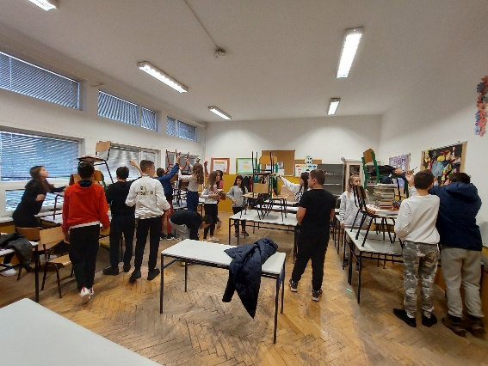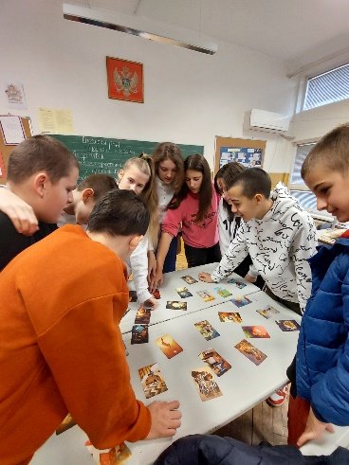
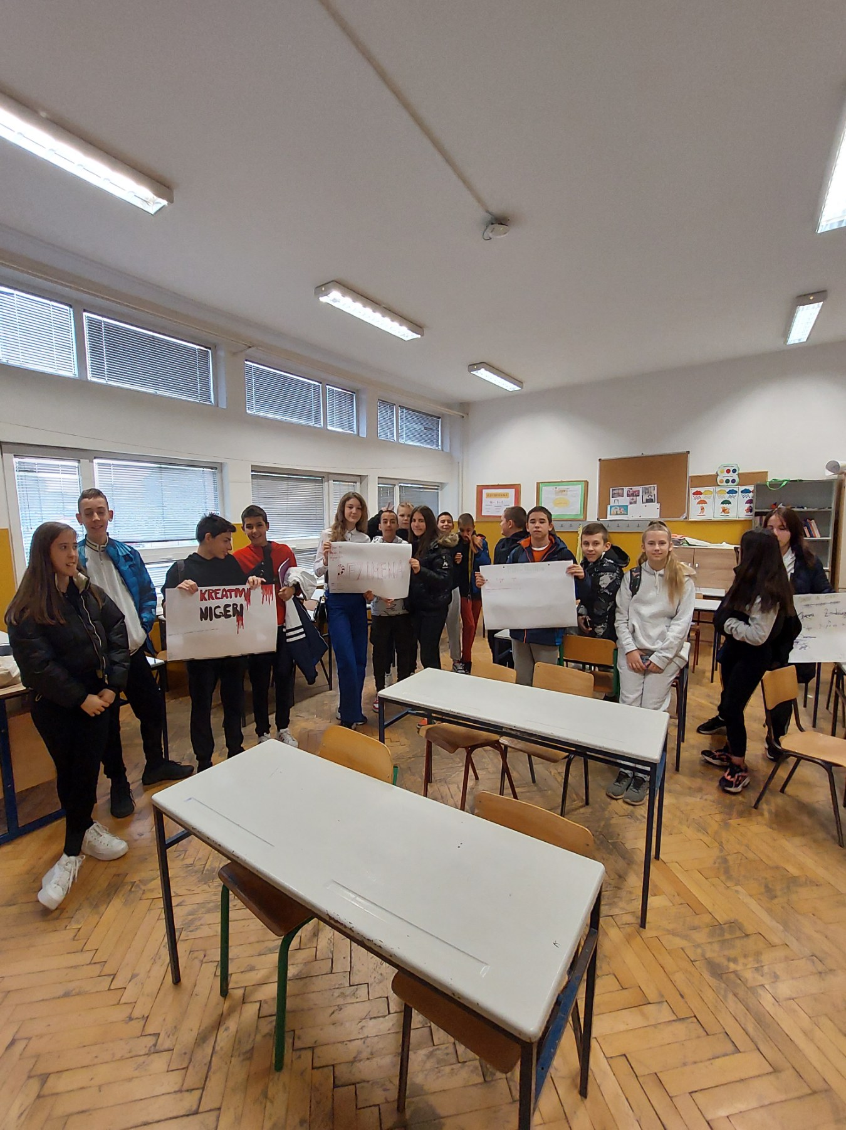

- Follow-up activity - (if any) One school class after all activities with students for follow-up

- Adaptations for students with learning difficulties – (if any)

- Extension for gifted students – (if any)

- Background information for teachers - Include any website links and resources that would provide teachers with useful information about the lesson’s topic
https://drive.google.com/file/d/1WwNACZWibrwe5qTUBCq9iRBd-4Ywe3k5/view?usp=drive_link
https://drive.google.com/file/d/1itNCAP-qOJ4_CaA1kDPf9zkRM6Xor9Pq/view?usp=drive_link
https://www.youtube.com/watch?v=WfGMYdalClU

- References – Acknowledge the resources that were used while developing the Lesson Plan.

