Report on the execution of the budget of Montenegro in the period January – July 2021
(GDDS table 7)
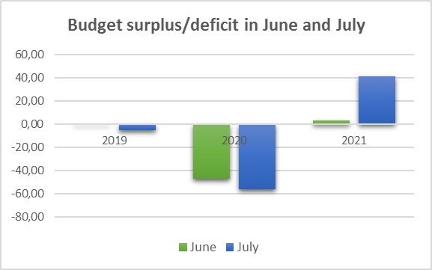
The positive result in the movement of fiscal indicators after June this year, continued in July, as evidenced by the realized budget surplus of 41.3 mill. € or 0.9% of estimated GDP.
The budget surplus in June and July 2021 indicates a significant recovery of economic activity, especially bearing in mind that in June and July 2019, the record in the realized revenues from tourism, the budget deficit amounted to 0.8 mill. € and 5.3 mill. €. The surplus in these two months of 2021 was recorded even after a large decline in 2020, when the deficit was 47.2 mill. € in June, i.e. 56.3 mill. € in July.
The main generators of the achieved result are good collection of revenues on the one hand, i.e. lower realization of expenditures compared to the originally planned, on the other hand.
According to the movement of revenues and expenditures, in the period January - July 2021, the deficit is lower by 86.4 mill. € or 42.1% of the planned and amounted to 118.9 mill. € or 2.6% of GDP. That is for 151.8 mill. € or 56.1% lower deficit compared to 2020.
Budget revenues in the period January - July 2021 amounted to 982.0 mill. € or 21.2% of GDP, which compared to the same period last year increased by almost 100.0 mill. € or 11.3%, while in relation to the plan they are at the level of 99.6%. If revenues from donations were excluded from the plan, i.e. execution, which primarily depend on the dynamics of withdrawal of funds from donors, total budget revenues would be realized above the plan by 7.6 mill. €, which shows the effect of economic activity growth on collection of budget revenues.

The recorded growth of revenues was mostly contributed by the growth of collection of revenues on the basis of value added tax, which are higher compared to the same period last year by 42.8 mill. € or 14.2%. Compared to the plan, revenues on this basis are higher by 14.7 mill. € or 4.5%, which indicates the recovery of economic activity, but also greater tax discipline, as well as the achieved positive effects from the implementation of electronic fiscalization of tax registers.

Revenues from excises also recorded an increase compared to the comparable period in 2020, as well as compared to the plan by 8.6 mill. € or 7.5%, or 6.3 mill. € or 5.4%. This growth in the period so far compensates for the planned effect of the proposed legal solutions, which are in the parliamentary procedure.

Growth for the seven months of the current year compared to last year was recorded by taxes and contributions on salaries in the amount of 16.1 mill. € or 4.9%.

Significant growth compared to the comparable period in 2020 was recorded in the category of other revenues in the amount of 27.0 mill. € or almost three times, due to payments of profits made in 2020 from majority state-owned companies, which further contributed to the stabilization of budget opportunities in the current year.
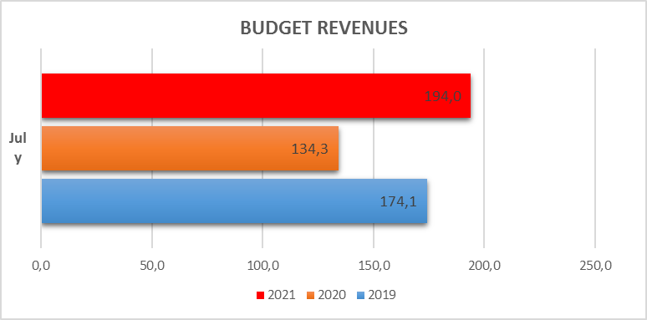
Budget revenues in July amounted to 194.0 mill. €, which is compared to the same month last year higher by 59.7 mill. € or 44.5%. The realized collection in July is also above July 2019 by 19.8 mill. € or 11.4%.

Budget expenditures in the period January - July 2021 amounted to 1,100.9 mill. € or 23.7% of the estimated GDP and are lower than planned by 90.0 mill. € or 7.6%. Compared to the same period in 2020, budget expenditures are lower by 51.9 mill. € or 4.5%.
Almost all categories of expenditures were recorded less than planned.
In the structure of budget expenditures, current expenditures were realized at the level of 477.4 mill. € and are lower by 45.6 mill. € or 8.7% compared to the planned. Compared to the comparable period in 2020, current expenditures are lower by 13.7 mill. € or 2.8%.
Capital expenditures were realized in the amount of 75.7 mill. €, which is 39.5 mill. € or 34.3% less than planned, while compared to the execution in the same period in 2020 they are lower by 33.4 mill. € or 30.6%. The realization of capital expenditures is largely determined by the realization that depends on the dynamics of works, and is expected to be significantly improved in the coming period, especially including the fact that the main section of the highway should be completed by November 30 this year.
Compared to the previous year, higher realization were recorded in:
Gross salary and contributions in the amount of 24.7 mill. € or 8.5% due to the increase in salaries in the sectors of Health and Education, as well as the different treatment of the gross salary fund of the University of Montenegro during 2020 compared to the 2021.
Reserves, primarily due to the allocation of funds for the founding capital of the new national airline "To Montenegro", but also monthly allocations based on subsidizing the salaries of employees in vulnerable activities defined by packages of measures to support citizens and the economy.
Repayment of liabilities from the previous period as a result of enforced collection based on the debt of "Montenegro Airlines" to "Airports of Montenegro".
Attachment: GDDS 7 montly data.xlsx
* The data in the GDDS table represents an overview of income and expenses by economic classification in one month, compared to the plan and the same period of the previous year.

Budget revenues refer to the net amount of collected revenues (gross revenues collected by the Revenue and Customs Administration reduced by refunds and redirections). Pursuant to legal solutions, a part of certain tax forms and other revenues belongs to the local government (through direct assignment or the Equalization Fund) or other public institutions.
In 2020, all costs of the University of Montenegro (including gross salaries) were planned on the expenditure category of Transfers, while temporary financing was used to reclassify expenditures, which increased the total fund of gross salaries in 2021.

