Pursuant to Article 163, paragraph 8, Article 170, paragraph 5 and Article 177, paragraph 4 and 7 of the Law on Foreigners ("Official Gazette of Montenegro", No. 12/18), the Ministry of Interior passed

RULEBOOK
ON REASONS FOR REQUIREMENTS AND PERMITS FOR THE TEMPORARY AND PERMANENT STAY OF CITIZENS OF MEMBER STATE OF THE EUROPEAN UNION AND MEMBERS OF THEIR FAMILIES *

Article 1

This Rulebook prescribes the application form for the issuance of a temporary residence permit for a member of the family of a citizen of a Member State of the European Union who is a third-country national, the application form for the issuance of a permanent residence permit for a citizen of a Member State of the European Union, the application form for issuance of a permanent residence permit for a member of the family of a citizen of a Member State of the European Union who is a third-country national, a temporary residence permit form issued to a member of the family of a national of a Member State of the European Union who is a third-country national, a permanent residence permit form issued to a national of a Member State of the European Union, issued to a member of the family of a national of a Member State of the European Union who is a national of a Member State of the European Union, a permanent residence permit form issued to a member of the family of a national of a Member State of the European Union who is a third-country national, data contained in a machine readable record, as well as the amount of compensation for the costs of drawing up the forms of such permits.

Article 2

The terms used in this Rulebook for male physical persons shall mean the same terms in the feminine gender.

Article 3

The terms used in this Rulebook have the following meanings:
1) a foreign travel document is a passport, a family passport, a joint passport, a diplomatic passport, an official passport, a naval booklet, a brochure and other travel document recognized in accordance with international agreements, on the basis of which the identity of its holder, in accordance with the regulations on issuing travel documents of another state;
2) a third-country national is a foreigner who has no nationality of a Member State of the European Union.

Article 4

The application for the issuance of a temporary residence permit of a member of the family of a citizen of a Member State of the European Union who is a third-country national shall be submitted on the form containing: name: "Montenegro", name of the authority to which the application is lodged, date of filing and number of applications, in the bar code format, a note stating that the application is filled in legibly printed letters, the name: "APPLICATION FOR ISSUANCE OF A PERMIT FOR A TEMPORARY STAY OF A FAMILY MEMBER OF A MEMBER STATE OF A EUROPEAN UNION THAT IS A THIRD-COUNTRY NATIONAL", legal basis, places for entering data on: (unique registration number, gender, last name, first name, date and place of birth, country of birth, citizenship, marital status, level of education and qualifications, profession and date of entry into Montenegro); duration of stay; staying in Montenegro and residing in the country of origin; the valid foreign travel document or identity card issued by the competent authority of the other country (number, date to which the name of the issuing authority also applies) and parents (unique identification number, surname and name, and for mother a maiden name); the applicant's consent to the notification of the status of the application; the applicant's statement on the accuracy of the entered data, the obligation to notify about the change of personal data, and the consent to electronically process his personal data, as well as the telephone number and signature of the applicant (Form 1).

Article 5

The application for a residence permit for a citizen of a Member State of the European Union and the application for a residence permit for a permanent member of a family member of a Member State of the European Union who is a national of a third country shall be submitted on a form containing: the name of the body to which the application is lodged, the number of request, the number of request in the format of the bar code, the note that the request is filled in plain text, the name: "APPLICATION FOR THE ISSUANSE OF A PERRMIT FOR PERMANENT RESIDENCE", whether the application is submitted by a citizen of a Member State of the European Union or a member of the family of a member state of the European Union which is a third-country national; legal base, places of entry of data on: applicant (unique identification number, gender, surname, name, birth surname, date and place of birth, country of birth, citizenship, marital status, level of education and qualification and occupation); stay in Montenegro and residence in the country of origin; the last and the first approved temporary stay; a valid foreign travel document or a personal card issued by the competent authority of the other country (number, date and the name of the body issuing the document) and parents (unique family number, family name and maiden name of a mother); the applicant's consent to the manner of notifying the status of the application; the claimant's statement on the accuracy of the entered data, the obligation to notify the personal data changes and the consent to his personal data being processed electronically, as well as the telephone number and the signature of the applicant (Form 2).

Article 6

Temporary residence permit issued to a member of the family of a citizen of a Member State of the European Union who is a third-country national (Form 3) is of a rectangular shape, in the form of a card of 86 mm x 54 mm, made of multilayer polycarbonate, which incorporates protective elements.
The form referred to in paragraph 1 of this Article has been manufactured in accordance with ISO / IEC 7810 standards for dimensions and physical characteristics and ISO / IEC 10373 for physical characteristics testing.
The form referred to in paragraph 1 of this Article, on the front, in the upper left corner, contains the Coat of Arms of Montenegro, and in the central upper part the name: "Montenegro" and "PERMIT FOR A TEMPORARY STAY OF A MEMBER STATE OF A FAMILIY OF THE EU MEMBER STATE WHO IS A THIRD-COUNTRY NATIONAL" under the Coat of Arms of Montenegro, a 28mm x 35mm dimension photograph and an optically variable security element kinegram with the Montenegrin border theme, Coat of Arms of Montenegro, and "MNE" marking the right end of the photo. On the right side of the photo there is an engraved "CG" protective element and the place for: the last name and the name, gender, citizenship and date of birth of the person who is being issued a permit, license number, date of issue, the date and the signature of the person to whom the permit is issued.
The form referred to in paragraph 1 of this Article, on the back, contains spaces for: the unique legal number of the person being issued the permit, the name of the issuing authority, in the upper right corner of the application form the borders of Montenegro with the drawn rivers and in the lower part of the area for the machine readable record.

Article 7

A residence permit form issued to a national of a Member State of the European Union and a residence permit form issued to a member of the family of a national of a Member State of the European Union who is a national of a Member State of the European Union (Form 4) is of a rectangular form, in the form of a card, mm x 54 mm, made of multilayer polycarbonate, in exemplary tones of predominantly blue color, in which protective elements are embedded.
The form referred to in paragraph 1 of this Article has been manufactured in accordance with ISO / IEC 7810 standards for dimensions and physical characteristics and ISO / IEC 10373 for physical characteristics testing.
The form referred to in paragraph 1 of this Article, on the front, in the upper left corner, contains the Coat of Arms of Montenegro, and in the central upper part of the name: "Montenegro" and "PERMIT FOR PERMANENT STAY OF A CITIZEN OF A MEMBER STATE OF THE EUROPEAN UNION" a photo of a 28-mm x 35 mm-wide license, and an optically variable security element kinegram with the Montenegrin border theme, Coat of Arms of Montenegro, and the "MNE" marking the right part of the photo. On the right side of the photo there is an engraved "CG" protective element and places for: the last name and the name, gender, citizenship and date of birth of the person to whom the permit is being issued, permit number, date and the signature of the person to whom the permit is issued.
The form referred to in paragraph 1 of this Article, on the back, contains the places for: the unique registration number of the person being issued the permit, the date of issue, the name of the issuing authority, in the upper right corner of the application form the borders of Montenegro with the drawn rivers, space for machine readable record.

Article 8

A residence permit form issued to a member of the family of a citizen of a Member State of the European Union who is a third-country national (Form 5) is of a rectangular shape, in the form of a card of 86 mm x 54 mm, made of multilayer polycarbonate, which incorporates protective elements.
The form referred to in paragraph 1 of this Article has been manufactured in accordance with ISO / IEC 7810 standards for dimensions and physical characteristics and ISO / IEC 10373 for physical characteristics testing.
The form referred to in paragraph 1 of this Article, on the front, in the upper left corner, contains Coat of Arms of Montenegro, and in the central upper part of the name: "Montenegro" and "PERMIT FOR A PERMANENT STAY OF A MEMBER OF A FAMILY OF A CITIZEN OF THE EU MEMBER STATE WHO IS A THIRD-COUNTRY NATIONAL" under the Coat of Arms of Montenegro, a 28mm x 35mm dimension photograph of a person to whom the permit is being issued and an optically variable security element kinegram with the Montenegrin border theme, Coat of Arms of Montenegro, and "MNE" marking the right part of the photo. On the right side of the photo there is an engraved "CG" protective element and places for: the last name and the name, gender, citizenship and date of birth of the person to whom the permit is issued, license number, date and the signature of the person to whom the permit is issued.
The form referred to in paragraph 1 of this Article, on the back, contains places for: the unique registration number of the person issuing the permit, the date of issue, the name of the issuing authority, in the upper right corner of the application form the borders of Montenegro with the drawn rivers, space for machine readable record.

Article 9

Machine-readable filing of license forms from Art. 6, 7 and 8 of this Rulebook contains information in accordance with the regulation establishing the contents of the machine readable form of temporary residence permit form, temporary residence permit and work permit and permanent residence permit.

Article 10

The amount of reimbursement of the costs of making the permit form referred to in Art. 6, 7 and 8 of this Rulebook shall be EUR 5.00.

Article 11

Forms no. 1 to 5 are an integral part of this Rulebook.

Article 12

This Rulebook shall be published in the "Official Gazette of Montenegro" and will come into force on the day of Montenegro's accession to the European Union.

* This Rulebook contains provisions of the Directive of the European Parliament and of the Council of 29 April 2004 on the right of citizens of the Union and their family members to move and reside freely within the territory of a Member State, amending the Regulatory (EEC) no. EEC, 90/364 / EEC, 90/364 / EEC, 90/364 / EEC, 75 / 365 / EEC and 93/96 / EEC.

01Number: 011 / 18-88684 / 2
Podgorica, 26 December, 2018
Minister,
Mevludin Nuhodžić

Form 1
Crna Gora
Ministarstvo unutrašnjih poslova Zahtjev se popunjava čitko štampanim slovima
Područna jedinica / Filijala
BARCODE
Broj:
Mjesto, godine.

ZAHTJEV ZA IZDAVANJE DOZVOLE ZA PRIVREMENI BORAVAK ČLANA PORODICE DRŽAVLJANINA DRŽAVE ČLANICE EVROPSKE UNIJE KOJI JE DRŽAVLJANIN TREĆE DRŽAVE / APLICATION FOR TEMPORARY RESIDENCE PERMIT FOR A FAMILY MEMBER OF AN EU MEMBER STATE NATIONAL, WHO IS A THIRD-COUNTRY NATIONAL
Pravni osnov:
Legal rationale:

Matični broj / Матични број: Pol / Пол: 1. muški / мушки 2. ženski / женски Jezik-pismo / Језик-писмо: _______________________
Prezime / презиме: Lice daje podatke za / Лице даје податке за
Ime / Име: _________________________________ 1. roditelj / родитељ
Rođ. пrezime / Рођ. презиме: __________________ 2. staratelj / старатељ
Datum rođenja / Датум рођења: ________________ Mjesto rođenja / Мјесто рођенја: ____________________
Država rođenja / Држава рођења: _______________ Državljanstvo / Државлјанство: _____________________
Stepen stručne spreme / Степен стручне спреме: ______________________
Vrsta stručne spreme / Врста стручне спреме: _________________________
Zanimanje / Занимање: _____________________
Država boravka / Држава боравка: _________________ Mjesto boravka / Мјесто боравка: ___________________
Adresa / Адреса: ____________________________________________________

Jedinstveni matični broj: Pol: muški ženski
Unique citizen number: Sex: male female
Prezime:
Surname: Bračno stanje/Marital status:
Ime: nije u braku / single
Name: u braku / married
Rođeno prezime: razveden/a / divorced
Birth name: udovac/ica / widowed

Datum rođenja: Mjesto rođenja:
Date of birth: Place of birth:
Država rođenja: Državljanstvo:
Country of birth: Nationality:

Nivo obrazovanja: Kvalifikacije:
The Degree of Qualification: Type of Professional Qualification:
Zanimanje:
Occupation:
Datum ulaska u Crnu Goru:
Date entry into Montenegro:

Predviđeno trajanje boravka: od do
Anticipated period of stay: from to

Boravak u Crnoj Gori/ Residence in Montenegro:
Opština / Residence City: Mjesto / Place of residence:
Adresa / Address:
Prebivalište u državi porijekla/Residence in the country of origin:
Država / Country: Opština / City:
Mjesto / Place:
Adresa / Address:

Vrsta isprave / Type document:
Broj isprave: važi do
Document Nr: date of expiry
Organ koji je izdao putnu ispravu:
The authority that has issued the travel document

Otac / Father:
Jedinstveni matični broj / Unique citizen registering number:
Prezime / Surname: Ime / Name:

Majka / Mother:
Jedinstveni matični broj Prezime / Surname
Unique citizen registering number:
Ime / Name: Rođeno prezime/Birth name:

Saglasan sam da o statusu zahtjeva budem obaviješten putem / I agree to be informed on the application status via:
- WEB portala Ministarstva / the Ministry WEB Portal,
- slanjem e-mail-a / e-mail,
- Na adresu boravka / the residence address.

Izjava podnosioca zahtjeva / Applicant's statement:
a) Ovim potvrđujem da su svi podaci navedeni u ovom zahtjevu tačni i da odgovaraju podacima u priloženim dokumentima.
Hereby I confirm that all information given in this application form are complete, that they are true and correspond to the data contained in the documents attached.
b) Ovim se obavezujem da ću svaku promjenu ličnih podataka, prije ulaska u Crnu Goru, putem diplomatsko-konzularnog predstavništva Crne Gore dostaviti nadležnim organima Crne Gore.
Hereby I oblige, that I will communicate any change of my personal data to the Montenegro competent authorities through diplomatic missions or consular offices of the Montenegro before entering to Montenegro.
c) Saglasan sam da moji lični podaci budu elektronski obrađeni.
I agree that my personal data are computer processed.

Broj telefona / Phone Potpis podnosioca zahtjeva / Signature of the applicant

Form 2
Crna Gora
Ministarstvo unutrašnjih poslova Zahtjev se popunjava čitko štampanim slovima
Područna jedinica / Filijala
BARCODE
Broj:
Mjesto, godine.

ZAHTJEV ZA IZDAVANJE DOZVOLE ZA STALNI BORAVAK(zaokružiti odgovarajući broj) /
APLICATION FOR PERMANENT RESIDENCE PERMIT (circle correct number)

- državljanin države članice Evropske unije
- član porodice državljanina države članice Evropske unije koji je državljanin treće države
Pravni osnov:
Legal rationale:

Matični broj / Матични број: Pol / Пол: 1. muški / мушки 2. ženski / женски Jezik-pismo / Језик-писмо: _______________________
Prezime / презиме: Lice daje podatke za / Лице даје податке за
Ime / Име: _________________________________ 1. roditelj / родитељ
Rođ. пrezime / Рођ. презиме: __________________ 2. staratelj / старатељ
Datum rođenja / Датум рођења: ________________ Mjesto rođenja / Мјесто рођенја: ____________________
Država rođenja / Држава рођења: _______________ Državljanstvo / Државлјанство: _____________________
Stepen stručne spreme / Степен стручне спреме: ______________________
Vrsta stručne spreme / Врста стручне спреме: _________________________
Zanimanje / Занимање: _____________________
Država boravka / Држава боравка: _________________ Mjesto boravka / Мјесто боравка: ___________________
Adresa / Адреса: ____________________________________________________

Jedinstveni matični broj: Pol: muški ženski
Unique citizen registering number: Sex: male female
Prezime:
Surname:
Ime:
Name:
Rođeno prezime:
Birth name:
Datum rođenja: Mjesto rođenja:
Date of birth: Place of birth:
Država rođenja: Državljanstvo:
Country of birth: Nationality:

Bračno stanje: neoženjen, neudata / single (unmarried) oženjen, udata / married
Marital status: razveden/a / divorced udovac/ica / widowed

Nivo obrazovanja: Kvalifikacije:
Education: Professional Qualification:
Zanimanje:
Occupation:

Boravak u Crnoj Gori/ Residence in Montenegro:
Opština / Residence City: Mjesto / Place of residence:
Adresa / Address:
Prebivalište u državi porijekla/Residence in the country of origin:
Država / Country: Opština / City:
Mjesto / Place of residence:
Adresa / Address:

Važenje posljednjeg odobrenog privremenog boravka
Period of validity of the last approved stay issued
Prvi privremeni boravak odobren:
First temporary stay:
:

Broj strane putne isprave/lične karte: važi do
Travel document No./ ID No. date of expiry
Organ koji je izdao stranu putnu ispravu/ličnu kartu:
The authority that has issued the travel document/ID card:

Otac / Father:
Jedinstveni matični broj / Unique citizen registering number:
Prezime / Surname: Ime / Name:

Majka / Mother:
Jedinstveni matični broj Prezime / Surname
Unique citizen registering number:
Ime / Name: Rođeno prezime/Birth name:

Saglasan sam da o statusu zahtjeva budem obaviješten putem / I agree to be informed on the application status via:
- WEB portala Ministarstva / the Ministry WEB Portal,
- slanjem e-mail-a / e-mail,
- Na adresu boravka / the residence address.
Izjava podnosioca zahtjeva:
Applicant's statement:
a) Ovim potvrđujem da su svi podaci navedeni u ovom zahtjevu tačni i da odgovaraju podacima u priloženim dokumentima.
Hereby I confirm that all information given in this application form are complete, that they are true and correspond to the data contained in the documents attached.
b) Ovim se obavezujem da ću svaku promjenu ličnih podataka, prije ulaska u Crnu Goru, putem diplomatsko-konzularnog predstavništva Crne Gore dostaviti nadležnim organima Crne Gore.
Hereby I oblige, that I will communicate any change of my personal data to the Montenegro competent authorities through diplomatic missions or consular offices of the Montenegro before entering to Montenegro.
c) Saglasan sam da moji lični podaci budu elektronski obrađeni.
I agree that my personal data are computer processed.

Broj telefona Potpis podnosioca zahtjeva
Phone Signature of the applicant

Form 3

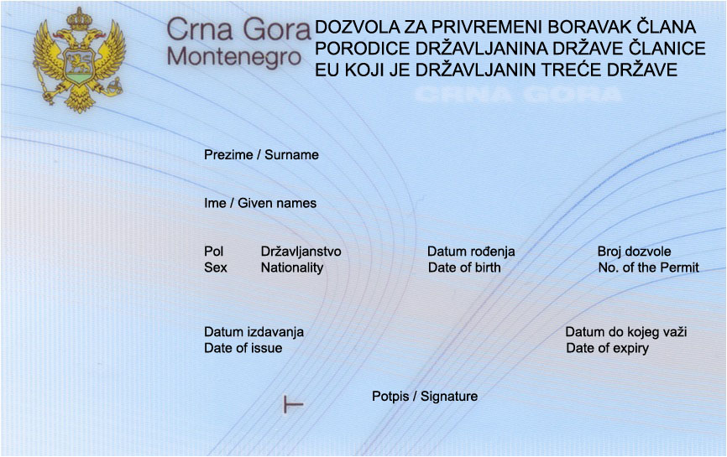

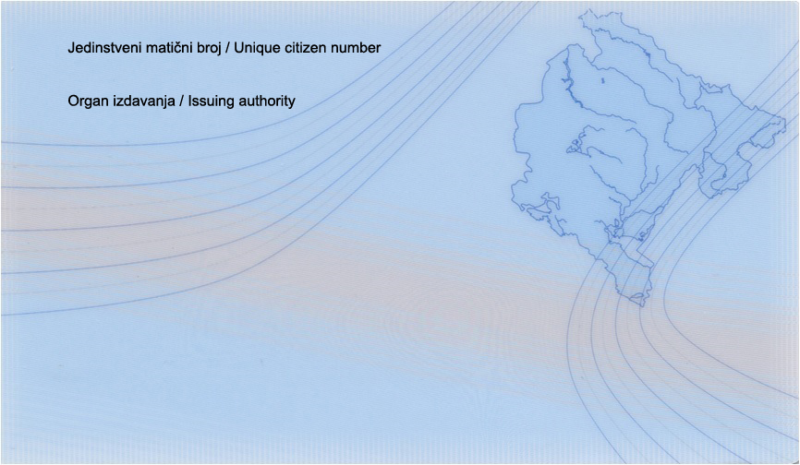

Form 4

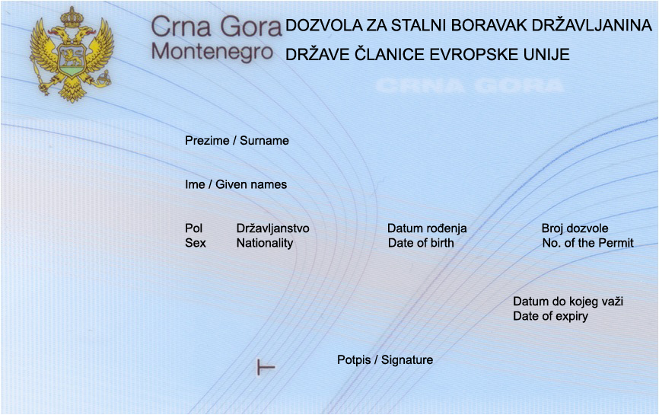

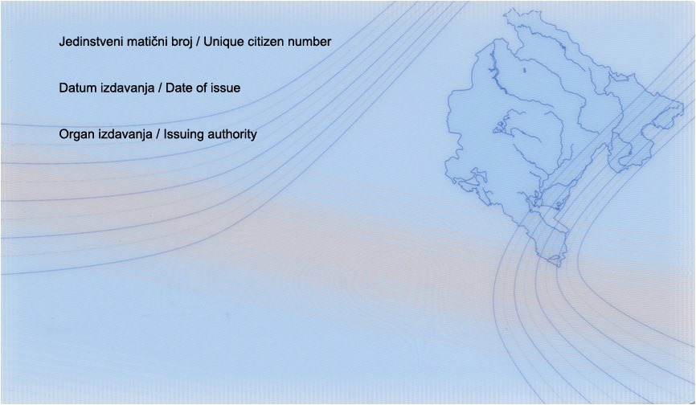

Form 5

