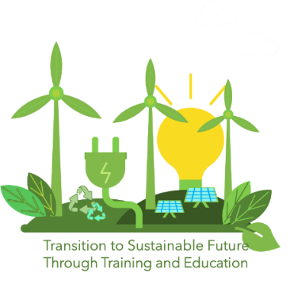
CONSENT FORM FOR THE COMPETITION
FOR THE BEST DRAWING

Project Title: TRANSITion to Sustainable Future Through Training and Education – TRANSIT (www.transitproject.eu)
The primary schools and their pupils of ages 7-11 are invited to participate in the competition for the best drawing of renewable energy, organized by the Foundation for Innovation and Research – Malta under TRANSIT project. The winner of the competition will receive a present from the organiser, which will be given to the child by their school. If you are willing to participate in the competition, please complete and sign this consent form, attach it to the drawing and submit it to your school.

I give consent for the drawing of my child (name surname) ______________________ to be published on the TRANSIT project and EU platforms.

_____________________ ______________ _______________
Name of Parent/Guardian Date Signature

