- AUTHOR DETAILS

- Name/s | Zorka Radonjic
- Country | Montenegro
- Institution/School | Elementary school “Kekec” Sutomore
- Email | zorka.radonjic@os-kekec.edu.me zorkaradonjic@gmail.com
- Programmes the school is participating in (Eco-Schools/LEAF/YRE/other)- | Eco Schools in Montenegro
- Would you like to receive monthly updates through our Newsletter? Yes/No | Yes
- Submission date (dd/mm/yyyy) | 28th August 2023.

- THE LESSON PLAN
- Theme – The title of the lesson | What we leave behind
- Introduction – A brief description of what the lesson is about. (100 words max.) | Being a witness to changes occurring every day, I dare not avoid teaching my students about our part in it. The topic of environmental changes is just on the talk level in Montenegro, and little is done to make people and children aware of it.  These lessons will influence my students to see that they can make a difference in their local community. It will also give them insight on how to. Since I teach EFL, they will be sending messages in English too. And they will also build compassion, understanding and empathy towards the environment.
- Age Group – Age group that it is suitable for (e.g. Age 6 to 9, Age 10 to 11, etc.) | Age 9 to 11
- Objectives or Learning Outcomes – List 3-5 objectives/learning outcomes that you are expecting to achieve during the lesson. | Lesson plan outcomes  Students will be able to:  - Look for and find necessary information in the text that reads ( who, what, where, when, how, whose, which, how many/how much, why...)  - Notice the main idea/aim of the text  - Ask for and provide information  - State a reason/explanation  - Express his/her attitude and opinion  Cross-curricular topic  Students will be able to:  - Develop responsibility to preserve the quality of environment.  Key competences for lifelong learning:  2. Communication in foreign language  1.2.1. Uses vocabulary, grammatical norms, and basic types of verbal interaction and registers of the first foreign language (usually English) at level A2 of the Common European Framework of Reference for Languages  1.2.4. Listens, reads, speaks, and writes the first foreign language (usually English) at level A2 of the Common European Framework of Reference for Languages  4. Digital competence  1.4.3. Uses different sources of information and data in digital environment  1.4.5. Use digital technologies for communication in the appropriate context  1.4.6. Creates and edits simple digital content using different digital tools  1.4.7. Searches, keeps and uses information and content in digital form  6. Social and citizenship qualification  1.6.1. Evaluates concepts, phenomena, role and importance of individuals, social groups, organizations, and institutions on social processes.  1.6.5. Distinguishes the causes and consequences of climate change, biodiversity change and demographic change at the local and global level.  1.6.16. Affirms a responsible attitude towards the environment and sustainable development.
- Time required to deliver the lesson plan – If more than one class session (30-45mins), please indicate the time required. | 3 lessons. 45 minutes each.
- Remote preparation - (if any) Anything that you (or the students) need to do BEFORE the lesson. (e.g. collect and bring to school 3 items labelled as hazardous) | No remote preparation.
- Planning considerations - (if any) such as (i) ‘warnings’ about misconceptions students might have about the lesson’s topic and how to deal with them; (ii) safety precautions; (iii) tips and other useful information | There shouldn’t be any issue regarding the topic since it is an important one and in our yearly plans approved by the Ministry of Education. Any misconception will be dealt on the spot carefully as not to hurt anybody’s feelings or/and beliefs.
- Resources Required to deliver the lesson plan – Material, equipment and reading resources needed | Textbook, notebook, blackboard, chalks, pencils and crayons, glue, scissors, phones.  One activity will be done in the IT classroom.
- Activity – Steps or description of how the lesson will be conducted/facilitated by the teacher.  Structure your description using these main headings:  - Introduction  - Development  - Conclusion | a.Introduction:  Activity 1. Students will be asked what they do when they get up in the morning; what’s their daily routine.  Activity 2. Students will learn about daily routines a person/ child has. It will include specific vocabulary like wash your face, brush your teeth, walk to school etc. They will listen to the recording of a unit so to order the pictures in their textbooks.  b. Development:  Activity 3. Students will be asked if they think they influence on the environment badly and if and how they can change the habits they have as to help the place they live in. They will be asked questions such as:  How much water do you spend? Can you spend less water while washing your face or/and brushing your teeth? Do you take any food to school? Do you walk to school? etc.  Activity 4. Students will be given a few facts about pollution, preserving food and carbon footprint they leave. All this to discuss and see what they think and how much they know about it. Teacher will explain any words or expressions they are not familiar with.  Facts will be written on a blackboard.  Do you know:  - that an average plastic bag is used only for 12 minutes, but it takes up to 1,000 years to decompose?  - which food you keep in the fridge and which you don’t?  - it matters how you wrap your sandwich for school?  - that what you do every day hurts the planet?  - what you can reuse?  Activity 5. Students will complete the KWL column about the above-mentioned questions.  I know I want to know I learnt  Activity 6. Students will find the information for the questions in the second column on the sites that promote clean energy, discuss environmental issues in Montenegro and in the world. The teacher will translate what is more complex. Sites such as:  ecoportal.me - Novosti o čistoj energiji  EcoDrive (ecodrivehk.com)  Climate Conversations  Home - Feedback (feedbackglobal.org)  c.Conclusion:  Activity 7. Students in groups will make a comic using the information they gained from the table. They will use an online tool https://makebeliefscomix.com  Group tasks will depend on the course of their answers and the information they learnt. They will do it in the IT classroom.  Using this tool, they avoid using too much paper and take small steps to reduce its use in the classroom. Likewise, they wouldn’t have additional garbage by using crayons, rubber etc.
- Evaluation and Assessment – How will you check that the Objectives or Learning Outcomes (listed in D) were achieved? | In the following lessons students will the given exercise to check the acquisition.  I Circle the odd one out. Explain why.  - coca cola-water-juice  - fruit-pizza-chocolate  - walk-ride-drive  - clean-dirty-bad  II Write true or false for the following statements. Explain why.  - It’s good to drive a car every day.  - It’s good to go by bus to school.  - Don’t eat food at school!  - Be careful to the planet!
- Dissemination – How will you communicate about the products of the lesson for awareness raising? If your lesson plan has already been implemented, attach a link of a product produced during the lesson (e.g., video, poster, presentation, URL link/website link). | Students will make a short video of their activities and findings. The video will be posted on school’s Facebook page and Instagram account. Their comics will be posted as links on the Facebook account.
- Follow-up activity - (if any) Suggest an activity that can build on what the students learned during your lesson | Activity 1. Students will make a personal reminder on things they can do to reduce their carbon footprint. They will draw it in their notebooks.  Activity 2. Students will be asked to use the following link and calculate the carbon footprint they make.  http://www.footprintcalculator.org/home/en  They should send a screenshot of the results to the teacher via MS Teams app. Teams app is an obligatory LMS in our educational system.
- Adaptations for students with learning difficulties – (if any) | Students will get cut out images to put/glue in the right column. They will draw the following table in their notebook and complete the task. That way they will show that they differ the things that are good and bad to do.  Good Bad  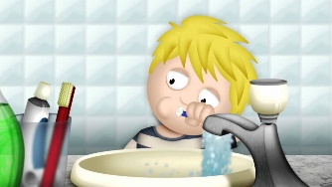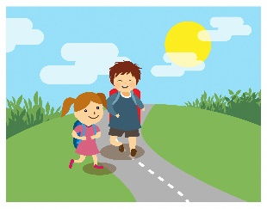  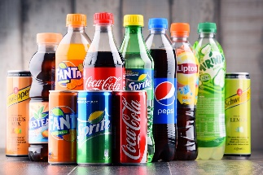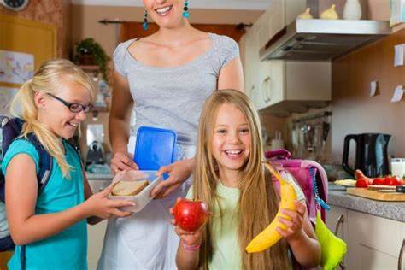  Then they will write a sentence for each image. Sentences such as: Don’t use too much water! Walk to school! Don’t drink fizzy drinks! Eat fruit! /Take lunch from home!
- Extension for gifted students – (if any) | Students will write texts for the video they will film together. The texts will include long messages and advice to parents, teachers, other students, and local community on how to take baby steps to preserve the environment we live in.
- Background information for teachers - Include any website links and resources that would provide teachers with useful information about the lesson’s topic | Carbon footprint calculator  http://www.footprintcalculator.org/home/en  Videos and information:  ecoportal.me - Novosti o čistoj energiji  EcoDrive (ecodrivehk.com)  infographics (ecodrivehk.com)  Climate Conversations  Home - Feedback (feedbackglobal.org)
- References – Acknowledge the resources that were used while developing the Lesson Plan. | Instragram pages:  Do you know information were taken from Waste Free Planet posts.  Images taken from:  water running too much while brushing teeth - Bing images  Walking to School Clip Art - Bing images  processed food and drinks - Bing images  taking food from home to school - Bing images

