Pre-Bid meeting

ADAPTATION OF NINE VOCATIONAL EDUCATION AND TRAINING (VET) SCHOOLS IN MONTENEGRO

ICB No:01-426/23-6031/1
Project: Montenegro Education Programme (MEP)
Contracting authority: Administration for Capital Projects
Promoter: Ministry of Education, Science and Innovation of Montenegro
Participants | - Mr. Filip Vujovic and Mr. Vuk Drakulovic, Capital Administration Project (SPA)  - Ms. Teodora Vukanic, Project Implementation Unit (PIU)  - Ms. Suzana Beaumard, Project Implementation Unit (PIU)  - Beneficiary representatives: School directors,  - Bidders’ representatives as specified below.
Task: | Pre bid meeting
Date: | 28th and 29th November 2023
Timetable | No. School Date and time  1 ṦSVSO Sergej Stanic Podgorica 28/11/2023 at 08:00  2 SSṦ “Cetinje” Cetinje 28/11/2023 at 10:00  3 SMṦ “Danilo Kis” Budva 28/11/2023 at 12:00  4 SSṦ “Bar” Bar 28/11/2023 at 15:00  5 SMŠ "Bećo Bašić" – Plav 29/11/2023 at 09:00  6 SSŠ "Berane" – Berane 29/11/2023 at 11:00  7 SSŠ "Vukadin Vukadinović" Berane 29/11/2023 at 12:00  8 SSŠ “Rožaje” – Rožaje 29/11/2023 at 14:00  9 SEEŠ "Bijelo Polje" - Bijelo Polje 29/11/2023 at 15:30
Location: | As given in the table above.
Annexes: Annex 1: Photos

INTRODUCTION
After participants introduced themselves, the representatives of the contracting authority and the project implementation unit thanked the representatives of the bidders for their participation. It was underlined that the pre-bid meeting was not mandatory and bidders not present were eligible to submit their bid (Ref: Bid data sheet ITB 7.4).
The representatives of the following Companies took part in the pre-bid meeting:
1/ LD gradnja
2/ Stambeno d.o.o
3/ Doo Lacolina
4/ Ramel
Representatives of the Contracting authority and PIU emphasized that the bid submission deadline is 15th January 2024 at 10:00 a.m. The bidders were advised to submit their bids in good time since no late bids will be accepted. (Ref: Bid data sheet ITB 22.1).
All attendees were requested to complete the attendance register.
2. DISCUSSION POINTS
2.1 Site Visit
School visits were organized on 28th and 29th November 2023 in accordance with the timetable given above. The CPA and PIU members presented the project and highlighted specifics relating to the requirements and expected outputs of the project in line with the ICB No:01-426/23-6031/1.
It was emphasized that, once the contract is signed, the dynamic activity plan for each school will have to be coordinated with the school management, considering the smooth running of classes as well as weather conditions and possible legal provisions when it comes to the coast of Montenegro and the summer season.
The total deadline for the contract implementation is 12 months, but it must be considered that this is the maximum period only for the Sergej Stanic school in Podgorica, while a shorter deadline is foreseen for the other eight schools. (Ref: Section VI. Works Requirement)
In order to facilitate the evaluation process, bidders were advised to pay attention to the instructions for calculating the VAT percentage.
It was also noted that during the implementation, it will be possible to use a contingency of 10% for additional and unforeseen works. (Ref: Bid Data Sheet ITB 2.1)
The visit to each school was carried out in accordance with the intervention plans, which show all planned activities at the facility. (Ref: Tender dossier: Drawings).
During the visit to the Sergej Stanic school in Podgorica and in accordance with the request of the bidder, a check of the electrical cabinets was carried out (attached photo).
Bearing in mind that the school principals attended the meeting, it was noted that in some schools the situation has worsened, especially now in the winter period (e.g SSS Plav).
CPA and PIU representatives confirmed that bids are to be prepared exclusively in accordance with the published tender documentation, while additional needs will be considered later by the Ministry of Education, Science and Innovation and Contracting authority.
Participants were informed as well that “Request for Bids” for supervision activities related to Adaptation of 9 VET schools, which was launched 31/10/2023 is one of preconditions for commencement of works.
It was also clarified that questions can be asked in written form and that the answers will be published on the same website as the tender documentation.
The school in Bijelo Polje was last to be visited and the pre bid meeting was concluded on 29th November 2023 at 17:00.

Photos:
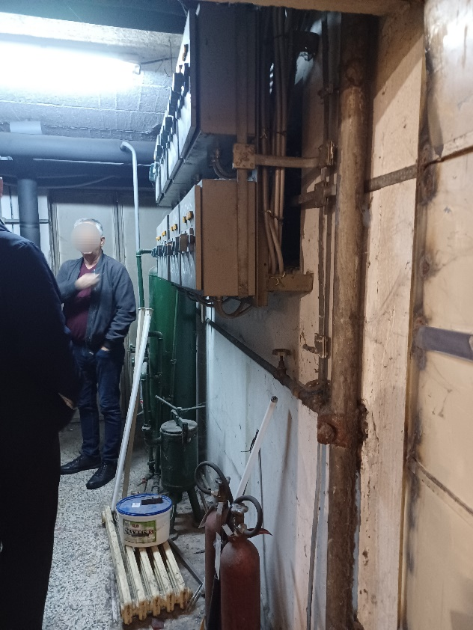  VET school: Sergej Stanic | 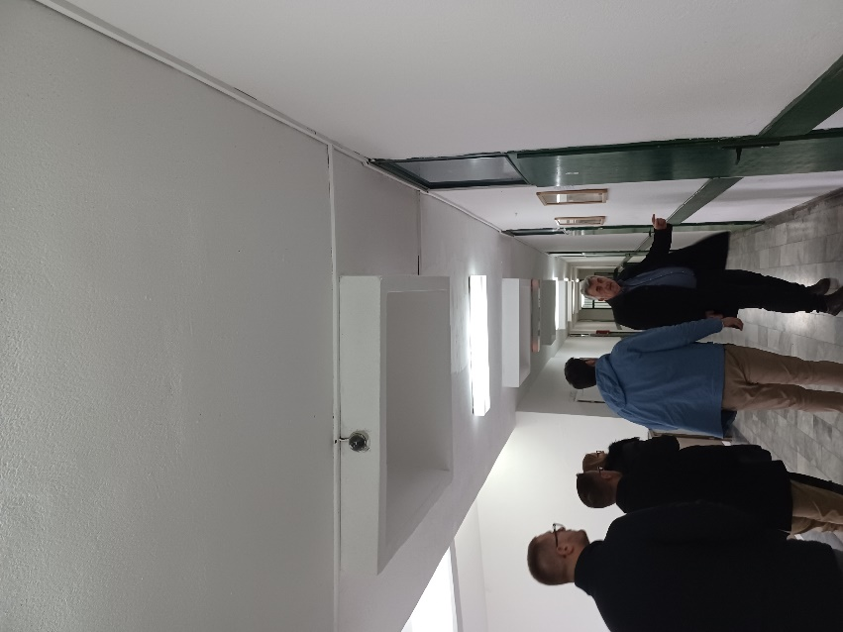  VET School: “Berane”, Berane

