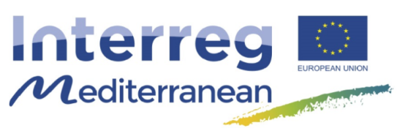

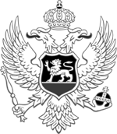
Government of Montenegro
Prime Minister's Office
European Integration Office

INFO DAY
Interreg MED transnational Programme 2014-2020
3rd Call for Projects Proposals
13 November 2017
Venue: EU Info centre, Podgorica

Agenda

10:00 Registration of participants
10:15 Opening speech - European Integration Office
10:30 General Presentation of the Interreg MED Programme – European Integration Office
11:00 Terms of References and Rules of Procedure: 3 rd call for projects proposal (single module and integrated projects) NCP MNE
11:30 Questions and answers
12:00 Closure of event

