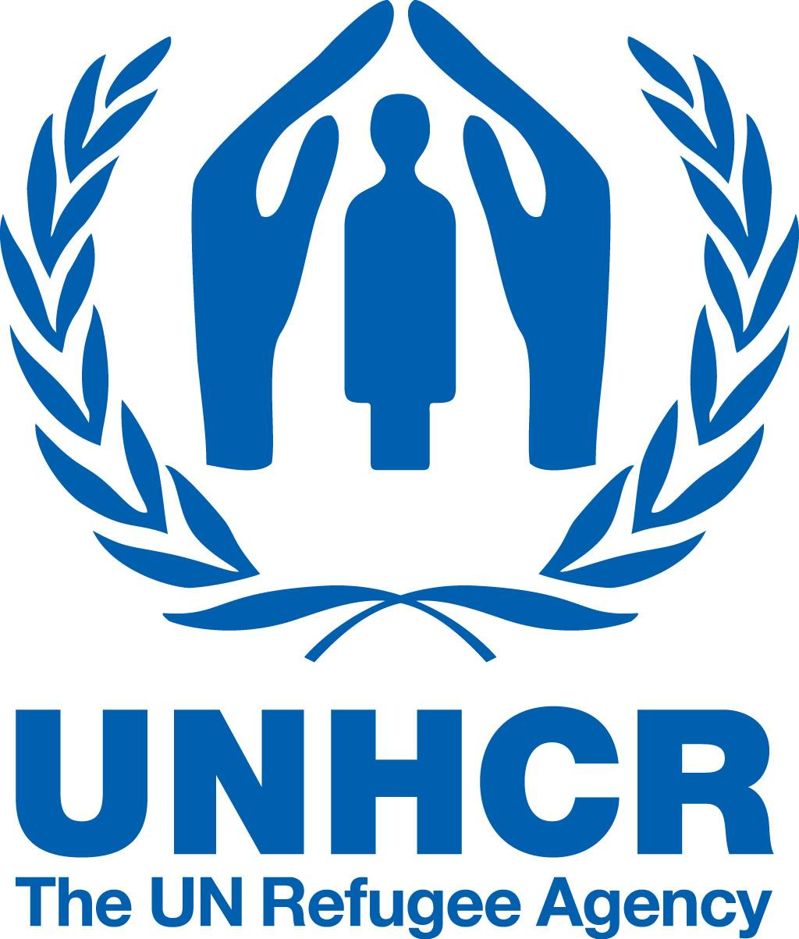


Launch of the regional information campaign on refugee housing within the framework of the Regional Housing Programme

Representatives of Bosnia and Herzegovina, Republic of Croatia, Republic of Montenegro and the Republic of Serbia will launch an information campaign about the Regional Housing Programme in a joint press conference to take place in the premises of the Government of the Republic of Serbia on Wednesday, 6 March 2013. The campaign aims to provide comprehensive information to refugees about possibilities related to voluntary repatriation, reintegration or local integration in Bosnia and Herzegovina, Croatia, Montenegro and Serbia through the Regional Housing Programme. This 5-year long Programme, which has begun in January 2013, is largely funded by donations of the European Union.
Following the conflicts on the territory of former Yugoslavia and forcible displacement of some two million persons in the region, the governments of Bosnia and Herzegovina, Republic of Croatia, Republic of Montenegro and the Republic of Serbia have started the so-called Sarajevo process, a regional cooperation initiative to end the protracted refugee situation in the region, with the support of the international community including the EU, the US UNHCR and the OSCE. ,.

One of the key results of this regional cooperation is the Regional Housing Programme aimed to ensure durable housing solutions for some 74,000 most vulnerable refugees in the four countries. The Programme builds on the joint efforts done so far by the partner countries and the international community to provide durable housing solutions and guarantees for protection of the rights of refugeesand displaced persons from the 1991-1995 conflict.

"The European Union welcomes the continuous dedication which the participating countries show to the Sarajevo Process and to work together on improving neighbourly relations. On the other hand, the EU has also shown its clear commitment to help to solve the refugee situation by donating some 90% of the funds allocated for the Regional Housing Programme destined to help the remaining refugee population start living a normal life, almost 20 years after the conflicts."

Part of the funds required for the implementation of this Regional Housing Programme were raised at the Sarajevo Donor Conference in April 2012, amounting to EUR 264 million. The biggest portion of the funds – EUR 234 million - was donated by the European Union. The Government of the United States donated USD 10 million and expressed an intention to continue allocating funds for this purpose over the next four years of the project implementation. Numerous bilateral donors: governments of Turkey, Germany, Czech Republic, Switzerland, Hungary, Denmark, Norway, Luxembourg, Slovakia, Cyprus, Italy and Romania have donated the outstanding amount.

The United Nations High Commissioner for Refugees (UNHCR) and the Organisation for Security and Cooperation in Europe (ОSCE) will jointly monitor the process of beneficiary selection and the Programme implementation in the partner countries.

A Regional Housing Program Fund, managed by the Council of Europe Development Bank, was established with the support of the European Union, the Government of the United States of America, the UN High Commissioner for Refugees and the Organisation for Security and Cooperation in Europe.

The regional information campaign, which will last in all the four countries throughout March and April 2013, will be funded by a personal USD 25,000 donation of Ms Sadako Ogata - the former UN High Commissioner for Refugees. The tailor-made national information campaigns, to last throughout the Programme implementation, are funded by the European Union and implemented by the Commissioner for Refugees and Migration of the Republic of Serbia.

For additional information please contact Ms Jelena Maric by phone: 011/312-95-90 or by e-mail: jelena.maric@kirs.gov.rs .

