Preparation form
School: Elementary school “Ivan Vušović”
Subject:The nature and the society
Correlation: biology, chemistry, the english language, informatics with technology
Circular economy
Introduction:
The activities encourage students to think about the fact that in nature everything circulates, everything moves in cycles.Circular economy is an opportunity to rethink and to come up with the way we make things.We make a question –Why is there no waste in natural processes?
Activities in the classroom:
Learning outcomes :
Students will be able to:
*to connect the lack of waste with circular flow;
*to understand that the current production system is linear;
*to see different ways of sustainable and circular lifestyles;
*to identify products that are repairable and recyclable;
*to separate waste for recycling;
*to compare living systems with man-made systems;

Time needed /duration
90 minutes
The first part. Introducing students to the term circylar economy - 45 min
The second part. Practical work– 45 min
Teaching tools: photos,banners,cards,posters,paper bags,can,apple,banana,chips,fruit and vegetable peels,water,brown sugar,plastic bottle,plastic bowl,TV.
Procedure
The first part.
Presentation of the topic of circular economy through video ,,What is circular economy? https://www.youtube.com/watch?v=q1j0hSMLdQM
-Students are standing in the circle.The concept of circulation and circularity is introduced. In nature, everything moves and everything flows in cycles
-They give examples of circulation in nature.(The circulation of water, the rotation of the Earth...)

-They observe pictures of polluted and untouched nature.They listen about waste and responsability towards the future of planet Earth.(Attachment 1)
-They are talking about the life of a leaf through the four seasons and they draw it in four groups
-They connect the life of the leaf with the cycle in nature( circulation of matter and energy,photo synthesis, food chain and they conclude why there is no waste in natural processes)
-They consider the possibilities of how we can achieve circularity using concepts repear,avoid ,recycle,use together,use it again.(Attachment 2)
-They listen to the explanation of each concept individually.
-They give examples of items that can be repeared,avoided,recycled ,use together,use it again.(What can be fixed?What we can recycle?Use together? Use again?What to avoid?)
-They get a card with the name of the subject they say .(Attachment 3)
--On the blank card they write the name of the subject that is not given on the cards ,but the students have mentioned it.
The second part
Activity 1.
Students use fruit waste mixed with brown sugar and water to obtain a bio- enzyme that has multiple uses in the household. The obtained mixture is placed in a plastic container, sealed hermetically and stored in a dark and cool place. (fermentation process)
Activity 2.
-All students receive paper bags with several products (chips,banana,can with juice,bottle of water ,apple)
-They separate waste that can be recycled (paper,metal,plastic) and put it in the recycling containers in the school hall.
-They dispose of organic waste in the school yard ,in a specially fenced area,intended for composting, which is located near „ the eco garden“.
-They discuss the possibilities of using the compost they will produce themselves (feeding plants in the school's eco garden, flowers in the eco corner)
--They suggest ways we can supplement our compost(Bringing surplus food from their homes,by collecting certain types of waste in the school yard...)
Accomplishment check:
*They will make a presentation on the circular economy using the example of a school composting site in order to introduce other students to activities that can reduce the amount of waste to a minimum.
- Ask students to make banners to encourage other school students to put their snack waste in the compost bin.
- Ask students to present more examples of the circular economy.
- Encourage students to think about the reuse process of the packaging they have sorted

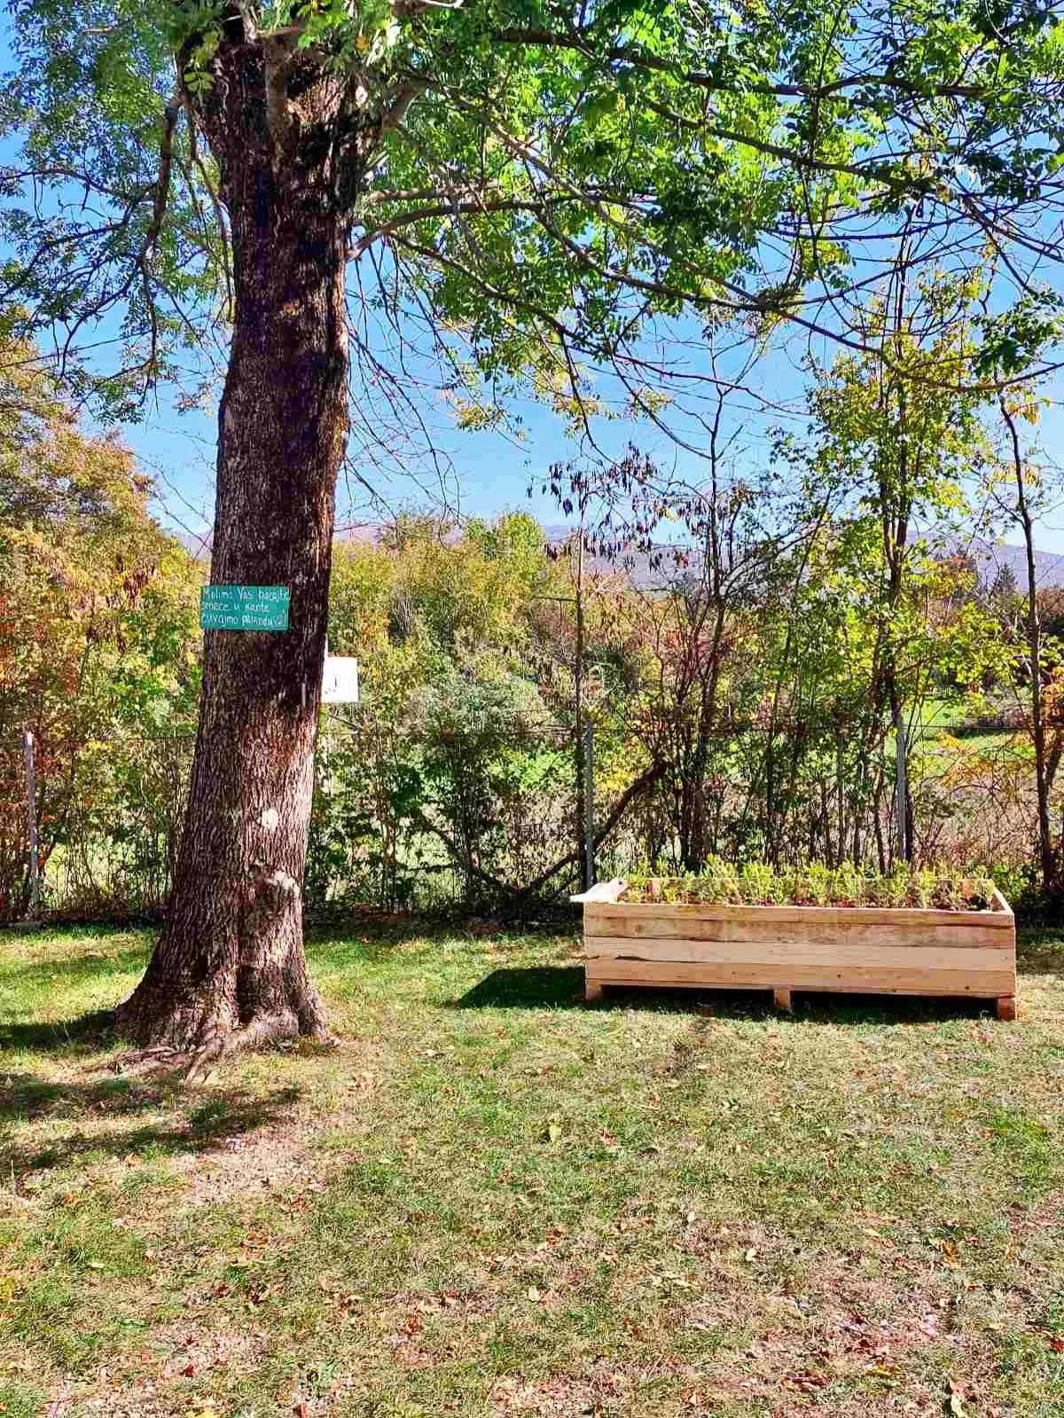
Attachment 1.

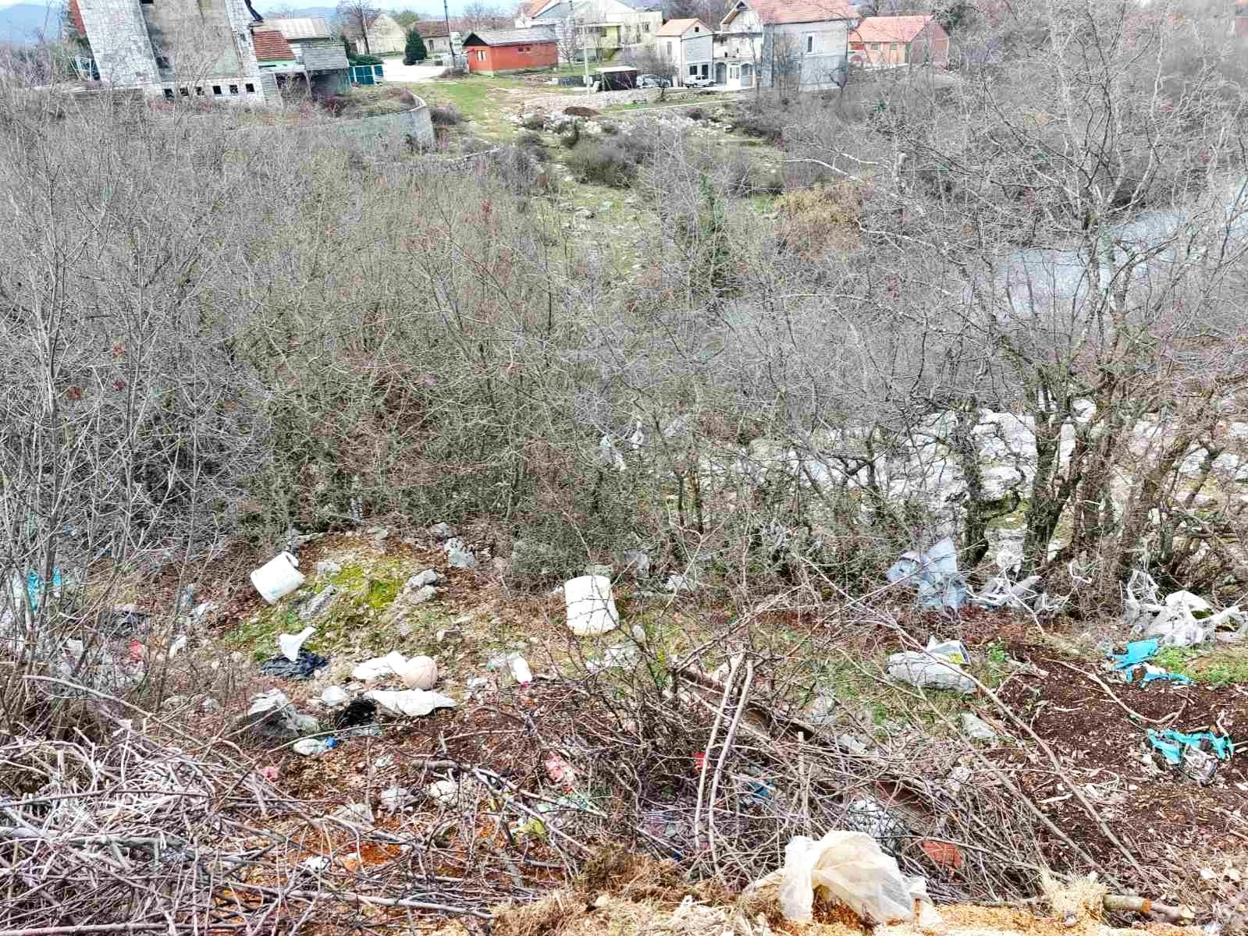

Attachment 2.

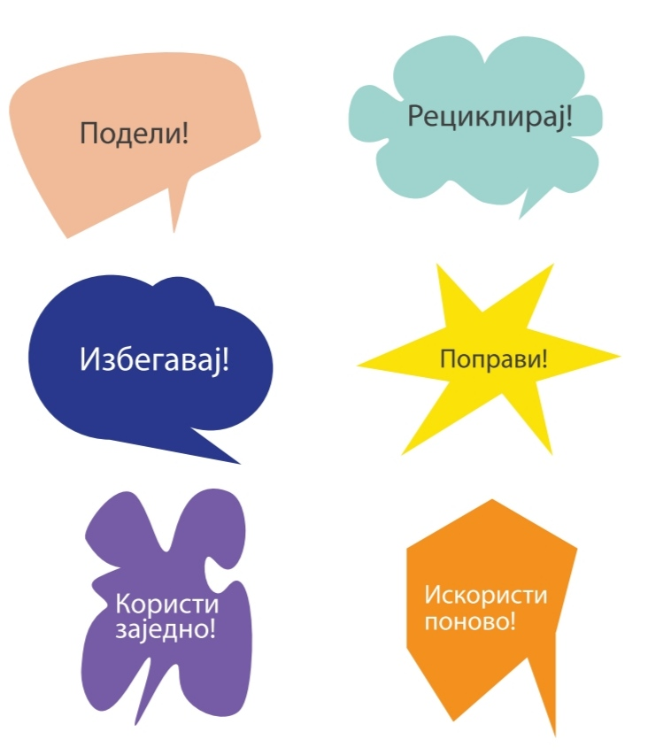

Share – recycle- avoid - fix it - use together- use it again !!!

Attachment 3.
