**GOVERNANCE**

**GOVERNANCE**

SUPPORTING THE GOVERNANCE OF A CB EQF 5 EDUCATIONAL SYSTEM

GOVERNANCE – Supporting the Governance of a CB EQF 5 Educational System – is a project funded by the European Union under the Interreg IPA South Adriatic Programme   
2021-2027.

**01.02.2024 – 31.01.2025**

**Main Goal**

GOVERNANCE aims to unify Italy, Albania and Montenegro under a shared cultural and educational vision, promoting strong cooperation for an effective European Qualifications Framework (EQF) level 5 training system in the Cross-Border dimension.

**83.920,10 €**

**69.342,82 €**

* **Lead Partner -** ITS Academy Antonio Cuccovillo Foundation **(Italy)**
* **Partner -** Ministry of Education, Science and Innovation of Montenegro **(Montenegro)**
* **Partner -** Puglia Region- Department of Labour market policies, Education, Training **(Italy)**
* **Partner -** Aleksandër Moisiu University Durrës **(Albania)**

**Project Partners**

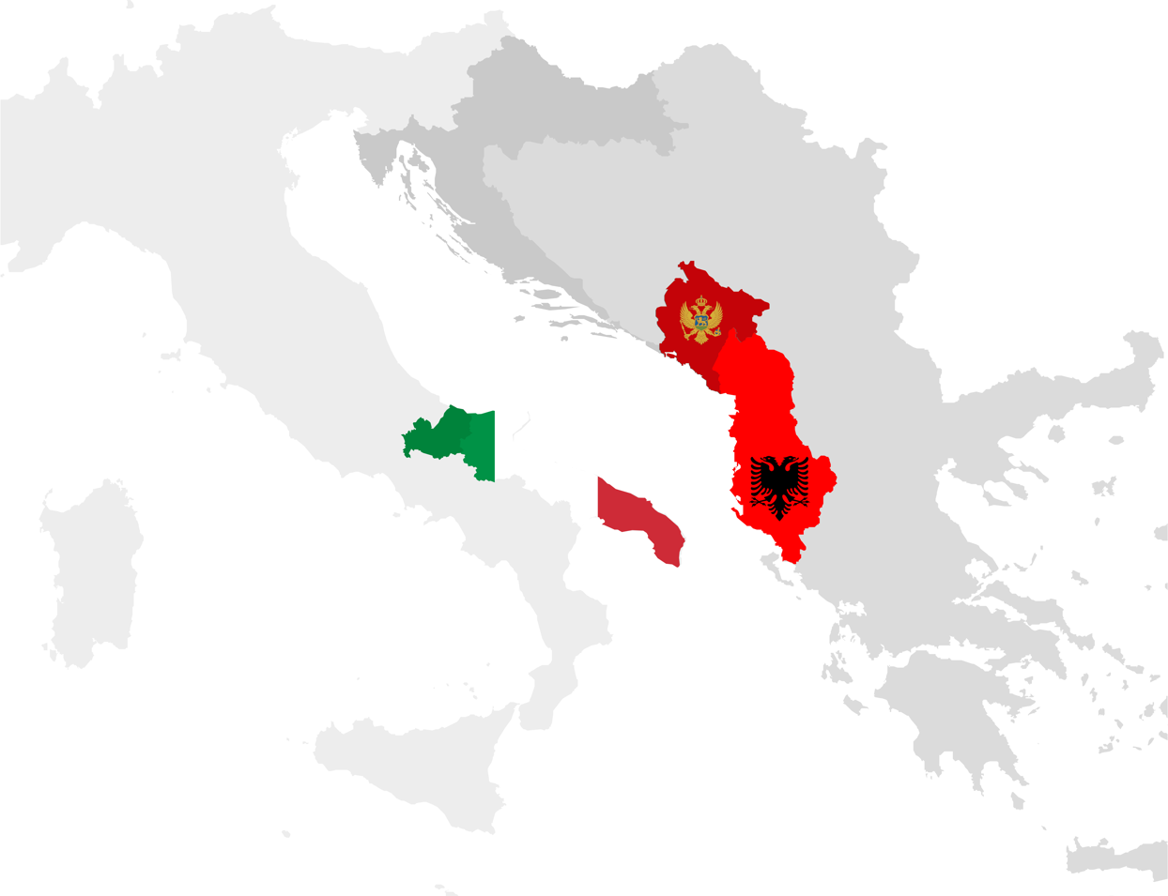

**Roberto Vingiani** – Director ITS Academy Antonio Cuccovillo Foundation

**E.** [direttoretecnico@itsmeccatronicapuglia.it](mailto:direttoretecnico@itsmeccatronicapuglia.it)

**Dragana Cetkovic** – General Director of the Directorate for Higher Education and Students' Standard Ministry of Education, Science and Innovation of Montenegro

**E.** [dragana.cetkovic@mpni.gov.me](mailto:dragana.cetkovic@mpni.gov.me)

**Silvia Pellegrini –** Director of the Department of Labour Policies, Education and Training Puglia Region **E.** [dipartimento.lavoroistruzioneformazione@regione.puglia.it](mailto:dipartimento.lavoroistruzioneformazione@regione.puglia.it)

**Azeta Tartaraj** – Associated Professor Faculty of Business Aleksandër Moisiu University Durrës **E.** [azetatartaraj@yahoo.co.uk](mailto:azetatartaraj@yahoo.co.uk)

**Contacts**

The capacity building seminars and the 3 context analyses (one for each country) and a final Joint Action Plan will offer useful suggestions on how to support the harmonization of strategies and procedures across borders, focusing on common Smart Specialization Strategies (S3), procedures for recognizing qualifications across borders for an effective future launch of European Qualifications Framework (EQF) level 5 educational system.

Aleksandër Moisiu University Durrës

Ministry of Education, Science and Innovation of Montenegro

Puglia Region- Department of Labour market policies, Education, Training

ITS Academy Cuccovillo Foundation

**Project main activities-Expected output/results**