INSTRUCTION FOR SUBMITTING THE REQUEST FOR ISSUING AN EXPATRIATE CARD

- Click on the banner in the right column on the Diaspora Administration website (www.uzd.gov.me):

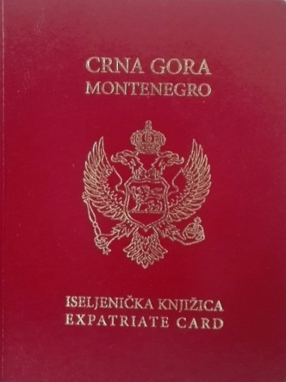

- After the menu appears, click on the option: Zahtjev za iseljeničku knjižicu (Application for an expatriate card).
- It is possible to download the Application form for issuing an expatriate card . Once the template is downloaded to your computer, this form will be opened, which is ready to enter your data:
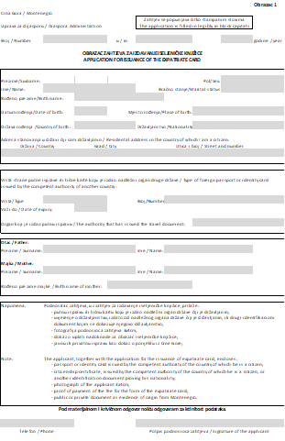
The information is filled in in the fields provided for it, in the letters used in the country where the expatriate lives and in accordance with the data from the passport and other personal documents. The fields are filled in, starting with 'Surname' and ending with 'Telephon / Phone'. Dates are entered in the form dd.mm.yy. (for example: 08/21/2017). The “Potpis / Signature” is not entered on the computer, but only if the expatriate physically in the Diaspora Directorate fills in this form. Otherwise, when he / she subsequently receives a completed and certified expatriate card, the expatriate should sign in the “Potpis / Signature” box, which is at the bottom of the page.

The completed form is saved under the name: Obrazac1.xls.

- Additionally, the emigrant must scan the main page of his passport, with information about the expatriate, as well as his photo, size 3x4cm, which we later print and stick to the card. The same, the Certificate of Citizenship of the Reception State whose emigrant is a citizen must also be scanned.

- The emigrant must also provide proof that he is of Montenegrin origin. The supporting document may be a birth certificate, his or her ancestor. If the Certificate of Citizenship contains such information, ie. some kind of genealogy, then it can be proof of origin.

- Also, the expatriate has to pay 5.00 Eur on foreign currency account of the Diaspora Administration: 2345011-1-11045120, where:
IBAN code: ME25510000000011400159
Swift Address: CKBCMEPG
for the reimbursement of the expatriate card. Expatriate attaches the scanned payment slip (Payment.jpg) with the request.

- These six documents must be saved by the expatriate under the names:
- Application for Issuing an Emigrant's Booklet: Form1.xls
- Passport: Pas.jpg
- Citizenship Certificate: Doc.jpg
- Photo: Foto.jpg
- Proof that it is from Montenegro: Proof.jpg
- Payment note for the payment of 5.00 Eur to the giro account: Payment.jpg
Under these names, the expatriate sends them to a special e-mail at the Diaspora Administration: is.knjizica@mfa.gov.me.
Please note that one email can send data for only one expatriate.
- After receiving these attachments, the Diaspora Administration will process these data,
enter them into a separate database, create a photo, and finally print the data in the emigrant booklet and paste the photo.

- The expatriate card will be sent to the emigrant at the address he has attached in his request, by post or by diplomatic post to the nearest diplomatic mission of Montenegro, about which the immigrant will be informed beforehand.

