Fiscalization service

(Version v4.2)

Functional specification

Versions
Version | Change description
v1 | Draft version
v2 | In chapter 7.2 added field 6. DATE AND TIME OF DEPOSIT CHANGE. In chapter 7.3.1 updated field 25 description and added fields 14 and 15 under Items.
v3 | Legislative framework added in chapter 1.  In chapter 5.2 software maintainer code is sent instead of software producer code.  Only fiscalization of the non-cash invoices can be done using the selfcare portal (SEP).  Examples for invoice fiscalization and corrective invoice fiscalization added.
v4 | Examples transferred in a separate document
v4.1 | - Tax period added (chapter 7.3.1)  - Notes for ENU registration (Chapter 5.2) and for fiscalization of cash invoices depending on the registration of cash deposit at ENU added (Chapter 5.4.1).  - Terms invoice (Chapter 3.4) and participants (Chapter 4) additionally described.  - Mandatory registration of ENU for issuing non-cash invoices added (Chapter 5.2) and accordingly to that changes registration of the initial cash deposit only for cash ENU changed (Chapter 5.3).
v4.2 | List of reports changed (Chapter 5.8).

Additional documentation
Document name | Description
Fiscalization service – Technical specification | Methods for fiscalization messages exchange are described.
Fiscalization service – Functional specification – Appendix 1 (Examples) | Examples for fiscalization

Content

1 Introduction 4
1.1 Abbreviations 4
1.2 Legislative framework 4
2 About the document 5
3 General expressions 5
3.1 Identification code of the taxpayer (IKOF) 5
3.2 Unique invoice identification code (JIKR) 6
3.3 Fiscalization 7
3.4 Invoice 7
4 Parties 9
5 Business processes 11
5.1 Preparation activities for the use of fiscalization service 12
5.2 ENU and ENU software registration 13
5.3 Cash deposit registration on the ENU 15
5.4 Invoice fiscalization 18
5.4.1 Cash invoices fiscalization 19
5.4.2 Fiscalization of the non-cash invoices 21
5.5 Corrective invoices cash or non-cash fiscalization 22
5.6 QR code creation and check 24
5.7 Verification of the IKOF on the ENU 25
5.8 Listing the turnover overview from the ENU for the tax inspectors 26
6 Business rules 27
6.1 Process of the ENU and cash invoices fiscalization registration 27
6.2 Process of the registration of non-cash invoices fiscalization software 27
6.3 Cash deposit registration on the ENU 27
6.4 Cash invoice fiscalization 28
6.5 Non-cash invoice fiscalization 28
6.6 Validation of invoices before storing them in CIS database 28
6.7 Validation of received invoices once they are in the CIS database 29
6.8 Corrective invoices 29
7 Data in processes 30
7.1 Message for the ENU registration 30
7.2 Message for cash deposit registration 30
7.3 Message for invoice fiscalization 30
7.3.1 Message for the cash and non-cash invoices fiscalization using ENU 30
7.4 Message for corrective invoice fiscalization 34

Introduction

Abbreviations
Abbreviation | Explanation
EFI | Electronic invoice fiscalization
CIS | Central information system EFI – Tax administration information system for acceptance of issued invoices data
SEP | Selfservicing portal EFI (Self-care portal) – web-portal that can be used by taxpayer to add some data and for other processes regarding invoice issuing and fiscalization process.
JIKR | Unique identification code of the invoice
IKOF | Taxpayer's identification code
UJI | Universal unique identificator
CA | Certificate authority – subject responsible for issuing and managing digital certificates
ENU | Electronic cash device – Electronic cash device, fiscal device for cash invoice issuing
PIB | Tax identification number – Taxpayer's unique identification number
Registered CA | Registered provider of the electronic service that is listed in the Registry of qualified electronic services providers in Montenegro
Table 1 – Abbreviations

Legislative framework
The legislative framework important for the introduction of the EFI system is as follows:
- Law on Value Added Tax (Official Gazette of the Republic of Montenegro, No. 65/01, 38/02, 72/02, 21/03, 76/05 and "Official Gazette of Montenegro", No. 16/07, 29 / 13 and 9/15)
- Ordinance on the application of the Law on Value Added Tax (Official Gazette of the Republic of Montenegro, No. 65/02, 13/3, 59/4, 79/05, 16/06, 64/08 and 30/13)
- Ordinance on the form and content of the application for calculation of value added tax (Official Gazette of the Republic of Montenegro 79/05, 28/06 and Official Gazette 64/11, 30/13)
- Rulebook on the manner of exercising the right to exemption from excise duty and value added tax for diplomatic and consular missions and international organizations (Official Gazette of Montenegro, No. 34/10, 52/13)
- Decree on the use of the cash register and the manner of recording the turnover of products or services through the cash register (Official Gazette of Montenegro 27/08 40/08 and 8/12)
- Rulebook on the content of records on tax cash registers (Official Gazette of Montenegro No. 38/08)
- Ordinance on the form and content of the service booklet of the tax cash register (Official Gazette of Montenegro No. 38/08)
- Ordinance on the form and content of the single application for registration of taxpayers, taxpayers and insured persons in the Central Register (Official Gazette of Montenegro No. 10/10, 32/10 and 30/17)
- Law on Qualification of Activities (Official Gazette of the Republic of Montenegro, 18/11)
- Law on Electronic Signature (Official Gazette of the Republic of Montenegro 55/03, 31/05, and Official Gazette of Montenegro 41/10, 40/11)
- Law on Electronic Document (Official Gazette of the Republic of Montenegro 05/08 and 40/11).
- Law on Information Security (Official Gazette of the Republic of Montenegro 14/10, 40/16)
- Law on Tax Administration (Official Gazette of the Republic of Montenegro, No. 065/01 of 31.12.2001, 080/04 of 29.12.2004, 029/05 of 09.05.2005, "Official Gazette of Montenegro", no. 073/10 from 10.12.2010, 020/11 from 15.04.2011, 028/12 from 05.06.2012, 008/15 from 27.02.2015, 047/17 from 19.07.2017, 052/19 from 10.09.2019)
- Law on Inspection Supervision (Official Gazette of the Republic of Montenegro, No. 039/03 of 30.06.2003, Official Gazette of Montenegro ", No. 076/09 of 18.11.2009, 057/11 of 30.11.2011, 018 / 14 from 11.04.2014, 011/15 from 12.03.2015, 052/16 from 09.08.2016)

About the document
In this document the way of exchange of information between Central information system of the Tax administration (CIS) and system for fiscalization of taxpayers is described. This document is for all interested parties that will be part of implementation of software solution on taxpayers' side. In this document are described all messages that systems exchange, processes of exchange of messages, defined are collections of data and rules that are strictly followed in the communication. Data exchange will be held via web-service that uses XML messages. This type of data exchange does not depend of technology used by taxpayer nor of technology used by the Tax administration, and it provides one-way communication between any taxpayer and the Tax administration.

General expressions

Identification code of the taxpayer (IKOF)
IKOF is an alphanumeric code that is used for confirmation of the connection between taxpayer who is obliged to issue invoices, and issued invoice.
IKOF is created by software solution of the taxpayer which is used for invoice issuing and represents mandatory element of each issued invoice, and is delivered to the Tax administration along with other mandatory elements of the invoice.
IKOF purpose is this:
- It protects the taxpayer from third-side parties to make him harm. Only the taxpayer can create the same IKOF again based on input parameters for code formation (procedure for code generation is described in fiscalization service technical specification document);
- Invoice verification in cases when the invoice is issued without JIKR. If that is the case, IKOF can be used as invoice identifier.
To provide described purpose fulfilment, IKOF must be defined using couple of parameters that secure these things:
- Invoice uniqueness with these verifications:
- Taxpayer's PIB;
- Invoice issuing date and time;
- Invoice number;
- Business unit code;
- Electronic cash device code;
- Used software code;
- Total invoice amount.
- Credible identity of the taxpayer, along with:
- Taxpayer's electronic signature.
Details regarding the way of declaring IKOF are described in fiscalization service technical specification.
Electronic signature is used along with valid digital fiscalization certificate that is issued to taxpayer and which is issued by registered certificate authority.
If the invoice is issued using self-care portal, then the IKOF does not contain electronic cash device code or software code, and it is generated by the Tax administration web service.

Unique invoice identification code (JIKR)
JIKR is the unique invoice identification code.
When issuing each invoice, the taxpayer electronically signs the invoice elements and delvers it to the fiscalization system using electronic connection.
Fiscalization system verifies if all mandatory elements are delivered and if those are signed by correct electronic signature using valid digital certificate.
If all conditions are fulfilled, fiscalization system generates unique JIKR and returns it to the taxpayer using electronic connection. Fiscalization system gives the JIKR as a confirmation of receiving the invoice elements. JIKR is unique for each invoice.
If the Tax administration fiscalization system cannot determine the JIKR, due to unsuccessful validation process, it returns the message to the taxpayer saying that JIKR generation is rejected., along with error description. Taxpayer can, in cases described by Law on fiscalization in trade of products and services, Chapter V, Section 17, and Policy of form and structure of messages and security mechanisms for exchange of fiscal invoice messages and the way of delivering invoices that are issued in case of break of permanent internet connection, Attachment 3, print out the invoice without JIKR and five it to the customer, correct the error that happened and repeat the fiscalization process of the same invoice in 48 hours time, with the same IKOF. In specific cases (blocking errors) that are specified in chapter 3.4, the taxpayer must correct the error first, then repeat the fiscalization process and only after successful verification print out the invoice and give it to the customer.
JIKR and IKOF, along with other mandatory data, are printed on the cash invoice and the represent the mandatory elements of each electronic invoice for non-cash transactions.

Fiscalization
Fiscalization is the process designed for avoiding the frauds, and it is introduced in various countries with the purpose of controlling the grey economy using real-time tax administration reporting regarding all or only specific transactions.

Invoice
Fiscalization system processes two invoice types:
- Cash invoices,
- Non-cash invoices.

It is possible to issue a summary invoice for specific purposes, ie for the needs of efficient execution of certain business processes.
A summary invoice can be an invoice issued on the same day for several individual invoices at the time of payment, and it can also be an invoice issued for the accounting period to which the individual invoices refer.
The summary invoice in its structure contains IKOFs of all individual, previously fiscalized, invoices, with the stated values ​​of each individual invoice (IKOF). The precondition for issuing a summary invoice to a customer who is a taxpayer is the existence of individual invoices in which the customer's personal identification number is entered in the customer's field when issuing the invoice, and for which a periodic summary invoice is finally issued.
For the summary invoice, it is obligatory to enter the period to which it refers, which cannot be longer than the tax period (calendar month).
Periodic bill is an individual bill for services used during the month (eg bills for services of telecommunications operators, electricity bills, water bills, etc.), ie invoices that are generated through billing systems for a certain period, and are issued as consequence of the realized turnover recorded through measuring instruments.
The taxpayer delivers the information on each cash and non-cash invoice individually. In extraordinary cases, the invoice data can be delivered additionally, but only in specific situations described by the Law.
In both cases (cash, non-cash), the process of data delivery is identical when it is about communication with CIS. Only difference is the message content.
When fiscalizing cash transactions the taxpayer can use the model where each ENU separately communicates with the CIS meaning it sends and signs electronic messages, or model that uses central information system of the taxpayer for sending and signing electronic messages for all ENUs that exist in one single business unit. From the fiscalization point of view there is no difference between these two models, all rules and specifications are the same for both. In this document there is no difference between the two, and the term ENU stands for electronic cash device that contains fiscal service or electronic cash device plus fiscal service on central system.
Data exchange process starts when the operator needs to issue an invoice to the client:
- ENU or any other device of the taxpayer along with installed software solution for invoice issuing, after the operator fills all invoice elements, prepares the data for the invoice and based on that calculates the identification code of the fiscalization (IKOF) in accordance with the Policy of content of registration of fiscalization service code, the way of generating IKOF and the way of delivering the data and generating the business unit code, Attachment 2 in the Technical specification;
- After that, the taxpayers prepares the XML message with the request and electronically signs it with the private key of the application certificate that was issued by the registered CA for fiscalization needs. Then the communication starts and server certificate is used to identify the Tax administration server;
- After the successful SSL communication the call is set up, the CIS receives and processes the request message. If fiscalization service successfully processes the application, it prepares the XML message with the response that contains JIKR, it electronically signs it with the application certificate and sends it to the ENU, meaning to the electronic device of the taxpayer, who receives the response message and checks the electronic signature with the application certificate public key;
- After that, the operator prints or electronically sends the invoice to the customer with the JIKR.
If error occurs during the data processing (incorrect message, incorrect signature…), the fiscalization service returns the XML message with the response that contains message error description. If that is the case, the response does not contain the JIKR, and in case when error cannot be fixed at the very same moment (system error or technical error or similar), the operator is obligated to issue the invoice without the JIKR and to fix the error (by himself, or that software producer/maintainer does so) in 48 hours time, and to fiscalize it subsequently. Operator must not subsequently change the invoice that has been sent to the fiscalization process and that was printed out and given to the customer, only thing that can be done is creation of a new XML message based on the issued invoice. The business process of invoice issuing must not be stopped because of the technical or system error (except for cases of blocking errors)., but the taxpayer is still obligated to fix the error, and after that the message of invoice must be delivered. Elements of the invoice of the new XML message must be the same (meaning IKOF must be the same), with the flag saying that the subsequent delivery is in question. If that flag is missing or IKOF is different that the IKOF printed on the issued invoice, it will be saved as completely new process of invoice issuing.

Important to remember!

If one of the following errors occurs when processing the request fiscalization message:
- received XML message exceed allowed size,
- received XML message failed XSD validation (because some mandatory fields are missing),
- issuer VAT status does not correspond to the IsIssuerInVAT attribute,
then the operator who has created the invoice needs to check if:
- there are more than 1000 items on the invoice,
- all the mandatory fields are not field in,
- the issuer of the invoice (i.e. the seller) is registered in the VAT register and the “IsIssuerInVAT” attribute is “false”, and vice versa (in this case if the taxpayer is not registered in VAT register and is not a case of “reverse charge” or self-invoice in case when the seller is a farmer registered for compensation scheme, than no VAT can be charged on that invoice).

In any case, the operator cannot issue such invoice (the software solution cannot have the function that the operator can print such an invoice), since the invoice itself is not correct, and it must:
- divide the invoice in 2 or more new invoices so that on each invoice there is no more than 1.000 items;
- field in all the missing mandatory invoice elements (i.e. fields in the fiscalization message);
- correct the “IsIssuerInVAT” attribute according to the status of the seller recorded in the Tax Administration register of taxpayers and the VAT on the invoice accordingly.

However, the software producer has to prevent such errors by integrating automatic controls at the moment when the invoice is being created by the operator and before it is issued and sent to fiscalization.

In all cases when the taxpayer did not get the JIKR for the issued invoice (internet connection break, ENU is not working…), the taxpayer is obligated to send the message once more. Only when the taxpayer gets the correct response message from the fiscalization system of the Tax administration, that contains the JIKR, it is considered that the Tax administration got the information on new invoice.
In cases where the taxpayer cannot get the JIKR, for example because of break of internet connection, when the connection is back up, the delivery of all invoices issued during the offline mode must be done automatically. In cases when the taxpayer cannot get the JIKR because of the error during the verification procedure, after correcting the mistake related to the fiscalization of cash invoices, the preference is given to the messages of new invoices, so that those can get the JIKR and be given to the customer without further due. Messages that did not get the JIKR should be delivered later, during the period of lesser ENU use.
Maximum period (time-out) during the taxpayer should wait for the response message with the JIKR from the Tax administration fiscalization system is set by the taxpayer himself. The taxpayer must make the assessment on what time is needed, considering type and availability of the internet connection he uses, and what is the deadline for getting the response that will be in accordance with his business. It should be noted that the maximum time of two seconds, during which the CIS needs to process the request message and return the response message (moment from message entering the CIS until the moment of getting the response from the CIS).

Parties
Parties in the fiscalization process are:
Taxpayers – all taxpayers who must issue the invoices are obligated to issue them in accordance with the Law on fiscalization in trade of products and services, and to do the fiscalization process for each invoice.
Operator– the person authorized by the taxpayer for invoice issuing (in most cases the employee of the taxpayer), and who uses the ENU during the process of the fiscalization of the cash invoice, or person who created the non-cash transaction invoice.
In the case of self-charging devices (vending machines), the operator is an employee of the company, who must be available for the purpose of participating in the process of performing inspection supervision on that machine.
Physical or legal person who is producer or maintainer of the software – for the compliance of IT solutions with the fiscalization process. That physical/legal person is the service provider for the taxpayer. The producer, ie the maintainer of the software solution can be an entrepreneur, ie a legal entity defined by the Companies Act.
Tax administration – responsible for the implementation of the fiscalization process, for managing the CIS for fiscalization, and for overview over fiscalization and invoice issuing
Citizens – users of the system for invoice correctness checking (invoice check application), they are required to look for the invoice for products or services they are buying and they have the option to report irregularities to the Tax administration.

Business processes
In this chapter the key business processes related to the fiscalization service, and all scenarios that can be supported in cash and non-cash transactions.

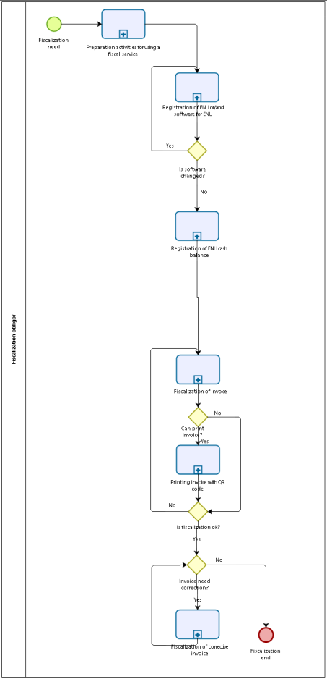
Diagram 1 – Fiscalization process
Business processes related to fiscalization services are:
  - Preparation activities for the use of fiscalization service
  - ENU, software producers, and software maintainers registration
  - Cash deposit registration on the ENU
  - Invoice fiscalization
  - Corrective invoice fiscalization
  - Print and check of the invoice QR code
  - IKOF verification on the ENU

Preparation activities for the use of fiscalization service
Preconditions for the invoice fiscalization implementation are:
- Owning of the „soft“ digital certificate (details are in technical specification document)
- Having the internet connection (except for special cases described in Law).
All preparation activities of this chapter are done by the taxpayer and the taxpayer is the only responsible person for those.
The digital certificate for fiscalization needs is issued by the registered CA. Detailed description of the request for digital certificate issuing, and getting the certificate is shown in registered CA user instructions and is not part of this document.
Prior digital certificate installation, the taxpayer is required to do the next:
Step 1 – During invoice fiscalization:
- Owns hardware infrastructure with the software that supports fiscalization process,
- Owns stable internet connection that is mandatory for the work of fiscalization service.
Step 1a. – During cash invoice fiscalization:
- Installs software for the ENU for invoice issuing that supports fiscalization process on each ENU that will be used for fiscalization process in the business unit..
- Installs digital certificate that can be taken for each ENU that will do the fiscalization process and on which the invoice issuing software is installed.
Step 1b. – During non-cash invoice fiscalization:
- Implements/updates the existing software for non-cash invoice issuing in the way that the software supports the fiscalization process or uses the internet (cloud) application along with corresponding software solution for issuing and fiscalizing invoices.
- Installs the digital certificate that can be downloaded and connected with the non-cash invoice issuing software.

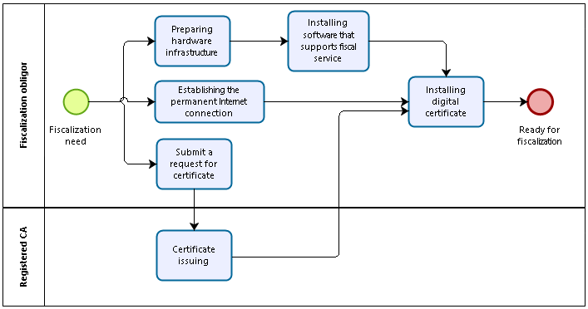
Diagram 2 – Preparation activities for fiscalization service use

ENU and ENU software registration
The taxpayer is obligated to do the registration of the ENU prior starting to issue and fiscalize the invoices, and that goes for all of his ENUs that will be a part of the fiscalization process.
Note: ENU registration must be done at least one hour before the start of fiscalization of cash and non-cash accounts at that ENU.
By registering the ENU in CIS, the taxpayer is also obligated to register the software producer and the software solution that will be used by the ENU in fiscalization process.
When the taxpayer does all the preparation works, he is required to prepare the initial message for the registration of each ENU. During the preparation of the initial XML message for the ENU registration, the taxpayer must deliver these data:
- Unique identifying code of the taxpayer (PIB),
- Business unit code (details are in technical specification document),
- Order number of the ENU (defined by the taxpayer, starts with number 1),
- Code of the software used on the ENU,
- Code of the software maintainer,
- Date when ENU starts to be used,
- ENU type:
- standard
- self-vending machine.
After the taxpayer inserts the above mentioned information, the ENU software generates the initial XML message for the registration, which contains these information also:
- Date and time of XML message creation,
- Date and time of sending the XML message to the Tax administration.
After the generation, the XML message is signed by the electronic signature and is sent to the Tax administration using the fiscalization service.
In special cases, if the taxpayer acts in area without the internet connection, the taxpayer can register the ENU on the SEP.
When the Tax administration gets the initial message for the registration, the received message is verified by these rules:
- Certificate position,
- Is certificate issued by the registered CA,
- Digital certificate validity,
- Message schema validation,
- Are all schema mandatory elements filled,
- Comparison of the PIB in the XML with the PIB in the certificate,
- Comparison of the PIB of the taxpayer in the XML with the PIB of taxpayer in the Register of taxpayers,
- Comparison of the business unit code in the XML with the business unit code in the Register of business units,
- Comparison of the software code in the XML with the software code in the database of the registering certification software,
- Comparison of the maintainer code in the XML with the codes of the producers in the Register of the software producers.
If the verification if the initial XML message for the registration went wrong, the Tax administration generates the XML message with the error description and sends it via ENU to the fiscalization service with the note that the ENU registration was not successful.
If the Tax administration verified the initial XML registration message, the fiscalization system:
- Generates the information on ENU and keeps it in its database for the business unit of the taxpayer where that ENU is used,
- Generates the unique alphanumeric code for the ENU,
- Enters additional information regarding ENU in the database.
After the generation of the data in the database, the Tax administration creates the XML message that contains the unique alphanumeric code of 10 characters for the ENU (detailed in technical specification). The unique alphanumeric code for the ENU is impossible to be repeated – it is the unique code that system generates automatically and is kept in ENU memory and Tax administration database.
After the generation of the XML, the Tax administration signs the XML message with the digital certificate and sends it to the taxpayer using fiscalization service. In special cases, when registration is done in SEP or using corresponding form, the taxpayer who issues the invoices must enter the invoice manually and save it in the ENU memory, as that is mandatory information for the cash invoices fiscalization.
Update or withdrawal of the ENU is done by using the same fiscalization service on the same ENU. During the withdrawal, field „valid to“ must contain the date after which the ENU will not be used anymore.

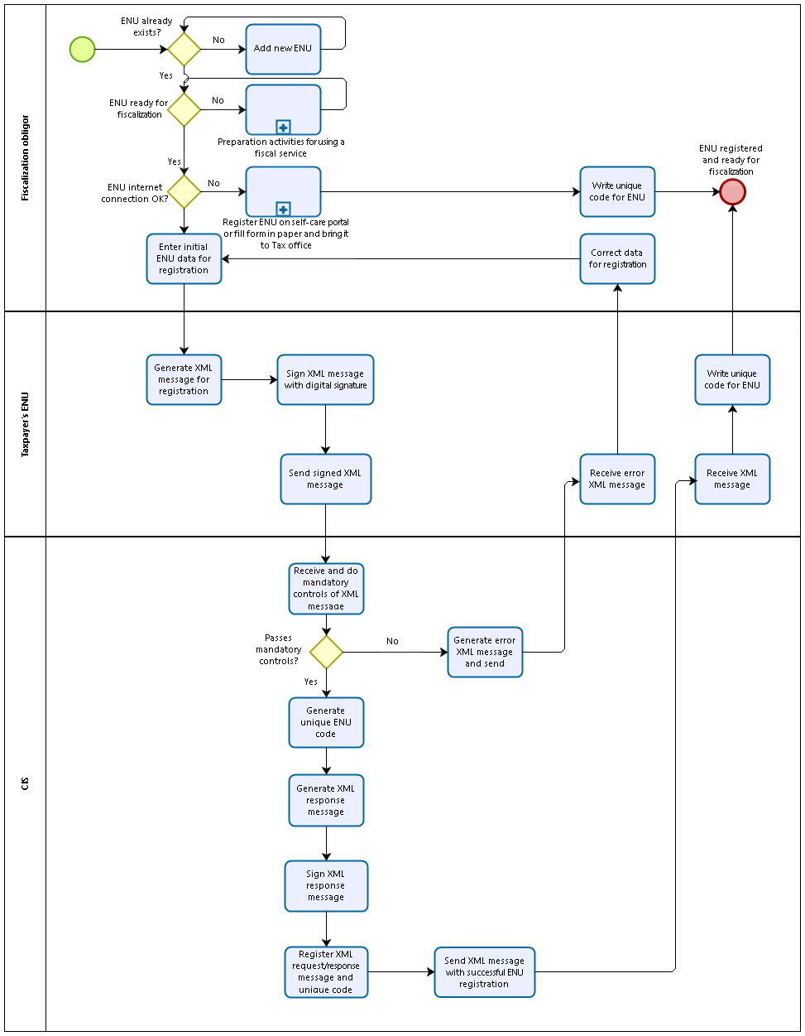
Diagram 3 – ENU and software registration

Cash deposit registration on the ENU
The taxpayer who issues the invoices is obligated to notify the Tax administration on the start of each workday – prior official working hours and prior starting the invoice issuing, on cash deposit for the ENU on that day.
The cash deposit is cash for return change at the beginning of the ENU business day.
The taxpayer also has the obligation to report on each changes in cash deposit during the day which is a result of the cash withdrawal.
After the ENU is in function, the taxpayer has the obligation to start the „registration of the cash deposit for the ENU“ function. Each ENU must have this functionality. When that function is started, the taxpayer will enter the amount of cash deposit in the ENU in the local currency. The ENU generates the XML message which the taxpayer signs with the electronic signature and which is sent to the CIS using the fiscalization service. That message must contain all necessary information that are shown in the XML schema.
CIS gets the signed XML message and checks the electronic signature, and the XML message structure.
If the message passed the validation, it is saved in the database, fiscalization service creates the response that is signed by the electronic signature of the Tax administration and the response is sent to the taxpayer's ENU. When ENU receives the Tax administration response message, the taxpayer can start with the process of issuing and fiscalizing the invoices.
If the message did not pass the CIS validation, the fiscalization service generates the XML response with the corresponding error and sends it to the taxpayer's ENU. The taxpayer has the obligation to, immediately after getting the note on error, to fix it and starts the deposit registration process once again.
The taxpayer CANNOT START THE CASH BUSINESS WITH THE ENU if the cash deposit registration is not successfully received and validated.
In special cases defined by the Law (internet connection break or similar…), the information on initial deposit must be kept in the ENU memory, digitally signed, and must be delivered along with the fiscalization process in previously set time and in defined way. If ENU breaks, data on deposit are noted in the book of special certified invoices at Tax Administration (paragon block).
Deposit can be 0,00.
For each business day (00:00:00-23:59:59) with ENU used to issue cash and non-cash invoices in retail, the initial amount of the cash deposit (operation INITIAL) must be registered. If ENU is used exclusively for issuing non-cash invoices, the deposit does not have to be entered before sending the first non-cash invoice because there is no cash register here as an integral part of ENU. Non-cash invoices can be issued regardless of the registration of the cash deposit.
The registration of the initial cash deposit is possible only once during the business day, whereby changes can be made until the moment of issuing the first invoice. The final value of the deposit is the one that the taxpayer registered as the last before issuing the first invoice.
If ENU will be used only for issuing non-cash invoices, there is no obligation to enter a deposit in ENU.
If during the day operator withdraws the cash from the ENU to deposit it into the bank, or similar, those changes also must be delivered to the Tax administration using fiscalization service, in moment when those happen. When the taxpayer withdraws the money from the ENU during the workday, he registers only the out amount (cash out).
In any moment, cash (coins and banknote) in the ENU must be like this:
- Initial registered cash deposit
- + cash made out of registered sales (based on issued and fiscalized invoices)
- + registered turnover of invoices that have been issued but have not yet been charged
- - registered withdrawn cash
- = cash in the ENU

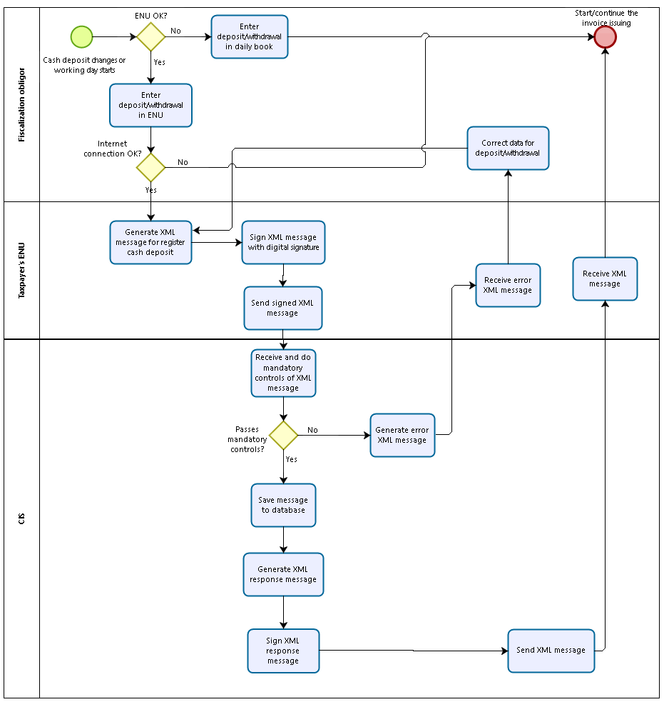
Diagram 4 – Registration of the cash deposit made each day

Invoice fiscalization
The taxpayer who is obligated to issue invoices and to be a part of fiscalization, is obligated to fiscalize invoices of both cash and non-cash transactions. Fiscalization means that all issued invoices are recorded in the Tax administration database.
Invoice fiscalization is done using ficalization service which is responsible for the communication between taxpayers who issue the invoices and Tax administration who processes received messages.
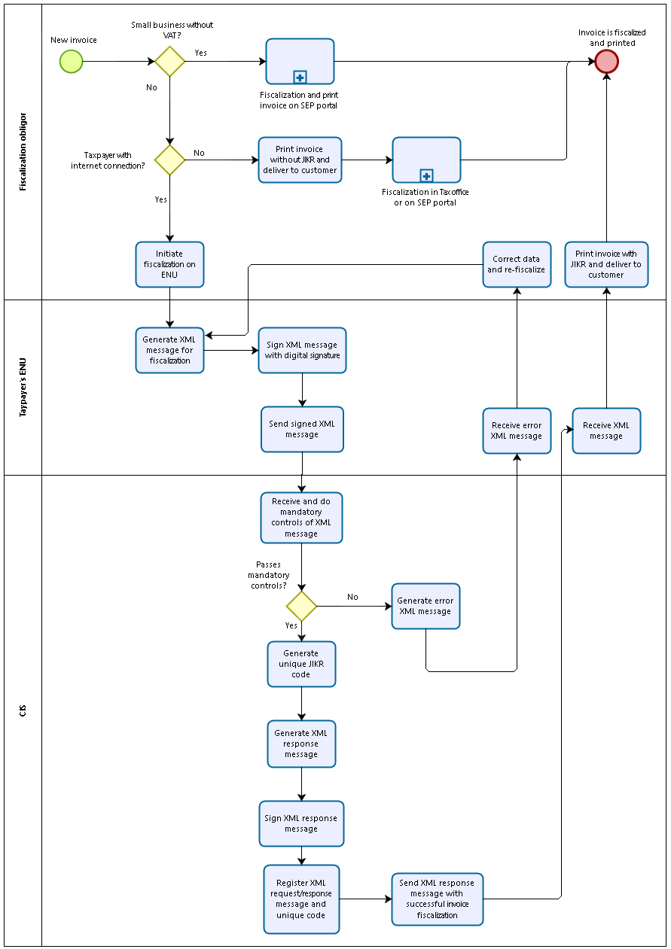
Diagram 5 – Invoice fiscalization

Cash invoices fiscalization
Cash invoice fiscalization can be done in these ways:
- Using fiscalization service using ENU;
- By fiscalizing of cash invoices in the Tax administration through a removable medium for those taxpayers who operate in an area where there is no internet connection or
- that the taxpayer does not carry a portable medium to the Tax Administration, but to independently find the location where he has access to the Internet connection and to upload (upload) information about the invoice, ie XML file with information about issued and non-fiscalized invoices with the help of a digital certificate.
The following text contains detailed overview of the invoice fiscalization process by using all of the three mentioned models.
Note: Before fiscalizing the first cash invoice on a calendar day, the taxpayer MUST register an initial cash deposit at ENU. This means that the taxpayer must have built-in control in his software that before registering the initial deposit on ENU on a calendar day, he MUST NOT start fiscalizing cash invoices on that ENU.

Fiscalization of the cash invoices using the ENU
The process of the fiscalization starts when the taxpayer is obligated to issue the cash invoice for the delivered products or services. The taxpayer creates the XML message (with the invoice elements) using the ENU. After the message is created, the taxpayer signs the XML message with his digital certificate which was provided to him by the registered CA. The message must contain all necessary information defined in the XML schema.
Signed message goes to the defined communication channel in accordance with the Tax administration information system. The Tax administration system gets the signed XML message and verifies the electronic signature and XML message structure.
If the message passed the validation, it is recorded in the database of fiscalized invoices (as a data and as a message in full XML format).. When the message is saved, the CIS through the fiscalization service creates the response with the JIKR. The response is signed electronically by the digital certificate and it is sent to the ENU of the taxpayer. After the ENU gets the response from the Tax administration, the taxpayer is obligated to print the invoice immediately with the JIKR he got from the Tax administration and to give or deliver the invoice to the customer.
If the message did not pass the validation, the information system of the Tax administration generates the XML answer with the corresponding error and sends it to the ENU of the taxpayer. The taxpayer is obligated to correct the error immediately after he receives the error notification and to fiscalize the non-fiscalized invoice immediately. If it is not possible to make the correction immediately, he should issue the invoice without the JIKR (except for cases with blocking error), then he should fix the ENU problem in defined deadline and the fiscalize the invoices through the fiscalization service.

Fiscalization of the cash invoices in the Tax administration
When the taxpayer does his business in the location that does not have stable internet connection and he cannot access the SEP, all the invoices that are not fiscalized are taken to the local branch of the Tax administration on portable media (USB, CD) and gives it to the Tax administration officer who will fiscalize those invoices using EFI application.
Each ENU must have the option to secure the function of copying/exporting the non-fiscalized invoices to a portable media in prescribed format (ZIP file with list of XML messages described in technical specification). Invoices are saved in the portable media separately and must be signed by the digital certificate of the taxpayer.
After the taxpayer copies the non-fiscalized invoices on the portable media in the XML format, he is mandated to go to the local branch of the Tax administration. By coming there, he is obligated to hive the portable media to the tax officer with the data containing non-fiscalized invoices issued in previous month. The officer gets the portable media, connects it to the computer and starts the process of loading the date. When the information system recognizes the media and the XML messages that contain the invoices, the system will verify the electronic signature of the taxpayer and the structure of the XML message using the standard fiscalization service.
In the moment when taxpayer digitally signs XML message in an offline mode for last month invoices, this signature will not be verified for certificate validity until internet connection is established that can ensure that certificate validation can be confirmed. This means that in case that taxpayer signs message digitally with a date of 5.5.2020 and delivers it to the Tax Administration office on 8.5.2020, in case that certificate expired on 6.5.2020 there will be an error during message validation and invoices will not be fiscalized.
Since all Tax Administration officers will be registered when using fiscalization service, system will have information which Tax Administration´s officer and when uploaded data on non-fiscalized invoices.
In the event that validation is successful the system will fiscalize all submitted invoices and create an JIKR for each invoice individually. Tax Administration´s officer will save the response message to the portable media and return it to the taxpayer. This message will be visible also in the taxpayer's message box in its user account on the SEP. After Tax Administration officer returned the portable media, taxpayer must in the period of 5 days upload this reply of the Tax Administration (with fiscalized invoices) to his ENU. After this, on customer request, taxpayer must issue copy of an invoice with JIKR visible.
If the invoice validation is not possible, the Tax Administration information system will automatically generate a response with the list of errors for which the fiscalization of the invoices is impossible. This message will be visible also in the taxpayer's message box in the taxpayer's account on the SEP and the Tax Administration´s officer will save the error message on the portable media and return it to the taxpayer. In this case, the taxpayer must correct the errors and repeat the procedure.
Alternatively, instead of carrying the portable media to the Tax Administration, he can upload the invoice information himself, that is, the XML file with the information about the issued and non-fiscalized invoices, to the SEP of the Tax Administration, that he can access with the digital certificate in place where an Internet connection is available from any electronic device. The SEP will have a special function for uploading data on non-fiscalized invoices issued in the previous month, only available to those taxpayers who, before issuing the invoice, will notify the Tax Administration that they operate in an area where the Internet connection cannot be established and this information will be saved in the Tax Administration database and in the taxpayer's register.
Also, in the event that the taxpayer has a portable ENU, he will be able to carry out a fiscalization process by connecting the ENU to the Internet in the nearby place where that Internet connection is available (for example, by connecting to a wi-fi in a post office, a restaurant, etc.) and from his ENU carry out the process of subsequent fiscalization of issued and non-fiscalized invoices.

Fiscalization of the non-cash invoices
Fiscalization of the non-cash invoices can be done in following ways:

- By using a fiscal service through any electronic device on which the software solution for fiscalization is installed, or through the use of the Cloud Application for fiscalization,
- Using the SEP of the Tax Administration, for taxpayers who are not in VAT system, and they have permanent internet connectivity,
- Fiscalization of non-cash invoices in the Tax Administration through a removable medium for those taxpayers who operate in an area where there is no internet connection or
- that the taxpayer does not carry a portable medium to the Tax Administration, but to independently find the location where he has access to the Internet connection and to upload (upload) information about the invoice, ie XML file with information about issued and non-fiscalized invoices with the help of a digital certificate.
The procedure for the fiscalization of non-cash invoices is the same as for cash invoices described in the previous chapter. The difference between cash and non-cash invoices is as follows:
- the payment method is different,
- payment deadlines are generally different, and in cash invoices in most cases the invoice issuance date and the payment deadline are the same, while in the non-cash invoices, payment deadline, in most cases is after the date of issuance of the invoice (except in the case of prepayment),
- cash invoices must be printed on paper and be given to the customer, while non-cash invoices can be issued on paper or in electronic form – it is on the seller to choose, along with customers agreement if it is going to be delivered electronically,
- for business units that are registered for issuing non-cash invoices only there is no cash deposit so there is also no need to report initial deposit.

Fiscalization of the non-cash invoices by using the selfcare portal (SEP)
In cases when the taxpayer is not part of the tax system, he can create and fiscalize his non-cash invoices by using the Self-care portal (SEP). If that is the case, he does not need to have the ENU, only computer or tablet or smartphone which will be used to access the SEP via internet connection.
The taxpayer will be able to access the SEP by using digital certificate that was issued to him by the registered CA or using other predefined ways of authentication.
When the access to the SEP is established, the taxpayer will have to enter all the date about his business unit, and under the information about operator his name will be automatically recorded – if the taxpayer is a physical person – if he is the legal person, he will have to register the person who will issue the invoices as the operator. The taxpayer will not have to install specific fiscalization software on his device and in that case it will not be needed to deliver software producer data nor software maintainer date to the Tax administration.
When CIS is creating the business unit code, and operator code, those codes are recorder in the database, in table with information about user data of that specific taxpayer.
After that, the taxpayer can create the new invoice in SEP by choosing that option on the menu.
When all the fields are filled, user confirms them and sends them to the fiscalization service (inside of the SEP). When the fiscalization process is finished, the data will be kept in database, and the CIS will create the response with the JIKR. That answer will be signed by the digital certificate of the Tax administration and will be sent to the taxpayer and automatically recorded in created user account and in fiscalized invoices folder on his user account on the SEP. After he receives the answer, the taxpayer must print that non-cash invoice with the JIKR and give it to the customer or send it using electronic mail, with his consent in specific cases described by the Law.
JIKR will be created in accordance with the rules described in part Unique invoice identification code (JIKR).

For situations in which non-cash invoices are issued on behalf of the taxpayer by a natural person authorized by him, or hereinafter an authorized person (eg an employee of an accounting agency that provides services) when fiscalizing such invoices, it is mandatory to use a digital certificate for electronic signature. issued in the name of the taxpayer in whose name the non-cash invoice is issued, and which contains as information the personal identification number of that taxpayer and the name and surname of the authorized person issuing the invoice.

Corrective invoices cash or non-cash fiscalization
Taxpayer cannot simply correct any cash and non-cash invoice issued, but if a good is returned by the buyer or if something is wrong on the invoice issued and fiscalized, the taxpayer can issue a corrective invoice with a reference to the initial invoice that is being corrected. In the case where there is no internet connection taxpayer first must fiscalize original invoice and then corrective invoice.
If taxpayer must change other elements on the invoice that are incorrect, then he must have to issue the corrective invoice with all the same elements like on the initial invoice (except for issue date, and invoice number), and whole amount must be negative: after that new invoice must be issued with correct data and with calling the IKOF of the initially issued invoice.
For example, on October 1, 2021 the invoice issued is 1/2021, but the PIB of the buyer on that invoice was incorrect so the taxpayer issued on October 15, 2021 the corrective invoice number 2/2021, with reference to the first invoice issued on October 1, 2021, where all other elements are the same as in the first invoice no. 1/2021, but all amounts should be negative (except unit price). On the same date, October 15, 2021, a new invoice no. 3/2021 with correct PIB is issued. All three invoices must be fiscalized at the time of issuance. If the taxpayer fiscalizes account no. 2/2021, and did not fiscalize account no. 1/2020, will receive an error notification from the information system of the Tax Administration where it is said that the basic account for account no.1/2021 has not been fiscalized.
If the taxpayer has to issue the corrective invoice, it is needed to do this:
At the ENU on which the invoice was created (in case the invoices are locally stored in the ENU of taxpayer), it is necessary to initiate the issuance of a corrective invoice procedure. If the taxpayer has a central database of all issued invoices, the correction of invoice can be started from any ENU device. After initiation of the correction procedure, the fiscal service generates an XML message in the same manner as for the initial invoice. The XML message for correction of invoice must contain:
- IKOF of the original invoice being corrected;
- all other prescribed invoice elements as for the original invoice
The XML message is signed by the digital signature of the taxpayer and is sent to the Tax Administration information system. After the XML message has been received by the Tax Administration, the following validations are performed:
- whether the message is properly signed with a digital certificate
- whether a message was received in accordance with the XSD schema
If an XML message is successfully validated, the Tax Administration Information System will generate an JIKR for the corrective invoice and will send it to the ENU of the taxpayer. Immediately afterwards the Tax Administration information system in back-up verification searches the database of all invoices by the UJI and IKOF criteria contained in the XML message of the corrective invoice registered. In the event that the initial (original) invoice is not found in the invoice database, the Tax Administration information system will generate a reply/error message that the error occurred in the correction procedure and it will send it to the taxpayer on his user account at central information system. The taxpayer has to correct the error (i.e. fiscalize the initial invoice). If the corrective invoice is incorrect, then a corrective invoice of that corrective invoice must be issued and fiscalized with the reference to that “wrong” corrective invoice, and a new corrective invoice with the reference to the initial (original) invoice must be issued and fiscalized.
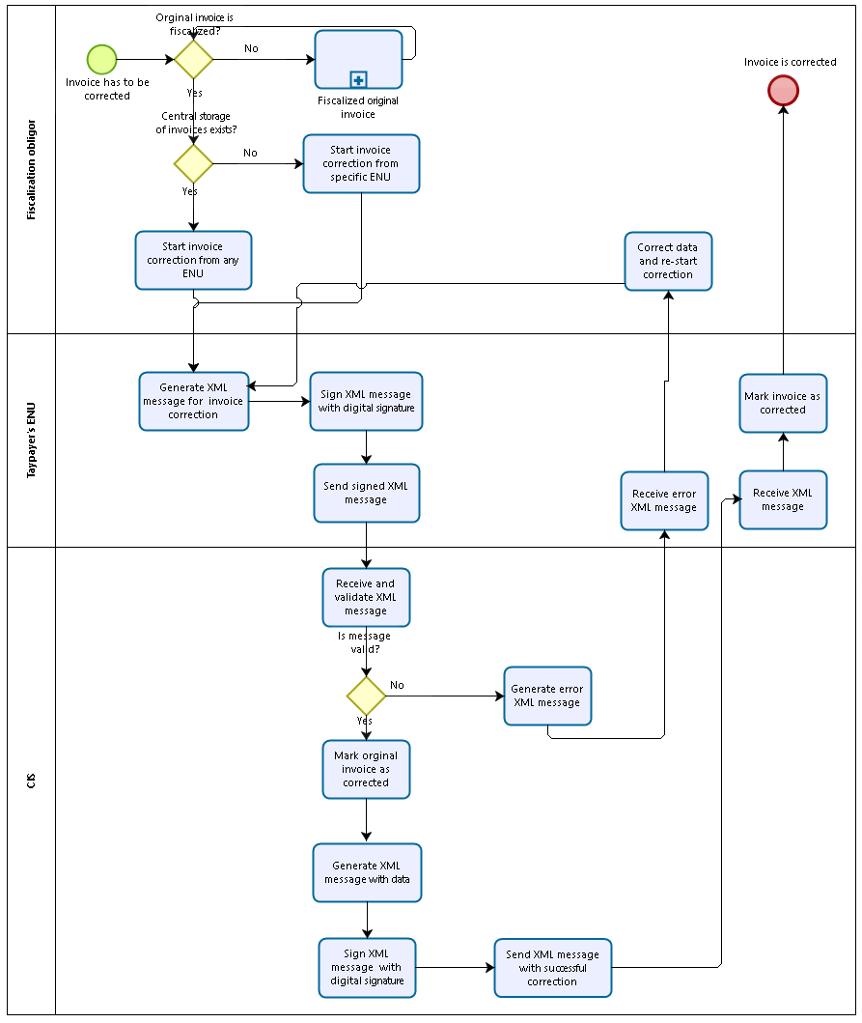
Diagram 6 – Corrective invoice fiscalization

QR code creation and check
To ensure easy verification of the fiscalized invoice a QR code must be printed on every issued invoice. QR code is printed both in case that invoice is successfully reported to the Tax Administration and fiscalized (invoice received JIKR), and in case that invoice cannot be fiscalized (lack of internet, unavailability of fiscalization service server etc.).
The QR code will be printed on paper for all cash invoices, while for electronic invoices the QR code must be attached to the electronic invoice file and must be printed on paper only in case of the delivery of goods where the printed QR code serves as a supporting transport document for the shipped goods.
For the details of how the QR code is being generated by ENU and verified by costumers please refer to the technical specification of the fiscalization service.
Citizen or tax inspector can scan the QR code on the invoice with the appropriate application on their smart phones or tablets and will be directed to validation page of central information system to confirm invoice fiscalization status.
Several outcomes are possible:
- Invoice is recorded in the database – verification page will return original invoice elements of the invoice associated with this JIKR. Citizen/tax inspector can validate that content stored in the CIS database is the same as printed out on the invoice.
- Invoice not found in the database, but invoice is issued in the last 48 hours – taxpayer has 48 hours timeframe to fiscalize the invoice. Although invoice is not found in the database this outcome is still not necessary a violation.
- Invoice not found in the database and invoice is older than 48 hours – in case that issuer/taxpayer has approval for late fiscalization (working in the area with no internet connection), invoice can be rechecked in a month.
- Invoice not found in the database and invoice is older than 48 hours – in case that invoice is not found and more than 48 hours has passed and the taxpayer has not an approval for late fiscalization, the citizen/tax inspector will receive the response that the invoice is not registered in the database and that they can report it to the Tax Administration using the same application so that this invoice can be submitted to a detailed analysis. After reporting, this invoice will be automatically send to the tax inspector in charge for field verification or to the tax investigation/tax audit department for further analysis. This invoice, i.e. the taxpayer is very probably in violation.
- Invoice not valid – in case that IKOF of the invoice is not formed appropriately, an error will be shown. This error points out that invoice is suspicious and can be analyzed further like described in point 4.
The prescribed dimensions of QR codes are at least 21mm x 21mm.

Verification of the IKOF on the ENU
For the purposes of tax investigation, each fiscalization software installed on ENU must be able to allow IKOF recreation based on the initial IKOF formation parameters.
This control activity can be executed by tax inspectors during investigation procedure when on the request of the tax inspector, operator must be able to recreate IKOF on ENU (for example when based on the scanned QR code by a citizen, the invoice is not registered in the database, i.e. has not passed the fiscalization procedure, and the inspector has to check and prove if this reported invoice is really issued by the taxpayer stated on the invoice).
Each ENU software must have function screen that allows that parameters needed for formation of IKOF be entered in the respective fields:
- PIB of the taxpayer
- Date and time of issuing invoice
- Number of the invoice
- Code of business unit
- Code of the ENU
- Code of software
- Total invoice amount
Once this is entered, ENU software can create IKOF using this parameters and taxpayer digital signature.
Generated IKOF must be the same for the same input parameters. This can be used to verify IKOF printed on individual invoice in the past.
So for example if the generated IKOF is the same like the one reported by the citizen/buyer, the tax inspector can use it as a proof that the taxpayer has violated the Law because has not registered the invoice in the fiscalization system, and can immediately prescribe a misdemeanor punishment.

Listing the turnover overview from the ENU for the tax inspectors
For the Tax inspection needs, each fiscalization software installed on the ENU must have an option to allow listing of various views on traffic records and current situation.
Controlling activity must be allowed for the tax inspector during the audit procedure – the taxpayer of the fiscalization is obligated to secure the access to the insight in requested reports by the tax inspector. Each report listed below must have the option of printing from the ENU with mandatory existence of the flag/code of the ENU it was created on, code of the business unit and code of the operator, that will act as a proof in an audit procedure, on court for violations, higher instance court or competent organ.
Mandatory reports:
- Current fiscal status (view over daily traffic until the start of the audit);
- Fiscal daily report – end of day (total turnover for the business working day 00:00:00-23:59:59) - on the basis of which the payment of daily markets is made;
- Periodic fiscal report on the realized turnover on the invoice device (from date to date);
- Periodic analytical review (report) - "electronic journal" (with items);
- Periodic analytical review (report) with items of all offline accounts and daily subtotals - '' offline electronic journal ''
- Periodic analytical review (report) with items of all "corrective" accounts with daily subtotals - "electronic journal of corrective accounts".

All data must be able to be printed in the structured form and can be printed on the printer or saved on the portable media that is supported by the ENU (USB stick, or microSD card).

Business rules

Process of the ENU and cash invoices fiscalization registration
Code | Rule
 | Each ENU must be registered individually
 | When registering ENU it is necessary to register ENU software as well
 | ENU registration can only be done once for each individual ENU
 | After receiving the registration message for ENU, CIS automatically generates a unique and unrepeatable code for each ENU and stores data on ECD and ENU used software in the database
 | After the successful registration and receipt of the response from the Tax Administration containing unique ENU code, the taxpayer is obliged to save this code in the software used by the ENU and use it for each invoice issuance.
 | ENU code is a mandatory part of IKOF that is generated with each invoice issuance and is mandatory information in number of the invoice for all cash invoices
 | The IKOF cannot be generated if the invoice does not contain the received ENU code
 | ENU code will be visible to the taxpayer on his user account in central invoice platform
 | If the business premise where the ENU is registered closes permanently, then the ENU must be deregistered. The deregistration can be done through the fiscalization service from the ENU directly or through the SEP. If the same ENU will be used in another business premise it has to be registered again as a new ENU and it will receive a new ENU code.

Process of the registration of non-cash invoices fiscalization software
Code | Rule
 | It is necessary to register any software supporting the fiscal service and issuing non-cash invoices note
 | Registration is made at the first issuance of a non-cash invoice in the XML message together with other mandatory invoice elements
 | After successful registration, software information is stored in the Tax Administration database
 | Whenever a non-cash invoice is issued, the software code is mandatory element used for generation of the IKOF and it is delivered through the fiscal service to the Tax Administration along with other elements of the non-cash invoice during fiscalization process
 | The Tax Administration's fiscal service for each fiscalized non-cash invoice, among other elements, also checks the software code that the taxpayer uses (subsequent verification, not in real time) and any changes are recorded in the database

Cash deposit registration on the ENU
Code | Rule
 | A taxpayer is required to report a cash deposit of each ENU prior to the commencement of ENU operations each day
 | The deposit notification procedure is done individually for each ECD in the business premises
 | The deposit notification is also required when the deposit is 0.00
 | ECD cannot start operating if no deposit is reported.
 | A taxpayer is required to report any cash withdrawal from ECD during the day.
 | For business premises which works 0-24, the initial deposit shall be registered each day immediately after 00.00 (midnight)
 | The deposit notification procedure is allowed only once per day.

Cash invoice fiscalization
Code | Rule
 | All cash invoices must be fiscalized
 | Each cash invoice must have IKOF and JIKR.
 | All valid cash invoices must be printed at the time of issue, and JIKR, IKOF, and QR code together with other mandatory invoice elements must be printed, except in special cases defined by Law
 | ENU operator is a person authorized by the taxpayer to issue cash invoices on the ENU.

Non-cash invoice fiscalization
Code | Rule
 | All non-cash invoices must be fiscalized
 | Each non-cash invoice must have an IKOF and a JIKR
 | For non-cash invoices that are issued for supply of goods with transport, the QR code of the invoice has to be printed and given to the carrier, which shall keep it until the destination of the goods.
 | There is ENU code data for non-cash invoice fiscalization
 | Any taxpayer who issues non-cash invoice must have at least one registered business premise (the place where the business is registered). The registered business premise code is a required part of the IKOF.
The operator's code is the identifier of the person authorized to issue an invoice for the taxpayer.
In cases when non-cash invoices are issued by an outsourced accounting service company, operator code is the PIB of that taxpayer authorized to issue invoices.

Validation of invoices before storing them in CIS database
Code | Rule
 | A message that has not been successfully validated will not be processed by the CIS or stored in the Tax Administration database.
 | The message must comply with the XML schema of the invoice
 | The taxpayer is obliged to obtain a digital application certificate from AKSHI, for the purpose of implementing the fiscalization process.
 | The message should be properly signed with the application certificate.
 | PIB of the taxpayer from the request message must be equal to PIB from the taxpayer digital certificate.

Validation of received invoices once they are in the CIS database
Code |  | Rule
 |  | Each received XML message is stored by the CIS. The reason for saving the message is the need to prove the credibility of the received XML message.

Corrective invoices
Code | Rule
 | The corrective invoice can be issued in the period of storage of the invoice (5 years following the year in which the invoice was issued).
 | First the invoice that should be corrected has to be fiscalized in the Tax Administration.
 | In case the Internet connection has been terminated, the taxpayer can only issue the invoices with IKOF. Once the Internet connection has been established, the invoice must first be fiscalized (get JIKR) and only then can the fiscalization of the corrective invoice be carried out.
 | Each invoice that is issued in an offline mode and corrected in an offline mode, must be fiscalized (first fiscalization of the issued invoice is needed and then fiscalization of the corrective invoice can be done), unless they are fiscalized at the same time.
 | Fiscalization of a corrective invoice if the initial invoice previously was not fiscalized, will be considered an error.
 | It is not possible to delete the invoice issued, but just to issue a corrective invoice which must also be fiscalized and registered in the Tax Administration.

Data in processes
This section of the documentation will detail the message content with its attributes as well as the controls that will be implemented on individual attributes.

Message for the ENU registration
FIELD | FIELD NAME | OPIS POLJA
 | TAXPAYER PIB | Unique taxpayer code
 | BUSINESS UNIT CODE | Unique business unit code
 | ENU ORDINAL NUMBER (internal ID) | ENU ordinal number inside of one unit
 | ENU SOFTWARE CODE | Unique software code of the software used in the ENU
 | SOFTWARE MAINTAINER CODE | Unique software maintainer code
 | DATE FROM THE ENU WILL BE IN USE | Date when ENU becomes active
 | DATE UNTIL THE ENU WILL BE IN USE | Date when ENU becomes inactive
 | ENU TYPE | ENU type  - regular  - vending machine (self-service)

Message for cash deposit registration
FIELD | FIELD NAME
 | CASH AMOUNT | Amount of cash deposited in the ENU
 | OPERATION | Operation done on the ENU:  - Initial deposit  - Cash withdrawal
 | ENU CODE | Code of the ENU that the deposit is registered for
 | PIB | Taxpayer identification number
 | INFORMATION IF THE DATA ON CASH DEPOSIT IS DELIVERED SUBSEQUENTLY | Is deposit information delivered subsequently:  - Yes  - No
 | DATE AND TIME OF DEPOSIT CHANGE | Date and time of deposit change

Message for invoice fiscalization

Message for the cash and non-cash invoices fiscalization using ENU
FIELD | FIELD NAME | FIELD DESCRIPTION
 | INVOICE TYPE | Invoice type  - Cash  - Non-cash
 | INVOICE ISSUED BY THE BUYER TYPE | This field is filled with next defined values:  - Previous agreement between the sides  - Buying from the local farmers  - Buying services from abroad  - Other.
 | IS INVOICE SIMPLIFIED | Is the invoice simplified  - Yes  - No
 | SELLER | - ID number type  - ID number  - Name  - Address  - Town  - Country
 | INVOICE ISSUING DATE AND TIME | Date when the invoice was issued
 | INVOICE NUMBER | Ordinal number + calendar year + business unit code + ENU code
 | TAXPAYER STATUS | Is the taxpayer in VAT system:  - Yes  - No
 | BUYER | - ID number type  - ID number  - Name  - Address  - Town  - Country
 | TOTAL AMOUNT OF EACH ITEM ON THE INVOICE PER SINGLE VAT RATE | Combination of multiple fields:  a. Number of items with same VAT rate  b. Tax base  c. Tax rate  d. Is exempt from VAT  e. Tax amount (VAT)
 | TOTAL INVOICE AMOUNT WITHOUT VAT | Total amount of goods when the VAT is not payed.
 | AMOUNT RELATED TO SPECIAL MARGIN SCHEME PROCEDURE | Amount of margin.
 | EXPORT OF GOODS | Zero VAT rate (0%), by the Law on VAT, art. 25.
 | FEES | Possible fees are entered here:  - Fee type  - Fee amount.
 | TOTAL AMOUNT WITHOUT VAT | Each item without VAT
 | TOTAL AMOUNT OF VAT | Total amount of VAT on whole invoice
 | TOTAL AMOUNT WITH VAT | Total invoice amount with VAT
 | PAYMENT METHOD | Method of invoice payment:  - Cash  - Non-cash
 | OPERATOR CODE | Alphanumeric code of the operator
 | BUSINESS UNIT CODE | Alphanumeric code of the business unit
 | SOFTWARE CODE | Alphanumeric code of the software used by the ENU
 | TAXPAYER ID | IKOF
 | SIGNED TAXPAYER ID | Signed identification code
 | INFORMATION ON SUBSEQUENT INVOICE DELIVERY | Is invoice delivered subsequently?
 | REVERSE CHARGE | Client has the obligation to pay the VAT instead of the seller
 | IS BAD DEBT | Is the original invoice payable?
 | DATE OR PERIOD OF SUPPLY OF GOODS OR SERVICES | Entered only if payment date is different than the invoice date.
 | CURRENCY | Here is inserted the currency of paying the invoice if it is not payed in domestic currency.
 | CURRENCY EXCHANGE RATE | Here is inserted the currency exchange rate if the invoice is not payed in domestic currency.
 | PAYMENT DEADLINE | Invoice payment deadline
 | SUMMARY INVOICE - INDIVIDUAL IKOF | There are two cases:  1. When the goods is paid by company card issued by the taxpayer who secures the goods or by vouchers that are issued for free, and summary invoice is issued to the buyer on the basis of the invoices for individual buyings issued during the month (that need to contain data on company card or voucher number), then the summary invoice is issued until the last day of the month for all buyings that month and in these circumstances only the summary invoice is taken into account for taxation purposes. Summary invoice like that surely contains calls on all IKOFs of each individual invoice for which the summary invoice is issued, and which are issued the very same month.  2. When the customer pays all the services in the hotel at once, when he is leaving the hotel, the seller will issue the summary invoice with calling each individual invoice issued during the stay at the hotel and will call each IKOF too. The same process is used for taxpayers who work in similar activities, and invoice issuing is done at the moment of getting the order, for each of them. With multiple orders from the same customer, the individual invoice must be issued for each order. If the customer pays multiple invoices at once at the end of specific period, the summary invoice will be issued with calling on all previously issued individual invoices.
 | PARAGON BLOCK NUMBER | Paragon block is used only in case of not being able to issue an invoice using the ENU.
 | TAX PERIOD | Tax period to which the invoice relates.

ITEMS
(also mandatory if the invoice is without VAT)
FIELD | FIELD NAME | FIELD DESCRIPTION
 | ITEM DESCRIPTION | Item name
 | ITEM CODE | Unique item name (barcode)
 | UNIT OF MEASURE | Unit of measurement of an item (kilo, liter…)
 | QUANTITY | Amount related to the unit of measurement (5 kilos).
 | ITEM PRICE EXCLUSIVE OF VAT | Item price without VAT
 | DISCOUNT OR REBATE - PERCENTAGE | Inserted if rebate or discount exist.
 | THE DISCOUNT DECREASES DISCOUNTABLE BASE | Tax base is reduced  - Yes  - Np
 | TAX BASE | Numeric field with two decimal spots.
 | TAX RATE | Percentile
 | EXEMPT OF VAT | Law on VAT
 | VAT | VAT amount (two decimal spots)
 | TOTAL UNIT PRICE WITH VAT | Total unit price with VAT included
 | UNIT PRICE WITH VAT | Unit price with VAT included
 | INVESTMENT | Is the item investment or not?
 | SOLD VOUCHERS | If it is voucher, list its price, value, serial number.

Message for corrective invoice fiscalization
FIELD | FIELD NAME | FIELD DESCRIPTION
 | IKOF REFERENCE ON THE INITIAL INVOICE | IKOF of the corrected invoice
 | CORRECTIVE INVOICE TYPE | Corrective invoice type:  - Corrective invoice
 | DATE AND TIME OF THE INITIAL INVOICE ISSUING | Date and time of issuing of the initial invoice that is being corrected

+ other fields described in previous chapters, depending of invoice type.

