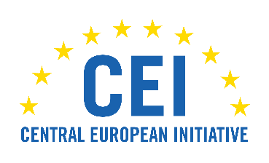 | 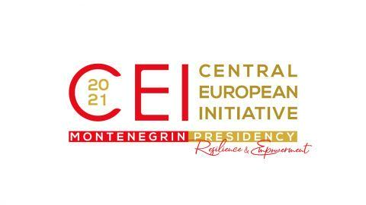
Meeting of the Heads of Government (CEI Summit)
Budva, 3 December 2021

Indicative list of Participants

Montenegro – Prime Minister Zdravko Krivokapić
Bosnia and Herzegovina – Chairman of the Council of Ministers Zoran Tegeltija
Republic of Bulgaria – Prime Minister Stefan Yanev (online)
Republic of Croatia – Prime Minister Andrej Plenković
Republic of Serbia – Prime Minister Ana Brnabić (online)
Republic of Slovenia – Prime Minister Janez Janša (online)
Hungary – Deputy Prime Minister and Minister of Finance Mihály Varga
Republic of North Macedonia – Deputy Prime Minister for Economy and Investments Fatmir Bytyqi
Ukraine – Deputy Prime Minister for European and Euro-Atlantic Integration Olga Stefanyshyna
Republic of Moldova – State Secretary of the Ministry of Foreign Affairs and European Integration Vladimir Cuc
Slovakia – State Secretary of the Ministry of Foreign Affairs Ingrid Brocková - tbc
Republic of Belarus – Deputy Minister of Foreign Affairs Sergei Aleinik
Czech Republic – Deputy Minister of Foreign Affairs Aleš Chmelař
Republic of Albania – Ambassador to Montenegro Ridi Kurtezi
Republic of Poland – Ambassador to Montenegro Artur Dmochowski
Romania – Ambassador to Podgorica Viorel-Matei Ardeleanu - tbc
Republic of Italy – tbc
CEI – Secretary General Roberto Antonione
WHO – Regional Director for Europe Hans Henri P. Kluge
EBRD – Vice President for Policy and Partnerships Mark Bowman

