Obrazac broj 1
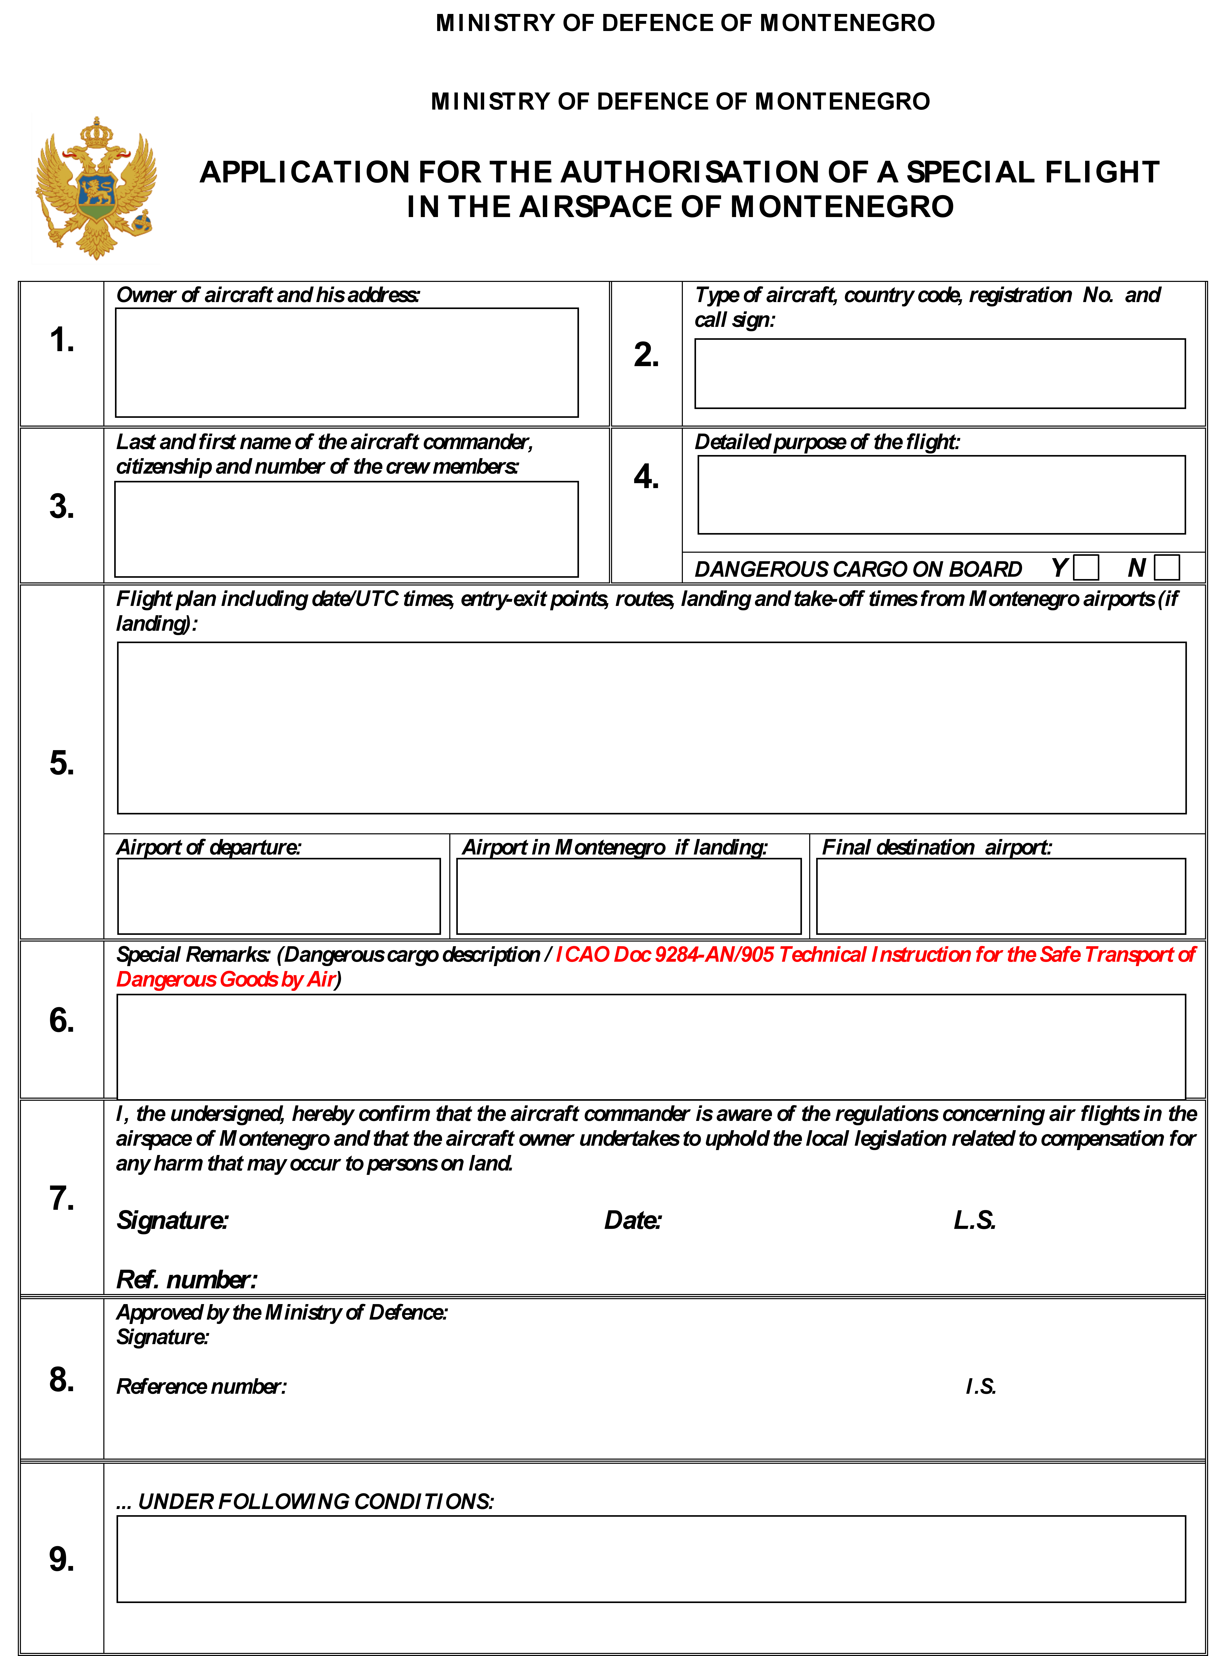

Obrazac broj 2
SHIPPER’S DECLARATION FOR DANGEROUS GOODS

Shipper | Air Waybill No.  Page of Pages  Shipper’s Reference No. (optional)
Consignee
Two completed and signed copies of this Declaration must be handed to the operator. | WARNING  Failure to comply in all respects with the applicable Dangerous Goods Regulations may be in breach of the applicable law, subject to legal penalties.  Shipment type: (delete non-applicable)
TRANSPORT DETAILS

This shipment is within the limitations Airport of Departure (optional):
prescribed for:

(delete non-applicable )

PASSENGER AND CARGO CARGO AIRCRAFT AIRCRAFT ONLY

Airport of Destination (optional):
 |  | NON-RADIOACTIVE | RADIOACTIVE
NATURE AND QUANTITY OF DANGEROUS GOODS
UN Number or Identification Number, Proper Shipping Name, Class or Division (subsidiary hazard), Packing Group (if required) and all other required information
Additional Handling Information
I hereby declare that the contents of this consignment are fully and accurately Name of Signatory
described above by the proper shipping name, and are classiﬁed, packaged marked
and labelled/placarded, and are in all respects in proper condition for transport
according to applicable international and national governmental regulations. I declare that Date
all of the applicable air transport requirements have been met.
Signature
(See warning above)
Obrazac broj 3

DANGEROUS GOODS DETAILS
for Application form for the authorisation of a special flight in the airspace of Montenegro

From [ICAO airfield code] to [ICAO airfield code]

UN  Nbr | Proper Shipping Name | Class or  Division | Packing  Group | Gross weight | Total Net  Quantity | Number of packages | Amount  p.p. | NEQ  (Class 1) | Remark
1 | 2 | 2 | 4 | 5 | 6 | 7 | 8 | 9 | 10

