URBAN - TECHNICAL REQUIREMENTS

MONTENEGRO
CAPITAL CITY OF PODGORICA
SECRETARIAT FOR SPATIAL PLANNING AND SUSTAINABLE DEVELOPMENT
Number: 08-352/19-3936
Podgorica. 24/12/2019

SECRETARIAT FOR SPATIAL PLANNING AND SUSTAINABLE DEVELOPMENT

On the basis of:

- Article 74 of the Law on Spatial Planning and Construction of Structures (“Official Gazette of Montenegro”, No. 64/17),

- Decree on the Delegation of Certain Tasks of the Ministry of Sustainable Development and Tourism to Local Government Units (“Official Gazette of Montenegro”, No. 087/18 of 31/12/2018)

- Detailed Urban Plan (DUP) for “Radoje Dakić”, Decision on Amendments to the Detailed Urban Plan No. 01-030/12-1056 of 20/07/2012

- submitted request: Ministry of Education, Podgorica, No. 08-352/19-3935 of 26/11/2019

ISSUES:
URBAN-TECHNICAL CONDITIONS
FOR THE CONSTRUCTION OF A STRUCTURE ON THE URBAN PLOT
UP 20, DUP “RADOJE DAKIĆ”

07/02/2023
This photocopy was made based on the original copy of the urban-technical conditions No. 08-352/19-3936 of 24/12/2019, by which the Ministry of Education is issued urban-technical conditions for the preparation of technical documentation for the construction of a structure intended for “education”, on urban plot UP20, within the scope of the amendments to the DUP “Radoje Dakić”, which has been archived as an archival copy in the Secretariat for Spatial Planning and Sustainable Development.

HEAD OF THE DEPARTMENT FOR NORMATIVE LEGAL AND HUMAN RESOURCES AFFAIRS
Dejan Mugoša, Law Graduate
[signature]
[seal: Secretariat for Spatial Planning and Sustainable Development, Montenegro, Capital City Podgorica, PODGORICA]
MONTENEGRO  Capital City - Podgorica Secretariat for Spatial Planning and Sustainable Development  Number: 08-352/19-3935  Podgorica, 24/12/2019 | DUP “Radoje Dakić”  – amendments –  Urban Plot UP 20  Applicant,  Ministry of Education

CURRENT STATUS:

Cadastral plots No. 1503/46 and 1503/48 according to the Property List No. 184 and No. 4346 Cadastral Municipality Podgorica 1, issued by the Real Estate Administration, ownership holder Shareholding Company “Radoje Dakić”. On the subject cadastral plots, according to the property lists and plan copy, there are existing structures:

PLANNED STATUS:

URBAN PLANNING PARAMETERS – tabular overview for UP 20

Urban plot:

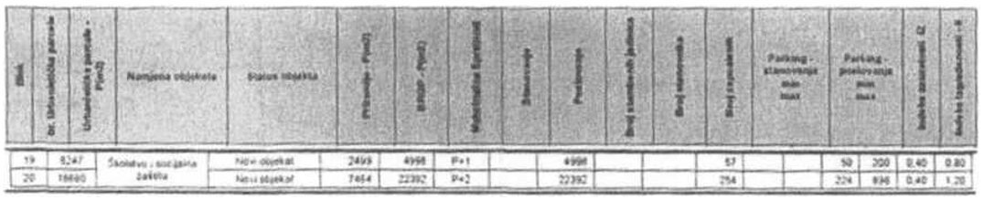

Urban plot UP 20, with an area of 18,660 m².

ANALYSIS OF NATURAL CHARACTERISTICS OF THE PLANNED AREA

Geographic conditions
The area of the General Urban Plan (GUP) of Podgorica covers 8,446 ha (valid GUP from 1990).
The town is located in the northern part of the Zeta plain, with a hilly-mountainous hinterland.
Most of the town lies on approximately flat terrain around 45 meters above sea level, which is also characteristic of the observed zone.
Physical structures are increasingly forming towards the higher elevations of Gorica (131 m), Malo brdo (205 m), Ljubović (100 m), Dajbabska gora (170 m), Donja Gorica (102 m), Kakaricka gora (220 m). From this, it follows that the formation of new physical structures should take into account the mentioned morphological features of the terrain and existing physical structures.
Engineering-geomorphological and geological characteristics
According to the map of land suitability for urbanization, (R=1:5,000), prepared for the GUP Revision purposes, this area is classified in Category I, i.e., land without limitations for urbanization. The geological composition of this terrain consists of gravel and sand with uneven grain-size distribution and variable cohesion. Sometimes these are entirely non-cohesive sediments, and sometimes true conglomerates, practically incompressible, which hold in vertical cuts and in overhangs and vaults.

[seal: Secretariat for Spatial Planning and Sustainable Development, Montenegro, Capital City Podgorica, PODGORICA]

2
These lithological structures are characterized by good water permeability, and the depth of the groundwater table is greater than 4 m throughout the area.
Soil bearing capacity ranges from 300 – 500 kN/m². Due to mild slopes, part of the GUP-covered area falls into the category of stable terrain.
Seismic Intensity Level
From a macroseismic perspective, Podgorica is located in an area of pronounced seismic activity. According to the Seismological Map, the urban area is classified under 8° of MCS scale (Mercalli–Cancani–Sieberg scale) as the maximum expected earthquake intensity for a return period of 100 years, with a probability of occurrence of 63%.
Comprehensive research and analyses conducted after the April 15, 1979 earthquake enabled the development of the Seismic Microzonation of the urban area and the Study on the Vulnerability of Structures and Infrastructure, prepared for the purposes of the GUP Revision.
The seismic hazard for this area pertains to two characteristic terrain models of conglomerate terrace, i.e., model C1 where the thickness of surface sediment layers (to the bedrock) is less than 35 m, and model C2 where the thickness exceeds 35 m.
The obtained parameters are as follows:
- seismic coefficient (SC) 0.079 - 0.090
- dynamic coefficient (DC) 1.00 >DC> 0.47
- soil acceleration Qmax(q) 0.288 - 0.360
- intensity in (MCS) 9° MCS
Amendments to the Detailed Urban Plan “Radoje Dakić” in Podgorica
WINsoft LLC 28
Pedological Characteristics
The observed area features shallow brown soil on gravel and conglomerate. Some areas have been cultivated and greened, thereby improving the pedological characteristics in those sections. At the same time, there are significant areas contaminated by industrial waste (especially around the foundry facility) where remediation is necessary.
Hydrological Characteristics
The territory of the GUP area is rich in surface watercourses, as well as underground aquifers. Surface waters gravitate toward the Morača River and belong to the Adriatic Sea basin. The water level of the Morača River depends on two main regimes: rainfall (pluvial) and snowmelt (nival). The related zone is not threatened by flooding. The maximum levels of underground water are at elevations that allow for the construction of underground floors.
Climatic Features
The proximity of the Adriatic Sea and the terrain configuration are key factors influencing the climate in the Podgorica area, which is slightly modified maritime climate. The average annual air temperature is 15.5° C. The coldest month is January, and the warmest is July. The annual amplitude is 21.7° C. Maximum annual temperatures occur from May to September and range between 35.4° and 44.8° C.
The trend of temperature increase due to global climate change has not yet been sufficiently statistically analyzed. The summer of 2003 is indicative, when for a period longer than 90 days the air temperature in Podgorica exceeded 35° C, while the highest recorded temperature was in August 2011, reaching 44.8° C.
Frost days (with air temperatures below 0° C) occur on average 24.5 days per year, and the frequency of days when the maximum daily temperature does not rise above 0° C is one.
The average annual sum of sunshine on horizontal surfaces, expressed in hours of sunlight, is 2465, resulting in an average relative sunshine of 56.1% of the possible sunshine for the latitude of Podgorica. The sunniest month is July, with 74% of potential sunshine.
Fog occurs on average 9 days during the period from October to April.

[seal: Secretariat for Spatial Planning and Sustainable Development, Montenegro, Capital City Podgorica, PODGORICA]
3
The average annual precipitation is 1692.2 mm. Of this amount, winter accounts for 34.6%, spring 22.2%, summer 10.1%, and autumn 33.1% of the average annual precipitation. Precipitation in the form of snow occurs on average only 5.4 days between January 9 and February 16. Snow rarely remains longer than one day.
The prevailing wind is the north wind, which occurs most often in summer and least often in spring.
The highest recorded wind speed is 34.8 m/s, or 125.3 km/h. The average annual frequency of days with strong wind, at a minimum of 12.3 m/s or 44.3 km/h, is 69.3 days or 16.3% of the year.

SPATIAL AND PROGRAMMATIC CONCEPT OF THE DETAILED URBAN PLAN

Planning Objectives

The zone for education and social protection covers an area of 2.49 ha.
Location
The zone includes part of the area of the industrial complex “Radoje Dakić” between the inner newly planned street A on the eastern side, street B on the western side, street D on the southern side, and is bordered on the north by Branko Deletić Street, which is also the boundary of the plan coverage.
Programme
Structures are formed on the corresponding urban plots 19 and 20. The designated urban areas are intended for educational facilities (primary of a school level – elementary school) on UP20 and a preschool institution (kindergarten) on UP19. The planned facilities for education and social protection will serve the residents of the area covered by this plan and parts of the adjacent detailed urban plans.
Analysis of Required Capacity for the Preschool Institution
According to the population projection from the GUP, the age group 0–6 years accounts for 4%. For the planned 12,672 residents within the plan area, this corresponds to 506 children. The GUP recommends planning for preschool institutions to cover 28% of the generation. The number of children within the plan area for whom a preschool institution should be provided is 141. According to the standard of 6 m² per child, the capacity required for a preschool institution for the residents of this area is 850 m². A dedicated kindergarten facility is planned within the plan area.

UTC for the construction of a building intended for “education” – elementary school on the corresponding urban plot (UP20)

On the newly formed urban plot, as shown in the graphic attachments, the construction of the building is planned under the following conditions

- On urban plot UP20, the construction of an elementary school building is envisaged
- The elementary school is planned with a maximum number of floors of Ground floor + 2 above-ground levels, as shown in the graphic and tabular annexes.
- The maximum coverage index is 0.40 and the maximum floor area ratio is 1.2; the indices are provided in the tabular annex.
- As part of the structure project, a site landscaping project must also be prepared.
- The floor heights of classrooms, the gymnasium, halls, etc., are to be defined according to the regulations for this type of a structure, namely the “Rulebook on detailed conditions for the establishment of institutions in the field of education and upbringing” published in the “Official Gazette of the Republic of Montenegro”, no. 40/2006 dated 22/6/2006.
[seal: Secretariat for Spatial Planning and Sustainable Development, Montenegro, Capital City Podgorica, PODGORICA]
4
- At the design stage, flexibility in space organization is allowed, including the use of semi-underground spaces and level differences.
- The entrance to the school complex should be organized from the direction of the main pedestrian routes into the school yard. The entrance to the school should be from the school yard.
- The complex of the urban plot must be enclosed with a fence harmonized with the architectural outlook of the building.
- In terms of materials, the typical use of durable materials is expected for this type of a structure, in line with practices in the Podgorica area.

INFRASTRUCTURE
TRAFFIC INFRASTRUCTURE

Parking
Parking within the plan boundaries is addressed according to the planned land uses. It has been aimed that each user resolves their parking needs within their construction plot.

Street parking is regulated with a separate regime. The concept provides for possible vehicle parking on streets of the secondary and lower network.

The land use within the area covered by the plan is a combination of commercial activities and residential function. The majority of the plan area is occupied by facilities related to industry, warehouses, and services. Vehicle parking in these zones is planned within the plots. The plot user must provide on-site areas for unobstructed vehicle maneuvering, and areas for the parking of passenger and freight vehicles.

When defining areas for the parking of passenger vehicles, the following standards are recommended to the user, based on the GUP standards, depending on the intended use of the planned facilities:

for industrial and warehouse zones – 1 parking lot (PL) per 170 m² of gross floor area (average), out of which:
for industrial zone  for open warehouse zone  for semi-open warehouse zone  for closed warehouse zone | 1 parking lot for 250 m² of gross floor area  1 parking lot for 200 m² of gross floor area  1 parking lot for 150 m² of gross floor area  1 parking lot for 100 m² of gross floor area

When designing standard garages, the following elements must be observed:
- ramp width in direction min. 2.75 m;
- clear garage height min. 2.2 m;
- parking lot dimensions min. 2.5x5.0 m,
- internal traffic lane width in direction min. 5.50 m.
- longitudinal slope of straight ramps max. 12% for uncovered and 15% for covered ramps.
Open parking lots should be designed to allow maximum greening, and for every 3 parking lots, a tree should be planted (where possible).

ELECTRICAL POWER SUPPLY

The location and method of connecting the facility to the power grid shall be determined by the expert services of CEDIS after the development of project documentation.

[seal: Secretariat for Spatial Planning and Sustainable Development, Montenegro, Capital City Podgorica, PODGORICA]
5
According to the Detailed Urban Plan “Radoje Dakić,” the power supply for the facility on UP 20, transformer area 5, is planned from the transformer station NDTS 10/0.4kV “No.5 – New” 2x1000 kVA

TELECOMMUNICATIONS NETWORK:
In accordance with Article 26, paragraph 2 of the Law on Electronic Communications (Official Gazette No. 50/08), the investor must construct subscriber communication cables, cable distribution system cables, and a common antenna system.
The telecommunications network shall be designed and constructed in accordance with the Rulebook on technical and other conditions for the design, construction, and use of electronic communications networks, electronic communications infrastructure, and associated equipment in buildings (Official Gazette of Montenegro No. 41/15).

HYDROTECHNICAL ENGINEERING
Hydrotechnical installations shall be designed and executed in accordance with the conditions of the Limited Liability Company “Vodovod i kanalizacija”, provided in the annex to this UTC.

LANDSCAPE ARCHITECTURE
Green areas of educational and healthcare facilities
The design of green and open spaces must serve the primary purpose of the area: preschool institution and primary school, healthcare institution.
The size of a schoolyard outside the city center should be 25–35 m² per student, considering a single shift only. In dense block-built areas, the optimal area per student may be 10–15 m² but not less than 4 m². In kindergartens for preschool-aged children, at least 15 m² of open space per child must be provided. For a kindergarten with four groups and a total of 100 children, at least 1500 m² of open space for children must be ensured.
The following conditions apply to green areas of education and healthcare facilities:
- landscaping should follow a landscape style, taking into account views, sun exposure, the balance of light and shade, and the need for creating shade,
- along fences, denser plantings of shrubs and tall trees should be planned as sanitary-hygienic and visual barriers from external influences,
- species with diverse colors and phenological characteristics, those that release phytoncides, and those improving the biological value of the air should be used,
- poisonous species, plants causing pollen allergies, and plants with thorns must not be used, and plants with thorns should not be used in green areas of preschool and primary school institutions,
- high-quality grass mixtures resistant to drought and trampling should be used for lawns,
- on open areas of preschool and school institutions, soft surfaces made of the highest quality materials should be used; additionally, the design should include small areas for educational plant cultivation and platforms for students’ rest and recreation,
- on playgrounds for preschool children, adequate shade must be provided, the surface should be treated with elastic coverings and equipped with certified play equipment that is attractive, easy to maintain, and allows creative play while minimizing the risk of injury,
- fountains and/or water taps should be included,
- urban furniture shall be functional and modern in design,
- a hydrant network for irrigation must be planned,
- existing vital and functional greenery must be preserved and integrated into the new landscape solutions,
landscaping shall be carried out based on a project design.

[seal: Secretariat for Spatial Planning and Sustainable Development, Montenegro, Capital City Podgorica, PODGORICA]
6
CONDITIONS REGARDING PROTECTION MEASURES

During the preparation of design documentation, and depending on the type of facilities, the following shall be applied:
- Law on Protection and Rescue (Official Gazette of Montenegro No. 13/07, 05/08, 86/09, and 32/11), guidelines of the National Strategy for Emergency Situations, and national and municipal protection and rescue plans,
- Rulebook on technical standards for access roads, turning points, and arranged platforms for fire-fighting vehicles near high fire-risk facilities (Official Gazette of SFRY, No. 8/95),
- Rulebook on Technical Standards for the Fire Protection of High-Rise Buildings (Official Gazette of the SFRY, no. 7/84).
- Rulebook on technical standards for fire and explosion protection of warehouses (Official Gazette of SFRY, No. 24/87),
- Rulebook on the construction of facilities for flammable liquids and on the storage and transfer of flammable liquids (Official Gazette of SFRY, No. 20/71 and 23/71),
- Rulebook on the construction of stations for the refueling of motor vehicles and on the storage and transfer of fuels (Official Gazette of SFRY, No. 27/71),
- Rulebook on the construction of facilities for liquefied petroleum gas and on the storage and transfer of liquefied petroleum gas (Official Gazette of SFRY, No. 24/71 and 26/71),
- Rulebook on technical standards for the protection of electric power lines with nominal voltage from 1 kV to 400 kV (Official Gazette of SFRY, No. 65/88 and Official Gazette of SFRY, No. 18/92).

OTHER CONDITIONS

The project must be prepared in accordance with the issued urban-technical conditions by an authorized legal entity registered in the Central Registry of the Commercial Court for performing activities related to the preparation of technical documentation and meeting the conditions prescribed by the Law on Spatial Planning and Construction of Structures (Official Gazette of Montenegro, No. 064/17 of 06/10/2017).
The design documentation and revision of technical documentation must be carried out in accordance with the Law on Spatial Planning and Construction of Structures (Official Gazette of Montenegro, No. 064/17 of 06/10/2017) and in accordance with the Rulebook on the method of preparation, scale, and detailed contents of technical documentation.

Processed by  Risto Lučić, graduate electrical engineer  [signature] | Authorized official II for construction and legalization of structures  Risto Lučić, graduate electrical engineer  [signature]  [seal: ILLEGIBLE]
Appendices:

07/02/2023
This photocopy was made based on the original copy of the urban-technical conditions No. 08-352/19-3936 of 24/12/2019, by which the Ministry of Education is issued urban-technical conditions for the preparation of technical documentation for the construction of a structure intended for “education”, on urban plot UP20, within the scope of the amendments to the DUP “Radoje Dakić”, which has been archived as an archival copy in the Secretariat for Spatial Planning and Sustainable Development.

HEAD OF THE DEPARTMENT FOR NORMATIVE LEGAL AND HUMAN RESOURCES AFFAIRS
Dejan Mugoša, Law Graduate
[signature]
[seal: Secretariat for Spatial Planning and Sustainable Development, Montenegro, Capital City Podgorica, PODGORICA]
[barcode 176000000084]
REAL ESTATE ADMINISTRATION

REGIONAL UNIT PODGORICA
Number: 101-956-67897/2019
Date: 18/12/2019
CADASTRAL MUNICIPALITY PODGORICA I
Pursuant to Article 173 of the Law on State Survey and Real Estate Cadastre (“Official Gazette of the Republic of Montenegro”, No. 29/07, “Official Gazette of Montenegro“, No. 73/10, 32/11, 40/11, 43/15, 37/17, and 17/18), acting upon the request of the SECTOR FOR CONSTRUCTION AND LEGALIZATION OF STRUCTURES No. 08-352/19-3936 956-101-5822/19, for the designated purpose, the following is issued

PROPERTY LIST 184 - EXCERPT

Plot data
Number/Subnumber | Number of building | Plan Drawing | Date of inscription | Section or street name and house number | Manner of use  Acquisition base | Ref. classification | Surface m2 | Income
1503 46 | 1 | 12  3 | 05/06/2019 | KRUŠEVAC | Business buildings in the economy  - |  | 372 | 0.00
Total |  |  |  |  |  |  | 372 | 0.00

Data of the owner or holder
Corporate ID - ID number | Name of the right holder - address and place | Rights | Scope of right
0000002014092 | RADOJE DAKIĆ JSC PODGORICA  CETINJSKI PUT BB Podgorica | Usage | 1/1

Data on burdens or limitations
Number/Subnumber | Number of building | SP | Serial number | Manner of use | Date of inscription  Description of rights | Title description
1503 46 | 1 |  | 1 | Business buildings in the economy | 05/06/2019  10:41 AM | Annotation of the enforcement decision  I.No. 1707/10 dated 17/03/2010 CREDITOR LAZOVIĆ MILAN AMOUNT 25,271.00 €
1503 46 | 1 |  | 2 | Business buildings in the economy | 05/06/2019  10:41 AM | Annotation of the enforcement decision  I.No. 3206/10 dated 17/05/2016 in the legal matter of the enforcement creditor Ćupić Miodrag and the enforcement debtor being the Shareholding Company RADOJE DAKIĆ.
1503 46 | 1 |  | 3 | Business buildings in the economy | 05/06/2019  10:42 AM | Annotation of the enforcement decision  I.No. 4893/09 dated 11/09/2009 in the legal matter of the enforcement creditor Klikovac Špiro and the enforcement debtor being the Shareholding Company RADOJE DAKIĆ.
1503 46 | 1 |  | 4 | Business buildings in the economy | 05/06/2019  10:42 AM | Annotation of the enforcement decision  I.No. 326/10 dated 23/01/2010 in the legal matter of the enforcement creditor Vidaković Lidija and the enforcement debtor being the Shareholding Company RADOJE DAKIĆ.
1503 46 | 1 |  | 5 | Business buildings in the economy | 05/06/2019  10:42 AM | Annotation of the enforcement decision  I.No. 4346/09 dated 02/07/2009 in the legal matter of the enforcement creditor Dabanović Zvezdana and the enforcement debtor being the Shareholding Company RADOJE DAKIĆ.
1503 46 | 1 |  | 6 | Business buildings in the economy | 05/06/2019  10:43 AM | Annotation of the enforcement decision  I.No. 2402/10 dated 12/04/2010 in the legal matter of the enforcement creditor Radević Raško and the enforcement debtor being the Shareholding Company RADOJE DAKIĆ.

[seal: Secretariat for Spatial Planning and Sustainable Development, Montenegro, Capital City Podgorica, PODGORICA]

Date and time: 18/12/2019 08:05:03 AM 1/14

8/21
Data on burdens or limitations
Number/Subnumber | Number of building | SP | Serial number | Manner of use | Date of inscription  Description of rights | Title description
1503 46 | 1 |  | 162 | Business buildings in the economy | 05/06/2019  11:44 AM | Entry of enforceability of claim  BURDEN – ANNOTATION OF THE ENFORCEMENT DECISION I.No. 420/10 dated 29/01/2010 FOR COMPENSATION DUE TO UNDERPAID SALARY FOR THE PERIOD FROM 01/01/1999 TO 01/06/2001 IN FAVOR OF VUKOVIĆ RATKO, DEBTOR BEIGN THE SHAREHOLDING COMPANY RADOJE DAKIĆ
1503 46 | 1 |  | 163 | Business buildings in the economy | 05/06/2019  11:45 AM | Entry of enforceability of claim  ANNOTATION OF THE ENFORCEMENT DECISION I.No. 692/10 dated 10/02/2010
1503 46 | 1 |  | 164 | Business buildings in the economy | 05/06/2019  11:45 AM | Entry of enforceability of claim  ANNOTATION OF THE ENFORCEMENT DECISION I.No. 350/10 dated 26/01/2010 BASIC COURT
1503 46 | 1 |  | 165 | Business buildings in the economy | 05/06/2019  11:45 AM | Annotation of the enforcement decision  I.NO. 2396/10 DATED 12/04/2010 IN THE LEGAL MATTER OF THE ENFORCEMENT CREDITOR GOLUBOVIĆ VOJKA AND THE ENFORCEMENT DEBTOR BEING THE SHAREHOLDING COMPANY RADOJE DAKIĆ.
1503 46 | 1 |  | 166 | Business buildings in the economy | 04/12/2019  8:17 AM | Annotation of the enforcement decision  ANNOTATION OF THE ENFORCEMENT DECISION OF THE BASIC COURT IN PG I.No. 2064/10 dated 31/03/2010
1503 46 | 1 |  | 167 | Business buildings in the economy | 06/12/2019  8:12 AM | Annotation of the enforcement decision  I.No. 6070/09 dated 09/10/2009 IN FAVOR OF ŠIKMANOVIĆ PETAR, LEKOVIĆ NOVAK, RAKOČEVIĆ JADRANKA, SEKULOVIĆ MIODRAG, JOVANOVIĆ MILORAD, KLJAJEVIĆ ŽARKO AND MARKOVIĆ VASILIJE
1503 46 | 1 |  | 168 | Business buildings in the economy | 16/12/2019  11:29 AM | Annotation of the enforcement decision  ANNOTATION OF THE MOTION FOR ENFORCEMENT No. 3128/10 dated 17/09/2010 DEBTOR RADOJE DAKIĆ CREDITORS BULATOVIĆ TADIJA, VUKČEVIĆ MILORAD, LEKOVIĆ MILKA, BOLJEVIĆ MILUTIN, DRAGOVIĆ TOMISLAV, PERIŠIĆ DRAGICA AND IVANOVIĆ MARIA

Fee payment is exempt based on Article 17 of the Law on Administrative Fees (“Official Gazette of Montenegro”, no. 18/19). Fee payment is exempt based on Article 174 of the Law on State Survey and Real Estate Cadastre (“Official Gazette of the Republic of Montenegro” no. 29/07, “Official Gazette of Montenegro” no 73/10, 032/11, 040/11, 043/15, 037/17 and 17/18).

Head
[signature]
[stamp: REAL ESTATE ADMINISTRATION, PODGORICA, MONTENEGRO]

[stamp: Secretariat for Spatial Planning and Sustainable Development, Montenegro, Capital City Podgorica, PODGORICA]

Date and time: 16/12/2019 1:36:58 PM 14/14

9/21
Data on burdens or limitations
Number/Subnumber | Number of building | SP | Serial number | Manner of use | Date of inscription  Description of rights | Title description
1503 48 | 3 |  | 118 | Business buildings in the economy | 20/06/2016  2:58 PM | Annotation of the enforcement decision  I.No. 1463/11 dated 10/03/2011 IN THE LEGAL MATTER OF THE ENFORCING CREDITOR ASANOVIĆ VESELINKA AND THE ENFORCED DEBTOR BEING THE SHAREHOLDING COMPANY RADOJE DAKIĆ.
1503 48 | 3 |  | 119 | Business buildings in the economy | 20/06/2016  15:2 | Annotation of the enforcement decision  I.No. 1007/15 dated 11/09/2015 IN THE LEGAL MATTER OF THE ENFORCING CREDITOR ZEČEVIĆ MIRKO AND THE ENFORCED DEBTOR BEING THE SHAREHOLDING COMPANY RADOJE DAKIĆ.
1503 48 | 3 |  | 120 | Business buildings in the economy | 04/01/2017  9:57 AM | ANNOTATION OF THE DECISION OF THE COMMERCIAL COURT OF MONTENEGRO NO. ST.490/16 DATED 19/12/2016 BY WHICH BANKRUPTCY PROCEEDINGS WERE INITIATED AGAINST THE BANKRUPTCY DEBTOR BEING THE SHAREHOLDING COMPANY RADOJE DAKIĆ.
1503 48 | 3 |  | 121 | Business buildings in the economy | 01/08/2017  2:15 PM | Annotation of the enforcement decision  ANNOTATION OF THE ENFORCEMENT DECISION OF JUDGE BOŠKOVIĆ ALEKSANDAR I.No. 1142/16 dated 22/03/2016 CREDITOR MALOVIĆ BOŽIDAR, DEBTOR BEING THE SHAREHOLDING COMPANY RADOJE DAKIĆ

Fee payment is exempt based on Article 17 of the Law on Administrative Fees (“Official Gazette of Montenegro”, no. 18/19). Fee payment is exempt based on Article 174 of the Law on State Survey and Real Estate Cadastre (“Official Gazette of the Republic of Montenegro” no. 29/07, “Official Gazette of Montenegro” no 73/10, 032/11, 040/11, 043/15, 037/17 and 17/18).

Head
[signature]
[seal: REAL ESTATE ADMINISTRATION, PODGORICA, MONTENEGRO]

[seal: Secretariat for Spatial Planning and Sustainable Development, Montenegro, Capital City Podgorica, PODGORICA]

Date and time: 16/12/2019 1:32:41 PM 19/19

11/21
[bar code 176000000084]
REAL ESTATE ADMINISTRATION

REGIONAL UNIT PODGORICA
Number: 101-956-67899/2019
Date: 18/12/2019
CADASTRAL MUNICIPALITY PODGORICA I
Pursuant to Article 173 of the Law on State Survey and Real Estate Cadastre (“Official Gazette of the Republic of Montenegro”, No. 29/07, “Official Gazette of Montenegro“, No. 73/10, 32/11, 40/11, 43/15, 37/17, and 17/18), acting upon the request of the SECTOR FOR CONSTRUCTION AND LEGALIZATION OF STRUCTURES No. 08-352/19-3936 956-101-5822/19, for the designated purpose, the following is issued

PROPERTY LIST 4346 - EXCERPT

Plot data
Number/Subnumber | Number of building | Plan Drawing | Date of inscription | Section or street name and house number | Manner of use  Acquisition base | Ref. classification | Surface m2 | Income
1503 48 |  | 12  3 | 20/11/2019 | KRUŠEVAC | Land next to a commercial building  LEGAL REGULATION |  | 10134 | 0.00
1503 48 | 2 | 12  3 | 05/06/2019 | KRUŠEVAC | Land next to a commercial building  LEGAL REGULATION |  | 84 | 0.00
1503 48 | 3 | 12  3 | 05/06/2019 | KRUŠEVAC | Land next to a commercial building  LEGAL REGULATION |  | 8030 | 0.00
Total |  |  |  |  |  |  | 18248 | 0.00

Data of the owner or holder
Corporate ID - ID number | Name of the right holder - address and place | Rights | Scope of right
0000002014092 | RADOJE DAKIĆ JSC PODGORICA  CETINJSKI PUT BB Podgorica | Usage | 1/1

Data of the facilities and separate parts
Number/Subnumber | Number of building | Method of use  Acquisition base  Rooms | SP  Year of construction | Number of floors / Floor Surface | Rights  Owner or the property right holder  Address, Place
1503 48 | 2 | Business buildings in the economy  CONSTRUCTION | 0 | P  84 | Ownership  RADOJE DAKIĆ JSC  PODGORICA  CETINJSKI PUT BB  Podgorica | 1/1  0000002014092
1503 48 | 2 | Business buildings in the economy  CONSTRUCTION | 0 | P  8030 | Ownership  RADOJE DAKIĆ JSC  PODGORICA  CETINJSKI PUT BB  Podgorica | 1/1  0000002014092

Data on burdens or limitations
Number/Subnumber | Number of building | SP | Serial number | Manner of use | Date of inscription  Description of rights | Title description
1503 48 |  |  | 1 | Land next to a commercial building | 05/06/2019  12:30 PM | Annotation of the enforcement decision  I.No. 1706/10 dated 17/03/2010 CREDITOR BAŠOVIĆ ILIJA AMOUNT €11,337.00
1503 48 |  |  | 2 | Land next to a commercial building | 05/06/2019  12:31 PM | Annotation of the enforcement decision  I.No. 7221/10 dated 13/12/2010 IN FAVOR OF POPOVIĆ ĐORĐIJE
1503 48 |  |  | 3 | Land next to a commercial building | 05/06/2019  12:31 PM | Annotation of the enforcement decision  I.No. 3540/11 dated 13/06/2011 CREDITOR LASICA LJILJANA AND OTHER /186 CREDITORS/
[seal: Secretariat for Spatial Planning and Sustainable Development, Montenegro, Capital City Podgorica, PODGORICA]

Date and time: 18/12/2019 08:08:24 AM 1/19
12/21
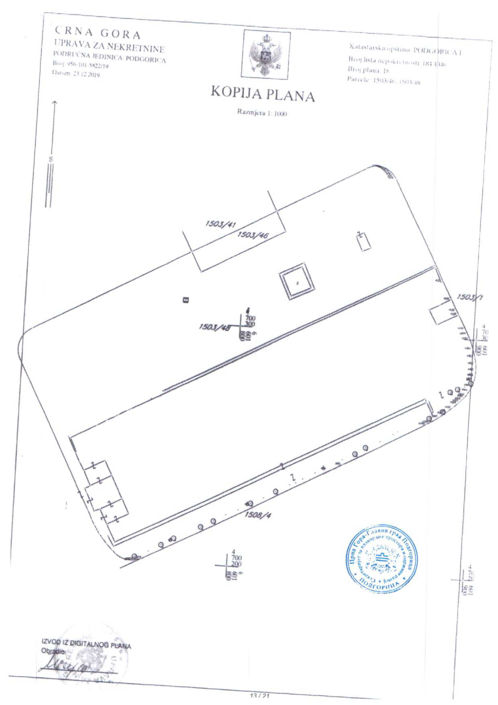
EXCERPT FROM THE DIGITAL PLAN
Processed by
[signature]
[seal: ILLEGIBLE]
Cadastral Municipality: PODGORICA I
Property list number: 184 ILLEGIBLE
Plan Number: 18
Plots: 1503/46, 1503/48
[seal: Secretariat for Spatial Planning and Sustainable Development, Montenegro, Capital City Podgorica, PODGORICA]
PLAN COPY
Scale 1:1000
MONTENEGRO
REAL ESTATE ADMINISTRATION
REGIONAL UNIT: PODGORICA
Number: 956-101-5822/19
Date: 23/12/2019

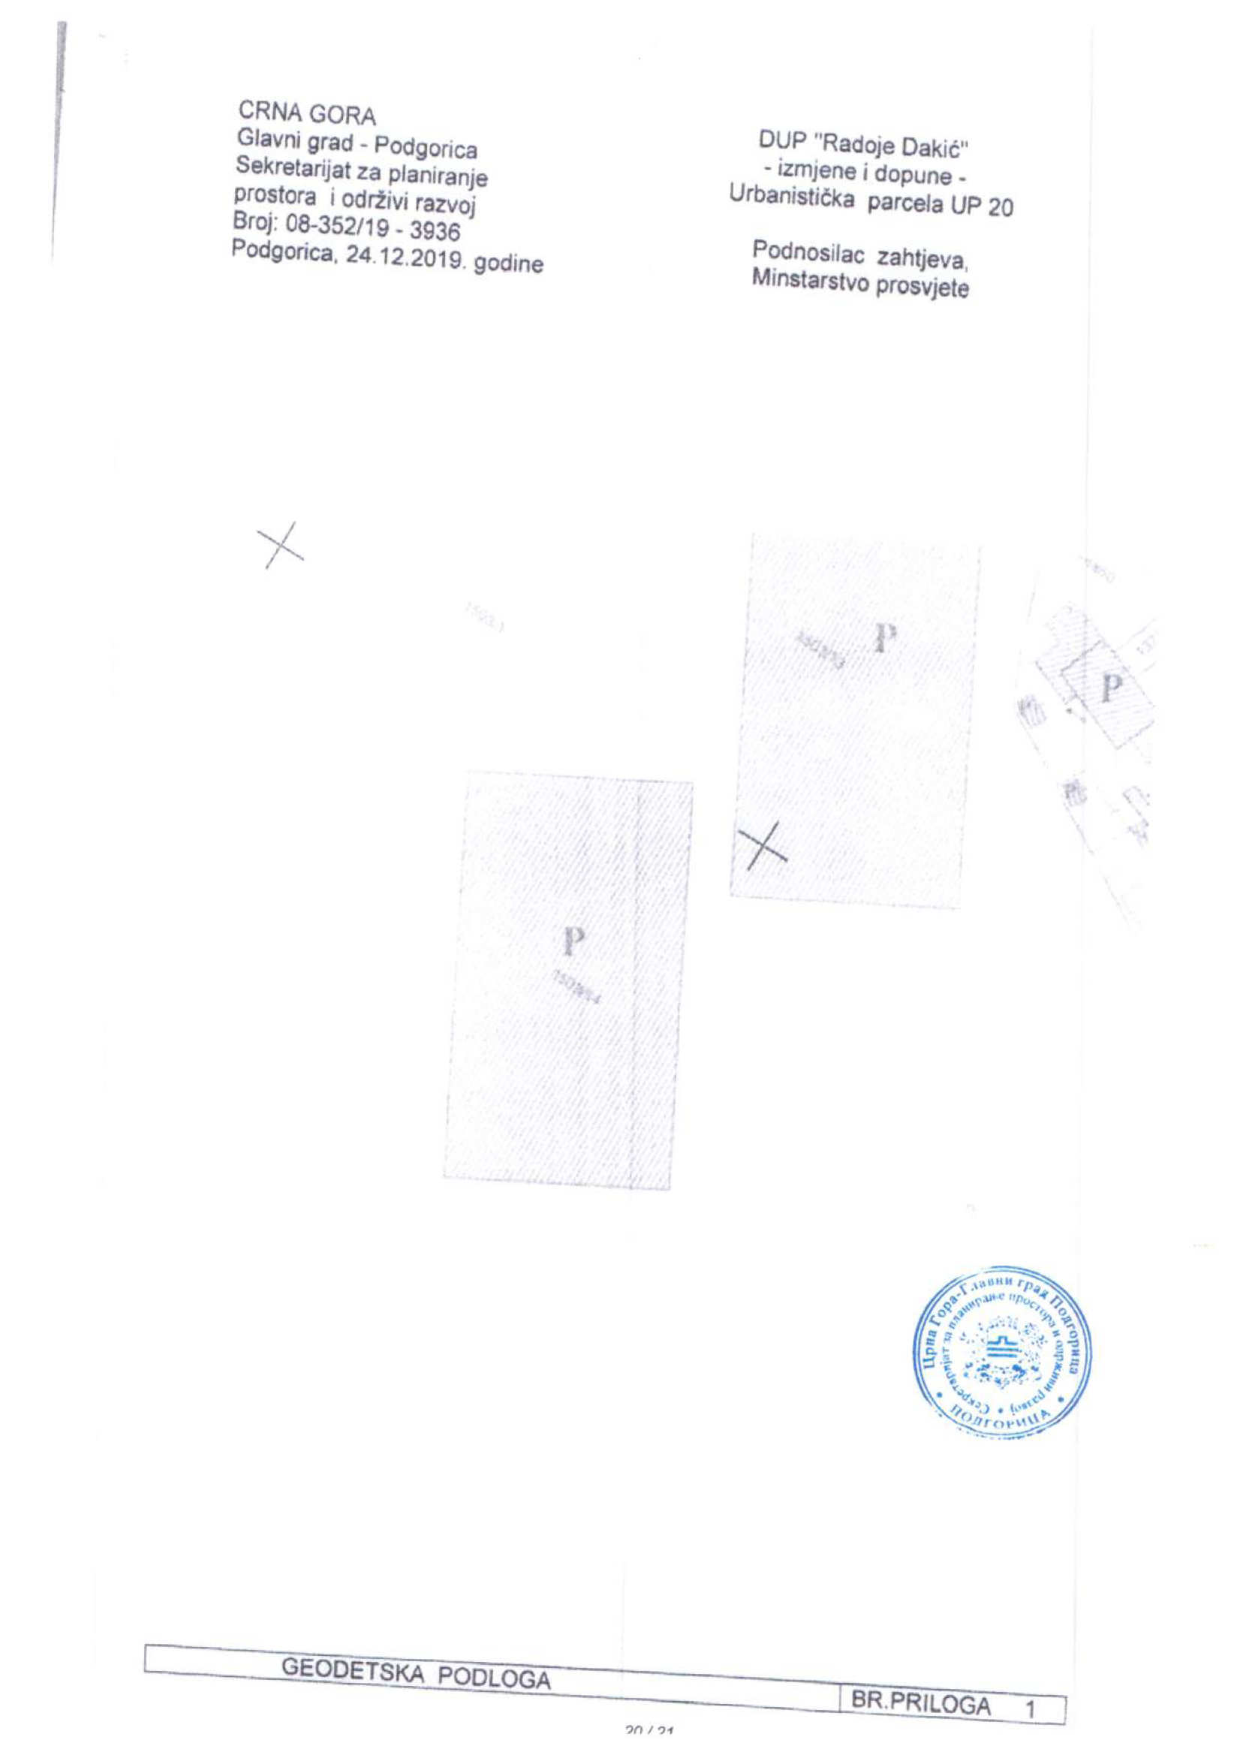
GEODETIC BASE ATTACHMENT NO. 1
[seal: Secretariat for Spatial Planning and Sustainable Development, Montenegro, Capital City Podgorica, PODGORICA]
DUP “Radoje Dakić”
– amendments and supplements –
Urban Plot UP 20

Applicant,
Ministry of Education
MONTENEGRO
Capital City – Podgorica
Secretariat for Spatial Planning and Sustainable Development
Number: 08-352/19 – 3936
Podgorica, 24/12/2019

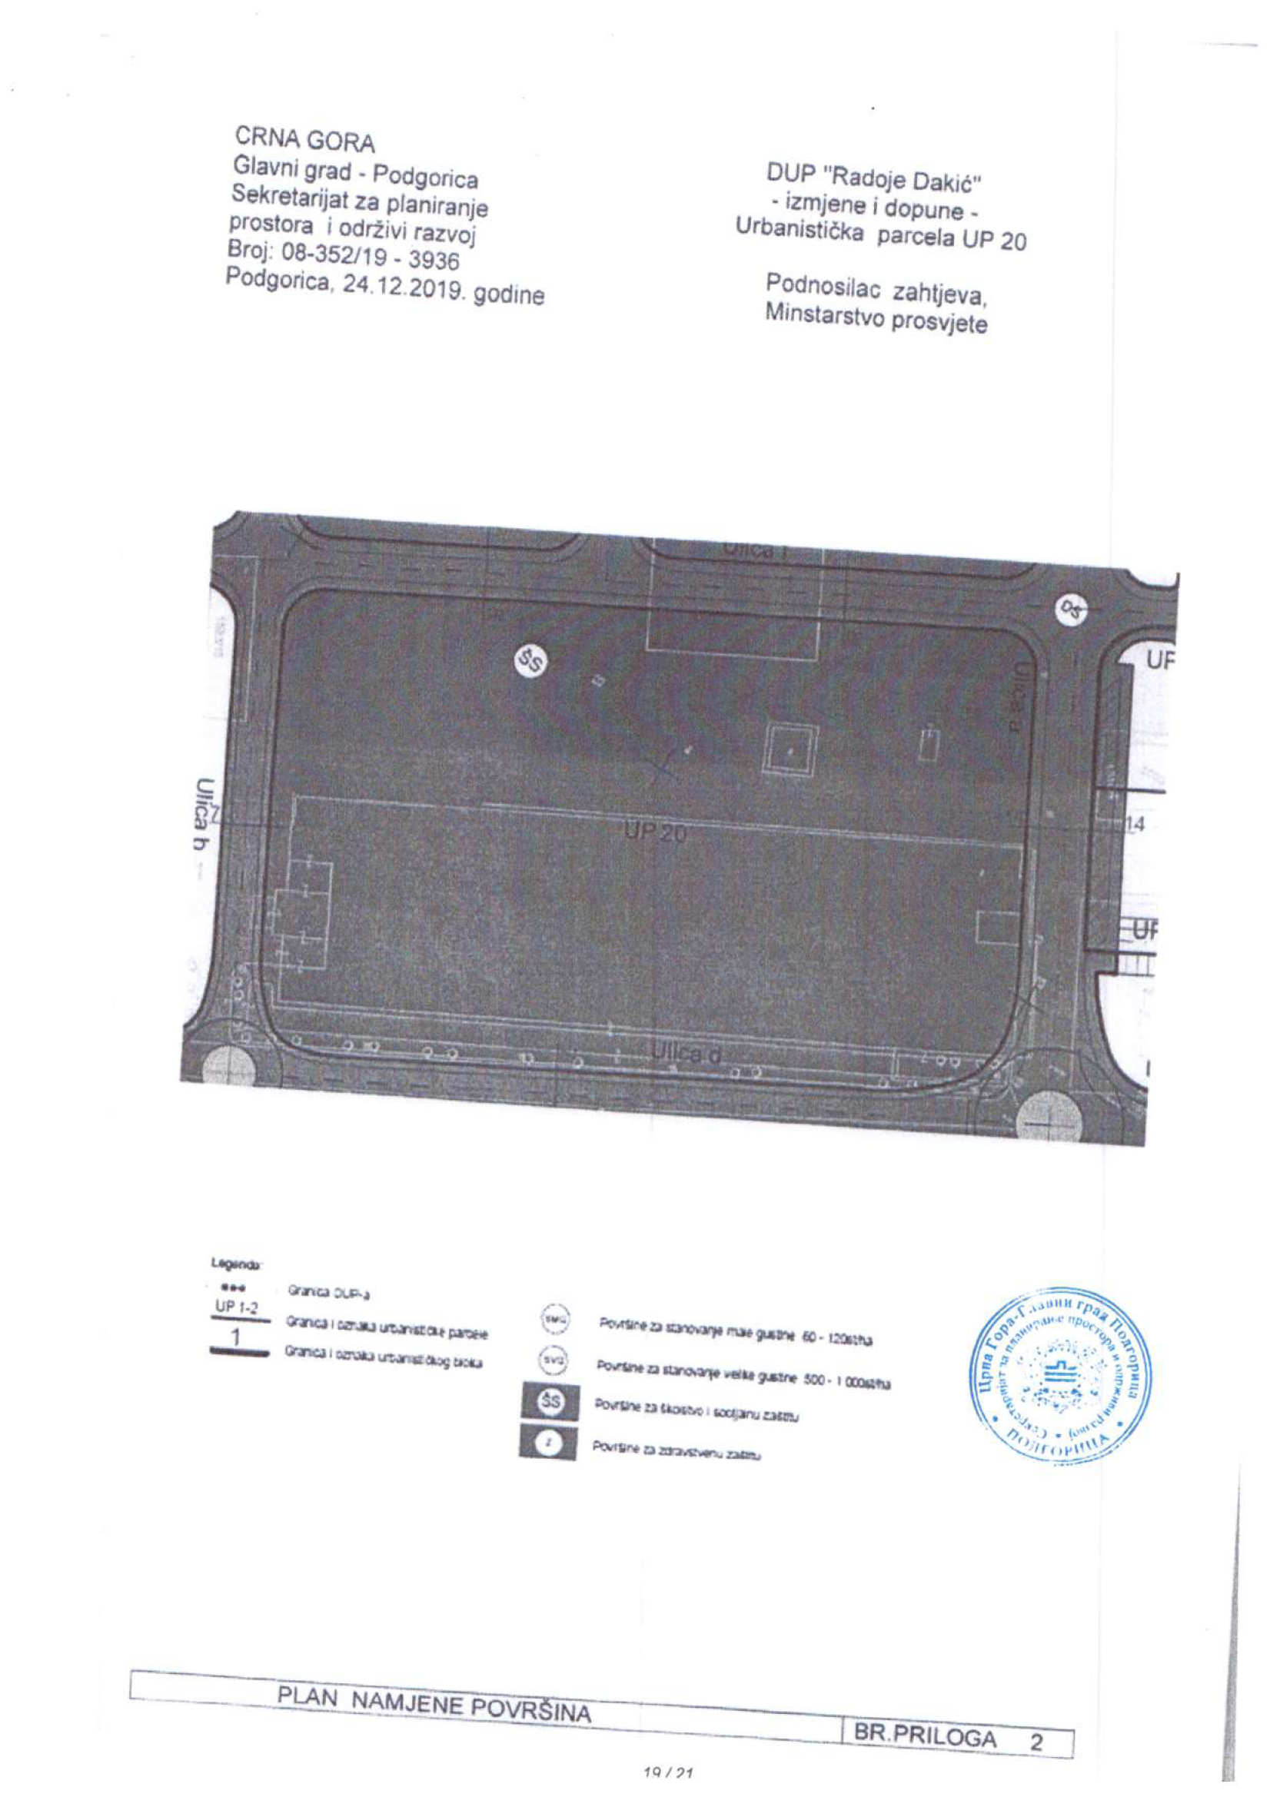
[seal: Secretariat for Spatial Planning and Sustainable Development, Montenegro, Capital City Podgorica, PODGORICA]
LAND USE PLAN ATTACHMENT NO. 2
MONTENEGRO
Capital City – Podgorica
Secretariat for Spatial Planning and Sustainable Development
Number: 08-352/19 – 3936
Podgorica, 24/12/2019
DUP “Radoje Dakić”
– amendments and supplements –
Urban Plot UP 20

Applicant,
Ministry of Education

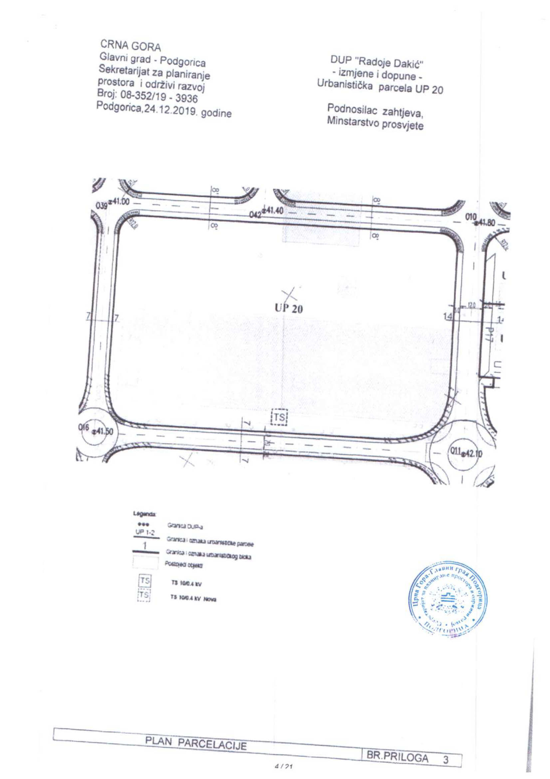
DUP “Radoje Dakić”
– amendments and supplements –
Urban Plot UP 20

Applicant,
Ministry of Education
PLOT DIVISION PLAN ATTACHMENT NO. 3
[seal: Secretariat for Spatial Planning and Sustainable Development, Montenegro, Capital City Podgorica, PODGORICA]
MONTENEGRO
Capital City – Podgorica
Secretariat for Spatial Planning and Sustainable Development
Number: 08-352/19 – 3936
Podgorica, 24/12/2019

