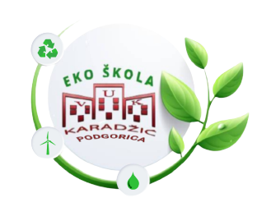

- AUTHOR DETAILS

- Name/s | Ana Đurović
- Country | Montenegro
- Institution/School | JU OŠ ,, Vuk Karadžić” Podgorica
- Subject | Chemistry

- THE LESSON PLAN

- Theme – Polymers and circular economy

B. Introduction – The lesson plan introduces students to the importance of the Polymers and circular economy. During this lesson, students learned the structure and division of polymers, understood the concept and importance of the circular economy, and learned about working on a 3D printer.

C. Age Group – The students were 14 years old (9th grade),

D. Objectives or Learning Outcomes
Outcomes that students will achieve:
- explain the structure of polymers, the division of polymers and the difference between synthetic and natural polymers;
- lists examples of the use of plastic materials;
- investigates the impact of polymers on development and environmental pollution;
- explains the impact of waste on environmental pollution;
- describes the importance of recycling.
- Become familiar with the concept of CIRCULAR ECONOMY and its principles;
- Get acquainted with the 3D printing process

E. Time required to deliver the lesson plan – 90 minutes

F. Resources Required to deliver the lesson plan –
- Computer with projector,
- Teams application,
- 3D printer
- PETko- a device for making plastic strips for 3d printing from bottles
- Plastic bottles
- Libra
- Paper and crayon

G. Remote preparation - For homework, the students had to watch the movie WALL-E
https://youtu.be/TaBhFu3Ti_g?si=cRhT0C5REeg2t0mQ

H. Activity
1st CLASS
  - Introduction (10 minutes)
- The teacher initiates a discussion on the WALL-E cartoon that the students watched for homework.
- Students discuss the topic of the cartoon, discuss what the film warns us about and what lessons can be learned from the film, whether they recognize the consequences of the consumer society on the environment and on people's health.

  - Development (25 minutes)
- They get to know the term POLYMERS and observe a presentation on the topic of polymers (polymer structure, polymer division, polymerization reaction)
- They watch a short video Plastic Facts from the National Geographic Channel (link is given below)

- https://youtu.be/WvyF3yXLrmk?si=qnc-_xHQIoVVXwXc

- Students discuss the topic of the amount of plastic that is thrown away and suggest other ways besides recycling to reduce that amount of plastic.
- They observe the diagram of linear and circular economy and become familiar with the term 5R.
  - Conclusion (10 minutes)
- Students are briefly introduced to 3D printing and the PETKO device. They observe the process of preparing strips and 3D printers from plastic bottles.
- Students do their homework in groups of 4 (they choose the groups themselves). They are given the task to collect as many plastic bottles as possible and to familiarize themselves with 3D modeling programs. Through the Teams application, they receive a link to the ultimaker cura program and the task of choosing what they would like to print. In the next class, the selection of the group that collects the most plastic bottles will be printed on a 3D printer.

2nd CLASS
  - Introduction (10 minutes)
- We measure the mass of plastic collected by the groups;
- The group that collected the largest amount of packaging is announced.
- Their model is put into print
  - Development (25 minutes)
- They look at the bottles they have collected and look for the type of polymer on them.
- Looking at the following cards, they classify plastic into toxic and non-toxic;
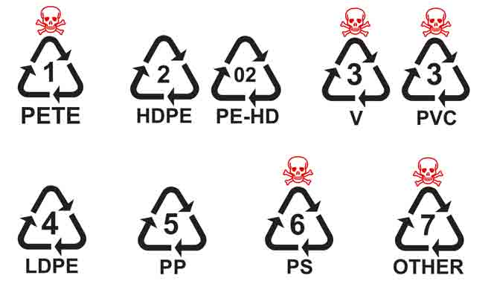
- They draw the chemical formulas of the monomers from which the collected polymers are made.
- After the finished demonstration, while waiting for the printer to print the given item, the students have the task in the same groups to make a sketch of an educational brochure that promotes the principles of the circular economy and the harmfulness of using plastic for the environment and health.

Conclusion (10 minutes)
- The groups present their works and for their homework they have to create a flyer in electronic format on the topic of promoting the circular economy and the harmfulness of using plastic for the environment and health.
- The best designed flyer will be printed and distributed in the school as educational material.
I. Evaluation and Assessment
- Amount of collected bottles;
- Printed item on a 3D printer;
- Created and produced educational material on the topic of circular economy and the harm of using plastic for the environment and health;

