 | 

APPLICATION FORM

Torino Process Award for the Entrepreneurship Key Competence
The vocational school/training centre will provide a description of its activities in promoting entrepreneurship key competence as well as details of the staff member to participate at the award ceremony in Brussels on 24 November 2017.

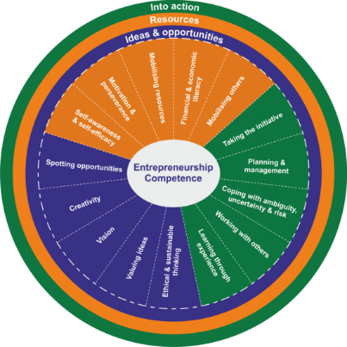

Please, submit the good practice by email to: EntreComp@etf.europa.eu

Deadline: 20 September 2017.

Torino Process Award for the Entrepreneurship Key Competence
The vocational school/training centre will provide a description of its activities in promoting entrepreneurship key competence as well as details of staff member to participate at the award ceremony in Brussels on 24 November 2017.

1. Torino Process Conference Delegate
Name

Country

Organisation

Email

Telephone

2. Details of vocational school or training centre
Name of school

Address

Telephone

Email

Director’s name (or other staff member who will participate in European Vocational Skills Week awards ceremony)

3. Entrepreneurship key competence
Which ‘EntreComp’ competence(s) are developed?

4. How is the ‘EntreComp’ competence(s) developed?
Provide an example(s) of a learning outcome(s) for the competence(s) chosen (max. 100 words)

Describe the teaching and learning approach to achieve the learning outcome(s) (max. 200 words)

